AI-Powered Cloud Scheduler for Hospitals
Course Name: Cloud Computing
Student Names & IDs:
Abdullah Mohamed, 233441
Pierre Fouad, 232849
Mohamed Mahmoud, 231113
Ibrahim Ayman, 232649
Hazem Waleed, 233965

Abstract
This project is about making a system for hospitals. It is called an AI-Powered Cloud Scheduler for Hospitals. The goal of this project is to guess how long people will have to wait in the emergency room. We used something called machine learning to make these guesses.
The old way of scheduling hospital appointments is not very good. Our system is better because it uses the internet and can handle a lot of users at the time. We took some data from the emergency room. Used it to train a machine learning model. Then we made a website for this model using something called FastAPI.
We put the website in a box called Docker so it can work on any computer. Then we put this box on a computer system called Kubernetes. This system can check if the website is working properly and add boxes if a lot of people are using it at the same time. We also added some checks to make sure the website is healthy and working correctly. The AI-Powered Cloud Scheduler, for Hospitals is a project that uses machine learning and cloud computing to make hospital scheduling better. Results indicate that the system is indeed capable of effective prediction of ER wait times while being highly available and scalable in a cloud environment.
1. Introduction
Accidental and emergency admissions add to much of the unpredictability of hospital admissions, especially in emergency departments. Most of the hospitals face the problem of imbalance between the supply and demand of medical staff, resource limitation, and budgetary constraints. Long waiting times diminish patient satisfaction and overall quality of healthcare. In recent years, artificial intelligence and cloud computing have increased so that their applications can be effectively reaped in improving hospital operations.
We're building an AI-powered scheduling system to predict ER waiting times, setting it up as a cloud-native application. This involves applying machine learning, containerizing the system with Docker, and deploying it on Kubernetes. That ensures it'll be reliable and scalable.

2. Literature Review and Background
Earlier studies have illustrated the potential of Artificial Intelligence in health operations, such as patient flow and scheduling optimization. Decision trees, random forests, and neural network models have been used to estimate patient waiting times and resource use. Cloud computing platforms provide horizontal scalability, fault tolerance, and centralized management; hence, they are an ideal candidate to suit health requirements. The present project will extend these ideas towards merging machine learning with cloud-native deployment methods.
3. Problem Statement
Traditional hospital scheduling systems are often static; they typically use manual or rule-based methods. This makes it hard for them to adjust to real-time patient demand. As a result, emergency rooms frequently struggle with overcrowding, wasted resources, and long wait times. We need an intelligent, scalable system that predicts ER queue times and responds to shifting workloads.

4. System Requirements/Tools Used
Software Tools
Python for Machine Learning and back-end work
FastAPI to build RESTful APIs
- Docker for containerization
Kubernetes is used for managing containers.
Docker Hub - Repository for container registry
Libraries and Frameworks:
The principal ones are Pandas and NumPy for data processing.
- Scikit-learn for training machine learning models
Hardware Requirements:
Personal computer with Docker Desktop and Kubernetes enabled

5. Methodology/ Approach
The solution follows an straightforward approach. First we do some preprocessing and feature selection on the ER dataset. We pick the features that are important for the ER dataset and then we train a Random Forest Regressor model. This Random Forest Regressor model is used to predict the waiting time for the ER dataset.
We save the trained Random Forest Regressor model. Add it to the FastAPI application. Then we use Docker to make the application work, in a container. After that we put the application on a cluster that we created in Kubernetes for the ER dataset. Health checks and auto-scaling deployment are set up.

6. System Design
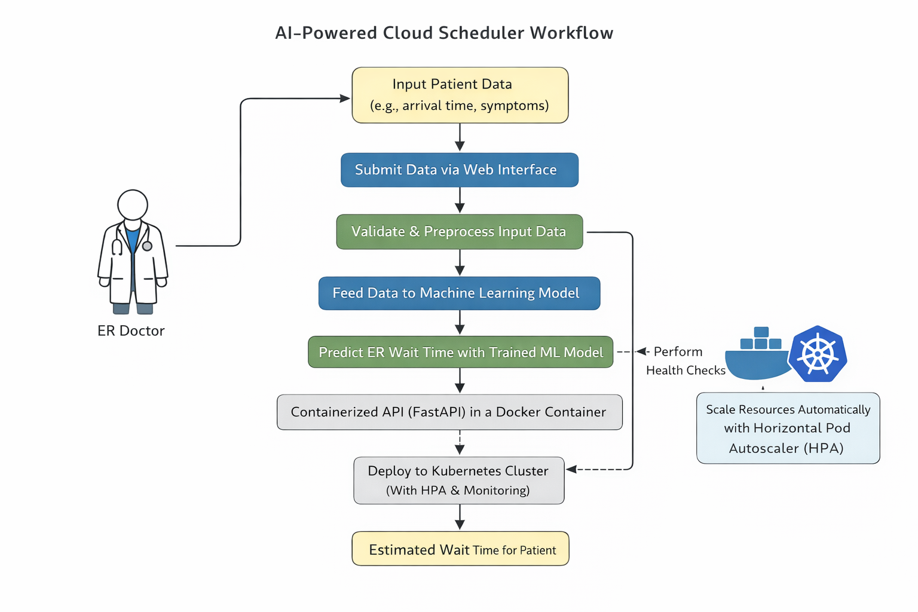
7. Implementation
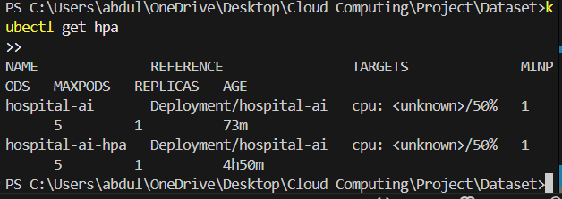
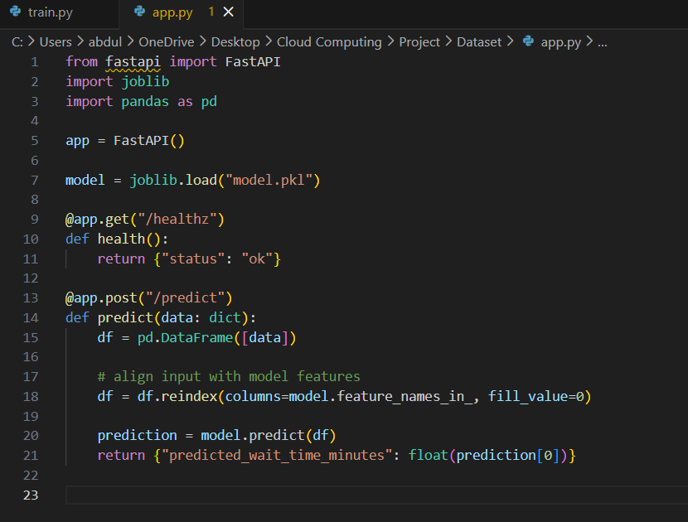
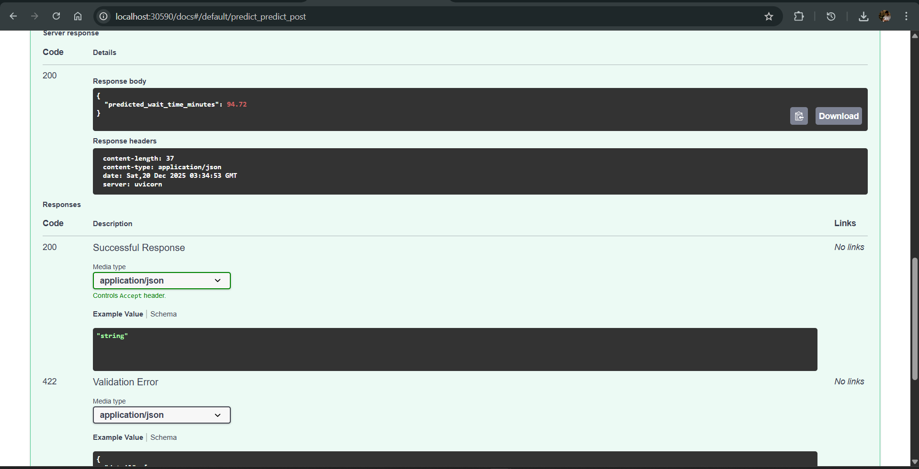
We used the FastAPI to make the machine learning model work and to get the results we needed. The predict endpoint returned values such as 94.72 minutes. This confirmed the model was operating as expected. We also monitored the Kubernetes pods and the Horizontal Pod Autoscaler to make sure they ran smoothly.
9. Discussion
The system worked well when we tested it and showed us the things about using cloud-native deployment. We had some problems, with taking care of container images and Kubernetes settings. We were able to fix these problems by keeping track of the versions of images and managing deployments carefully.

10. Conclusion
This project really showed us that machine learning and cloud computing can work together. We. Tested a hospital scheduling system that uses artificial intelligence in a place called Kubernetes. Doing this project taught us a lot about making cloud based machine learning applications that can handle a lot of work and are always available.

11. References
We looked at papers and information online about Docker and Kubernetes and FastAPI and other things, about machine learning while we were working on this project.

12. Appendix
