**CIFAR-10 CNN Implementation report**

Here I have implemented my custom CNN over the dataset of CIFAR contains 50000 images of size 32 by 32 size colored images. These images are divided into 5 batches and are saved in the dictionary and each dictionary have its label and data is stored in 1d form with the size of 3072 in each record and each 3072 pixel is combination of 1024 x 3 records where first 1024 records are for Red and then second and third are for green and blue, After this we reshape the images and converted it into 3 color channel images as shown below:

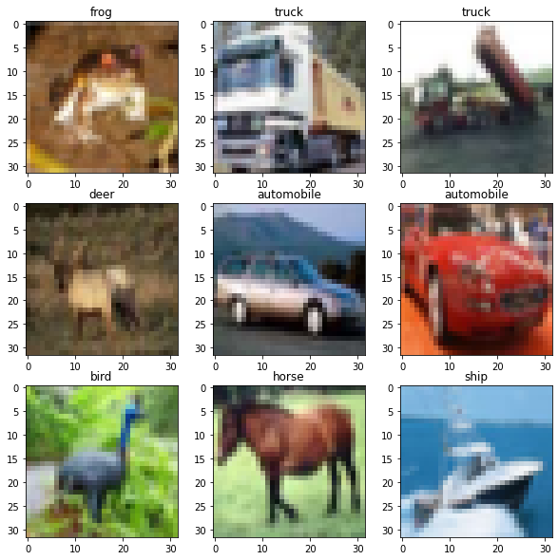

Figure 1: Some images from the dataset

Here is the graphical distribution of all the classes in the dataset that contains about 5000 images for each class.

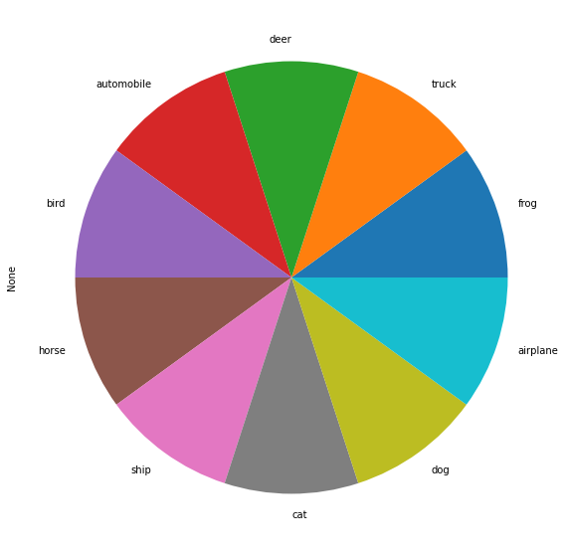

Figure 2: CIFAR Dataset Classes Distribution

After this, we convert the labels into number and then converted into categorical form for the CNN model to learn from it. Here I have used my custom CNN model with six convolutional layers, 3 Average pooling layers, two dense layer and a flatten layer. Here is the summary and visual representation of the architecture of the custom CNN model.

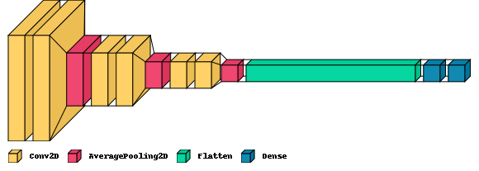

Figure 3: Custom CNN architecture model

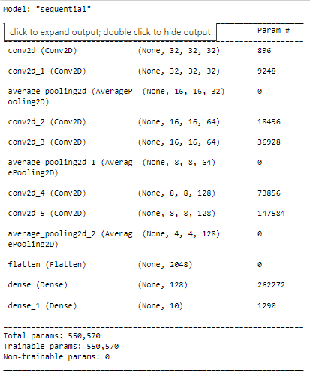

Figure 4: CNN Model Summary

First, I spilt the dataset into train and test data. Here is the train and test distribution of the dataset.

Train data: (33500, 32, 32, 3)

Test data: (16500, 32, 32, 3)

For the train images, the samples are 33500 and for the test data, the samples are 16500, each sample contains 32-by 32-size image. After this, I have train the data over this model. Here is the graphical view of the model performance over the dataset.

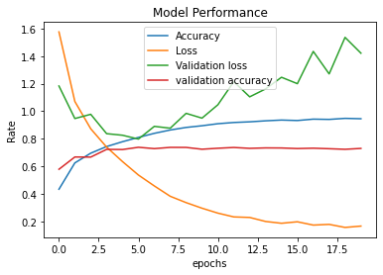

Figure 5: CNN Model training performance

After the training of the model, I have tested the model over the test data the model achieved the accuracy of 73% over the test data the classification report is shown below:

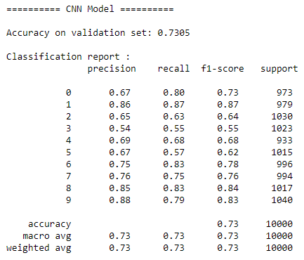

Figure 6: Classification report of the CNN Model

After this, we used the Alex Net model pretrained model for this dataset. Here the model of Alex Net will not be used completely here I have used the output of the fully connected sixth layer then I have generated the output of 1000 values in a list and combine them into a data. Here the data will be use in the machine-learning model for the training and evaluation. Here is the architecture of the fc6-layered Alex Net:

Model: "model"

_________________________________________________________________

Layer (type) Output Shape Param #

=================================================================

conv2d_input (InputLayer) [(None, 32, 32, 3)] 0

_________________________________________________________________

conv2d (Conv2D) (None, 8, 8, 96) 34944

_________________________________________________________________

batch_normalization (BatchNo (None, 8, 8, 96) 384

_________________________________________________________________

activation (Activation) (None, 8, 8, 96) 0

_________________________________________________________________

max_pooling2d (MaxPooling2D) (None, 4, 4, 96) 0

_________________________________________________________________

conv2d_1 (Conv2D) (None, 4, 4, 256) 614656

_________________________________________________________________

batch_normalization_1 (Batch (None, 4, 4, 256) 1024

_________________________________________________________________

activation_1 (Activation) (None, 4, 4, 256) 0

_________________________________________________________________

max_pooling2d_1 (MaxPooling2 (None, 2, 2, 256) 0

_________________________________________________________________

conv2d_2 (Conv2D) (None, 2, 2, 384) 885120

_________________________________________________________________

batch_normalization_2 (Batch (None, 2, 2, 384) 1536

_________________________________________________________________

activation_2 (Activation) (None, 2, 2, 384) 0

_________________________________________________________________

conv2d_3 (Conv2D) (None, 2, 2, 384) 1327488

_________________________________________________________________

batch_normalization_3 (Batch (None, 2, 2, 384) 1536

_________________________________________________________________

activation_3 (Activation) (None, 2, 2, 384) 0

_________________________________________________________________

conv2d_4 (Conv2D) (None, 2, 2, 256) 884992

_________________________________________________________________

batch_normalization_4 (Batch (None, 2, 2, 256) 1024

_________________________________________________________________

activation_4 (Activation) (None, 2, 2, 256) 0

_________________________________________________________________

max_pooling2d_2 (MaxPooling2 (None, 1, 1, 256) 0

_________________________________________________________________

flatten (Flatten) (None, 256) 0

_________________________________________________________________

dense (Dense) (None, 4096) 1052672

_________________________________________________________________

batch_normalization_5 (Batch (None, 4096) 16384

_________________________________________________________________

activation_5 (Activation) (None, 4096) 0

_________________________________________________________________

dropout (Dropout) (None, 4096) 0

_________________________________________________________________

dense_1 (Dense) (None, 4096) 16781312

_________________________________________________________________

batch_normalization_6 (Batch (None, 4096) 16384

_________________________________________________________________

activation_6 (Activation) (None, 4096) 0

_________________________________________________________________

dropout_1 (Dropout) (None, 4096) 0

_________________________________________________________________

dense_2 (Dense) (None, 1000) 4097000

_________________________________________________________________

batch_normalization_7 (Batch (None, 1000) 4000

_________________________________________________________________

activation_7 (Activation) (None, 1000) 0

=================================================================

Total params: 25,720,456

Trainable params: 25,699,320

Non-trainable params: 21,136

_________________________________________________________________

After generating the features of 1000 values for each images I applied a machine-learning model of Decision Tree Classifier. Here the model achieved the accuracy of 65% over the test dataset. Here is the results of the decision tree model below:

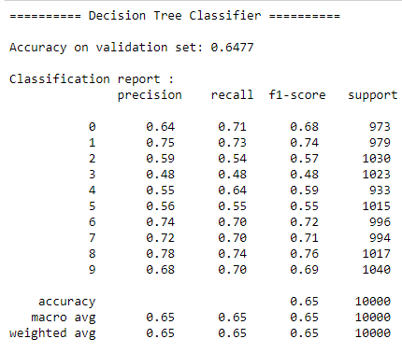

Figure 7: FC6 Model Classification Report

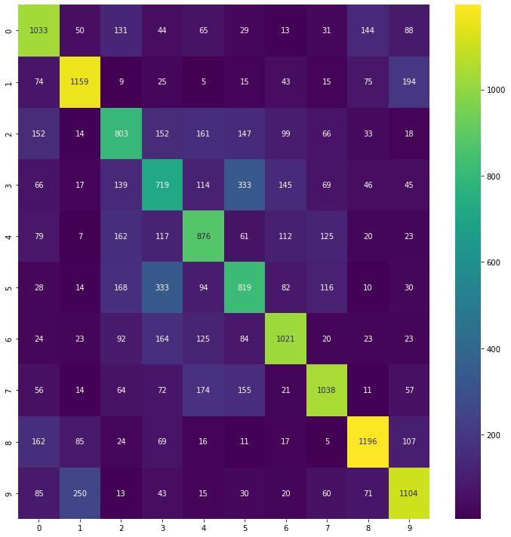

Figure 8: FC6 Confusion Matrices

After this, I have used the same Network of but now the output will be taken from the seventh layer of the fully connected layers. In addition, this time the model achieved the accuracy of 64% here is the classification of the model output over the Decision tree model.

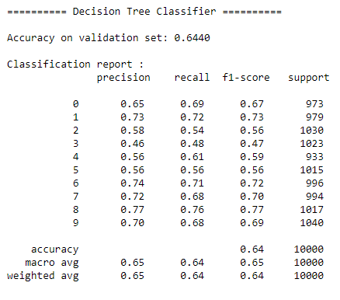

Figure 9: FC7 Model Classification Report

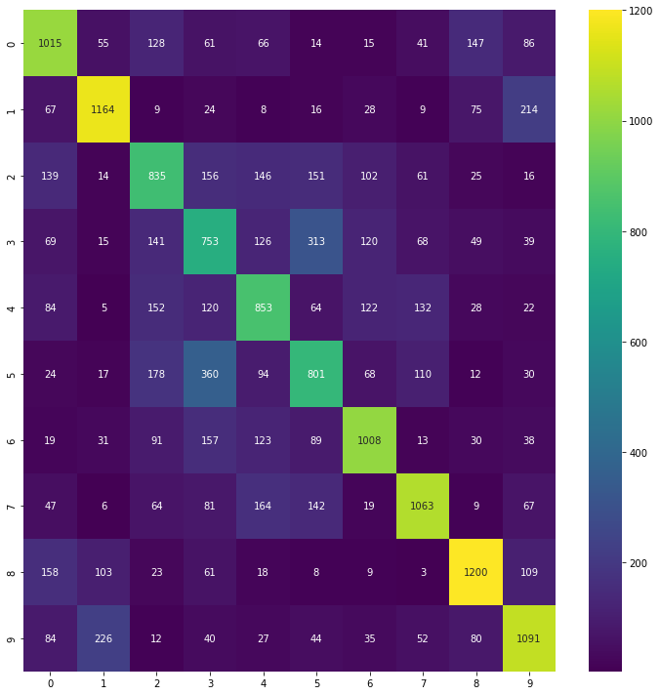

Figure 10: FC7 Confusion Matrices

FC6 and FC7 Models Comparisons:

Here we noticed that both the model performed well in the classification but the FC7 score is the FC7 model achieved the accuracy of 65% and the FC6 layer model achieved 64% accuracy. Here the model have the following comparisons as below:

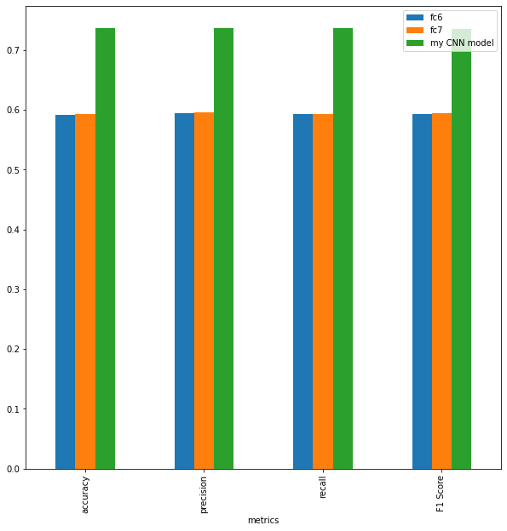

Figure 11: Models Accuracy, Precision and Recall Comparisons