Fundamentals Of Software Engineering

Skill Barter System
Sprint 2 — Iteration 2 Report

Names:
Abdullah Zahid | Usman Gohar
Roll Numbers:
24L-2597 | 24L-2584
Deliverable: D2 (Iteration 2 / Sprint 2)
Submission Date: 14/04/2026

1. Project Title & Introduction
Project Title: Skill Barter System
The Skill Barter System is a desktop application designed for university students to connect, collaborate, and exchange skills within their campus community. Students create profiles listing skills they can teach and skills they want to learn, enabling structured peer-to-peer skill exchange without any financial transactions.

Introduction to Sprint 2 — Matching Module
Sprint 2 focuses on the core functionality that connects students: the Skill Matching System. Building on the User Management Module from Sprint 1, this sprint delivers skill search, match suggestions, exchange requests, and request management.

Features implemented in this iteration:
- Skill Search & Filter
- Skill Match Suggestion
- Send Exchange Request
- Accept / Reject Requests
- Request Status Display

2. Sprint Backlog — Sprint 2
Module: Matching Module
The module developed in Sprint 2 is the Matching Module. This module enables students to find suitable skill exchange partners, send requests, and manage exchange interactions.

User Stories

Story ID: US-06 Story Title: Skill Search & Filter
Priority: | High | Estimated Hours: 7
User Story: | As a user, I want to search for other students by skill so that I can find suitable learning partners.
Description: | This story involves creating a search interface where students can search for peers based on skill name, category, or department.
Sub User Stories: | As a user, I want to type a skill name and see matching students.  As a user, I want to filter results by department or skill category.  As a user, I want the search results to be displayed clearly.
Acceptance Criteria: | A search bar must be accessible from the main dashboard.  Results must show relevant students with their skills.  Filter options by department and category must be available.  Empty results should display a helpful message.

Story ID: US-07 Story Title: Skill Match Suggestion
Priority: | High | Estimated Hours: 8
User Story: | As a user, I want the system to suggest potential skill matches so that I can find exchange partners easily.
Description: | The system automatically identifies students whose teach skills match the user's learn skills and vice versa.
Sub User Stories: | As a user, I want to see a list of suggested matches on my dashboard.  As a user, I want to see what skill is matched between us.  As a user, I want to navigate to a matched student's profile.
Acceptance Criteria: | System must compare the user's learn skills with others' teach skills.  Suggestions must be displayed in a dedicated Matches section.  Each suggestion must show the matched skill and student name.  Mutual matches must be highlighted.

Story ID: US-08 Story Title: Send Exchange Request
Priority: | High | Estimated Hours: 6
User Story: | As a user, I want to send an exchange request to another student so that we can agree to exchange skills.
Description: | Users can send a formal exchange request to a matched student specifying which skill they want to learn and what they can offer in return.
Sub User Stories: | As a user, I want to click a button to send an exchange request.  As a user, I want to specify the skill I want to learn and offer.  As a user, I want to confirm before sending a request.
Acceptance Criteria: | A Send Request button must appear on each student's profile.  The request form must allow selecting the skill to learn and offer.  A confirmation prompt must be shown before submission.  The request must be saved and the recipient notified.

Story ID: US-09 Story Title: Accept / Reject Requests
Priority: | High | Estimated Hours: 5
User Story: | As a user, I want to accept or reject incoming exchange requests so that I can manage my commitments.
Description: | Users can view their incoming exchange requests and accept or reject them. The sender is updated accordingly.
Sub User Stories: | As a user, I want to view all incoming requests in one place.  As a user, I want to accept a request with one click.  As a user, I want to reject a request with one click.
Acceptance Criteria: | An Incoming Requests panel must be accessible from the dashboard.  Each request must show sender name, skill offered and requested.  Accept and Reject buttons must be present on each request.  The sender must receive a status update upon action.

Story ID: US-10 Story Title: Request Status Display
Priority: | Medium | Estimated Hours: 4
User Story: | As a user, I want to see the status of my sent requests so that I know if they have been accepted or rejected.
Description: | All outgoing requests made by the user are displayed with their current status: Pending, Accepted, or Rejected.
Sub User Stories: | As a user, I want to see all my sent requests in a list.  As a user, I want to see the status label for each request.  As a user, I want to cancel a pending request.
Acceptance Criteria: | A Sent Requests section must be available in the user's account.  Each request must display the status: Pending, Accepted, or Rejected.  Users must be able to cancel requests that are still Pending.  Status must update when action is taken by the recipient.

3. Structured Specifications

US-06: Skill Search & Filter
US-06.1: Search Interface
Type | Specification
Functional | A search bar must be present and accessible on the main dashboard.
Functional | Users must be able to type a skill name and retrieve matching results.
UX | Search results must load quickly and display student name and matched skill.

US-06.2: Filter Options
Type | Specification
Functional | Filter options for department and skill category must be provided.
Functional | Filters must work in combination with the search query.
UX | Active filters must be visually highlighted.

US-06.3: Empty State Handling
Type | Specification
Functional | If no results are found, the system must show a 'No matches found' message.
UX | The empty state must include a suggestion to adjust search terms or filters.

US-07: Skill Match Suggestion
US-07.1: Match Algorithm
Type | Specification
Functional | System must compare the current user's learn skills against all other users' teach skills.
Functional | Mutual matches must be identified separately.
Performance | Match suggestions must be generated within 3 seconds of login.

US-07.2: Match Display
Type | Specification
Functional | A dedicated Suggested Matches panel must appear on the dashboard.
Functional | Each match card must display student name, shared skill, and a View Profile button.
UX | Mutual matches must be visually distinguished with a badge or highlight.

US-08: Send Exchange Request
US-08.1: Request Initiation
Type | Specification
Functional | A Send Request button must appear on every student profile page.
Functional | Users must select the skill they want to learn and the skill they offer in return.
UX | A confirmation dialog must be shown before the request is submitted.

US-08.2: Request Storage & Notification
Type | Specification
Functional | Submitted requests must be stored in the database with a Pending status.
Functional | The recipient must receive a notification about the new request.
Performance | Request submission must complete within 2 seconds.

US-09: Accept / Reject Requests
US-09.1: Incoming Requests Panel
Type | Specification
Functional | An Incoming Requests section must be accessible from the user dashboard.
Functional | Each request must show the sender's name, skill offered, and skill requested.
UX | Accept and Reject buttons must be clearly visible and labelled.

US-09.2: Status Update
Type | Specification
Functional | Accepting a request must update the status to Accepted in the database.
Functional | Rejecting a request must update the status to Rejected in the database.
Functional | The sender must receive a status change notification.

US-10: Request Status Display
US-10.1: Sent Requests List
Type | Specification
Functional | A Sent Requests panel must be available in the user's account section.
Functional | Each entry must show the recipient name, skills involved, and current status.
UX | Status labels must be colour-coded: Pending (yellow), Accepted (green), Rejected (red).

US-10.2: Cancellation
Type | Specification
Functional | Users must be able to cancel any request with a Pending status.
Functional | Cancellation must remove the request from the recipient's incoming list.
UX | A confirmation prompt must appear before cancellation is finalised.

4. Trello Board

Snapshot 1:

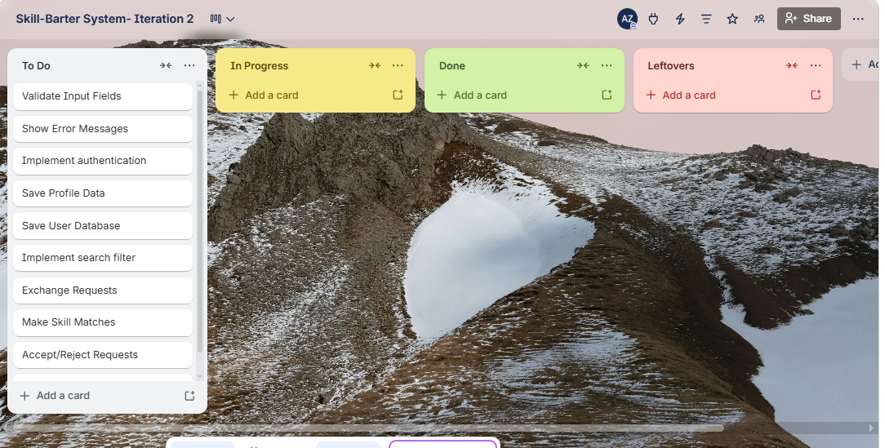

Snapshot 2:

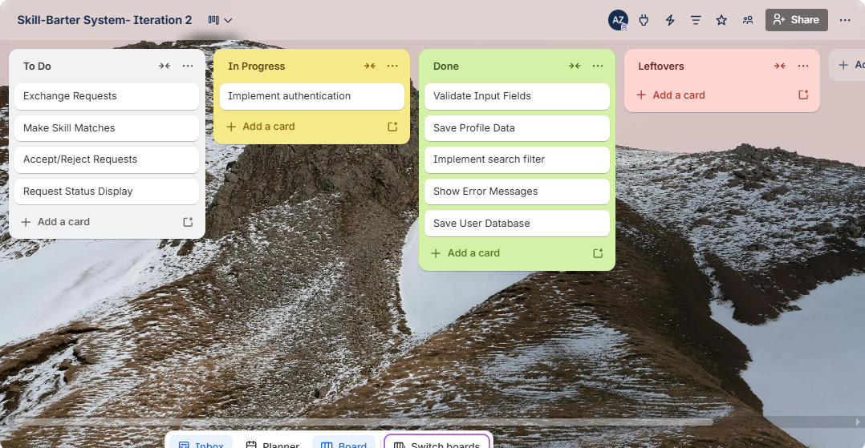
Snapshot 3:

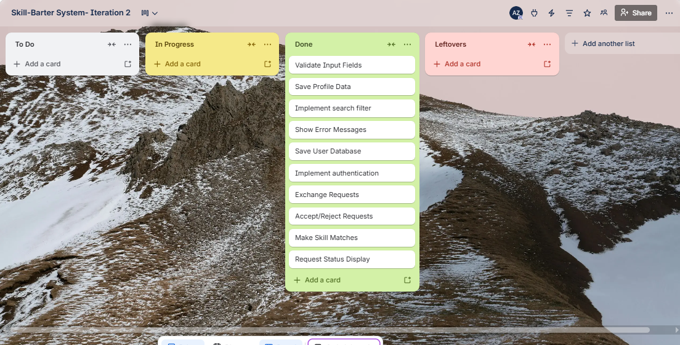

4. Implementation Screenshots

Screenshot 1:

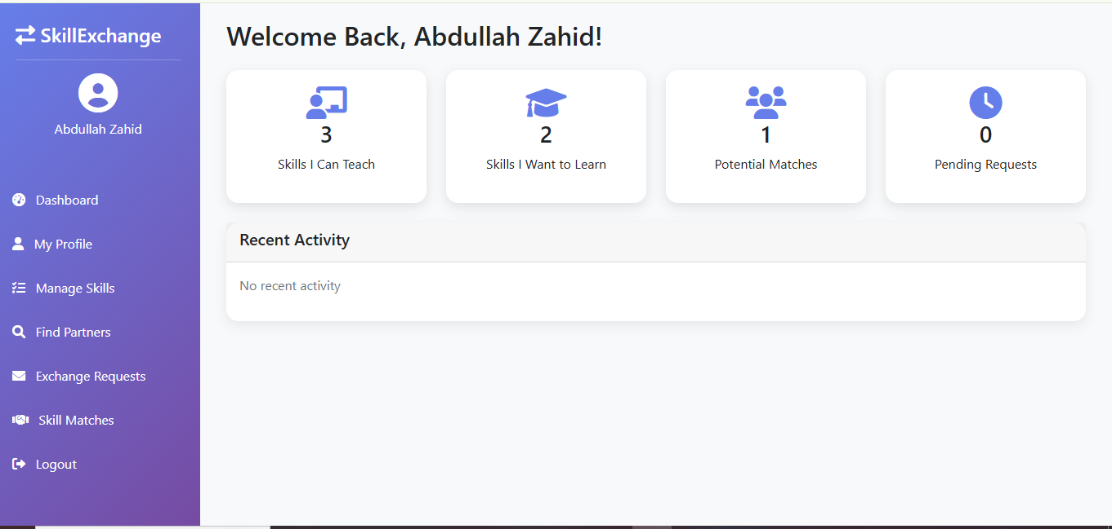

Screenshot 2:

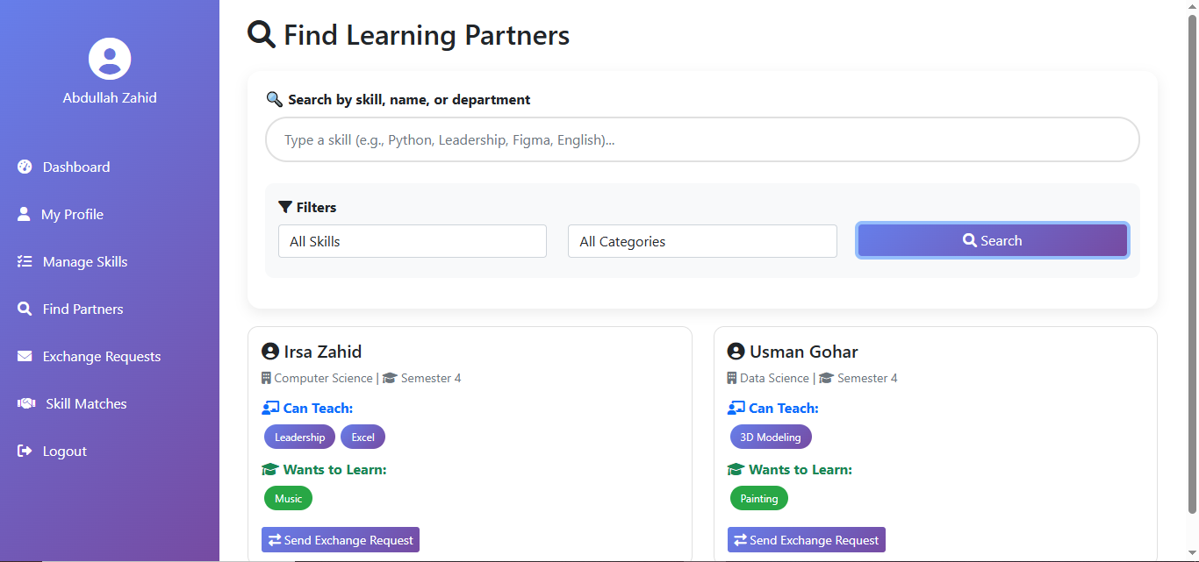

Screenshot 3:

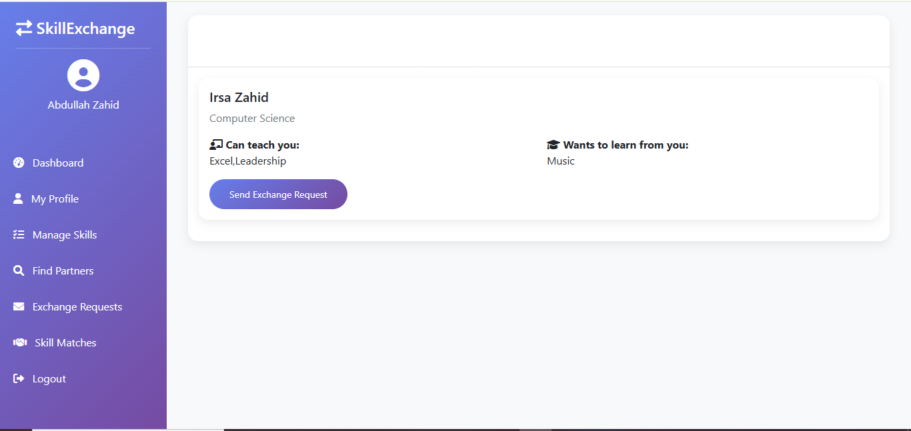

4. Design
4a. Activity Diagrams
Activity diagrams illustrate the step-by-step workflow of the three main processes in Sprint 2 of the Skill Barter System. Each diagram shows the decision points and alternate flows that occur during user interactions.

Activity Diagram 1: Skill Search & Filter
This diagram shows the complete flow when a student searches for a skill partner. The student enters a keyword, optionally applies filters by department or category, and the system returns matching student profiles. If no results are found, the student is prompted to adjust the search. Upon finding a match, the student can view the profile and optionally send an exchange request.

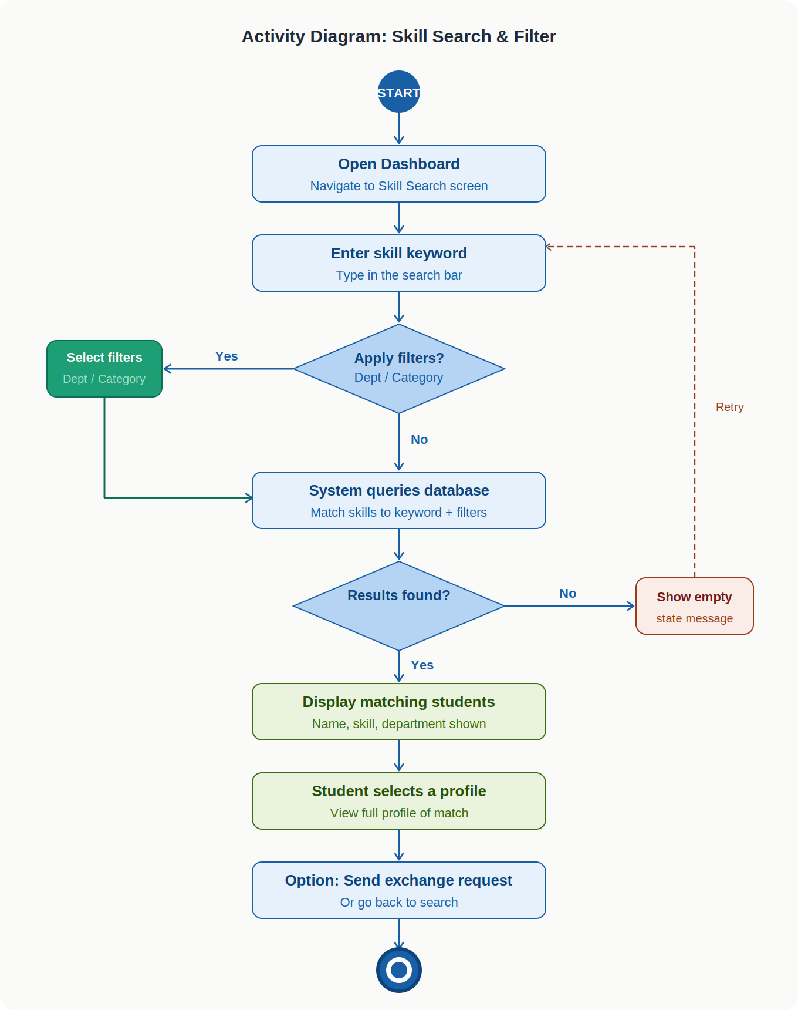

Activity Diagram 2: Send Exchange Request
This diagram covers the full flow of sending an exchange request. After opening a student's profile, the sender clicks 'Send Request', selects the skills to exchange, and confirms. The system validates the inputs, saves the request with a Pending status, and notifies the recipient. If the user cancels, the request is discarded.

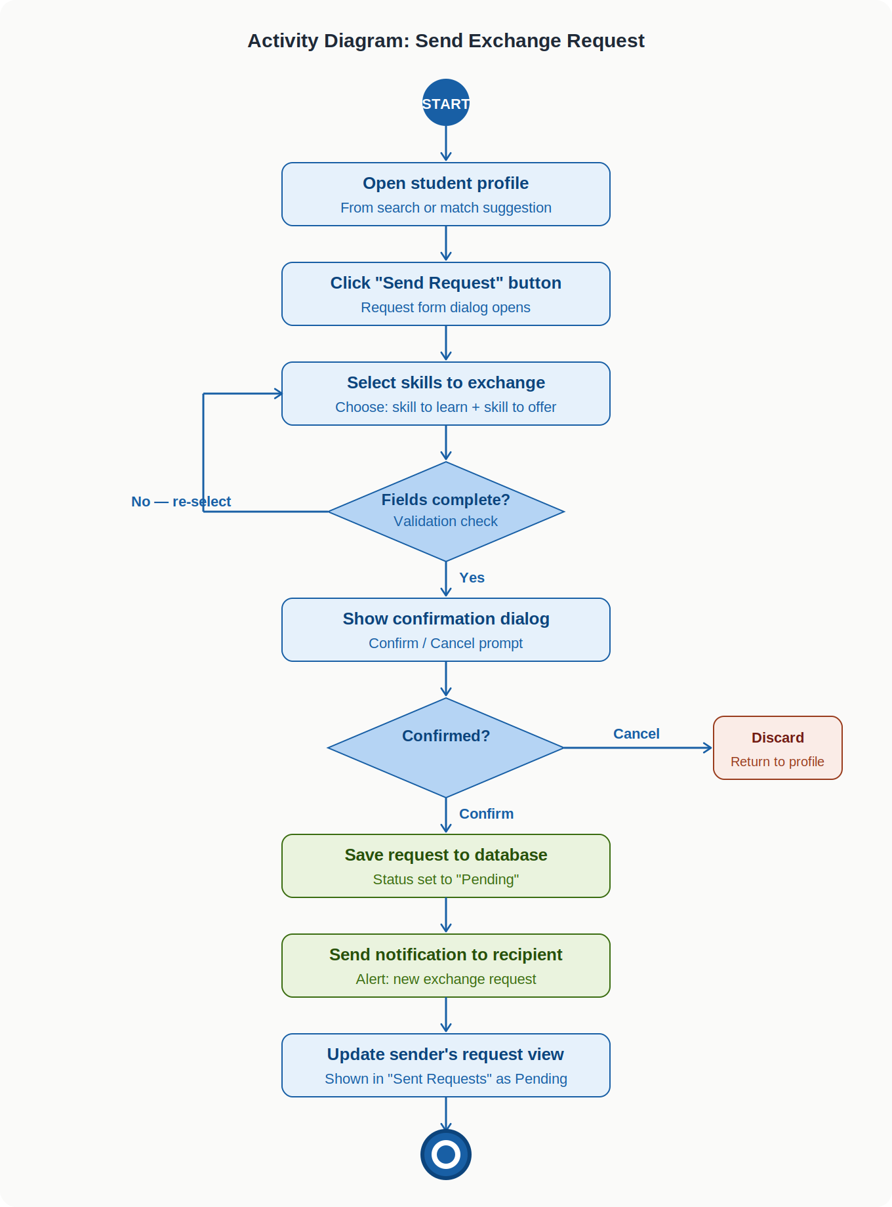

Activity Diagram 3: Accept / Reject Exchange Request
This diagram shows the recipient's flow upon receiving an exchange request. The recipient opens the Incoming Requests panel, reviews the details, and either accepts or rejects. The system updates the request status in the database and sends a notification to the original sender. If accepted, both users gain the option to schedule a session.

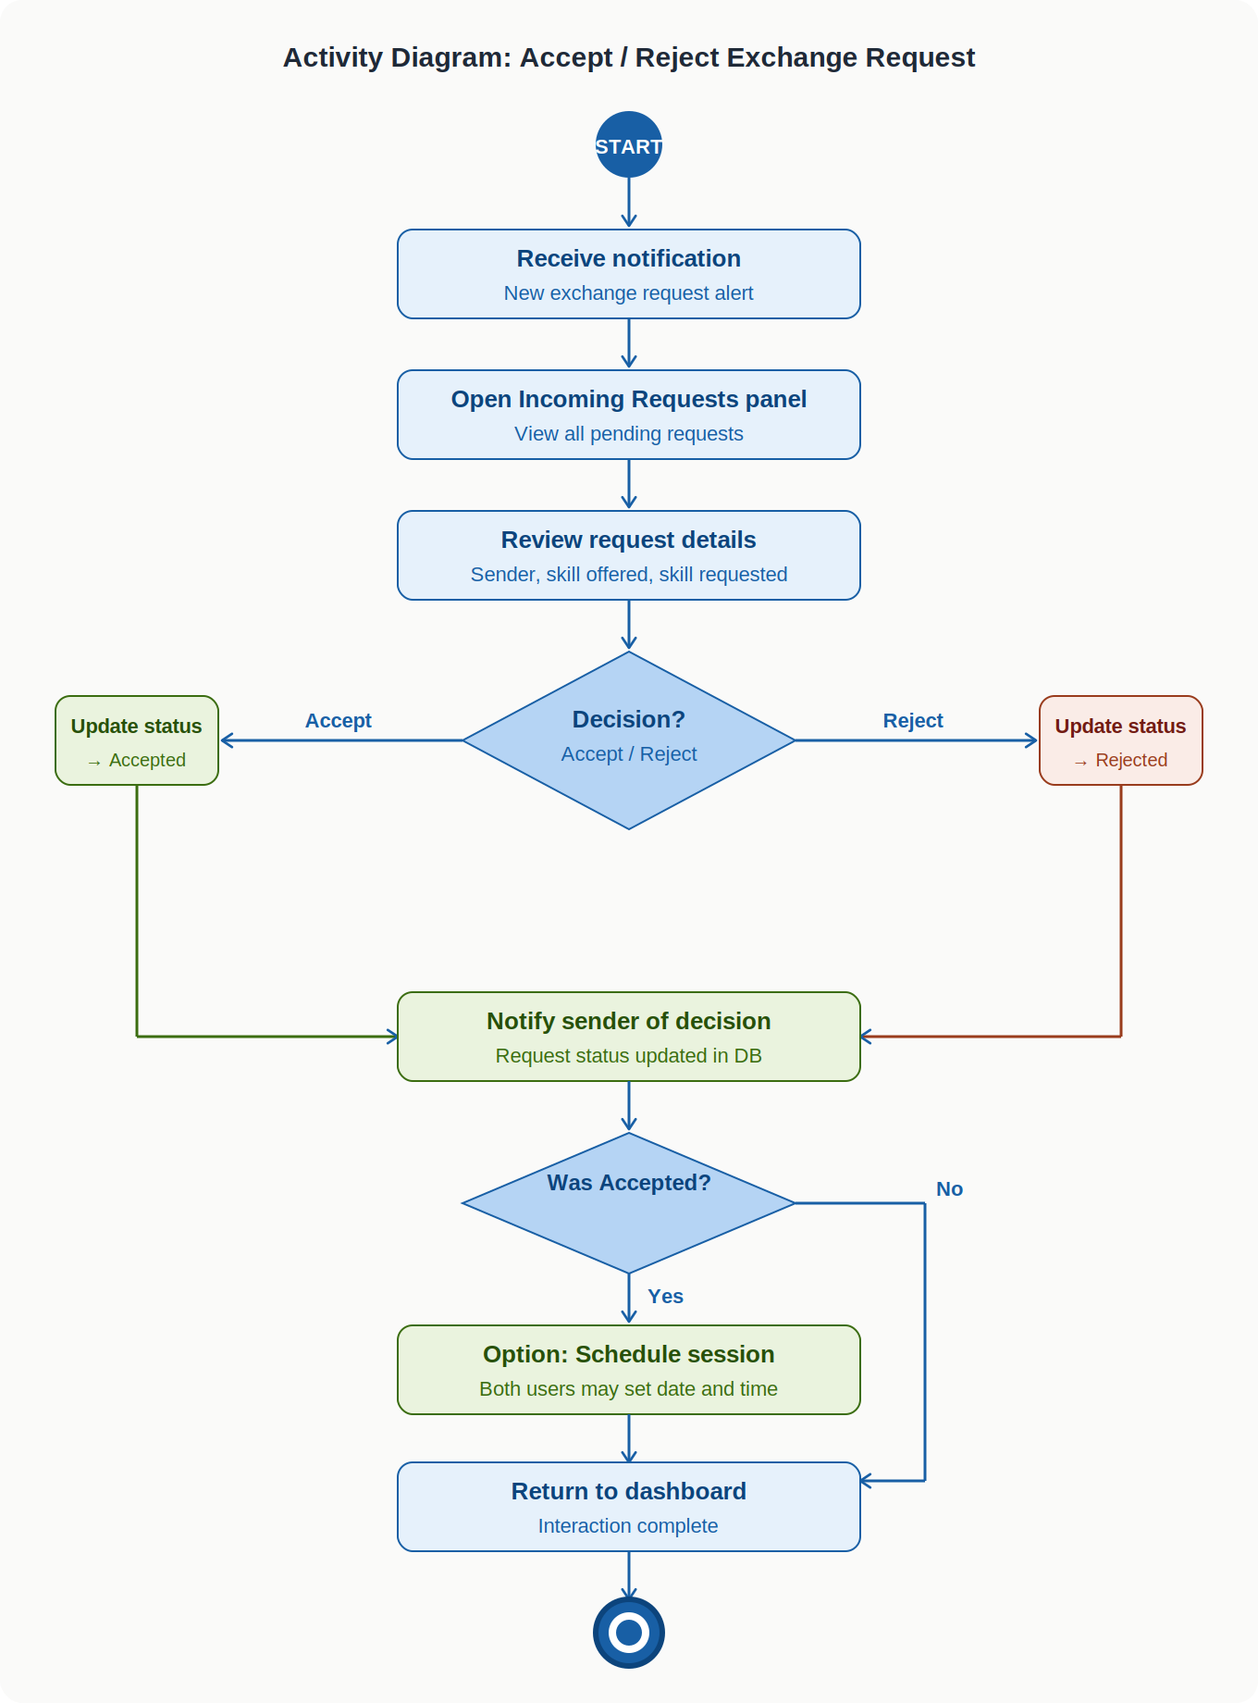

4b. Use Case Diagram
The Use Case Diagram below presents all actors and their interactions with the Skill Barter System in Sprint 2. The two actors are Student (primary) and Admin. The Student initiates all core matching and request use cases. The Admin monitors system activity. Dashed arrows show include relationships — for example, viewing incoming requests includes the ability to accept or reject.

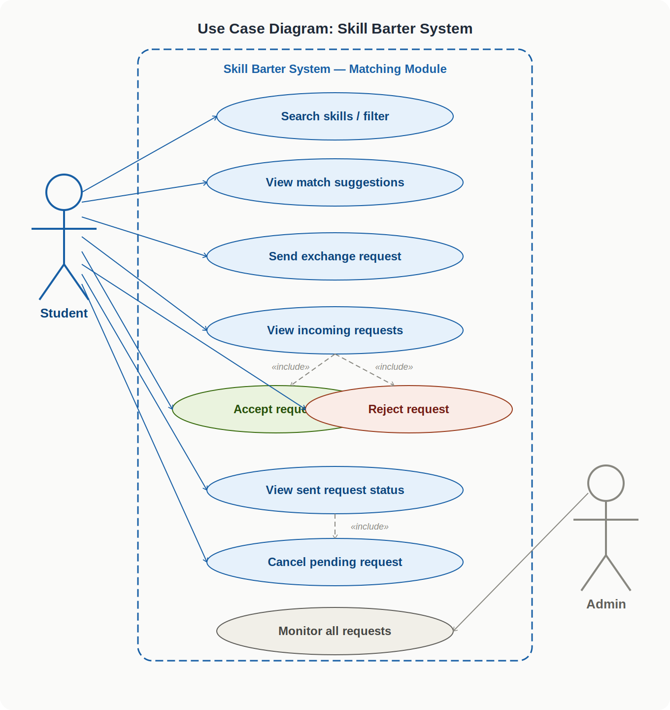

Student use cases: Search skills / filter, View match suggestions, Send exchange request, View incoming requests, Accept request, Reject request, View sent request status, Cancel pending request.
Admin use cases: Monitor all requests.

4c. Sequence Diagrams
Sequence diagrams show the message flow between system components over time. Three diagrams cover the main processes of Sprint 2. Solid arrows represent method calls and solid lines with dashed returns represent responses. Activation boxes show the period during which each component is active.

Sequence Diagram 1: Skill Search & Filter
The User enters a keyword and optional filters on the Dashboard UI. The Dashboard forwards the query to the Search Controller, which queries the Database. If results are found, they are returned and displayed. If no results are found, the Controller instructs the UI to show an empty-state message. The user then selects a profile to view.

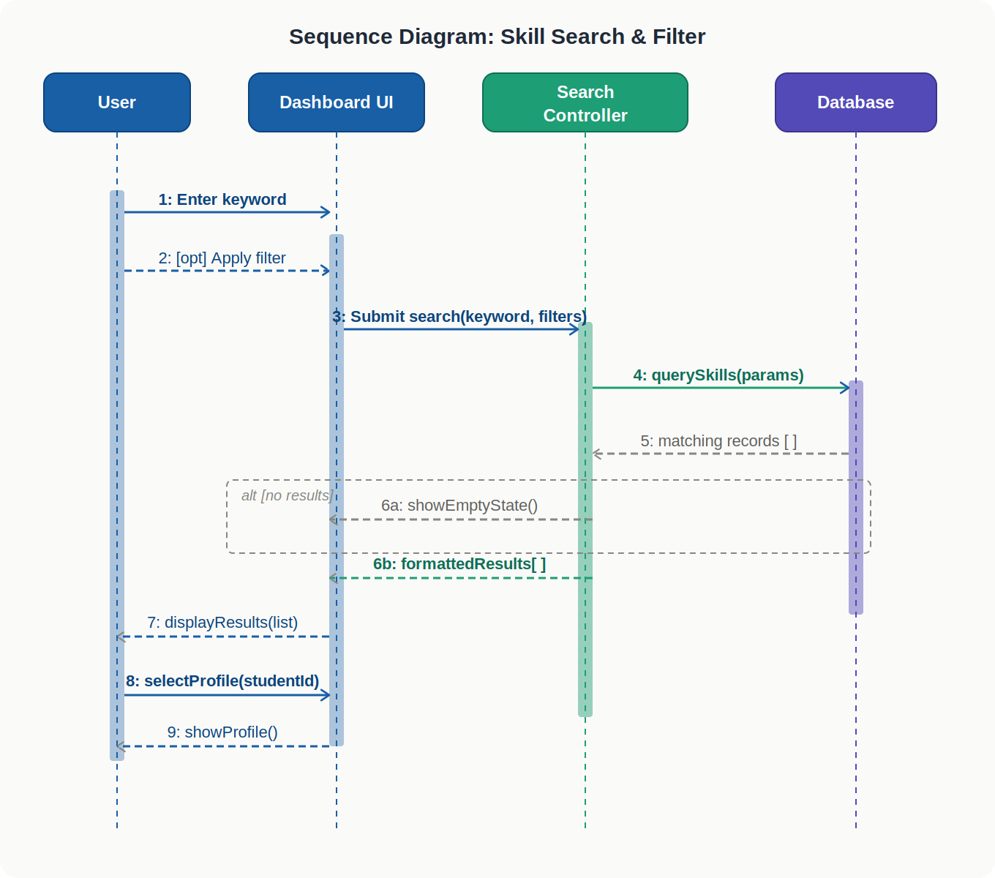

Sequence Diagram 2: Send Exchange Request
The Sender opens a student's profile and clicks Send Request. The Profile UI shows a request form. The Sender selects skills and confirms. The Profile UI calls the Request Controller which validates and saves the request to the Database. The Controller then calls the Notification Service to alert the recipient. The UI confirms success to the Sender.

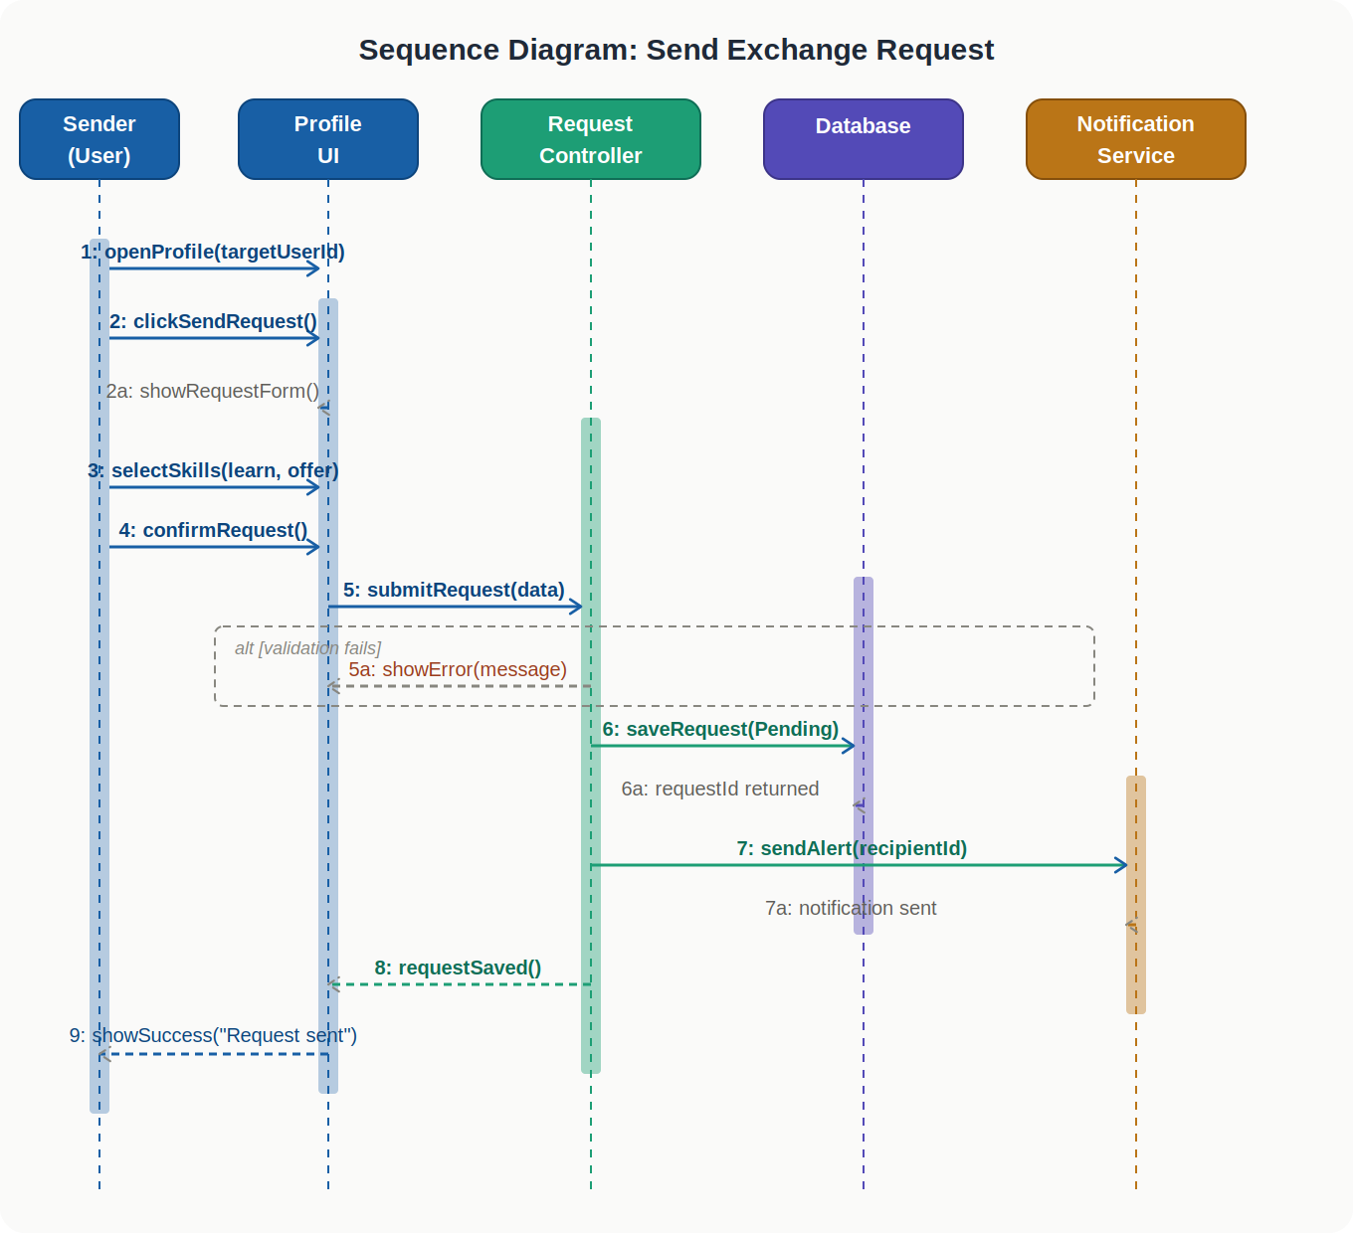

Sequence Diagram 3: Accept / Reject Exchange Request
The Recipient opens the Requests UI and reviews the incoming request. The Recipient clicks Accept or Reject. The Requests UI calls the Request Controller with the decision. The Controller updates the request status in the Database and calls the Notification Service to alert the Sender. The UI is refreshed to reflect the new status.

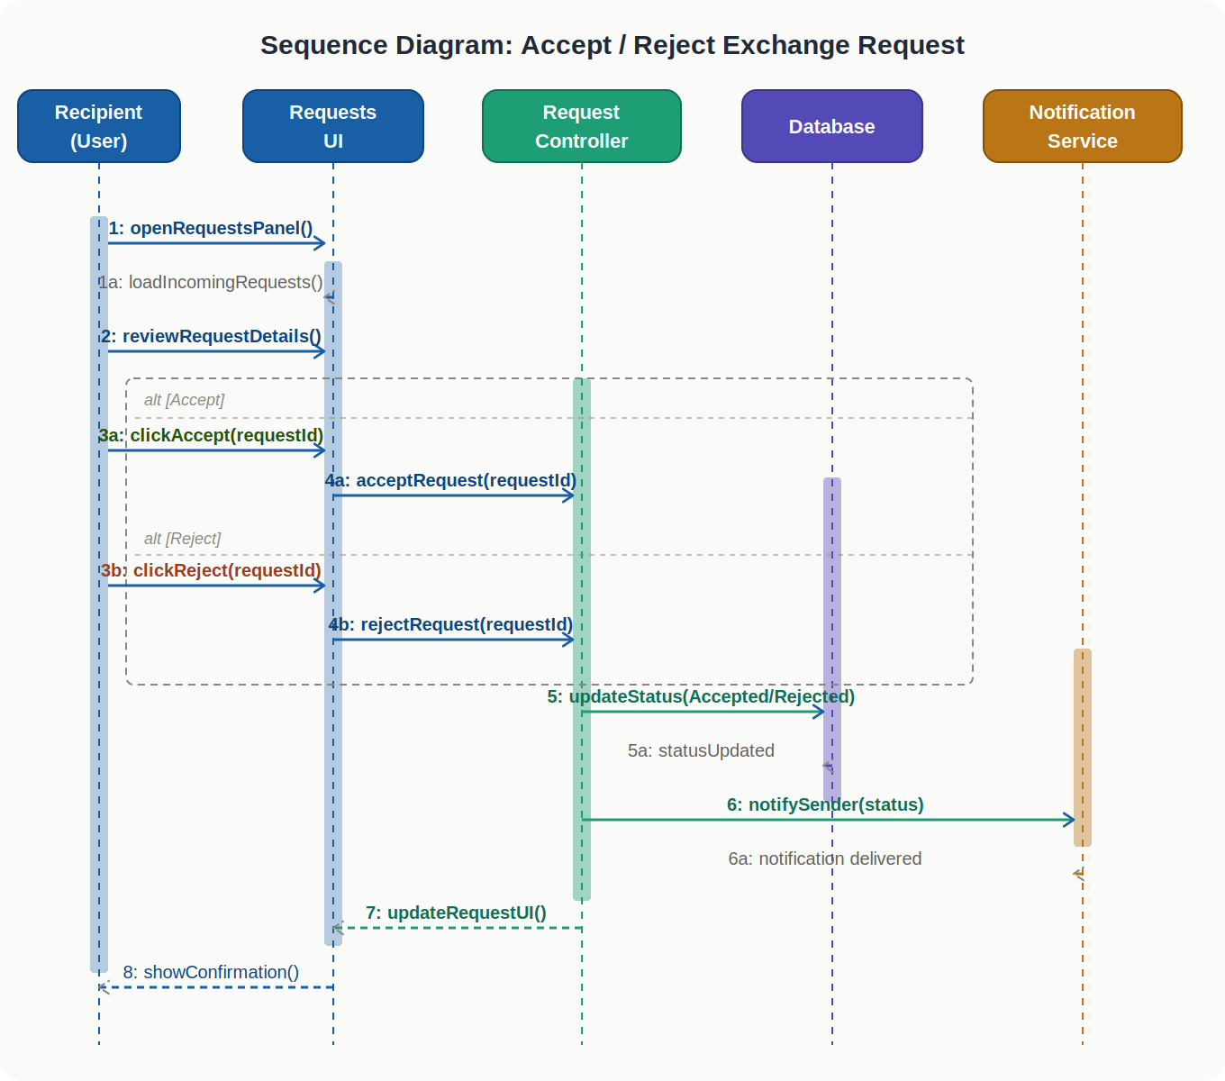

4d. Class Diagram
The Class Diagram below shows the five key classes in the Sprint 2 system and their relationships. Solid lines with filled diamonds represent composition, solid lines with open arrows represent associations, and dashed lines represent dependencies. Multiplicity labels are shown where relevant.

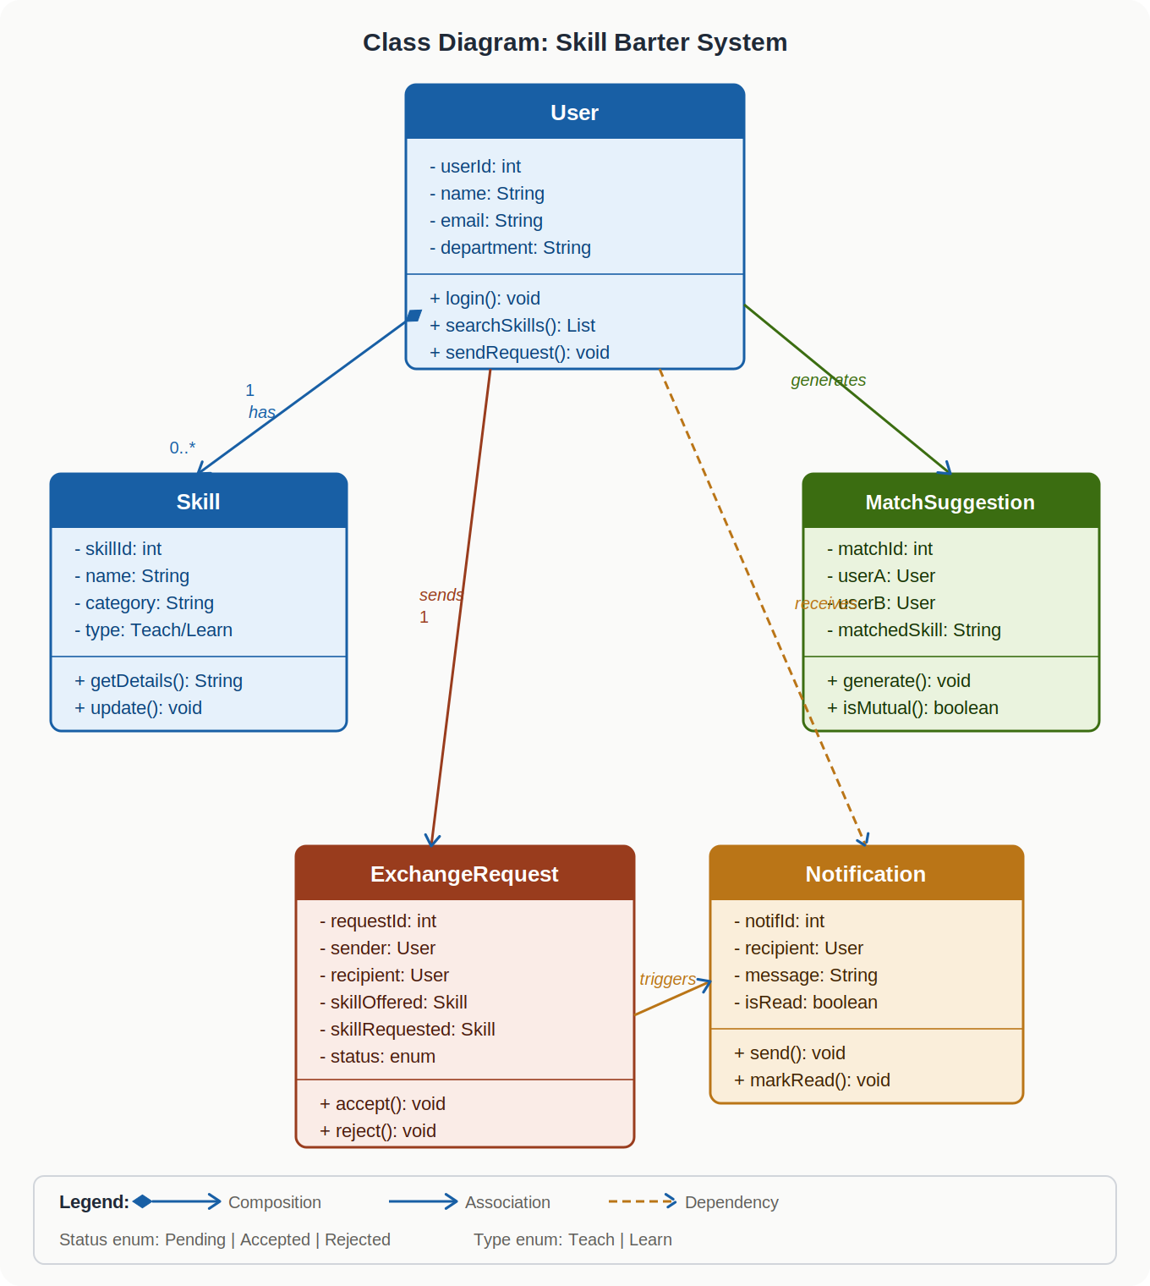

Class descriptions:
- User — central class with attributes userId, name, email, department. Composed of many Skills (teach and learn). Sends ExchangeRequests and receives Notifications.
- Skill — owned by a User. Has attributes skillIed, name, category, and type (Teach or Learn). Supports get and update operations.
- MatchSuggestion — links two Users based on compatible skills. Includes a method isMutual() to identify bidirectional matches.
- ExchangeRequest — created by a Sender User, directed at a Recipient User. References two Skill objects (offered and requested). Status enum: Pending, Accepted, Rejected.
- Notification — linked to a recipient User and generated when an ExchangeRequest changes status. Supports send() and markRead() operations.

5. Scrum Board
The Trello board was updated at the start of Sprint 2. All Sprint 1 user stories were moved to Done. Sprint 2 user stories (US-06 to US-10) were added to the Backlog and progressively moved through In Progress to Done during the sprint.

Sprint 2
This tracks the daily progress of Sprint 2. A total of 15 tasks were planned initially, with approximately 3 tasks completed per day over 5 days.

Day | Remaining Tasks
0 | 15
1 | 12
2 | 9
3 | 6
4 | 3
5 | 0

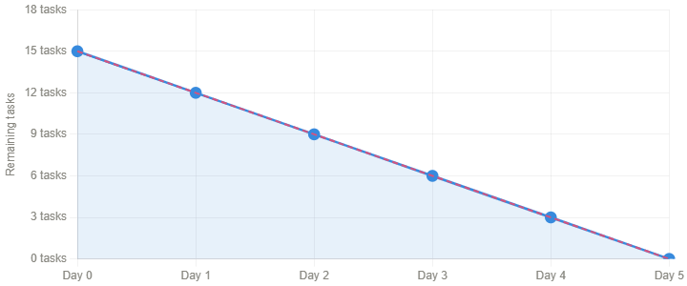

6. Work Division

Abdullah Zahid — Team Lead & Backend Developer
Responsibilities in Sprint 2:
- Designed and implemented the skill search and filter backend logic
- Developed the skill match suggestion algorithm
- Built the exchange request creation, storage, and retrieval system
- Implemented accept/reject logic and status update functionality
- Managed database schema updates for Sprint 2 features
- Coordinated team tasks and monitored sprint progress

Usman Gohar — Frontend Developer & UI Designer
Responsibilities in Sprint 2:
- Designed and developed the Skill Search screen with filter controls
- Created the Suggested Matches panel on the dashboard
- Built the Exchange Request form and confirmation dialog
- Developed the Incoming Requests panel with Accept/Reject buttons
- Created the Sent Requests status view with colour-coded labels
- Ensured consistent UI design across all Sprint 2 screens

