

Fundamentals Of Software Engineering
Skill Barter System
Names: Abdullah Zahid and Usman Gohar
Deliverable 2
Submission: 19/03/2026

Sprint 1:
User Management Module

Story ID: US-01 Story Title: User Registration | Priority: High  Estimated Hours: 6
User Story:
As a user, I want to register an account so that I can access the system.
Description:
This story involves creating a registration system where users can sign up using their details such as name, email, password, department, and semester.
Sub User Stories:
- As a user, I want to enter my personal details.
- As a user, I want my password to be secure.
- As a user, I want validation for incorrect inputs.
Acceptance Criteria:
- Registration form should be accessible.
- System should validate inputs.
- User data should be stored in database.
- User should be redirected after successful registration.

Story ID: US-02 Story Title: User Login | Priority: High  Estimated Hours: 5
User Story:
As a user, I want to log in so that I can access my account.
Description:
This feature allows registered users to log into the system using email and password.
Sub User Stories:
- As a user, I want to enter login credentials.
- As a user, I want error messages for incorrect login.
- As a user, I want secure authentication.
Acceptance Criteria:
- Login form should be available.
- Correct credentials should allow access.
- Incorrect credentials should show error.
- Session should be maintained.

Story ID: US-03 Story Title: Profile Management | Priority: High  Estimated Hours: 6
User Story:
As a user, I want to create and edit my profile so that I can share my information.
Description:
Users can create and update their profile including department, semester, and bio.
Sub User Stories:
- As a user, I want to add profile details.
- As a user, I want to edit my profile anytime.
- As a user, I want my data saved.
Acceptance Criteria:
- Profile page should exist.
- Users should be able to edit details.
- Changes should be saved in database.

Story ID: US-04 Story Title: Manage Skills | Priority: High  Estimated Hours: 7
User Story:
As a user, I want to add and manage my skills so that I can teach or learn from others.
Description:
Users can add skills under “Teach” and “Learn” categories.
Sub User Stories:
- As a user, I want to add skills.
- As a user, I want to edit skills.
- As a user, I want to delete skills.
Acceptance Criteria:
- Users can add multiple skills.
- Skills should be categorized.
- Users can edit/remove skills.

Story ID: US-05 Story Title: Themes | Priority: High  Estimated Hours: 5
User Story:
As a user, I want to switch between light and dark themes so that I can personalize the visual appearance.
Description:
This story involves developing a theme switching mechanism that allows users to toggle between light and dark themes.
Sub User Stories:
- As a user, I want to select between multiple themes.
- As a user, I want my theme preference to be saved.
- As a user, I want the theme applied across the app.
Acceptance Criteria:
- Theme toggle should be in settings.
- Preference should persist between sessions.
- UI should update.

Structured Specifications
US-01: User Registration
US-01.1: User Registration Form Access
Type | Specification
Functional | Registration form must be accessible from the main interface.
Functional | Users must be able to input name, email, password, department, and semester.
UX | Form layout must be clear and user-friendly.
US-01.2: Input Validation & Security
Type | Specification
Functional | System must validate all required fields before submission.
Functional | Email format must be validated.
Functional | Password must meet security requirements (e.g., minimum length).
UX | Clear error messages must be shown for invalid inputs.
US-01.3: Data Storage & Redirection
Type | Specification
Functional | User data must be stored securely in the database.
Functional | Passwords must be encrypted before storage.
Functional | User must be redirected after successful registration.
US-02: User Login
US-02.1: Login Form Access
Type | Specification
Functional | Login form must be accessible to all registered users.
Functional | Users must be able to enter email and password.
UX | Login interface must be simple and intuitive.
US-02.2: Authentication Handling
Type | Specification
Functional | System must authenticate user credentials securely.
Functional | Correct credentials must allow access.
Functional | Incorrect credentials must trigger error messages.
US-02.3: Session Management
Type | Specification
Functional | User session must be maintained after login.
Functional | Session must expire securely after logout or inactivity.
Performance | Login process should complete quickly without delays.
US-03: Profile Management
US-03.1: Profile Creation & Access
Type | Specification
Functional | Profile page must be available for each user.
Functional | Users must be able to add profile details (department, semester, bio).
UX | Profile interface must be easy to navigate.
US-03.2: Profile Editing
Type | Specification
Functional | Users must be able to edit profile information anytime.
Functional | Changes must be saved successfully.
UX | Users must receive feedback on successful updates.
US-03.3: Data Persistence
Type | Specification
Functional | Profile data must be stored in the database.
Functional | Updated data must be reflected immediately.
US-04: Manage Skills
US-04.1: Add Skills
Type | Specification
Functional | Users must be able to add skills under “Teach” and “Learn” categories.
Functional | Multiple skills must be allowed.
UX | Skill input interface must be simple and responsive.
US-04.2: Edit & Delete Skills
Type | Specification
Functional | Users must be able to edit existing skills.
Functional | Users must be able to delete skills.
UX | Confirmation must be shown before deletion.
US-04.3: Skill Organization
Type | Specification
Functional | Skills must be categorized properly (Teach/Learn).
Functional | Skills must be displayed clearly in the user profile.
US-05: Themes
US-05.1: Select between multiple themes
Type | Specification
Functional | A theme selector must be accessible from the Settings screen at all times.
Functional | At minimum, light and dark theme options must be available to the user.
UX | The currently active theme must be visually indicated in the selector.
US-05.2: Theme preference saved
Type | Specification
Functional | Selected theme must persist across sessions using local storage or user profile.
Functional | On app launch, the last saved theme must be applied before the first render.
Performance | Theme must load without a visible flash of unstyled content (FOUC).
US-05.3: Theme applies consistently across app
Type | Specification
Functional | All UI components such as buttons, modals, inputs, and cards must reflect the active theme.
UX | Theme change must apply instantly with no full page reload required.
UX | Third-party embedded components must also conform to the selected theme where possible.

Non-Functional Requirements
1. Usability
- The system should have a simple and user-friendly interface.
- Users should be able to navigate without training.
- Forms should include clear labels and error messages.
2. Performance
- The system should respond within 2–3 seconds for user actions.
- It should handle multiple users without slowing down.
3. Security
- User passwords must be encrypted (hashed).
- Only authenticated users can access the system.
- Data should be protected from unauthorized access.
4. Reliability
- The system should work consistently without crashes.
- Data should not be lost during operations.
5. Scalability
- The system should support increasing number of users in future.
6. Maintainability
- Code should be modular and easy to update.
- Bugs should be easy to fix.
7. Compatibility
- The application should run on standard desktop environments.

Scrum Board

Snapshot 1:
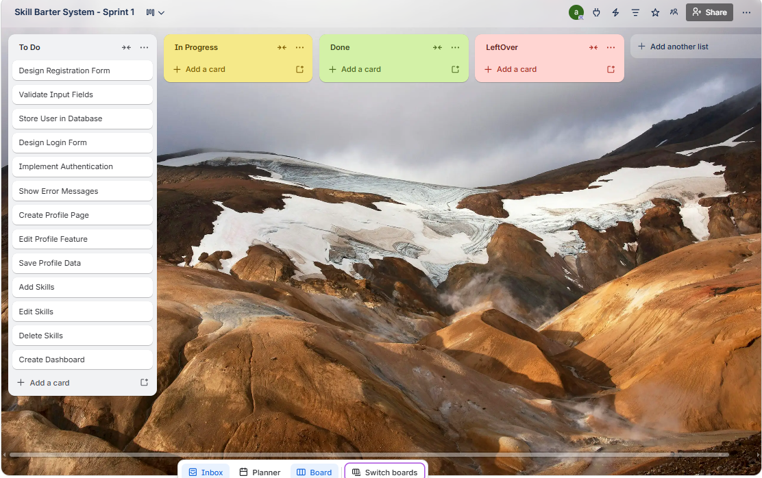

Snapshot 2:
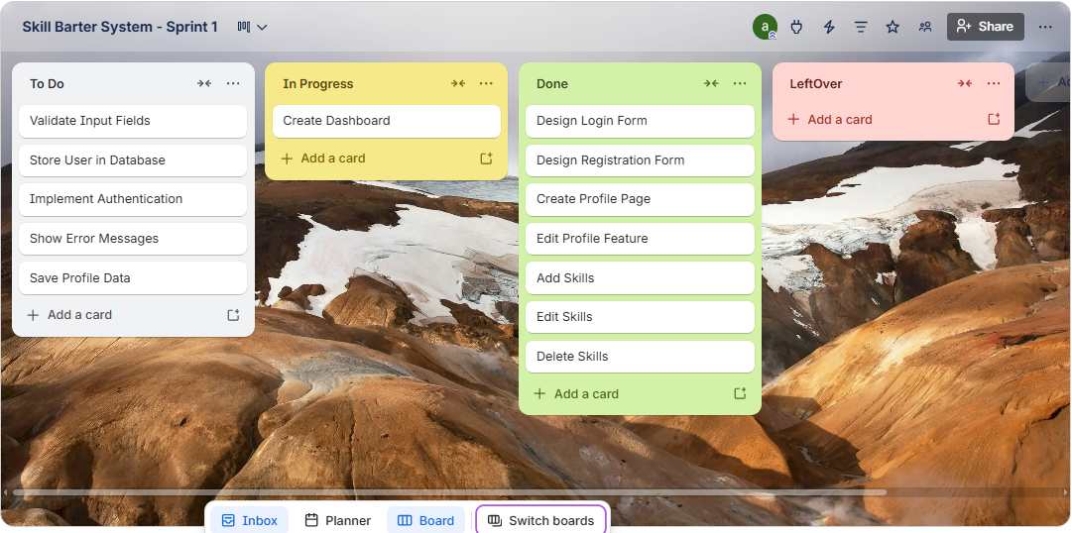

Snapshot 3:
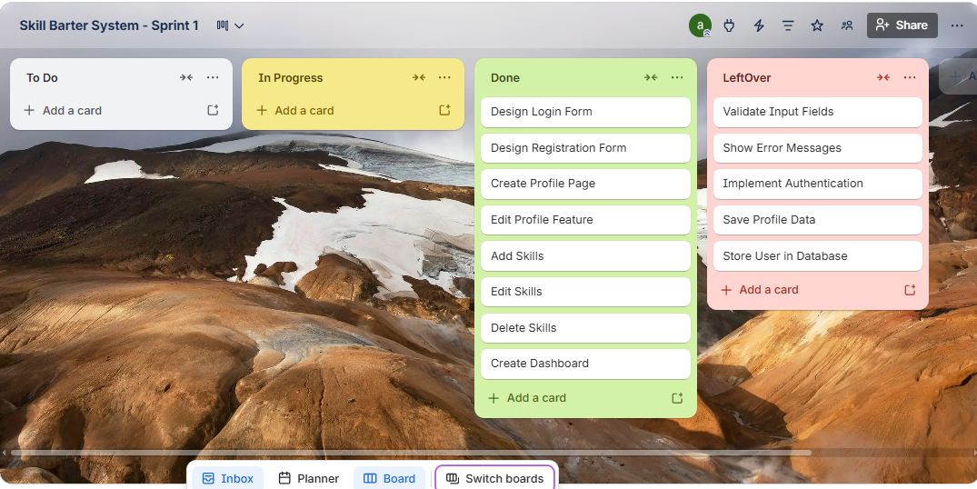

Sprint 1 Burndown Chart
This chart shows the daily progress of Sprint 1. A total of 13 tasks were initially planned, with approximately 2 tasks completed per day over 4 days.
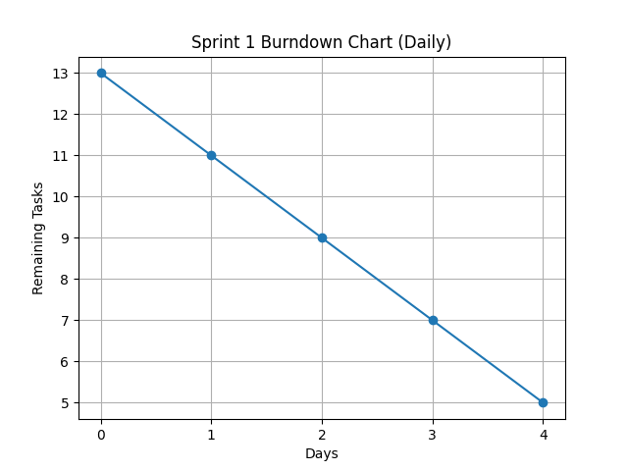
Day Remaining Tasks
0 13
1 11
2 9
3 7
4 5

Work Division
Abdullah Zahid — Team Lead & Backend Developer
Responsibilities:
- Decided user registration and login logic
- Developed profile management backend
- Implemented skill management functionality (add/edit/delete)
- Coordinated team tasks and monitored progress
Usman Gohar — Frontend Developer & UI Designer
Responsibilities:
- Designed the Graphical User Interface (GUI)
- Developed registration and login forms
- Created profile and dashboard screens
- Implemented user interaction features
- Worked on theme switching (light/dark mode)
- Ensured user-friendly and responsive design

Screenshots
Screenshot 1
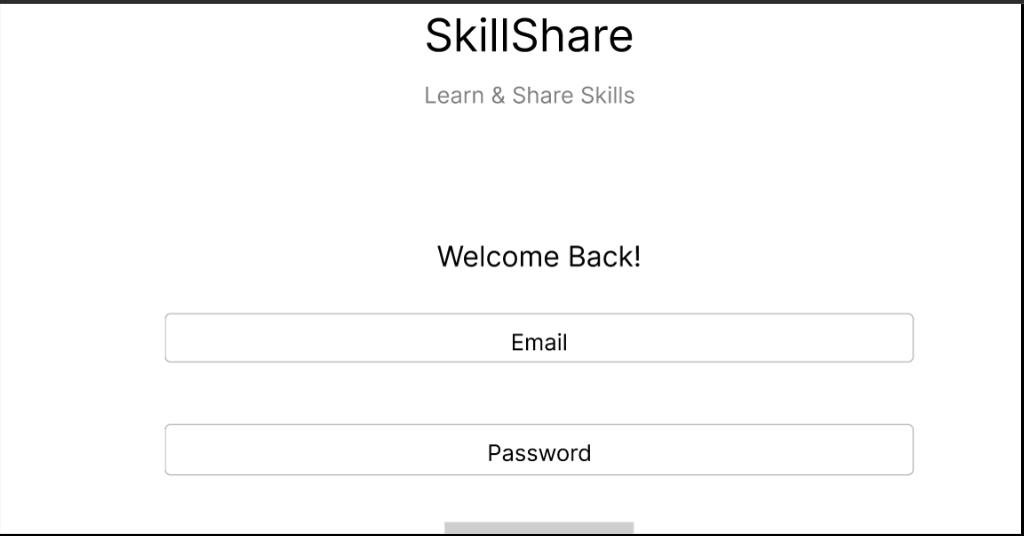

Screenshot 2
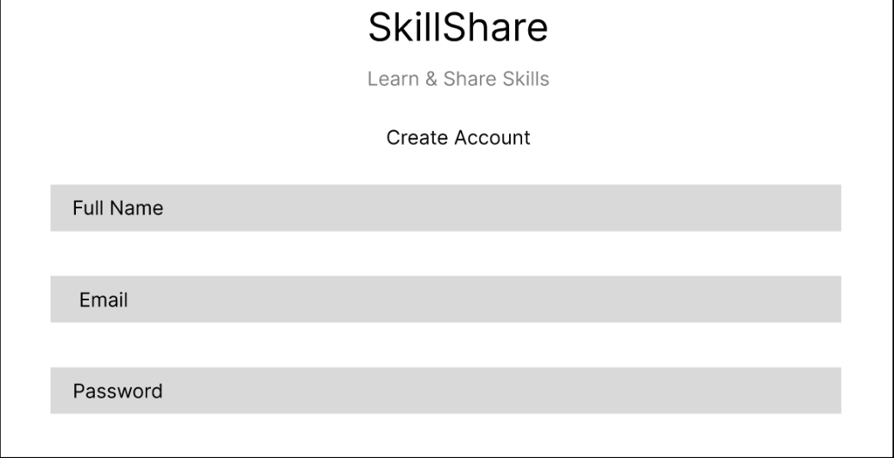
Screenshot 3
