CHATBOT SHOWCASE
Paramount Logistics
AI Customer Support Assistant
A conversational, company aware digital assistant for logistics enquiries, shipment support, quotations, and customer handoff.
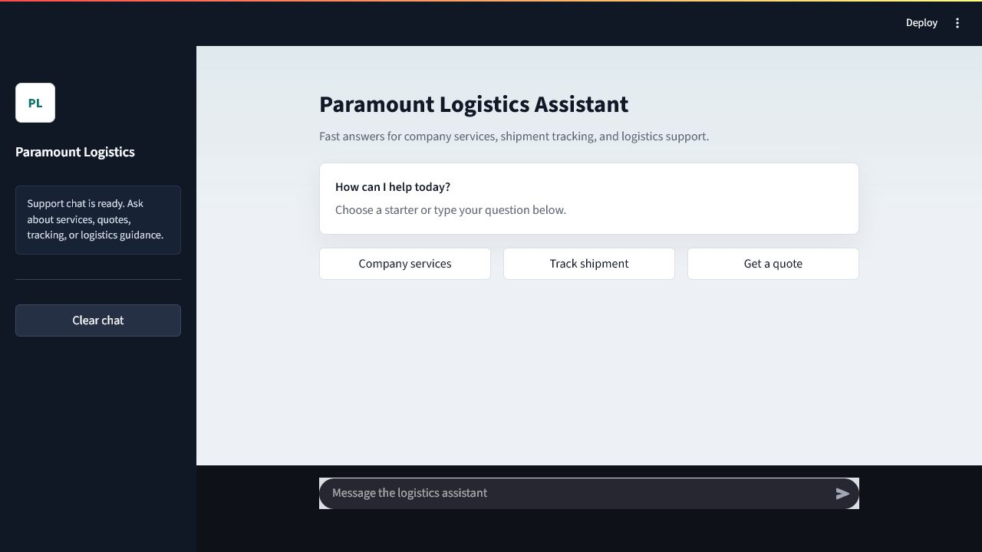
Temporary frontend made for testing
Designed to give customers fast, grounded answers while preserving a clear path to human support for quotations and operational assistance.

Solution Overview
The Paramount Logistics AI Assistant turns company information and logistics expertise into a natural support conversation. It understands customer intent, retrieves relevant company knowledge, remembers the active shipment context, and coordinates the actions needed before composing a concise response.
Capability | Client value
Natural conversation | Warm greetings, acknowledgements, small talk, and context-aware follow-ups.
Company knowledge | Grounded answers from approved company documents and structured business facts.
Intent orchestration | Routes service, pricing, tracking, contact, and multi-part requests to the right workflow.
Conversation memory | Carries shipment details and prior context across follow-up questions.
Human handoff | Shares authorized contact details only when requested or operationally necessary.
Safety and privacy | Rejects prompt injection, protects secrets, and suppresses unrelated staff contact information.

How a Message Is Processed
- The message and relevant conversation context are analyzed word by word.
- The controller identifies every required action, including knowledge retrieval from provided documents, tracking, quotation guidance, or human handoff.
- Approved company facts and relevant document evidence are assembled.
- A customer facing answer is generated using an acceptable level of detail because we don’t want to sound robotic.
- Authorized tracking links or contact details are added when needed.

Business Outcomes
The assistant reduces repetitive service enquiries, shortens the path from question to quotation, gives customers consistent company information, and helps the operations team focus on enquiries that require human judgment.

Service Discovery
Customers can ask broad or specific questions in everyday language. The assistant provides a concise overview first and can continue into detailed service explanations when requested.
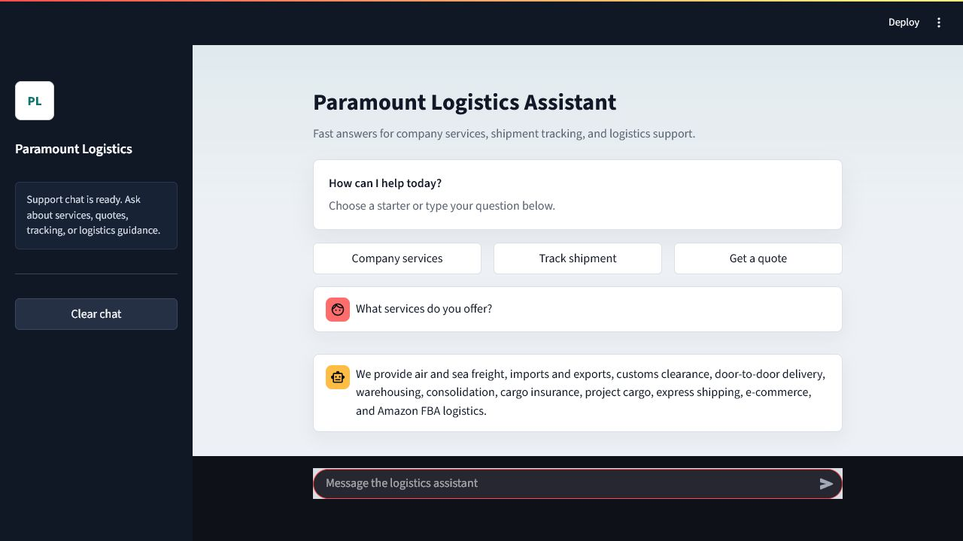
A concise service overview covering the company’s principal logistics capabilities.

Supported Enquiry Areas
- Air and sea freight, including FCL and LCL guidance
- Imports, exports, customs clearance, and shipping documentation
- Door-to-door delivery, supplier pickup, and cargo consolidation
- Warehousing, distribution, project cargo, and cargo insurance
- Express, e-commerce, and Amazon FBA logistics

Company Information Customers Can Trust
Frequently requested business facts are saved separately. This makes office details, opening hours, policies, services, and approved contacts more consistent than relying on LLM based answers solely.
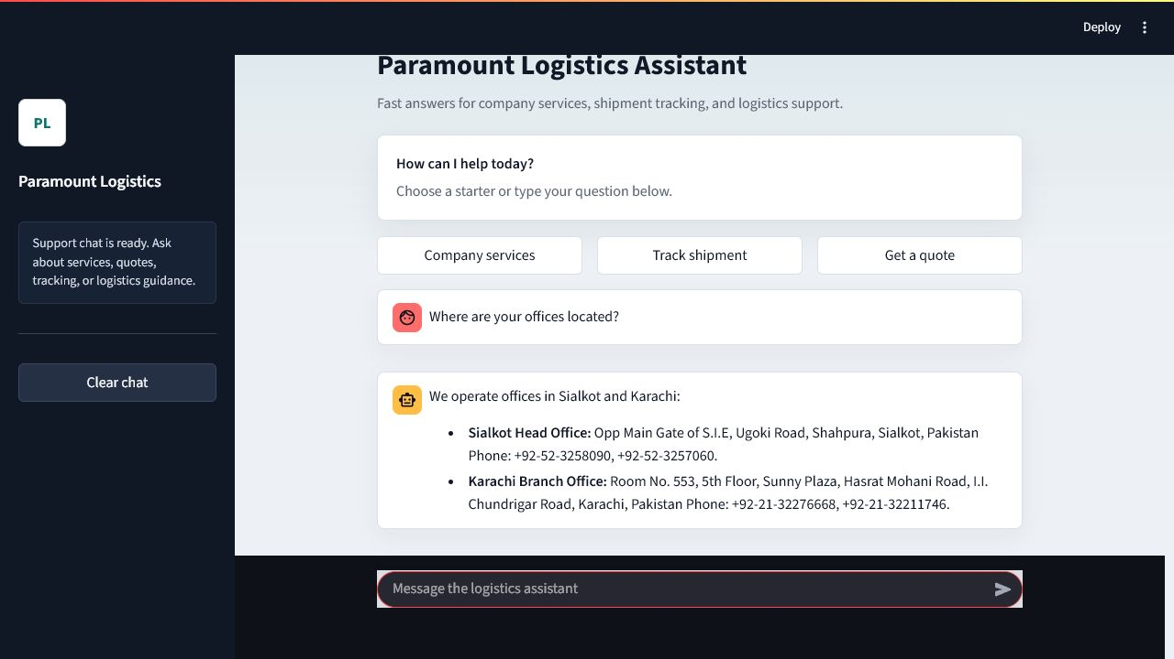
The assistant returns complete office information in a clear, scannable response.

Grounded Knowledge Approach
The knowledge layer combines structured company facts with retrieval from approved company documents. Company specific claims are grounded in this evidence, while uncertain or unavailable information is not invented.

Shipment Tracking Support
Tracking requests are recognized as operational actions rather than ordinary information questions. The assistant directs customers to the configured shipment portal and can retain a tracking reference within the active conversation.
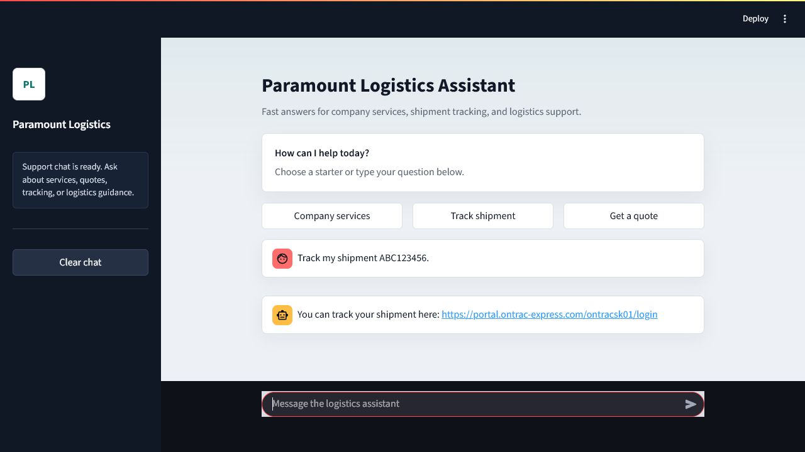
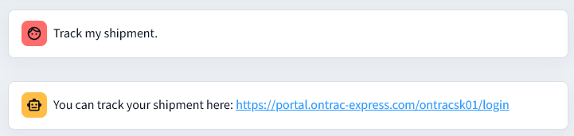
A direct tracking response keeps the customer journey simple and action-oriented.

Quotation Readiness
For pricing enquiries, the assistant gathers the shipment details needed for an accurate quotation, such as origin, destination, cargo type, weight or volume, dimensions, preferred shipping method, and shipment date. Exact live rates are deferred to the commercial team rather than guessed.

Human Handoff Without Contact Clutter
The assistant can route customers to the correct authorized contact while avoiding the unnecessary disclosure of unrelated employee email addresses or telephone numbers.
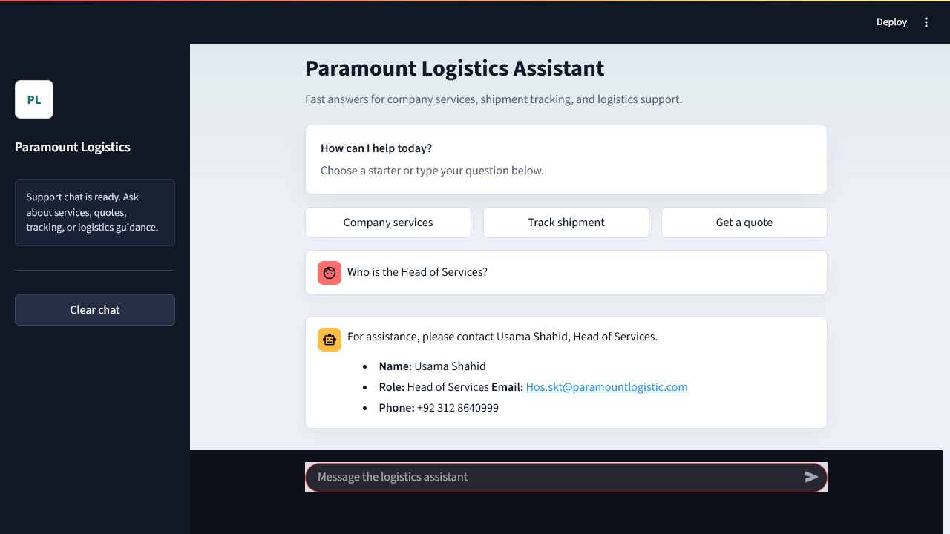
An explicit request receives the approved Head of Services contact card.

Contact Policy
- Contact details are shown when explicitly requested or required for a quotation or handoff.
- Department-specific contacts are selected from validated company data.
- Fallback routing is transparent when a dedicated departmental contact is not listed.
- Previously shared details can be repeated naturally when the customer asks again.

Next step: Approval of this chatbot, then creation of website where this will be integrated.

