**Documentation**

**Orientation**

**Key Concepts:**

* Cloud Computing
* Intro to AWS
* Intro to DevOps
* Intro to CDK

**Sprint 1**

**Objective:**

Create a webhealth application that reads 4 urls from a json file uploaded on s3bucket and then periodically gauges their availability and latency, raising alarms when the values cross a certain threshold. These alarms are then notified via email and also stored in a dynamodb table.

**Task 1:**

Setting up the cloud9 environment. And creating a hello world lambda function.

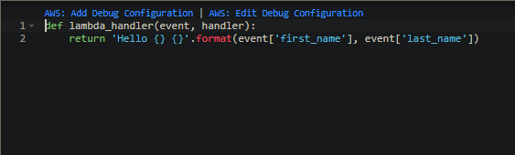

**Task 2:**

Make a webhealth lambda function that periodically updates the values

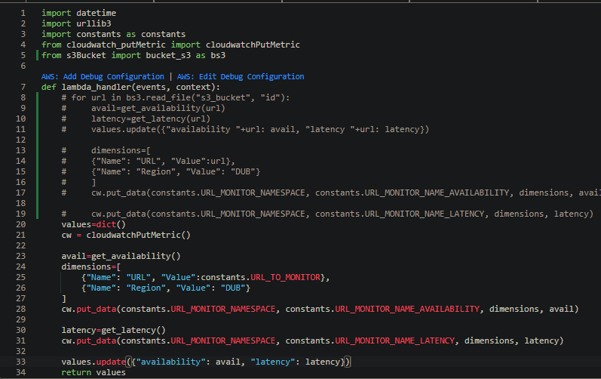

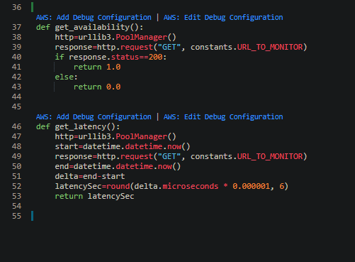

**Task 3:**

Publish Webhealth metrics to cloudwatch

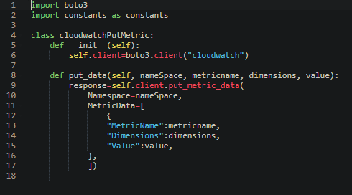

**Task 4:**

Setup alarms and get notified via email

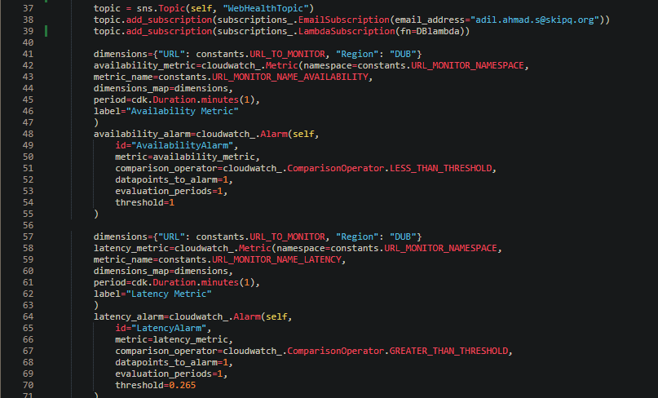

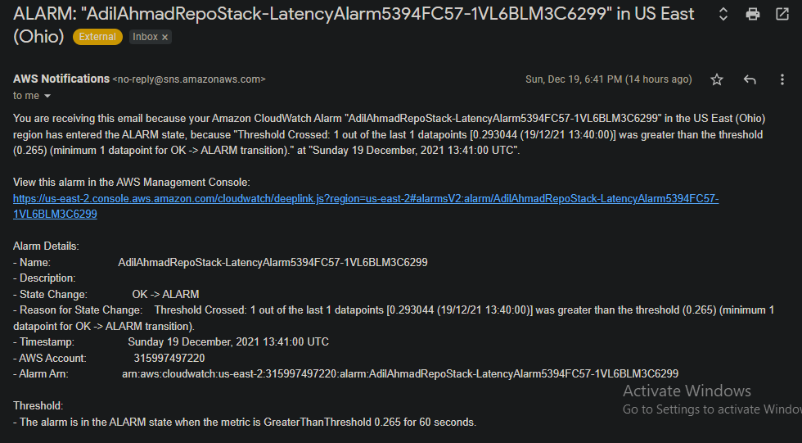

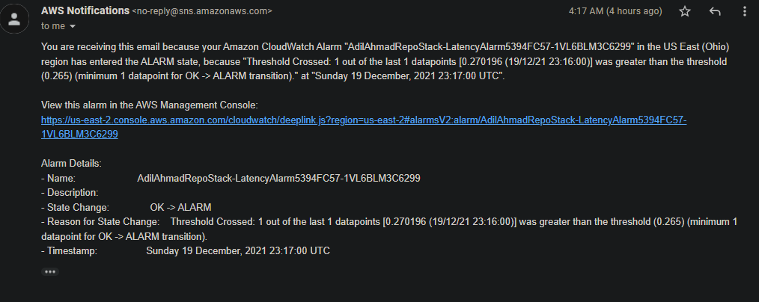

**Task 5:**

Dynamo DB Table creation

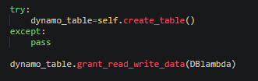

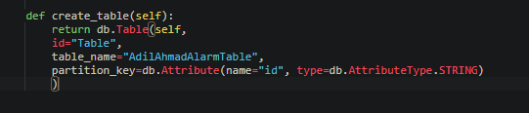

**Task 6:**

4 URLs