Siam's Aqua: feature-by-feature QA report
Every feature in the project's checklist, tested as a real person would use it. For each one this report says what the feature is for, what the tester did, what the tester saw, and shows the screens along the way.

How to read it
- Works: the tester used the feature and it did what it should.
- Does not work as described: the tester used the feature and it did not do what the checklist says. These are the findings to fix.
- Only partly shown: part of the feature was shown. The note says what could not be shown and why.
- Could not be tested: the test itself broke before reaching a verdict. It says where.
- Not built yet: the checklist says this is not built, so there is nothing to test.
- Not tested yet: this feature has not been reached in this pass. Its explanation is included so the list is complete.
- Everything was done on a copy of the development site with sample data, in English, as the person named in each picture.

At a glance
Area | Features | Works | Does not work as described | Only partly shown | Could not be tested | Not built yet | Not tested yet
Foundation | 21 | 16 | 0 | 3 | 0 | 2 | 0
Pricing | 14 | 12 | 0 | 2 | 0 | 0 | 0
Visibility | 9 | 8 | 0 | 1 | 0 | 0 | 0
Stock System | 64 | 59 | 0 | 5 | 0 | 0 | 0
Draft Invoice | 24 | 23 | 0 | 1 | 0 | 0 | 0
Paikari Sector | 38 | 33 | 0 | 5 | 0 | 0 | 0
Counter Sale | 21 | 19 | 0 | 2 | 0 | 0 | 0
Offers | 28 | 25 | 0 | 3 | 0 | 0 | 0
MPO Sector | 20 | 12 | 0 | 8 | 0 | 0 | 0
Medicine Database | 13 | 13 | 0 | 0 | 0 | 0 | 0
Returns | 28 | 19 | 0 | 9 | 0 | 0 | 0
Public Market | 41 | 29 | 0 | 11 | 0 | 1 | 0
Wholesale and Commission | 44 | 33 | 0 | 10 | 0 | 1 | 0
Multi-Sector and Custom Orders | 50 | 34 | 0 | 16 | 0 | 0 | 0
Food, Gaming, Help | 44 | 29 | 0 | 13 | 0 | 2 | 0
Delivery and Courier | 35 | 21 | 0 | 14 | 0 | 0 | 0
Pre-Order, Memos, Chat, Wallet | 34 | 28 | 0 | 6 | 0 | 0 | 0
Admin, Staff, Security | 43 | 39 | 0 | 3 | 0 | 1 | 0
Payments, Legal, Technical | 42 | 16 | 0 | 17 | 0 | 9 | 0
All features | 613 | 468 | 0 | 129 | 0 | 16 | 0

Foundation
1. Public account and sign-up Works
What it is for: Anyone can create an ordinary shopper account with an email and password, then buy from the public shops.
What the tester did: Opened the sign-up page as a stranger, filled in a name, email and password, and created an account.
What the tester saw:
- Yes. The new shopper is signed in and greeted by name
Step 1: The sign-up form, filled in | Step 2: Right after signing up: the shopper is inside their own account
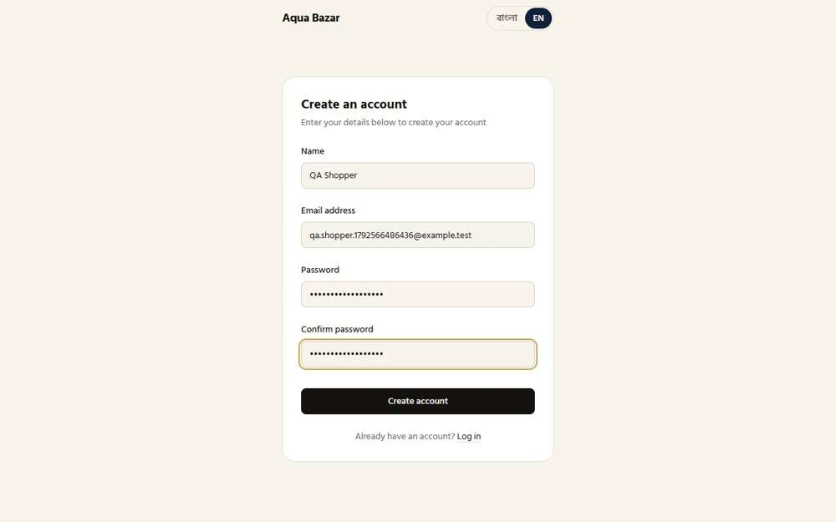  Seen as a stranger (not signed in) | /register | 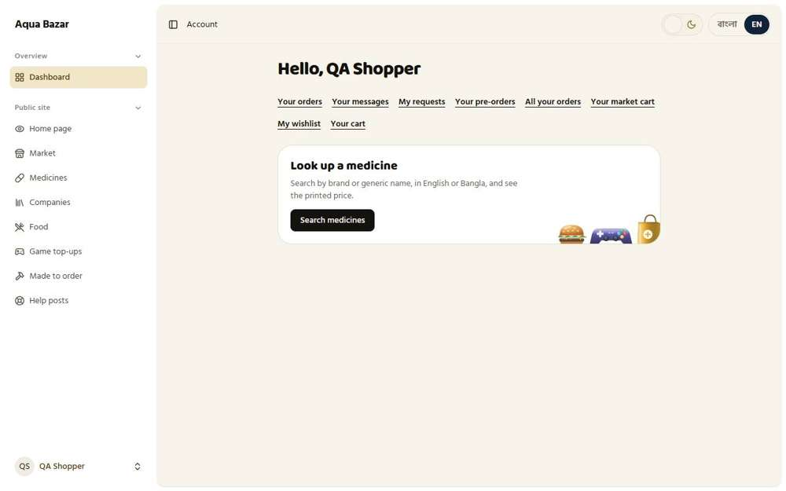  Seen as a stranger (not signed in) | /dashboard
2. Social login (Google, Facebook) Works
What it is for: People can sign in with their Google or Facebook account instead of making a new password.
What the tester did: Opened the Connected accounts page, where a shopper links Google or Facebook to their account.
What the tester saw:
- Yes. The page offers Google or Facebook sign-in
Step 1: Connected accounts: where Google and Facebook sign-in is managed | Step 2: The sign-in page, as a stranger sees it
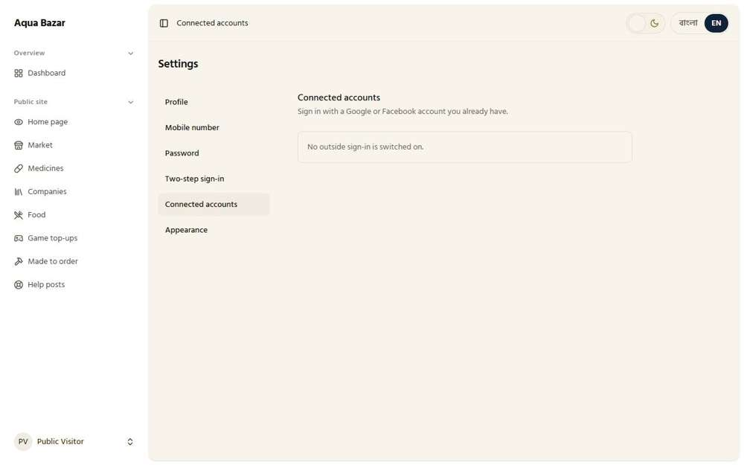  Seen as a signed-in shopper | /settings/connected-accounts | 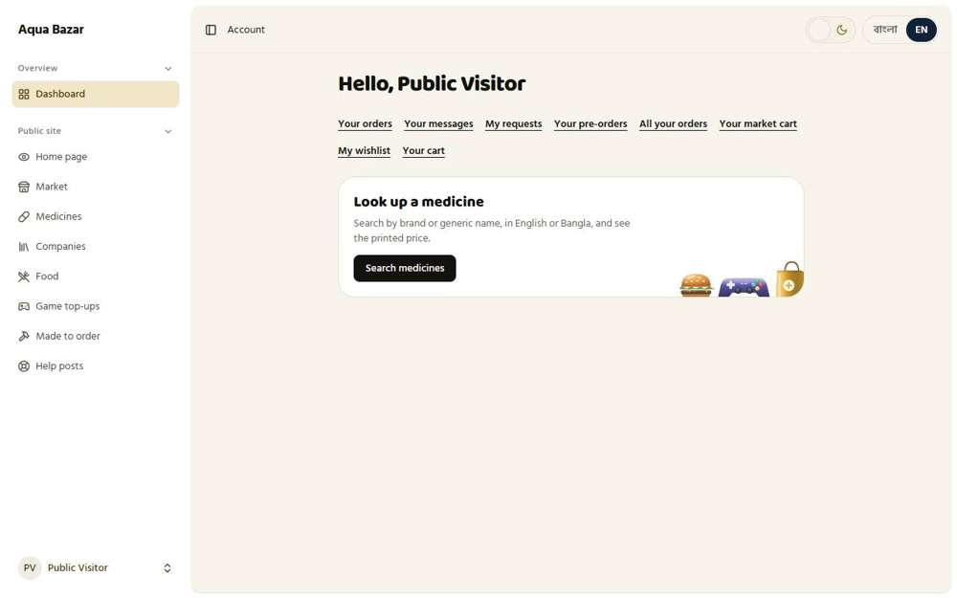  Seen as a signed-in shopper | /dashboard
3. Paikari account Works
What it is for: A pharmacy shop can have a paikari account. It unlocks the shop-to-shop buying screen and special discounts.
What the tester did: Signed in as a pharmacy shop (paikari) and saw the shop-to-shop buying screen. Then looked the account up in the owner's customer list.
What the tester saw:
- Yes. The paikari ordering screen is shown
- Yes. The owner sees Karim Pharmacy in the customer list
- Yes. Its account type is Paikari
Step 1: The paikari shop's own buying screen | Step 2: The owner's customer list: Karim Pharmacy is a Paikari account
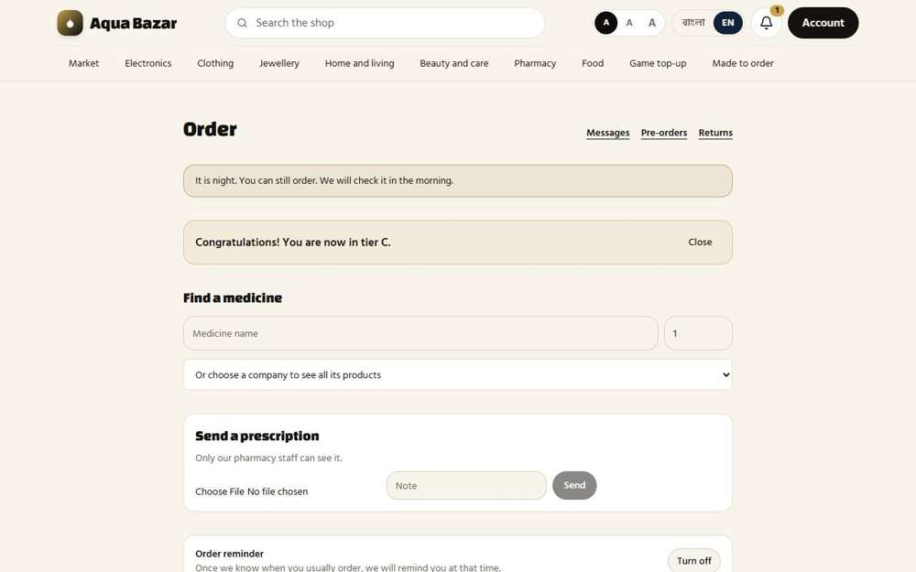  Seen as a paikari shop | /paikari | 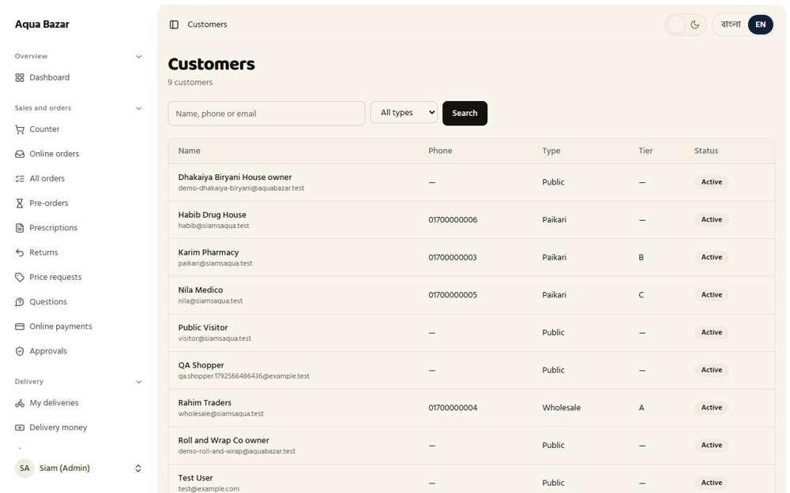  Seen as the owner | /admin/customers
4. Wholesale account and application Works
What it is for: A wholesaler applies for an account and the owner reviews the application before approving it.
What the tester did: Signed in as a wholesaler to see the wholesale screen, then opened the owner's Applications page where new wholesale applications wait for review.
What the tester saw:
- Yes. The owner has an Applications page
- Yes. It lists applications that are waiting for a decision
Step 1: The wholesale buyer's screen | Step 2: The owner's Applications page: wholesale requests wait here to be approved
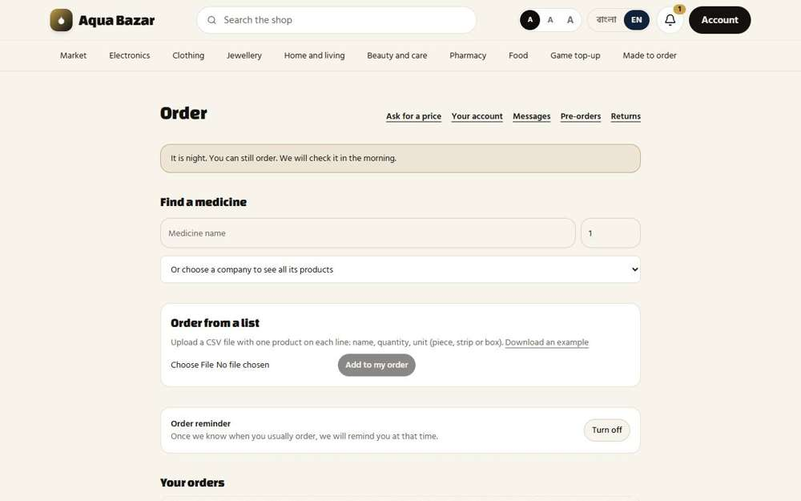  Seen as a wholesaler | /wholesale | 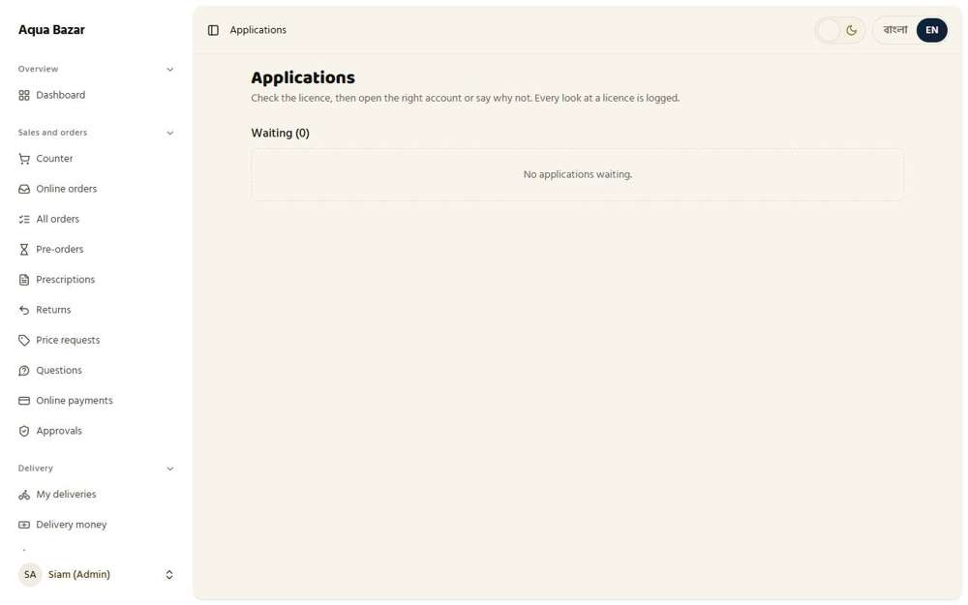  Seen as the owner | /admin/applications
5. License upload and verification Only partly shown
What it is for: A wholesaler uploads their trade licence and the owner checks it is real before they are approved.
What the tester did: Opened the Applications page. A licence file is uploaded with the application and the owner checks it there.
What the tester saw:
- Yes. The Applications page opens
Note: No wholesale application was waiting in the test data, so the licence preview itself could not be shown.
Step 1: Where the owner reviews an application and its licence
Seen as the owner | /admin/applications
6. MPO account (only admin opens) Works
What it is for: Medical sales representatives (MPOs) can only be created by the owner, never by themselves.
What the tester did: Opened the MPO page, which only the owner can reach. Then tried to open it as an ordinary shopper.
What the tester saw:
- Yes. The owner has an MPO page
- Yes. An ordinary shopper cannot open the MPO page
Step 1: The owner's MPO page: MPO accounts are created here, never by the MPOs | Step 2: A shopper trying the same page is sent away
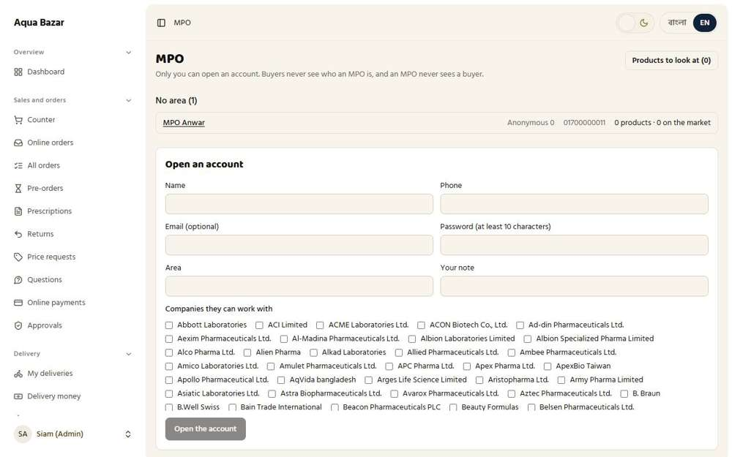  Seen as the owner | /admin/mpo | 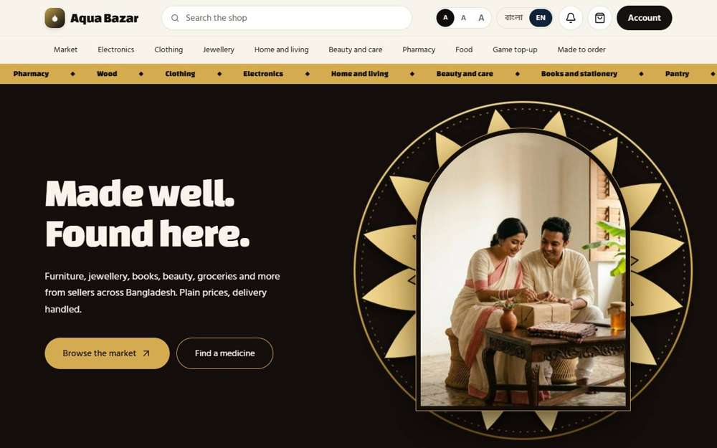  Seen as a signed-in shopper | /
7. Food vendor account Works
What it is for: A restaurant owner gets their own account to manage their menu and orders.
What the tester did: Signed in as a restaurant owner.
Step 1: The restaurant owner's own screen: menu and orders | Step 2: The owner's Food page lists the restaurants
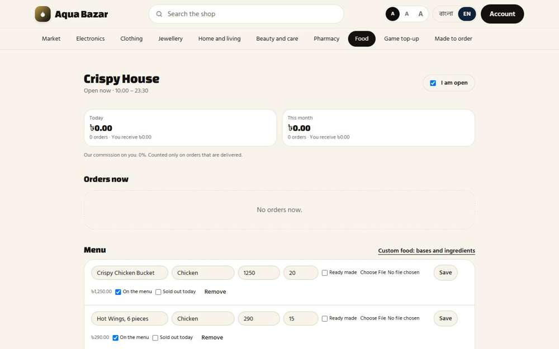  Seen as a restaurant owner | /food/vendor | 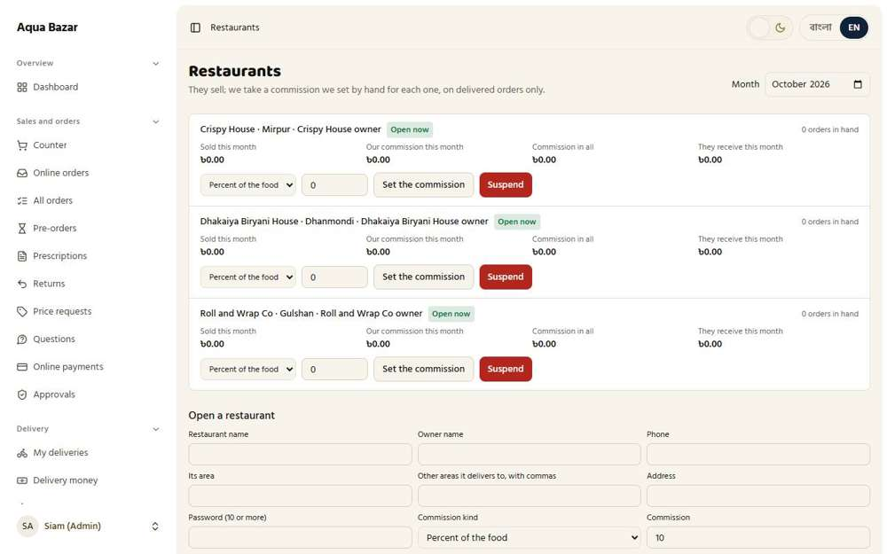  Seen as the owner | /admin/food
8. Craftsman account Works
What it is for: Carpenters and tailors get an account that shows only their jobs, not prices or profit.
What the tester did: Signed in as a craftsman and looked at what they can see.
What the tester saw:
- Yes. The craftsman screen shows no profit figures
Step 1: The craftsman's screen: jobs only | Step 2: The owner's Craftsmen page
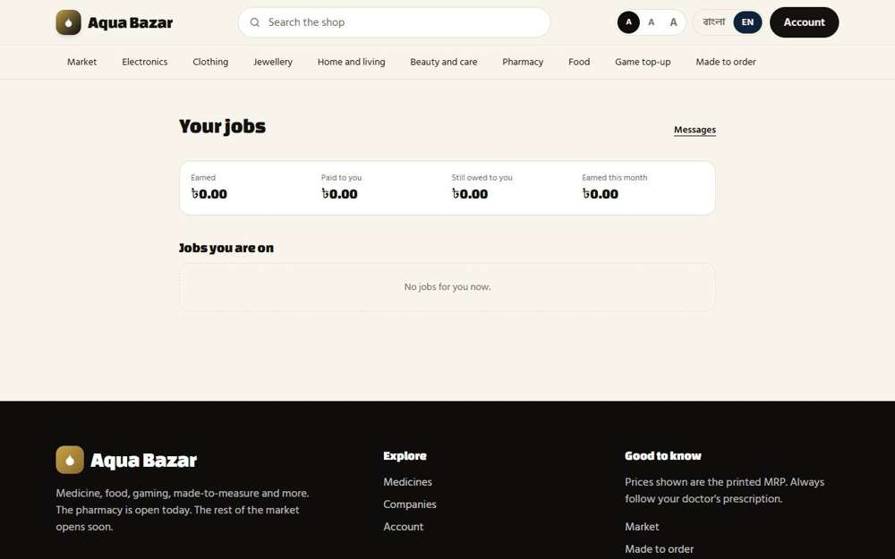  Seen as a craftsman | /craftsman | 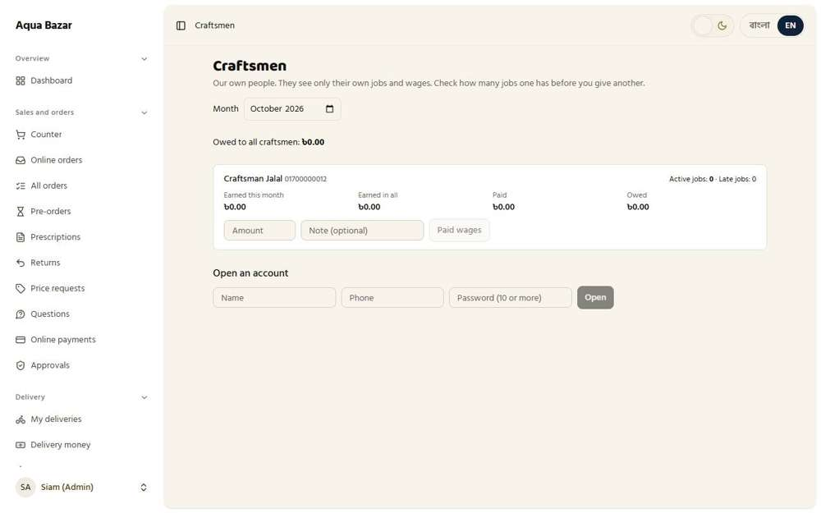  Seen as the owner | /admin/craftsmen
9. Staff accounts and roles Works
What it is for: The owner can create accounts for staff. Each person logs in as themselves.
What the tester did: Opened the Staff page, where the owner makes accounts and roles for staff, then signed in as a staff member.
What the tester saw:
- Yes. The staff member has their own account
Step 1: The owner's Staff page | Step 2: The staff member signed in as themselves, on the counter
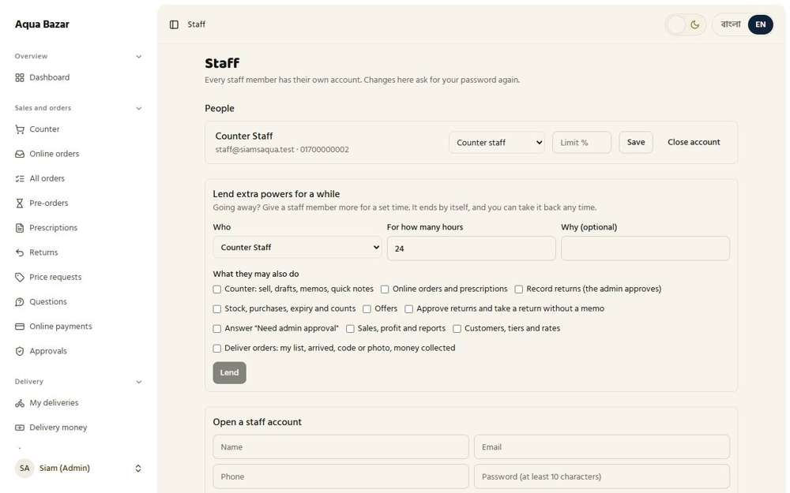  Seen as the owner | /admin/staff | 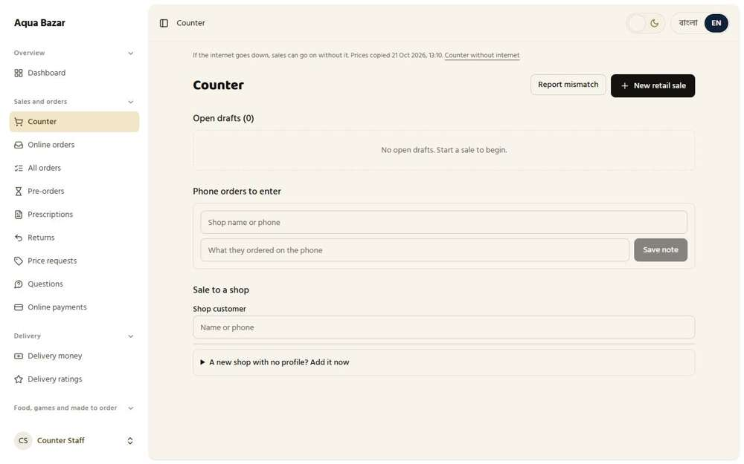  Seen as a staff member | /admin/counter
10. Role-based login redirect Works
What it is for: After signing in, each person lands on the screen made for their role. Admin to the back office, paikari to the ordering screen.
What the tester did: Signed in as each kind of person and noted where they land.
What the tester saw:
- Yes. admin lands on /dashboard (landed on /dashboard)
- Yes. staff lands on /dashboard (landed on /dashboard)
- Yes. paikari lands on /paikari (landed on /paikari)
- Yes. wholesale lands on /wholesale (landed on /wholesale)
- Yes. vendor lands on /food/vendor (landed on /food/vendor)
- Yes. craftsman lands on /craftsman (landed on /craftsman)
- Yes. mpo lands on /mpo (landed on /mpo)
Step 1: Signed in as admin: the first screen they see | Step 2: Signed in as staff: the first screen they see
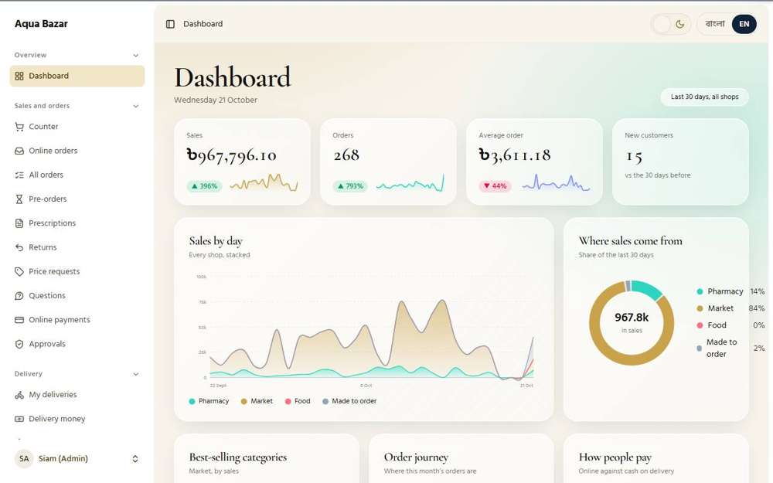  Seen as the owner | /dashboard | 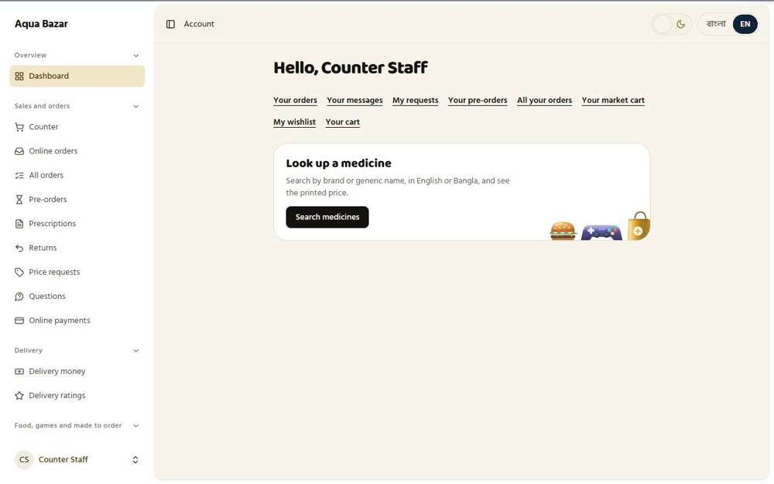  Seen as a staff member | /dashboard
Step 3: Signed in as paikari: the first screen they see | Step 4: Signed in as wholesale: the first screen they see
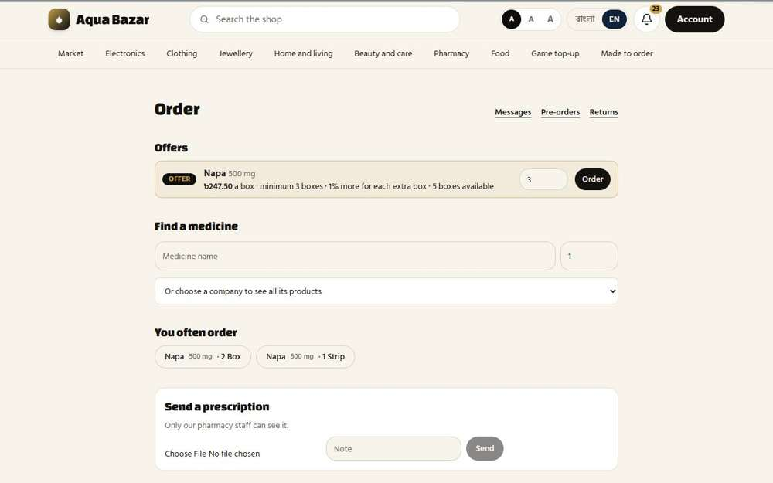  Seen as a paikari shop | /paikari | 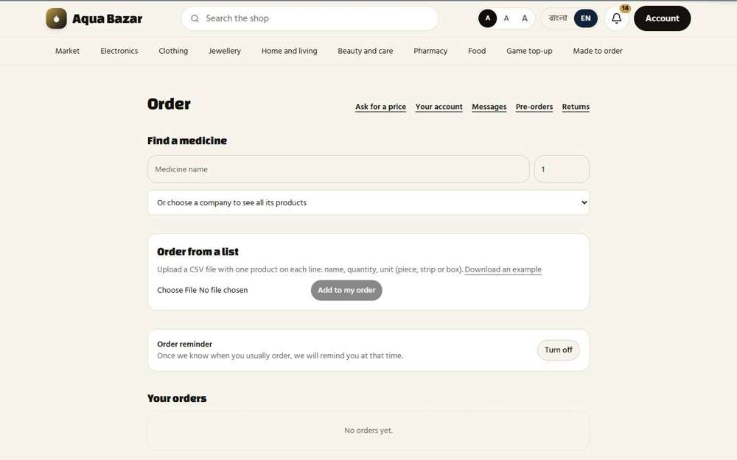  Seen as a wholesaler | /wholesale
Step 5: Signed in as vendor: the first screen they see | Step 6: Signed in as craftsman: the first screen they see
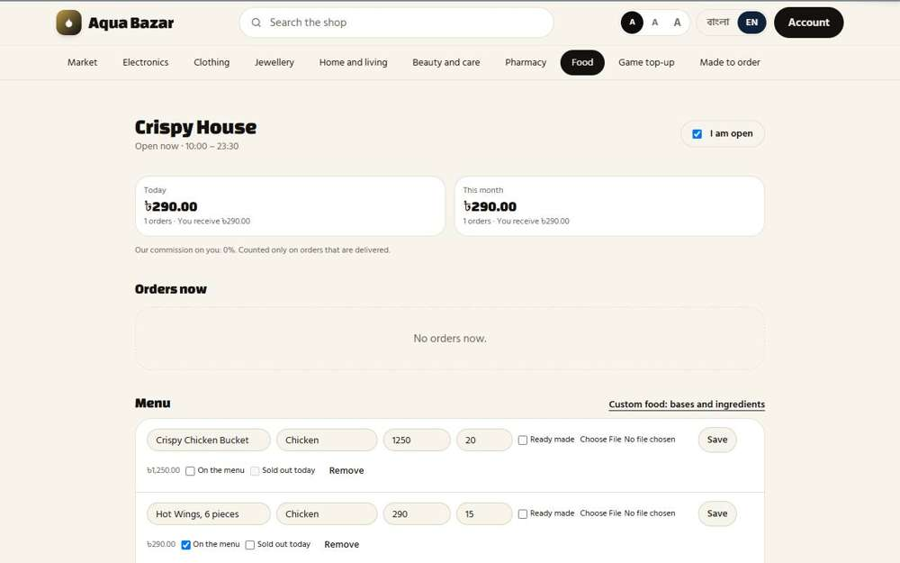  Seen as a restaurant owner | /food/vendor | 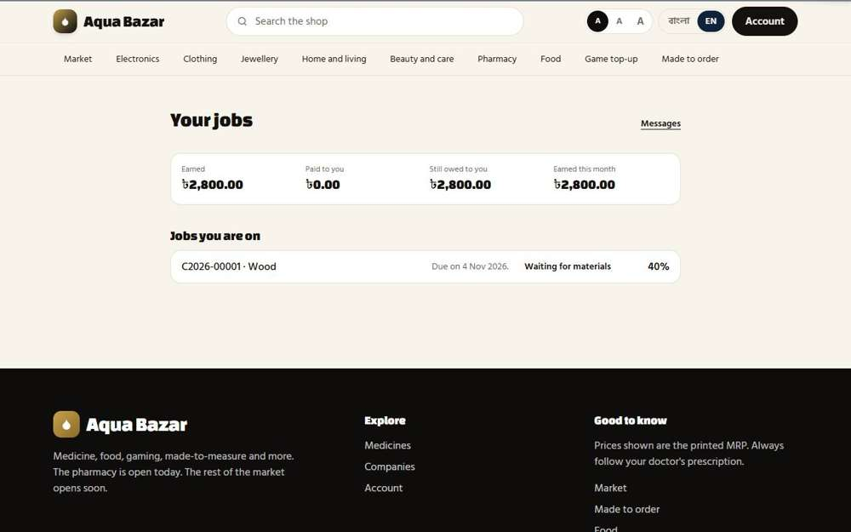  Seen as a craftsman | /craftsman
Step 7: Signed in as mpo: the first screen they see
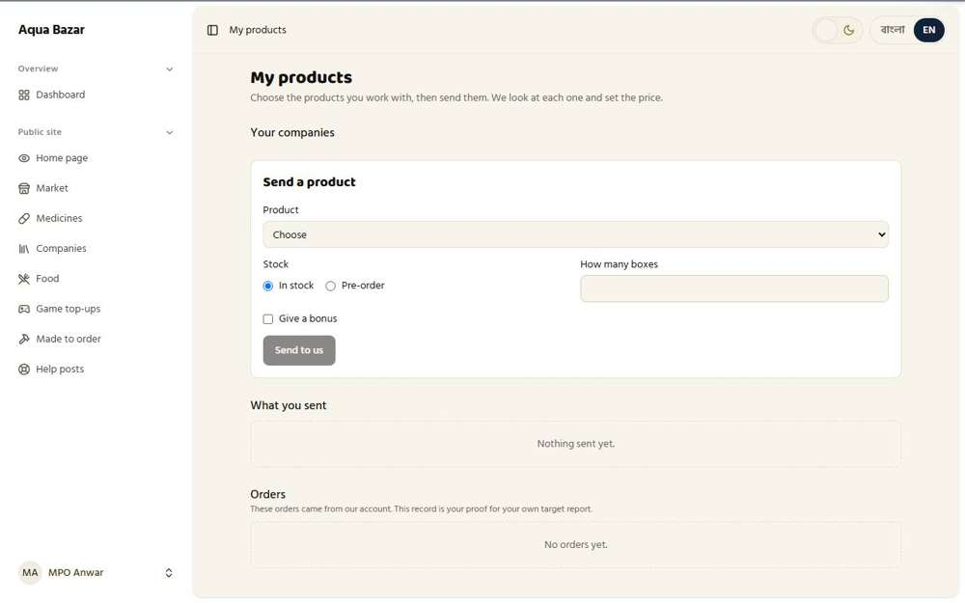
Seen as an MPO | /mpo
11. Server-side visibility checks Works
What it is for: The system checks permissions on the server, so changing a web address cannot reveal pages someone is not allowed to see.
What the tester did: Signed in as a paikari shop and typed the web addresses of the owner's pages by hand, as a curious person might.
What the tester saw:
- Yes. /admin/stock is closed to a paikari shop
- Yes. /admin/reports is closed to a paikari shop
- Yes. /admin/staff is closed to a paikari shop
Step 1: After typing an owner-only address, the shop is turned away | Step 2: Staff also cannot open every owner page
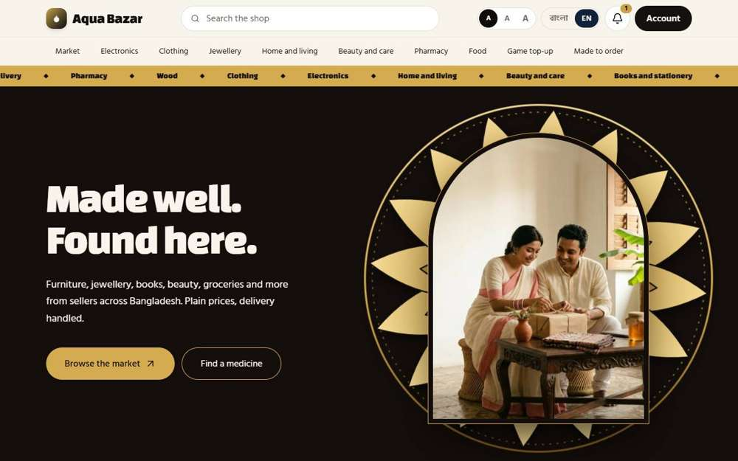  Seen as a paikari shop | / | 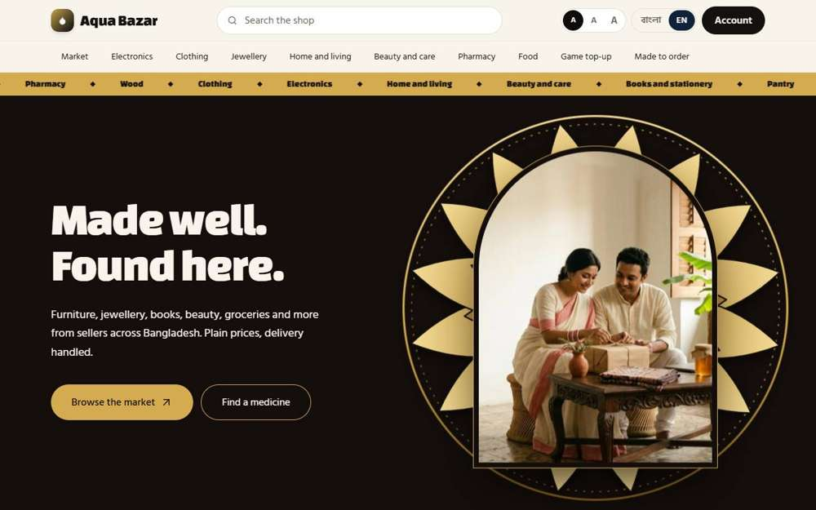  Seen as a staff member | /
12. 2FA Works
What it is for: Extra security: a second code is needed at sign-in, so a stolen password alone is not enough.
What the tester did: Opened Two-step sign-in in the shopper's settings.
What the tester saw:
- Yes. A Two-step sign-in page exists
- Yes. It asks for the password before turning anything on
Step 1: Two-step sign-in settings
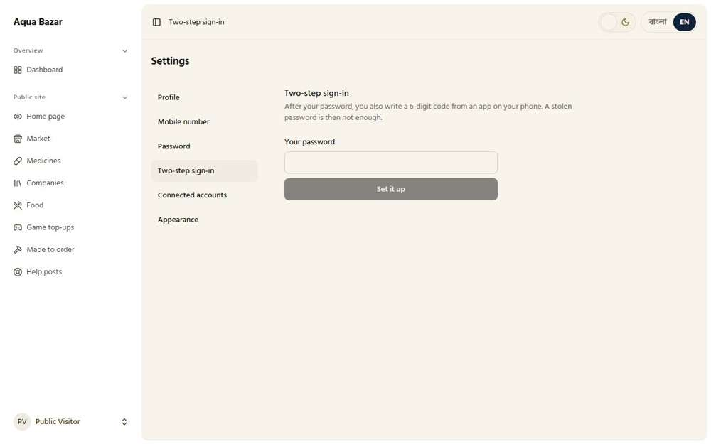
Seen as a signed-in shopper | /settings/two-factor
13. Password reset (code by phone) Works
What it is for: If a password is forgotten, a reset link comes by email. The phone-code version is waiting for the text-message service.
What the tester did: Chose "Forgot password" and asked for a reset link.
What the tester saw:
- Yes. The page confirms a reset link is on its way
Note: Reset by email works. Reset by phone code is waiting for the text-message service.
Step 1: The forgot-password form | Step 2: The confirmation after asking for the reset link
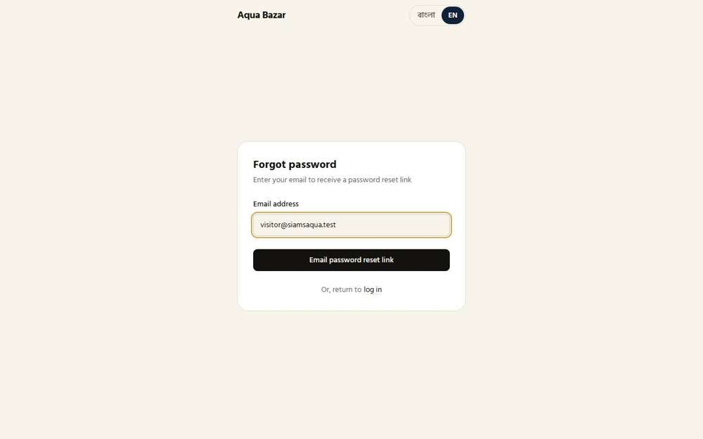  Seen as a stranger (not signed in) | /forgot-password | 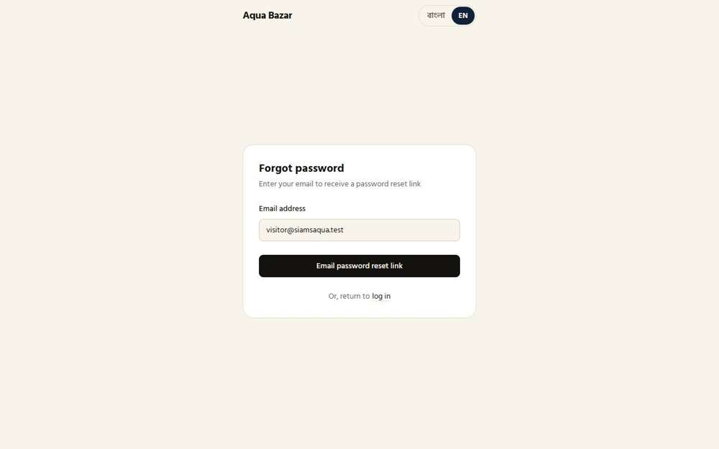  Seen as a stranger (not signed in) | /forgot-password
14. One account per phone number Works
What it is for: One phone number can only belong to one account, which stops duplicate and fake accounts.
What the tester did: Tried to save a mobile number that already belongs to another account (the paikari shop).
What the tester saw:
- Yes. The system refuses a number that is already in use
Step 1: Typing a number that another account already uses | Step 2: The system says the number is taken
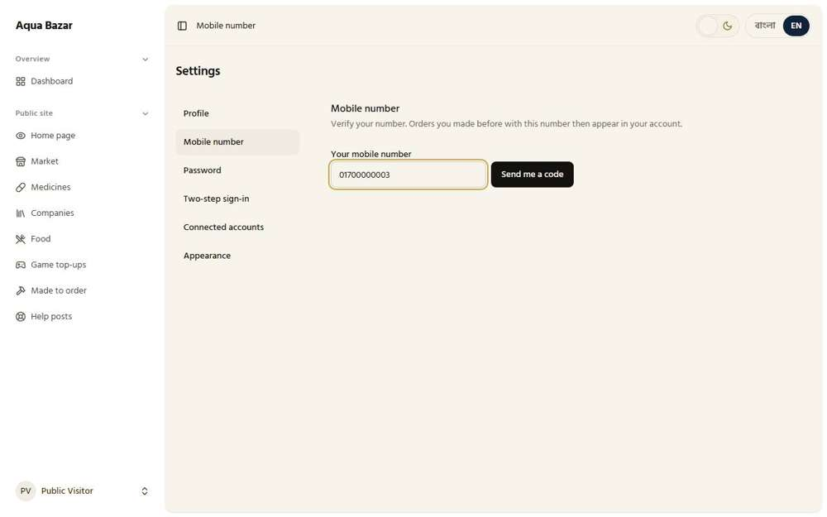  Seen as a signed-in shopper | /settings/phone | 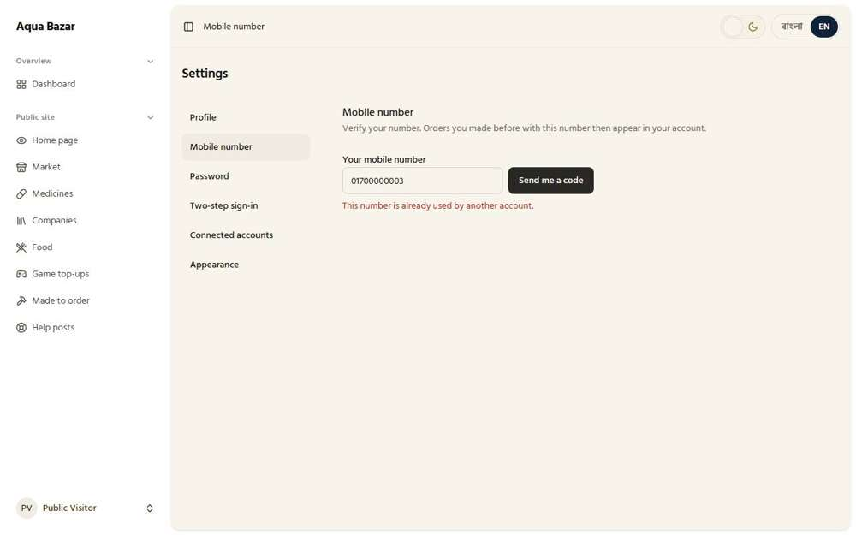  Seen as a signed-in shopper | /settings/phone
15. Guest orders linked to the account later Only partly shown
What it is for: An order placed as a guest can later be joined to the person's account once they sign up.
What the tester did: Opened the shopper's order history, where earlier guest orders are joined once the shopper signs in.
Note: Joining a guest order to an account needs a phone code, which cannot be sent in the test setup. Only the history screen was shown.
Step 1: The shopper's full order history
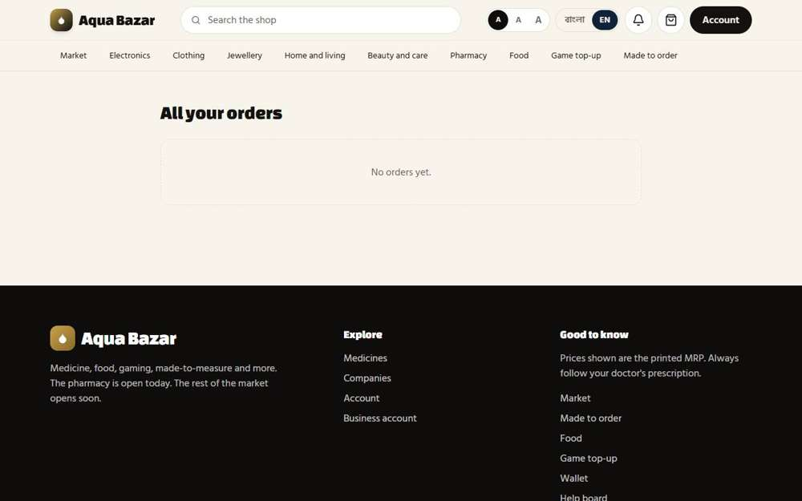
Seen as a signed-in shopper | /history
16. Customer app Works
What it is for: The shopper's app: browsing shops, ordering and tracking. Most of it works; a few role screens are still being finished.
What the tester did: Opened the shopper side of the site on a phone-sized screen.
Step 1: The shopper's app on a phone-sized screen | Step 2: The shopper's own page on a phone
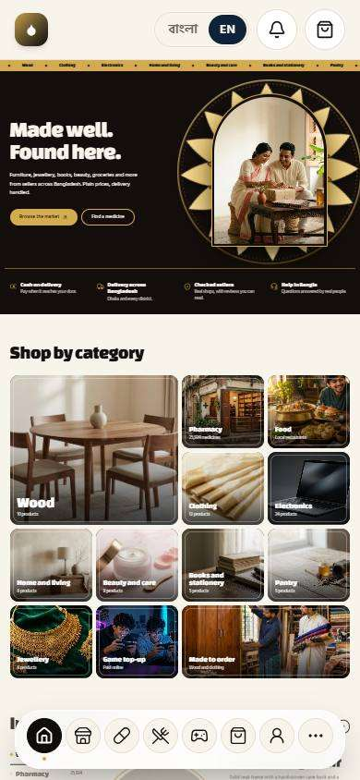  Seen as a signed-in shopper | / | 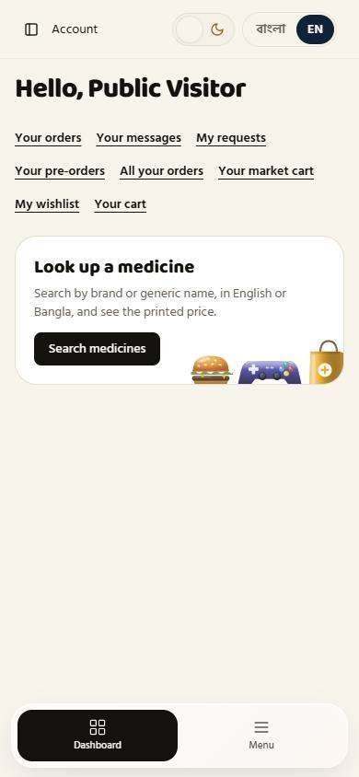  Seen as a signed-in shopper | /dashboard
17. Supplier app Not built yet
What it is for: The separate app for suppliers has not been built yet.
What the tester did: Checked the checklist.
Note: The separate supplier app has not been built yet.
18. One login in both apps, switch button Not built yet
What it is for: One login for both apps with a switch button has not been built yet.
What the tester did: Checked the checklist.
Note: One login with a switch button between the two apps has not been built yet.
19. Admin panel (web) Works
What it is for: The owner's control room on the web: orders, stock, customers, reports and settings.
What the tester did: Signed in as the owner and opened the back office.
What the tester saw:
- Yes. The back office has stock, orders, customers and reports
Step 1: The owner's back office home | Step 2: Orders in the back office
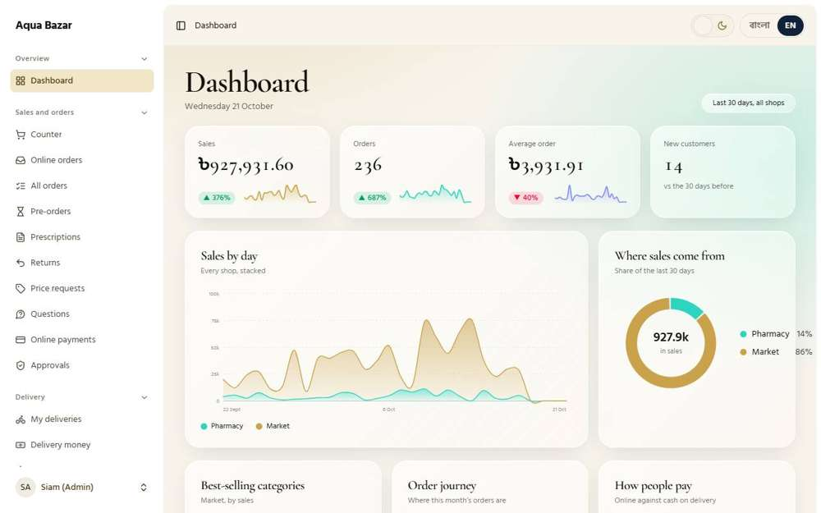  Seen as the owner | /dashboard | 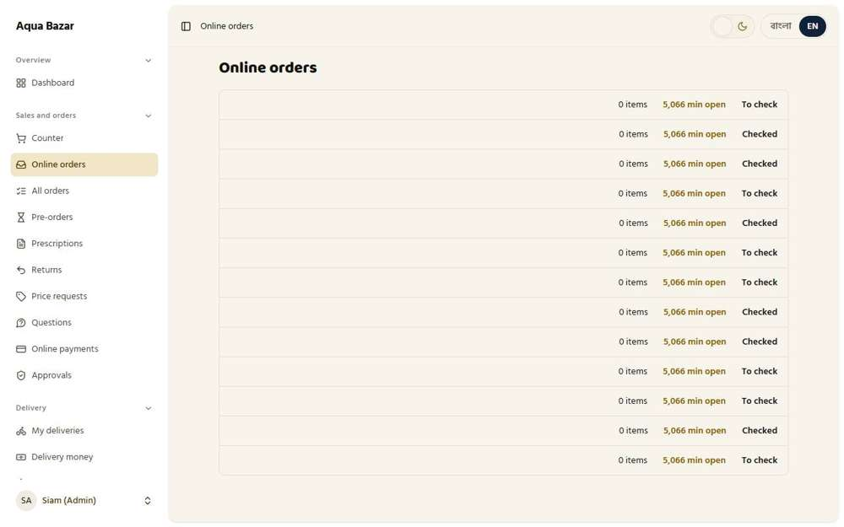  Seen as the owner | /admin/orders
Step 3: Stock in the back office
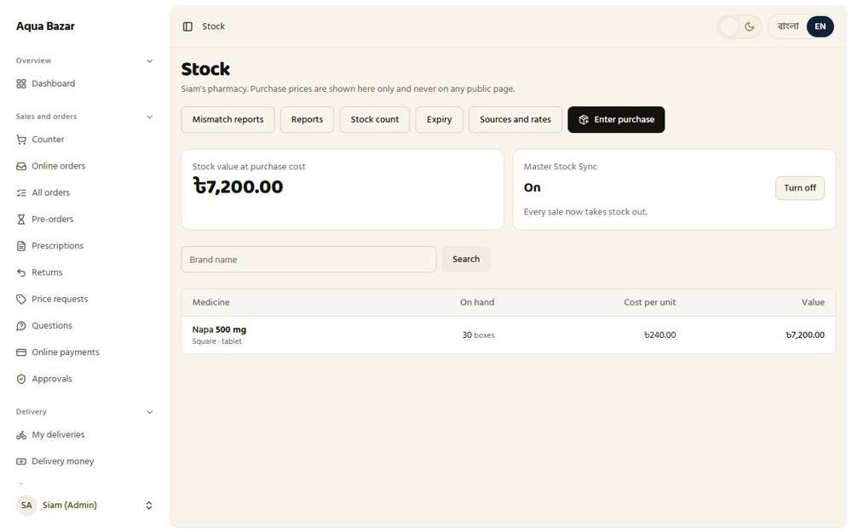
Seen as the owner | /admin/stock
20. Different screens by role (MPO, craftsman) Works
What it is for: People with different jobs (MPO, craftsman, wholesaler) see different screens after signing in.
What the tester did: Signed in as an MPO and then as a craftsman to see that each gets a different screen.
What the tester saw:
- Yes. The two screens are different
Step 1: The MPO's own screen | Step 2: The craftsman's own, different screen
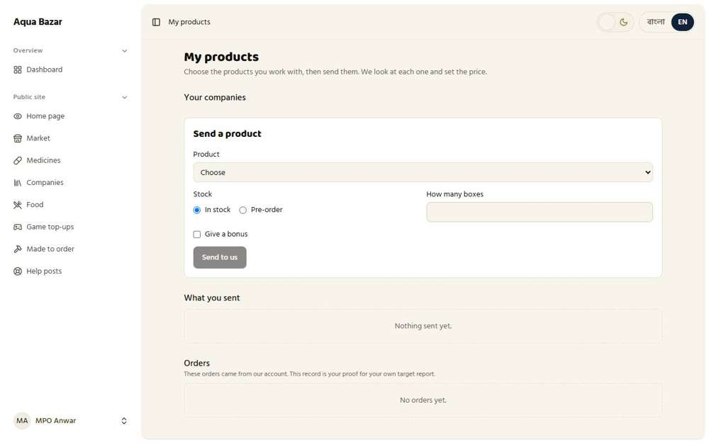  Seen as an MPO | /mpo | Seen as a craftsman | /craftsman
21. Two business accounts per person, separate stats Only partly shown
What it is for: One person can run two businesses, each with its own numbers kept apart.
What the tester did: Looked at how one person can have two business accounts.
Note: Running two business accounts for one person was not exercised end to end here.
Step 1: The customer list: each account has its own business type and its own numbers
Seen as the owner | /admin/customers

Pricing
22. Tier system — unlimited tiers Works
What it is for: Customers are grouped into levels (tiers) A, B and C. Each level gets its own default discount.
What the tester did: Opened the Tiers page to see the discount levels. Then signed in as a paikari shop on tier B and looked at what it is charged for Napa 500 mg. Finally added a new tier "D".
What the tester saw:
- Yes. Tier A exists
- Yes. Tier A gives 10%
- Yes. Tier B gives 15%
- Yes. Tier C gives 20%
- Yes. A tier B shop pays 255 for a box printed at 300, which is 15% off (saw 255 at 15%)
- Yes. The new tier D appears with its 25% discount
Step 1: The owner's Tiers page: three discount levels | Step 2: A paikari shop on tier B: the box printed at 300 is charged 255
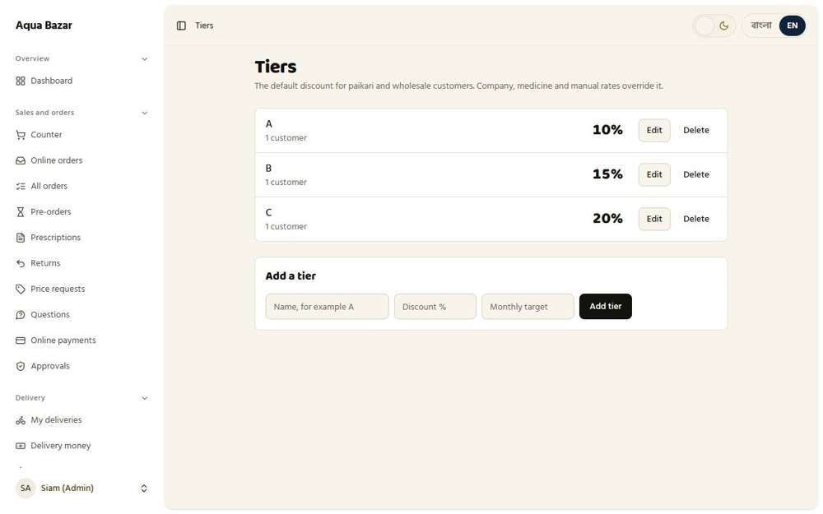  Seen as the owner | /admin/tiers | 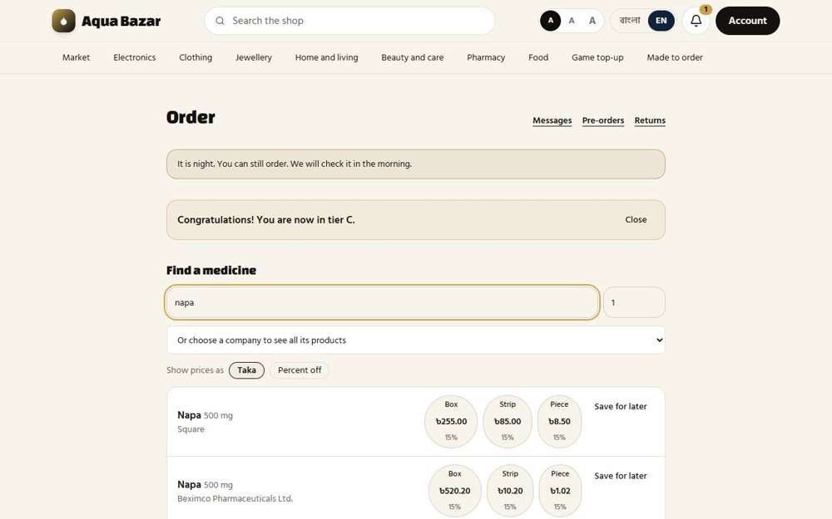  Seen as a paikari shop | /paikari
Step 3: Adding a fourth tier, D, at 25% | Step 4: Tier D is now on the list: the number of tiers is not fixed
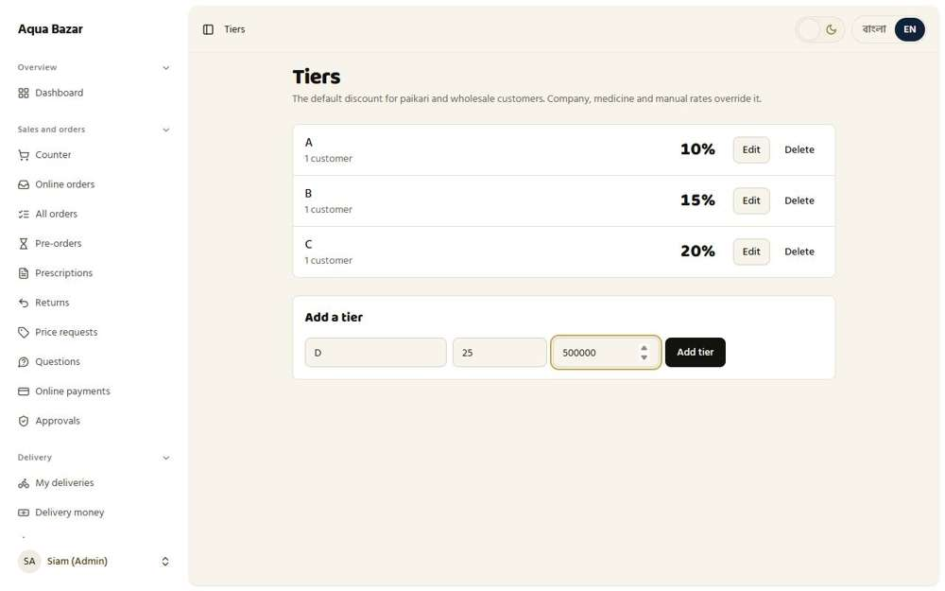  Seen as the owner | /admin/tiers | 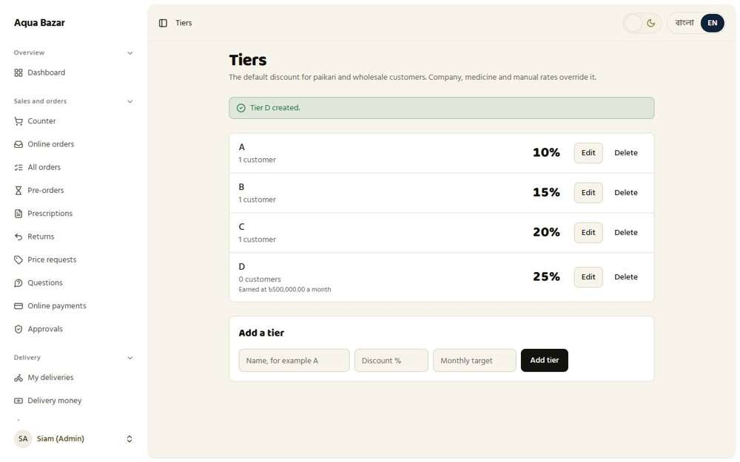  Seen as the owner | /admin/tiers
23. Company-level rate Works
What it is for: A discount can be set once for a whole company, and it covers all that company's medicines.
What the tester did: On the Tiers page, set a 10% rate for the whole company "Square", then looked at what a Square medicine costs a shop, then removed the rate.
What the tester saw:
- Yes. The Tiers page has a place for rates by company
- Yes. The company rate is saved: every Square medicine is 10% off for customers without a rate of their own
Step 1: A 10% rate for the company Square | Step 2: The company rate is saved and listed
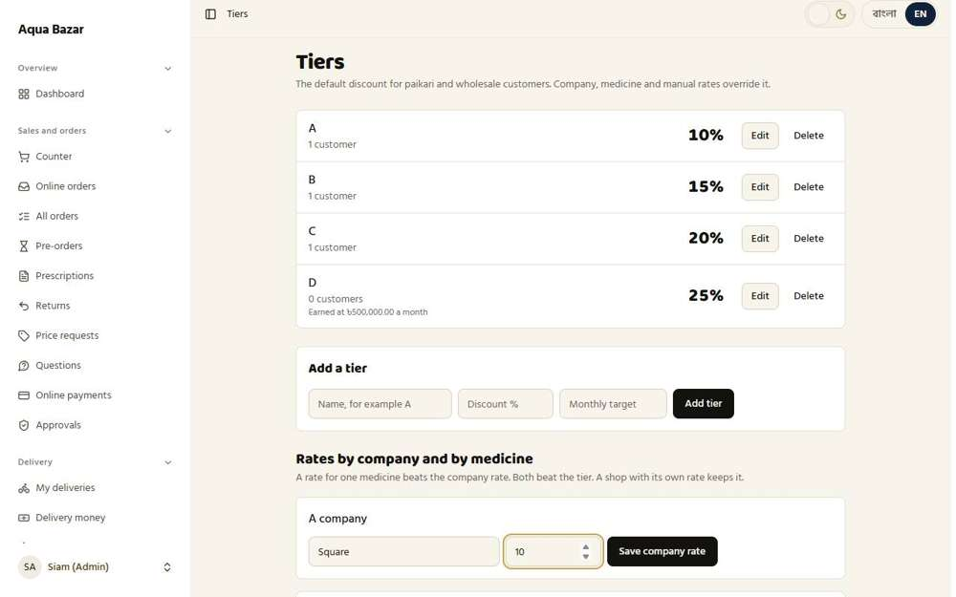  Seen as the owner | /admin/tiers | 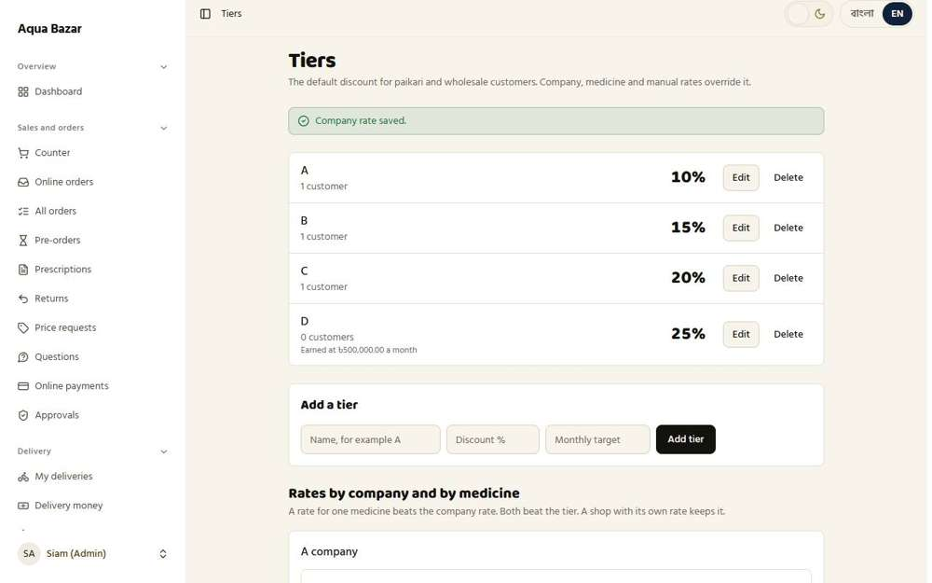  Seen as the owner | /admin/tiers
Step 3: Removed again
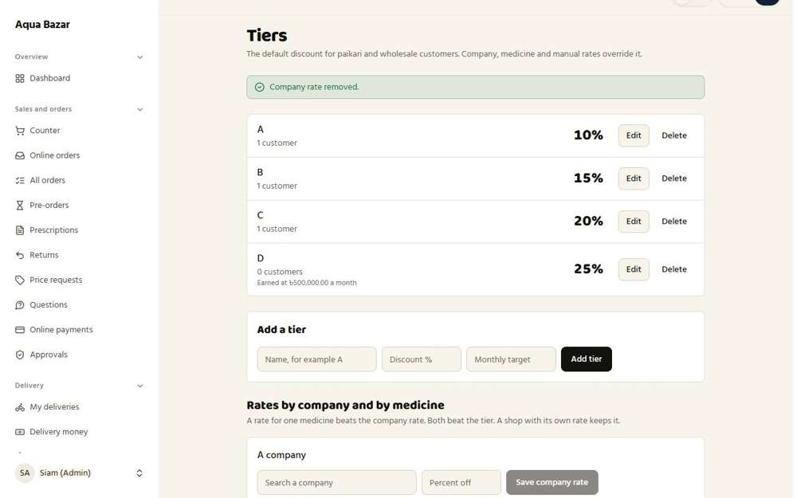
Seen as the owner | /admin/tiers
24. Product-level override Works
What it is for: A discount can also be set for one single medicine, overriding the company's.
What the tester did: On the Tiers page, set a 12% rate for one medicine (Napa 500 mg), then removed it.
What the tester saw:
- Yes. The rate for one medicine is saved
Step 1: A 12% rate for one medicine | Step 2: The medicine rate is saved and listed
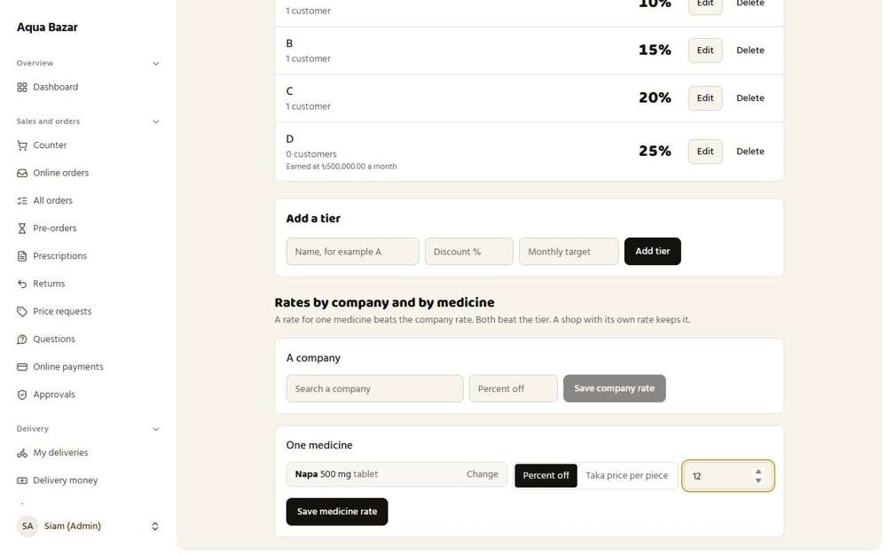  Seen as the owner | /admin/tiers | 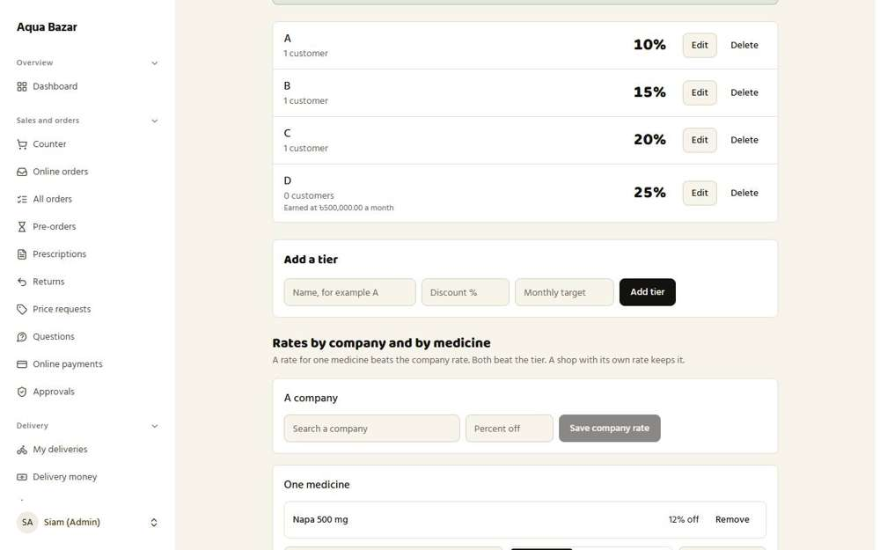  Seen as the owner | /admin/tiers
Step 3: Removed again
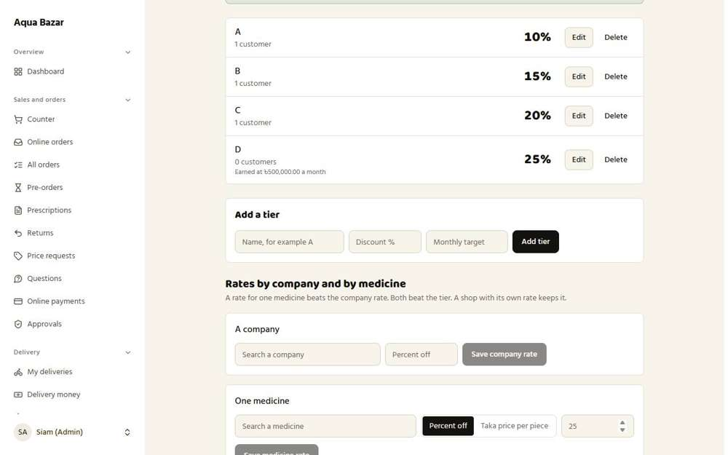
Seen as the owner | /admin/tiers
25. Customer-specific manual rate Works
What it is for: The owner can give one customer a special price on one medicine. This beats every other rule.
What the tester did: Gave Karim Pharmacy a hand-set 18% price on Napa 500 mg, then signed in as Karim to see the price.
What the tester saw:
- Yes. The special rate shows in the shop's Manual rates list
- Yes. The shop pays 246 for a box printed at 300 (18% off) instead of the tier price (saw 246 at 18%)
Step 1: Typing 18 percent off for this shop on Napa 500 mg | Step 2: The special rate is saved on the shop's profile
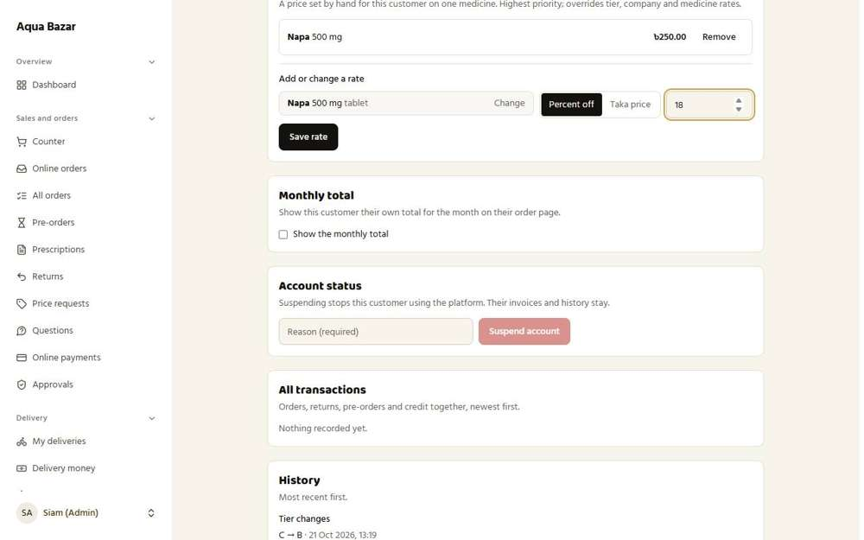  Seen as the owner | /admin/customers/4 | 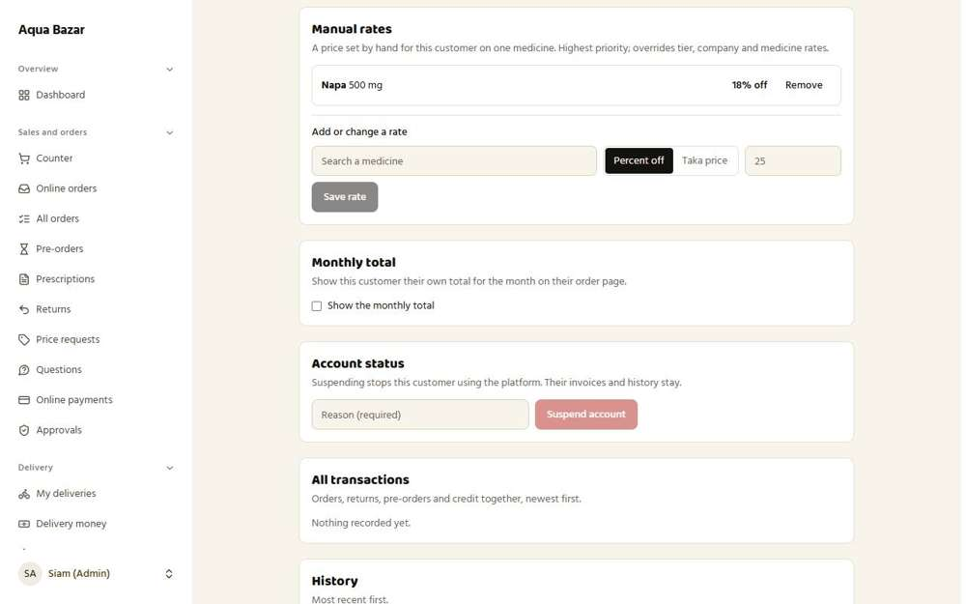  Seen as the owner | /admin/customers/4
Step 3: Karim now sees the box at 246, not 255
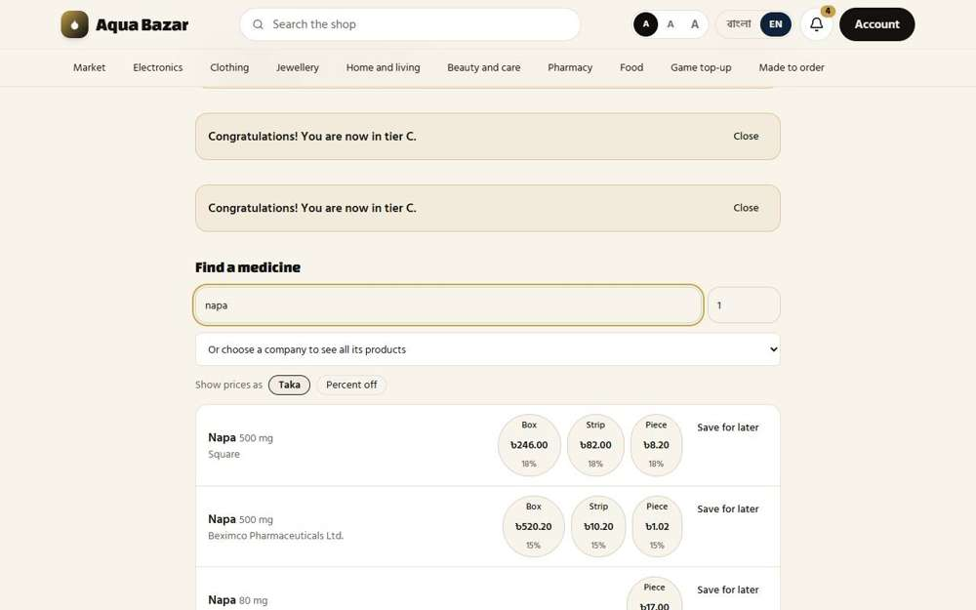
Seen as a paikari shop | /paikari
26. Four-layer priority Only partly shown
What it is for: When several discounts could apply, the system always picks in a fixed order: hand-set price first, then medicine, company, then tier.
What the tester did: Set a hand-set rate, saw it beat the tier rate, then removed it and watched the price fall back to the tier rate.
What the tester saw:
- Yes. Hand-set rate wins over the tier rate (saw 246)
- Yes. Without the hand-set rate the tier rate applies again (saw 255)
Note: Only two of the four layers could be shown (hand-set and tier). The company and medicine layers have no screen to set them.
Step 1: Typing 18 percent off for this shop on Napa 500 mg | Step 2: With the hand-set rate: 246
Seen as the owner | /admin/customers/4 | 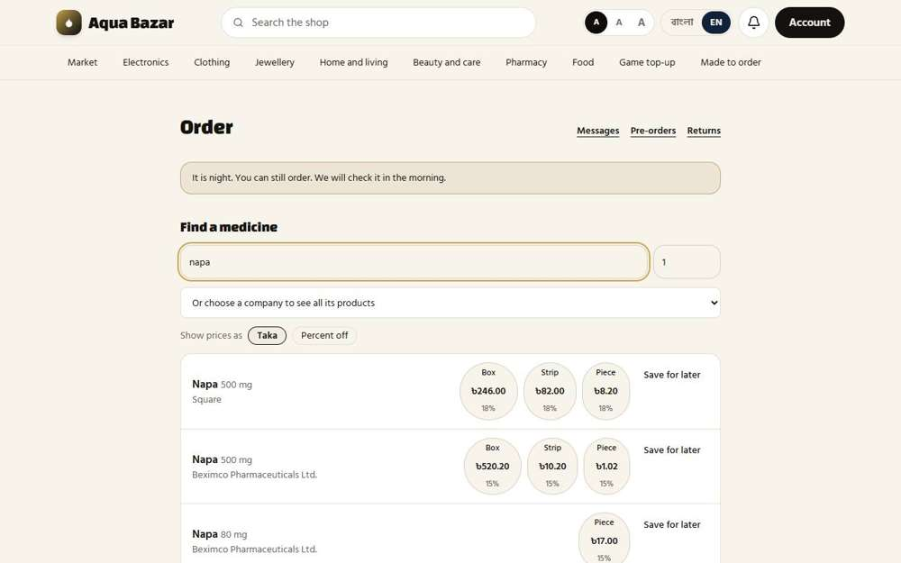  Seen as a paikari shop | /paikari
Step 3: The hand-set rate has been removed | Step 4: After removing it the shop is back on its tier price: 255
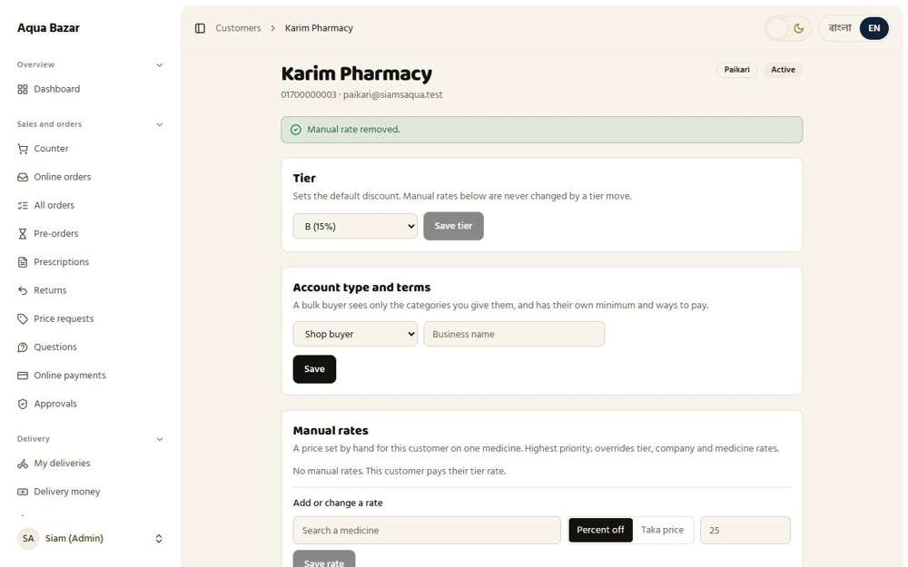  Seen as the owner | /admin/customers/4 | 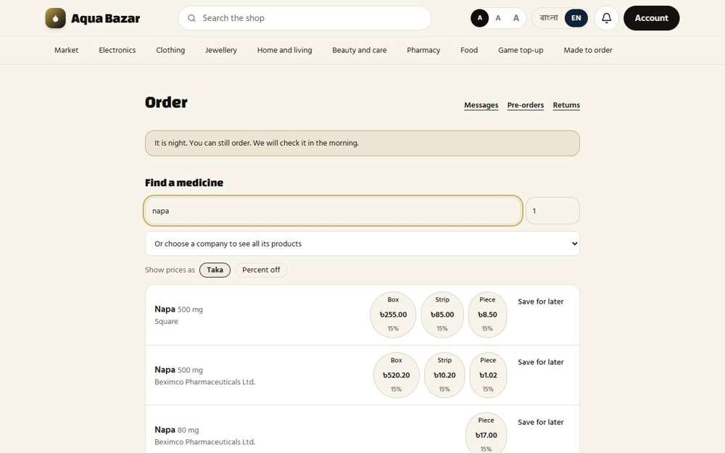  Seen as a paikari shop | /paikari
27. Manual rate unchanged when tier changes Works
What it is for: Moving a customer to a new tier does not change the special prices already set by hand for them.
What the tester did: Set a hand-set 18% rate, moved the shop from tier B to tier C, and checked the hand-set price did not change.
What the tester saw:
- Yes. The hand-set price stays at 246 after the tier change (saw 246 at 18%)
Step 1: Typing 18 percent off for this shop on Napa 500 mg | Step 2: The shop is moved to tier C
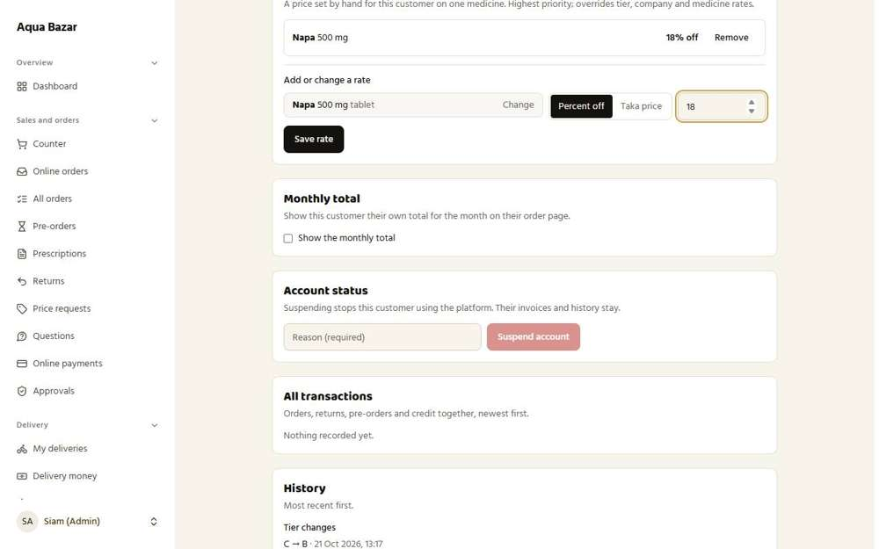  Seen as the owner | /admin/customers/4 | 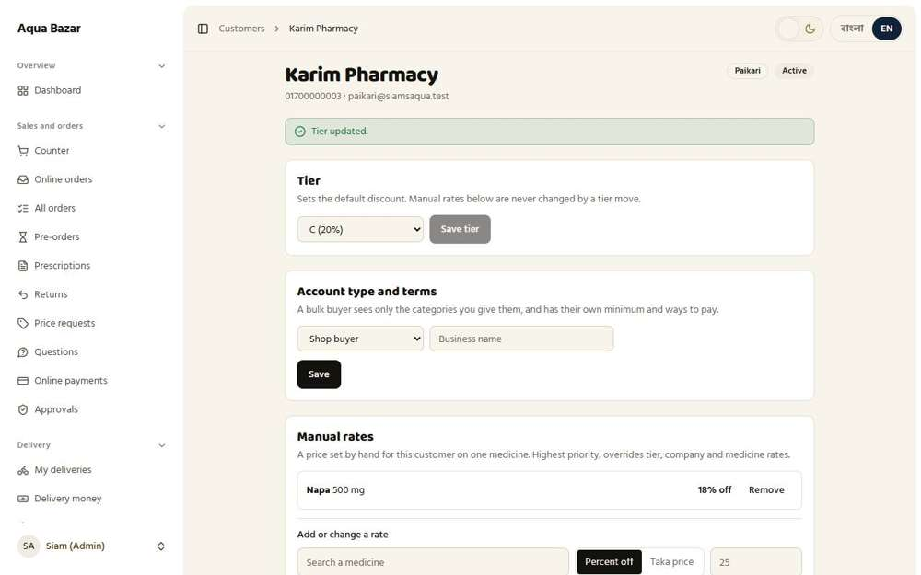  Seen as the owner | /admin/customers/4
Step 3: After the tier change the hand-set price is still 246
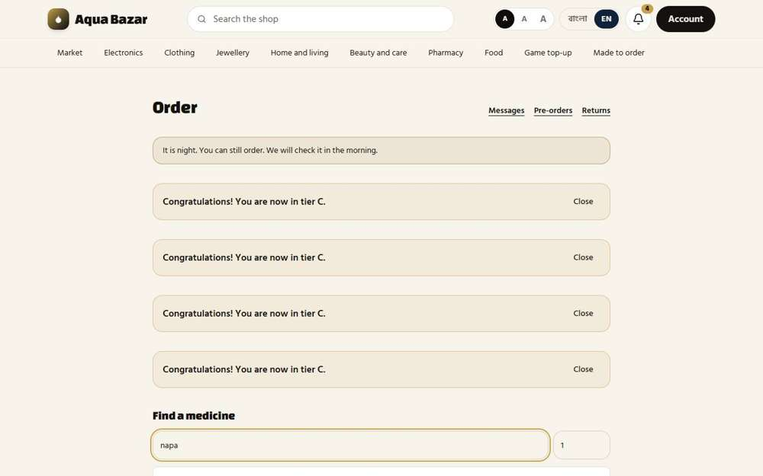
Seen as a paikari shop | /paikari
28. Percentage and taka — both Works
What it is for: A discount can be written as a percentage or as a fixed taka amount.
What the tester did: Gave the shop a fixed taka price on Napa 500 mg. First typed 250, thinking of the price of a box. Then typed 8.2, the price of one piece.
What the tester saw:
- Yes. A box price typed by mistake is refused, and the message says a taka price is for one piece and what the printed piece price is
- Yes. A fixed taka price typed per piece works (8.2 per piece gives 246 for a box)
Step 1: Typing a fixed taka price for this shop on Napa 500 mg | Step 2: Typed 250, a box price, into the "Taka price per piece" box: the system explains the mistake
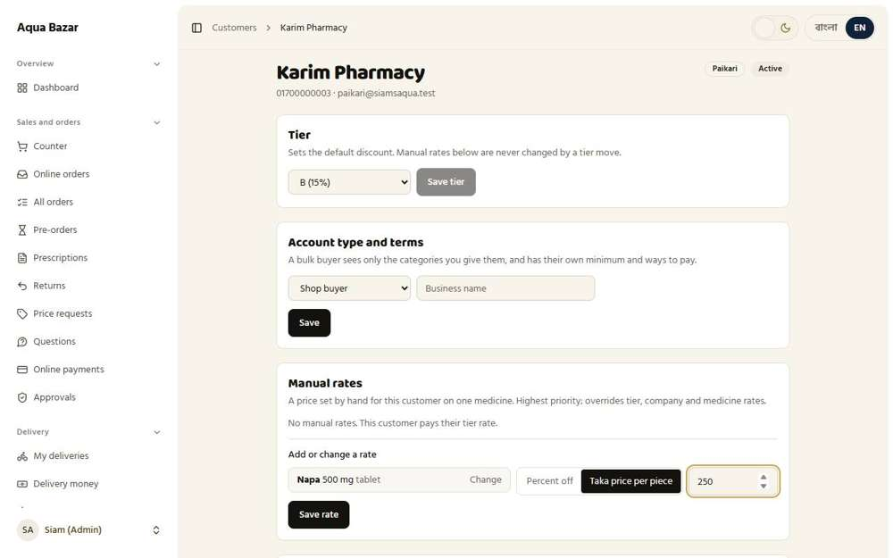  Seen as the owner | /admin/customers/4 | 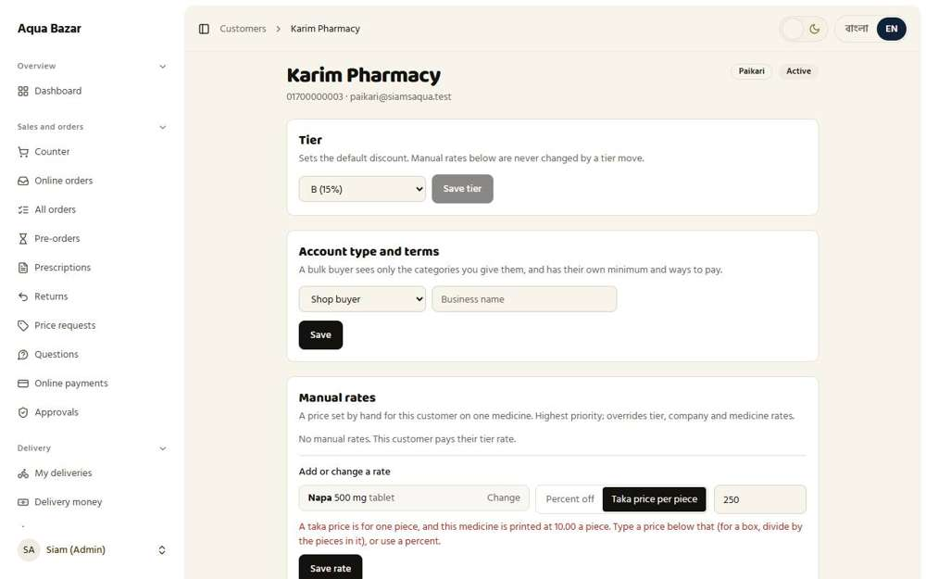  Seen as the owner | /admin/customers/4
Step 3: Typing a fixed taka price for this shop on Napa 500 mg | Step 4: Typed 8.2 as the price of one piece: the box is now 246
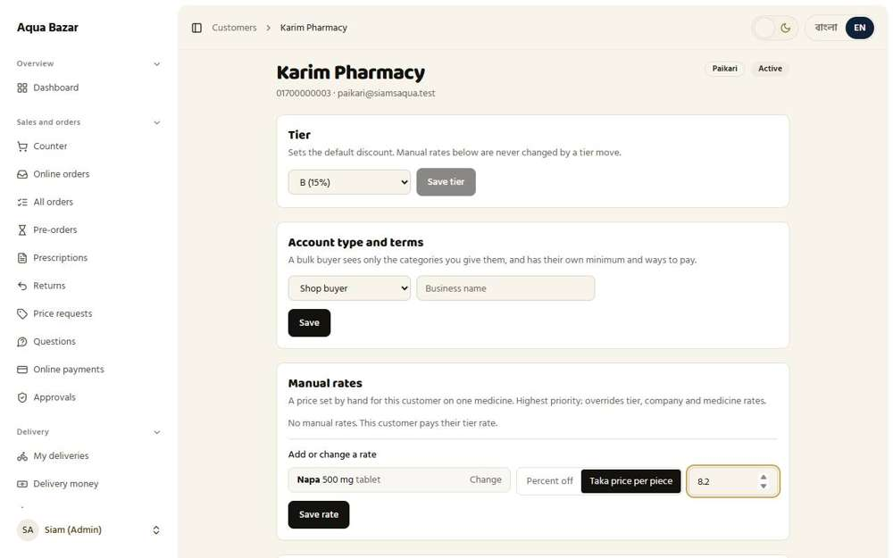  Seen as the owner | /admin/customers/4 | 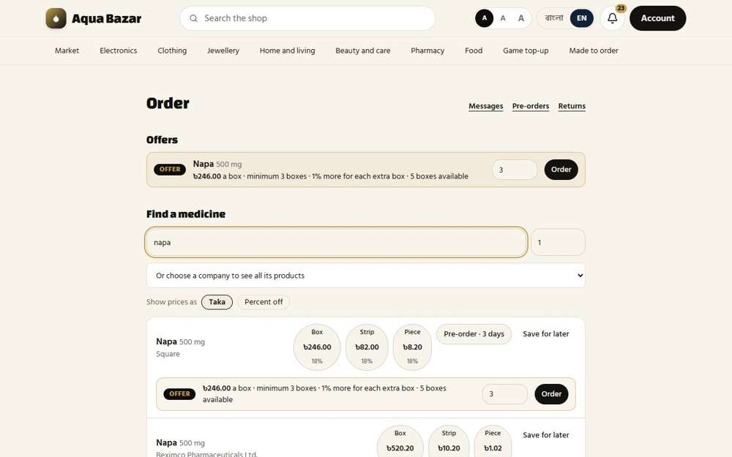  Seen as a paikari shop | /paikari
29. Percentage/taka toggle Works
What it is for: A switch on the price form flips between percentage and taka.
What the tester did: On the rate form, flipped the switch between "Percent off" and "Taka price".
What the tester saw:
- Yes. The form can be set to percent
- Yes. The same form can be switched to a fixed taka price
Step 1: Percent mode of the rate form | Step 2: Taka mode of the rate form
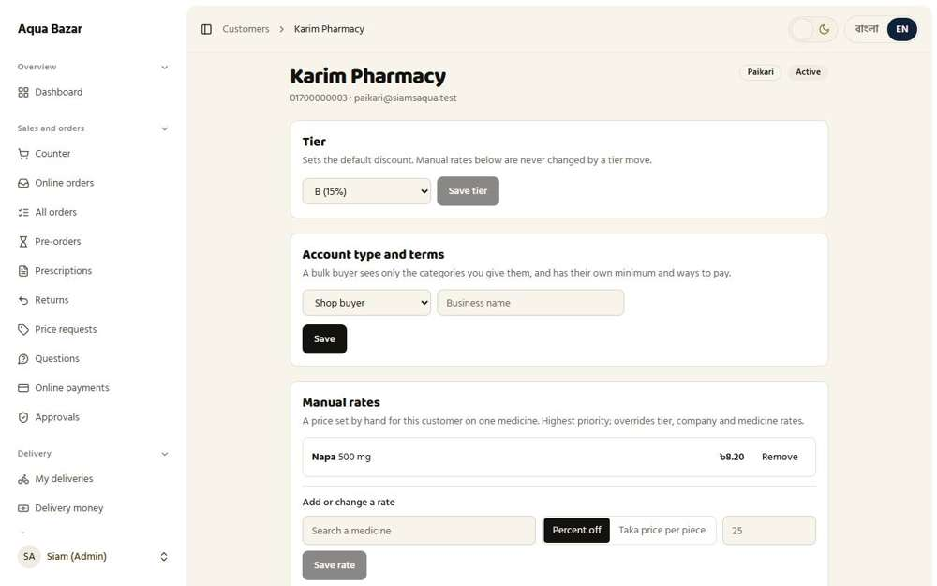  Seen as the owner | /admin/customers/4 | 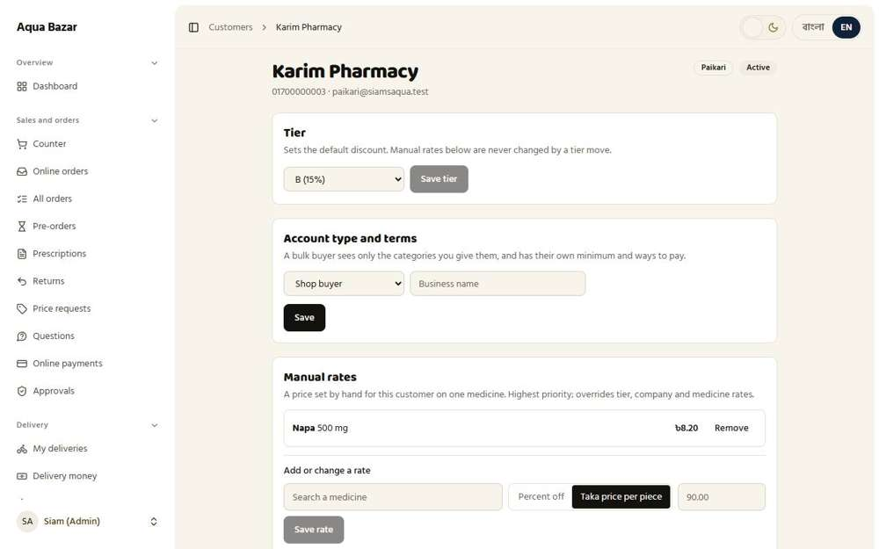  Seen as the owner | /admin/customers/4
30. Quantity-based discount steps Works
What it is for: Bigger orders can earn bigger discounts, in steps.
What the tester did: On the medicine screen, added a step to "Buy more, pay less": from 5 boxes, 10% off each. Saved it and reloaded to see it was kept.
What the tester saw:
- Yes. The step is kept after reloading the page (the field shows "5")
Step 1: The "Buy more, pay less" section before any step is added | Step 2: A step typed in: from 5 boxes, 10 percent off each
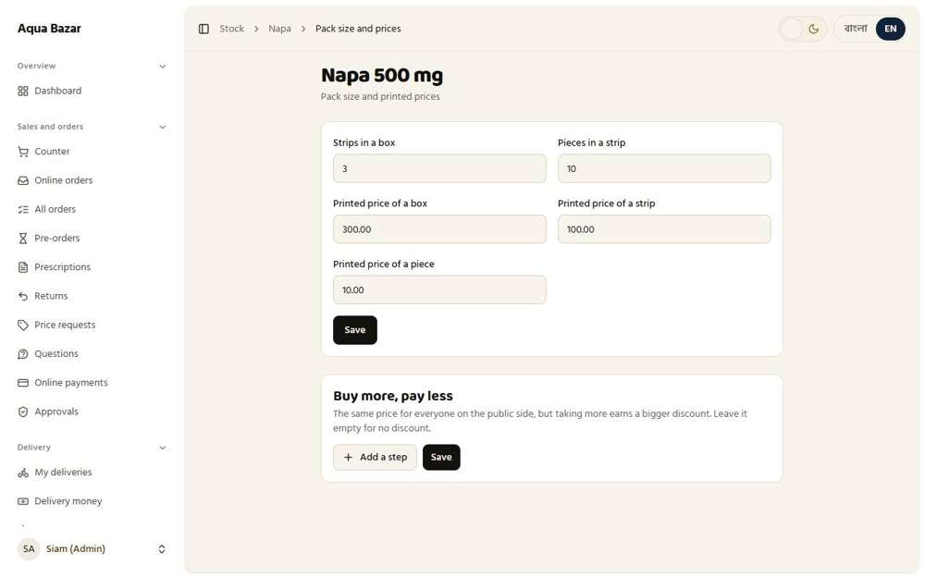  Seen as the owner | /admin/stock/medicines/1/edit | 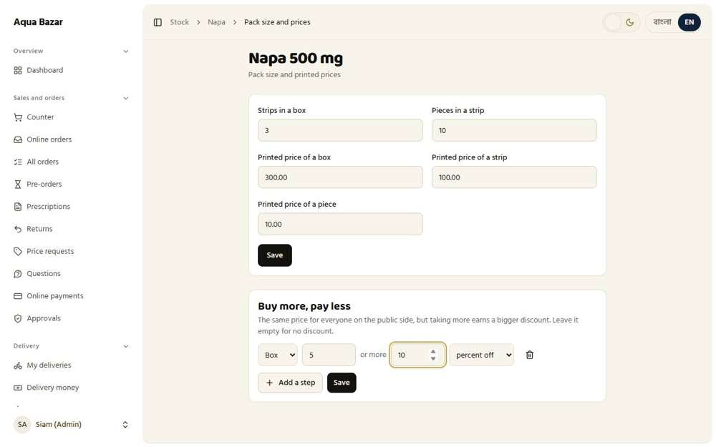  Seen as the owner | /admin/stock/medicines/1/edit
Step 3: After reloading, the step is still there
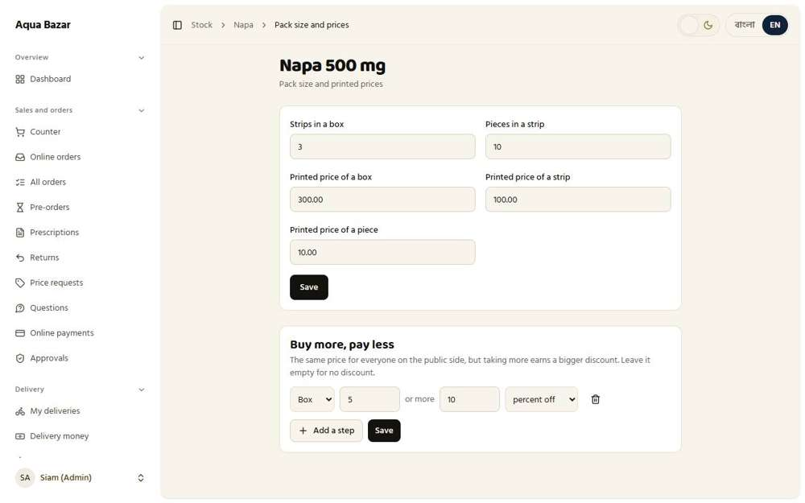
Seen as the owner | /admin/stock/medicines/1/edit
31. Discount steps shown on product page Works
What it is for: The steps are shown on the product page so buyers see what they save by ordering more.
What the tester did: Opened the public page for Napa 500 mg as a stranger and looked for the quantity discount.
What the tester saw:
- Yes. The public page shows that buying 5 or more boxes earns 10% off
Note: The discount is the same for every public buyer.
Step 1: The public medicine page shows the quantity discount steps
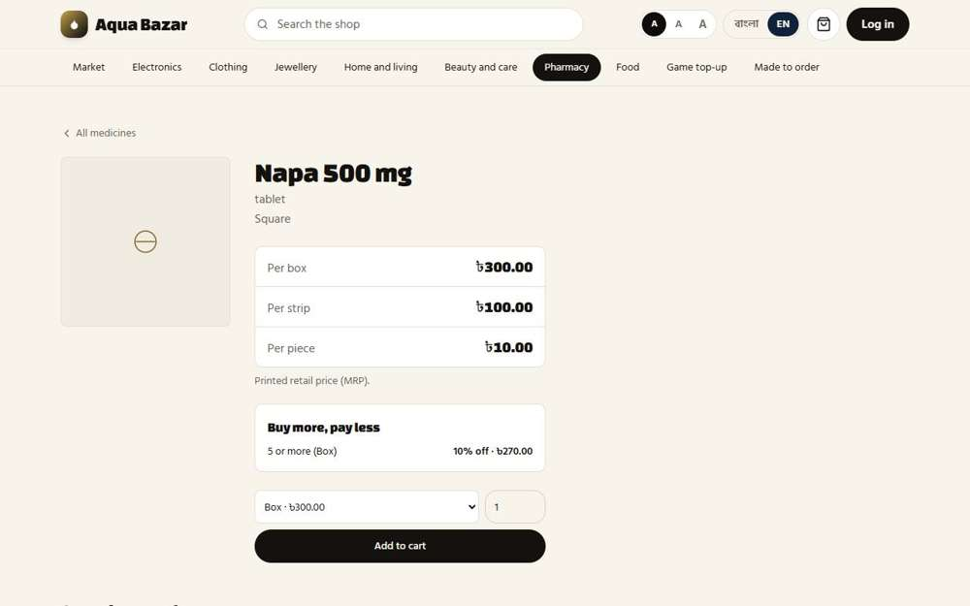
Seen as a stranger (not signed in) | /medicines/1
32. Discount order (price → quantity → token → credit) Only partly shown
What it is for: Discounts stack in a fixed order: price first, then quantity, then token, then credit.
What the tester did: As a stranger, put 5 boxes of Napa 500 mg in the cart to see the quantity discount applied in the price.
What the tester saw:
- Yes. Five boxes cost 1,350 (270 each, 10% off the printed 300), not 1,500
Note: Only the quantity step was shown in the cart. The full order (price, then quantity, then token, then credit) happens inside the system and was not shown screen by screen.
Step 1: The cart with 5 boxes: the quantity discount is already in the price
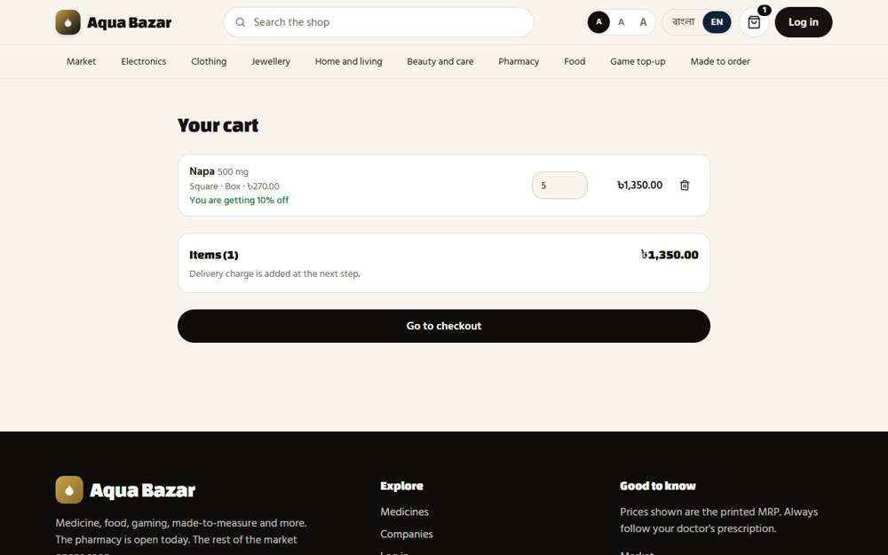
Seen as a stranger (not signed in) | /cart
33. Warning on abnormal prices Works
What it is for: If someone types a strange price, such as far too high or low, the system warns them.
What the tester did: Tried to change the printed price of a box from 300 to 30, a drop that looks like a typing mistake.
What the tester saw:
- Yes. The system warns about an unusually big price drop
Step 1: Typing 30 where 300 was | Step 2: What the system says
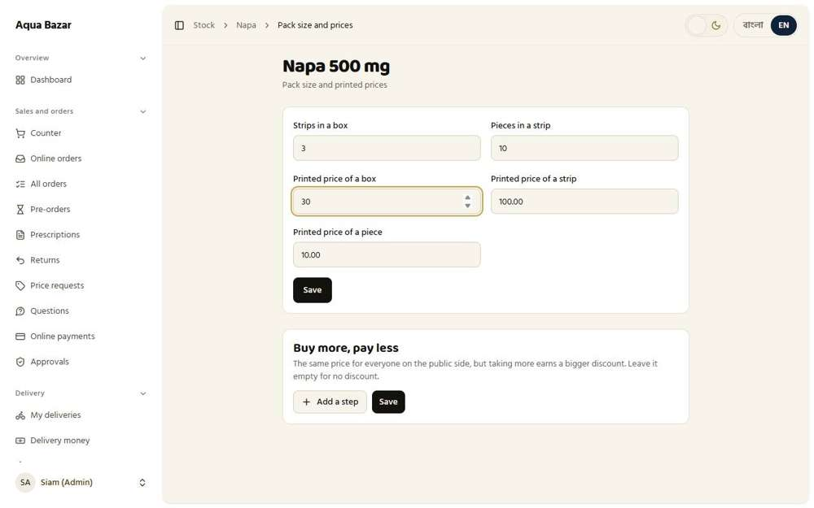  Seen as the owner | /admin/stock/medicines/1/edit | 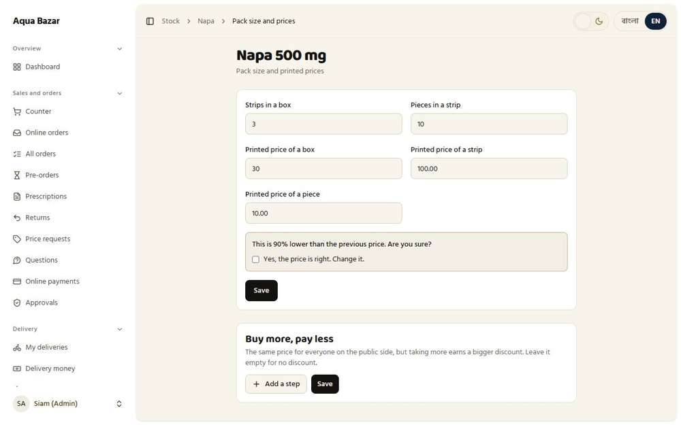  Seen as the owner | /admin/stock/medicines/1/edit
34. Tier change log Works
What it is for: Every tier change is written to the customer's history, with date and who changed it.
What the tester did: Changed the shop's tier and looked at the Tier changes list on the customer page.
What the tester saw:
- Yes. The customer page has a Tier changes list
- Yes. The change between tiers is written down
Step 1: The customer page lists every tier change
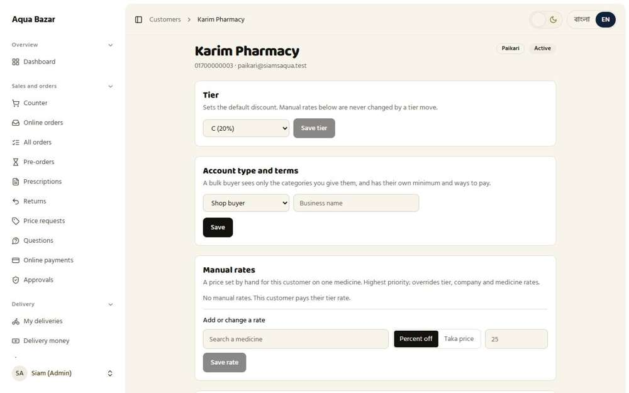
Seen as the owner | /admin/customers/4
35. Invoice stores that day's price Works
What it is for: An invoice keeps the price from the day it was made, so later price changes never alter old invoices.
What the tester did: Finished a retail sale of a box of Napa at 300, then raised the printed price to 320 and opened the memo again.
What the tester saw:
- Yes. The memo shows the box at 300
- Yes. The memo still shows 300: it keeps that day's price
- Yes. It does not change to the new price
Step 1: The finished memo at 300 | Step 2: The same memo after the printed price rose to 320
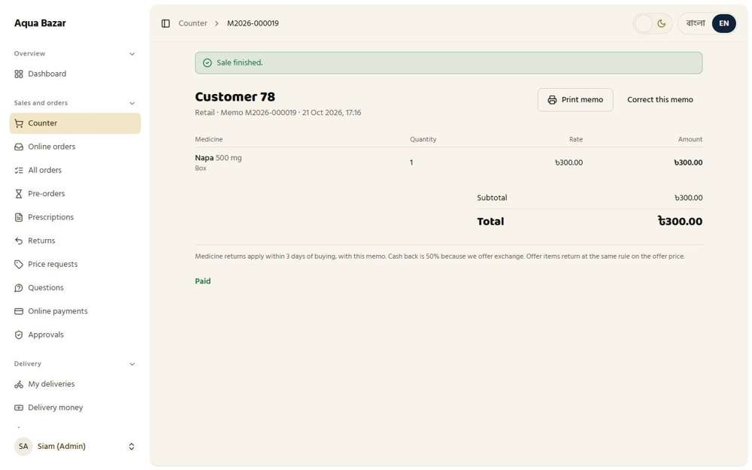  Seen as the owner | /admin/counter/248 | 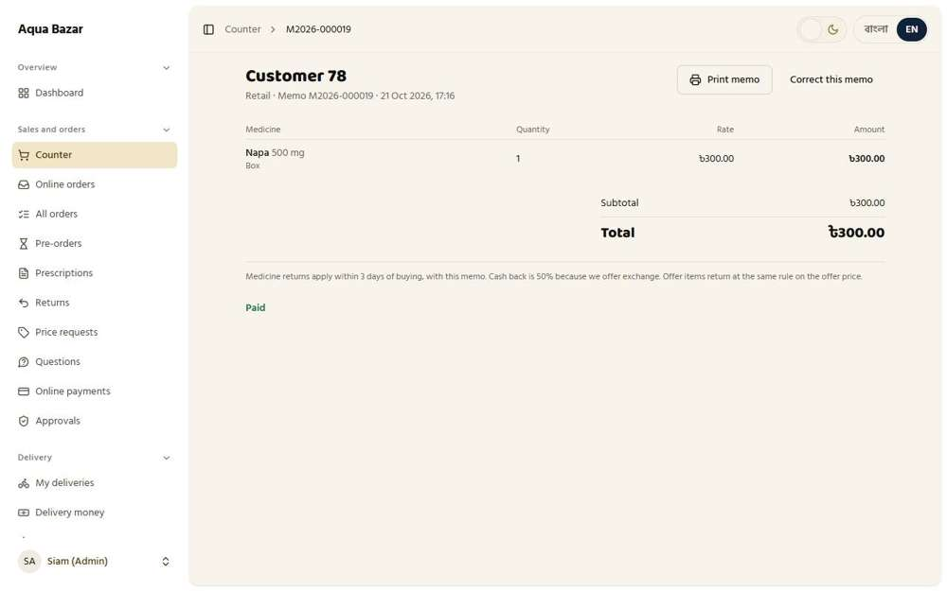  Seen as the owner | /admin/counter/248

Visibility
36. Wholesale section invisible to paikari Works
What it is for: Paikari shop owners can never see the wholesale section, and wholesalers cannot see the paikari one.
What the tester did: Signed in as a paikari shop and tried to open the wholesale screen. Then signed in as a wholesaler and tried to open the paikari screen.
What the tester saw:
- Yes. A paikari shop cannot open /wholesale (they were sent to /)
- Yes. A paikari shop gets no scary error page, just a quiet redirect
- Yes. A wholesaler cannot open /paikari (they were sent to /)
- Yes. A wholesaler gets no scary error page, just a quiet redirect
Step 1: A paikari shop on its own ordering screen | Step 2: After typing the wholesale address, the paikari shop is sent back
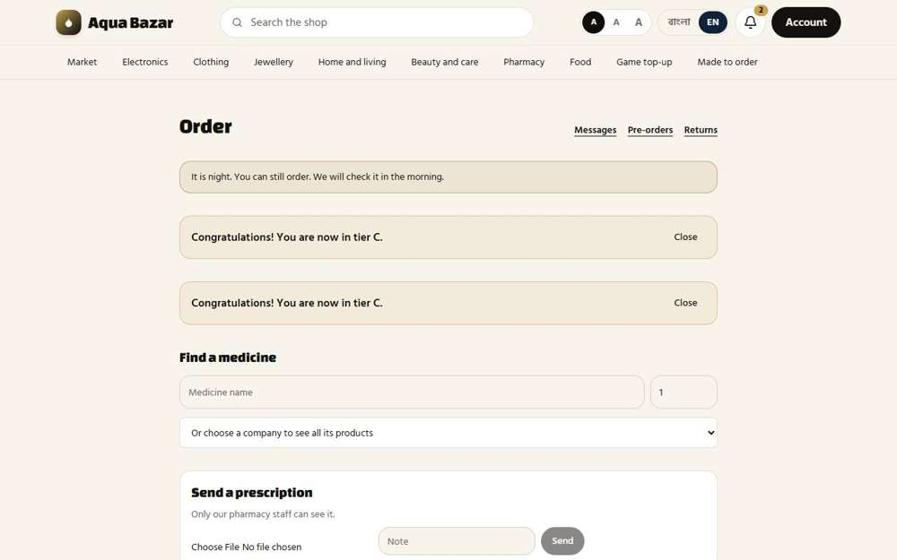  Seen as a paikari shop | /paikari | 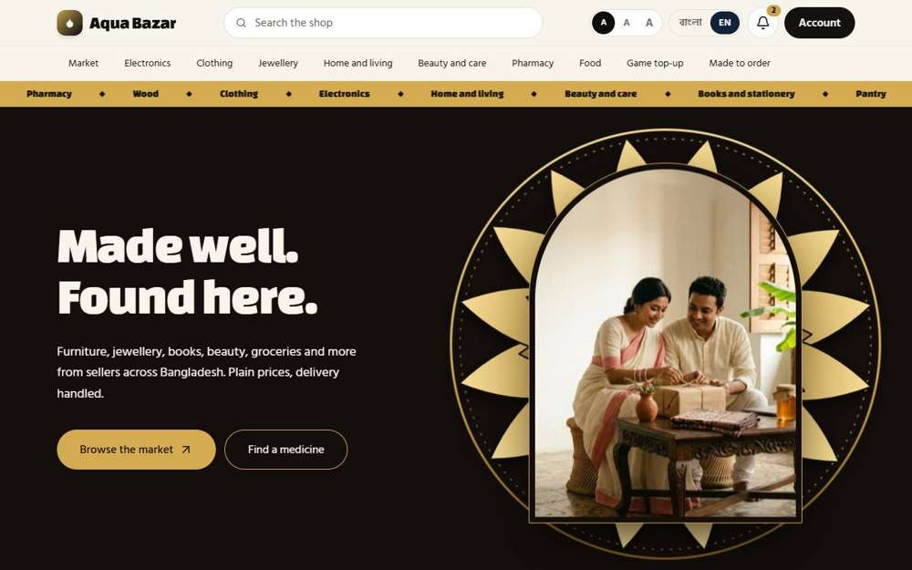  Seen as a paikari shop | /
Step 3: A wholesaler on the wholesale screen | Step 4: After typing the paikari address, the wholesaler is sent back
Seen as a wholesaler | /wholesale | 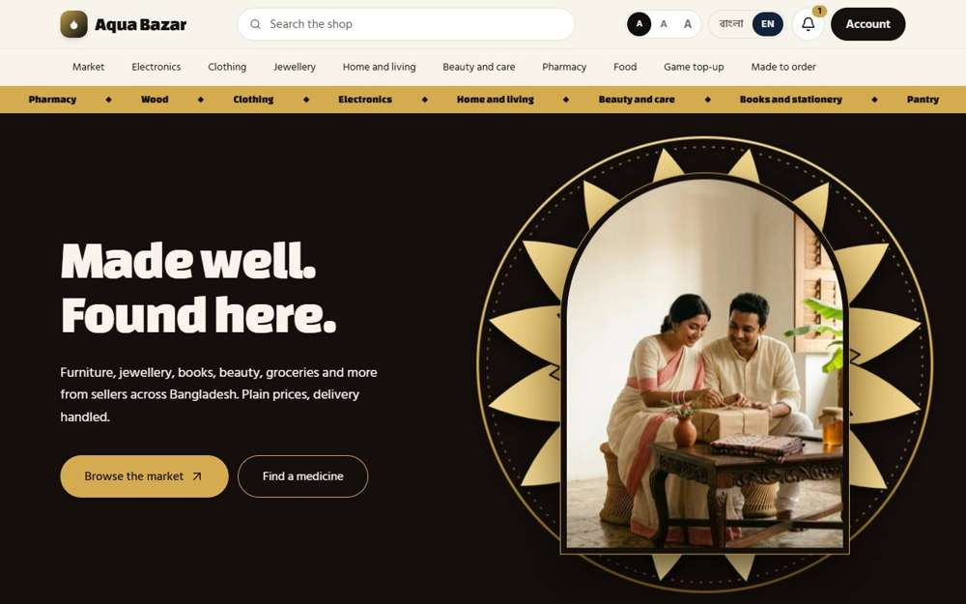  Seen as a wholesaler | /
37. Category-based access Works
What it is for: A wholesale buyer only sees the product categories the owner has opened up for them.
What the tester did: As the owner, took the "Medicine" category away from the wholesaler Rahim Traders. Then signed in as Rahim to see if the medicine ordering list was still there. Finally gave the category back.
What the tester saw:
- Yes. With the Medicine category removed, the list of medicine companies is gone
- Yes. Giving the category back brings the medicine list back
Step 1: The owner's "Categories they can see" for Rahim Traders | Step 2: Rahim's screen without the Medicine category
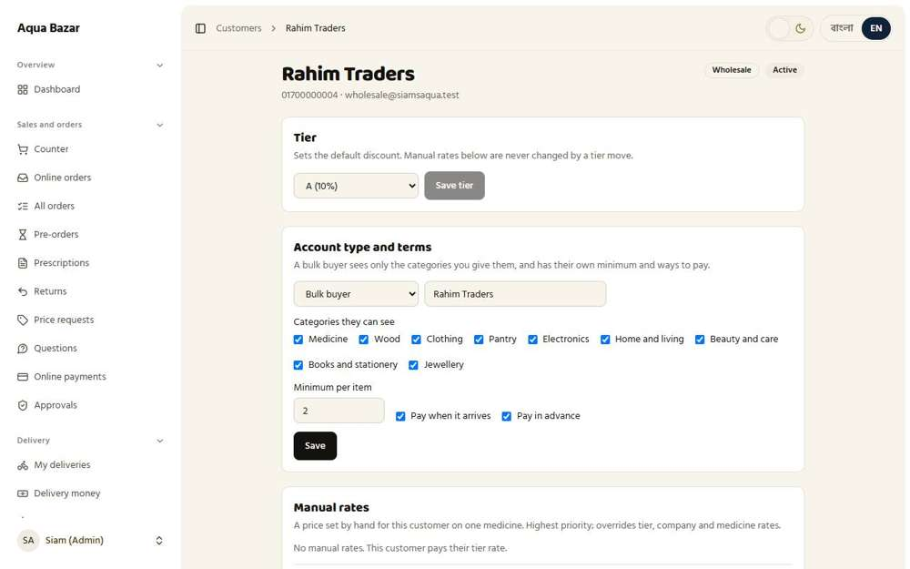  Seen as the owner | /admin/customers/5 | 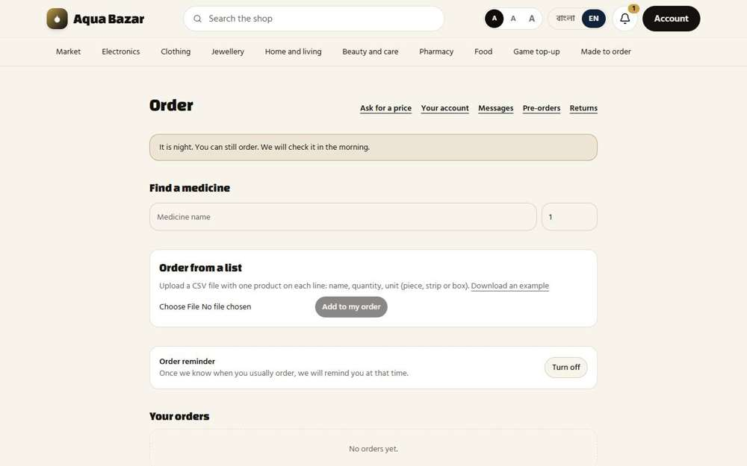  Seen as a wholesaler | /wholesale
Step 3: The category is given back and the list returns
Seen as a wholesaler | /wholesale
38. Deep links Works
What it is for: A link to a product opens correctly for people allowed to see it, and quietly redirects everyone else.
What the tester did: As a stranger, opened a direct link to a public product, then a direct link to a restricted page.
What the tester saw:
- Yes. A direct link to a public product opens straight to it
- Yes. A stranger cannot open /wholesale (they were sent to /login)
- Yes. A stranger gets no scary error page, just a quiet redirect
Step 1: A direct product link works for everyone allowed to see it | Step 2: A direct link to a restricted page quietly goes elsewhere
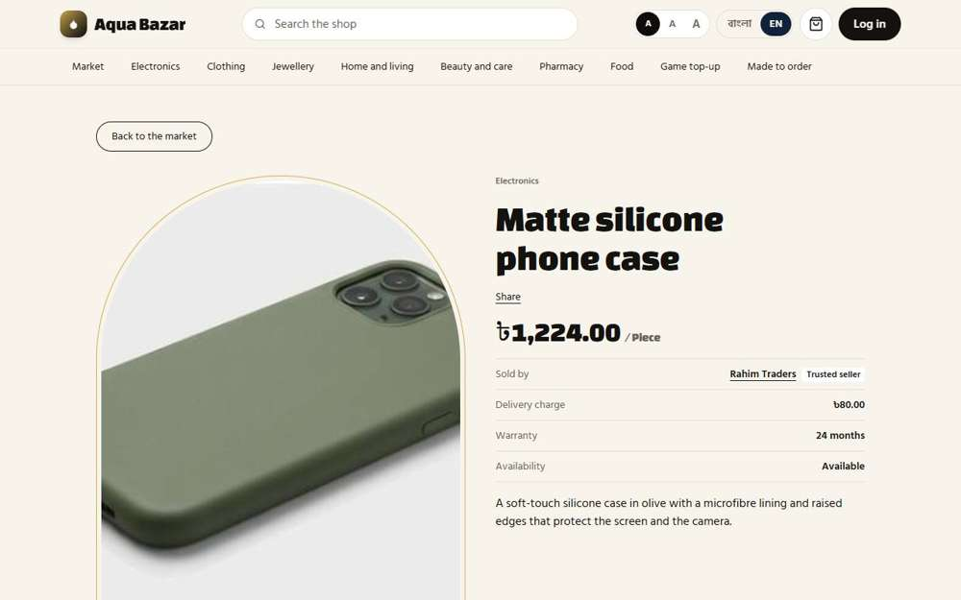  Seen as a stranger (not signed in) | /market/78 | 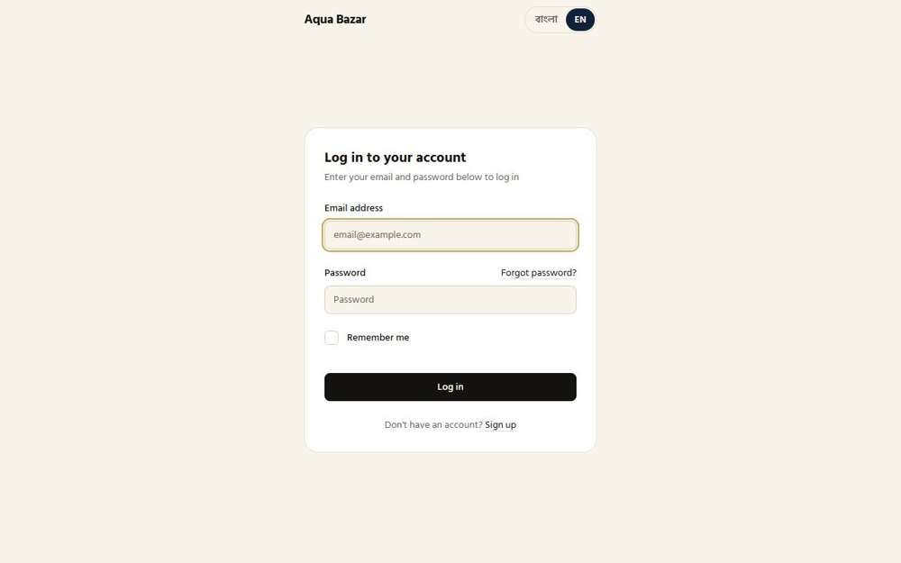  Seen as a stranger (not signed in) | /login
39. No permission → quietly to home Works
What it is for: If someone opens a page they have no permission for, they are quietly sent home with no scary error.
What the tester did: As an ordinary shopper, typed the addresses of three restricted pages.
What the tester saw:
- Yes. A shopper cannot open /wholesale (they were sent to /)
- Yes. A shopper gets no scary error page, just a quiet redirect
- Yes. A shopper cannot open /paikari (they were sent to /)
- Yes. A shopper gets no scary error page, just a quiet redirect
- Yes. A shopper cannot open /admin/stock (they were sent to /)
- Yes. A shopper gets no scary error page, just a quiet redirect
Step 1: Where the shopper ends up: back on an ordinary page, with no error message
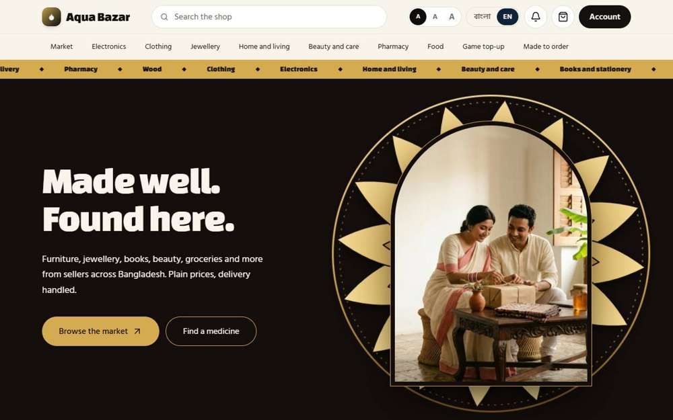
Seen as a signed-in shopper | /
40. Seller identity hidden Works
What it is for: Shoppers do not see who the seller is when the seller wants to stay private.
What the tester did: As a stranger, looked at who the seller of a product is, with the seller's own name switched off and then on.
What the tester saw:
- Yes. Switching changes who the shopper sees as the seller (off: "Siam's AquaTrusted seller", on: "Rahim TradersTrusted seller")
- Yes. With the switch off, the real seller's name is not shown (it showed "Siam's AquaTrusted seller")
Note: With the switch off the page said "Sold by Siam's AquaTrusted seller". With it on it said "Sold by Rahim TradersTrusted seller".
Step 1: The product page with the seller's own name switched off | Step 2: The product page with the seller's own name switched on
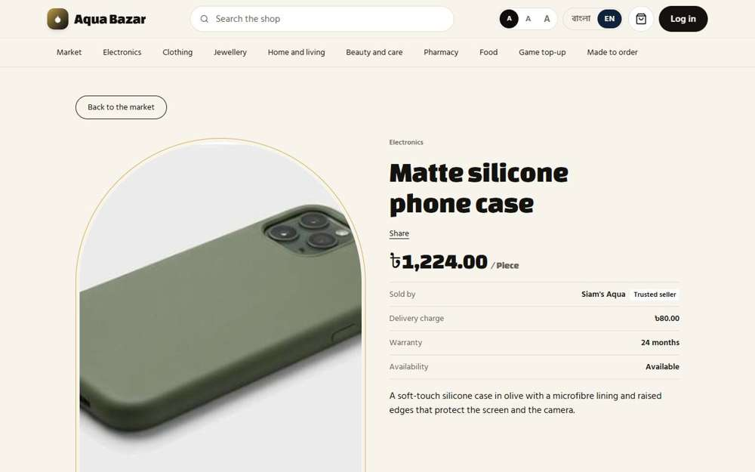  Seen as a stranger (not signed in) | /market/78 | Seen as a stranger (not signed in) | /market/78
41. Name display toggle Works
What it is for: The owner can switch seller names on or off on the public product pages.
What the tester did: Opened the owner's Market page and found the switch beside each product: "Show this seller's own name instead of ours".
What the tester saw:
- Yes. Each product has a switch for showing the seller's own name
Step 1: The switch on each product in the owner's Market page
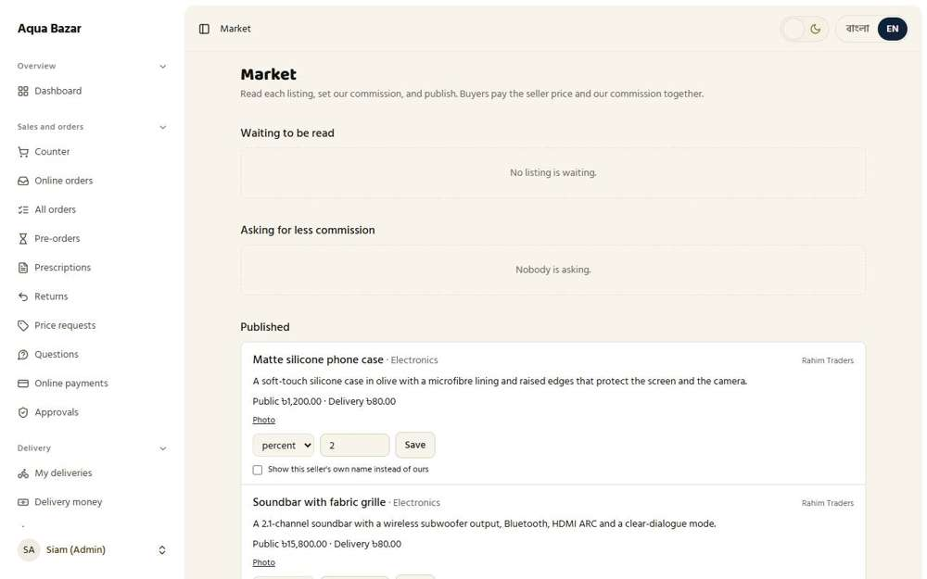
Seen as the owner | /admin/market
42. Staff don't see sales and profit Works
What it is for: Counter staff can sell, but cannot see how much profit the shop makes or how much stock costs.
What the tester did: Signed in as counter staff and tried to open the reports and the stock-value pages, and looked at the counter for profit figures.
What the tester saw:
- Yes. The counter shows no profit figures
- Yes. Staff cannot open /admin/reports
- Yes. Staff cannot open /admin/stock/reports
- Yes. Staff cannot see what stock cost the shop
Step 1: The counter, as staff see it | Step 2: Reports are closed to staff
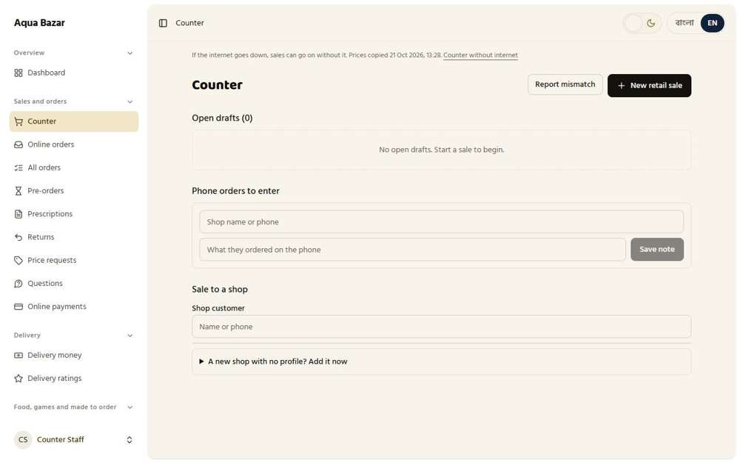  Seen as a staff member | /admin/counter | 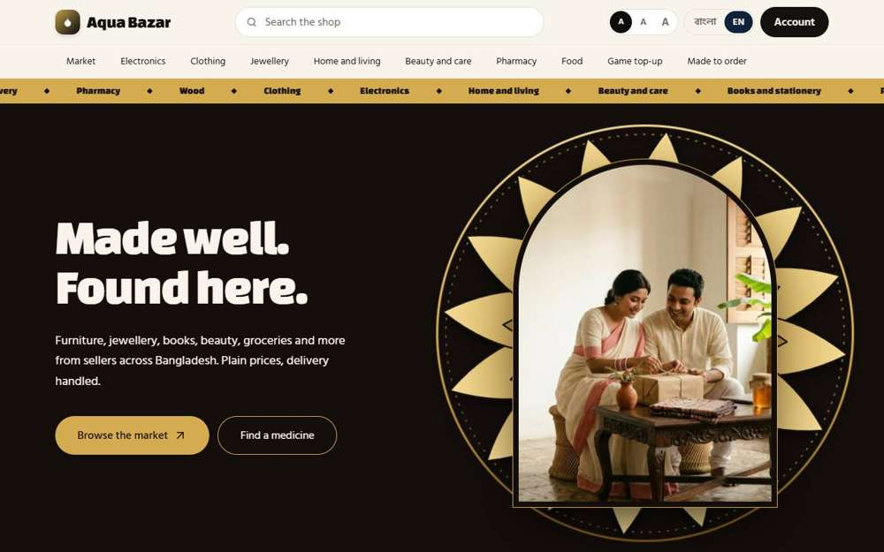  Seen as a staff member | /
Step 3: The stock page, as staff see it
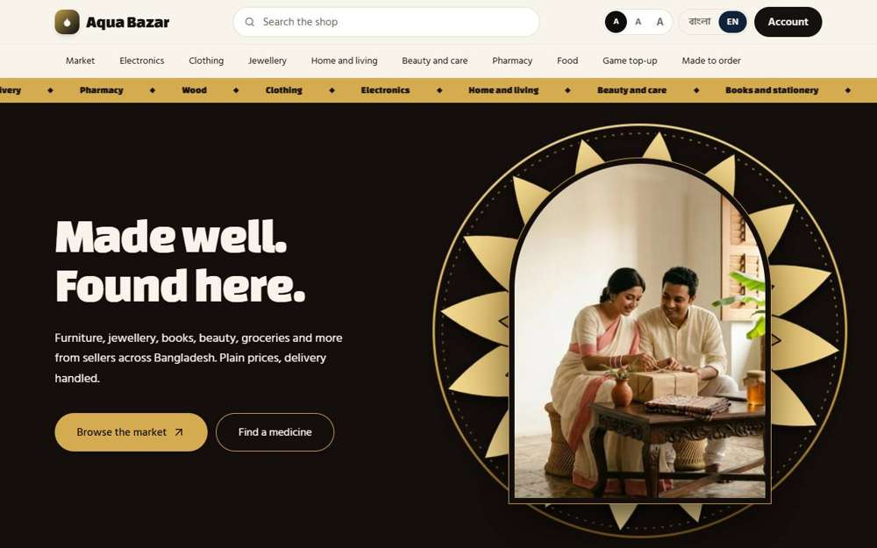
Seen as a staff member | /
43. Staff see loss warnings Works
What it is for: Staff are warned when a sale would lose money, so they do not make a mistake by accident.
What the tester did: The owner raised the discount staff may give from 5% to 50%. Then, as a staff member, a retail sale was started with a Special % of 40 on a box of Napa that cost 240 and is printed at 300.
What the tester saw:
- Yes. Staff are warned that the sale would lose money
Step 1: A box at 40% below the printed price, which is below cost
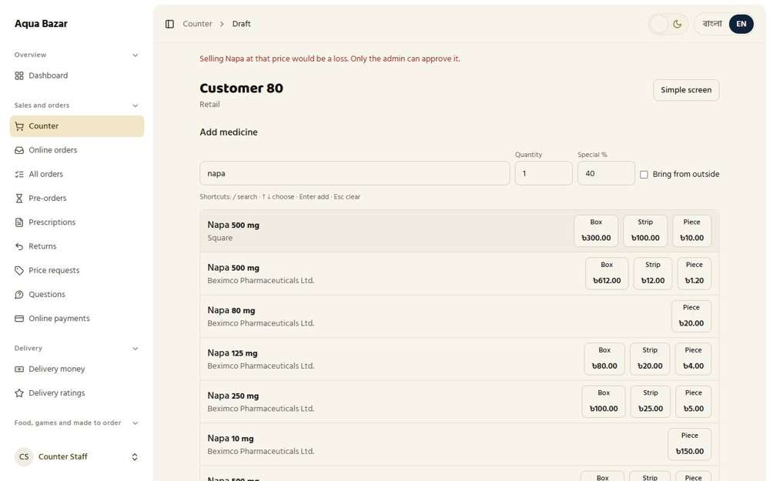
Seen as a staff member | /admin/counter/251
44. Craftsmen don't see price and profit Only partly shown
What it is for: Craftsmen see the job, not the price or profit of the order.
What the tester did: Signed in as a craftsman and looked at everything on their screen for prices or profit.
What the tester saw:
- Yes. The craftsman's screen shows no profit, margin or commission
Note: There was no job assigned in the test data, so the job list itself was empty. Prices on a real job were not shown.
Step 1: The craftsman's screen
Seen as a craftsman | /craftsman

Stock System
45. Draft sale vs complete sale Works
What it is for: A sale is first a draft, still open. It becomes a complete sale only when the goods are received.
What the tester did: Checked the stock of Napa 500 mg, started a sale at the counter and added a box (a draft), then finished the sale. Looked at the stock at each step.
What the tester saw:
- Yes. While the sale is still a draft, the box is already out of stock (27 became 26)
- Yes. The unfinished sale is listed as an open draft
- Yes. The finished sale shows a receipt
Step 1: Stock before the sale: 27 boxes | Step 2: A sale in progress: the box is on the draft
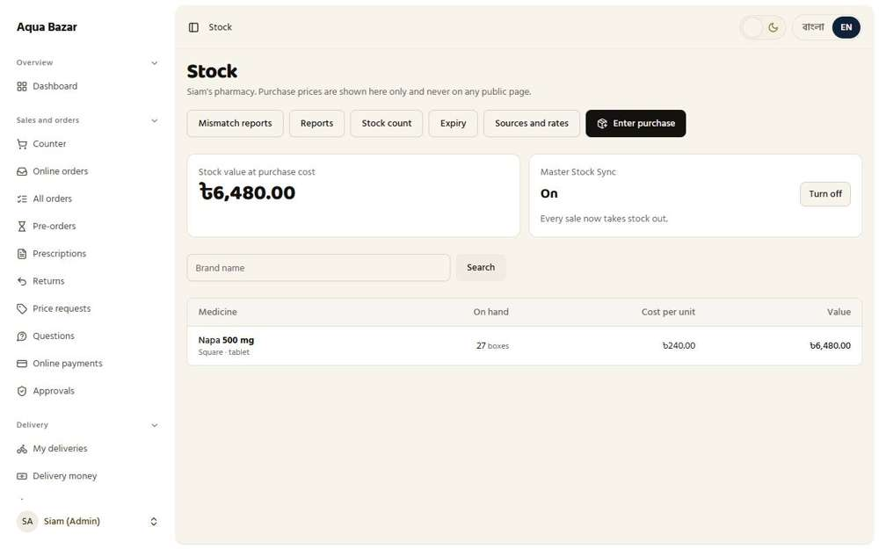  Seen as the owner | /admin/stock | 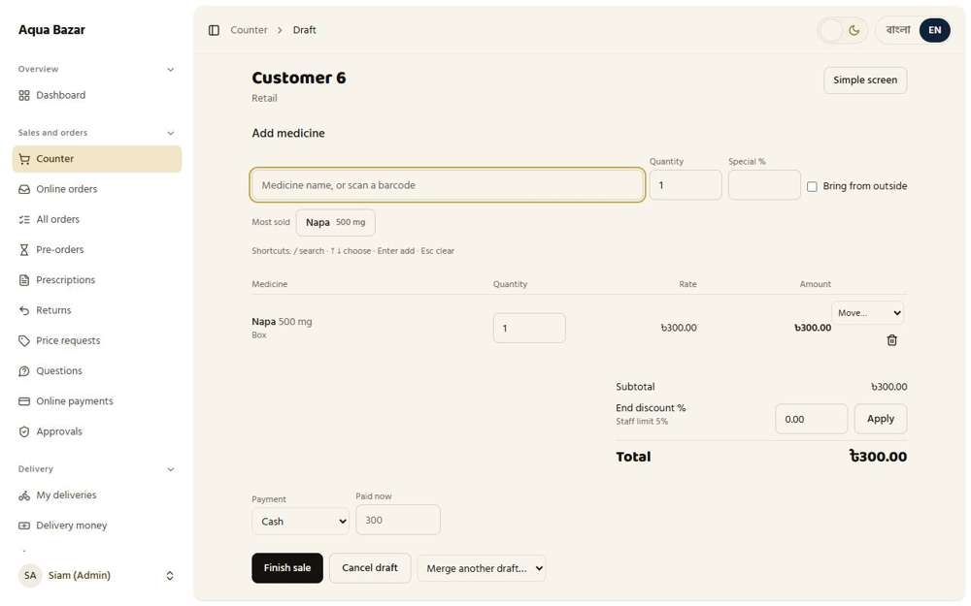  Seen as the owner | /admin/counter/128
Step 3: The counter lists the sale under "Open drafts" | Step 4: After pressing Finish sale
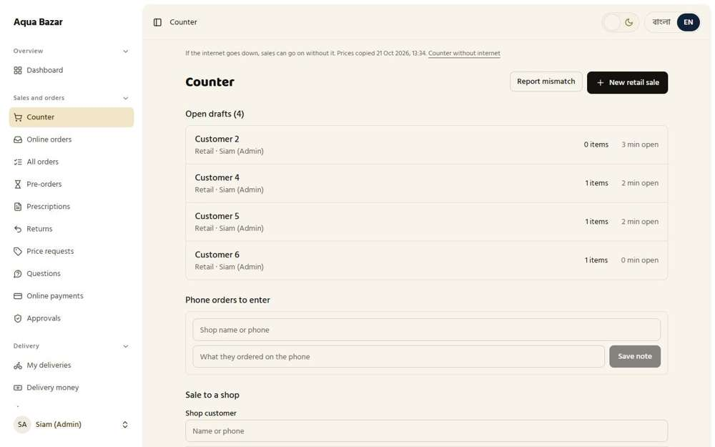  Seen as the owner | /admin/counter | 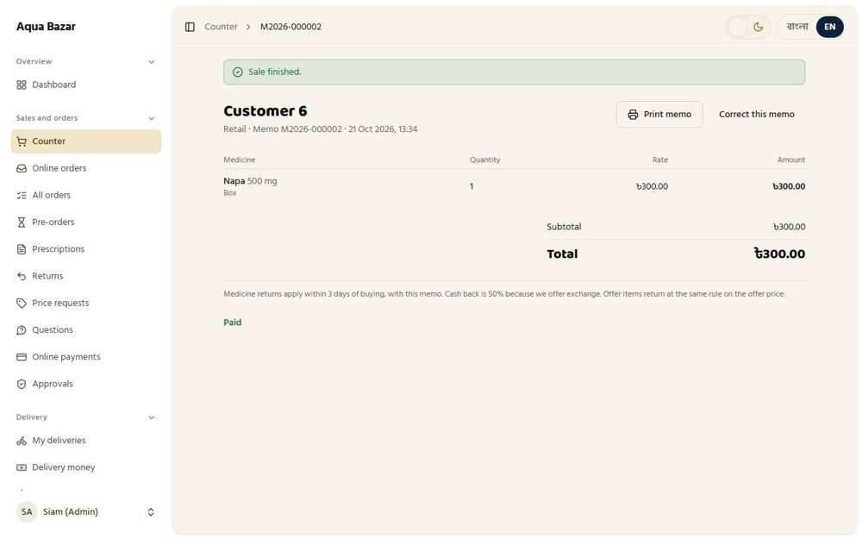  Seen as the owner | /admin/counter/128
46. Not received → returns to stock Works
What it is for: If the goods are not received, the items go back into stock automatically.
What the tester did: Started a sale, added a box, then cancelled the draft, and watched the stock go down and come back.
What the tester saw:
- Yes. The box left stock while on the draft (26 became 25)
- Yes. After the draft is cancelled the box is back in stock (26)
Step 1: The draft with its box, about to be cancelled | Step 2: After cancelling the draft
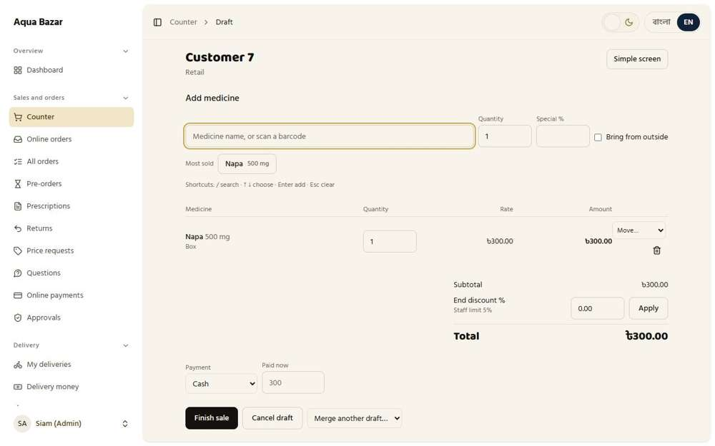  Seen as the owner | /admin/counter/129 | 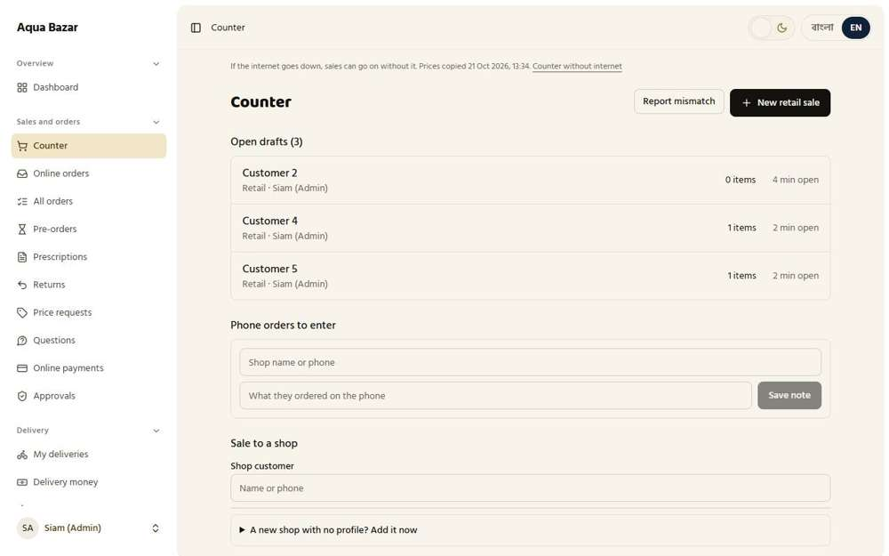  Seen as the owner | /admin/counter
47. Commission only on complete sales Works
What it is for: The shop's commission is charged only on completed sales, never on drafts.
What the tester did: Read the month's commission, then a buyer ordered a phone case and the seller accepted and sent it, and the commission was read again. Then the buyer pressed "Yes, I got it" and it was read a third time.
What the tester saw:
- Yes. An order that is only on its way is not counted (72 before, 72 after)
- Yes. Once the buyer has it, the commission is counted: 72 became 96 (2% of 1,200)
Step 1: Commission before the order: 72 | Step 2: Commission with the order on its way: 72
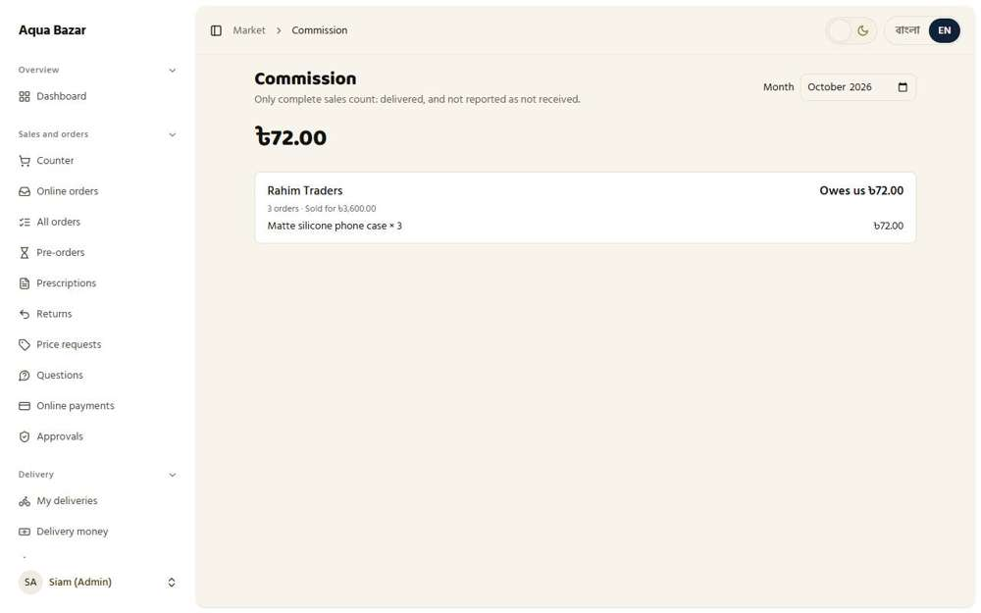  Seen as the owner | /admin/market/commissions | Seen as the owner | /admin/market/commissions
Step 3: Commission after delivery: 96
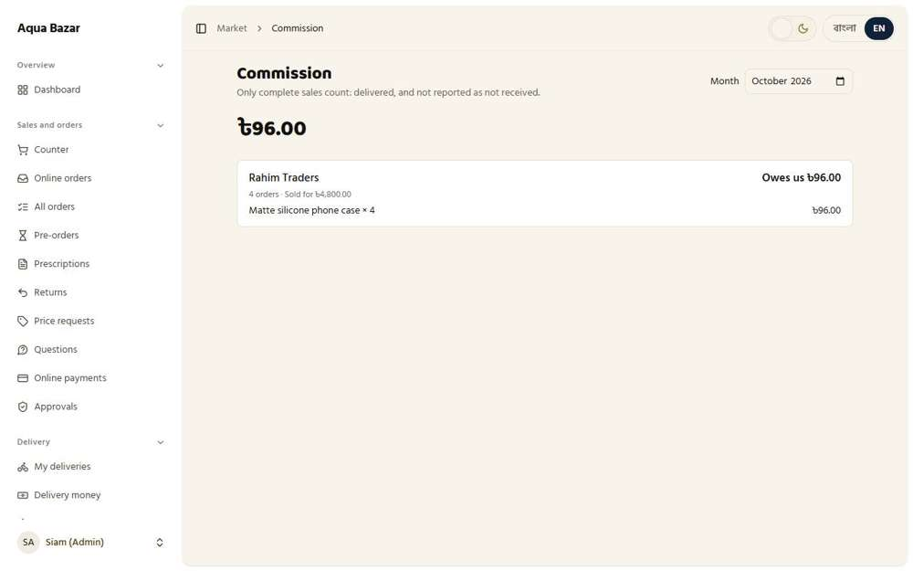
Seen as the owner | /admin/market/commissions
48. Reports count only complete sales Works
What it is for: Reports count only completed sales, so open drafts never inflate the numbers.
What the tester did: Read "Sales today" in the report, then started a retail sale with one box in it and read it again, then finished the sale and read it a third time.
What the tester saw:
- Yes. A sale that is only a draft is not counted (5977.5 before, 5977.5 with the draft open)
- Yes. Once finished the sale is counted: 5977.5 became 6277.5
Step 1: "Sales today" before: 5977.5 | Step 2: "Sales today" while the sale is only a draft: 5977.5
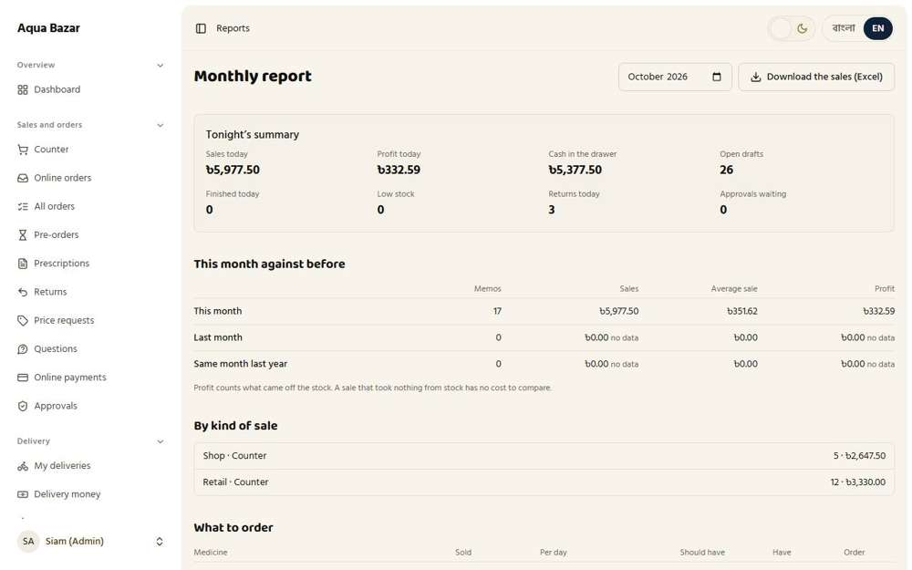  Seen as the owner | /admin/reports | 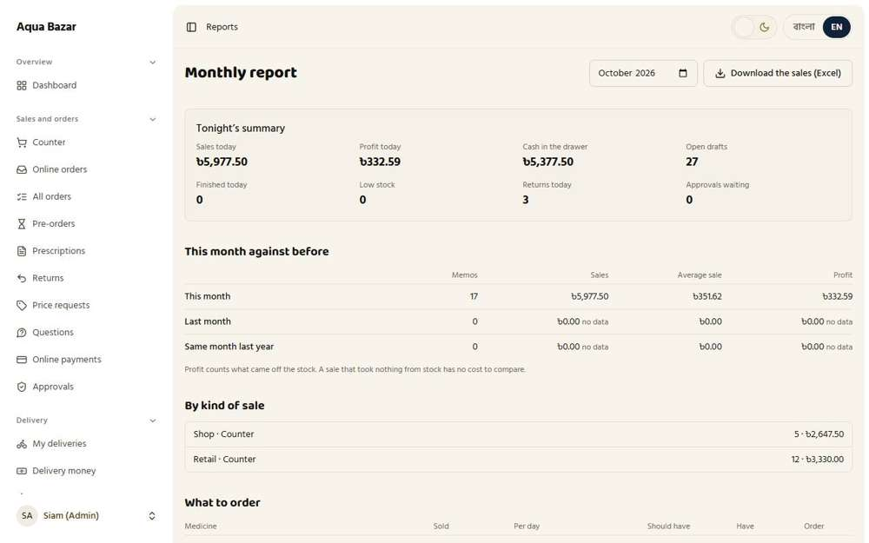  Seen as the owner | /admin/reports
Step 3: "Sales today" after the sale is finished: 6277.5
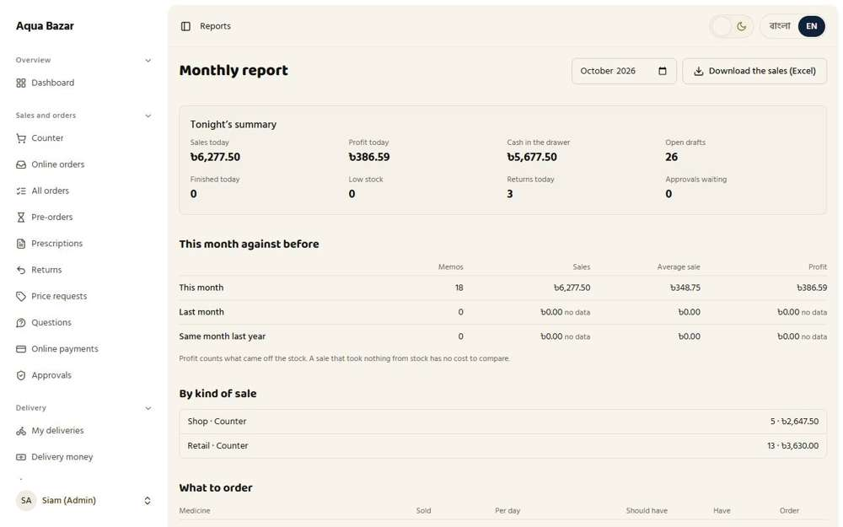
Seen as the owner | /admin/reports
49. Return window counted from receipt Only partly shown
What it is for: The window for returning an item starts on the day it is received, not the day it was ordered.
What the tester did: Opened the Returns screen, where the return window is counted.
Note: The return window starting from receipt is covered with the Returns features later in this report.
Step 1: Returns
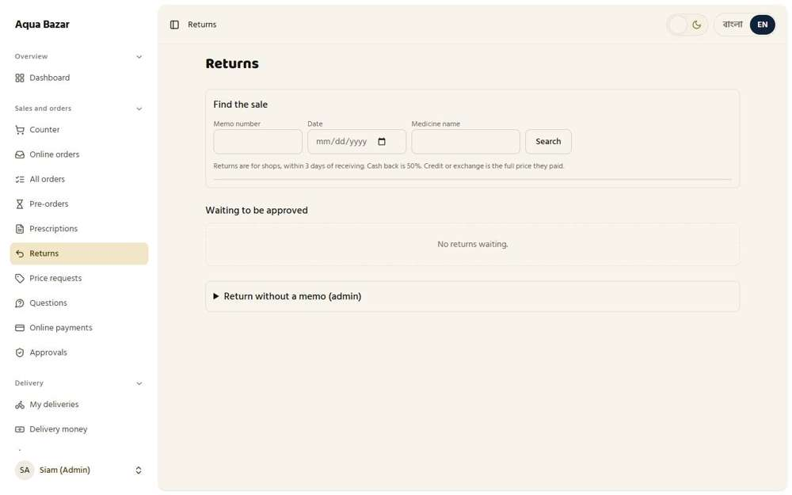
Seen as the owner | /admin/returns
50. Five kinds of draft kept separate Works
What it is for: The five kinds of draft (orders, invoices, stock entries and so on) are kept separate and never mixed up.
What the tester did: Looked at the screens that hold the different kinds of draft: counter drafts, stock-entry drafts and pre-orders.
What the tester saw:
- Yes. Pre-orders have their own screen, apart from counter drafts
Step 1: Counter drafts | Step 2: Stock-entry drafts (the "Save as draft" button)
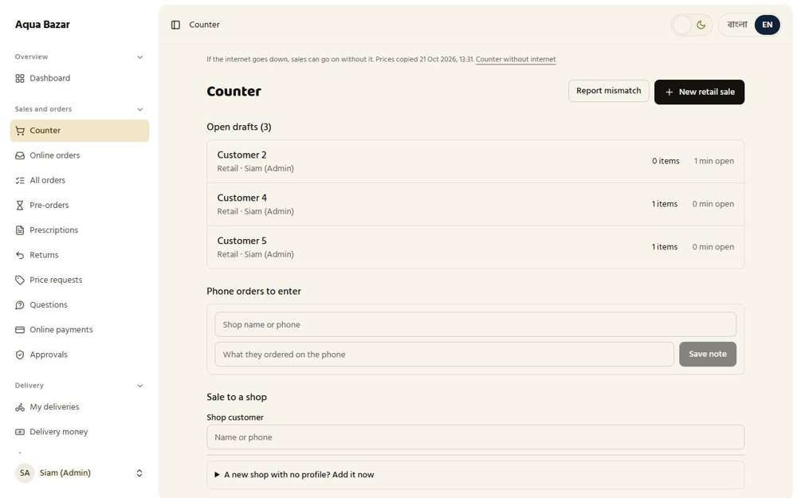  Seen as the owner | /admin/counter | 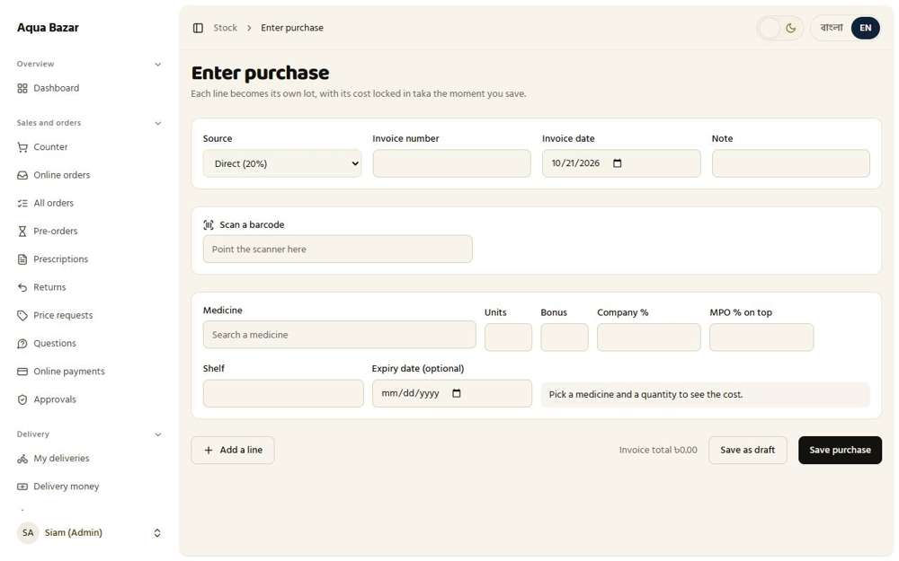  Seen as the owner | /admin/stock/receive
Step 3: Pre-orders
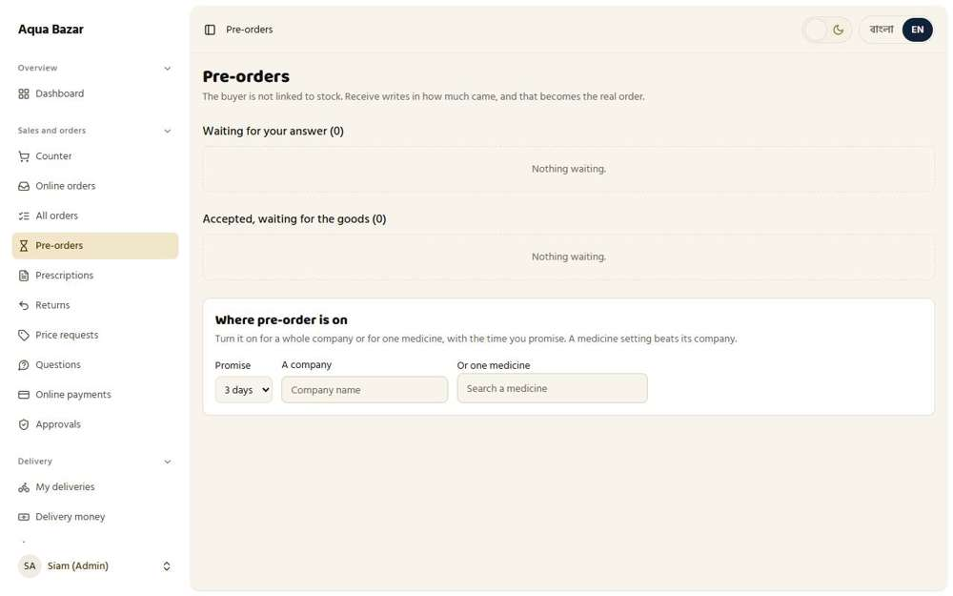
Seen as the owner | /admin/preorders
51. Master Stock Sync switch Works
What it is for: One master switch decides whether stock goes down on every sale or only on offers.
What the tester did: On the stock page, looked at the Master Stock Sync switch in its On position.
What the tester saw:
- Yes. The stock page has a Master Stock Sync switch
- Yes. When it is on, every sale takes stock out
- Yes. When it is off, only offer orders take stock out
Step 1: Master Stock Sync is on: every sale takes stock out | Step 2: Master Stock Sync is off: only offer orders take stock out
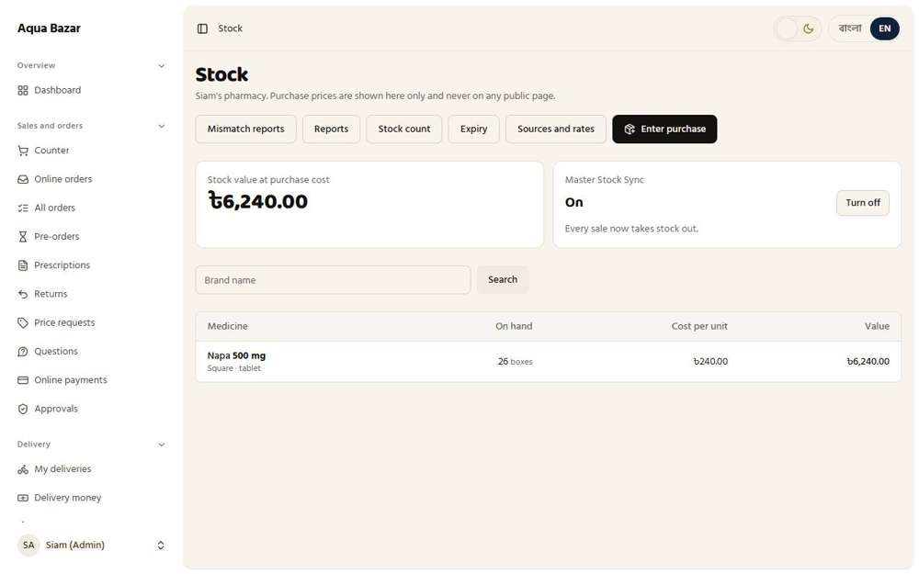  Seen as the owner | /admin/stock | 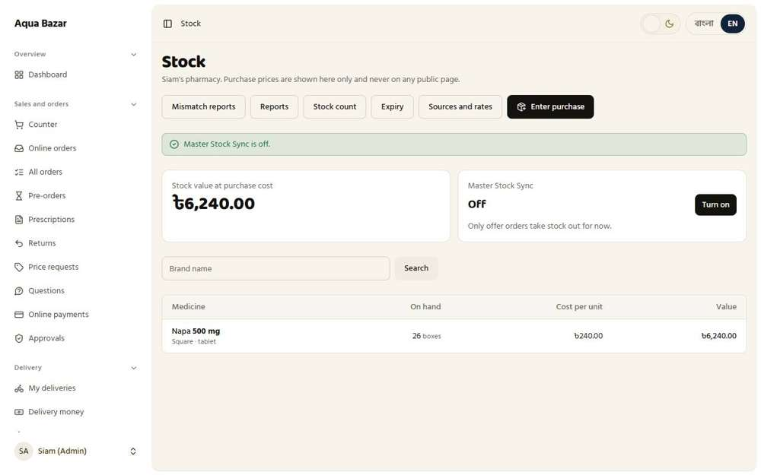  Seen as the owner | /admin/stock
52. Warning before turning the switch on Works
What it is for: Before the switch is turned on, a warning explains what will change.
What the tester did: With the switch off, pressed "Turn on" and read the pop-up that appeared before anything changed.
What the tester saw:
- Yes. Before turning the switch on, the screen warns the owner to enter all goods first
Note: The pop-up said: "Make sure all goods are entered first. Then Master Stock Sync will take paikari and retail sales out of stock too. Turn it on?"
Step 1: After agreeing to the warning, the switch is on
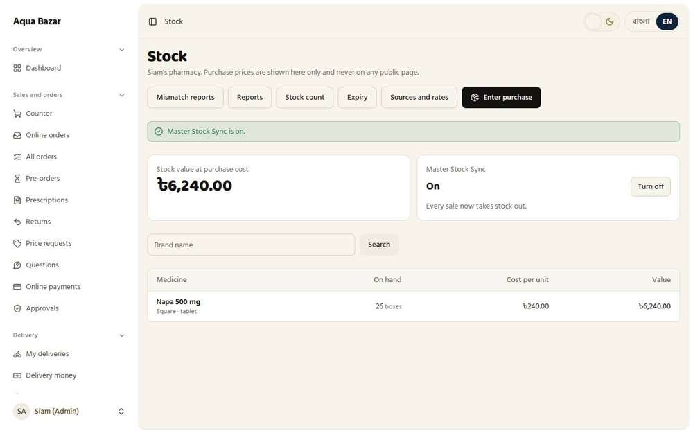
Seen as the owner | /admin/stock
53. Option to turn it off again Works
What it is for: The switch can be turned off again if needed.
What the tester did: Turned the switch off again from the stock page.
What the tester saw:
- Yes. The system confirms the switch is off
Step 1: The switch can be turned off again
Seen as the owner | /admin/stock
54. One single inventory Works
What it is for: The whole business uses one single stock list, not separate lists per screen.
What the tester did: Looked at the stock page and the medicine page to see one stock list used everywhere.
What the tester saw:
- Yes. The medicine page shows the same stock as lots
Step 1: The single stock list | Step 2: The same medicine's own stock page, with its lots
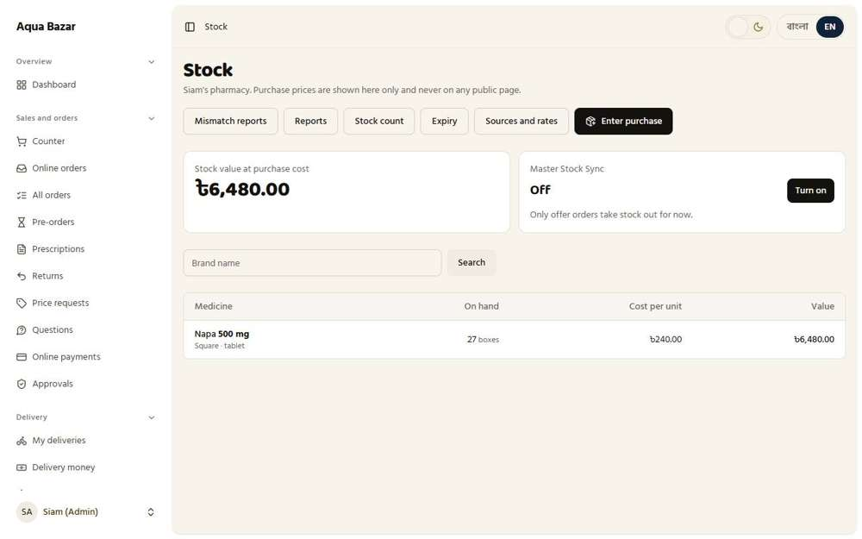  Seen as the owner | /admin/stock | 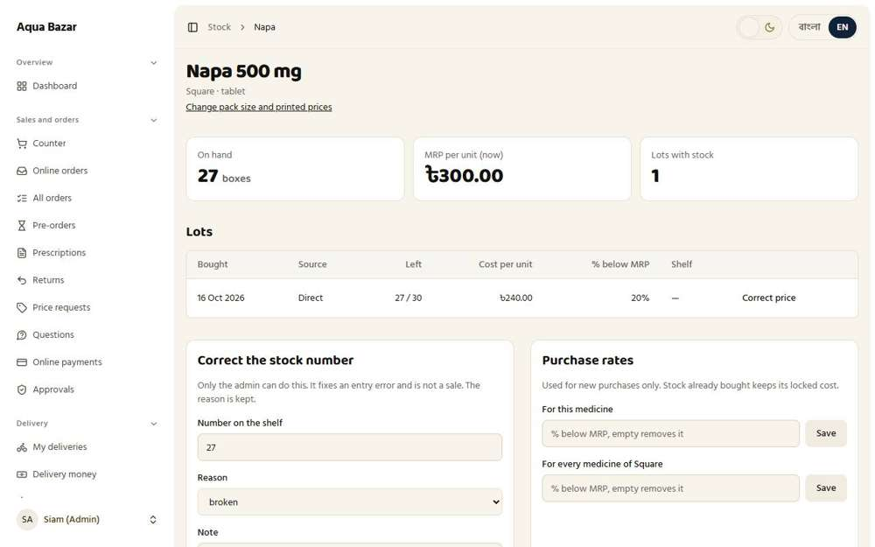  Seen as the owner | /admin/stock/medicines/1
55. Sync with PharmaTrack Only partly shown
What it is for: Stock sync with the PharmaTrack system is not finished. Entries are done on this site.
What the tester did: Looked for PharmaTrack sync.
Note: Syncing with PharmaTrack is not finished. Stock is entered on this site.
Step 1: The stock page: no PharmaTrack sync control
Seen as the owner | /admin/stock
56. Unlimited sources (mediums) Works
What it is for: The owner can add any number of buying sources, such as a company, an MPO or a shop.
What the tester did: Opened Sources and rates and added three new buying sources: a company, an MPO and a shop.
What the tester saw:
- Yes. The new company source is on the list
- Yes. The new MPO source is on the list
- Yes. The new shop source is on the list
Step 1: Sources and rates, before adding | Step 2: Four buying sources now: there is no fixed limit
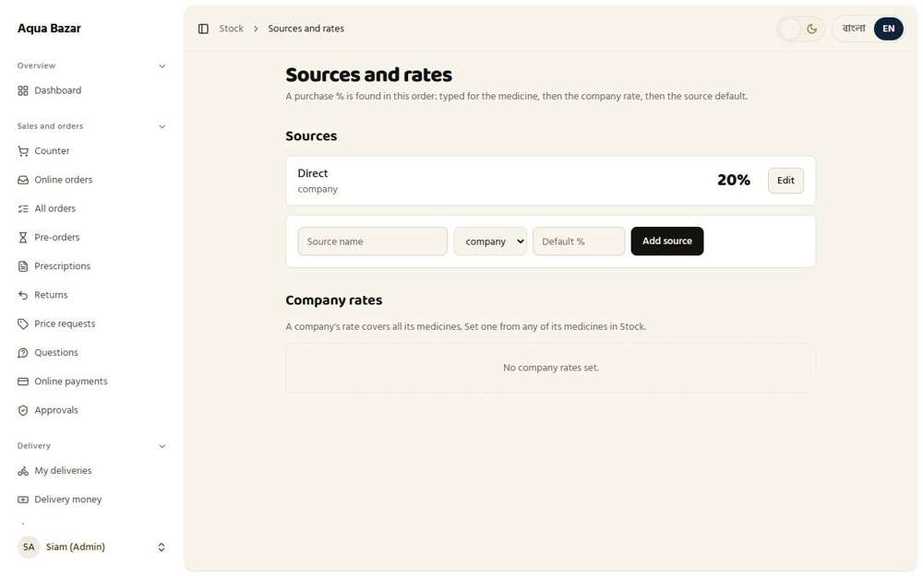  Seen as the owner | /admin/stock/sources | 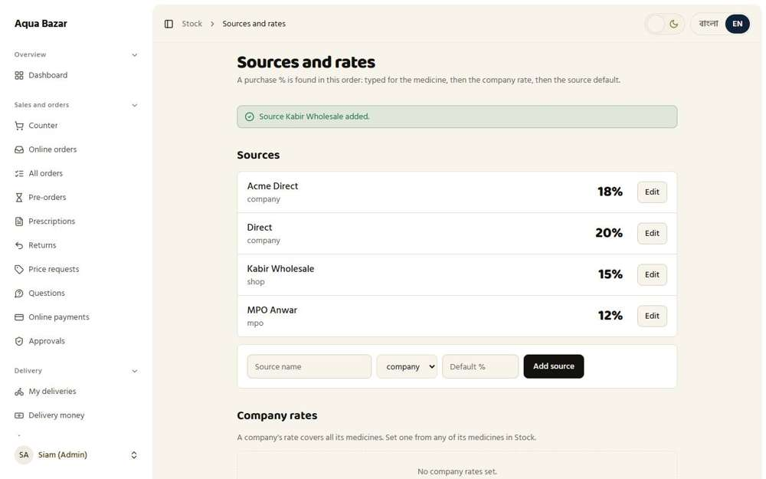  Seen as the owner | /admin/stock/sources
57. Default percentage per source Works
What it is for: Each source has a default percentage taken off the printed price when buying.
What the tester did: Looked at the list of sources to see each one's default percentage below the printed price.
What the tester saw:
- Yes. The company source shows its 18% default
- Yes. The MPO source shows its 12% default
- Yes. The shop source shows its 15% default
Step 1: Each source with its own default percentage
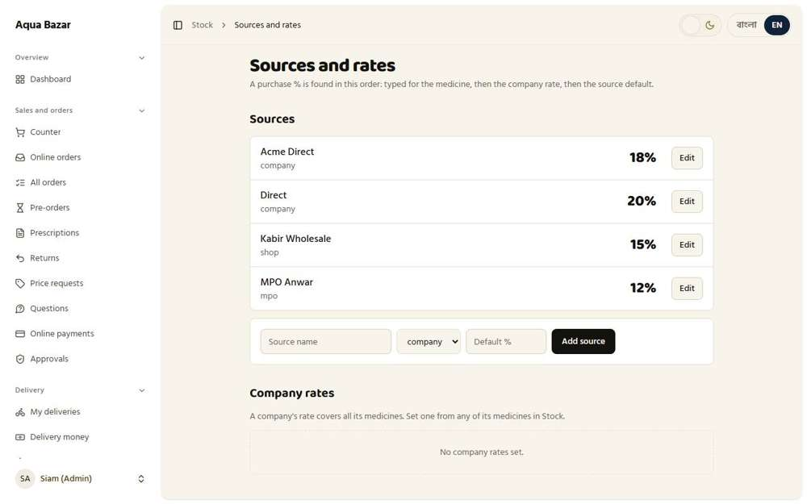
Seen as the owner | /admin/stock/sources
58. Three-layer rates (source/company/product) Works
What it is for: The buying percentage is picked in order: the medicine's own, then the company's, then the source's.
What the tester did: Entered a purchase using the source's default, then typed a percentage for the medicine itself and watched which one is used.
What the tester saw:
- Yes. The screen states the order: the medicine's own percentage, then the company's, then the source's
- Yes. The source default (20%) is used when nothing else is typed (saw 20%)
- Yes. A percentage typed on the line wins over the source default (saw 30%)
Step 1: The screen explains the order of the three layers | Step 2: With nothing typed, the source's 20% is used
Seen as the owner | /admin/stock/sources | 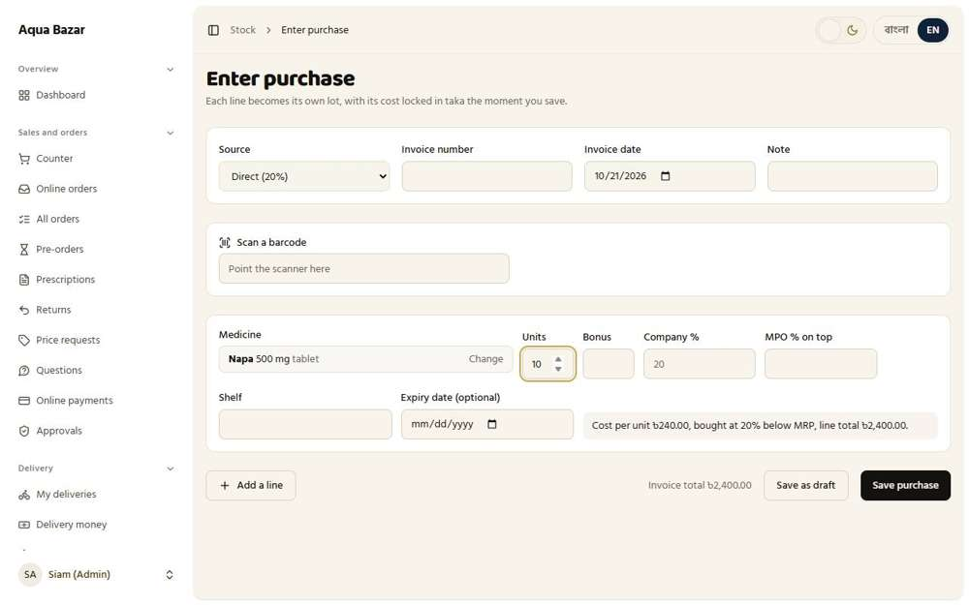  Seen as the owner | /admin/stock/receive
Step 3: With 30% typed on the line, 30% is used instead
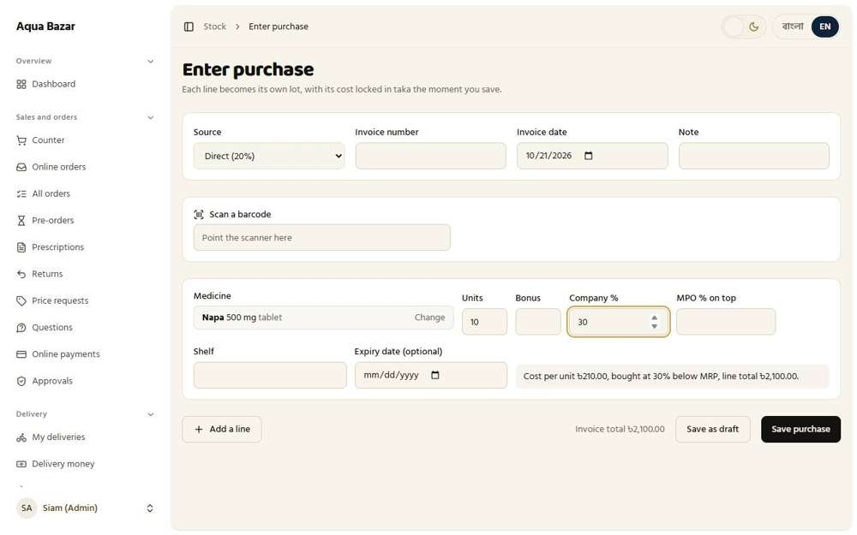
Seen as the owner | /admin/stock/receive
59. Cascading discount (company → MPO) Works
What it is for: Discounts can chain, for example the company's percentage and then the MPO's on top.
What the tester did: Typed a company percentage of 20 and an MPO percentage of 5 on top, to see them chain.
What the tester saw:
- Yes. The two discounts chain to 24% (20% off, then 5% off what is left), saw 24%
Step 1: 20% from the company, then 5% on top from the MPO
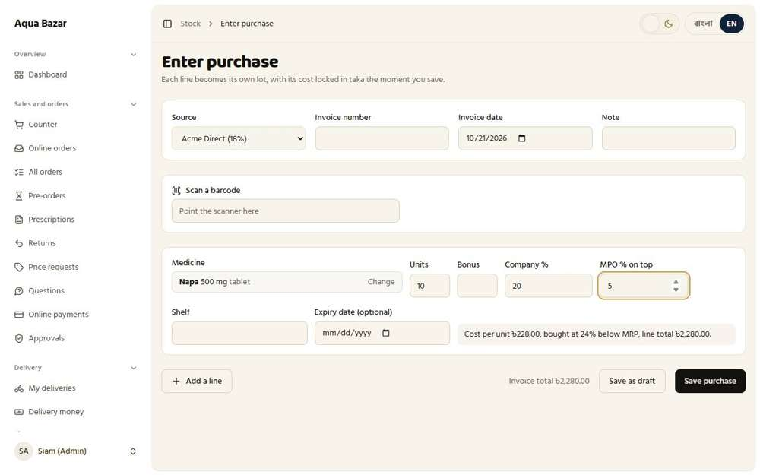
Seen as the owner | /admin/stock/receive
60. MPO percentage entered by hand Works
What it is for: The MPO's percentage is typed by hand when entering stock.
What the tester did: Looked at the "MPO % on top" box on the purchase line.
What the tester saw:
- Yes. There is a box for the MPO's percentage, typed by hand
- Yes. Typing 7% for the MPO changes the cost (saw 23.74% below the printed price)
Step 1: The MPO percentage typed by hand
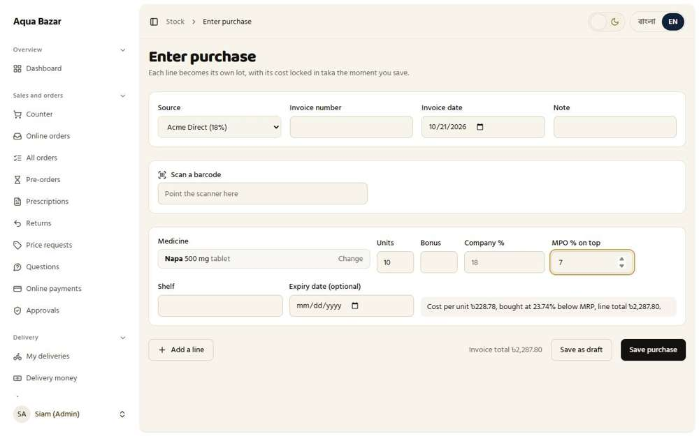
Seen as the owner | /admin/stock/receive
61. Show total purchase percentage Works
What it is for: The screen shows the total buying percentage so the owner sees the true cost.
What the tester did: Filled a purchase line and read the sentence under it.
What the tester saw:
- Yes. The line says the total percentage the goods were bought at, below the printed price
Step 1: The total purchase percentage is shown in words under the line
Seen as the owner | /admin/stock/receive
62. Per-box purchase price including bonus Works
What it is for: The cost per box includes any free bonus boxes, so the cost shown is the real one.
What the tester did: Bought 10 boxes with 2 free bonus boxes and read the cost per box.
What the tester saw:
- Yes. The cost per box counts the bonus (228 for 10 becomes 190 over 12), saw 190
- Yes. The line total is for the 10 paid boxes (2,280), saw 2280
Step 1: 10 boxes plus 2 free: the cost per box is spread over all 12
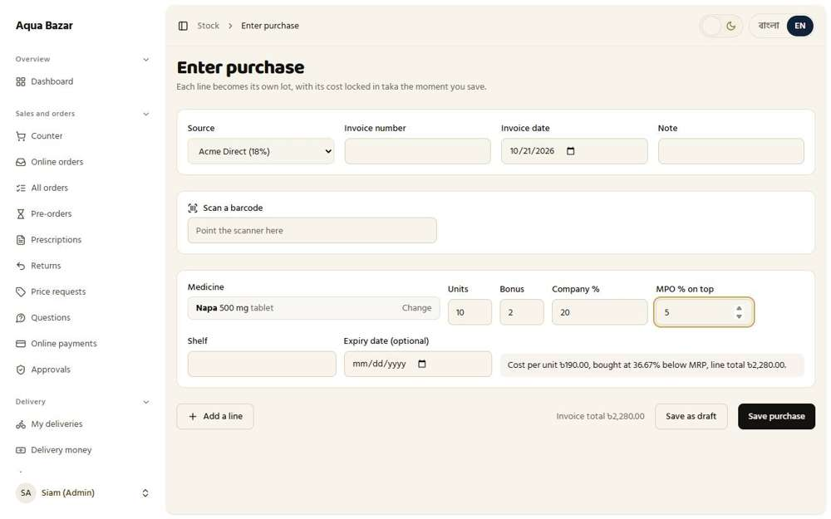
Seen as the owner | /admin/stock/receive
63. Bonus turned on manually Works
What it is for: Bonus boxes (such as buy 10 get 2 free) are switched on by hand when the stock is entered.
What the tester did: Looked at the Bonus box on the purchase line, which stays empty until the owner types a number.
What the tester saw:
- Yes. The Bonus box starts empty: a bonus only counts when the owner types one
Step 1: The Bonus box, empty until the owner turns it on by typing
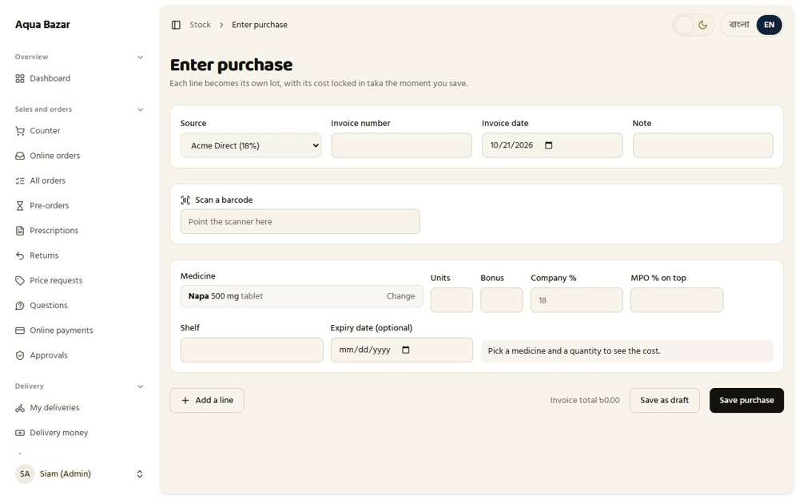
Seen as the owner | /admin/stock/receive
64. Medicine set up once, then only stock Works
What it is for: A medicine is set up once. After that, buying more only means adding stock.
What the tester did: Entered a second purchase of a medicine that already exists, to see what the screen asks.
What the tester saw:
- Yes. Nothing about pack sizes or printed prices is asked again
Step 1: Only quantities, percentages and dates are asked: the medicine is already set up
Seen as the owner | /admin/stock/receive
65. Purchase price locked in taka Works
What it is for: The buying price is saved in taka at entry, so later percentage changes do not rewrite history.
What the tester did: Saved a purchase at 20%, then changed the percentage for the medicine, then looked at the saved lot.
What the tester saw:
- Yes. The lot's cost is written down in taka (240 a box)
Note: The cost is stored as a taka amount, so a later change to any percentage cannot rewrite what was paid.
Step 1: A purchase of 10 boxes at 20%: cost 240 a box | Step 2: The saved lot shows its cost in taka
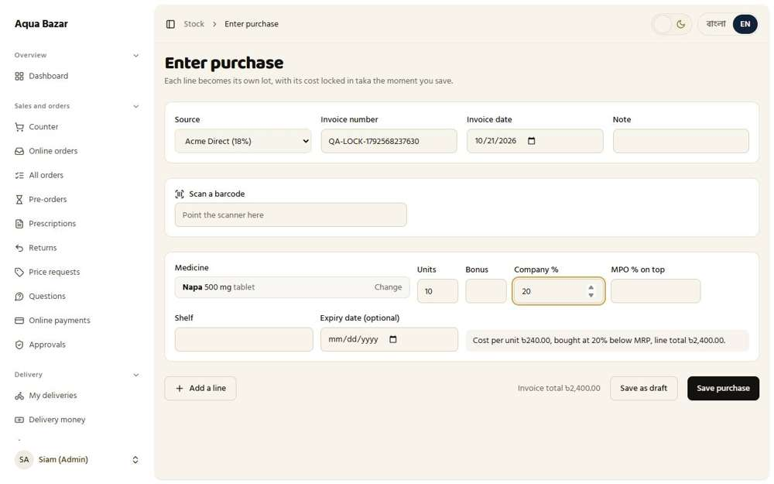  Seen as the owner | /admin/stock/receive | 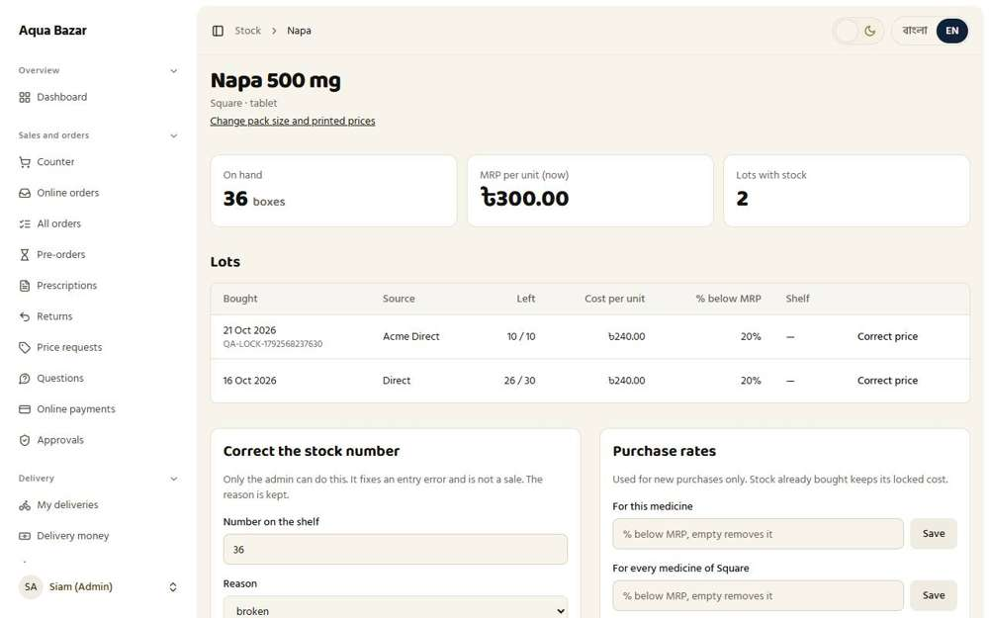  Seen as the owner | /admin/stock/medicines/1
66. Sales at the latest MRP Works
What it is for: Sales always use the latest printed price.
What the tester did: Raised the printed price of a box from 300 to 320, then added a box to a counter sale.
What the tester saw:
- Yes. A sale uses the latest printed price (320)
Step 1: The counter now offers the box at the new printed price
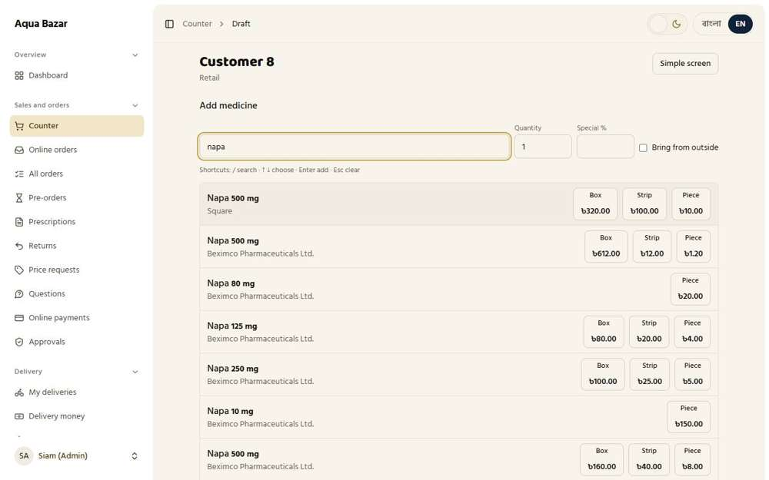
Seen as the owner | /admin/counter/130
67. One-month mark when MRP changes Works
What it is for: When the printed price changes, the system marks that stock for a month.
What the tester did: Changed the printed price and looked for a one-month marker on the medicine.
What the tester saw:
- Yes. The medicine page says the printed price changed, with the date and the old price (300)
Step 1: The medicine page after the printed price changed
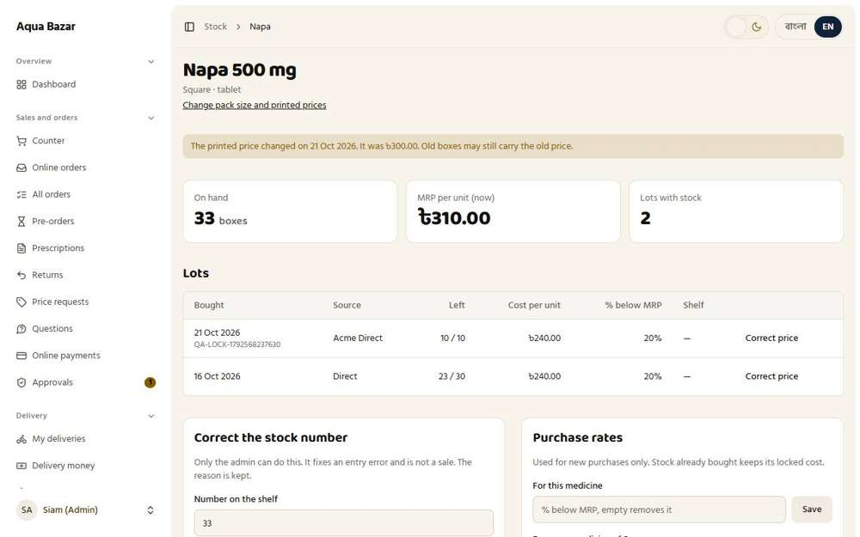
Seen as the owner | /admin/stock/medicines/1
68. Loss blocked when setting the rate Works
What it is for: The owner cannot set a selling rate that would lose money.
What the tester did: Tried to give a shop a price below what the medicine cost (25% off a box that cost 240 and is printed at 300).
What the tester saw:
- Yes. The rate is refused with "below what this medicine cost"
- Yes. The owner can still confirm on purpose, and the sale is flagged in reports
Step 1: The system stops the rate: it is below cost
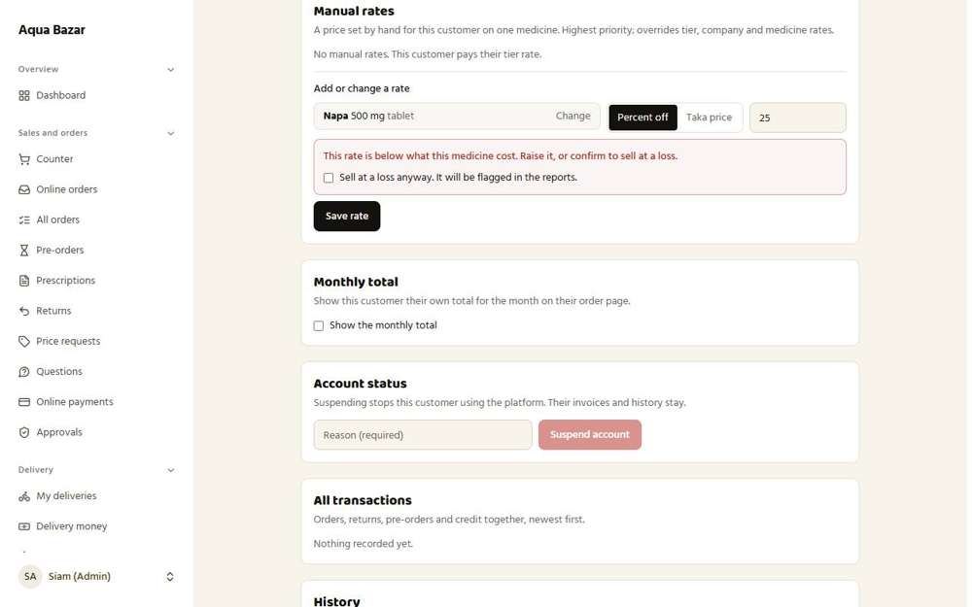
Seen as the owner | /admin/customers/4
69. Loss check on all rates (including retail end discount) Works
What it is for: The loss check covers every rate, including the retail end discount.
What the tester did: At the counter, as the owner, gave a retail sale a 30% end discount (the box cost 240 and sells at 300, so 30% off means selling at 210), then pressed Finish sale.
What the tester saw:
- Yes. Before finishing, the owner is warned that the sale is below cost, and by how much
- Yes. The owner is allowed to go on, because only the owner may sell at a loss
Note: Staff are held back (see feature 43). The loss the owner chose is counted in the reports (see feature 75).
Step 1: A 30% end discount: the total falls to 210, below the box's cost of 240 | Step 2: The owner may still finish it: only the owner can sell at a loss
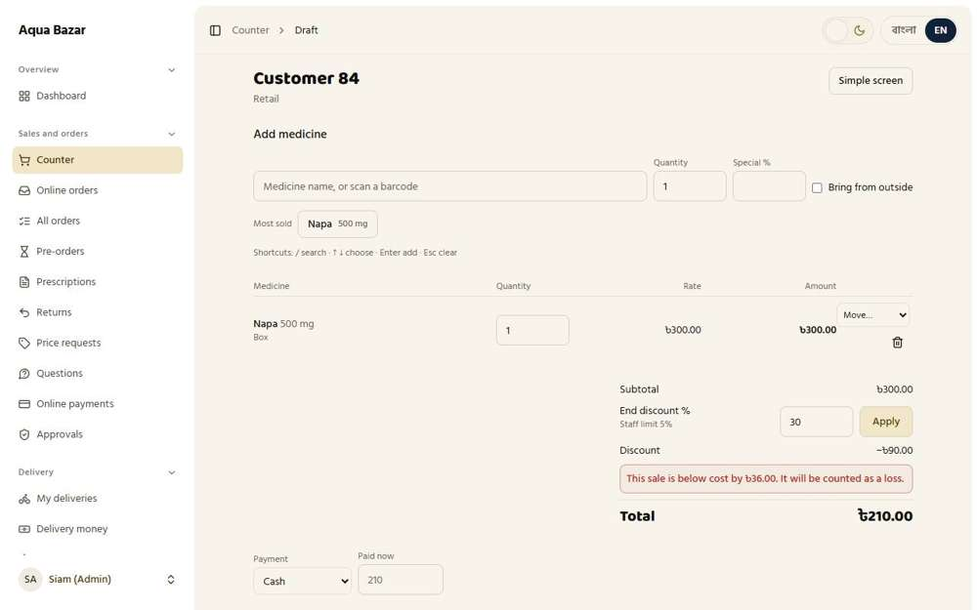  Seen as the owner | /admin/counter/257 | 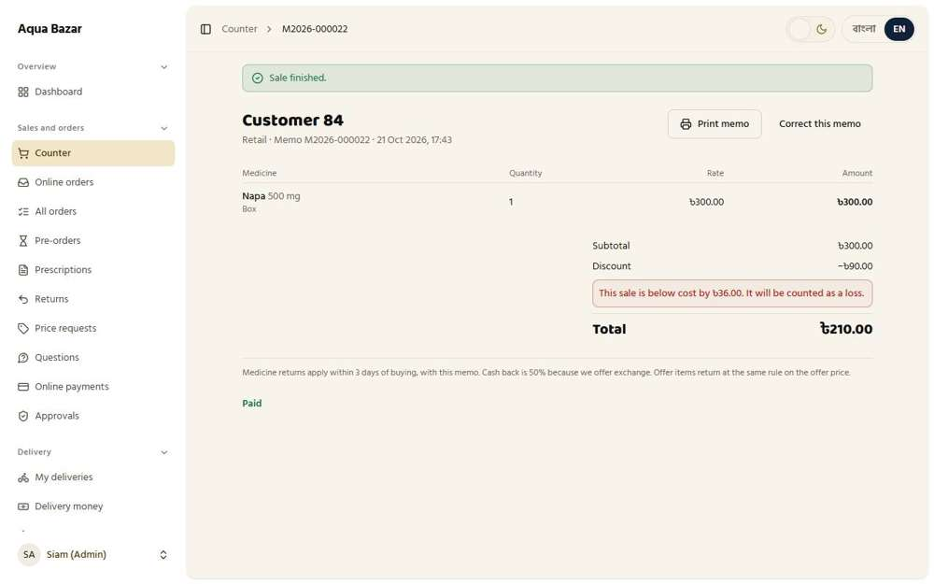  Seen as the owner | /admin/counter/257
70. Staff cannot sell at a loss Works
What it is for: Staff cannot sell below cost. The counter simply blocks it.
What the tester did: Signed in as counter staff and gave a retail sale a 30% end discount, far above their 5% limit.
What the tester saw:
- Yes. The Apply button turns into "Need admin approval"
- Yes. The discount is not applied: the total stays at 300 and no discount line appears
Step 1: Staff type 30%: the button changes to "Need admin approval" and the total stays at 300
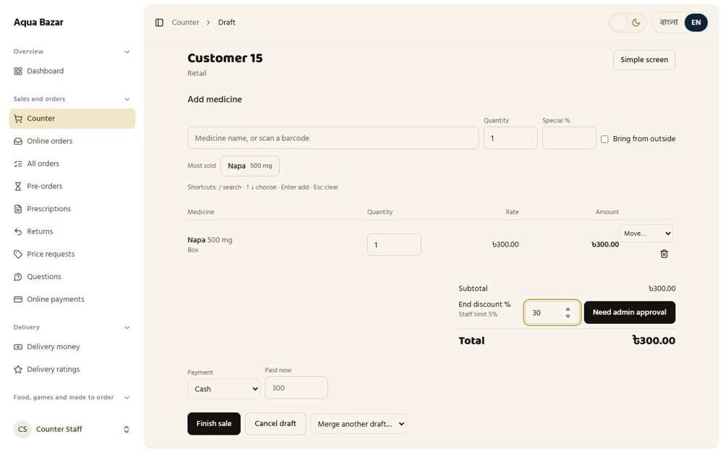
Seen as a staff member | /admin/counter/137
71. Admin notified when staff try Works
What it is for: When staff try to sell at a loss, the owner is notified.
What the tester did: Opened the Approvals and Activity pages to see whether the owner was told about the staff attempt.
What the tester saw:
- Yes. The staff attempt shows up for the owner
Step 1: Approvals waiting for the owner | Step 2: The activity log
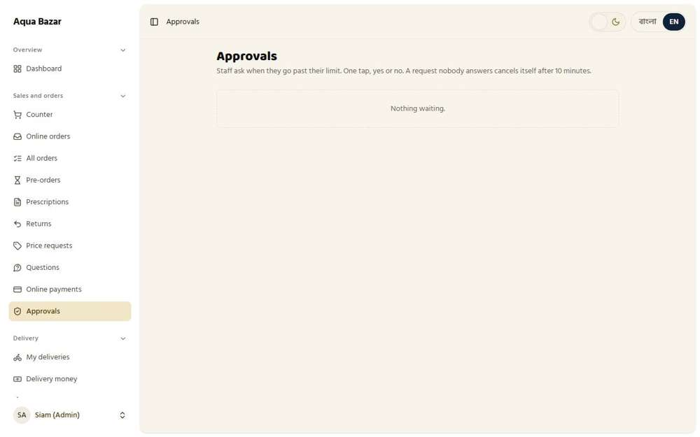  Seen as the owner | /admin/approvals | 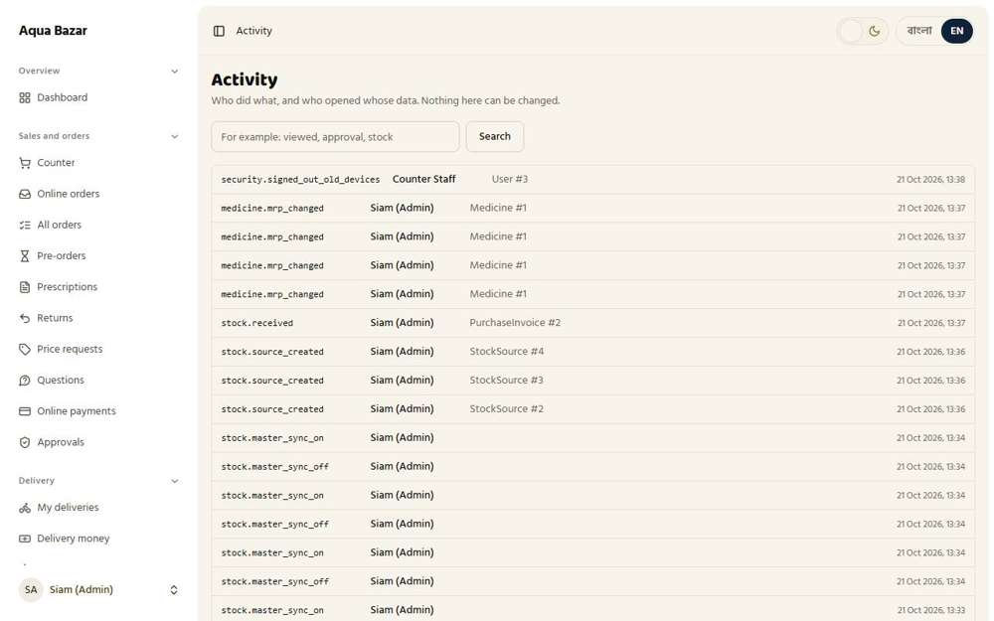  Seen as the owner | /admin/activity
72. "Need admin approval" with time limit Works
What it is for: If a discount is above what a staff role is allowed, it waits for the owner's approval within a time limit.
What the tester did: As staff, typed a 10% discount (their limit is 5%), pressed "Need admin approval", and then looked at the owner's Approvals page.
What the tester saw:
- Yes. The screen says the request is waiting for the owner
- Yes. The owner sees the 10% discount request
Step 1: After asking: the request is waiting for the owner | Step 2: The owner's Approvals page lists the request
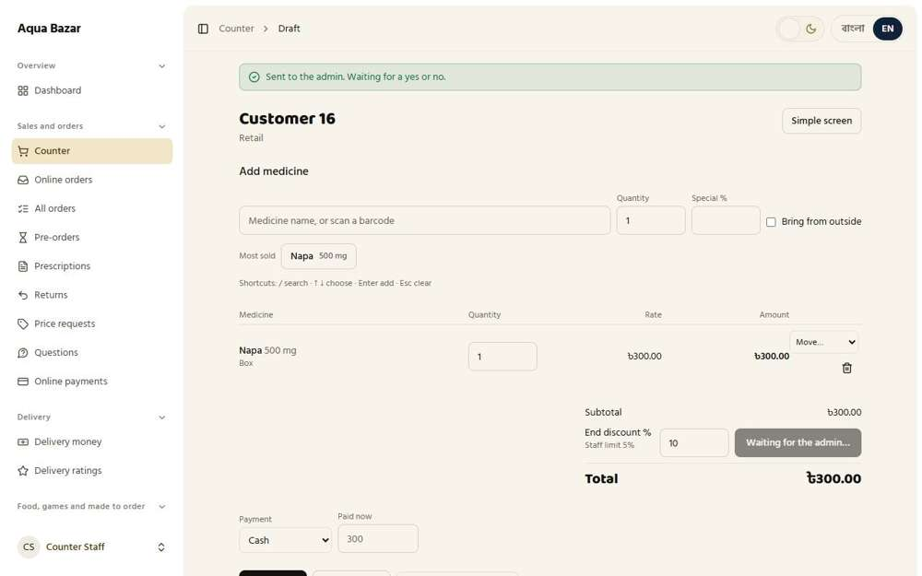  Seen as a staff member | /admin/counter/138 | 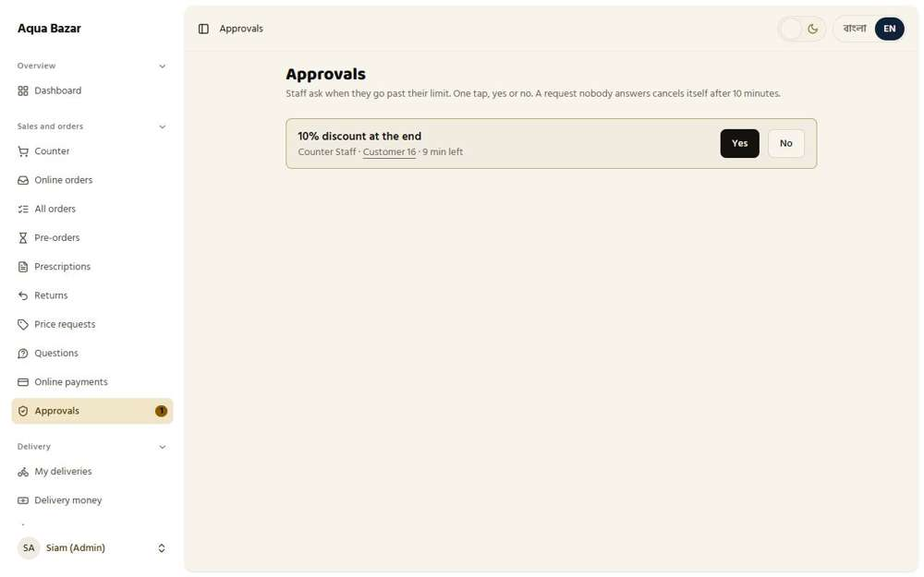  Seen as the owner | /admin/approvals
73. Invoice loss → separate % only on those items Works
What it is for: If one invoice must go at a loss, a separate percentage can apply to only those items.
What the tester did: Looked at the counter for a way to apply a loss percentage to only some items on an invoice.
What the tester saw:
- Yes. There is a "Special %" box that applies to one item at a time
Step 1: The counter draft: "Special %" sits on each item
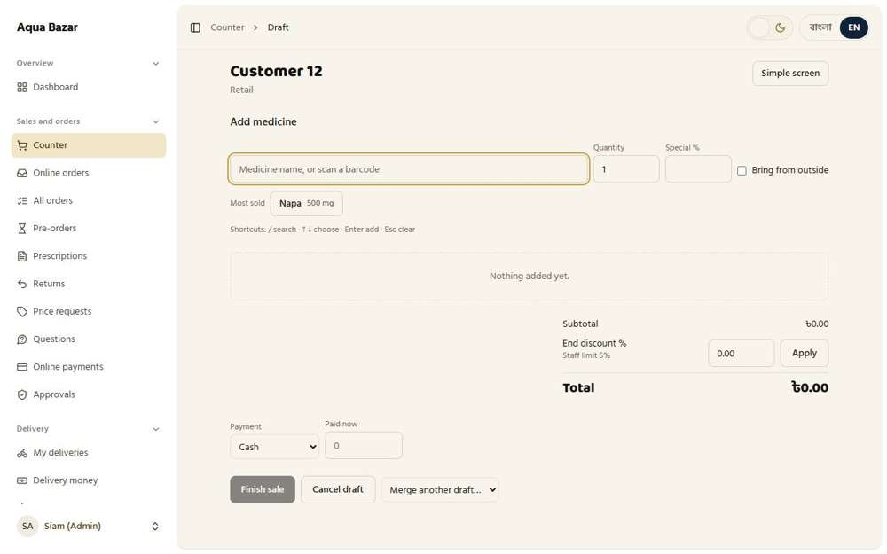
Seen as the owner | /admin/counter/134
74. Staff discount limit per role (above it needs admin approval) Works
What it is for: Each staff role has a discount limit. Above it, the owner must approve.
What the tester did: Opened the Staff page and looked at the box for each staff member's own discount limit.
What the tester saw:
- Yes. Each staff member has a discount limit box ("Limit %")
Note: Above the limit, staff cannot apply the discount themselves. They must ask the owner (see feature 72).
Step 1: Each staff member has a "Limit %" box
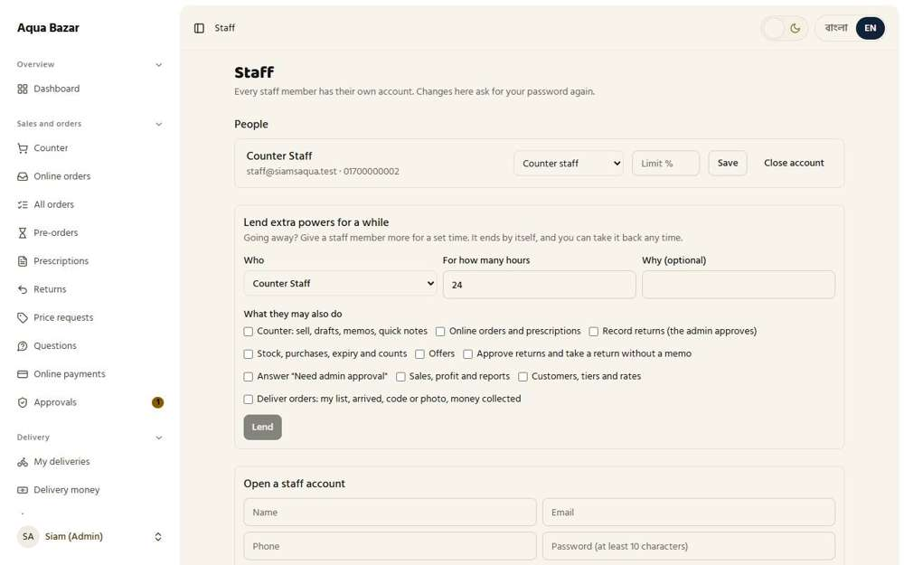
Seen as the owner | /admin/staff
75. Forced loss sale counted as loss Works
What it is for: A sale forced through at a loss is counted as a loss in the reports.
What the tester did: Looked in the reports for the sale the owner made at a loss earlier (a box sold at 210 that cost 240).
What the tester saw:
- Yes. A sale forced through at a loss is counted as a loss in the reports
Step 1: The monthly report | Step 2: The stock profit report
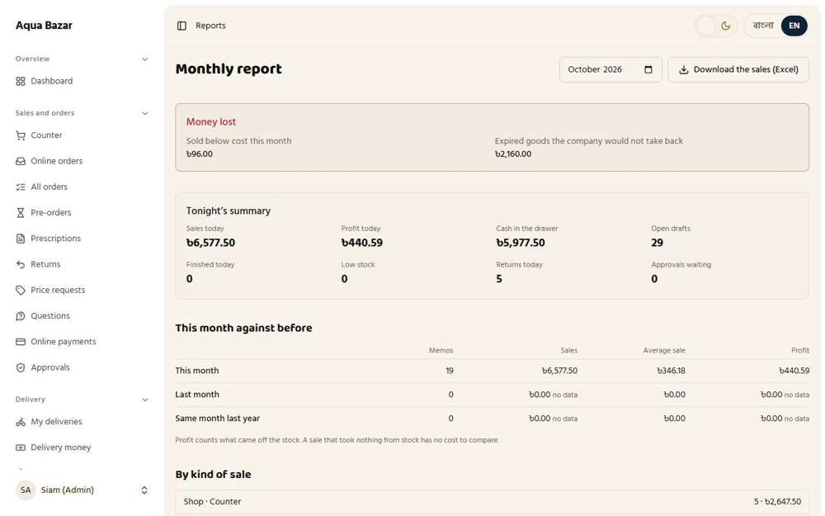  Seen as the owner | /admin/reports | 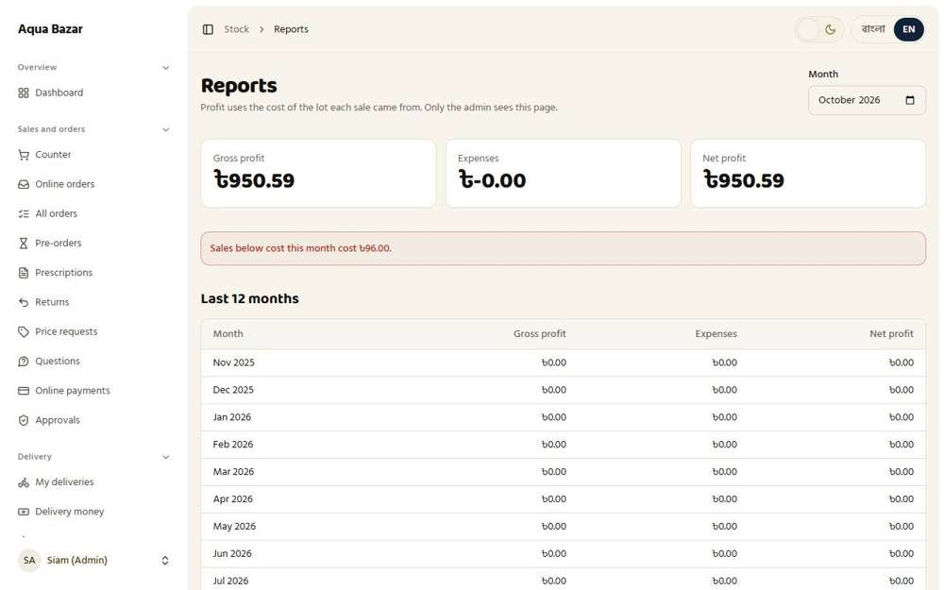  Seen as the owner | /admin/stock/reports
76. Deduct from a lot that leaves profit Works
What it is for: Stock is taken from the batch (lot) that still leaves a profit.
What the tester did: Bought an older, dearer lot of 5 boxes (cost 285 each), then sold a box with a 10% special price (270). A lot costing 285 would lose money at 270, so the system should take the box from a cheaper lot.
What the tester saw:
- Yes. The dear lot (285) was left alone because selling from it at 270 would lose money (it still has 5 of 5)
Step 1: An older lot bought at only 5% off: cost 285 a box | Step 2: Lots before the sale
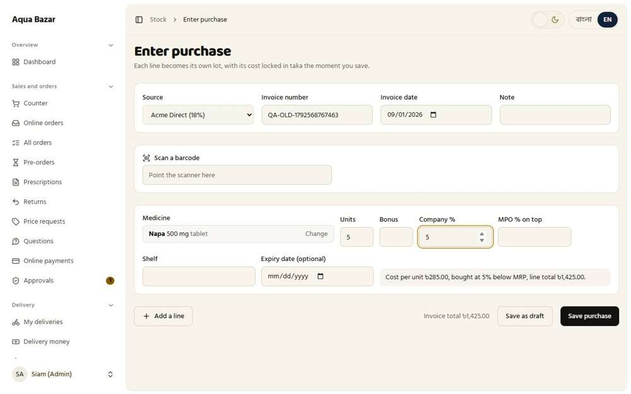  Seen as the owner | /admin/stock/receive | 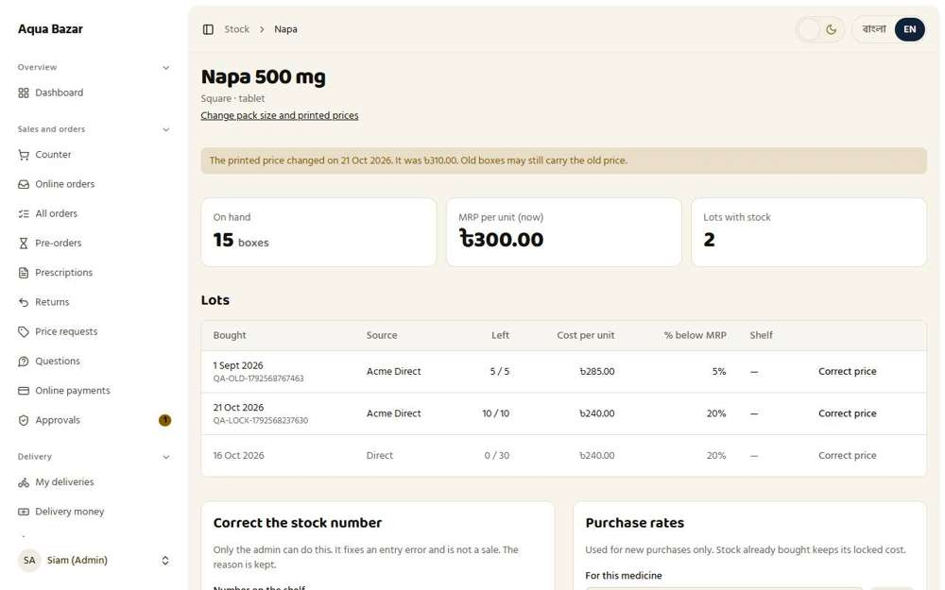  Seen as the owner | /admin/stock/medicines/1
Step 3: Lots after selling one box at a 10% special price
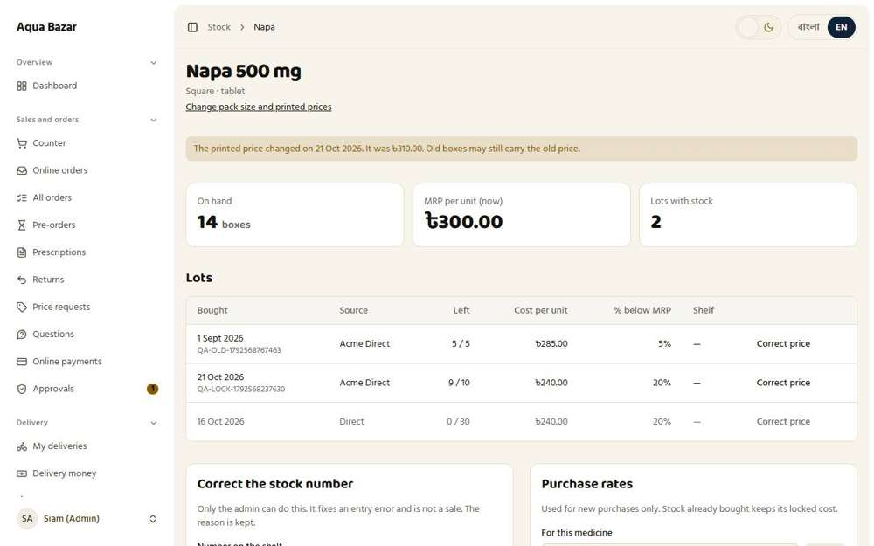
Seen as the owner | /admin/stock/medicines/1
77. Stagnant stock detection Works
What it is for: The system finds stock that has sat unsold for too long.
What the tester did: Opened the Expiry page to see which goods have been sitting still.
What the tester saw:
- Yes. The page says only slow-moving goods are a risk
- Yes. There is a "Needs checking" list for slow stock
Step 1: The Expiry page: goods that sit still are the risk
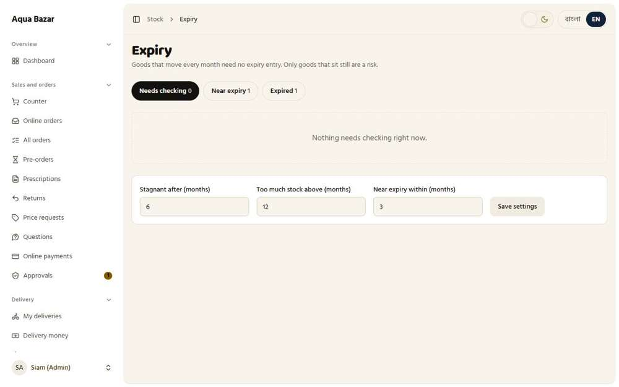
Seen as the owner | /admin/stock/expiry
78. "Months of stock" calculation Works
What it is for: It also works out how many months of stock are on the shelf.
What the tester did: Looked for the "months of stock" figure next to slow-moving goods.
What the tester saw:
- Yes. Each slow item says how many months of stock it is at the current pace of selling
Step 1: "... months of stock at the current pace"
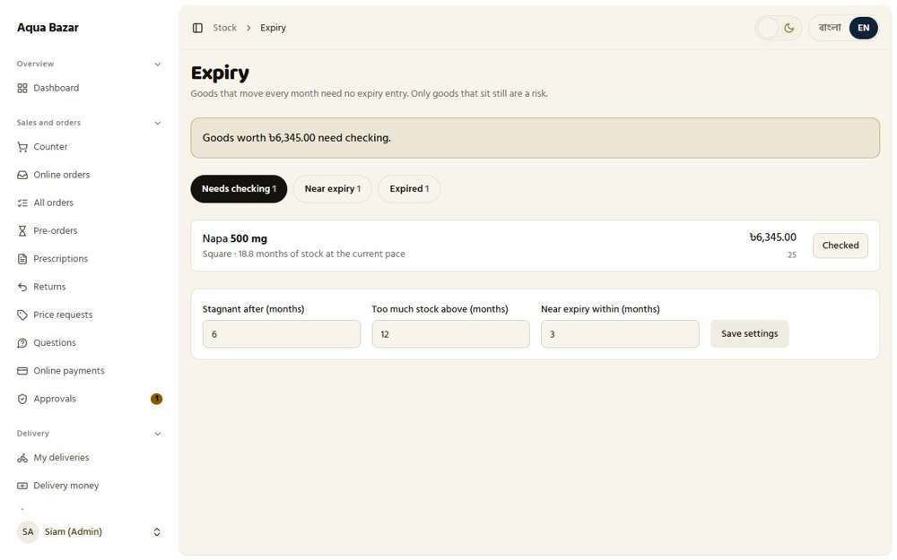
Seen as the owner | /admin/stock/expiry
79. Thresholds changeable in settings Works
What it is for: The limits used to flag slow stock can be changed in settings.
What the tester did: Changed "Stagnant after (months)" in the settings at the bottom of the Expiry page, saved, and checked it was kept. Then put it back.
What the tester saw:
- Yes. The new limit is kept after saving (it shows 2)
Step 1: The three limits can be changed here
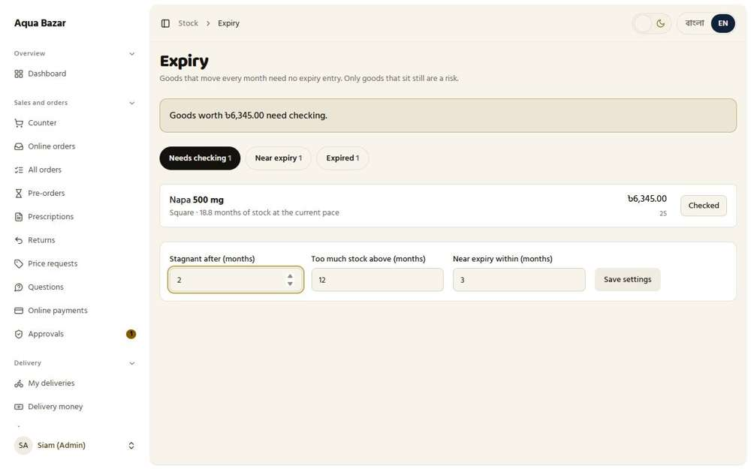
Seen as the owner | /admin/stock/expiry
80. Two check outcomes Works
What it is for: A stock check has two outcomes: fine, or needs action.
What the tester did: Pressed "Checked" on a slow item and looked at the outcomes offered.
What the tester saw:
- Yes. One outcome: "Still good, keep it"
- Yes. The other: record the expiry date, which moves it to the near-expiry or expired lists
Step 1: After pressing Checked: the owner records the result
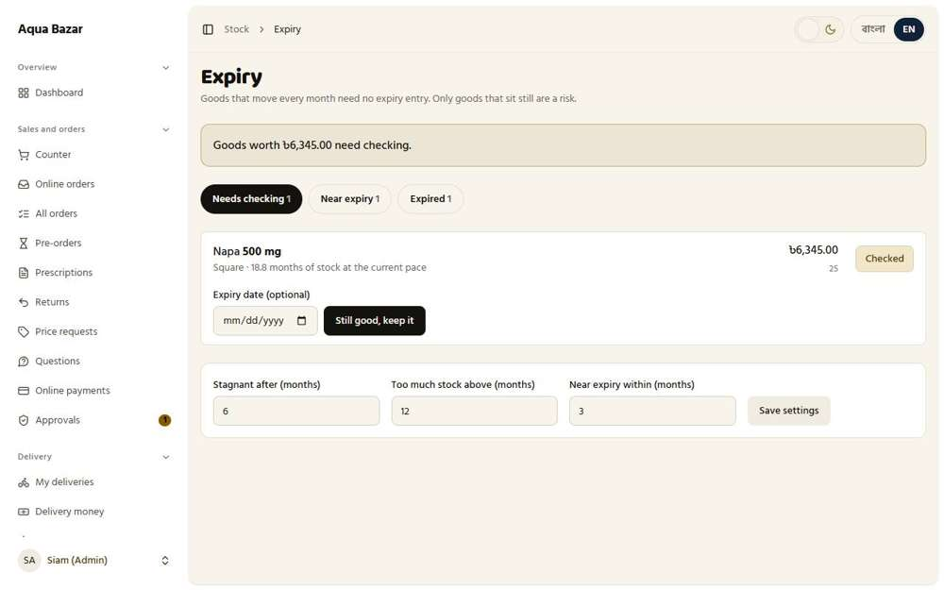
Seen as the owner | /admin/stock/expiry
81. Expiry date field when marking "Checked" Works
What it is for: When marking a medicine as checked, the staff enter its expiry date.
What the tester did: Looked at the Checked form for an expiry date box.
What the tester saw:
- Yes. Marking an item Checked asks for its expiry date
Step 1: The Expiry date box on the Checked form
Seen as the owner | /admin/stock/expiry
82. Show money at risk Works
What it is for: The screen shows how much money is at risk in near-expiry stock.
What the tester did: Read the money figure on the Expiry page.
What the tester saw:
- Yes. The page shows how much money is in goods that need checking
- Yes. Each slow item shows its value
Step 1: The page states how much money is at risk
Seen as the owner | /admin/stock/expiry
83. Near-expiry → offer suggestion Works
What it is for: Medicines near expiry are suggested as offers so they sell before they expire.
What the tester did: Opened the "Near expiry" list and looked at what it suggests for each lot.
What the tester saw:
- Yes. Each near-expiry lot shows the lowest price it can be sold at without a loss
- Yes. It suggests a discount for an offer
Step 1: Near expiry: each lot shows its lowest safe price and a suggested discount
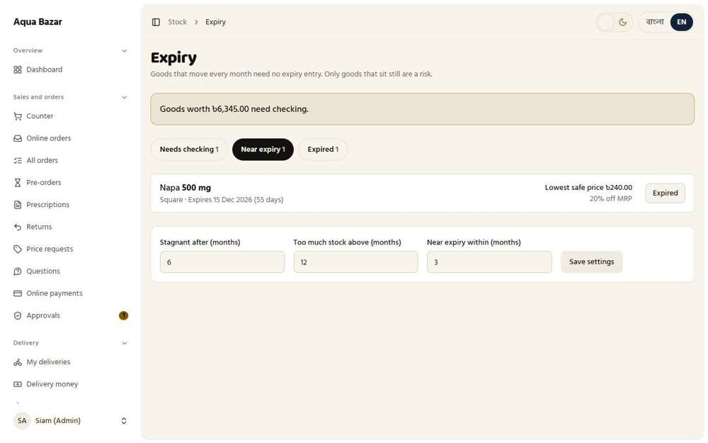
Seen as the owner | /admin/stock/expiry
84. Expired section — by company Works
What it is for: Expired medicines sit in their own section, grouped by company.
What the tester did: Moved a near-expiry lot to the expired section and opened the Expired list.
What the tester saw:
- Yes. Expired goods are grouped under their company, with the unit count and value
Step 1: The expired section, grouped by company
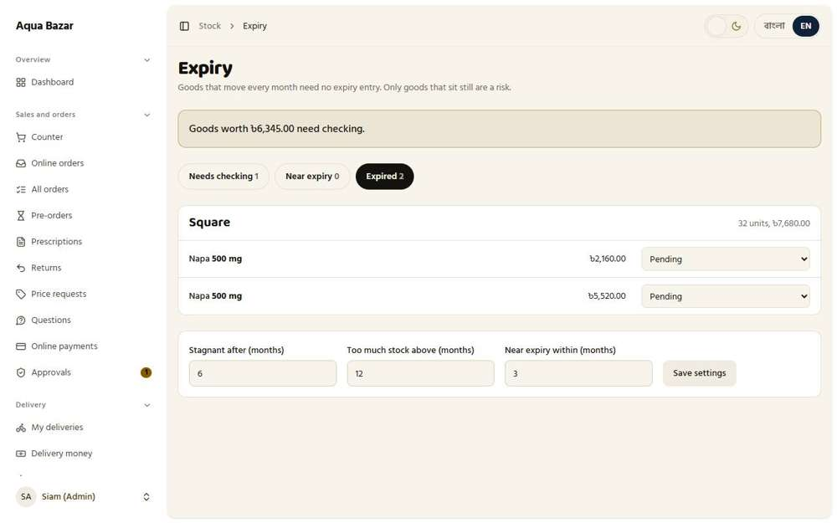
Seen as the owner | /admin/stock/expiry
85. Return to company and PDF Works
What it is for: An expired list can be printed as a PDF to send back to the company.
What the tester did: Looked on the expired list for a way to hand the goods back to the company, with a printable list.
What the tester saw:
- Yes. There is a PDF or print link for the company return list
- Yes. The list opens on plain paper with the heading "Return to company"
- Yes. And a line to sign when the goods are handed back
Step 1: The expired list | Step 2: The return list on plain paper, ready to print or save as PDF
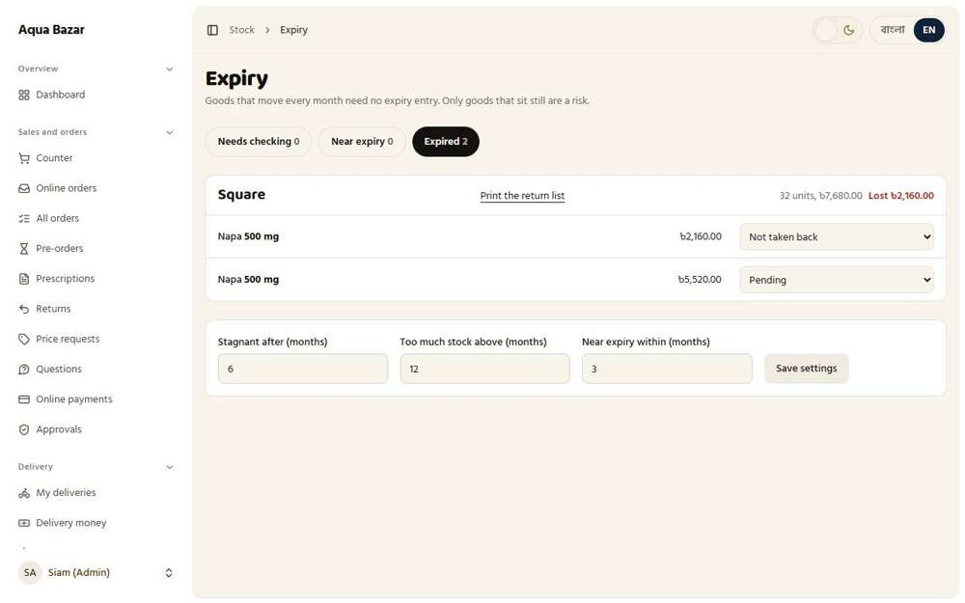  Seen as the owner | /admin/stock/expiry | 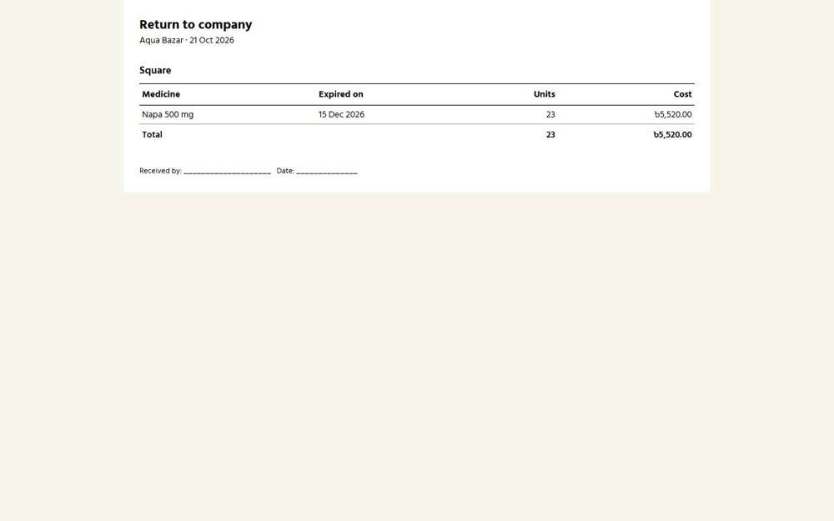  Seen as the owner | /admin/stock/expiry/return-list
86. Three states (returned/not taken/pending) Works
What it is for: Each expired batch is marked returned, not taken back, or pending.
What the tester did: Looked at the three states offered for each expired lot.
What the tester saw:
- Yes. State one: Pending
- Yes. State two: Returned to company representative
- Yes. State three: Not taken back
Step 1: Pending, Returned, or Not taken back
Seen as the owner | /admin/stock/expiry
87. Not taken back counted as loss Works
What it is for: If the company will not take it back, it is counted as a loss.
What the tester did: Marked an expired lot as "Not taken back" and looked for the loss.
What the tester saw:
- Yes. The money in goods the company would not take back shows up as a loss in the reports
Step 1: After marking a lot as not taken back | Step 2: The monthly report: no loss line for the expired goods
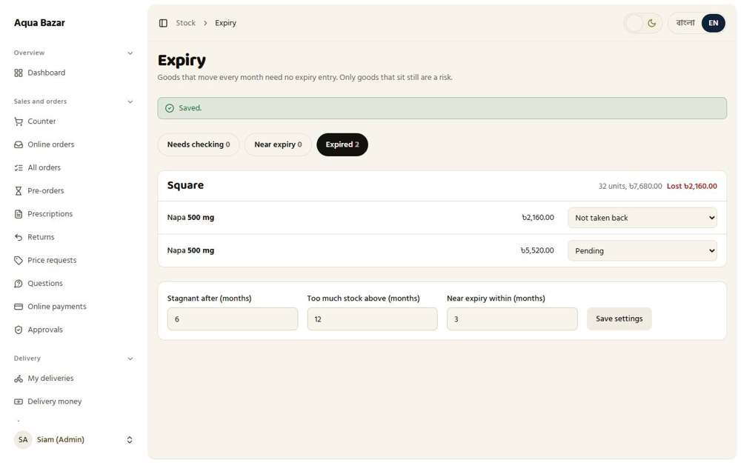  Seen as the owner | /admin/stock/expiry | Seen as the owner | /admin/reports
Step 3: The stock profit report: no loss line either
Seen as the owner | /admin/stock/reports
88. Now only offers deduct stock Works
What it is for: For now, only offers reduce stock. The other options are ready for later.
What the tester did: Checked that, with Master Stock Sync off, only offer orders take stock out.
What the tester saw:
- Yes. With the switch off, an ordinary retail sale does not take stock out (25 stayed 25)
Step 1: A sale made while the switch is off
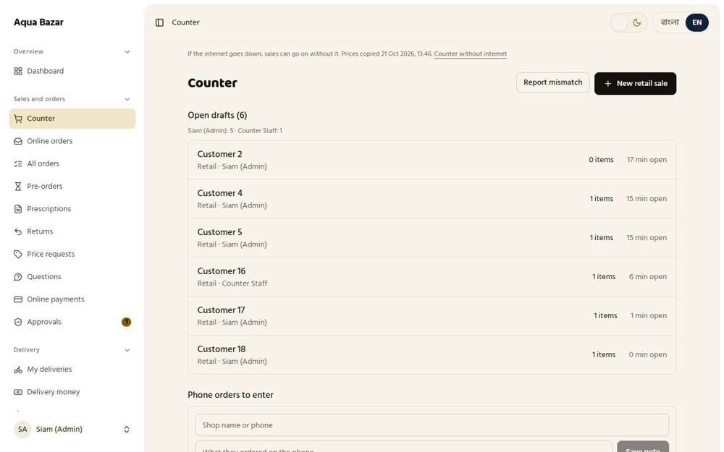
Seen as the owner | /admin/counter
89. Retail options built now, used later Works
What it is for: The options for retail selling are built now and will be used later.
What the tester did: Looked at the options that are built for retail but not used yet.
What the tester saw:
- Yes. The screen says how things work "for now", pointing to later use
Step 1: Stock page with the switch off: the screen says how things work "for now"
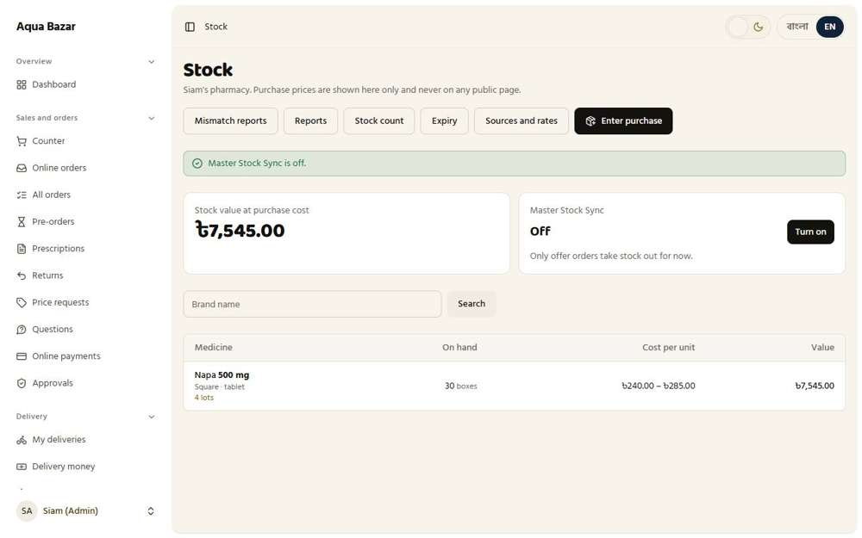
Seen as the owner | /admin/stock
90. Old stock entered manually Works
What it is for: Old stock already on the shelf is entered by hand once at the start.
What the tester did: Entered an old lot by hand, with an earlier invoice date, as a shop does when it first starts using the system.
What the tester saw:
- Yes. The old lot is on the shelf with its old date
Step 1: An old stock lot typed in by hand with an old date | Step 2: The old lot in the Lots table
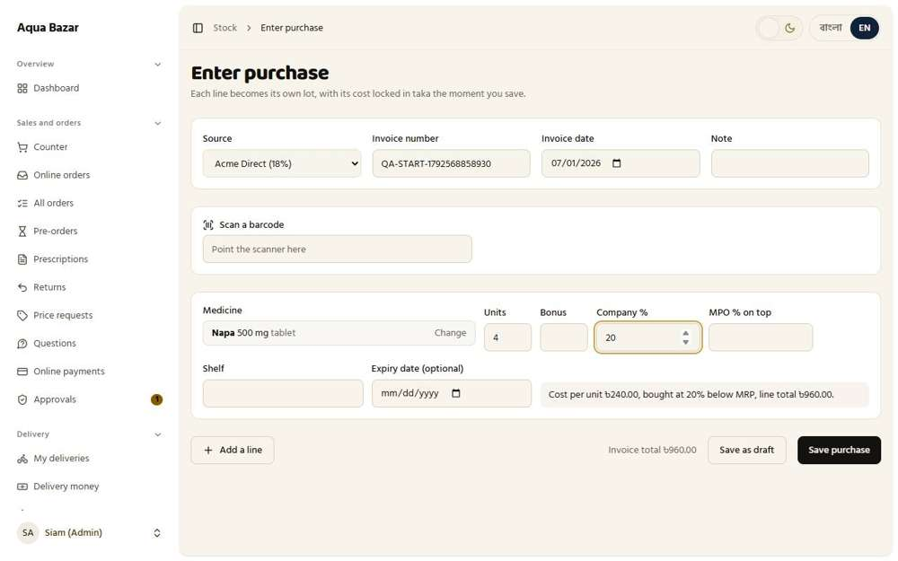  Seen as the owner | /admin/stock/receive | 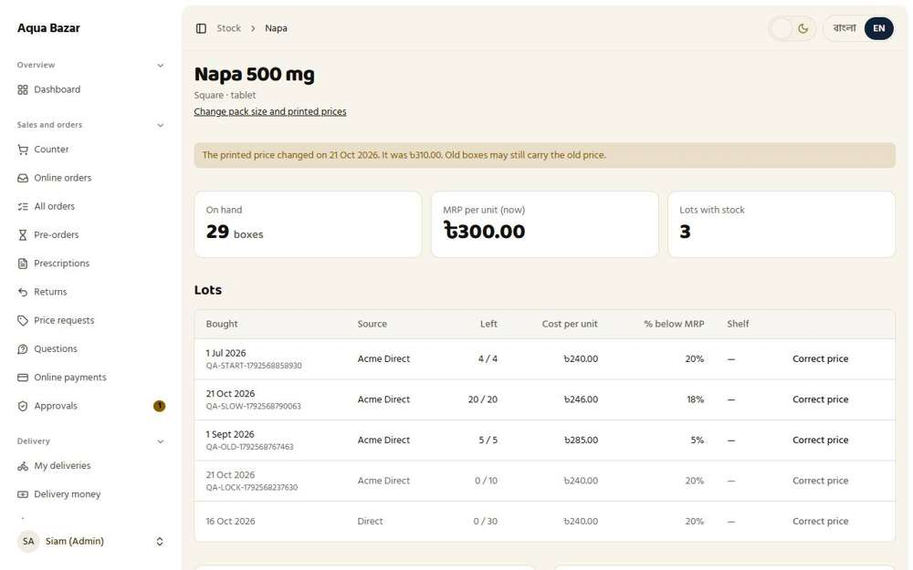  Seen as the owner | /admin/stock/medicines/1
91. Stock correction — admin only Works
What it is for: Only the owner can correct a stock number.
What the tester did: As staff, tried to open the stock-correction screen. Then as the owner, opened it.
What the tester saw:
- Yes. Staff cannot correct a stock number
- Yes. The owner's screen says only the admin can correct stock
Step 1: A staff member on the medicine page | Step 2: The owner's "Correct the stock number" box
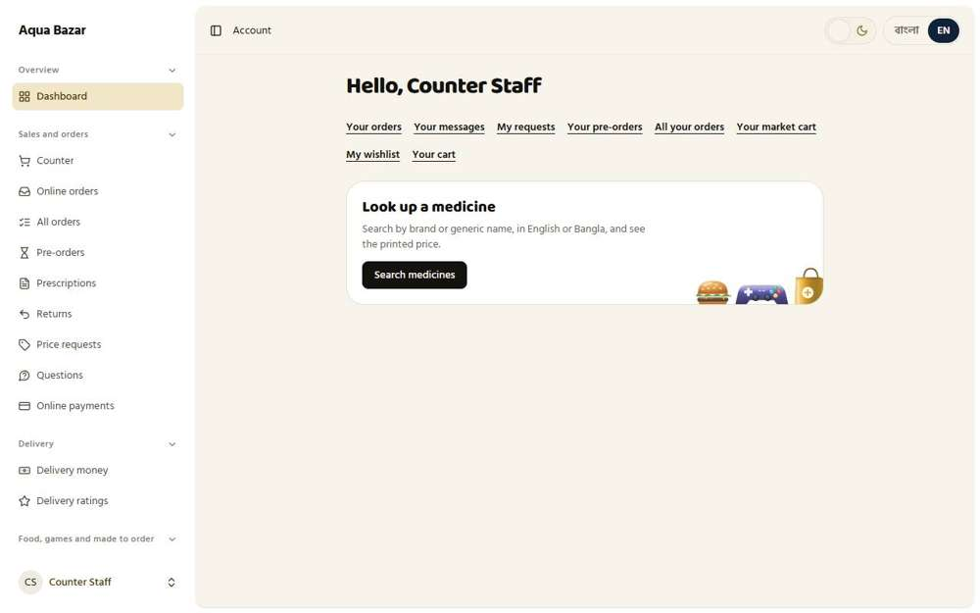  Seen as a staff member | /dashboard | Seen as the owner | /admin/stock/medicines/1
92. Correction not counted as loss Works
What it is for: A correction is not counted as a loss.
What the tester did: Corrected the stock number and looked at how it was recorded.
What the tester saw:
- Yes. The page says a correction is an entry fix, not a sale, so it is not counted as a loss
- Yes. The movement is written as a correction
Note: The system asked the owner to type the password again before saving. It was typed and the change went through.
Step 1: Correcting the number by one, as an entry mistake | Step 2: After the correction
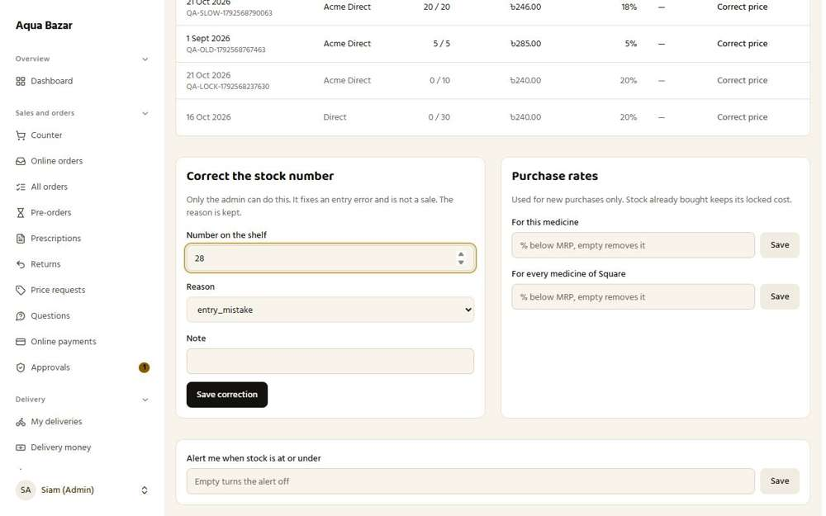  Seen as the owner | /admin/stock/medicines/1 | Seen as the owner | /admin/stock/medicines/1
93. Correction record and reason Works
What it is for: Every correction is saved with a reason.
What the tester did: Looked at the movement list after a correction to see its record and reason.
What the tester saw:
- Yes. The medicine page keeps a movement list
- Yes. The reason for the correction is kept
Step 1: Recent movements: the correction and its reason
Seen as the owner | /admin/stock/medicines/1
94. Staff "Report mismatch" button Works
What it is for: Staff can press "Report mismatch" when the shelf and the system disagree.
What the tester did: As staff, pressed "Report mismatch" at the counter when the shelf number looked wrong. Then looked at the owner's Mismatch reports.
What the tester saw:
- Yes. Staff get a form to report that the shelf and the system disagree
Note: The form has 6 visible boxes.
Step 1: The mismatch form
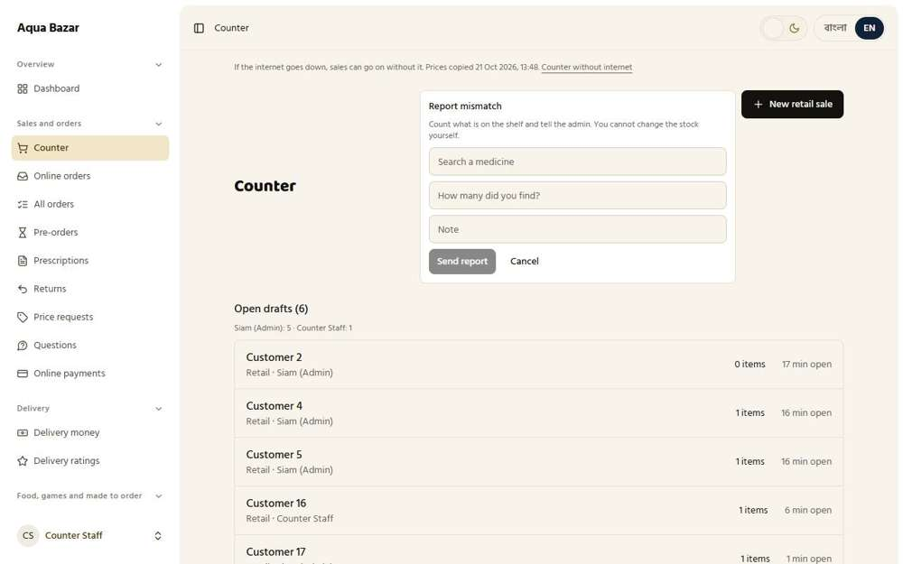
Seen as a staff member | /admin/counter
95. Warning on fragmented lots Works
What it is for: The system warns when stock is split into many tiny batches.
What the tester did: Lowered "Warn when one medicine has this many lots" to 2 in Settings, then looked at the stock page and the medicine page. Napa has several lots.
What the tester saw:
- Yes. The stock list shows how many lots a medicine is spread over
- Yes. The medicine page warns when stock is split across many lots, and says what to do
Step 1: The stock page after lowering the lot limit | Step 2: The medicine page warns: "This medicine is spread over 5 lots. Sell the old small ones first."
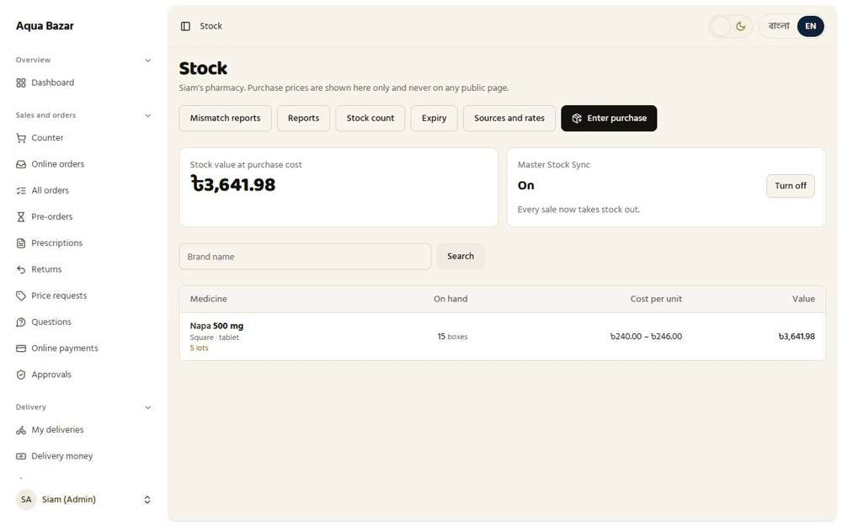  Seen as the owner | /admin/stock | 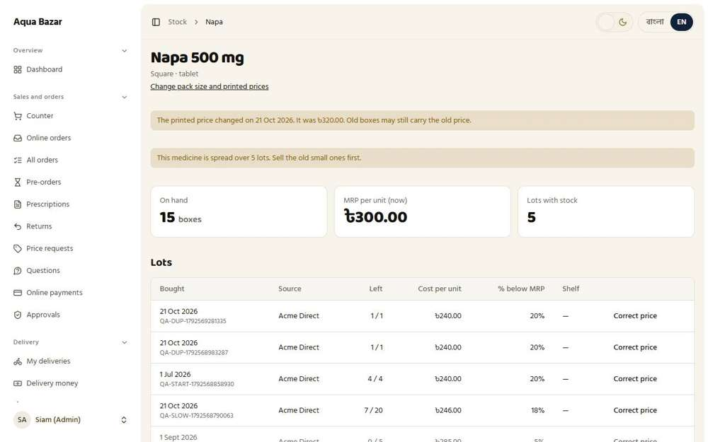  Seen as the owner | /admin/stock/medicines/1
96. Invoice number field Works
What it is for: Every stock entry has a field for the supplier's invoice number.
What the tester did: Opened Enter purchase and looked for the supplier invoice number box.
What the tester saw:
- Yes. Every purchase has an invoice number box
Step 1: Enter purchase: the invoice number box
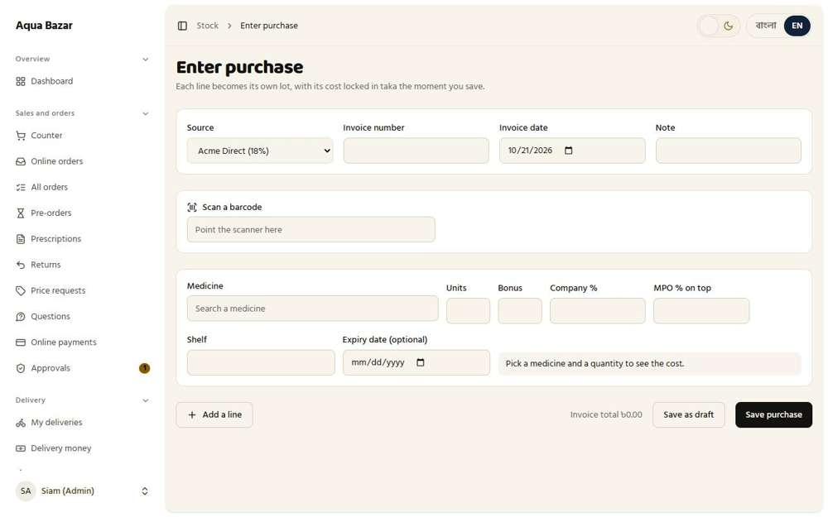
Seen as the owner | /admin/stock/receive
97. Entry won't save without percentage Works
What it is for: An entry will not save until the buying percentage is filled in.
What the tester did: Added a buying source with no percentage and tried to save a purchase from it with no percentage typed.
What the tester saw:
- Yes. The purchase is refused until a percentage is given
Step 1: Adding a source with no default percentage | Step 2: A purchase from it with no percentage typed
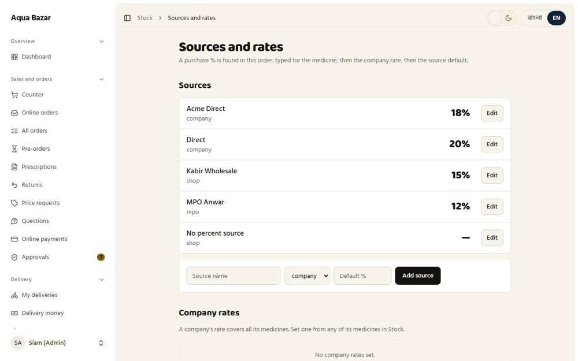  Seen as the owner | /admin/stock/sources | 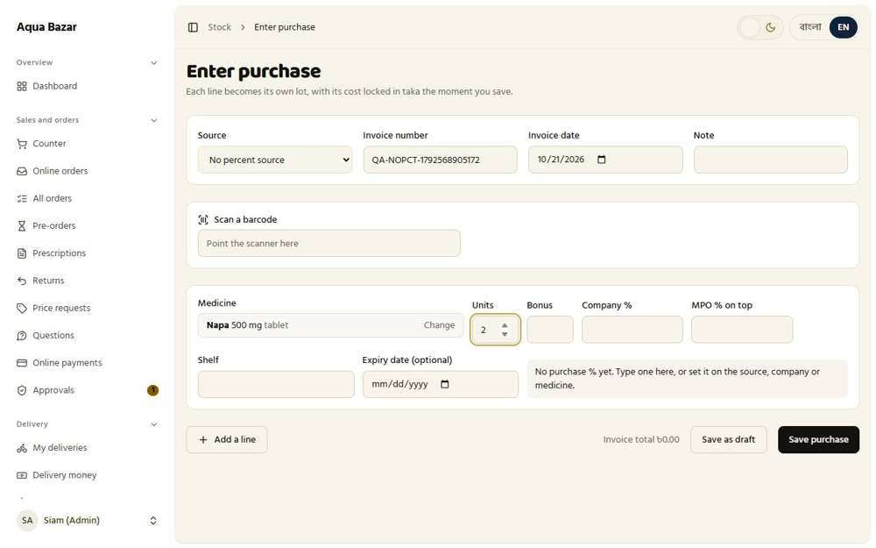  Seen as the owner | /admin/stock/receive
Step 3: What the system says
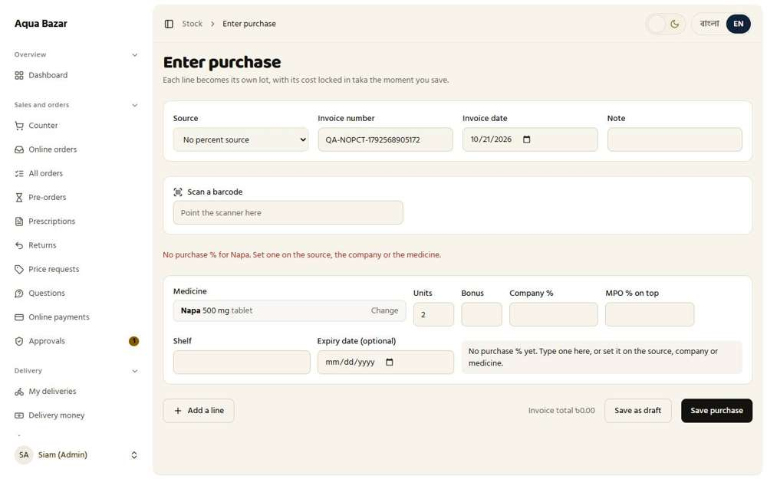
Seen as the owner | /admin/stock/receive
98. Stock entry saved as draft Works
What it is for: A half-finished stock entry is saved as a draft and can be finished later.
What the tester did: Filled part of a purchase and pressed "Save as draft", then looked for it on the next visit.
What the tester saw:
- Yes. The half-finished purchase is kept as a draft
Step 1: After "Save as draft" | Step 2: Back on Enter purchase: the draft waits here
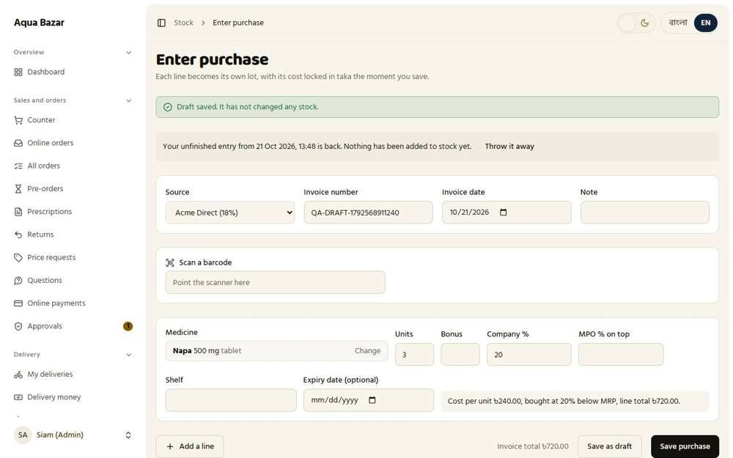  Seen as the owner | /admin/stock/receive | 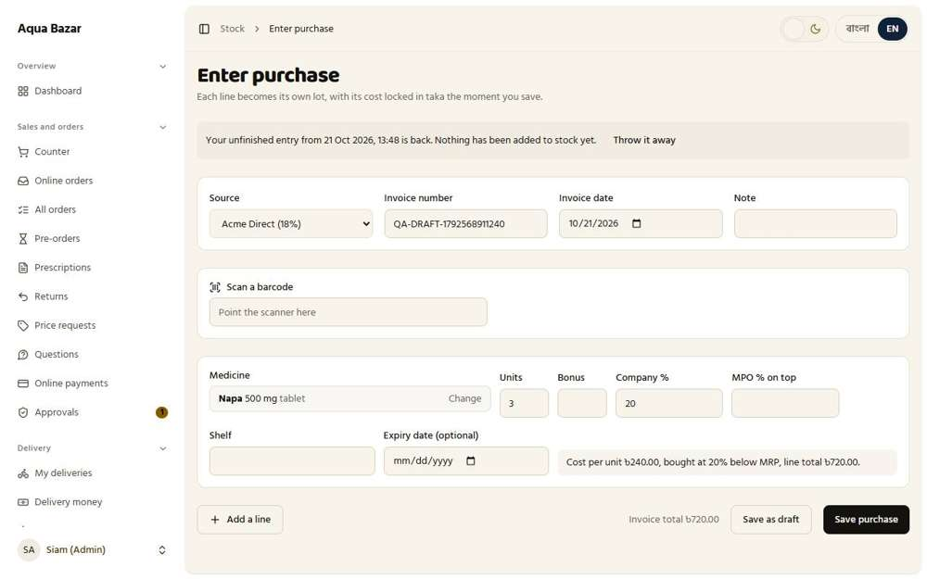  Seen as the owner | /admin/stock/receive
99. Add many at once by company Only partly shown
What it is for: Many medicines from one company can be entered at once.
What the tester did: Pressed "Add a line" to enter several medicines in one purchase.
What the tester saw:
- Yes. A purchase can hold many lines
Note: Adding all of one company's medicines in one go was not found as a separate control. Lines are added one at a time.
Step 1: A second line added to the same purchase
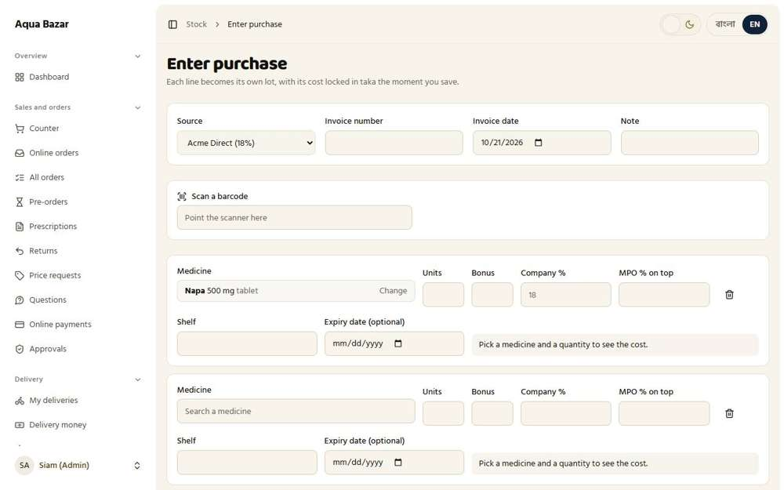
Seen as the owner | /admin/stock/receive
100. Set percentage once at top for all Works
What it is for: The percentage is set once at the top and applies to all rows.
What the tester did: Looked for one place at the top of the purchase to set the percentage for every line.
What the tester saw:
- Yes. The Source at the top sets one default percentage for every line
Note: The percentage is set once through the Source at the top. Each line can still change it.
Step 1: The purchase form: the Source sets one default for all lines
Seen as the owner | /admin/stock/receive
101. Warning when unit changes Only partly shown
What it is for: If the unit changes (piece, strip, box), a warning appears.
What the tester did: Looked for a warning when the unit of a purchase differs from the medicine's usual unit.
Note: No unit-change warning was found on the purchase line.
Step 1: Purchase line
Seen as the owner | /admin/stock/receive
102. Shelf number (optional) Works
What it is for: An optional shelf number can be saved with each batch.
What the tester did: Looked for the optional shelf number on a purchase line.
What the tester saw:
- Yes. Each purchase line has an optional Shelf box
Step 1: The Shelf box
Seen as the owner | /admin/stock/receive
103. Warning on entering the same invoice twice Works
What it is for: Entering the same supplier invoice twice triggers a warning.
What the tester did: Saved a purchase, then tried to save another with the same invoice number.
What the tester saw:
- Yes. The system warns that this invoice number was already entered
Step 1: The second time with the same invoice number
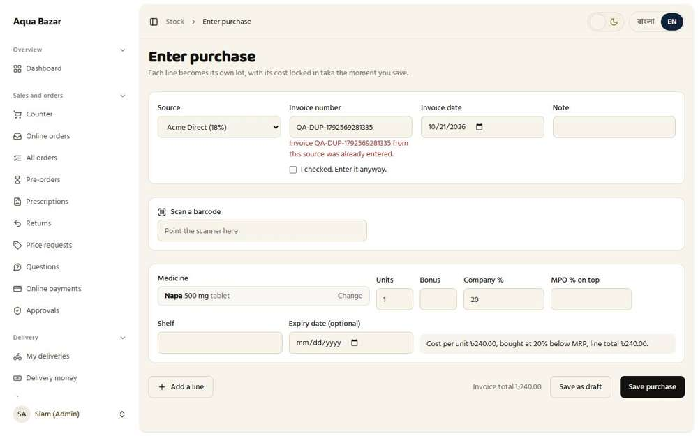
Seen as the owner | /admin/stock/receive
104. Stock count mode (shelf/company-wise physical count) Works
What it is for: Stock count mode lets staff count shelf by shelf or company by company.
What the tester did: Opened Stock count and looked at the ways to count: whole shop, one company or one shelf.
What the tester saw:
- Yes. A count can be the whole shop
- Yes. Or one company
- Yes. Or one shelf
Step 1: Choosing how to count
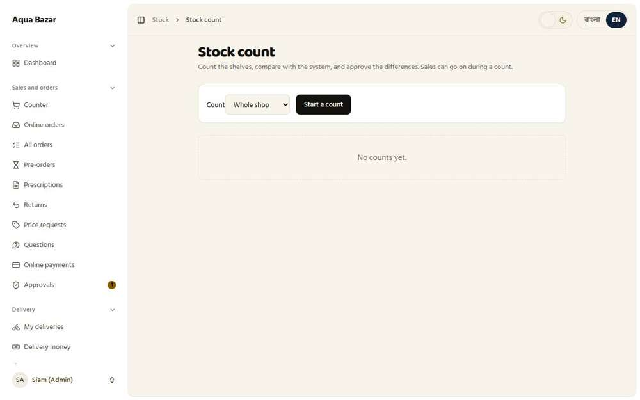
Seen as the owner | /admin/stock/counts
105. Count differences approved only by admin, count report saved Works
What it is for: Differences are approved only by the owner, and each count report is saved.
What the tester did: Started a count of one company and looked at how differences are approved.
What the tester saw:
- Yes. A count compares what is on the shelf with the system
Note: Approving the differences needs counted numbers typed against each medicine, which was not taken further here.
Step 1: A count in progress
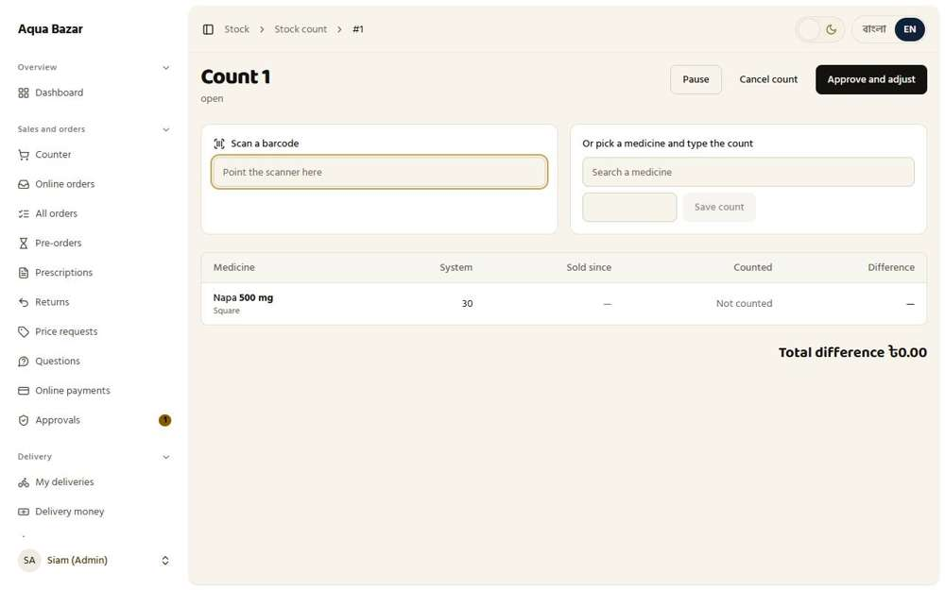
Seen as the owner | /admin/stock/counts/1
106. Barcode scanning (counter, stock entry, count) Works
What it is for: A barcode scanner can be used at the counter, in stock entry and in counts.
What the tester did: Typed a known barcode the way a scanner does (the digits, then Enter), first at the counter and then on the purchase form.
What the tester saw:
- Yes. At the counter, scanning a known barcode adds that medicine to the sale
- Yes. On the purchase form, scanning a known barcode adds a line for that medicine
Note: The scan box on the purchase form sits inside the purchase form. The browser console reports "a form cannot be a descendant of a form", and pressing Enter reloads the page instead of looking the barcode up.
Step 1: At the counter: the scanned barcode | Step 2: On the purchase form: the same barcode
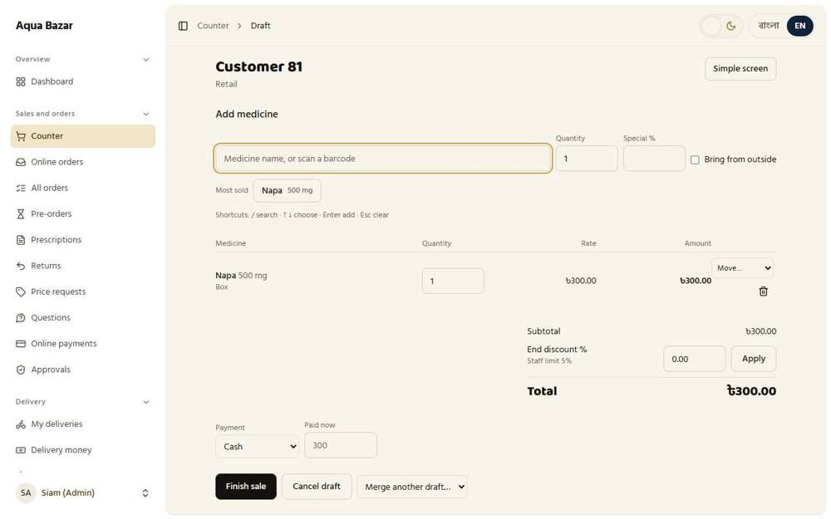  Seen as the owner | /admin/counter/252 | 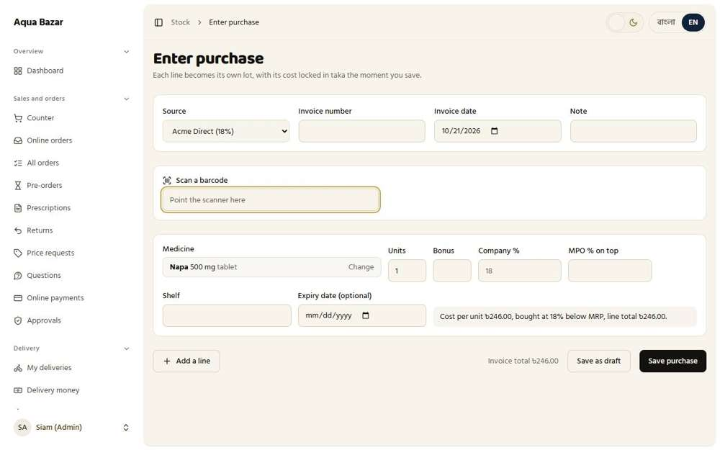  Seen as the owner | /admin/stock/receive
107. Phone-camera scanning and multiple barcodes per medicine Only partly shown
What it is for: Phone-camera scanning is not finished. USB and Bluetooth scanners work.
What the tester did: Looked for phone-camera scanning.
Note: Scanning with a phone camera is not built. USB and Bluetooth scanners, which type the number, are supported.
Step 1: The scan box works with a USB or Bluetooth scanner that types the code
Seen as the owner | /admin/stock/receive
108. Unknown barcode linked once, remembered Works
What it is for: An unknown barcode is linked to a medicine once and remembered afterwards.
What the tester did: Typed a barcode the system has never seen into the scan box on the purchase form, expecting it to ask which medicine it belongs to.
What the tester saw:
- Yes. An unknown barcode asks "Which medicine is it?" so the owner can link it once
Note: Linking the code once, so it is remembered, cannot be reached because the scan box on this screen does not respond to Enter (see feature 106). Once a code is linked, the counter does recognise it.
Step 1: An unknown barcode on the purchase form
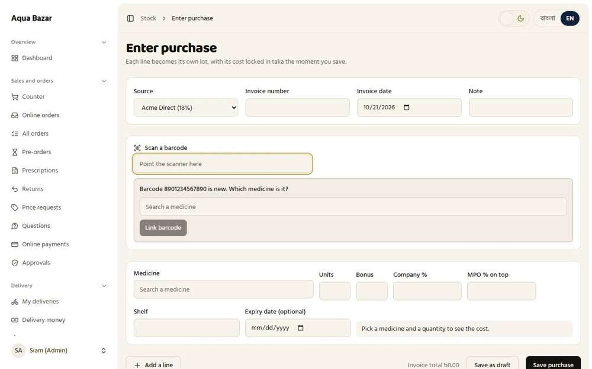
Seen as the owner | /admin/stock/receive

Draft Invoice
109. Draft invoice — kept open, items added Works
What it is for: A draft invoice stays open while items are added, so a long order can be built up slowly.
What the tester did: Started a sale, added a box, left the screen and came back from the list of open drafts.
What the tester saw:
- Yes. Coming back, the item is still on the draft
Step 1: The sale is kept in "Open drafts" while the owner does something else | Step 2: The same draft, reopened with its item
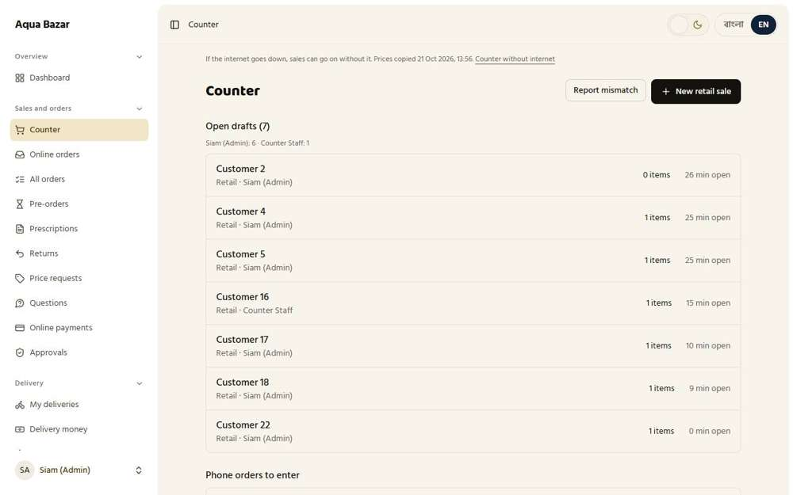  Seen as the owner | /admin/counter | 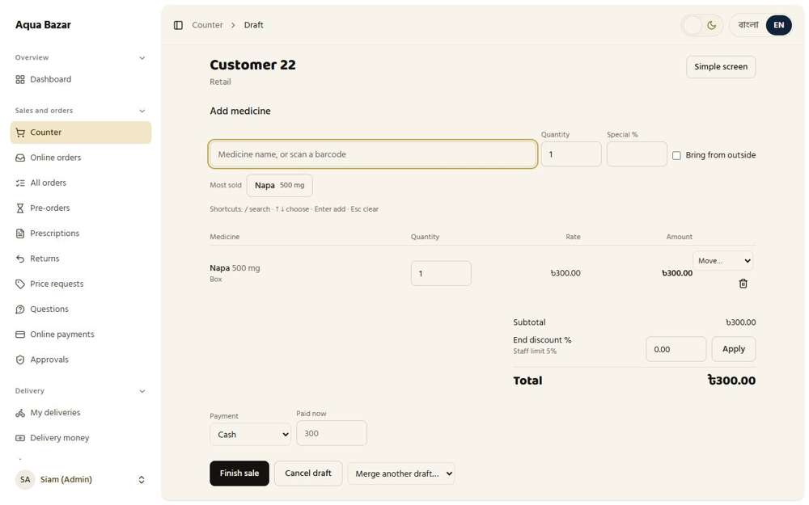  Seen as the owner | /admin/counter/144
110. Stock out the moment an item is added Works
What it is for: The moment an item is added to a draft, it comes out of stock so nobody else sells it.
What the tester did: Added a box to a draft and looked at the stock number straight away.
What the tester saw:
- Yes. The box left stock the moment it was added (31 became 30)
Step 1: The draft: stock is already reduced
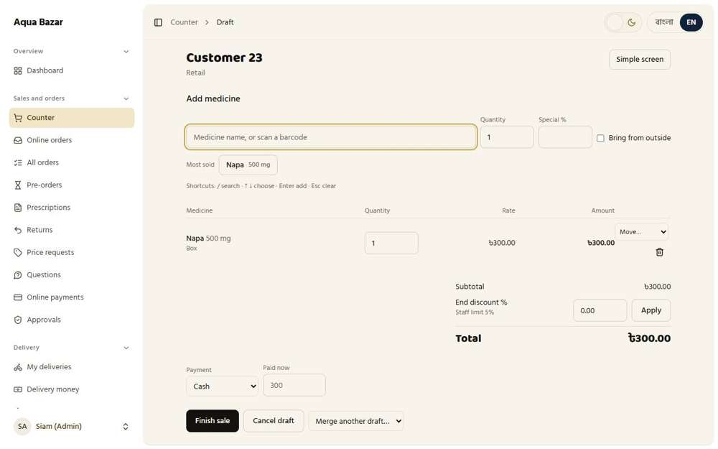
Seen as the owner | /admin/counter/145
111. Removed → back to stock, kept in history Works
What it is for: If an item is removed, it returns to stock and the removal stays in the history.
What the tester did: Added a box to a draft, then pressed the bin icon to remove it, and looked at the stock and the history.
What the tester saw:
- Yes. The removed box is back in stock (31 then 31)
- Yes. The removal is kept in the medicine's movement history as a return
Step 1: A draft with a box | Step 2: After removing the box from the draft
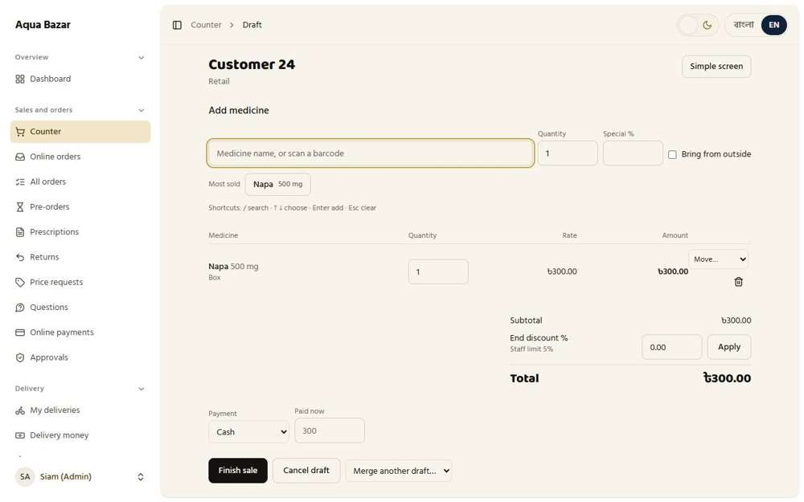  Seen as the owner | /admin/counter/146 | 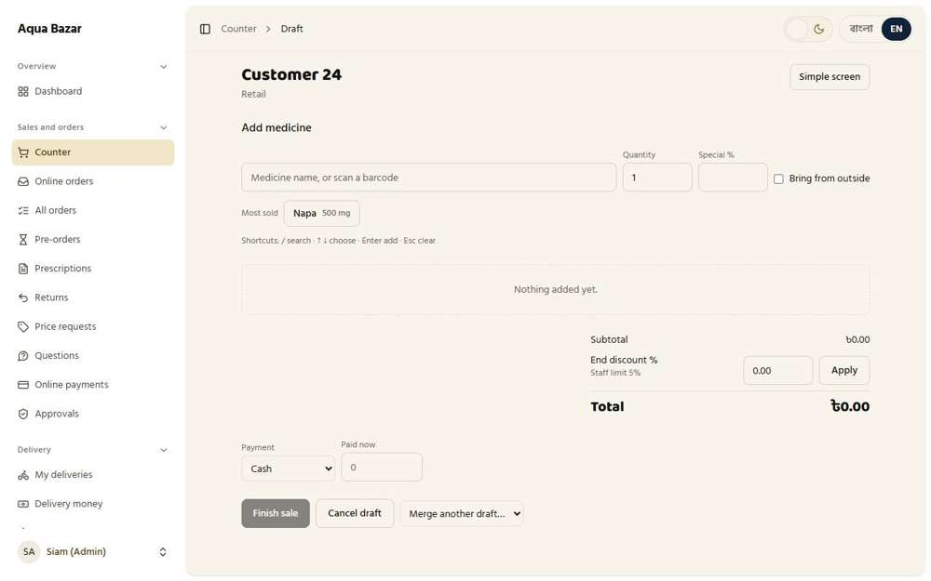  Seen as the owner | /admin/counter/146
Step 3: The movement history keeps the removal
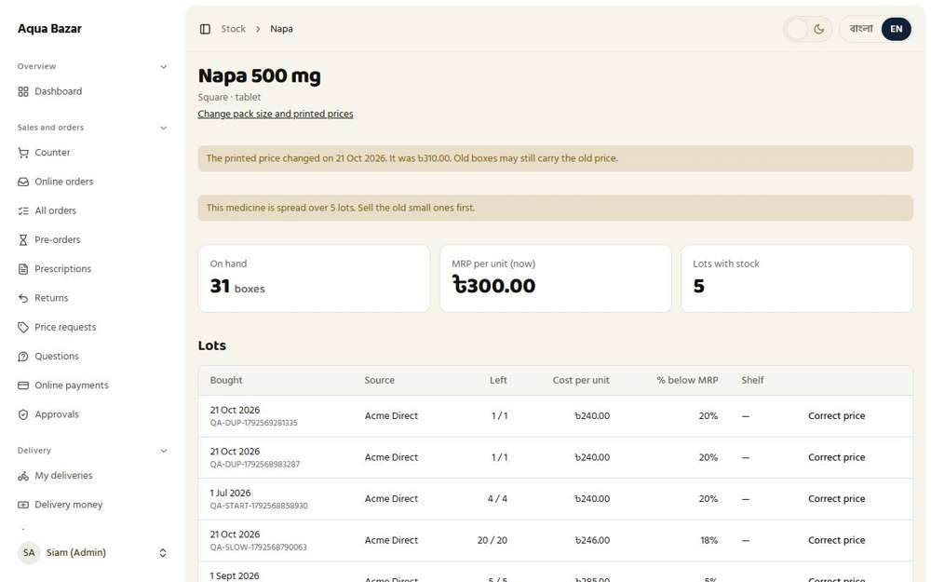
Seen as the owner | /admin/stock/medicines/1
112. Multiple drafts, separate invoice numbers Works
What it is for: A shop can have several drafts open at once, each with its own invoice number.
What the tester did: Opened two retail drafts and looked at how each is named on the counter list.
What the tester saw:
- Yes. Each open draft has its own number (Customer 2, Customer 4, Customer 5, Customer 16 ...)
Step 1: Several drafts open, each with its own name
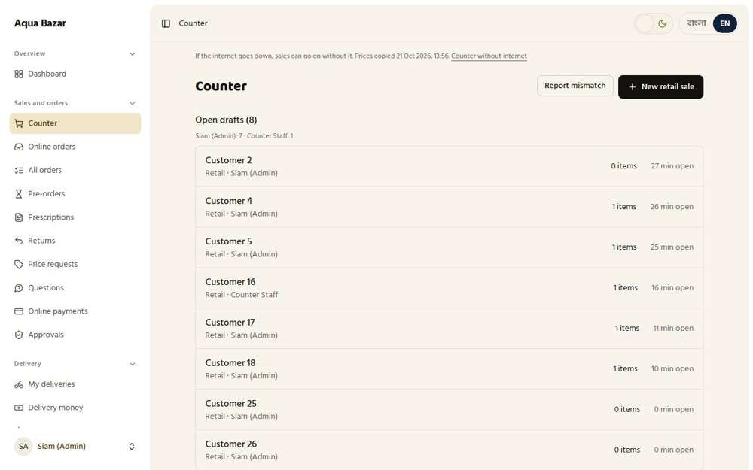
Seen as the owner | /admin/counter
113. All add up into one memo at the end Works
What it is for: At the end, all the drafts add up into one memo.
What the tester did: Finished a sale and looked at the one memo that comes out, with its year-based number.
What the tester saw:
- Yes. The finished sale gets one memo number
Step 1: One memo for the whole sale
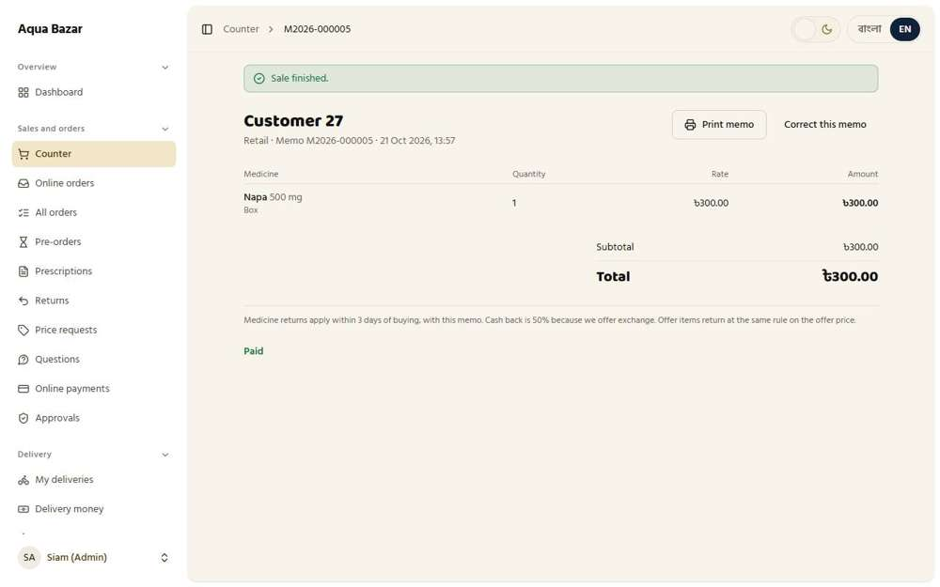
Seen as the owner | /admin/counter/149
114. Merge two drafts Works
What it is for: Two drafts for the same shop can be merged into one.
What the tester did: Made two drafts with a box each, then used "Merge another draft" to join them.
What the tester saw:
- Yes. The draft offers other drafts to merge in
- Yes. After merging, the items of both drafts are on one
Step 1: The second draft, with its own box | Step 2: After merging: both boxes are on one draft
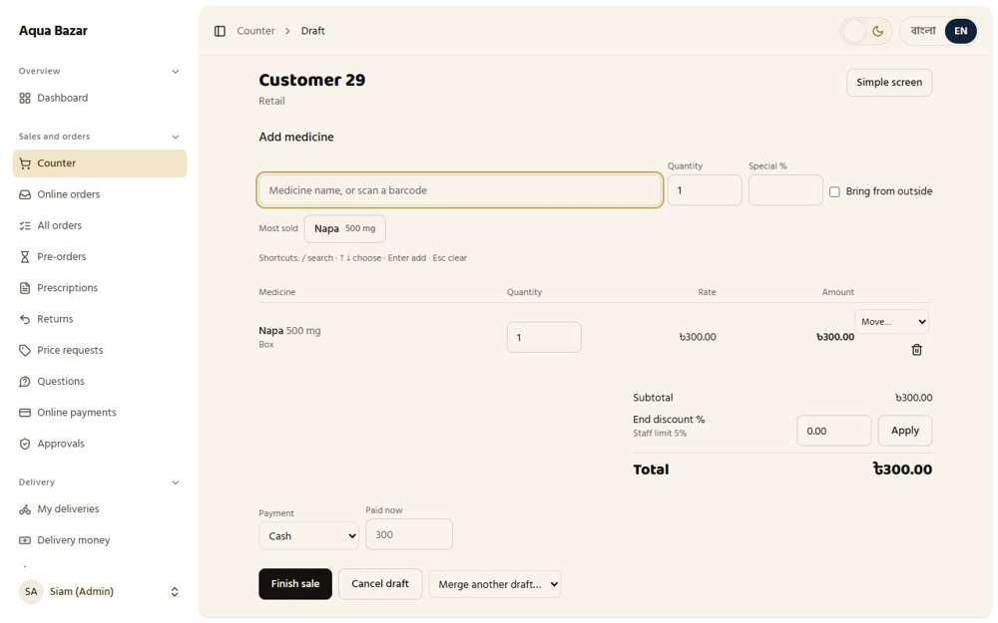  Seen as the owner | /admin/counter/151 | Seen as the owner | /admin/counter/151
115. Unlimited retail drafts Works
What it is for: Walk-in retail customers can have as many drafts as needed.
What the tester did: Looked at the number of retail drafts open at once.
What the tester saw:
- Yes. There is no small limit on retail drafts (9 open)
Step 1: 9 retail drafts are open at the same time
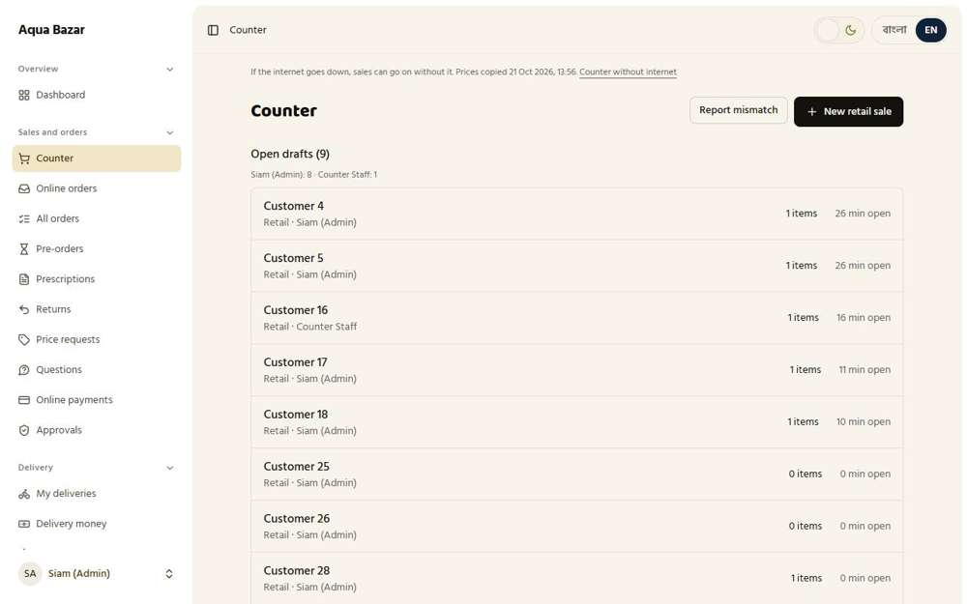
Seen as the owner | /admin/counter
116. First click wins on drafts Works
What it is for: If two staff touch the same draft, the first click wins and the other is told.
What the tester did: Opened one draft as the owner and, at the same time, as staff, and looked for any sign on the screen that someone else is working on it.
What the tester saw:
- Yes. Staff are told that another person has the draft open
Step 1: Staff open the owner's draft while the owner has it open
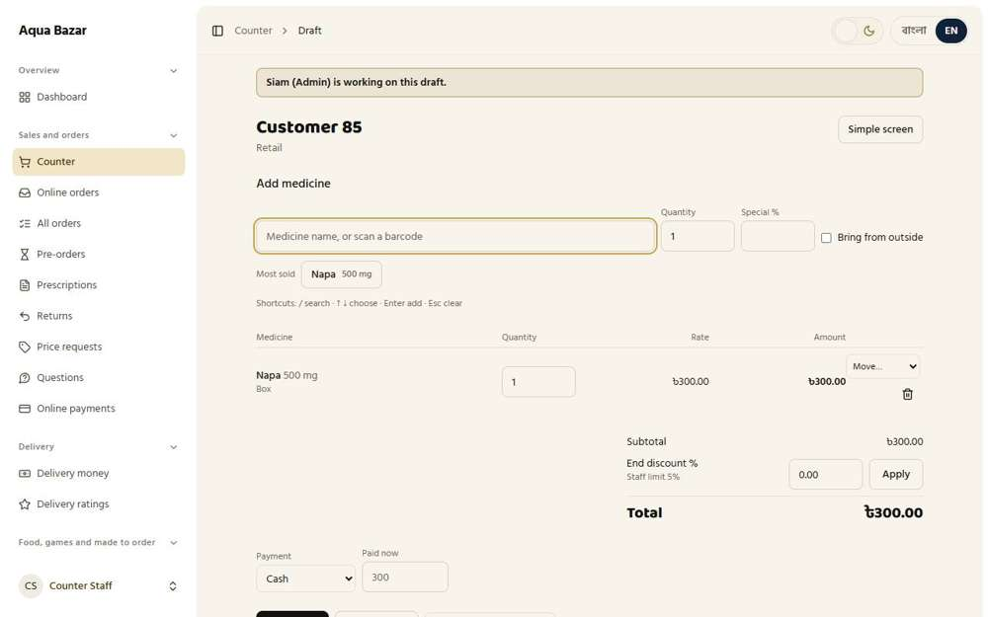
Seen as a staff member | /admin/counter/260
117. Draft timer and color change Only partly shown
What it is for: A timer on each draft turns red as it gets old, so forgotten drafts stand out.
What the tester did: Looked at the time shown on each open draft.
What the tester saw:
- Yes. Each draft shows how many minutes it has been open
Note: The colour change as a draft gets old was not shown, because it needs a draft to age for hours.
Step 1: Each draft shows how long it has been open
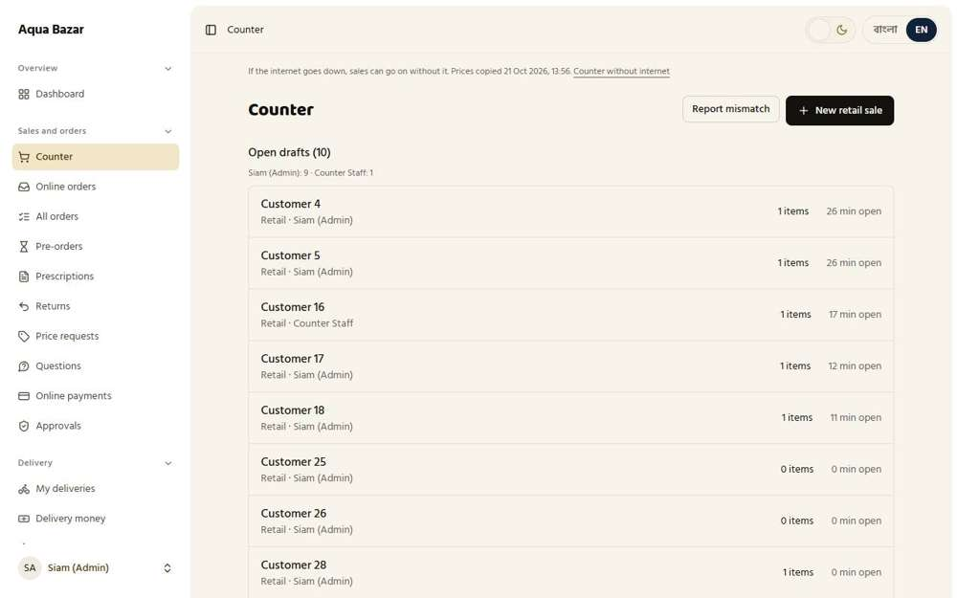
Seen as the owner | /admin/counter
118. Open draft count Works
What it is for: The screen shows how many drafts are open right now.
What the tester did: Read the "Open drafts" count at the top of the list.
What the tester saw:
- Yes. The counter shows how many drafts are open
Step 1: "Open drafts (n)"
Seen as the owner | /admin/counter
119. Notification after 1–2 days (two buttons) Works
What it is for: After one or two days, the system reminds staff about old drafts, with two buttons to act on them.
What the tester did: Set "Ask about a draft nobody touched for" to a very short time in Settings, then opened the counter where many drafts have been left.
What the tester saw:
- Yes. The counter asks what to do with a draft nobody has touched: return its goods to stock, or keep it
Step 1: The counter, with old drafts
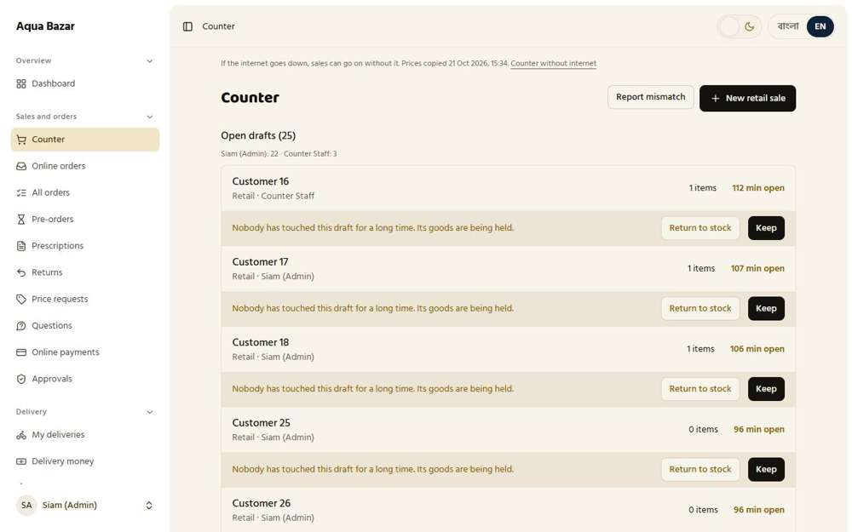
Seen as the owner | /admin/counter
120. Open drafts by staff name Works
What it is for: Open drafts are listed under the name of the staff member working on them.
What the tester did: Looked at the name of the staff member under each open draft.
What the tester saw:
- Yes. Each draft shows who is working on it
Step 1: Each open draft carries the name of its staff member
Seen as the owner | /admin/counter
121. Anyone can enter any draft Works
What it is for: Any staff member can open and continue any draft.
What the tester did: As staff, opened a draft that the owner started.
What the tester saw:
- Yes. Staff can open and see a draft the owner started
Step 1: Staff on the owner's draft
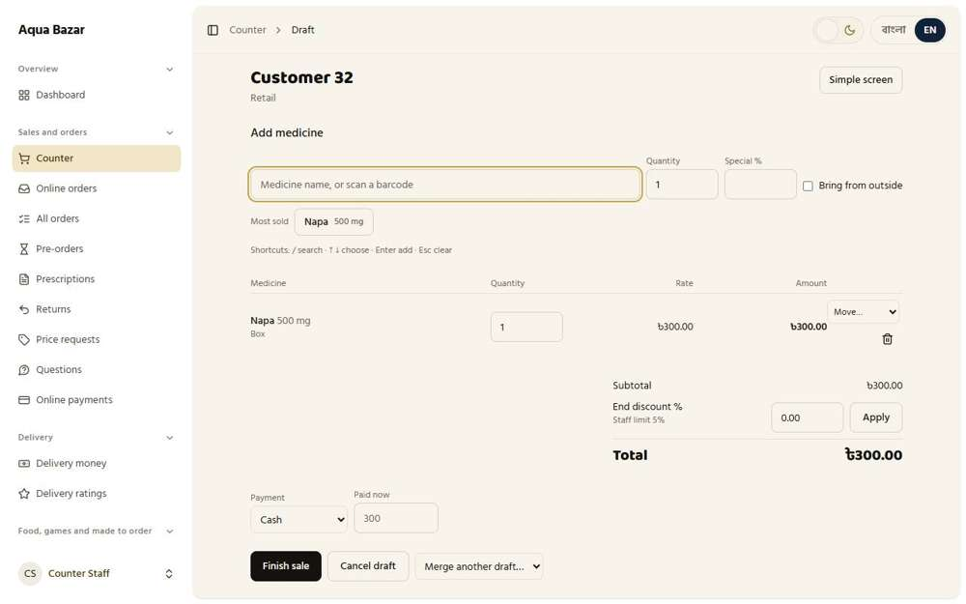
Seen as a staff member | /admin/counter/154
122. Show "Robiul is working" Works
What it is for: The screen shows "Robiul is working" so two people do not collide.
What the tester did: Sent an online order. The owner opened it to check it. While it was open, staff opened the same order.
What the tester saw:
- Yes. Staff see "Siam (Admin) is working on this order"
Note: The same note was not found on counter drafts (see feature 116).
Step 1: The owner has the order open | Step 2: Staff open the same order: a note says who else is working on it
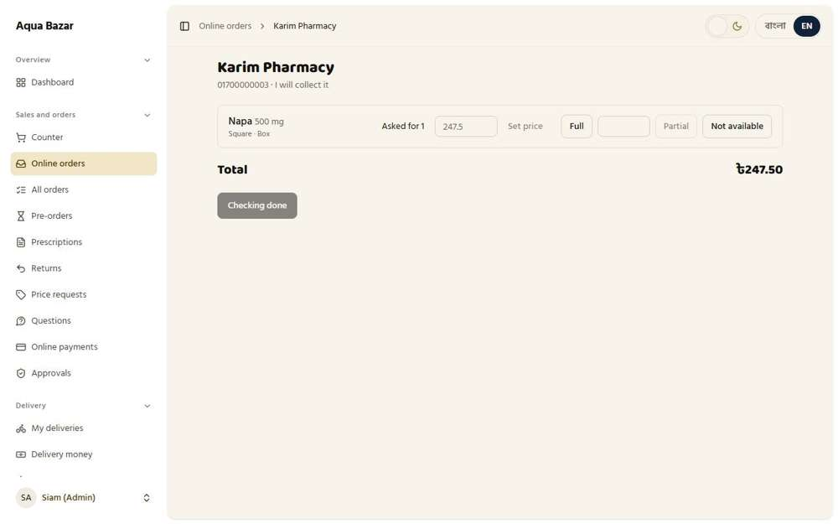  Seen as the owner | /admin/orders/259 | 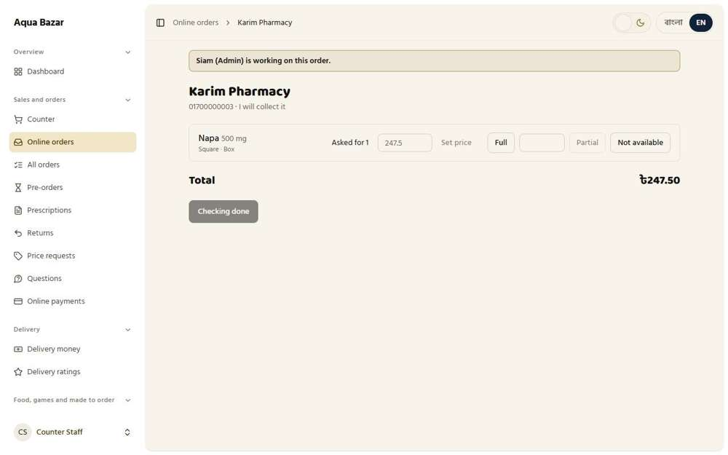  Seen as a staff member | /admin/orders/259
123. "Move to another draft" in three-dot menu Works
What it is for: A three-dot menu has "Move to another draft" to shift an item.
What the tester did: On a draft with an item, opened the "Move…" menu beside the item.
What the tester saw:
- Yes. Each item has a "Move…" menu to shift it to another draft
Note: The menu lists: Move…, Customer 4, Customer 5, Customer 16, Customer 17, Customer 18, Customer 25, Customer 26, Customer 28, Customer 29, Customer 31, Customer 33
Step 1: The "Move…" menu beside the item
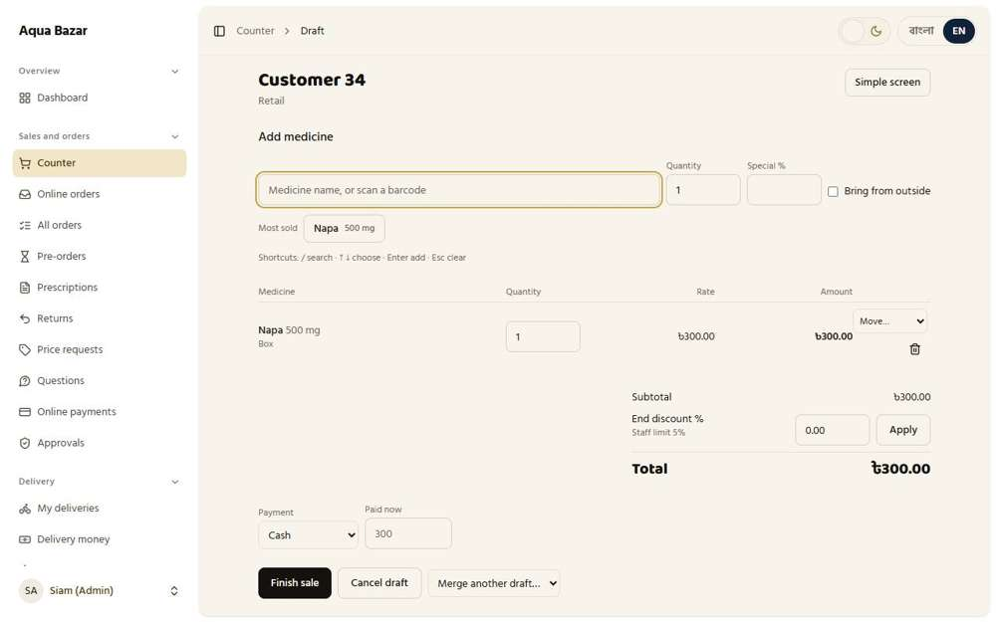
Seen as the owner | /admin/counter/156
124. Warning when the same medicine is added twice Works
What it is for: If the same medicine is added twice, the system warns.
What the tester did: Added the same medicine twice to one draft.
What the tester saw:
- Yes. The screen tells the user the medicine was already on the sale and that the amount was added to it
Step 1: The same medicine added twice
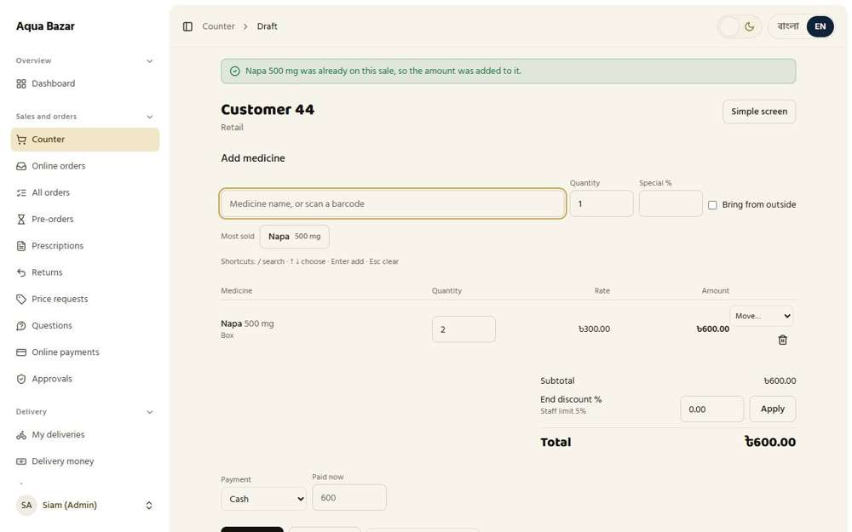
Seen as the owner | /admin/counter/166
125. "This shop has 2 drafts open" Works
What it is for: The screen says "This shop has 2 drafts open" before starting a third.
What the tester did: Started a sale to a shop that already has a draft open and looked for a warning.
What the tester saw:
- Yes. The counter warns that this shop already has an order open, and offers to open it
Note: The warning names one open order. A count such as "2 drafts open" was not seen.
Step 1: Choosing a shop that already has a draft open: the counter warns before starting another | Step 2: The shop's existing draft opens
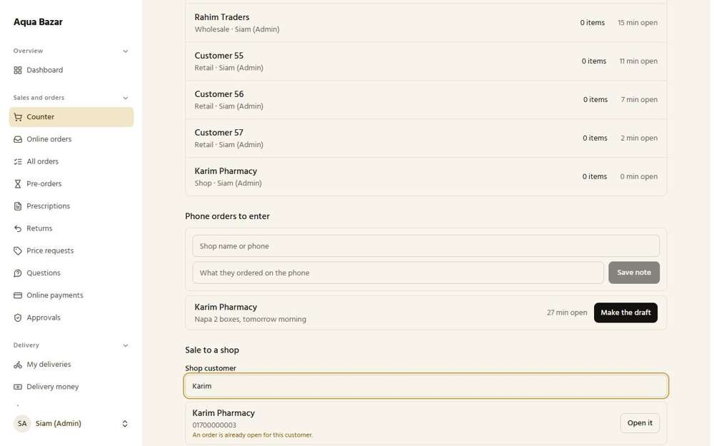  Seen as the owner | /admin/counter | 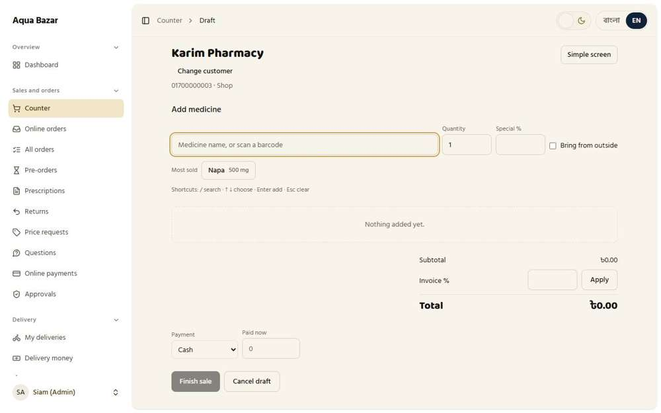  Seen as the owner | /admin/counter/200
126. Every item saved instantly Works
What it is for: Every item is saved the instant it is added. Nothing is lost if the page closes.
What the tester did: Added a box, reloaded the page, and saw the item was kept.
What the tester saw:
- Yes. After reloading the page, the item is still on the draft (every item is saved at once)
Step 1: After reloading the page
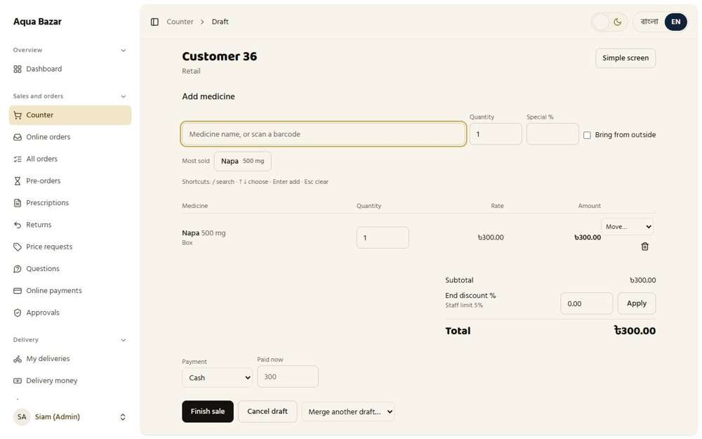
Seen as the owner | /admin/counter/158
127. "Bring from outside" mark Works
What it is for: An item the shop does not hold can be marked "bring from outside".
What the tester did: Looked at the "Bring from outside" tick box beside the medicine search.
What the tester saw:
- Yes. There is a "Bring from outside" box for goods the shop does not hold
Step 1: The "Bring from outside" tick box
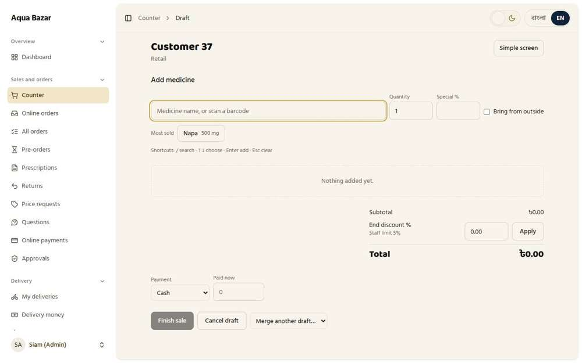
Seen as the owner | /admin/counter/159
128. Invoice correction (admin) Works
What it is for: The owner can correct a finished invoice. The old one is kept in the history.
What the tester did: Finished a sale, then pressed "Correct this memo".
What the tester saw:
- Yes. The owner can correct a finished memo
Step 1: The correction screen
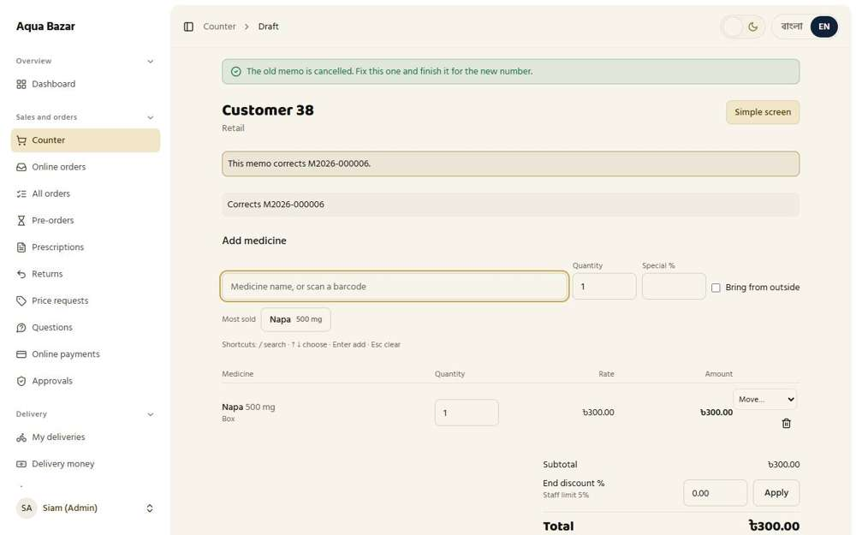
Seen as the owner | /admin/counter/161
129. Change customer option Works
What it is for: The customer on an invoice can be changed by the owner.
What the tester did: On the correction screen, looked for a way to change the customer.
What the tester saw:
- Yes. The correction screen has a customer option
Step 1: The correction screen
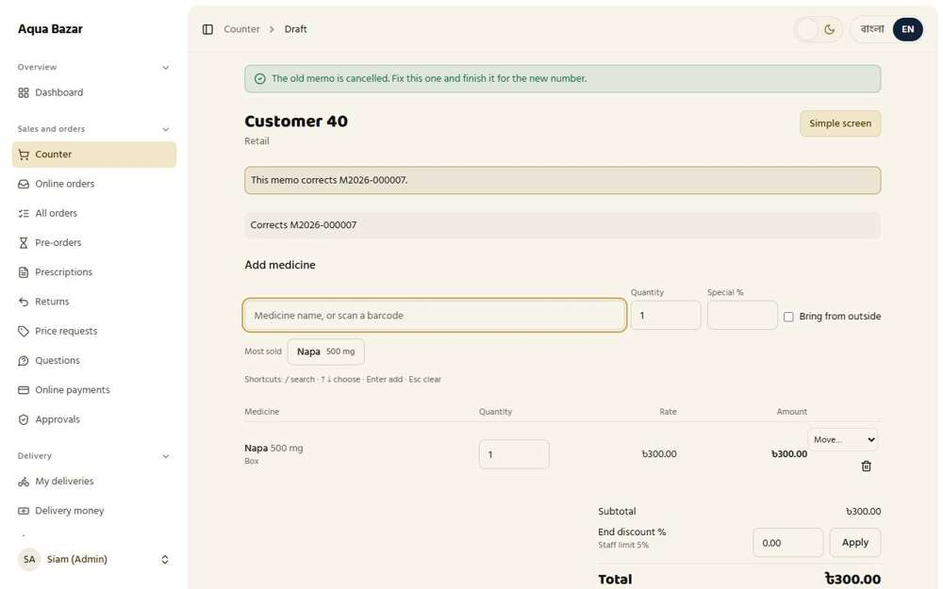
Seen as the owner | /admin/counter/163
130. "End of day" button Works
What it is for: An "End of day" button closes the day's drafts and totals.
What the tester did: Opened the End of day page.
What the tester saw:
- Yes. There is an end-of-day screen for closing the day
Step 1: End of day
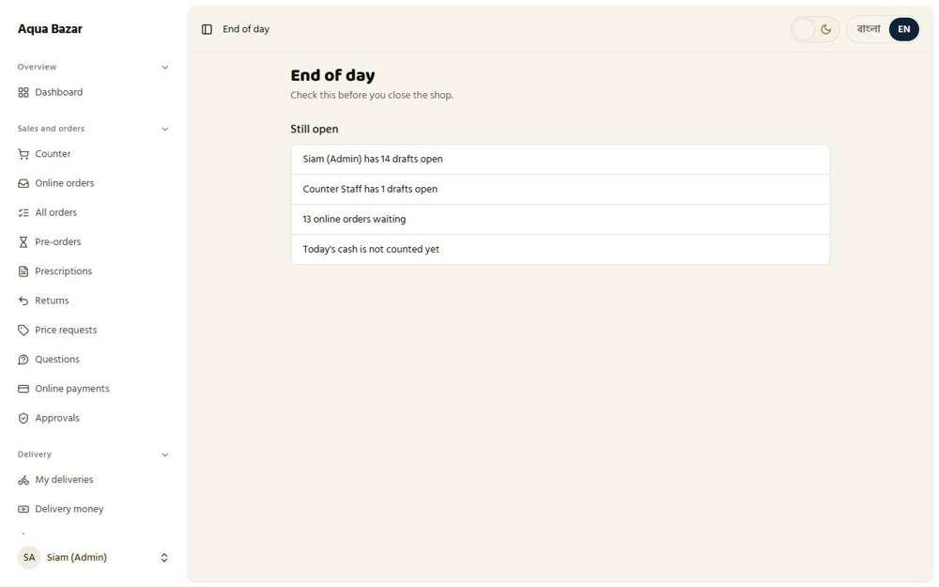
Seen as the owner | /admin/end-of-day
131. Draft-day rate applies Works
What it is for: A draft uses the rate that applied on the day it was started.
What the tester did: Added a box at the printed price of 300, then changed the printed price to 320, then reopened the draft and finished the sale.
What the tester saw:
- Yes. The draft keeps the rate it was started at (300)
Step 1: The draft after the printed price rose to 320 | Step 2: The finished memo
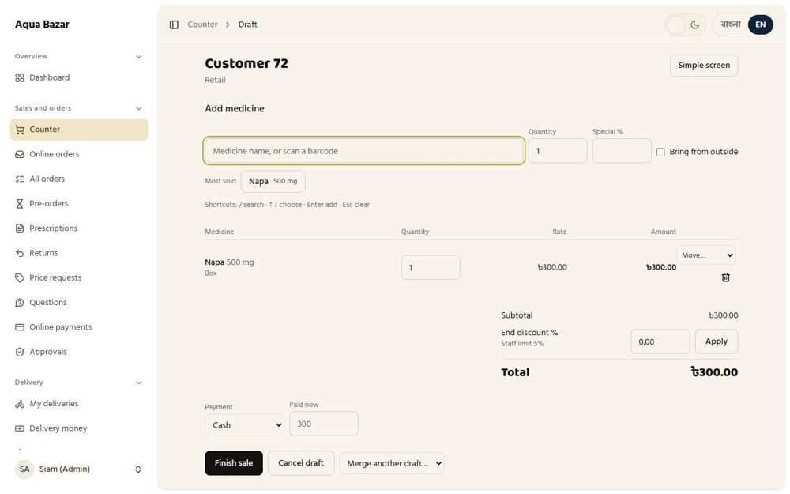  Seen as the owner | /admin/counter/220 | 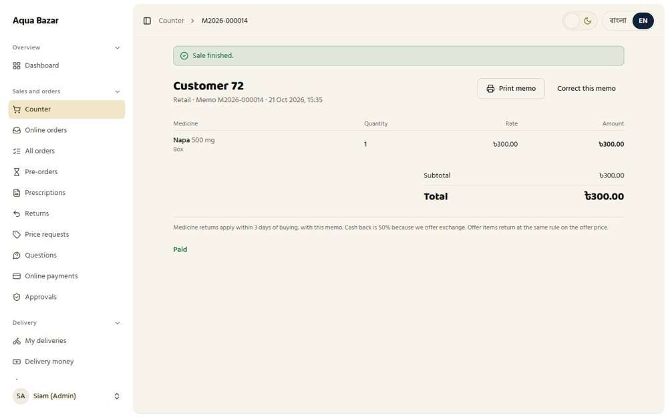  Seen as the owner | /admin/counter/220
132. Profit at the price of the lot used Works
What it is for: Profit is worked out from the cost of the batch actually used.
What the tester did: Read how profit is worked out on the stock report.
What the tester saw:
- Yes. The report says profit uses the cost of the lot each sale came from
Step 1: Profit uses the cost of the lot each sale came from
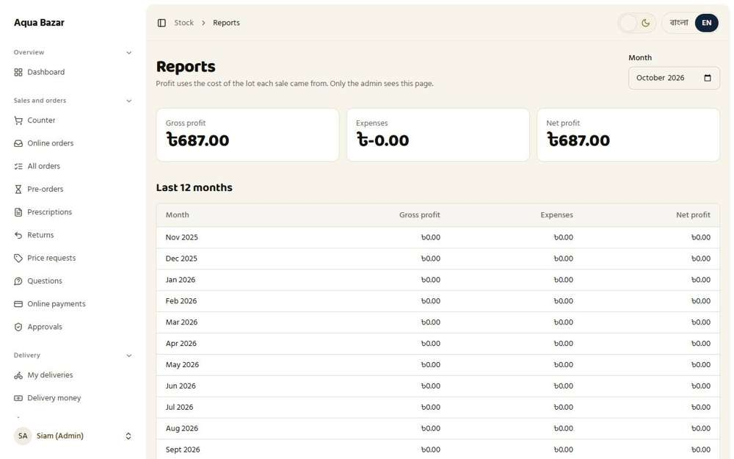
Seen as the owner | /admin/stock/reports

Paikari Sector
133. No stock shown (permanent) Works
What it is for: Paikari buyers never see how much stock the shop has. This is permanent.
What the tester did: Signed in as a paikari shop, searched for Napa and read the results looking for any mention of how much stock the shop holds.
What the tester saw:
- Yes. The results show prices and units, never how many the shop holds
- Yes. The medicine itself is listed
Step 1: The search results a paikari shop sees
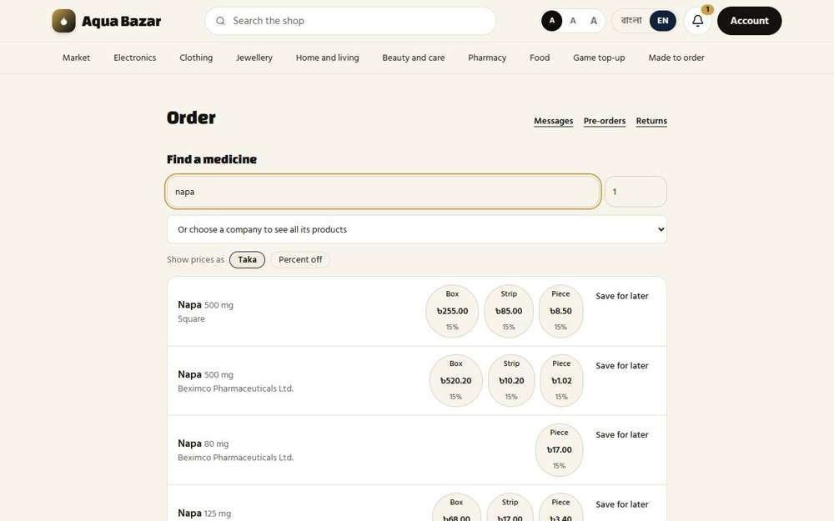
Seen as a paikari shop | /paikari
134. Medicine search and order Works
What it is for: A paikari buyer searches for a medicine and orders it, choosing the unit.
What the tester did: Searched for Napa, put a box on the order and sent it.
What the tester saw:
- Yes. The chosen medicine appears under "Your order"
- Yes. The order is sent and shows as "Checking…"
Step 1: Search results with a price for each unit | Step 2: The box is on "Your order"
Seen as a paikari shop | /paikari | 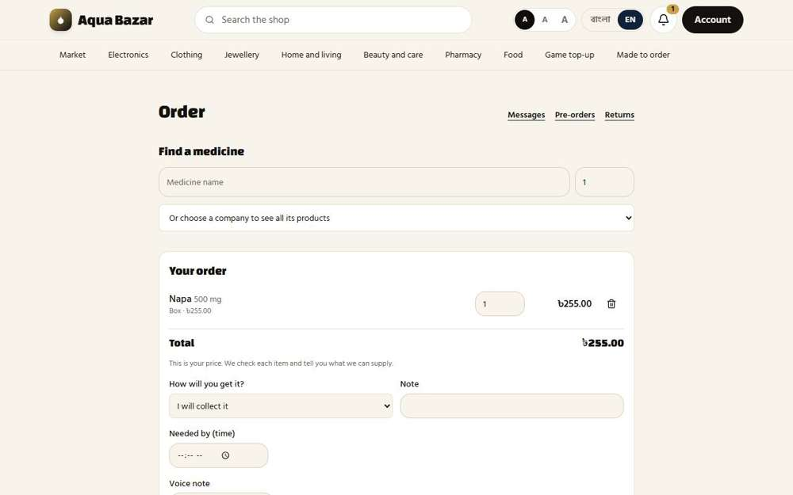  Seen as a paikari shop | /paikari
Step 3: The order has been sent and is being checked
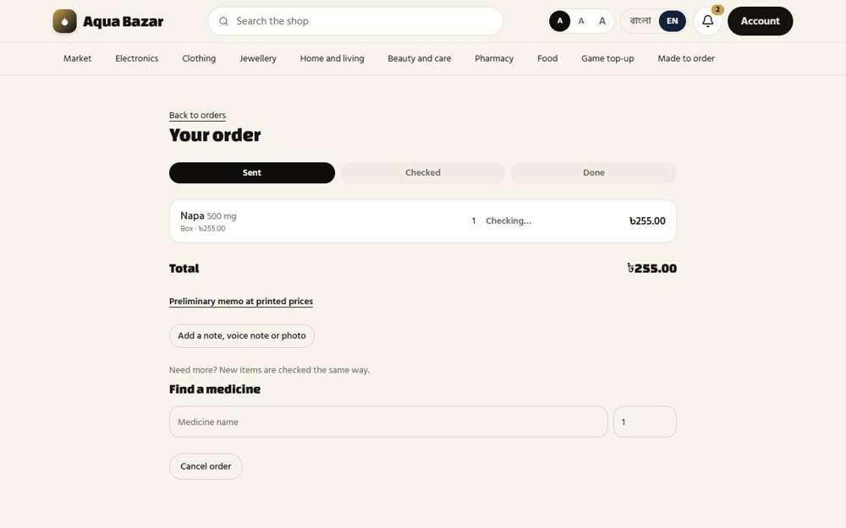
Seen as a paikari shop | /paikari/orders/168
135. Piece/strip/box Works
What it is for: A medicine can be ordered by piece, strip or box.
What the tester did: Looked at the unit choices under one medicine.
What the tester saw:
- Yes. A box can be ordered
- Yes. A strip can be ordered
- Yes. A single piece can be ordered
Step 1: Box, strip or piece, each with its own price
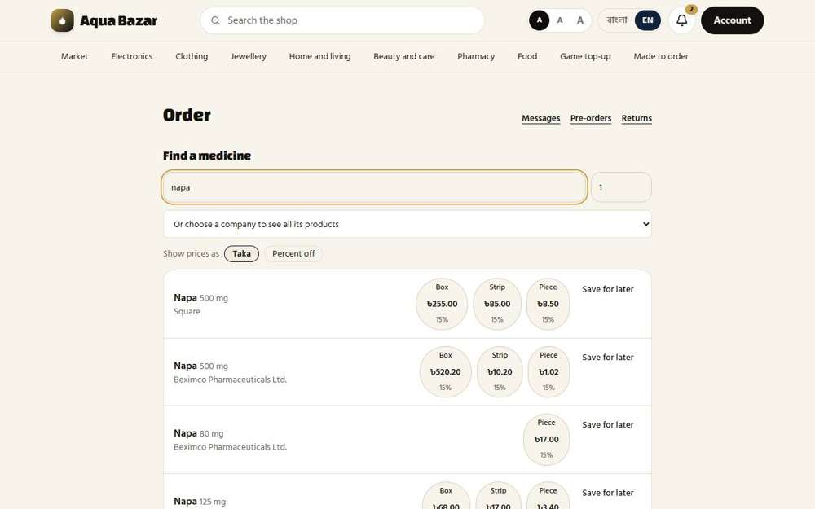
Seen as a paikari shop | /paikari
136. Short list (free feature) Works
What it is for: A free short list lets a shop save the medicines it buys often.
What the tester did: Pressed "Save for later" under a medicine to put it on the short list.
What the tester saw:
- Yes. The medicine goes onto a short list
Step 1: After "Save for later"
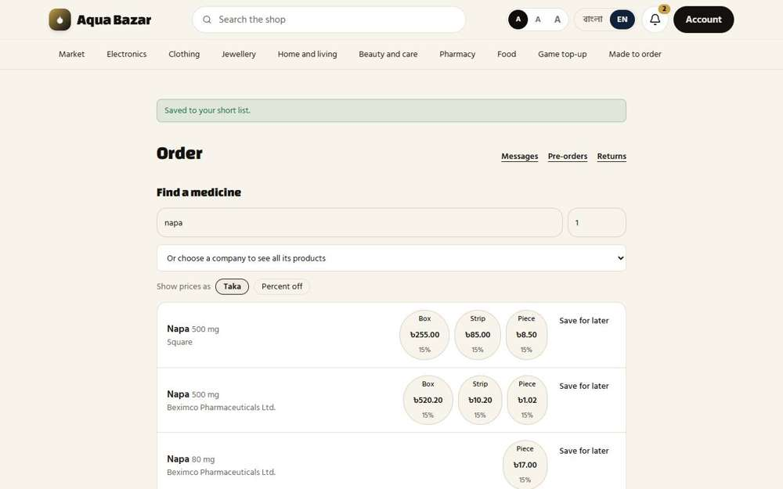
Seen as a paikari shop | /paikari
137. Order directly from short list Works
What it is for: An order can be placed straight from the short list.
What the tester did: Looked at the short list for a way to order from it directly.
What the tester saw:
- Yes. The short list is on the ordering screen
- Yes. Each short-list entry has an "Order now" button, so it can be ordered straight from the list
Step 1: The short list on the ordering screen, with an "Order now" button
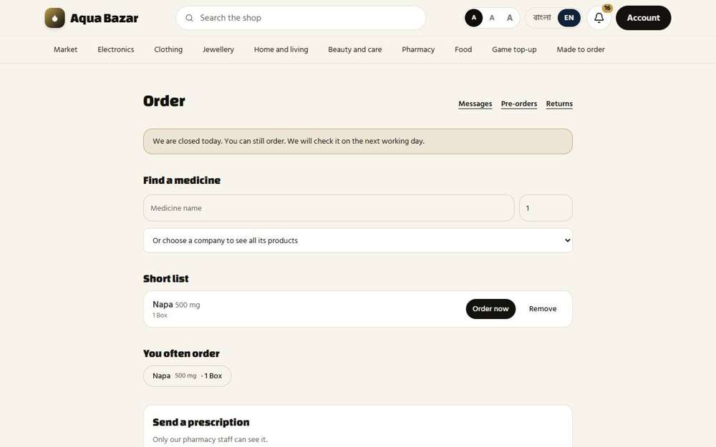
Seen as a paikari shop | /paikari
138. "Not available" items to PharmaTrack Works
What it is for: Medicines that are not available are sent to the PharmaTrack list.
What the tester did: Opened an order in the back office and looked for the "Not available" choice.
What the tester saw:
- Yes. Staff can mark a medicine "Not available"
Note: The record of medicines asked for but not available is kept on the Price requests and Reports pages.
Step 1: An order being checked: Full, Partial or Not available
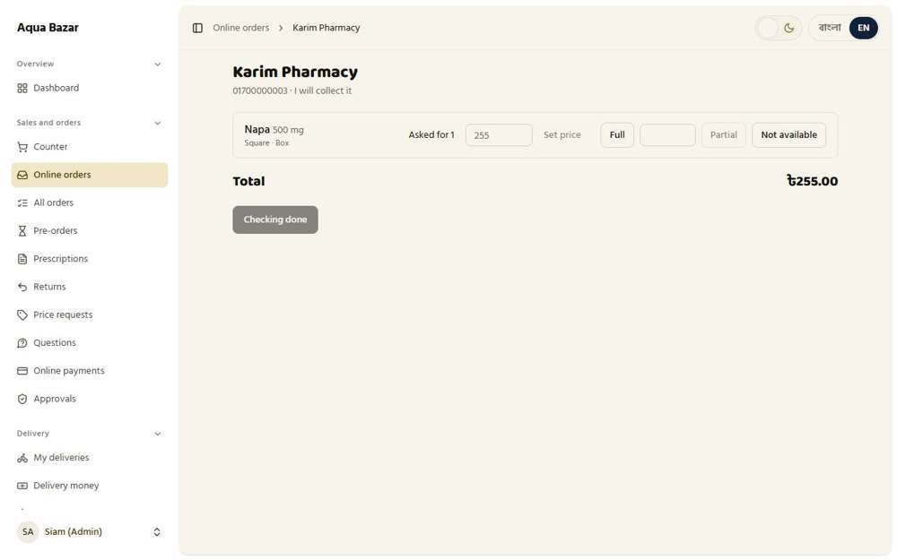
Seen as the owner | /admin/orders/168
139. Initial MRP memo Works
What it is for: An initial memo is shown at the printed price right after ordering.
What the tester did: After sending an order, read what the shop sees straight away.
What the tester saw:
- Yes. The shop gets a first memo at the printed prices straight away
Step 1: Right after sending: a memo at the printed price
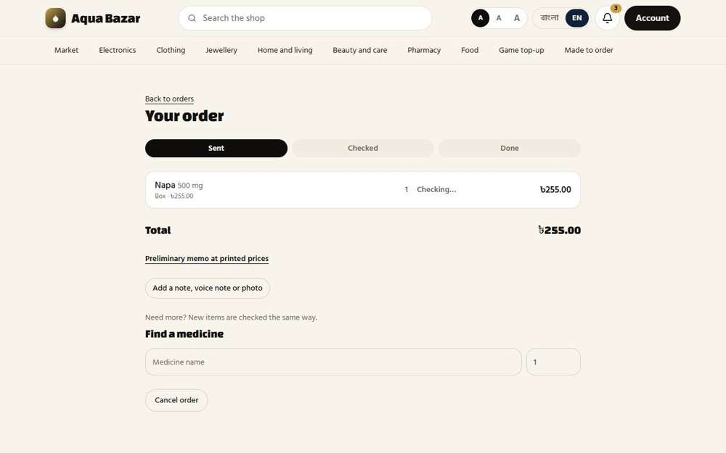
Seen as a paikari shop | /paikari/orders/169
140. Three-option verification (= draft) Works
What it is for: Staff check an order with three choices. Checking works like a draft.
What the tester did: Opened the newest order and looked at the three choices staff have for each item.
What the tester saw:
- Yes. Choice one: Full
- Yes. Choice two: Partial
- Yes. Choice three: Not available
Step 1: Full, Partial or Not available for each item
Seen as the owner | /admin/orders/169
141. Offer items marked by color/label on staff list Works
What it is for: Items on offer are marked with a colour or label on the staff list.
What the tester did: As a paikari shop, ordered 3 boxes through the offer and sent the order. Then the owner opened the online orders list.
What the tester saw:
- Yes. The order with an offer item is marked on the owner's list
Step 1: The offer boxes are in the shop's order | Step 2: The owner's list of online orders
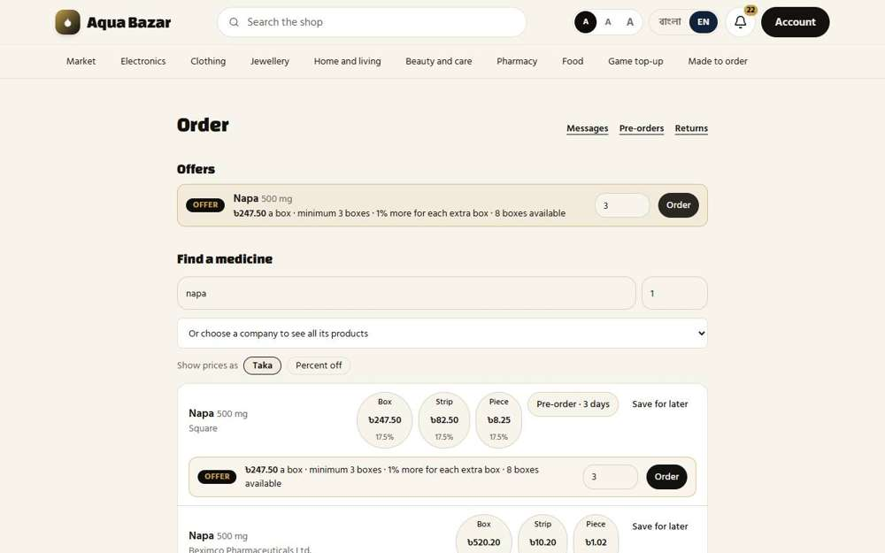  Seen as a paikari shop | /paikari | 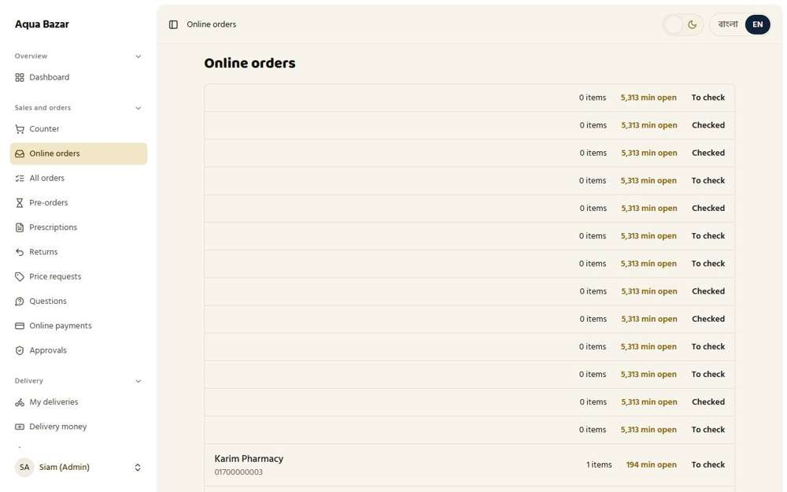  Seen as the owner | /admin/orders
142. Staff concurrency and live updates Works
What it is for: Several staff can work on orders at once, and the screen updates live.
What the tester did: Kept the shop's order page open. Meanwhile the owner marked the item Full and pressed "Checking done". Then looked at the shop's page without reloading it.
What the tester saw:
- Yes. The shop's open page updates by itself once the owner is done
Step 1: The shop's page while the order is still being checked | Step 2: The owner has finished checking
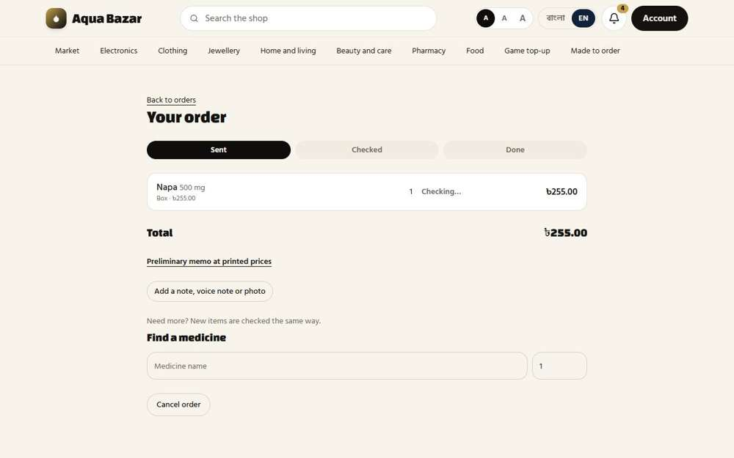  Seen as a paikari shop | /paikari/orders/170 | 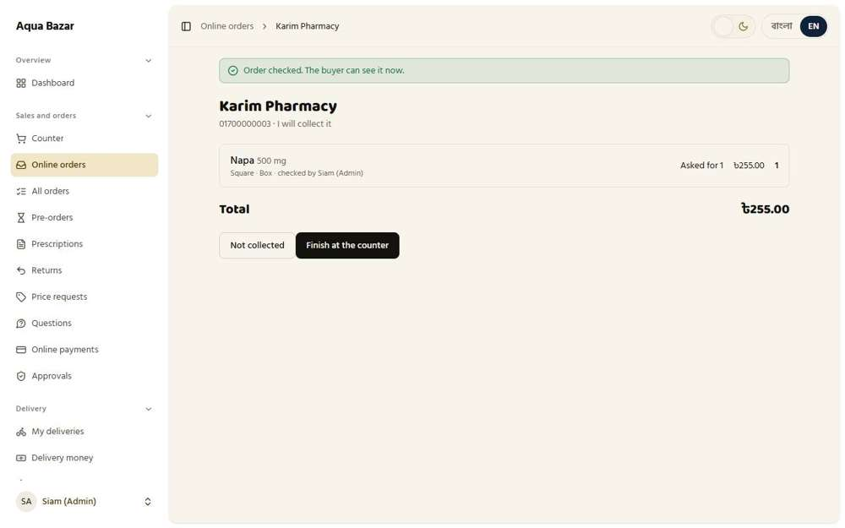  Seen as the owner | /admin/orders/170
Step 3: The shop's page, not reloaded, some seconds later
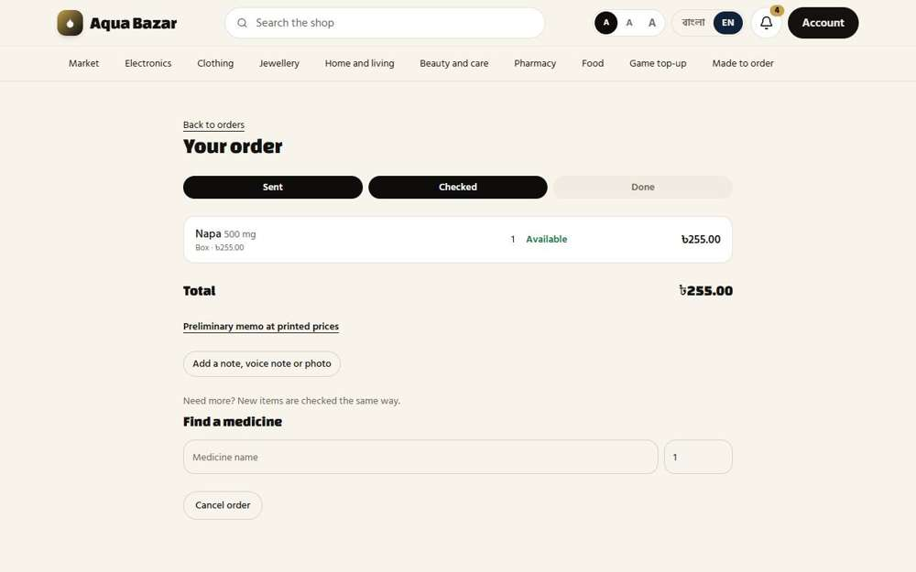
Seen as the owner | /paikari/orders/170
143. Buyer sees instantly Works
What it is for: The buyer sees the change instantly, without refreshing.
What the tester did: Looked at the shop's page right after the owner finished checking.
What the tester saw:
- Yes. The order and its result are shown
Step 1: The shop's page: the buyer sees the result at once
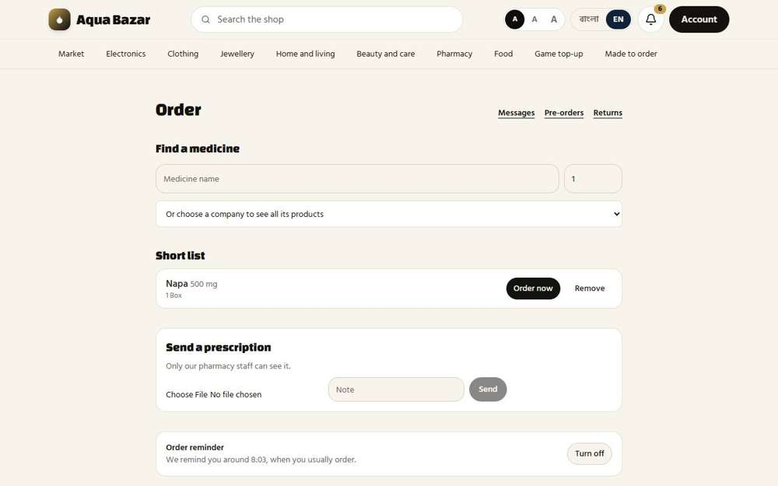
Seen as a paikari shop | /paikari
144. Real-time status Works
What it is for: The order status updates in real time for both sides.
What the tester did: Looked at the status words on the shop's orders.
What the tester saw:
- Yes. Each order shows a status
Step 1: Orders with their status
Seen as a paikari shop | /paikari
145. Final memo (at buyer's price) Works
What it is for: The final memo is made at the buyer's own price.
What the tester did: Sent an order and read the memo total on the shop's order page.
What the tester saw:
- Yes. Each box is priced at the shop's own price (255 for a box printed at 300)
- Yes. The memo link says it is the first, preliminary memo
Step 1: The shop's order page: the total is at the shop's own price
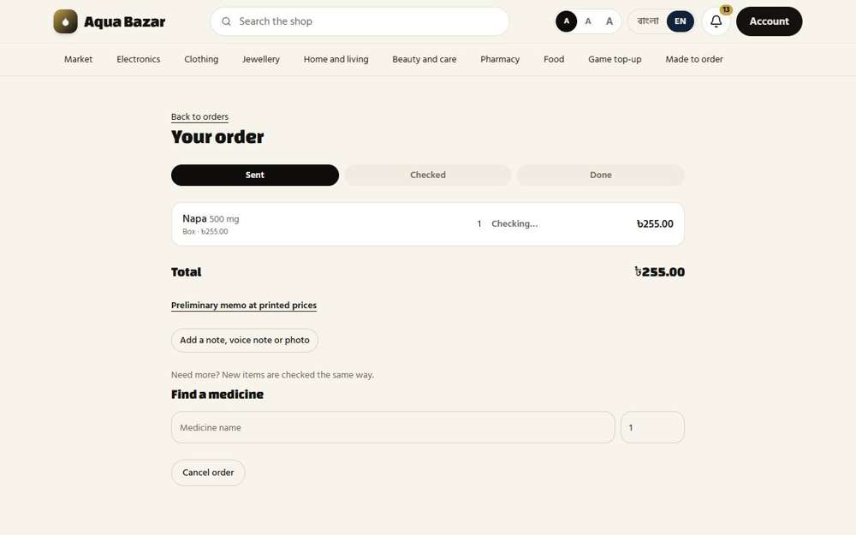
Seen as a paikari shop | /paikari/orders/175
146. Edit prices before sending Works
What it is for: Staff can edit prices before the memo is sent.
What the tester did: Opened a new order being checked, typed a different price for the item (250 instead of 255), pressed "Set price", then looked at the order from the shop's side.
What the tester saw:
- Yes. The owner changed the price and the total is 250
Step 1: The order before the price is changed | Step 2: After "Set price": the total is now 250
Seen as the owner | /admin/orders/173 | 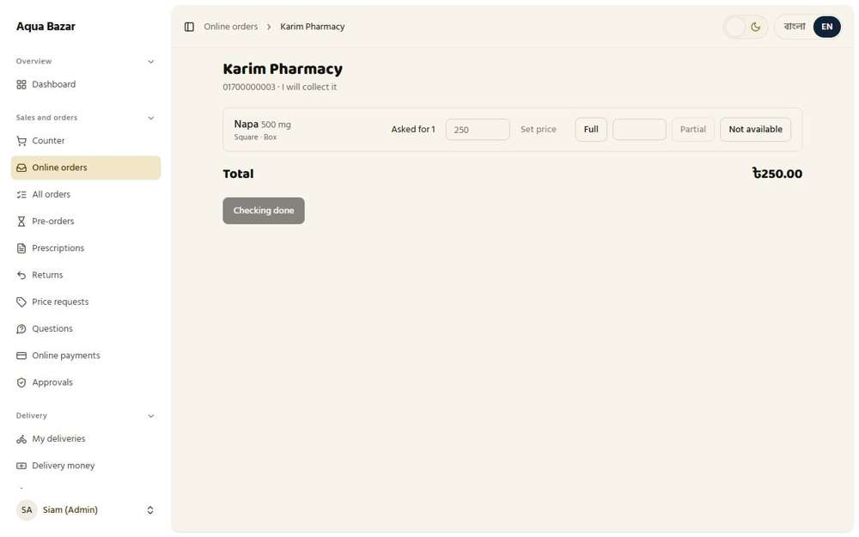  Seen as the owner | /admin/orders/173
Step 3: The shop's side shows the price the owner set
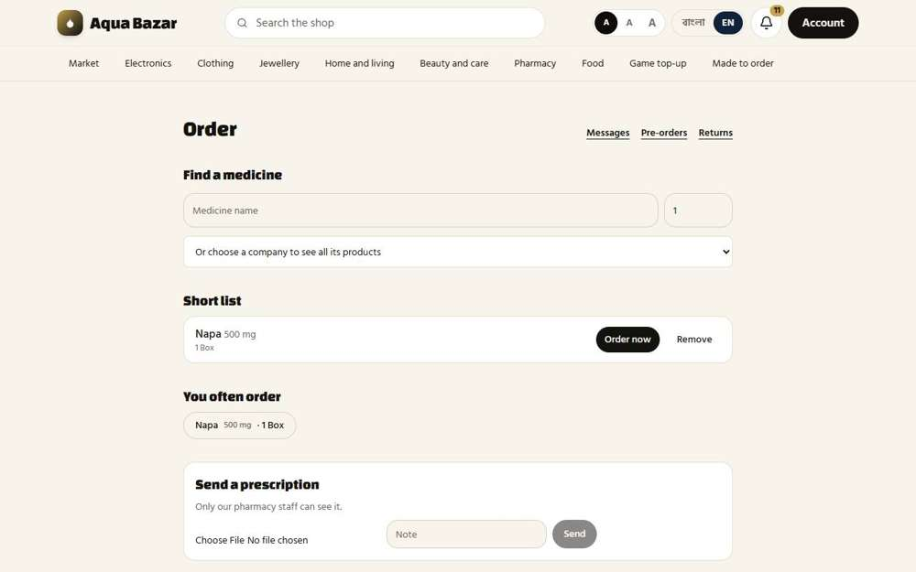
Seen as a paikari shop | /paikari
147. Add more after the memo Works
What it is for: The buyer can add more items after the memo was sent.
What the tester did: On an order that was already sent, read the note about adding more items.
What the tester saw:
- Yes. The shop can add more after the memo, and the new items are checked the same way
- Yes. The search box is still on the order page for adding more
Step 1: "Need more? New items are checked the same way."
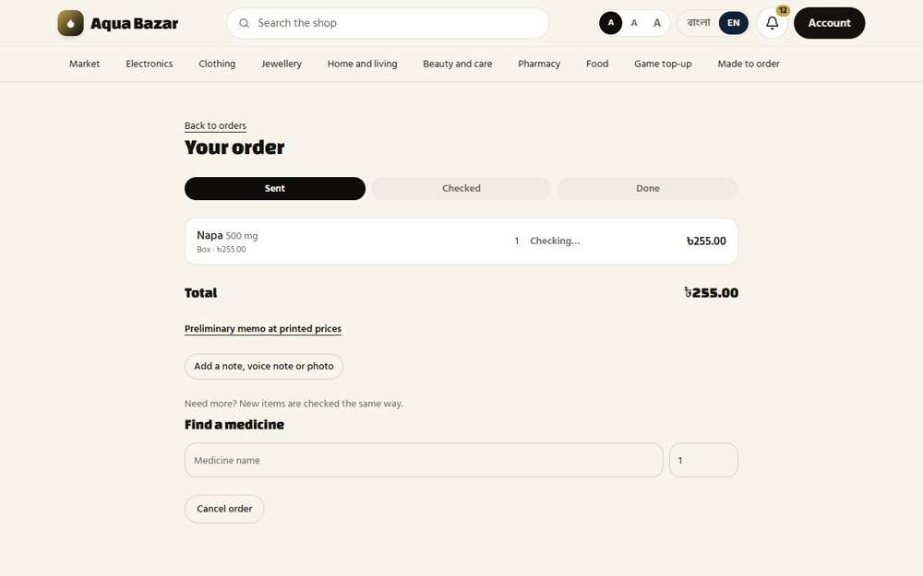
Seen as a paikari shop | /paikari/orders/174
148. Three collection options Works
What it is for: The buyer has three ways to collect the goods.
What the tester did: Looked at the choices for how to receive the goods.
What the tester saw:
- Yes. There are three collection options (I will collect it, Send it by courier, Deliver it to me)
Note: The choices are: I will collect it / Send it by courier / Deliver it to me
Step 1: Collection choices on the order
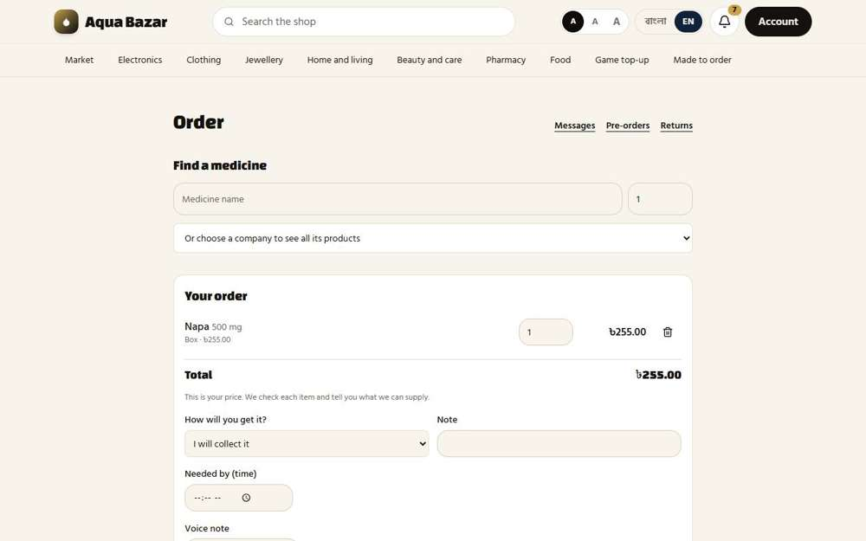
Seen as a paikari shop | /paikari
149. Delivery charge entered by hand Works
What it is for: The delivery charge is entered by hand by staff.
What the tester did: Looked for a box where staff type the delivery charge by hand.
What the tester saw:
- Yes. The order screen has a delivery charge to type in by hand
Step 1: The order screen
Seen as the owner | /admin/orders/171
150. Free delivery progress Works
What it is for: The buyer sees how far they are from free delivery.
What the tester did: Set free delivery to start at 300 taka and looked at the shop's order with one box (255) and with two boxes (510).
What the tester saw:
- Yes. The order shows how much more to add for free delivery
- Yes. Once the level is passed it says delivery is free
Step 1: One box with delivery to the shop: how far from free delivery | Step 2: Two boxes: the free delivery level is passed
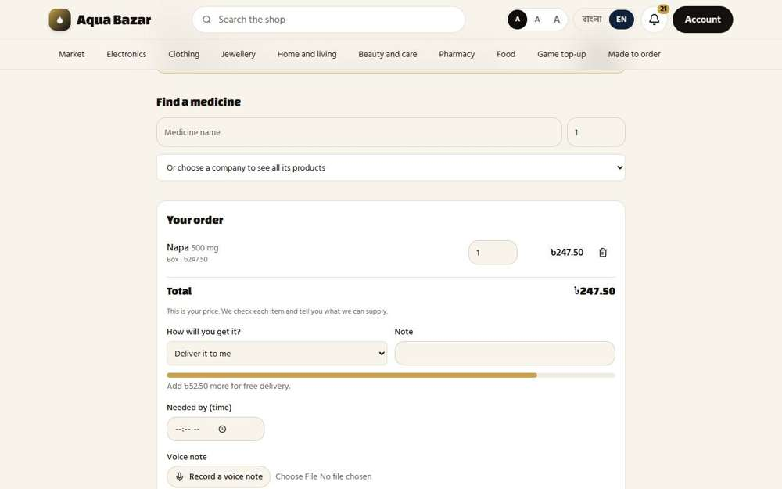  Seen as a paikari shop | /paikari | 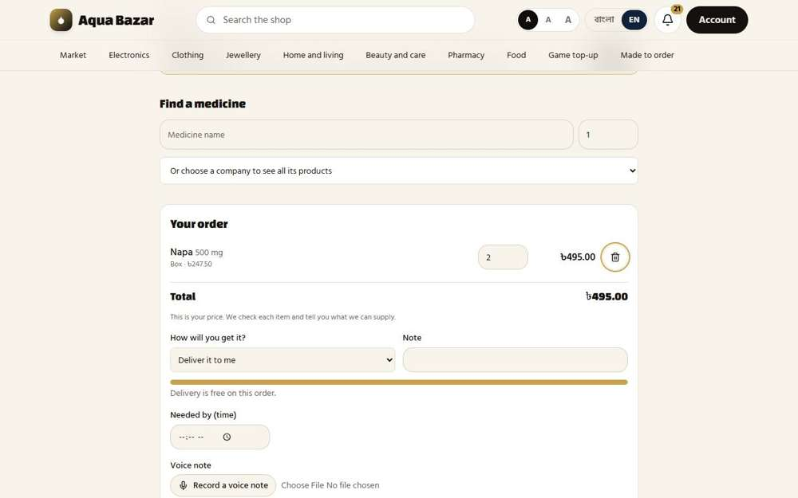  Seen as a paikari shop | /paikari
151. Warning past the threshold Works
What it is for: A warning shows when the order passes a set limit.
What the tester did: Set "Delivery charge paid first on orders of" to 100 taka, put a medicine in the public cart (300 taka) and opened checkout.
What the tester saw:
- Yes. An order above the limit warns that the delivery charge is paid first
Step 1: Checkout for an order above the limit
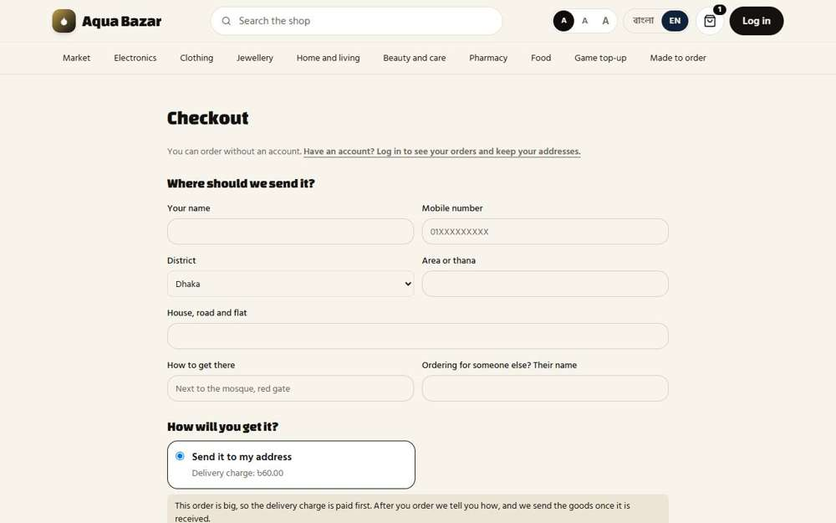
Seen as a stranger (not signed in) | /checkout
152. Placing orders on their behalf Works
What it is for: Staff can place orders on behalf of a customer who phones in.
What the tester did: At the counter, started a sale to Karim Pharmacy on the shop's behalf, as if the shop had phoned in.
What the tester saw:
- Yes. The sale is in the shop's name
Step 1: A sale started for Karim Pharmacy by the owner
Seen as the owner | /admin/counter/198
153. Quick note at the counter Works
What it is for: A quick note can be added at the counter.
What the tester did: At the counter, typed a quick note about a phone order from a shop and saved it.
What the tester saw:
- Yes. The note is kept under "Phone orders to enter"
Step 1: A quick note typed at the counter | Step 2: The note waits to be entered as an order
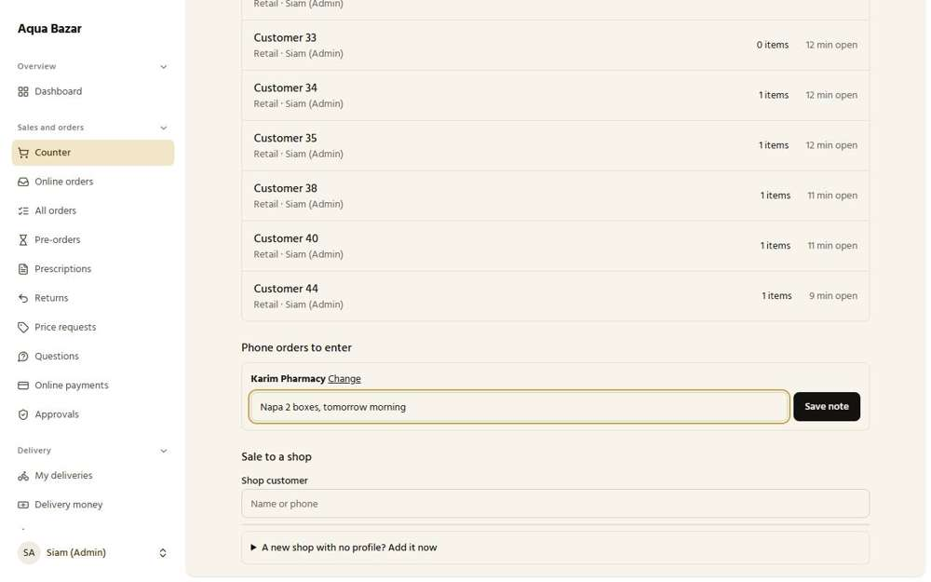  Seen as the owner | /admin/counter | 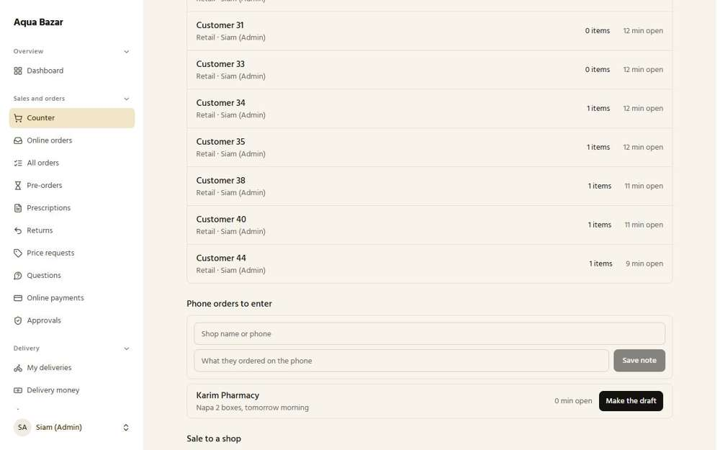  Seen as the owner | /admin/counter
154. Frequency-based suggestions Works
What it is for: The system suggests medicines the shop usually buys.
What the tester did: Looked at the shop's orders page for suggestions based on what the shop buys often.
What the tester saw:
- Yes. The ordering screen has a "You often order" list built from the shop's own orders
- Yes. It suggests Napa 500 mg, which the shop has ordered before
Step 1: "You often order": suggestions from what the shop has bought
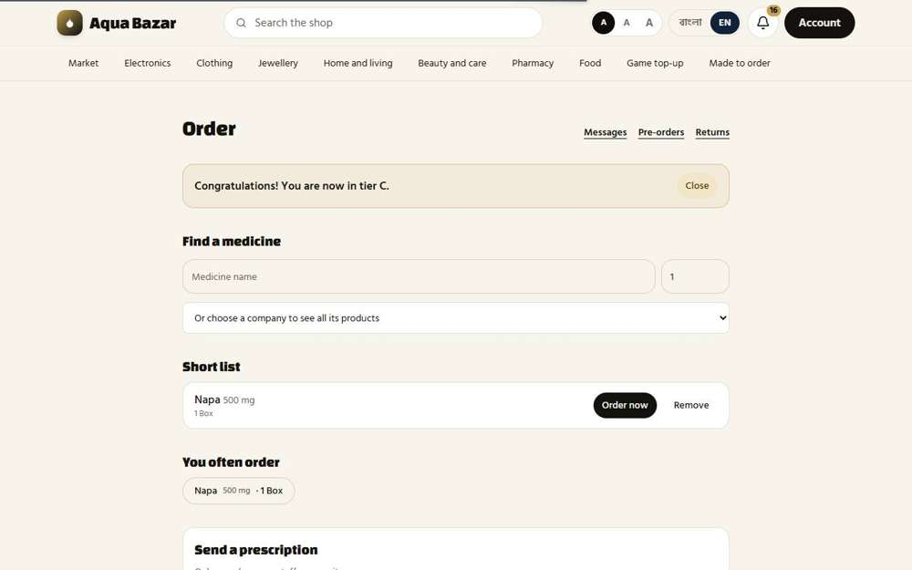
Seen as a paikari shop | /paikari
155. Habit-based reminders Only partly shown
What it is for: It reminds the shop when it usually reorders.
What the tester did: Read the reminder note on the shop's orders page.
What the tester saw:
- Yes. The shop is told it will be reminded when a regular medicine is due
Note: An actual reminder arriving at the right time was not reproduced, because it needs months of history.
Step 1: The reminder explained
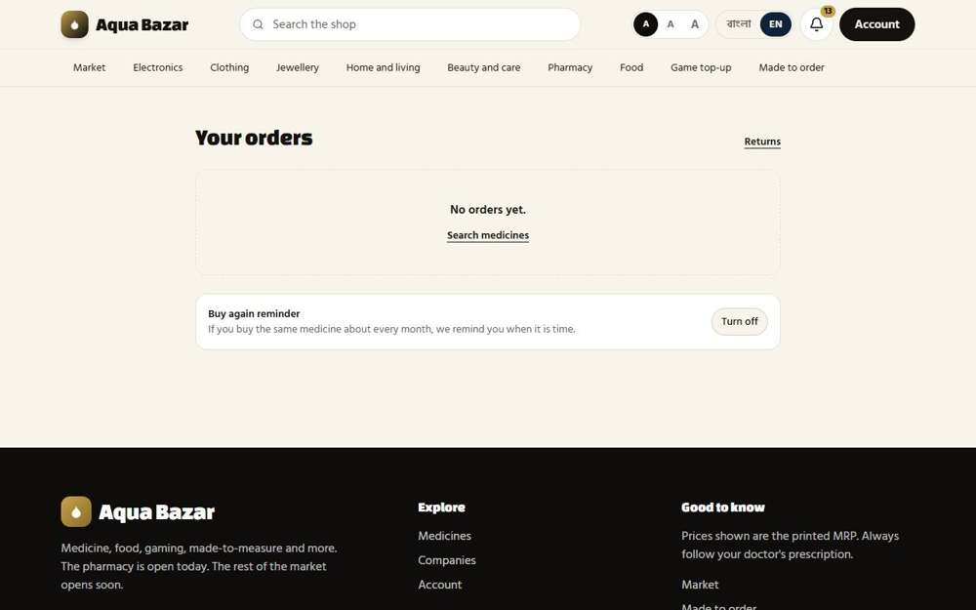
Seen as a paikari shop | /my-orders
156. Option to turn reminders off Works
What it is for: The shop can turn those reminders off.
What the tester did: Pressed "Turn off" on the reminder, saw it change, then turned it back on.
What the tester saw:
- Yes. The button changes to "Turn on", so the reminder is off
Step 1: After pressing Turn off
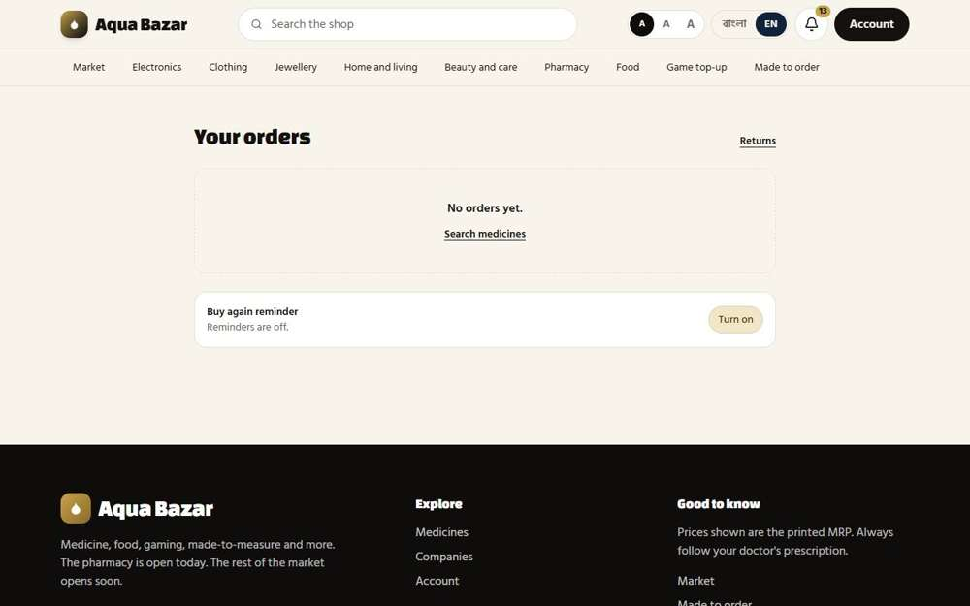
Seen as a paikari shop | /my-orders
157. Night-order note Works
What it is for: A note explains that orders sent at night are handled the next morning.
What the tester did: Made the owner's night hours cover the present time, then opened the shop's ordering screen.
What the tester saw:
- Yes. At night the shop is told its order will be checked in the morning
Note: The night hours follow the app's own clock, which is set to UTC, six hours behind Bangladesh. To make the message appear I set the night hours to match the app's clock. With the clock left on UTC, a Dhaka shop would be told "night" at the wrong time of day.
Step 1: At night: the shop is told when the order will be looked at
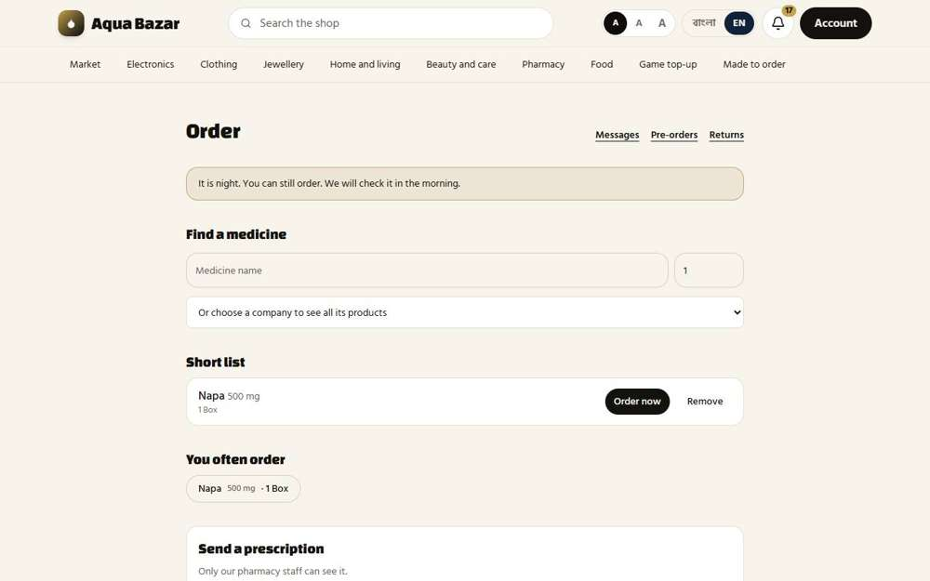
Seen as a paikari shop | /paikari
158. No order cut-off Works
What it is for: There is no cut-off hour. Orders can be placed at any time.
What the tester did: Sent an order while the screen said it was night.
What the tester saw:
- Yes. The order was accepted at night: there is no cut-off time
Step 1: An order accepted during the night
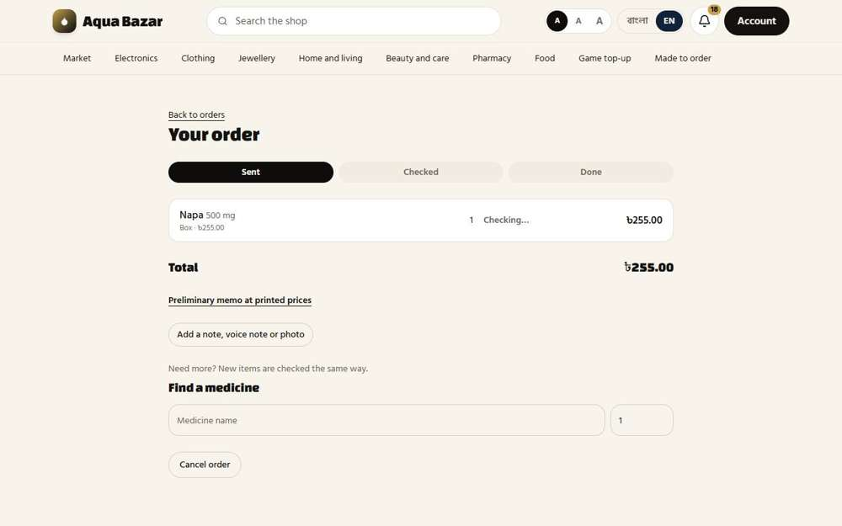
Seen as a paikari shop | /paikari/orders/180
159. Holiday order message ("next working day") Works
What it is for: On holidays the buyer is told the order goes out on the next working day.
What the tester did: Marked today as a closed day in the owner's settings and opened the shop's ordering screen.
What the tester saw:
- Yes. The shop sees a message about the closed day and the next working day
Step 1: Today added as a closed day | Step 2: The shop is told the shop is closed and when the order will be looked at
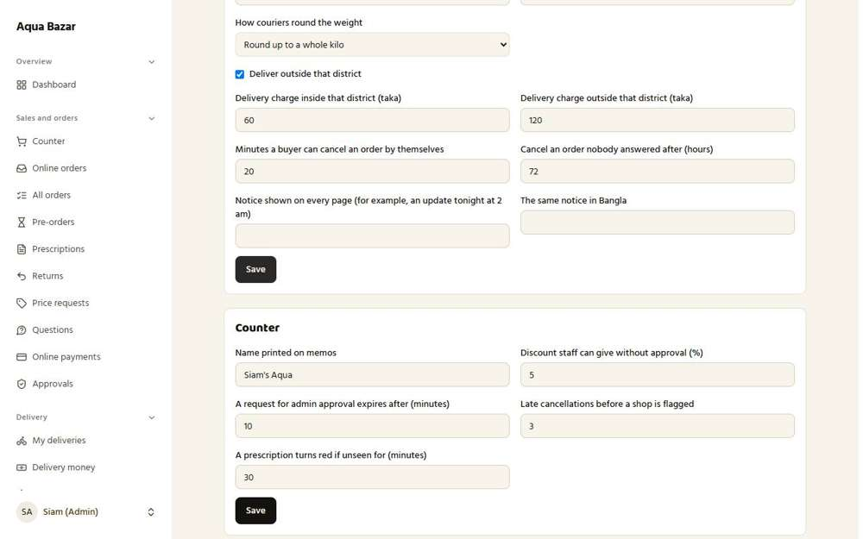  Seen as the owner | /admin/settings | 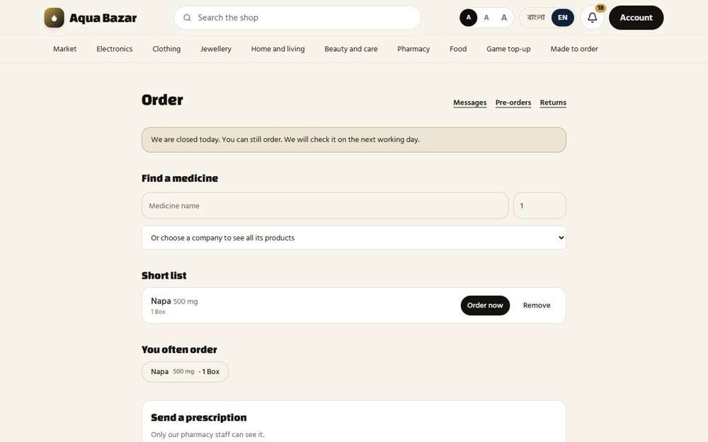  Seen as a paikari shop | /paikari
160. Three cancellation states Only partly shown
What it is for: An order can be cancelled in three different ways, depending on how far it got.
What the tester did: Sent an order and then pressed "Cancel order" while it was still waiting to be checked.
What the tester saw:
- Yes. The order is cancelled
Note: Only one of the three cancellation situations was shown (cancelled before it was checked). The others, after checking and after packing, need the owner to move the order along first.
Step 1: An order just sent, with its Cancel order button | Step 2: After cancelling
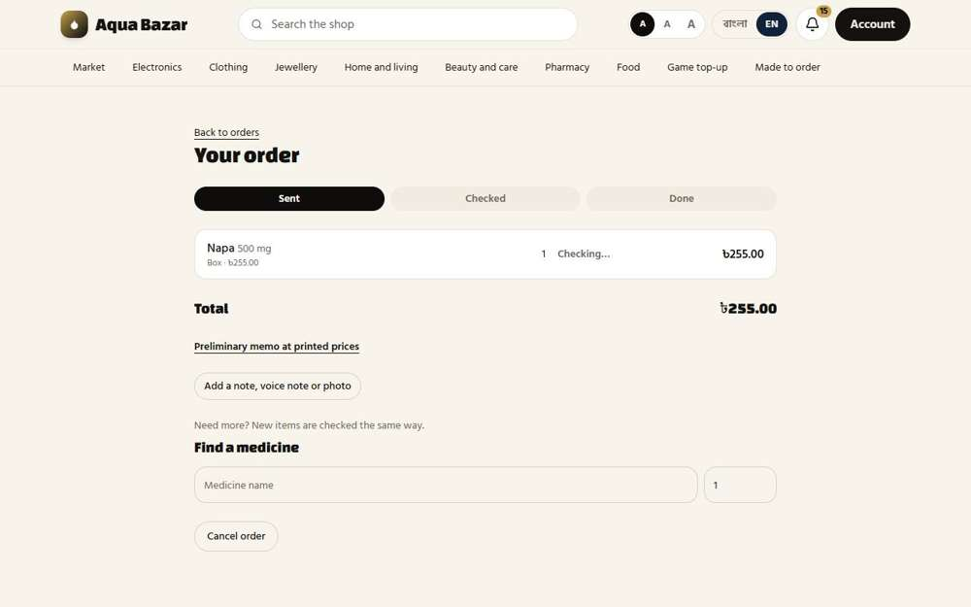  Seen as a paikari shop | /paikari/orders/177 | 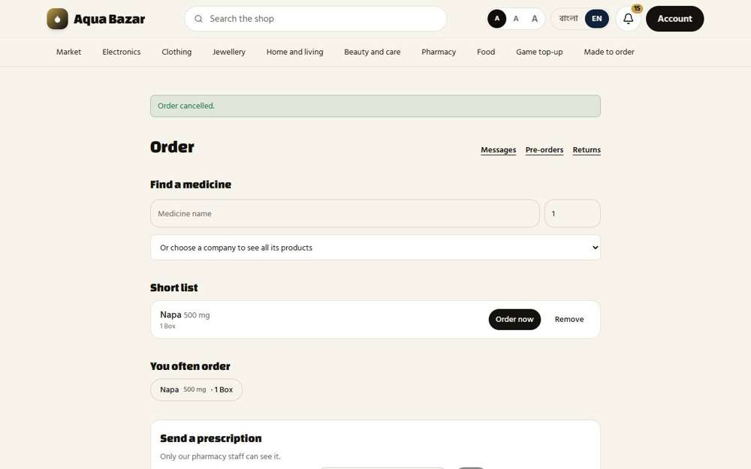  Seen as a paikari shop | /paikari
161. Packed but not collected — refund and stock back Only partly shown
What it is for: If goods were packed but not collected, the money is refunded and stock returns.
What the tester did: Looked at the settings that govern cancelling and packed orders that are not collected.
What the tester saw:
- Yes. The owner sets how long a buyer may cancel alone
Note: Packing an order, not collecting it, and seeing the refund and stock return was not carried through.
Step 1: The cancelling settings
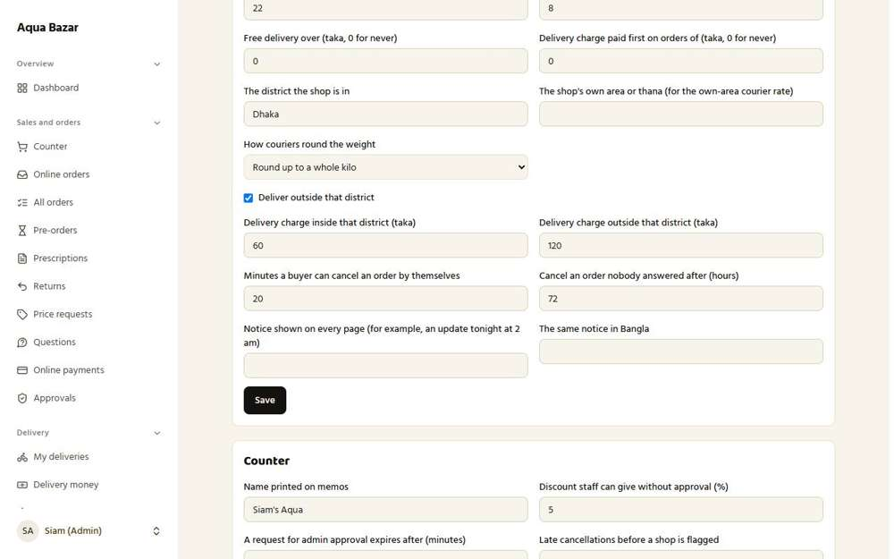
Seen as the owner | /admin/settings
162. Auto-flagging problem customers Only partly shown
What it is for: Customers who often cause problems are flagged automatically.
What the tester did: Looked for a flag on shops that keep cancelling late.
Note: A shop being flagged after repeated late cancellations was not reproduced.
Step 1: The customer list
Seen as the owner | /admin/customers
163. Flagging count in settings Works
What it is for: The number of problems before a flag appears can be set in settings.
What the tester did: Looked in the settings for the number of late cancellations before a shop is flagged.
What the tester saw:
- Yes. The owner can set how many late cancellations flag a shop
Step 1: The "flagged" setting
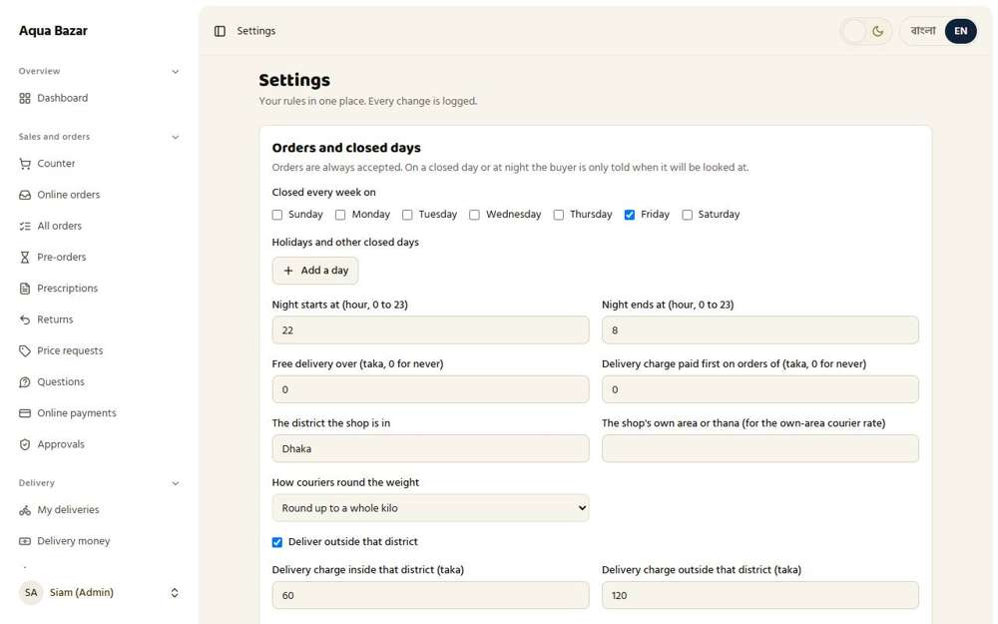
Seen as the owner | /admin/settings
164. Monthly business total shown Works
What it is for: A buyer's monthly business total is shown on their account.
What the tester did: Switched on "Show the monthly total" for Karim Pharmacy and looked at what the shop sees.
What the tester saw:
- Yes. The shop can see its own total for the month
Step 1: The owner switches the monthly total on for this shop | Step 2: The shop's page
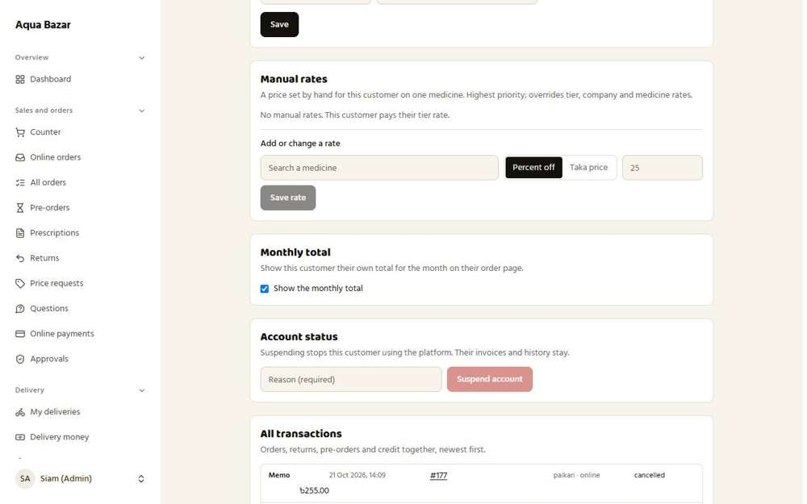  Seen as the owner | /admin/customers/4 | 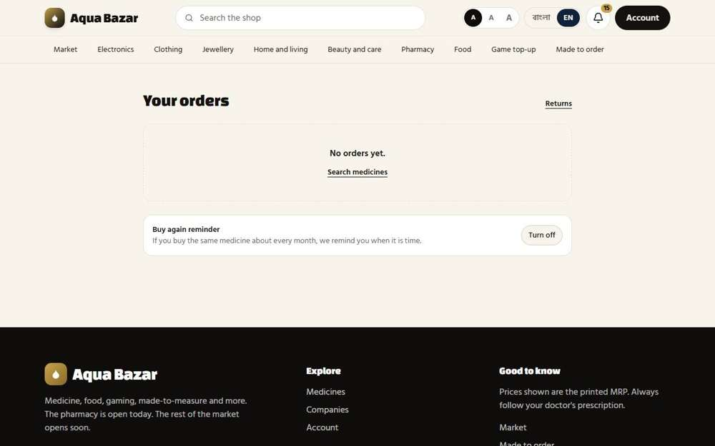  Seen as a paikari shop | /my-orders
165. Toggle for whom to show Works
What it is for: The owner decides which customers can see their own monthly total.
What the tester did: Looked at the switch the owner uses to decide which shops see their monthly total.
What the tester saw:
- Yes. The owner decides, shop by shop, who sees their monthly total
Step 1: The "Monthly total" switch on a customer
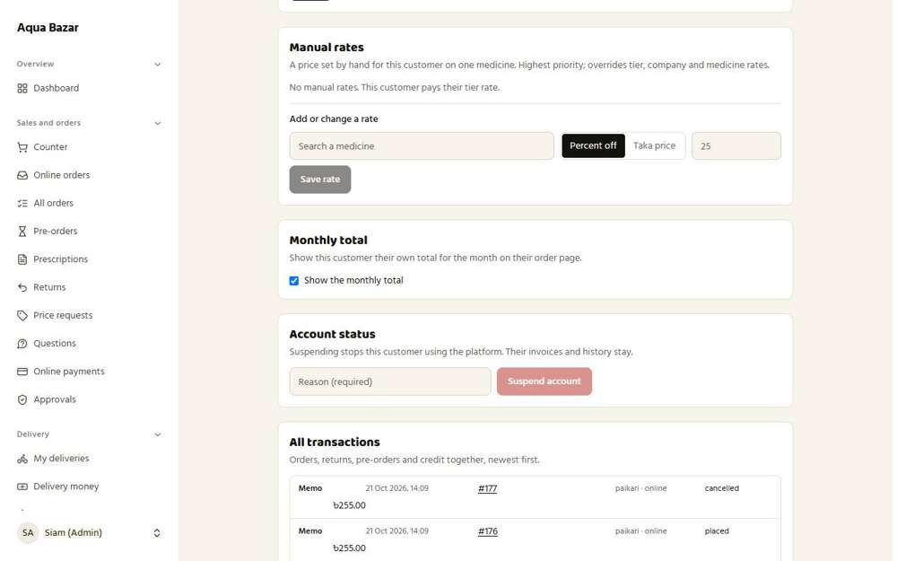
Seen as the owner | /admin/customers/4
166. Tier upgrade like a task Only partly shown
What it is for: Moving to a higher tier is handled like a task for the owner to approve.
What the tester did: Looked for the tier upgrade task that appears near the end of the month.
What the tester saw:
- Yes. The owner sets the month-end window for tier tasks
Note: A shop qualifying for the next tier at month end was not reproduced, because it needs a month of sales.
Step 1: The month-end tier task setting
Seen as the owner | /admin/settings
167. I check and upgrade Works
What it is for: The owner checks the total and upgrades the tier.
What the tester did: Changed the shop's tier by hand, as the owner does when checking an upgrade.
What the tester saw:
- Yes. The owner can upgrade the shop with one save
Step 1: The owner moves the shop up a tier
Seen as the owner | /admin/customers/4
168. Congratulations message on upgrade Works
What it is for: The buyer gets a congratulations message on being upgraded.
What the tester did: After the owner moved the shop up a tier, looked at what the shop saw.
What the tester saw:
- Yes. The shop gets a congratulations message naming its new tier
Step 1: The shop is congratulated
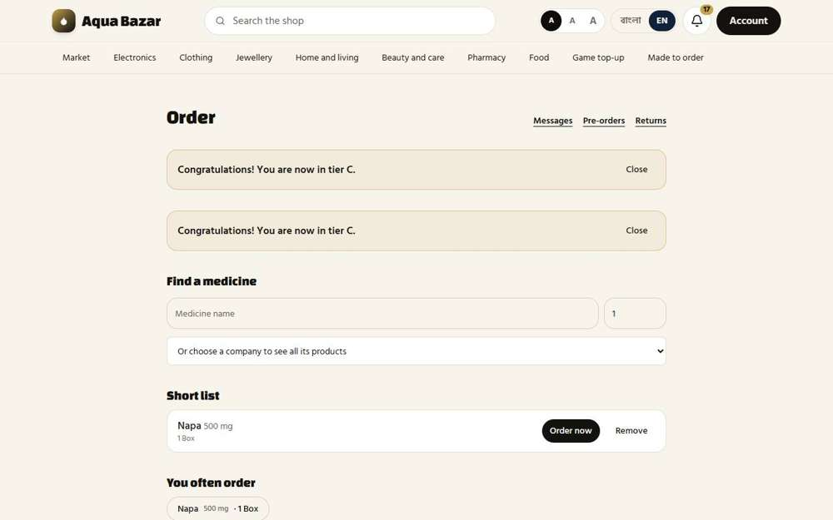
Seen as a paikari shop | /paikari
169. Prescription upload (only to my side) Works
What it is for: A buyer uploads a prescription. Only the shop can see it.
What the tester did: On the ordering screen, attached a prescription photo and sent it.
What the tester saw:
- Yes. The prescription is on the owner's Prescriptions page
Step 1: A prescription chosen, with a note | Step 2: After sending the prescription
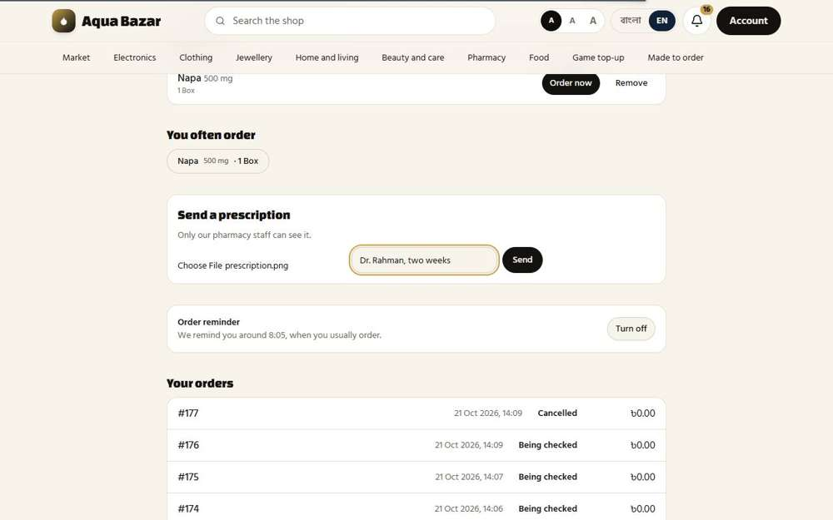  Seen as a paikari shop | /paikari | 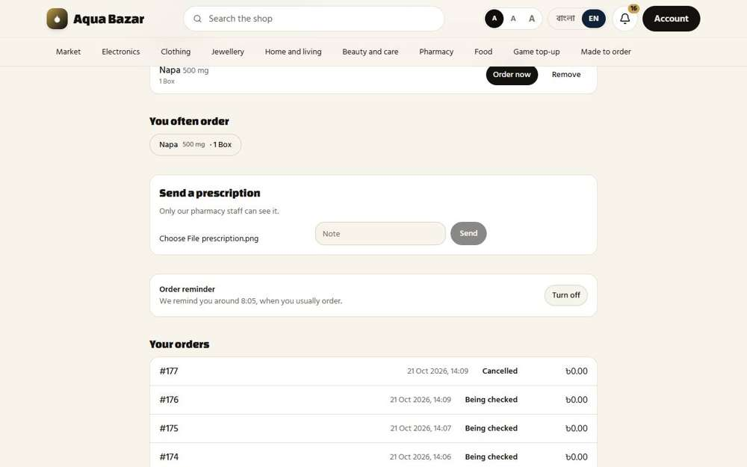  Seen as a paikari shop | /paikari
Step 3: The prescription arrives on the owner's side only
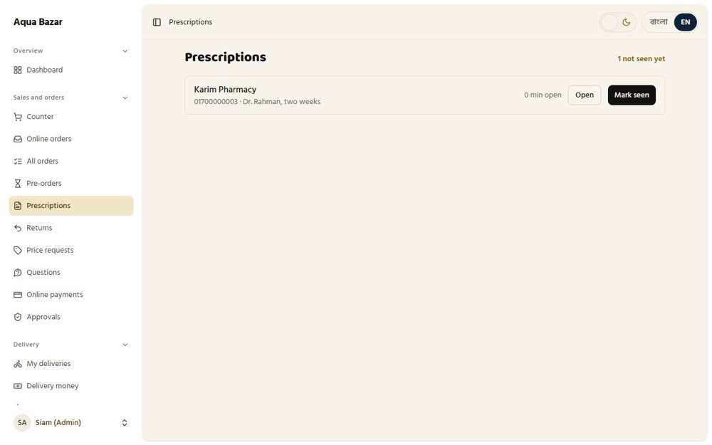
Seen as the owner | /admin/prescriptions
170. Unseen prescription count Works
What it is for: The shop sees how many prescriptions are still unseen.
What the tester did: Looked at the owner's menu and Prescriptions page for the count of prescriptions not yet seen.
What the tester saw:
- Yes. The page shows how many prescriptions are waiting to be seen
Step 1: Prescriptions, with the count of unseen ones
Seen as the owner | /admin/prescriptions

Counter Sale
171. Three sections (retail/paikari/wholesale) Works
What it is for: The counter has three sections: retail, paikari and wholesale.
What the tester did: Started a retail sale, a sale to a paikari shop, and a sale to a wholesaler, and looked at how each is labelled.
What the tester saw:
- Yes. A walk-in sale is a Retail sale
- Yes. A sale to Karim Pharmacy is in the paikari section
- Yes. A sale to Rahim Traders is in the wholesale section
Step 1: Section one: Retail | Step 2: Section two: a paikari shop
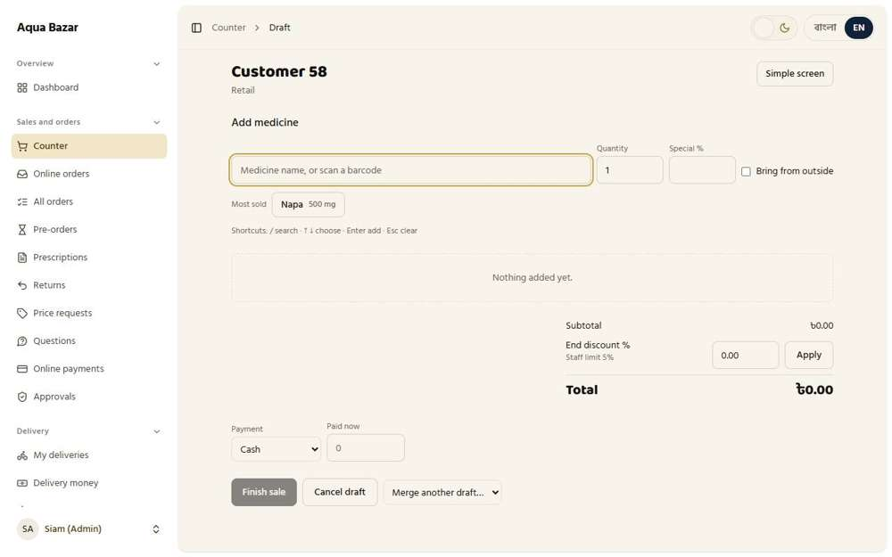  Seen as the owner | /admin/counter/201 | Seen as the owner | /admin/counter/200
Step 3: Section three: a wholesaler
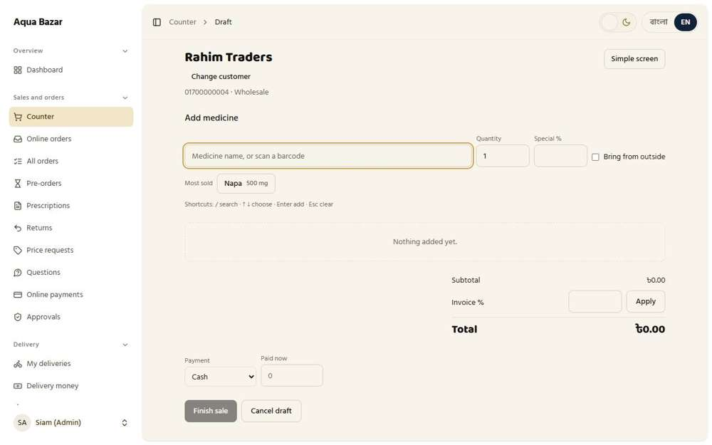
Seen as the owner | /admin/counter/192
172. Rate priority (medicine → invoice → tier) Works
What it is for: Rates are picked in order: the medicine's rate, then the invoice's, then the tier's.
What the tester did: Sold a box of Napa to Karim Pharmacy with and without a hand-set price, to see which rate the counter uses first.
What the tester saw:
- Yes. The hand-set price for this shop (246) is used first
- Yes. With no hand-set price the tier rate is used (255)
Step 1: With a hand-set rate of 18%, the counter offers the box at 246 | Step 2: Without it, the shop's tier rate (255) is used
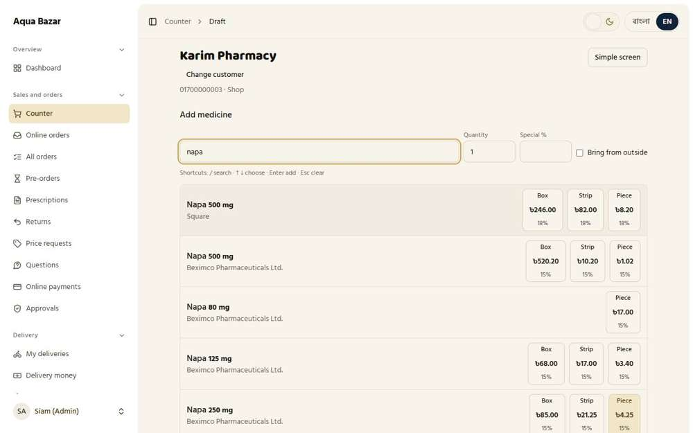  Seen as the owner | /admin/counter/200 | 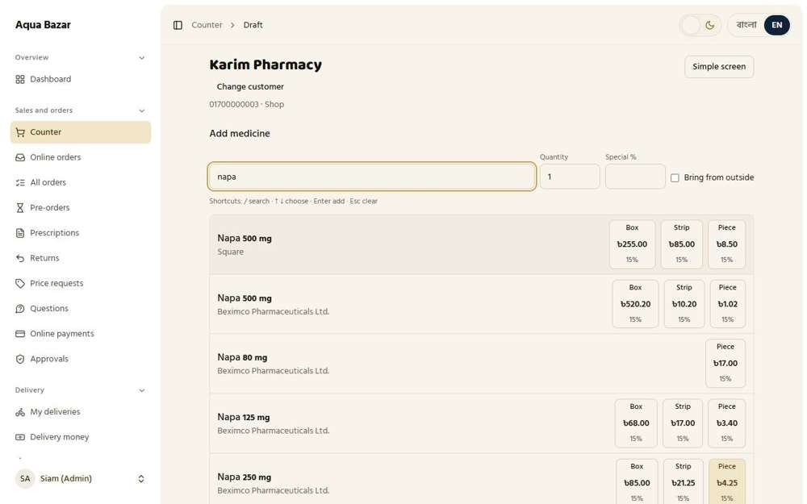  Seen as the owner | /admin/counter/202
173. Search and select customer Works
What it is for: Staff search for a customer and select them.
What the tester did: Typed part of a shop's name in the customer box and chose the shop from the suggestions.
What the tester saw:
- Yes. The shop appears as the owner types, to be chosen
Step 1: Suggestions as the owner types
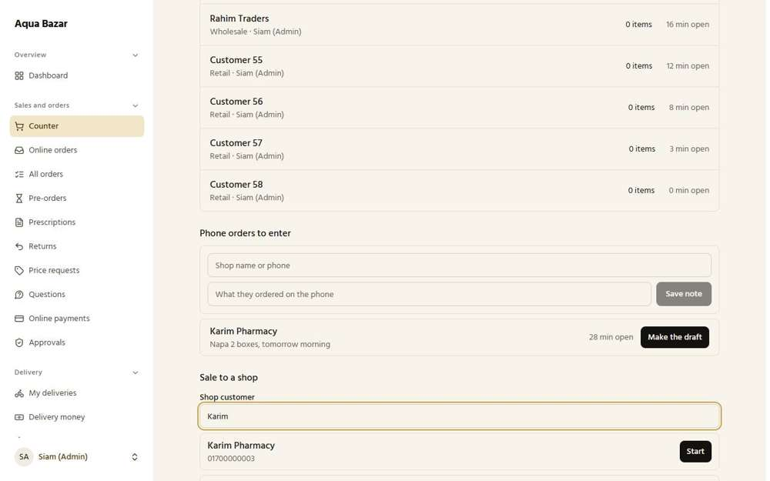
Seen as the owner | /admin/counter
174. Sale added to e-commerce profile Works
What it is for: A counter sale also appears on the customer's own online profile.
What the tester did: Sold a box to Karim Pharmacy at the counter, then opened the shop's profile.
What the tester saw:
- Yes. The counter sale is on the shop's profile under All transactions
Step 1: The counter sale is finished | Step 2: The shop's profile lists its transactions
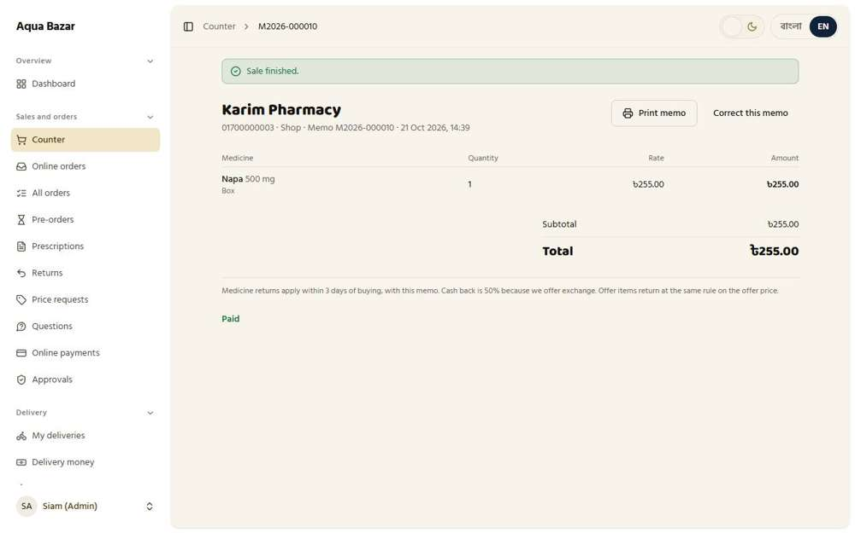  Seen as the owner | /admin/counter/203 | 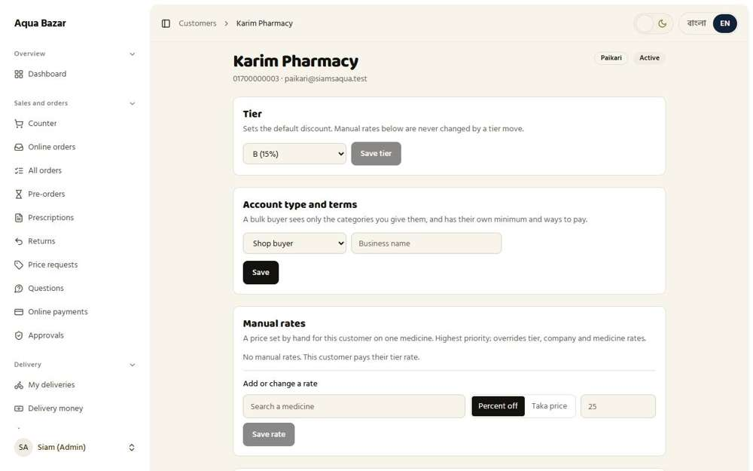  Seen as the owner | /admin/customers/4
175. Shop owner doesn't see their own total Works
What it is for: A shop owner does not see their own purchase total at the counter.
What the tester did: Looked at the shop's own pages for its monthly total when the owner has not switched it on.
What the tester saw:
- Yes. The shop does not see its own monthly total unless the owner switches it on
Step 1: The shop's page, with the monthly total switched off
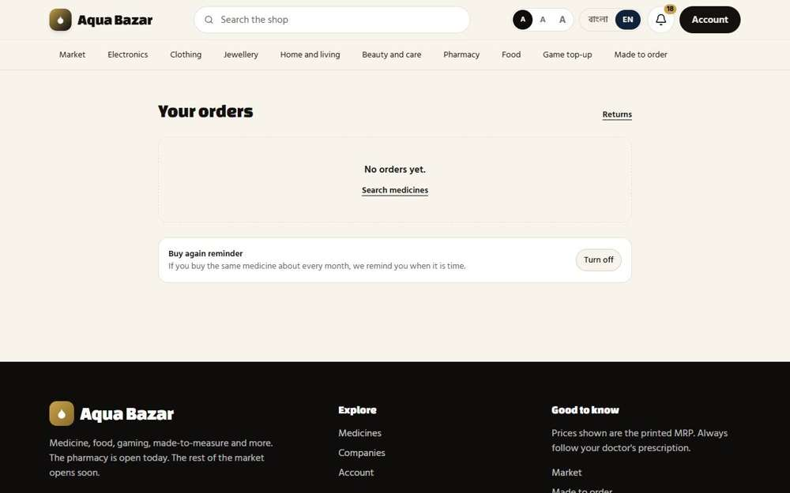
Seen as a paikari shop | /my-orders
176. Quick profile creation at the counter Works
What it is for: A new customer can be created quickly at the counter.
What the tester did: Opened "A new shop with no profile? Add it now" at the counter and added a shop.
What the tester saw:
- Yes. A shop can be added at the counter with its name and phone
Note: The quick form has 3 boxes.
Step 1: The quick form for a new shop
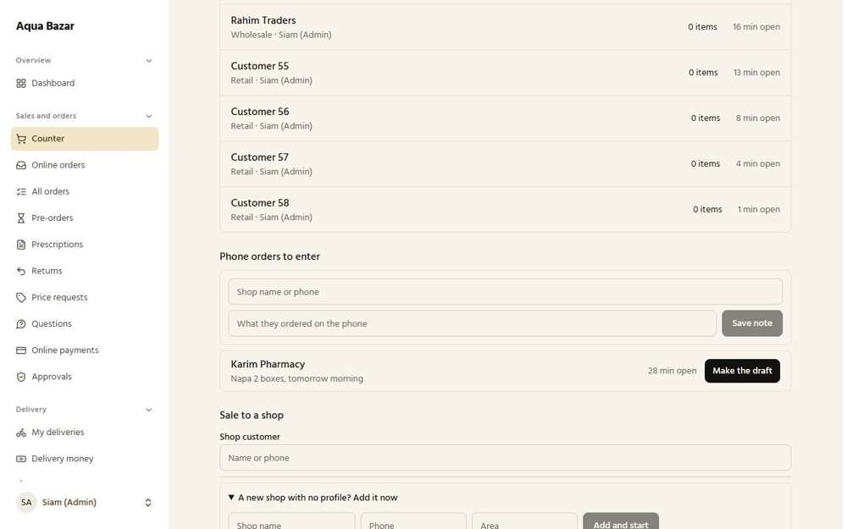
Seen as the owner | /admin/counter
177. Area and phone shown in search Works
What it is for: Area and phone are shown in the customer search to tell people apart.
What the tester did: Looked at what shows beside each shop in the counter search.
What the tester saw:
- Yes. The phone number shows beside the shop's name
Step 1: Suggestions show the shop's phone number
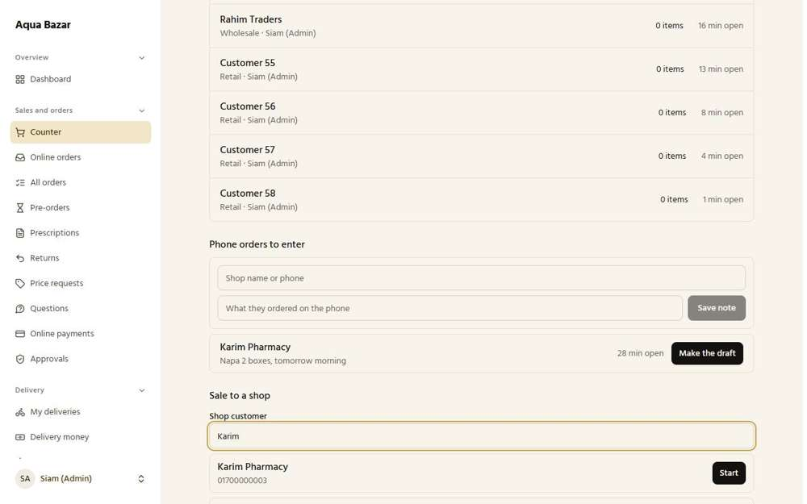
Seen as the owner | /admin/counter
178. "Active order exists" shown Works
What it is for: The search shows if the customer already has an active order.
What the tester did: Looked for an "active order exists" note when choosing a shop that has an online order open.
What the tester saw:
- Yes. The counter says "An order is already open for this customer"
Step 1: Choosing a shop that already has an order open
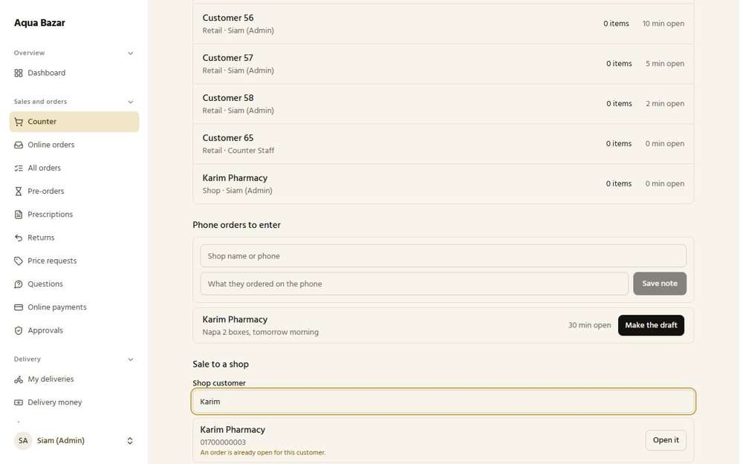
Seen as the owner | /admin/counter
179. Retail: MRP + end discount Works
What it is for: Retail sells at the printed price, with a discount taken off the total at the end.
What the tester did: Sold a retail box with an end discount of 4% (inside the staff limit).
What the tester saw:
- Yes. A retail sale is the printed price with a discount taken off the total
Step 1: Retail: printed price 300, end discount 4%, total 288
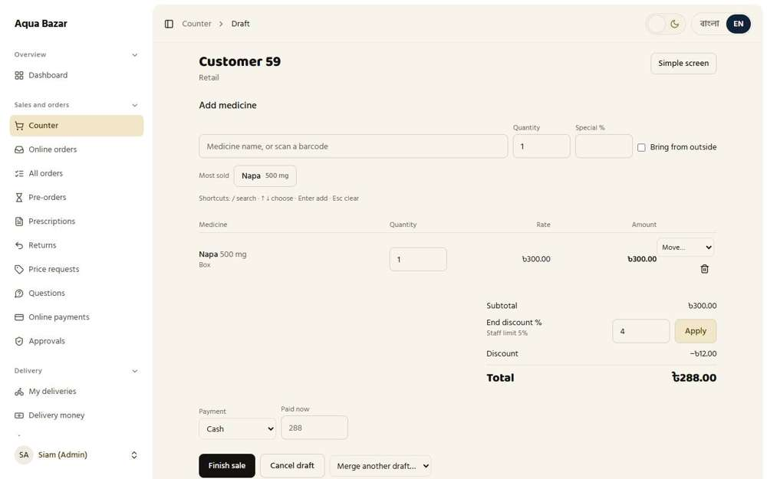
Seen as the owner | /admin/counter/204
180. Specially discounted items excluded from end discount Works
What it is for: Items already specially discounted are left out of the end discount.
What the tester did: Gave one item a special discount, then added an end discount, and looked at the total.
What the tester saw:
- Yes. The end discount is not applied on top of an item that already has a special discount (total 285, not 273)
Step 1: An item with its own special discount, plus an end discount
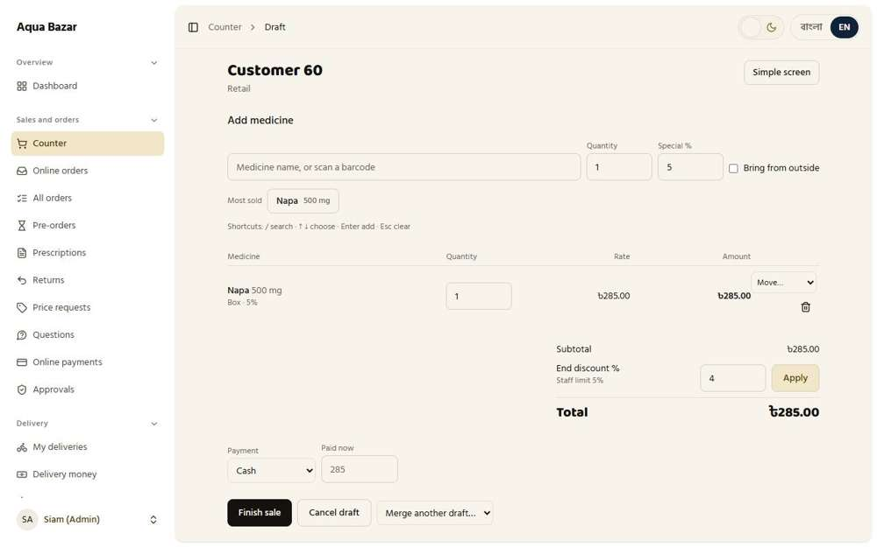
Seen as the owner | /admin/counter/205
181. Offers at the counter too (not retail) Works
What it is for: Offers can also be used at the counter, but not for retail customers.
What the tester did: Started a sale to a shop and searched for Napa 500 mg, then started a retail sale and searched again.
What the tester saw:
- Yes. The sale to a shop shows the offer
- Yes. A retail sale does not show the offer
Step 1: Sale to a shop: the offer card appears in the search | Step 2: Retail sale: no offer in the search
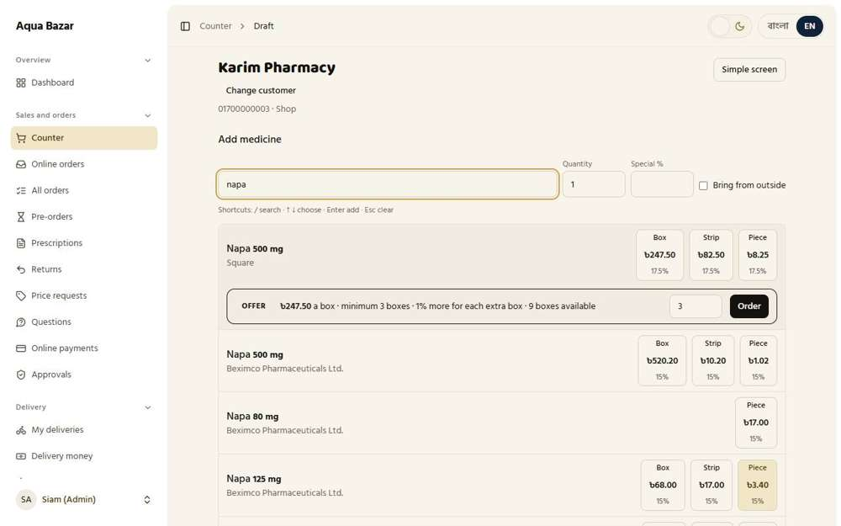  Seen as the owner | /admin/counter/234 | 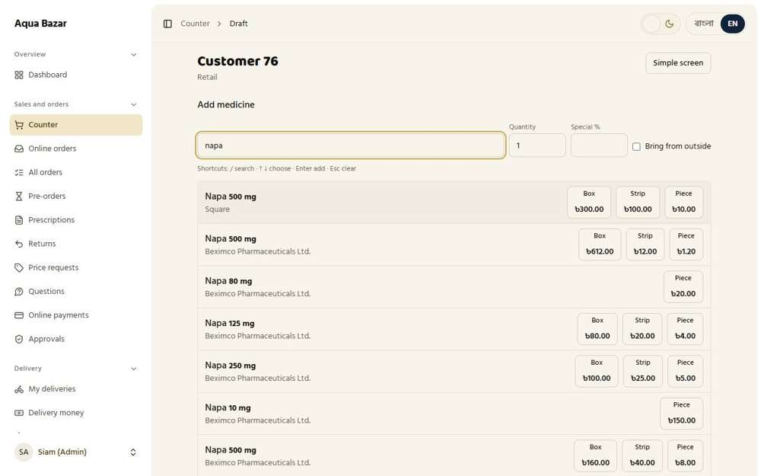  Seen as the owner | /admin/counter/235
182. Normal and offer both shown in search Works
What it is for: Both the normal price and the offer price show in the search.
What the tester did: In a sale to a shop, searched for Napa 500 mg (Square) and read the normal price and the offer.
What the tester saw:
- Yes. The normal box rate is shown
- Yes. And the offer, with its price and minimum
- Yes. The offer shows how many boxes are left
Step 1: The normal rate and the offer, side by side
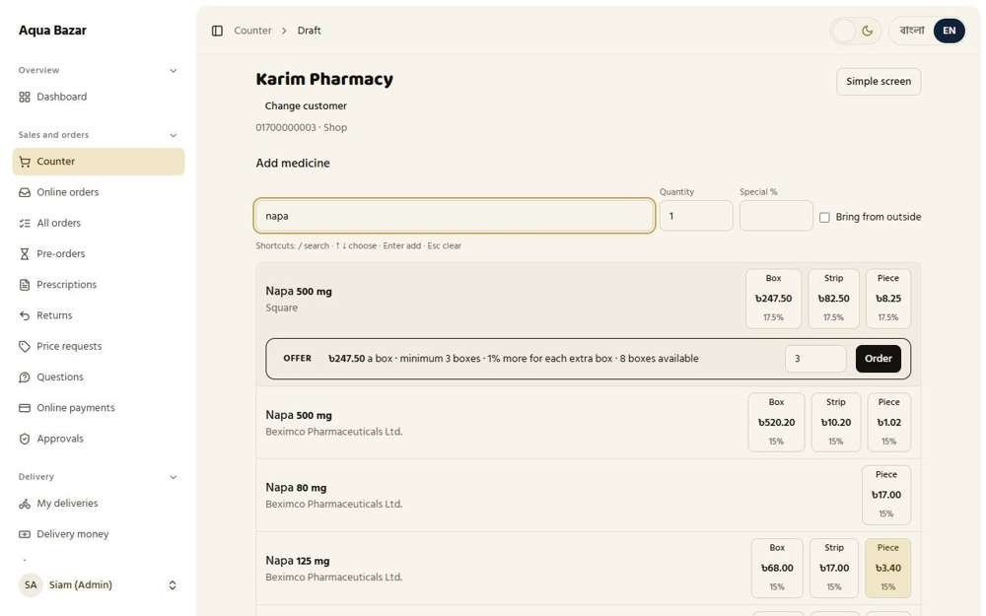
Seen as the owner | /admin/counter/242
183. Counter offer goes into the customer's profile offer section Works
What it is for: A counter offer goes into the customer's offer section.
What the tester did: Opened the shop profile after selling it offer boxes at the counter.
What the tester saw:
- Yes. The shop profile has an offers section
- Yes. It lists the offer boxes sold at the counter with the offer price
- Yes. With the memo number
Step 1: The shop profile: Offers taken
Seen as the owner | /admin/customers/4
184. Two rates in one invoice Works
What it is for: One invoice can carry two kinds of rate.
What the tester did: In a sale to a shop, added one strip of Napa at its normal rate first, and then 3 boxes through the offer.
What the tester saw:
- Yes. The offer line is marked OFFER
- Yes. The ordinary line keeps its own rate (a strip at 82.50)
- Yes. The offer line is priced at 3 boxes at 247.50 (742.50)
Step 1: One draft with two kinds of rate
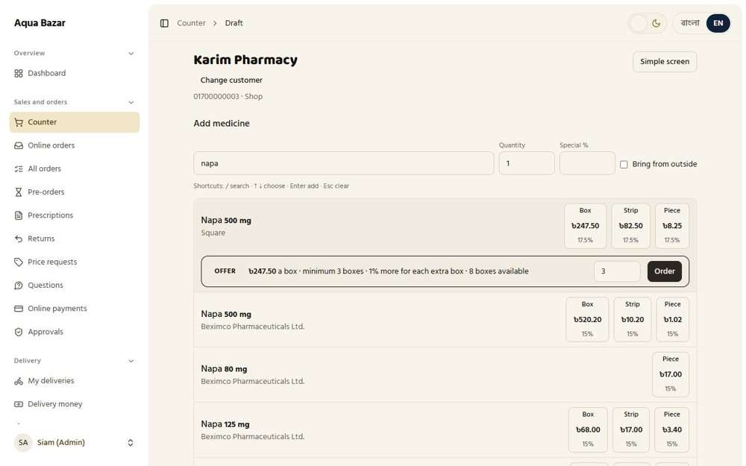
Seen as the owner | /admin/counter/254
185. Invoice order: offer section first, regular next, combined total Works
What it is for: On the invoice, the offer section comes first, then regular items, then one combined total.
What the tester did: Looked at the order of the lines in the draft where the ordinary strip was added first and the offer after it.
What the tester saw:
- Yes. The offer lines come first, the ordinary lines after, and one total at the bottom
- Yes. One combined total
Step 1: Order of the lines
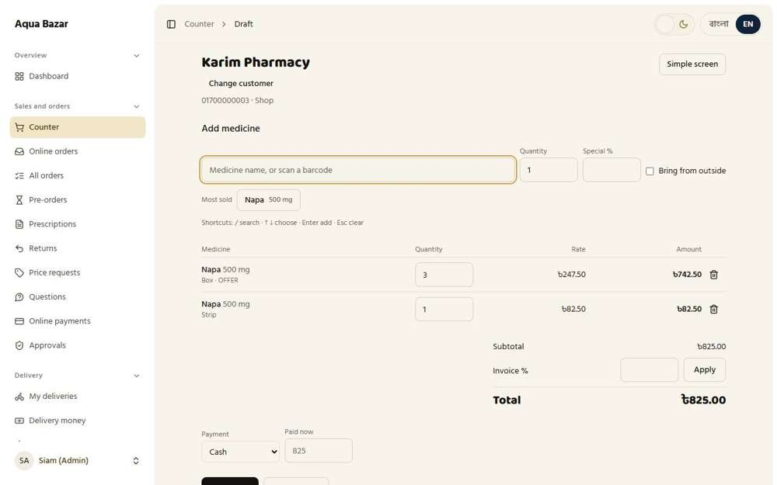
Seen as the owner | /admin/counter/254
186. Warning on similar names, strength in bold Works
What it is for: Medicines with similar names trigger a warning, with the strength shown in bold.
What the tester did: Searched for "napa" and looked at how similar medicine names are told apart.
What the tester saw:
- Yes. Several Napa medicines are listed with their strength and company (12 shown)
Step 1: Similar names listed with their strength and company
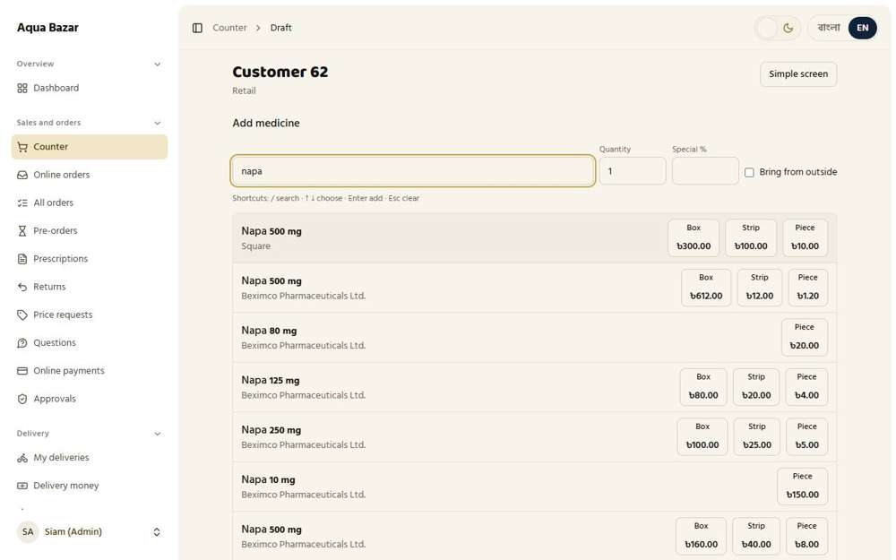
Seen as the owner | /admin/counter/207
187. Keyboard shortcuts Works
What it is for: Keyboard shortcuts make the counter fast for busy staff.
What the tester did: Used the keyboard only: pressed "/" to reach the search, typed, moved down with the arrow key and pressed Enter.
What the tester saw:
- Yes. The keyboard shortcuts add a medicine without touching the mouse
Step 1: A medicine added with the keyboard alone
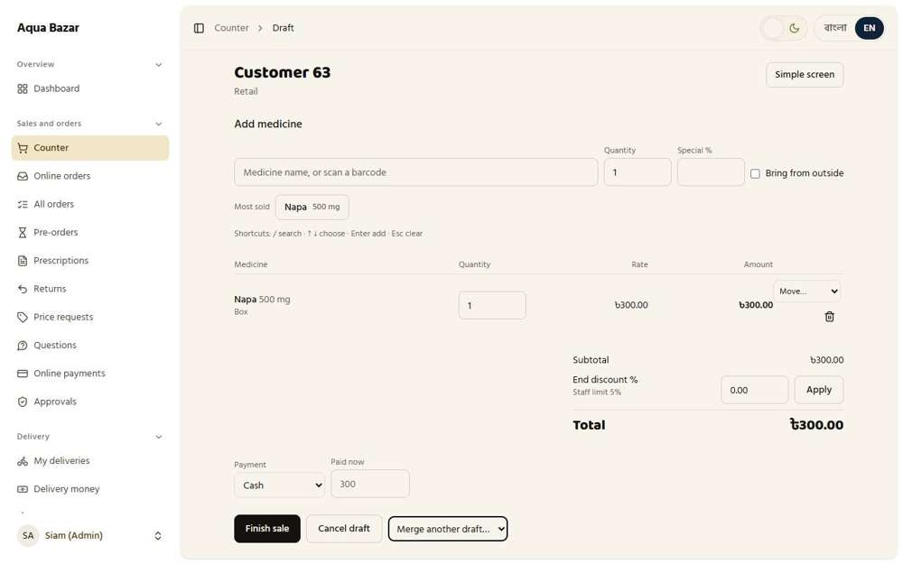
Seen as the owner | /admin/counter/208
188. Most-used medicines in one click Works
What it is for: The most-used medicines are one click away.
What the tester did: Pressed the "Most sold" button on a new sale.
What the tester saw:
- Yes. The counter lists the most-sold medicines
- Yes. One click adds the medicine to the sale
Step 1: "Most sold" shows the favourite medicines | Step 2: One click puts it on the sale
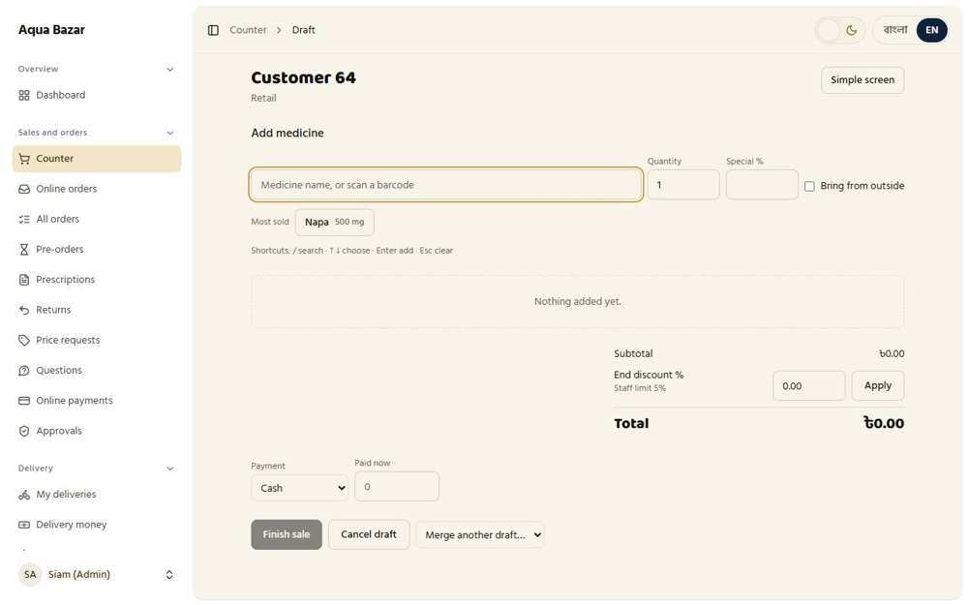  Seen as the owner | /admin/counter/209 | 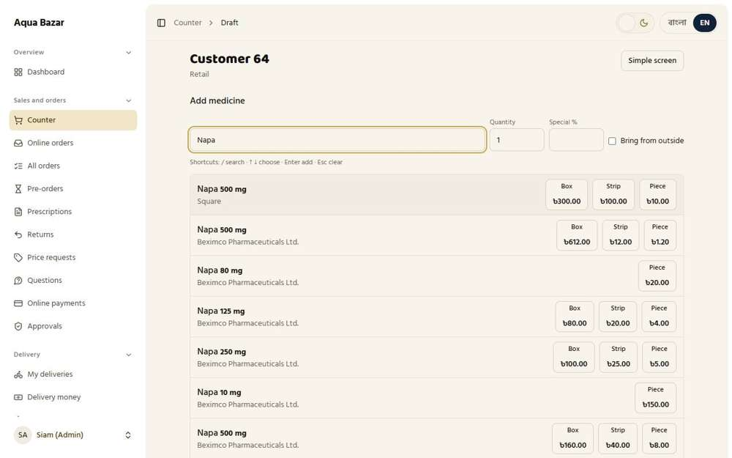  Seen as the owner | /admin/counter/209
189. Simple screen for staff Works
What it is for: Staff get a simple, cut-down counter screen.
What the tester did: As staff, pressed "Simple screen" on a draft.
What the tester saw:
- Yes. A simpler screen is available
Step 1: The simple screen for staff
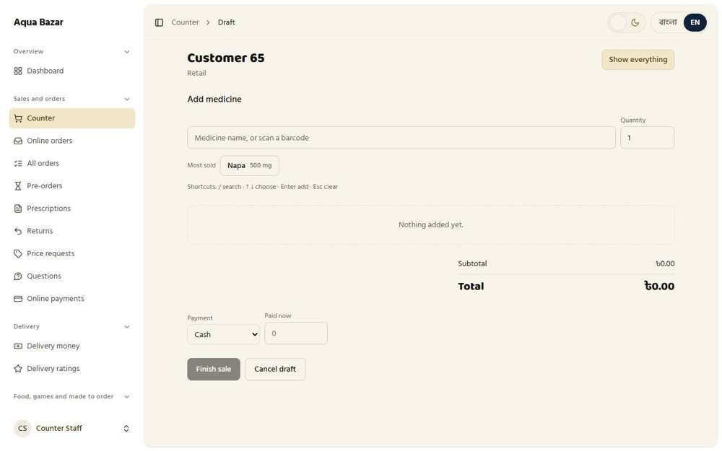
Seen as a staff member | /admin/counter/210
190. Offline counter — sell without internet, sync later Only partly shown
What it is for: The counter keeps working when the internet drops. Sales sync later.
What the tester did: Opened the "Counter without internet" page.
What the tester saw:
- Yes. There is a counter that keeps working without internet
Note: Actually disconnecting the internet and selling was not done here.
Step 1: The offline counter
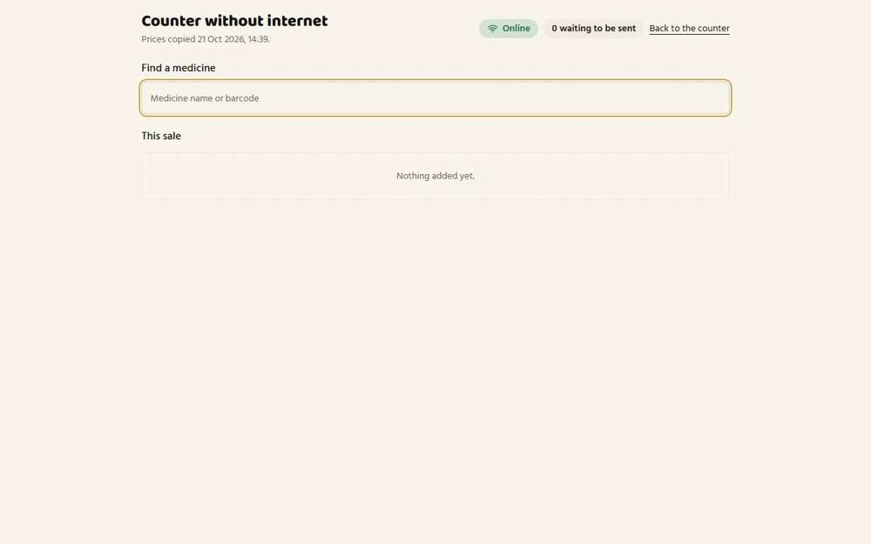
Seen as the owner | /admin/counter/offline
191. Temporary memo numbers offline, conflict alert on sync Only partly shown
What it is for: Sales made offline get temporary memo numbers. Any clash shows an alert when syncing.
What the tester did: Looked at the offline counter for temporary memo numbers.
Note: Temporary memo numbers and the clash alert when syncing need a real offline period, which was not reproduced.
Step 1: The offline counter
Seen as the owner | /admin/counter/offline

Offers
192. Offer product (minimum boxes) Works
What it is for: An offer product needs a minimum number of boxes to qualify.
What the tester did: Made an offer product: Napa 500 mg at 10% off, with a minimum of 3 boxes, and started it.
What the tester saw:
- Yes. The offer product is listed as running
- Yes. It has a minimum of 3 boxes
Step 1: The offer form filled in: 10% off, from 3 boxes | Step 2: The offer is running
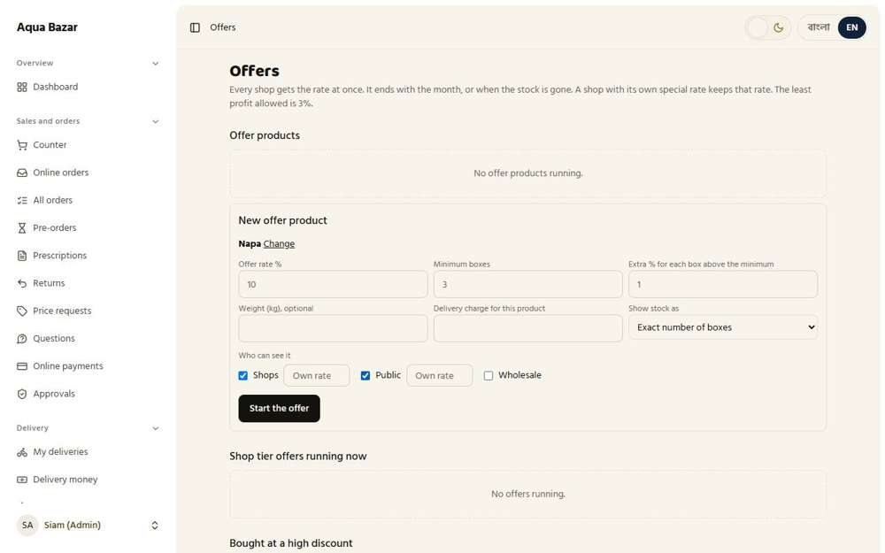  Seen as the owner | /admin/offers | 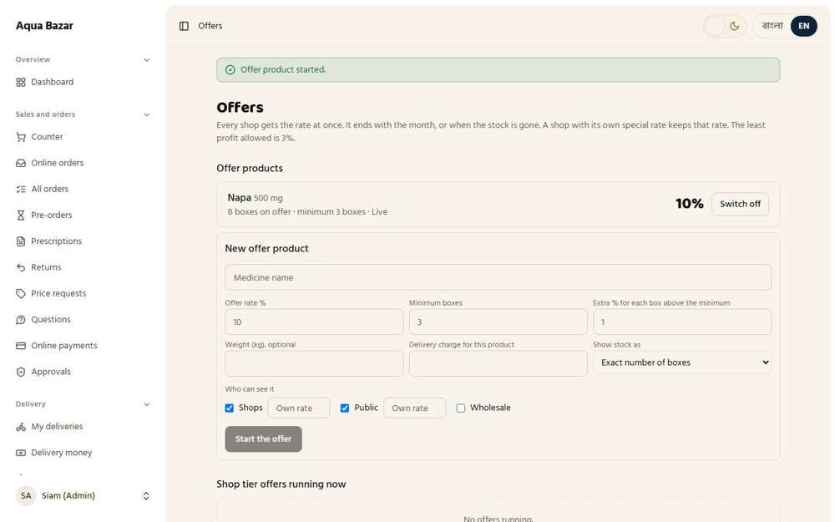  Seen as the owner | /admin/offers
193. Boxes only, no MRP memo Works
What it is for: Offers are sold in boxes only, with no printed-price memo.
What the tester did: Looked at how the offer is sold to a paikari shop.
What the tester saw:
- Yes. The shop sees that Napa 500 mg is on offer
Note: An offer is sold in boxes only. The search shows one box price for the offer, with its minimum.
Step 1: The medicine search with the offer
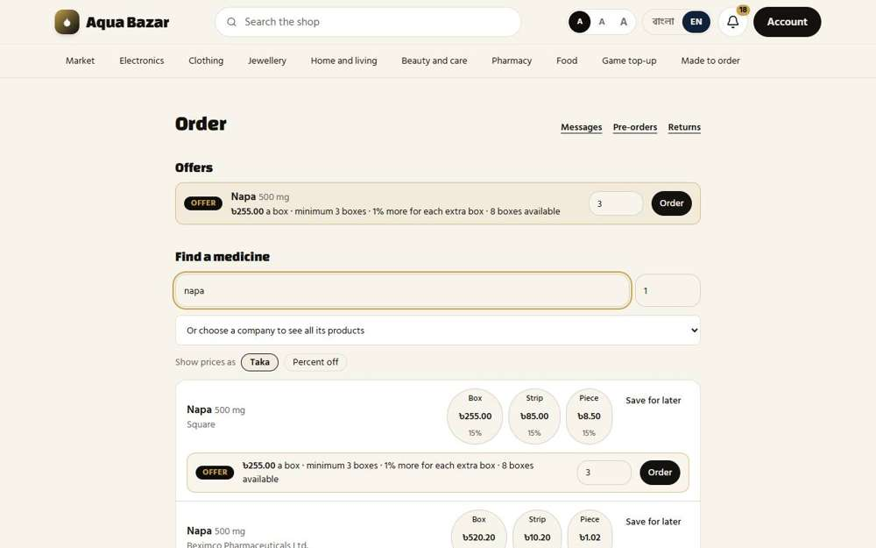
Seen as a paikari shop | /paikari
194. Put on offer by hand or by notification Works
What it is for: An offer is turned on by hand or when the system notifies the owner.
What the tester did: Looked at the two ways to put a medicine on offer: by hand with "New offer product", and from the "Bought at a high discount" list the system builds.
What the tester saw:
- Yes. The owner can put a medicine on offer by hand
- Yes. The system also lists medicines bought at a high discount, as suggestions
Step 1: Two routes: by hand, or from the suggestions
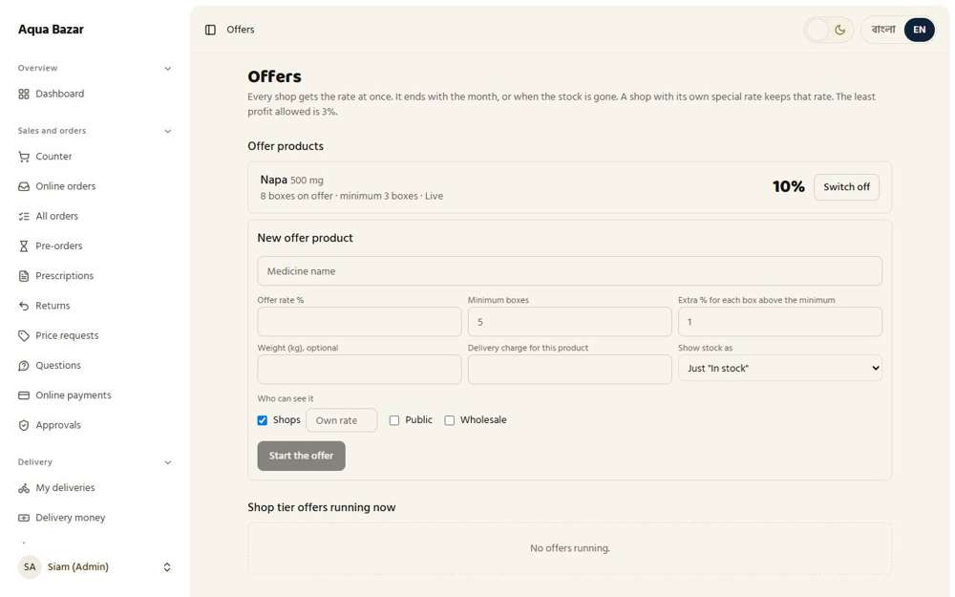
Seen as the owner | /admin/offers
195. Minimum profit margin set by hand Works
What it is for: The owner sets a minimum profit margin for each offer.
What the tester did: Tried to start an offer at 20% off, which leaves almost no profit on a box that cost 240.
What the tester saw:
- Yes. The system refuses an offer that leaves less than the smallest profit allowed
- Yes. The page states the smallest profit an offer must keep, set by the owner in Settings
Step 1: An offer at 20% off a box that cost 240 | Step 2: What the system says
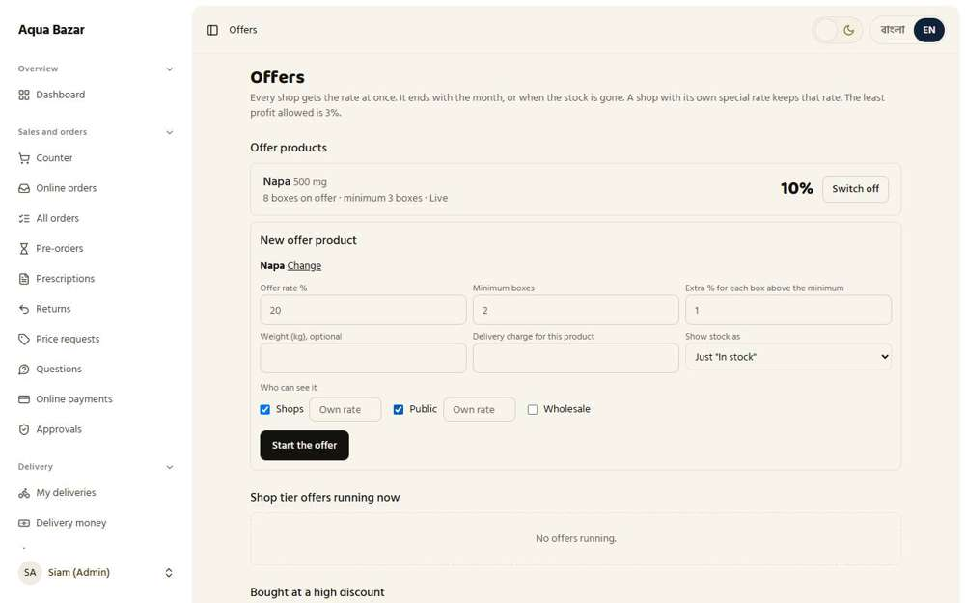  Seen as the owner | /admin/offers | 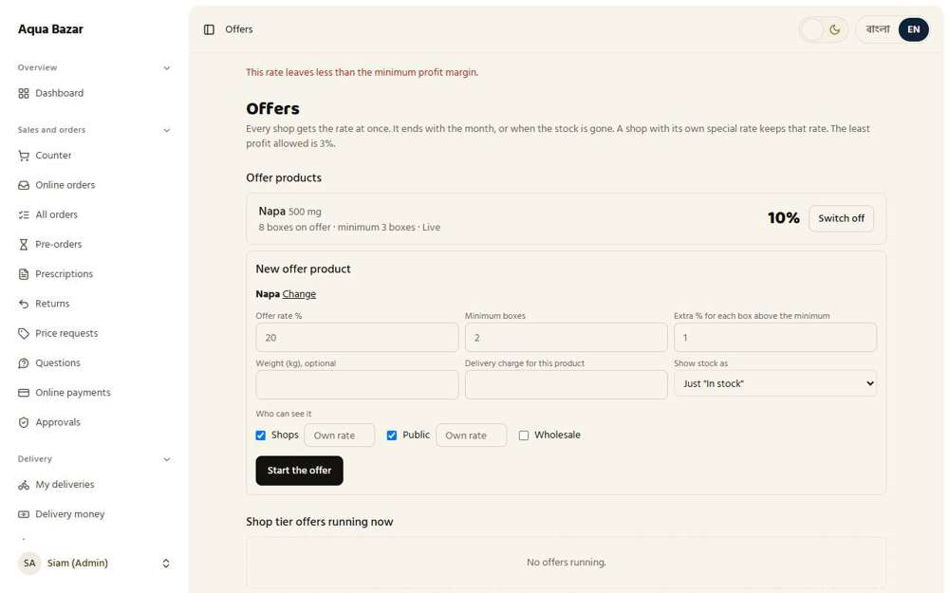  Seen as the owner | /admin/offers
196. Only the higher-% lot goes on offer Works
What it is for: Only the batch with the higher buying percentage goes on offer.
What the tester did: Looked at the list of medicines bought at a high discount.
What the tester saw:
- Yes. Each suggestion is a lot bought at a high discount, with its boxes in the shop
Step 1: Only lots bought at a high discount are suggested
Seen as the owner | /admin/offers
197. Visibility — public/paikari/wholesale Works
What it is for: An offer can be shown to the public, to paikari or to wholesale.
What the tester did: Looked at who the offer can be shown to.
What the tester saw:
- Yes. The form asks who can see the offer
- Yes. Shops can be chosen
- Yes. Public can be chosen
- Yes. Wholesale can be chosen
Step 1: Shops, Public or Wholesale
Seen as the owner | /admin/offers
198. Two stock display modes Works
What it is for: Stock can be shown to buyers in two different ways.
What the tester did: Looked at the choices for how the offer's stock is shown.
What the tester saw:
- Yes. There are two ways to show stock (Just "In stock", Exact number of boxes)
Note: The choices are: Just "In stock" / Exact number of boxes
Step 1: "Just In stock" or "Exact number of boxes"
Seen as the owner | /admin/offers
199. Cannot order more than the stock Works
What it is for: A buyer cannot order more than the offer stock.
What the tester did: Tried to order 9 boxes of an offer that has only 8 boxes available.
What the tester saw:
- Yes. More boxes than the offer holds are not given at the offer rate
- Yes. The screen tells the owner how many boxes the offer has
Step 1: 9 boxes asked for, 8 available
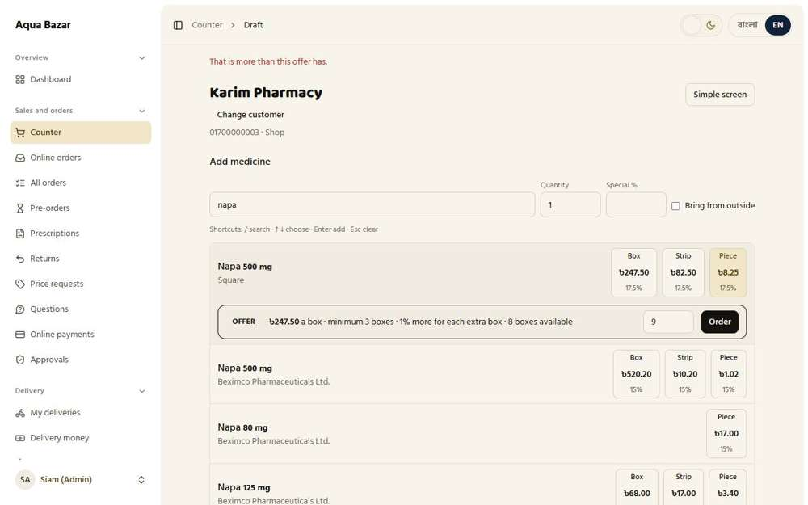
Seen as the owner | /admin/counter/243
200. Quantity-based discount Works
What it is for: An offer can also give a discount for larger quantities.
What the tester did: Looked at the "Extra % for each box above the minimum" box on the offer form.
What the tester saw:
- Yes. An offer can give a bigger discount for each extra box
Step 1: The extra discount per box
Seen as the owner | /admin/offers
201. Weight field on offers Works
What it is for: A weight can be stored on each offer to work out courier cost.
What the tester did: Looked at the weight box on the offer form.
What the tester saw:
- Yes. An offer can carry a weight
Step 1: The weight box
Seen as the owner | /admin/offers
202. Minimum delivery charge per product Works
What it is for: Each offer product can have a minimum delivery charge.
What the tester did: Looked at the delivery charge box on the offer form.
What the tester saw:
- Yes. An offer can carry its own minimum delivery charge
Step 1: A delivery charge for this product
Seen as the owner | /admin/offers
203. Minimum not met → normal rate Works
What it is for: If the minimum quantity is not met, the normal rate applies.
What the tester did: Ordered 2 boxes through the offer, below its minimum of 3, and looked at the line in the draft.
What the tester saw:
- Yes. Below the minimum the line is not an offer line, so it is sold at the normal rate
- Yes. The rate on the line is the normal rate (247.50)
Step 1: Two boxes: below the minimum
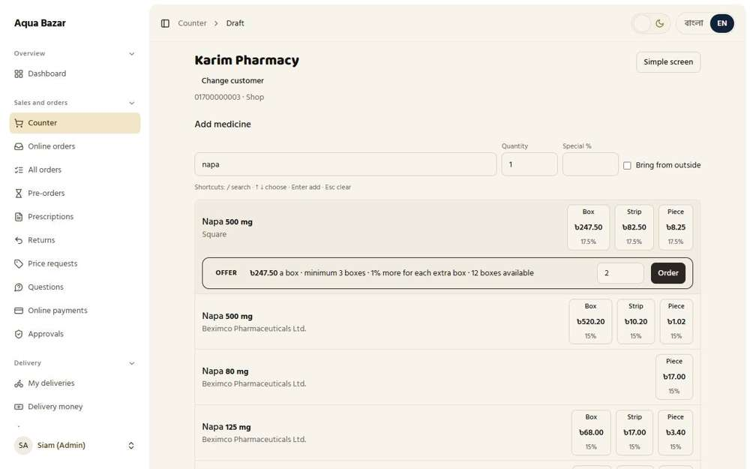
Seen as the owner | /admin/counter/238
204. Then profit at the normal rate too Only partly shown
What it is for: The profit is then worked out at the normal rate too.
What the tester did: Looked at profit on offers below the minimum.
Note: Profit worked out at the normal rate below the minimum was not reproduced.
Step 1: Offers
Seen as the owner | /admin/offers
205. Offer pop-up in search Works
What it is for: A pop-up in search tells staff when an offer exists.
What the tester did: At the counter, searched for the medicine that is on offer.
What the tester saw:
- Yes. The search points out that this medicine is on offer
- Yes. And has its own Order button
Step 1: The offer card points out the offer
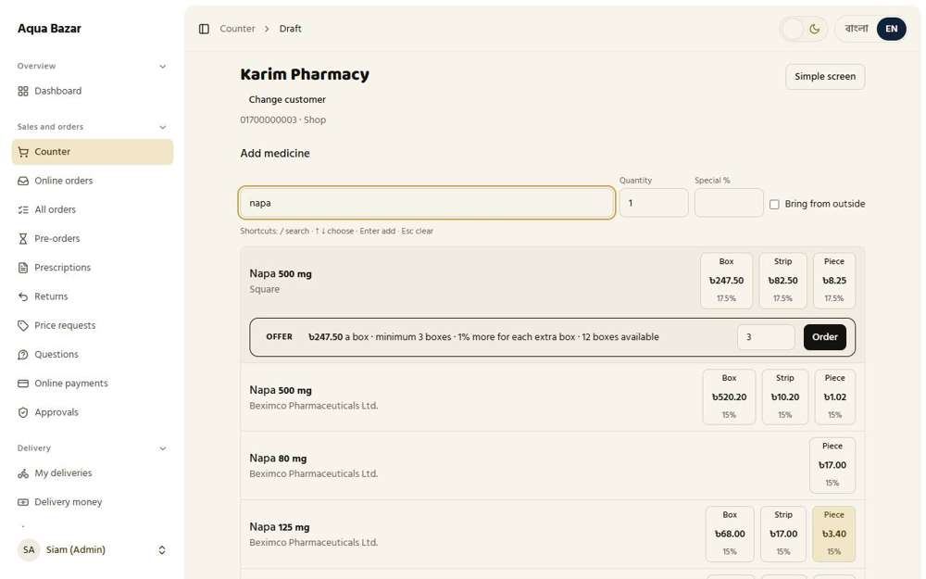
Seen as the owner | /admin/counter/237
206. Mixed-order memo Works
What it is for: One memo can hold both offer items and regular items.
What the tester did: Finished the shop sale that held an offer line and an ordinary line, paying on credit, and opened the memo.
What the tester saw:
- Yes. The memo is made with both kinds of line: the offer box line and the ordinary strip line
- Yes. The memo tells the buyer how offer items are returned
Step 1: After pressing Finish sale
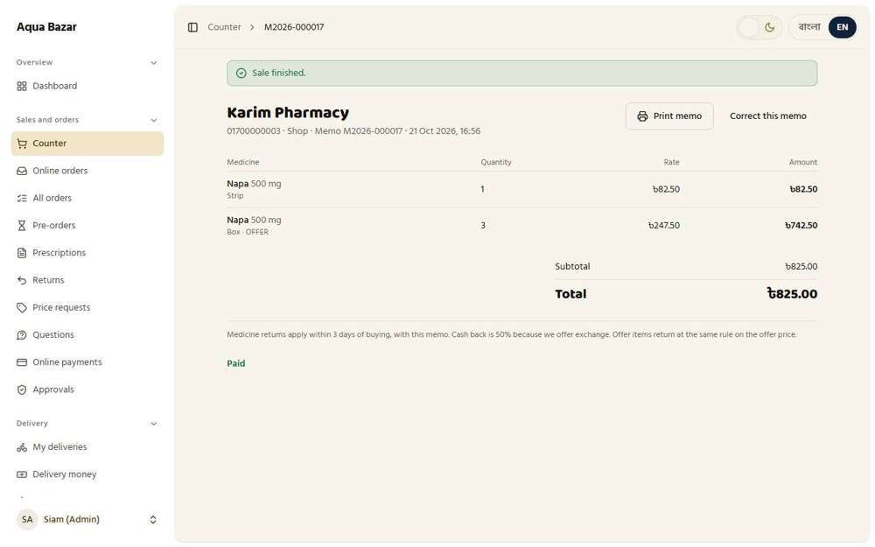
Seen as the owner | /admin/counter/241
207. Alert before offer stock runs out Works
What it is for: An alert warns the owner before offer stock runs out.
What the tester did: Looked at the setting for the warning before an offer runs out.
What the tester saw:
- Yes. The owner sets how many boxes left should trigger a warning
Step 1: The setting
Seen as the owner | /admin/settings
208. Grey for 1–1.5 hours when stock out Works
What it is for: When offer stock runs out, the offer goes grey for 1 to 1.5 hours.
What the tester did: Looked at the setting for how long a sold-out offer stays grey.
What the tester saw:
- Yes. A sold-out offer stays grey for a time the owner sets
Step 1: The grey time setting
Seen as the owner | /admin/settings
209. Cannot add to cart during that time Works
What it is for: During that time it cannot be added to a cart.
What the tester did: At the counter, ordered every box of the offer (8) into a draft, then looked at the offer as a paikari shop and tried to add it.
What the tester saw:
- Yes. The offer is greyed out and says "Was on offer a moment ago. Stock out."
- Yes. It has no order box and no price, so it cannot be added to the order
Step 1: All 8 offer boxes are now in a draft | Step 2: The shop looks at the offer after it is all taken
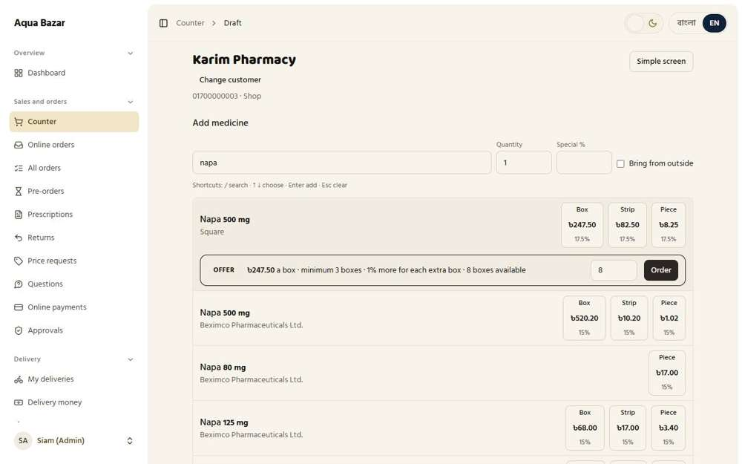  Seen as the owner | /admin/counter/245 | 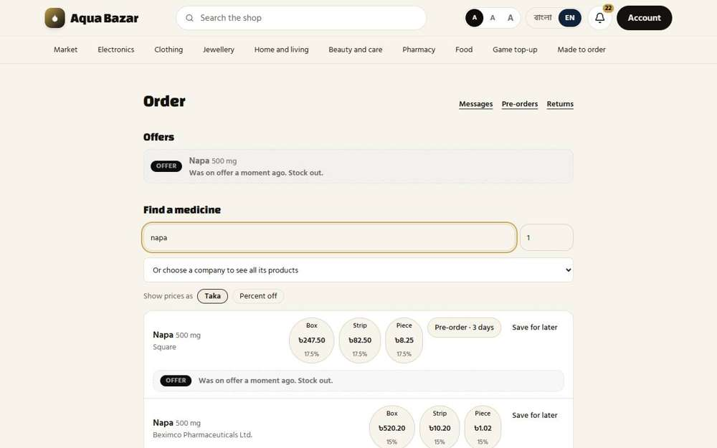  Seen as a paikari shop | /paikari
210. Listing normal again when a draft is cancelled Works
What it is for: If a draft is cancelled, the listing goes back to normal.
What the tester did: Cancelled the counter draft that held all 8 offer boxes, then looked at the offer again.
What the tester saw:
- Yes. The offer is on sale again with its boxes back
Step 1: The draft is cancelled | Step 2: The offer is back for the shop
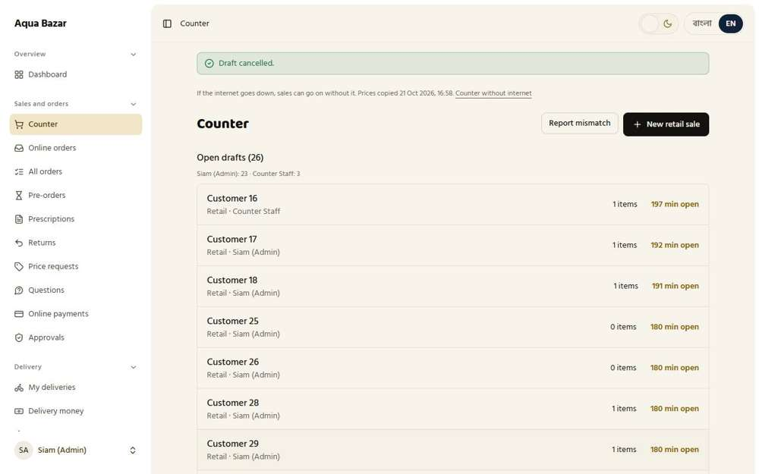  Seen as the owner | /admin/counter | 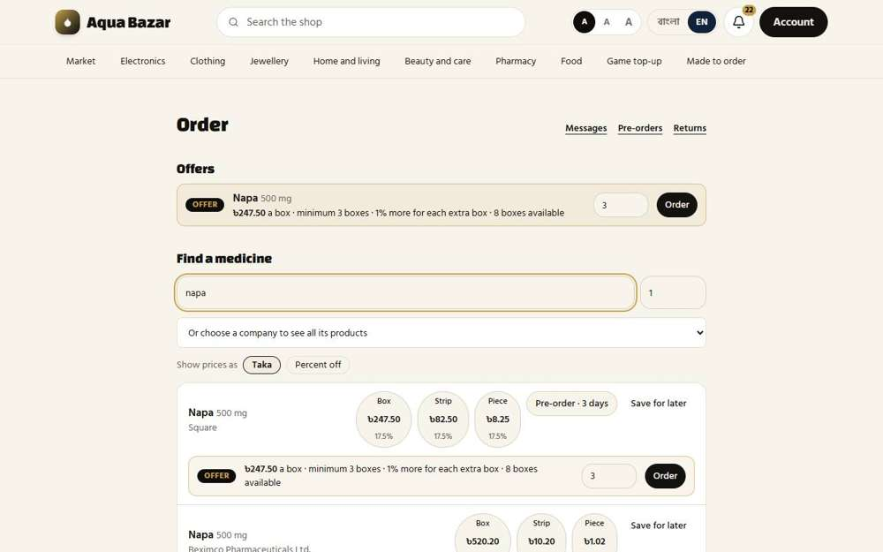  Seen as a paikari shop | /paikari
211. Tier offer (no minimum) Works
What it is for: A tier offer has no minimum quantity.
What the tester did: Pressed "Upload to the shop tier" for a medicine bought at a high discount, to start a tier offer with no minimum.
What the tester saw:
- Yes. The medicine now shows under "Shop tier offers running now"
Step 1: A shop tier offer is running
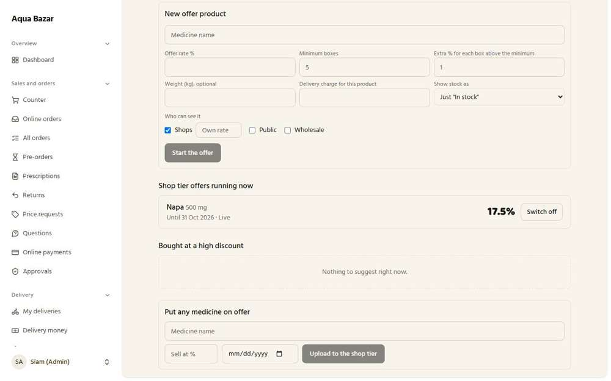
Seen as the owner | /admin/offers
212. Company offer list Works
What it is for: There is a list of offers per company.
What the tester did: Looked at the list of medicines grouped for offers.
What the tester saw:
- Yes. A list of offer candidates is kept
Step 1: Medicines bought at a high discount
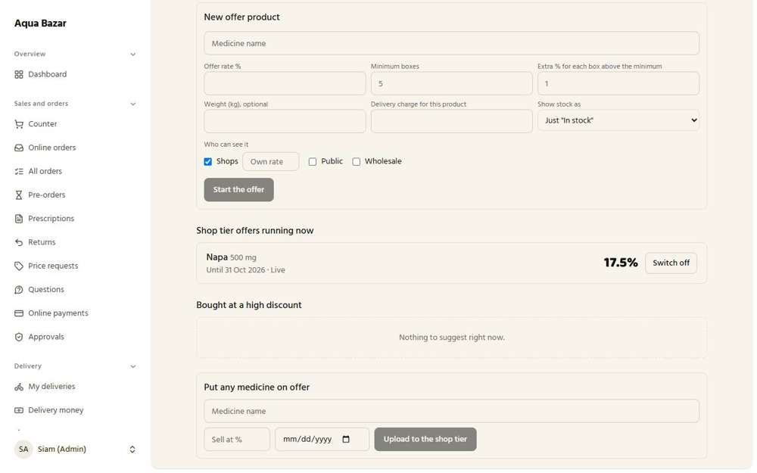
Seen as the owner | /admin/offers
213. One click to the paikari tier Works
What it is for: One click puts an offer to the paikari tier.
What the tester did: After the owner pressed one button, looked at what the paikari shop sees.
What the tester saw:
- Yes. The shop can see Napa 500 mg
Note: The tier offer is a single click for the owner and needs no minimum.
Step 1: The paikari search after a tier offer
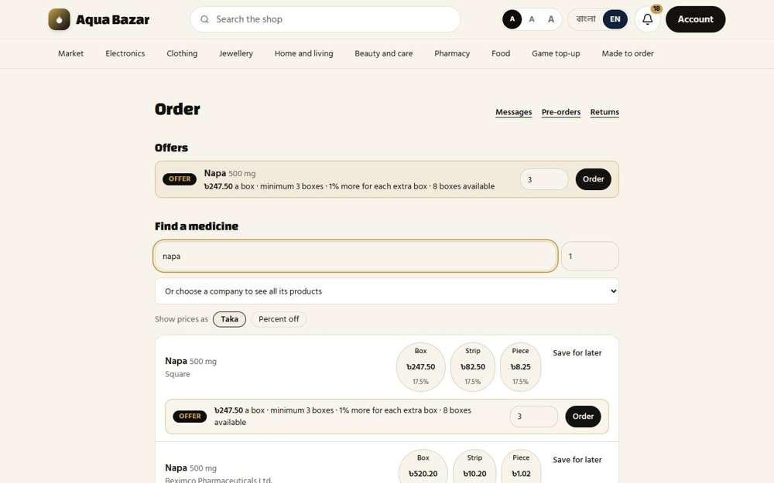
Seen as a paikari shop | /paikari
214. Offer duration field Works
What it is for: An offer has a duration field.
What the tester did: Looked at the date box for how long an offer runs.
What the tester saw:
- Yes. An offer has an end date
Step 1: The offer's date box
Seen as the owner | /admin/offers
215. Auto non-offer at month end Only partly shown
What it is for: At the end of the month the offer ends by itself.
What the tester did: Looked for offers ending themselves at month end.
What the tester saw:
- Yes. The page says an offer ends with the month or when stock is gone
Note: Waiting for a month end to see it happen was not possible.
Step 1: The Offers page explains when offers end
Seen as the owner | /admin/offers
216. Ask after the month passes Only partly shown
What it is for: After the month passes, the system asks the owner what to do.
What the tester did: Looked for a question after the month passes.
Note: Needs a month to pass.
Step 1: Offers
Seen as the owner | /admin/offers
217. Off when stock ends, on again with new stock Works
What it is for: An offer switches off when stock ends and on again with new stock.
What the tester did: Watched the offer go off when its boxes were all taken, and come back when the boxes were put back.
What the tester saw:
- Yes. With no boxes left the offer goes off by itself
- Yes. When the boxes are back the offer comes on again by itself
Step 1: Boxes all taken: the offer is off | Step 2: Boxes back: the offer is on again
Seen as a paikari shop | /paikari | Seen as a paikari shop | /paikari
218. Manual rate above offers Works
What it is for: A hand-set rate beats any offer.
What the tester did: Gave Karim Pharmacy a hand-set 18% price while a tier offer is running, and looked at what the shop pays.
What the tester saw:
- Yes. The shop pays its own hand-set price (246), not the offer
Step 1: Karim keeps the hand-set rate while an offer runs
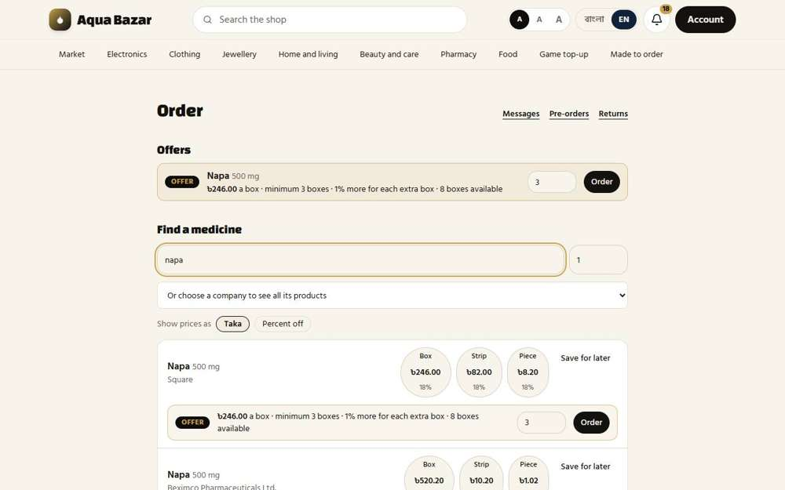
Seen as a paikari shop | /paikari
219. Loss warning on purchase price correction Works
What it is for: If the buying price is corrected, the system warns about any loss.
What the tester did: On the medicine's lot, pressed "Correct price" to raise the cost while offers are running.
What the tester saw:
- Yes. The screen warns when a corrected cost would make an offer or rate lose money
Step 1: Correcting a lot's cost
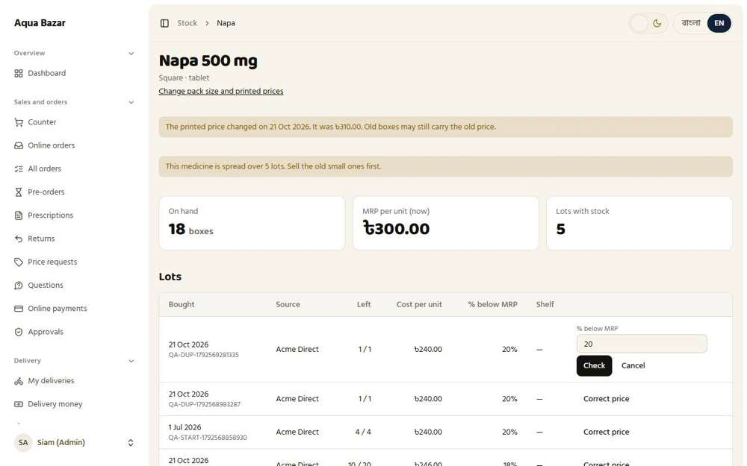
Seen as the owner | /admin/stock/medicines/1

MPO Sector
220. Detailed MPO profile Only partly shown
What it is for: Each medical sales representative (MPO) has a detailed profile. Part of it is still to be finished.
What the tester did: Opened the MPO page and looked at what is kept for each MPO.
What the tester saw:
- Yes. Each MPO has an anonymous number
- Yes. The list counts each MPO's products and how many are on the market
Note: The checklist marks the detailed MPO profile as only partly built. A full profile page was not found.
Step 1: The MPO list: name, anonymous number, phone, area and counts
Seen as the owner | /admin/mpo
221. Area and auto-grouping Works
What it is for: MPOs are grouped automatically by the area they cover.
What the tester did: Opened a second MPO account in the area "Mirpur" and looked at how the list groups MPOs by area.
What the tester saw:
- Yes. MPOs are grouped by the area they cover
Step 1: The account form filled in, with an area and companies | Step 2: The list, grouped by area
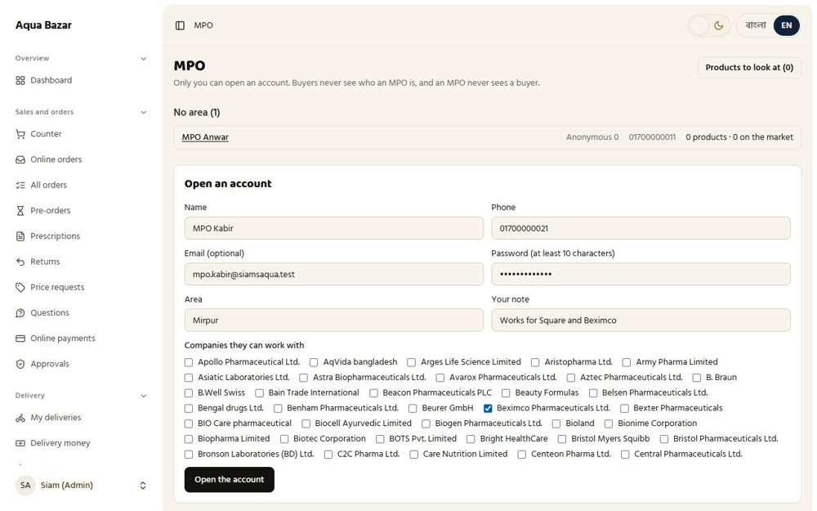  Seen as the owner | /admin/mpo | 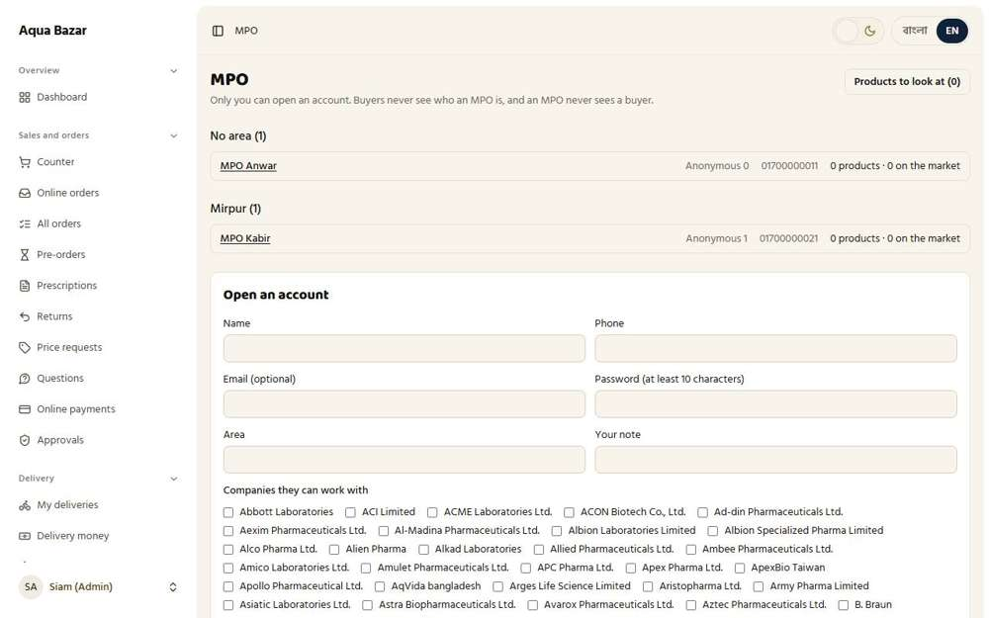  Seen as the owner | /admin/mpo
222. Product selection (they choose) Works
What it is for: An MPO chooses which products they work with.
What the tester did: Signed in as the new MPO and looked at how an MPO chooses a product to work with.
What the tester saw:
- Yes. The MPO sends the products they choose to work with
- Yes. The MPO chooses the products themselves
Step 1: The MPO's own page
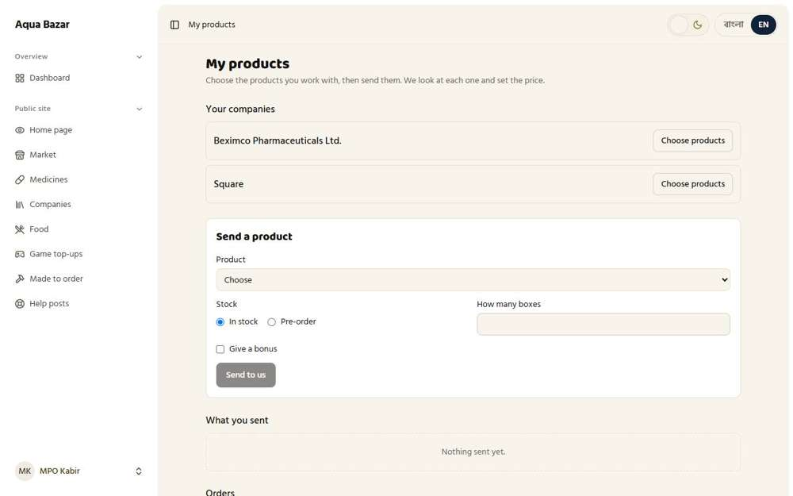
Seen as mpo2 | /mpo
223. Access to multiple companies Works
What it is for: One MPO can work with several companies.
What the tester did: Looked at the companies this MPO may work with.
What the tester saw:
- Yes. The MPO sees the companies the owner gave them
Step 1: One MPO, several companies
Seen as mpo2 | /mpo
224. One-to-many data structure Only partly shown
What it is for: One company can have many MPOs behind it.
What the tester did: Looked at the MPO list to see one company linked to more than one MPO.
Note: The one-to-many structure is how the data is stored. The screen shows MPOs and their companies, but not the structure itself.
Step 1: The MPO list
Seen as the owner | /admin/mpo
225. MPOs don't see each other Works
What it is for: MPOs cannot see each other.
What the tester did: Signed in as MPO Anwar and looked for any trace of another MPO.
What the tester saw:
- Yes. MPO Anwar cannot see MPO Kabir
Step 1: MPO Anwar's page shows only their own things
Seen as an MPO | /mpo
226. Stock status (in stock / pre-order) Works
What it is for: Each MPO product shows if it is in stock or can be pre-ordered.
What the tester did: Looked at the Stock choice when sending a product.
What the tester saw:
- Yes. A product can be marked In stock
- Yes. Or Pre-order
Note: Choices on the page: Choose
Step 1: Stock: In stock or Pre-order
Seen as mpo2 | /mpo
227. Bonus products (10+2) Works
What it is for: Bonus products such as buy 10, get 2 free are supported.
What the tester did: Looked at the bonus box on the product form.
What the tester saw:
- Yes. An MPO can give a bonus, for example 10 boxes plus 2 free
Step 1: The bonus box
Seen as mpo2 | /mpo
228. Bonus on a separate memo line Only partly shown
What it is for: A bonus shows on its own line on the memo.
What the tester did: Looked for a bonus on its own memo line.
Note: Needs an MPO product with a bonus to be sold and a memo made. Not carried through.
Step 1: Invoices
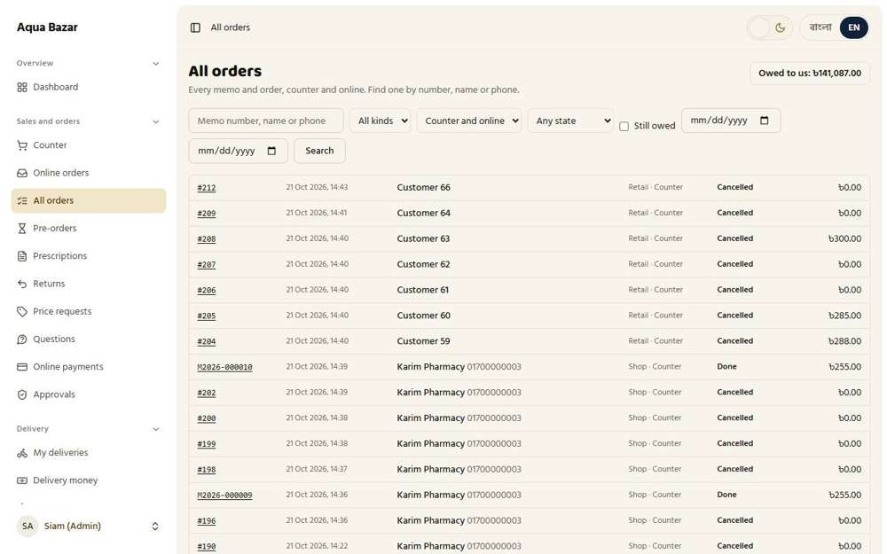
Seen as the owner | /admin/invoices
229. My review and approval Works
What it is for: The owner reviews and approves MPO goods before they go on sale.
What the tester did: Opened the owner's page for MPO products waiting to be looked at.
What the tester saw:
- Yes. The owner reviews each product and chooses where it shows and the price
- Yes. Products from several MPOs sit side by side
Step 1: Products to look at
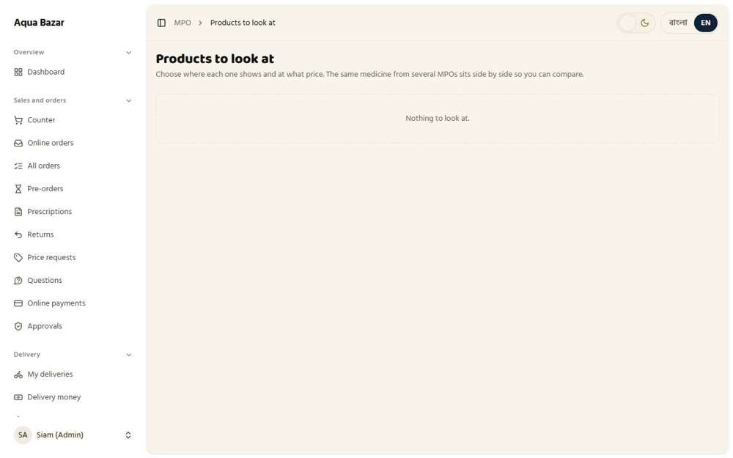
Seen as the owner | /admin/mpo/listings
230. Anonymous 1 (my name) format Only partly shown
What it is for: MPO identities appear as "Anonymous 1 (my name)" to the other side.
What the tester did: Looked at how an MPO is named on screens other than the owner's.
What the tester saw:
- Yes. An MPO appears as "Anonymous" with a number
Note: The "Anonymous 1 (my name)" wording on the MPO's own side was not found.
Step 1: Anonymous 0, 1, 2...
Seen as the owner | /admin/mpo
231. Identity secrecy (both directions) Works
What it is for: Identity stays secret in both directions.
What the tester did: Read the notes on the MPO's page about who can see whom.
What the tester saw:
- Yes. The MPO sees orders as coming from the owner's account, never from a buyer
- Yes. The owner's screen states identity is hidden both ways
Step 1: The MPO sees our account, not the buyer
Seen as an MPO | /mpo
232. Order record for the MPO (proof) Works
What it is for: The MPO gets an order record as proof.
What the tester did: Looked at the MPO's Orders section.
What the tester saw:
- Yes. The MPO's Orders list is a proof record for their own target report
Step 1: The Orders record
Seen as an MPO | /mpo
233. Blind bidding Works
What it is for: Wholesalers bid on MPO goods without seeing each other's bids.
What the tester did: As a wholesaler, found the MPO product among "Other offers", asked for a 12% discount on it and sent the offer.
What the tester saw:
- Yes. The MPO product is listed as "Other offers", under an anonymous name
- Yes. The wholesaler sees that the offer was sent
Step 1: A wholesaler asks for a 12% discount | Step 2: After sending the offer
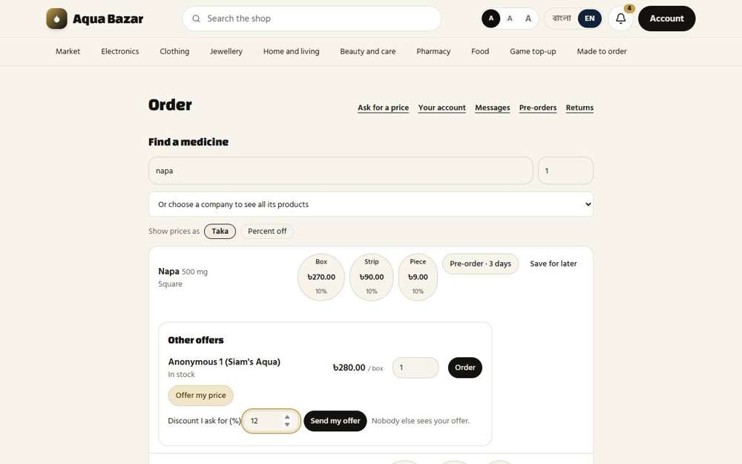  Seen as a wholesaler | /wholesale | 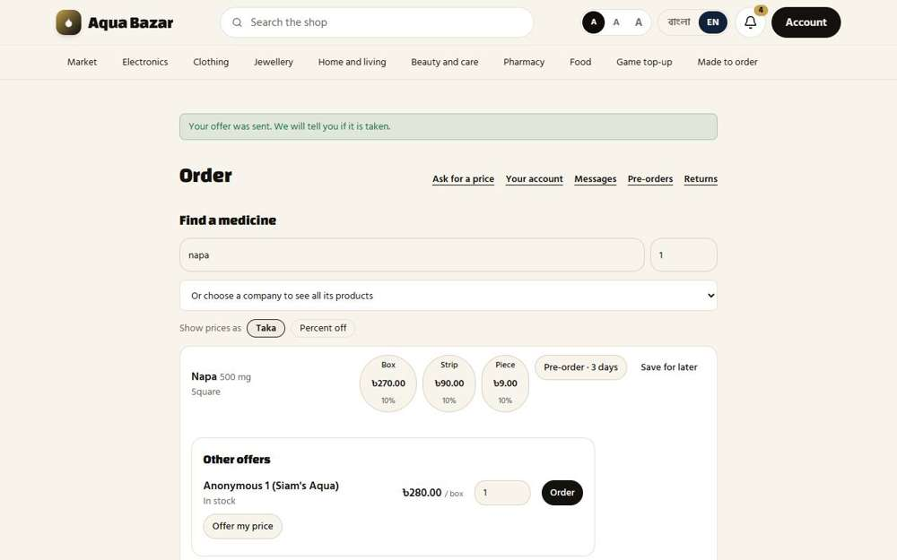  Seen as a wholesaler | /wholesale
234. Wholesalers don't see each other's bids Only partly shown
What it is for: One wholesaler never sees another's bid.
What the tester did: Looked at the offer again after sending the bid, and read what the wholesaler sees about it.
What the tester saw:
- Yes. The wholesaler sees their own offer and that it is waiting
- Yes. No other bidder appears anywhere
Note: Only one wholesaler account exists in this copy, so a second bidder could not be set up to prove that bids are hidden from each other. The screen shows only the wholesaler's own offer.
Step 1: The wholesaler sees only their own offer
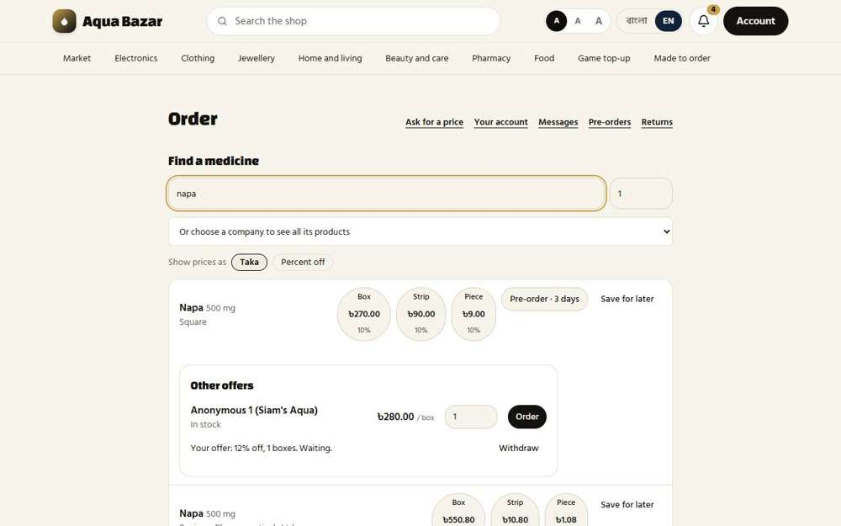
Seen as a wholesaler | /wholesale
235. MPO accepts the bid Works
What it is for: The MPO accepts the bid they like.
What the tester did: As the MPO, opened the portal, found the bid on the product and pressed Accept.
What the tester saw:
- Yes. The MPO sees the bid (12%) and a button to accept it
- Yes. The accepted bid becomes a confirmed order in the MPO's own record
- Yes. And the bid is no longer waiting
Step 1: The MPO's portal: the bid under the product | Step 2: After accepting
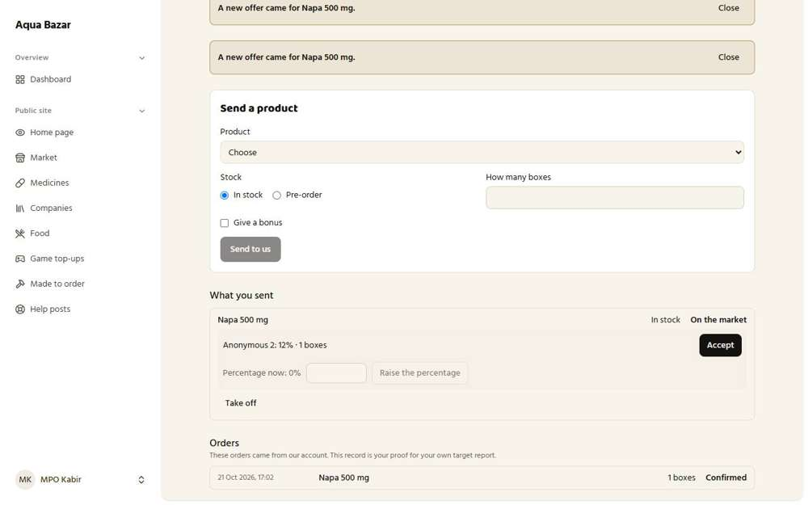  Seen as mpo2 | /mpo | 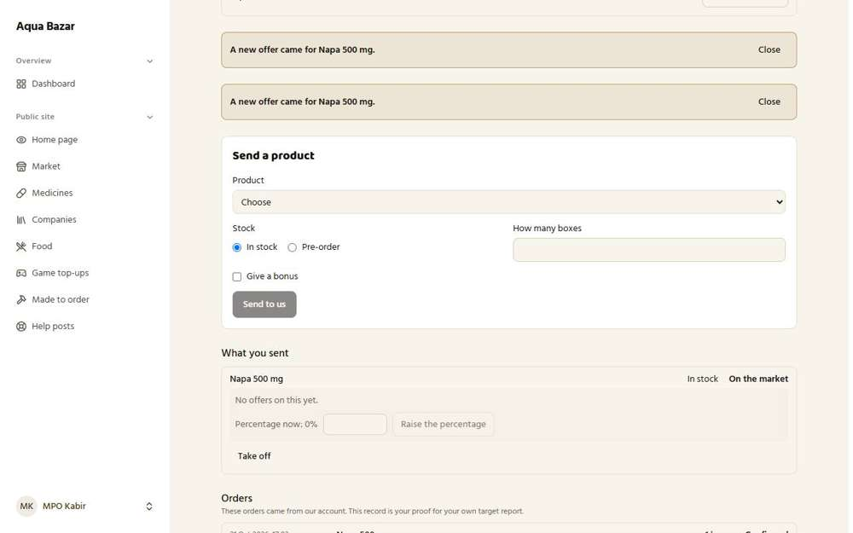  Seen as mpo2 | /mpo
236. Notification to raise % if not selling Only partly shown
What it is for: If the goods are not selling, the MPO is told to raise the percentage.
What the tester did: Looked for the notification asking an MPO to raise the percentage if goods are not selling.
Note: Needs goods that sit unsold for a while. Not carried through.
Step 1: The MPO page
Seen as an MPO | /mpo
237. Count of failed deliveries Only partly shown
What it is for: The system counts how many deliveries failed.
What the tester did: Looked for a count of failed deliveries.
Note: Not carried through.
Step 1: The MPO list
Seen as the owner | /admin/mpo
238. Goods pass through my hands Works
What it is for: The goods pass through the owner's hands before reaching the buyer.
What the tester did: Looked at how goods pass through the owner.
What the tester saw:
- Yes. Goods from an MPO are entered as a purchase from an MPO source
Step 1: Enter purchase has an "MPO" source
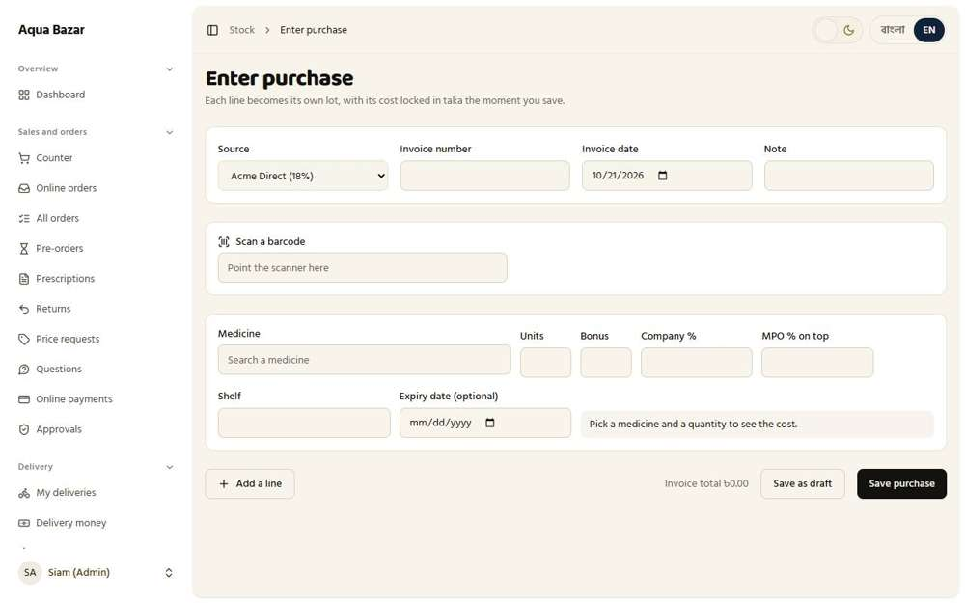
Seen as the owner | /admin/stock/receive
239. MPO goods enter stock Only partly shown
What it is for: MPO goods then enter the shop's own stock.
What the tester did: Looked at the stock page for goods that came from an MPO.
Note: MPO goods entering stock was not carried through end to end.
Step 1: Stock
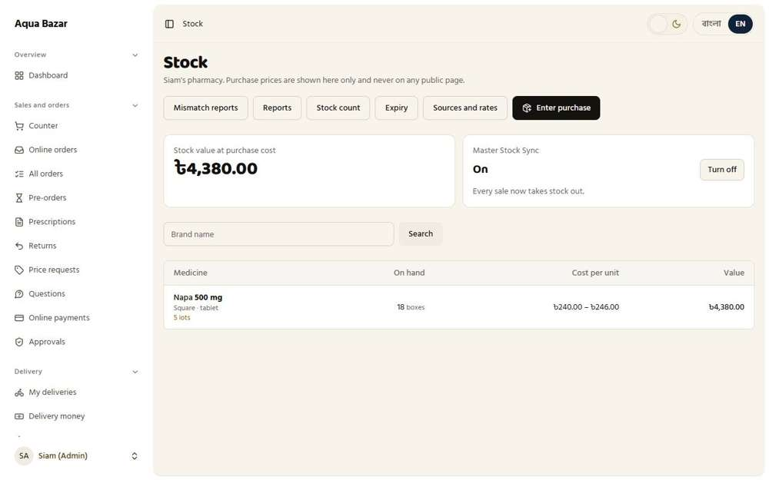
Seen as the owner | /admin/stock

Medicine Database
240. Complete medicine database Works
What it is for: A complete medicine database holds every brand with its details.
What the tester did: As a stranger, searched the public medicine database for a generic name and looked at how many brands came back.
What the tester saw:
- Yes. A large database answers: 30 brands listed for one generic name
Step 1: Searching the medicine database for "paracetamol"
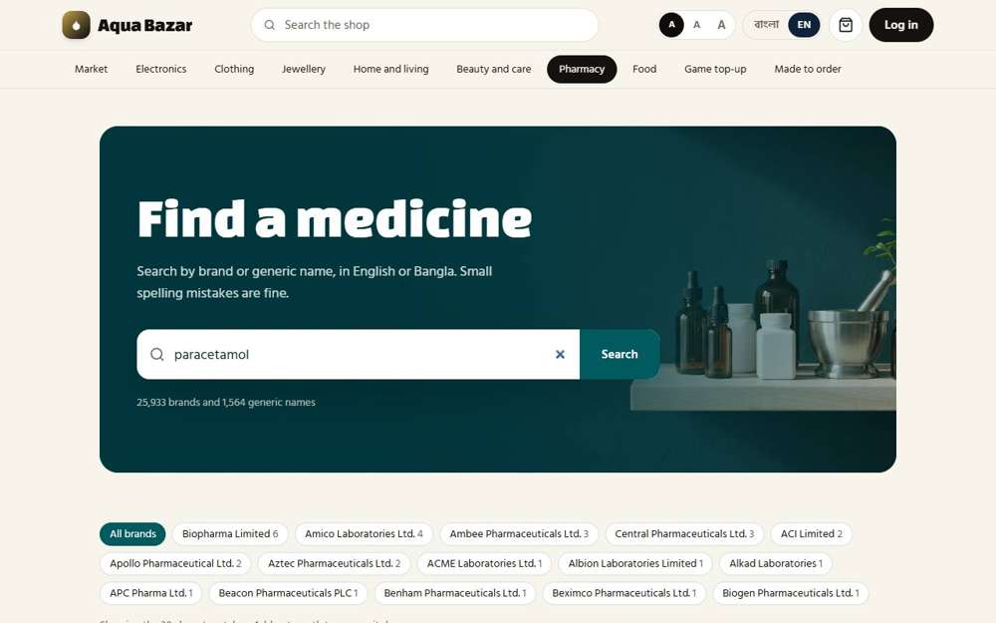
Seen as a stranger (not signed in) | /medicines?q=paracetamol
241. Brand, generic, company, strength, MRP Works
What it is for: Each medicine has brand, generic name, company, strength and printed price.
What the tester did: Opened one medicine's page and looked for its brand, generic name, company, strength and printed price.
What the tester saw:
- Yes. The brand name
- Yes. The company
- Yes. The strength
- Yes. The printed price (MRP)
- Yes. The page says it is the printed retail price
- Yes. The form of the medicine
Step 1: One medicine's page
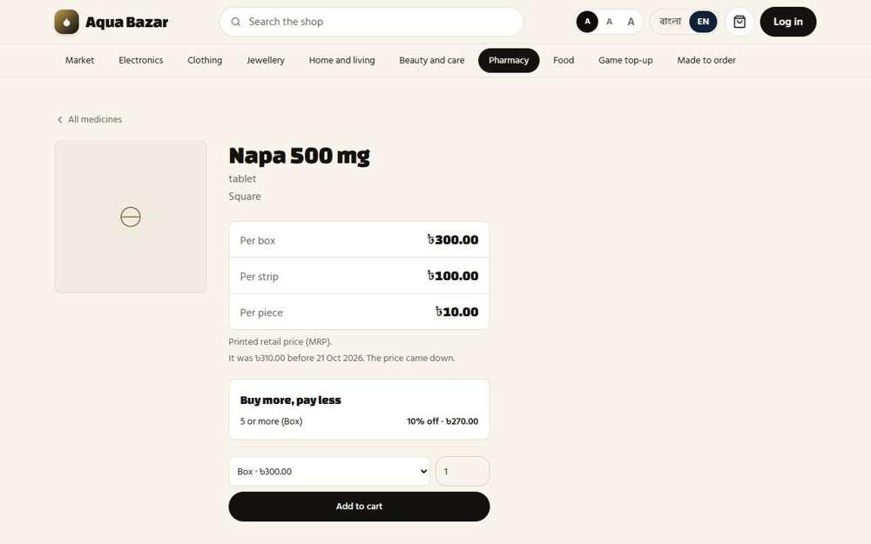
Seen as a stranger (not signed in) | /medicines/1
242. Generic alternative suggestions Works
What it is for: The search suggests other brands of the same generic medicine.
What the tester did: Opened a medicine page and read the list "Same medicine, other brands".
What the tester saw:
- Yes. The page offers other brands of the same medicine
- Yes. They share the generic, strength and form, with the cheapest first
Step 1: Cheaper brands of the same generic medicine
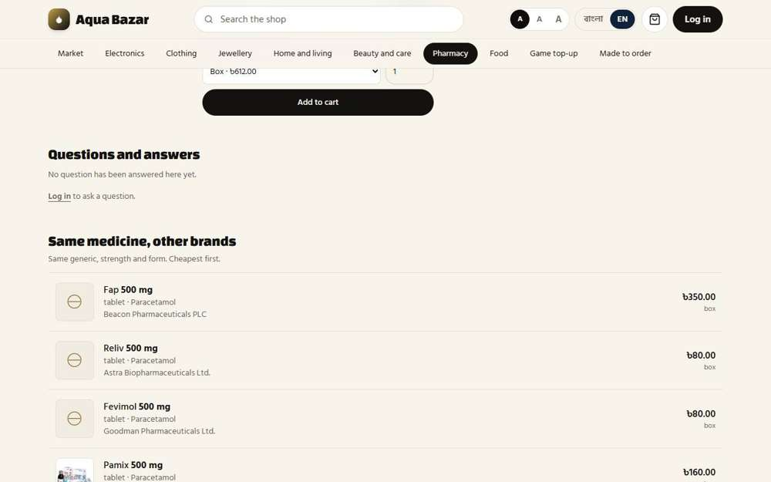
Seen as a stranger (not signed in) | /medicines/4864
243. Names only from the database Works
What it is for: Medicine names can only be chosen from the database, never typed freely.
What the tester did: On the purchase form, typed a medicine name that is not in the database.
What the tester saw:
- Yes. A name that is not in the database cannot be chosen, so no stray medicine names get in
Step 1: A made-up name finds nothing to choose
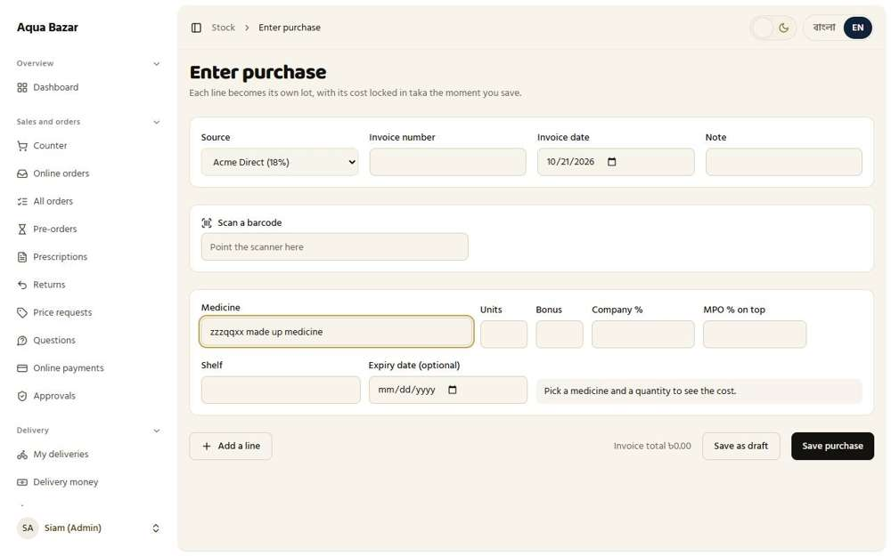
Seen as the owner | /admin/stock/receive
244. Company list preset Works
What it is for: The list of companies is preset.
What the tester did: Opened the company list on the ordering screen.
What the tester saw:
- Yes. A preset list of companies is offered (292 companies)
Step 1: A preset list of companies
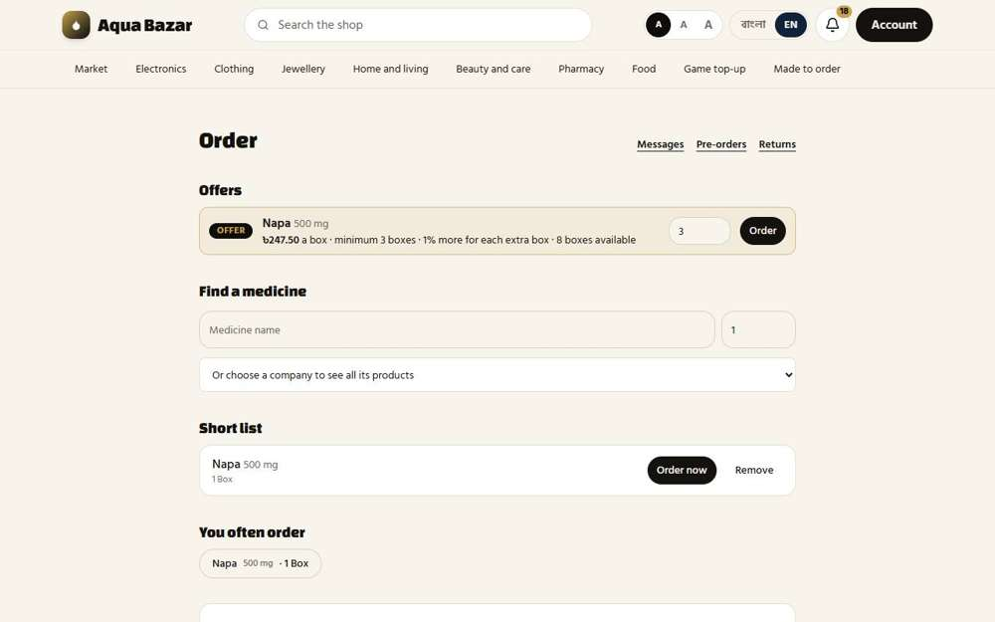
Seen as a paikari shop | /paikari
245. Search results for misspellings Works
What it is for: The search still finds a medicine when its name is spelled wrongly.
What the tester did: Searched with a spelling mistake ("paracetmol") and with "napaa".
What the tester saw:
- Yes. "paracetmol" still finds paracetamol medicines (1 found)
- Yes. "napaa" still finds Napa (14 found)
Step 1: A misspelled search

Seen as a stranger (not signed in) | /medicines?q=paracetmol
246. Alternative names linked Works
What it is for: Other names for the same medicine are linked together.
What the tester did: Searched by the generic name and by the Bangla spelling of Napa.
What the tester saw:
- Yes. Searching the generic name finds the Napa brand
- Yes. The Bangla spelling finds the medicine too (28 found)
Step 1: Searching in Bangla
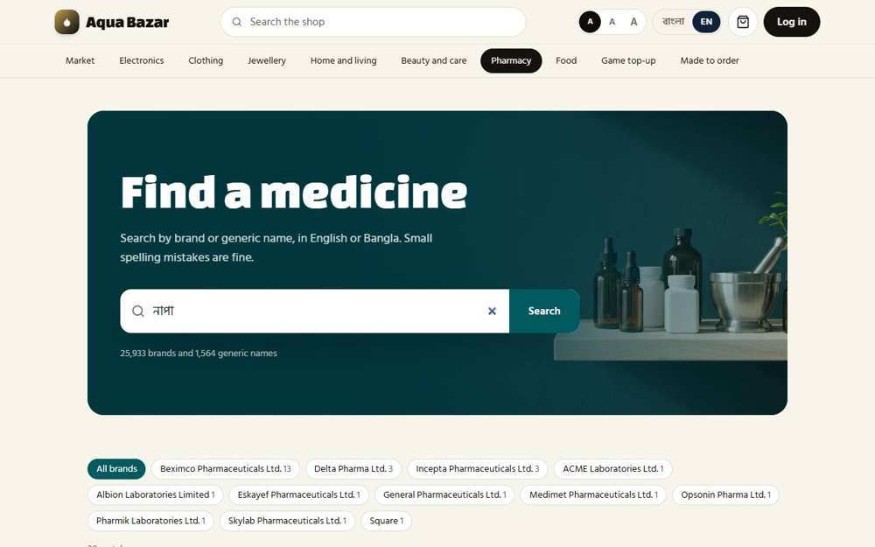
Seen as a stranger (not signed in) | /medicines?q=%E0%A6%A8%E0%A6%BE%E0%A6%AA%E0%A6%BE
247. "Inactive" mark Works
What it is for: A medicine no longer sold can be marked inactive.
What the tester did: Looked for Napa 80 mg, which was switched to inactive in the test data.
What the tester saw:
- Yes. An inactive medicine is either hidden or clearly marked as inactive
Note: No screen lets the owner switch a medicine to inactive. It was done in the test database.
Step 1: Napa search: the inactive medicine
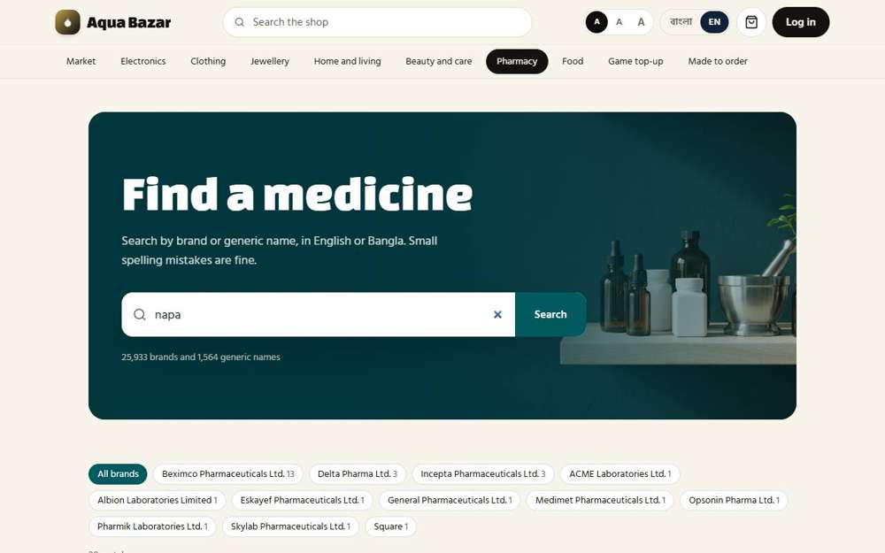
Seen as a stranger (not signed in) | /medicines?q=napa
248. "Prescription required" mark Works
What it is for: A medicine that needs a prescription carries a "prescription required" mark.
What the tester did: Opened the page of a medicine flagged as needing a prescription.
What the tester saw:
- Yes. The page carries a "Prescription required" mark
Step 1: The "Prescription required" mark
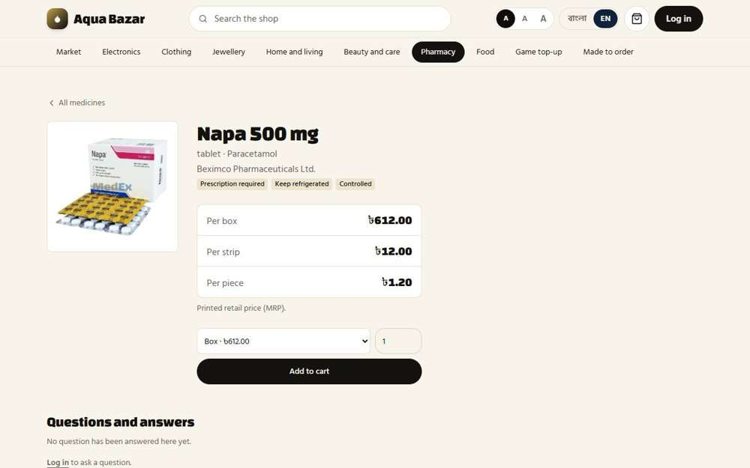
Seen as a stranger (not signed in) | /medicines/4864
249. Cold-chain ("Keep refrigerated") flag Works
What it is for: Medicines that need a fridge are flagged "keep refrigerated".
What the tester did: Opened the same medicine, flagged as cold-chain.
What the tester saw:
- Yes. The page says "Keep refrigerated"
- Yes. And explains it in plain words
Step 1: The "Keep refrigerated" mark
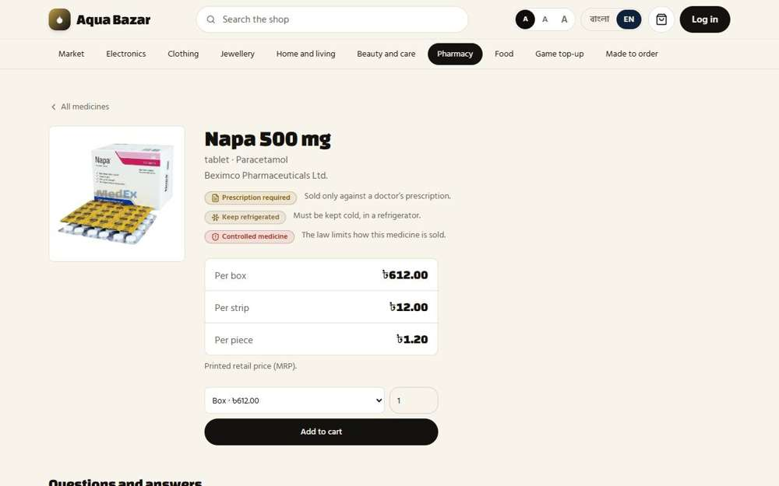
Seen as a stranger (not signed in) | /medicines/4864
250. Cold-chain items blocked from normal courier Works
What it is for: Fridge medicines are blocked from normal couriers.
What the tester did: Added the cold-chain medicine to the cart and opened the cart.
What the tester saw:
- Yes. Checkout says something in the cart must stay cold
- Yes. And that it goes by our own delivery, or cannot go by courier, so no normal courier is offered
Step 1: Checkout with a cold-chain medicine
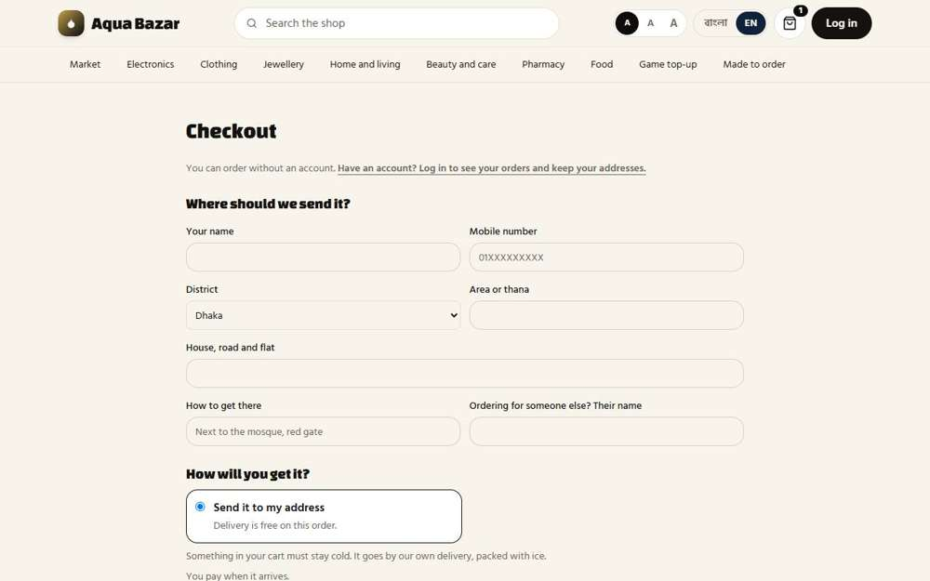
Seen as a stranger (not signed in) | /checkout
251. Controlled-medicine flag Works
What it is for: Controlled medicines are flagged and handled under stricter rules.
What the tester did: Opened the medicine flagged as controlled.
What the tester saw:
- Yes. The page carries a "Controlled" mark
Step 1: The "Controlled" mark
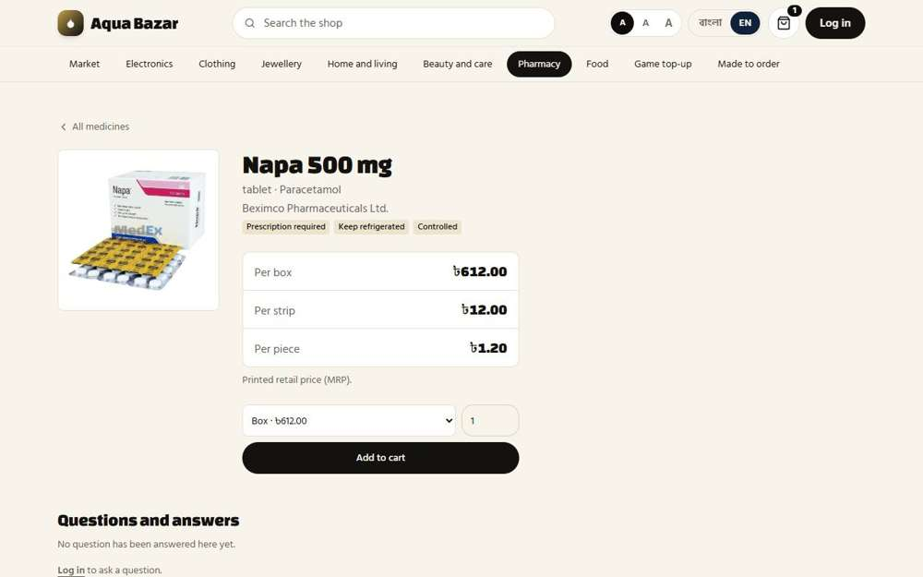
Seen as a stranger (not signed in) | /medicines/4864
252. In-stock medicines first in search Works
What it is for: Medicines that are in stock show first in the search.
What the tester did: Searched for "napa" on the public site and looked at where the one medicine the shop actually holds appears.
What the tester saw:
- Yes. The medicine in stock (Napa 500 mg, Square) comes first in the results
Note: On the paikari ordering screen the first result is "Napa 500 mg".
Step 1: The public search for "napa" | Step 2: The paikari search puts the in-stock one first
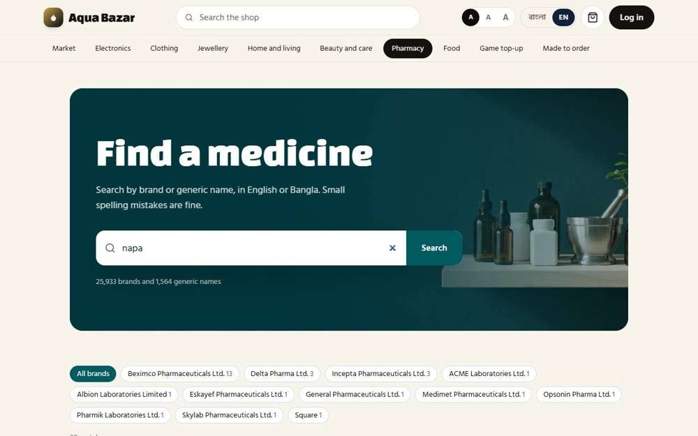  Seen as a stranger (not signed in) | /medicines?q=napa | 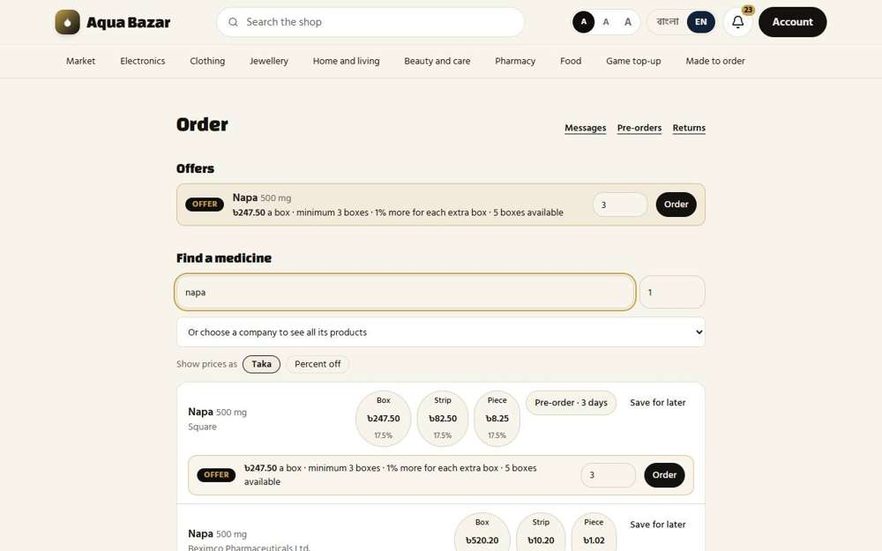  Seen as a paikari shop | /paikari

Returns
253. Returns only for paikari Works
What it is for: Only paikari buyers can return medicines.
What the tester did: As an ordinary shopper, tried the shops' return page. Then opened it as a paikari shop.
What the tester saw:
- Yes. An ordinary shopper cannot use the paikari return page
- Yes. A paikari shop sees its own memos with a return form
Step 1: A shopper is turned away | Step 2: The paikari shop's Returns page
  Seen as a signed-in shopper | /dashboard | 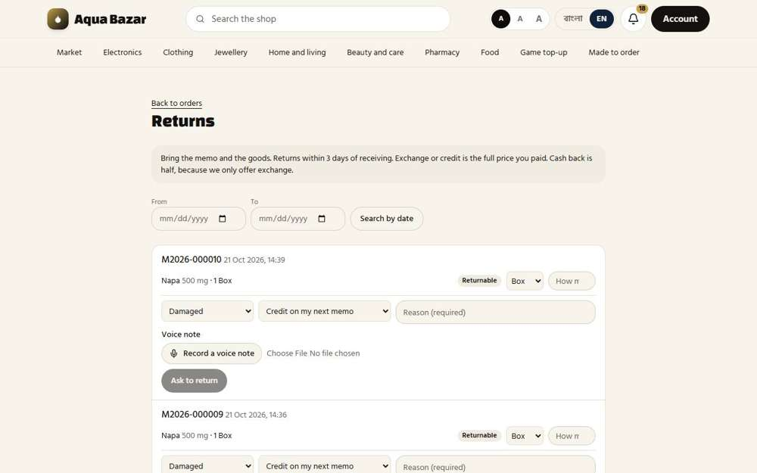  Seen as a paikari shop | /paikari/returns
254. 2–3 day limit, memo required Works
What it is for: A return has a two to three day limit and needs the memo.
What the tester did: Read the return rule on the owner's Returns page and the setting behind it.
What the tester saw:
- Yes. The rule is shown: shops only, within 3 days of receiving
- Yes. The number of days is a setting
Step 1: The return rule
Seen as the owner | /admin/returns
255. Exchange, or 50% if cash Works
What it is for: The buyer gets an exchange, or half the money back if they paid cash.
What the tester did: Looked at the choices the shop has for what it wants back.
What the tester saw:
- Yes. One choice: an exchange
- Yes. Another: cash back at half the price
- Yes. And: credit on the next memo
Note: The choices are: Credit on my next memo / Exchange for another medicine / Cash back (half the price)
Step 1: Credit, exchange or half the price in cash
Seen as a paikari shop | /paikari/returns
256. "Returnable" mark Works
What it is for: A "returnable" mark shows which medicines can come back.
What the tester did: Looked for the "Returnable" mark beside each memo.
What the tester saw:
- Yes. A memo that can still be returned is marked "Returnable"
Step 1: The "Returnable" mark
Seen as a paikari shop | /paikari/returns
257. Search by date Works
What it is for: Returns can be searched by date.
What the tester did: Used the From and To boxes to search the memos by date.
What the tester saw:
- Yes. Memos from that day are listed
Step 1: Memos searched by date
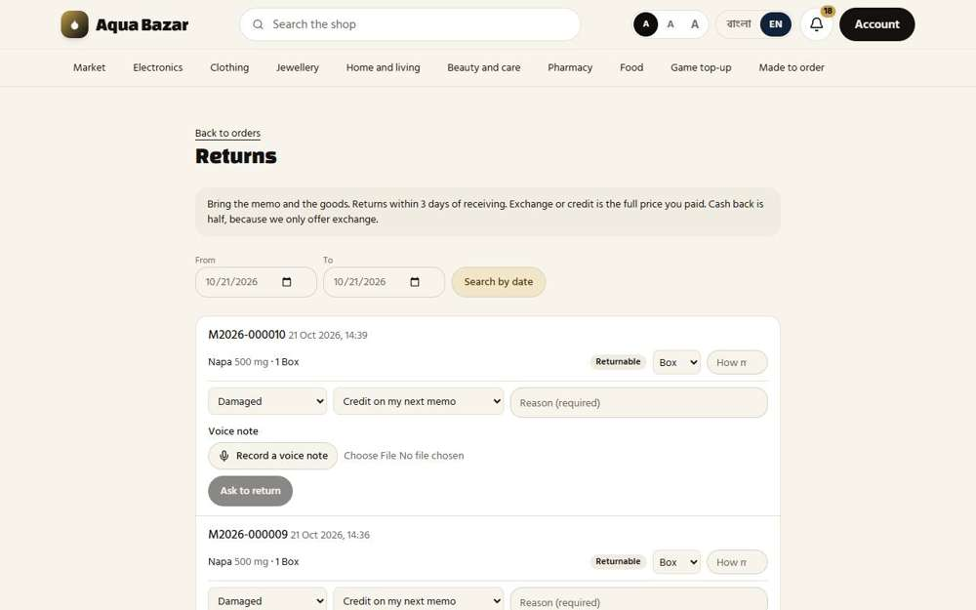
Seen as a paikari shop | /paikari/returns?from=2026-10-21&to=2026-10-21
258. Public: apply → approve → call Works
What it is for: Public buyers apply for a return, the shop approves, then calls them.
What the tester did: As an ordinary shopper, opened the page for asking to return something.
What the tester saw:
- Yes. Public shoppers have a return page: apply, wait for approval, then be called
Step 1: A public shopper's return page
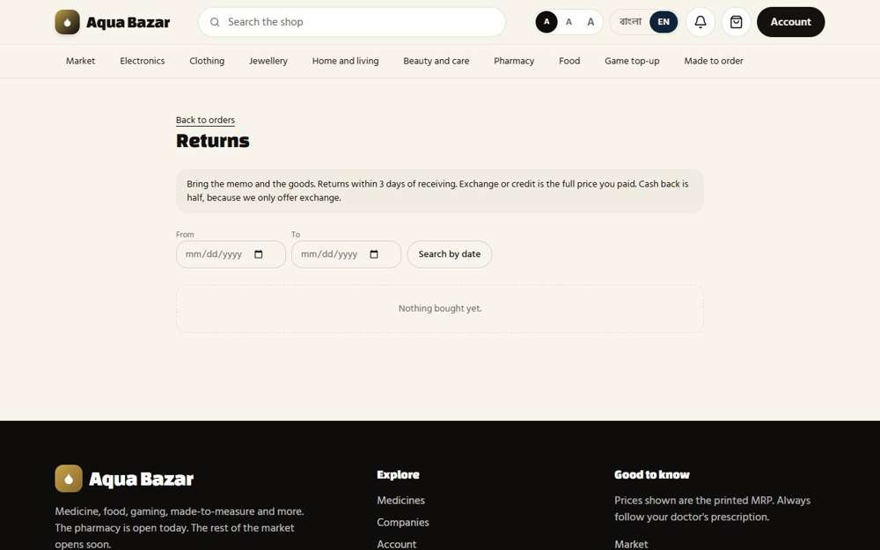
Seen as a signed-in shopper | /my-orders/returns
259. Login required to return Works
What it is for: A buyer must be signed in to return something.
What the tester did: As a stranger, opened the return page.
What the tester saw:
- Yes. A stranger must sign in before returning anything
Step 1: A stranger is sent to sign in
Seen as a stranger (not signed in) | /login
260. Reason or voice note required Works
What it is for: A reason or a voice note is required for a return.
What the tester did: Filled in a return but left the reason blank, and pressed "Ask to return".
What the tester saw:
- Yes. The "Ask to return" button stays disabled until a reason is typed (or a voice note is attached)
- Yes. A voice note can be used instead of typing a reason
Step 1: A return with no reason typed: the "Ask to return" button stays greyed out
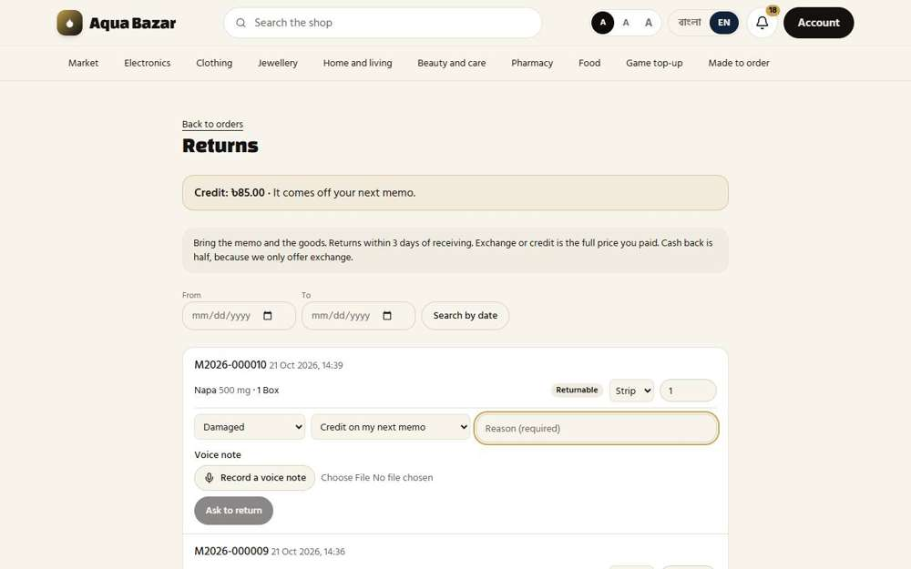
Seen as a paikari shop | /paikari/returns
261. Partial returns Works
What it is for: Part of an order can be returned.
What the tester did: Asked to return one strip out of a box.
What the tester saw:
- Yes. The request is for a strip, not the whole box
Step 1: Asking to return one strip, not the whole box | Step 2: The request is sent
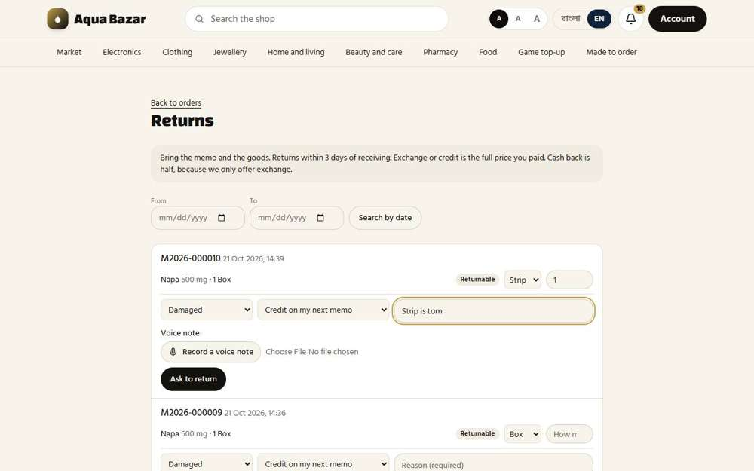  Seen as a paikari shop | /paikari/returns | Seen as a paikari shop | /paikari/returns
Step 3: The owner sees the part-return waiting
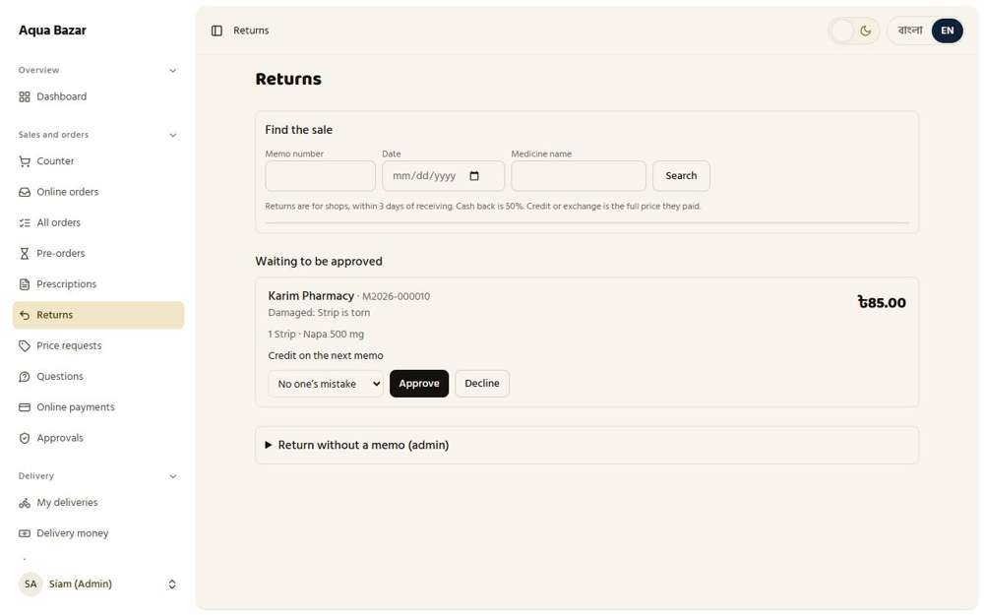
Seen as the owner | /admin/returns
262. At the purchase price Works
What it is for: Returns are valued at the original buying price.
What the tester did: Opened a return waiting to be approved and read the amount.
What the tester saw:
- Yes. The return is valued at what the shop paid (85 for a strip)
Step 1: A return waiting
Seen as the owner | /admin/returns
263. Credit and minus on next memo Works
What it is for: The return becomes credit, taken off the next memo.
What the tester did: Approved the waiting return as credit and looked at what the shop sees.
What the tester saw:
- Yes. The owner approves the return
- Yes. The shop has credit, shown in taka, that comes off its next memo
Step 1: A return waiting for the owner | Step 2: After approving: "Return approved."
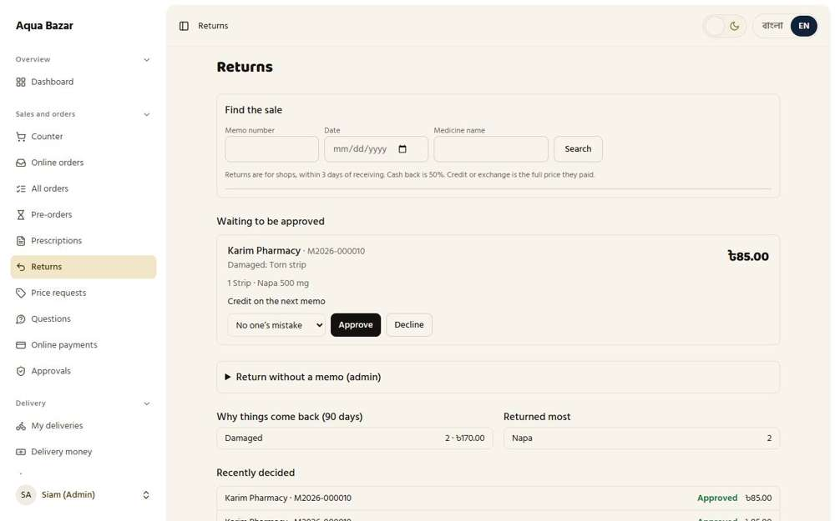  Seen as the owner | /admin/returns | 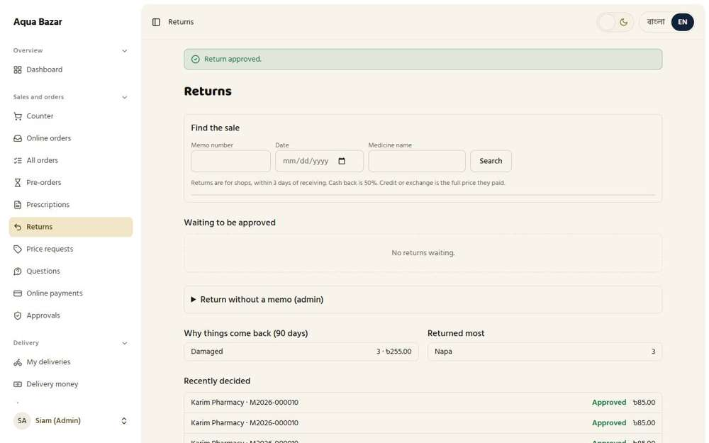  Seen as the owner | /admin/returns
Step 3: The shop sees its credit
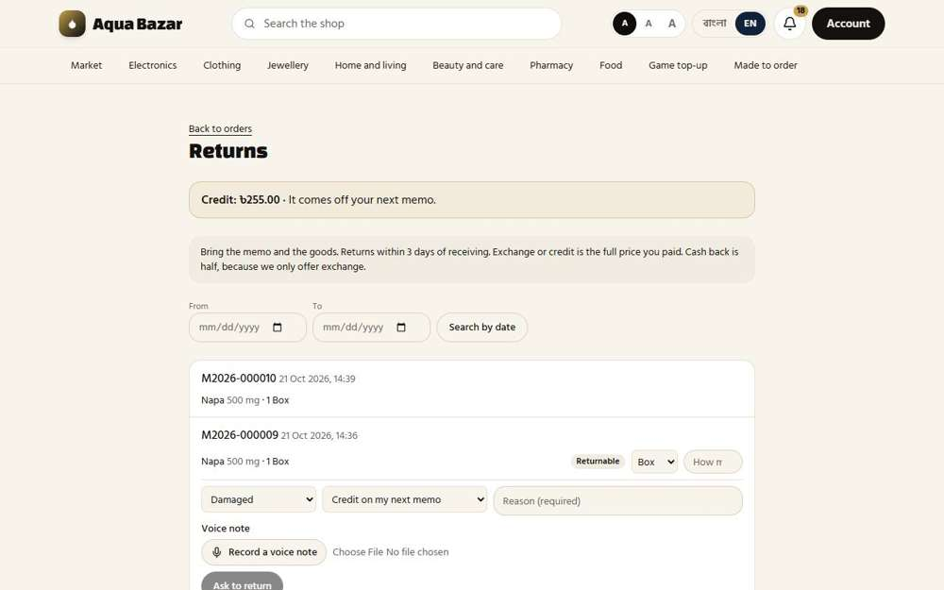
Seen as a paikari shop | /paikari/returns
264. Warning on credit after 1–2 months Works
What it is for: If the credit sits unused for one or two months, a warning shows.
What the tester did: Looked at the setting for warning about credit that has sat unused.
What the tester saw:
- Yes. The owner sets how many days before unused credit is flagged
Step 1: The credit warning setting
Seen as the owner | /admin/settings
265. Return goes back to its own lot Works
What it is for: A returned item goes back to its own batch.
What the tester did: Opened the medicine's lots after a return was approved to see where the returned goods went.
What the tester saw:
- Yes. The medicine's movements show the return
Step 1: The lots and movements after a return
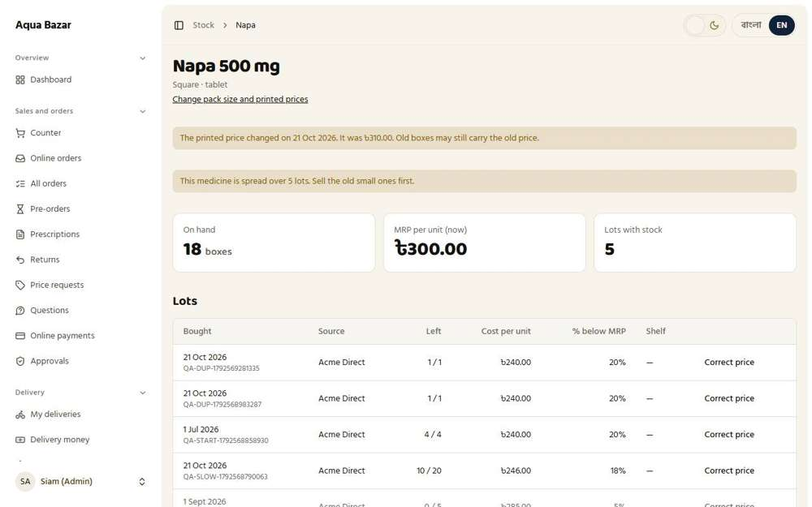
Seen as the owner | /admin/stock/medicines/1
266. Lot reopens if finished Only partly shown
What it is for: If that batch was finished, it is reopened.
What the tester did: Looked for a finished lot reopening.
Note: Needs a lot that is completely sold and then returned. Not reproduced.
Step 1: Lots
Seen as the owner | /admin/stock/medicines/1
267. Returned goods resold Only partly shown
What it is for: Returned goods can be sold again.
What the tester did: Looked for returned goods being sold again.
Note: Not reproduced.
Step 1: Lots
Seen as the owner | /admin/stock/medicines/1
268. Retail refunds — no profile Only partly shown
What it is for: Retail refunds need no customer profile.
What the tester did: Looked at the return screen for a retail sale with no customer profile.
Note: A retail refund with no profile was not carried through.
Step 1: The owner's return page
Seen as the owner | /admin/returns
269. Three kinds of search (memo/date/medicine name) Works
What it is for: A return can be found by memo, by date or by medicine name.
What the tester did: Looked at the three ways to find a sale to return.
What the tester saw:
- Yes. Search by memo number
- Yes. Search by date
- Yes. Search by medicine name
Step 1: Memo, date or medicine name
Seen as the owner | /admin/returns
270. Return without invoice (rare) Works
What it is for: In rare cases a return is allowed without an invoice.
What the tester did: Looked for a way to take a return with no memo.
What the tester saw:
- Yes. The owner can take a return without a memo, for rare cases
Step 1: Return without a memo (admin)
Seen as the owner | /admin/returns
271. Optional "Will receive return money" field Only partly shown
What it is for: An optional field notes who will receive the return money.
What the tester did: Looked for the optional "will receive return money" field.
Note: The optional "will receive return money" field was not found on the return screens.
Step 1: Returns
Seen as the owner | /admin/returns
272. Return policy on retail memos Works
What it is for: Retail memos print the return policy.
What the tester did: Finished a retail sale and read the policy printed on the memo.
What the tester saw:
- Yes. The retail memo prints the return policy
Step 1: The memo carries the return policy
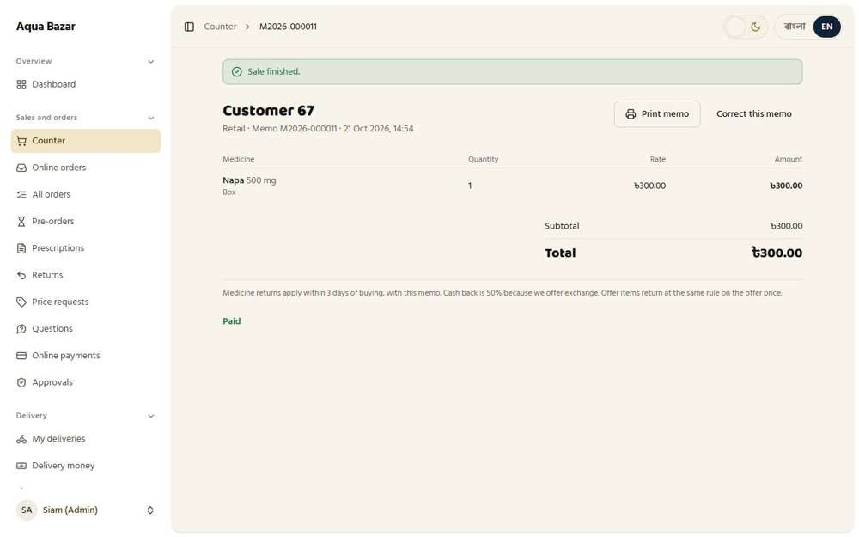
Seen as the owner | /admin/counter/213
273. Offer returns at 50% of offer rate Only partly shown
What it is for: Offer items return at half the offer rate.
What the tester did: Read the offer return rule printed on the memo.
What the tester saw:
- Yes. The memo says how offer items are returned
Note: The checklist says offer returns pay 50% of the offer rate. The memo wording says "the same rule on the offer price", and an offer return itself was not made.
Step 1: Offer items on the memo
Seen as the owner | /admin/counter/213
274. Delivery charge — after/before sending Only partly shown
What it is for: The delivery charge rule differs if the return is before or after sending.
What the tester did: Looked at the delivery charge rule on returns.
Note: Needs a delivered order. Not reproduced.
Step 1: Returns
Seen as the owner | /admin/returns
275. 50% on product advance Only partly shown
What it is for: If a product advance was paid, 50 per cent applies.
What the tester did: Looked at the 50% on product advance rule.
Note: Needs an advance payment on an order. Not reproduced.
Step 1: Returns
Seen as the owner | /admin/returns
276. Return analysis (customer and product) Works
What it is for: Return analysis shows which customers and products come back most.
What the tester did: Looked for return analysis by customer and product.
What the tester saw:
- Yes. The owner sees why things come back, by reason, with counts and amounts
- Yes. And which products come back most
Step 1: Why things come back, and what comes back most
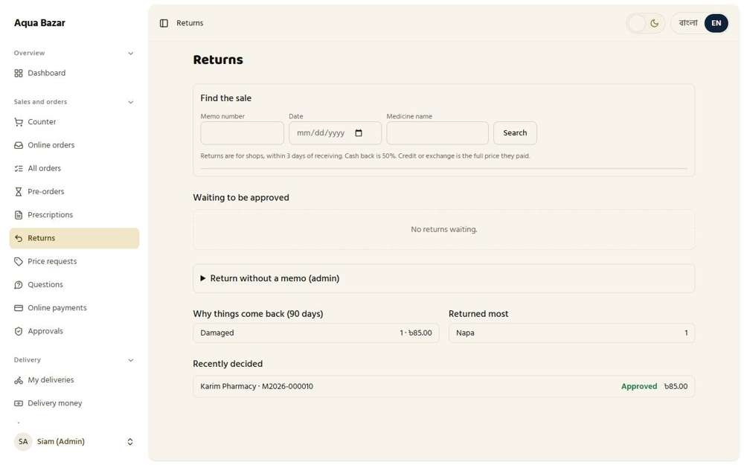
Seen as the owner | /admin/returns
277. Warnings when mistakes are found Only partly shown
What it is for: When a mistake is found, warnings appear.
What the tester did: Looked for warnings when mistakes are found.
Note: Not reproduced.
Step 1: Returns
Seen as the owner | /admin/returns
278. Auto warning for repeated mistakes Only partly shown
What it is for: Repeated mistakes trigger an automatic warning.
What the tester did: Looked for an automatic warning for repeated mistakes.
Note: Not reproduced.
Step 1: Returns
Seen as the owner | /admin/returns
279. "Previously returned" mark Works
What it is for: A "previously returned" mark shows on the item.
What the tester did: As a paikari shop, asked to return one strip from its newest memo. Then, as the owner, looked the same memo up on the Returns screen.
What the tester saw:
- Yes. The line that already has a return is marked "Previously returned"
Step 1: The shop asks to return one strip | Step 2: The owner opens memo M2026-000016
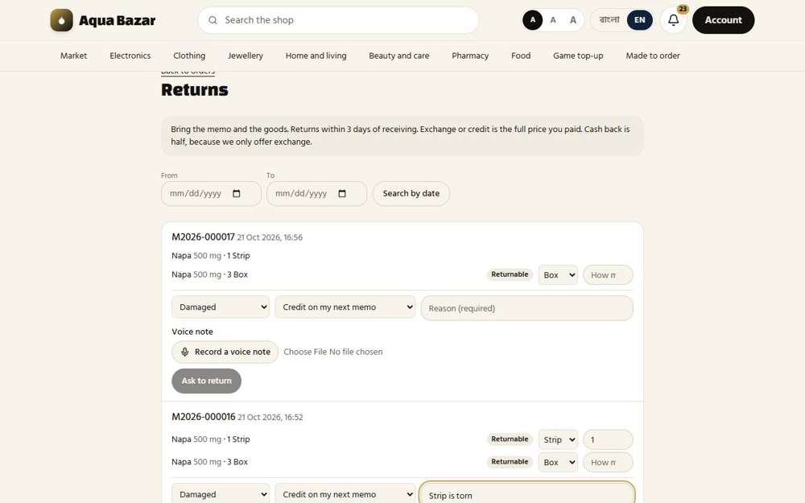  Seen as a paikari shop | /paikari/returns | 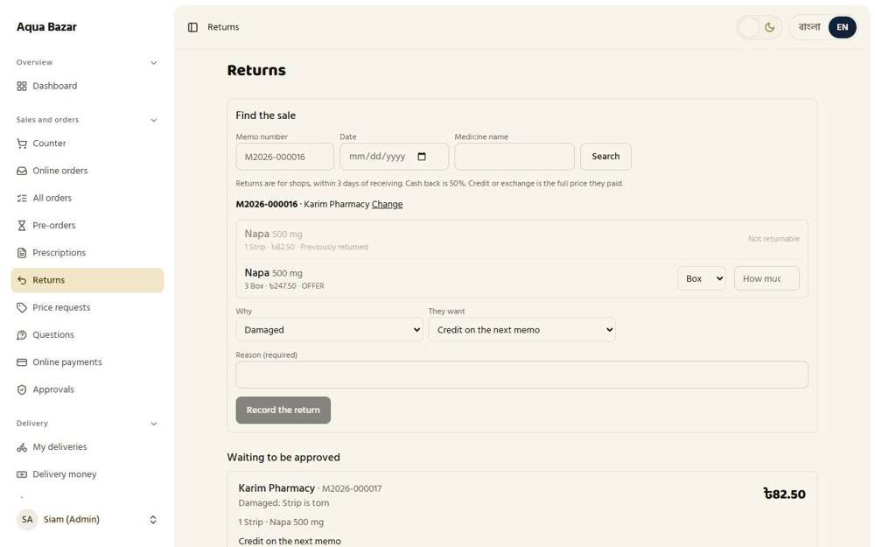  Seen as the owner | /admin/returns
280. "Reprint" on memos Works
What it is for: A memo can be reprinted when needed.
What the tester did: Opened a finished memo and looked for a print or reprint button.
What the tester saw:
- Yes. A finished memo has a "Print memo" button, so it can be printed again
Step 1: A memo with its print button
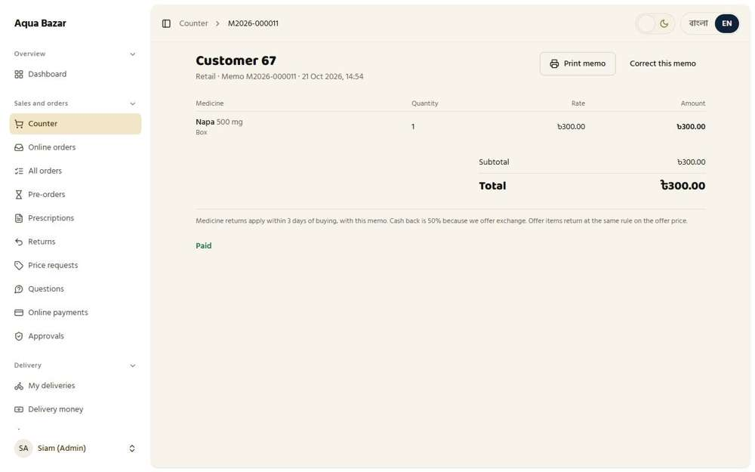
Seen as the owner | /admin/counter/213

Public Market
281. Sector icons on homepage Works
What it is for: The homepage shows an icon for each shop sector.
What the tester did: Opened the home page as a stranger and looked at the row of sector icons and names.
What the tester saw:
- Yes. The Market sector is on the top row
- Yes. The Electronics sector is on the top row
- Yes. The Clothing sector is on the top row
- Yes. The Jewellery sector is on the top row
- Yes. The Pharmacy sector is on the top row
- Yes. The Food sector is on the top row
- Yes. The Game top-up sector is on the top row
Step 1: The home page with the sector row
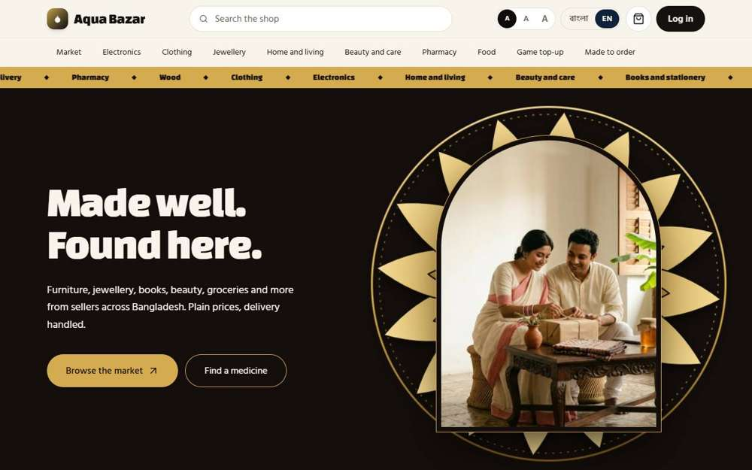
Seen as a stranger (not signed in) | /
282. Own-area items first Works
What it is for: Items from the shopper's own area show first.
What the tester did: Opened the full product list and looked at the sort choices.
What the tester saw:
- Yes. The first sort choice puts the nearest shops, and the newest items, first
Step 1: The full list with its sort choices
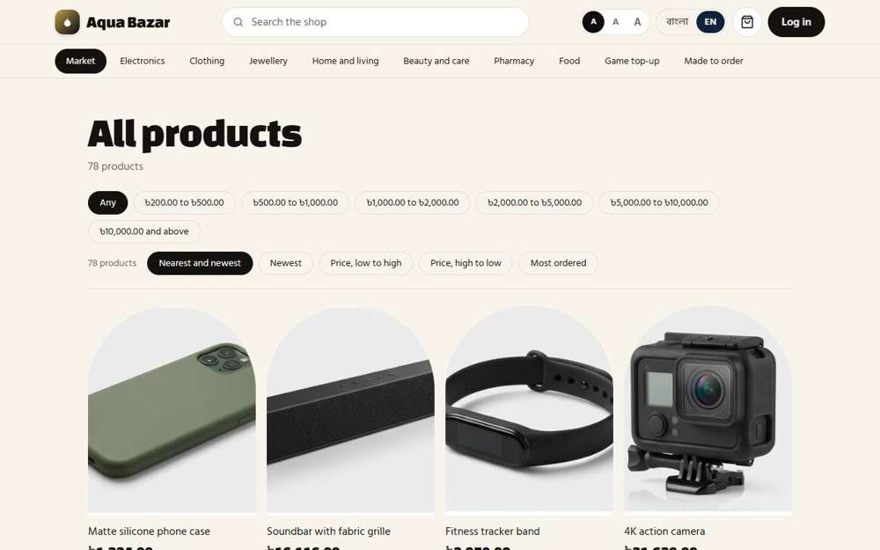
Seen as a stranger (not signed in) | /market?all=1
283. Categories, search, filters, sorting Works
What it is for: Shoppers can browse categories, search, filter and sort.
What the tester did: Searched, filtered by price and changed the sort order on the market list.
What the tester saw:
- Yes. Sort: price, low to high
- Yes. Sort: price, high to low
- Yes. Sort: most ordered
- Yes. Search finds the Soundbar
Step 1: Price filters and sorting | Step 2: Searching for "soundbar"
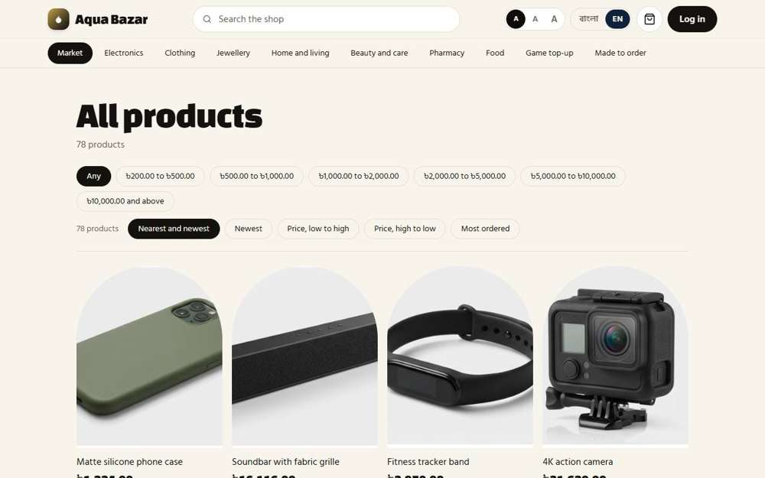  Seen as a stranger (not signed in) | /market?all=1 | 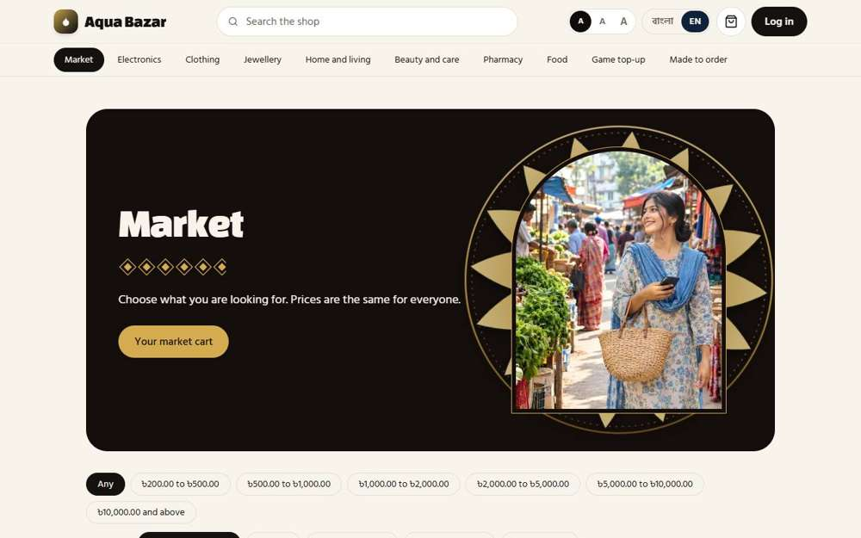  Seen as a stranger (not signed in) | /market?q=soundbar
284. Personal recommendations Not built yet
What it is for: Personal recommendations have not been built yet.
What the tester did: Checked the checklist.
Note: Personal recommendations have not been built yet.
285. Sector by budget Works
What it is for: Shoppers can start from a budget and see what fits.
What the tester did: Looked at the budget buttons that let a shopper start from what they want to spend.
What the tester saw:
- Yes. Price ranges are offered as buttons
Step 1: Budget ranges as buttons
Seen as a stranger (not signed in) | /market?all=1
286. Premium sector (automatic) Works
What it is for: A premium sector fills itself with the highest priced items.
What the tester did: Opened a shop's page and looked for the premium section.
What the tester saw:
- Yes. The shop has a Premium section that fills itself with the dearest items
Step 1: The Electronics shop: its premium picks
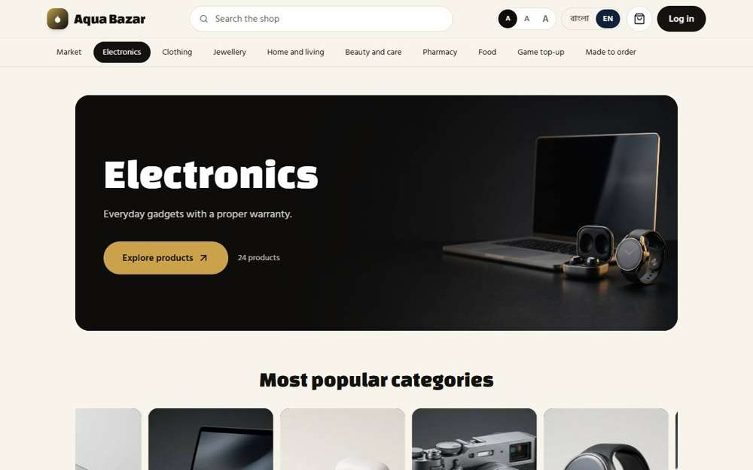
Seen as a stranger (not signed in) | /market?sector=electronics
287. Moves in/out of premium when price changes Only partly shown
What it is for: When a price changes, the item moves in or out of premium by itself.
What the tester did: Looked for items moving in and out of premium when their price changes.
Note: Changing a price and watching an item move in or out of Premium was not carried through.
Step 1: The owner's Market page
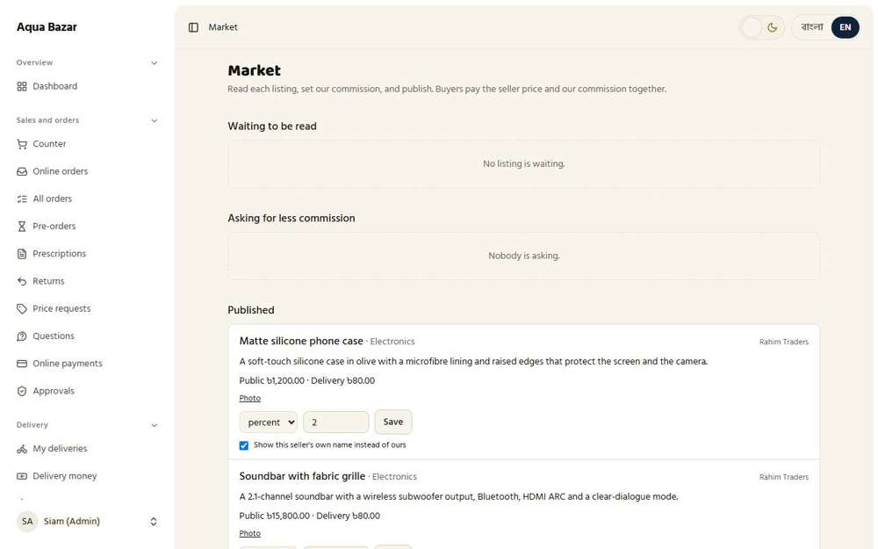
Seen as the owner | /admin/market
288. Only existing price ranges shown Works
What it is for: Only price ranges that actually have products are shown.
What the tester did: Looked at the price ranges and compared them with the prices of the products.
What the tester saw:
- Yes. Only a handful of ranges that match real prices are shown (6)
Note: Ranges shown: ৳200.00 to ৳500.00 | ৳500.00 to ৳1,000.00 | ৳1,000.00 to ৳2,000.00 | ৳2,000.00 to ৳5,000.00 | ৳5,000.00 to ৳10,000.00 | ৳10,000.00 and above
Step 1: Only price ranges that have products
Seen as a stranger (not signed in) | /market?all=1
289. One product, many sellers Only partly shown
What it is for: One product can be sold by many sellers.
What the tester did: Opened the Catalogue page, which joins listings of the same product from different sellers.
What the tester saw:
- Yes. The owner has a catalogue of products that several sellers can list under
Note: Only one seller exists in this copy, so a product page with two sellers side by side could not be shown.
Step 1: The catalogue: one product, many sellers
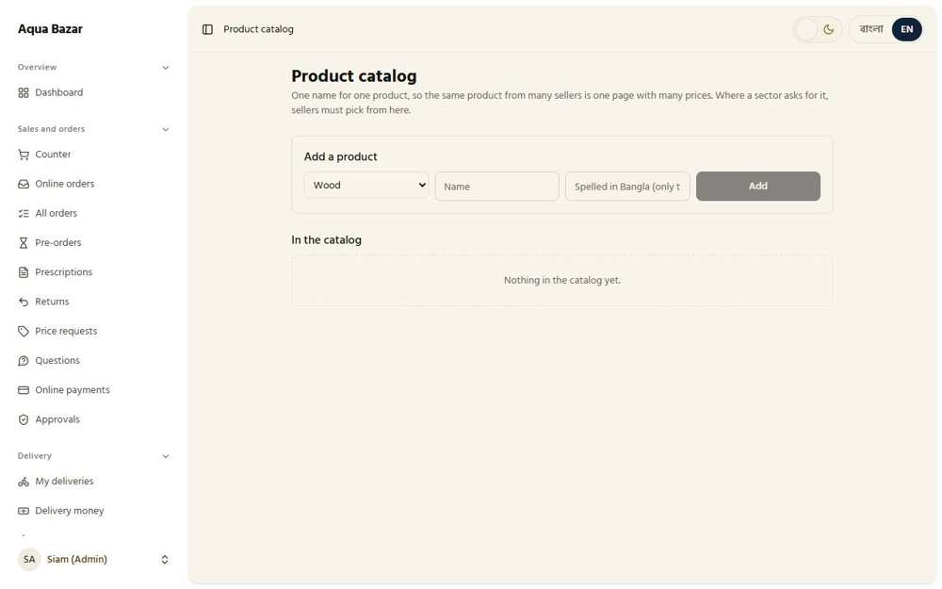
Seen as the owner | /admin/catalog
290. Order by price + charge + rating Only partly shown
What it is for: Sellers are ordered by price, delivery charge and rating together.
What the tester did: Looked for sellers ordered by price, charge and rating together.
Note: Needs one product with several sellers, which the test data does not have.
Step 1: A product page
Seen as a stranger (not signed in) | /market/78
291. Central product catalog Works
What it is for: A central product catalogue keeps one entry per product.
What the tester did: Opened the Product catalog, where each product has one name for every seller.
What the tester saw:
- Yes. The catalog keeps one name per product
Step 1: The Product catalog
Seen as the owner | /admin/catalog
292. Shop's own page Works
What it is for: Each shop has its own public page.
What the tester did: Opened the seller's own page from a product.
What the tester saw:
- Yes. The shop has a page of its own
Step 1: The seller's own page
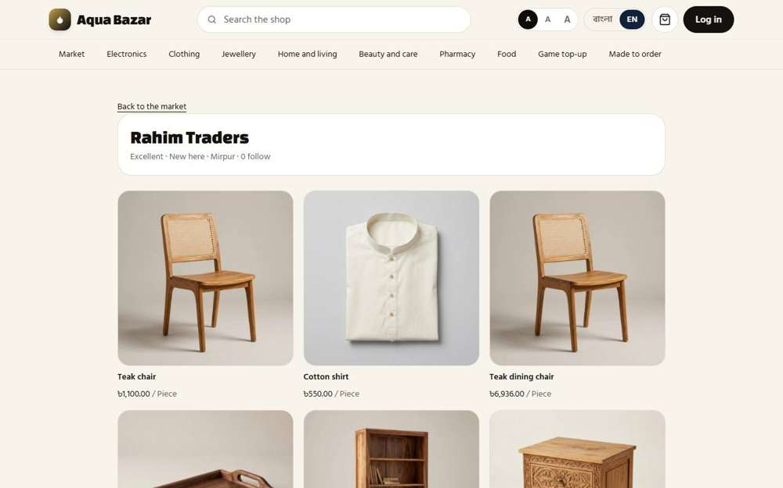
Seen as a stranger (not signed in) | /shop/5
293. Follow a shop Works
What it is for: A shopper can follow a shop.
What the tester did: On the seller's page, looked for a Follow button.
What the tester saw:
- Yes. The shop's page has a Follow button
Step 1: The shop's page for a signed-in shopper
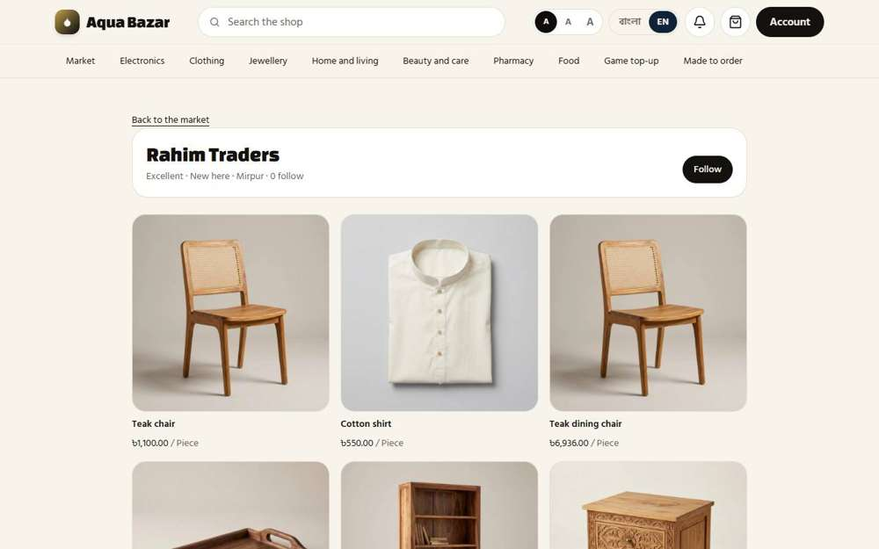
Seen as a signed-in shopper | /shop/5
294. Multiple photos, zoom Only partly shown
What it is for: A product page can show many photos with zoom.
What the tester did: Looked at the product photo and pressed it to look closer.
What the tester saw:
- Yes. Pressing the photo opens it large, so the buyer can look closer
Note: Only one photo exists on this product, so the row of thumbnails to look through was not shown. The seller adds more with "More photos".
Step 1: The product photo | Step 2: The photo opened large
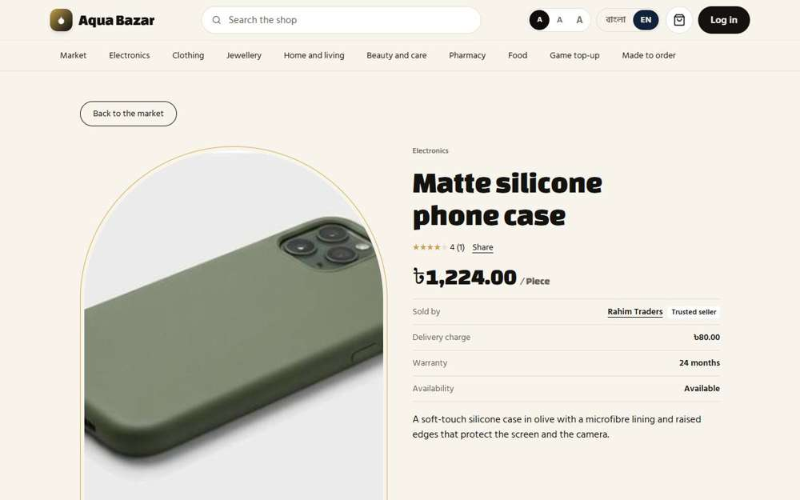  Seen as a stranger (not signed in) | /market/78 | 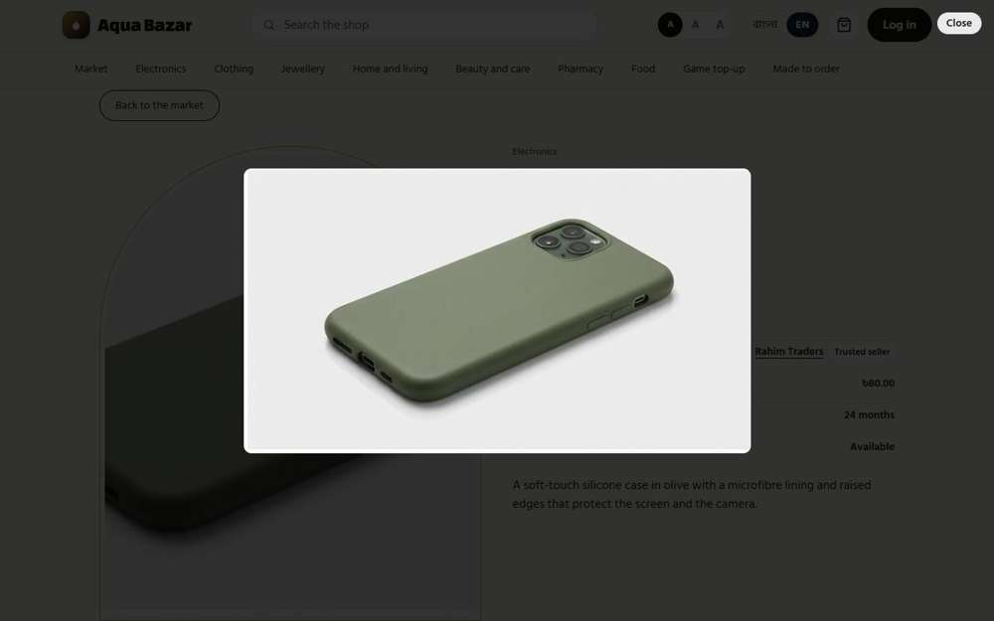  Seen as a stranger (not signed in) | /market/78
295. Variants (size, color) Works
What it is for: Products can come in variants such as size and colour.
What the tester did: Opened a clothing product and looked for size and colour choices.
What the tester saw:
- Yes. A clothing product offers size and colour choices
Step 1: The Clothing shop | Step 2: A clothing product page
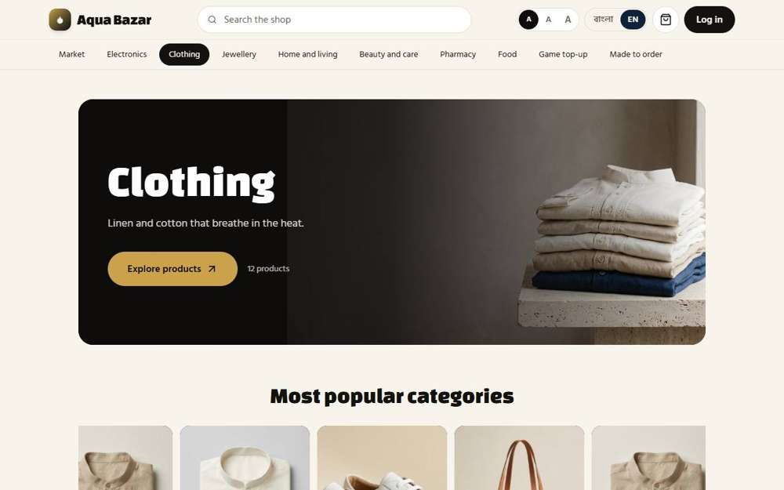  Seen as a stranger (not signed in) | /market?sector=clothing | 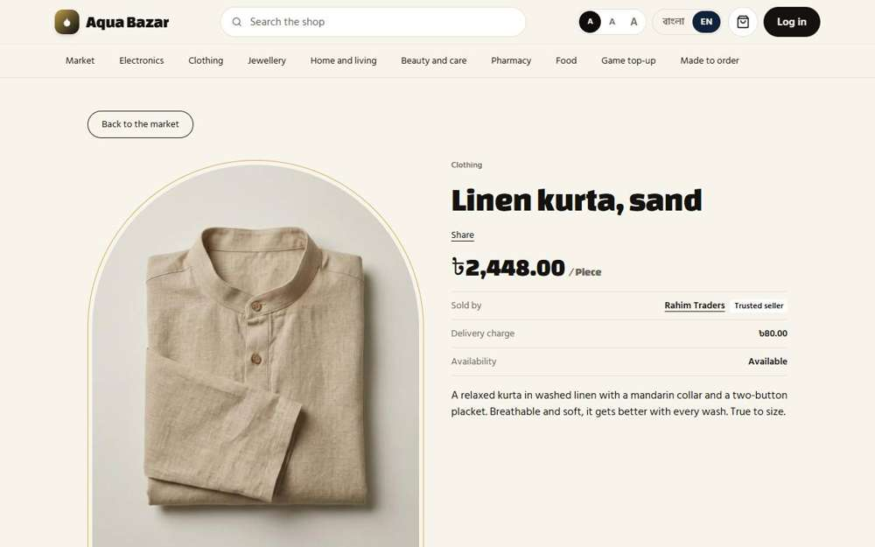  Seen as a stranger (not signed in) | /market/7
296. Reviews and ratings, with photos Works
What it is for: Buyers can leave reviews and ratings, with photos.
What the tester did: On the delivered order, gave four stars, wrote a few words, attached a photo and pressed Send my review. Then looked at the product page.
What the tester saw:
- Yes. After delivery the buyer is asked "How was it?"
- Yes. The review shows on the product page
- Yes. Marked as a verified buyer, with no name
Step 1: A four-star review with a photo, ready to send | Step 2: After sending the review
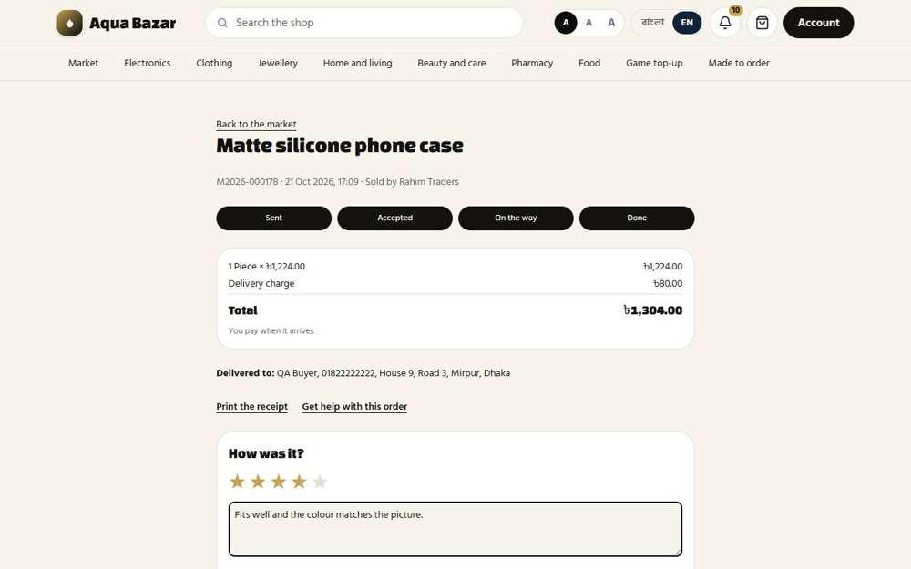  Seen as a signed-in shopper | /market/orders/MWOP9Rd1CCx7CnkWHLrsUwFijMJ3qEPJqjLpnJZk | 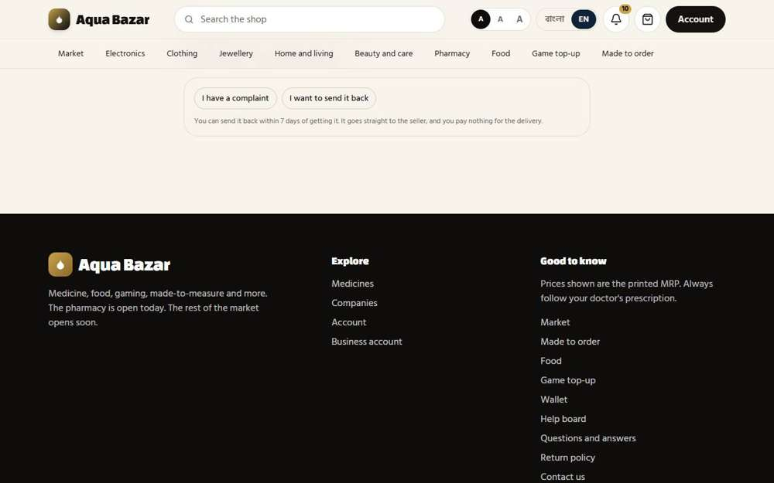  Seen as a signed-in shopper | /market/orders/MWOP9Rd1CCx7CnkWHLrsUwFijMJ3qEPJqjLpnJZk
Step 3: The review on the product page
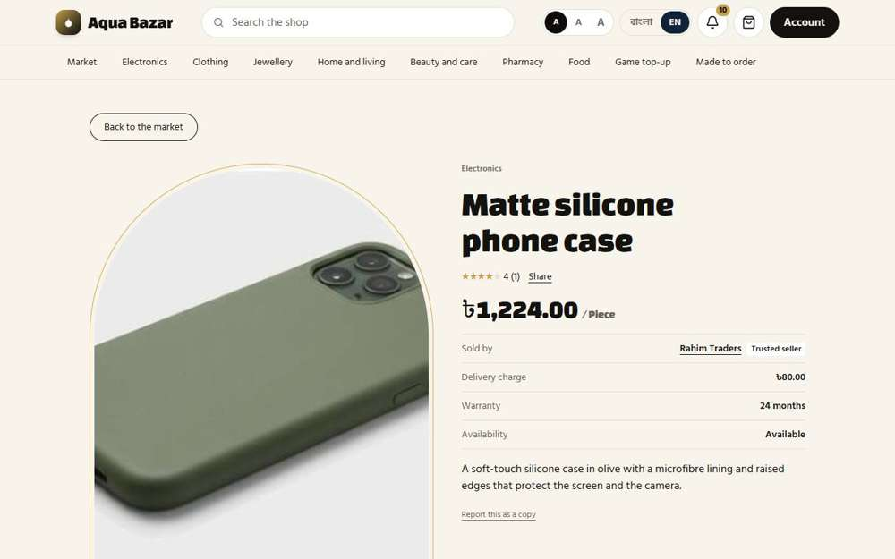
Seen as a signed-in shopper | /market/78
297. Only verified buyers review Works
What it is for: Only people who really bought can review.
What the tester did: Read who may write a review.
What the tester saw:
- Yes. Only people who bought the product may review it
Step 1: Only buyers can review
Seen as a stranger (not signed in) | /market/78
298. Social share Works
What it is for: A product page has share buttons for social media.
What the tester did: Looked for the Share button on a product.
What the tester saw:
- Yes. A product has a Share button
Step 1: Share
Seen as a stranger (not signed in) | /market/78
299. Price history Works
What it is for: A price history shows how the price moved.
What the tester did: The owner raised the printed price of a box of Napa from 300 to 320. A visitor then opened the medicine page. The owner put the price back afterwards.
What the tester saw:
- Yes. The page tells the buyer what the price was before the recent change
Step 1: The medicine page after a recent price change
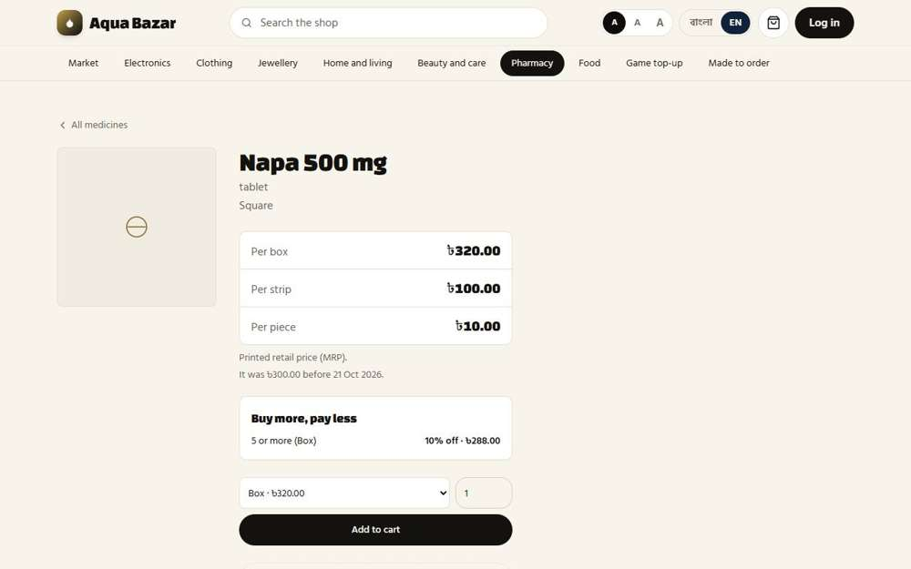
Seen as a stranger (not signed in) | /medicines/1
300. Frequently bought together Only partly shown
What it is for: The page suggests things often bought together.
What the tester did: Opened a medicine page and looked for "bought together".
Note: The "bought together" row is built into the medicine page, but it shows only after at least five memos carry both medicines. The test data does not have that many, so the row stayed hidden (it did not appear).
Step 1: A medicine page
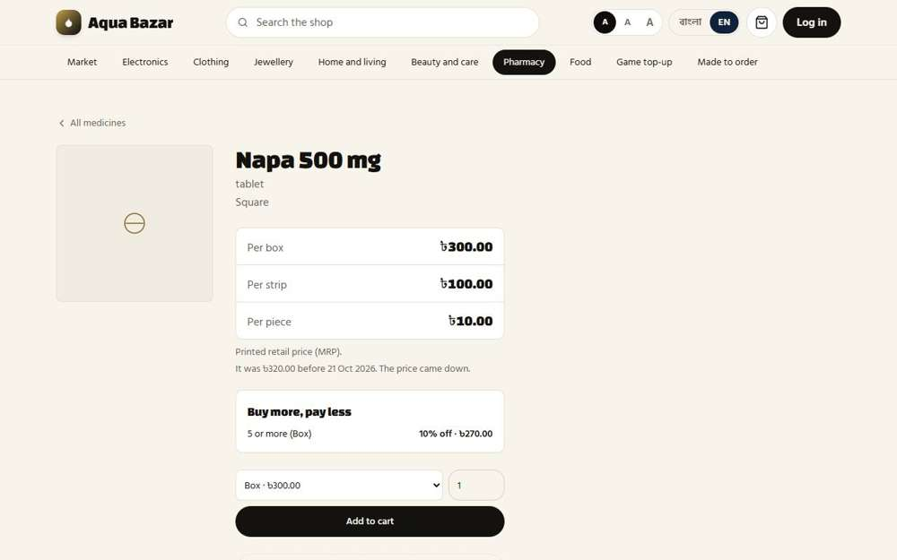
Seen as a stranger (not signed in) | /medicines/1
301. "Why didn't you buy" and price offers Works
What it is for: If a shopper leaves without buying, they can say why and propose a price.
What the tester did: Pressed "Not buying? Tell us why" on a product.
What the tester saw:
- Yes. A form asks why, and lets the shopper offer a price
Step 1: Tell us why you are not buying, and offer a price
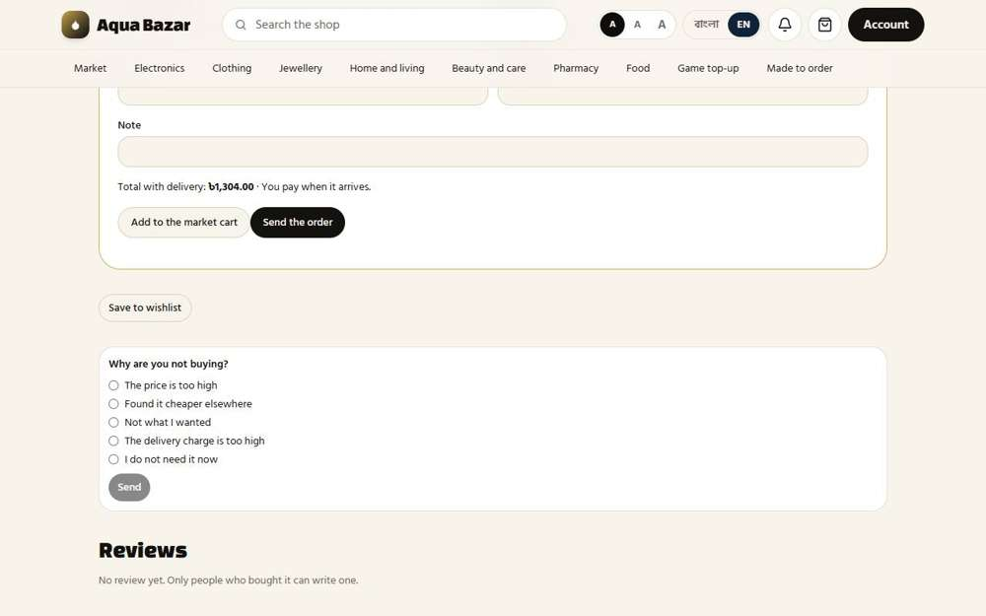
Seen as a signed-in shopper | /market/78
302. Offer cancelled after 24 hours Only partly shown
What it is for: A price offer lapses after 24 hours.
What the tester did: Looked for price offers lapsing after 24 hours.
Note: Waiting 24 hours to watch an offer lapse was not possible.
Step 1: Requests
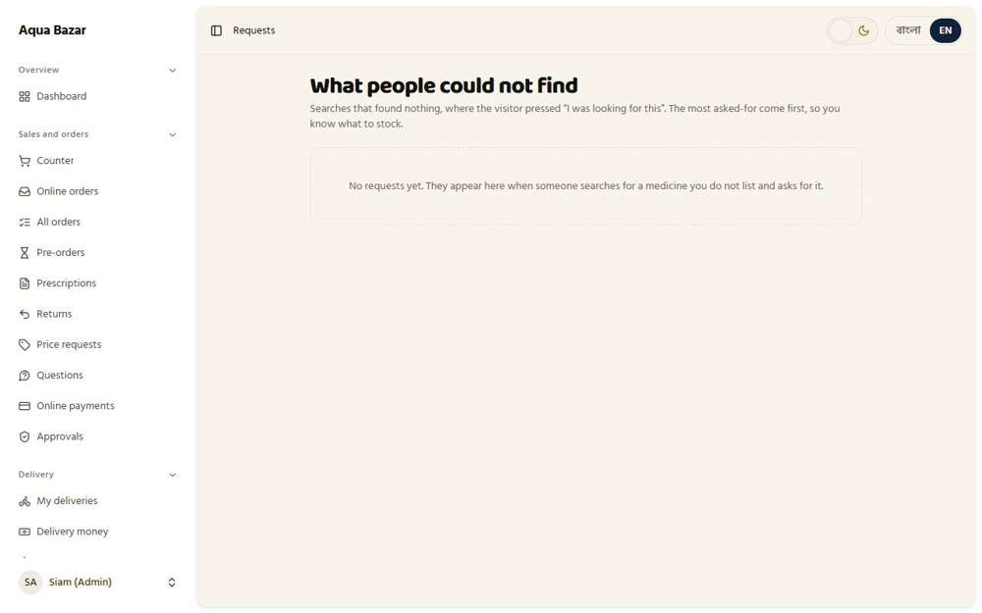
Seen as the owner | /admin/requests
303. "I was looking for this" button Works
What it is for: A button says "I was looking for this" when something is missing.
What the tester did: Searched for something the market does not sell and looked for the "I was looking for this" button.
What the tester saw:
- Yes. A medicine search with no result offers an "I was looking for this" button
- Yes. Pressing it tells the owner what the shopper could not find
Note: The button is on the medicine search and the home page search. The market list for other goods shows only "Nothing here yet."
Step 1: A medicine search with no result | Step 2: After pressing it
  Seen as a signed-in shopper | /medicines?q=zzzunobtainium | 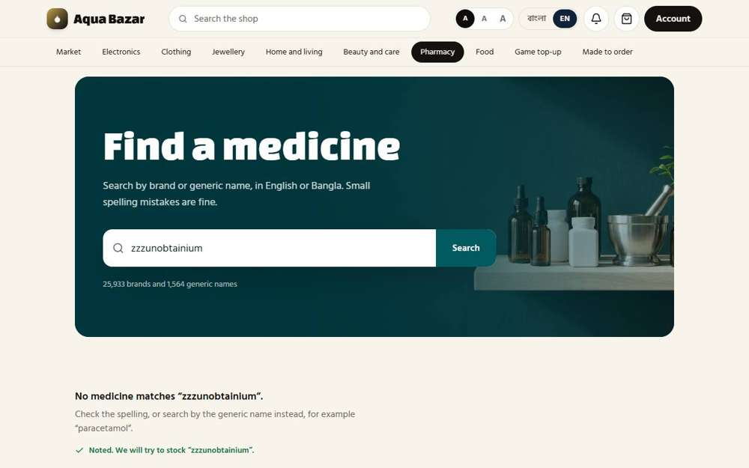  Seen as a signed-in shopper | /medicines?q=zzzunobtainium
304. Grouped "looking for" requests in admin Works
What it is for: The owner sees those requests grouped together.
What the tester did: Opened the owner's requests page, where "looking for" requests are grouped.
What the tester saw:
- Yes. The owner sees what shoppers asked for
Step 1: Requests grouped by what shoppers asked for
Seen as the owner | /admin/requests
305. Mixed cart, wishlist Works
What it is for: A shopper can keep a mixed cart and a wishlist.
What the tester did: Put a product in the market cart and in the wishlist, then opened both.
What the tester saw:
- Yes. The cart holds what was added
- Yes. The wishlist holds what was saved for later
Step 1: The market cart | Step 2: The wishlist
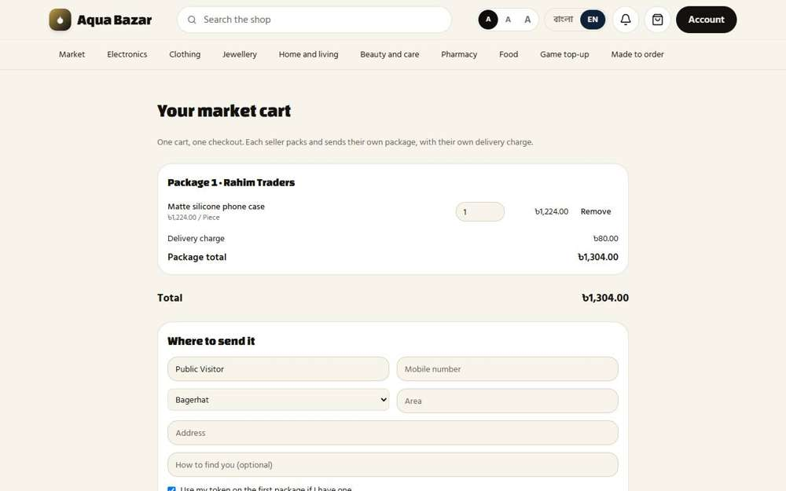  Seen as a signed-in shopper | /market-cart | 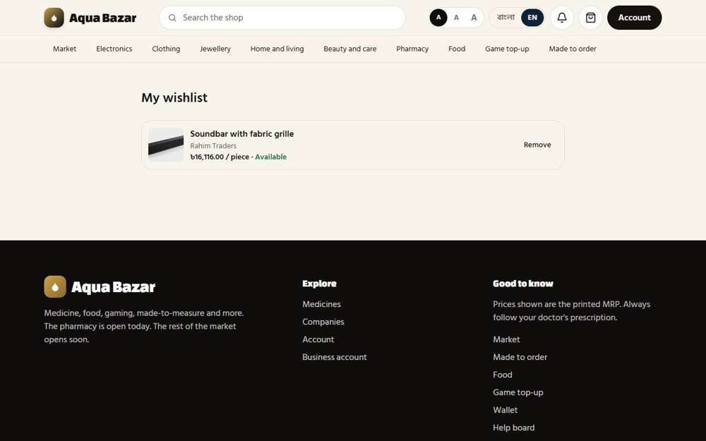  Seen as a signed-in shopper | /wishlist
306. Multi-address book Works
What it is for: A shopper can save several delivery addresses.
What the tester did: Ordered with "Save this address for next time" ticked, then started a new order and looked for the saved address.
What the tester saw:
- Yes. A shopper who saved an address sees it the next time they order
- Yes. With its details, ready to use
Step 1: Saving the address with the order | Step 2: A new checkout offers the saved address
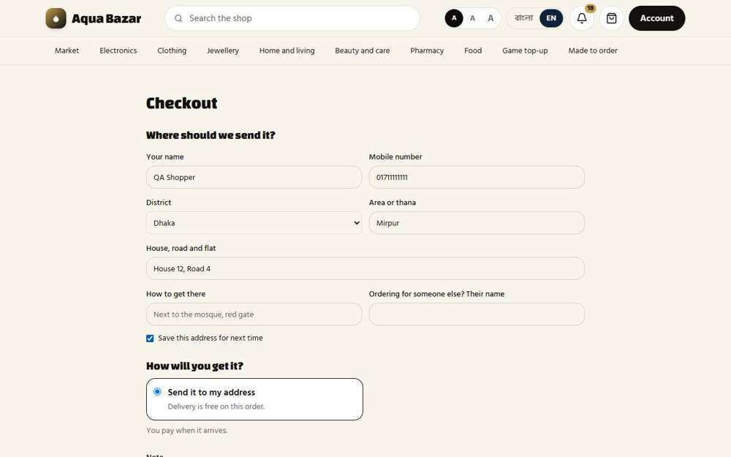  Seen as a signed-in shopper | /checkout | 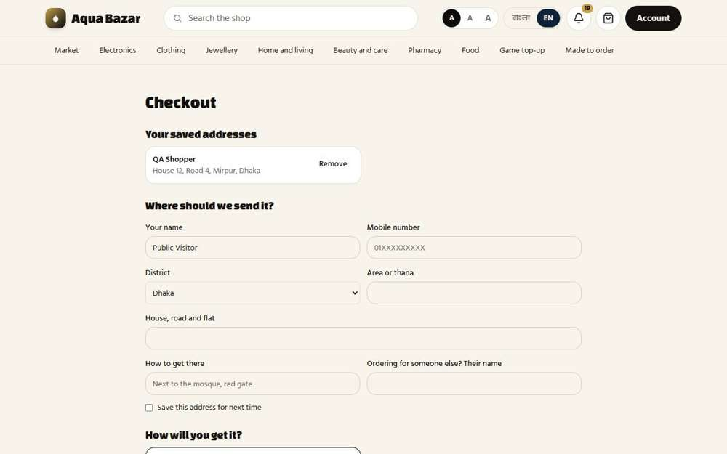  Seen as a signed-in shopper | /checkout
307. Guest checkout (name/phone/address) Works
What it is for: A guest can check out with just name, phone and address.
What the tester did: As a stranger, ordered a phone case with just a name, phone number and address.
What the tester saw:
- Yes. A stranger can order without making an account
Step 1: A guest order filled in: name, phone and address only | Step 2: After sending the order
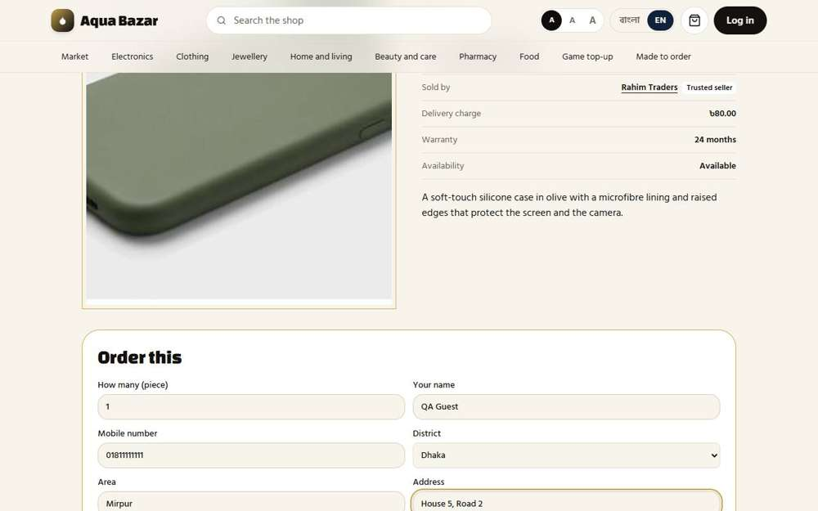  Seen as a stranger (not signed in) | /market/78 | 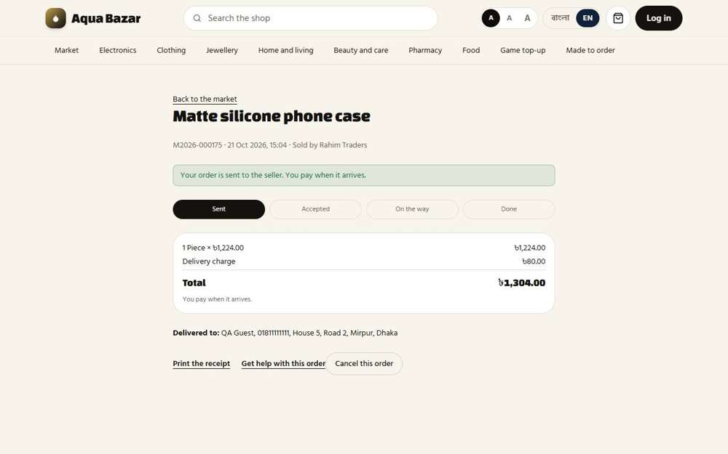  Seen as a stranger (not signed in) | /market/orders/K5VodWBgZl27EoEe5qvsGgaPoTapummYNsRysRfc
308. COD toggle per product Only partly shown
What it is for: Each product can allow or refuse cash on delivery.
What the tester did: Looked at the owner's Market page for the cash-on-delivery choice on each product.
What the tester saw:
- Yes. A product that allows it tells the buyer they pay on arrival
Note: The cash-on-delivery switch is set by the seller on their own listing form. It was not changed here. The product page tells the buyer "You pay when it arrives" when cash on delivery is allowed.
Step 1: The owner's Market page
Seen as the owner | /admin/market
309. COD hidden if any item lacks COD Only partly shown
What it is for: If any item refuses cash on delivery, that choice is hidden.
What the tester did: Looked at the cart for the payment choice when every item allows cash on delivery.
Note: Hiding cash on delivery when one item does not allow it needs a product that refuses it, which the test data does not have.
Step 1: The market cart
Seen as a signed-in shopper | /market-cart
310. Daraz-style multi-seller split Only partly shown
What it is for: An order with several sellers splits into one order per seller.
What the tester did: Put products from two sellers in the cart and looked at how the order splits.
Note: All products in the test data belong to one seller, so a split into two seller orders could not be shown.
Step 1: The market cart
Seen as a signed-in shopper | /market-cart
311. Separate courier per seller Only partly shown
What it is for: Each seller's part can use a different courier.
What the tester did: Looked at the couriers each seller can choose.
Note: A separate courier per seller part needs two sellers in one order.
Step 1: Couriers
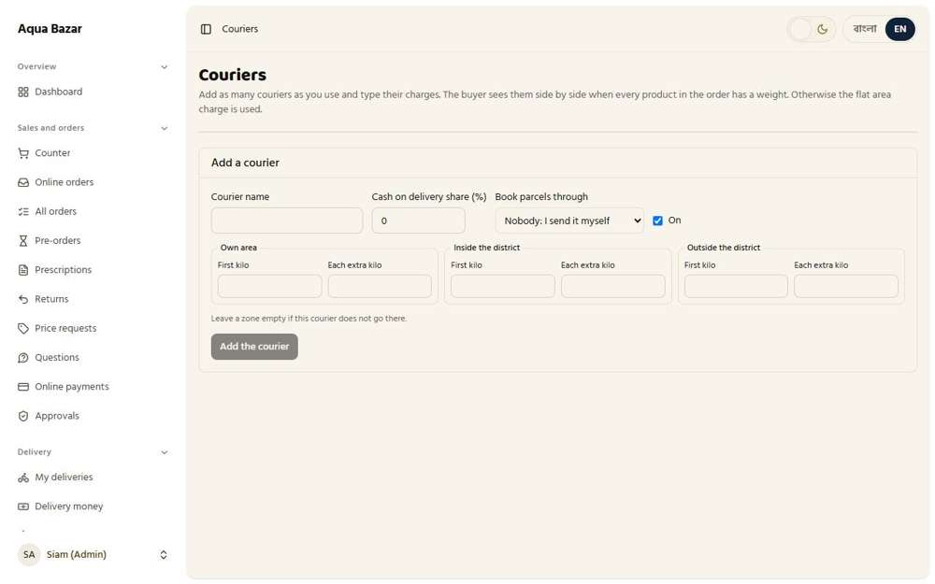
Seen as the owner | /admin/couriers
312. Shipping tracking Works
What it is for: Shoppers can track where their order is.
What the tester did: As the buyer, placed an order, then watched its steps change as the seller accepted it and sent it, and finally pressed "Yes, I got it".
What the tester saw:
- Yes. The buyer is told the order went to the seller, and that payment is on arrival
- Yes. The order shows its four steps: Sent, Accepted, On the way, Done
- Yes. Once it is on the way the buyer is asked if it arrived
- Yes. The buyer confirms it arrived and the order is done
Step 1: Step 1: the order is sent to the seller | Step 2: Step 2: the seller accepted it
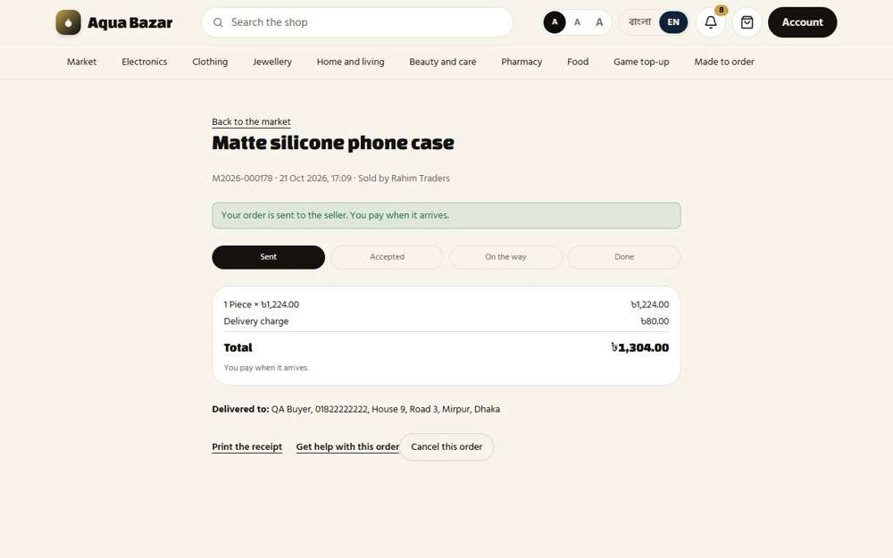  Seen as a signed-in shopper | /market/orders/MWOP9Rd1CCx7CnkWHLrsUwFijMJ3qEPJqjLpnJZk | 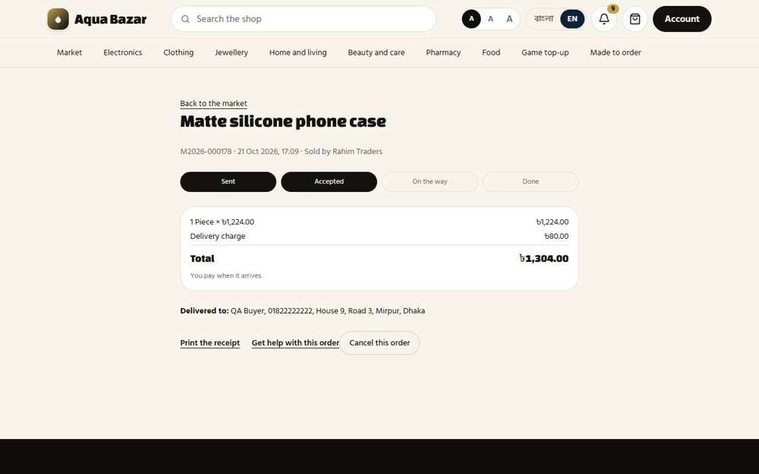  Seen as a signed-in shopper | /market/orders/MWOP9Rd1CCx7CnkWHLrsUwFijMJ3qEPJqjLpnJZk
Step 3: Step 3: the seller sent it, so the buyer is asked "Did it arrive?" | Step 4: Step 4: the buyer confirms it arrived
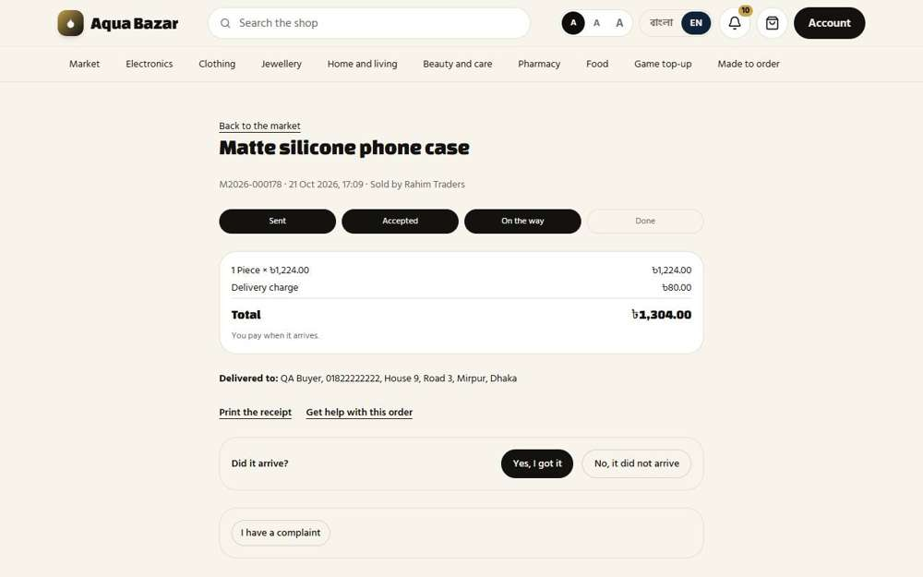  Seen as a signed-in shopper | /market/orders/MWOP9Rd1CCx7CnkWHLrsUwFijMJ3qEPJqjLpnJZk | 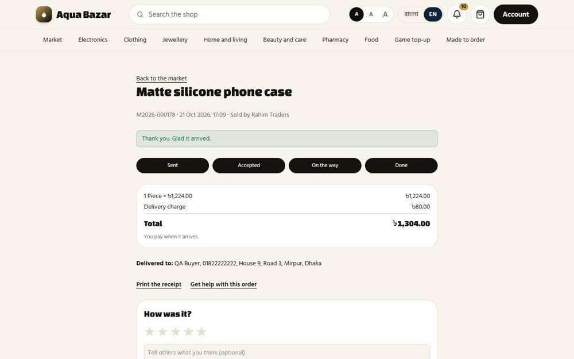  Seen as a signed-in shopper | /market/orders/MWOP9Rd1CCx7CnkWHLrsUwFijMJ3qEPJqjLpnJZk
313. Order history and profile Works
What it is for: Order history and profile are kept for every shopper.
What the tester did: Opened the shopper's order history and profile.
What the tester saw:
- Yes. The shopper has a profile
Step 1: All the shopper's orders | Step 2: The shopper's profile
Seen as a signed-in shopper | /history | 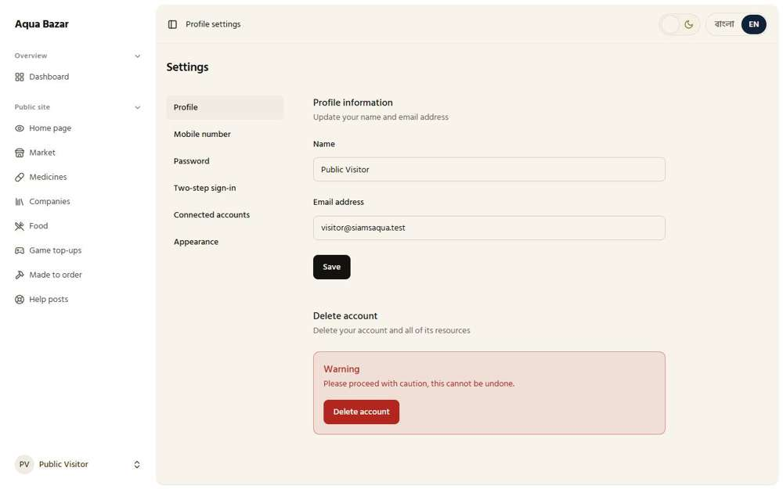  Seen as a signed-in shopper | /settings/profile
314. "Buy again" reminder Works
What it is for: A "buy again" reminder appears when a product is due.
What the tester did: Looked at the "Buy again" reminder on the shop's orders page.
What the tester saw:
- Yes. A "Buy again" reminder exists
Step 1: The Buy again reminder
Seen as a paikari shop | /my-orders
315. Edit and cancel within a set time Works
What it is for: An order can be edited or cancelled within a set time.
What the tester did: Looked at the setting for how long a buyer can cancel an order alone.
What the tester saw:
- Yes. The owner sets how many minutes a buyer can cancel alone
Step 1: The cancel window setting
Seen as the owner | /admin/settings
316. Change address (before packing) Only partly shown
What it is for: The address can be changed before the order is packed.
What the tester did: Looked for changing the address before packing.
Note: Changing an address needs an order that has not been packed. Not reproduced.
Step 1: The shopper's market orders
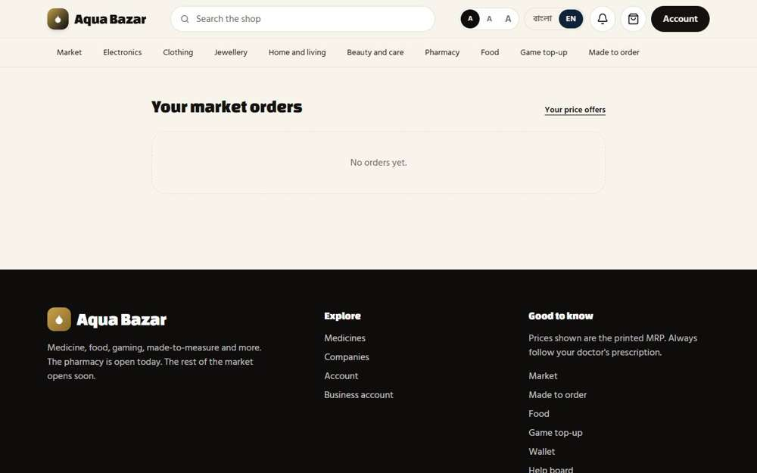
Seen as a signed-in shopper | /market-orders
317. "For whom" address field Works
What it is for: A "for whom" field says who the parcel is for.
What the tester did: Put a medicine in the cart and opened checkout, looking for a box saying who the parcel is for.
What the tester saw:
- Yes. The order form asks who the parcel is for, if it is not the buyer
Step 1: Checkout: "Ordering for someone else? Their name"
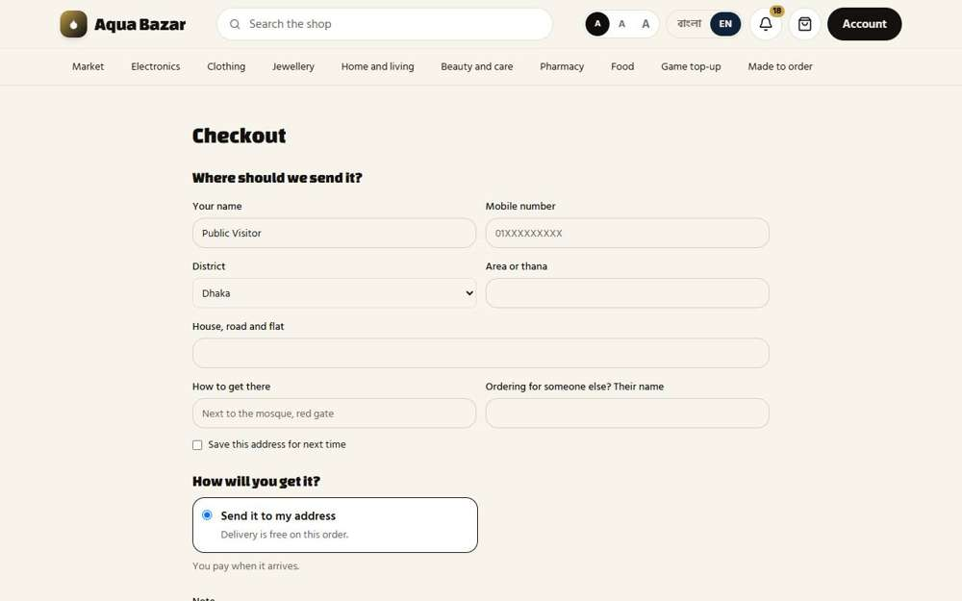
Seen as a signed-in shopper | /checkout
318. Old orders auto-cancelled Works
What it is for: Old unconfirmed orders cancel by themselves.
What the tester did: Looked at the setting that cancels old orders nobody answered.
What the tester saw:
- Yes. Old unanswered orders cancel themselves after a time the owner sets
Step 1: The auto-cancel setting
Seen as the owner | /admin/settings
319. Digital products and download limits Works
What it is for: Digital products are supported, with download limits.
What the tester did: On the seller's listing, pressed "Add a file to download" and looked at what the seller can set for a digital product.
What the tester saw:
- Yes. The seller can say how many times the file may be downloaded
- Yes. And for how many days
Step 1: A digital file with download limits
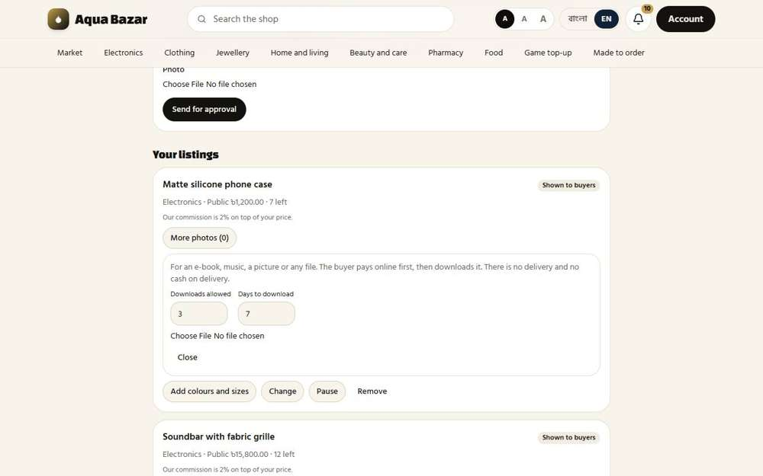
Seen as a wholesaler | /wholesale/sell
320. All Companies sector Works
What it is for: An All Companies sector lists every pharmaceutical company.
What the tester did: Opened the Companies page (the "All Companies" sector).
What the tester saw:
- Yes. Many companies are listed (56 links)
Step 1: All Companies

Seen as a stranger (not signed in) | /companies
321. Brand filter Works
What it is for: Shoppers can filter by brand.
What the tester did: Opened one company and looked at filtering its products by brand.
What the tester saw:
- Yes. A company page lists its brands
Step 1: One company's brands
Seen as a stranger (not signed in) | /companies/245

Wholesale and Commission
322. Category-based access Works
What it is for: A wholesale buyer only sees categories opened for them.
What the tester did: Opened the wholesaler's customer page and looked at the categories the owner gives them.
What the tester saw:
- Yes. The owner chooses which categories a wholesale buyer can see
Step 1: "Categories they can see"
Seen as the owner | /admin/customers/5
323. MOQ Works
What it is for: A wholesale buyer has a minimum order quantity.
What the tester did: Looked at the wholesaler's account page for their minimum order.
What the tester saw:
- Yes. The wholesaler has a minimum quantity per item
Step 1: Minimum per item
Seen as a wholesaler | /wholesale/account
324. Payment settings per customer Works
What it is for: Payment options can be set for each customer.
What the tester did: Looked at how this wholesaler may pay.
What the tester saw:
- Yes. The account says how this buyer may pay (on arrival, in advance)
Step 1: Payment choices set by the owner for this buyer
Seen as a wholesaler | /wholesale/account
325. Wholesale dashboard (with own grade) Works
What it is for: The wholesale dashboard shows the buyer's own grade.
What the tester did: Opened the wholesaler's account page and looked for their grade and month-by-month buying.
What the tester saw:
- Yes. The wholesaler sees their own grade
- Yes. And a month-by-month record of their buying
Step 1: The wholesale dashboard
Seen as a wholesaler | /wholesale/account
326. Pre-order time window Only partly shown
What it is for: Pre-orders for wholesale open within a set time window.
What the tester did: Looked at the Pre-orders page and the pre-order setting.
What the tester saw:
- Yes. The owner sets the share asked up front on a pre-order
Note: A time window for wholesale pre-orders was not found as a separate setting.
Step 1: The pre-order setting
Seen as the owner | /admin/settings
327. Bulk order upload Only partly shown
What it is for: Wholesalers can upload orders in bulk.
What the tester did: Looked for a bulk order upload.
Note: No bulk upload control was found on the wholesale screen.
Step 1: The wholesale screen
Seen as a wholesaler | /wholesale
328. Custom quotation Works
What it is for: A buyer can ask for a custom quotation.
What the tester did: Asked for a price on a bulk purchase using the quotation form, then looked at the owner's Quotes page.
What the tester saw:
- Yes. The owner sees the quotation request
Step 1: A custom quotation request | Step 2: The request is sent
Seen as a wholesaler | /wholesale/quotes | Seen as a wholesaler | /wholesale/quotes
Step 3: The owner sees the request
Seen as the owner | /admin/quotes
329. Wholesalers sell too Works
What it is for: Wholesalers can also sell to the public.
What the tester did: Opened the seller screen a wholesaler uses to sell to the public.
What the tester saw:
- Yes. A wholesaler can add products to sell
Step 1: The seller screen
Seen as a wholesaler | /wholesale/sell
330. Cannot sell in paikari Works
What it is for: Wholesalers cannot sell into the paikari section.
What the tester did: Looked at what a wholesaler may sell, to see if medicine for paikari shops is left out.
What the tester saw:
- Yes. Medicine for paikari shops cannot be listed from the seller screen
Note: The categories offered when adding a listing include: Wood, Clothing, Electronics, Home and living, Beauty and care, Books and stationery, Pantry, Jewellery We decide, 2 days, 3 days, 4 days, 5 days inch, foot, cm
Step 1: The categories a wholesaler may sell in
Seen as a wholesaler | /wholesale/sell
331. Commission added on top of price Works
What it is for: The platform's commission is added on top of the seller's price.
What the tester did: Compared a product's seller price in the owner's Market page with the price the public pays.
What the tester saw:
- Yes. The seller's price for the phone case is 1,200
- Yes. The public pays 1,224: the commission of 24 is added on top
Step 1: The public price includes the commission
Seen as the owner | /market/78
332. Separate commission per product Works
What it is for: Each product can have its own commission.
What the tester did: Looked at the commission box on each product in the owner's Market page.
What the tester saw:
- Yes. Each product has its own commission box
Step 1: Each product has its own commission
Seen as the owner | /admin/market
333. Percentage and taka Works
What it is for: Commission can be a percentage or a fixed taka amount.
What the tester did: Looked at the choice between percent and taka on the commission.
What the tester saw:
- Yes. A commission can be a percent or a fixed taka amount
Note: The choices are: percent / taka
Step 1: Percent or taka
Seen as the owner | /admin/market
334. Who owes how much, how many sold Works
What it is for: The owner sees who owes how much, and how many were sold.
What the tester did: Opened the owner's commission page.
What the tester saw:
- Yes. The page shows commission owed
Step 1: Who owes how much, and how many were sold
Seen as the owner | /admin/market/commissions
335. Commission reduction request and note Works
What it is for: A seller can ask for a lower commission and add a note.
What the tester did: Looked at the "Asking for less commission" list on the owner's Market page.
What the tester saw:
- Yes. Sellers can ask for less commission, and the owner sees the requests
Step 1: Requests for less commission
Seen as the owner | /admin/market
336. My approval before publishing Works
What it is for: The owner approves a product before it goes live.
What the tester did: Looked at the "Waiting to be read" list, where a new product waits before it is published.
What the tester saw:
- Yes. New products wait for the owner before they go live
Step 1: Waiting to be read
Seen as the owner | /admin/market
337. Pending product count Works
What it is for: The owner sees how many products wait for approval.
What the tester did: Read the number beside "Waiting to be read".
What the tester saw:
- Yes. The owner sees how many products are waiting
Step 1: The pending count
Seen as the owner | /admin/market
338. Products without photos flagged Only partly shown
What it is for: Products without photos are flagged.
What the tester did: Looked at the Market page for a flag on products with no photo.
Note: The page has a "No photo" flag for a waiting product that has no picture. Every product in this copy has a photo, so the flag never had a chance to show.
Step 1: The Market page
Seen as the owner | /admin/market
339. Monthly commission statement and reply Works
What it is for: A monthly commission statement is sent and the seller replies.
What the tester did: Looked at the monthly commission statement from both sides.
What the tester saw:
- Yes. The owner can make the monthly statements
- Yes. The seller answers each statement with Paid, or Problem with a reason
Step 1: The owner's statements page | Step 2: The seller's statements page: answer Paid or Problem
Seen as the owner | /admin/market/statements | Seen as a wholesaler | /wholesale/sell/statements
340. Suspended if no reply Works
What it is for: A seller who does not reply is suspended.
What the tester did: Read the rule about a seller who does not answer a statement.
What the tester saw:
- Yes. The page says what happens if a seller does not answer within 10 days
Step 1: The rule on unanswered statements
Seen as a wholesaler | /wholesale/sell/statements
341. Commission removed on cancellation Works
What it is for: If an order is cancelled, its commission is removed.
What the tester did: A buyer ordered a phone case, the seller accepted it and then cancelled it. The month's commission was read before and after.
What the tester saw:
- Yes. The order now shows as cancelled
- Yes. A cancelled sale carries no commission (96 before, 96 after)
Step 1: The seller writes why and cancels | Step 2: The seller cancelled the order
Seen as a wholesaler | /wholesale/sell/orders | Seen as a wholesaler | /wholesale/sell/orders
Step 3: Commission after the cancel: 96
Seen as the owner | /admin/market/commissions
342. Money outside the platform Works
What it is for: Customer money is settled outside the platform, between seller and buyer.
What the tester did: Read how money moves between buyer and seller.
What the tester saw:
- Yes. Buyers pay the seller directly, outside the platform
Step 1: Money is paid outside the platform
Seen as a wholesaler | /wholesale/sell/statements
343. White-label dashboard Works
What it is for: A white-label dashboard shows sellers only what they need.
What the tester did: Looked at the seller's own dashboard.
What the tester saw:
- Yes. The seller has a dashboard of orders for their products
Step 1: The seller's own dashboard
Seen as a wholesaler | /wholesale/sell
344. Only phone and address, name hidden Works
What it is for: Sellers see only the buyer's phone and address, not their name.
What the tester did: Opened the seller's list of orders and looked at what is shown about the buyer.
What the tester saw:
- Yes. The seller sees the buyer's phone
- Yes. And the delivery address
- Yes. But not the buyer's name
Step 1: An order as the seller sees it
Seen as a wholesaler | /wholesale/sell/orders
345. Phone and address masked as *** after sale Works
What it is for: After a sale, the phone and address show as stars so sellers cannot poach customers.
What the tester did: Accepted an order and marked it sent, then looked at the buyer's phone and address again.
What the tester saw:
- Yes. On a finished order, the buyer's phone shows as stars
- Yes. And the address shows as stars
- Yes. The page says why: the details are hidden once an order is finished
Note: While an order is still on its way, the seller needs the phone and address, so they are shown in full. They are masked only when the order is finished.
Step 1: The order just sent: still "On the way", so the buyer's details are still shown
Seen as a wholesaler | /wholesale/sell/orders
346. Notifications from my site Only partly shown
What it is for: Notifications come from the owner's site, not the seller's.
What the tester did: Looked for notifications that come from the owner's site.
Note: Not reproduced.
Step 1: Messages
Seen as the owner | /admin/messages
347. No promotional material in packages Only partly shown
What it is for: The rule against promotional material in parcels is partly in place.
What the tester did: Read the package rule.
What the tester saw:
- Yes. Sellers are told not to put cards or leaflets in the package
Note: The checklist marks this rule only partly built: it is a notice, with no way to check what is in a package.
Step 1: The package rule
Seen as a wholesaler | /wholesale/sell/orders
348. Penalty steps Only partly shown
What it is for: Penalty steps for rule breaking are partly in place.
What the tester did: Looked at the cases page for penalty steps.
Note: The checklist marks penalty steps as partly built. Applying a penalty was not carried through.
Step 1: Market cases
Seen as the owner | /admin/market/cases
349. Return money — COD and online separate Only partly shown
What it is for: Return money is handled separately for cash on delivery and online.
What the tester did: Looked at the return page for money handling.
Note: Return money for cash on delivery versus online was not reproduced.
Step 1: Returns
Seen as a wholesaler | /wholesale/returns
350. Goods go straight to the seller Only partly shown
What it is for: Returned goods go straight to the seller.
What the tester did: On a delivered order, read what happens when the buyer wants to send the goods back.
What the tester saw:
- Yes. The buyer is told returned goods go straight to the seller, within 7 days, with no delivery charge
Note: A return was not carried through to the seller receiving the goods, so only the rule is shown here.
Note: Only the rule was shown. The goods were not actually posted back to the seller.
Step 1: "I want to send it back"
Seen as a signed-in shopper | /market/orders/MWOP9Rd1CCx7CnkWHLrsUwFijMJ3qEPJqjLpnJZk
351. Online payment held Only partly shown
What it is for: Holding online payments until delivery is partly built.
What the tester did: Looked at online payments held until delivery.
Note: The checklist marks holding online payments as partly built. Not reproduced.
Step 1: Online payments
Seen as the owner | /admin/payments
352. Gradual trust Works
What it is for: New sellers gain trust gradually.
What the tester did: Looked for sellers gaining trust over time.
What the tester saw:
- Yes. A seller with a clean record wears a "Trusted seller" mark
Step 1: The "Trusted seller" mark
Seen as the owner | /market/78
353. Security deposit Not built yet
What it is for: A security deposit has not been built yet.
What the tester did: Checked the checklist.
Note: A security deposit has not been built yet.
354. Complaints seen by both Works
What it is for: Both the buyer and the seller see a complaint.
What the tester did: Ordered again, the seller sent it and the buyer confirmed it arrived. Then the buyer wrote what went wrong and sent the complaint. Then looked at it from the seller's side and the owner's side.
What the tester saw:
- Yes. The complaint is kept on the order
- Yes. The seller's record counts the complaint
- Yes. The owner sees the same complaint in one place
Step 1: A complaint typed on the buyer's order | Step 2: After the complaint is sent
Seen as a signed-in shopper | /market/orders/Uij6GEqlFtmq5USSbY4qRfdu3t3mskUoGjPcpL8R | Seen as a signed-in shopper | /market/orders/Uij6GEqlFtmq5USSbY4qRfdu3t3mskUoGjPcpL8R
Step 3: The seller's orders after the complaint | Step 4: The owner's cases page
Seen as a wholesaler | /wholesale/sell/orders | Seen as the owner | /admin/market/cases
355. Separate place for serious complaints Works
What it is for: Serious complaints go to a separate place.
What the tester did: After a complaint on a delivered order, the buyer pressed "Ask us to look into it". Then the owner's Complaints page was opened.
What the tester saw:
- Yes. The owner's page has a separate place for serious complaints
- Yes. The buyer's complaint is now listed there
Step 1: The complaint is brought to the owner | Step 2: Serious complaints have their own place
Seen as a signed-in shopper | /market/orders/Uij6GEqlFtmq5USSbY4qRfdu3t3mskUoGjPcpL8R | Seen as the owner | /admin/market/cases
356. Returns go to the seller's profile Works
What it is for: Returns are recorded on the seller's profile.
What the tester did: Looked at the seller's record, which shows returns.
What the tester saw:
- Yes. The seller's record counts orders sent back
Step 1: The seller's record
Seen as a wholesaler | /wholesale/sell/orders
357. Reports for sellers Works
What it is for: Sellers get their own reports.
What the tester did: Opened the seller's reports page.
What the tester saw:
- Yes. The seller sees their own rank
- Yes. And which products sell the most
Step 1: Seller reports
Seen as a wholesaler | /wholesale/sell/reports
358. Viewed but not bought Works
What it is for: Sellers see who viewed but did not buy.
What the tester did: Looked on the reports for "viewed but not bought".
What the tester saw:
- Yes. Each product shows how many people looked at it, how many ordered and how many sold, so "looked but did not buy" can be seen
Step 1: Seller reports
Seen as a wholesaler | /wholesale/sell/reports
359. Supplier rank Works
What it is for: Suppliers are ranked.
What the tester did: Read the seller's rank and what it depends on.
What the tester saw:
- Yes. The seller has a rank
- Yes. The rank rewards fast sending and few returns
Step 1: Supplier rank
Seen as a wholesaler | /wholesale/sell/reports
360. "Not received" option Works
What it is for: A "not received" option is available to buyers.
What the tester did: Looked at the seller reports for "Buyer said it did not arrive".
What the tester saw:
- Yes. A "not received" figure is kept
Step 1: The "did not arrive" figure
Seen as a wholesaler | /wholesale/sell/reports
361. Block buying own product Works
What it is for: A seller cannot buy their own product.
What the tester did: As the seller, tried to order the seller's own phone case.
What the tester saw:
- Yes. The seller is stopped: "You cannot buy your own product."
Step 1: The seller trying to buy their own product
Seen as a wholesaler | /market/78
362. Vacation mode Works
What it is for: A seller can switch on vacation mode.
What the tester did: Looked at the "I am going away" holiday mode.
What the tester saw:
- Yes. The seller has a Holiday mode
- Yes. It turns off new orders while the seller is away
Step 1: Holiday mode
Seen as a wholesaler | /wholesale/sell
363. Can't delete a product with active orders Works
What it is for: A product with active orders cannot be deleted.
What the tester did: On the seller's listings, pressed Remove on the phone case, which has several orders still on the way.
What the tester saw:
- Yes. The seller is told the listing has orders on the way and to pause it instead
- Yes. The product is still on sale: it was not removed
Step 1: After pressing Remove on a product with live orders
Seen as a wholesaler | /wholesale/sell
364. Report copied products Works
What it is for: A seller can report copied products.
What the tester did: Looked at the "Report this as a copy" link on a product.
What the tester saw:
- Yes. Anyone can report a copied product
Step 1: Report this as a copy
Seen as a signed-in shopper | /market/78
365. Unseen order count and SMS Only partly shown
What it is for: Sellers see how many orders are unseen. Text-message alerts are partly built.
What the tester did: Looked at the seller's orders for a count of orders not yet seen.
What the tester saw:
- Yes. The tab shows how many orders there are
Note: The checklist marks the text-message alert as partly built. No text message was sent.
Step 1: The seller screen with its orders count
Seen as a wholesaler | /wholesale/sell

Multi-Sector and Custom Orders
366. Sector-builder system Works
What it is for: A sector builder lets the owner add a new kind of shop without a programmer.
What the tester did: Opened the Sectors area of the owner's Market page, where each kind of shop is set up.
What the tester saw:
- Yes. Each sector has a list of the fields its business needs
- Yes. And whether sellers must pick from the catalog
Step 1: Each sector has its own settings: no programmer needed
Seen as the owner | /admin/market
367. Own fields and unit per sector Only partly shown
What it is for: Each sector gets its own fields and its own unit, such as piece or metre.
What the tester did: Looked at the fields a sector can ask sellers for.
What the tester saw:
- Yes. A sector can ask for "Colour"
- Yes. A sector can ask for "Size"
- Yes. A sector can ask for "Measurements"
- Yes. A sector can ask for "Weight"
- Yes. A sector can ask for "Expiry date"
- Yes. A sector can ask for "Warranty"
Note: A unit for each sector (piece, metre, kilo) was not found on this screen. The unit shows on product pages, such as "/ Piece".
Step 1: Fields a sector can ask for
Seen as the owner | /admin/market
368. Fractional quantities Works
What it is for: Some sectors allow fractional quantities, such as 2.5 metres.
What the tester did: Looked for the "Fractions allowed" switch on a sector.
What the tester saw:
- Yes. A sector can allow fractional quantities, such as 2.5 metres
Step 1: Fractions allowed
Seen as the owner | /admin/market
369. Chat/pre-order toggle per sector Works
What it is for: Each sector decides between chat and pre-order.
What the tester did: Looked for the Pre-order and Chat switches on a sector.
What the tester saw:
- Yes. A sector can switch pre-order on or off
- Yes. A sector can switch chat on or off
Step 1: Pre-order and Chat switches
Seen as the owner | /admin/market
370. Color-size grid Works
What it is for: Clothing has a colour and size grid.
What the tester did: Opened the seller's "Add a listing" form and looked for the colour and size grid.
What the tester saw:
- Yes. A listing can carry a grid of colours and sizes
Step 1: The "Add colours and sizes" grid on a listing
Seen as a wholesaler | /wholesale/sell
371. Only that color greys out when sold out Only partly shown
What it is for: When one colour sells out, only that colour greys out.
What the tester did: Looked for a colour greying out when it sells out.
Note: Needs a clothing product with several colours and one sold out. Not in the test data.
Step 1: Clothing
Seen as a stranger (not signed in) | /market?sector=clothing
372. Separate price and photo per color/size Only partly shown
What it is for: Each colour and size can have its own price and photo.
What the tester did: Looked for a price and photo for each colour and size.
Note: Needs a clothing product with a variant grid. Not in the test data.
Step 1: Clothing
Seen as a stranger (not signed in) | /market?sector=clothing
373. Sizes on wooden items Only partly shown
What it is for: Wooden items can have sizes too.
What the tester did: Looked for sizes on wooden items.
Note: Needs a wooden product with sizes. Not carried through.
Step 1: Wood
Seen as a stranger (not signed in) | /market?sector=wood
374. Basic stock for sellers (best/worst sellers, own purchase price) Works
What it is for: Sellers get basic stock figures, such as best and worst sellers and their own purchase price.
What the tester did: Looked at the seller's reports for best and worst sellers and what each earns.
What the tester saw:
- Yes. The seller sees their best sellers
- Yes. And their worst sellers
- Yes. And which product earns the most
Step 1: Basic stock figures for sellers
Seen as a wholesaler | /wholesale/sell/reports
375. One product in many categories, one stock Only partly shown
What it is for: One product can sit in many categories with one stock.
What the tester did: Looked for one product in many categories.
Note: Not carried through.
Step 1: The catalog
Seen as the owner | /admin/catalog
376. Prohibited category list Only partly shown
What it is for: A list of prohibited categories blocks banned goods.
What the tester did: Looked for a prohibited-category list.
Note: No prohibited-category list was found on the owner's screens.
Step 1: The owner's Market page
Seen as the owner | /admin/market
377. Wood/clothing returns through the same Return section Only partly shown
What it is for: Wood and clothing returns use the same Return section.
What the tester did: Looked for wood and clothing returns in the same Return section.
Note: Not carried through.
Step 1: Returns
Seen as the owner | /admin/returns
378. Custom orders — wood and clothing Works
What it is for: Custom orders cover wood and clothing made to measure.
What the tester did: Opened "Made to order" and looked at the two kinds of work.
What the tester saw:
- Yes. Wood can be made to order
- Yes. Clothing can be made to order
- Yes. Step one: tell us what you need
- Yes. Step two: we send a price
- Yes. Step three: we make it
Step 1: Made to order: wood and clothing
Seen as a signed-in shopper | /custom
379. Everyone can order Works
What it is for: Everyone can place a custom order.
What the tester did: As an ordinary shopper, opened the made-to-order form. Then did the same as a paikari shop and as a stranger.
What the tester saw:
- Yes. An ordinary shopper can start a made-to-order job
- Yes. A shop account can start one too
Note: A stranger is sent to sign in first. The job needs a name, a chat and a payment trail, so "everyone" here means every kind of account.
Step 1: An ordinary shopper on the made-to-order form | Step 2: A stranger is asked to sign in first, because a job has a chat, a price and money to follow
Seen as a signed-in shopper | /custom/new/wood | Seen as a stranger (not signed in) | /login
380. Measurement form (A to Z) Works
What it is for: A measurement form takes every measurement from A to Z.
What the tester did: Opened the clothing order form and looked at the measurements it asks for.
What the tester saw:
- Yes. The form asks for Chest
- Yes. The form asks for Waist
- Yes. The form asks for Length
- Yes. The form asks for Sleeve
- Yes. The form asks for Shoulder
- Yes. The form asks for Neck
- Yes. The form asks for Trouser length
- Yes. The form asks for Thigh
- Yes. The form asks for Hem (mohori)
Step 1: The measurement form
Seen as a signed-in shopper | /custom/new/clothing
381. Price changes with wood type Works
What it is for: The price changes with the type of wood.
What the tester did: Opened the wood order form and looked at how the wood type is chosen and priced.
What the tester saw:
- Yes. The buyer chooses the wood
- Yes. Each wood has its own rate, shown to the buyer when they choose
Step 1: Which wood? | Step 2: Woods and fabrics each have a rate
Seen as a signed-in shopper | /custom/new/wood | Seen as the owner | /admin/custom
382. Fabric type and details Works
What it is for: The buyer picks the fabric and its details.
What the tester did: Looked at the fabric choices on the clothing form.
What the tester saw:
- Yes. The buyer chooses the fabric
- Yes. Or brings their own
- Yes. Or the shop supplies it
Step 1: Fabric choices
Seen as a signed-in shopper | /custom/new/clothing
383. Photo of the space Works
What it is for: A photo of the space can be uploaded.
What the tester did: Looked for an upload box for a photo of the space.
What the tester saw:
- Yes. There is a box to upload a photo of the place
Step 1: A photo of the place
Seen as a signed-in shopper | /custom/new/wood
384. Saved measurement profiles (by name) Works
What it is for: Measurements are saved under a name, such as "Rahim".
What the tester did: Saved a set of measurements under the name "Rahim" on the Saved measurements page.
What the tester saw:
- Yes. The measurements are saved under a name
Step 1: A measurement profile filled in | Step 2: The saved profile
Seen as a signed-in shopper | /custom/profiles | Seen as a signed-in shopper | /custom/profiles
385. Several profiles in one order Works
What it is for: One order can use several saved profiles.
What the tester did: Looked at the clothing form for choosing a saved profile and how many pieces.
What the tester saw:
- Yes. The form lets the buyer pick saved measurements
- Yes. And how many pieces
Step 1: Saved measurements and a quantity
Seen as a signed-in shopper | /custom/new/clothing
386. Measurement date and reminder when old Works
What it is for: The measurement date shows, with a reminder when it is old.
What the tester did: Looked at the saved profile for its measuring date.
What the tester saw:
- Yes. Each profile shows the date it was measured, so an old one can be spotted
Step 1: Saved profiles
Seen as a signed-in shopper | /custom/profiles
387. Previous orders list per profile Only partly shown
What it is for: Each profile lists its previous orders.
What the tester did: Looked for previous orders on a profile.
Note: Needs a job made from a saved profile. Not carried through.
Step 1: Saved profiles
Seen as a signed-in shopper | /custom/profiles
388. Measurements finalized with both sides' consent Works
What it is for: Measurements are final only when both sides agree.
What the tester did: On the buyer's page for the job, read what the buyer must do before the work starts, and what the owner did before sending the price.
What the tester saw:
- Yes. The buyer gave the measurements
- Yes. The owner checked them and made the memo
- Yes. The buyer then checked the measurements and agreed to the price
- Yes. Work began only after the advance was received
Step 1: The buyer's job page: the history of the job
Seen as a signed-in shopper | /custom/YWqp5Mw964YyEaqPGFkNVXFzqoPOexRqu8CRvOea
389. Trial step (clothing) Only partly shown
What it is for: Clothing has a trial step before finishing.
What the tester did: Looked for a trial step on clothing.
Note: Needs a job in progress. Not carried through.
Step 1: Made to order
Seen as a signed-in shopper | /custom
390. One craftsman per order Works
What it is for: Each order is given to one craftsman.
What the tester did: Opened the Craftsmen page.
What the tester saw:
- Yes. Craftsmen are the shop's own people and see only their own jobs and wages
Step 1: Craftsmen
Seen as the owner | /admin/craftsmen
391. Shift and share option Works
What it is for: A job can be shifted or shared with another craftsman.
What the tester did: Looked at the choice to give a job to someone else.
What the tester saw:
- Yes. A job can be shifted to another craftsman
Note: Sharing a job between two craftsmen was not found as a separate control. Only moving it to one other person.
Step 1: "Give it to someone else"
Seen as the owner | /admin/custom
392. Shift record Works
What it is for: Every shift is recorded.
What the tester did: Opened the job on the owner's page and read the record of who the job was given to.
What the tester saw:
- Yes. Every hand-over is recorded with its time
Step 1: The job with its record
Seen as the owner | /admin/custom
393. Wages and progress by percentage Works
What it is for: Wages and progress are tracked by percentage.
What the tester did: Signed in as the craftsman and opened the job, looking at the wage and progress.
What the tester saw:
- Yes. The craftsman sees the wage for the whole job
- Yes. And what they have earned so far
- Yes. Progress is tracked as a percentage
Step 1: Wage and progress
Seen as a craftsman | /craftsman/jobs/1
394. Not complete below 100% Works
What it is for: A job is not complete below 100 per cent.
What the tester did: Saved a progress of 40% with a photo, then looked at the job to see that it is not marked complete.
What the tester saw:
- Yes. The progress is now 40%
- Yes. The job is still being made: it is not complete below 100%
Step 1: 40% saved with a photo | Step 2: The owner's page: still "Being made", not ready
Seen as a craftsman | /craftsman/jobs/1 | Seen as the owner | /admin/custom
395. Photo mandatory with percentage Works
What it is for: A photo is required each time progress is updated.
What the tester did: Typed a progress of 40% and pressed Save without attaching a photo.
What the tester saw:
- Yes. The page says a photo is needed each time
- Yes. The Save button stays disabled until a photo is attached, so progress cannot be saved without one
Step 1: 40% typed, no photo attached: the Save button stays greyed out
Seen as a craftsman | /craftsman/jobs/1
396. Buyer doesn't see craftsman names Works
What it is for: The buyer does not see craftsman names.
What the tester did: Looked through the buyer's page for the job for the craftsman's name.
What the tester saw:
- Yes. The buyer never sees the craftsman's name
Step 1: The buyer's job page
Seen as a signed-in shopper | /custom/YWqp5Mw964YyEaqPGFkNVXFzqoPOexRqu8CRvOea
397. I assign jobs Works
What it is for: The owner assigns the jobs.
What the tester did: Looked at where the owner assigns jobs.
What the tester saw:
- Yes. Jobs move through stages; the owner assigns a craftsman
Step 1: Made to order
Seen as the owner | /admin/custom
398. Active job count Works
What it is for: The screen shows each craftsman's active job count.
What the tester did: Looked at the active job count shown for each craftsman.
What the tester saw:
- Yes. Each craftsman shows active and late jobs
Step 1: Active jobs per craftsman
Seen as the owner | /admin/craftsmen
399. No job sent before wages agreed Only partly shown
What it is for: No job goes out before the wage is agreed.
What the tester did: Looked at the owner's page for the order of steps: the wage is set before the job is given and started.
What the tester saw:
- Yes. A wage is set for the job
- Yes. The owner sets it
Note: The checklist says no job goes out before the wage is agreed. On this screen "Give the job" was available before a wage had been set, so the rule was not enforced here.
Step 1: Wage, then craftsman, then advance, then start
Seen as the owner | /admin/custom
400. Craftsman owed/paid accounting Works
What it is for: The owner sees what each craftsman is owed and has been paid.
What the tester did: Looked at the craftsman accounting.
What the tester saw:
- Yes. There is a place to record wages paid
- Yes. And a total earned
Step 1: Owed and paid
Seen as the owner | /admin/craftsmen
401. Send "Materials needed" Works
What it is for: A "materials needed" message can be sent.
What the tester did: On the job, typed what materials are needed and sent it to the owner.
What the tester saw:
- Yes. The owner sees what materials are needed
Step 1: A materials request typed | Step 2: After sending
Seen as a craftsman | /craftsman/jobs/1 | Seen as a craftsman | /craftsman/jobs/1
Step 3: The owner sees the request
Seen as the owner | /admin/custom
402. Chat (details in Chapter 23) Works
What it is for: Custom orders use the chat system.
What the tester did: Opened the buyer's job page and looked at the chat.
What the tester saw:
- Yes. The job has a chat for the buyer
- Yes. The chat says the shop can read it
Step 1: The chat on the job
Seen as a signed-in shopper | /custom/YWqp5Mw964YyEaqPGFkNVXFzqoPOexRqu8CRvOea
403. "Send measurements" button in chat Only partly shown
What it is for: A "send measurements" button in the chat shares them in one tap.
What the tester did: Looked for the "Send measurements" button in chat.
Note: Needs a chat on a job. Not carried through.
Step 1: Chats
Seen as the owner | /admin/chats
404. "Send offer" button in chat Only partly shown
What it is for: A "send offer" button shares a price offer.
What the tester did: Looked for the "Send offer" button in chat.
Note: Needs a chat on a job. Not carried through.
Step 1: Chats
Seen as the owner | /admin/chats
405. Numbers and links blocked Works
What it is for: Phone numbers and links are blocked in chat.
What the tester did: In the job chat, typed a message that contains a phone number and a web link.
What the tester saw:
- Yes. The chat says phone numbers and links cannot be sent
- Yes. A phone number and a link are blocked or hidden in the chat
Step 1: A message with a number and a link | Step 2: What the chat shows
Seen as a signed-in shopper | /custom/YWqp5Mw964YyEaqPGFkNVXFzqoPOexRqu8CRvOea | Seen as a signed-in shopper | /custom/YWqp5Mw964YyEaqPGFkNVXFzqoPOexRqu8CRvOea
406. I can see every chat Works
What it is for: The owner can read every chat.
What the tester did: Opened the chat of the job as the owner.
What the tester saw:
- Yes. The owner can open the chat of any job
Step 1: The owner reads the chat
Seen as the owner | /admin/chats/1
407. Measurements and offers as separate cards Only partly shown
What it is for: Measurements and offers show as separate cards.
What the tester did: Looked for measurements and offers as cards in chat.
Note: Needs a chat on a job. Not carried through.
Step 1: Chats
Seen as the owner | /admin/chats
408. Notification if the craftsman doesn't reply Only partly shown
What it is for: The owner is notified if a craftsman does not reply.
What the tester did: Looked for a notice when a craftsman does not reply.
Note: Needs time to pass. Not carried through.
Step 1: Chats
Seen as the owner | /admin/chats
409. Advance percentage, goes to the craftsman Works
What it is for: An advance percentage is taken and goes to the craftsman.
What the tester did: Looked at the advance on the job.
What the tester saw:
- Yes. The buyer is told the advance: 30%, 6,600
- Yes. And that it was received
Step 1: The advance, on the buyer's page
Seen as a signed-in shopper | /custom/YWqp5Mw964YyEaqPGFkNVXFzqoPOexRqu8CRvOea
410. No returns on custom orders Works
What it is for: Custom orders cannot be returned.
What the tester did: Read the return rule on the made-to-order page.
What the tester saw:
- Yes. The page says returns do not apply to made-to-order work
Step 1: No returns on made-to-order work
Seen as a signed-in shopper | /custom
411. "Work not done right" complaint Only partly shown
What it is for: A "work not done right" complaint is available instead.
What the tester did: Looked on the buyer's page for a "work not done right" complaint.
Note: A complaint that the work was not done right would be made once the job is finished. The job is still being made.
Step 1: The buyer's job page while the work is under way
Seen as a signed-in shopper | /custom/YWqp5Mw964YyEaqPGFkNVXFzqoPOexRqu8CRvOea
412. Cancellation rules before/after work starts Works
What it is for: Cancellation rules differ before and after work starts.
What the tester did: Read what the buyer is told about cancelling.
What the tester saw:
- Yes. The buyer is told the advance is not refunded if they cancel after work has started
Note: Cancelling before work starts was not carried through.
Step 1: The cancelling rule
Seen as a signed-in shopper | /custom/YWqp5Mw964YyEaqPGFkNVXFzqoPOexRqu8CRvOea
413. Urgent order and extra charge Works
What it is for: An urgent order carries an extra charge.
What the tester did: Looked at the urgent box on the wood order form.
What the tester saw:
- Yes. An urgent job costs an extra 20%, and the buyer is told so
Step 1: Urgent order: extra 20%
Seen as a signed-in shopper | /custom/new/wood
414. Wood deducted from stock Only partly shown
What it is for: Wood used is taken from stock.
What the tester did: Looked for wood being taken from stock.
Note: Needs a finished job. Not carried through.
Step 1: Made to order
Seen as the owner | /admin/custom
415. No commission on custom orders Works
What it is for: No commission is charged on custom orders.
What the tester did: Read the note about commission on made-to-order work.
What the tester saw:
- Yes. No commission is charged on made-to-order work
Step 1: No commission on made-to-order work
Seen as the owner | /admin/custom

Food, Gaming, Help
416. Location-based restaurants Works
What it is for: Restaurants near the shopper show first.
What the tester did: Opened Food as a stranger and looked at how restaurants near the shopper are found.
What the tester saw:
- Yes. Restaurants that deliver to the typed area are listed
Step 1: Restaurants for the area "Mirpur"
Seen as a stranger (not signed in) | /food?area=Mirpur
417. Menu management Works
What it is for: A restaurant manages its own menu.
What the tester did: Signed in as a restaurant owner and opened the menu.
What the tester saw:
- Yes. The restaurant owner has a Menu
- Yes. Each dish has its own price
Step 1: The restaurant's menu: price, Save, Remove
Seen as a restaurant owner | /food/vendor
418. Per-item "Sold out today" toggle Works
What it is for: Each dish has a "sold out today" switch.
What the tester did: Looked for the "Sold out today" button on each dish.
What the tester saw:
- Yes. Each dish has a "Sold out today" button
Step 1: After pressing "Sold out today"
Seen as a restaurant owner | /food/vendor
419. Opening hours and auto-close Only partly shown
What it is for: Opening hours are set, and the restaurant closes itself.
What the tester did: Looked at the owner's Restaurants page for opening hours and the open/closed mark.
What the tester saw:
- Yes. Each restaurant shows "Open now" or closed
Note: Setting opening hours and seeing the restaurant close by itself was not reproduced.
Step 1: Restaurants and whether they are open now
Seen as the owner | /admin/food
420. Cooking time given when confirming Works
What it is for: The restaurant gives a cooking time when it confirms an order.
What the tester did: As the restaurant, opened the waiting order, wrote that it will take 20 minutes and pressed Confirm.
What the tester saw:
- Yes. The new order is waiting on the restaurant's screen
- Yes. The restaurant is asked how long it will take
- Yes. The order is now confirmed and being cooked
Step 1: A cooking time of 20 minutes typed in | Step 2: After pressing Confirm
Seen as a restaurant owner | /food/vendor | Seen as a restaurant owner | /food/vendor
421. Timer on the buyer's screen Works
What it is for: The buyer sees a timer counting the cooking time.
What the tester did: As the shopper, opened the food order after the restaurant confirmed it.
What the tester saw:
- Yes. The shopper sees a countdown timer: "Cooking. It will be ready in about 19:51"
- Yes. And the order moves to the "Confirmed: cooking" step
Step 1: The shopper's order after confirmation
Seen as a signed-in shopper | /food/orders/RKkL3lhJVoauV7z6cA20rHB59JU4w3hmvJBWnyfl
422. Notification if not confirmed Only partly shown
What it is for: The owner is told when an order is not confirmed in time.
What the tester did: Looked for a notice when an order is not confirmed.
Note: Needs time to pass on a live order. Not carried through.
Step 1: Restaurants
Seen as the owner | /admin/food
423. Home delivery / eat there Works
What it is for: The buyer picks home delivery or eating there.
What the tester did: Looked at the "Eat there" choice on the Food page.
What the tester saw:
- Yes. The shopper can choose to eat at the restaurant
Step 1: Eat there, or have it delivered
Seen as a stranger (not signed in) | /food
424. Custom food Works
What it is for: Custom food lets a buyer build their own dish.
What the tester did: Opened the restaurant's Custom food page, where a buyer builds a burger, pizza, sandwich or roll.
What the tester saw:
- Yes. A buyer can build their own dish on a base
Step 1: Custom food bases
Seen as a restaurant owner | /food/vendor/custom
425. Central ingredient list Works
What it is for: A central list holds every ingredient.
What the tester did: Opened the central ingredient list.
What the tester saw:
- Yes. One ingredient list serves every restaurant
- Yes. It holds many ingredients
Step 1: The one ingredient list
Seen as the owner | /admin/food-ingredients
426. Restaurant ticks what it has Works
What it is for: A restaurant ticks the ingredients it has.
What the tester did: Looked at how a restaurant ticks the ingredients it has.
What the tester saw:
- Yes. The restaurant ticks what it has
- Yes. Each ingredient has a "We have it" tick
Step 1: Ticking ingredients
Seen as a restaurant owner | /food/vendor/custom
427. Restaurant sets its own prices Works
What it is for: A restaurant sets its own price for each ingredient.
What the tester did: Looked at the price box beside each ingredient.
What the tester saw:
- Yes. Each restaurant sets its own price
Step 1: Your own price for each ingredient
Seen as a restaurant owner | /food/vendor/custom
428. Request to add to the list Works
What it is for: A restaurant can ask to add an ingredient to the list.
What the tester did: Read what a restaurant does when an ingredient is not in the list.
What the tester saw:
- Yes. A restaurant can ask for a missing ingredient to be added
Step 1: Asking for a new ingredient
Seen as a restaurant owner | /food/vendor/custom
429. "Sold out today" on ingredients Works
What it is for: An ingredient can be marked sold out today.
What the tester did: As the restaurant, switched on one ingredient ("Bacon") at a price, then ticked "Sold out today" on it and reloaded the page.
What the tester saw:
- Yes. Each ingredient the restaurant offers has a "Sold out today" tick
- Yes. The tick stays after the page is reloaded, so the ingredient is marked sold out for today
Step 1: An ingredient the restaurant has: price, On, Sold out today | Step 2: After ticking it and reloading
Seen as a restaurant owner | /food/vendor/custom | Seen as a restaurant owner | /food/vendor/custom
430. Maximum ingredient limit Works
What it is for: A maximum ingredient limit applies to each dish.
What the tester did: On the restaurant's custom food page, looked at the limit on how many ingredients one dish can have.
What the tester saw:
- Yes. The restaurant can set the most ingredients in one dish
- Yes. And the extra cooking minutes custom food needs
Step 1: Limit and time
Seen as a restaurant owner | /food/vendor/custom
431. Rules for combinations that don't work Works
What it is for: Rules block combinations that do not work.
What the tester did: On the restaurant's custom food page, looked at the rules for ingredients that do not go together.
What the tester saw:
- Yes. The restaurant can list ingredients that do not go together
- Yes. By picking a first and a second ingredient
Step 1: Ingredients that do not go together
Seen as a restaurant owner | /food/vendor/custom
432. Save favorite combinations Only partly shown
What it is for: A buyer can save favourite combinations.
What the tester did: Looked for saved favourite combinations.
Note: Saving a favourite combination was not carried through.
Step 1: Food
Seen as a signed-in shopper | /food
433. Kitchen print Works
What it is for: The kitchen can print the order.
What the tester did: As the restaurant, opened the kitchen ticket of the order.
What the tester saw:
- Yes. The ticket carries the order number
- Yes. And what to cook
Step 1: The kitchen ticket
Seen as a restaurant owner | /food/vendor/orders/1/print/kitchen
434. Three delivery-charge options Works
What it is for: Three delivery-charge options are partly built.
What the tester did: On the restaurant's page, looked at how the delivery charge is set.
What the tester saw:
- Yes. The charge can depend on the area: one price inside, another outside
- Yes. Or the restaurant writes it on each order
Note: The checklist marks the third choice as partly built.
Step 1: Delivery charge choices
Seen as a restaurant owner | /food/vendor
435. Maximum distance and minimum charge Not built yet
What it is for: A maximum distance and minimum charge have not been built yet.
What the tester did: Checked the checklist.
Note: A maximum distance and minimum charge have not been built yet.
436. Calculated by road distance Not built yet
What it is for: Charging by road distance has not been built yet.
What the tester did: Checked the checklist.
Note: Charging by road distance has not been built yet.
437. Advance payment Only partly shown
What it is for: A restaurant can ask for an advance payment.
What the tester did: On the restaurant's page, looked at the advance payment setting.
What the tester saw:
- Yes. The restaurant can ask for an advance on orders above an amount
- Yes. And choose what percentage
Note: A big order with an advance was not placed, so the shopper side of paying the advance was not seen.
Step 1: Advance for big orders
Seen as a restaurant owner | /food/vendor
438. Memo in the restaurant's name Works
What it is for: The memo is made in the restaurant's name.
What the tester did: As the restaurant, opened the memo of the order.
What the tester saw:
- Yes. The memo is in the restaurant's own name
- Yes. With the total the buyer pays
Step 1: The memo
Seen as a restaurant owner | /food/vendor/orders/1/print/memo
439. Own or platform delivery Works
What it is for: The restaurant delivers itself or uses the platform's riders.
What the tester did: On the restaurant's page, looked at who delivers.
What the tester saw:
- Yes. The restaurant can deliver with its own people
- Yes. Or ask the platform's courier
Step 1: Who delivers: own people or the platform's courier
Seen as a restaurant owner | /food/vendor
440. Commission per restaurant Works
What it is for: Commission is set for each restaurant.
What the tester did: Looked at the commission each restaurant pays.
What the tester saw:
- Yes. The owner sets a commission for each restaurant, on delivered orders only
- Yes. Each restaurant has a "Set the commission" button
Step 1: Commission per restaurant
Seen as the owner | /admin/food
441. Restaurant dashboard Works
What it is for: The restaurant has its own dashboard.
What the tester did: Looked at the restaurant owner's dashboard.
What the tester saw:
- Yes. Today's sales
- Yes. This month's sales
- Yes. The commission the restaurant pays
Step 1: The restaurant dashboard
Seen as a restaurant owner | /food/vendor
442. Complaints with photos Works
What it is for: Complaints can include photos.
What the tester did: The restaurant moved the order through Packing, Out for delivery and Delivered. Then the shopper opened the order, wrote what was wrong and sent it with a photo.
What the tester saw:
- Yes. The restaurant's sales for today count the delivered order
- Yes. After delivery the shopper is asked if something was wrong with the food
- Yes. The complaint is accepted and shown on the order
Step 1: The restaurant has delivered the order: today's sales show | Step 2: A complaint with a photo, ready to send
Seen as a restaurant owner | /food/vendor | Seen as a signed-in shopper | /food/orders/RKkL3lhJVoauV7z6cA20rHB59JU4w3hmvJBWnyfl
Step 3: After sending the complaint
Seen as a signed-in shopper | /food/orders/RKkL3lhJVoauV7z6cA20rHB59JU4w3hmvJBWnyfl
443. Two orders on one delivery Only partly shown
What it is for: Two orders can go on one delivery.
What the tester did: Looked for two orders on one delivery.
Note: Not carried through.
Step 1: Deliveries
Seen as the owner | /admin/deliveries
444. Game and package list Works
What it is for: A list of games and their top-up packages.
What the tester did: Opened Game top-up and looked at the games and their packages.
What the tester saw:
- Yes. A list of games
- Yes. Mobile Legends is listed
- Yes. Each game shows its cheapest package
Step 1: Games and their prices
Seen as a stranger (not signed in) | /gaming
445. Game ID verification (shows name) Only partly shown
What it is for: The player's name shows after typing the game ID, so a wrong ID is caught.
What the tester did: Opened a game and looked at how the player ID is checked.
What the tester saw:
- Yes. The game page asks for the player ID
Note: The name check (showing the player's name for an ID) needs a live game connection and was not reproduced.
Step 1: A game page asks for the player ID
Seen as a stranger (not signed in) | /gaming/mobile-legends
446. Automatic top-up Only partly shown
What it is for: Automatic top-up is partly built.
What the tester did: Looked at the automatic top-up.
What the tester saw:
- Yes. Top-ups are done by hand until a provider does it
Note: The checklist marks automatic top-up as partly built: it is manual for now.
Step 1: Game top-ups
Seen as the owner | /admin/gaming
447. Manual top-up backup Works
What it is for: Top-ups can also be done by hand as a backup.
What the tester did: Looked at the manual top-up lists.
What the tester saw:
- Yes. A list of paid orders to top up by hand
Step 1: Manual top-up
Seen as the owner | /admin/gaming
448. Auto refund on failed top-up Works
What it is for: A failed top-up is refunded automatically.
What the tester did: Looked at the failed and refunds list.
What the tester saw:
- Yes. A failed top-up is listed with its refund
Step 1: Failed and refunds
Seen as the owner | /admin/gaming
449. Online payment only Works
What it is for: Game top-ups are paid online only.
What the tester did: Read the payment rule for game top-ups.
What the tester saw:
- Yes. Top-ups are paid online only
Step 1: Online payment only
Seen as the owner | /admin/gaming
450. Help posts and approval Works
What it is for: Help posts need approval before they appear.
What the tester did: Opened the owner's Help posts page.
What the tester saw:
- Yes. Every post is read before it is shown
- Yes. There is a "Waiting to be read" list
Step 1: Help posts wait for approval
Seen as the owner | /admin/help
451. Job opportunities for unemployed young people Works
What it is for: The Help section lists job opportunities for young unemployed people.
What the tester did: Opened the Help board and its post types.
What the tester saw:
- Yes. A post can be about needing a worker
- Yes. Or looking for a product
- Yes. Or needing help
Step 1: The Help board
Seen as a stranger (not signed in) | /help
452. Page owners finding moderators Only partly shown
What it is for: Page owners can find moderators.
What the tester did: Looked for page owners finding moderators.
Note: Not carried through.
Step 1: A new post
Seen as a signed-in shopper | /help/new
453. Product card in comments Only partly shown
What it is for: A product card can appear inside a comment.
What the tester did: Looked for a product card inside a comment.
Note: Needs an approved post with a comment. Not carried through.
Step 1: The Help board
Seen as a stranger (not signed in) | /help
454. Card shows photo, name, price, "View" button Only partly shown
What it is for: The card shows photo, name, price and a "View" button.
What the tester did: Looked for the product card's photo, name, price and View button.
Note: Needs an approved post with a product card. Not carried through.
Step 1: The Help board
Seen as a stranger (not signed in) | /help
455. Card follows visibility rules Only partly shown
What it is for: The card follows the visibility rules.
What the tester did: Looked for the card following visibility rules.
Note: Not carried through.
Step 1: The Help board
Seen as a stranger (not signed in) | /help
456. No photos allowed Works
What it is for: Photos are not allowed in help posts.
What the tester did: Read the photo rule on the new-post form.
What the tester saw:
- Yes. The form says photos are not allowed
Step 1: No photos on the board
Seen as a signed-in shopper | /help/new
457. "Still needed?" after 30 days Only partly shown
What it is for: After 30 days the post asks "still needed?".
What the tester did: Looked for the "still needed?" question after 30 days.
Note: Needs a post that is 30 days old. Not carried through.
Step 1: The shopper's own posts
Seen as a signed-in shopper | /help/mine
458. Post limit Only partly shown
What it is for: There is a limit on how many posts one person can make.
What the tester did: Looked for a limit on how many posts one person can make.
Note: Not carried through.
Step 1: A new post
Seen as a signed-in shopper | /help/new
459. "Transactions not our responsibility" stated clearly Works
What it is for: The page says clearly that deals between people are not the platform's responsibility.
What the tester did: Read the notice about deals between people.
What the tester saw:
- Yes. The page says plainly that deals between people are not the platform's responsibility
Step 1: The responsibility notice
Seen as a signed-in shopper | /help/new

Delivery and Courier
460. Automatic location Only partly shown
What it is for: Location is filled in automatically.
What the tester did: Looked at the district box on a product order form to see how the place is chosen.
What the tester saw:
- Yes. A full list of districts is offered (64)
Note: Filling the place in automatically from the phone's location was not reproduced.
Step 1: The district list on an order form
Seen as a stranger (not signed in) | /market/78
461. Map pin Only partly shown
What it is for: A map pin is partly built.
What the tester did: Looked for a map pin on the order form.
Note: The checklist marks the map pin as partly built. No map was found on the order form.
Step 1: The order form
Seen as a stranger (not signed in) | /market/78
462. "How to get there" field Works
What it is for: A "how to get there" field helps the rider.
What the tester did: Looked at the order form for a "how to get there" box.
What the tester saw:
- Yes. The form has a box to help the rider find the place (a Note box)
Step 1: The order form
Seen as a stranger (not signed in) | /market/78
463. Three-layer delivery charge order Works
What it is for: Delivery charge is worked out in three layers.
What the tester did: Looked at the delivery charges in settings and on a product to see the layers.
What the tester saw:
- Yes. A charge for inside the shop's district
- Yes. A charge for outside it
- Yes. A charge set on a product beats every other delivery charge
Step 1: The shop-wide delivery charges | Step 2: A product's own charge beats the others
Seen as the owner | /admin/settings | Seen as the owner | /admin/weights
464. Mandatory product charge highest Works
What it is for: A product's mandatory delivery charge is the highest layer.
What the tester did: Read the rule that a product's own charge is the highest.
What the tester saw:
- Yes. The mandatory product charge is the highest layer
Step 1: Weights and delivery charges
Seen as the owner | /admin/weights
465. Courier list in profile Works
What it is for: A courier list is kept in the seller's profile.
What the tester did: Opened the Couriers page where the shop lists the couriers it uses.
What the tester saw:
- Yes. The shop keeps a list of couriers
Step 1: Couriers
Seen as the owner | /admin/couriers
466. Unlimited couriers Works
What it is for: There is no limit on couriers.
What the tester did: Added a new courier called "QA Express" with its charges.
What the tester saw:
- Yes. The new courier is added and kept on the list with its charges: there is no fixed limit
Step 1: The courier is on the list, with its charges
Seen as the owner | /admin/couriers
467. Charges entered by hand (no API) Works
What it is for: Charges are typed in by hand, with no outside service.
What the tester did: Looked at how courier charges are entered.
What the tester saw:
- Yes. Charges are typed by hand
Step 1: Charges typed by hand
Seen as the owner | /admin/couriers
468. Zone + first kg + additional kg Works
What it is for: A courier's price uses a zone, a first kilogram and each extra kilogram.
What the tester did: Looked at the zones, first kilo and extra kilo for a courier.
What the tester saw:
- Yes. A zone: Own area
- Yes. A zone: Inside the district
- Yes. A zone: Outside the district
- Yes. A price for the first kilo
- Yes. And for each extra kilo
Step 1: Zone, first kilo and extra kilo
Seen as the owner | /admin/couriers
469. COD charge percentage Works
What it is for: A percentage is added for cash on delivery.
What the tester did: Looked at the cash-on-delivery percentage on a courier.
What the tester saw:
- Yes. A courier has a cash-on-delivery percentage
Step 1: Cash on delivery share
Seen as the owner | /admin/couriers
470. Weight rounding rule Works
What it is for: A rounding rule for weight is set.
What the tester did: Looked at the weight rounding rule in settings.
What the tester saw:
- Yes. A rule for rounding weight
- Yes. One choice is round up to half a kilo
Step 1: Weight rounding
Seen as the owner | /admin/settings
471. All couriers side by side at checkout Only partly shown
What it is for: All couriers show side by side at checkout.
What the tester did: Looked for all couriers side by side at checkout.
Note: Courier choices side by side appear only when every product in the order has a weight. The test products have none.
Step 1: A product page
Seen as a stranger (not signed in) | /market/78
472. Flat charge when no weight Works
What it is for: If there is no weight, a flat charge applies.
What the tester did: Looked at the flat delivery charge on a product with no weight.
What the tester saw:
- Yes. A product with no weight uses a flat delivery charge (80)
Step 1: A flat delivery charge
Seen as a stranger (not signed in) | /market/78
473. Reminders to add weight Works
What it is for: Reminders ask staff to add weights.
What the tester did: Looked at the list of products with no weight.
What the tester saw:
- Yes. The owner is shown how many products still have no weight
Step 1: Products with no weight
Seen as the owner | /admin/weights
474. Courier rate check after 3 months Only partly shown
What it is for: Courier rates are checked again after three months.
What the tester did: Looked at the top of the Couriers page for the rate check.
What the tester saw:
- Yes. The page says when the courier rates were last checked
- Yes. The owner confirms they are still correct with one press
Note: The reminder that appears after three months was not waited for.
Step 1: Rates last checked
Seen as the owner | /admin/couriers
475. Delivery charge draft (add extra) Only partly shown
What it is for: A delivery charge draft lets staff add extra.
What the tester did: Looked at the order screen for adding an extra delivery charge.
Note: Needs an order in delivery. Not carried through.
Step 1: My deliveries
Seen as the owner | /admin/deliveries
476. "Product on the way" shown Only partly shown
What it is for: "Product on the way" shows to the buyer.
What the tester did: Looked at an order for the "On the way" step.
Note: The "On the way" step was seen on a seller order earlier (see feature 345).
Step 1: A product page
Seen as a stranger (not signed in) | /market/78
477. 50-50 courier charge in wholesale Only partly shown
What it is for: Wholesale courier charge is split 50-50.
What the tester did: Looked for the 50-50 courier split in wholesale.
Note: Not carried through.
Step 1: Couriers
Seen as the owner | /admin/couriers
478. By weight and carton Only partly shown
What it is for: Charges can be by weight and by carton.
What the tester did: Looked for charges by weight and by carton.
Note: Not carried through.
Step 1: Weights
Seen as the owner | /admin/weights
479. Advance delivery charge Works
What it is for: An advance delivery charge can be taken.
What the tester did: Looked at the setting for an advance delivery charge.
What the tester saw:
- Yes. Large orders can ask for the delivery charge first
Step 1: Delivery charge paid first
Seen as the owner | /admin/settings
480. Pickup point Works
What it is for: A pickup point can be used.
What the tester did: Looked at the seller screen for a pickup point.
What the tester saw:
- Yes. A seller can set a pickup point
Step 1: Where buyers can collect
Seen as a wholesaler | /wholesale/sell
481. Only for name-visible sellers Works
What it is for: It is only for sellers whose name is visible.
What the tester did: Read the condition on the pickup point.
What the tester saw:
- Yes. A pickup point removes the delivery charge
Step 1: Pickup point
Seen as a wholesaler | /wholesale/sell
482. Reminder after 3 days Only partly shown
What it is for: A reminder goes out after three days.
What the tester did: Looked for a pickup reminder after three days.
Note: Needs three days to pass. Not carried through.
Step 1: My deliveries
Seen as the owner | /admin/deliveries
483. Delivery person's list Works
What it is for: The delivery person has a list of drops.
What the tester did: Opened "My deliveries", the delivery person's list.
What the tester saw:
- Yes. A delivery person has their own list
Step 1: The delivery person's list
Seen as the owner | /admin/deliveries
484. Grouped by area Only partly shown
What it is for: The list is grouped by area.
What the tester did: Looked for deliveries grouped by area.
Note: Needs several deliveries. Not carried through.
Step 1: My deliveries
Seen as the owner | /admin/deliveries
485. "Arrived" mark and notification Only partly shown
What it is for: An "arrived" mark notifies the buyer.
What the tester did: Looked for the "Arrived" mark.
Note: Needs a delivery. Not carried through.
Step 1: My deliveries
Seen as the owner | /admin/deliveries
486. Delivery person's cash accounting Works
What it is for: The delivery person's cash is accounted for.
What the tester did: Opened Delivery money.
What the tester saw:
- Yes. The owner sees what each delivery person holds
- Yes. The owner counts it and presses Received
Step 1: Delivery money
Seen as the owner | /admin/delivery-cash
487. Delivery confirmation by OTP or photo Only partly shown
What it is for: Delivery is confirmed by a code or a photo.
What the tester did: Looked for confirming delivery by code or photo.
Note: Needs a delivery. Not carried through.
Step 1: My deliveries
Seen as the owner | /admin/deliveries
488. OTP turns draft sale into complete sale automatically Only partly shown
What it is for: The code turns the draft sale into a complete sale.
What the tester did: Looked for the code turning a draft sale into a complete sale.
Note: Needs a delivery. Not carried through.
Step 1: My deliveries
Seen as the owner | /admin/deliveries
489. "Received" tap / auto-confirm for courier deliveries Only partly shown
What it is for: A "received" tap or automatic confirm is partly built.
What the tester did: Looked for a "Received" tap.
Note: The checklist marks this as partly built. Not reproduced.
Step 1: A product page
Seen as a stranger (not signed in) | /market/78
490. Delivery and service rating Works
What it is for: The buyer can rate the delivery and the service.
What the tester did: Opened Delivery ratings.
What the tester saw:
- Yes. Buyers rate the delivery and the service
- Yes. Buyers do not see the names of people rated
Step 1: Delivery ratings
Seen as the owner | /admin/delivery-ratings
491. Ratings per delivery person and staff, low-rating alert Works
What it is for: Ratings are kept per delivery person and per staff, with an alert if one is low.
What the tester did: Looked at ratings kept per delivery person and per staff.
What the tester saw:
- Yes. Ratings are kept for delivery people
- Yes. And for staff
Step 1: Ratings per person
Seen as the owner | /admin/delivery-ratings
492. Courier integration and tracking Works
What it is for: Courier tracking is connected.
What the tester did: Looked at the courier list for booking parcels with a courier service.
What the tester saw:
- Yes. A courier can book parcels through a service
- Yes. Steadfast is offered
- Yes. Pathao is offered
Note: Both services show "not switched on" in the test copy.
Step 1: Courier integration
Seen as the owner | /admin/couriers
493. Delivery zones Works
What it is for: Delivery zones are set.
What the tester did: Looked at the zones on a courier.
What the tester saw:
- Yes. A courier can leave out zones it does not serve
Step 1: Delivery zones
Seen as the owner | /admin/couriers
494. "Delivery by arrangement" Works
What it is for: "Delivery by arrangement" is an option.
What the tester did: Looked for "delivery by arrangement".
What the tester saw:
- Yes. Delivery can be "I send it myself"
Step 1: "Nobody: I send it myself"
Seen as the owner | /admin/couriers

Pre-Order, Memos, Chat, Wallet
495. Pre-order is one system Works
What it is for: Pre-order is one system used in every sector.
What the tester did: Opened the owner's Pre-orders page and the shop's own pre-order page.
What the tester saw:
- Yes. Pre-orders have one page on the owner's side
- Yes. And one page on the shop's side
Step 1: The owner's Pre-orders page | Step 2: The same system, seen by a shop
Seen as the owner | /admin/preorders | Seen as a paikari shop | /preorders
496. Order goes to whoever turned it on Works
What it is for: The order goes to whoever turned pre-order on.
What the tester did: Read where pre-orders are switched on and who they go to.
What the tester saw:
- Yes. Pre-order is switched on in one place
- Yes. The owner turns it on for a company or one medicine, with a promised time
Step 1: Where pre-order is on
Seen as the owner | /admin/preorders
497. Medicine by company/product Works
What it is for: Medicines are pre-ordered by company or product.
What the tester did: Looked at the choices for a whole company or one medicine.
What the tester saw:
- Yes. A medicine setting beats its company's
Step 1: By company or by medicine
Seen as the owner | /admin/preorders
498. Other sectors by size and color Works
What it is for: Other sectors pre-order by size and colour.
What the tester did: Looked at what a pre-order can be switched on for.
What the tester saw:
- Yes. Pre-order can be switched on for a whole company
- Yes. Or for one medicine
Note: No size or colour choice was found. Pre-order here is by company or medicine only.
Step 1: A company or one medicine
Seen as the owner | /admin/preorders
499. Limited options on pre-orders Works
What it is for: Pre-orders have limited options.
What the tester did: Looked at how long the promise can be.
What the tester saw:
- Yes. Four promise times are offered (2 days, 3 days, 4 days, 5 days)
Step 1: Promise: 2 to 5 days
Seen as the owner | /admin/preorders
500. Accumulated pre-orders shown together Works
What it is for: Pre-orders are shown together in one total.
What the tester did: Looked at the buying list that gathers pre-orders together.
What the tester saw:
- Yes. Pre-orders waiting for the owner are gathered in one list
- Yes. And accepted ones waiting for the goods
Step 1: Pre-orders gathered together
Seen as the owner | /admin/preorders
501. Not linked to stock Works
What it is for: They are not linked to stock.
What the tester did: Read how pre-orders relate to stock.
What the tester saw:
- Yes. A pre-order is not tied to stock; when the goods are received, the real order is made
Step 1: Not linked to stock
Seen as the owner | /admin/preorders
502. Told after goods arrive Works
What it is for: The buyer is told after the goods arrive.
What the tester did: Looked at the shop's messages for a note that the goods arrived.
What the tester saw:
- Yes. The shop is told after the goods arrive
Step 1: The shop's messages
Seen as a paikari shop | /inbox
503. Reserve or general stock Works
What it is for: Goods are held in reserve or general stock.
What the tester did: Opened the owner's Pre-orders page and the "Buying list".
What the tester saw:
- Yes. Waiting pre-orders are counted
- Yes. A buying list gathers what to order from suppliers
Step 1: Waiting orders and the buying list
Seen as the owner | /admin/preorders
504. Draft memo (editable) Works
What it is for: A draft memo can be edited.
What the tester did: Looked at the shop's pre-orders after one was made and accepted.
What the tester saw:
- Yes. The pre-order is listed with its medicine and quantity
- Yes. And its state
Step 1: The shop's pre-orders
Seen as a paikari shop | /preorders
505. Buyer also sees on "Receive" Works
What it is for: The buyer also sees it when they press "Receive".
What the tester did: Looked at the notice the shop gets about its pre-order.
What the tester saw:
- Yes. The shop is told its pre-order was accepted and when to expect it
Step 1: The acceptance notice
Seen as a paikari shop | /preorders
506. Advance field and refund rules Works
What it is for: An advance field and refund rules are on the memo.
What the tester did: Looked at the advance a pre-order asks for.
What the tester saw:
- Yes. A share of the price can be asked up front on a pre-order
Step 1: The advance on a pre-order
Seen as the owner | /admin/settings
507. Sorry note if goods don't come Only partly shown
What it is for: A sorry note is sent if the goods do not come.
What the tester did: Looked at the Decline button and its reason box on the owner's Pre-orders page.
Note: A decline with a reason was not carried through, so the shop's sorry note was not seen. Acceptance was seen (see feature 505).
Step 1: Pre-orders
Seen as the owner | /admin/preorders
508. Red and notification when time passes Only partly shown
What it is for: A late pre-order turns red and notifies the owner.
What the tester did: Looked for a pre-order turning red when its promised time passes.
Note: Needs time to pass. Not carried through.
Step 1: Pre-orders
Seen as the owner | /admin/preorders
509. Short supply → earlier orders first Works
What it is for: When supply is short, earlier orders are served first.
What the tester did: Accepted the shop's pre-order, then wrote in fewer boxes than were ordered ("Boxes that came") and pressed "Share out".
What the tester saw:
- Yes. The accepted pre-order waits for the goods
- Yes. The shop is told what came
Step 1: The pre-order is accepted and waits for the goods | Step 2: After the goods came and were shared out
Seen as the owner | /admin/preorders | Seen as the owner | /admin/preorders
Step 3: The shop sees the result
Seen as a paikari shop | /preorders
510. Nice memos in every sector Works
What it is for: Every sector has a nicely formatted memo.
What the tester did: Opened a finished memo.
What the tester saw:
- Yes. The memo carries the shop's name
- Yes. And its items
- Yes. And who served the customer
Step 1: A memo
Seen as the owner | /memo/213
511. Every step on its own memo line Works
What it is for: Each step has its own memo line.
What the tester did: Looked at the memo lines.
What the tester saw:
- Yes. Each line shows the quantity, unit and price
Step 1: Memo lines
Seen as the owner | /memo/213
512. Year in memo number Works
What it is for: The year is part of the memo number.
What the tester did: Looked at the memo number.
What the tester saw:
- Yes. The memo number includes the year (2026)
Step 1: The year is in the memo number
Seen as the owner | /memo/213
513. Thermal receipt printer format (58/80 mm) Works
What it is for: Memos print on 58 mm and 80 mm receipt printers.
What the tester did: Opened a memo and looked at the paper sizes.
What the tester saw:
- Yes. A 58 mm receipt printer
- Yes. An 80 mm receipt printer
- Yes. Or a full A4 page
Step 1: 58 mm, 80 mm or A4
Seen as the owner | /memo/213
514. Correction → new number, old cancelled Only partly shown
What it is for: A correction gets a new number and the old one is cancelled.
What the tester did: Looked at the correction screen for a new memo number.
Note: Making a correction and seeing the old number cancelled was not carried through.
Step 1: A memo
Seen as the owner | /memo/213
515. PDF, email, WhatsApp Works
What it is for: Memos can be sent as PDF or email. WhatsApp is partly built.
What the tester did: Finished a sale, then looked at what the memo page offers for sending it. Pressed "Send by WhatsApp" and looked at the address it opened.
What the tester saw:
- Yes. The memo can be printed
- Yes. The memo can be saved as a PDF
- Yes. The memo can be sent by WhatsApp
- Yes. The memo can be sent by email
- Yes. WhatsApp opens with the message already written
Step 1: The finished memo: print, PDF, WhatsApp and email
Seen as the owner | /admin/counter/262
516. Print-friendly format Works
What it is for: A print-friendly format is available.
What the tester did: Looked at the print-friendly format.
What the tester saw:
- Yes. A memo has a Print button and a plain printing layout
Step 1: Print
Seen as the owner | /memo/213
517. Automatic status messages Works
What it is for: Automatic status messages go out as orders move along. Some channels are partly built.
What the tester did: Opened the Messages page, where the owner controls the automatic status messages.
What the tester saw:
- Yes. Customers are told about their order automatically
- Yes. For example when the order is received
Step 1: Automatic status messages
Seen as the owner | /admin/messages
518. Four channels (inbox/push/SMS/email) Only partly shown
What it is for: Four channels are planned: inbox, push, text message and email. Some are partly built.
What the tester did: Looked at the channels on the Messages page.
What the tester saw:
- Yes. Channel: Inbox
- Yes. Channel: Email
- Yes. Channel: SMS
- Yes. Channel: Phone notification
- Yes. The inbox is always on; SMS starts off because it costs money
Note: The checklist marks the channels as partly built. Only the inbox was seen working; email, SMS and phone notifications were not sent.
Step 1: Four channels
Seen as the owner | /admin/messages
519. Controlled from admin Works
What it is for: Messages are controlled from admin.
What the tester did: Looked at the table that controls each message.
What the tester saw:
- Yes. Each message has an importance
Step 1: Controlled from admin
Seen as the owner | /admin/messages
520. Notes and voice notes Works
What it is for: Notes and voice notes can be sent.
What the tester did: Sent an order and looked at the order page for a way to add a note, a voice note or a photo.
What the tester saw:
- Yes. The order page lets the shop add a note, a voice note or a photo
Step 1: Add a note, voice note or photo
Seen as a paikari shop | /paikari/orders/214
521. Time and photo with orders Only partly shown
What it is for: A time and photo can go with an order.
What the tester did: Looked at the order page for the time and photo with orders.
Note: Not carried through.
Step 1: The ordering screen
Seen as a paikari shop | /paikari
522. Q&A Works
What it is for: Buyers ask questions on a product page and the seller answers.
What the tester did: Looked at the questions and answers area on a product page.
What the tester saw:
- Yes. A product page has a questions and answers area
Step 1: Questions and answers
Seen as a stranger (not signed in) | /market/78
523. Unanswered → comes to me Works
What it is for: An unanswered question comes to the owner.
What the tester did: Opened the owner's Questions page.
What the tester saw:
- Yes. Buyers ask under a product and everyone reads the answer
- Yes. Unanswered questions come to the owner
Step 1: Questions waiting for an answer
Seen as the owner | /admin/questions
524. Wallet — two parts Works
What it is for: The wallet has two parts.
What the tester did: Opened the shop's wallet.
What the tester saw:
- Yes. The first part: Aqua Tokens
- Yes. The second part: money from a return, which works in one place only
Step 1: The wallet has two parts
Seen as a paikari shop | /wallet
525. Aqua Token — two levels Only partly shown
What it is for: Aqua Token has two levels.
What the tester did: Opened the owner's Aqua Tokens page.
What the tester saw:
- Yes. The owner gives tokens that work once, in any sector
Note: The two levels (the shop's tokens and a seller's tokens) were seen on separate screens, but giving a token and using it was not carried through.
Step 1: Aqua Tokens
Seen as the owner | /admin/tokens
526. Seller token only on their products Works
What it is for: A seller's token works only on their own products.
What the tester did: Looked at the seller's own token form.
What the tester saw:
- Yes. A seller can make a token
- Yes. It works only on the seller's own products
Step 1: A seller's token
Seen as a wholesaler | /wholesale/sell
527. Token back on cancellation Works
What it is for: A token is returned when an order is cancelled.
What the tester did: Looked at the token rule on cancellation.
What the tester saw:
- Yes. A token comes back if the order is cancelled
Step 1: A token comes back on cancellation
Seen as the owner | /admin/tokens
528. Offer and token don't combine Works
What it is for: An offer and a token do not combine.
What the tester did: Read the rule that a token does not go with an offer.
What the tester saw:
- Yes. A token cannot be used together with an offer price
Step 1: Token and offer do not combine
Seen as a paikari shop | /wallet

Admin, Staff, Security
529. Product management (all options) Only partly shown
What it is for: The owner manages products with every option. A few options are still being finished.
What the tester did: Looked at the owner's Market page, where products are managed.
What the tester saw:
- Yes. Products are listed with their status
Note: The checklist marks product management as only partly built; not every option was tried.
Step 1: Product management
Seen as the owner | /admin/market
530. All controls on the customer profile Works
What it is for: Every control for a customer sits on that customer's profile page.
What the tester did: Opened a customer's page and looked at the controls on it.
What the tester saw:
- Yes. The customer page has: Tier
- Yes. The customer page has: Account type and terms
- Yes. The customer page has: Manual rates
- Yes. The customer page has: Monthly total
- Yes. The customer page has: Account status
Step 1: Every control for a customer, on one page
Seen as the owner | /admin/customers/4
531. All transactions on one page Works
What it is for: All of a customer's transactions show on one page.
What the tester did: Looked at the "All transactions" block on a customer's page.
What the tester saw:
- Yes. All a customer's transactions are on one page
- Yes. Orders, returns, pre-orders and credit sit together, newest first
Step 1: All transactions
Seen as the owner | /admin/customers/4
532. Application review and license verification Only partly shown
What it is for: The owner reviews applications and checks licences.
What the tester did: Opened the Applications page.
What the tester saw:
- Yes. Applications wait here for review
Note: Reviewing a real application and checking its licence was not carried through (none was waiting).
Step 1: Applications
Seen as the owner | /admin/applications
533. Order management Works
What it is for: The owner manages every order from one place.
What the tester did: Opened the owner's Online orders.
What the tester saw:
- Yes. The owner manages every online order from one place
Step 1: Order management
Seen as the owner | /admin/orders
534. Sector management Works
What it is for: The owner manages sectors: add, change or hide a shop type.
What the tester did: Looked at sector management on the owner's Market page.
What the tester saw:
- Yes. The owner manages the sectors
Step 1: Sector management
Seen as the owner | /admin/market
535. Central list management Works
What it is for: Central lists such as companies are managed in one place.
What the tester did: Looked at the central lists the owner manages.
What the tester saw:
- Yes. Central lists (ingredients, product catalog, companies) are managed in one place each
Step 1: The ingredient list | Step 2: The product catalog
Seen as the owner | /admin/food-ingredients | Seen as the owner | /admin/catalog
536. Holiday / closed days setting Works
What it is for: Holidays and closed days are set in settings.
What the tester did: Looked at the closed days in Settings.
What the tester saw:
- Yes. The owner sets weekly closed days
- Yes. And other closed days
Step 1: Closed days
Seen as the owner | /admin/settings
537. Sales reports (separate per sector) Works
What it is for: Sales reports are kept separate for each sector.
What the tester did: Opened the monthly report and looked at "By kind of sale".
What the tester saw:
- Yes. Sales are split by kind (retail, shops, trade)
Step 1: Sales by kind
Seen as the owner | /admin/reports
538. Monthly ranking report Works
What it is for: A monthly ranking report lists the best sellers.
What the tester did: Looked at the ranking lists on the monthly report.
What the tester saw:
- Yes. The medicine that earns the most
- Yes. The companies that move most
- Yes. The best customers
Step 1: Rankings
Seen as the owner | /admin/reports
539. Boxes per day, ideal stock level Works
What it is for: It shows boxes sold per day and the ideal stock level.
What the tester did: Looked at the "What to order" table.
What the tester saw:
- Yes. A table says what to order
- Yes. With boxes sold per day
- Yes. And the stock the shop should have
Step 1: What to order
Seen as the owner | /admin/reports
540. Which medicine earns most Works
What it is for: It shows which medicine earns the most.
What the tester did: Looked for which medicine earns most.
What the tester saw:
- Yes. The report names the medicine that earns the most
Step 1: Earns the most
Seen as the owner | /admin/reports
541. Shop expenses and net profit Works
What it is for: Shop expenses are entered, and net profit is worked out.
What the tester did: Opened the stock profit report.
What the tester saw:
- Yes. Gross profit
- Yes. Shop expenses
- Yes. And net profit
Step 1: Gross profit, expenses and net profit
Seen as the owner | /admin/stock/reports
542. Recurring expenses (rent, salary) Works
What it is for: Repeating expenses such as rent and salary are set once.
What the tester did: Looked at the expenses block for repeating expenses.
What the tester saw:
- Yes. An expense can repeat every month (rent, salary)
Step 1: Repeating expenses
Seen as the owner | /admin/stock/reports
543. Seasonal forecast Works
What it is for: A seasonal forecast predicts busy periods.
What the tester did: Looked at the seasonal forecast on the report.
What the tester saw:
- Yes. The report looks at the same days last year
Step 1: Seasonal forecast
Seen as the owner | /admin/reports
544. Inactive customer list Works
What it is for: A list shows customers who have stopped buying.
What the tester did: Looked on the monthly report for the list of shops that stopped buying.
What the tester saw:
- Yes. The report has a list of shops that have gone quiet
- Yes. It names each shop and how long ago it last bought, or says nobody has stopped buying
Step 1: The report: shops that have gone quiet
Seen as the owner | /admin/reports
545. Comparison with last year Works
What it is for: This year can be compared with last year.
What the tester did: Looked at the comparison with last month and last year.
What the tester saw:
- Yes. Compared with last month
- Yes. And with the same month last year
Step 1: Comparison
Seen as the owner | /admin/reports
546. Two-way reorder suggestion Works
What it is for: A two-way reorder suggestion says what to buy and what to stop buying.
What the tester did: Looked at the "What to order" advice.
What the tester saw:
- Yes. The advice can say to order more or to take less
Step 1: Two-way advice
Seen as the owner | /admin/reports
547. What finished today Works
What it is for: A page shows what ran out today.
What the tester did: Looked at "Finished today".
What the tester saw:
- Yes. A list shows what ran out today
Step 1: Finished today
Seen as the owner | /admin/stock/reports
548. End-of-day cash reconciliation Works
What it is for: End-of-day cash reconciliation checks the till against the books.
What the tester did: Opened End of day.
What the tester saw:
- Yes. A check before closing the shop
- Yes. Lists what is still open
- Yes. And the cash to count
Step 1: End of day
Seen as the owner | /admin/end-of-day
549. Staff name on every memo Works
What it is for: The staff name is on every memo.
What the tester did: Looked at a memo for the staff member's name.
What the tester saw:
- Yes. The memo shows who served the customer
Step 1: Served by
Seen as the owner | /memo/213
550. Asked for but not available Works
What it is for: A list shows what customers asked for but the shop did not have.
What the tester did: Opened the page of things shoppers asked for.
What the tester saw:
- Yes. The owner sees searches that found nothing
Step 1: Asked for but not available
Seen as the owner | /admin/requests
551. Overnight report generation Not built yet
What it is for: Overnight report generation has not been built yet.
What the tester did: Checked the checklist.
Note: Overnight report generation has not been built yet.
552. Day-by-day breakdown Works
What it is for: A day-by-day breakdown is available.
What the tester did: Looked at the "Day by day" table.
What the tester saw:
- Yes. A day-by-day breakdown
Step 1: Day by day
Seen as the owner | /admin/reports
553. Data export (CSV/Excel) Works
What it is for: Reports export to CSV or Excel.
What the tester did: Looked for the export buttons.
What the tester saw:
- Yes. Sales can be downloaded for Excel
- Yes. And the controlled register as CSV
Step 1: Export
Seen as the owner | /admin/controlled
554. Nightly summary by WhatsApp/SMS Only partly shown
What it is for: A nightly summary to the owner's phone by WhatsApp or text is partly built.
What the tester did: Looked at "Tonight's summary".
What the tester saw:
- Yes. A summary of the night's figures
Note: The checklist marks the nightly message to the owner's phone as partly built. No WhatsApp or text message was sent.
Step 1: Tonight's summary
Seen as the owner | /admin/reports
555. VAT / Mushak report for the accountant Works
What it is for: A VAT report (Mushak) is made for the accountant.
What the tester did: Opened the VAT report.
What the tester saw:
- Yes. A VAT (Mushak) report for the accountant
- Yes. With a download
Step 1: VAT report
Seen as the owner | /admin/reports/vat
556. VAT fields in database from the start Works
What it is for: VAT fields are in the database from the start.
What the tester did: Looked at the VAT setting.
What the tester saw:
- Yes. A VAT switch exists from the start
Step 1: VAT setting
Seen as the owner | /admin/settings
557. Activity log Works
What it is for: An activity log records who did what and when.
What the tester did: Opened the Activity log.
What the tester saw:
- Yes. A log of who did what, which cannot be changed
Step 1: Activity
Seen as the owner | /admin/activity
558. Staff roles and permissions Works
What it is for: Staff roles and what each may do are set here.
What the tester did: Looked at the role choice for staff.
What the tester saw:
- Yes. A staff member has a role
Step 1: Roles
Seen as the owner | /admin/staff
559. Create new roles Works
What it is for: The owner can create new roles.
What the tester did: Looked for a way to create a new role.
What the tester saw:
- Yes. The owner can create new roles
Step 1: Staff
Seen as the owner | /admin/staff
560. Separate account for every staff member Works
What it is for: Every staff member has their own account.
What the tester did: Looked at the form for opening a staff account.
What the tester saw:
- Yes. Each staff member gets their own account
- Yes. The page says so
Step 1: One account per staff member
Seen as the owner | /admin/staff
561. Device login limit Works
What it is for: A limit on how many devices one account can sign in on.
What the tester did: Looked at the device limit in Settings.
What the tester saw:
- Yes. A staff account has a limit on devices
Step 1: Device limit
Seen as the owner | /admin/settings
562. Close staff account, records stay Works
What it is for: Closing a staff account keeps all their records.
What the tester did: Looked at "Close account" on a staff member.
What the tester saw:
- Yes. A staff account can be closed
Note: Closing keeps the staff member's records.
Step 1: Close account
Seen as the owner | /admin/staff
563. Separate confirmation for big changes Works
What it is for: Big changes ask for a separate confirmation.
What the tester did: Tried a big change (setting a customer's hand-set rate) without having confirmed the password recently, then looked at what happened.
What the tester saw:
- Yes. The Staff page says changes ask for the password again
- Yes. There is a separate password confirmation for big changes
Step 1: Changes ask for the password again | Step 2: The password confirmation screen
Seen as the owner | /admin/staff | Seen as the owner | /confirm-password
564. Log of who viewed whose data Works
What it is for: A log shows who viewed whose data.
What the tester did: Read the Activity log description.
What the tester saw:
- Yes. The log also records who opened whose data
Step 1: Who opened whose data
Seen as the owner | /admin/activity
565. Temporary powers for sub-admin Works
What it is for: A sub-admin can be given powers for a limited time.
What the tester did: Looked at "Lend extra powers for a while" on the Staff page.
What the tester saw:
- Yes. The owner can lend powers for a set number of hours
- Yes. They end by themselves
Step 1: Temporary powers
Seen as the owner | /admin/staff
566. Notifications by importance Works
What it is for: Notifications are sorted by importance.
What the tester did: Looked at the importance of each message.
What the tester saw:
- Yes. Some messages are Urgent
- Yes. Some are Low
Step 1: Messages by importance
Seen as the owner | /admin/messages
567. 30-day "Deleted" bin Works
What it is for: Deleted items wait in a 30-day bin before they are gone.
What the tester did: Opened the Deleted page.
What the tester saw:
- Yes. Deleted items stay for 30 days and can be put back
- Yes. With a Put back button
Step 1: Deleted
Seen as the owner | /admin/deleted
568. IP block Works
What it is for: An IP address can be blocked.
What the tester did: Opened "Blocked addresses" in the owner's menu, blocked the address 203.0.113.7 for 2 days with a reason, then lifted the block.
What the tester saw:
- Yes. The address is listed as blocked
- Yes. With the day the block ends
- Yes. After unblocking the address is gone from the list
- Yes. The owner cannot block the address they are using
Step 1: Blocked addresses | Step 2: An address, a reason and 2 days
Seen as the owner | /admin/blocked-ips | Seen as the owner | /admin/blocked-ips
Step 3: The address is blocked | Step 4: The block is lifted
Seen as the owner | /admin/blocked-ips | Seen as the owner | /admin/blocked-ips
569. Time-limited suspension Works
What it is for: An account can be suspended for a set time.
What the tester did: On a customer, wrote a reason and 3 days in the Suspend box and pressed Suspend account, then looked at the status.
What the tester saw:
- Yes. The status says the suspension lasts until a date
Step 1: A reason and a number of days | Step 2: The account is suspended until a date
Seen as the owner | /admin/customers/6 | Seen as the owner | /admin/customers/6
Step 3: Reactivated again
Seen as the owner | /admin/customers/6
570. Suspicious login records Works
What it is for: Suspicious sign-ins are recorded.
What the tester did: Looked at the customer page for recent logins.
What the tester saw:
- Yes. The customer page lists recent sign-ins
Step 1: Recent logins
Seen as the owner | /admin/customers/4
571. Lock after repeated wrong passwords Works
What it is for: The account locks after repeated wrong passwords.
What the tester did: Typed a wrong password for the same account several times in a row.
What the tester saw:
- Yes. After repeated wrong passwords the account is locked for a while
Step 1: After several wrong passwords
Seen as a stranger (not signed in) | /login

Payments, Legal, Technical
572. bKash, Nagad, Rocket, bank, card Only partly shown
What it is for: Payment by bKash, Nagad, Rocket, bank and card. Some are partly built.
What the tester did: Opened Online payments and the Connections page to see which payment methods are set up.
What the tester saw:
- Yes. Online payment is not switched on in the test copy
- Yes. bKash, Nagad and Rocket can be connected
Note: The checklist marks the payment methods as partly built. No payment was made.
Step 1: Online payments | Step 2: Connections
Seen as the owner | /admin/payments | Seen as the owner | /admin/connections
573. COD and advance Only partly shown
What it is for: Cash on delivery and advance payment. Partly built.
What the tester did: Looked at cash on delivery on a product and the advance option for a wholesale buyer.
What the tester saw:
- Yes. A product can be paid for on arrival
- Yes. A wholesale buyer can be set to pay in advance
Note: The checklist marks this partly built: paying an advance through the site was not made.
Step 1: Cash on delivery
Seen as a stranger (not signed in) | /market/78
574. "Paid / Due" on invoices Works
What it is for: Invoices show Paid or Due.
What the tester did: Looked at a memo for Paid or Due.
What the tester saw:
- Yes. The memo says Paid
Step 1: Paid
Seen as the owner | /memo/213
575. Terms of Service and Privacy Policy Works
What it is for: Terms of Service and Privacy Policy pages are on the site.
What the tester did: Opened the Terms of Service and the Privacy Policy.
What the tester saw:
- Yes. The Terms of Service page opens
- Yes. The Privacy Policy page opens
Step 1: Terms of Service | Step 2: Privacy Policy
Seen as a stranger (not signed in) | /terms | Seen as a stranger (not signed in) | /privacy
576. Controlled-medicine sale register (required details, printable) Only partly shown
What it is for: A register records every controlled-medicine sale, with required details, and can be printed.
What the tester did: Opened the Controlled register.
What the tester saw:
- Yes. A register of every controlled-medicine sale
- Yes. It can be printed
- Yes. And downloaded
Note: A controlled medicine was not sold, so the register itself was empty.
Step 1: Controlled register
Seen as the owner | /admin/controlled
577. Prescription marketplace stub Not built yet
What it is for: The prescription marketplace has not been built.
What the tester did: Checked the checklist.
Note: The prescription marketplace has not been built.
578. Verified badge and trust signals Works
What it is for: A verified badge and trust signals show on sellers.
What the tester did: Looked at a product for a verified badge.
What the tester saw:
- Yes. A seller with a clean record wears a "Trusted seller" mark
Step 1: Trusted seller
Seen as a stranger (not signed in) | /market/78
579. WhatsApp / Messenger button Works
What it is for: A WhatsApp or Messenger button helps buyers reach the shop.
What the tester did: Looked on the Site design page for a WhatsApp and Messenger setting.
What the tester saw:
- Yes. The owner can set a WhatsApp number
- Yes. And a Messenger page
Step 1: WhatsApp and Messenger
Seen as the owner | /admin/site
580. FAQ / Help center Works
What it is for: A FAQ and help centre answers common questions.
What the tester did: Opened the FAQ.
What the tester saw:
- Yes. A help centre with questions and answers
Step 1: FAQ
Seen as a stranger (not signed in) | /faq
581. Bangla and English toggle Works
What it is for: The site switches between Bangla and English.
What the tester did: Pressed the Bangla and English buttons at the top.
What the tester saw:
- Yes. The page is shown in Bangla
- Yes. And back in English
Step 1: The site in Bangla | Step 2: And back in English
Seen as a stranger (not signed in) | / | Seen as a stranger (not signed in) | /
582. Product names never auto-translated Works
What it is for: Product names are never auto-translated.
What the tester did: Switched to Bangla and looked at the name of a product.
What the tester saw:
- Yes. The product name is not translated
Step 1: A product page in Bangla: the name is left as it was written
Seen as a stranger (not signed in) | /market/78
583. Web-app sync Works
What it is for: The web version stays in sync with the app.
What the tester did: Opened the files that make the site installable as an app.
What the tester saw:
- Yes. The site has an app manifest, so it can be installed on a phone
Step 1: The app manifest | Step 2: The offline page
Seen as a stranger (not signed in) | /manifest.webmanifest | Seen as a stranger (not signed in) | /offline
584. SEO Works
What it is for: Pages are set up so search engines can find them.
What the tester did: Opened the files that help search engines find the site.
What the tester saw:
- Yes. A robots.txt file is served
- Yes. A sitemap is served
Step 1: robots.txt | Step 2: sitemap.xml
Seen as a stranger (not signed in) | /robots.txt | Seen as a stranger (not signed in) | /sitemap.xml
585. Mobile-friendly and fast loading Only partly shown
What it is for: The site is mobile friendly and quick. Some speed work remains.
What the tester did: Opened the home page and a product page on a phone-sized screen.
What the tester saw:
- Yes. The page fits a phone screen without sideways scrolling
Note: Loading speed on a real phone connection was not measured.
Step 1: The home page on a phone | Step 2: A product page on a phone
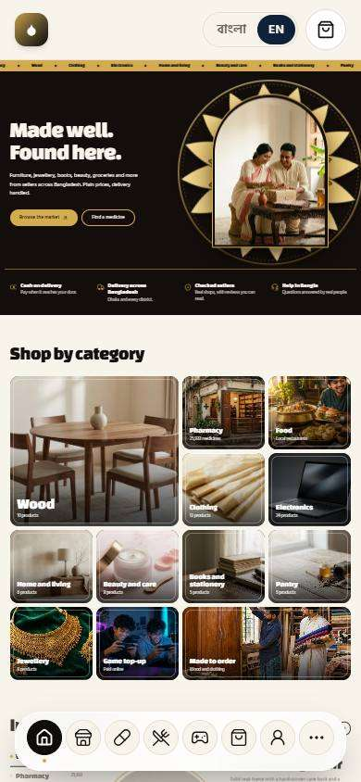  Seen as a stranger (not signed in) | / | Seen as a stranger (not signed in) | /market/78
586. Text-size option Works
What it is for: The text size can be changed for easier reading.
What the tester did: Pressed the larger "A" in the header to change the text size.
What the tester saw:
- Yes. A "Normal text size" button exists
- Yes. A "Large text" button exists
- Yes. A "Largest text" button exists
- Yes. Choosing the largest makes the whole page's text bigger (16px became 20.8px)
Step 1: Normal text size | Step 2: After choosing "Largest text"
Seen as a stranger (not signed in) | /market/78 | Seen as a stranger (not signed in) | /market/78
587. Everything works on the web too Only partly shown
What it is for: Everything works on the web too. A few things are still partial.
What the tester did: Looked at the web version.
Note: The checklist marks "everything works on the web" as partly built. Not every feature was compared with the app.
Step 1: The web version
Seen as a stranger (not signed in) | /
588. App update message Only partly shown
What it is for: An app update message tells people when a new version is ready.
What the tester did: Looked for the "A new version is ready" message.
What the tester saw:
- Yes. The site serves an installable app worker that carries its build number, which is how it knows a newer build exists
Note: The message "A new version is ready" appears only after a second build is published and the installed app fetches it. Only one build existed, so the banner itself could not be shown.
Step 1: The dashboard (the banner only appears once a newer build has been fetched)
Seen as the owner | /dashboard
589. Main photo selection Works
What it is for: The main product photo can be chosen.
What the tester did: Looked at the seller listing form for choosing the main photo.
What the tester saw:
- Yes. A seller can choose the main photo
Step 1: The seller's listings
Seen as a wholesaler | /wholesale/sell
590. Daily backup, 30 days Works
What it is for: A backup is taken daily and kept for 30 days.
What the tester did: Looked on the dashboard for the daily backup.
What the tester saw:
- Yes. The owner sees when the last backup was made
- Yes. And is warned when the nightly backup is not running
Step 1: The dashboard: backup status
Seen as the owner | /dashboard
591. Backup stored outside the server Only partly shown
What it is for: Backups stored outside the server are partly built.
What the tester did: Looked for backups stored outside the server.
Note: The checklist marks off-server backup as partly built. Not found on a screen.
Step 1: Connections
Seen as the owner | /admin/connections
592. Monthly backup test Only partly shown
What it is for: A backup is tested each month.
What the tester did: Looked for the monthly backup test.
Note: Not found on a screen.
Step 1: Settings
Seen as the owner | /admin/settings
593. Work not lost when internet drops Only partly shown
What it is for: Work is not lost when the internet drops. Partly built.
What the tester did: Opened the counter without internet.
What the tester saw:
- Yes. A counter page that keeps working without internet
Note: The checklist marks this as partly built. A real internet drop was not reproduced.
Step 1: The counter without internet
Seen as the owner | /admin/counter/offline
594. Bulk import of old data Only partly shown
What it is for: Old data can be imported in bulk.
What the tester did: Looked for a bulk import of old data.
Note: No import screen was found. The medicine database was loaded in bulk before this test.
Step 1: Settings
Seen as the owner | /admin/settings
595. Correct system time Works
What it is for: The system clock is correct.
What the tester did: Made a retail sale and compared the time printed on the memo with the real time in Bangladesh.
What the tester saw:
- Yes. The system clock shows Bangladesh time
Note: The memo says 15:32. The time in Dhaka is 15:32. Times on screen follow the viewer's own clock. Rules that run on the server, such as the night hours, use the server's clock, which is set to UTC (six hours behind Bangladesh): see feature 157.
Step 1: The memo time
Seen as the owner | /admin/counter/216
596. Monthly report date in settings Only partly shown
What it is for: The monthly report date is in settings. Partly built.
What the tester did: Looked for the monthly report date in settings.
What the tester saw:
- Yes. A month-end window is set in Settings
Note: The checklist marks the monthly report date as partly built. A date for the monthly report itself was not found.
Step 1: Month-end window
Seen as the owner | /admin/settings
597. Store user behavior data from day one Works
What it is for: User behaviour data is stored from day one.
What the tester did: Opened "What people look for".
What the tester saw:
- Yes. The site records what visitors search and view
- Yes. From search to cart
Step 1: Behaviour data
Seen as the owner | /admin/behavior
598. Old data stored separately Not built yet
What it is for: Old data stored separately has not been built yet.
What the tester did: Checked the checklist.
Note: Old data stored separately has not been built yet.
599. Auto image compression Only partly shown
What it is for: Photos are compressed automatically.
What the tester did: Looked for image compression.
What the tester saw:
- Yes. Uploads are limited in size
Note: Automatic compression of uploaded images was not measured.
Step 1: Site design
Seen as the owner | /admin/site
600. Low-quality image first Only partly shown
What it is for: A low quality image shows first, then the sharp one.
What the tester did: Looked for a low-quality image that loads first.
Note: Progressive image loading was not measured.
Step 1: A product page
Seen as a stranger (not signed in) | /market/78
601. Handle festival order peaks Only partly shown
What it is for: Festival order peaks are handled. Partly built.
What the tester did: Looked for festival peak handling.
Note: The checklist marks this as partly built. A load test was not run.
Step 1: Settings
Seen as the owner | /admin/settings
602. Updates at night or on closed days Works
What it is for: Updates run at night or on closed days.
What the tester did: Looked at the notice shown on every page.
What the tester saw:
- Yes. The owner can post a notice on every page, for example about a night update
Step 1: A notice for updates at night
Seen as the owner | /admin/settings
603. Reward points and referral Only partly shown
What it is for: Reward points and referrals are partly built.
What the tester did: The owner set the token for a referral to 50 taka. A shopper then opened the wallet. The owner switched it off again afterwards.
What the tester saw:
- Yes. The wallet offers "Invite a friend"
- Yes. It says what the shopper earns when the friend orders
- Yes. And counts the friends who joined by the shopper's link
Note: Points earned on the shopper's own purchases are not built. The checklist marks this feature as partly built: the referral token works, the purchase points do not exist yet.
Step 1: The wallet with the referral switched on
Seen as a signed-in shopper | /wallet
604. Bundle deals and flash sale Not built yet
What it is for: Bundle deals and flash sales have not been built yet.
What the tester did: Checked the checklist.
Note: Bundle deals and flash sales have not been built yet.
605. Abandoned cart reminder Only partly shown
What it is for: An abandoned cart reminder is sent.
What the tester did: Looked for an abandoned cart reminder.
Note: Waiting for a reminder to arrive was not possible.
Step 1: The cart
Seen as a signed-in shopper | /market-cart
606. Price-drop alert Only partly shown
What it is for: A price-drop alert tells buyers when a saved item gets cheaper.
What the tester did: Looked at the wishlist for a price-drop alert.
Note: A price drop and its alert were not reproduced.
Step 1: The wishlist
Seen as a signed-in shopper | /wishlist
607. Support tickets Works
What it is for: Support tickets let buyers ask for help.
What the tester did: Opened a support ticket as a shopper, then looked at it on the owner's Support page.
What the tester saw:
- Yes. The owner sees the ticket
Step 1: A support ticket filled in | Step 2: The ticket is sent
Seen as a signed-in shopper | /support/new | Seen as a signed-in shopper | /support/t/blWt1jQQwPo5Exv4OUY7WQU1IO3SkT4G0PbUdWNW
Step 3: The owner's Support tickets
Seen as the owner | /admin/support
608. Facebook Pixel and Analytics Not built yet
What it is for: Facebook Pixel and Analytics have not been built yet.
What the tester did: Checked the checklist.
Note: Facebook Pixel and Analytics have not been built yet.
609. Affiliate and bulk SMS Not built yet
What it is for: Affiliate and bulk text messages have not been built yet.
What the tester did: Checked the checklist.
Note: Affiliate and bulk text messages have not been built yet.
610. Credit ledger (baki khata) Not built yet
What it is for: A credit ledger (baki khata) has not been built yet.
What the tester did: Checked the checklist.
Note: A credit ledger (baki khata) has not been built yet.
611. Supplier/company dues (in the ledger book) Not built yet
What it is for: Company and supplier dues have not been built yet.
What the tester did: Checked the checklist.
Note: Company and supplier dues have not been built yet.
612. Full PharmaTrack sync Not built yet
What it is for: A full PharmaTrack sync has not been built yet.
What the tester did: Checked the checklist.
Note: A full PharmaTrack sync has not been built yet.
613. Service / coaching booking Not built yet
What it is for: Service and coaching booking has not been built yet.
What the tester did: Checked the checklist.
Note: Service and coaching booking has not been built yet.

