Bahria University,

Karachi Campus



COURSE: CEL-223 COMPUTER COMMUNICATION AND NETWORKING

TERM: Fall 2022, CLASS: BSE- 5 (A)

PROJECT NAME

Bahria College Network

Submitted By:

|  |  |  |
| --- | --- | --- |
| S.NO | Student Name | Enrollment # |
| 1 | Ahmed Ayaz | 02-131202-051 |
| 2 | Muhammad Araib | 02-131202-053 |
| 3 | Muhammad Abdullah | 02-131202-054 |

Submitted to:

Engr.Dr Osama/ Engr. Saniya Sarim

Signed Remarks: Score:

Table of Content

1. INTRODUCTION
2. CCN CONCEPTS USED IN PROJECT
3. FEATURES OF YOUR PROJECT
4. TOPOLOGY
5. CODE
6. CONCLUSION

**Introduction:**

This College Network Scenario is about designing a topology of a network that is a LAN (Local Area Network) for a College in which various computers of different departments are set up so that they can interact and communicate with each other by interchanging data. To design a networking scenario for a college which connects various departments to each other’s, it puts forward communication among different departments. CNS is used to design a systematic and well-planned topology, satisfying all the necessities of the college (i.e. client). CNS comes up with a network with good performance. The main objective of the proposed network is to update the existing network and also enhance its capabilities and increase the flexibility of the network which will eventually provide good security.

**COMPUTER COMMUNICATION & NETWORKING CONCEPTS USED IN PROJECT:**

We are implementing the concept of:

* RIP (Routing Information Protocol)
* VLAN (virtual local area network)
* Static Routing

**FEATURES OF OUR PROJECT:**

The existing system is a very basic system. College mainly comprises of three main sections as

1. TPO & Other

2. Exam Center

3. Office

* All the hosts are assigned with static IPs and are assigned in the order in which it where set up.
* No support for dynamic IP allocations
* The system has no remote access to the network

**TOPOLOGY:**

* The College Network project is based on **star topology.**

**CODE:**

**IP Addressing Plan**

**IT DEPARTMENT (192.168.1.0)**

|  |  |
| --- | --- |
| HOD CABIN | 192.168.1.2 |
|  |  |
| IT LAB 1 | 192.168.1.3 |
|  |  |
| IT LAB 2 | 192.168.1.4 |
|  |  |
| IT LAB 3 | 192.168.1.5 |
|  |  |
| IT LAB 4 | 192.168.1.6 |
|  |  |
| Printer 0 | 192.168.1.7 |
|  |  |



**COMPUTER DEPARTMENT (192.168.2.0)**

|  |  |
| --- | --- |
| CS HOD CABIN | 192.168.2.2 |
|  |  |
| CS LAB 1 | 192.168.2.3 |
|  |  |
| CS LAB 2 | 192.168.2.4 |
|  |  |
| CS LAB 3 | 192.168.2.5 |
|  |  |
| CS LAB 4 | 192.168.2.6 |
|  |  |
| Printer 7 | 192.168.2.7 |
|  |  |



**OTHERS (192.168.3.0)**

|  |  |
| --- | --- |
| OFFICE | 192.168.3.2 |
|  |  |
| Printer 2 | 192.168.3.6 |
|  |  |
| EXAM CELL | 192.168.3.3 |
|  |  |
| Printer 3 | 192.168.3.7 |
|  |  |
| ENQUIRY | 192.168.3.4 |
|  |  |
| TPO | 192.168.3.5 |
|  |  |
| Printer 4 | 192.168.3.8 |
|  |  |



**INTERNET LAB (128.168.0.0)**

|  |  |
| --- | --- |
| PC2 | 128.168.0.2 |
|  |  |
| PC3 | 128.168.0.3 |
|  |  |
| PC4 | 128.168.0.4 |
|  |  |
| PC5 | 128.168.0.5 |
|  |  |
| Printer 5 | 128.168.0.6 |
|  |  |



**PRINCIPLE ROOM (192.168.4.0)**

PC 0

192.168.4.2

LAPTOP 0

192.168.4.3

**Routing Protocol Plan**

Routing Information Protocol (RIP) is a dynamic routing protocol which uses hop count as

a routing metric to find the best path between the source and the destination network. It is a distance vector routing protocol which has AD value 120 and works on the application layer of OSI model.

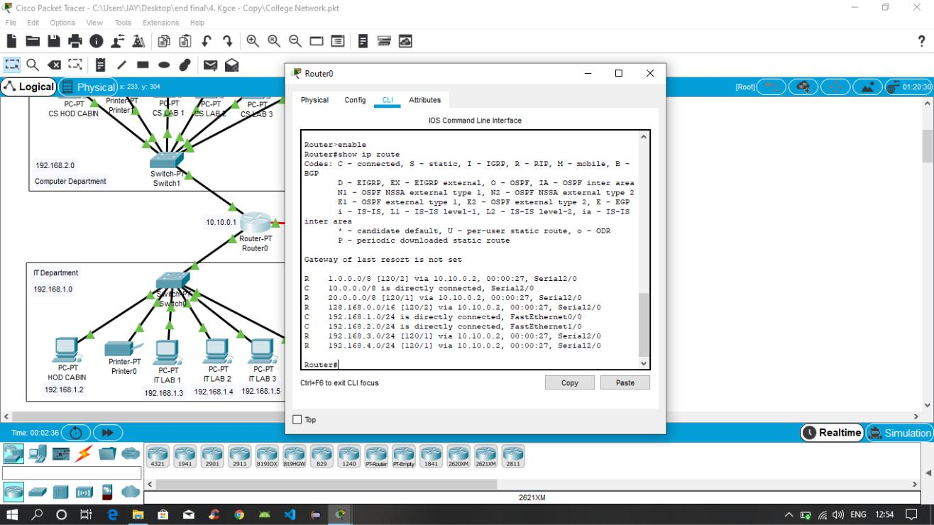

*Routing Protocol Plan for Router0*

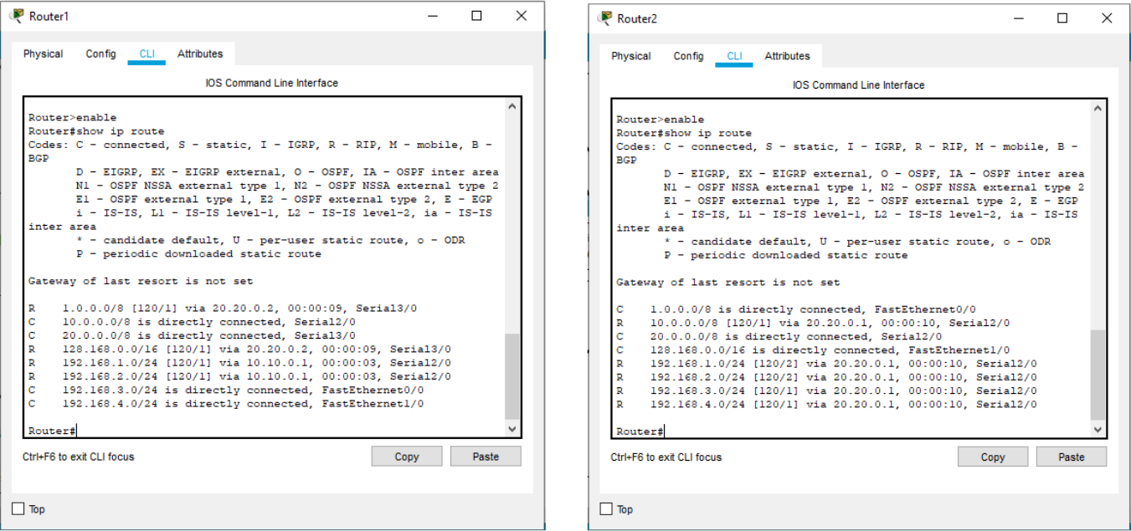

*Routing Protocol Plan for Router1* *Routing Protocol Plan for Router2*

**Network Design**

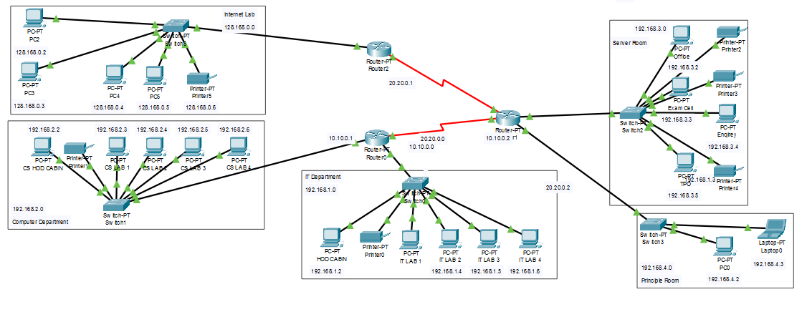

*The prototype of the proposed network is implemented on cisco packet tracer*

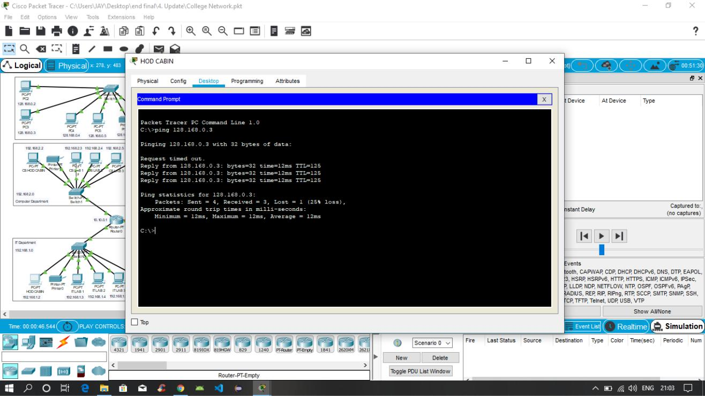

*Testing VLAN communications from HOD Cabin to Internet Lab*

**CONCLUSION:**

The outcome of the proposed system will be a fail-safe backbone network infrastructure which meets the requirements for readily available access to information and security of the private network, and also ensures optimized productivity when telecommunication services are accessed. The installed equipment allowed organizing high-speed wired and wireless Internet access throughout the whole complex of hospital buildings as well as providing transfer of all types of data throughout the single optimized network.