**BAHRIA UNIVERSITY (KARACHI CAMPUS)**

|  |  |  |
| --- | --- | --- |
|  | OPEN ENDED LAB 1 – Fall 2022 | |
|  |  | (CLO-1) |
| **Course Title:** | Web Engineering | **Course Code**: SEL 310 |
| **Course Instructor:** | **Engr. Adnan ur Rehman** | **Class**: BSE-5(A) |
| **Lab Engineer:** | **Engr. Rehan Baig** | **Name: MUHAMMAD ABDULLAH** |
| **Max. Marks:** | 12 Marks | **Reg no: 02-131202-054** |
| **Time:** | **120** Min |  |

**Note:**

* **The probability of similarity is 0% hence Copied OEL will be marked as ZERO**
* Save Document (Containing Screenshot of Code and Result) of your solution with your name+enrollment like xyz015
* **Must Upload your code folder to Github Public Repository and share your repo URL in doc file.**
* **Login form**

**Invalid format:**

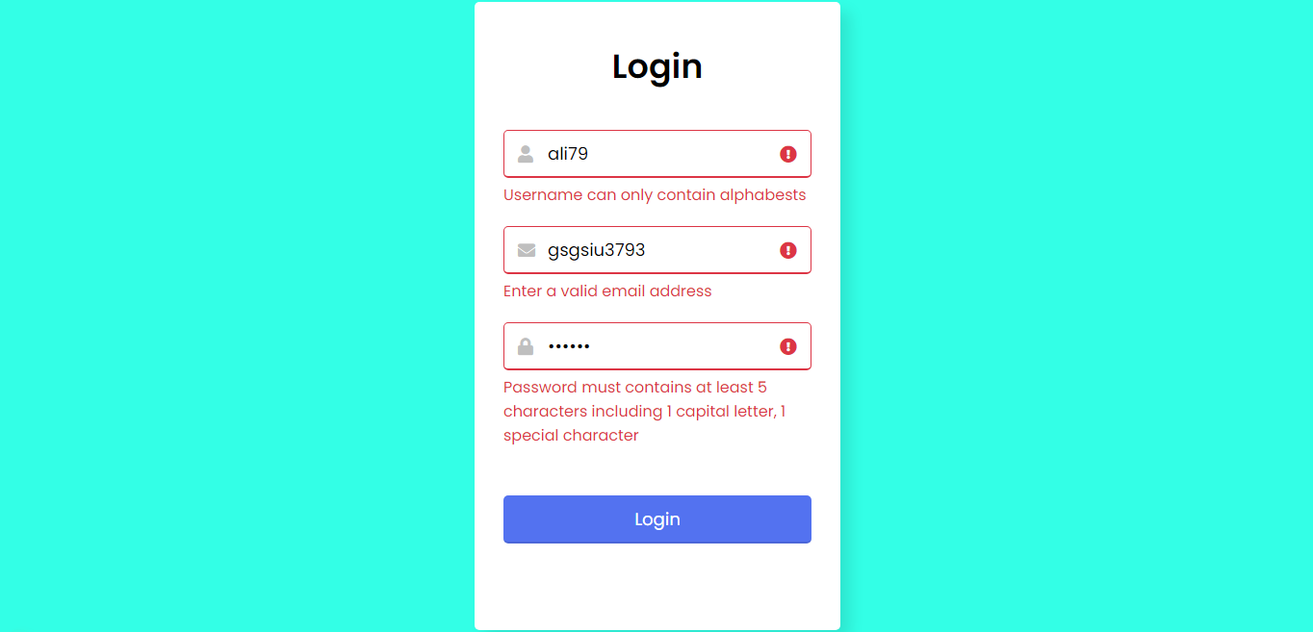

Valid format: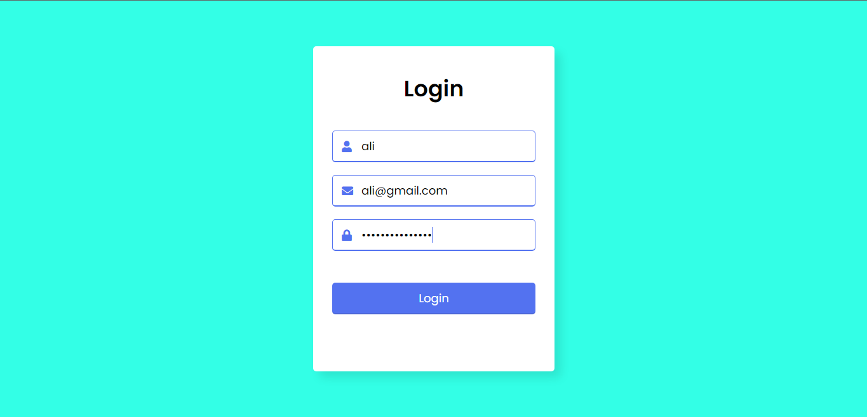

**HTML**

<!DOCTYPE html>

<html lang="en">

<head>

<meta charset="UTF-8">

<meta name="viewport" content="width=device-width, initial-scale=1.0">

<title>Login</title>

<link rel="stylesheet" href="Login.css">

<link rel="stylesheet" href="https://cdnjs.cloudflare.com/ajax/libs/font-awesome/5.15.3/css/all.min.css"/>

</head>

<body>

<div class="wrapper">

<header>Login</header>

<form action="DASHBOARD.html">

<div class="field username">

<div class="input-area">

<input type="text" placeholder="UserName">

<i class="icon fa fa-user"></i>

<i class="error error-icon fas fa-exclamation-circle"></i>

</div>

<div class="error error-txt">Username can only contain alphabests</div>

</div>

<div class="field email">

<div class="input-area">

<input type="text" placeholder="Email Address">

<i class="icon fas fa-envelope"></i>

<i class="error error-icon fas fa-exclamation-circle"></i>

</div>

<div class="error error-txt">Email can't be blank</div>

</div>

<div class="field password">

<div class="input-area">

<input type="password" placeholder="Password">

<i class="icon fas fa-lock"></i>

<i class="error error-icon fas fa-exclamation-circle"></i>

</div>

<div class="error error-txt">Password must contains at least 5 characters including 1 capital letter, 1 special character</div>

</div>

<input type="submit" value="Login">

</form>

<script src="login.js"></script>

</body>

</html>

**CSS**

@import url('https://fonts.googleapis.com/css2?family=Poppins:wght@400;500;600&display=swap');

*{

margin: 0;

padding: 0;

box-sizing: border-box;

font-family: "Poppins", sans-serif;

}

body{

width: 100%;

height: 100vh;

display: flex;

align-items: center;

justify-content: center;

background: #33FFE6;

}

::selection{

color: #fff;

background: #5372F0;

}

.wrapper{

width: 380px;

padding: 40px 30px 50px 30px;

background: #fff;

border-radius: 5px;

text-align: center;

box-shadow: 10px 10px 15px rgba(0,0,0,0.1);

}

.wrapper header{

font-size: 35px;

font-weight: 600;

}

.wrapper form{

margin: 40px 0;

}

form .field{

width: 100%;

margin-bottom: 20px;

}

form .field.shake{

animation: shake 0.3s ease-in-out;

}

@keyframes shake {

0%, 100%{

margin-left: 0px;

}

20%, 80%{

margin-left: -12px;

}

40%, 60%{

margin-left: 12px;

}

}

form .field .input-area{

height: 50px;

width: 100%;

position: relative;

}

form input{

width: 100%;

height: 100%;

outline: none;

padding: 0 45px;

font-size: 18px;

background: none;

caret-color: #5372F0;

border-radius: 5px;

border: 1px solid #bfbfbf;

border-bottom-width: 2px;

transition: all 0.2s ease;

}

form .field input:focus,

form .field.valid input{

border-color: #5372F0;

}

form .field.shake input,

form .field.error input{

border-color: #dc3545;

}

.field .input-area i{

position: absolute;

top: 50%;

font-size: 18px;

pointer-events: none;

transform: translateY(-50%);

}

.input-area .icon{

left: 15px;

color: #bfbfbf;

transition: color 0.2s ease;

}

.input-area .error-icon{

right: 15px;

color: #dc3545;

}

form input:focus ~ .icon,

form .field.valid .icon{

color: #5372F0;

}

form .field.shake input:focus ~ .icon,

form .field.error input:focus ~ .icon{

color: #bfbfbf;

}

form input::placeholder{

color: #bfbfbf;

font-size: 17px;

}

form .field .error-txt{

color: #dc3545;

text-align: left;

margin-top: 5px;

}

form .field .error{

display: none;

}

form .field.shake .error,

form .field.error .error{

display: block;

}

form .pass-txt{

text-align: left;

margin-top: -10px;

}

.wrapper a{

color: #5372F0;

text-decoration: none;

}

.wrapper a:hover{

text-decoration: underline;

}

form input[type="submit"]{

height: 50px;

margin-top: 30px;

color: #fff;

padding: 0;

border: none;

background: #5372F0;

cursor: pointer;

border-bottom: 2px solid rgba(0,0,0,0.1);

transition: all 0.3s ease;

}

form input[type="submit"]:hover{

background: #2c52ed;

}

**JavaScript**

const form = document.querySelector("form");

uField = form.querySelector(".username"),

uInput = uField.querySelector("input"),

eField = form.querySelector(".email"),

eInput = eField.querySelector("input"),

pField = form.querySelector(".password"),

pInput = pField.querySelector("input");

form.onsubmit = (e)=>{

e.preventDefault();

(uInput.value == "") ? uField.classList.add("shake", "error") : checkUser();

(eInput.value == "") ? eField.classList.add("shake", "error") : checkEmail();

(pInput.value == "") ? pField.classList.add("shake", "error") : checkPass();

setTimeout(()=>{

uField.classList.remove("shake");

eField.classList.remove("shake");

pField.classList.remove("shake");

}, 500);

uInput.onkeyup = ()=>{checkUser();}

eInput.onkeyup = ()=>{checkEmail();}

pInput.onkeyup = ()=>{checkPass();}

function checkUser(){

var letters = /^[A-Za-z]+$/;

if(!uInput.value.match(letters)){

uField.classList.add("error");

uField.classList.remove("valid");

}else{

uField.classList.remove("error");

uField.classList.add("valid");

}

}

function checkEmail(){

let pattern = /^[^ ]+@[^ ]+\.[a-z]{2,3}$/;

if(!eInput.value.match(pattern)){

eField.classList.add("error");

eField.classList.remove("valid");

let errorTxt = eField.querySelector(".error-txt");

(eInput.value != "") ? errorTxt.innerText = "Enter a valid email address" : errorTxt.innerText = "Email can't be blank";

}else{

eField.classList.remove("error");

eField.classList.add("valid");

}

}

function checkPass(){

var pass = /^(?=.*[a-z])(?=.*[A-Z])(?=.*\d)[a-zA-Z\d]{8,}$/;

if(!pInput.value.match(pass)){

pField.classList.add("error");

pField.classList.remove("valid");

}else{

pField.classList.remove("error");

pField.classList.add("valid");

}

}

if(!eField.classList.contains("error") && !pField.classList.contains("error") && !uField.classList.contains("error")){

window.location.href = form.getAttribute("action");

}

}

* **Dashboard**

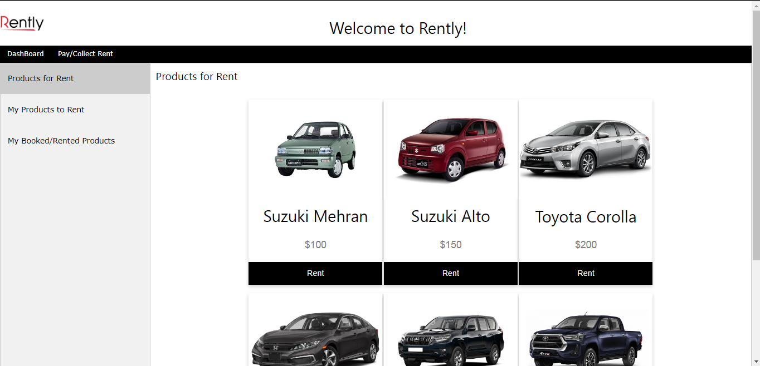

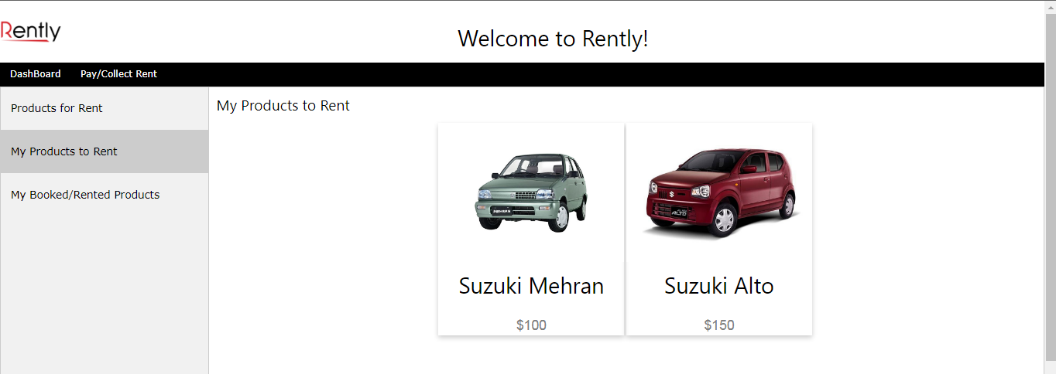

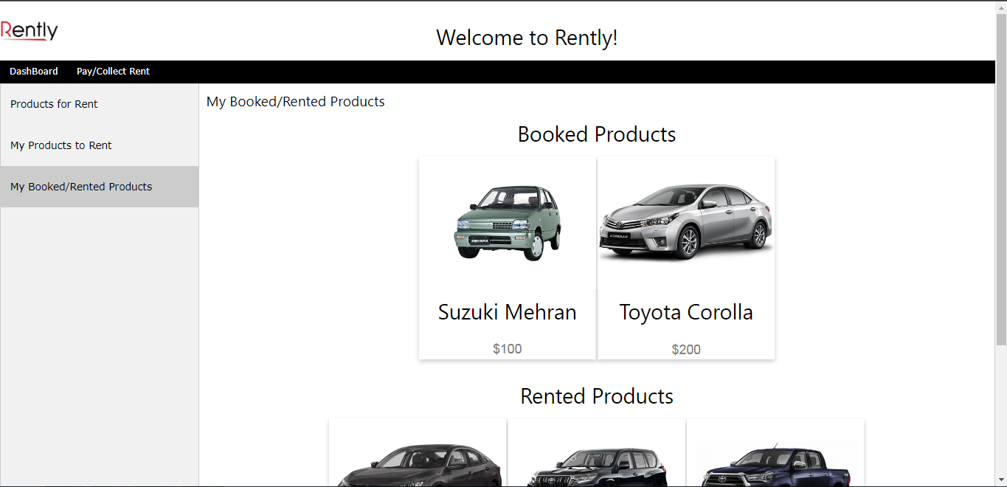

**HTML**

<!DOCTYPE html>

<html lang="en">

<head>

<meta charset="UTF-8">

<meta name="viewport" content="width=device-width, initial-scale=1">

<link rel="stylesheet" href="Dashboard.css">

<link rel="stylesheet" href="https://www.w3schools.com/w3css/4/w3.css">

<title>Dashboard</title>

<link rel="stylesheet" href="https://cdnjs.cloudflare.com/ajax/libs/font-awesome/5.15.3/css/all.min.css"/>

</head>

<body>

<img src="https://scontent.fkhi22-1.fna.fbcdn.net/v/t1.6435-9/72472942_132912998096357_2048147453944791040_n.jpg?_nc_cat=100&ccb=1-7&_nc_sid=09cbfe&_nc_ohc=1coq4pZr9y8AX_pTqL2&_nc_ht=scontent.fkhi22-1.fna&oh=00_AfDkhx1j4u5ApU0FvSZLMym9Kl7aVjK7SsmzB0xsrCmjNw&oe=639B1F97" align="left" style="width:100px;height:100px;"><br>

<h1 align="center">Welcome to Rently!</h1>

<div class="w3-bar w3-black">

<a href="#" class="w3-bar-item w3-button w3-mobile">DashBoard</a>

<a href="Pay-CollectRent.html" class="w3-bar-item w3-button w3-mobile">Pay/Collect Rent</a>

</div>

<div class="tab">

<button class="tablinks" onclick="openEvent(event, 'one')" id="defaultOpen">Products for Rent</button>

<button class="tablinks" onclick="openEvent(event, 'two')">My Products to Rent</button>

<button class="tablinks" onclick="openEvent(event, 'three')">My Booked/Rented Products</button>

</div>

<div id="one" class="tabcontent">

<h3>Products for Rent</h3>

<br>

<table align="center">

<tr>

<td>

<div class="card" data-name="Mehran" data-price="100" data-id="0">

<img src="https://cache2.pakwheels.com/system/car_generation_pictures/2873/original/Suzuki_Mehran_2012.jpg?1444111663" style="width:100%">

<h1>Suzuki Mehran</h1>

<p class="price">$100</p>

<p><button>Rent</button></p>

</div>

</td>

<td>

<div class="card" data-name="Alto" data-price="150" data-id="1">

<img src="https://cache4.pakwheels.com/system/car_generation_pictures/6013/original/Suzuki_Alto_-_PNG.png?1635945100" style="width:100%">

<h1>Suzuki Alto</h1>

<p class="price">$150</p>

<p><button>Rent</button></p>

</div>

</td>

<td>

<div class="card" data-name="Corolla" data-price="200" data-id="2">

<img src="https://oils-finder.com/galery/350.jpg" style="width:100%">

<h1>Toyota Corolla</h1>

<p class="price">$200</p>

<p><button>Rent</button></p>

</div>

</td>

</tr>

<tr>

<td>

<div class="card" data-name="Civic" data-price="250" data-id="3">

<img src="https://crdms.images.consumerreports.org/c_lfill,w_470,q_auto,f_auto/prod/cars/chrome/white/2021HOC020061_1280_01" style="width:100%">

<h1>Honda Civic</h1>

<p class="price">$250</p>

<p><button>Rent</button></p>

</div>

</td>

<td>

<div class="card" data-name="Prado" data-price="300" data-id="4">

<img src="https://cache1.pakwheels.com/system/car_generation_pictures/5245/original/prado.jpg?1595594818" style="width:100%">

<h1>Toyota Prado</h1>

<p class="price">$300</p>

<p><button>Rent</button></p>

</div>

</td>

<td>

<div class="card" data-name="Hilux" data-price="400" data-id="5">

<img src="https://cache2.pakwheels.com/system/car_generation_pictures/6006/original/Revo_-_PNG.png?1635483853" style="width:100%">

<h1>Toyota Hilux</h1>

<p class="price">$400</p>

<p><button>Rent</button></p>

</div>

</td>

</tr>

</table>

</div>

<div id="two" class="tabcontent">

<h3>My Products to Rent</h3>

<table align="center">

<tr>

<td>

<div class="card" data-name="Mehran" data-price="100" data-id="0">

<img src="https://cache2.pakwheels.com/system/car_generation_pictures/2873/original/Suzuki_Mehran_2012.jpg?1444111663" style="width:100%">

<h1>Suzuki Mehran</h1>

<p class="price">$100</p>

</div>

</td>

<td>

<div class="card" data-name="Alto" data-price="150" data-id="1">

<img src="https://cache4.pakwheels.com/system/car_generation_pictures/6013/original/Suzuki_Alto_-_PNG.png?1635945100" style="width:100%">

<h1>Suzuki Alto</h1>

<p class="price">$150</p>

</div>

</td>

<td>

</tr>

</table>

</div>

<div id="three" class="tabcontent">

<h3>My Booked/Rented Products</h3>

<h1 align="center">Booked Products</h1>

<table align="center">

<tr>

<td>

<div class="card">

<img src="https://cache2.pakwheels.com/system/car_generation_pictures/2873/original/Suzuki_Mehran_2012.jpg?1444111663" style="width:100%">

<h1>Suzuki Mehran</h1>

<p class="price">$100</p>

</div>

</td>

<td>

<div class="card">

<img src="https://oils-finder.com/galery/350.jpg" style="width:100%">

<h1>Toyota Corolla</h1>

<p class="price">$200</p>

</div>

</td>

</tr>

</table>

<h1 align="center">Rented Products</h1>

<table align="center">

<tr>

<td>

<div class="card">

<img src="https://crdms.images.consumerreports.org/c_lfill,w_470,q_auto,f_auto/prod/cars/chrome/white/2021HOC020061_1280_01" style="width:100%">

<h1>Honda Civic</h1>

<p class="price">$250</p>

</div>

</td>

<td>

<div class="card">

<img src="https://cache1.pakwheels.com/system/car_generation_pictures/5245/original/prado.jpg?1595594818" style="width:100%">

<h1>Toyota Prado</h1>

<p class="price">$300</p>

</div>

</td>

<td>

<div class="card">

<img src="https://cache2.pakwheels.com/system/car_generation_pictures/6006/original/Revo_-_PNG.png?1635483853" style="width:100%">

<h1>Toyota Hilux</h1>

<p class="price">$400</p>

</div>

</td>

</tr>

</table>

</div>

<script src="Dashboard.js"></script>

</body>

</html>

**CSS**

* {box-sizing: border-box}

body {font-family: "Lato", sans-serif;}

.tab {

float: left;

border: 1px solid #ccc;

background-color: #f1f1f1;

width: 20%;

height: 1000px;

}

.tab button {

display: block;

background-color: inherit;

color: black;

padding: 22px 16px;

width: 100%;

border: none;

outline: none;

text-align: left;

cursor: pointer;

transition: 0.3s;

font-size: 17px;

}

.tab button:hover {

background-color: #ddd;

}

.tab button.active {

background-color: #ccc;

}

.tabcontent {

float: left;

padding: 0px 12px;

border: 1px solid #ccc;

width: 80%;

border-left: none;

height: 1000px;

}

.card {

box-shadow: 0 4px 8px 0 rgba(0, 0, 0, 0.2);

width: 300px;

margin: auto;

text-align: center;

font-family: arial;

}

.price {

color: grey;

font-size: 22px;

}

.card button {

border: none;

outline: 0;

padding: 12px;

color: white;

background-color: #000;

text-align: center;

cursor: pointer;

width: 100%;

font-size: 18px;

}

.card button:hover {

opacity: 0.7;

}

**JavaScript**

function openEvent(evt, Name) {

var i, tabcontent, tablinks;

tabcontent = document.getElementsByClassName("tabcontent");

for (i = 0; i < tabcontent.length; i++) {

tabcontent[i].style.display = "none";

}

tablinks = document.getElementsByClassName("tablinks");

for (i = 0; i < tablinks.length; i++) {

tablinks[i].className = tablinks[i].className.replace(" active", "");

}

document.getElementById(Name).style.display = "block";

evt.currentTarget.className += " active";

}

document.getElementById("defaultOpen").click();

* **Pay/CollectRent**

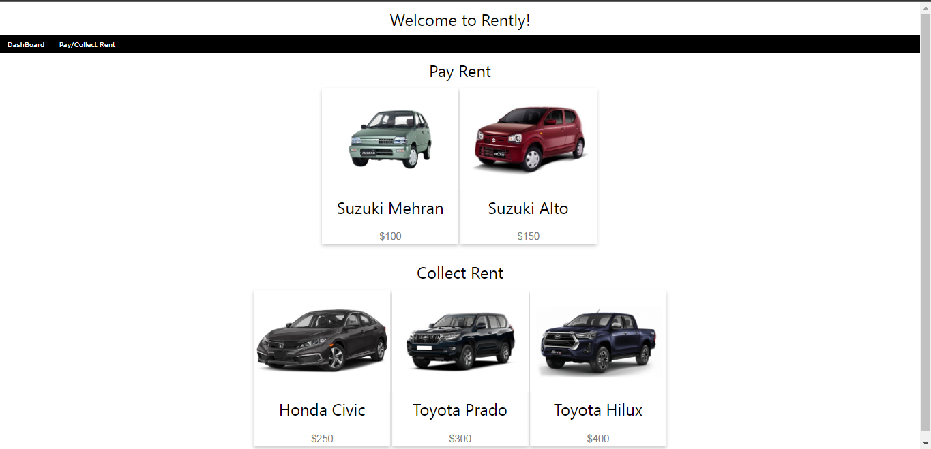

**HTML**

<!DOCTYPE html>

<html lang="en">

<head>

<meta charset="UTF-8">

<meta name="viewport" content="width=device-width, initial-scale=1">

<link rel="stylesheet" href="Dashboard.css">

<link rel="stylesheet" href="https://www.w3schools.com/w3css/4/w3.css">

<title>Dashboard</title>

<link rel="stylesheet" href="https://cdnjs.cloudflare.com/ajax/libs/font-awesome/5.15.3/css/all.min.css"/>

</head>

<body>

<h1 align="center">Welcome to Rently!</h1>

<div class="w3-bar w3-black">

<a href="DASHBOARD.html" class="w3-bar-item w3-button w3-mobile">DashBoard</a>

<a href="#" class="w3-bar-item w3-button w3-mobile">Pay/Collect Rent</a>

</div>

<h1 align="center">Pay Rent</h1>

<table align="center">

<tr>

<td>

<div class="card" data-name="Mehran" data-price="100" data-id="0">

<img src="https://cache2.pakwheels.com/system/car_generation_pictures/2873/original/Suzuki_Mehran_2012.jpg?1444111663" style="width:100%">

<h1>Suzuki Mehran</h1>

<p class="price">$100</p>

</div>

</td>

<td>

<div class="card" data-name="Alto" data-price="150" data-id="1">

<img src="https://cache4.pakwheels.com/system/car_generation_pictures/6013/original/Suzuki_Alto_-_PNG.png?1635945100" style="width:100%">

<h1>Suzuki Alto</h1>

<p class="price">$150</p>

</div>

</td>

<td>

</tr>

</table>

<h1 align="center">Collect Rent</h1>

<table align="center">

<tr>

<td>

<div class="card">

<img src="https://crdms.images.consumerreports.org/c_lfill,w_470,q_auto,f_auto/prod/cars/chrome/white/2021HOC020061_1280_01" style="width:100%">

<h1>Honda Civic</h1>

<p class="price">$250</p>

</div>

</td>

<td>

<div class="card">

<img src="https://cache1.pakwheels.com/system/car_generation_pictures/5245/original/prado.jpg?1595594818" style="width:100%">

<h1>Toyota Prado</h1>

<p class="price">$300</p>

</div>

</td>

<td>

<div class="card">

<img src="https://cache2.pakwheels.com/system/car_generation_pictures/6006/original/Revo_-_PNG.png?1635483853" style="width:100%">

<h1>Toyota Hilux</h1>

<p class="price">$400</p>

</div>

</td>

</tr>

</table>

</body>

</html>