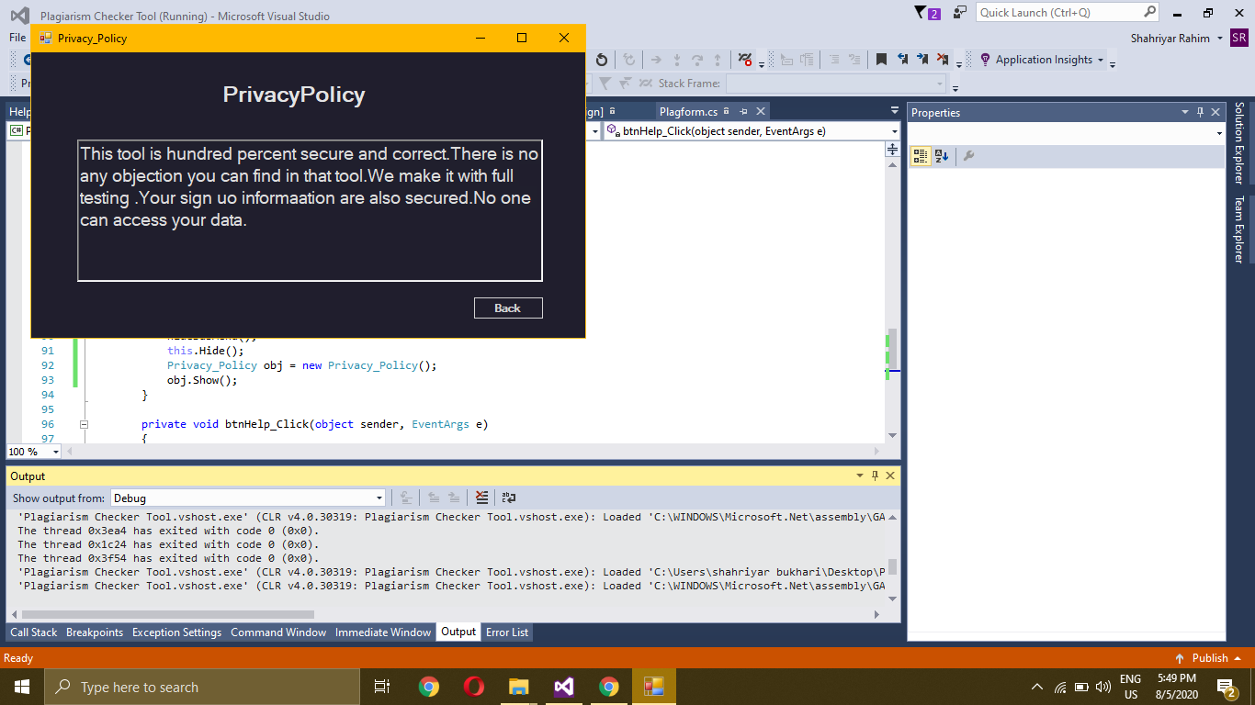

using System;

using System.Collections.Generic;

using System.ComponentModel;

using System.Data;

using System.Drawing;

using System.Linq;

using System.Text;

using System.Threading.Tasks;

using System.Windows.Forms;

namespace Plagiarism_Checker_Tool

{

public partial class Privacy_Policy : Form

{

public Privacy_Policy()

{

InitializeComponent();

}

private void btnBack_Click(object sender, EventArgs e)

{

this.Hide();

Plagform obj = new Plagform();

obj.Show();

}

}

}