Abstract
BinSpell – commitment to a symbol is withheld until the appropriate level of evidence has been reached. We present 2 interface designs which are possible to control given low bandwidth and noisy channels.
Introduction
Many of the devices designed to make communication possible for individuals with motor disabilities usually require some vestige of neuro-muscular control. Brain computer interfaces (BCI) affords individuals with severe neuro-muscular impairments, direct neural control of external devices. One of the primary focuses of BCI research has been to enable motor-limited individuals to control communication devices. Thus, much research has gone into providing BCI-controlled spelling devices, or virtual keyboards, to these individuals.
Control of external devices requires the BCI system be able to differentiate between different patterns embedded in continuous brain signals. The number of distinguishable patterns—brain states—partially hinges upon classification accuracy. BCIs using binary classifiers in general reach an accuracy of around 90%, although there are classifiers who perform well below this value. Because BCI bandwidth is already so low, low classification error is critical for acceptable performance of BCI-controlled communication devices. Information transfer rates decrease as accuracy decreases, increasing the user's frustration and undermining the viability of BCI as a communication modality.
Currently, there remains a significant imbalance in bandwidths between a BCI system and its user: very little useful information is successfully extracted from an acquired neural signal, while feedback to the user can present a great deal of information. This is especially true of non-invasive brain imaging systems, such as EEG or MEG, which have lower signal to noise ratio then their invasive counterparts, e.g. Ecog. Thus the communication speed also depends on how well a BCI system is able to compress the information the user is trying to convey, into the fewest possible bits.
Statisical properties of language can aid in comperssion by providing context for compression algorithms. While much work has gone into the improvement of classification methods, statistical properties of language, if properly exploited, can also improve the effective rate of communication.
One of the virtual keyboards presented in this paper, BinSpell, is designed for binary classifiers whose bandwidth is additionally reduced by very noisy channels. We use Huffman encoding techniques to efficiently represent the user's intent as a series of binary choices. We implement a language model based on a trigram character model, and a bigram word model in order to increase the accuracy of predictions we make, by inferring the user's intended output. Redundancy is used to counter the error rate of the classifier, thus also improving the accuracy of the predictions.
A second keyboard design, Circ-O-Spell, presented is an extension of an existing keyboard, Hex-o-spell . With Circ-O-Spell, we present an alternative method of making selections, which we argue requires fewer steps on average. We also employ a Hidden Markov Model and borrow from Huffman coding to reduce the number of steps to a correct selection, and hence increase communication speed.
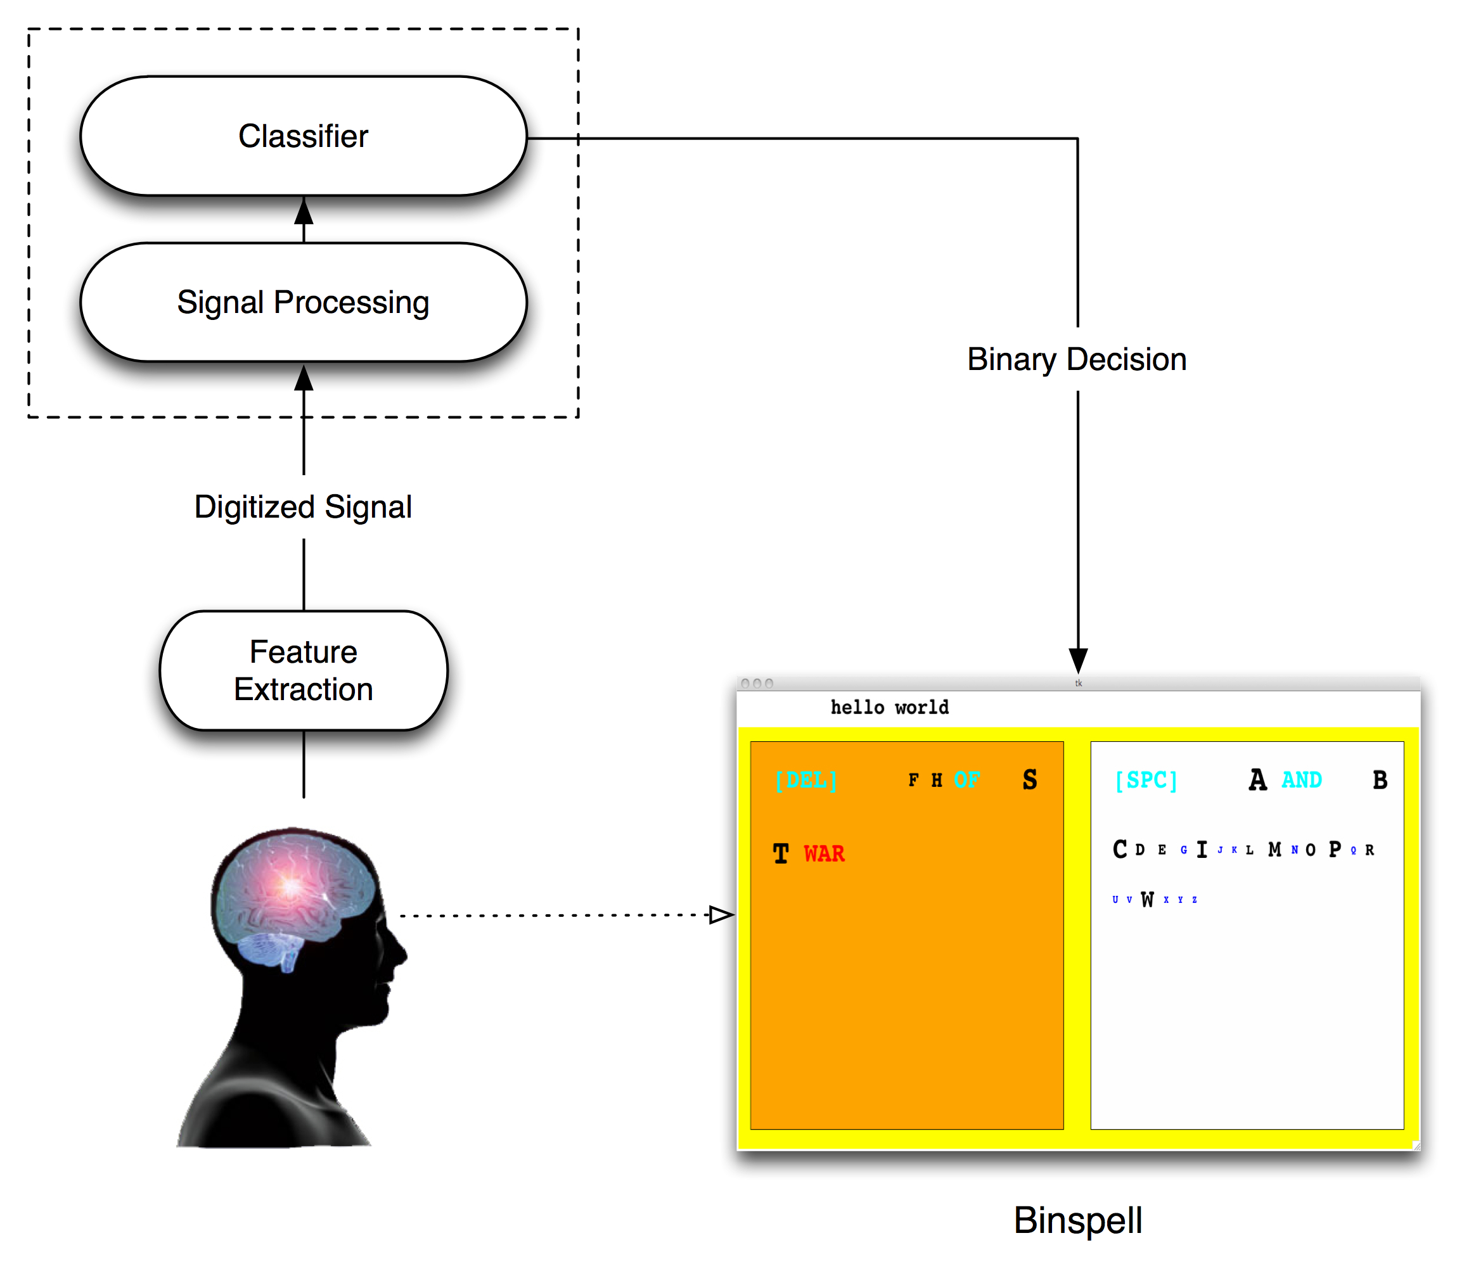

History and Related Work
BCI
A brain computer interface (BCI) is a communication channel between the brain and a computer. It records changes in electrical activity in the brain, and translates them into control signals. Acquired signals are first amplified, then digitized for analysis. Unwanted artifacts, such as those produced by a heartbeat, and noise, are filtered out, and the target signal feature is extracted. Built in classifiers characterize brain state by correlating specific mental activities with the target features. The interpreted brain state is commuted into control signals, and sent to the device being operated.
BCI's can be either invasive, such as single-unit recording or electrocorticography (EcoG), or non-invasive, such as EEG or MEG. Invasive techniques provide the most information per channel, but carry the greatest risk, as they require surgery to provide openings in the skull. Most BCI systems are non-invasive, and use EEG signals recorded from the scalp .

Virtual Keyboards
Generally, virtual keyboards are devices or software, which emulate physical keyboards, but do not have physical sensing buttons. They can be controlled by pointing devices, such as mice, touch pads, photo-electric sensing devices, or active finger tracking methods . Virtual keyboard key layout can be dynamic, and can readily include words, phrases, or pictures.
Virtual keyboards designed for BCI control are on-screen keyboards. Although the area of software keyboards is limited by the size of the screen on which it is displayed, they can be more adaptable to compact mobile devices.

P300 Speller
The P300 Speller is an synchronous EEG controlled spelling system. It relies on the P300 event related potentials (ERPs) that result when users respond to specific stimuli generated by the BCI system .

Hex-O-Spell
Hex-O-Spell, is controlled by the Berlin Brain Computer Interface (BBCI). The BBCI is an EEG based system which decodes motor imagery without subject training. Its use of machine learning techniques and its ability to operate at high decision speeds, affords high quality feedback to the user. reports 98% accuracy at an average speed of 1 decision every 2.1s.
Hex-O-Spell keyboard layout is comprised of 6 hexagonal fields surrounding a circle, each containing 5 characters. The center of the circle contains an arrow used to make selections. A language model determines how the letters are layed out within each hexagon.
Hex-O-Spell is mentally controlled by imagined right hand and foot movements. Imagined right hand movement effects a clockwise rotation of the arrow in the center of the circle. Imagined right foot movement ceases rotation, and causes the arrow to extend towards a hexagon. Selection of a hexagon is caused by sustained right foot motor imagery, and causes all other hexagons to be cleared. The 5 characters in the chosen hexagon are then redistributed among the empty hexagons, and the arrow is reset to its minimal length. Parameters such as the arrow turning and growing speeds, can be tailored to the user.
Hex-O-Spell was tested with two subjects who had no training on the BBCI, and who had very little experience with the keyboard. The acheived typing speeds were between 2.3 and 5 chars/min for one subject, and between 4.6 and 7.6 char/min for the other, for error free completed phrases.

Dasher

Circ-O-Spell
This keyboard is an extension of the Hex-O-Spell keyboard. The hexagonal fields are replaced by circular fields, containing sets of symbols (fig#). Letters are arranged according to their frequency of use. A symbol for the space-bar is provided. The initially highlighted circle contains the highest probability symbol.
Control with a BCI system would be effected by the imagined movement of the left or right hand. When a circle containing a set of symbols is selected, a new layout is presented containing only the symbols in the selected set (fig#). In the new layout, each circle contains only a single symbols from the selected set, and symbols for 'back-space' and delete are also presented. The delete returns the keyboard to the state prior to the symbol being deleted. The back-space key exits the new layout, and returns the user to the layout of the entire set of symbols. If the selected circle contains only one symbol, the symbol is added to the text box at the top of the window, and the initial configuration returns (fig#).
Circ-O-Spell uses a 1st order Hidden Markov Model (HMM) to attempt to reduce the number of steps needed to make a selections. It has been suggested that most bigram frequency tables reflect unrealistic counts because they do not distinguish the positions of the bigram within words. It has been shown that there is a marked difference in bigram frequencies, depending on their positions within words. Thus, we use two different tables of bigram frequencies, which differ by their positions, to calculate two tables of transition probabilities. In addition to a table of priors, these transition probabilities are used to determine which circle is highlighted. The first is calculated from frequency counts of bigrams found solely at the beginning of words. The second is calculated from frequency counts of bigrams found in any other position besides the beginning. The frequency tables represent bigram frequencies per 1000 words, of words occurring at least once per million in normal usage, and of more than three letters. Each new word begins a new HMM. New words are detected by the selection of the space-bar key.

BinSpell
The start screen (fig#) contains the entire alphabet, and the 3 words with the highest probability. Symbols for “space bar” and for delete, are provided after at least one other symbol has been output. The size and color of symbols are determined by their prior probabilities. Those with the lowest probabilities are small and blue, the next largest are black. Whole words are provided in cyan to help distinguish them from single letters. The most likely letter or word is the largest and is displayed in red. In the simulation, the up-arrow key and the down-arrow key are used to select the left and right boxes, respectively. Control with a BCI system would be effected by the imagined movement of the left or right hand.

D.J.C. MacKay, Information Theory, Inference, and Learning Algorithms. Cambridge, U.K.: Cambridge Univ. Press, 2003.
– huffman coding num steps reduction
We use Huffman coding to reduce the number of steps it would take to access the most likely symbols. Huffman coding is an algorithm originally designed for the binary encoding of sequences of ascii symbols. It uses each symbol's frequency of occurrence to build up an optimal way of representing that character as a binary string . It works by creating a binary tree of nodes, each of which represents a symbol and it's associated probability. The way in which the tree is walked produces codes that represent the symbols. Thus the least number of bits encode the most commonly used symbols. It is most commonly used within lossless compression schemes, such as JPEG, or MP3 . We use Huffman coding to determine the members of a box-set. Thus, the left and right boxes reflect loosely the left and right halves of a Huffman tree. Individual letters are alphabetized, however, to facilitate visual scanning.
When a selection is made, the probabilities of all symbols within that box are weighted by the accuracy of the classifier (80% in our case). The probabilities of the symbols in the box that was not chosen are weighted by 1 minus the accuracy. All of the probabilities are then re-normalized, and a new Huffman tree is generated and used to determine the new layout. In this way, the symbols are “shuffled” until one of the probabilities surpasses a threshold, and the associated symbol is output into the text box at the top (fig#).
Selections also cause the background of the selected box to be shaded in orange, while the background color of the non-selected box becomes white (fig#). If a box is selected in succession, the border of the box becomes bolded for a few seconds, in order to indicate its selection. Selection of a word outputs
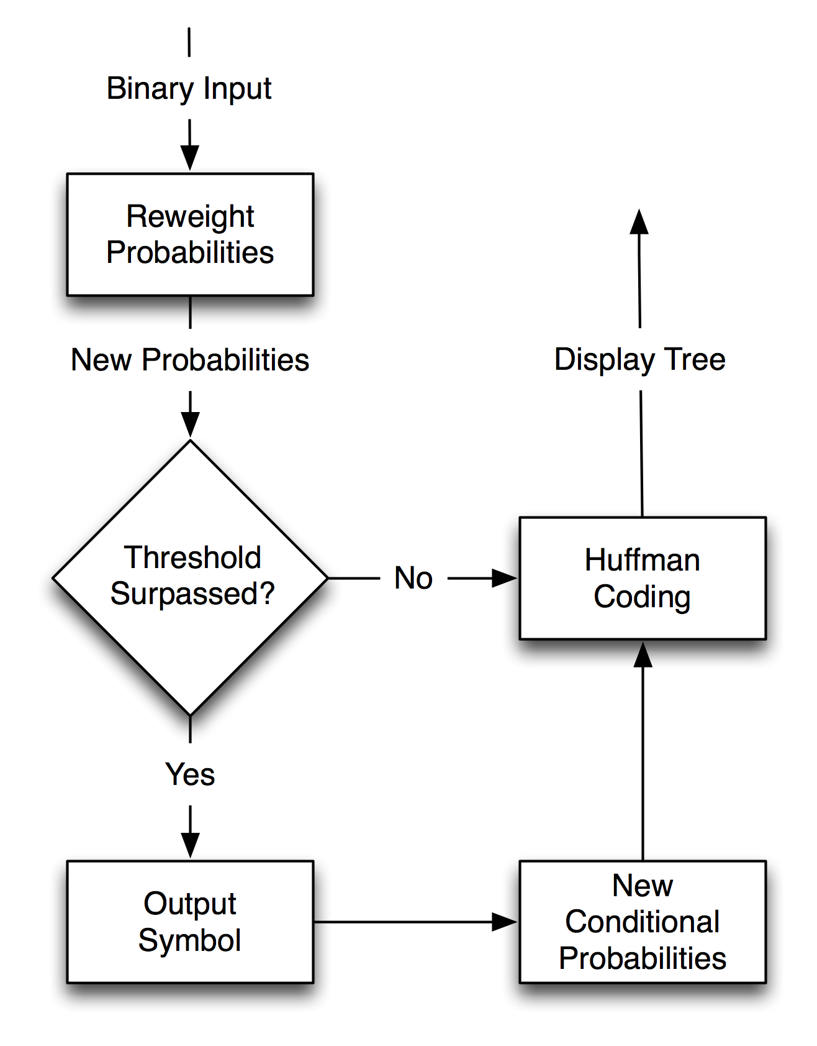

the word into the text box, along with a trailing “space”, in anticipation of a new word. In the case of an incorrectly selected word, the entire word is erased, and the keyboard is returned to the state prior to the incorrect selection.
Dynamic Bayesian Networks provide the opportunity to factor the hidden state in an arbitrary way. Thus it is better suited then HMMs to model the complex interactions parallel stochastic processes. It is used in BinSpell to model the 2nd order, character-level Markov process and the 1st order, word-level Markov process, underlying our language model. Just as in Circ-O-Spell, bigram character frequency counts represent those bigrams found solely at the beginning of words. The weighting described above determines the emission probabilities. We use prefix matching to infer which word the user is most likely attempting to type, given the string which has already been typed. The 'space' character is used as a word delimiter. The probability for the delete option is calculated as the average of the top 3 probabilities, in order to facilitate its access.

Methods
Threshold Testing
In order to determine the most effective combination of weighting and thresholding levels, a python script automated the typing out of 5 phrases, 100 times each. This was done for a simulated classifier accuracy of both 80% and 90%. The results, shown in (fig#) demonstrated that in both cases, the best performance, in terms of typing speed, was obtained when the classifier accuracy determined the weighting, and the threshold was 5% above the accuracy.

Experimental Setup
5 subjects(3 females, 2 males, ages 22-28) paritcipated in testing the virtual keyboard. It ran on an Apple MacBook laptop, running Mac OSX. They were seated in a comfortable desk chair.
Training consisted of a 5-10 minute period, consisting of a trial run in which they were asked to type out their names, while directions for using the keyboard were explained to them.
For BinSpell, each participant was informed that they should first scan for their word of choice. If that word had not yet been suggested, they should scan for the next single character of choice. It was also explained that during the shuffling, if a box did not contain the symbol they were attempting to output, they should choose the other box, instead of continuing their attempt to visually locate the letter.
For Circ-O-Spell, each participant was informed that in the case of an incorrect symbol selection, they should simply select the first available circle, in order to get to the delete option.
Participants were provided with 10 phrases selected from among the top 10 Google search queries, for the U.S. on Nov. 13th, 2009. These were:
    - tony alamo
    - harrison barnes
    - what drives edward phase
    - palladia
    - we look forward to a world founded upon
    - walmart black friday deals
    - wizard of oz hanging
    - water on the moon
    - david banner
    - bold fresh tour
There were two trials. The entire phrase set was typed once per trial. The first trial simulated classifier accuracy of 80%. The second simulated 90% classifier accuracy. Typing speed was measured for complete error-free phrases. If an error occurred, the delete option had to be selected in order to correct it. The total number of characters typed per subject per trial was 193.

Results
The typing speeds achieved by the six subjects are shown in (fig#).

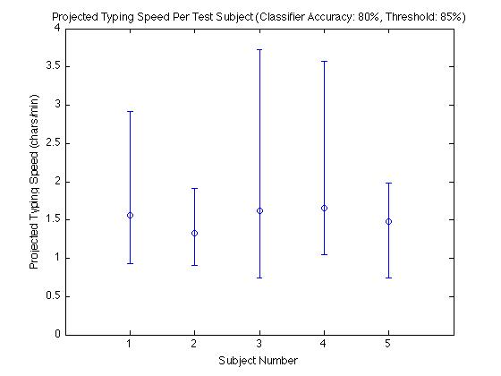
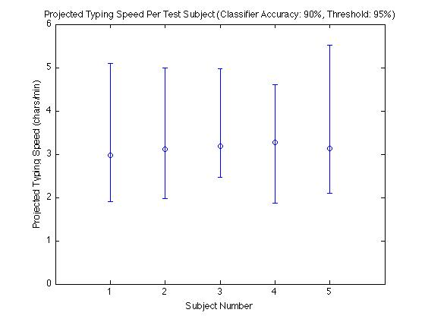
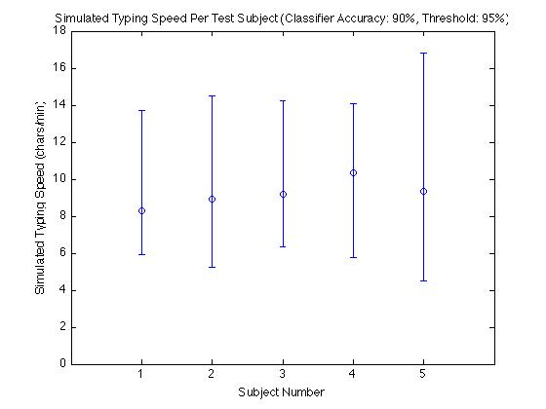
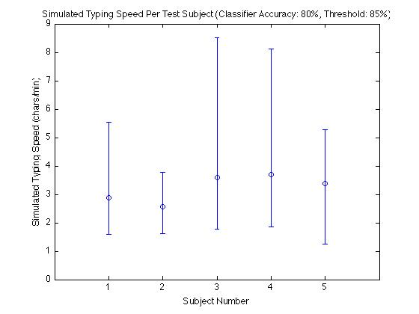

Discussion
reports patients having difficulty using a matrix which included many items, and with the rapid rate of highlighting a 6x6 matrix.
Even with the use of a mouse, controlling a mouse pointer on a screen requires at least one byte of information. The dynamics of a cursor, given a noisy environment, make it difficult to control effectively using a single bit of information.
One of the aims of research into BCI typing designs, is to reduce the cognitive load on the user. Keyboards with static layouts do not incur a penalty on the information transfer rate, in terms of scanning time. They also have the advantage that learning the keyboard takes less time, and thus communication speed increases, as the user becomes more familiar with the layout of the keys.
Although advances in storage have allowed for greater memory capacity on mobile devices, the number of applications available for portable devices has also increased. Thus it is still important to consider code size when writing for portable devices. One way to avoid leaving large footprints is to interpret a scripting language instead of executing compiled object code, which tend to be much larger than the source.

Conclusion
BCI systems promise to deliver applications that will one day allow both patient and non patient populations to bypass conventional motor control pathways enabling direct neural communication with devices.
We borrow from machine learning, information theory, and artificial intelligence, in order to minimize the adverse effects of a noisy channel, thus effectively increasing the useful bandwidth.

del R. Millan and Mourino, “Asynchronous bci and local neural classifiers: an overview of the adaptive brain interface project.”
Blankertz et al., “Advanced Human-Computer Interaction with the Berlin Brain-Computer Interface.”
Guger et al., “Design of an EEG-based Brain-Computer Interface (BCI) from Standard Components running in Real-time under Windows-Entwurf eines EEG-basierten Brain-Computer Interfaces (BCI) mit Standardkomponenten, das unter Windows in Echtzeit arbeitet.”
Kölsch and Turk, “Keyboards without keyboards.”
Rakotomamonjy and Guigue, “BCI competition III.”
Blankertz et al., “Advanced Human-Computer Interaction with the Berlin Brain-Computer Interface.”
Blankertz et al., “The berlin brain-computer interface presents the novel mental typewriter hex-o-spell.”
Blankertz et al., “The berlin brain-computer interface presents the novel mental typewriter hex-o-spell.”Blankertz et al., “The Berlin Brain-Computer Interface.”
Blankertz et al., “The non-invasive Berlin brain–computer interface.”
Blankertz et al., “Advanced Human-Computer Interaction with the Berlin Brain-Computer Interface.”
Rawlinson, “Bigram frequency counts and anagram lists.”
Ibid.
Ibid.
Cormen et al., Introduction to Algorithms, Second Edition.
“Huffman coding - Wikipedia, the free encyclopedia.”
Zweig and Russell, “Speech recognition with dynamic Bayesian networks.”
“Google Trends: Nov 13, 2009.”
Sellers and Donchin, “A P300-based brain–computer interface.”
“download.pdf.”

