Explainable and Leakage-Safe Machine Learning for Diabetes Risk Screening Using CDC BRFSS Health Indicators
Abdullah Mahmood
Student ID: i26043871

Abstract—Diabetes is frequently undiagnosed, and low-cost screening tools that rely only on self-reported information could help identify people who should be referred for laboratory testing. This paper presents an explainable, leakage-safe machine-learning pipeline and web prototype for diabetes risk screening using the CDC Diabetes Health Indicators dataset (BRFSS 2015; 253,680 survey responses, 21 features). Exact duplicate records (9.5%) were removed before a stratified 70/15/15 train/validation/test split; class imbalance was handled with class weights instead of synthetic oversampling; hyperparameters were tuned by five-fold cross-validation on the training set only; and decision thresholds were chosen on the validation set. Logistic Regression, Random Forest and XGBoost were compared once on the untouched test set. XGBoost achieved the best discrimination (ROC-AUC 0.822, PR-AUC 0.454, F1 0.480, recall 0.620), but its advantage over the interpretable Logistic Regression baseline was small (+0.008 ROC-AUC). SHAP analysis identified self-rated general health, number of chronic conditions, age, BMI and high blood pressure as the dominant predictors, and permutation-based feature selection showed that ten features retain almost all predictive performance. Error analysis revealed that most missed cases were younger, non-obese respondents who rated their health as good, and 84% of them were also missed by both other models, indicating a limit set by the information in the data rather than by the algorithm. Our results agree with published studies that evaluate on the original class distribution, whereas much higher published figures coincide with oversampling-based protocols. A Streamlit prototype returns a risk score, a risk band and a per-person explanation.
Index Terms—diabetes screening, machine learning, XGBoost, explainable AI, SHAP, data leakage, class imbalance, BRFSS.
I. Introduction
A. Background
Diabetes mellitus is one of the most widespread chronic diseases and a leading cause of cardiovascular disease, kidney failure, blindness and lower-limb amputation. The U.S. Centers for Disease Control and Prevention (CDC) reports that a substantial proportion of adults living with diabetes have not been diagnosed, and that many more have prediabetes without knowing it [1]. Early detection matters because lifestyle change and treatment can delay or prevent complications. A definitive diagnosis, however, requires a blood test such as HbA1c or fasting plasma glucose, which in turn requires a clinic visit.
Self-reported health questionnaires are cheap, fast and can be completed by millions of people. Population surveillance systems such as the Behavioral Risk Factor Surveillance System (BRFSS) already collect hundreds of thousands of such responses every year [4]. If a machine-learning (ML) model can rank people by diabetes risk using only questionnaire answers, it could act as a first-stage screening tool that tells high-risk people to get a blood test. Because such a tool influences health decisions, it must also be transparent about why it flags a person, and its reported performance must be trustworthy.
B. Problem Statement
Several recent studies have applied ML to the same public benchmark, the CDC Diabetes Health Indicators dataset derived from BRFSS 2015 [2]. Their reported results differ widely: some report ROC-AUC values around 0.83 [6], while others report 0.99 or more [7], [8]. Evaluation protocols—especially whether oversampling was applied before or after the train/test split, and whether duplicate records were handled—are often not fully reported. It is therefore unclear how well survey-only screening really performs, which models are worth their added complexity, and why the models make the predictions they do.
C. Motivation
Inflated performance claims can mislead practitioners into over-trusting a screening tool. Data leakage, in which information from the evaluation data reaches the training process, is a well-known source of such inflation [19]. A transparent, reproducible benchmark that reports honest performance, explains individual predictions and analyses its own errors is therefore more useful in practice than a marginally higher headline accuracy.
D. Aim and Objectives
The aim of this project is to develop and evaluate an explainable, leakage-safe ML pipeline and web prototype that estimates diabetes risk from self-reported health indicators, and to compare it fairly with recent published studies. The objectives are:
O1) Perform exploratory data analysis (EDA) of the 253,680-record dataset, documenting class balance, duplicates and key feature relationships.
O2) Train and tune Logistic Regression, Random Forest and XGBoost on a stratified train/validation/test split, fitting all data-dependent steps on training data only.
O3) Evaluate the models once on the untouched test set using ROC-AUC, PR-AUC, recall, precision, F1 and confusion matrices, and compare them with at least three published studies.
O4) Explain the best model with SHAP, select a reduced feature set, and analyse false negatives, false positives and subgroup performance.
O5) Deliver a reproducible Streamlit prototype that returns a risk score, a risk band and a per-person explanation.
E. Research Questions
RQ1: Which of Logistic Regression, Random Forest and XGBoost gives the best discrimination and minority-class recall under a leakage-safe protocol?
RQ2: How much does an ensemble model improve on an interpretable linear baseline?
RQ3: Which indicators drive the predictions according to SHAP, and do they agree with known clinical risk factors?
RQ4: Which groups and feature patterns account for most misclassifications, and how do the results compare with published studies?
F. Contributions
This work does not propose a new algorithm. Its contributions are: (i) a transparent, leakage-safe and fully reproducible comparison of three models on a widely used benchmark, including duplicate removal before splitting; (ii) SHAP-based global and local explanations combined with a permutation-based feature-selection experiment; (iii) a structured error and subgroup analysis; (iv) a working screening prototype with per-person explanations; and (v) a critical comparison with published results that explains why reported figures differ.
The rest of the paper is organised as follows. Section II reviews related work, Section III describes the dataset and EDA, Section IV the methodology, Section V the system design, Section VI the results, Section VII the discussion, and Section VIII concludes.
II. Literature Review
A. Machine Learning for Diabetes Risk from Survey Data
Xie et al. [5] built type 2 diabetes risk models from the 2014 BRFSS survey (138,146 respondents) using support vector machines, decision trees, logistic regression, random forests, neural networks and Gaussian Naive Bayes. All models achieved ROC-AUC between 0.718 and 0.795, with the neural network performing best, demonstrating that survey answers alone carry useful—but limited—diagnostic signal. Tree ensembles such as Random Forest [15] and gradient boosting, in particular XGBoost [14], have since become standard for tabular health data. For imbalanced outcomes, oversampling methods such as SMOTE [17] are popular, while precision–recall analysis is recommended over accuracy and ROC curves alone [18].
B. Studies Using the CDC Diabetes Health Indicators Dataset
Shechter and Shomron [6] (2026) compared logistic regression, KNN, Random Forest, gradient boosting, CatBoost and XGBoost on the 253,680-record BRFSS 2015 subset, exploring several resampling strategies and 2,240 configurations. CatBoost reached ROC-AUC 0.83 with 0.86 accuracy, XGBoost reached 0.87 accuracy, and a recall-oriented logistic regression achieved 0.97 recall at only 0.43 accuracy, illustrating the precision–recall trade-off. They used SHAP and stressed that the self-reported labels lack biochemical confirmation.
Majcherek et al. [7] (2025) evaluated eighteen ML models on the same 253,680 respondents and compared three oversampling techniques (SMOTE, ADASYN and random oversampling). The Extra Trees classifier achieved accuracy above 90% and ROC-AUC of 0.99, and SHAP highlighted BMI, age, general health, income, physical health and education. Islam et al. [8] (2025) combined LASSO, recursive feature elimination and mutual information for feature selection, applied SMOTE with Tomek links, and reported a stacking ensemble (XGBoost and KNN with a LightGBM meta-learner) with accuracy 0.948, F1 0.949 and ROC-AUC 0.990, whereas their plain logistic regression reached ROC-AUC 0.814. The paper does not state whether resampling was applied before or after the 80/20 split, and the reported confusion-matrix total (77,724 records) does not match a 20% split of the original 253,680 rows.
Aich et al. [9] (2025) proposed CopulaSMOTE, a copula-based oversampler, and evaluated it with a 5×2 cross-validation protocol in which oversampling is applied only to the training half of each fold. They found improvements mainly in F1 and minority-class recall, with ROC-AUC depending on the classifier. Allani [10] (2025) built an interactive Dash application combining SHAP, LIME [24] and comorbidity analysis and found that LightGBM with undersampling gave the best recall, while Horestani and Owrang [11] (2024) analysed the role of income and health factors on the same survey.
C. Explainability in Diabetes Prediction
SHAP [12] attributes each prediction to its input features using Shapley values, and TreeExplainer [13] computes exact SHAP values for tree ensembles efficiently. Several of the above studies report global SHAP rankings [6], [7], [10], consistently placing general health, BMI, age and blood pressure near the top. Fewer studies analyse individual errors, report subgroup performance, or deliver explanations inside a usable prototype.
D. Research Gap
Three gaps emerge. First, published performance on this dataset ranges from about 0.83 to 0.99 ROC-AUC, and the higher values coincide with oversampling-based protocols whose timing relative to the split is not always reported, which leaves room for leakage [19]. Second, the dataset contains many exact duplicates, which can place identical records in both training and test sets, yet duplicate handling is rarely discussed. Third, error analysis, subgroup (fairness) reporting and practical explanation interfaces are limited. This work addresses these gaps with a deliberately transparent protocol rather than a more complex model.

TABLE I
Summary of Related Studies
Study | Data | Approach | Best reported result | Note
Xie et al. [5], 2019 | BRFSS 2014 (138,146) | SVM, DT, LR, RF, NN, NB | ROC-AUC 0.718–0.795 | Different survey year; background study
Shechter & Shomron [6], 2026 | BRFSS 2015 (253,680) | LR, KNN, RF, GB, CatBoost, XGBoost + SHAP | CatBoost ROC-AUC 0.83, Acc 0.86 | Imbalanced evaluation; self-report caveat
Majcherek et al. [7], 2025 | BRFSS 2015 (253,680) | 18 models, SMOTE/ADASYN/ROS + SHAP | Extra Trees Acc >0.90, ROC-AUC 0.99 | Oversampling-based protocol
Islam et al. [8], 2025 | BRFSS 2015 | Feature selection + SMOTE-Tomek + stacking | Acc 0.948, F1 0.949, ROC-AUC 0.990 | Resampling timing not stated
Aich et al. [9], 2025 | BRFSS 2015 (253,680) | CopulaSMOTE, 5×2 CV | Gains in F1 and minority recall | Oversampling on training folds only
Allani [10], 2025 | BRFSS 2015 | LR, RF, XGB, LGBM, KNN, NN; SHAP + LIME; Dash app | Best recall: LightGBM + undersampling | Interactive prototype
Acc = accuracy; ROS = random oversampling; CV = cross-validation.

III. Dataset and Exploratory Analysis
A. Dataset
The CDC Diabetes Health Indicators dataset [2] is a cleaned subset of the 2015 BRFSS telephone survey [3], [4], published on the UCI Machine Learning Repository (dataset 891, DOI 10.24432/C53919). It contains 253,680 responses and 21 integer-coded features covering medical history, lifestyle, general and mental health, access to healthcare and demographics (Table II). The target, Diabetes_binary, is documented as 0 = no diabetes and 1 = prediabetes or diabetes. The dataset was downloaded programmatically with the ucimlrepo package, which makes the data source reproducible. The patient identifier column was dropped because it carries no health information.
TABLE II
Dataset Summary
Property | Value
Records / features | 253,680 / 21
Target | Diabetes_binary (0/1)
Class 0 / class 1 | 218,334 (86.1%) / 35,346 (13.9%)
Missing values | 0
Exact duplicate rows | 24,206 (9.5%)
Binary features (14) | HighBP, HighChol, CholCheck, Smoker, Stroke, HeartDiseaseorAttack, PhysActivity, Fruits, Veggies, HvyAlcoholConsump, AnyHealthcare, NoDocbcCost, DiffWalk, Sex
Ordinal / count features (7) | BMI (12–98), GenHlth (1–5), MentHlth (0–30), PhysHlth (0–30), Age (13 groups), Education (1–6), Income (1–8)
Sensitive attributes | Sex, Age, Income, Education

B. Data Quality
The dataset contains no missing values, and every feature lies within its documented range (for example BMI 12–98, GenHlth 1–5, Age groups 1–13). There are 24,206 exact duplicate rows (9.5%). Because most features are binary or bucketed, different people can give identical answers; however, if identical rows appear in both training and test data, the model is partly tested on records it has already seen. Notably, 98.7% of duplicated rows belong to class 0, so removing them also changes the class balance. The positive class contains exactly 35,346 records. Although UCI documents label 1 as "prediabetes or diabetes", this count is consistent with diabetes-only coding in the three-class version of the data, so the exact handling of prediabetes should be treated with care.
C. EDA Findings
Fig. 2 shows the strong class imbalance: a trivial model that always predicts "no diabetes" would already reach 86.1% accuracy. Fig. 3 shows clear risk gradients. The diabetes rate rises from about 2.5% among respondents reporting excellent health to about 38% among those reporting poor health, increases with age up to about 22% in the 70–74 group, and is about four times higher with high blood pressure (≈24% vs ≈6%). The median BMI is 31 for respondents with diabetes and 27 for those without.
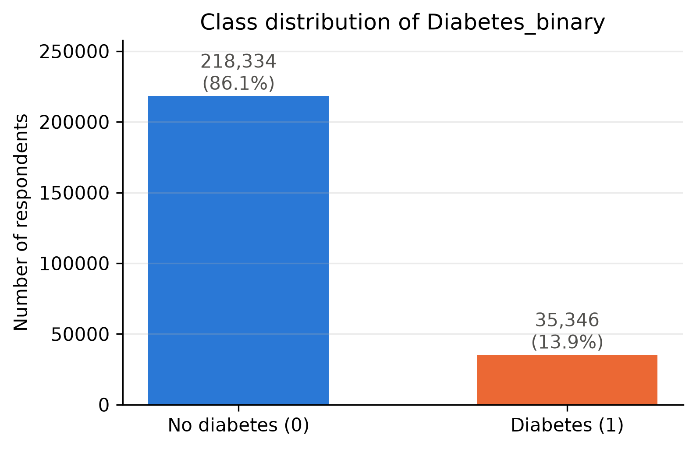
Fig. 2. Class distribution of the target variable (full dataset, before deduplication).
Because most features are binary or ordinal, Spearman rank correlation was used (Fig. 4). The features most correlated with the target are GenHlth (0.29), HighBP (0.26), BMI (0.23), DiffWalk (0.22), HighChol (0.20) and Age (0.18), while Income (−0.16) and Education (−0.12) are negatively correlated, revealing a socio-economic gradient. GenHlth, PhysHlth and DiffWalk are moderately inter-correlated (0.42–0.45), which is relevant when interpreting SHAP values later. No single feature is strongly correlated with the target, which suggests that the achievable performance from survey data alone is limited.
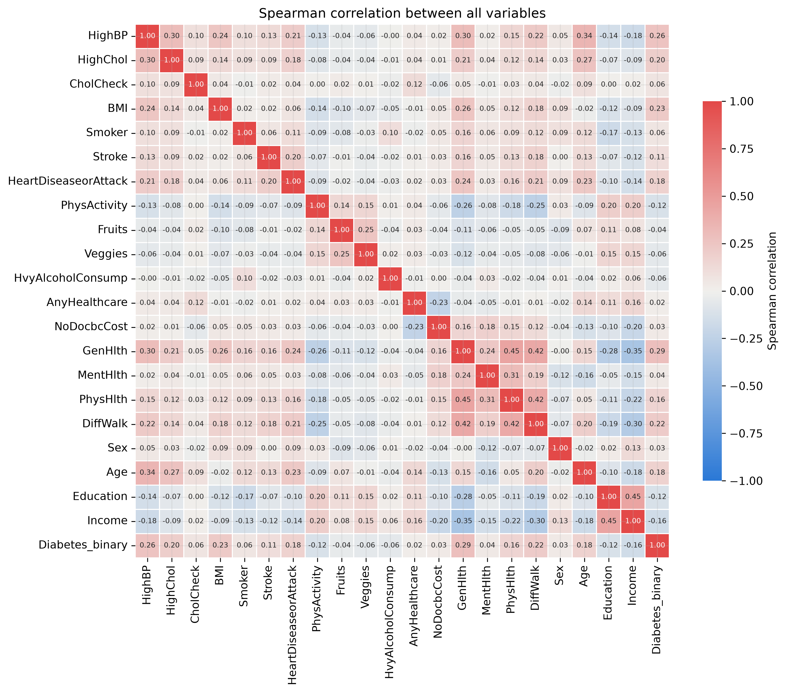
Fig. 4. Spearman correlation between all variables.
Fig. 5 shows the socio-economic gradient more directly. The diabetes rate falls steadily as household income rises, from roughly one in four respondents in the lowest income band to about one in ten in the highest, and it is also lower among college graduates than among respondents without a high-school diploma. These patterns reflect well-documented social determinants of health, but they also mean that income and education act partly as proxies for access to care and for diagnosis. They were therefore examined again in the subgroup analysis of Section VI.
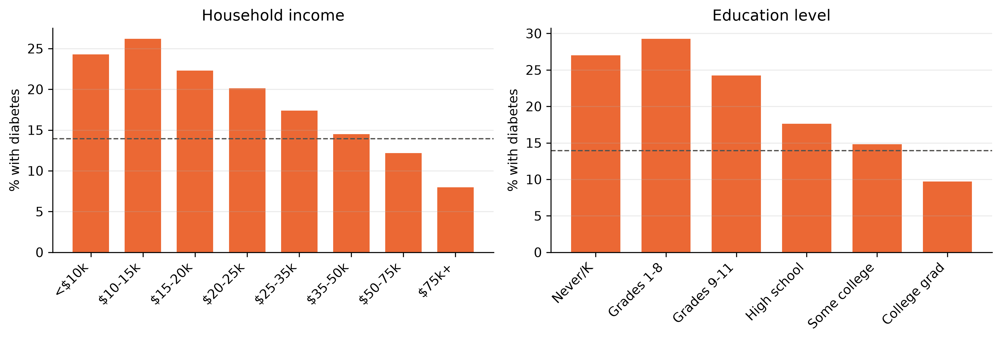
Fig. 5. Percentage of respondents with diabetes by household income and education level.
In summary, the EDA showed (i) strong class imbalance, so accuracy is an unsuitable primary metric; (ii) a non-trivial number of exact duplicates that must be removed before splitting; (iii) monotonic risk gradients for general health, age, BMI and blood pressure; and (iv) only weak-to-moderate individual correlations with the target, which suggests that the achievable performance from survey data alone is bounded.

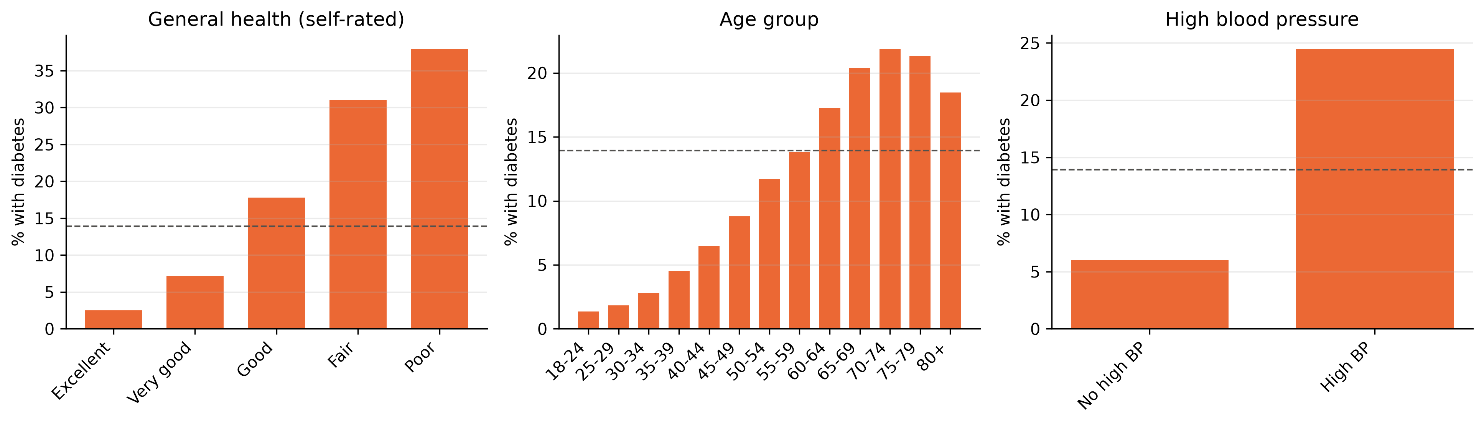
Fig. 3. Percentage of respondents with diabetes by self-rated general health, age group and high blood pressure. The dashed line marks the overall rate (13.9%).

IV. Methodology
A. Pipeline Overview
The workflow (Fig. 1) consists of data loading and quality checks, EDA, deduplication and feature engineering, a stratified split, model training and tuning on the training set, threshold selection on the validation set, a single evaluation on the test set, explanation with SHAP, and deployment of the saved pipeline in a web prototype. Each step is implemented as a separate Python script, and a fixed random seed (42) is used throughout.
B. Preprocessing and Feature Engineering
Exact duplicates were removed first, reducing the data to 229,474 rows and raising the positive share from 13.93% to 15.29%. No encoding was required because all features are already numeric; ordinal features (GenHlth, Age, Education, Income) were kept as ordered integers, which tree models and a linear model can both use. Extreme BMI values were retained because they correspond to real people (only 0.32% of rows exceed 60). Two clinically motivated features were added: BMICategory, the World Health Organization BMI band (underweight, normal, overweight, obese), and ComorbidityCount, the number of reported chronic conditions among high blood pressure, high cholesterol, stroke and heart disease. Both are computed from each person's own answers, so they cannot leak information between rows.
C. Data Splitting and Leakage Prevention
The deduplicated data were split into 70% training (160,631 rows), 15% validation (34,421) and 15% test (34,422) sets using stratified sampling, so each part contains 15.3% positives. An automatic check confirmed that no identical row appears in two splits. All data-dependent operations were confined to the appropriate partition: feature scaling sits inside an scikit-learn Pipeline and is therefore refitted on the training folds during cross-validation; hyperparameters were tuned on the training set only; thresholds were chosen on the validation set; and the test set was used exactly once for the final results.
D. Machine Learning Models
Three models representing different levels of complexity were selected. Logistic Regression (with standardisation) is the interpretable baseline whose coefficients show the direction of each effect. Random Forest [15] averages many decorrelated decision trees (bagging) and captures non-linear interactions. XGBoost [14] builds trees sequentially, each correcting the errors of the previous ones (gradient boosting), and is typically the strongest model on tabular data. A majority-class dummy classifier was added as a reference. Deep learning was not used: on 21 mostly binary tabular features, tree ensembles usually match or outperform neural networks while being cheaper to train and easier to explain.
In more detail, Logistic Regression models the log-odds of diabetes as a weighted sum of the standardised features; L2 regularisation, controlled by the inverse strength C, shrinks the weights to reduce overfitting. Random Forest trains each tree on a bootstrap sample of the rows and considers only a random subset of features at each split, so the trees make different errors that partly cancel out when their votes are averaged. XGBoost adds shallow trees one at a time, each fitted to the gradient of the loss of the current ensemble, with a learning rate that scales down each tree's contribution and with row and column subsampling for regularisation. The three models therefore span a spectrum from a fully transparent linear model, through an averaging ensemble, to a sequential boosting ensemble, which allows the benefit of added complexity to be measured directly.
E. Class Imbalance and Hyperparameter Tuning
Class imbalance was handled by class weighting rather than synthetic oversampling: class_weight="balanced" for Logistic Regression and Random Forest, and scale_pos_weight = 5.54 (the negative-to-positive ratio of the training set) for XGBoost. Class weights create no artificial records, so synthetic samples cannot leak into evaluation data. Hyperparameters were tuned with randomised search and stratified five-fold cross-validation on the training set, optimising ROC-AUC (6, 8 and 20 sampled configurations for the three models, respectively). The search spaces and selected values are listed in Table III.
TABLE III
Hyperparameter Search and Selected Values
Model | Search space | Selected
Logistic Regression | C ∈ log-uniform[0.001, 10] | C = 0.0042
Random Forest | trees 150–350; max depth 8–20; min leaf 5–50; max features {sqrt, 0.5} | 224 trees, depth 17, min leaf 27, sqrt
XGBoost | trees 200–600; depth 3–7; learning rate log-uniform[0.02, 0.2]; subsample 0.7–1.0; column sample 0.6–1.0; min child weight 1–10 | 240 trees, depth 4, lr 0.081, subsample 0.97, colsample 0.92, min child weight 7

F. Threshold Selection
Class weighting shifts predicted scores upwards, so the default threshold of 0.5 is not appropriate. For each model, the threshold that maximises F1 on the validation set was selected: 0.62 for Logistic Regression, 0.60 for Random Forest and 0.64 for XGBoost. These thresholds were then fixed before the test set was used.
G. Evaluation Metrics
Because only about 15% of records are positive, accuracy alone is misleading. The primary metrics are ROC-AUC (threshold-independent ranking quality), PR-AUC (average precision, whose random baseline equals the prevalence of 0.153 [18]), recall (the share of people with diabetes who are flagged, the most important metric for screening) and F1. Precision, specificity, accuracy and confusion matrices are reported as secondary measures, where precision = TP/(TP+FP), recall = TP/(TP+FN) and specificity = TN/(TN+FP).
H. Explainability
SHAP values [12] were computed for XGBoost with TreeExplainer [13] on a random sample of 3,000 test records. Global importance was summarised by the mean absolute SHAP value and a beeswarm plot, and local explanations were produced as waterfall plots for a true positive, the most confidently missed positive and the most confident false positive. SHAP values are expressed in log-odds and add up exactly to the model output.
I. Feature Selection
To test whether a shorter questionnaire would suffice, features were ranked by permutation importance [15] (the drop in ROC-AUC when a feature is shuffled), averaged over five folds of the training set. XGBoost, with its tuned hyperparameters, was retrained on the top-k features for k ∈ {3, 5, 8, 10, 12, 15, 18, 23}; the smallest k whose validation ROC-AUC was within 0.002 of the full model was selected and then checked once on the test set.
J. Error Analysis
Test predictions were grouped into true/false positives and negatives. The analysis compares the feature profiles of missed and detected diabetics, reports recall and false-positive rate by sex, age, income and education, measures error rates for predictions close to the threshold (within ±0.10), and checks how many missed cases are missed by all three models.

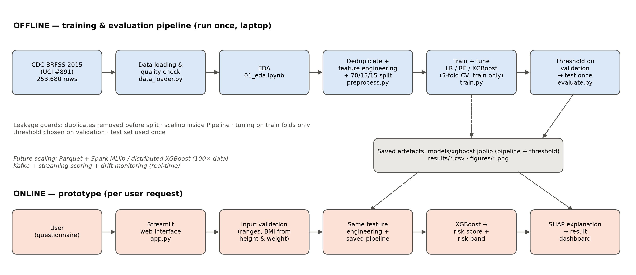
Fig. 1. System architecture. The offline pipeline produces a saved model and threshold that the online prototype reuses, so training and serving apply identical preprocessing.

V. System Design and Implementation
A. Architecture
Fig. 1 shows the complete workflow. The offline part runs once on a laptop and produces a saved scikit-learn pipeline (models/xgboost.joblib) together with its validation-chosen threshold, result tables and figures. The online part is the prototype: a user fills in a questionnaire, the inputs are validated and converted to the dataset's codes, the same feature-engineering function and saved pipeline produce a risk score, the score is mapped to a risk band, and SHAP explains the result. Reusing the exact training code at prediction time prevents training–serving mismatch.
B. Technologies
The system is implemented in Python 3.14 with pandas for data handling, scikit-learn 1.9.1 [16] for pipelines, Logistic Regression, Random Forest, cross-validation and metrics, XGBoost 3.4.1 [14], SHAP 0.54.1 [12], matplotlib and seaborn for figures, and Streamlit 1.66.1 for the web interface. All library versions are pinned in requirements.txt.
C. Code Structure and Reproducibility
The code is organised as eight numbered scripts (data loading, preprocessing, training, evaluation, explanation, feature selection, scalability benchmark and architecture diagram) plus two notebooks for EDA and error analysis. A single command (python src/run_pipeline.py) reproduces all results in about 15–20 minutes, and all randomness is controlled by one seed. The code package includes a README with setup instructions and a plain-language code guide.
D. Web Prototype
The Streamlit prototype (Figs. 6 and 7) asks the 21 survey questions in plain language, computes BMI from height and weight, and rejects inputs outside the BMI range seen in training (12–98). It displays the risk score, the decision threshold and one of three bands: high risk (score ≥ threshold + 0.10), low risk (score ≤ threshold − 0.10) or borderline/uncertain. The borderline band exists because the error analysis showed that predictions close to the threshold are wrong almost half of the time. The result page lists the answers that raised and lowered the score most and shows a SHAP waterfall plot. A clear disclaimer states that the tool is not a diagnosis, and no user data are stored. A second page shows the model's test performance.
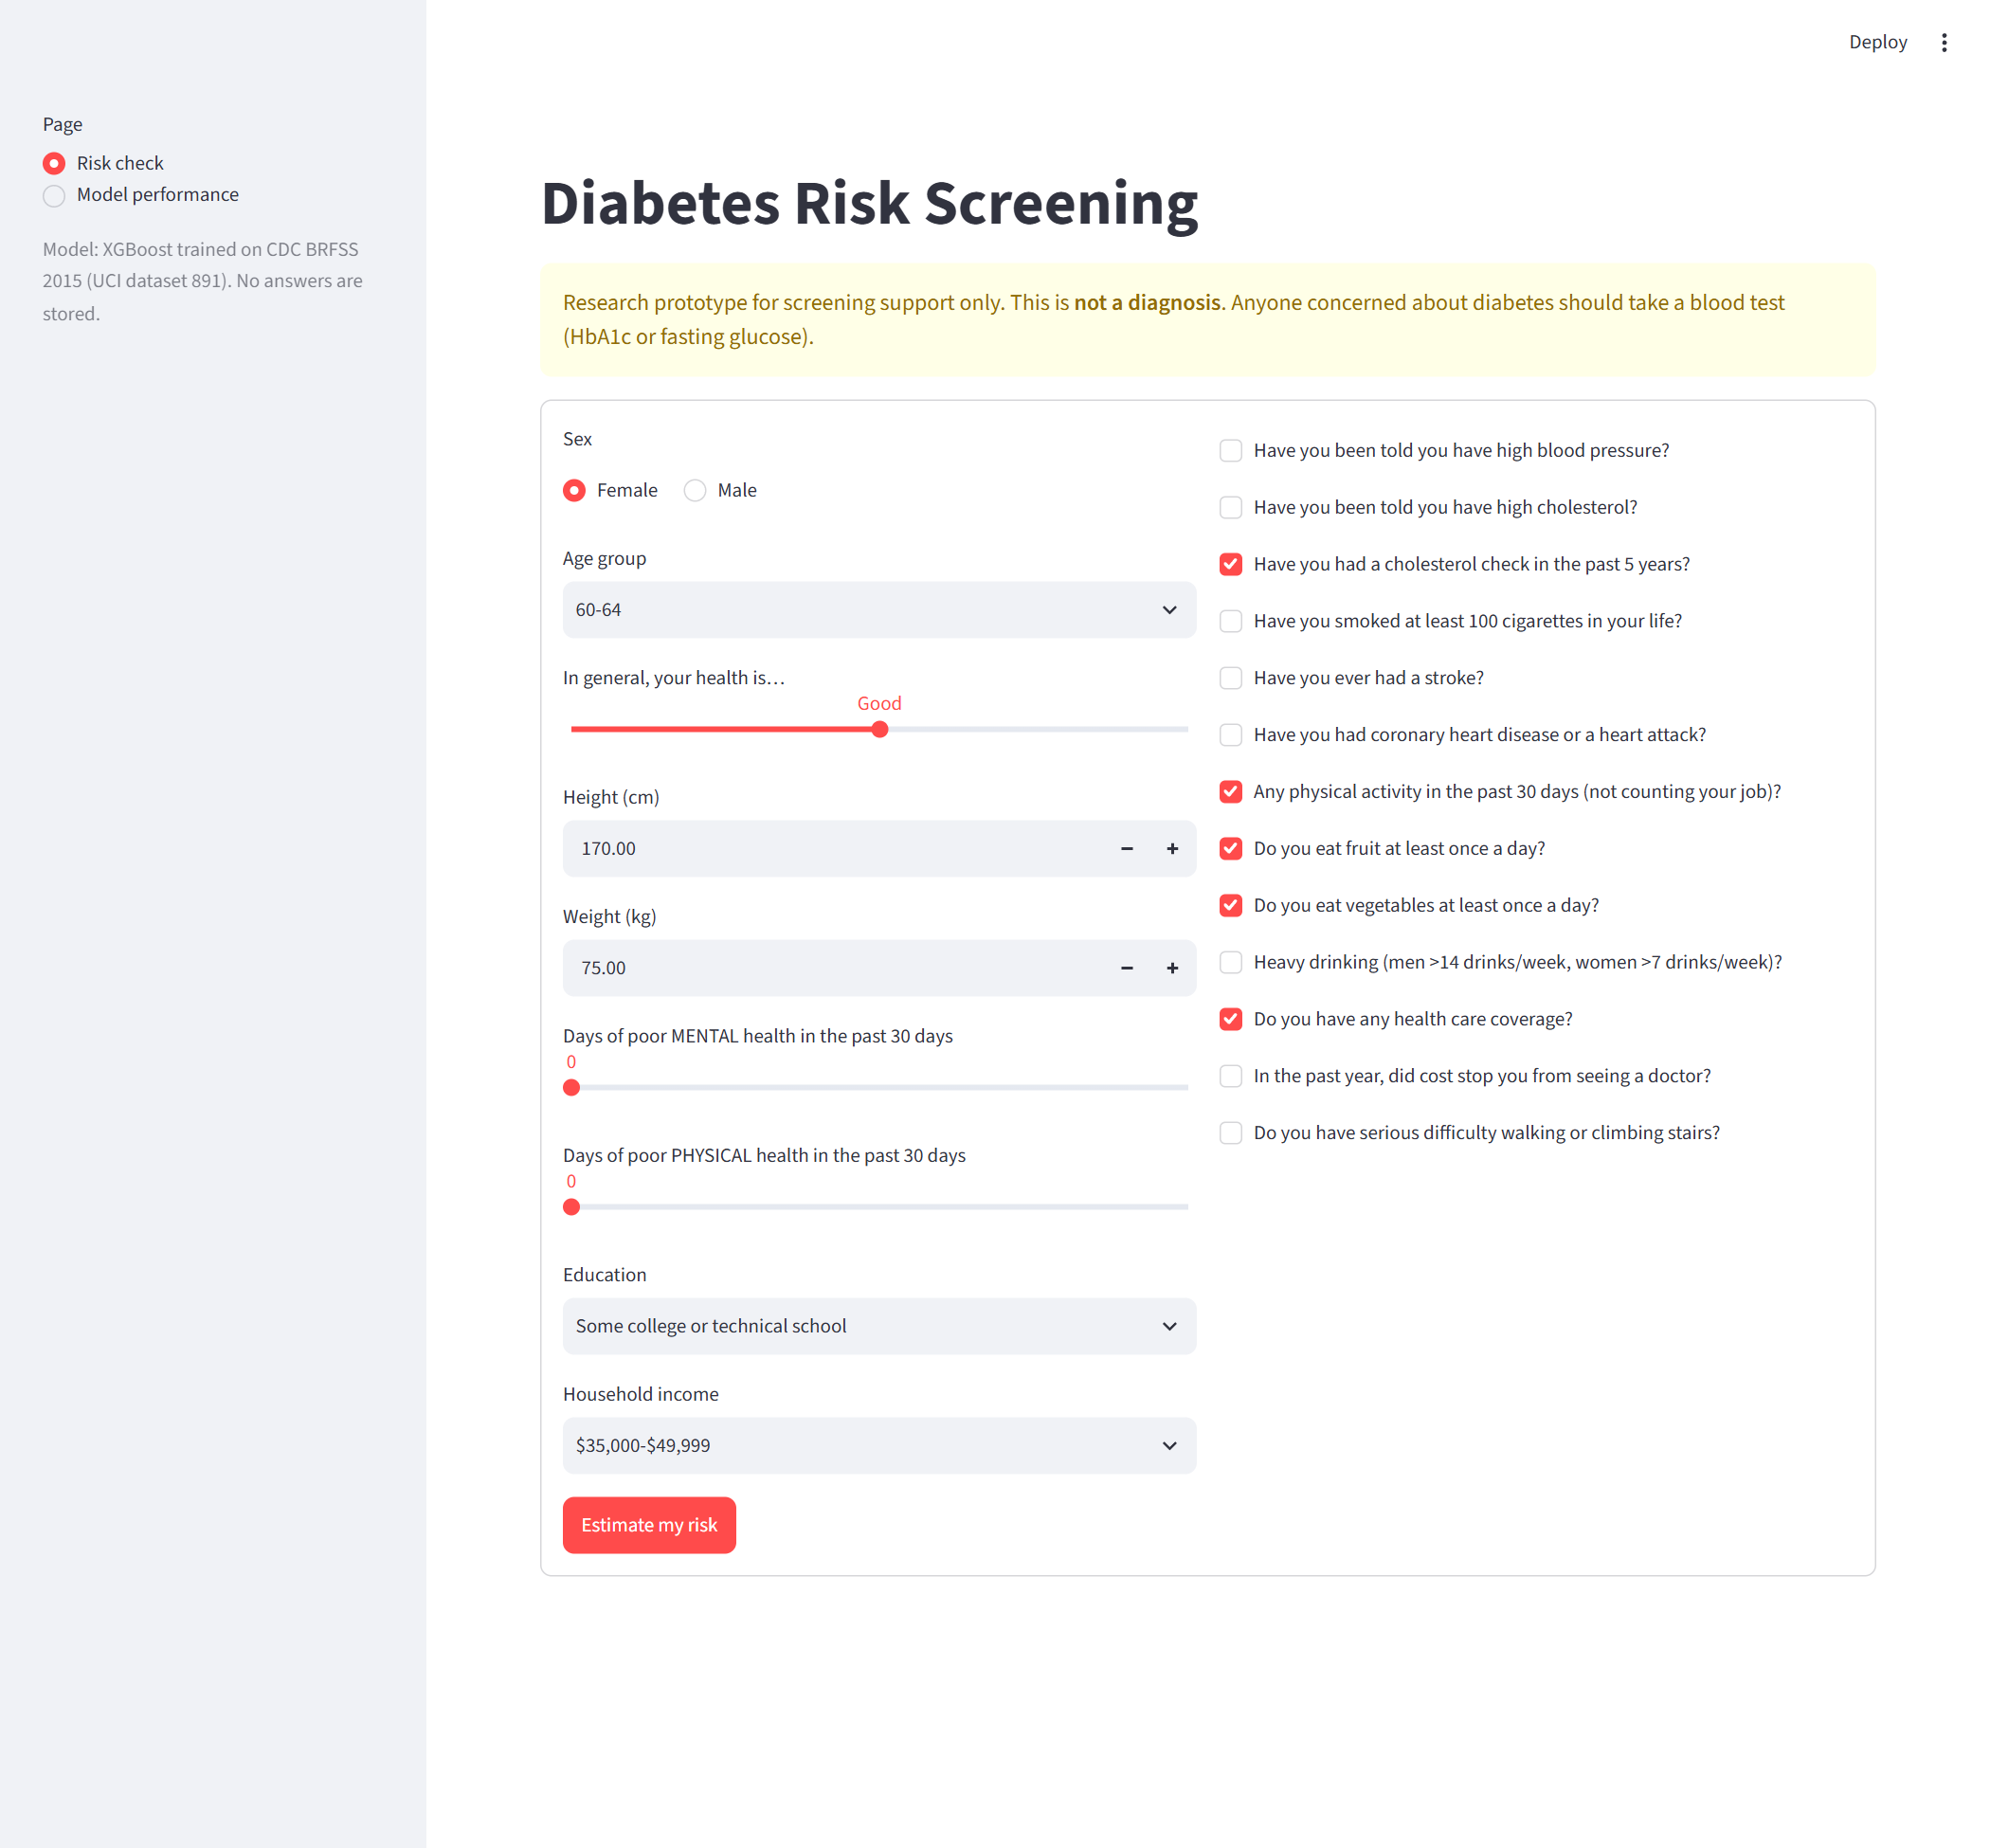
Fig. 6. Prototype questionnaire page (Streamlit).
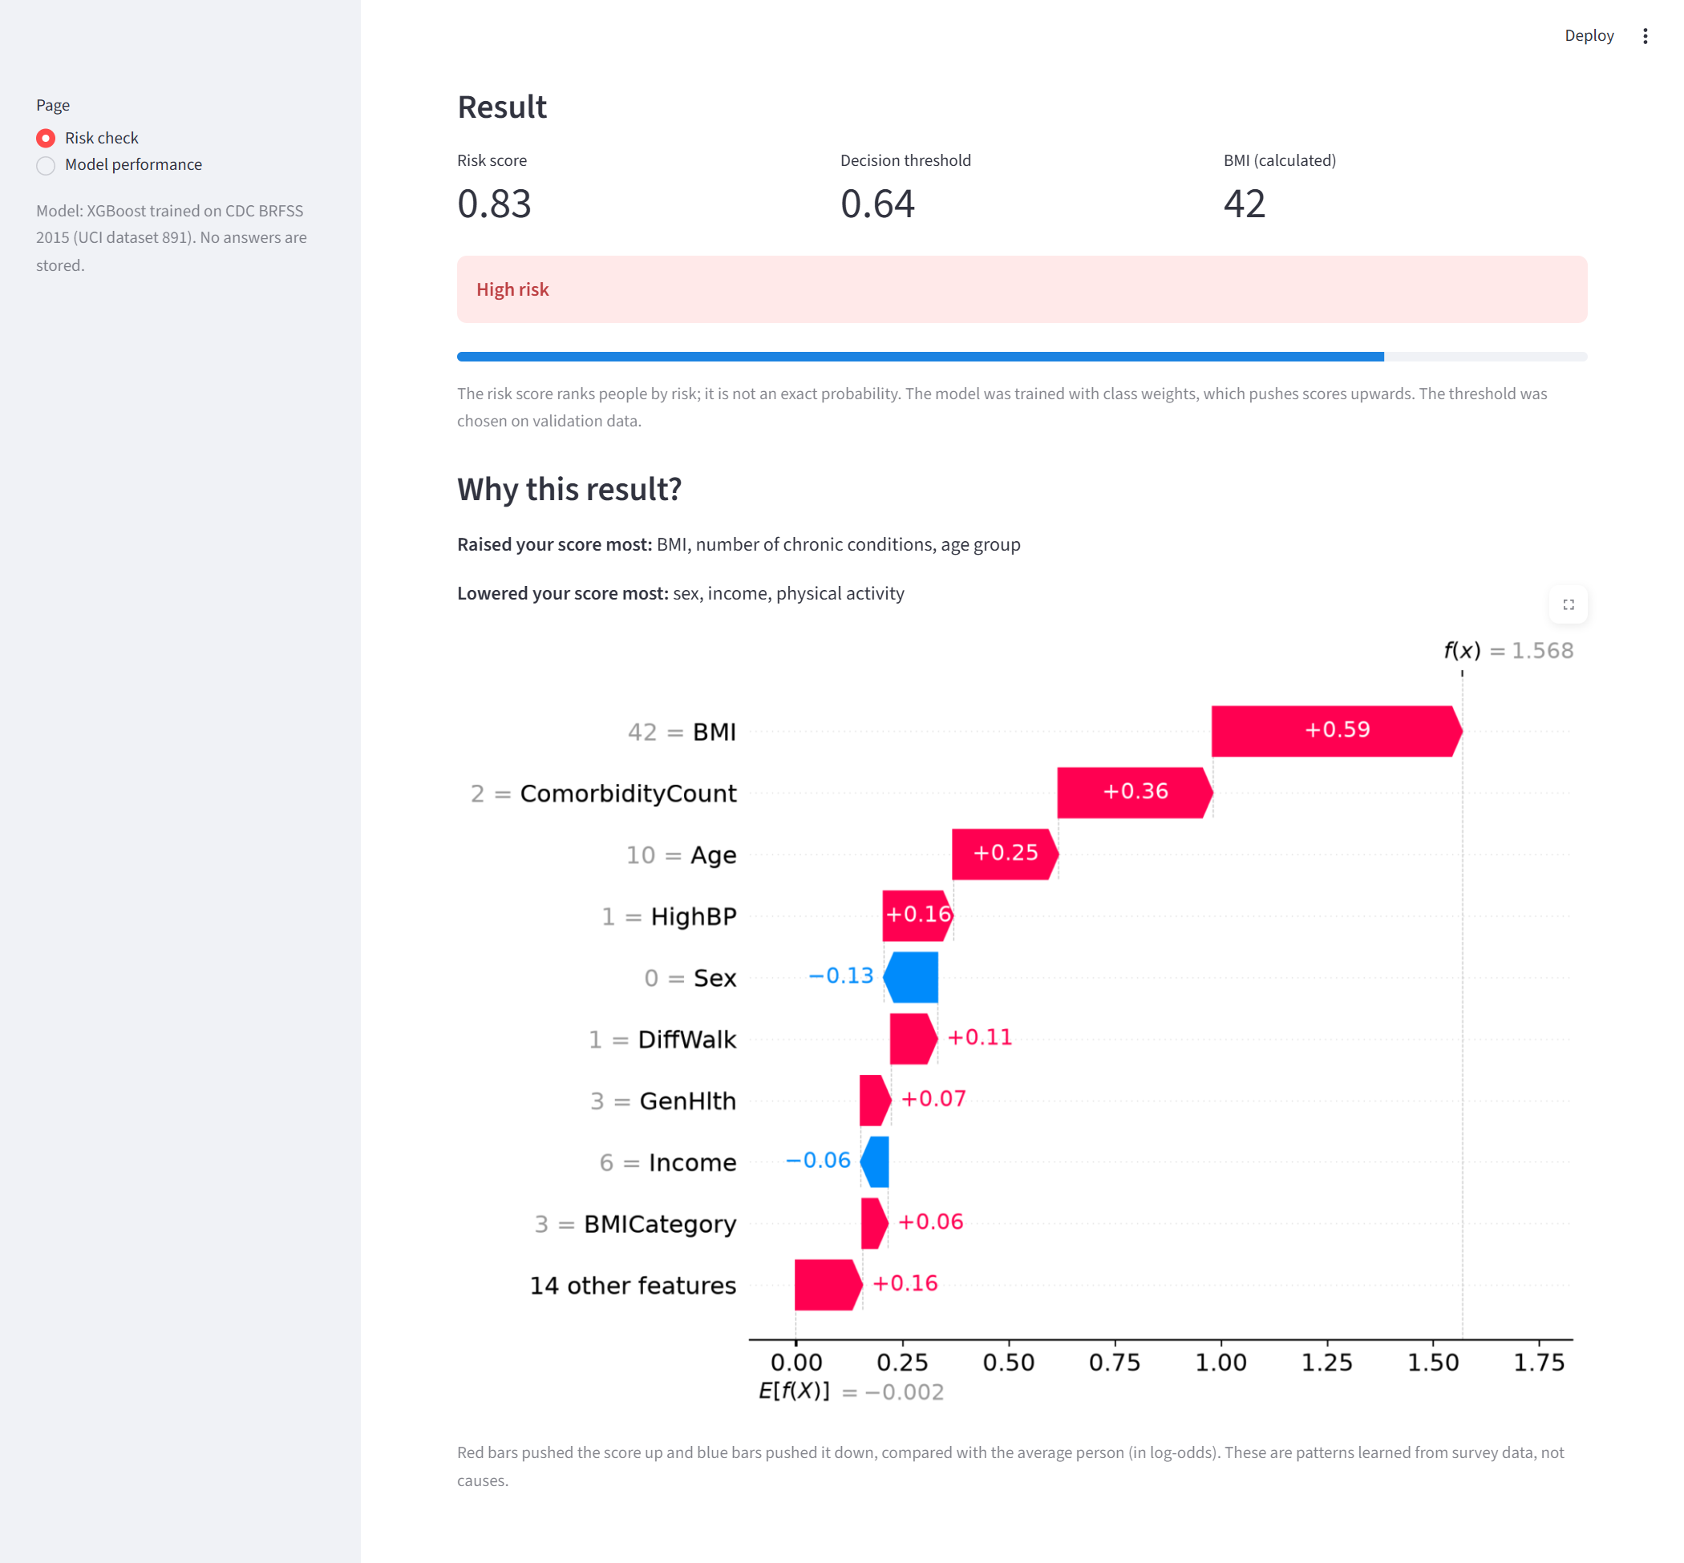
Fig. 7. Prototype result for an example high-risk profile: risk score 0.83 (threshold 0.64), high-risk band, and a SHAP explanation of the answers that raised or lowered the score.
VI. Results
A. Model Selection on Training and Validation Data
Table IV summarises the results used for model selection, before the test set was opened. All three models have small cross-validation standard deviations (≤ 0.003), so the ranking is stable across folds. XGBoost achieved the highest cross-validation and validation ROC-AUC and PR-AUC and was therefore chosen as the model to explain and deploy. It also trains about six times faster than Random Forest, and its saved model is far smaller (about 0.4 MB against 64 MB), which matters for deployment.
TABLE IV
Cross-Validation and Validation Results Used for Model Selection
Model | CV ROC-AUC | Val ROC-AUC | Val PR-AUC | Threshold | Fit time
Logistic Regression | 0.807 ± 0.003 | 0.811 | 0.414 | 0.62 | 0.3 s
Random Forest | 0.811 ± 0.003 | 0.815 | 0.430 | 0.60 | 10.1 s
XGBoost | 0.815 ± 0.003 | 0.817 | 0.436 | 0.64 | 1.7 s
CV = five-fold cross-validation on the training set; Val = validation set; fit time = time to train the final model once on the full training set.
B. Model Performance on the Test Set
Table V reports the final test-set results. All three models clearly outperform the dummy reference on every metric except accuracy and specificity: the dummy has the highest accuracy (0.847) because it predicts "no diabetes" for everyone, yet it detects no diabetic at all. XGBoost achieved the best ROC-AUC (0.822), PR-AUC (0.454) and F1 (0.480), followed closely by Random Forest and Logistic Regression. Recall was similar across models (0.617–0.625), meaning roughly 62% of people with diabetes were flagged.
TABLE V
Test-Set Performance (34,422 records, 15.3% positive)
Model | Acc | Prec | Rec | Spec | F1 | ROC-AUC | PR-AUC
Dummy (majority) | 0.847 | 0.000 | 0.000 | 1.000 | 0.000 | 0.500 | 0.153
Logistic Regression | 0.786 | 0.378 | 0.617 | 0.817 | 0.469 | 0.814 | 0.427
Random Forest | 0.790 | 0.385 | 0.625 | 0.819 | 0.476 | 0.819 | 0.447
XGBoost | 0.794 | 0.391 | 0.620 | 0.826 | 0.480 | 0.822 | 0.454
Thresholds chosen on validation: LR 0.62, RF 0.60, XGBoost 0.64. Five-fold CV ROC-AUC on training data: 0.807 ± 0.003, 0.811 ± 0.003 and 0.815 ± 0.003.
Cross-validation, validation and test scores agree closely (for XGBoost: 0.815, 0.817 and 0.822 ROC-AUC), indicating no overfitting. The ROC and precision–recall curves (Figs. 8 and 9) show that the three models rank people almost identically over most of the operating range; XGBoost and Random Forest are better mainly in the high-precision region at low recall. The confusion matrices (Fig. 10) show that XGBoost produced 3,266 true positives, 1,999 false negatives and 5,086 false positives, i.e. a precision of about 0.39: roughly two in five flagged people have diabetes, which is acceptable for a screening step whose follow-up is an inexpensive blood test.
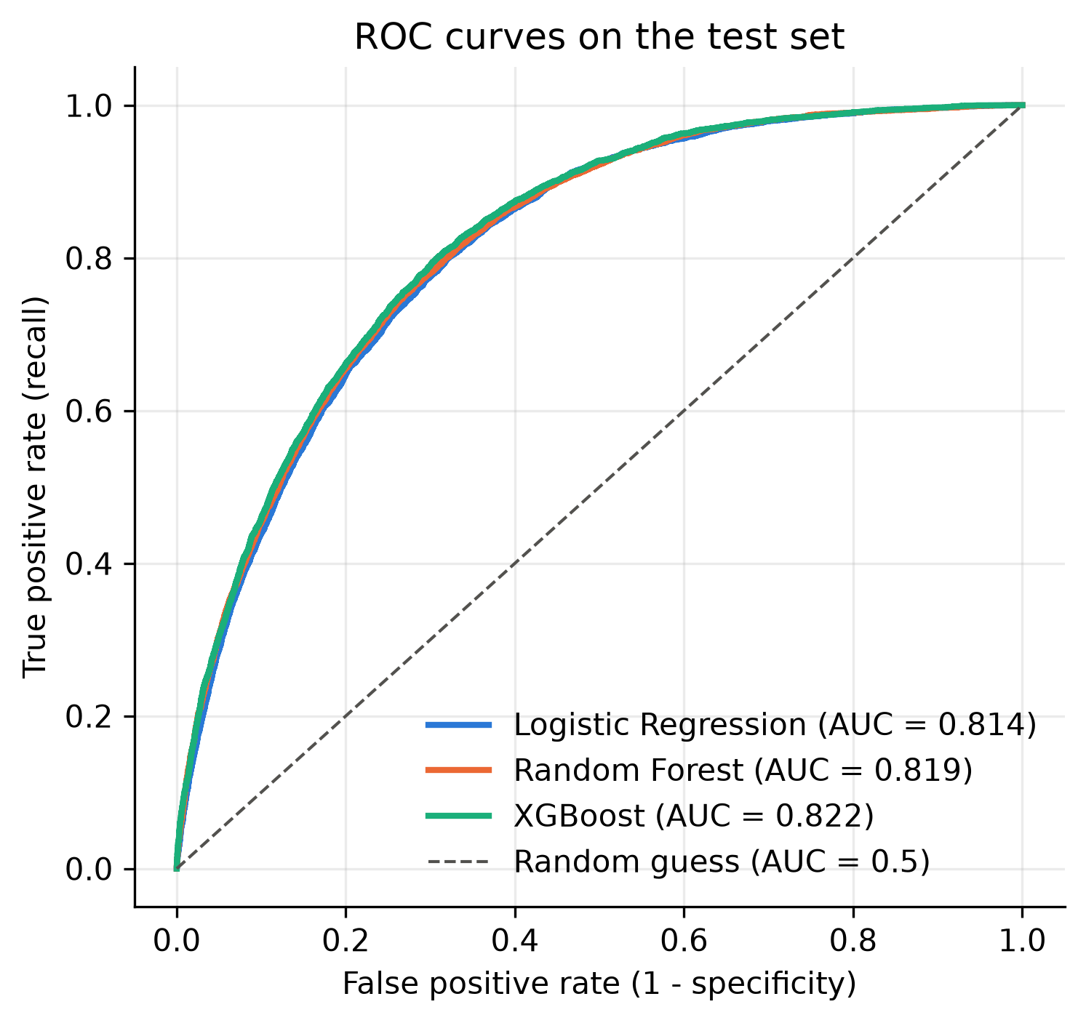
Fig. 8. ROC curves on the test set.
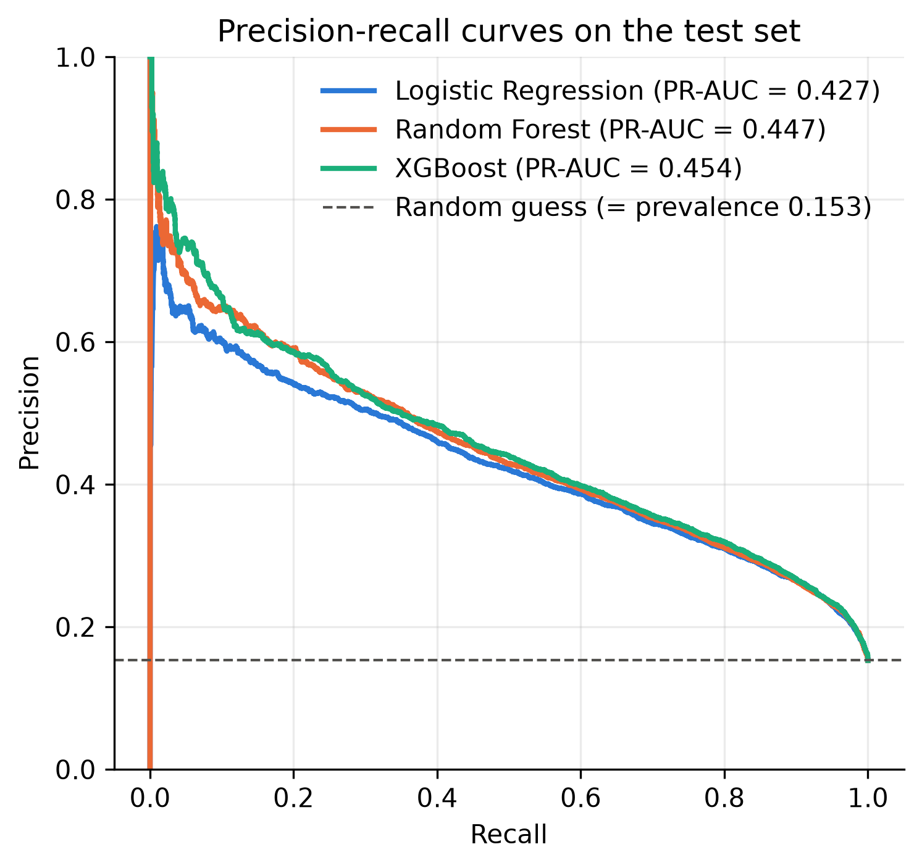
Fig. 9. Precision–recall curves on the test set. The dashed line is the random baseline (prevalence 0.153).

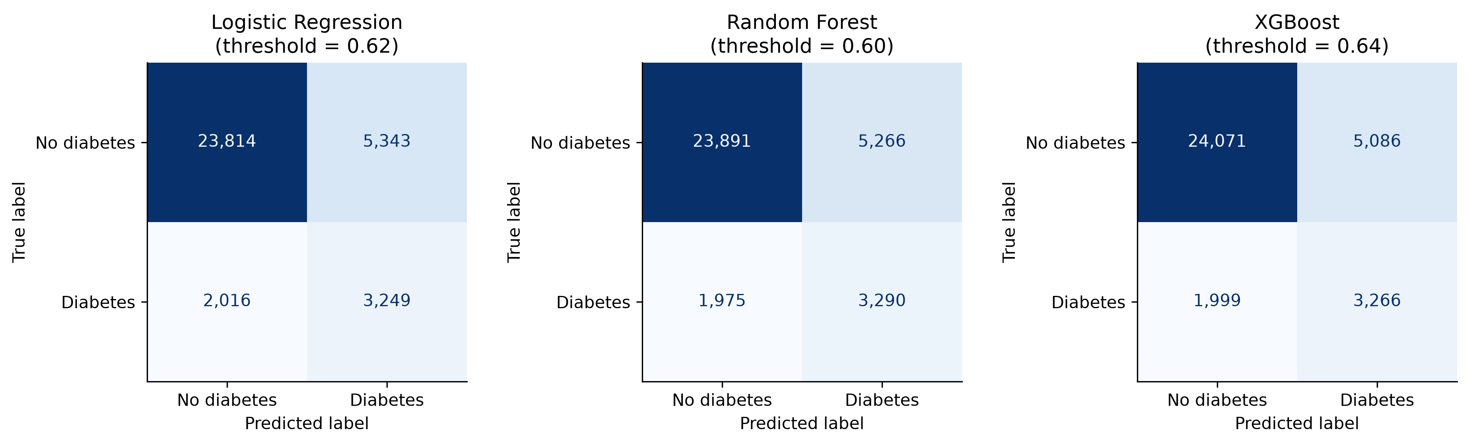
Fig. 10. Test-set confusion matrices at the validation-chosen thresholds.

C. Explainability
Figs. 11 and 12 summarise the SHAP values of XGBoost. The five most influential features are self-rated general health (mean |SHAP| 0.54), ComorbidityCount (0.41), age (0.39), BMI (0.35) and high blood pressure (0.22), which agree with established clinical risk factors and with the EDA. Higher values of these features consistently push risk upwards. Two less intuitive patterns appear: not having had a cholesterol check in five years strongly lowers predicted risk, and heavy alcohol consumption also lowers it. The first plausibly reflects diagnosis bias (people outside the healthcare system are less often diagnosed), and the second plausibly reflects reverse causation (people diagnosed with diabetes are advised to stop drinking). Both illustrate that SHAP explains the model's learned associations, not causal effects. The engineered ComorbidityCount absorbed much of the credit of its components (high cholesterol, stroke and heart disease rank low individually), a known effect of correlated features on SHAP attributions.
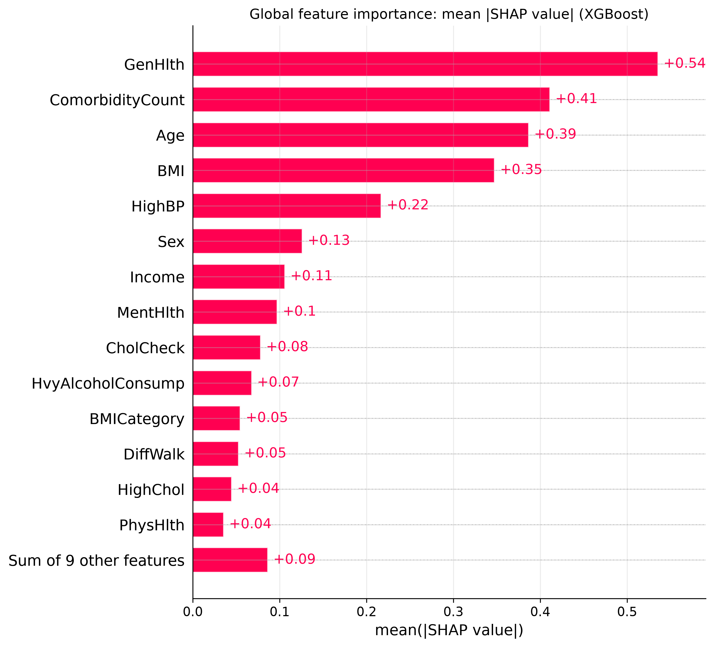
Fig. 11. Global feature importance of XGBoost: mean absolute SHAP value per feature.
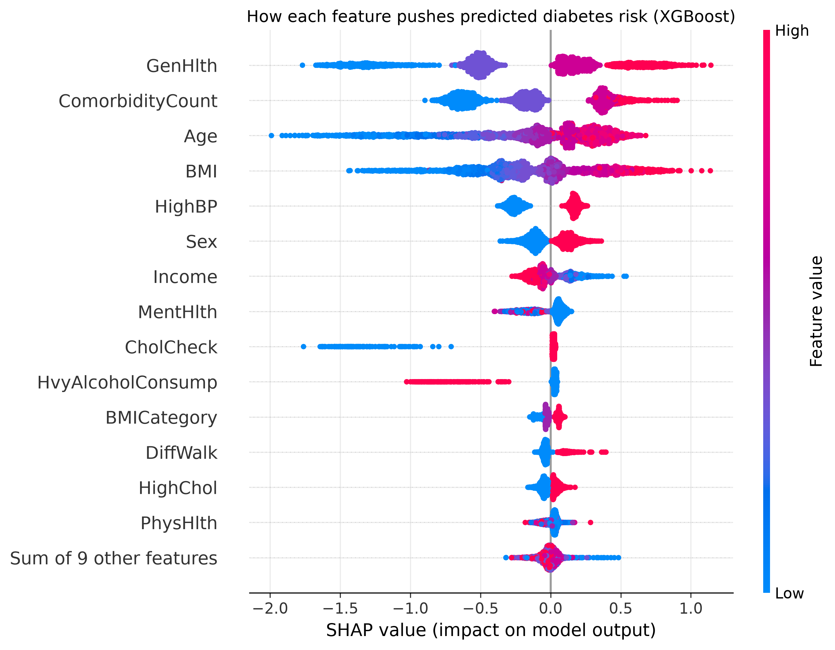
Fig. 12. SHAP beeswarm plot for XGBoost (3,000 test records). Each dot is one person; colour shows the feature value and position shows its effect on predicted risk.
Fig. 13 explains the most confidently missed diabetic (predicted risk 0.03). This respondent reported excellent general health (−1.63 log-odds), was aged 40–44 (−0.66), had no high blood pressure (−0.27) and a BMI of 28. From the questionnaire alone this person looks healthy, which shows why some cases cannot be detected without laboratory measurements.
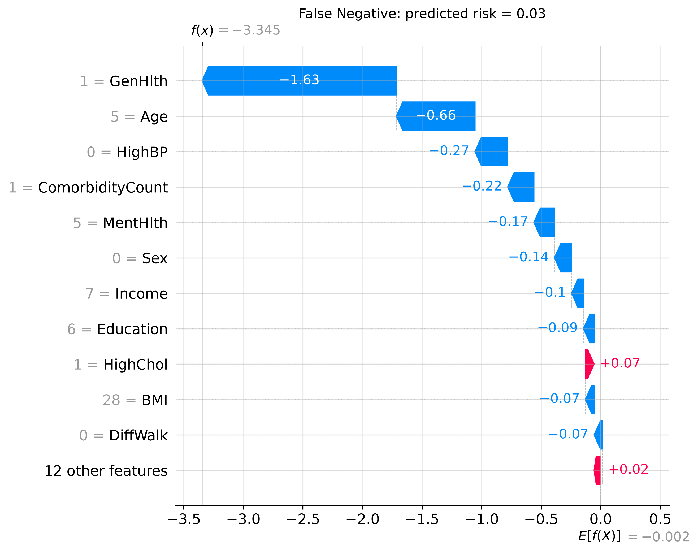
Fig. 13. SHAP waterfall plot for the most confidently missed diabetic in the SHAP sample.
D. Feature Selection
Permutation importance on the training folds ranked GenHlth, Age, BMI and ComorbidityCount highest—the same top four as SHAP. Fig. 14 shows that validation ROC-AUC rises quickly up to about eight features and then flattens. Ten features (GenHlth, Age, BMI, ComorbidityCount, CholCheck, HvyAlcoholConsump, Sex, Income, HighBP, MentHlth) came within 0.002 of the full model and were selected. On the test set, the 10-feature model achieved ROC-AUC 0.820, PR-AUC 0.450 and F1 0.478, compared with 0.822, 0.454 and 0.480 for all 23 features. Because ComorbidityCount uses four questions and BMI needs height and weight, this corresponds to a questionnaire of about 12 questions instead of 21. The deployed prototype keeps all features because they gave the best test performance.
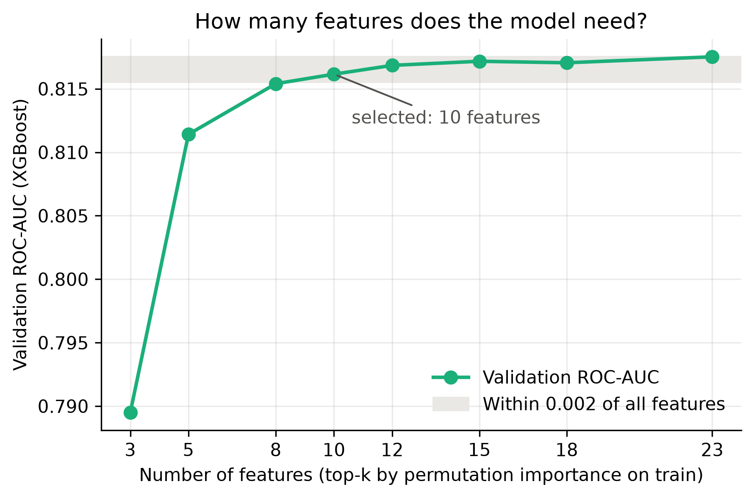
Fig. 14. Validation ROC-AUC of XGBoost when only the top-k features (by permutation importance) are used.
E. Comparison with Published Studies
Table VI compares our XGBoost with three recent studies on the same dataset. Our ROC-AUC (0.822) is within 0.01 of Shechter and Shomron [6] (0.83), who evaluated on the original, imbalanced class distribution. Our accuracy is lower than theirs (0.79 vs 0.86) because our threshold was chosen to maximise F1 rather than accuracy; at the 0.5 default the trade-off would differ. The much higher figures of Majcherek et al. [7] and Islam et al. [8] (ROC-AUC 0.99) were obtained with oversampling-based protocols. When synthetic minority samples are generated before the data are split, or when the test set itself is balanced, the evaluation no longer reflects the real 15% prevalence and near-duplicate synthetic records can appear on both sides of the split, which inflates performance [19]. The present data do not allow us to determine exactly how those results were obtained, so we do not claim that they are wrong; we note only that they are not directly comparable with an evaluation on unmodified, deduplicated test data. Aich et al. [9], who restricted oversampling to the training folds, likewise report gains mainly in F1 and recall rather than ROC-AUC near 0.99.

TABLE VI
Comparison with Published Studies on the CDC Diabetes Health Indicators Dataset
Study | Best model | Acc | Prec | Rec | F1 | ROC-AUC | Imbalance handling / protocol | ΔROC-AUC (ours − theirs)
Shechter & Shomron [6], 2026 | CatBoost | 0.86 | – | – | – | 0.83 | Resampling variants explored; evaluated on imbalanced data | −0.008
Majcherek et al. [7], 2025 | Extra Trees | >0.90 | – | – | – | 0.99 | SMOTE / ADASYN / random oversampling | −0.168
Islam et al. [8], 2025 | Stacking (XGB+KNN) | 0.948 | 0.929 | 0.970 | 0.949 | 0.990 | SMOTE + Tomek links; timing vs. split not stated | −0.168
This work | XGBoost | 0.794 | 0.391 | 0.620 | 0.480 | 0.822 | Class weights, no resampling; deduplicated; test used once | –
– = not reported in the source. Differences may also arise from split ratios, deduplication, feature selection, hyperparameters and threshold choice.

F. Error Analysis
The 1,999 missed diabetics differ systematically from the 3,266 detected ones (Fig. 15): they rate their health better (mean GenHlth 2.71 vs 3.70), have lower BMI (28.6 vs 34.2), less often report high blood pressure (51% vs 90%) and have fewer chronic conditions (1.12 vs 2.14); 64.6% of them are not obese. False positives, by contrast, look clinically similar to true positives (mean BMI 32.6, 87% with high blood pressure), so many may be high-risk or undiagnosed individuals for whom a blood test is reasonable.
Uncertainty is concentrated near the threshold: 20.1% of test predictions lie within ±0.10 of it, and their error rate is 46.7% compared with 14.0% for the remaining predictions; these cases account for 45.7% of all errors. This finding motivated the borderline band in the prototype. Finally, 1,685 diabetics (32.0%) were missed by all three models, and 84.3% of XGBoost's false negatives were also missed by both Logistic Regression and Random Forest. The limitation is therefore the information available in the questionnaire, not the choice of algorithm.

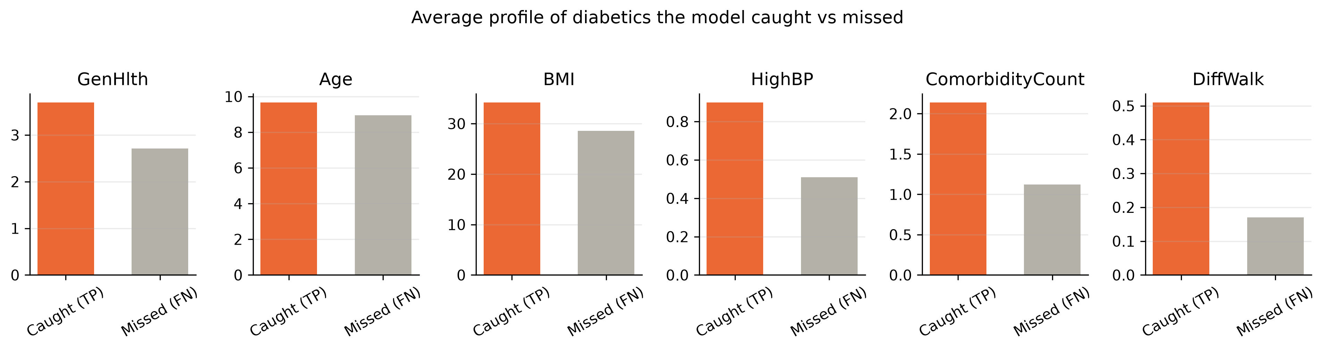
Fig. 15. Average profile of diabetics the model detected (TP) versus missed (FN).

Table VII and Fig. 16 report subgroup performance. Recall is almost identical for women and men (0.616 vs 0.625). It is much lower for adults aged 18–44 (0.281) and for high-income respondents (0.485), groups in which diabetes is less prevalent (4.3% and 10.9%), whereas the false-positive rate is highest for people aged 65+ (0.303) and for low-income respondents (0.336). The model largely follows prevalence, which is statistically expected but has fairness implications: younger and wealthier people with diabetes are the most likely to be missed.
TABLE VII
Subgroup Performance of XGBoost on the Test Set
Group | n | Prevalence | Recall | FPR
Female | 19,075 | 14.2% | 0.616 | 0.155
Male | 15,347 | 16.7% | 0.625 | 0.200
Age 18–44 | 7,385 | 4.3% | 0.281 | 0.025
Age 45–64 | 14,453 | 15.4% | 0.597 | 0.158
Age 65+ | 12,584 | 21.6% | 0.679 | 0.303
Income < $20k | 5,652 | 24.7% | 0.764 | 0.336
Income $20k–50k | 12,083 | 17.0% | 0.643 | 0.212
Income ≥ $50k | 16,687 | 10.9% | 0.485 | 0.103
≤ High school | 11,155 | 19.6% | 0.684 | 0.254
Some college + | 23,267 | 13.2% | 0.575 | 0.139
FPR = false-positive rate.

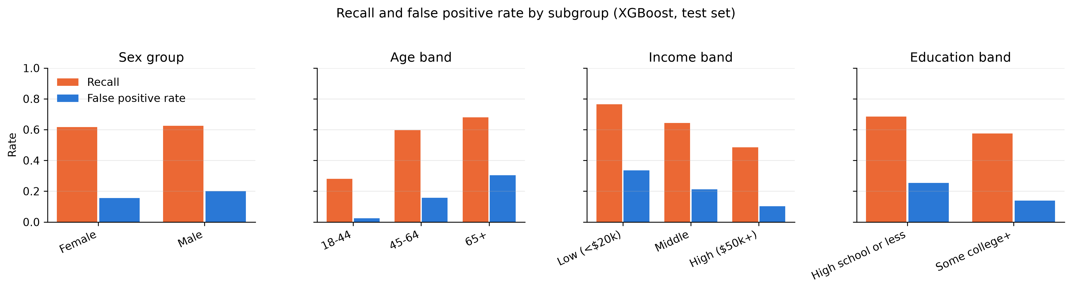
Fig. 16. Recall and false-positive rate of XGBoost by subgroup.

VII. Discussion
A. Answers to the Research Questions
RQ1: XGBoost gave the best discrimination (ROC-AUC 0.822, PR-AUC 0.454, F1 0.480), while recall was similar for all three models (about 0.62). RQ2: The improvement over Logistic Regression was small (+0.008 ROC-AUC, +0.027 PR-AUC, +0.011 F1). In a setting where transparency is important, Logistic Regression remains a defensible alternative. RQ3: General health, comorbidity count, age, BMI and high blood pressure dominate the predictions, consistent with clinical knowledge, while cholesterol-check and alcohol effects reveal data biases. RQ4: Errors concentrate among younger, non-obese people who report good health and near the decision threshold; our performance matches the published study that evaluates on the original class distribution.
B. Why XGBoost Performed Best
Gradient boosting fits successive trees to the remaining errors, so it can model non-linear effects (for example the steep rise of risk with BMI) and interactions (for example age combined with blood pressure) that a linear model cannot represent. Random Forest captures similar structure but averages independent trees and benefits less from refining difficult cases. The gains are small because most of the signal in these features is monotonic and nearly additive, which a linear model already captures, and because the remaining uncertainty stems from information the survey does not contain.
C. Interpretable versus Complex Models
Because the gap between XGBoost and Logistic Regression is below one ROC-AUC point, the choice of deployed model involves a trade-off rather than a clear winner. Logistic Regression offers global transparency: each coefficient states how one answer changes the log-odds for everyone, which is easy to audit and to explain to clinicians. XGBoost offers slightly better ranking and better precision among the highest-risk people, and SHAP restores much of the lost transparency by providing exact per-person attributions. The two models also agree on what matters: both rank general health, age, BMI and blood pressure among the strongest signals. We deployed XGBoost because it was best on every validation metric and SHAP explanations are available, but a deployment that prioritised simplicity and auditability could reasonably choose Logistic Regression at almost no cost in performance.
D. Practical Implications for Screening
At the selected threshold, about 24% of the test population would be flagged (8,352 of 34,422 people), of whom about 39% actually have diabetes, while 62% of all diabetics would be found. For a first-stage screen whose follow-up is an inexpensive blood test, this is a reasonable operating point; the threshold can be lowered to catch more cases at the cost of more referrals, as the precision–recall curve in Fig. 9 shows. The tool is most useful for adults over 45 and for people with several risk factors, and least reliable for young, normal-weight people who rate their health as good. It should therefore complement, not replace, guideline-based testing, and its explanations can help motivate people by showing which modifiable factors, such as BMI and physical activity, contribute to their score.
E. Big Data Platform Evaluation and Scalability
Current implementation. The deduplicated training data occupy only 30.8 MB in memory, and the full dataset easily fits on a laptop. As Table VIII and Fig. 17 show, XGBoost trains on all 160,631 training rows in 1.8 s and scores about 0.84 million records per second; Logistic Regression is even faster, while Random Forest takes about 9 s and produces a 64 MB model. Training time for XGBoost grows more slowly than the data (4× the rows, about 2.4× the time), whereas Random Forest grows faster (about 6×). A single-machine Python stack (pandas, scikit-learn, XGBoost) is therefore the appropriate platform: it is free, simple, reproducible and offers a rich explainability ecosystem. A distributed framework such as Apache Spark [20] would add cluster start-up, serialisation and configuration overhead without any benefit at this scale. Its disadvantages are that it is limited by one machine's memory, does not distribute training, and has no native support for streaming data.
TABLE VIII
Training Time and Prediction Throughput
Training rows | LR fit | RF fit | XGB fit | XGB predictions/s
40,158 (25%) | 0.06 s | 1.6 s | 0.7 s | 0.89 M
80,316 (50%) | 0.11 s | 3.4 s | 1.1 s | 0.89 M
160,631 (100%) | 0.25 s | 9.1 s | 1.8 s | 0.84 M

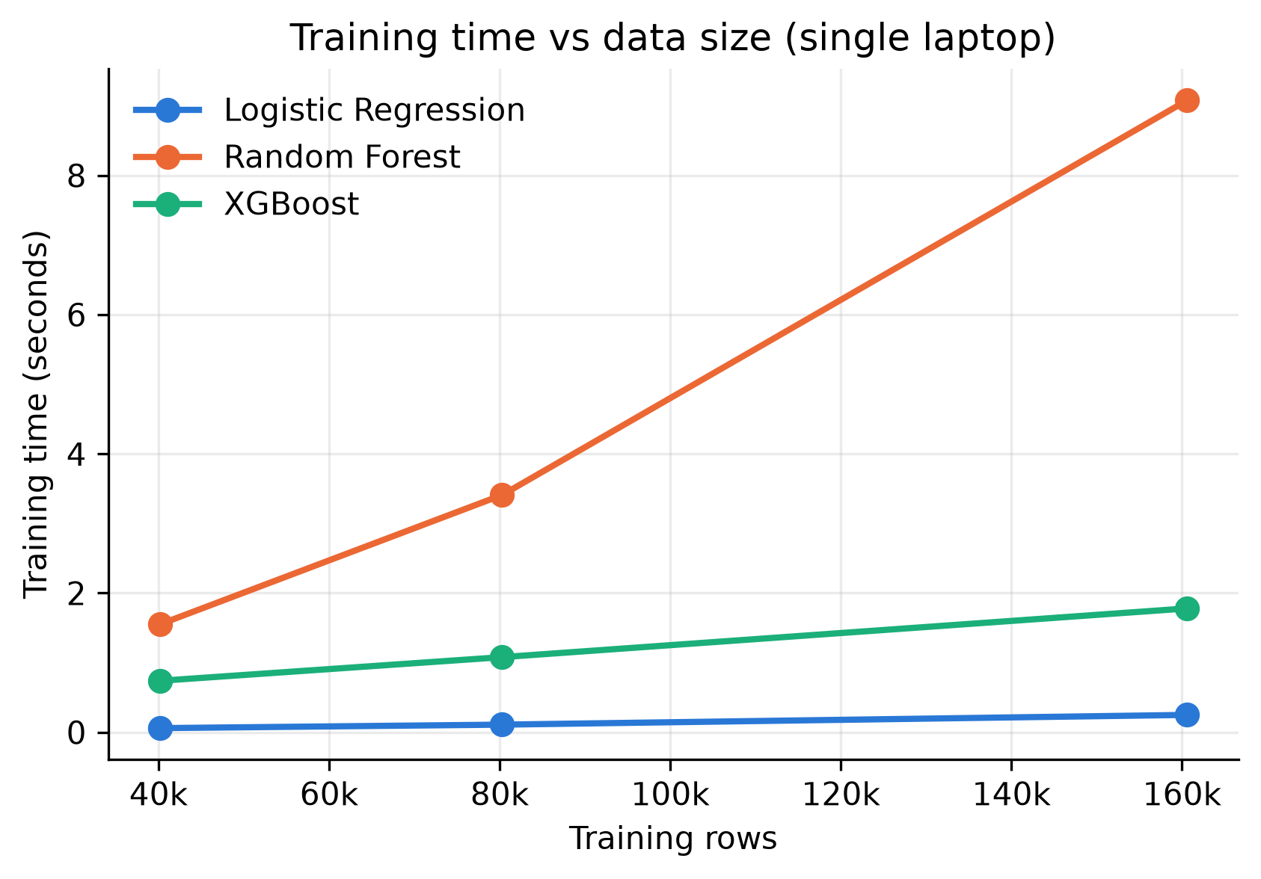
Fig. 17. Training time versus number of training rows on a single laptop.
Future scalability. If the system were extended to all BRFSS years or to national electronic questionnaire data (100× or more records), the same pipeline could be moved to columnar Parquet storage and distributed processing with Spark and MLlib [21], or to XGBoost's distributed training on a managed platform such as Databricks. For real-time or streaming use, for example questionnaires submitted through a public-health website, responses could be published to a message queue such as Apache Kafka and scored by a stateless service that loads the saved pipeline; the measured throughput shows that a single instance can already score hundreds of thousands of records per second. Data-drift monitoring and scheduled retraining would then be required, because the population and survey design change over time.
F. Limitations
First, the data are self-reported: labels miss undiagnosed diabetes, and there are no laboratory measurements, which caps achievable recall. Second, the data come from a single year (2015) of a U.S. survey, so temporal and geographic generalisation has not been tested. Third, the coding of prediabetes in the binary label is ambiguous. Fourth, because of class weighting, the scores are risk rankings rather than calibrated probabilities. Fifth, SHAP attributions are associations and can be distorted by correlated features. Sixth, performance differs across age and income groups. Finally, hyperparameter search was deliberately limited (6–20 configurations) to remain laptop-friendly.
G. Ethical Considerations
The dataset is public and anonymised, and the prototype stores no user inputs. Sex, age, income and education are sensitive attributes; they were kept because they are recognised risk factors, but subgroup performance was reported so that unequal error rates are visible. The low recall for younger people means the tool must not be used to reassure anyone that they do not have diabetes. The system is a screening aid, not a diagnostic device: the interface shows a disclaimer and recommends a blood test, and its explanations are presented as associations. Any real deployment would require clinical validation, calibration and governance.
VIII. Conclusion and Future Work
This paper presented a transparent and leakage-safe ML pipeline for diabetes risk screening from self-reported survey data, together with a working explainable prototype. Using deduplication before splitting, class weighting, training-only tuning, validation-based thresholds and a single test evaluation, XGBoost reached ROC-AUC 0.822 and recall 0.62, only slightly above an interpretable Logistic Regression. SHAP and permutation importance agreed that general health, comorbidities, age, BMI and blood pressure drive the predictions, and ten features preserve almost all of the performance. The results match published work that evaluates on the original class distribution and suggest that much higher reported figures depend on oversampling-based protocols. The main limitation is the information content of survey data: most missed cases look healthy on paper and are missed by every model.
Future work includes validating the model on other BRFSS years (temporal validation), calibrating the risk scores, modelling the three-class target that separates prediabetes, testing group-specific thresholds to reduce subgroup gaps, and deploying a shortened 12-question version of the questionnaire.
AI Usage Statement
As permitted by the course instructor, generative AI (Claude, Anthropic) was used to assist with code development, literature search and the drafting and editing of this report. All experiments were run with the project's own code, all reported numbers come from those runs, and the author reviewed and verified the content.
References
[1] Centers for Disease Control and Prevention, "National Diabetes Statistics Report," U.S. Dept. of Health and Human Services. [Online]. Available: https://www.cdc.gov/diabetes/php/data-research/
[2] "CDC Diabetes Health Indicators," UCI Machine Learning Repository, 2017, doi: 10.24432/C53919.
[3] N. R. Burrows, I. Hora, L. S. Geiss, E. W. Gregg, and A. Albright, "Incidence of end-stage renal disease attributed to diabetes among persons with diagnosed diabetes—United States and Puerto Rico, 2000–2014," Morbidity and Mortality Weekly Report, vol. 66, no. 43, pp. 1165–1170, 2017.
[4] Centers for Disease Control and Prevention, "Behavioral Risk Factor Surveillance System (BRFSS)." [Online]. Available: https://www.cdc.gov/brfss/
[5] Z. Xie, O. Nikolayeva, J. Luo, and D. Li, "Building risk prediction models for type 2 diabetes using machine learning techniques," Preventing Chronic Disease, vol. 16, p. 190109, 2019, doi: 10.5888/pcd16.190109.
[6] S. Shechter and N. Shomron, "Machine learning for diabetes screening: Insights from the Behavioral Risk Factor Surveillance System and Pima Indians Diabetes databases," Journal of Scientific Innovation in Medicine, vol. 9, no. 1, art. 3, 2026, doi: 10.29024/jsim.283.
[7] D. Majcherek, A. Ciesielski, and P. Sobczak, "AI-driven analysis of diabetes risk determinants in U.S. adults: Exploring disease prevalence and health factors," PLOS ONE, vol. 20, no. 9, e0328655, 2025, doi: 10.1371/journal.pone.0328655.
[8] M. N. Islam, M. M. H. Rimon, S. S.-E.-A. Shamim, Z. M. Fahad, M. J. I. Mony, and M. J. U. Chowdhury, "An improved ensemble-based machine learning model with feature optimization for early diabetes prediction," in Proc. 7th Int. Conf. Trends in Computational and Cognitive Engineering (TCCE), 2025; arXiv:2512.02023.
[9] A. Aich, M. M. Murshed, B. Wade, and S. Hewage, "CopulaSMOTE: A copula-based oversampling approach for imbalanced classification in diabetes prediction," arXiv:2506.17326, 2025.
[10] U. Allani, "Interactive diabetes risk prediction using explainable machine learning: A Dash-based approach with SHAP, LIME, and comorbidity insights," arXiv:2505.05683, 2025.
[11] F. J. Horestani and M. M. Owrang O, "Predicting diabetes with machine learning analysis of income and health factors," arXiv:2404.13260, 2024.
[12] S. M. Lundberg and S.-I. Lee, "A unified approach to interpreting model predictions," in Advances in Neural Information Processing Systems 30 (NeurIPS), 2017, pp. 4765–4774.
[13] S. M. Lundberg et al., "From local explanations to global understanding with explainable AI for trees," Nature Machine Intelligence, vol. 2, pp. 56–67, 2020, doi: 10.1038/s42256-019-0138-9.
[14] T. Chen and C. Guestrin, "XGBoost: A scalable tree boosting system," in Proc. 22nd ACM SIGKDD Int. Conf. Knowledge Discovery and Data Mining, 2016, pp. 785–794, doi: 10.1145/2939672.2939785.
[15] L. Breiman, "Random forests," Machine Learning, vol. 45, no. 1, pp. 5–32, 2001, doi: 10.1023/A:1010933404324.
[16] F. Pedregosa et al., "Scikit-learn: Machine learning in Python," Journal of Machine Learning Research, vol. 12, pp. 2825–2830, 2011.
[17] N. V. Chawla, K. W. Bowyer, L. O. Hall, and W. P. Kegelmeyer, "SMOTE: Synthetic minority over-sampling technique," Journal of Artificial Intelligence Research, vol. 16, pp. 321–357, 2002, doi: 10.1613/jair.953.
[18] T. Saito and M. Rehmsmeier, "The precision-recall plot is more informative than the ROC plot when evaluating binary classifiers on imbalanced datasets," PLOS ONE, vol. 10, no. 3, e0118432, 2015, doi: 10.1371/journal.pone.0118432.
[19] S. Kaufman, S. Rosset, C. Perlich, and O. Stitelman, "Leakage in data mining: Formulation, detection, and avoidance," ACM Transactions on Knowledge Discovery from Data, vol. 6, no. 4, art. 15, 2012, doi: 10.1145/2382577.2382579.
[20] M. Zaharia et al., "Apache Spark: A unified engine for big data processing," Communications of the ACM, vol. 59, no. 11, pp. 56–65, 2016, doi: 10.1145/2934664.
[21] X. Meng et al., "MLlib: Machine learning in Apache Spark," Journal of Machine Learning Research, vol. 17, no. 34, pp. 1–7, 2016.
[22] World Health Organization, "A healthy lifestyle – WHO recommendations (body mass index classification)." [Online]. Available: https://www.who.int/
[23] American Diabetes Association Professional Practice Committee, "Diagnosis and classification of diabetes: Standards of Care in Diabetes," Diabetes Care, published annually.
[24] M. T. Ribeiro, S. Singh, and C. Guestrin, "'Why should I trust you?': Explaining the predictions of any classifier," in Proc. 22nd ACM SIGKDD Int. Conf. Knowledge Discovery and Data Mining, 2016, pp. 1135–1144, doi: 10.1145/2939672.2939778.
Appendix: Reproducibility
Source code is provided in the submitted code package (i26043871_Abdullah_Mahmood_Code.zip). Setup: python -m venv .venv; pip install -r requirements.txt. Reproduce all results: python src/run_pipeline.py (about 15–20 minutes). Run the prototype: streamlit run app/app.py. Notebooks: notebooks/01_eda.ipynb and notebooks/02_error_analysis.ipynb. All randomness uses RANDOM_STATE = 42.

