UNIVERSITY ASSIGNMENT SUBMISSION

DeadlineIQ
Assignment Deadline Planner

Topic | #12 – Assignment Deadline Planner
Assignment | Assignment 1 – Client-Side Web Application
Student Name | Abdullah Ahmed
CMS ID | 503939
Class | BESE 15 B
Date of Submission | October 28, 2026

Web Development | CLO 1, 2, 4

🔗 GitHub Repository:
https://github.com/abdullah6093/Assignment-Deadline-Planner-

🌐 Live Demo URL:
https://abdullah6093.github.io/Assignment-Deadline-Planner-/

1. Project Overview

DeadlineIQ is a fully responsive, client-side Assignment Deadline Planner built using semantic HTML5, vanilla CSS (with custom properties, Flexbox, Grid, and media queries), and vanilla JavaScript. The application allows university students to manage multiple assignment deadlines across different courses.

Key Features
- 📋 Dashboard with task cards showing priority, progress, status, and countdown
- ➕ Add / Edit / Delete assignments via a validated form
- 📅 Interactive calendar view with month navigation and day-detail panel
- ⚡ Automatic conflict detection (2+ HIGH-priority tasks on same day)
- 🔥 Overload alerts (3+ any-priority tasks on same day)
- 🔄 Recurring task auto-generation (weekly / bi-weekly / monthly)
- 🔍 Live search with debounce + multi-filter (course, priority, status, sort)
- 💾 localStorage persistence — data survives page refresh
- 🎨 Theme switcher: Dark / Light / Midnight + 4 accent colors
- 📤 Export to CSV and JSON; Import from JSON
- ♿ Full accessibility: ARIA labels, keyboard navigation, focus management

Technology Stack
Technology | Usage
HTML5 | Semantic structure: header, nav, main, section, article, aside, form
CSS3 | Custom properties, Grid, Flexbox, 4 media-query breakpoints
JavaScript | Vanilla ES6+: CRUD, DOM events, localStorage, form validation
Storage | localStorage (client-side) — no backend required for Assignment 1
Hosting | GitHub Pages (static site, free)

GitHub & Live Links
- GitHub Repository: https://github.com/abdullah6093/Assignment-Deadline-Planner-
- Live Demo (GitHub Pages): https://abdullah6093.github.io/Assignment-Deadline-Planner-/

2. Application Screenshots

2.1 Dashboard View
The main dashboard shows 4 summary stat cards (Total Tasks, Due Soon, Completed, Conflicts), a sidebar with course filters and priority/status dropdowns, and a responsive grid of task cards. Each card displays the course badge, priority badge, assignment title, due date, status chip, countdown timer, progress bar, and action buttons.

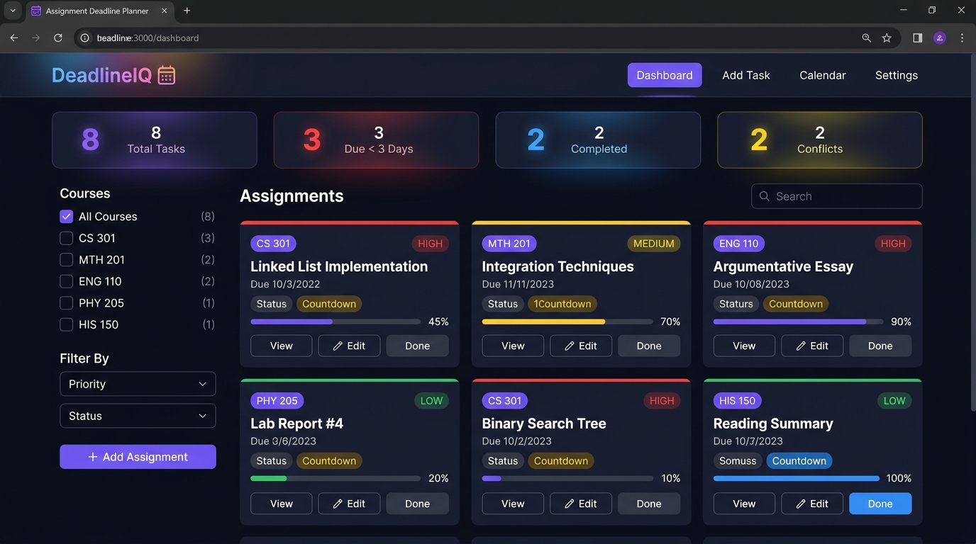
Figure 1: Dashboard – Task card grid with sidebar filters and stat summary

2.2 Add New Assignment Form
The Add Task form includes all required fields: Course Name, Assignment Title, Due Date & Time, Priority (High/Medium/Low), a live progress slider (0–100%), Status, Recurring frequency, and Notes. Custom JavaScript validation prevents empty fields, past dates on new entries, and auto-syncs the Status field when progress reaches 100%. Required fields are marked with a red asterisk (*).

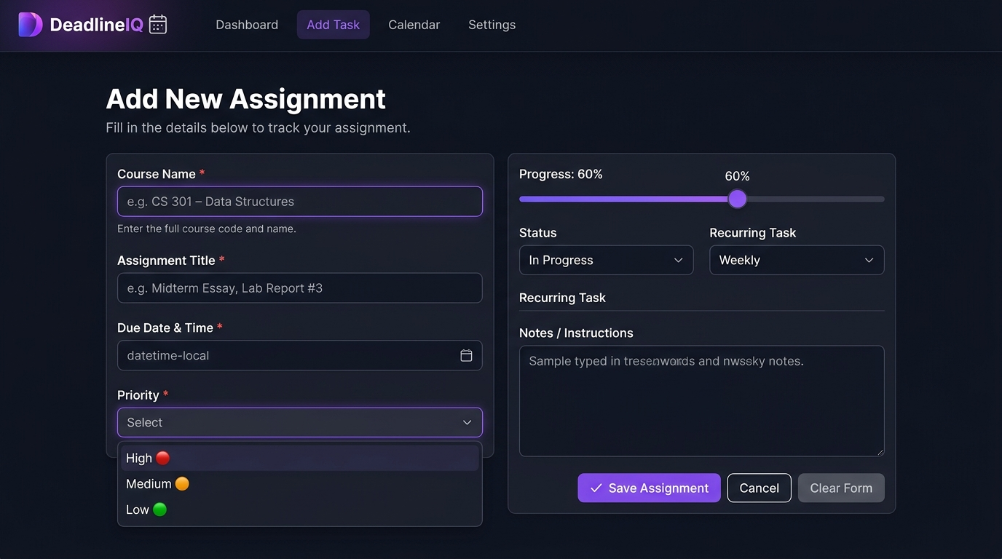
Figure 2: Add Assignment Form with 2-column grid layout, range slider, and action buttons

2.3 Calendar View
The interactive calendar renders all assignment due dates visually on a monthly grid. Today's date is highlighted. Colored dots appear under each date (🔴 red = High, 🟡 yellow = Medium, 🟢 green = Low priority). Clicking a day opens the Day Detail panel below showing all assignments due on that date with course, priority, and status information. Month navigation buttons allow browsing past and future months.

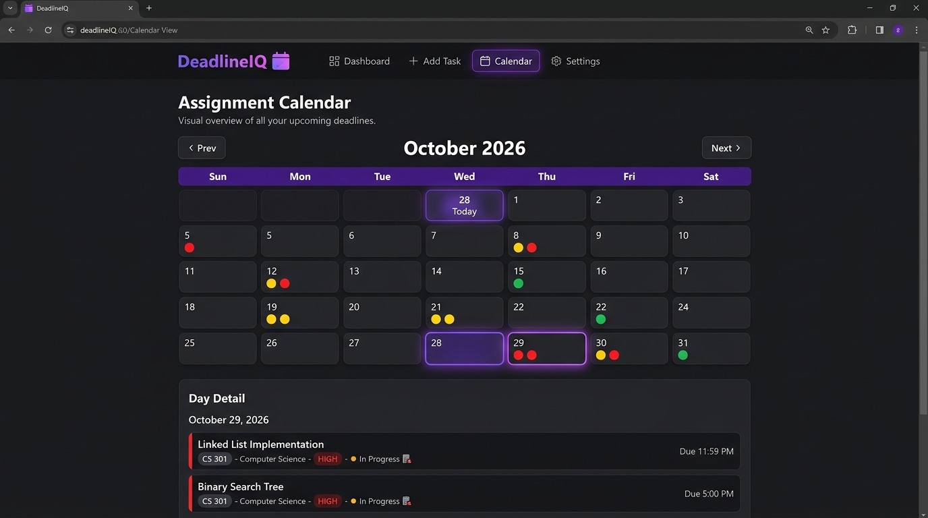
Figure 3: Calendar View – October 2026 with color-coded deadline dots and Day Detail panel

2.4 Task Detail Modal
Clicking 'View' on any task card opens a full-detail modal dialog. The modal shows the course badge, assignment title, due date/time, priority, recurring status, current state, progress bar, notes, and a live countdown chip (e.g., '2d left'). Footer buttons allow Edit, Mark Complete (toggle), or Delete with a confirmation dialog. The modal is fully keyboard accessible (Escape to close, Tab to navigate buttons) and uses ARIA roles.

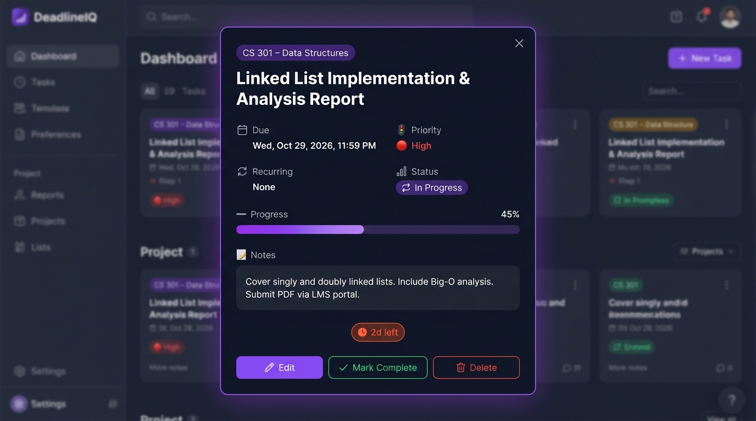
Figure 4: Task Detail Modal – showing assignment info, progress bar, countdown, and action buttons

2.5 Settings & Preferences
The Settings page allows the user to customize the app experience. Appearance settings include theme (Dark / Light / Midnight Blue) and accent color (Violet / Cyan / Rose / Amber). Reminder settings let users set the warning threshold (days before deadline), and toggle overload alerts and conflict detection on or off. The Data card shows how many tasks are stored and storage usage, with Import/Export/Clear options. All settings are saved to localStorage instantly.

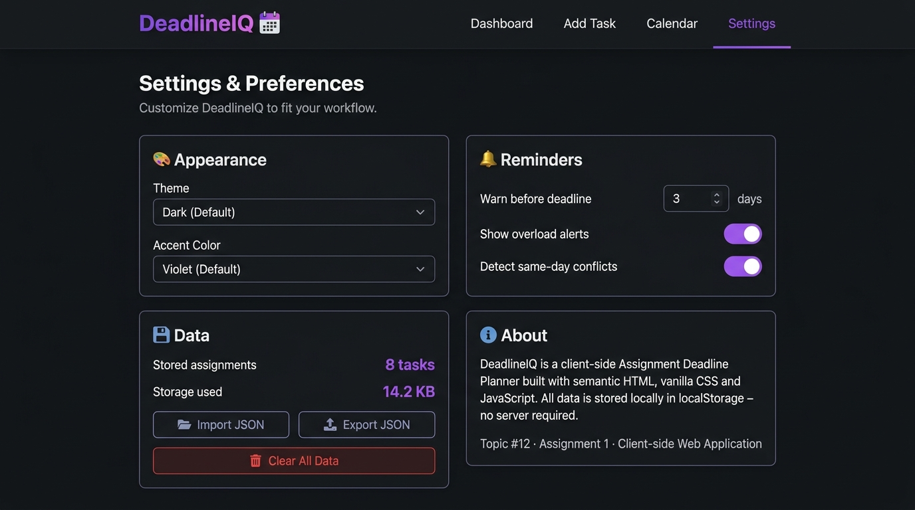
Figure 5: Settings Page – Appearance, Reminders, Data management, and About sections

3. Design Notes & WDLC Stages

3.1 User & Problem
Target User: University student enrolled in 4–6 courses simultaneously.
Core Problem: Overlapping assignment deadlines across multiple courses lead to missed submissions, last-minute panic, and poor time allocation.
Solution: A single-page planner with visual priority, progress tracking, and automatic conflict detection.

3.2 WDLC Stages
Stage | Activity
Planning | Defined user persona, core use cases, data model, and feature list.
Analysis | Identified: CRUD operations, filtering, calendar view, conflict detection needed.
Design | Wireframed all 4 views; chose dark glassmorphism theme; defined CSS custom property token system.
Development | Built HTML structure → CSS design system → JavaScript data layer → app logic.
Testing | Tested on Chrome, Firefox; tested empty state, invalid inputs, past-date validation, edge cases.
Deployment | Pushed to GitHub; enabled GitHub Pages for static hosting at the live URL above.

3.3 Client vs Server
Concern | Location | Technology
UI Rendering | Client | HTML + CSS
User Interactions | Client | Vanilla JavaScript
Form Validation | Client | JS + HTML5 required/minlength/type
Data Storage (A1) | Client | localStorage
Conflict Detection | Client | JS algorithm
Theme/Settings | Client | localStorage
REST Persistence (A2) | Server | Future: fetch() + JSON API
Authentication (A3) | Server | Future: JWT / sessions

4. Sample Data Records (8 pre-loaded)

# | Course | Assignment Title | Priority | Status | Progress
1 | CS 301 | Linked List Implementation & Analysis Report | High | In Progress | 45%
2 | MTH 201 | Integration Techniques Problem Set | Medium | In Progress | 70%
3 | ENG 110 | Argumentative Essay – Climate Policy | High | In Progress | 90%
4 | PHY 205 | Lab Report #4 – Projectile Motion | Low | In Progress | 20%
5 | CS 301 | Binary Search Tree – Coding Assignment | High | Not Started | 10%
6 | HIS 150 | Reading Summary – Chapter 12 & 13 | Low | Completed | 100%
7 | MTH 201 | Midterm Exam Preparation Quiz | Medium | In Progress | 55%
8 | ENG 110 | Peer Review – Classmate Draft | Medium | Not Started | 0%

5. Marking Rubric Coverage

Criterion | Marks | Evidence in Project
Working application & interactions | 10/30 | CRUD, filter/sort/search, conflict detection, calendar, modal, progress tracking
Semantic HTML, forms & accessibility | 5/30 | header/nav/main/section/article/aside, labels, aria-*, role=*, skip link
CSS layout & responsive behavior | 7/30 | Grid + Flexbox, 4 breakpoints (1024px/768px/480px), CSS custom properties
JavaScript logic, DOM events & edge cases | 5/30 | Arrays/functions/conditionals, debounce, event delegation, empty state, XSS prevention
GitHub, README, attribution & walkthrough | 3/30 | README with setup, WDLC, client vs server, AI disclosure, live URL

6. AI Assistance Disclosure

This project was developed with AI coding assistance (Google Antigravity / Claude). AI assistance was used for: boilerplate HTML structure suggestions, CSS design token layout patterns, and JavaScript utility function patterns. All code was personally reviewed, understood, and adapted. No full-site templates or framework code were used. All sample records are original student-created data.

— End of Document —

