

Artificial intelligence

(Code description file)



*SIR:  
Haseeb Arshad*

Member name

19f-0240 -Abdullah Awan

“Exam Schedule Generator Using Local

Search Algorithms”

The project was scheduling of exams. Here we implemented simulated annealing to find out the best solution on the basis of probability which had a low cost and less conflicts in the timetable. Moreover, we used GUI graphical user interface of tkinter for better and unique output and interface.

Here’s the code

code:

import numpy as np  
import pandas as pd  
import copy  
import math  
import random  
import tkinter as tk  
from tkinter import ttk  
from tkinter import messagebox  
  
def import_data(fileDir):  
 teachers_df = pd.read_csv(fileDir + 'teachers.csv')  
 students_df = pd.read_csv(fileDir + 'studentNames.csv')  
 rooms_df = pd.read_csv(fileDir + 'rooms.csv')  
 courses_df = pd.read_csv(fileDir + 'courses.csv')  
 registered_courses_df = pd.read_csv(fileDir + 'studentCourse.csv')  
  
 teachers = list(teachers_df.iloc[:**, 0**])  
 students = list(students_df.iloc[:**, 0**])  
 rooms = {i + **1**: capacity for i**,** capacity in enumerate(rooms_df.iloc[:**, 1**])}  
 courses = {course_code: course_name for course_code**,** course_name in  
 zip(courses_df.iloc[:**, 0**]**,** courses_df.iloc[:**, 1**])}  
 student_courses = {(student_name**,** course_code) for student_name**,** course_code in  
 zip(registered_courses_df.iloc[:**, 1**]**,** registered_courses_df.iloc[:**, 2**])}  
  
 return teachers**,** students**,** rooms**,** courses**,** student_courses  
  
def random_solution(courses**,** students**,** rooms):  
 exam_schedule = {}  
 for course_code**,** course_name in courses.items():  
 exam_schedule[course_code] = {  
 'course': course_name**,** 'room': random.sample(list(rooms.keys())**, 1**)**,** 'teacher': random.sample(teachers**, 1**)**,** 'time': random.choice([**9, 14**])**,** # 9 AM or 2 PM  
 'date': random.randint(**1,** num_days) # Random date between 1 and num_days  
 }  
 return exam_schedule  
  
def calculate_fitness(exam_schedule**,** student_courses**,** num_days):  
  
 num_violations = **0** for day in range(**1,** num_days + **1**):  
 for time in [**9, 14**]:  
 exams_at_time = [course_code for course_code**,** exam in exam_schedule.items() if exam['date'] == day and exam['time'] == time]  
 for student in students:  
 num_exams = sum(**1** for course_code in exams_at_time if (student**,** course_code) in student_courses)  
 if num_exams > **1**:  
 num_violations += **1** for day in range(**1,** num_days + **1**):  
 for time in [**9, 14**]:  
 exams_at_time = [exam for exam in exam_schedule.values() if exam['date'] == day and exam['time'] == time]  
 teachers_at_time = [exam['teacher'][**0**] for exam in exams_at_time]  
 if len(set(teachers_at_time)) != len(teachers_at_time):  
 num_violations += **1** return num_violations  
  
def generate_neighbor_solution(current_solution**,** rooms):  
 new_solution = copy.deepcopy(current_solution)  
  
 exam_code**,** exam_info = random.choice(list(new_solution.items()))  
  
  
 new_date = random.randint(**1,** num_days)  
  
  
 new_solution[exam_code]['date'] = new_date  
 new_solution[exam_code]['room'] = random.sample(list(rooms.keys())**, 1**)  
  
 return new_solution  
  
def simulated_annealing(initial_solution**,** student_courses**,** num_days**,** max_iterations**,** initial_temperature**,** cooling_rate):  
 current_solution = initial_solution  
 current_fitness = calculate_fitness(current_solution**,** student_courses**,** num_days)  
 best_solution = current_solution.copy()  
 best_fitness = current_fitness  
  
 temperature = initial_temperature  
  
 for i in range(max_iterations):  
 new_solution = generate_neighbor_solution(current_solution**,** rooms)  
 new_fitness = calculate_fitness(new_solution**,** student_courses**,** num_days)  
  
 if new_fitness < current_fitness or random.uniform(**0, 1**) < math.exp((current_fitness - new_fitness) / temperature):  
 current_solution = new_solution  
 current_fitness = new_fitness  
  
 if new_fitness < best_fitness:  
 best_solution = new_solution  
 best_fitness = new_fitness  
  
 temperature *= cooling_rate  
  
 print(f"Iteration {i + **1**}: Fitness = {best_fitness}")  
  
 return best_solution  
  
def check_break_constraint(exam_schedule**,** num_days):  
 num_violations = **0** for day in range(**1,** num_days + **1**):  
 exams_at_time = [exam for exam in exam_schedule.values() if exam['date'] == day and exam['time'] == **13**] # 1 PM  
 if exams_at_time:  
 num_violations += **1** return num_violations  
  
def check_consecutive_exams_constraint(exam_schedule**,** student_courses**,** num_days):  
 num_violations = **0** for day in range(**1,** num_days + **1**):  
 exams_at_day = [exam for exam in exam_schedule.values() if exam['date'] == day]  
 exams_at_day.sort(key=lambda x: x['time']) # Sort exams by time on the day  
 for i in range(len(exams_at_day) - **1**):  
 current_exam = exams_at_day[i]  
 next_exam = exams_at_day[i + **1**]  
 if current_exam['time'] == **9** and next_exam['time'] == **14**: # Consecutive exams  
 for student in students:  
 if (student**,** current_exam['course']) in student_courses and (student**,** next_exam['course']) in student_courses:  
 num_violations += **1** return num_violations  
  
def check_preferred_order_constraint(exam_schedule**,** student_courses):  
 num_violations = **0** for student in students:  
 has_mg_course = any(course_code.startswith('MG') for (_**,** course_code) in student_courses if student == student)  
 has_cs_course = any(course_code.startswith('CS') for (_**,** course_code) in student_courses if student == student)  
 if has_mg_course and has_cs_course:  
 mg_course_exam = next((exam for exam in exam_schedule.values() if exam['course'].startswith('MG') and (student**,** exam['course']) in student_courses)**,** None)  
 cs_course_exam = next((exam for exam in exam_schedule.values() if exam['course'].startswith('CS') and (student**,** exam['course']) in student_courses)**,** None)  
 if mg_course_exam and cs_course_exam:  
 if mg_course_exam['date'] > cs_course_exam['date']:  
 num_violations += **1** return num_violations  
  
  
def check_faculty_meeting_constraint(exam_schedule**,** num_days):  
 num_violations = **0** half_days = math.ceil(num_days / **2**)  
 for day in range(**1,** half_days + **1**):  
 exams_at_day = [exam for exam in exam_schedule.values() if exam['date'] == day]  
 if len(exams_at_day) == **0**:  
 num_violations += **1** return num_violations  
  
def calculate_soft_constraints(exam_schedule**,** student_courses**,** num_days):  
  
 soft_constraints = {  
 'Break on Friday': check_break_constraint(exam_schedule**,** num_days)**,** 'Consecutive Exams': check_consecutive_exams_constraint(exam_schedule**,** student_courses**,** num_days)**,** 'Preferred Order of MG and CS Courses': check_preferred_order_constraint(exam_schedule**,** student_courses)**,** 'Faculty Meeting Constraints': check_faculty_meeting_constraint(exam_schedule**,** num_days)  
 }  
 return soft_constraints  
  
def display_schedule_gui(exam_schedule_df**,** soft_constraints_df):  
 root = tk.Tk()  
 root.title("Exam Schedule and Soft Constraints")  
  
  
 exam_schedule_frame = ttk.Frame(root)  
 exam_schedule_frame.pack(pady=**10**)  
  
 exam_schedule_label = tk.Label(exam_schedule_frame**,** text="Exam Schedule for Two Weeks:"**,** font=("Arial"**, 14,** "bold"))  
 exam_schedule_label.grid(row=**0,** column=**0,** columnspan=**5,** pady=**5**)  
  
  
 exam_schedule_tree = ttk.Treeview(exam_schedule_frame**,** columns=('Course'**,** 'Room'**,** 'Day'**,** 'Time'**,** 'Teacher')**,** show='headings'**,** height=**15**)  
 exam_schedule_tree.grid(row=**1,** column=**0,** columnspan=**5,** padx=**5**)  
  
 exam_schedule_tree.heading('Course'**,** text='Course')  
 exam_schedule_tree.heading('Room'**,** text='Room')  
 exam_schedule_tree.heading('Day'**,** text='Day')  
 exam_schedule_tree.heading('Time'**,** text='Time')  
 exam_schedule_tree.heading('Teacher'**,** text='Teacher')  
  
 # Add data to the Treeview widget  
 for i**,** row in exam_schedule_df.iterrows():  
 exam_schedule_tree.insert(''**,** tk.END**,** values=(row['Course']**,** row['Room']**,** row['Day']**,** row['Time']**,** row['Teacher']))  
  
 # Create a Frame to contain the soft constraint violations data  
 soft_constraints_frame = ttk.Frame(root)  
 soft_constraints_frame.pack(pady=**10**)  
  
 # Create a Label for the soft constraint violations section  
 soft_constraints_label = tk.Label(soft_constraints_frame**,** text="Soft Constraint Violations:"**,** font=("Arial"**, 14,** "bold"))  
 soft_constraints_label.grid(row=**0,** column=**0,** columnspan=**5,** pady=**5**)  
  
 # Create a Treeview widget to display the soft constraint violations data in a table format  
 soft_constraints_tree = ttk.Treeview(soft_constraints_frame**,** columns=('Soft Constraint'**,** 'Violations')**,** show='headings'**,** height=**10**)  
 soft_constraints_tree.grid(row=**1,** column=**0,** columnspan=**5,** padx=**5**)  
  
 # Add columns to the Treeview widget  
 soft_constraints_tree.heading('Soft Constraint'**,** text='Soft Constraint')  
 soft_constraints_tree.heading('Violations'**,** text='Violations')  
  
 # Add data to the Treeview widget  
 for i**,** row in soft_constraints_df.iterrows():  
 soft_constraints_tree.insert(''**,** tk.END**,** values=(row['Soft Constraint']**,** row['Violations']))  
  
 # Run the GUI event loop  
 root.mainloop()  
  
# Constants  
fileDir = './test_dataset/'  
num_days = **14**max_iterations = **1000**initial_temperature = **1000.0**cooling_rate = **0.95**# Load data  
teachers**,** students**,** rooms**,** courses**,** student_courses = import_data(fileDir)  
  
# Generate initial solution  
initial_solution = random_solution(courses**,** students**,** rooms)  
  
# Run simulated annealing algorithm to generate exam schedule for two weeks  
exam_schedule_2_weeks = simulated_annealing(initial_solution**,** student_courses**,** num_days**,** max_iterations**,** initial_temperature**,** cooling_rate)  
  
# Calculate soft constraints  
soft_constraints = calculate_soft_constraints(exam_schedule_2_weeks**,** student_courses**,** num_days)  
  
# Create a list of dictionaries to store the exam schedule data  
exam_schedule_data = []  
for course_code**,** exam_info in exam_schedule_2_weeks.items():  
 day = exam_info['date']  
 time = "9 AM" if exam_info['time'] == **9** else "2 PM"  
 teacher = exam_info['teacher'][**0**]  
 exam_schedule_data.append({  
 'Course': exam_info['course']**,** 'Room': f"Room {exam_info['room'][**0**]}"**,** 'Day': f"Day {day}"**,** 'Time': time**,** 'Teacher': teacher  
 })  
  
# Convert the list of dictionaries to a DataFrame  
exam_schedule_df = pd.DataFrame(exam_schedule_data)  
  
# Save exam schedule and soft constraint violations to CSV files  
exam_schedule_df.to_csv('exam_schedule.csv'**,** index=False)  
soft_constraints_df = pd.DataFrame(soft_constraints.items()**,** columns=['Soft Constraint'**,** 'Violations'])  
soft_constraints_df.to_csv('soft_constraints.csv'**,** index=False)  
  
# Display the exam schedule and soft constraint violations in a GUI  
display_schedule_gui(exam_schedule_df**,** soft_constraints_df)

output

code generates iterations and fitness and two CSV files

1. Exam_schedule.csv
2. Soft_constraints.csv
3. And also A GUI of timetable using tkinter

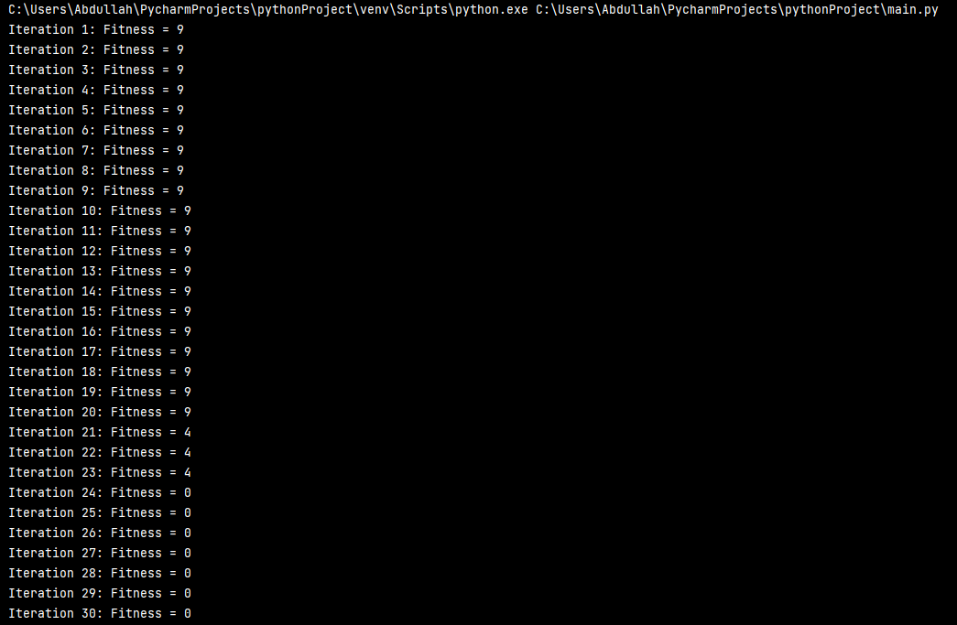

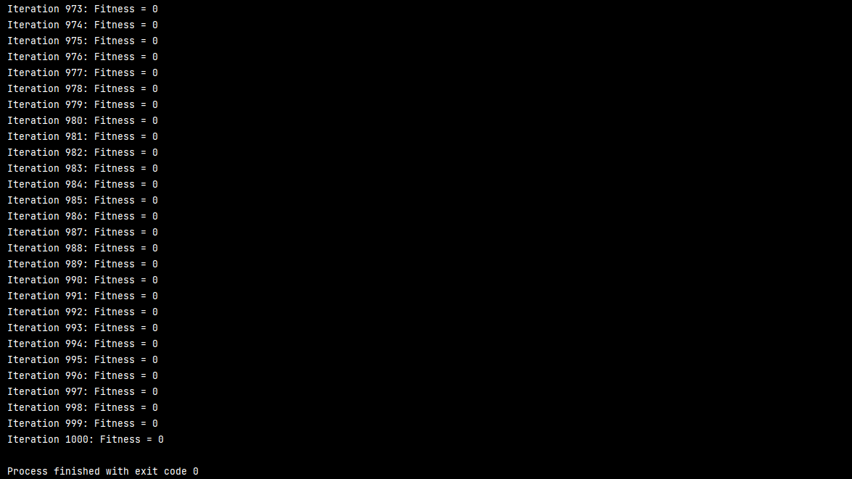

GUI output

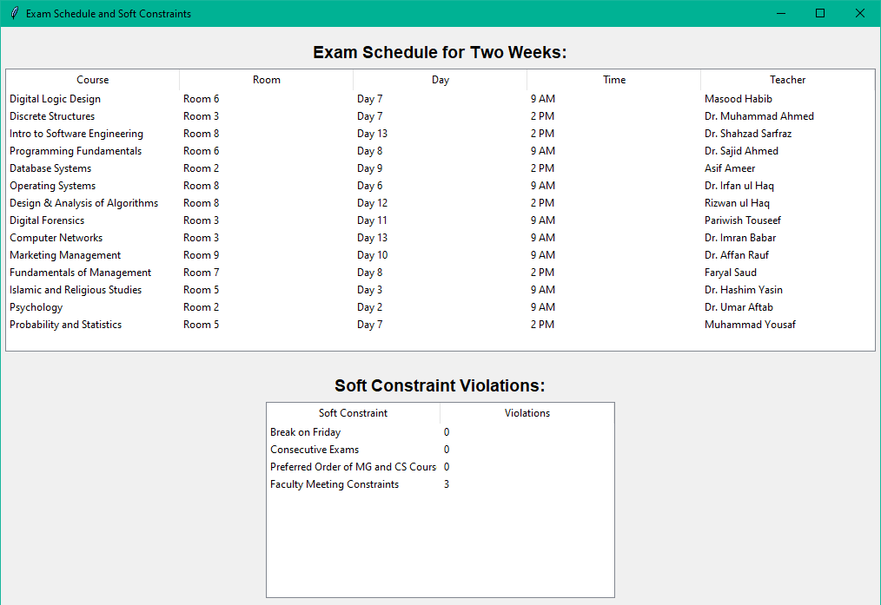

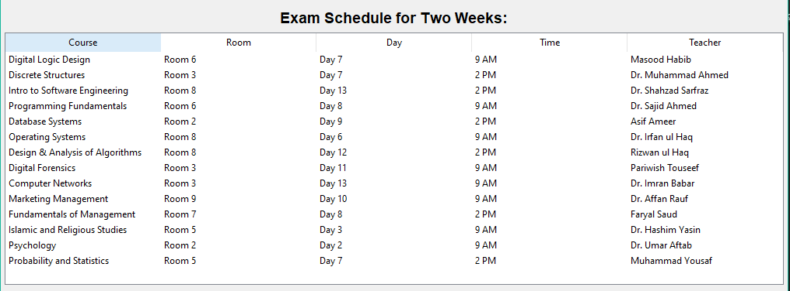

These two files will form  
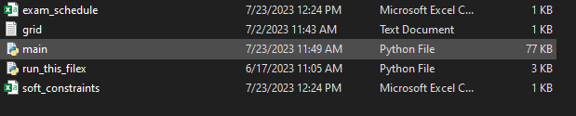

Files Output

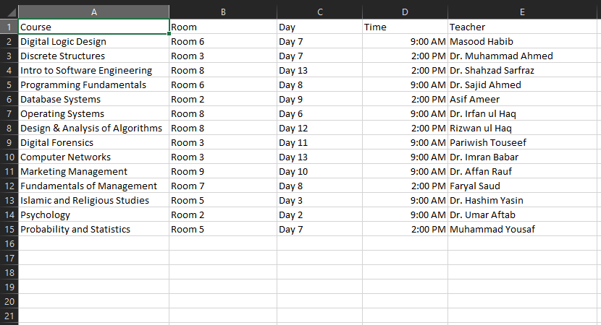

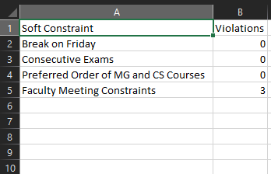

After performing some test on the code we updated the code which not only do simple two week also do three weeks exam schedule and also make two csv files and two soft constraints file with output of two GUI:

Here is updated code:

import numpy as np  
import pandas as pd  
import copy  
import math  
import random  
import tkinter as tk  
from tkinter import ttk  
from tkinter import messagebox  
  
def import_data(fileDir):  
 teachers_df = pd.read_csv(fileDir + 'teachers.csv')  
 students_df = pd.read_csv(fileDir + 'studentNames.csv')  
 rooms_df = pd.read_csv(fileDir + 'rooms.csv')  
 courses_df = pd.read_csv(fileDir + 'courses.csv')  
 registered_courses_df = pd.read_csv(fileDir + 'studentCourse.csv')  
  
 teachers = list(teachers_df.iloc[:**, 0**])  
 students = list(students_df.iloc[:**, 0**])  
 rooms = {i + **1**: capacity for i**,** capacity in enumerate(rooms_df.iloc[:**, 1**])}  
 courses = {course_code: course_name for course_code**,** course_name in  
 zip(courses_df.iloc[:**, 0**]**,** courses_df.iloc[:**, 1**])}  
 student_courses = {(student_name**,** course_code) for student_name**,** course_code in  
 zip(registered_courses_df.iloc[:**, 1**]**,** registered_courses_df.iloc[:**, 2**])}  
  
 return teachers**,** students**,** rooms**,** courses**,** student_courses  
  
def random_solution(courses**,** students**,** rooms**,** num_days):  
 exam_schedule = {}  
 for course_code**,** course_name in courses.items():  
 exam_schedule[course_code] = {  
 'course': course_name**,** 'room': random.sample(list(rooms.keys())**, 1**)**,** 'teacher': random.sample(teachers**, 1**)**,** 'time': random.choice([**9, 14**])**,** # 9 AM or 2 PM  
 'date': random.randint(**1,** num_days) # Random date between 1 and num_days  
 }  
 return exam_schedule  
  
def calculate_fitness(exam_schedule**,** student_courses**,** num_days):  
 num_violations = **0** for day in range(**1,** num_days + **1**):  
 for time in [**9, 14**]:  
 exams_at_time = [course_code for course_code**,** exam in exam_schedule.items() if exam['date'] == day and exam['time'] == time]  
 for student in students:  
 num_exams = sum(**1** for course_code in exams_at_time if (student**,** course_code) in student_courses)  
 if num_exams > **1**:  
 num_violations += **1** for day in range(**1,** num_days + **1**):  
 for time in [**9, 14**]:  
 exams_at_time = [exam for exam in exam_schedule.values() if exam['date'] == day and exam['time'] == time]  
 teachers_at_time = [exam['teacher'][**0**] for exam in exams_at_time]  
 if len(set(teachers_at_time)) != len(teachers_at_time):  
 num_violations += **1** return num_violations  
  
def generate_neighbor_solution(current_solution**,** rooms**,** num_days):  
 new_solution = copy.deepcopy(current_solution)  
  
 exam_code**,** exam_info = random.choice(list(new_solution.items()))  
  
 new_date = random.randint(**1,** num_days)  
  
 new_solution[exam_code]['date'] = new_date  
 new_solution[exam_code]['room'] = random.sample(list(rooms.keys())**, 1**)  
  
 return new_solution  
  
def simulated_annealing(initial_solution**,** student_courses**,** num_days**,** max_iterations**,** initial_temperature**,** cooling_rate):  
 current_solution = initial_solution  
 current_fitness = calculate_fitness(current_solution**,** student_courses**,** num_days)  
 best_solution = current_solution.copy()  
 best_fitness = current_fitness  
  
 temperature = initial_temperature  
  
 for i in range(max_iterations):  
 new_solution = generate_neighbor_solution(current_solution**,** rooms**,** num_days)  
 new_fitness = calculate_fitness(new_solution**,** student_courses**,** num_days)  
  
 if new_fitness < current_fitness or random.uniform(**0, 1**) < math.exp((current_fitness - new_fitness) / temperature):  
 current_solution = new_solution  
 current_fitness = new_fitness  
  
 if new_fitness < best_fitness:  
 best_solution = new_solution  
 best_fitness = new_fitness  
  
 temperature *= cooling_rate  
  
 print(f"Iteration {i + **1**}: Fitness = {best_fitness}")  
  
 return best_solution  
  
def check_break_constraint(exam_schedule**,** num_days):  
 num_violations = **0** for day in range(**1,** num_days + **1**):  
 exams_at_time = [exam for exam in exam_schedule.values() if exam['date'] == day and exam['time'] == **13**] # 1 PM  
 if exams_at_time:  
 num_violations += **1** return num_violations  
  
def check_consecutive_exams_constraint(exam_schedule**,** student_courses**,** num_days):  
 num_violations = **0** for day in range(**1,** num_days + **1**):  
 exams_at_day = [exam for exam in exam_schedule.values() if exam['date'] == day]  
 exams_at_day.sort(key=lambda x: x['time']) # Sort exams by time on the day  
 for i in range(len(exams_at_day) - **1**):  
 current_exam = exams_at_day[i]  
 next_exam = exams_at_day[i + **1**]  
 if current_exam['time'] == **9** and next_exam['time'] == **14**: # Consecutive exams  
 for student in students:  
 if (student**,** current_exam['course']) in student_courses and (student**,** next_exam['course']) in student_courses:  
 num_violations += **1** return num_violations  
  
def check_preferred_order_constraint(exam_schedule**,** student_courses):  
 num_violations = **0** for student in students:  
 has_mg_course = any(course_code.startswith('MG') for (_**,** course_code) in student_courses if student == student)  
 has_cs_course = any(course_code.startswith('CS') for (_**,** course_code) in student_courses if student == student)  
 if has_mg_course and has_cs_course:  
 mg_course_exam = next((exam for exam in exam_schedule.values() if exam['course'].startswith('MG') and (student**,** exam['course']) in student_courses)**,** None)  
 cs_course_exam = next((exam for exam in exam_schedule.values() if exam['course'].startswith('CS') and (student**,** exam['course']) in student_courses)**,** None)  
 if mg_course_exam and cs_course_exam:  
 if mg_course_exam['date'] > cs_course_exam['date']:  
 num_violations += **1** return num_violations  
  
  
def check_faculty_meeting_constraint(exam_schedule**,** num_days):  
 num_violations = **0** half_days = math.ceil(num_days / **2**)  
 for day in range(**1,** half_days + **1**):  
 exams_at_day = [exam for exam in exam_schedule.values() if exam['date'] == day]  
 if len(exams_at_day) == **0**:  
 num_violations += **1** return num_violations  
  
def calculate_soft_constraints(exam_schedule**,** student_courses**,** num_days):  
  
 soft_constraints = {  
 'Break on Friday': check_break_constraint(exam_schedule**,** num_days)**,** 'Consecutive Exams': check_consecutive_exams_constraint(exam_schedule**,** student_courses**,** num_days)**,** 'Preferred Order of MG and CS Courses': check_preferred_order_constraint(exam_schedule**,** student_courses)**,** 'Faculty Meeting Constraints': check_faculty_meeting_constraint(exam_schedule**,** num_days)  
 }  
 return soft_constraints  
  
import tkinter as tk  
from tkinter import ttk  
  
def display_schedule_gui(exam_schedule_df_two_weeks**,** exam_schedule_df_three_weeks**,** soft_constraints_df_two_weeks**,** soft_constraints_df_three_weeks):  
 # Create the main window for exam schedule  
 exam_schedule_window = tk.Tk()  
 exam_schedule_window.title("2-Week and 3-Week Exam Schedule")  
  
 # Create a Frame for 2-week exam schedule  
 exam_schedule_frame_two_weeks = ttk.Frame(exam_schedule_window)  
 exam_schedule_frame_two_weeks.pack(pady=**10**)  
  
 exam_schedule_label_two_weeks = tk.Label(exam_schedule_frame_two_weeks**,** text="2-Week Exam Schedule:"**,** font=("Arial"**, 14,** "bold"))  
 exam_schedule_label_two_weeks.grid(row=**0,** column=**0,** columnspan=**5,** pady=**5**)  
  
 exam_schedule_tree_two_weeks = ttk.Treeview(exam_schedule_frame_two_weeks**,** columns=('Course'**,** 'Room'**,** 'Date'**,** 'Time'**,** 'Teacher')**,** show='headings'**,** height=**15**)  
 exam_schedule_tree_two_weeks.grid(row=**1,** column=**0,** columnspan=**5,** padx=**5**)  
  
 exam_schedule_tree_two_weeks.heading('Course'**,** text='Course')  
 exam_schedule_tree_two_weeks.heading('Room'**,** text='Room')  
 exam_schedule_tree_two_weeks.heading('Date'**,** text='Date')  
 exam_schedule_tree_two_weeks.heading('Time'**,** text='Time')  
 exam_schedule_tree_two_weeks.heading('Teacher'**,** text='Teacher')  
  
 # Add data to the Treeview widget for 2-week exam schedule  
 for i**,** row in exam_schedule_df_two_weeks.iterrows():  
 exam_schedule_tree_two_weeks.insert(''**,** tk.END**,** values=(row['course']**,** row['room']**,** f"Day {row['date']}"**,** f"{row['time']} {['AM'**,** 'PM'][row['time'] == **14**]}"**,** row['teacher']))  
  
 # Add a vertical scrollbar to the Treeview widget for 2-week exam schedule  
 scrollbar_two_weeks = ttk.Scrollbar(exam_schedule_frame_two_weeks**,** orient="vertical"**,** command=exam_schedule_tree_two_weeks.yview)  
 scrollbar_two_weeks.grid(row=**1,** column=**6,** sticky="ns")  
 exam_schedule_tree_two_weeks.configure(yscrollcommand=scrollbar_two_weeks.set)  
  
 # Create a Frame for 3-week exam schedule  
 exam_schedule_frame_three_weeks = ttk.Frame(exam_schedule_window)  
 exam_schedule_frame_three_weeks.pack(pady=**10**)  
  
 exam_schedule_label_three_weeks = tk.Label(exam_schedule_frame_three_weeks**,** text="3-Week Exam Schedule:"**,** font=("Arial"**, 14,** "bold"))  
 exam_schedule_label_three_weeks.grid(row=**0,** column=**0,** columnspan=**5,** pady=**5**)  
  
 exam_schedule_tree_three_weeks = ttk.Treeview(exam_schedule_frame_three_weeks**,** columns=('Course'**,** 'Room'**,** 'Date'**,** 'Time'**,** 'Teacher')**,** show='headings'**,** height=**15**)  
 exam_schedule_tree_three_weeks.grid(row=**1,** column=**0,** columnspan=**5,** padx=**5**)  
  
 exam_schedule_tree_three_weeks.heading('Course'**,** text='Course')  
 exam_schedule_tree_three_weeks.heading('Room'**,** text='Room')  
 exam_schedule_tree_three_weeks.heading('Date'**,** text='Date')  
 exam_schedule_tree_three_weeks.heading('Time'**,** text='Time')  
 exam_schedule_tree_three_weeks.heading('Teacher'**,** text='Teacher')  
  
 # Add data to the Treeview widget for 3-week exam schedule  
 for i**,** row in exam_schedule_df_three_weeks.iterrows():  
 exam_schedule_tree_three_weeks.insert(''**,** tk.END**,** values=(row['course']**,** row['room']**,** f"Day {row['date']}"**,** f"{row['time']} {['AM'**,** 'PM'][row['time'] == **14**]}"**,** row['teacher']))  
  
 # Add a vertical scrollbar to the Treeview widget for 3-week exam schedule  
 scrollbar_three_weeks = ttk.Scrollbar(exam_schedule_frame_three_weeks**,** orient="vertical"**,** command=exam_schedule_tree_three_weeks.yview)  
 scrollbar_three_weeks.grid(row=**1,** column=**6,** sticky="ns")  
 exam_schedule_tree_three_weeks.configure(yscrollcommand=scrollbar_three_weeks.set)  
  
 # Run the GUI event loop for exam schedule  
 exam_schedule_window.mainloop()  
  
 # Create a separate window for soft constraints  
 soft_constraints_window = tk.Tk()  
 soft_constraints_window.title("Soft Constraint Violations")  
  
 # Create a Frame to contain the soft constraint violations data for 2-week  
 soft_constraints_frame_two_weeks = ttk.Frame(soft_constraints_window)  
 soft_constraints_frame_two_weeks.pack(pady=**10**)  
  
 # Create a Label for the soft constraint violations section for 2-week  
 soft_constraints_label_two_weeks = tk.Label(soft_constraints_frame_two_weeks**,** text="Soft Constraint Violations (2-Week):"**,** font=("Arial"**, 14,** "bold"))  
 soft_constraints_label_two_weeks.grid(row=**0,** column=**0,** columnspan=**5,** pady=**5**)  
  
 # Create a Treeview widget to display the soft constraint violations data in a table format for 2-week  
 soft_constraints_tree_two_weeks = ttk.Treeview(soft_constraints_frame_two_weeks**,** columns=('Soft Constraint'**,** 'Violations')**,** show='headings'**,** height=**10**)  
 soft_constraints_tree_two_weeks.grid(row=**1,** column=**0,** columnspan=**5,** padx=**5**)  
  
 soft_constraints_tree_two_weeks.heading('Soft Constraint'**,** text='Soft Constraint')  
 soft_constraints_tree_two_weeks.heading('Violations'**,** text='Violations')  
  
 # Add data to the Treeview widget for 2-week  
 for i**,** row in soft_constraints_df_two_weeks.iterrows():  
 soft_constraints_tree_two_weeks.insert(''**,** tk.END**,** values=(row['Soft Constraint']**,** row['Violations']))  
  
 # Create a Frame to contain the soft constraint violations data for 3-week  
 soft_constraints_frame_three_weeks = ttk.Frame(soft_constraints_window)  
 soft_constraints_frame_three_weeks.pack(pady=**10**)  
  
 # Create a Label for the soft constraint violations section for 3-week  
 soft_constraints_label_three_weeks = tk.Label(soft_constraints_frame_three_weeks**,** text="Soft Constraint Violations (3-Week):"**,** font=("Arial"**, 14,** "bold"))  
 soft_constraints_label_three_weeks.grid(row=**0,** column=**0,** columnspan=**5,** pady=**5**)  
  
 # Create a Treeview widget to display the soft constraint violations data in a table format for 3-week  
 soft_constraints_tree_three_weeks = ttk.Treeview(soft_constraints_frame_three_weeks**,** columns=('Soft Constraint'**,** 'Violations')**,** show='headings'**,** height=**10**)  
 soft_constraints_tree_three_weeks.grid(row=**1,** column=**0,** columnspan=**5,** padx=**5**)  
  
 soft_constraints_tree_three_weeks.heading('Soft Constraint'**,** text='Soft Constraint')  
 soft_constraints_tree_three_weeks.heading('Violations'**,** text='Violations')  
  
 # Add data to the Treeview widget for 3-week  
 for i**,** row in soft_constraints_df_three_weeks.iterrows():  
 soft_constraints_tree_three_weeks.insert(''**,** tk.END**,** values=(row['Soft Constraint']**,** row['Violations']))  
  
 # Run the GUI event loop for soft constraints  
 soft_constraints_window.mainloop()  
  
# Constants  
fileDir = './test_dataset/'  
num_days_two_weeks = **14**num_days_three_weeks = **21**max_iterations = **1000**initial_temperature = **1000.0**cooling_rate = **0.95**# Load data  
teachers**,** students**,** rooms**,** courses**,** student_courses = import_data(fileDir)  
  
# Generate initial solution for two weeks  
initial_solution_two_weeks = random_solution(courses**,** students**,** rooms**,** num_days_two_weeks)  
  
# Run simulated annealing algorithm to generate exam schedule for two weeks  
exam_schedule_2_weeks = simulated_annealing(initial_solution_two_weeks**,** student_courses**,** num_days_two_weeks**,** max_iterations**,** initial_temperature**,** cooling_rate)  
  
# Calculate soft constraints for two weeks  
soft_constraints_two_weeks = calculate_soft_constraints(exam_schedule_2_weeks**,** student_courses**,** num_days_two_weeks)  
  
# Generate initial solution for three weeks  
initial_solution_three_weeks = random_solution(courses**,** students**,** rooms**,** num_days_three_weeks)  
  
# Run simulated annealing algorithm to generate exam schedule for three weeks  
exam_schedule_3_weeks = simulated_annealing(initial_solution_three_weeks**,** student_courses**,** num_days_three_weeks**,** max_iterations**,** initial_temperature**,** cooling_rate)  
  
# Calculate soft constraints for three weeks  
soft_constraints_three_weeks = calculate_soft_constraints(exam_schedule_3_weeks**,** student_courses**,** num_days_three_weeks)  
  
# Convert the exam schedules to DataFrames  
exam_schedule_df_two_weeks = pd.DataFrame(exam_schedule_2_weeks.values())  
exam_schedule_df_three_weeks = pd.DataFrame(exam_schedule_3_weeks.values())  
  
# Save exam schedules and soft constraint violations to CSV files  
exam_schedule_df_two_weeks.to_csv('exam_schedule_two_weeks.csv'**,** index=False)  
exam_schedule_df_three_weeks.to_csv('exam_schedule_three_weeks.csv'**,** index=False)  
  
soft_constraints_df_two_weeks = pd.DataFrame(soft_constraints_two_weeks.items()**,** columns=['Soft Constraint'**,** 'Violations'])  
soft_constraints_df_three_weeks = pd.DataFrame(soft_constraints_three_weeks.items()**,** columns=['Soft Constraint'**,** 'Violations'])  
  
soft_constraints_df_two_weeks.to_csv('soft_constraints_two_weeks.csv'**,** index=False)  
soft_constraints_df_three_weeks.to_csv('soft_constraints_three_weeks.csv'**,** index=False)  
  
# Display the exam schedules and soft constraint violations in GUIs  
display_schedule_gui(exam_schedule_df_two_weeks**,** exam_schedule_df_three_weeks**,** soft_constraints_df_two_weeks**,** soft_constraints_df_three_weeks)

output:

code generates iterations and fitness and four(4) CSV files

1. 2- Exam_schedule.csv
2. 2- Soft_constraints.csv
3. And also A GUI of timetable using tkinter with two interfaces

Output of latest code:

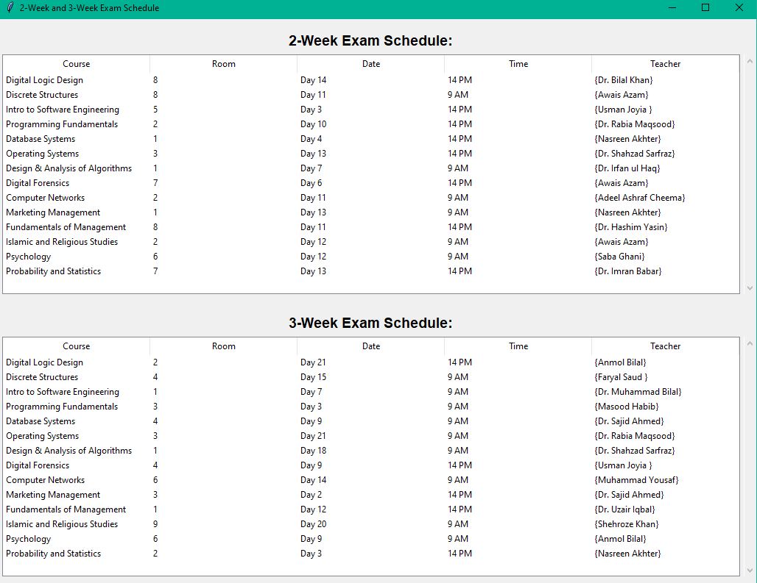

Files:

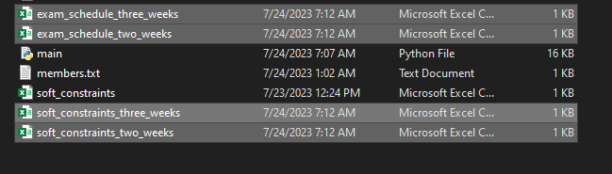

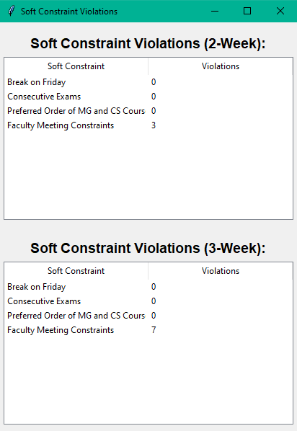

Files output:

