
Mawlana Bhashani Science and Technology University
Santosh, Tangail-1902.

Lab Report

Department of Information and Communication Technology

Report No: 01

Report Name: Mininet Walkthrough
Course Title: Network Planning and designing Lab.
Course Code: ICT-3208

Submitted By | Submitted To
Name: Md.Abdullah Al Mamun  ID: IT-18040  Session: 2017-18  3rd Year 2nd Semester  Dept. of Information & Communication Technology, MBSTU. | Nazrul Islam  Assistant Professor,  Dept. of Information & Communication Technology, MBSTU.

Submission Date: 13-11-2020

Objectives. In this lab, you will start by learning the basics of running Mininet in a virtual machine. Mininet facilitates creating and manipulating Software Defined Networking components. Through mininet you will explore OpenFlow, which is an open interface for controlling the network elements through their forwarding tables. A network element may be converted into a switch, router or even an access points via low-level primitives defined in OpenFlow. This lab is your opportunity to gain hands-on experience with the platforms and debugging tools most useful for developing network control applications on OpenFlow.
Access Mininet on the virtual machine.
Run the Ryu controller with a sample application.
Use various commands to gain experience with openFlow control of OpenvSwitch.

Explanation :
Mininet: Mininet is a network emulator which creates a network of virtual hosts, switches, controllers, and links. Mininet hosts run standard Linux network software, and its switches support OpenFlow for highly flexible custom routing and Software-Defined Networking.

Everyday Mininet Usage
### Display startup options: ‘sudo mn -h’ command to display a help message describing Mininet’s startup options.
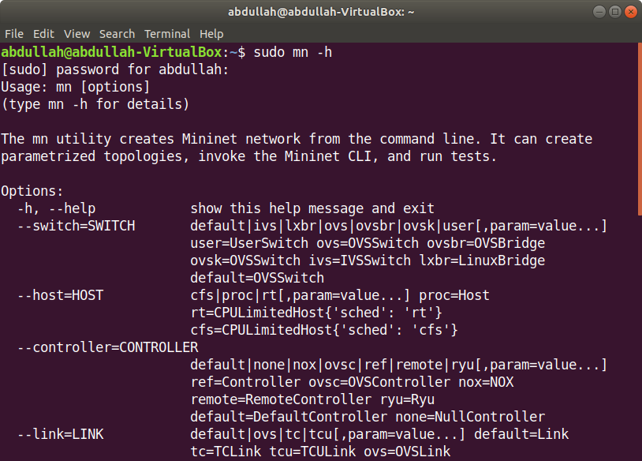

### Start Wireshark : To view control traffic using the OpenFlow Wireshark dissector, first open wireshark in the background

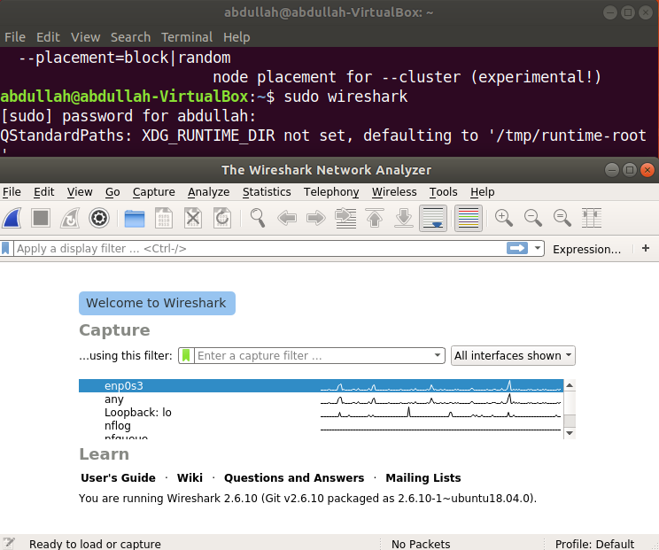

Interact with Hosts and Switches:
## Start a minimal topology and enter the CLI

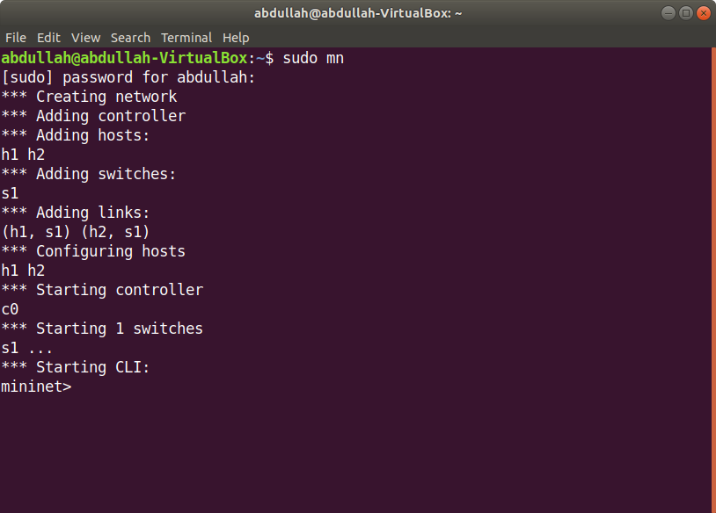

## Display Mininet CLI commands:

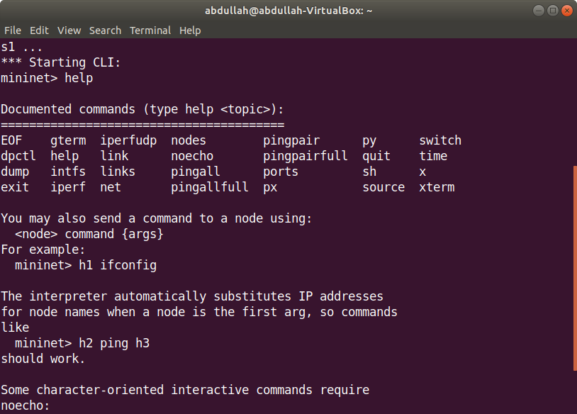

## Display nodes:

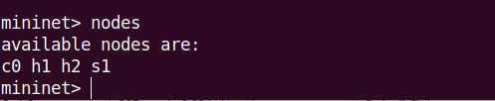

## Display links:

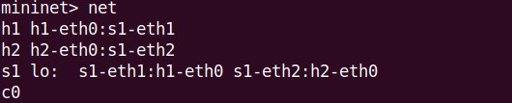

## Dump information about all nodes:

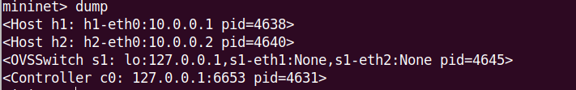

Run a command on a host process:

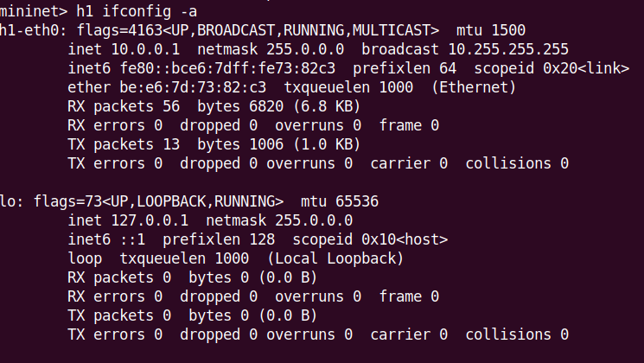

## Running a command on the “switch” is the same as running it from a regular terminal:

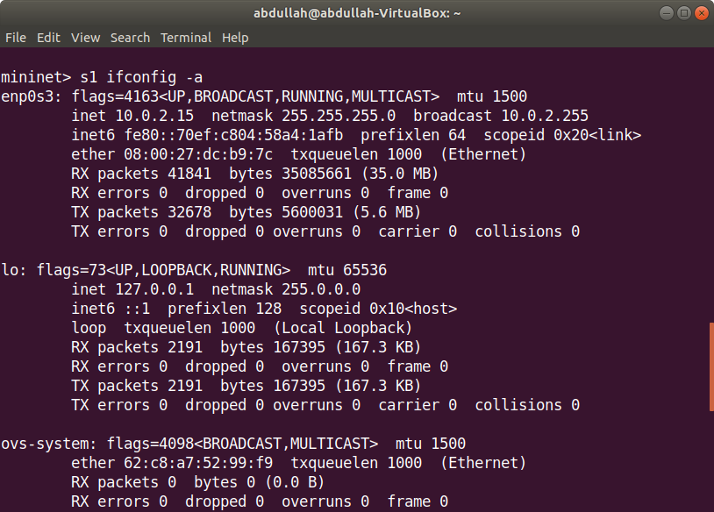

### print the process list from a host process:

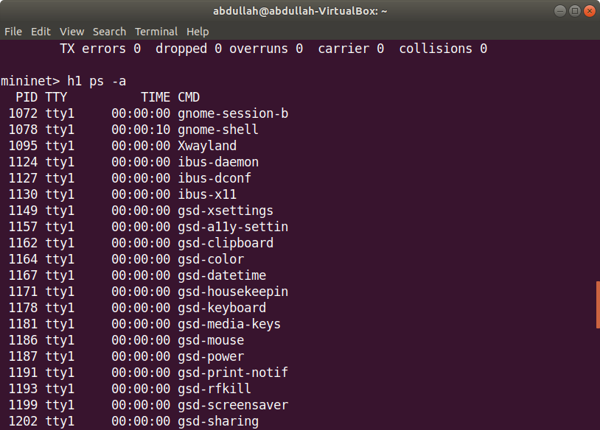

### Host processseen by the root network namespace:

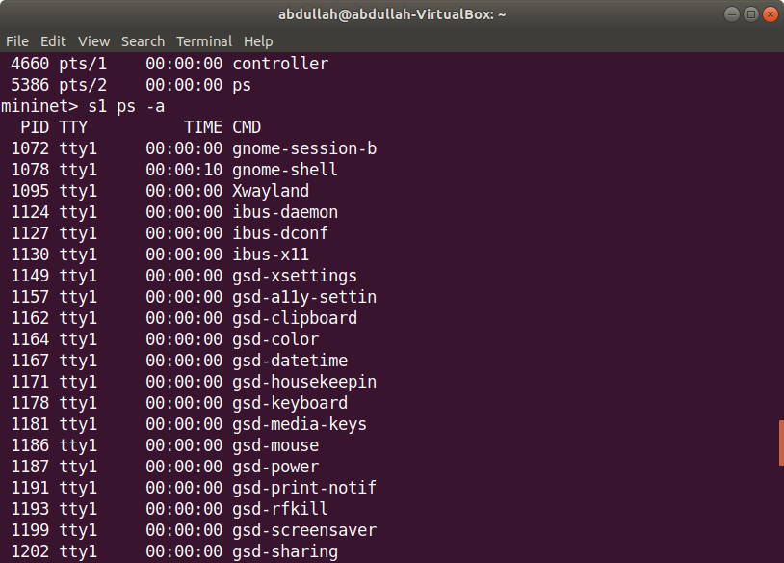

### Now, verify that you can ping from host 0 to host 1

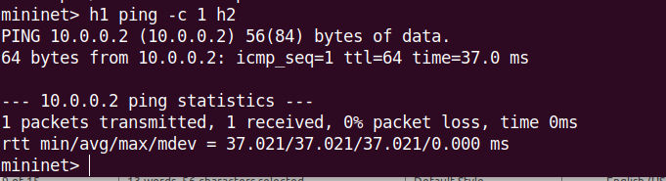

### An easier way to run this test is to use the Mininet CLI built-in pingall command, which does an all-pairs ping me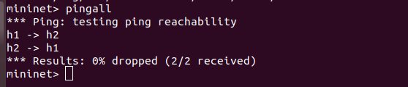:

### Try starting a simple HTTP server on h1, making a request from h2, then shutting down the web server:
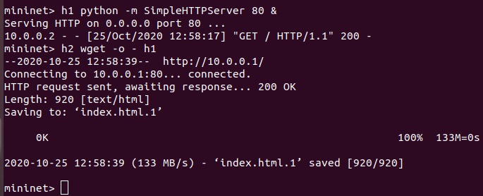
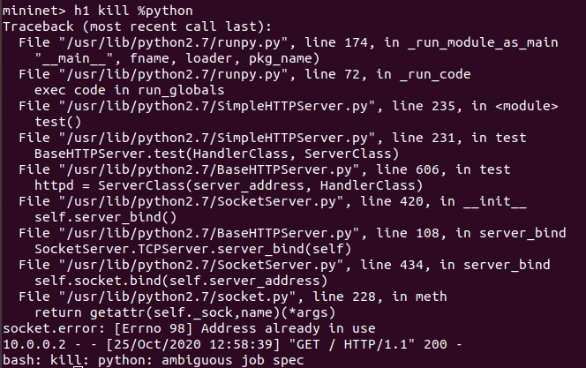

Advanced Startup Options:

### Run a regression test:

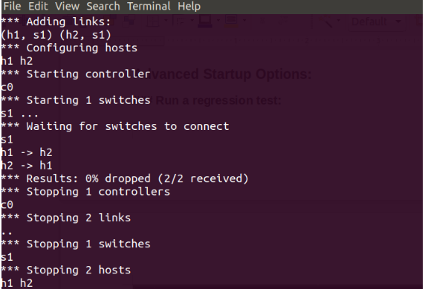

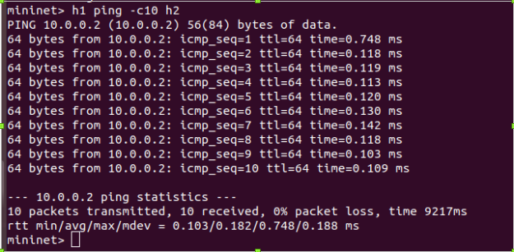

### Mininet 2.0 allows you to set link parameters, and these can even be set automatially from the command line:

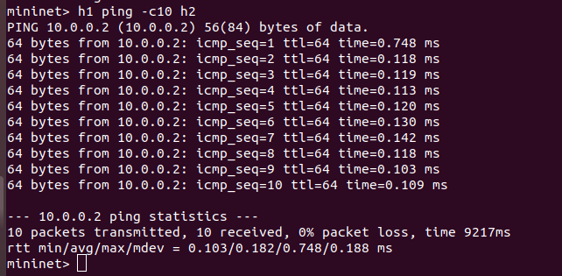

### The --mac option is super-useful, and sets the host MAC and IP addrs to small, unique, easy-to-read IDs.

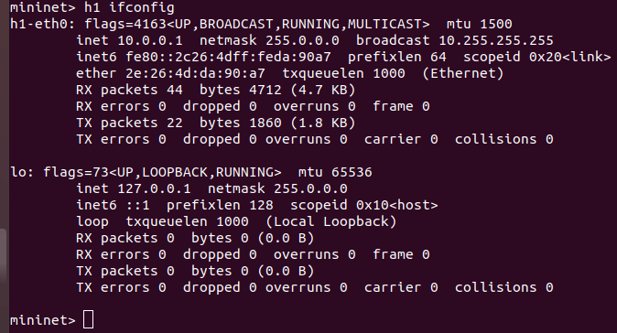

### The iperf-reported TCP bandwidth should be similar to the OpenFlow kernel module, and possibly faster:

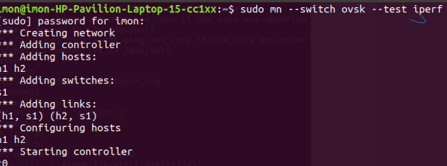
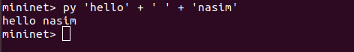

### Print the accessible local variables
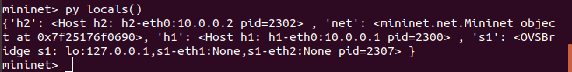

### I can also evaluate methods of variables:
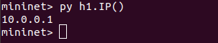

Conclusion:Mininet is a software emulator for prototyping a large network on a single machine. Mininet can be used to quickly create a realistic virtual network running actual kernel, switch and software application code on a personal computer. From this lab , I have known that the walkthrough of mininet . I also known that mininet how to creates a network of virtual hosts, switches, controllers, and links. Mininet hosts run standard Linux network software, and its switches support OpenFlow for highly flexible custom routing and Software-Defined Networking. In future , Mininet supports research, development, learning, prototyping, testing, debugging, and any other tasks

