

Mawlana Bhashani Science and Technology University

Lab-Report

Report No: Linux assignment -2
Course code: ICT-3208
Course title:Networking configuration, Routing table,virtual interface.
Date of Performance:29-12-20
Date of Submission:30-12-20

Submitted by Submitted To
Nazrul Islam
Assistant Professor
Dept. of ICT
MBSTU.

Name: Md.Abdullah Al Mamaun
ID:IT-18040
3th year 2ndsemester
Session: 2017-2018
Dept. of ICT
MBSTU.

1. If you have a network that ranges from 192.168.1.0 to192.168.1.255 expline why individual devices in the network can only be assigned IP addresses in the range of 192.168.1.0 to 192.168.1.255
ANSWER :

IP address use to identify individual computer.
The range from 192.168.1.0 to 192.168.1.255 are class in C
We know that in class C .Every IP address has 32 bit. There are 24 bit are use to network and 8 bit use to host.

192. 168.1.255
Net bits=24
Host Bits=8
11000000 .10101000. 00000001 . 11111111
NetID HostID

Host 8 bits means. We can 28 = 256 identify individual computer for every a device. Actually 00000000 and 11111111 are not use to specific host and it is not effective address.
So
Host per network = 28 = 255-2 = 254 .
So Individual devices in the network can only be assigned IP addresses in the range of 192.168.1.1 to 192.168.1.254

2.Find IP address and MAC Address in your computer?
Answer:
IP address : 192.168.42.15
Physical address (MAC): B6-FF-33-9F-EA-88

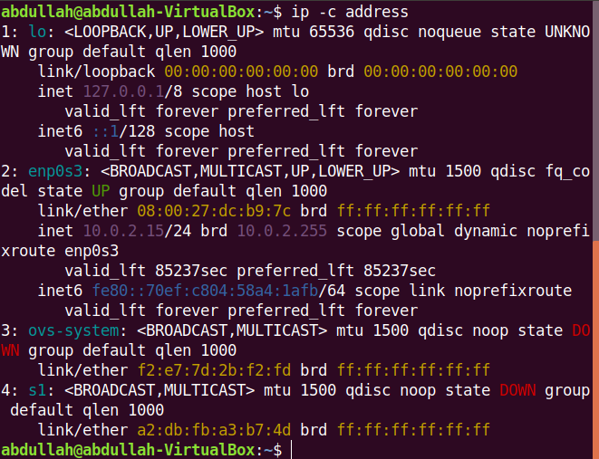

3) Routing Table basics

Now, enter the command: "$ netstat -r" to print your computers routing table.
Explain (very briefly) the different columns: Destination, Gateway, Genmask,
Flags, MSS, Window, irtt and Iface, (write the answer in your written report
in table form).

Answer:
When a router receives a packet, it examines the destination IP address, and looks up
into its Routing Table to figure out which interface packet will be sent out.

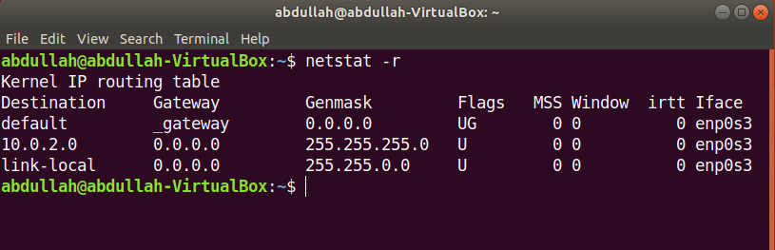
Destination : The network ID or destination corresponding to the route.

Gateway : This column indicates the defined gateway for the network. If you see an *
in this column, it means that no forwarding gateway is needed for the specified
network.
Genmask :
The mask that is used to match a destination IP address to the network ID.
Flags: The U output in this columns means that the route is up. The G output
indicates that specified gateway should be used for this route. D stands for
dynamically installed, M stands for modified, and R means reinstated.
MSS : The MSS column indicates the default Maximum Segment Size for TCP
connections over this route.

Windows : The Window column indicates the default window size for TCP
connections over this route.
Irtt : The Irtt column indicates the Initial Round Trip Time for this route.

Iface : The Iface column shows the network interface. If you had more than one
interface, you would see lo (for loopback), eth0 (first Ethernet device), and eth1 (for
the second Ethernet device), and so on for the number of interfaces you have
installed.

4) Virtual Interfaces

Linux offers the possibility to set up interfaces according to your networking needs.
For instance, if needed, you can configure an interface for multiple IP addresses by
creating new virtual interfaces with another IP address.

a) Create a new virtual interface with following IP address, 192.168.2.32 an netmask
255.255.255.0 then check to see if the interface was created successfully? (save a
print screen of your interface table to display in your written report document).

b) Now, you need to set up a route for this interface so that your computercan see it.
Otherwise, everyone else on the network will be able to reach the new interface
except you. Issue the needed command, then issue the "$ netstat" -‐r" command and
check if the route to your added interface is visible (save a print screen of your
routing table to display in your written report document together with the
command(s) you used to set up the interface).

c) Next remove the route for this interface, (write down the command(s) in your
written report).

d) Then remove the interface completely, (write down the command(s) in your
written report).

Answer:

a) Creating Virtual Interface :

sudo ip addr add 192.168.2.32/24 brd + dev eno1 label eno1:vir

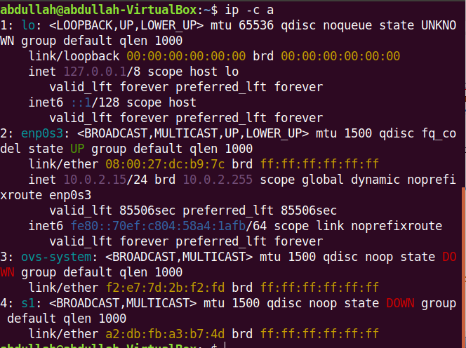

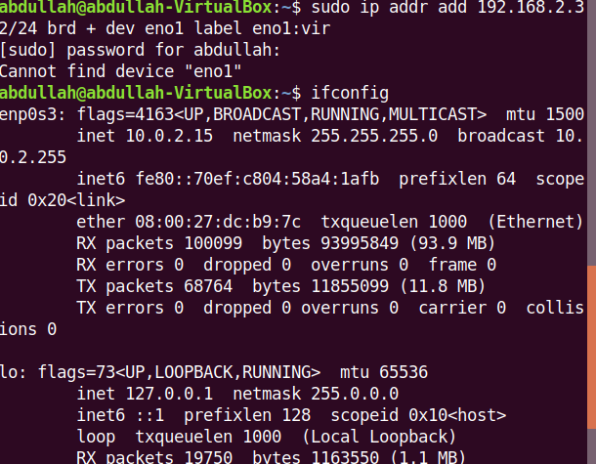

b) Inserting Interface in the Routing Table:

sudo route add default gw 192.168.2.32

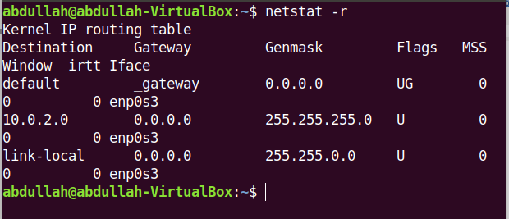

c) Deleting Interface from Routing table:

sudo route delete default gw 192.168.2.32

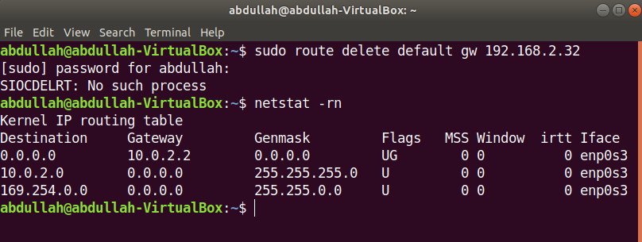

d) Deleting Virtual Interface:

sudo ip addr delete 192.168.2.32/24 dev eno1:vir

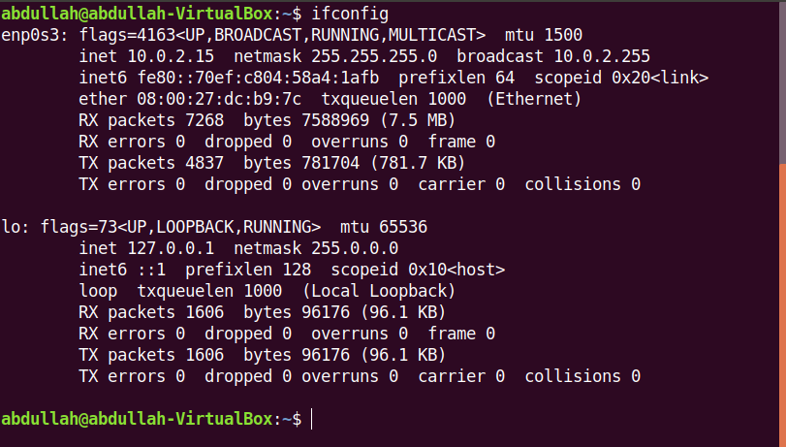

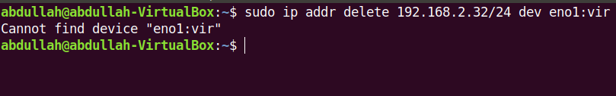

5) Add a New Network

Add a new network. Obviously, first you need to be aware of your network address,
netmask, gateway and what ethernet device you wish to set up for it. However, to
keep things simple but still get a feel for the principle, in our case we will use the
values for the primary network you belong to.

a) Enter the command needed to add another network with the same values as your
primary network meaning: (yourPrimaryNetorkAddress) and
(netmaskForYourNetwork), (write down the command(s) in your written
report).

b) Assign the default gateway for your newly added network (tip the same default
gateway as you primary network), (yourDefaultGatewayAddress)

c) Look for your newly added network in your routing table by issuing the "$ netstat
-r" command. You should now have a double setup of your primary network in the
table (save a print screen of your routing table to display in your written report
document).

d) Now, remove your changes meaning the double routing table setup for your
primary network. First issue the command needed to delete your newly added
route then issue the command to delete your newly added default gateway. (write
down the command(s) in your written report)

6) Multinetwork Scenario Configuration.

You should now set up a working routing table for a multi-‐network scenario.
Assume that you have two network cards available connected to two different
LANs. The destination of the first network is, 10.0.2.0 with netmask 255.0.0.0
and the second, 192.168.1. with netmask 255.255.255.0. Furthermore, a firewall is
assumed to exist between the two networks, where network card eth0 is attached to
the 10.0.2.0 network and eth1 is attached to the 192.168.1.0 network. To forward
packets on the Internet the firewall needs to route packets from the 10.0.2.0 network
through the 192.168.1.0 network. The firewall system must be set up with two IP
addresses, 10.0.2.1 on eth0 and 192.168.1.25 on eth1. The gateway to the Internet on
the 192.168.1.0 network should be 192.168.1.1.

Provide the necessary commands to route on the firewall/router system:
a) Assign the firewall IP addresses to eth1 and eth2.
b) Add the routesfor the networks, i.e.,192.168.1.0 on eth1 and 10.0.2.0 on eth0
c) Assign the Internet gateway (meaning: 192.168.1.1) as the default gateway.
(Write down the command(s) in your written report)

d) Enter the necessary command(s) in order for packets belonging to computers in the
10.0.2.0 network to be routed to the 192.168.1.0 network and the Internet. In other
words this should tell each computer on the 10.0.2.0, which the default gateway is,
i.e., your firewall/router. You do not need to worry about the route back configuration
it is enough to assign the proper default gateway for the 10.0.2.0 network. (write
down the command(s) in your written report)

Answer:

Linux easily manages multiple network interface adapters. Laptops typically
include both wired and wireless interfaces, and may also support WiMax
interfaces for cellular networks. Linux desktop computers also support multiple
network interfaces, and you can use your Linux computer as a multi-network client,
or as a router for internal networks; such is the case with a couple of my own
systems. Every network interface has its own configuration file in the
/etc/sysconfig/network-scripts directory. Each interface has a configuration file
named ifcfg-X, where X is the number of the interface, starting with zero or 1

depending upon the naming convention in use; for example /etc/sysconfig/network-
scripts/ifcfg-eth0 for the first Ethernet interface.

Most of the other files in the /etc/sysconfig/network-scripts directory are scripts
used to start, stop and perform various network configuration activities.

Each interface configuration file is bound to a specific physical network interface
by the MAC address of the interface.

There are many configuration options for the interface configuration files. These
are some of the more common options:

• DEVICE : The logical name of the device, such as eth0 or enp0s2.

• HWADDR : The MAC address of the NIC that is bound to the file, such as
00:16:76:02:BA:DB

• ONBOOT : Start the network on this device when the host boots. Options are
yes/no. This is typically set to "no" and the network does not start until a user
logs in to the desktop. If you need the network to start when no one is logged
in, set this to "yes".

• IPADDR : The IP Address assigned to this NIC such as 192.168.0.10

• BROADCAST : The broadcast address for this network such as 192.168.0.255

• NETMASK : The netmask for this subnet such as the class C mask
255.255.255.0

• NETWORK : The network ID for this subnet such as the class C ID
192.168.0.0‐

• SEARCH : The DNS domain name to search when doing lookups on
unqualified hostnames such as "example.com" BOOTPROTO: The boot
protocol for this interface. Options are static, DHCP, bootp, none. The "none"
option defaults to static.

