***Lab Report - 01***

**What is Linux Operating System**?

Just like Windows, iOS, and Mac OS, Linux is an operating system. In fact, one of the most popular platforms on the planet, Android, is powered by the Linux operating system. An operating system is software that manages all of the hardware resources associated with your desktop or laptop. To put it simply, the operating system manages the communication between your software and your hardware. Without the operating system (OS), the software wouldn?function.

The Linux operating system comprises several different pieces:

1. Bootloader –  The software that manages the boot process of your computer. For most users, this will simply be a splash screen that pops up and eventually goes away to boot into the operating system.
2. Kernel – This is the one piece of the whole that is actually called ?Linux?. The kernel is the core of the system and manages the CPU, memory, and peripheral devices. The kernel is the lowest level of the OS.
3. Init system – This is a sub-system that bootstraps the user space and is charged with controlling daemons. One of the most widely used init systems is systemd? which also happens to be one of the most controversial. It is the init system that manages the boot process, once the initial booting is handed over from the bootloader (i.e., GRUB or GRand Unified Bootloader).
4. Daemons – These are background services (printing, sound, scheduling, etc.) that either start up during boot or after you log into the desktop.
5. Graphical server – This is the sub-system that displays the graphics on your monitor. It is commonly referred to as the X server or just X.
6. Desktop environment – This is the piece that the users actually interact with. There are many desktop environments to choose from (GNOME, Cinnamon, Mate, Pantheon, Enlightenment, KDE, Xfce, etc.). Each desktop environment includes built-in applications (such as file managers, configuration tools, web browsers, and games).
7. Applications – Desktop environments do not offer the full array of apps. Just like Windows and macOS, Linux offers thousands upon thousands of high-quality software titles that can be easily found and installed. Most modern Linux distributions (more on this below) include App Store-like tools that centralize and simplify application installation. For example, Ubuntu Linux has the Ubuntu Software Center (a rebrand of GNOME Software? Figure 1) which allows you to quickly search among the thousands of apps and install them from one centralized location.

## Different Type of Linux Distribution:

## 1. Ubuntu

Yes, Ubuntu has become the poster child for Linux these days, and no wonder--it's the most popular distro by far, garnering more than 2,200 hits per day on the Distrowatch site alone, compared with some 1,400 for Fedora, the No. 2 contender.

Ubuntu is actually a relatively late arrival on the Linux scene, having been announced in just 2004, but it's more than made up for that shorter history. Founded by South African millionaire Mark Shuttleworth, Canonical--the company behind Ubuntu--for many years shipped Ubuntu CDs to interested users for free, thus speeding its market penetration.

Ubuntu is based on Debian (see below) and includes well-known apps such as Firefox and OpenOffice.org. It has a predictable, six-month release schedule, with occasional Long Term Support (LTS) versions that are supported with security updates for three to five years.

Ubuntu is also notable for its ease of use and its inclusion of a migration assistant for Windows users and support for the latest technologies. Version 10.10 of Ubuntu--also known as Maverick Meerkat will include a multitouch and gesture stack. The final iteration of that version is due out next month.

It's also worth understanding that Ubuntu is available in various remixes and spin-off sub-distros targeted at specific niches, such as Kubuntu, Xubuntu and Lubuntu. Most of these differ primarily by offering a desktop environment other than Ubuntu's standard GNOME

## **2. Fedora**

Fedora is the free version of Red Hat, whose RHEL (Red Hat Enterprise Linux) has been a commercial product since 2003. Because of that close connection, Fedora is particularly strong on enterprise features, and it often offers them before RHEL does.

Fedora also offers a six-month release schedule, and its security features are excellent. While some have viewed it as a cutting-edge distro for the Linux "hobbyist," I think improvements over the years and widespread popularity have combined to make it a good choice for newer Linux users as well.

## **3. Linux Mint**

Currently in Distrowatch's third spot in popularity, Linux Mint is an Ubuntu-based distro that was just launched in 2006. The operating system adds to Ubuntu with its own, distinct desktop theme and a different set of applications; also unique to the distro are a variety of graphical tools for enhanced usability, such as mintDesktop for configuring the desktop environment, mintInstall for easier software installation and mintMenu for easier navigation.

Mint enjoys a well-deserved reputation for ease of use, so it's another good one for beginning users. It also includes some proprietary multimedia codecs that are often absent from larger distributions, thereby enhancing its hardware compatibility. Mint doesn't have a fixed release schedule, but typically a new version comes out shortly after each stable Ubuntu release.

## **4. openSUSE**

With some 1,200 hits per day on Distrowatch, openSUSE holds the No. 4 spot in popularity on the site and is also the foundation for Novell's SUSE Linux Enterprise Desktop and SUSE Linux Enterprise Server products.

The package's administration utility, YaST, is widely acknowledged as one of the best, and its boxed edition comes with some of the best printed documentation you'll find for any distro. I'd say openSUSE rates a "medium" on difficulty level.

## **5. PCLinuxOS**

Rather than GNOME, PCLinuxOS uses the KDE desktop environment and is essentially a lighter-weight version of Mandriva (see below). With good support for graphics drivers, browser plugins and media codecs, PCLinuxOS can be a good choice for beginners. Its release cycle can be erratic, though, and there is also no 64-bit version of the software.

## **6. Debian**

Dating back to 1993, Debian is currently known as one of the most well-tested and bug-free distros available today. Though it serves as the foundation for Ubuntu, most view Debian as a distro best-suited for those experienced with Linux. The distro uses all open-source components, which is a good thing, but means it can be more difficult to achieve compatibility with proprietary code such as wireless network drivers. Debian also has a relatively slow release cycle, with stable ones coming out every one to three years.

## **7. Mandriva**

Formerly known as Mandrake, Mandriva is notable for its cutting-edge software, excellent administration suite and 64-bit edition. It was also the first major distribution to jump on the netbook bandwagon with out-of-the box support. Nevertheless, Mandriva has been struggling lately as a result of some controversial decisions made by its French maker. It recently restructured, with the result that some view the future of its community version as uncertain.

## **8. Sabayon/Gentoo**

Italian Sabayon is essentially a LiveCD version of Gentoo, which is known for allowing users to individually optimize each component. Both are considered advanced Linux distributions aimed primarily at experienced users.

## **9. Arch Linux... plus Slackware**

Arch is another package aimed primarily at experienced users interested in tweaking and optimizing their systems. Though not in the top 10 currently, Slackware is similarly oriented toward Linux gurus.

## **10. Puppy Linux... plus DSL**

Last on Distrowatch's top 10 currently is Puppy Linux, a compact distro that's ideal for older hardware and situations where computing resources are minimal. (Damn Small Linux, incidentally, is similar.) Though it has a small footprint, Puppy is still full-featured and includes a variety of configuration and application installation wizards. The whole OS is small enough to run directly from system RAM, so applications start quickly and respond to user input instantly.

**How can we install Linux Operating system**

### Installing Linux using Virtual Machine

This is a popular method to install a Linux operating system. The virtual installation offers you the freedom of running Linux on an existing OS already installed on your computer. This means if you have Windows running, then you can just run Linux with a click of a button.

Virtual machine software like Oracle VM can install Ubuntu in easy steps. Let us look at them.

**Here the brief steps**

[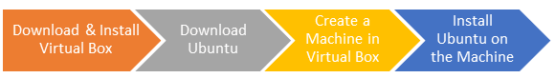](https://www.guru99.com/images/2-2017/092017_0628_Ubuntuinsta1.png)

**PART A) Download and Install Virtual Box**

Download Virtual box using this

Depending on your processor and OS, select the appropriate package. In our case, we have selected Windows with AMD

[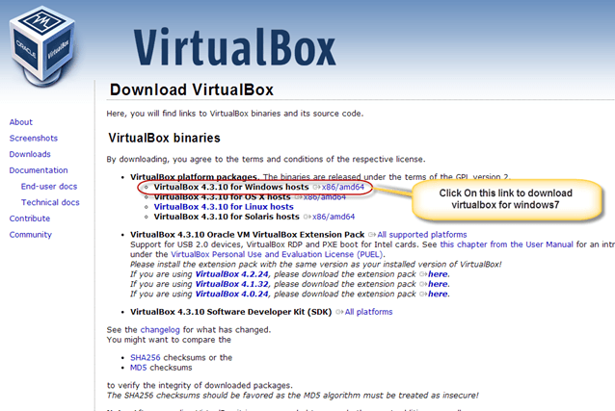](https://www.guru99.com/images/Big_Data/061114_1146_Ubuntuinsta2.png)

Once the download is complete, Open setup file and follow the steps below:

**Step-1)**Click On next

[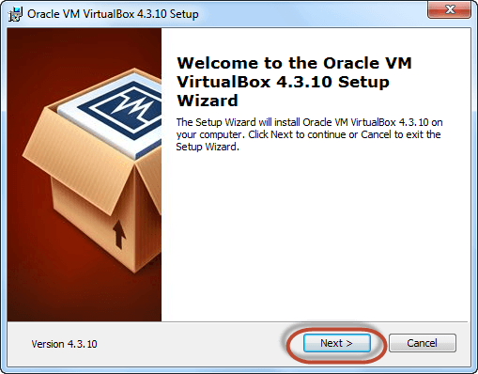](https://www.guru99.com/images/Big_Data/061114_1146_Ubuntuinsta3.png)

**Step-2)**Select you're the directory to install VirtualBox and click on next

[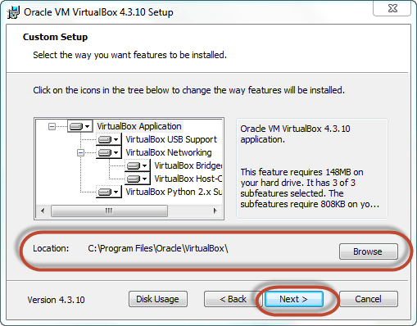](https://www.guru99.com/images/Big_Data/061114_1146_Ubuntuinsta4.png)

**Step-3)**Select Desktop icon and click on next, now click on yes

[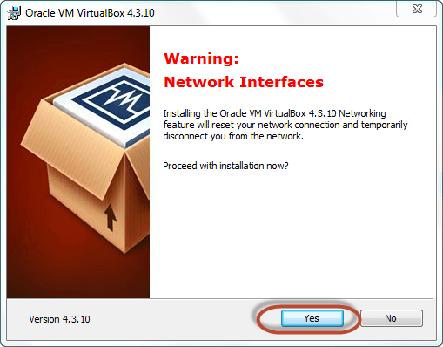](https://www.guru99.com/images/Big_Data/061114_1146_Ubuntuinsta5.png)

**Step-4)**Click On install.

[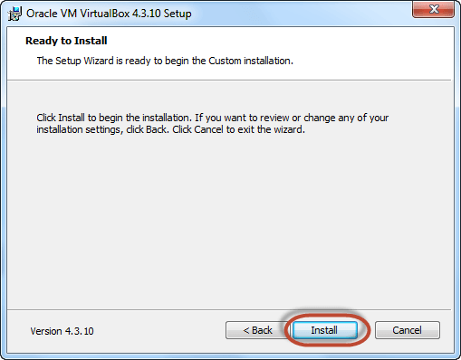](https://www.guru99.com/images/Big_Data/061114_1146_Ubuntuinsta6.png)

**Step-5)**Now installation of the virtual box will start. Once complete, click on Finish Button to start Virtual Box

[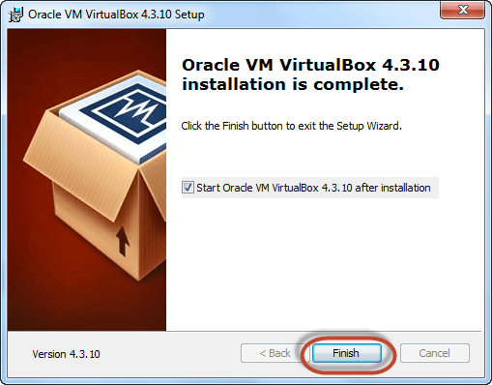](https://www.guru99.com/images/Big_Data/061114_1146_Ubuntuinsta7.png)

The virtual box dashboard looks like this-

[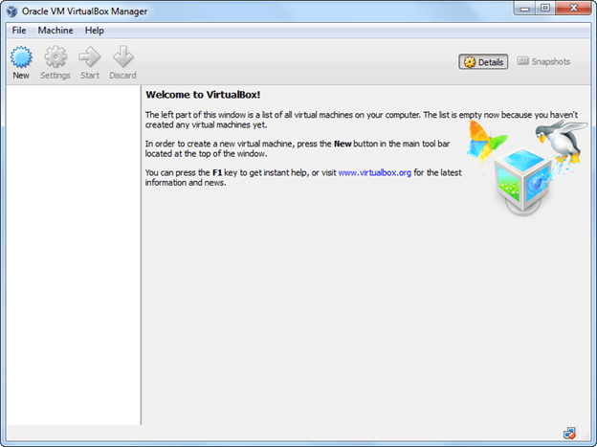](https://www.guru99.com/images/Big_Data/061114_1146_Ubuntuinsta8.png)

**PART B) Download Ubuntu**

Visit this link to download  Ubuntu.

[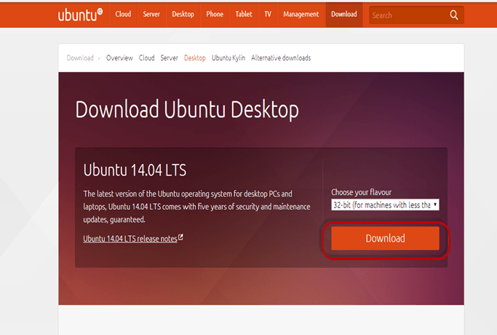](https://www.guru99.com/images/Big_Data/061114_1146_Ubuntuinsta9.png)

You can select 32/64-bit versions as per your choice.

**PART C) Create a Machine in Virtual Box**

**Step-1)**Open Virtual box and click on new button

[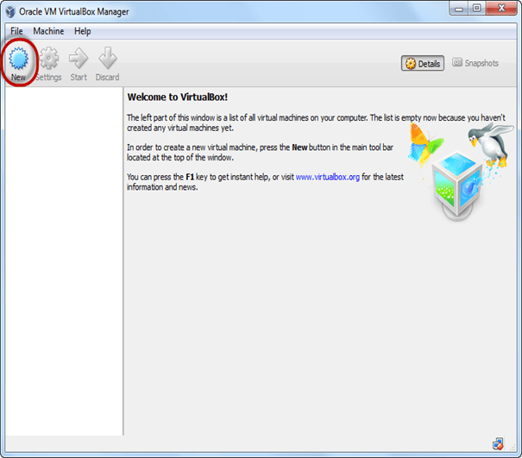](https://www.guru99.com/images/Big_Data/061114_1146_Ubuntuinsta10.png)

**Step-2)**In next window**,**give the name of your OS which you are installing in virtual box. And select OS like Linux  and version as Ubuntu 32 bit. And click on next

[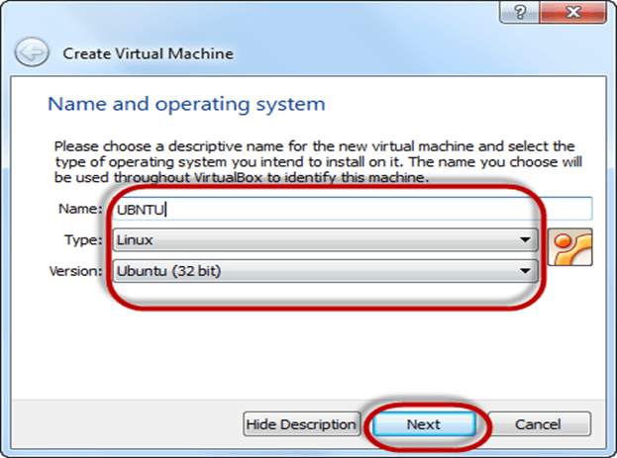](https://www.guru99.com/images/Big_Data/061114_1146_Ubuntuinsta11.png)

**Step-3)**Now Allocate Ram Size To your Virtual OS. I recommended keeping 1024mb (1 GB) ram to run Ubuntu better. And click on next.

[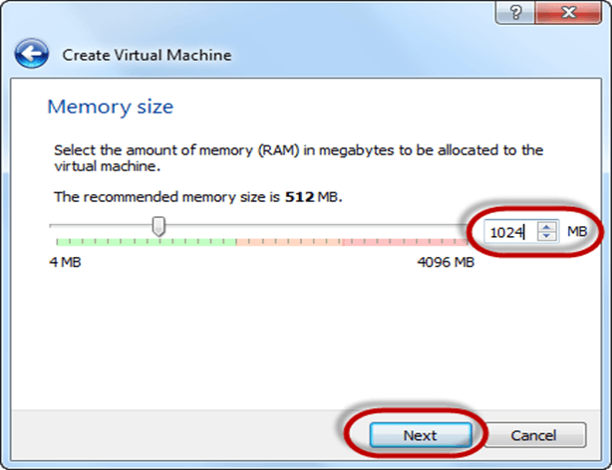](https://www.guru99.com/images/Big_Data/061114_1146_Ubuntuinsta12.png)

**Step-4)**Now To run OS in virtual box we have to create virtual hard disk, click on create a virtual hard drive now and click on create button.

The virtual hard disk is where the OS installation files and data/applications you create/install in this Ubuntu machine will reside

[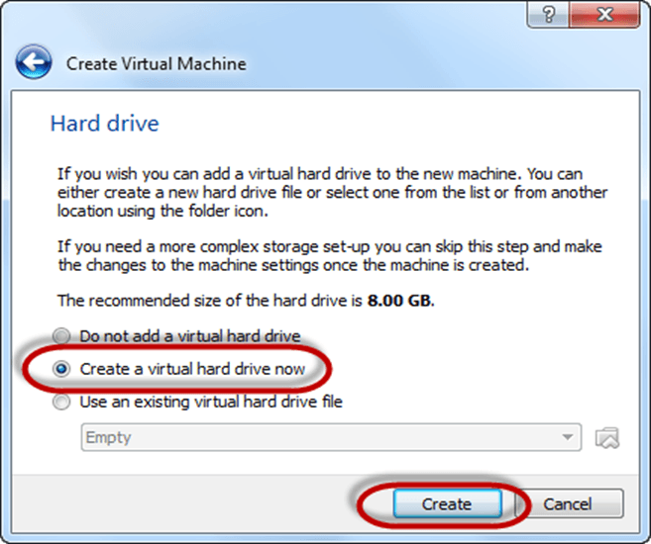](https://www.guru99.com/images/Big_Data/061114_1146_Ubuntuinsta13.png)

**Step-5)**select VHD (virtual hard disk) option and click on next.

[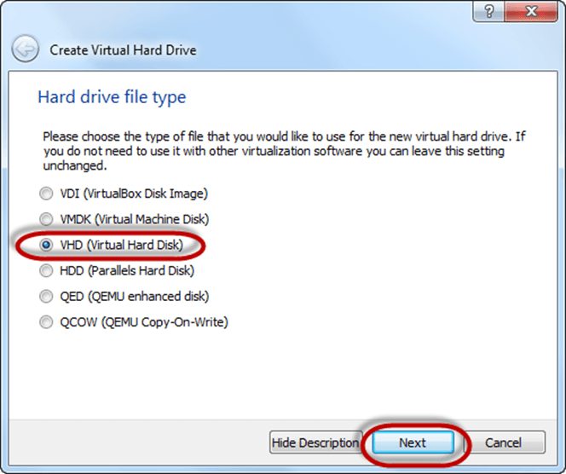](https://www.guru99.com/images/Big_Data/061114_1146_Ubuntuinsta14.png)

**Step-6)**Click on dynamic allocated and click on next. This means that the size of the disk will increase dynamically as per requirement.

[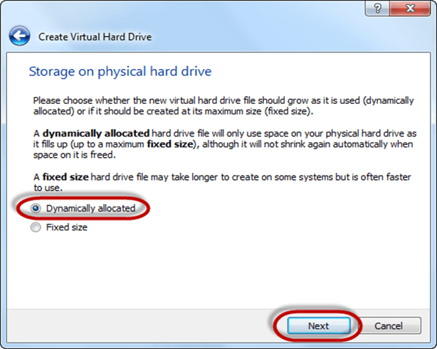](https://www.guru99.com/images/Big_Data/061114_1146_Ubuntuinsta15.png)

**Step-7)**Allocate memory to your virtual hard drive .8GB recommended. Click on create button.

[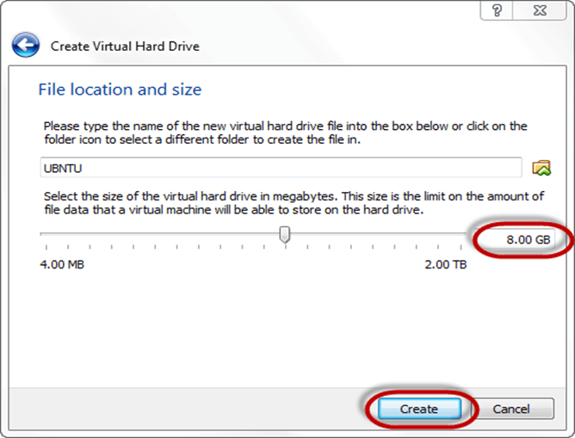](https://www.guru99.com/images/Big_Data/061114_1146_Ubuntuinsta16.png)

**Step-8)**Now you can see the machine name in left panel

[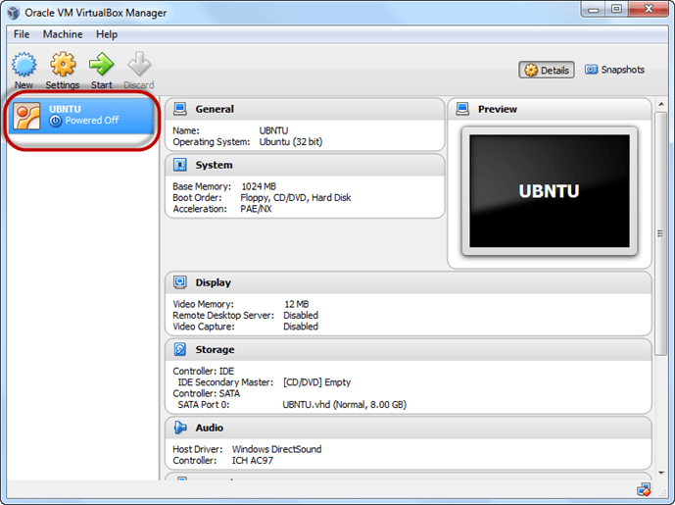](https://www.guru99.com/images/Big_Data/061114_1146_Ubuntuinsta17.png)

So a Machine (PC) with 8GB Hardisk, 1GB RAM is ready.

**PART D) Install Ubuntu on the Machine**

**Step 1**) Select the Machine and Click on Start

[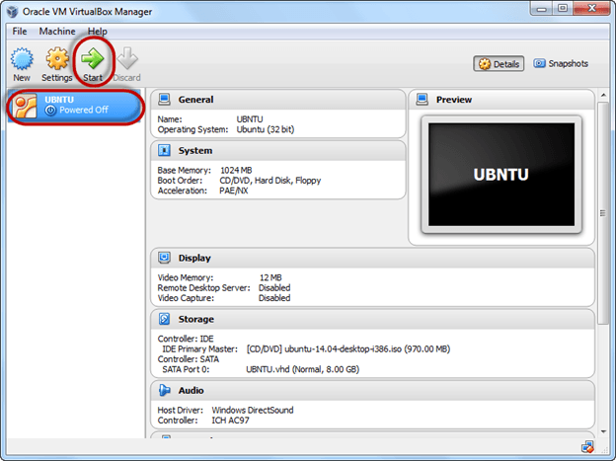](https://www.guru99.com/images/Big_Data/061114_1146_Ubuntuinsta18.png)

**Step 2)** Select the Folder Option

[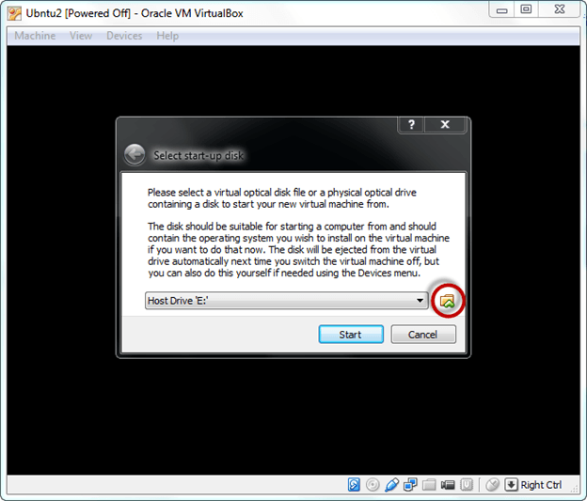](https://www.guru99.com/images/Big_Data/061114_1146_Ubuntuinsta19.png)

**Step 3)** Select the Ubuntu iso file

[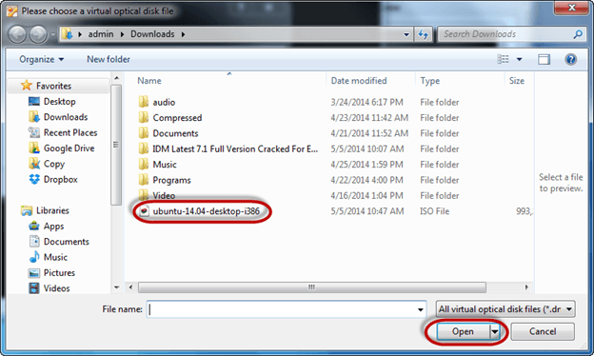](https://www.guru99.com/images/Big_Data/061114_1146_Ubuntuinsta20.png)

**Step 4)** Click Start

[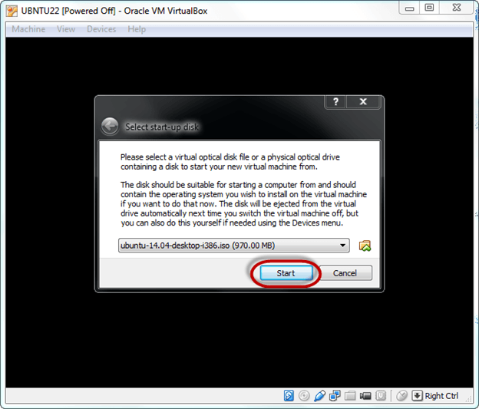](https://www.guru99.com/images/Big_Data/061114_1146_Ubuntuinsta21.png)

**Step-5)**You have an option to Run Ubuntu WITHOUT installing. In this tutorial will install Ubuntu

[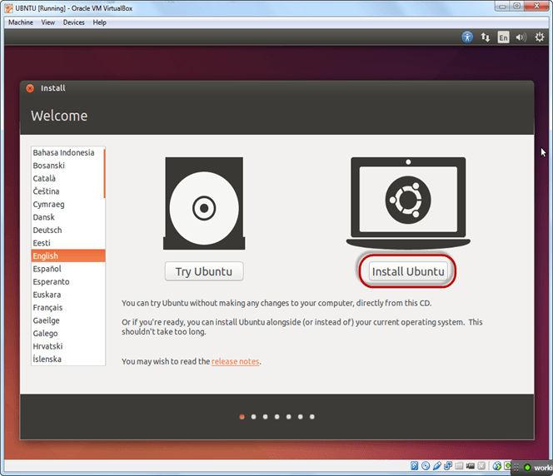](https://www.guru99.com/images/Big_Data/061114_1146_Ubuntuinsta22.png)

**Step-6)** Click continue.

[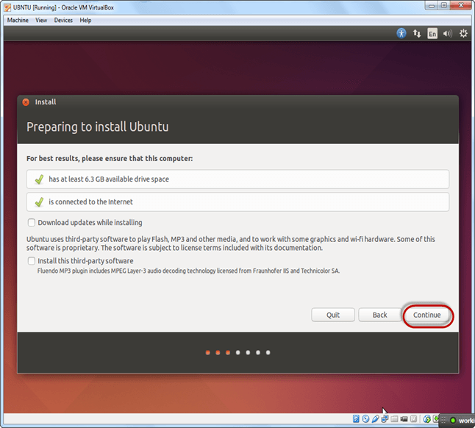](https://www.guru99.com/images/Big_Data/061114_1146_Ubuntuinsta23.png)

**Step-7)**Select option to erase the disk and install Ubuntu and click on install now. This option installs Ubuntu into our virtual hard drive which is we made earlier. It will not harm your PC or Windows installation

[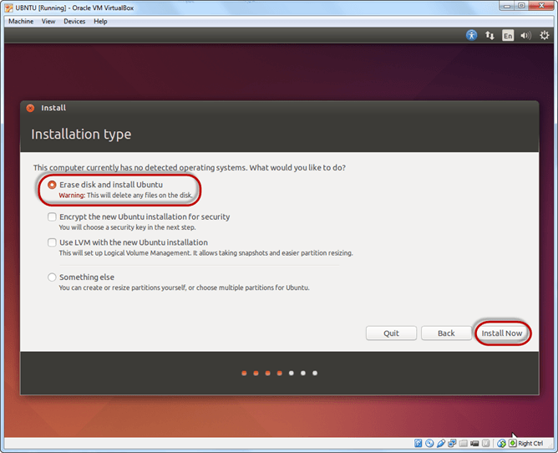](https://www.guru99.com/images/Big_Data/061114_1146_Ubuntuinsta24.png)

**Step-8)**Select your location for setting up time zone, and click on continue

[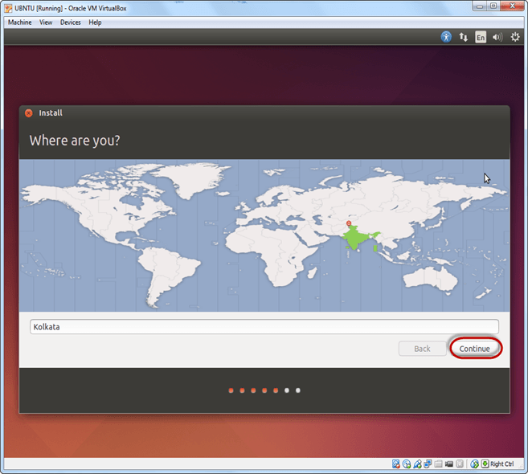](https://www.guru99.com/images/Big_Data/061114_1146_Ubuntuinsta25.png)

**Step-9)**Select your keyboard layout, by default English (US) is selected but if you want to change then, you can select in the list. And click on continue

[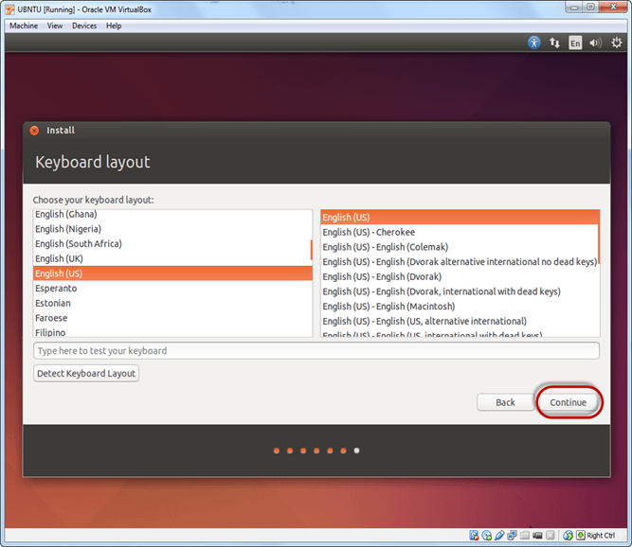](https://www.guru99.com/images/Big_Data/061114_1146_Ubuntuinsta26.png)

**Step-10)**Select your username and password for your Ubuntu admin account. This information has been needed for installing any software package into Ubuntu and also for login to your OS. Fill up your details and tick on login automatically to ignore login attempt and click on continue

[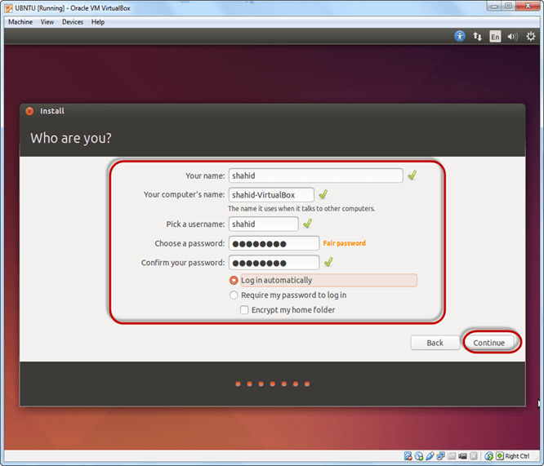](https://www.guru99.com/images/Big_Data/061114_1146_Ubuntuinsta27.png)

**Step-11)**Installation process starts. May take up to 30 minutes. Please wait until installation process completes.

[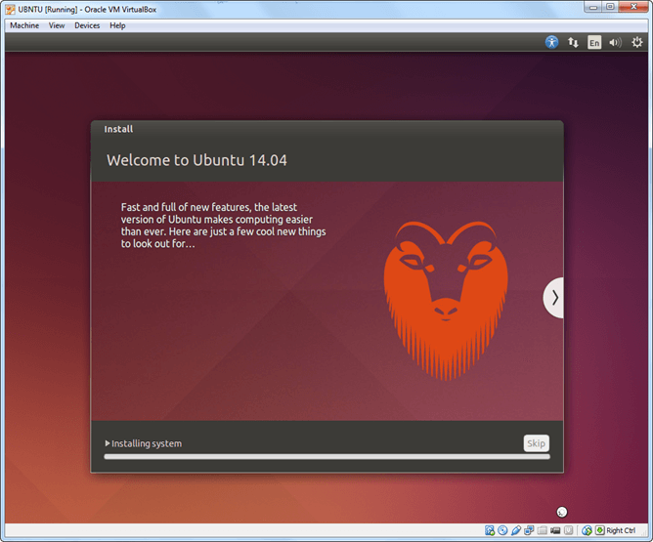](https://www.guru99.com/images/Big_Data/061114_1146_Ubuntuinsta28.png)

**Step-12)**After finishing the installation, you will see Ubuntu Desktop.

[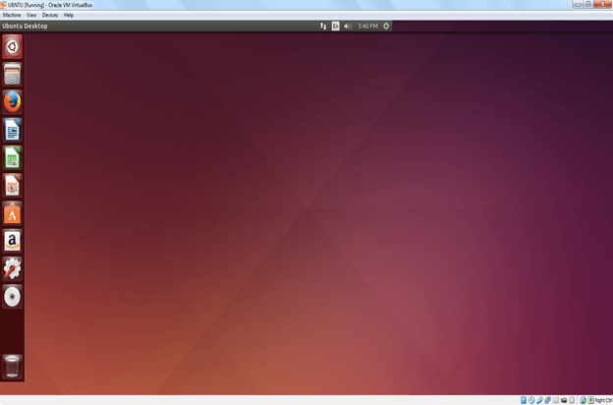](https://www.guru99.com/images/Big_Data/061114_1146_Ubuntuinsta29.png)