Project Report: Web-Based Hospital Management System (HMS)
Name: Muhammad Abdullah
Roll #: 3342

Contents
Project Report: Web-Based Hospital Management System (HMS) 1
1. Introduction 1
2. System Specifications & Tech Stack 1
3. Database Design (ER Diagram) 2
Database Schema Explanation 2
4. Project Architecture and Setup Guide 2
Installation Steps 2
5. Module Implementation Details 5
5.1 Authentication and Role Management 5
5.2 Admin Module 5
5.3 Doctor Module 5
5.4 Patient Module 6
5.5 Queue Management (Live Screen) 6
5.6 REST API (JWT Authentication) 6
6. Conclusion 7

1. Introduction
The Hospital Management System (HMS) is a web-based application designed to digitize and streamline operational processes within a healthcare facility. The primary goal of this project is to replace manual appointment booking and queue management with an efficient digital interface.
The system caters to three distinct user roles: Administrators, Doctors, and Patients. It facilitates secure appointment scheduling, manages doctor availability, generates digital OPD slips in PDF format, and displays a real-time queue status on a live screen to reduce waiting room anxiety. Furthermore, the system includes a RESTful API layer secured by JWT to allow for future external integrations or mobile application testing.

2. System Specifications & Tech Stack
The project is built using a robust, modern web development stack ensuring security, scalability, and a responsive user interface.
- Backend Framework: Laravel 11 (PHP Framework)
- Frontend Templating: Laravel Blade Engine
- UI Framework: Bootstrap 5 (integrated with TailwindCSS utilities for responsive design)
- Database: MySQL (via XAMPP)
- API Authentication: Laravel Sanctum (JWT Tokens)
- PDF Generation: barryvdh/laravel-dompdf library
- Local Development Server: Apache (via XAMPP)

3. Database Design (ER Diagram)
The system utilizes a relational database model. Below is the Entity-Relationship Diagram (ERD) using standard Chen notation, representing the entities, attributes, and relationships.
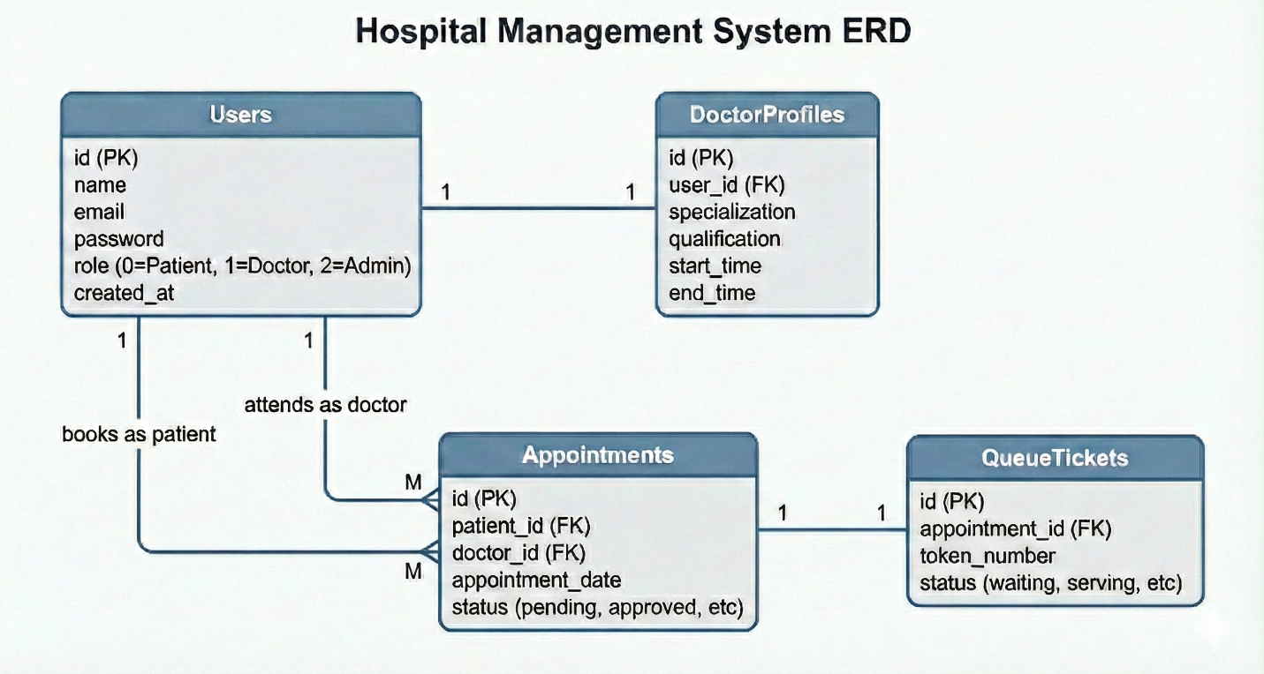

Database Schema Explanation
The schema is designed around a central User entity using a Single-Table Inheritance strategy to manage roles.
- Users Table: This is the core authentication table. It contains standard credentials (email, password) and a critical role integer column to distinguish user types:
  - 0: Patient
  - 1: Doctor
  - 2: Administrator
- DoctorProfiles Table: Connected via a One-to-One relationship with the users table. It stores extended information required only for doctors, such as specialization, qualification, and shift timings (start/end time), keeping the main users table clean.
- Appointments Table: This is the transaction table linking a Patient (User) and a Doctor (User). It has two One-to-Many relationships with the users table (one for the patient who books, one for the doctor who attends). It stores the appointment date and current status (pending, approved, cancelled, completed).
- QueueTickets Table: Connected via a One-to-One relationship with the appointments table. A ticket entry is created only when a doctor approves an appointment. It holds the sequential token number for the day and the status on the live screen (waiting, serving).

4. Project Architecture and Setup Guide
The project follows the standard Model-View-Controller (MVC) architectural pattern enforced by Laravel, ensuring a clean separation of concerns:
- Models (app/Models): Represent database entities (User, DoctorProfile, Appointment, QueueTicket) and handle Eloquent relationships.
- Views (resources/views): Laravel Blade templates that render the user interface. The UI utilizes Bootstrap 5 for layout and responsiveness, integrated with TailwindCSS for utility styling where necessary.
- Controllers (app/Http/Controllers): Handle business logic, process incoming HTTP requests, interact with Models, and return Views or JSON responses.

Installation Steps
To set up the project on a local machine, follow these precise steps:
1. System Prerequisites
Ensure the following software is installed:
- XAMPP/WAMP: For the Apache server and MySQL database (PHP >= 8.2 required).
- Composer: For managing PHP dependencies.
- Node.js & NPM: For compiling frontend assets.
2. Database Configuration
- Open phpMyAdmin (e.g., http://localhost/phpmyadmin).
- Create a new, empty database named hms_db.
3. Project Setup
Navigate to the project root directory in your terminal and execute the following commands:
- Install PHP Dependencies:
Bash
composer install
- Environment Configuration:
Duplicate the example environment file and configure the database connection:
Bash
cp .env.example .env
Open .env and verify the settings:
Ini, TOML
DB_CONNECTION=mysql
DB_HOST=127.0.0.1
DB_PORT=3306
DB_DATABASE=hms_db
DB_USERNAME=root
DB_PASSWORD=
4. Automated Setup (Recommended)
Since the project includes a custom setup script in composer.json, you can initialize the application key, migrations, and frontend assets with a single command:
Bash
composer run setup
This command performs: Key Generation, Database Migration, NPM Install, and NPM Build.
5. Manual Setup (Alternative)
If the automated script is not used, run these commands manually:
Bash
php artisan key:generate
php artisan migrate:fresh
npm install
npm run build
6. Database Seeding (Admin Account)
Populate the database with the initial Administrator account using Laravel Tinker:
Bash
php artisan tinker
Inside the Tinker console, run:
PHP
App\Models\User::create([
'name' => 'Super Admin',
'email' => 'admin@admin.com',
'password' => bcrypt('password123'),
'role' => 2
]);
exit
7. Running the Application
Start the local development server:
Bash
php artisan serve
The application will be accessible at: http://127.0.0.1:8000

5. Module Implementation Details

5.1 Authentication and Role Management
Security is managed via Laravel's built-in authentication and custom middleware.
- Controller: AuthController.php handles registration (defaulting new users to role 0/Patient), login, and logout. Upon successful login, it redirects users to their specific dashboard based on their role.
- Middleware: A custom middleware EnsureUserRole was created. It intercepts route requests and verifies if the authenticated user possesses the required role (admin, doctor, or patient) before granting access to protected routes.

5.2 Admin Module
The administrator has complete oversight of the system.
- Controller: AdminController.php
- Key Features:
  - Dashboard: Displays counter statistics for total doctors, patients, and appointments.
  - Add Doctor: A form that captures user credentials and doctor details. Crucially, this uses a Database Transaction to ensure that inserts into both the users table and doctor_profiles table either both succeed or both fail, maintaining data integrity.
  - View Appointments: A tabular view of all appointments in the system, showing patient names, assigned doctors, and current status.

5.3 Doctor Module
Doctors use this portal to manage their daily schedule.
- Controller: DoctorController.php
- Key Features:
  - Dashboard: Shows a list of appointments specifically booked for the logged-in doctor for the current day and future.
  - Appointment Actions: Doctors can mark appointments as Approved, Cancelled, or Completed.
  - Token Generation Logic: When a doctor clicks "Approve" on a pending appointment, the controller logic calculates the count of existing tickets for that day and inserts a new entry into the QueueTickets table with the next sequential token number.

5.4 Patient Module
Patients use this portal for self-service booking.
- Controller: PatientController.php
- Key Features:
  - Book Appointment: A form listing available doctors in a dropdown. It validates that the selected date is not in the past and performs a duplicate check to prevent double-booking.
  - Dashboard History: Displays a list of the patient's past and upcoming appointments with their status.
  - PDF Slip Generation: If an appointment status is "Approved", a "Download Slip" button appears. This uses the dompdf library to render a Blade view (resources/views/pdf/slip.blade.php) containing appointment details and the assigned token number into a downloadable PDF file.

5.5 Queue Management (Live Screen)
This module replaces physical queuing with a digital display.
- Controller: QueueController.php
- Route: /live-queue (Publicly accessible).
- Implementation: The controller queries the QueueTickets table to find tickets belonging to appointments scheduled for today that have a status of 'waiting' or 'serving'.
- UI: The Blade view uses high-contrast styling suitable for a large TV screen. It includes a JavaScript snippet that automatically reloads the page every 10 seconds to fetch fresh data without manual intervention.

5.6 REST API (JWT Authentication)
To satisfy external connectivity requirements, a basic REST API is included.
- Setup: Laravel Sanctum is installed and configured.
- Route File: routes/api.php
- Implementation: The AuthController contains an apiLogin method. It validates credentials and, upon success, issues a plain-text JWT token. Subsequent API requests (e.g., fetching user details) must provide this token in the Authorization: Bearer header to pass the auth:sanctum middleware.

6. Conclusion
The developed Hospital Management System successfully meets all project requirements. It provides a secure, role-based environment for managing hospital operations, digitizes the appointment workflow, and introduces a modern queue management display. The integration of PDF reporting and a JWT-secured API ensures the system is both functional for immediate use and extensible for future developments.

