# **Project Report**

**Project Name: Semester Project Managment**

# Name: Syed Mustafa

# Registration Number: SP23-BSE-015

Use Case 1: Submit Proposal

**Use Case Name:** Submit Proposal

**Actor:** Student

**Goal in Context:** The student wants to submit a proposal document for the assigned project.

**Preconditions:**

The student must be logged into the system.

The student must be part of a group.

The project must be assigned.

**Postconditions:**

* Proposal is submitted and saved in the system.
* Submission date is recorded.

**Main Success Scenario (Basic Flow):**

* Student logs into the system.
* Navigates to the proposal submission section.
* Uploads the proposal document.
* Enters any required metadata (e.g., title, description).
* Submits the proposal.
* System stores the proposal and confirms submission.
* System logs the date and time of submission.

**Extensions (Alternative Flows):**

1. If the file format is invalid, system shows an error message.
2. If required fields are missing, system prevents submission and displays a prompt.

**Includes**

**Date of submission**

**Special Requirements**

The uploaded document must be in PDF or DOCX format.

Maximum file size allowed: 10MB.

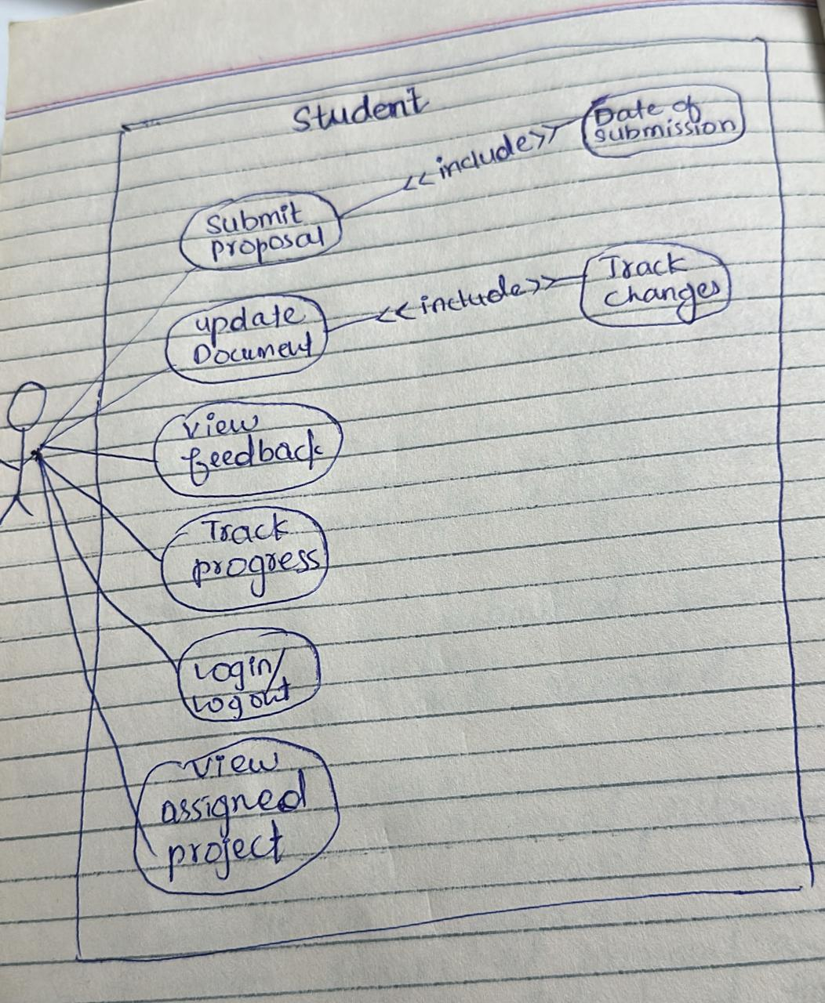

# Name: Rana Asad Ur Rahman

# Registration Number: SP23-BSE-029

# Fully Dressed Use Case: Update Project Status

| **Use Case Name** | **Update Project Status** |
| --- | --- |
| **Scope** | Project Management System |
| **Level** | User goal |
| **Primary Actor** | Faculty |
| **Stakeholders and Interests** | - **Faculty**: Wants to reflect the accurate status of the project based on its progress. - **Students**: Want to be informed of their project's progress. - **Admin**: Needs accurate records for tracking and reporting. |
| **Preconditions** | - Project exists in the system. - Faculty is assigned as the advisor to the project. - User is authenticated. |
| **Post conditions** | - Project status is updated successfully in the system. |
| **Success Metrics** | The status of the project is updated to the selected new status and stored correctly. |
| **Minimal Guarantee** | The system logs the update attempt even if it fails and shows an appropriate error message. |

**📋 Main Success Scenario (Basic Flow)**

1. Faculty logs into the system.
2. Faculty navigates to the project list and selects a specific project.
3. Faculty clicks on the “Update Status” button.
4. The system displays current project status and a list of valid status options (e.g., "Not Started", "In Progress", "Completed").
5. Faculty selects a new status and clicks “Submit”.
6. The system validates the change.
7. The system updates the project status in the database.
8. The system confirms the update with a success message.
9. Project status is now reflected in the project details.

**🔁 Extensions (Alternate Flows)**

**3a. Project not found**

* 3a1. System shows an error: "Project not found."
* 3a2. Use case ends.

**5a. Invalid status selected**

* 5a1. System shows an error: "Invalid status."
* 5a2. Faculty selects a valid status.
* 5a3. Returns to step 6.

**6a. Database update fails**

* 6a1. System displays error: "Failed to update project status."
* 6a2. Faculty retries or contacts admin.
* 6a3. Use case ends.

**🔐 Special Requirements**

* The system must validate user permissions before allowing the update.
* Status values must be predefined and consistent (possibly from an enum).
* Audit trail should log the date/time of the update and the actor's ID.

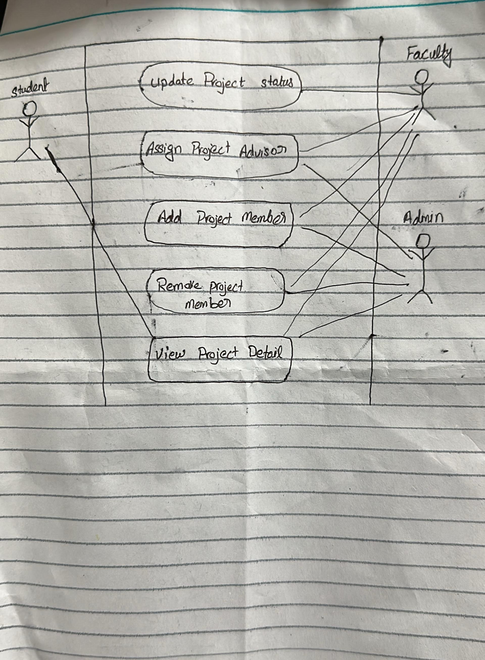

**Comprehensive Use Case Specification for Admin in FYP Management System**

**1. System Overview**

The **Final Year Project (FYP) Management System** allows university administrators to manage student projects, supervisors, evaluations, and system configurations. The **Admin** is the primary actor responsible for maintaining data, generating reports, and ensuring smooth system operations.

**2. Actors**

| **Actor** | **Description** |
| --- | --- |
| **Admin** | Manages students, supervisors, projects, and system settings. |
| *Student* | (Secondary) Submits project proposals and reports. |
| *Supervisor* | (Secondary) Guides students and evaluates projects. |

**3. Detailed Use Cases**

**Use Case 1: Login to System**

* **Actor:** Admin
* **Description:** Admin logs into the FYP Management System.
* **Preconditions:** Admin has valid credentials.
* **Basic Flow:**
  1. Admin enters email and password.
  2. System verifies credentials.
  3. On success, redirects to Admin Dashboard.
* **Alternative Flow:**
  1. If credentials are invalid, system displays an error.
* **Post conditions:** Admin gains access to the system.

**Use Case 2: Manage Students**

* **Actor:** Admin
* **Description:** Admin adds, edits, or removes student records.
* **Preconditions:** Admin is logged in.
* **Basic Flow:**
  1. Admin clicks **"Manage Students"**.
  2. System displays a list of students.
  3. Admin selects:
     + **Add Student**: Enters (Name, ID, Email, and Program).
     + **Edit Student**: Modifies existing details.
     + **Delete Student**: Removes record after confirmation.
  4. System validates and updates the database.
* **Alternative Flows:**
  1. If student ID already exists, system rejects duplication.
* **Post conditions:** Student records are updated.

**Use Case 3: Manage Supervisors**

* **Actor:** Admin
* **Description:** Admin adds or assigns faculty supervisors.
* **Preconditions:** Admin is logged in.
* **Basic Flow:**
  1. Admin clicks **"Manage Supervisors"**.
  2. System shows the list of supervisors.
  3. Admin:
     + **Adds Supervisor** (Name, Department, Max Projects).
     + **Assigns Supervisor** to a project.
  4. System checks availability and updates records.
* **Alternative Flows:**
  1. If supervisor’s project limit is exceeded, system shows an error.
* **Post conditions:** Supervisor assignments are updated.

**Use Case 4: Manage Projects**

* **Actor:** Admin
* **Description:** Admin creates, assigns, and tracks FYP projects.
* **Preconditions:** Students and supervisors are registered.
* **Basic Flow:**
  1. Admin clicks **"Manage Projects"**.
  2. Chooses:
     + **Create Project** (Title, Description, and Deadline).
     + **Assign Student & Supervisor** (from dropdown lists).
  3. System validates and links them in the database.
* **Alternative Flows:**
  1. If a student is already assigned, system prevents duplication.
* **Post conditions:** Project is added and visible in tracking.

**Use Case 5: Generate Reports**

* **Actor:** Admin
* **Description:** Admin exports project progress or evaluation reports.
* **Preconditions:** Projects exist with submission data.
* **Basic Flow:**
  1. Admin clicks **"Generate Reports"**.
  2. Selects report type:
     + **Progress Report** (Student milestones).
     + **Evaluation Report** (Supervisor feedback).
  3. Filters by Department/Date Range.
  4. System compiles data into **PDF/Excel**.
  5. Admin downloads or prints.
* **Alternative Flows:**
  1. If no data exists, system displays "No records found."
* **Post conditions:** Report is generated for review.

**Use Case 6: System Configuration**

* **Actor:** Admin
* **Description:** Admin sets deadlines, grading rules, and permissions.
* **Basic Flow:**
  1. Admin clicks **"System Configuration"**.
  2. Updates:
     + **Submission Deadlines** (e.g., Proposal: 30-May-2024).
     + **Grading Criteria** (e.g., 70% for final report).
  3. System saves changes and notifies affected users.
* **Alternative Flows:**
  1. If a deadline is in the past, system rejects it.
* **Postconditions:** System settings are updated.



Admin System

Extend

Notify Supervisor

Generate Project

Extend

Export PDF/Excel

Admin

System Configuration

Manage Project

Manage Supervisor

Manage Student

Login

Name: Abdullah

Reg No: SP23-BSE-116

**Use Case 1:** **addMember()**

**Use Case Name:** Add Member

**Scope:** Group Management

**Level:** User goal

**Primary Actor:** Administrator

**Stakeholders and Interests:**

**Administrator:** Wants to add students to a group efficiently.

**Students:** Want to be part of the correct group for their semester project.

**Preconditions:**

* The group must already exist.
* The student must be registered in the system.
* The student is not already part of another group.

**Postconditions:**

The student is successfully added to the group’s member list.

**Main Success Scenario (Basic Flow):**

* Administrator selects an existing group.
* Administrator selects a student to add.
* System checks if the student is already part of any group.
* System adds the student to the selected group.
* System confirms the addition and displays updated group information.

**Extensions (Alternate Flows):**

3a. If the student is already part of another group:

→ System shows an error message and aborts the addition.

4a. If the group has reached its member limit:

→ System prevents the addition and notifies the administrator.

**Special Requirements:**

* Real-time validation of student eligibility.
* Notification sent to the student upon successful addition.

✅ **Use Case 2:** removeMember()

**Use Case Name:** Remove Member

**Scope:** Group Management

**Level:** User goal

**Primary Actor:** Administrator

**Stakeholders and Interests:**

**Administrator:** Needs control over group membership.

**Students:** Should be properly removed if they withdraw or switch groups.

**Preconditions:**

* Group and student must exist.
* Student must already be a member of the group.

**Postconditions:**

The student is removed from the group member list.

**Main Success Scenario (Basic Flow):**

* Administrator opens group details.
* Administrator selects the student to remove.
* System verifies the student’s membership in the group.
* Student is removed from the list.
* System confirms removal.

**Extensions (Alternate Flows):**

3a. If the student is not found in the group:

→ System notifies the admin and aborts the removal.

4a. If the removed student is a group leader:

→ System prompts to assign a new leader or continue.

**Special Requirements:**

Notification sent to the student upon removal.

**✅ Use Case 3:** assignAdvisor()

**Use Case Name:** Assign Advisor

**Scope:** Group Management

**Level:** User goal

**Primary Actor:** Administrator

**Stakeholders and Interests:**

**Administrator:** Needs to assign supervisors fairly and efficiently.

**Supervisors:** Want to be assigned groups within their capacity.

**Students:** Need an advisor for guidance.

**Preconditions:**

* Group must exist.
* Advisor must be registered.
* Advisor must be available (not exceeding their group limit).

**Postconditions:**

Advisor is successfully linked to the group.

**Main Success Scenario (Basic Flow):**

* Administrator selects a group.
* Administrator chooses an advisor from a list.
* System checks advisor’s availability.
* Advisor is assigned to the group.
* Confirmation message is shown.

**Extensions (Alternate Flows):**

3a. If the advisor already has maximum assigned groups:

→ System blocks the assignment and shows a warning.

**Special Requirements:**

* System should prevent duplicate advisor assignments to the same group.
* Email notification to advisor and group members upon assignment.

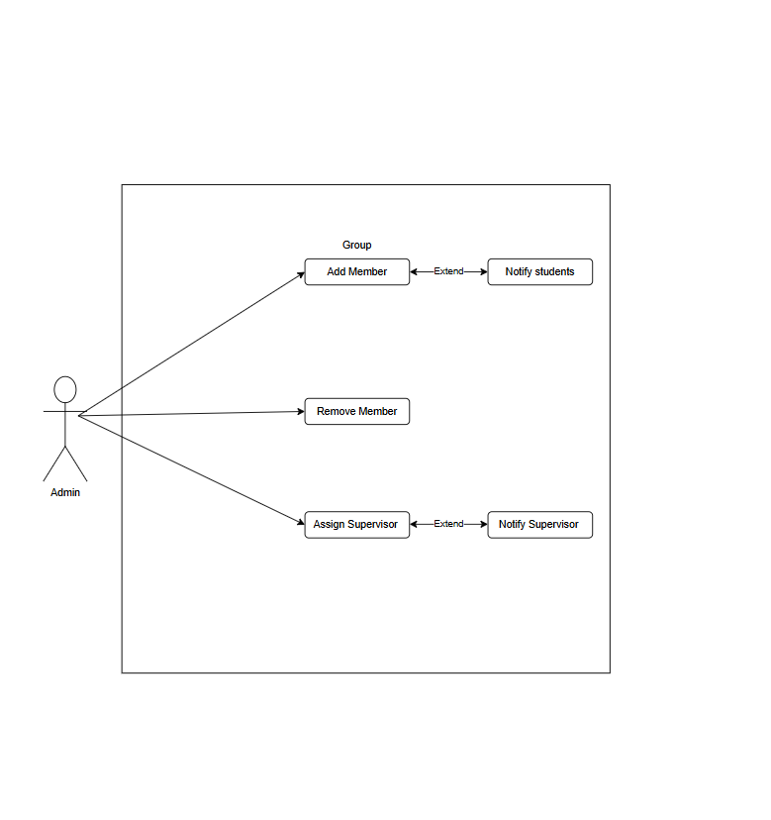

NAME: Aizaz ullah

Reg No: SP23-BSE-003

