**Table of Contents**

Work Distribution 2

Revision History 3

Document Approval 3

1. Introduction 7

1.1 Purpose 7

1.2 Scope 7

1.3 Definitions, Acronyms, and Abbreviations 7

1.4 References 8

1.5 Overview 8

2. General Description 9

3. Specific Requirements 9

3.1 External Interface Requirements 9

3.1.1 User Interfaces 9

3.1.1.1 Set Prices for Different Services 10

3.1.1.2 Make Reservation 11

4.1.1.3 Modify Reservation 12

4.1.1.4 Create Account 13

4.1.1.5 View Statistical Charts 14

3.2 Functional Requirements 14

3.2.1 14

3.2.2 15

3.2.3 15

3.2.4 15

3.2.5 15

3.2.6 15

3.2.7 16

3.2.8 16

3.2.9 16

3.2.10 16

3.2.11 16

3.2.12 17

3.2.13 17

3.2.14 17

3.2.15 17

3.3 Use Cases 18

3.4 Use Cases Description 19

3.4.1 Set Price for Different Services 19

3.4.2 Make Reservation 20

3.4.3 Modify Reservation 21

3.4.4 Create Account 22

3.4.5 View Statistical Charts 23

3.5 Classes / Objects 24

3.6 Non-Functional Requirements 24

3.6.1 Response time 24

3.6.1.1 24

3.6.1.2 24

3.6.2 Ease of use 24

3.6.2.1 24

3.6.3 Accessibility 24

3.6.3.1 24

3.6.4 Recovery time 25

3.6.4.1 25

3.6.5 Robustness 25

3.6.5.1 25

3.6.5.2 25

3.6.6 Availability 25

3.6.6.1 25

3.6.7 Security 25

3.6.7.1 25

3.6.8 Capacity 25

3.6.8.1 25

3.6.9 Accuracy 25

3.6.9.1 25

3.6.10 Throughput 25

3.6.10.1 25

3.6.10.2 25

3.8 Design Constraints 25

3.8.1 25

3.8.2 26

3.8.3 26

3.8.4 26

3.8.5 26

3.8.6 26

3.10 Other Requirements 26

4. Analysis Models 27

4.1 Sequence Diagrams 27

4.1.1 Set Prices for Different Services 27

4.1.2 Make reservation 28

4.1.3 Modify Reservation 29

4.1.4 Create Account 30

4.1.5 View Statistical Charts 31

4.3 Activity Diagram 32

4.3.1 Set Prices for Different Services 32

4.3.2 Make reservation 33

4.3.3 Modify Reservation 34

4.3.4 Create Account 35

4.3.5 View Statistical Charts 36

# 1. Introduction

This project is to intends to develop a computerized system to manage parking usage and online reservations in a parking garage

## 1.1 Purpose

The purpose of this project is to track and manage occupancy of a parking garage and allow customers to find and reserve available parking places and to make The parking garage operates without any computerized system.

## 1.2 Scope

The Parking Garage Reservation Auto Parkis to control and track and manage occupancy of a parking garage it will lower the traffic because the most of the visitors will have a parking place in the parking garages and it will make it faster than the usual by 75% and make it easier because it will book a parking place for you before you even come.

Furthermore, the software needs to be in Web browser or a smart phone application and display results. All system information is maintained in a database, which is located on a web-server. The software also interacts with the PayPal payment. If the user use the system in his phone he need to download it , users can view the available parking spots in the app or the web. The application also has the capability of representing both summary and detailed information about the user.

## 1.3 Definitions, Acronyms, and Abbreviations

|  |  |
| --- | --- |
| **Term** | **Definition** |
| Customer | Someone who interacts with the system. |
| Operator | System administrator who is given specific permission for managing the system |
| Payment | The external system that controls all the payment methods in the system |
| Elevator camera | A device that identify the car using license plate in the elevator. |
| Exit camera | A device that identifies the car using license plate before the customer leaves. |
| Elevator console | Used to enter reservation confirmation number. |
| Monitor | Display the available spots for the customer in the ground floor |
| Confirmed reservations | Represent registered customers who make reservations as the need arises. These reservations are honored until a specified time (including the grace period after the start of the reserved interval). Such customers represent the critical element in no-shows |
| Guaranteed reservations | represent​ the registered customers who made a *contract*​​with the parking garage for a parking spot, such as commuters going to work who need parking on a daily basis during a predetermined period |
| Overstays | ​They are the currently parked customers who wish to extend their stay beyond the time for which they made reservations |
| Understays | ​Are customers who arrive on time but decide to leave before their predicted time of departure. |
| Walk-ins | ​They are the registered customers who arrive to the parking garage without a contract or reservation. They are welcome because they can enhance the garage occupancy percentages (if there are available parking spaces). |
| No-shows | The customer who registered and never shows |

## 1.4 References

## 1.5 Overview

The remainder of this document includes three chapters and appendixes. The second one will explain the General factors that affect the product and its requirement Description

The third chapter provides an overview of the system functionality and system interaction with other systems. This chapter also introduces different types of stakeholders and their interaction with the system (use case). Further, the chapter also mentions the system constraints and assumptions about the product. And provides the requirements specification in detailed terms and a description of the different system interfaces. Different specification techniques are used in order to specify the requirements more precisely for different audiences.

The fourth chapter deals with all the analysis models they have been used in developing specific requirementswith the prioritization of the requirements

# 2. General Description

# 3. Specific Requirements

## 3.1 External Interface Requirements

### 3.1.1 User Interfaces

The home page of the website shall contain several of functions such as: creating an account, checking garage availability, modification of the reservation, and reservation of parking spot.

The home page in the phone application shall view the most important functions such as: reservation of parking spot, checking garage availability.

#### 3.1.1.1 Set Prices for Different Services

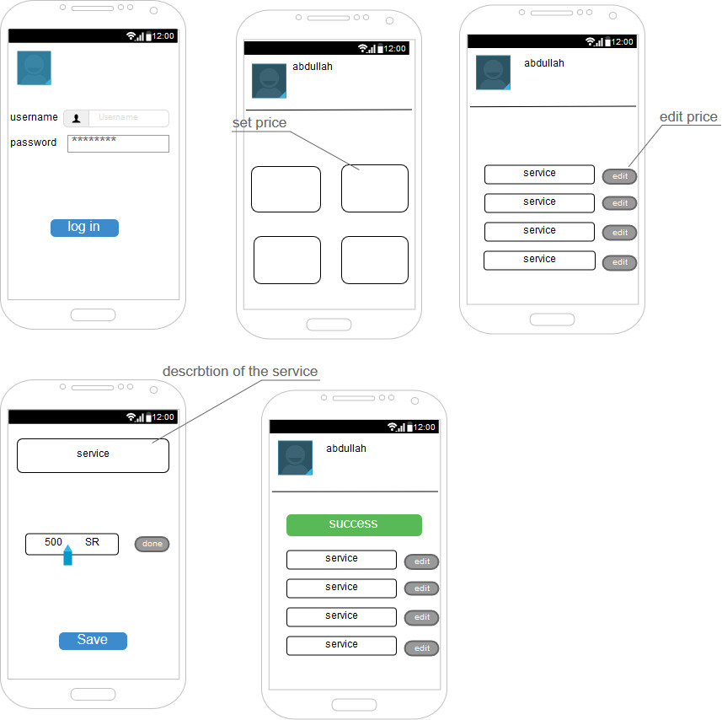

#### 3.1.1.2 Make Reservation

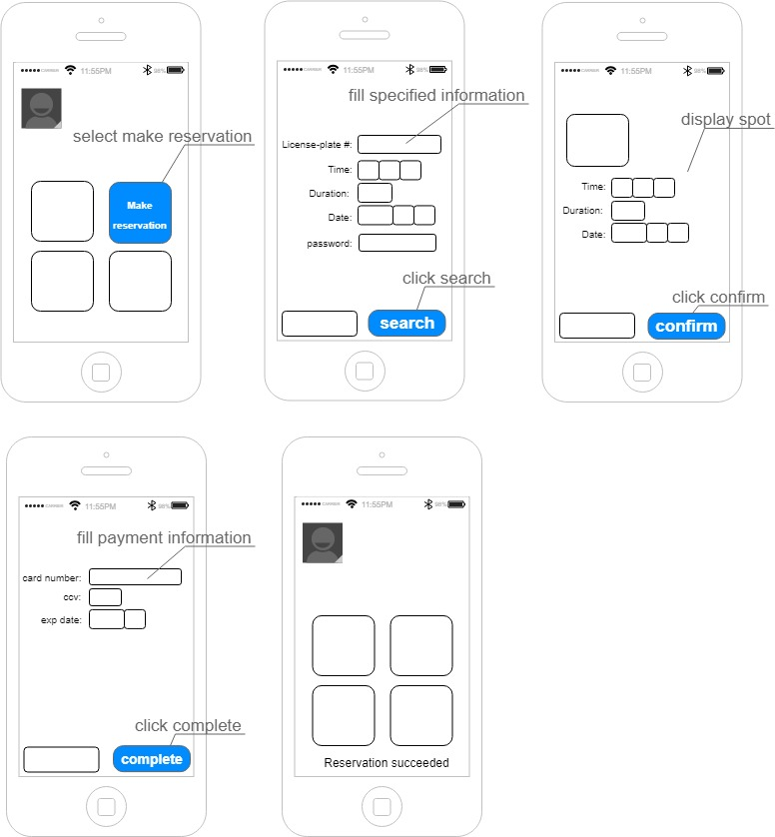

#### 4.1.1.3 Modify Reservation

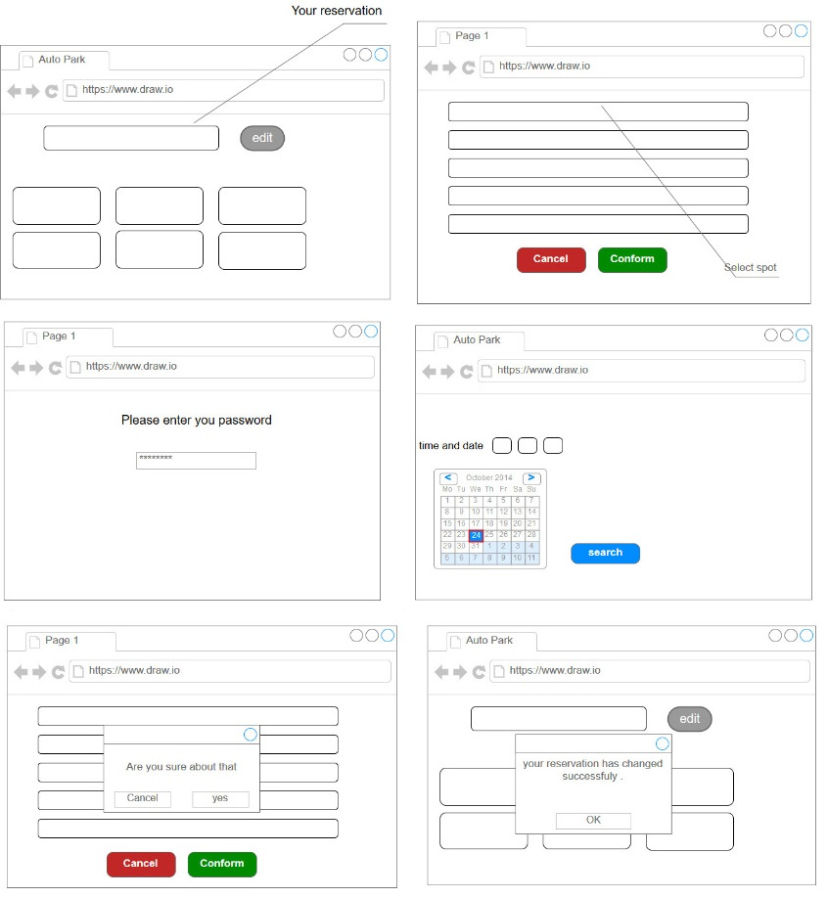

#### 4.1.1.4 Create Account

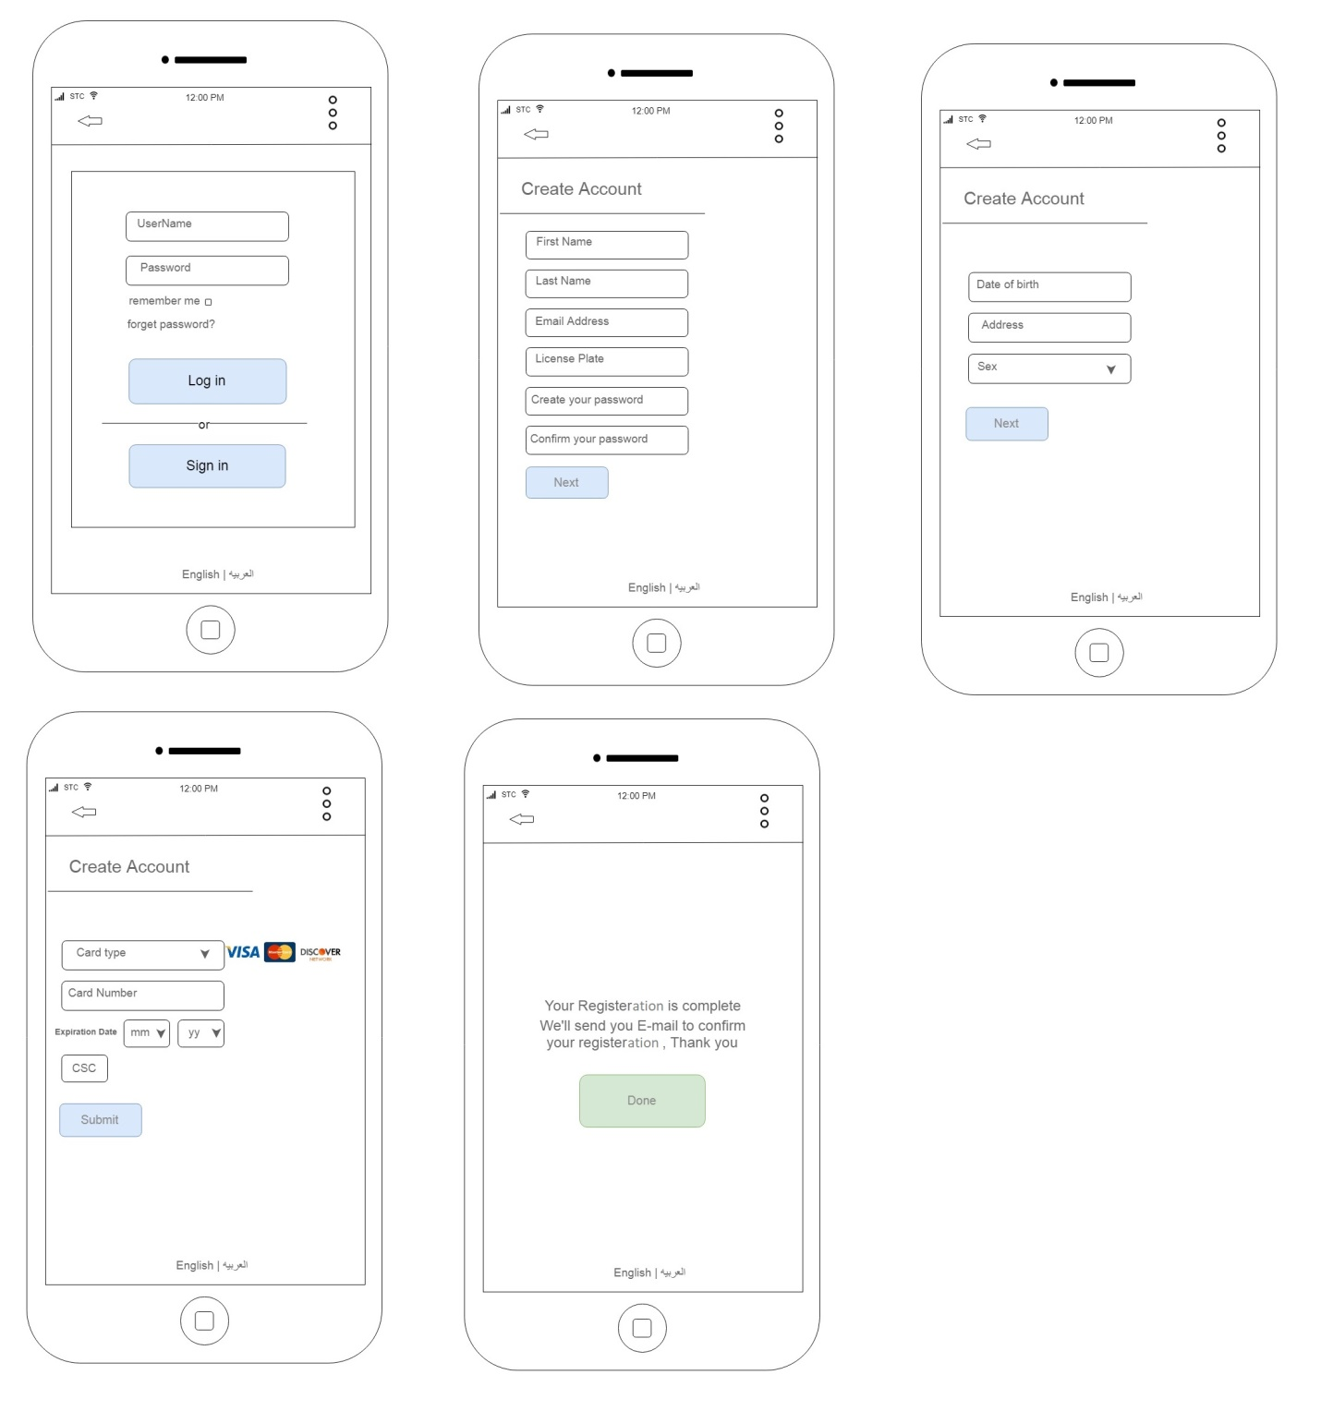

#### 4.1.1.5 View Statistical Charts

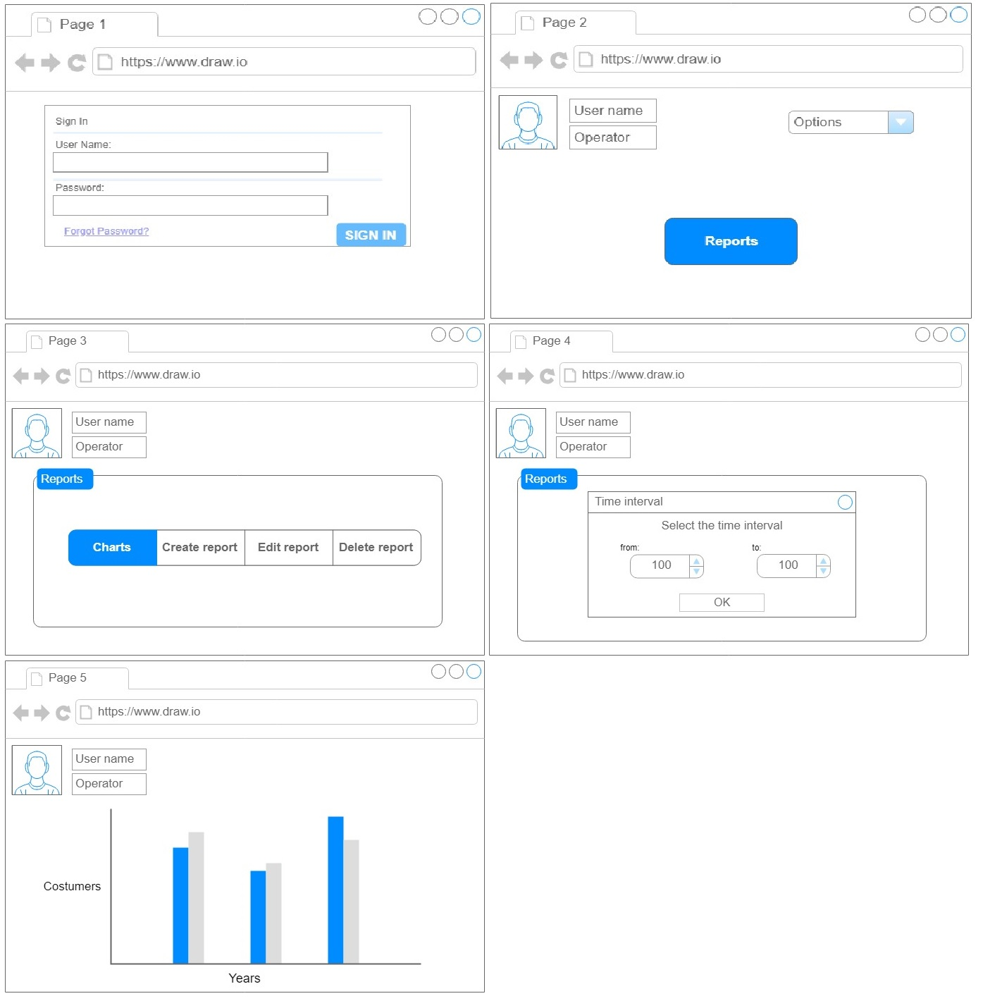

## 3.2 Functional Requirements

### 3.2.1

The purpose of this project is to track and manage occupancy of a parking garage and allow customers to find and reserve available parking places. And the system will provide a reservation confirmation number after completing the reservation.

INPUT: date and time interval

OUTPUT: park is reserved and the customer will receive a reservation confirmation number.

* The customer shall be able to reserve a park.
* The system shall provide reservation confirmation number.

### 3.2.2

​Customer will be able to register at the company website in advance of using the parking garage.

INPUT: customer and vehicle information

OUTPUT: account is created

* The customer shall be able to register at the company website.

### 3.2.3

In case of a borrowed or rented vehicle, the customer will specify the registration plate number at the time of making a parking reservation. If the specified registration number is different from the number in the customer’s profile, the software-to-be will create a temporary association of the number to this customer, and the association will be deleted after the parking garage is used during the requested interval.

INPUT: the customer will specify the registration plate number

OUTPUT: create a temporary association of the number to this customer

* The system shall create a temporary association number for the customer when he/she borrows or rents a vehicle.

### 3.2.4

The registration software may also support guaranteed reservations, which allow customers to make a (monthly) contract with the parking garage for a parking spot.

INPUT: make monthly reservation

OUTPUT: the parking spot is reserved for a month

* The system shall provide monthly reservation.

### 3.2.5

The customer can check the parking space availability by specifying the desired date and time interval, using a client device such as Web browser or a smart phone app.

INPUT: time interval and date

OUTPUT: parking occupancy

* The customer shall be able to check parking space availability.

### 3.2.6

The customer should be able to modify their existing reservation(s) before the starting time of a particular reservation. Also he should be able to extend their current occupancy of a parking space.

INPUT: new time interval for the modifying

OUTPUT: reservation is modified.

* The customer shall be able to modify their existing reservation.
* The customer shall be able extend their existing reservation.

### 3.2.7

The customer should be notified about the identifier (e.g., number) of their specific parking spot. Because the parking does not have installed a driver-guidance system, the customer will use this identifier to locate their parking spot in the garage.

INPUT: make a reservation

OUTPUT: parking spot identifier

* The system shall notify the customer about the identifier parking spot.

### 3.2.8

If the license-plate recognition system in the vehicle elevator does not recognize the car’s registration number, the customer should be able to type in their reservation confirmation number and enter the parking garage.

INPUT: reservation confirmation number

OUTPUT: car is recognized

* The system shall enable the customer to enter reservation confirmation number in case of missing or not recognized license-plate

### 3.2.9

The garage operator can view but not edit the profiles of registered customers.

INPUT: There should be a registered customer

OUTPUT: profile is displayed

* The garage operator shall be able to view profiles of registered customers.

### 3.2.10

The operator should also be able to set the prices for different services, such as parking fee within the reserved period, parking fee during overstays, and the fee for no-shows.

INPUT: choose service to set its price

OUTPUT: new price is set

* The garage operator shall be able to set the price for parking fee within the reserved period.
* The garage operator shall be able to set the price for parking fee during overstays
* The garage operator shall be able to set the price for parking fee for no-shows.

### 3.2.11

The parking operator should be able to view various statistical charts about garage occupancy over different periods (day, week, month, etc.), number of overbooked reservations, number of customers who were turned away because of overbooking, number of customers who do not show up, depart earlier than booked, or overstay, average duration of overstays, etc. The operator may explicitly request the list of all transactions for a given customer.

INPUT: time interval or a customer and type of chart

OUTPUT: chart is displayed

* The garage operator shall be able to view statistical charts about garage occupancy.
* The garage operator shall be able to view statistical charts about number of overbooked reservations.
* The garage operator shall be able to view statistical charts about number of customers who do not show up.
* The garage operator shall be able to view statistical charts about customers who depart earlier than booked.
* The garage operator shall be able to view statistical charts about customers who overstay than booked.
* The garage operator shall be able to view statistical charts about number of customers who were turned away because of overbooking.

### 3.2.12

The garage will have installed two license-plate readers: one at the lift platform and the other at the end of the exit pathway. The reader will use a digital camera and a license-plate recognition system widely used in toll stations in road-tolling systems. When a vehicle drives up on to the lift platform, the license-plate reader will read the vehicle registration number. The other reader will record the registration number of the departing vehicles.

INPUT: vehicle registration number

OUTPUT: information of bookings and such are recorded

* The system shall record information about customers reservation and Understays, overstays, no-shows.

### 3.2.13

If a customer does not show up at the start of their reserved interval, the parking spot will be held reserved for a given “grace period” (e.g., one-half hour) after the start of the reserved interval. If the customer arrives within the holding period, he or she shall park on their reserved spot and will be billed for the full reserved period. The customer will be offered to pay an additional fee to hold the reservation beyond the regular grace period. If the customer does not arrive during their reserved interval, he or she will be billed for the entire duration of their reserved interval.

INPUT: customer is late

OUTPUT: the parking spot will be held reserved for a given period

* The system shall be held reserved for a given grace period.
* The system shall allow customers to extend the grace period

### 3.2.14

If a customer fails to depart as scheduled after their reserved period expires, he or she will be billed for the duration of their reserved period at a regular rate and at a higher rate for the duration of their overstay. The rate will be increased progressively with the duration of overstay. A notification will be sent to the customer about these actions.

INPUT: the customer does not leave as scheduled

OUTPUT: the customer will be billed and will receive notifications about the billing

* The system shall send notifications for customers about the fees during overstays.

### 3.2.15

The registered customer is billed once a month by emailing a monthly statement, which includes parking fees or penalty fees, if any.

INPUT: monthly reservation

OUTPUT: monthly statement of fees

* The system shall provide list transactions for customers.
* The system shall email a monthly statement to a registered customer which includes parking fees or penalty fees, if any.

## 3.3 Use Cases

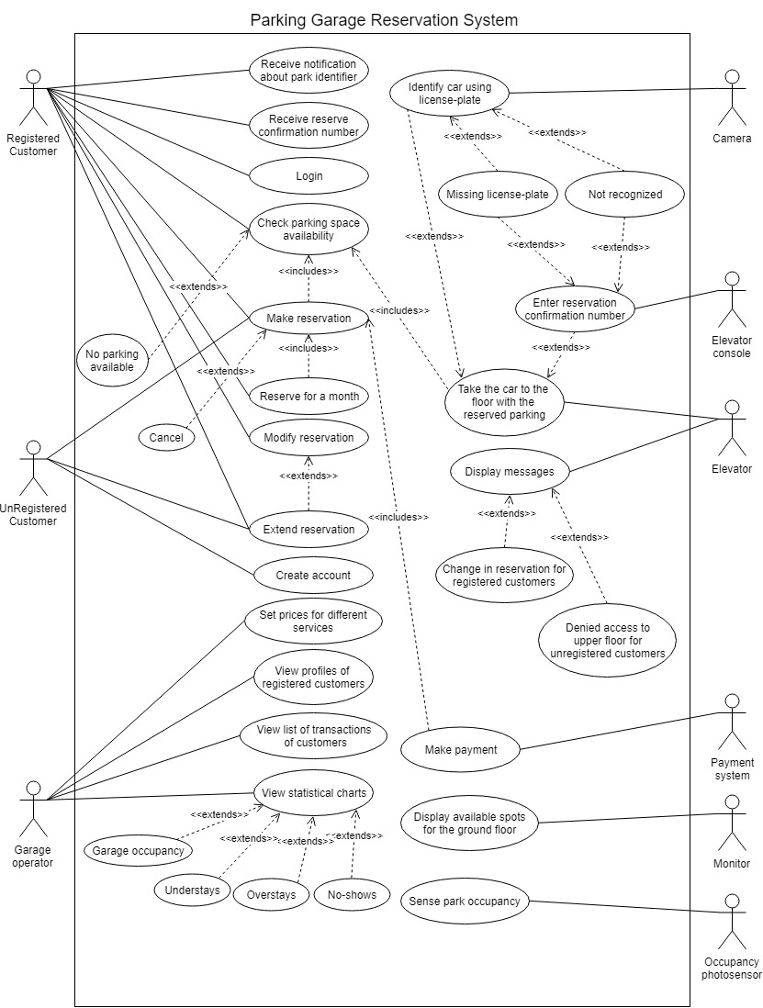

## 3.4 Use Cases Description

### 3.4.1 Set Price for Different Services

|  |  |
| --- | --- |
| **Use Case Description** | |
| **System:**  Parking Garage Reservation System. |  |
| **Use Case name:**  Set Price for different services |  |
| **Primary actor:**  Garage Operator | **Other actors:** |
| **Description:**  Allow the operator to set prices for different services. | |
| **Relationships:**   * **Includes:** * **Extends:** | |
| **Pre-conditions:**  Services should exist in the system. | |
| **Basic flow:** | |
| **Actor** | **System** |
| 1. Operator Select services page.  3. Operator select service   * parking fee within the reserved period * parking fee during overstays * fee for no-shows   4. Operator set or edit price.  6. Operator confirms the setting.  8. Operator click “save” to save the setting. | 2. System display page containing all services in the system.  5. System asks for confirmation for the new setting.  7. System displays services page.  9. System displays a success message. |
| Alternative and exceptional flows:  A7 Service doesn’t get save   * A7.1 Display error message.   A8 Select another service to Edit   * Steps from 4 to 7 are repeated.   A8 Setting is not saved   * A8.1 Reset to previous price. | |
| **Post-conditions:**  System shall send e-mail to customers about the new prices sets. | |

### 3.4.2 Make Reservation

|  |  |
| --- | --- |
| **Use Case Description** | |
| **System:**  Parking Garage Reservation System. |  |
| **Use Case name:**  Make reservation. |  |
| **Primary actor:**  Registered Customer. | **Other actors:**  Unregistered Customer. |
| **Description:**  Allow customer to reserve a parking. | |
| **Relationships:**   * **Includes:** Check parking space availability. * **Extends:** | |
| **Pre-conditions:**  The customer should be logged in. | |
| **Basic flow:** | |
| **Actor** | **System** |
| 1. The customer selects parking reservation.  3. The customer will provide:   * License-plate number. * Time and Date of reservation. * Duration of reservation. * Password.   4. The customer selects 'search'.  7. The customer clicks on 'confirm'.  9. The customer selects payment method and enters credit-card number. | 2. The system displays parking reservation page.  5. The system checks parking space availability.  6. The system displays a spot.  8. The system display payment page.  10. The system completes the payment.  11. The system display success message. |
| **Alternative and exceptional flows:**  A3. Invalid password   * A3.1 Display error message.   A5. No available parking spots in the specified time or duration   * A6.1 The system will display available parking spot on the same date in a different time or on a different date in the same time.   A9. Invalid credit-card number   * A9.1 Display error message | |
| **Post-conditions:**   * Park is reserved * Customer receives reservation confirmation number. | |

### 3.4.3 Modify Reservation

|  |  |
| --- | --- |
| **Use Case Description** | |
| **System:**  Parking Garage Reservation System. |  |
| **Use Case name:**  Modify reservation |  |
| **Primary actor:**  Registered Customer. | **Other actors:** |
| **Description:**  Let customer Modify his\her own reservation | |
| **Relationships:**   * **Includes:** * **Extends:** | |
| **Pre-conditions:**   * The customer should be logged in. * Customer should have a reservation. | |
| **Basic flow:** | |
| **Actor** | **System** |
| 1. Customer select reservations page  2. Customer select the reservation to be modified  4. Customer enter what he\she wants to change   * Change parking spot * Extend reservation   5. Customer select save to save his\her modify  7. Customer enter password | 3. System display reservation page  6. System asks the customer to enter password to confirm.  8. System display success message. |
| **Alternative** **and** **exceptional** **flows**:  1A Customer doesn’t have reserve   * A1.1 Transfer to make reservation page.   A4. No available parking spots   * A4.1 Display error message ”sorry there is no spot available”   A7. Customer enter wrong password.   * A7.1 Display error message | |
| **Post-conditions:**  The customer receives email concerning the changes that has been made to the reservation. | |

### 3.4.4 Create Account

|  |  |
| --- | --- |
| **Use Case Description** | |
| **System:**  Parking Garage Reservation System. |  |
| **Use Case name:**  Create account |  |
| **Primary actor:**  Unregistered Customer. | **Other actors:** |
| **Description:**  Allow to customer to register into the system. | |
| **Relationships:**   * **Includes:** * **Extends:** | |
| **Pre-conditions:**  The customer must have a driver's license. | |
| **Basic flow:** | |
| **Actor** | **System** |
| 1. The Customer select sign in to register  3. The customer should provide the following   * demographic information * valid email * credit card number * license-plate number * password   4. Customer applies to policy and privacy conditions.  5. Customer select submit  8. Customer confirms his\her e-mail. | 2. The system display sign in page  6. System display success message  7. System send confirmation mail to the customer |
| **Alternative and exceptional flows:**  A3.Customer e-mail already exist in the system   * A3.1 Display error message * A3.2 Transfer to log in page   A3. Customer e-mail not validated.   * A3.1. Display error message.   A4. Reject policy and privacy conditions.   * Cancel account creation.   A6. Confirmation mail not sent   * A6.1 Resend confirmation mail. | |
| **Post-conditions:**  Customer account is created | |

### 3.4.5 View Statistical Charts

|  |  |
| --- | --- |
| **Use Case Description** | |
| **System:**  Parking Garage Reservation System. |  |
| **Use Case name:**  View statistical charts |  |
| **Primary actor:**  Garage operator | **Other actors:** |
| **Description:**  Allow the operator to view charts about different information | |
| **Relationships:**   * **Includes:** * **Extends:** | |
| **Pre**-**conditions**:  The operator is logged in | |
| **Basic flow:** | |
| **Actor** | **System** |
| 1. The operator clicks on Reports  3. The operator clicks on charts  5. The operator select the time-interval and type of information to view   * Garage occupancy * Understays * Overstays * No-shows   6. The operator clicks on view | 2. The system display reports page  4. The system display charts page  7. The system will display the charts of requested time-interval and information |
| **Alternative and exceptional flows:**  5A. Incorrect time   * 5A1. The system will display error message   7A. Unavailable data for information type   * 7A1. The system will display error message | |
| **Post-conditions:** | |

## 3.5 Classes / Objects

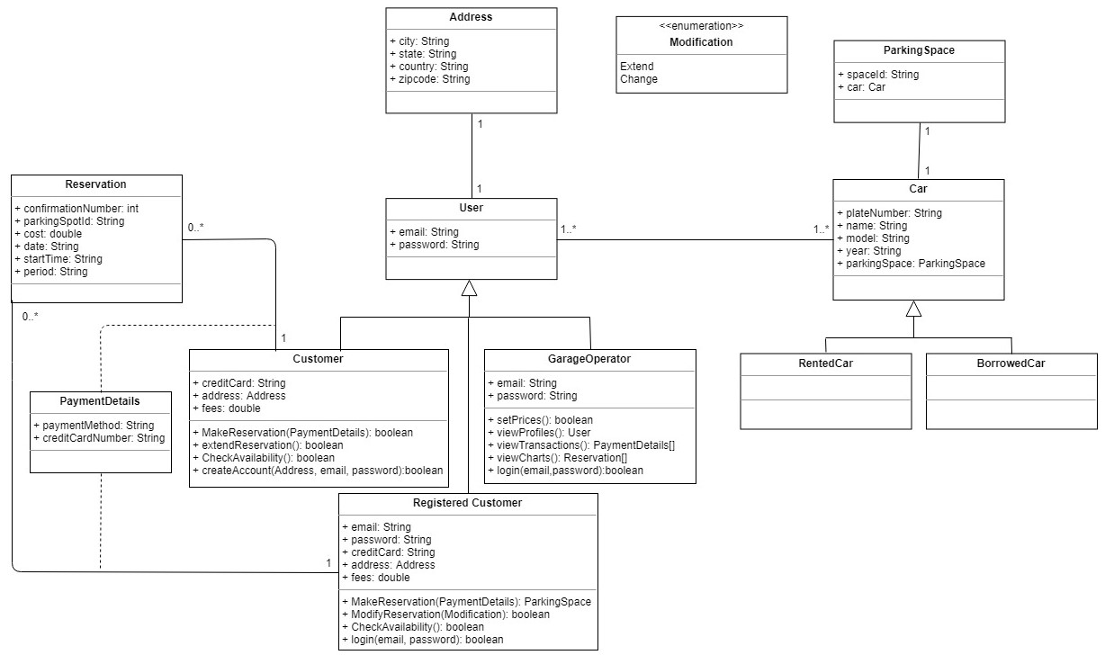

## 

## 3.6 Non-Functional Requirements

### 3.6.1 Response time

#### 3.6.1.1

The sensors and camera-based license recognition system shall send information about parking spot within 5 seconds.

#### 3.6.1.2

The system shall provide reservation confirmation number to the customer within ten seconds.

### 3.6.2 Ease of use

#### 3.6.2.1

The Average time to reserve a parking shall not exceed ten minutes.

### 3.6.3 Accessibility

#### 3.6.3.1

The number of steps to make a reservation shall be no longer than four steps.

### 3.6.4 Recovery time

#### 3.6.4.1

The time needed to recover the system after failure shall not exceed one hour.

### 3.6.5 Robustness

#### 3.6.5.1

The system shall display a message when the vehicle registration number is not recognized.

#### 3.6.5.2

The system shall display an error message when the customer enters wrong reservation confirmation number.

### 3.6.6 Availability

#### 3.6.6.1

The system shall be available 24/7.

### 3.6.7 Security

#### 3.6.7.1

License-plate or reservation confirmation number shall be required to access customer to the parking.

### 3.6.8 Capacity

#### 3.6.8.1

The system shall accommodate 500 reservations per minute.

### 3.6.9 Accuracy

#### 3.6.9.1

The bills shall be calculated and stored in database with accuracy of two decimal numbers.

### 3.6.10 Throughput

#### 3.6.10.1

The parking spot shall be changed to available as soon as the vehicle leaves the spot.

#### 3.6.10.2

Camera-based license recognition shall not exceed 5 seconds to recognize the vehicle.

## 3.8 Design Constraints

### 3.8.1

The system shall be programmed so it runs smoothly with a camera-based license recognition system.

### 3.8.2

The company website shall be developed by using modern programming language.

### 3.8.3

The system shall be programmed so it runs smoothly with a license-plate reader system.

### 3.8.4

The database shall be developed by experience developers.

### 3.8.5

A digital display shall be installed on the ground floor.

### 3.8.6

The system shall give a priority to People with special needs to make a reservation.

## 3.10 Other Requirements

The system shall be available in Arabic and English.

# 4. Analysis Models

## 4.1 Sequence Diagrams

### 4.1.1 Set Prices for Different Services

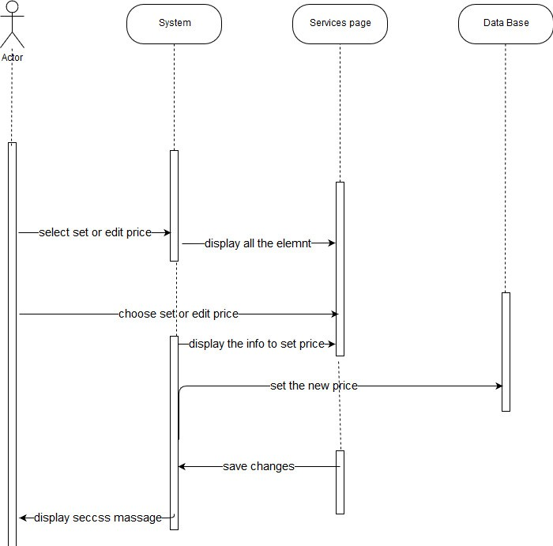

### 4.1.2 Make reservation

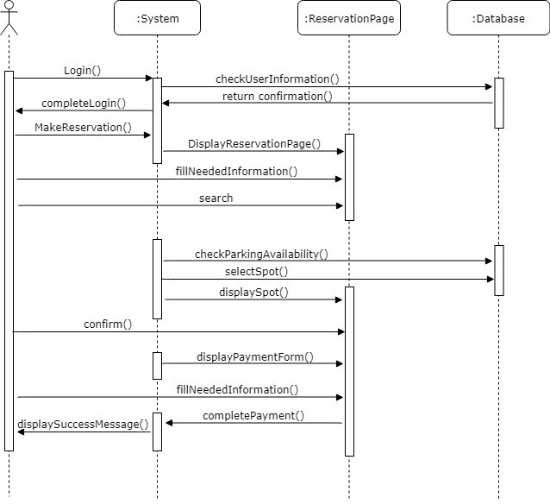

### 4.1.3 Modify Reservation

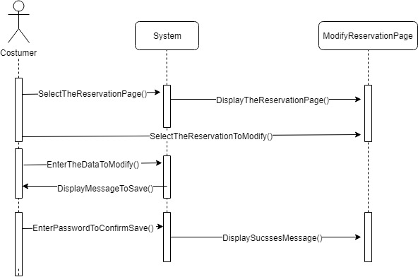

### 4.1.4 Create Account

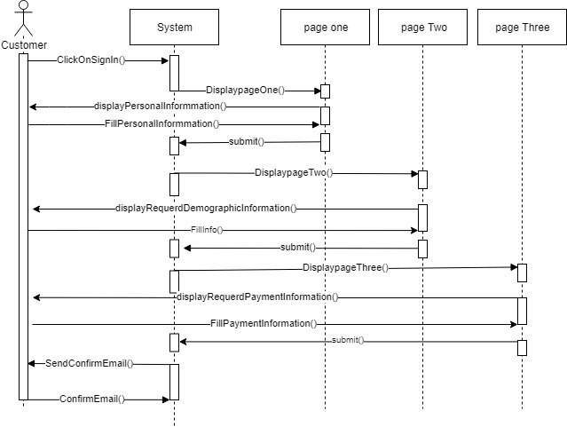

### 4.1.5 View Statistical Charts

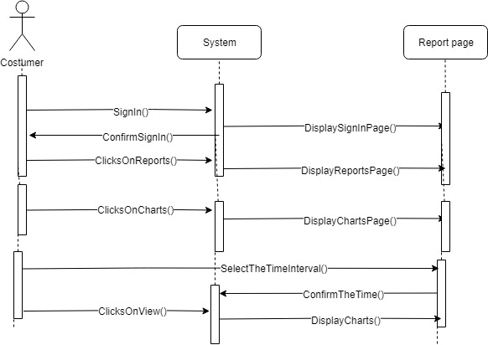

## 4.3 Activity Diagram

### 4.3.1 Set Prices for Different Services

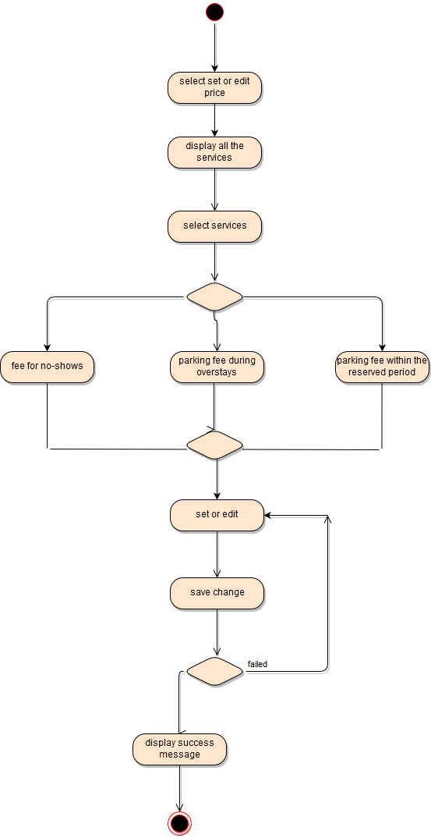

### 4.3.2 Make reservation

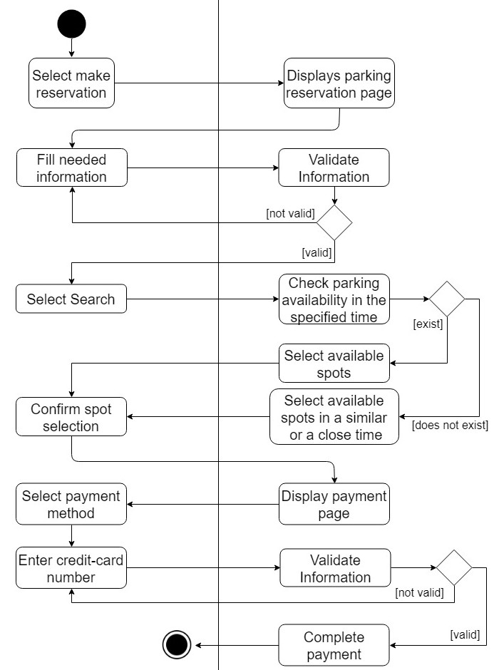

### 4.3.3 Modify Reservation

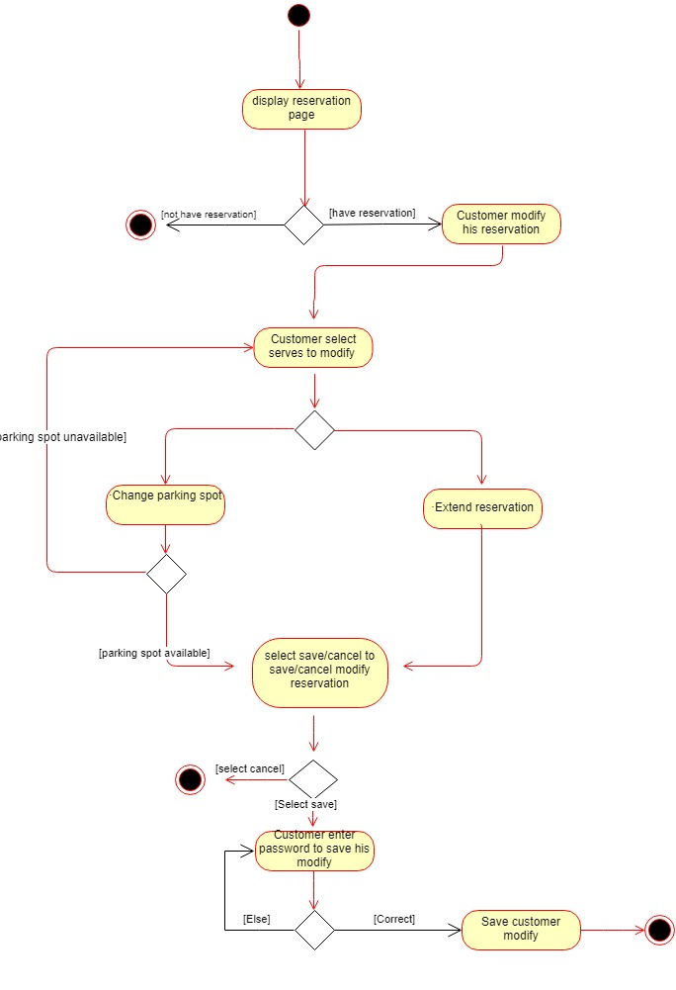

### 4.3.4 Create Account

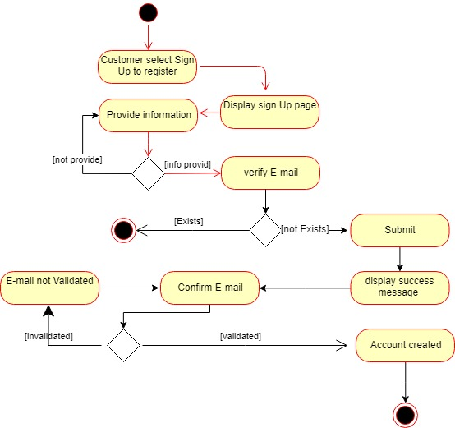

### 4.3.5 View Statistical Charts

