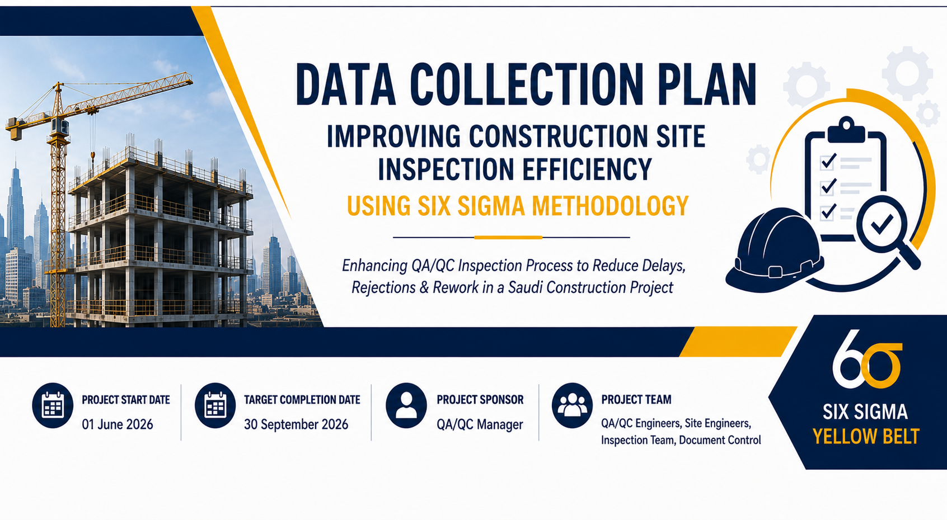

Data Collection Plan
“Improving Construction Site Inspection Efficiency Using Six Sigma DMAIC Methodology.”

Purpose of Data Collection
The purpose of this data collection plan is to gather operational and QA/QC inspection data related to delays, inspection rejections, rework activities, and documentation inefficiencies within the construction site inspection process.
The collected data will support the Measure and Analyze phases of the Six Sigma DMAIC methodology and help identify process inefficiencies affecting project performance.

Data Collection Scope
The data collection activities will focus on QA/QC inspection workflow, inspection request handling, approval and rejection activities, rework cases, and inspection documentation management. The data will be collected from ongoing construction inspection activities within the selected project scope.

Data Collection Table
Measure | Definition | Data Type | Unit of Measure | Data Source | Collection Method | Frequency | Responsible Person
Inspection Turnaround Time | Time taken from inspection request submission to final approval | Continuous | Hours | Inspection Logs | Manual Record Review | Weekly | QA/QC Engineer
Inspection Rejection Rate | Percentage of inspections rejected during review | Attribute | Percentage (%) | QA/QC Reports | Inspection Report Analysis | Weekly | QA/QC Inspector
Rework Frequency | Number of rework cases resulting from failed inspections | Discrete | Number of Cases | Rework Logs | Site Record Analysis | Weekly | Site Engineer
Documentation Error Rate | Percentage of inspection requests with incomplete or incorrect documents | Attribute | Percentage (%) | Document Control Records | Documentation Review | Weekly | Document Controller
Delayed Inspection Requests | Number of inspection requests delayed beyond target response time | Discrete | Number of Requests | Inspection Tracking Sheet | Delay Tracking Analysis | Weekly | Planning Coordinator
Approval Response Time | Time taken by QA/QC team to respond. | Continuous | Hours | Inspection Records | Process Time Tracking | Weekly | QA/QC Engineer

Data Collection Period
The data collection process will be conducted over a period of 8 weeks to capture sufficient operational data for process analysis and performance measurement.

Data Validation Approach
To ensure data accuracy and reliability:
- all inspection records will be verified against official QA/QC reports, duplicate entries will be removed, incomplete records will be reviewed with responsible departments, and collected data will be validated by the QA/QC Engineer before analysis.

Expected Outcome
The collected data will help identify major causes of inspection delays, operational bottlenecks, quality deficiencies, documentation issues, and areas requiring process improvement within the construction QA/QC inspection workflow.

