HYPOTHESES
“Improving Construction Site Inspection Efficiency Using Six Sigma DMAIC Methodology.”

Purpose
The purpose of this document is to define the null and alternative hypotheses for the key operational performance measures identified in the construction site QA/QC inspection process. These hypotheses support the Analyze phase of the Six Sigma DMAIC methodology.

Hypothesis Statements
Measure | Current Condition | Null Hypothesis (H₀) | Alternative Hypothesis (H₁)
Inspection Turnaround Time | Average turnaround time exceeds project target | There is no significant reduction in inspection turnaround time after process improvement. | Inspection turnaround time is significantly reduced after process improvement.
Inspection Rejection Rate | High percentage of inspections are rejected | There is no significant reduction in inspection rejection rate after improvement. | Inspection rejection rate is significantly reduced after improvement.
Rework Frequency | Frequent rework activities occur after failed inspections | There is no significant reduction in rework frequency after process improvement. | Rework frequency is significantly reduced after process improvement.
Documentation Error Rate | Inspection requests contain incomplete or incorrect documentation | There is no significant reduction in documentation errors after improvement. | Documentation error rate is significantly reduced after improvement.
Approval Response Time | Approval responses are delayed beyond operational targets | There is no significant improvement in approval response time after process changes. | Approval response time improves significantly after process changes.

2. Fishbone Diagram (Root Cause Analysis)

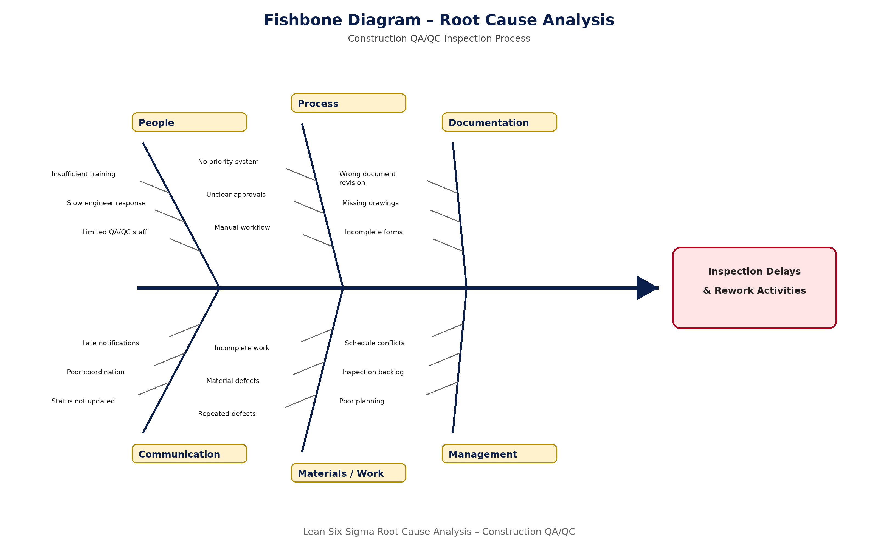

Analysis Approach
The project team will compare operational performance data collected before and after process improvement activities. Statistical analysis and process performance evaluation will be used to determine whether improvements in inspection efficiency, approval time, rejection rates, and documentation accuracy are statistically significant.

Expected Outcome
The hypothesis analysis is expected to support the identification of major process inefficiencies and validate whether the proposed process improvements contribute to measurable enhancements in construction QA/QC inspection performance.

