PROCESS MAP
“Improving Construction Site Inspection Efficiency Using Six Sigma DMAIC Methodology”.

High-Level Process Flow
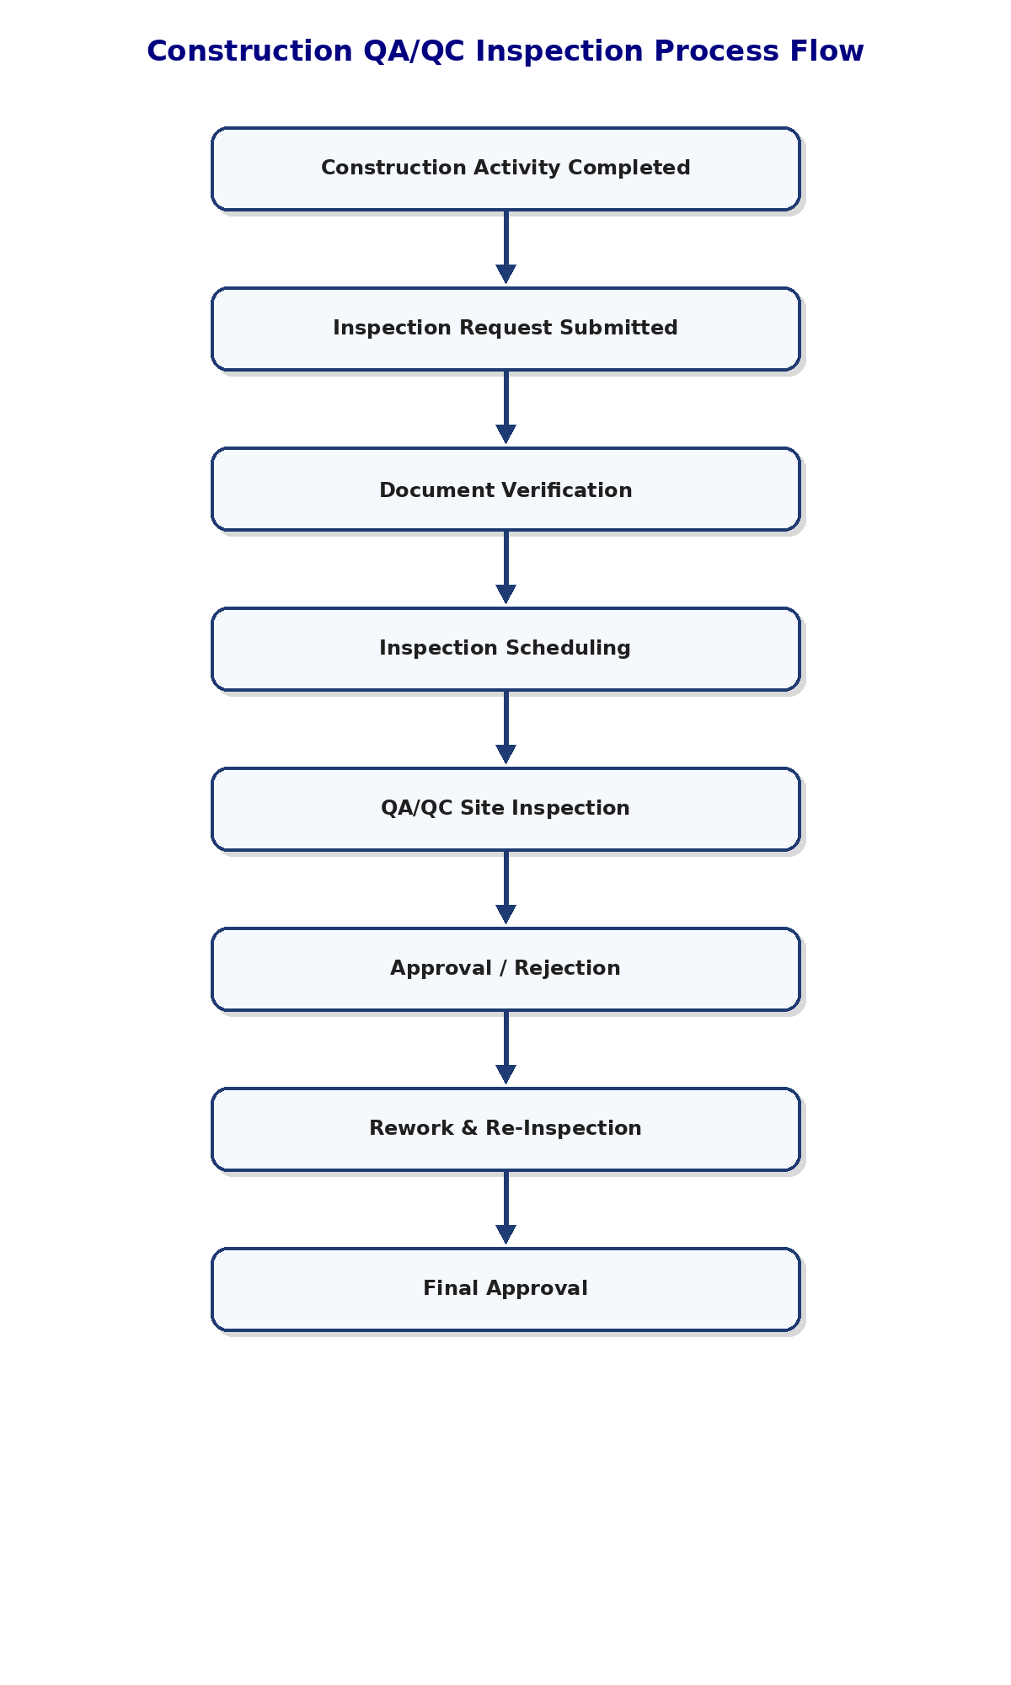

Detailed Process Map

Inspection Request Submission
Process Owner: Site Engineer
Time: 5–15 minutes
Steps:
- Complete construction activity
- Prepare inspection request
- Attach supporting documents
- Submit request to QA/QC department
Inputs: Completed construction work, inspection documents
Outputs: Inspection request submitted
Key Metrics: Submission accuracy, request volume

Document Verification
Process Owner: Document Controller
Time: 10–20 minutes
Steps:
- Review attached documents
- Verify drawings and specifications
- Check document completeness
- Forward request for scheduling
Inputs: Inspection request package
Outputs: Verified inspection request
Key Metrics: Documentation error rate

Inspection Scheduling
Process Owner: QA/QC Coordinator
Time: 1–4 hours
Steps:
- Review inspection queue
- Assign QA/QC inspector
- Schedule inspection time
- Notify site team
Inputs: Verified inspection request
Outputs: Scheduled inspection
Key Metrics: Scheduling delay, pending inspections

QA/QC Site Inspection
Process Owner: QA/QC Inspector
Time: 30–90 minutes
Steps:
- Conduct field inspection
- Verify quality compliance
- Review workmanship
- Record findings
Inputs: Scheduled inspection
Outputs: Inspection findings
Key Metrics: Inspection turnaround time

Approval / Rejection
Process Owner: QA/QC Engineer
Time: 15–30 minutes
Steps:
- Review inspection findings
- Approve or reject inspection
- Issue comments if needed
- Update inspection status
Inputs: Inspection findings
Outputs: Approved or rejected inspection
Key Metrics: Approval rate, rejection rate

Rework & Re-Inspection
Process Owner: Construction Team
Time: Varies
Steps:
- Perform corrective actions
- Rectify quality issues
- Submit re-inspection request
- Repeat inspection process
Inputs: Rejected inspection report
Outputs: Corrected work
Key Metrics: Rework frequency

Process Performance Data
Process Step | Average Time | Variation (±) | Key Issues
Inspection Request Submission | 10 minutes | 5 minutes | Incomplete forms
Document Verification | 15 minutes | 8 minutes | Missing documentation
Inspection Scheduling | 3 hours | 2 hours | Inspector availability delays
QA/QC Site Inspection | 60 minutes | 20 minutes | Site coordination delays
Approval / Rejection | 25 minutes | 10 minutes | Approval bottlenecks
Rework & Re-Inspection | 1–3 days | 1 day | Repeated quality failures

Key Process Issues Identified
- Delayed inspection approvals
- Incomplete documentation submission
- Communication gaps between teams
- Repeated inspection failures
- High rework activities
- Manual tracking inefficiencies

5. Waste Identification (Lean Six Sigma)
- Waiting – Delays in inspection scheduling and approvals
- Rework – Repeated correction activities after failed inspections
- Motion – Excessive coordination between departments
- Overprocessing – Multiple approval reviews
- Inventory – Backlog of pending inspection requests

6. Improvement of Opportunities
- Implement digital inspection tracking system
- Standardized inspection request documentation
- Improve inspection scheduling coordination
- Develop QA/QC checklist templates
- Enhance communication between site and QA/QC teams

