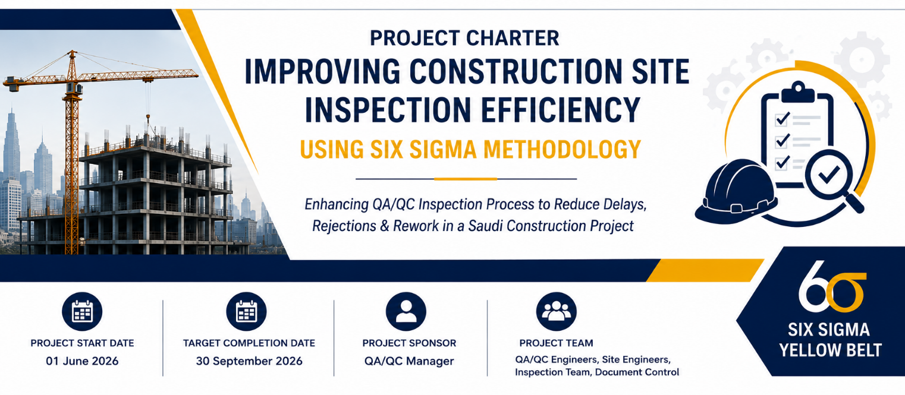

Project Name | Improving Construction Site Inspection Efficiency Using Six Sigma DMAIC Methodology
Today’s Date | 16 May 2026
Project Start Date | 01 June 2026
Target Completion Date | 30 September 2026

Project Element | Response
Problem Statement  - Includes time, measurable item, gap and business impact | The QA/QC inspection process in the construction project is experiencing delays in inspection approvals, high inspection rejection rates, and repeated rework activities. Over the past six months, the average inspection turnaround time has exceeded the project target by approximately 35%, resulting in construction delays, increased labor costs, inefficient resource utilization, and reduced operational efficiency. Incomplete documentation and communication gaps between site engineers and QA/QC inspectors have further contributed to process inefficiencies and delayed project progress.
Business Case  - Why is this project important to do now?  - What is the project’s financial impact?  - What is the impact on DPMO/ Sigma level?  - What is the impact on customer service | Timely and efficient construction site inspections are critical to maintaining project schedules, quality standards, and client satisfaction in large-scale Saudi construction projects. Delays in QA/QC inspections and repeated inspection rejections negatively impact project timelines, increase operational costs, and reduce workforce productivity.  This project is important because inefficient inspection processes can lead to:  - delayed construction activities,  - increased rework costs,  - idle labor hours,  - scheduling disruptions,  - and reduced compliance with project quality standards.  Improving the inspection process is expected to reduce inspection delays, improve approval rates, decrease rework activities, and enhance coordination between construction and QA/QC teams.
Goal Statement  - Specific  - Measurable  - Achievable  - Realistic  - Time-bound | The goal of this project is to improve the efficiency of the QA/QC construction site inspection process by reducing the average inspection turnaround time from 48 hours to 24 hours and decreasing inspection rejection rates from 18% to below 8% within four months through process standardization, improved coordination, and better documentation management.
List of Improvement Goals  1.  2.  3.  4.  5. | Measure (units) | Baseline |  | Goal
 | Average Inspection Turnaround Time | 48 Hours |  | 24 Hours
 | Inspection Rejection Rate | 18% |  | Below 8%
 | Rework Frequency | 15 Cases per Month |  | Below 5 Cases per Month
 | Documentation Error Rate | 22% |  | Below 10%
 | Delayed Inspection Requests | 30 Requests per Month |  | Below 10 Requests per Month
Process  - Describe the process in which the problem exists | The construction site inspection process begins when the site engineer submits an inspection request for completed construction work. The QA/QC department reviews the request, verifies supporting documentation, and schedules the inspection activity.  A QA/QC inspector then performs the site inspection to evaluate compliance with project specifications, quality standards, approved drawings, and safety requirements. If the inspection passes, approval is issued and construction activities proceed to the next stage.  If deficiencies or non-conformities are identified, the inspection is rejected and rework activities are assigned to the construction team. After corrective actions are completed, a re-inspection request is submitted and the process repeats until final approval is achieved.  The current process experiences delays due to incomplete documentation, poor coordination between teams, delayed inspection scheduling, and repeated quality issues during inspection activities.
Project Scope  - What part of the process will be addressed?  - What are the boundaries of the project or process?  - What areas are inside or outside the team’s focus or authority?  - Attach a SIPOC diagram if necessary | This project will focus on improving the efficiency of the QA/QC construction site inspection process for structural and finishing activities within the selected construction project.  The project scope includes:  - inspection request submission,  - documentation verification,  - inspection scheduling,  - QA/QC site inspection activities,  - approval and rejection handling,  - rework coordination,  - and final inspection approval workflow.  The project will specifically address process inefficiencies related to:  - delayed inspections,  - repeated inspection rejections,  - incomplete documentation,  - and communication gaps between construction and QA/QC teams.  The project scope does not include:  - procurement activities,  - contractor hiring processes,  - financial management,  - or external client approval procedures.
Team | Member Name
Project Sponsor | QA/QC Manager
Key Stakeholders | - Construction Project Manager  - Site Engineers  - QA/QC Department
Team Lead | QA/QC Engineer
Team Members | - Site Engineer  - QA/QC Inspector  - Document Controller  - Planning Coordinator
Process Owner | Construction Project Manager
Other | HSE Coordinator (Support Role)
Timeline by Project Stage | Milestone |  | Target Completion Date
Define | Project Charter Approval and Project Kickoff |  | 05 June 2026
Measure | Data Collection and Baseline Performance Analysis |  | 30 June 2026
Analysis | Root Cause Identification and Process Analysis |  | 31 July 2026
Improve | Development of Improvement Recommendations and Process Enhancements |  | 31 August 2026
Control | Standardization of Improved Inspection Procedures and Monitoring Plan |  | 30 September 2026

SIPOC Diagram
