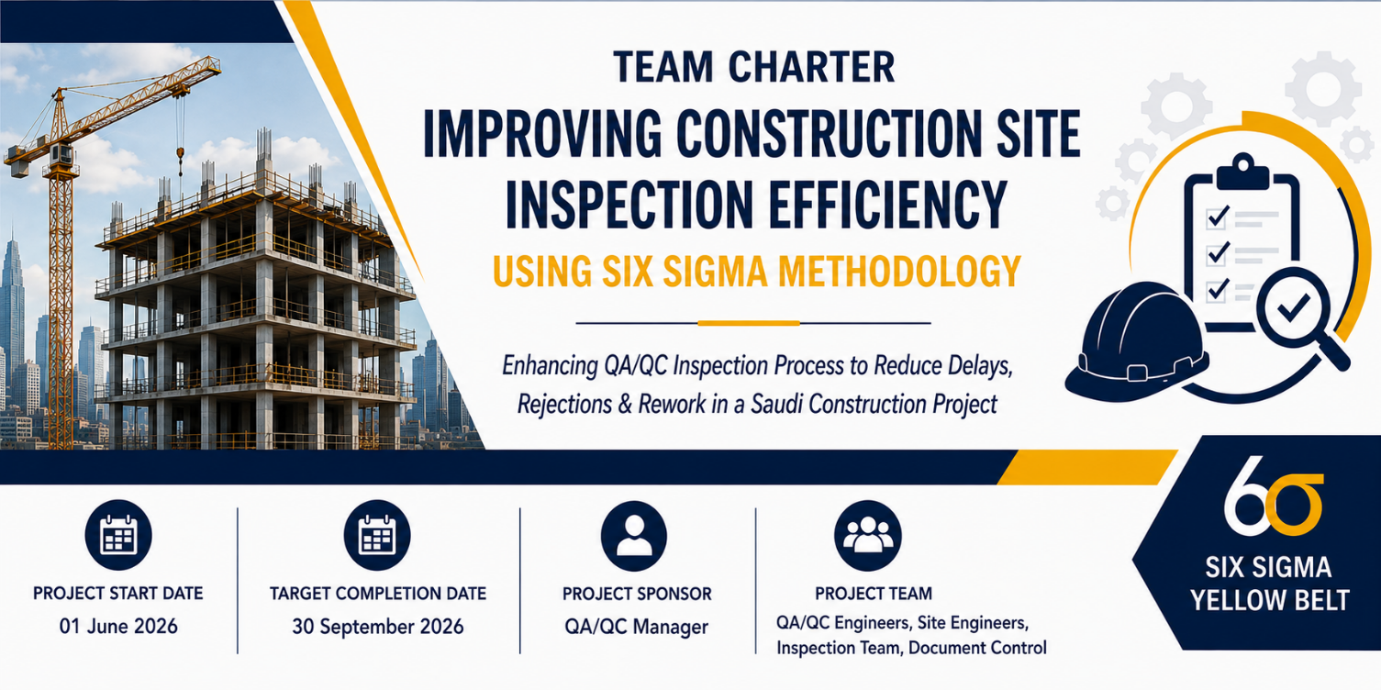

Project Title | Improving Construction Site Inspection Efficiency Using Six Sigma DMAIC Methodology

Expectation | Team Rule
Attendance | All team members are expected to attend scheduled project meetings and site coordination sessions. Any absence or schedule change must be communicated at least 24 hours in advance to ensure uninterrupted project activities.
Participation | All team members are expected to actively contribute to discussions, share operational insights, and support project tasks related to QA/QC inspection improvement activities.
Focus | The team will remain focused on improving the construction site inspection process and achieving the project objectives defined in the Project Charter. Meeting discussions and activities will remain aligned with project scope and operational priorities.
Interruptions | Interruptions during meetings and inspection coordination sessions should be minimized. Mobile devices should remain on silent mode unless required for project-related communication or emergencies.
Preparation | Team members are responsible for reviewing meeting agendas, preparing required documents, and completing assigned tasks before scheduled meetings and inspection review sessions.
Timeliness | Meetings, inspection reviews, and coordination activities will begin and end according to the scheduled time to maintain operational efficiency and project discipline.
Decisions | Project decisions will be based on operational data, inspection findings, process analysis, and team collaboration. All members are expected to support agreed improvement actions and recommendations.
Data | The project team will use accurate and verified QA/QC inspection data for process analysis, KPI measurement, and improvement evaluation throughout the DMAIC phases.
Conflict | Team members are encouraged to communicate professionally and resolve disagreements respectfully. Any unresolved conflicts will be escalated to the Team Lead or Project Sponsor for resolution.

Team Member | Role | Signature
QA/QC Manager | Project Sponsor
QA/QC Engineer | Team Lead
Construction Project Manager | Process Owner
Site Engineer | Team Member
QA/QC Inspector | Team Member
Document Controller | Team Member
Planning Coordinator | Support Member
HSE Coordinator | Support Member

