**Week 4 (Mechanical Engineer):**

This week two tasks were given:

1-Design joint for humanoid robot

2-Design joint for robot arm

The joint that I designed is suitable for *both* the humanoid and robot arm, I created this design in Fusion 360.

This design has three parts:

1. Element one (this will have two U shaped parts)
2. Element two (this has the roller bearing)
3. Rod (this will connect both element one and two)

Here are photos of this design:

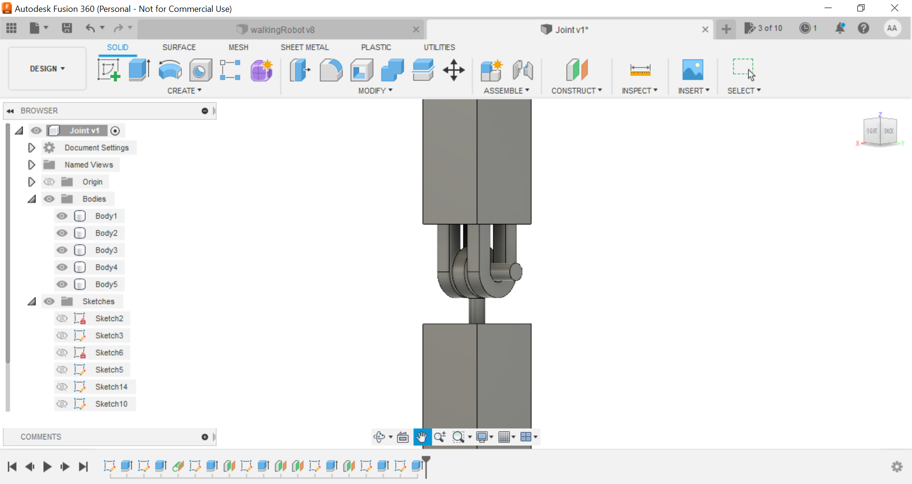

(This is the joint assembled in isometric view)

The dimensions of the joint are as follows:

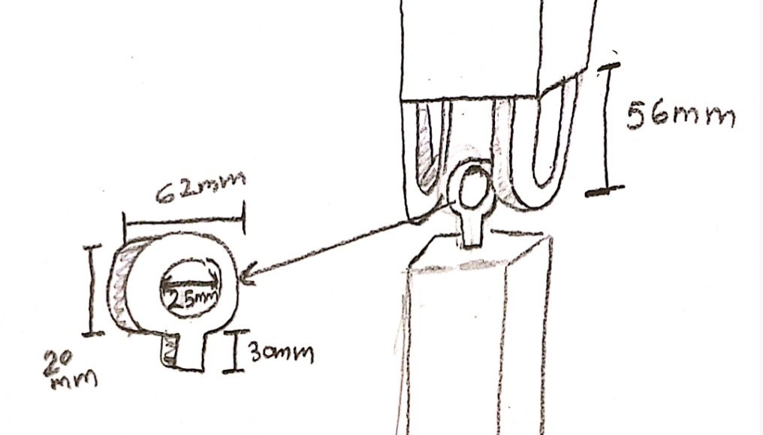

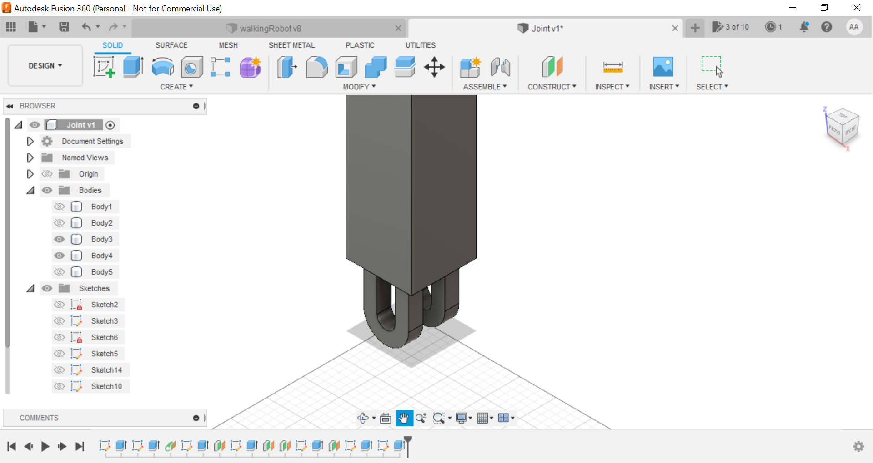

(This is element one with two U shaped parts attached to its base)

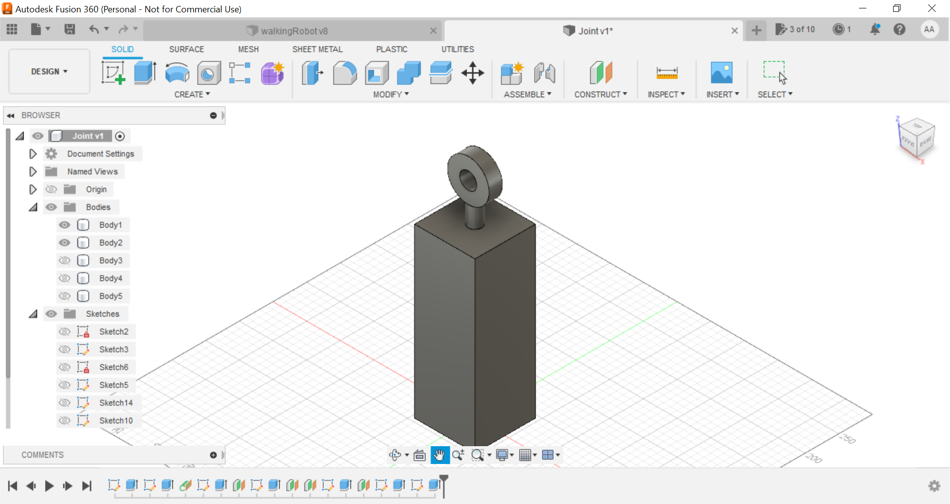

(Element two with the roller bearing)

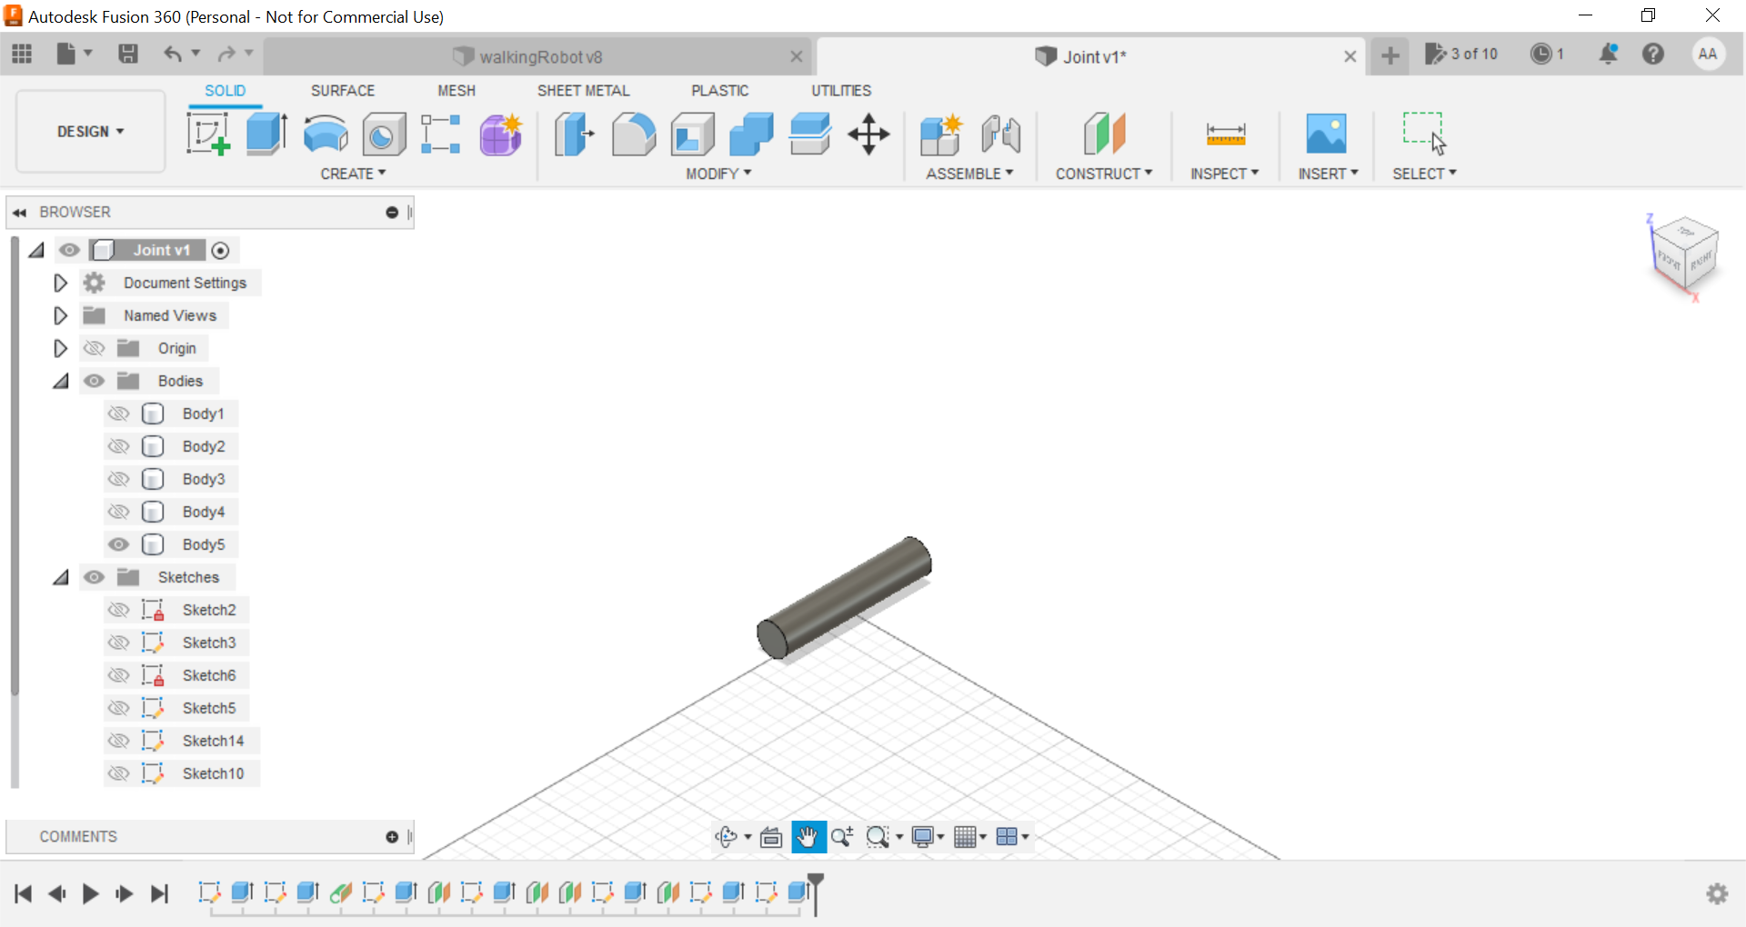

(This is the rod that will connect element one and two)

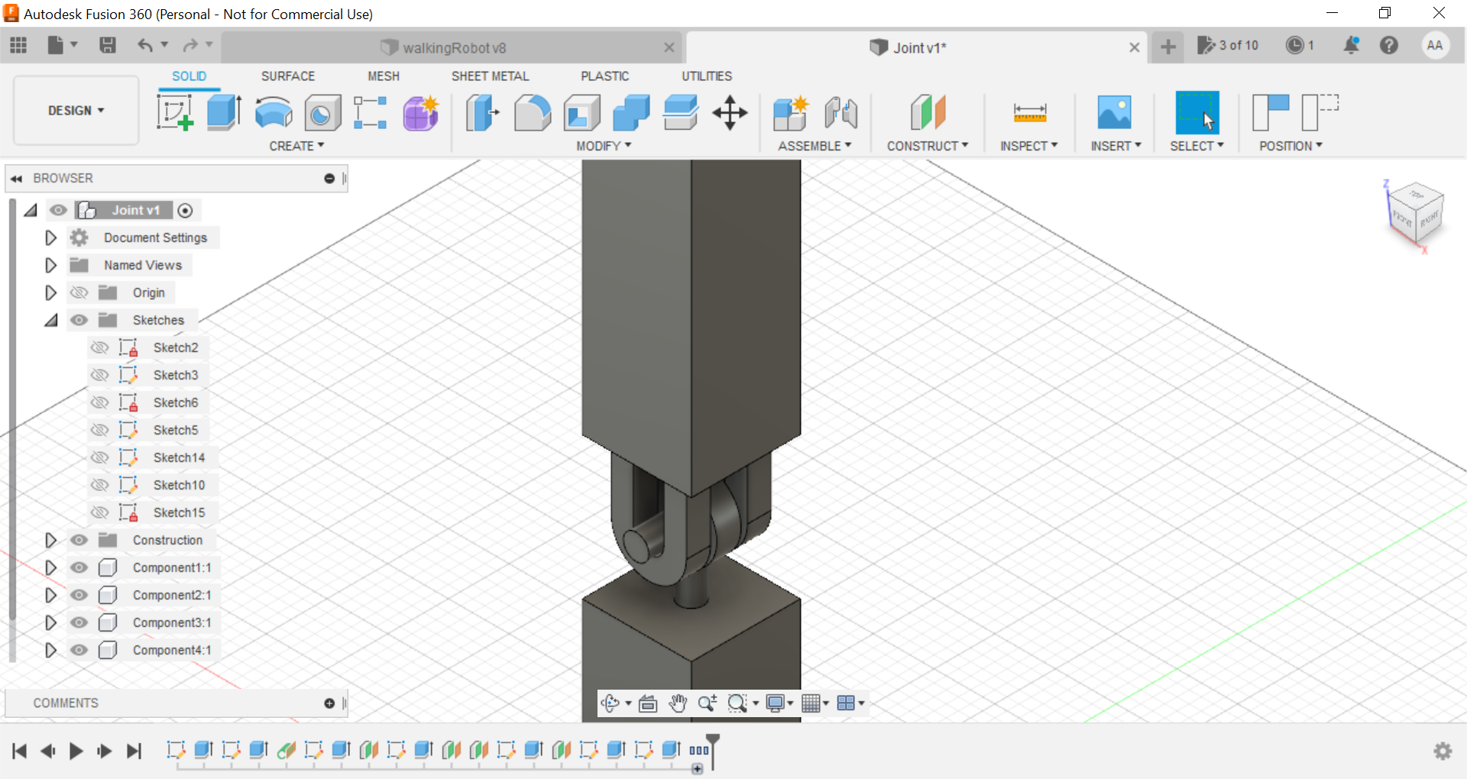

(Isometric view)

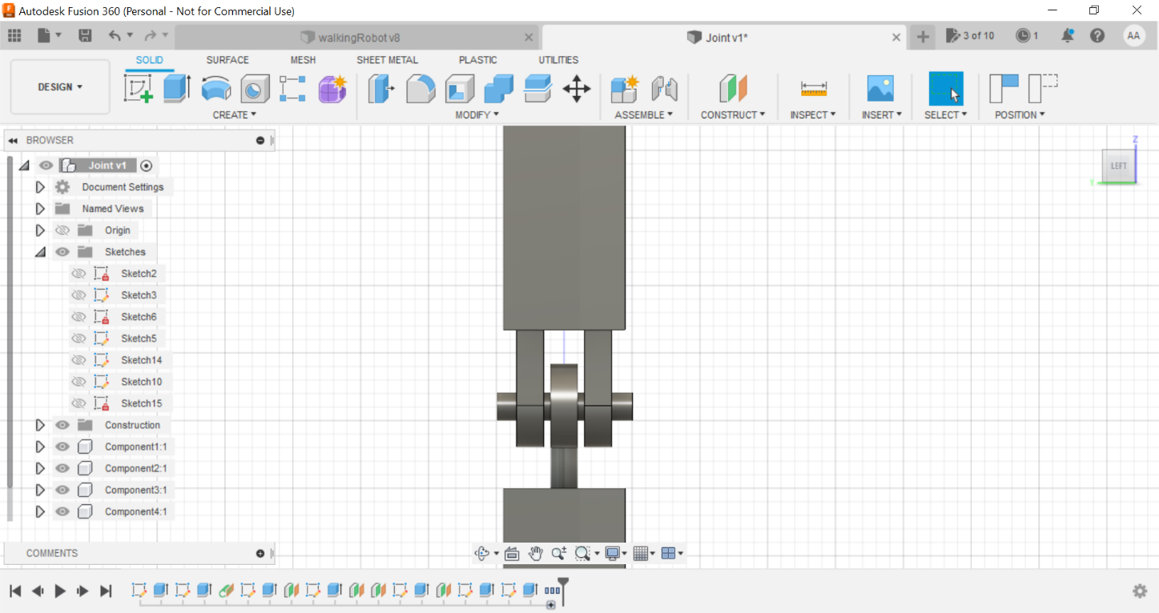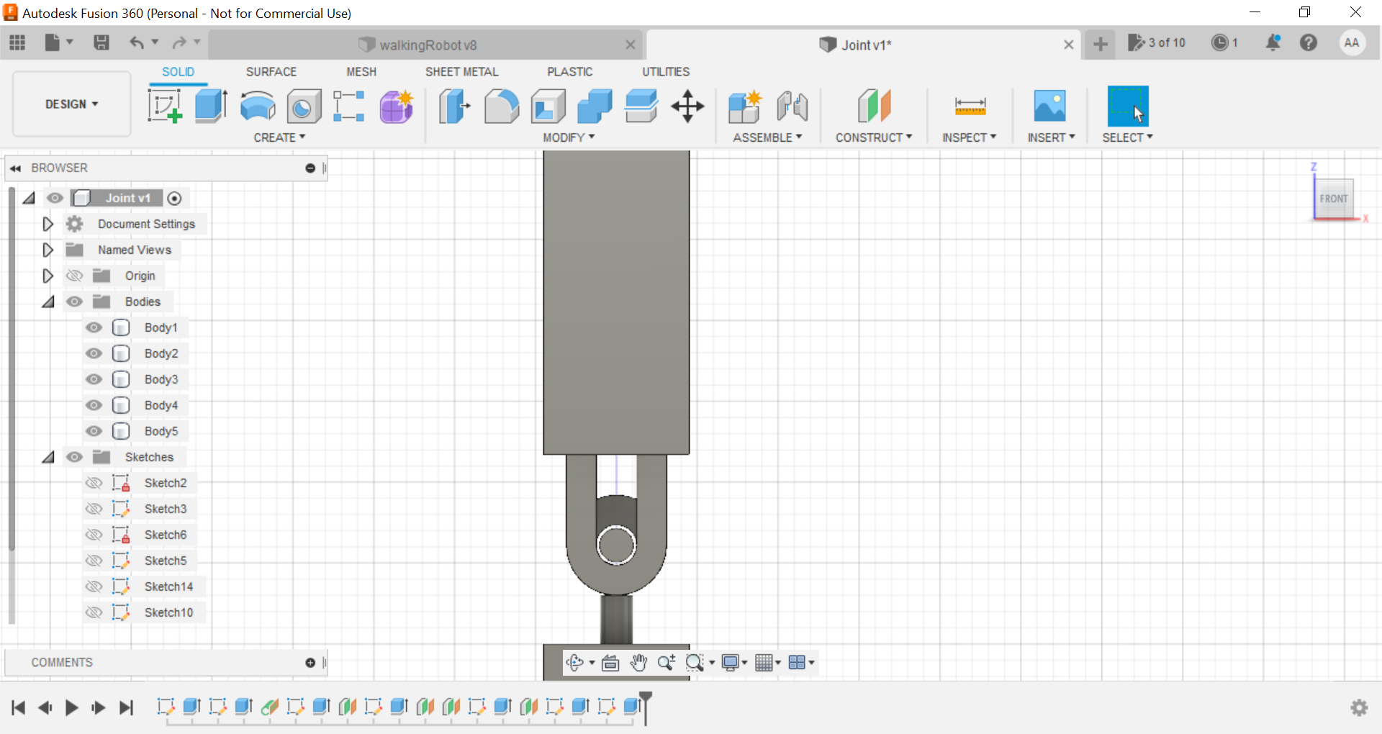

(Front view) (Side view)