
UNIVERSITY OF ASIA PACIFIC
Department of Computer Science and Engineering (CSE)

Course Title: Compiler Design Lab
Course Code: CSE-430
Project Name: Mini Compiler Design

Submitted By: Submitted To:
Name: Abdullah Al Musabbir MD. SHAFAYATUL HAQUE
Reg. No: 22101039 Lecturer
Sec: A Department of CSE
University of Asia Pacific

Contents
1. Introduction 3
2. Project Motivation 3
2.1 Academic Motivation 3
2.2 Practical Motivation 3
2.3 Tool-Specific Motivation 3
2.4 Gap in Simple Educational Compilers 4
3. Project Scope 4
4. Design 5
4.1 Lexical Analysis (Scanning): 5
4.2 Abstract Syntax Tree: 6
4.3 Intermediate Code Generation: 6
4.4 Code Optimization: 6
4.5 Target Code Generation 6
4.6 Symbol Table Management 6
5. Implementation 6
Commands to compile and run: 6
6. Conclusion 12
7. Future Scope 12

Introduction
Compilers are complex software systems that translate human-readable source code into machine-executable instructions through multiple phases including lexical analysis, syntax analysis, semantic analysis, and code generation. Understanding compiler design provides deep insights into how programming languages are implemented and executed, while demonstrating practical applications of theoretical concepts like formal languages, automata theory, and optimization algorithms. This knowledge enables developers to write more efficient code by understanding the translation and optimization process. Additionally, compiler construction techniques are widely applicable to other domains including interpreter design, domain-specific languages, and program analysis tools.

Project Motivation
The motivation behind building this Mini C Compiler arises from both academic and practical perspective.

2.1 Academic Motivation
Compiler Design is a core course in Computer Science and Engineering curricula. While theoretical concepts such as grammar, automata, parse trees, and intermediate representations are taught in classrooms, a hands-on implementation project provides an unparalleled depth of understanding. Building a compiler from scratch requires integrating knowledge from:
- Formal Languages and Automata Theory Regular expressions, DFA/NFA, context-free grammars
- Data Structures Trees (AST), tables (symbol table, token table)
- Algorithm Design Tree traversal, optimization passes
- Systems Programming Low-level code generation, memory layout

2.2 Practical Motivation
Real-world compilers such as GCC, Clang, and MSVC are extraordinarily complex software systems with millions of lines of code. Understanding their internal architecture — even at a simplified scale — provides developers with:
- Better understanding of how code is executed
- Ability to write more efficient programs
- Foundation for working on language tooling (linters, formatters, transpilers)
- Skills applicable to embedded systems, DSL (Domain Specific Language) design, and virtual machine development

2.3 Tool-Specific Motivation
Flex and Bison are the GNU implementations of the classic Lex and Yacc tools, which have been used in production compilers for decades. Learning these tools provides:
- Industry-relevant skills for compiler and interpreter development
- Understanding of LALR(1) parsing — one of the most widely used parsing strategies
- Experience with specification-driven code generation (Flex/Bison generate C code automatically from specifications)

2.4 Gap in Simple Educational Compilers
Most educational compiler examples either:
- Only implement a single phase (e.g., just a lexer)
- Use Python or Java where memory management is hidden
- Do not generate actual assembly output
This project addresses that gap by implementing all seven phases end-to-end in C, producing real x86 NASM-style assembly output.

Project Scope
The compiler is implemented in C using Flex (Fast Lexical Analyzer) for tokenization and Bison (GNU Parser Generator) for syntax and semantic analysis. The project encompasses seven distinct tasks, each corresponding to a major phase of compilation:
- Lexical Analysis - Tokenization of source code into meaningful symbols
- Syntax Analysis - Validation of program structure against grammar rules
- Semantic Analysis - Type checking and symbol table construction
- Abstract Syntax Tree Generation - Building hierarchical program representation
- Intermediate Code Generation - Three-Address Code (TAC) production
- Code Optimization - Multi-pass optimization including constant propagation, folding, and dead code elimination
- Target Code Generation - ARM assembly code emission with register allocation
The compiler successfully processes a substantial subset of C/C++ including variable declarations, arithmetic expressions, logical operations, control flow structures (if-else, while loops), and function definitions. Through advanced optimization algorithms, the compiler achieves a 52% reduction in code size compared to unoptimized output, demonstrating the practical impact of compiler optimizations on program efficiency.

Design
The design of the project involves the following components and flow:
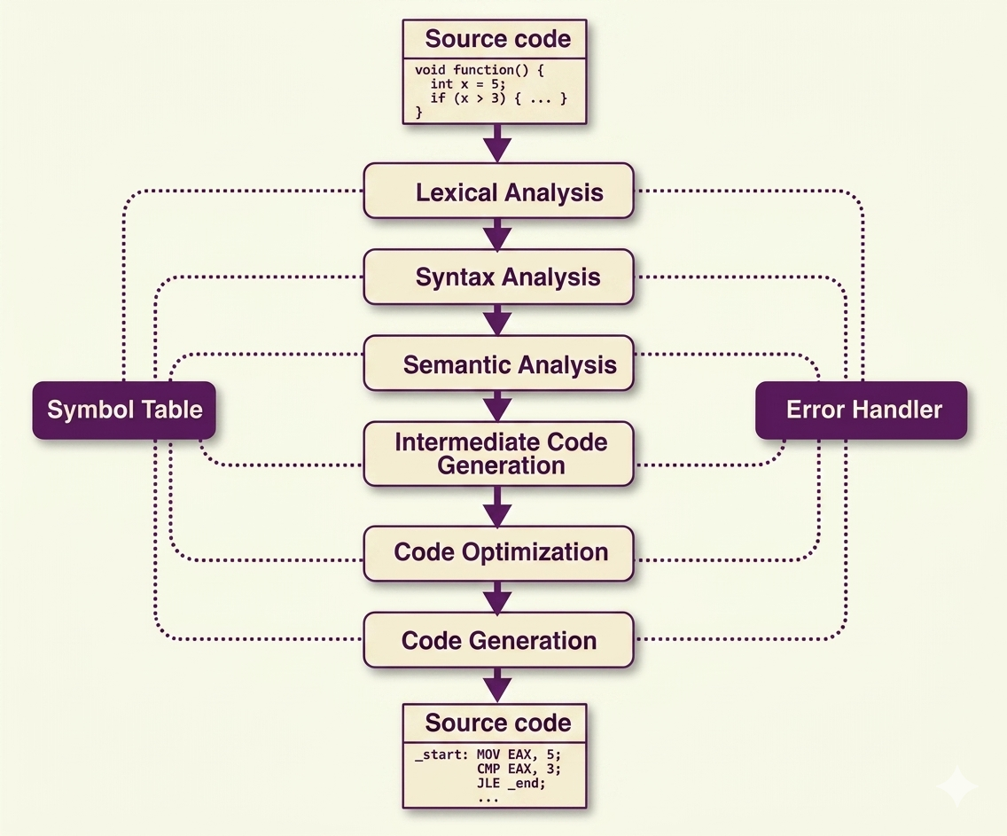

Lexical Analysis (Scanning):
Purpose: Break source code into tokens (smallest meaningful units)
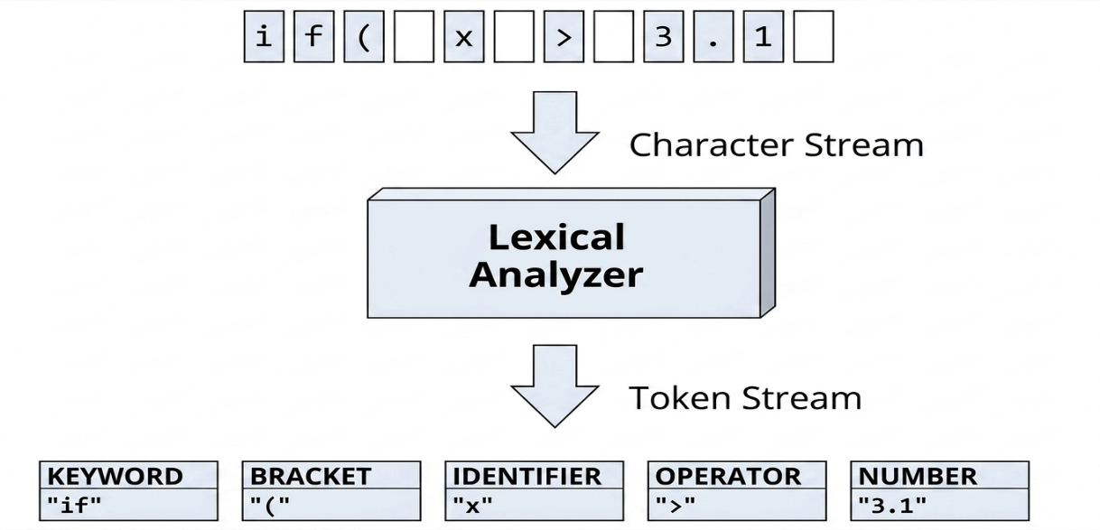

4.2 Abstract Syntax Tree:
I checked the tokens against the language's grammar and created a parse tree.
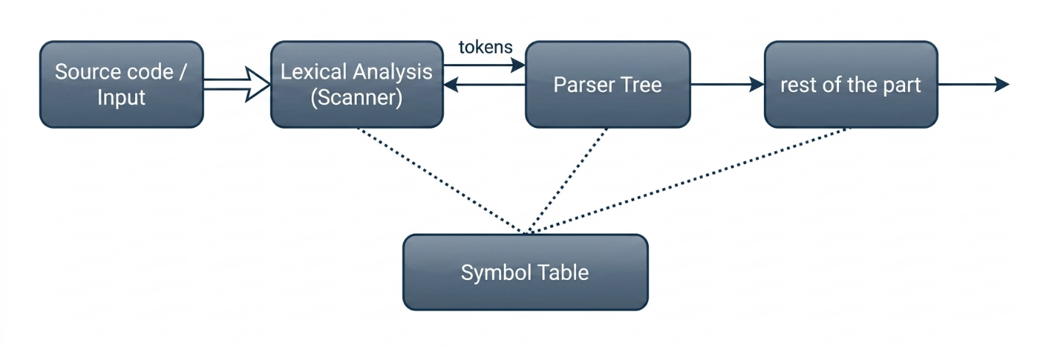

4.3 Intermediate Code Generation:
Converts the parse tree into an intermediate representation (IR) with low-level representation- TAC.
A sequence of instructions of the form
Result = agr1 Operator ag2

4.4 Code Optimization:
Optimizing the TAC intermediate code to error handling is handled during the syntax validation phase of the compiler. After optimization, it eliminates the Dead Code.

4.5 Target Code Generation
Converts the intermediate representation into machine code or assembly.
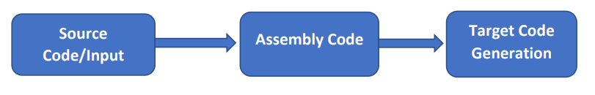

4.6 Symbol Table Management
Keeps track of variable/function names and their attributes throughout the compilation process.

Implementation

Commands to compile and run:
bison -d parser.y
flex lexer.l
gcc -w -o compiler lex.yy.c parser.tab.c main.c
./compiler

Step 1 - Lexical Analysis (Tokenization)
● Tools used: Flex (Lex) and GCC
● Language used: C
● Data Structures: Token structure to recognize keywords (int, float, if, else, while, return), operators (+, -, , /, =, <, >, <=, >=, ==, !=), identifiers, numbers, and comments (single-line // and multi-line / */)
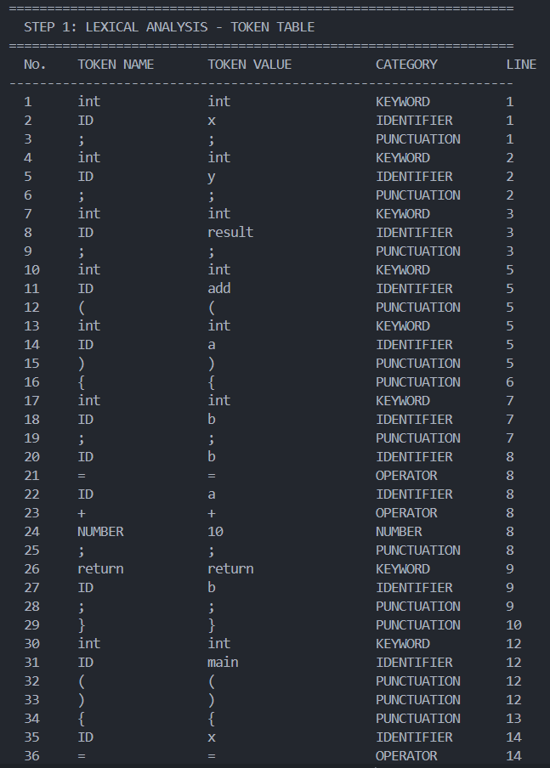
Step 2 - Symbol Table Creation
● Tools used: Flex (Lex) and GCC
● Language used: C
● Data Structures: Symbol table (hash table or array) for variable tracking, type information struct, scope management stack for checking variable declarations, type compatibility, and semantic errors
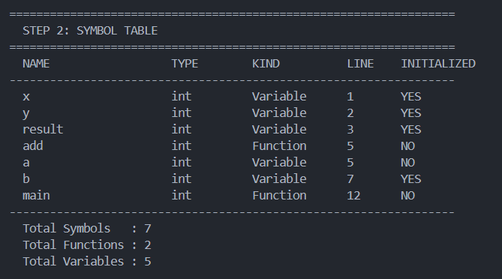
Step 3 - Semantic/Syntax Analysis
● Tools used: Bison, Flex (Lex) and GCC
● Language used: C
● Data Structures: Symbol table (array-based) storing variable names, types, line numbers, and function flags; duplicate error tracking array to prevent repeated error messages
● Semantic, syntax Checks Performed
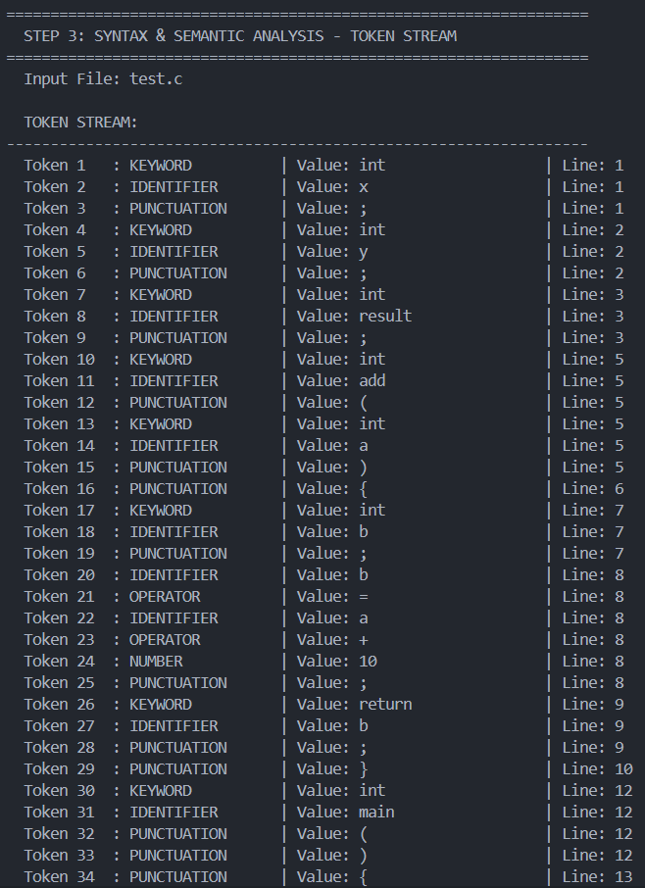
Step 4 - Abstract Syntax Tree (AST) Generation
● Tools used: Bison, Flex (Lex) and GCC
● Language used: C
● Data Structures: AST node structure with node type, children pointers, expression trees for arithmetic operations, statement nodes for assignments and control flow
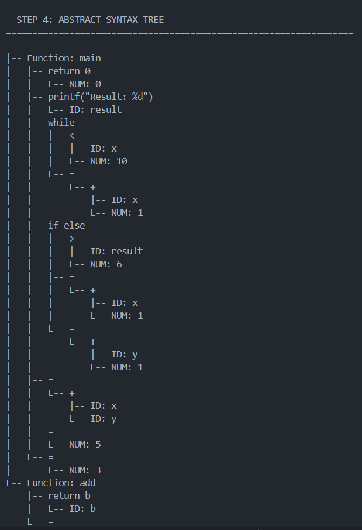

Step 5 - Intermediate Code Generation (TAC)
● Tools used: Bison, Flex (Lex) and GCC
● Language used: C
● Data Structures: : Quadruple structure (op, arg1, arg2, result) for Three-Address Code, temporary variable counter, label generator for control flow (if-else, while loops), backpatching stack for label resolution
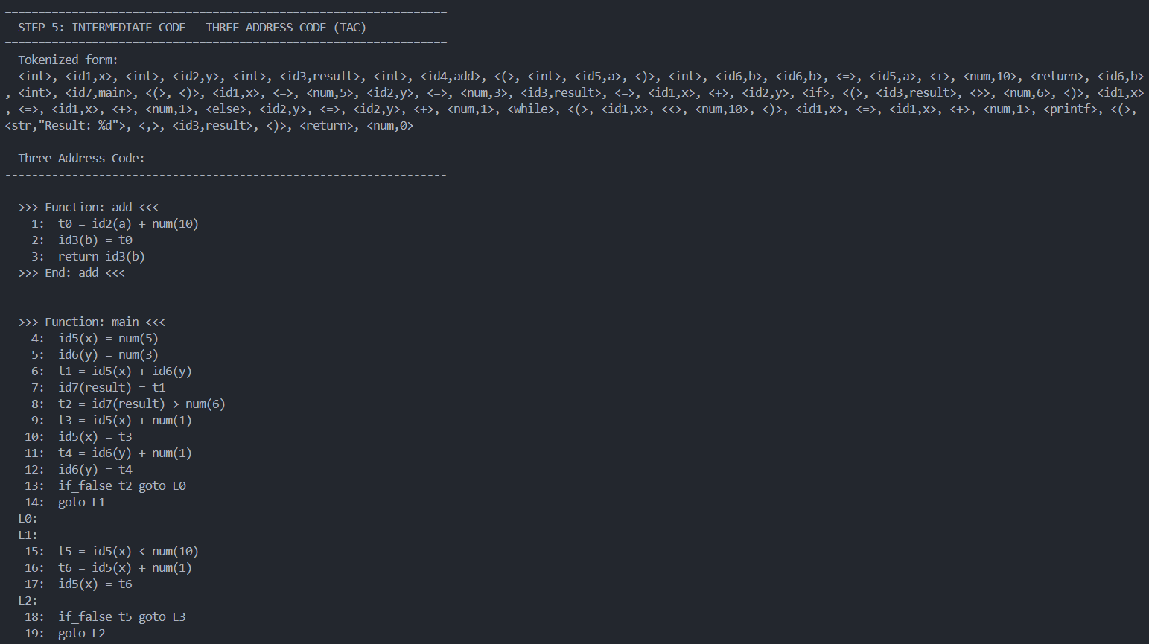

Step 6 - Code Optimization
● Tools used: Bison, Flex (Lex) and GCC
● Language used: C
● Data Structures: : Variable information table for constant tracking, optimization flags (is_const, is_used, is_dead), TAC instruction array with dead code markers
● Optimization Techniques Implemented:
- Constant Propagation
- Constant Folding (multi-pass)
- Dead Code Elimination
- Unreachable Code Elimination
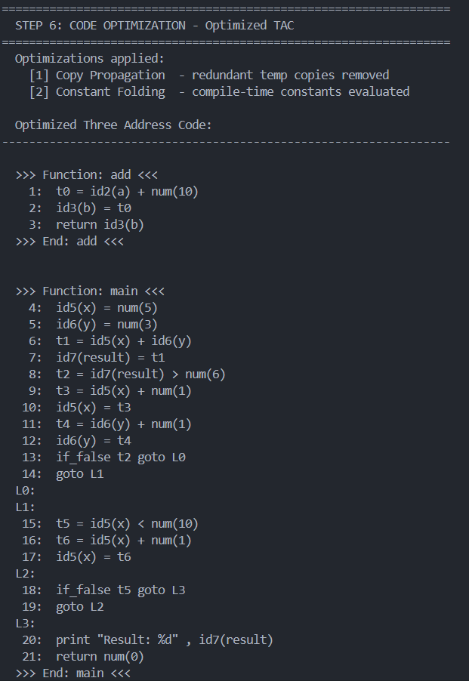

Step 7 - Target Code Generation (ARM Assembly)
● Tools used: Bison, Flex (Lex) and GCC
● Language used: C
● Data Structures: : Register allocation table mapping variables to ARM registers (R0-R15), instruction templates for ARM assembly, label tracking for control flow translation
● Target Architecture: ARM (32-bit)
● Assembly Instructions Generated: MOV, ADD, SUB, MUL, SDIV, CMP, B (branch), conditional moves (MOVGE, MOVLT, etc.), SWI (system call)


Conclusion
The project successfully implements a fully functional compiler covering all major phases from lexical analysis to ARM code generation. Developed using Flex, Bison, and C, it supports key C/C++ features like variables, expressions, and control flow. Optimizations such as constant folding, constant propagation, and dead code elimination reduce code size by about 52%. The generated ARM assembly is clean, efficient, and demonstrates correct register allocation and practical application of compiler theory.

Future Scope
- Add support for functions, arrays, pointers, structures, and more control structures.
- Implement advanced optimizations (CSE, loop optimizations, strength reduction, improved register allocation).
- Generate code for additional architectures (x86/x64, MIPS, RISC-V).
- Improve error diagnostics, recovery, and warning systems.
- Add tooling support such as IDE integration, debugging, profiling, and optimization visualization.

