

PROJECT PROPOSAL

ShopSathi: An AI Sales Agent for Facebook Shops

Course: SE-331 Project Proposal Report
Submitted By
Member | ID | Name
1 | 232-35-003 | Abdullah Al Noman
2 | 232-35-016 | Reduan Ahmad
3 | 232-35-214 | Asraful Alam

Submitted To
Md. Rashedul Alam
Lecturer
Department of Software Engineering
Daffodil International University

Submission Date:

ShopSathi is a SaaS tool that lets small Facebook and Instagram shops in Bangladesh hand their customer chats to an AI agent. The agent answers questions in Bangla, English or Banglish from the shop's own product list, suggests products and turns the chat into an order for the seller to confirm.

1. Introduction
In Bangladesh, a large share of online shopping happens on Facebook, not on websites. We want to build an AI sales agent that answers these shops' customers for them, so small sellers stop losing orders in a crowded inbox.

1.1 Background Overview
Domain: e-commerce, specifically f-commerce (selling through Facebook and Instagram pages).
How big it is: The e-Commerce Association of Bangladesh estimates that 2 to 2.5 lakh Facebook pages are run by f-commerce sellers, and about 60,000 of them make regular sales (The Business Standard, July 2024). Most of these are small home-based businesses selling clothes, cosmetics, food, gadgets and handicrafts.
How it works today:
- The seller posts product photos with a line like "price jante inbox korun" (message us for the price).
- Customers send messages in Bangla, English or Banglish: "price koto?", "XL ache?", "Khagan e delivery charge koto?"
- The seller or a hired moderator reads every message and replies by hand.
- To place an order, the seller asks for name, phone, address and size one by one, then copies it into a notebook, Excel sheet or courier app.
How AI is used now: Very little. Most small shops use no AI at all. Some use Meta's saved replies or keyword-based chatbots that send a fixed answer when they see a word like "price". These tools can't understand Banglish, don't know the shop's real stock, and can't take an order from a normal conversation.

1.2 Problem Statement
Small f-commerce sellers can't keep up with customer messages, and they lose sales because of it.
The problem:
- A popular page can get hundreds of messages a day, and most of them ask the same few things: price, size, colour, stock, delivery charge and delivery time.
- Customers expect a quick reply. If the seller replies hours later, the customer has often bought from another page.
- Taking an order by chat is slow and full of mistakes. Wrong sizes, missing phone numbers and half-written addresses lead to failed deliveries and returns.
- Messages come in mixed Bangla, English and Banglish, often with spelling mistakes, so simple keyword bots fail.
Gaps in existing tools:
- Keyword and menu bots only match fixed words. "eta ki XL e pawa jabe?" and "XL size ache?" mean the same thing, but a keyword bot treats them differently.
- They don't read the shop's product list, so they can't give a correct price or say if an item is in stock.
- They can't pull an order out of a free-form chat.
- Big international chatbot tools are expensive for a small seller and are built mainly for English.
Who is affected:
- Sellers, who spend most of the day replying to messages instead of sourcing products or packing orders.
- Moderators, who do repetitive, tiring work.
- Customers, who wait for answers and sometimes get wrong information.
Why a software solution is needed: The work is repetitive, happens all day and night, and grows with every new customer. Hiring more people is too costly for a small shop. A shared online service (SaaS) lets many shops use the same tool at a low monthly cost.
Why AI is needed: Today a human does three things by hand. They read and understand a messy Banglish message, look up the answer in the product list, and write down the order details. Rules and keywords can't do this reliably, because customers ask the same thing in hundreds of different ways. A large language model (LLM) can understand the meaning, and retrieval over the shop's own product data keeps its answers correct.
Keeping it realistic: We are not trying to replace the seller. The AI handles common questions and drafts orders. The seller still confirms each order, handles payment and delivery, and can take over any chat at any time.

1.3 Objectives
General Objective: To build a web-based SaaS platform where any small Facebook or Instagram shop can sign up, add its products, and let an AI agent reply to customers and collect orders for it.
AI Objectives:
- Understand customer messages written in Bangla, English or Banglish, including spelling mistakes and short forms.
- Answer questions about price, size, colour, stock and delivery using only the shop's own product list and shop policy, and never make up facts.
- Suggest suitable products based on what the customer asks for, such as budget, occasion or size.
- Pull order details (product, size, quantity, name, phone and address) out of a normal conversation and fill an order form automatically.
- Know when it is not sure, and pass the chat to the seller instead of guessing.

1.4 Scope
In scope (what the system will include):
- Shop sign-up and login, with each shop's data kept separate from every other shop (multi-tenant).
- A product catalogue where the seller adds products by hand or uploads a CSV/Excel file with name, price, sizes, colours, stock and photos.
- A shop policy page for delivery charges, delivery time, return rules and payment options.
- Connecting the shop's Facebook Page so the AI can read and reply to Messenger chats.
- A test chat window inside the dashboard, so sellers can try the AI before going live.
- AI replies, product suggestions and automatic order drafts.
- An order dashboard where the seller confirms, edits or cancels each AI-drafted order.
- Human takeover: the seller can pause the AI for any chat and reply personally.
- A simple report showing messages handled, orders drafted, orders confirmed and common questions.
- Subscription plans (Free, Basic, Pro) with monthly message limits, and a platform admin panel.
Out of scope (what the system will not cover):
- Real online payment. Plans and payments will be simulated, and there is no real bKash, Nagad or card gateway.
- Courier booking, delivery tracking and stock management inside warehouses.
- WhatsApp, Instagram DM, website chat and phone calls. We will support Facebook Messenger only; the Instagram DM API works in a similar way and is left for future work.
- Voice messages and reading product details from customer-sent photos.
- A native mobile app. The dashboard will be a responsive website that works on phones.
- Posting ads or running marketing campaigns.
What the AI will do:
- Read and understand each customer message.
- Find the matching products and policy details from that shop's data.
- Write a short, polite reply in the same language style the customer used.
- Suggest products and draft orders.
- Flag chats it can't handle, such as complaints, refunds, angry customers or questions not covered by the shop's data.
What the AI will not do:
- It will not confirm an order by itself. The seller always gives the final approval.
- It will not change prices, give discounts or promise anything that is not in the shop's data.
- It will not take payment or handle money.
- It will not answer questions unrelated to the shop.
System boundaries: ShopSathi starts when a customer message reaches the shop's Facebook Page and ends when the seller confirms an order in the dashboard. Everything after that, including payment, packing and delivery, stays with the seller's current process.

1.5 Stakeholders
ShopSathi has two kinds of users: the shops who pay for it, and the shoppers who chat with it.
Stakeholder | Type | Role in the system | Interest in the system
Shop owner (seller) | Client and end user | Signs up, adds products and policies, connects the Facebook Page, confirms orders, takes over chats | Reply faster, get more orders, spend less time on the inbox, cut wrong orders
Shop moderator / staff | End user | Watches chats, handles flagged messages, manages orders for the owner | Less repetitive typing, clear list of chats that need a human
Customer (shopper) | End user (indirect) | Chats with the shop on Messenger; talks to the AI without logging in to ShopSathi | Quick, correct answers any time of day, easy ordering
Platform administrator | System administrator | Manages shops, plans and limits, watches system health and AI costs, handles abuse reports | Keep the service running, secure and affordable
Meta (Facebook) | External platform | Provides the Messenger Platform API that ShopSathi connects to | Its platform rules must be followed, such as the 24-hour reply window
LLM API provider | External service | Provides the language model and embeddings used by the AI | Fair use of its API and data rules
Courier companies | Indirect | Receive the confirmed orders from the seller (outside our system) | Fewer failed deliveries because addresses and phone numbers are complete

1.6 Proposed Solution
ShopSathi puts an AI agent between the shop's Facebook inbox and the seller. The AI answers the easy, repeated questions right away, drafts orders, and sends only the hard chats to a human.
How it solves the problem:
- Slow replies: the AI replies within seconds, day or night.
- Wrong answers: every answer comes from the shop's own product list and policy, not from the AI's general knowledge.
- Messy orders: the AI collects all the needed details and checks nothing is missing before the order reaches the seller.
- Banglish messages: the LLM understands meaning, not just keywords.
- Cost: many shops share one platform, so each pays a small monthly fee.
Key features:
- Shop account and multi-shop (multi-tenant) setup
- Product catalogue and shop policy manager
- Facebook Page connection
- AI chat replies in Bangla, English and Banglish (AI)
- Product suggestions (AI)
- Automatic order drafting from chat (AI)
- Smart handover to a human when the AI is unsure (AI)
- Order dashboard with confirm, edit and cancel
- Test chat window for sellers
- Reports and common-question insights (AI summary)
- Subscription plans and admin panel
Overall workflow:
- The seller signs up, chooses a plan and connects their Facebook Page.
- The seller adds products (or uploads a CSV) and writes the shop policy. The system turns this data into searchable embeddings for that shop only. (AI)
- A customer sends a message to the Page. Facebook forwards it to ShopSathi through a webhook.
- The AI works out what the customer wants: a price question, a size check, a product suggestion, an order, or a complaint. (AI)
- The system searches that shop's products and policy for the most relevant facts. (AI)
- The LLM writes a short reply using only those facts, in the customer's language style, and it is sent back through Messenger. (AI)
- If the customer wants to buy, the AI asks for any missing details and fills an order draft. (AI)
- If the AI is unsure, or the customer is upset, the chat is flagged and the seller is notified. (AI)
- The seller reviews the order draft in the dashboard and confirms it. The confirmed order can be exported for the courier.
System overview diagram:
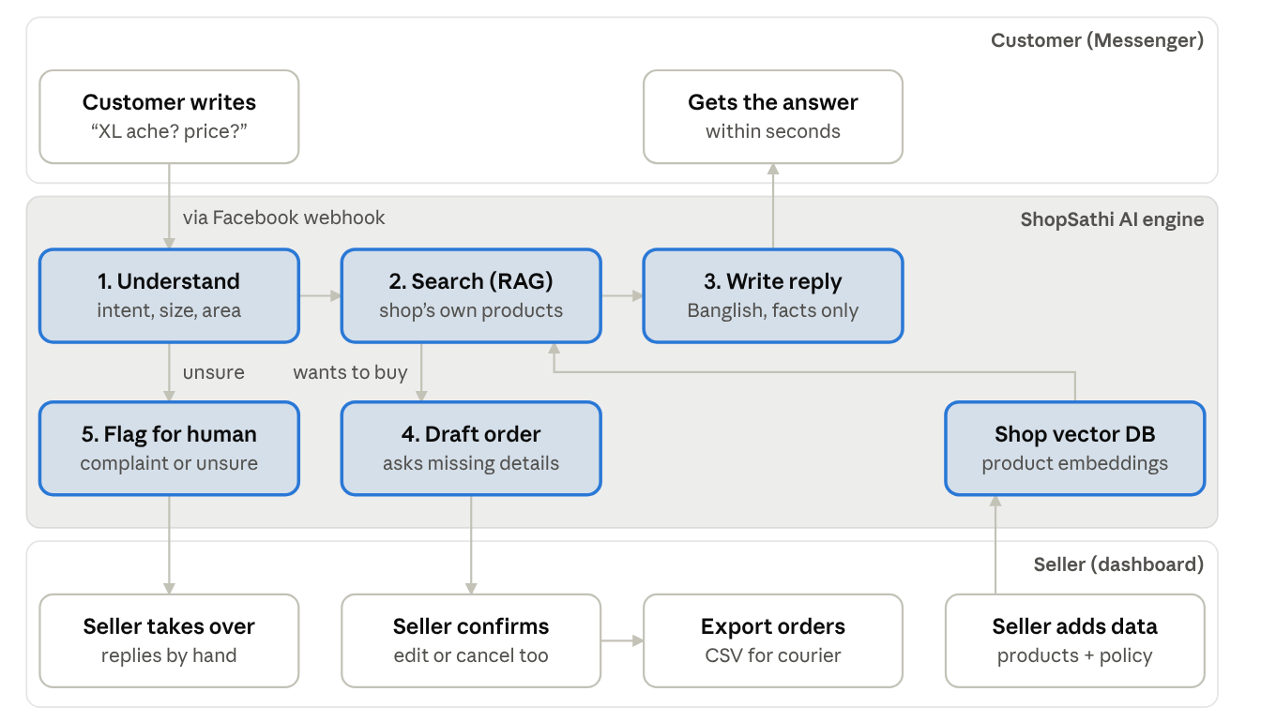
Figure 1: System overview · AI parts highlighted
Every customer message goes through the AI engine first. Only orders to confirm and chats the AI can't handle reach the seller.

1.7 AI Features

Existing AI Features
Existing tool | What it does | Limitation
Meta saved replies and automated FAQ replies | Sends a fixed answer when a customer taps a set question or sends a message | Same answer every time; can't read stock or price; can't understand a free-form question
Keyword and menu chatbots (e.g. ManyChat-style flow builders) | Matches keywords or button clicks to a pre-written flow | Breaks with Banglish and spelling mistakes; the seller must build every flow by hand; can't take an order from a normal chat
General AI chatbots (e.g. ChatGPT used directly) | Writes fluent replies to any question | Doesn't know the shop's products, so it can make up prices or stock; not connected to Messenger or an order system

Proposed AI Features
# | AI feature | Input | Output | Manual work it replaces
AI-1 | Banglish message understanding | Customer message in Bangla, English or Banglish | The customer's intent (price, size, stock, delivery, suggestion, order, complaint, other) and key details such as product name, size and area | A person reading and working out what each message means
AI-2 | Catalogue-grounded replies (RAG) | Customer question and the shop's product list and policy | A short reply using only the shop's facts, in the customer's language style | A person looking up the product and typing the answer
AI-3 | Product suggestions | Customer's needs, such as "eid er jonno 1500 er moddhe panjabi" | 1 to 3 matching in-stock products with price and photo | A person scrolling the catalogue to find options
AI-4 | Order extraction | The full chat history | An order draft: product, size, colour, quantity, name, phone, address, and a list of any missing fields | A person copying details into a notebook or Excel sheet
AI-5 | Smart handover | Message, detected intent, and the AI's confidence | Flag plus reason (complaint, refund, low confidence, off-topic) and a seller notification | A person watching every chat to spot problems
AI-6 | Chat insights | All chats for a week | A short summary of the top questions and products customers asked about but the shop doesn't have | A person reading through old chats to learn what customers want

AI Techniques
- LLM integration: a hosted LLM API (such as GPT-4o-mini or Gemini Flash) for understanding messages and writing replies. We will use structured JSON output for intent detection and order extraction.
- RAG over our own data: each shop's products and policy are split into small chunks, turned into embeddings and stored in a vector database. For each message, the most relevant chunks are retrieved and given to the LLM.
- Semantic search: multilingual embeddings match "lal saree" with a product listed as "Red Jamdani Saree".
- AI agent with tools: the LLM can call a small set of tools: search products, check stock, get delivery charge, and update the order draft.
- Bangla language AI: handling Bangla script, Banglish (Bangla written in English letters) and mixed messages.

Why AI Is Essential
If we removed all the AI features, ShopSathi would be just a product list and an empty order form. It could not read a single customer message, answer a question or create an order, and the seller would be back to replying by hand. The AI is the product itself, not a chatbot added on top of a management system.

2. System Requirements
Each requirement below is written so it can be checked with a clear test. The AI targets will be measured on a test set of 200 real-style customer messages that we will collect and label ourselves.

2.1 Functional Requirements
ID | Requirement
FR-01 | The system shall allow a shop owner to sign up, log in, log out and reset the password by email.
FR-02 | The system shall keep each shop's products, chats and orders separate, so no shop can see another shop's data.
FR-03 | The system shall allow the owner to add staff accounts with a "Moderator" role.
FR-04 | The system shall allow the seller to add, edit and delete products with name, description, price, sizes, colours, stock count and up to 5 photos.
FR-05 | The system shall allow the seller to import products from a CSV or Excel file and show which rows failed and why.
FR-06 | The system shall allow the seller to write shop policies: delivery charge by area, delivery time, return rules and payment options.
FR-07 | The system shall allow the seller to connect and disconnect a Facebook Page.
FR-08 | The system shall receive new Messenger messages through a webhook and send replies back to the same customer.
FR-09 | The system shall provide a test chat window where the seller can chat with the AI without using Facebook.
FR-10 | The system shall show all chats in an inbox, with flagged chats at the top.
FR-11 | The system shall allow the seller to pause the AI for a single chat and reply manually, and to turn it back on.
FR-12 | The system shall list all order drafts and allow the seller to confirm, edit or cancel each one.
FR-13 | The system shall allow the seller to export confirmed orders as a CSV file with the columns courier services usually need.
FR-14 | The system shall show a report with messages handled by AI, chats handed to humans, orders drafted and orders confirmed, for a chosen date range.
FR-15 | The system shall offer Free, Basic and Pro plans with monthly message limits and stop AI replies when the limit is reached.
FR-16 | The system shall allow the platform admin to view, suspend and reactivate shops and change their plan.

2.2 AI Requirements
ID | Requirement
AI-R01 | The system shall detect the intent of a customer message (price, size/stock, delivery, suggestion, order, complaint, other) with at least 85% accuracy on our test set.
AI-R02 | The system shall understand messages in Bangla script, English and Banglish, and reply in the same style the customer used.
AI-R03 | The system shall answer product questions using only the shop's own data. In testing, at least 95% of the prices and stock values in AI replies shall match the catalogue exactly.
AI-R04 | The system shall reply "I'll check with the shop" and flag the chat, instead of guessing, when the answer is not in the shop's data.
AI-R05 | The system shall suggest 1 to 3 in-stock products that match the customer's stated needs (type, budget, size, colour).
AI-R06 | The system shall never suggest a product whose stock is zero.
AI-R07 | The system shall extract product, size, colour, quantity, name, phone and address from a chat into an order draft, with at least 90% of fields correct on our test set.
AI-R08 | The system shall check that the phone number is a valid 11-digit Bangladeshi mobile number and ask the customer again if it is not.
AI-R09 | The system shall ask the customer for any missing order field before creating the order draft.
AI-R10 | The system shall flag a chat and notify the seller when the customer complains, asks for a refund, uses abusive language, or when the AI's confidence is low.
AI-R11 | The system shall not confirm orders, change prices or offer discounts on its own.
AI-R12 | The system shall generate a weekly summary of the top 5 customer questions and the most-asked products that the shop does not have.
AI-R13 | The system shall update a product's embeddings within 1 minute after the seller adds or edits it.

2.3 Non-Functional Requirements
ID | Requirement
NFR-01 | Speed: The system shall send an AI reply within 8 seconds for 90% of messages.
NFR-02 | Availability: The system shall be available 99% of the time during the demo and testing period.
NFR-03 | Security: Passwords shall be hashed, all traffic shall use HTTPS, and Facebook Page tokens shall be stored encrypted.
NFR-04 | Privacy: Customer names, phone numbers and addresses shall be visible only to that shop's users and the platform admin.
NFR-05 | Usability: A new seller shall be able to sign up, add 5 products and test the AI in under 15 minutes.
NFR-06 | Responsive design: The dashboard shall work on mobile phone screens as well as laptops.
NFR-07 | Scalability: The system shall support at least 20 shops and 50 chats at the same time during testing.
NFR-08 | Cost control: The system shall log AI API usage per shop so the admin can see the cost of each shop.
NFR-09 | Platform rules: The system shall follow Meta's Messenger rules, including replying only within the 24-hour messaging window .

3. Tools and Technologies
We chose tools that are free or low-cost, well documented, and that our team can learn within the semester.
Category | Tool / technology | What we use it for
Programming languages | Python, TypeScript (JavaScript) | Python for the backend and AI pipeline; TypeScript for the frontend
Frontend | React with Next.js, Tailwind CSS | Seller dashboard, admin panel and test chat window
Backend | FastAPI (Python) | REST API, Facebook webhook, background jobs
Background tasks | Celery or FastAPI background tasks, with Redis | Creating embeddings and processing incoming messages without slowing the API
Database | PostgreSQL | Shops, users, products, orders, chats and plans
Vector database | pgvector (PostgreSQL extension) | Storing product and policy embeddings, kept separate for each shop
Cache and queue | Redis | Message queue, rate limits and short-term chat memory
LLM API | OpenAI GPT-4o-mini or Google Gemini Flash | Understanding messages, writing replies, extracting orders (structured JSON output)
Embedding model | OpenAI text-embedding-3-small, or open-source multilingual models such as bge-m3 or multilingual-e5 | Turning products and questions into vectors for semantic search in Bangla and English
AI framework | LangChain or LlamaIndex | RAG pipeline, tool calling and prompt management
Messaging platform | Meta Messenger Platform API (Graph API, webhooks) | Receiving and sending Facebook Messenger messages
Authentication | JWT with hashed passwords (bcrypt) | Secure login and role-based access
File handling | pandas, openpyxl | Reading product CSV and Excel files
Testing | pytest, Postman, our own labelled test set | Unit and API tests, and measuring AI accuracy
Version control and project management | Git, GitHub, GitHub Projects | Code sharing, code review and task tracking
Deployment | Docker; Render, Railway or a small VPS; Vercel for the frontend | Hosting a live demo with HTTPS (needed for Facebook webhooks)
Design | draw.io | system diagrams

4. Project Timeline and Work Plan
The project runs for 10 weeks in six milestones. We build a working AI chat in the test window first (Milestone 3), so the riskiest part is proven early, before we connect Facebook.

4.1 Milestone Plan
Milestone | Weeks | Main tasks | Deliverable
M1: Planning and requirements | 1-3 | Finalise the idea and scope; study existing tools; collect about 200 sample customer messages from public shop pages and by role-play; write the requirements | Project proposal (this report)
M2: Design | 1-3 | Database design; system architecture; first prompt designs; create a Facebook test Page and developer app | Design document
M3: Core system and first AI version | 4-7 | Login and multi-shop setup; product catalogue and CSV import; shop policies; embeddings and RAG pipeline; AI replies in the test chat window | Working demo: seller adds products and chats with the AI in the test window
M4: Full AI features and Messenger | 4-7 | Intent detection; product suggestions; order extraction and phone check; smart handover; Messenger webhook; inbox and order dashboard | Working demo on a real Facebook test Page
M5: Testing and improvement | 8-10 | Label the test set; measure intent, answer and order accuracy; improve prompts; security and load tests; trial with 2-3 real sellers | Test report with accuracy results
M6: Final features and delivery | 8-10 | Reports and weekly AI summary; plans and admin panel; deploy live; user guide; final report and presentation | Live system, final report and presentation

4.2 Task Breakdown Among Team Members
Member | Main role | Responsibilities
Abdullah Al Noman | Team lead and backend developer . Integration, testing and deployment | Project planning and tracking; FastAPI backend; login, roles and multi-shop data separation; plans and admin panel. Facebook developer app and Messenger webhook; database design; Docker and deployment; API and security testing; user guide and documentation
Reduan Ahmad | AI engineer (RAG and replies) | Embedding pipeline and pgvector; product and policy retrieval; reply prompts; Bangla and Banglish handling; product suggestions
Asraful Alam | AI engineer (extraction and evaluation) , Frontend developer | Intent detection; order extraction and field checks; smart handover rules; building and labelling the test set; measuring AI accuracy; weekly AI summary . Seller dashboard; product and policy pages; inbox; order dashboard; test chat window; reports page

5. Optional Sections

5.1 Existing System
Today most small f-commerce shops run fully by hand. A typical day looks like this:
- The seller posts products on the Page with "inbox for price".
- Messages pile up in Meta Business Suite. The seller or a moderator answers them one by one, often late at night.
- For price and stock, they check a notebook, an Excel sheet or their own memory.
- When a customer wants to buy, they ask for details in several messages and copy them into a notebook or spreadsheet.
- At the end of the day they type the orders into a courier's app or website.
Problems with the existing system:
- Replies are slow, especially at night and during sales like Eid, when message volume jumps.
- Answers depend on who is replying, so prices and delivery charges are sometimes quoted wrong.
- Order details are often incomplete or copied wrongly, which causes failed deliveries.
- The seller has no record of what customers ask most, or which products they want but can't find.
- Growing the shop means hiring more moderators, which small sellers can't afford.
How ShopSathi compares:
Point | Manual inbox | Keyword chatbot | ShopSathi
Reply time | Minutes to hours | Seconds | Seconds
Understands Banglish and typos | Yes | No | Yes
Uses the shop's real price and stock | Yes, if the person checks | No | Yes
Takes an order from a normal chat | Yes, by hand | No | Yes, seller confirms
Works at night | No | Yes | Yes
Knows when to call a human | Not needed | No | Yes
Setup effort for seller | None | High (build every flow) | Low (add products and policy)

5.2 System Architecture
ShopSathi uses a five-layer architecture. Each layer only talks to the layer next to it, so each team member can work on one layer without breaking the others.
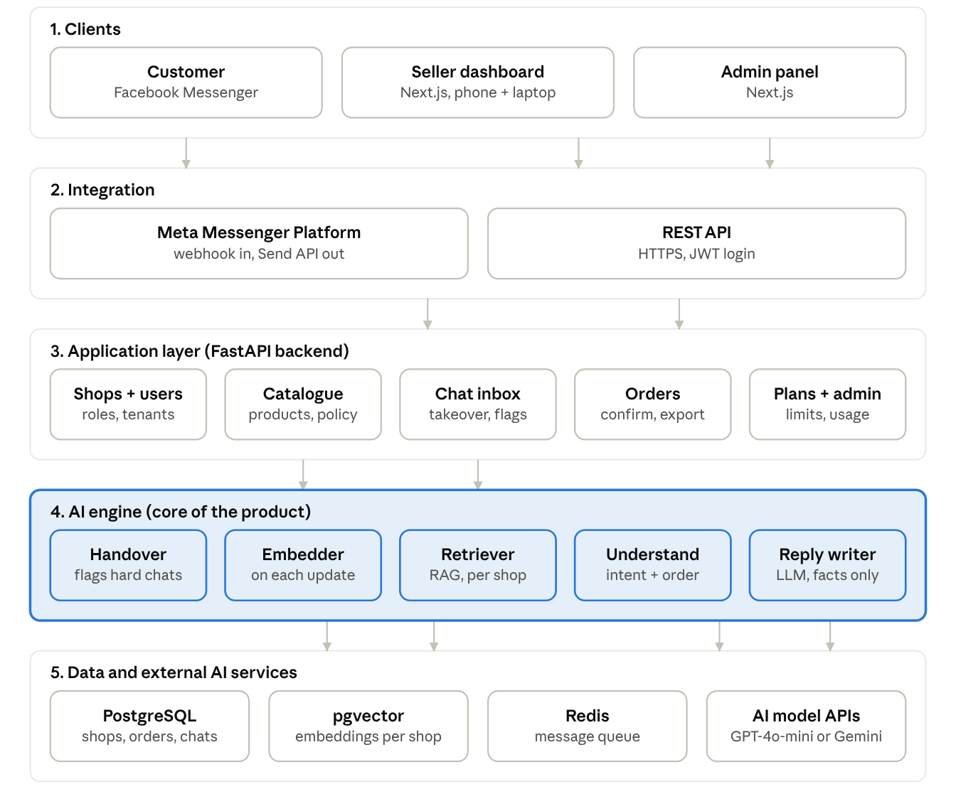
Figure 2: System architecture · five layers
- Clients: the seller dashboard and admin panel are web apps. Customers never log in; they just use Facebook Messenger.
- Integration: the Meta Messenger Platform sends new messages to our webhook and delivers our replies. The dashboards talk to the backend through a REST API.
- Application layer: the FastAPI backend handles shops, users, products, chats, orders and plans. Every database query is filtered by shop ID, so one shop can never see another shop's data.
- AI engine: the core of the product. It turns product data into embeddings, finds the right facts for each message, understands the customer, writes the reply and decides when to call a human.
- Data and external services: PostgreSQL stores normal data, pgvector stores embeddings, Redis queues incoming messages, and the LLM and embedding APIs run the models.

5.3 Ethical, Legal and Social Considerations
Data privacy:
- Customer names, phone numbers and addresses are personal data. Only that shop's users and the platform admin can see them.
- Each shop's data is kept separate, and one shop's data is never used to answer another shop's customers.
- We send the LLM only what it needs for one reply, not the whole customer history.
- Sellers can delete their shop, and all its chats and orders are then removed.
Honesty and transparency:
- The first AI reply in a chat tells the customer they are talking to the shop's automatic assistant, and that they can ask for a person.
- The AI answers only from the shop's data. If it doesn't know, it says so and passes the chat to the seller, instead of making something up.
Human control:
- The AI never confirms an order, changes a price or gives a discount by itself.
- The seller can pause the AI for any chat at any time.
AI bias and fairness:
- Customers who write in Bangla script, English or Banglish should get equally good answers. Our test set will include all three, and we will report accuracy for each one separately.
- Product suggestions are based on the customer's stated needs and stock, not on guesses about the customer's gender, religion or background.
Legal:
- We follow Meta's Messenger Platform rules, including the 24-hour reply window.
- Product details shown by the AI come from the seller, so the seller stays responsible for honest pricing and descriptions under Bangladesh's consumer rights law and the government's 2021 digital commerce guidelines.
- ShopSathi will not be used for fake reviews, spam messages or misleading offers, and the admin can suspend shops that break these rules.
Social impact:
- Positive: Small and home-based sellers, many of them women and students, can serve more customers without hiring staff.
- Risk: Moderator jobs may shrink. We see ShopSathi as a helper that removes repetitive typing, so moderators can focus on complaints, returns and customer care.

5.4 Future Work
- Instagram DM and WhatsApp Business support.
- Understanding customer-sent photos, e.g. "ei design ta ache?" with a screenshot.
- Voice message support using Bangla speech-to-text.
- Real payment through bKash, Nagad and SSLCommerz.
- Direct booking with courier services such as Pathao, Steadfast and RedX.
- Automatic follow-up with customers who asked but didn't order, within Meta's rules.
- A native mobile app for sellers.
- Fine-tuning a smaller Bangla model on our own chat data to cut API costs.

