Daffodil International University
Department of Software Engineering
ShopSathi
An AI Sales Agent for Facebook Shops
Final Project Report
Course: SE-331
Submitted by
Abdullah Al Noman
Reduan Ahmad
Asraful Alam
Submitted to
Md. Rashedul Alam
Lecturer, Department of Software Engineering
Daffodil International University
October 2026
This report describes the system as it is implemented in the project repository.

02. Declaration
We, Abdullah Al Noman, Reduan Ahmad and Asraful Alam, declare that this report describes the work done by our project team. The software, the tests and the documents named in it are in the project repository. Where we used other people's ideas, libraries or services, we name them in the References section.
We also declare that the results in this report are the results we measured. When something was only simulated, only tested on one computer, or not tested at all, the report says so. Nothing in the report claims a production deployment, a Facebook production review, real payments or a user study, because none of these was done.
Signature of the team representative: ____________________
Date: ____________________
Signature of the supervisor (Md. Rashedul Alam): ____________________
Date: ____________________

03. Acknowledgement
We thank our course teacher and supervisor, Md. Rashedul Alam, Lecturer in the Department of Software Engineering at Daffodil International University, for the guidance given during the course SE-331 and for reading the proposal and the progress of the project.
We thank the shop owners who talk about their daily work in public groups and pages. Their problems with slow replies and lost orders gave the project its direction.
We also thank the open-source communities behind FastAPI, SQLAlchemy, PostgreSQL, pgvector, Redis, Celery, Next.js, LangChain and the many small libraries we used. Finally, we thank our families and friends for their patience during the long weeks of work.

04. Abstract
Many small shops in Bangladesh sell through a Facebook or Instagram page and answer every customer by hand in Messenger. Answers are slow at night, prices and stock are asked again and again, and orders are written down in a rush. ShopSathi is a web application that helps these shops. A shop owner adds products and a policy; the AI assistant then answers customer questions in Messenger in Bangla, English or Banglish, suggests products inside a budget, collects order details, and passes difficult chats to a person.
The system has a Next.js dashboard, a FastAPI backend, a PostgreSQL database with pgvector, Redis and Celery for background work, and a separate AI engine package. Each shop sees only its own data. The AI uses the shop's live product data for prices and stock and checks its own replies before sending them. The AI never confirms an order; the seller reviews each draft and exports confirmed orders as a CSV file for the courier. Owners, moderators and a platform admin have different permissions.
The project has 63 API operations, 19 database tables and 13 migrations. The automated tests pass: 396 backend tests, 251 AI engine tests and 82 evaluation tests. A local load test with the real gpt-4o-mini model, 50 simultaneous chats and 20 shops gave a 90th percentile reply time of 5.8 seconds against the 8 second target. A real-model run on 32 sample evaluation cases gave 100% intent accuracy on 16 checks and 93.8% price and stock accuracy on 16 checks, which is below the 95% target. The team's 200-message labelled test set does not exist yet, so these figures are not final accuracy results.
All Messenger tests used a simulated Facebook (a fake Graph API and signed test events). The system was not connected to a real Facebook Page, was not reviewed by Facebook, and was not deployed to a public server. Payments are a simulation. This report documents what is built, how it was tested, and what is still missing.
Keywords: AI sales assistant, Messenger, multi-tenant SaaS, retrieval, pgvector, FastAPI, Next.js, Bangladesh.

05. Table of Contents
01. Cover Page i
02. Declaration ii
03. Acknowledgement iii
04. Abstract iv
05. Table of Contents v
06. List of Figures xi
07. List of Tables xiii
08. Abbreviations xv
09. Introduction 1
9.1 Overview 1
9.2 What this report contains 1
9.3 How to read the status words 1
9.4 Report structure 1
10. Background 2
10.1 Selling on Facebook in Bangladesh 2
10.2 Language 2
10.3 Technology background 2
11. Problem Statement 3
12. Motivation 4
13. Objectives 5
14. Scope 6
14.1 In scope (implemented) 6
14.2 Out of scope or not done 6
15. Target Users 7
16. Existing System 8
17. Existing Problems 9
18. Proposed System 10
19. Stakeholders 11
20. User Roles 12
21. Functional Requirements 13
21.1 Requirement list 13
21.2 Requirements that depend on external services 14
21.3 Traceability matrix 14
22. Non-Functional Requirements 17
23. Business Rules 18
24. Use Case Diagram 19
25. Use Case Descriptions 23
26. Scenario Writing 28
26.1 Scenario A: a new owner starts 28
26.2 Scenario B: a customer asks about price and stock 28
26.3 Scenario C: suggestion with a budget 28
26.4 Scenario D: order with a wrong phone number 28
26.5 Scenario E: complaint and handover 28
26.6 Scenario F: the 24-hour window 28
26.7 Scenario G: the plan limit 28
26.8 Scenario H: the admin suspends a shop 29
27. Context Diagram 30
28. System Flowchart 31
29. Activity Diagrams 32
29.1 Registration, shop creation 32
29.2 Login and logout 33
29.3 Password reset 34
29.4 Product creation, update and photos 35
29.5 Csv or excel import 36
29.6 Ai message processing 37
29.7 Retrieval and suggestion 38
29.8 Order draft 39
29.9 Order management 40
29.10 Csv export 40
29.11 Human handover 41
29.12 Facebook page connection 42
29.13 Messenger webhook and reply delivery 43
29.14 Seller reply from the inbox 44
29.15 Shop deletion 45
29.16 Weekly insights 46
30. Sequence Diagrams 47
30.1 Customer message to ai reply 47
30.2 Understanding, retrieval and reply 48
30.3 Order collection 49
30.4 Seller reply 50
30.5 Facebook page connection 51
30.6 Login, protected request and logout 52
30.7 Product embedding 52
30.8 Test chat 53
30.9 Weekly insights 53
31. State Diagrams 54
31.1 Order status 54
31.2 Chat control: AI pause and flag 54
31.3 Customer message processing 55
31.4 Shop status 55
31.5 Facebook connection 55
31.6 Order collection in chat 56
32. System Architecture 57
32.1 Main design decisions 58
33. Component Diagram 59
34. Deployment Diagram 61
35. AI Architecture 62
36. Messenger Architecture 63
37. ER Diagram 64
38. Database Schema 67
38.1 Table plans 67
38.2 Table shops 67
38.3 Table ai_usage_logs 67
38.4 Table delivery_areas 68
38.5 Table embedding_chunks 68
38.6 Table facebook_pages 68
38.7 Table products 69
38.8 Table shop_message_usage 69
38.9 Table shop_policies 69
38.10 Table simulated_payments 70
38.11 Table users 70
38.12 Table weekly_insights 70
38.13 Table admin_actions 71
38.14 Table chats 71
38.15 Table password_reset_tokens 71
38.16 Table handover_events 72
38.17 Table messages 72
38.18 Table notifications 73
38.19 Table orders 73
39. Database Relationships 74
39.1 What the delete rules mean 74
39.2 Tenant isolation in the database 74
40. Indexing & Migration 76
40.1 Indexes and unique rules 76
40.2 Vector storage 76
40.3 Migrations 76
41. UI/UX Design 78
41.1 Page map 78
42. Wireframes 79
43. UI Screens 81
43.1 Public pages 81
43.2 Seller set-up 82
43.3 Daily work 86
43.4 Moderator and admin 90
43.5 Phone screens 93
44. Module Implementation 94
44.1 Authentication and roles 94
44.2 Tenancy 94
44.3 Products, photos and import 94
44.4 Policy and delivery 94
44.5 Embeddings and retrieval 94
44.6 Conversation service 94
44.7 Messenger ingest and processor 94
44.8 Facebook integration 95
44.9 Inbox and orders 95
44.10 Plans, usage and payment simulation 95
44.11 Reports and weekly insights 95
44.12 Admin 95
44.13 Shop deletion and privacy 95
44.14 Frontend 95
44.15 Feature inventory 95
45. API Documentation 98
45.1 Health and authentication 98
45.2 Plans, shop and staff 98
45.3 Products 99
45.4 Test Chat and notifications 99
45.5 Facebook 99
45.6 Inbox 100
45.7 Orders 100
45.8 Reports 100
45.9 Platform admin 101
45.10 Webhook 101
45.11 Conventions 101
46. AI Implementation 102
46.1 Engine overview 102
46.2 Providers 102
46.3 Pipeline steps 102
46.4 Semantic retrieval and pgvector 103
46.5 Memory 103
46.6 Suggestions and budget 103
46.7 Order collection 103
46.8 Hand-over (confidence and flags) 103
46.9 Usage tracking and failure handling 104
46.10 What was tested and with what 104
46.11 Limitations of the AI part 104
47. Security 105
47.1 Not implemented or not verified 105
48. Multi-Tenant Isolation 106
49. Authentication/RBAC 107
50. Facebook Security 108
51. Testing Strategy 109
51.1 Test environment 109
51.2 Three kinds of AI and Facebook testing 109
52. Unit Testing 110
53. Integration Testing 111
54. API Testing 112
55. E2E Testing 113
56. AI Testing 114
56.1 Real-model run on the 32 sample cases 114
56.2 The two failures 114
56.3 Coverage of the proposal's AI requirements 114
56.4 Other AI tests 115
57. UI/Responsive Testing 116
58. Test Results 117
58.1 Test case tables 117
58.2 Defects found by testing 120
59. Performance Evaluation 121
59.1 Environment and method 121
59.2 Results 121
59.3 Other measurements 122
59.4 What is verified and what is not 122
60. NFR Evaluation 123
61. Deployment 124
61.1 Production compose: what was checked locally 124
61.2 Not done 124
62. Docker 125
63. Environment Setup 126
63.1 Extra variables of the production compose 127
64. CI/CD 128
65. Monitoring 129
66. Results 130
66.1 Size of the project 130
66.2 Demonstration 130
67. Limitations 131
68. Future Work 132
69. Conclusion 133
70. References 134
71. Appendix 135
A. Repository layout 135
B. CSV formats 135
C. Database summary 135
D. Management commands 136
E. Where the other numbers come from 136
72. Installation Guide 137
72.1 Database and Redis 137
72.2 Backend 137
72.3 Worker and scheduler 137
72.4 Frontend 137
72.5 Platform admin and demo data 137
72.6 Facebook without a Meta app (for testing) 138
72.7 Tests 138
72.8 Production stack with Docker 138
73. User Manual 139
73.1 Shop owner 139
73.2 Moderator 139
73.3 Customer (on Messenger) 139
73.4 Platform admin 140
74. Sample API 141
74.1 Login 141
74.2 Wrong password 141
74.3 Plan and usage 141
74.4 List products 142
74.5 Orders 143
74.6 Report summary 143
74.7 Flagged chats 144
74.8 Missing query fields 144
74.9 Messenger webhook event (shape) 144
74.10 Health 145
75. Sample Test Cases 146
76. Screenshots 147
76.1 Extra screens 148

06. List of Figures
Figure 1: Use case diagram: shop setup and administration by the owner 19
Figure 2: Use case diagram: daily work in the Inbox and Orders 20
Figure 3: Use case diagram: customer chat on Messenger 21
Figure 4: Use case diagram: platform administration 21
Figure 5: Context diagram of ShopSathi 30
Figure 6: System flowchart: from set-up to the courier list 31
Figure 7: Activity diagram: registration, shop creation 32
Figure 8: Activity diagram: login and logout 33
Figure 9: Activity diagram: password reset 34
Figure 10: Activity diagram: product creation, update and photos 35
Figure 11: Activity diagram: CSV or Excel import 36
Figure 12: Activity diagram: AI message processing 37
Figure 13: Activity diagram: retrieval and suggestion 38
Figure 14: Activity diagram: order draft 39
Figure 15: Activity diagram: order management 40
Figure 16: Activity diagram: CSV export 40
Figure 17: Activity diagram: human handover 41
Figure 18: Activity diagram: Facebook Page connection 42
Figure 19: Activity diagram: Messenger webhook and reply delivery 43
Figure 20: Activity diagram: seller reply from the Inbox 44
Figure 21: Activity diagram: shop deletion 45
Figure 22: Activity diagram: weekly insights 46
Figure 23: Sequence diagram: customer message to AI reply 47
Figure 24: Sequence diagram: understanding, retrieval and reply 48
Figure 25: Sequence diagram: order collection 49
Figure 26: Sequence diagram: seller reply 50
Figure 27: Sequence diagram: Facebook Page connection 51
Figure 28: Sequence diagram: login, protected request and logout 52
Figure 29: Sequence diagram: product embedding 52
Figure 30: Sequence diagram: Test Chat 53
Figure 31: Sequence diagram: weekly insights 53
Figure 32: State diagram: order status 54
Figure 33: State diagram: chat control: ai pause and flag 54
Figure 34: State diagram: customer message processing 55
Figure 35: State diagram: shop status 55
Figure 36: State diagram: facebook connection 55
Figure 37: State diagram: order collection in chat 56
Figure 38: System architecture 57
Figure 39: Component diagram 59
Figure 40: Deployment diagram 61
Figure 41: AI architecture: the pipeline of the engine 62
Figure 42: Messenger architecture 63
Figure 43: ER overview of all 19 tables 64
Figure 44: ER diagram: plans, shops, users and usage 65
Figure 45: ER diagram: catalogue, policy, embeddings and AI usage 65
Figure 46: ER diagram: chats, messages, orders and Facebook 66
Figure 47: Wireframe: login page 79
Figure 48: Wireframe: seller dashboard layout 79
Figure 49: Wireframe: Inbox 80
Figure 50: Wireframe: Orders list and CSV export 80
Figure 51: Screenshot: Login page 81
Figure 52: Screenshot: Sign up page with plan choice 81
Figure 53: Screenshot: Forgot password page 82
Figure 54: Screenshot: Products list with search, stock and photos 82
Figure 55: Screenshot: Add product form 83
Figure 56: Screenshot: Shop policy and delivery charges 84
Figure 57: Screenshot: Test Chat before a conversation 84
Figure 58: Screenshot: Test Chat with an order draft (real OpenAI model) 85
Figure 59: Screenshot: Facebook Page page (not connected) 85
Figure 60: Screenshot: My plan with usage 85
Figure 61: Screenshot: Staff page with a moderator 86
Figure 62: Screenshot: Dashboard start page 86
Figure 63: Screenshot: Inbox with flagged chats 87
Figure 64: Screenshot: Open conversation in the Inbox 87
Figure 65: Screenshot: Orders: draft tab and CSV export 88
Figure 66: Screenshot: Order detail 88
Figure 67: Screenshot: Reports with the weekly AI summary 89
Figure 68: Screenshot: Settings with the danger zone 89
Figure 69: Screenshot: Moderator sees the Inbox 90
Figure 70: Screenshot: Admin: shops list 90
Figure 71: Screenshot: Admin: shop detail 91
Figure 72: Screenshot: Admin: plans 91
Figure 73: Screenshot: Admin: AI usage and cost 91
Figure 74: Screenshot: Admin: system health 92
Figure 75: Screenshots at 375 px width: dashboard, menu, products, orders, Inbox and notifications 93
Figure 76: Multi-tenant isolation: how a request is scoped to one shop 106
Figure 77: 90th percentile reply time with the real model 121
Figure 78: 90th percentile reply time with the offline mock model 121
Figure 79: Screenshot: Orders: Confirmed tab 148
Figure 80: Screenshot: Inbox filtered to flagged chats 148
Figure 81: Screenshot: Edit product page 149
Figure 82: Screenshot: Notification list on a laptop screen (cropped) 149

07. List of Tables
Table 1: Abbreviations used in this report xv
Table 2: Status words used in this report 1
Table 3: Target users 7
Table 4: Problems of the manual way of selling 9
Table 5: How the proposed system answers the problems 10
Table 6: Stakeholders 11
Table 7: Permissions by role 12
Table 8: Functional requirements 13
Table 9: Traceability matrix 14
Table 10: Non-functional requirements 17
Table 11: Business rules 18
Table 12: List of use cases 22
Table 13: Use case description UC-01: Sign up and create shop 23
Table 14: Use case description UC-02: Log in and log out 23
Table 15: Use case description UC-03: Reset password 23
Table 16: Use case description UC-04: Manage products 24
Table 17: Use case description UC-06: Import products from CSV or Excel 24
Table 18: Use case description UC-09: Connect a Facebook Page 24
Table 19: Use case description UC-13: View chat list and read chats 24
Table 20: Use case description UC-14: Reply to a customer 25
Table 21: Use case description UC-18: Confirm or cancel an order 25
Table 22: Use case description UC-19: Export confirmed orders 25
Table 23: Use case description UC-23: Ask about product, price or stock 26
Table 24: Use case description UC-25: Ask for suggestions with a budget 26
Table 25: Use case description UC-26: Give order details in chat 26
Table 26: Use case description UC-27: Ask for a human / handover 26
Table 27: Use case description UC-32: Suspend or reactivate a shop 27
Table 28: Use case description UC-12: Delete shop 27
Table 29: Technology stack 57
Table 30: Components and their files 59
Table 31: Columns of plans 67
Table 32: Columns of shops 67
Table 33: Columns of ai_usage_logs 67
Table 34: Columns of delivery_areas 68
Table 35: Columns of embedding_chunks 68
Table 36: Columns of facebook_pages 68
Table 37: Columns of products 69
Table 38: Columns of shop_message_usage 69
Table 39: Columns of shop_policies 69
Table 40: Columns of simulated_payments 70
Table 41: Columns of users 70
Table 42: Columns of weekly_insights 70
Table 43: Columns of admin_actions 71
Table 44: Columns of chats 71
Table 45: Columns of password_reset_tokens 71
Table 46: Columns of handover_events 72
Table 47: Columns of messages 72
Table 48: Columns of notifications 73
Table 49: Columns of orders 73
Table 50: Foreign keys 74
Table 51: Indexes 76
Table 52: Alembic migrations 76
Table 53: Page map of the frontend 78
Table 54: Feature inventory 95
Table 55: API: health and authentication 98
Table 56: API: plans, shop and staff 98
Table 57: API: products 99
Table 58: API: test chat and notifications 99
Table 59: API: facebook 99
Table 60: API: inbox 100
Table 61: API: orders 100
Table 62: API: reports 100
Table 63: API: platform admin 101
Table 64: API: webhook 101
Table 65: AI providers 102
Table 66: What was tested for the AI 104
Table 67: Security measures 105
Table 68: Authentication and role control 107
Table 69: Facebook security checks 108
Table 70: Test levels 109
Table 71: Kinds of testing and their limits 109
Table 72: Unit tests of the AI engine 110
Table 73: Integration test groups 111
Table 74: API test files and test counts 112
Table 75: End-to-end runs 113
Table 76: Evaluation of the real model on 32 sample cases 114
Table 77: Proposal AI requirements and their status 114
Table 78: Page-width checks (docs/TEST_REPORT.md section 10) 116
Table 79: Automated test results 117
Table 80: Test cases TC-01 to TC-23 117
Table 81: Test cases TC-24 to TC-46 118
Table 82: Test cases TC-47 to TC-68 119
Table 83: Load test results 122
Table 84: Evaluation of the non-functional requirements 123
Table 85: Deployment options 124
Table 86: Docker images and services 125
Table 87: Settings of the backend 126
Table 88: Monitoring 129
Table 89: Objectives and results 130
Table 90: Size of the project 130
Table 91: Repository layout 135
Table 92: Tables and counts 135
Table 93: Manual and scripted checks 146
Table 94: Screenshot index 147

08. Abbreviations
Table 1: Abbreviations used in this report
Short form | Meaning
AI | Artificial intelligence
API | Application programming interface
BDT | Bangladeshi taka
BR | Business rule
CORS | Cross-origin resource sharing
CRUD | Create, read, update, delete
CSV | Comma-separated values
DB | Database
ER | Entity relationship
FK | Foreign key
FR | Functional requirement
HMAC | Hash-based message authentication code
HNSW | Hierarchical navigable small world (a vector index)
HTTP / HTTPS | Hypertext transfer protocol (secure)
JSON | JavaScript object notation
JWT | JSON web token
LLM | Large language model
NFR | Non-functional requirement
OAuth | Open authorisation standard used for Facebook login
ORM | Object-relational mapper (SQLAlchemy)
PII | Personally identifiable information
PK | Primary key
PSID | Page-scoped user id (Messenger customer id)
RAG | Retrieval-augmented generation
RBAC | Role-based access control
SaaS | Software as a service
SMTP | Simple mail transfer protocol
SQL | Structured query language
TTL | Time to live
UC | Use case
UI / UX | User interface / user experience
UML | Unified modelling language

09. Introduction

9.1 Overview
ShopSathi is an AI sales assistant for small shops that sell on Facebook and Instagram in Bangladesh. The name means "shop friend". The owner puts the shop's products, prices, stock and delivery rules into a web dashboard. The assistant reads this data and answers customers in Messenger. It can talk in Bangla script, in English or in Banglish (Bangla written with English letters), which is how many customers really write.
The assistant does not decide on its own what the shop sells or what it costs. Prices, stock and delivery charges are read from the shop's data every time. When a customer wants to buy, the assistant collects the name, phone number, address and the product choice, and creates a draft order. The seller must confirm it. When a customer is angry, asks for a refund or asks for a person, the assistant stops and the seller takes over from the Inbox.

9.2 What this report contains
This is the final report of the project. It follows the 76 sections required for submission. It describes the system that exists in the project repository on the date of this report, and it uses the source code, the database migrations, the test results and the running application as its sources. The report does not describe planned features as if they were finished. Every part that is not implemented or not verified is marked in the text.

9.3 How to read the status words
Table 2: Status words used in this report
Word | Meaning in this report
Implemented | The code exists in the repository.
Tested | An automated test or a recorded manual run checks it and passes.
Simulated | Tested with a stand-in: the mock AI, a fake Facebook Graph API, a stub Send API, or a simulation script.
Real model | Tested with the real OpenAI model (gpt-4o-mini) and real OpenAI embeddings.
Not tested | Code exists but no test or run covers it.
Not implemented | Not implemented in the current version.

9.4 Report structure
Sections 09 to 20 explain the problem and the proposed system. Sections 21 to 31 give the requirements and the behaviour of the system with diagrams. Sections 32 to 44 describe the architecture, the database and the user interface. Sections 45 to 50 document the API, the AI engine and security. Sections 51 to 60 explain testing and results. Sections 61 to 68 cover deployment, results, limits and future work. Sections 69 to 76 hold the conclusion, references and appendices.

10. Background

10.1 Selling on Facebook in Bangladesh
A large number of small businesses in Bangladesh sell clothes, cosmetics, food and gifts through Facebook pages and groups. Customers write to the page in Messenger. The owner, or one helper, answers each message, writes down orders, and sends the delivery details to a courier. There is usually no shop system behind it.

10.2 Language
Customers write in Bangla script, in English, and very often in Banglish, for example "Red saree ta ache?" or "Dam koto?". There is no fixed spelling in Banglish. A useful assistant must understand all three and reply in the same style.

10.3 Technology background
- Large language models (LLM) can read a customer message and return structured data (intent, product, size) or write a reply. They can also invent facts, so their answers must be checked.
- Embeddings turn text into a list of numbers. Texts with a similar meaning get similar numbers, so the system can find the right product even when the customer uses different words.
- pgvector is a PostgreSQL extension that stores embeddings and searches them by distance.
- Messenger Platform lets a Facebook Page receive customer messages by webhook and reply with the Send API. A Page may reply freely only within 24 hours after the customer's last message.
- Multi-tenancy means many shops share one system, and each shop must see only its own data.

11. Problem Statement
Small shop owners lose sales and time because they answer customer messages by hand. The main problems are:
- Customers wait for hours when the owner is busy or asleep, and many leave.
- The same questions (price, stock, size, delivery charge, return rule) are answered again and again.
- Orders written in chat are incomplete: a phone number is missing or has a typing error, or the size is not clear.
- Angry customers and refund requests need a person, but the owner does not notice them in a long list of chats.
- There is no simple record of how many orders came from chat, and the courier needs a list of confirmed orders.
The project needs a system that answers common questions at any time, collects orders correctly, hands difficult chats to a person quickly, and keeps each shop's data private.

12. Motivation
Big shopping sites have order systems, but a home-based seller with ten to a hundred products does not use them. Chat is the shop. A tool that works inside Messenger, understands Banglish, and costs little can make a real difference for such sellers.
The team also wanted to learn how to build a safe AI product. A chatbot that guesses prices or confirms orders by itself can harm a small shop. So the project has a strict design rule: the AI may talk, but the shop's data and the seller's decisions stay in control. This rule shaped many parts of the system: live data for prices, code checks for phone numbers, draft orders, and hand-over to a person.

13. Objectives
1. Let a shop owner create an account and a shop, and add products, photos and a delivery and return policy.
2. Answer customer questions about price, stock, sizes, colours and delivery in Bangla, English and Banglish using only the shop's data.
3. Suggest up to three in-stock products inside the customer's budget.
4. Collect order details in chat, validate the phone number, and create a draft order that only the seller can confirm.
5. Detect complaints, refund requests, abuse and requests for a human, stop the AI in that chat and tell the seller.
6. Connect a Facebook Page, receive Messenger messages safely, and reply only inside the 24-hour window.
7. Give the seller an Inbox, order pages, a CSV export for the courier, simple reports and a weekly AI summary.
8. Keep every shop's data separate, with owner, moderator and platform admin roles.
9. Limit AI use by plan, record the AI usage and cost per shop, and give the platform admin tools to manage shops.
10. Measure the system with automated tests, a load test and an evaluation harness, and report the results honestly.

14. Scope

14.1 In scope (implemented)
- Web dashboard for owners and moderators, and admin pages for the platform admin (30 page and layout files in the Next.js app).
- REST API with 63 operations, plus the Facebook OAuth callback.
- Product management with photos, search and CSV or Excel import.
- Shop policy and delivery charges.
- AI engine with language detection, understanding, retrieval, suggestions, order collection, hand-over and reply checking.
- Test Chat for the owner, and Messenger chats through a webhook and a Celery worker.
- Inbox with pause, resume, resolve and manual reply.
- Orders with draft, confirm, cancel, edit and CSV export.
- Reports and weekly AI insights.
- Plans, monthly AI reply limits and usage tracking; simulated payment.
- Platform admin: shops, plans, AI usage and cost, system health.
- Shop deletion and log masking.
- Docker images and a production compose file.

14.2 Out of scope or not done
- Instagram messaging: Not implemented in the current version.
- Real online payments (bKash, Nagad, cards): Not implemented in the current version. Payment is a simulation.
- Direct courier integration: Not implemented in the current version. The seller exports a CSV file.
- Facebook production approval (App Review): Not done. Messenger was tested only with a simulated Facebook.
- Public production deployment: Not done. The Docker stack was run only on a developer computer.
- Voice and image understanding: Not implemented. Non-text messages are stored as a placeholder and handed to the seller.
- A mobile app: Not implemented. The web dashboard is responsive.
- Automatic stock reduction when an order is confirmed: Not implemented (a test confirms that stock is not changed).
- A user study with real shop owners: Not done.

15. Target Users
Table 3: Target users
User | Description | Main needs
Shop owner | Runs a small Facebook shop; may not be technical. | Add products quickly, see that the AI answers correctly, take over when needed, confirm orders, send a list to the courier.
Moderator | A helper who answers chats and handles orders for the owner. | Read the Inbox, reply, pause the AI, confirm or cancel orders. No access to settings, products or Facebook.
Customer | A person who writes to the shop's Page on Messenger. | Quick answers on price, stock and delivery, in the language they write; an easy way to order; a human when needed.
Platform admin | A member of the ShopSathi team. | See all shops, suspend a shop, change plans, watch AI cost and system health.

16. Existing System
The usual way today is fully manual. The owner opens Messenger on a phone, reads each message, types the answer, copies the price from a note, and writes orders in a notebook or a spreadsheet. Some shops use Facebook's built-in quick replies or an away message. These help with a greeting or a fixed answer, but they cannot read the customer's question, check live stock, or collect an order.
Several chatbot builders exist for Messenger. They are mostly based on fixed menus and keywords, they need set-up work for every question, and they do not understand Banglish well. We did not test any of these products in this project, so this report makes no comparison with them.

17. Existing Problems
Table 4: Problems of the manual way of selling
Problem in the manual way | Effect on the shop
Slow replies at night and during busy hours | Customers leave before they get an answer
Same questions answered many times | Owner's time is wasted
Prices and stock come from memory or old notes | Wrong prices are quoted; sold-out items are offered
Orders typed by hand in chat | Missing or wrong phone numbers and addresses; delivery fails
Complaints are lost in a long chat list | Unhappy customers wait longest
No summary of what customers ask | The owner does not know which products are missing from the shop
Order list for the courier is built by hand | Slow and full of copy mistakes

18. Proposed System
ShopSathi puts an assistant between the customer and the seller. The seller keeps control; the assistant does the repeated work.
Table 5: How the proposed system answers the problems
Problem | How ShopSathi handles it
Slow replies | The worker answers a Messenger message in about 6 seconds (measured locally with the real model).
Repeated questions | The AI answers from the product table, the policy and the delivery areas.
Wrong prices or stock | Prices and stock are read live from the database. The reply is checked: numbers must come from the facts.
Bad orders | Code validates the phone number, product, size, colour and stock. The seller confirms.
Lost complaints | 7 hand-over reasons flag the chat, pause the AI and create a notification.
No overview | Reports and a weekly AI summary of customer questions and missing products.
Courier list | Confirmed orders export as a CSV file.

The system has three parts: the dashboard where the seller works, the backend with its background worker, and the AI engine. A Facebook Page is connected by the owner through Facebook login. The architecture is shown in section 32.

19. Stakeholders
Table 6: Stakeholders
Stakeholder | Interest | Influence on the system
Shop owner | More sales with less time spent | Defines products, policy and what the AI may say; confirms orders
Moderator | Easy daily work | Replies and handles orders within the owner's shop
Customer | Fast and correct answers | Their messages drive the AI; their data must be protected
Platform admin / project team | A working, safe and affordable service | Plans, limits, suspension, cost control
Courier companies | Complete addresses and phone numbers, fewer failed deliveries | Indirect: receive the CSV list from the seller outside the system
Course supervisor | A well-built, honestly reported project | Reviews proposal, progress and this report
Meta (Facebook) | Apps that follow the platform rules | Controls the Messenger API, the 24-hour window and App Review
AI provider (OpenAI, Google) | Fair API use | Supplies the language models and embeddings; cost and speed depend on them

20. User Roles
The users table has a role column with three values. A database CHECK makes sure that a platform admin has no shop and that owners and moderators have one. The role is read from the database on every request, not trusted from the token.
Table 7: Permissions by role
Area | Owner | Moderator | Platform admin
Sign up, log in, reset password | Yes | Log in, reset | Log in
Products, import, photos | Yes | No | No
Shop policy and delivery | Yes | No | No
Staff (add moderators) | Yes | No | No
Plan view | Yes | Yes | No
Plan change | Yes | No | No (admin changes a plan through /admin)
Facebook Page connection | Yes | No | No
Test Chat | Yes | No | No
Inbox and replies | Yes | Yes | No
Orders and CSV export | Yes | Yes | No
Notifications | Yes | Yes | No
Reports and weekly summary | Yes | No | No
Delete shop | Yes | No | No
All shops, suspend, plans, AI usage, health | No | No | Yes

The table is generated from the access rules that the test test_role_matrix.py checks for every endpoint with four kinds of caller: anonymous, owner, moderator and platform admin.

21. Functional Requirements
The table lists the functional requirements of the implemented system. The numbering FR-01 to FR-37 belongs to this report. The column "Proposal ref" shows the matching number from the project proposal where we could verify it; a dash means that the proposal number is not recorded in the repository.

21.1 Requirement list
Table 8: Functional requirements
ID | Requirement | Proposal ref | Use case
FR-01 | An owner can sign up with shop name, e-mail and password, choose a plan, and gets a shop and an owner account. | FR-01 | UC-01
FR-02 | Users log in and out with a signed token; logout stops the token at once; suspended shops cannot log in. | FR-01 | UC-02, UC-38
FR-03 | A user can reset a forgotten password with a one-time link that expires. | FR-01 | UC-03
FR-04 | Every shop sees only its own data; the shop is taken from the token, never from the request. | FR-02 | All
FR-05 | Three roles exist: owner, moderator and platform admin, each with fixed permissions. | FR-03 | All
FR-06 | The owner can add moderators to the shop and list them. | FR-03 | UC-10
FR-07 | The owner can create, edit, delete, list and search products (name, description, price, stock, sizes, colours). | FR-04 | UC-04
FR-08 | The owner can upload up to 5 photos per product (PNG, JPEG, WebP, up to 5 MB) and delete them. | FR-04 | UC-05
FR-09 | The owner can import products from a CSV or Excel file (2 MB, 1000 rows); invalid rows are reported. | FR-05 | UC-06
FR-10 | The owner stores delivery time, return rules, payment options and delivery charges per area. | FR-06 | UC-07
FR-11 | Products and policy are turned into embeddings and stored for semantic search; changes update them. | AI-R13 | UC-04, UC-07
FR-12 | The owner can chat with the shop's AI in a Test Chat that sends nothing to Facebook. | FR-09 | UC-08
FR-13 | The AI answers questions about price, stock, sizes, colours, delivery charge and policy using only shop data. | AI-R03 | UC-23, UC-24
FR-14 | The AI replies in the customer's style: Bangla script, English or Banglish. | AI-R02 | UC-23
FR-15 | The AI remembers the last 8 turns of a chat (Redis, 6 hours) and rebuilds them from the database if Redis lost them. | — | UC-23
FR-16 | The AI suggests up to 3 in-stock products that fit the customer's need and budget, with photos. | AI-R05, AI-R06 | UC-25
FR-17 | The AI collects order details, checks the phone number, product, size, colour and stock, and creates a draft order. | AI-R07 to AI-R09 | UC-26, UC-30
FR-18 | The AI detects 7 handover reasons, stops answering, flags the chat and sends a safe reply. | AI-R04, AI-R10 | UC-27, UC-29
FR-19 | A notification is created for each flagged Messenger chat and the seller can read it in a bell menu. | AI-R10 | UC-20
FR-20 | The owner connects one Facebook Page through Facebook login; the Page token is stored encrypted. | FR-07 | UC-09
FR-21 | The system receives Messenger events, checks the signature, ignores duplicates and stores the message. | FR-08 | UC-28
FR-22 | AI replies are sent through the Send API only inside the 24-hour window, with retries; failed sends are not counted. | FR-08, NFR-09 | UC-28
FR-23 | The seller can list chats (flagged first), filter them and read a whole conversation. | FR-10 | UC-13
FR-24 | The seller can pause and resume the AI for a chat and mark a flag as handled. | FR-11 | UC-15, UC-16
FR-25 | The seller can send a manual reply to a customer from the Inbox. | FR-11 | UC-14
FR-26 | The seller can list orders by status and view and edit a draft order. | FR-12 | UC-17
FR-27 | The seller confirms or cancels a draft order; the AI never confirms. | FR-12, AI-R11 | UC-18
FR-28 | The seller exports confirmed orders as a CSV file for the courier, with an optional date range. | FR-13 | UC-19
FR-29 | The owner sees a report: AI messages handled, chats handed to humans, orders drafted and confirmed. | FR-14 | UC-21
FR-30 | A weekly AI summary of customer questions and missing products is created every week (Sunday 20:00 UTC, which is Monday 02:00 in Bangladesh) and shown to the owner. | AI-R12 | UC-22, UC-37
FR-31 | Each plan has a monthly limit of AI replies; replies stop at the limit; usage is counted per shop and month (Dhaka time). | FR-15 | UC-11
FR-32 | Paid plans use a simulated payment confirmation; no real payment is made. | FR-15 | UC-01, UC-11
FR-33 | The platform admin lists and searches shops, sees details, suspends or reactivates a shop and changes its plan. | FR-16 | UC-31 to UC-33
FR-34 | The platform admin edits plans, views AI usage and cost, and checks system health. | FR-16, NFR-08 | UC-34 to UC-36
FR-35 | Every AI call (chat, embedding, extraction, insights) is logged with tokens, cost and time per shop. | NFR-08 | UC-35
FR-36 | The owner can delete the shop and all its data after entering the password and the exact shop name. | Section 5.3 | UC-12
FR-37 | A health endpoint reports the API, database and Redis state (503 when a part is down). | — | UC-36

Every requirement is Implemented. The last column of the traceability matrix (section 21.3) shows how far each was tested.

21.2 Requirements that depend on external services
- FR-20 to FR-22 and FR-25 (Facebook) were tested with a fake Graph API, a stub Send API and signed simulated events. They were not tested with a real Facebook Page.
- FR-13, FR-16, FR-17 and FR-30 (AI) were tested with the mock AI in the automated tests and with the real gpt-4o-mini model in the evaluation and load runs.
- FR-03 sends a reset link by SMTP. Without an SMTP host the link is written to the log in local mode only. A real mail server was not tested.
- FR-32 (paid plans) is a simulation. Not implemented in the current version: real payment.

21.3 Traceability matrix
The matrix connects each requirement to its use case, module, API, database tables and tests. Test names refer to files in backend/tests, ai_engine/tests and evaluation. The status shows the strongest evidence we have.
Table 9: Traceability matrix
Req. ID | Requirement | Use case | Module | API | Database | Test case | Status
FR-01 | An owner can sign up with shop name, e-mail and password, choose a pla... | UC-01 | Auth, Plans | POST /auth/signup | shops, users, plans, simulated_payments | test_auth, test_plans | Implemented, tested
FR-02 | Users log in and out with a signed token; logout stops the token at on... | UC-02, UC-38 | Auth | POST /auth/login, /auth/logout, GET /auth/me | users | test_auth, test_auth_security | Implemented, tested
FR-03 | A user can reset a forgotten password with a one-time link that expire... | UC-03 | Auth | POST /auth/password-reset/request, /confirm | password_reset_tokens | test_auth, test_webhook_and_limits | Implemented, tested (mail is logged locally; SMTP not tested)
FR-04 | Every shop sees only its own data; the shop is taken from the token, n... | All | Tenancy | All shop endpoints | all shop-owned tables | test_tenancy, test_privacy | Implemented, tested
FR-05 | Three roles exist: owner, moderator and platform admin, each with fixe... | All | Security | All endpoints | users | test_role_matrix | Implemented, tested
FR-06 | The owner can add moderators to the shop and list them. | UC-10 | Staff | GET/POST /shop/staff | users | test_staff | Implemented, tested
FR-07 | The owner can create, edit, delete, list and search products (name, de... | UC-04 | Products | /products | products | test_products | Implemented, tested
FR-08 | The owner can upload up to 5 photos per product (PNG, JPEG, WebP, up t... | UC-05 | Products, Storage | POST/DELETE /products/{id}/photos | products | test_products | Implemented, tested
FR-09 | The owner can import products from a CSV or Excel file (2 MB, 1000 row... | UC-06 | Product import | POST /products/import, GET /products/import/template | products | test_product_import | Implemented, tested
FR-10 | The owner stores delivery time, return rules, payment options and deli... | UC-07 | Policy | GET/PUT /shop/policy | shop_policies, delivery_areas | test_policy | Implemented, tested
FR-11 | Products and policy are turned into embeddings and stored for semantic... | UC-04, UC-07 | Embeddings, Celery | none (background) | embedding_chunks | test_embeddings | Implemented, tested
FR-12 | The owner can chat with the shop's AI in a Test Chat that sends nothin... | UC-08 | Test chat | /test-chat/sessions | chats, messages | test_test_chat | Implemented, tested
FR-13 | The AI answers questions about price, stock, sizes, colours, delivery ... | UC-23, UC-24 | AI engine | (via chat) | products, shop_policies, delivery_areas | test_conversation, evaluation | Implemented, tested with real model on samples
FR-14 | The AI replies in the customer's style: Bangla script, English or Bang... | UC-23 | AI engine | (via chat) | messages.language_style | test_validators, test_test_chat | Implemented, tested
FR-15 | The AI remembers the last 8 turns of a chat (Redis, 6 hours) and rebui... | UC-23 | Chat memory | (via chat) | messages | test_test_chat | Implemented, tested
FR-16 | The AI suggests up to 3 in-stock products that fit the customer's need... | UC-25 | Suggestions | (via chat) | products | test_suggestions, test_suggestions_api | Implemented, tested
FR-17 | The AI collects order details, checks the phone number, product, size,... | UC-26, UC-30 | Ordering | (via chat) | orders, chats.pending_order | test_orders, test_orders_api | Implemented, tested
FR-18 | The AI detects 7 handover reasons, stops answering, flags the chat and... | UC-27, UC-29 | Handover | (via chat) | handover_events, chats | test_handover, test_handover_api | Implemented, tested
FR-19 | A notification is created for each flagged Messenger chat and the sell... | UC-20 | Notifications | /notifications | notifications | test_handover_api | Implemented, tested
FR-20 | The owner connects one Facebook Page through Facebook login; the Page ... | UC-09 | Facebook | /facebook/* | facebook_pages | test_facebook | Implemented, tested with a fake Facebook only
FR-21 | The system receives Messenger events, checks the signature, ignores du... | UC-28 | Messenger webhook | GET/POST /webhooks/messenger | chats, messages | test_messenger, test_webhook_and_limits | Implemented, tested with simulated events only
FR-22 | AI replies are sent through the Send API only inside the 24-hour windo... | UC-28 | Messenger sender | (worker) | messages | test_messenger | Implemented, tested with a stub Send API only
FR-23 | The seller can list chats (flagged first), filter them and read a whol... | UC-13 | Inbox | GET /chats, /chats/{id} | chats, messages | test_inbox | Implemented, tested
FR-24 | The seller can pause and resume the AI for a chat and mark a flag as h... | UC-15, UC-16 | Inbox | POST /chats/{id}/pause, /resume, /resolve-flag | chats | test_inbox | Implemented, tested
FR-25 | The seller can send a manual reply to a customer from the Inbox. | UC-14 | Inbox | POST /chats/{id}/reply | messages | test_inbox | Implemented, tested with a stub Send API only
FR-26 | The seller can list orders by status and view and edit a draft order. | UC-17 | Orders | GET /orders, /orders/{id}, PATCH /orders/{id} | orders | test_orders_dashboard | Implemented, tested
FR-27 | The seller confirms or cancels a draft order; the AI never confirms. | UC-18 | Orders | POST /orders/{id}/confirm, /cancel | orders | test_orders_dashboard, test_orders_api | Implemented, tested
FR-28 | The seller exports confirmed orders as a CSV file for the courier, wit... | UC-19 | Orders | GET /orders/export | orders | test_orders_dashboard | Implemented, tested
FR-29 | The owner sees a report: AI messages handled, chats handed to humans, ... | UC-21 | Reports | GET /reports/summary | messages, handover_events, orders | test_reports | Implemented, tested
FR-30 | A weekly AI summary of customer questions and missing products is crea... | UC-22, UC-37 | Insights | GET /reports/weekly-insights | weekly_insights | test_insights | Implemented, tested with real model on demo data
FR-31 | Each plan has a monthly limit of AI replies; replies stop at the limit... | UC-11 | Plans, Usage | GET /plans, GET /shop/plan | plans, shop_message_usage | test_plans, test_limits_under_load | Implemented, tested
FR-32 | Paid plans use a simulated payment confirmation; no real payment is ma... | UC-01, UC-11 | Plans | POST /shop/plan/change | simulated_payments | test_plans | Implemented (simulation only)
FR-33 | The platform admin lists and searches shops, sees details, suspends or... | UC-31 to UC-33 | Admin | /admin/shops... | shops, admin_actions | test_admin | Implemented, tested
FR-34 | The platform admin edits plans, views AI usage and cost, and checks sy... | UC-34 to UC-36 | Admin | /admin/plans, /admin/ai-usage, /admin/system-health | plans, ai_usage_logs | test_admin | Implemented, tested
FR-35 | Every AI call (chat, embedding, extraction, insights) is logged with t... | UC-35 | Usage | (internal) | ai_usage_logs | test_embeddings, test_test_chat | Implemented, tested
FR-36 | The owner can delete the shop and all its data after entering the pass... | UC-12 | Shop deletion | DELETE /shop | all shop-owned tables | test_privacy | Implemented, tested
FR-37 | A health endpoint reports the API, database and Redis state (503 when ... | UC-36 | Health | GET /health | none | test_health | Implemented, tested

22. Non-Functional Requirements
The NFR numbers NFR-01 to NFR-09 come from the project proposal. NFR-10 and NFR-11 were added during implementation. The last column states honestly how far each one is verified. Details are in section 60.
Table 10: Non-functional requirements
ID | Requirement | Evidence | Status
NFR-01 | AI reply within 8 seconds for 90% of messages. | p90 5.8 s with the real model (gpt-4o-mini), 50 chats, one machine, stub Facebook. 8.5 s at 100 chats with the mock model. | Tested locally; not tested with real Facebook
NFR-02 | 99% availability. | Not measured. The system was never run as a public service. | Not verified
NFR-03 | Passwords hashed, HTTPS, tokens encrypted. | bcrypt hashes, Fernet-encrypted Page tokens: tested. HTTPS is done by Caddy in the production compose; tested with a local certificate only. | Partly verified
NFR-04 | Customer data private to the shop. | Cross-tenant sweep and 47 security tests pass. | Tested
NFR-05 | A new owner can sign up, add 5 products and test the AI in under 15 minutes. | A scripted walk-through took 58.5 s of machine time; a person's time was estimated at 5 to 8 minutes, not measured with users. | Estimated, not user-tested
NFR-06 | Dashboard works on a phone and a laptop. | 70 of 70 page-width checks (375 px and 1366 px) showed no sideways overflow (docs/TEST_REPORT.md section 10). | Tested
NFR-07 | At least 20 shops and 50 simultaneous chats. | 50 chats on 20 shops: all answered, no failed message (local load test). | Tested locally
NFR-08 | AI usage is logged per shop. | ai_usage_logs, one row per AI call. | Implemented, tested
NFR-09 | Reply only inside Facebook's 24-hour window. | Checked in the processor and again in the sender. | Implemented, tested
NFR-10 | Logs must not contain secrets or customer data (added during implementation). | Log masking tests and a conversation test that scans the logs. | Tested
NFR-11 | The system can be started with Docker (added during implementation). | Production compose stack built and run locally; not deployed to a public server. | Tested locally

23. Business Rules
Business rules are decisions about how the shop process must work. Each rule below is enforced in the code or the database.
Table 11: Business rules
ID | Rule
BR-01 | A shop has one owner. A moderator belongs to one shop. The platform admin has no shop (database CHECK on users).
BR-02 | The AI never confirms an order. Only the seller confirms or cancels a draft order.
BR-03 | Only a draft order can be edited, confirmed or cancelled; other states return HTTP 409.
BR-04 | The AI replies only within 24 hours of the customer's last message.
BR-05 | Each plan has a monthly AI reply limit. A reply counts only after Facebook accepted it. Test Chat is not counted.
BR-06 | A product with zero stock is never suggested. At most 3 products are suggested.
BR-07 | A Bangladesh mobile number must match 01[3-9] followed by 8 digits; otherwise the AI asks again.
BR-08 | Prices and stock come from the live product table, not from embeddings.
BR-09 | On any of 7 handover reasons the AI stops for that chat until the seller resumes it.
BR-10 | A Facebook Page can belong to one shop only, and a shop has one Page.
BR-11 | A suspended shop cannot log in, and its customers get no AI replies.
BR-12 | A paid plan needs a simulated payment confirmation. No real payment exists.
BR-13 | The first AI reply in a chat tells the customer that it is an automatic assistant.
BR-14 | A product has at most 5 photos; each is PNG, JPEG or WebP and up to 5 MB.
BR-15 | Deleting a shop needs the owner's password and the exact shop name and cannot be undone.
BR-16 | Test Chat chats and test orders are never shown in the Inbox, reports or exports.
BR-17 | Monthly usage and report days use Bangladesh time (Asia/Dhaka).
BR-18 | A product import accepts at most 2 MB and 1000 rows; invalid rows are skipped and reported.

24. Use Case Diagram
The system has four kinds of actors: the shop owner, the moderator, the customer and the platform admin. The AI engine, Facebook and the scheduler take part as supporting actors. We split the use cases into four diagrams so that each stays readable. There are 38 use cases in total (UC-01 to UC-38).
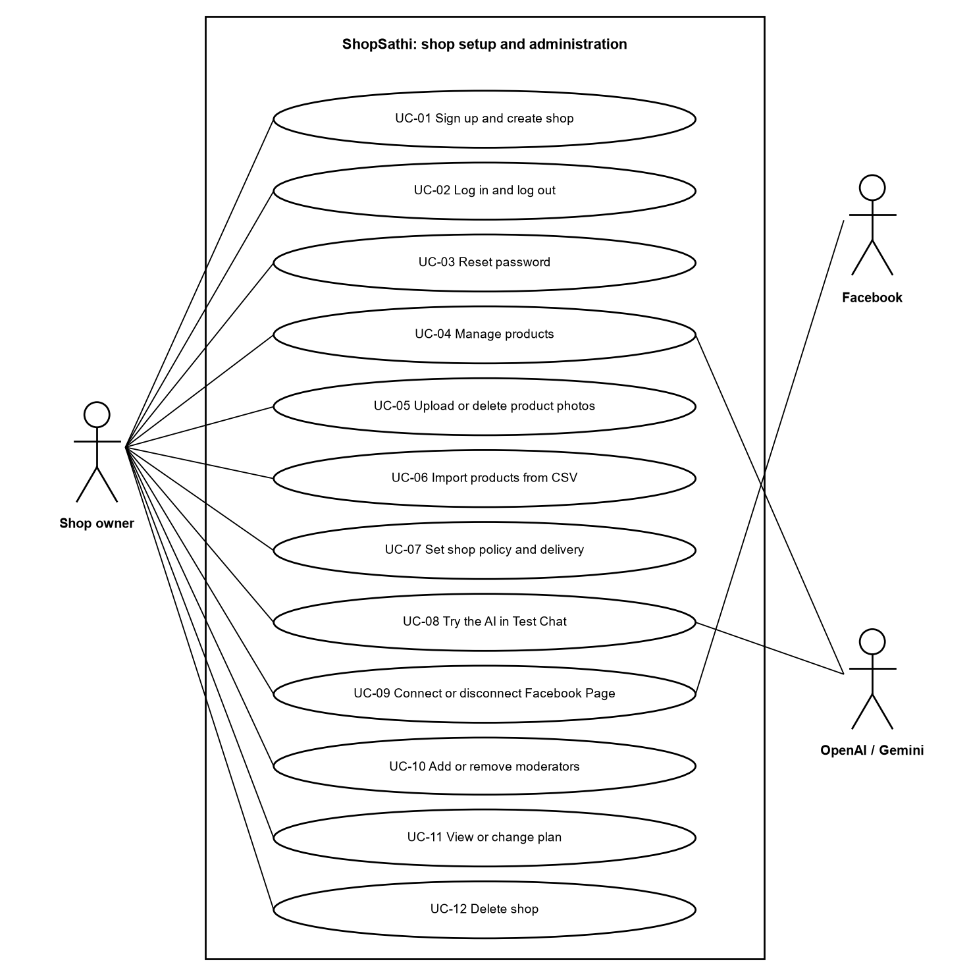
Figure 1: Use case diagram: shop setup and administration by the owner
The owner prepares the shop: account, products, policy, Test Chat, Facebook Page, staff, plan and deletion. OpenAI or Gemini is used when products are embedded and when Test Chat runs. Facebook is used when the Page is connected.
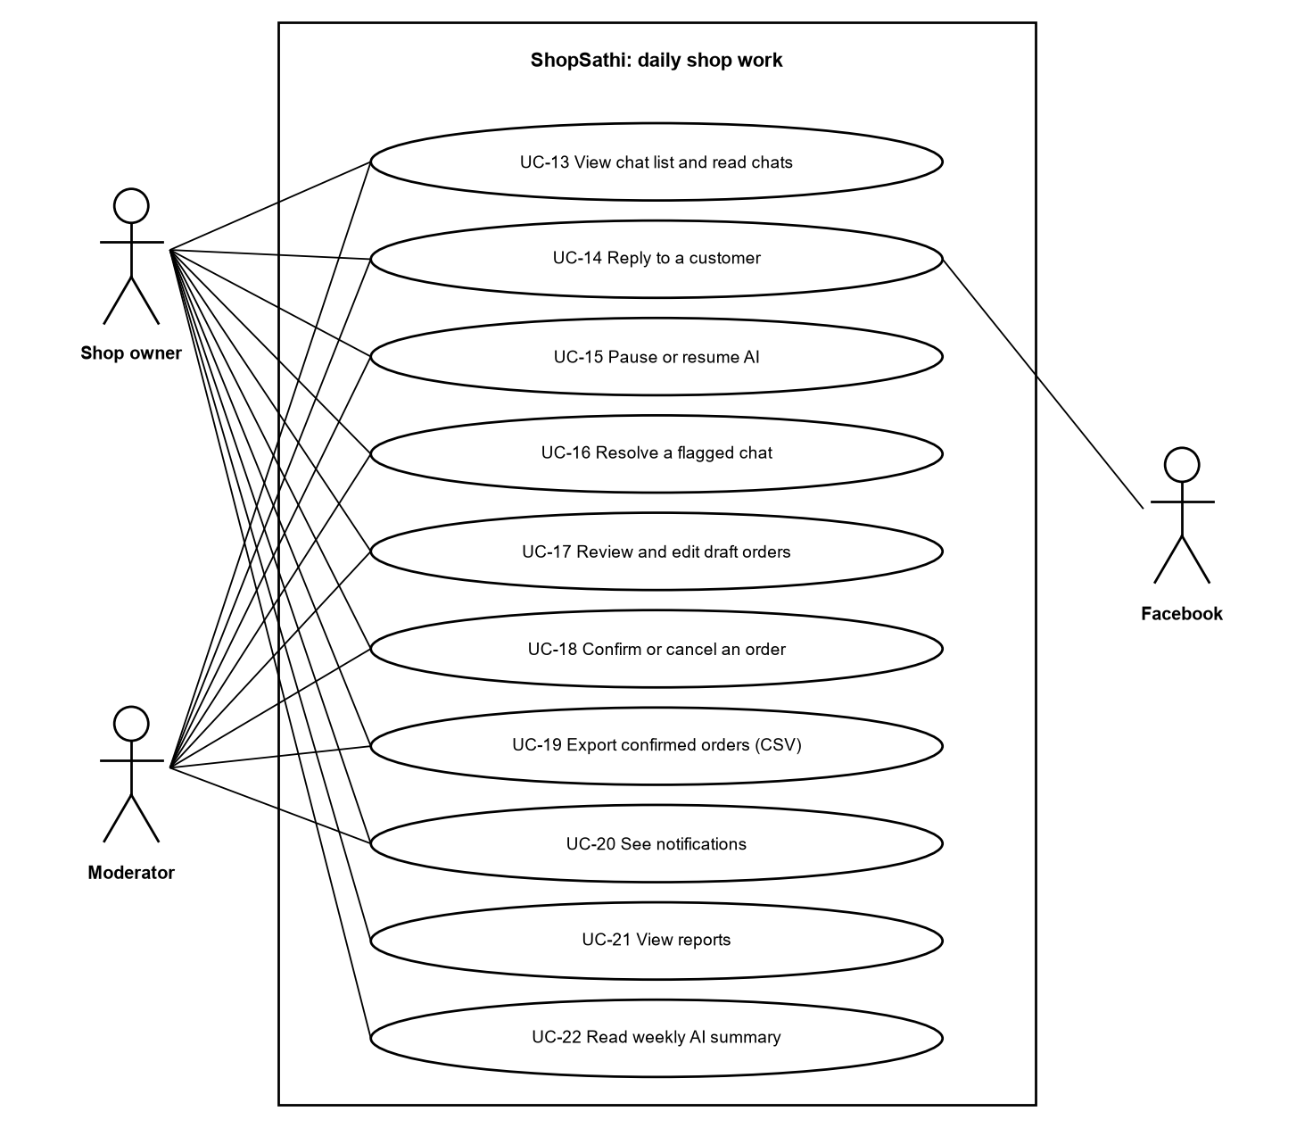
Figure 2: Use case diagram: daily work in the Inbox and Orders
Owner and moderator share the daily work. Reports and the weekly summary are for the owner only. Facebook receives the replies sent from the Inbox.
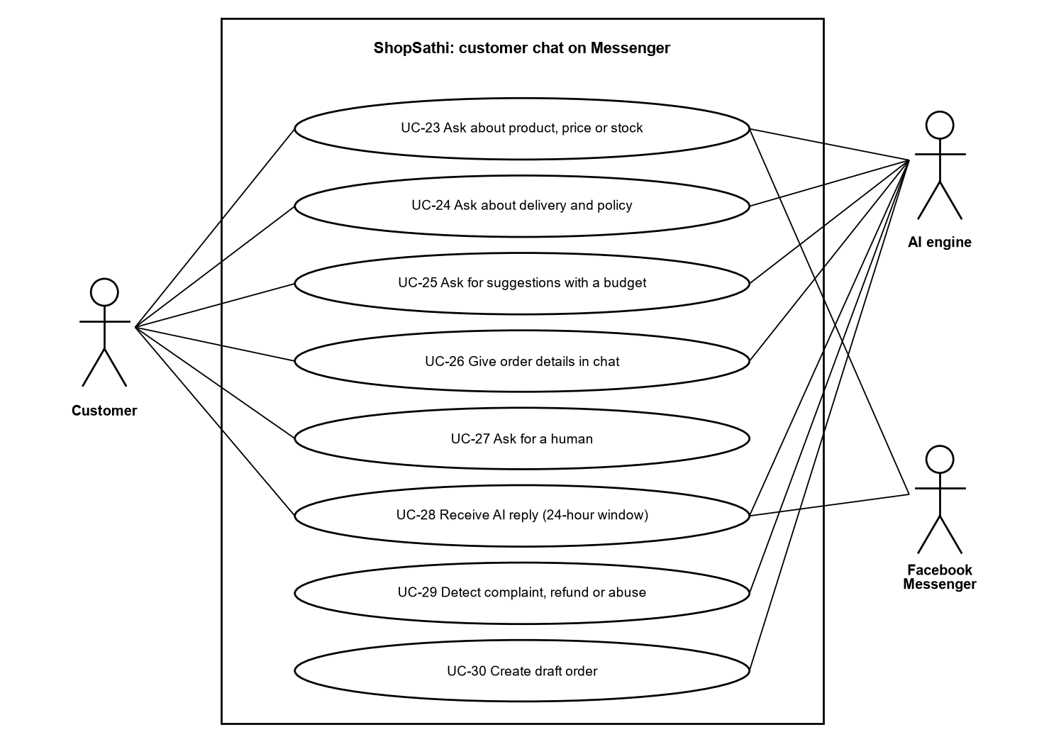
Figure 3: Use case diagram: customer chat on Messenger
The customer writes to the Page. The AI engine answers, suggests, collects the order or hands over. Facebook delivers the messages.
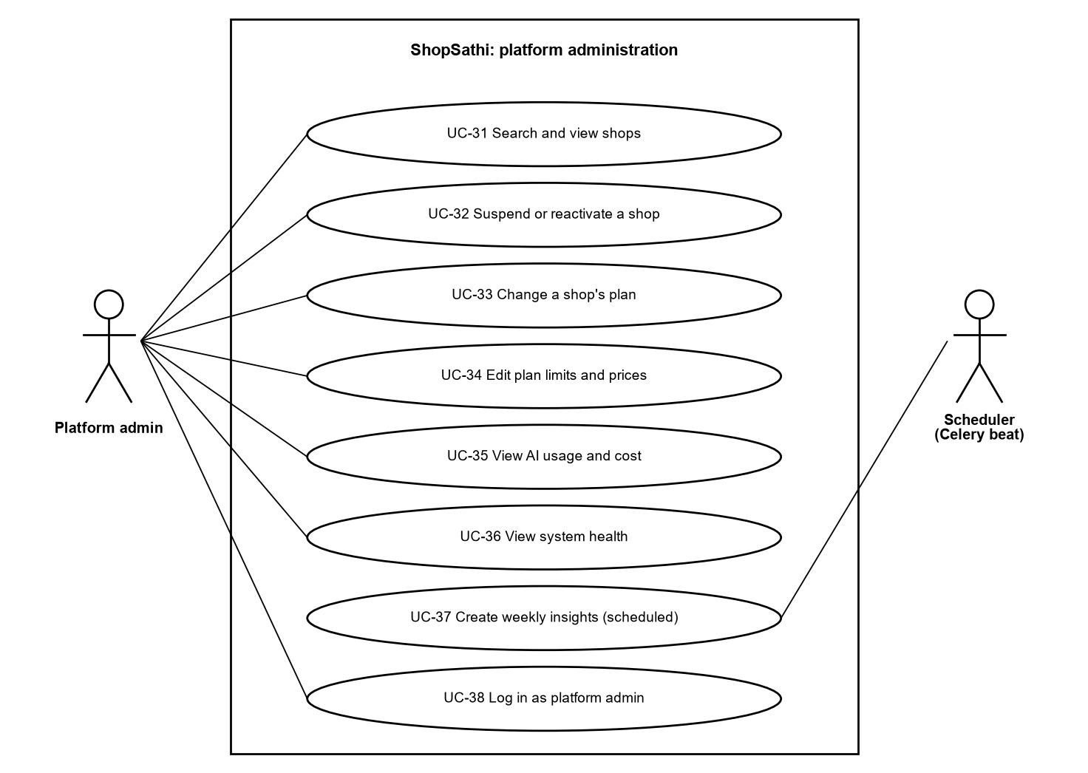
Figure 4: Use case diagram: platform administration
The platform admin manages shops and plans and watches cost and health. The weekly summary is started by the Celery beat scheduler.
Table 12: List of use cases
ID | Use case | Actor | Requirement
UC-01 | Sign up and create shop | Shop owner | FR-01
UC-02 | Log in and log out | Owner, Moderator, Admin | FR-02
UC-03 | Reset password | Owner, Moderator | FR-03
UC-04 | Manage products | Shop owner | FR-07
UC-05 | Upload or delete product photos | Shop owner | FR-08
UC-06 | Import products from CSV or Excel | Shop owner | FR-09
UC-07 | Set shop policy and delivery charges | Shop owner | FR-10
UC-08 | Try the AI in Test Chat | Shop owner | FR-12
UC-09 | Connect or disconnect a Facebook Page | Shop owner | FR-20
UC-10 | Add moderators | Shop owner | FR-06
UC-11 | View or change plan | Shop owner | FR-31, FR-32
UC-12 | Delete shop | Shop owner | FR-36
UC-13 | View chat list and read chats | Owner, Moderator | FR-23
UC-14 | Reply to a customer | Owner, Moderator | FR-25
UC-15 | Pause or resume AI | Owner, Moderator | FR-24
UC-16 | Resolve a flagged chat | Owner, Moderator | FR-24
UC-17 | Review and edit draft orders | Owner, Moderator | FR-26
UC-18 | Confirm or cancel an order | Owner, Moderator | FR-27
UC-19 | Export confirmed orders (CSV) | Owner, Moderator | FR-28
UC-20 | See notifications | Owner, Moderator | FR-19
UC-21 | View reports | Shop owner | FR-29
UC-22 | Read weekly AI summary | Shop owner | FR-30
UC-23 | Ask about product, price or stock | Customer | FR-13
UC-24 | Ask about delivery and policy | Customer | FR-13
UC-25 | Ask for suggestions with a budget | Customer | FR-16
UC-26 | Give order details in chat | Customer | FR-17
UC-27 | Ask for a human | Customer | FR-18
UC-28 | Receive AI reply (24-hour window) | Customer | FR-21, FR-22
UC-29 | Detect complaint, refund or abuse | AI engine | FR-18
UC-30 | Create draft order | AI engine | FR-17
UC-31 | Search and view shops | Platform admin | FR-33
UC-32 | Suspend or reactivate a shop | Platform admin | FR-33
UC-33 | Change a shop's plan | Platform admin | FR-33
UC-34 | Edit plan limits and prices | Platform admin | FR-34
UC-35 | View AI usage and cost | Platform admin | FR-34, FR-35
UC-36 | View system health | Platform admin | FR-34, FR-37
UC-37 | Create weekly insights (scheduled) | Scheduler | FR-30
UC-38 | Log in as platform admin | Platform admin | FR-02

25. Use Case Descriptions
The tables below describe the main use cases in detail. The other use cases in Table "List of use cases" follow the same pattern and are explained by the activity diagrams in section 29.
Table 13: Use case description UC-01: Sign up and create shop
ID and name | UC-01 Sign up and create shop
Actor | Shop owner (new visitor)
Precondition | The visitor has no account with this e-mail.
Main flow | 1. The visitor opens the Sign up page.  2. Enters shop name, owner name, e-mail and password, and chooses a plan.  3. For a paid plan the visitor confirms the simulated payment.  4. The system creates the shop (status active) and the owner account.  5. The system returns an access token and opens the dashboard.
Alternative flows | Data invalid: the form shows the errors (HTTP 422).  E-mail already used: HTTP 409 "Email is already registered".  Paid plan without confirmation: rejected.
Postcondition | A shop and an owner exist; a simulated payment is recorded for a paid plan.
Requirement | FR-01, FR-32

Table 14: Use case description UC-02: Log in and log out
ID and name | UC-02 Log in and log out
Actor | Owner, moderator, platform admin
Precondition | The user has an account.
Main flow | 1. The user enters e-mail and password.  2. The system checks the rate limit, the password hash and the shop status.  3. The system creates a token with a unique id and returns it.  4. The user works. On log out the token id is put on a deny list in Redis.
Alternative flows | Too many attempts: HTTP 429.  Wrong e-mail or password: HTTP 401 with the same text for both.  Shop suspended: HTTP 403.
Postcondition | A valid token exists, or the old token is revoked.
Requirement | FR-02

Table 15: Use case description UC-03: Reset password
ID and name | UC-03 Reset password
Actor | Owner, moderator
Precondition | The user knows the e-mail address.
Main flow | 1. The user asks for a reset link on the Forgot password page.  2. The system always answers "If that email is registered, a reset link has been sent".  3. For an active user, a hashed one-time token valid for 60 minutes is stored and the link is e-mailed.  4. The user opens the link and enters a new password.  5. The system saves the new hash and marks the token used.
Alternative flows | Unknown e-mail: same message, nothing sent.  Token used, unknown or expired: HTTP 400.  Too many requests: HTTP 429.
Postcondition | Password changed; the token cannot be used again.
Requirement | FR-03

Table 16: Use case description UC-04: Manage products
ID and name | UC-04 Manage products
Actor | Shop owner
Precondition | Logged in as owner.
Main flow | 1. The owner opens Products and chooses Add product or Edit.  2. Enters name, description, price, stock, sizes and colours.  3. The system validates and saves the product for this shop.  4. A background task creates the embedding of the product.
Alternative flows | Invalid data: validation errors.  Product of another shop: HTTP 404.  Queue is down: the product is still saved (tested).
Postcondition | The product is saved and will be searchable after the embedding task.
Requirement | FR-07, FR-11

Table 17: Use case description UC-06: Import products from CSV or Excel
ID and name | UC-06 Import products from CSV or Excel
Actor | Shop owner
Precondition | Logged in as owner; has a file.
Main flow | 1. The owner downloads the template (optional) and uploads the file.  2. The system reads up to 1000 rows (2 MB).  3. Each valid row becomes a product through the same service as a manual product.  4. The result lists created rows and failed rows with the reason.
Alternative flows | Wrong type, too large, too many rows or missing columns: the file is rejected with a clear message.  Invalid rows: skipped and reported.
Postcondition | Valid products exist; embeddings are queued.
Requirement | FR-09

Table 18: Use case description UC-09: Connect a Facebook Page
ID and name | UC-09 Connect a Facebook Page
Actor | Shop owner
Precondition | Facebook app settings exist in the server configuration.
Main flow | 1. The owner clicks Connect Facebook Page.  2. The system returns a Facebook login URL with a signed single-use state.  3. The owner logs in at Facebook and accepts the permissions.  4. Facebook calls the callback; the system checks the state, exchanges the code and reads the Pages.  5. The owner chooses a Page.  6. The system subscribes the Page to messages, encrypts the Page token and saves it.
Alternative flows | Invalid, used or expired state: rejected, nothing stored.  Missing permission or no Page: explained to the owner.  Page used by another shop: rejected.  Facebook refuses the subscription: nothing is connected.
Postcondition | One Page is connected to the shop.
Requirement | FR-20

Table 19: Use case description UC-13: View chat list and read chats
ID and name | UC-13 View chat list and read chats
Actor | Owner, moderator
Precondition | Logged in; Messenger chats exist.
Main flow | 1. The user opens Inbox.  2. The system lists chats, flagged ones first, then by latest activity.  3. The user filters All or Flagged and opens a chat.  4. The system shows all messages, the order drafts and product cards.
Alternative flows | Chat of another shop or a test chat: HTTP 404.
Postcondition | None (read only).
Requirement | FR-23

Table 20: Use case description UC-14: Reply to a customer
ID and name | UC-14 Reply to a customer
Actor | Owner, moderator
Precondition | The AI is paused in this chat; a Page is connected.
Main flow | 1. The user writes a reply and presses Send.  2. The system checks that the chat is a Messenger chat, that the AI is paused and that the 24-hour window is open.  3. The message is saved as sender seller and sent through the Send API.  4. The time of sending is stored.
Alternative flows | AI not paused: rejected.  Window closed: rejected with a clear message.  Facebook refuses: the reply is not stored.
Postcondition | The customer has the reply.
Requirement | FR-25

Table 21: Use case description UC-18: Confirm or cancel an order
ID and name | UC-18 Confirm or cancel an order
Actor | Owner, moderator
Precondition | A draft order exists.
Main flow | 1. The user opens the order and checks the details.  2. The user presses Confirm or Cancel.  3. The system sets the status and the time. For confirm it also stores who confirmed.
Alternative flows | Order is not a draft: HTTP 409.  Order of another shop: HTTP 404.
Postcondition | The order is confirmed or cancelled. Stock is not changed.
Requirement | FR-27

Table 22: Use case description UC-19: Export confirmed orders
ID and name | UC-19 Export confirmed orders
Actor | Owner, moderator
Precondition | Confirmed orders exist.
Main flow | 1. The user chooses an optional From and To date.  2. The system selects confirmed orders of the shop for those Bangladesh days.  3. It writes a CSV file with fixed columns and protects cells that start with =, +, - or @.  4. The browser downloads the file.
Alternative flows | Invalid dates: validation error.  No orders: a file with only the header.
Postcondition | A CSV file is downloaded.
Requirement | FR-28

Table 23: Use case description UC-23: Ask about product, price or stock
ID and name | UC-23 Ask about product, price or stock
Actor | Customer
Precondition | The Page is connected, AI is active, window is open, limit not reached.
Main flow | 1. The customer writes a question in Messenger.  2. The system stores it and the worker runs the AI engine.  3. The engine finds the product and reads price and stock from the database.  4. The reply is written from these facts and checked.  5. The reply is sent and counted.
Alternative flows | Product not found or fact missing: the AI says it will check with the shop and the chat is flagged (not_in_shop_data).
Postcondition | The customer has an answer; usage is logged.
Requirement | FR-13, FR-14

Table 24: Use case description UC-25: Ask for suggestions with a budget
ID and name | UC-25 Ask for suggestions with a budget
Actor | Customer
Precondition | As UC-23.
Main flow | 1. The customer asks, for example, for a gift under 3000 taka.  2. The engine extracts the needs and the budget.  3. Code filters the shop's live products: in stock and inside the budget.  4. The best three become product cards with photos.  5. A short text is written and sent with the photos.
Alternative flows | No match: an honest reply without cards (tested).
Postcondition | Suggestion reply sent.
Requirement | FR-16

Table 25: Use case description UC-26: Give order details in chat
ID and name | UC-26 Give order details in chat
Actor | Customer
Precondition | As UC-23.
Main flow | 1. The customer says which product they want.  2. The engine extracts product, size, colour, quantity, name, phone and address.  3. Code checks the product, size, colour, stock and the phone number format.  4. Missing or invalid fields are asked for again; partial data is kept in the chat for 24 hours.  5. When all fields are valid a draft order is created.
Alternative flows | Out-of-stock or unknown product, bad size or too many pieces: no draft.  Invalid phone: asked again.
Postcondition | A draft order waits for the seller.
Requirement | FR-17

Table 26: Use case description UC-27: Ask for a human / handover
ID and name | UC-27 Ask for a human / handover
Actor | Customer, AI engine
Precondition | As UC-23.
Main flow | 1. The customer complains, asks for a refund, uses abusive words, asks for a person, writes off-topic, or the AI is not confident.  2. The engine returns a hand-over reason.  3. The system saves a hand-over event, flags the chat, pauses the AI and creates a notification.  4. A short safe reply is sent in the customer's style.
Alternative flows | The same chat stays quiet (no AI reply, no second notification) until the seller resumes it.
Postcondition | The seller sees the flag in the Inbox and the bell.
Requirement | FR-18, FR-19

Table 27: Use case description UC-32: Suspend or reactivate a shop
ID and name | UC-32 Suspend or reactivate a shop
Actor | Platform admin
Precondition | Logged in as platform admin.
Main flow | 1. The admin searches the shop and opens it.  2. The admin presses Suspend or Reactivate.  3. The system changes the status and writes a row in the admin action log.
Alternative flows | Suspending twice is harmless and logged once.
Postcondition | Suspended: users cannot log in or use old tokens, and customers get no AI reply.
Requirement | FR-33

Table 28: Use case description UC-12: Delete shop
ID and name | UC-12 Delete shop
Actor | Shop owner
Precondition | Logged in as owner.
Main flow | 1. The owner opens Settings, Danger zone, Delete this shop.  2. Enters the exact shop name and the password.  3. The system tells Facebook to stop events, deletes photo files and Redis keys, and deletes the shop row; the database removes all shop data.  4. The current token is revoked.
Alternative flows | Wrong name or password: nothing deleted.  Too many tries: rate limited.  Facebook or storage failure: the deletion still completes.
Postcondition | No data of the shop remains; the other shops are untouched.
Requirement | FR-36

26. Scenario Writing
The scenarios below follow typical days of the system. Names and numbers are examples from the demo data and from the automated tests; they are not real customers.

26.1 Scenario A: a new owner starts
Rina opens the Sign up page, enters her shop name and e-mail, chooses the Free plan and signs up. The dashboard opens. She adds seven products, uploads one photo, and fills the policy: delivery charge 60 taka inside Dhaka and 120 outside, with return rules. In Test Chat she writes "Red Jamdani Saree ta nibo, 1ta. Naam Rina, phone 01711223344, Dhaka Mirpur 10". The AI replies with a summary and an "Order draft created" card (see the screenshot in section 43). Nothing was sent to Facebook.

26.2 Scenario B: a customer asks about price and stock
A customer writes "Red saree ta ache? Dam koto?" on Messenger. The webhook stores the message and the worker starts the AI engine. The engine detects Banglish, finds the product, reads the price and stock from the database, writes the reply in Banglish, checks that the numbers come from the facts, and the sender delivers it. The measured time from receiving to sending was about 6 seconds in the local load test with the real model.

26.3 Scenario C: suggestion with a budget
A customer writes "Eid-er jonno panjabi lagbe, 1500 takar moddhe". The engine reads the budget in code, filters the live products (stock above zero and price within the budget), keeps at most three, and the reply is sent with the photos of those products. A product with zero stock is never shown.

26.4 Scenario D: order with a wrong phone number
The customer gives the name, the address and the phone "0171-1223". The phone does not match the Bangladesh mobile format, so the draft is not created and the AI asks again. After the customer sends 01711223344 the draft order is created. The seller sees it under Orders, Draft.

26.5 Scenario E: complaint and handover
A customer writes that the product was bad and asks for a refund. The engine returns the reason refund (or complaint). A hand-over event is saved, the chat is flagged, the AI is paused, and a notification appears in the bell. The customer gets a short polite reply that promises nothing. The seller opens the chat, writes a reply, marks the flag as handled and, if wanted, resumes the AI.

26.6 Scenario F: the 24-hour window
A customer wrote two days ago and writes again after a long time. The first message is inside its own window and is answered. If the seller tries to reply to a chat whose last customer message is older than 24 hours, the system refuses with a clear message and sends nothing.

26.7 Scenario G: the plan limit
A Free shop has 100 AI replies per month. The 100th reply is sent; for the 101st message the worker marks the message as skipped with the reason limit_reached. The message stays in the Inbox for the seller. The owner can change the plan on My plan, which uses a simulated payment.

26.8 Scenario H: the admin suspends a shop
The admin finds a shop, presses Suspend, and the action is logged. The shop's users can no longer log in and old tokens stop working. Customers of that shop get no AI reply until the admin presses Reactivate.

27. Context Diagram
The context diagram shows ShopSathi as one system with the people and external services around it. All data flows pass the system boundary.
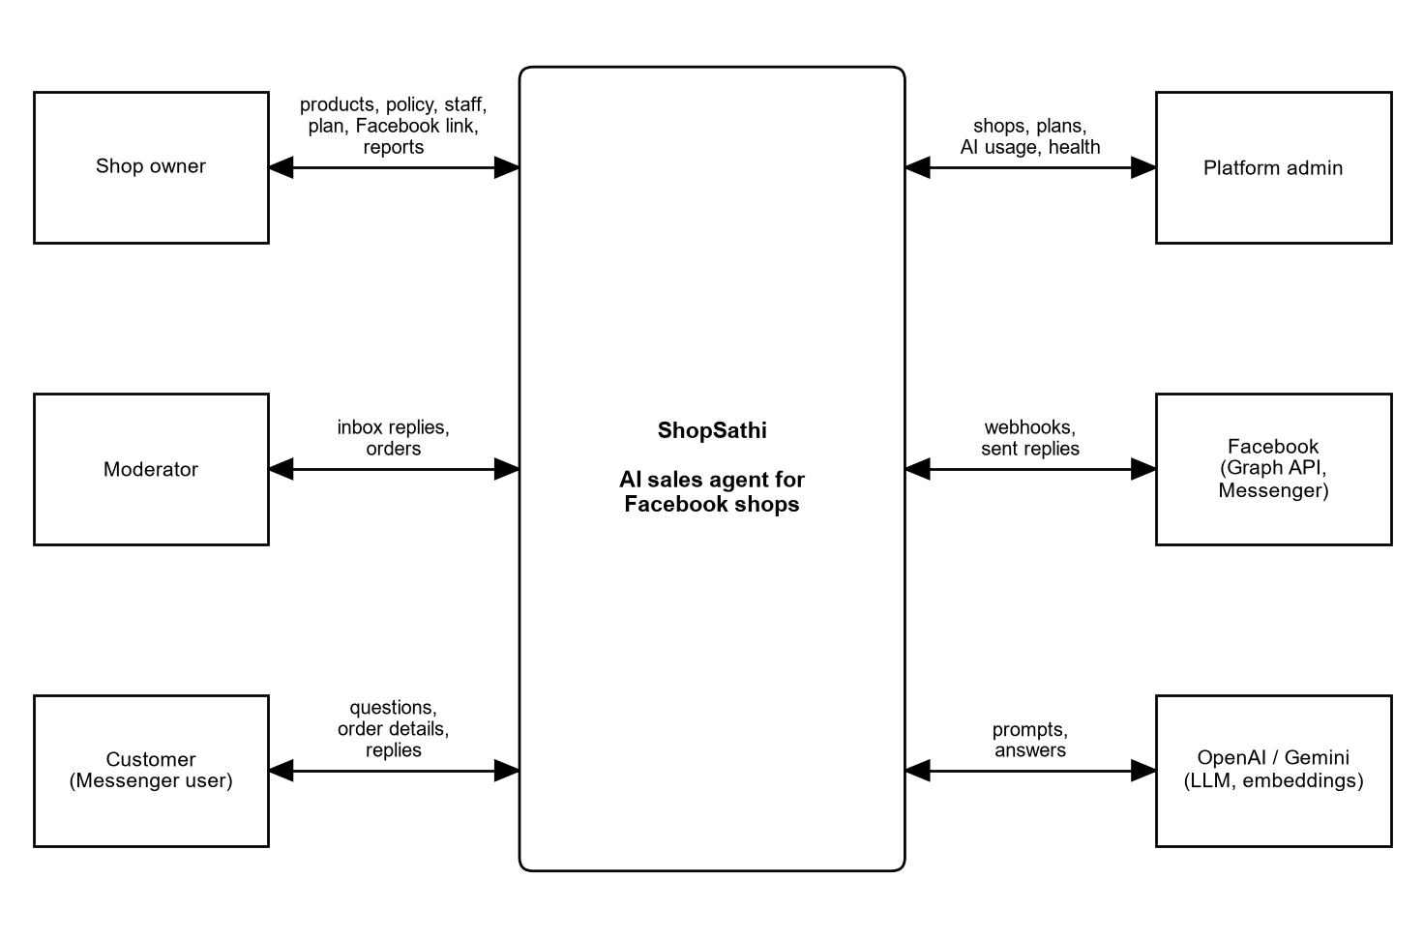
Figure 5: Context diagram of ShopSathi
The owner and moderator use the dashboard. The customer talks to the shop through Facebook Messenger. The platform admin uses the admin pages. ShopSathi calls the Facebook Graph API and Send API, and it calls OpenAI or Gemini for language and embeddings. The AI provider is chosen by configuration.

28. System Flowchart
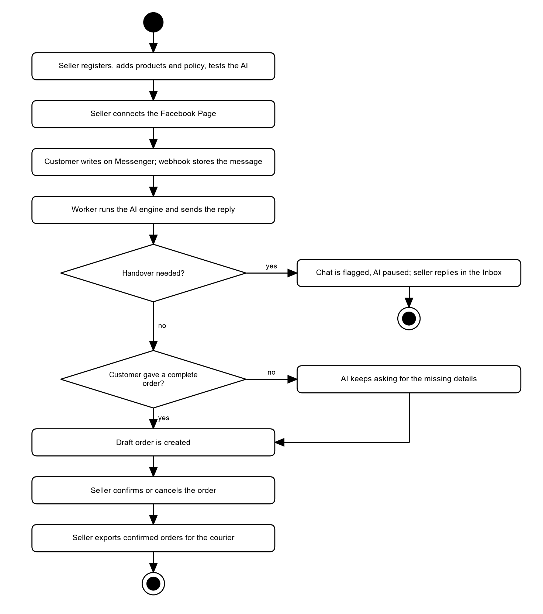
Figure 6: System flowchart: from set-up to the courier list
The flow shows the whole life of a sale: the seller prepares the shop and connects the Page, the customer writes, the worker answers, difficult chats are handed over, a complete order becomes a draft, and the seller confirms and exports it. Each step is explained in detail by an activity diagram in section 29.

29. Activity Diagrams
The activity diagrams show the real workflows. A diamond is a decision, a rounded box is an action, the black circle starts the flow and the circle with a dot ends it.

29.1 Registration, shop creation
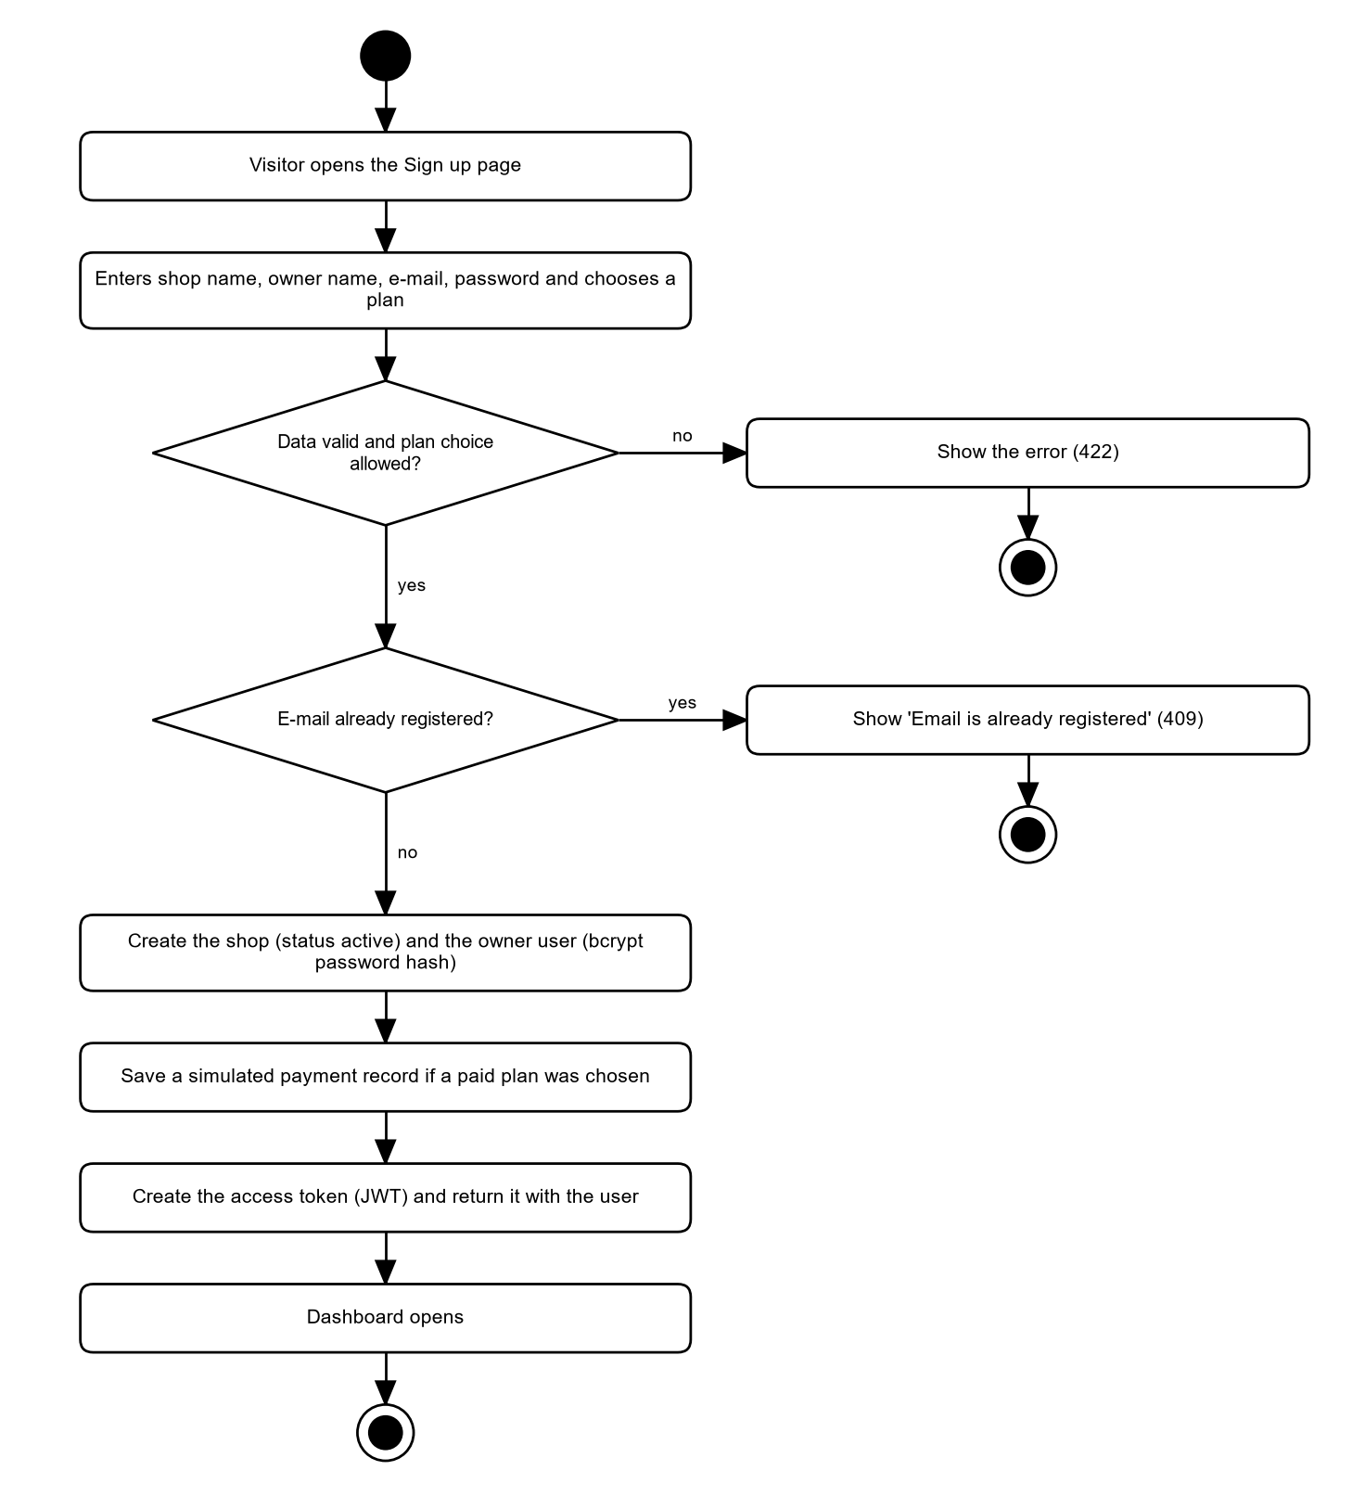
Figure 7: Activity diagram: registration, shop creation
The sign-up form checks the data and the plan choice, rejects a used e-mail, then creates the shop and the owner in one step. A bcrypt hash is stored, never the password. The user is logged in at once.

29.2 Login and logout
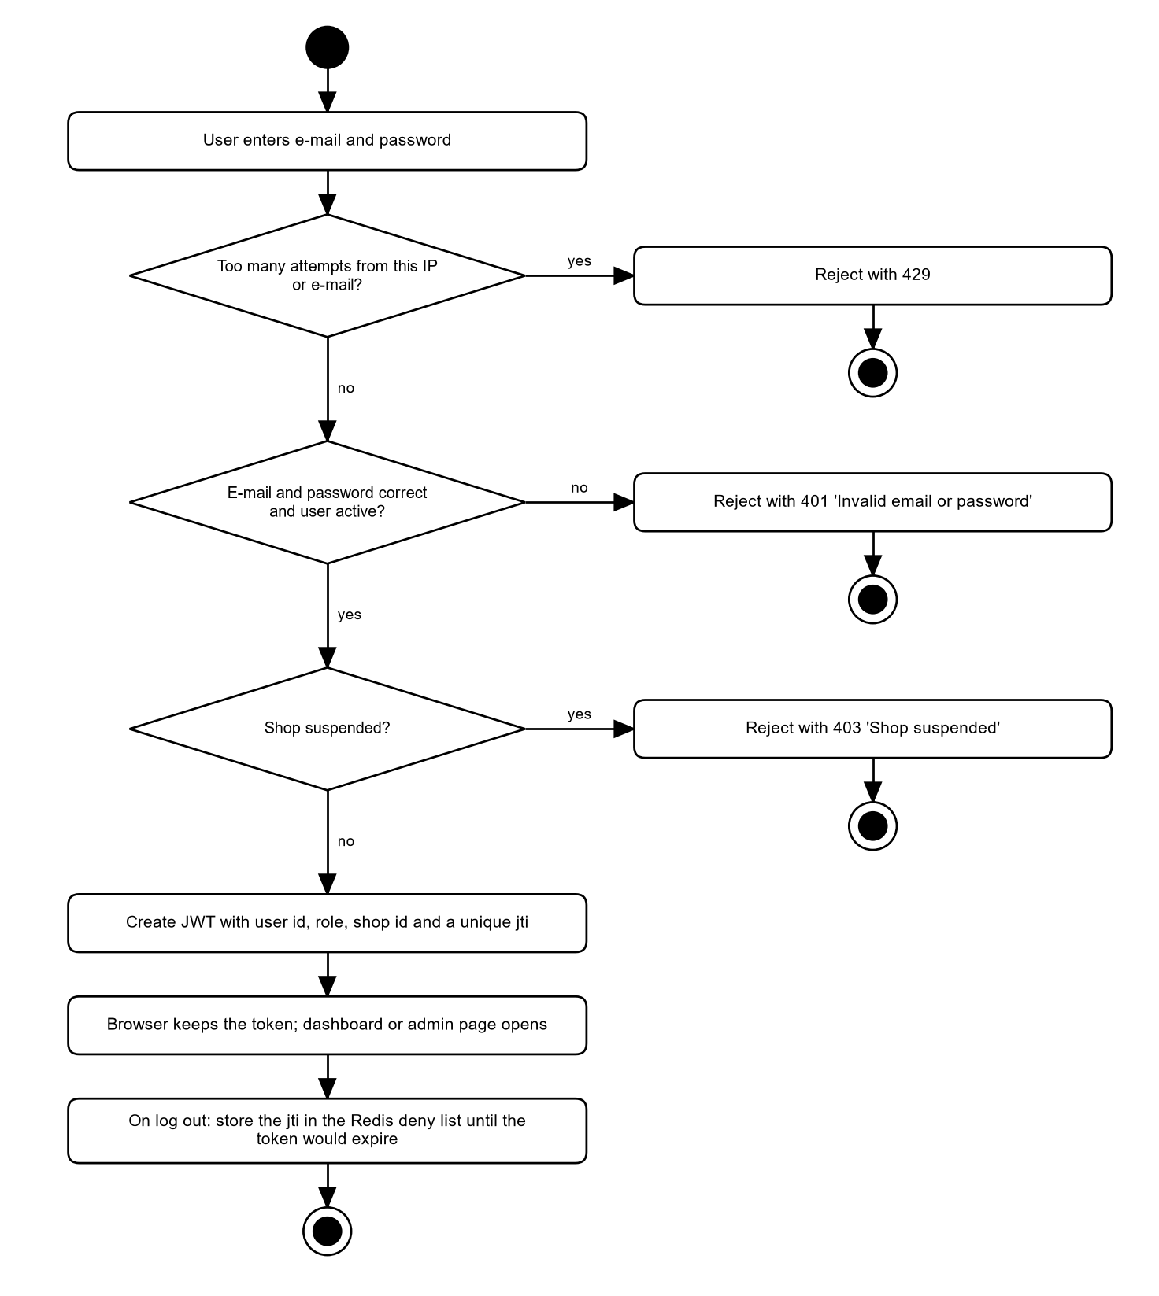
Figure 8: Activity diagram: login and logout
Login is rate limited per IP and per e-mail. A wrong e-mail and a wrong password give the same answer. A suspended shop is refused. Logout puts the token id on a Redis deny list.

29.3 Password reset
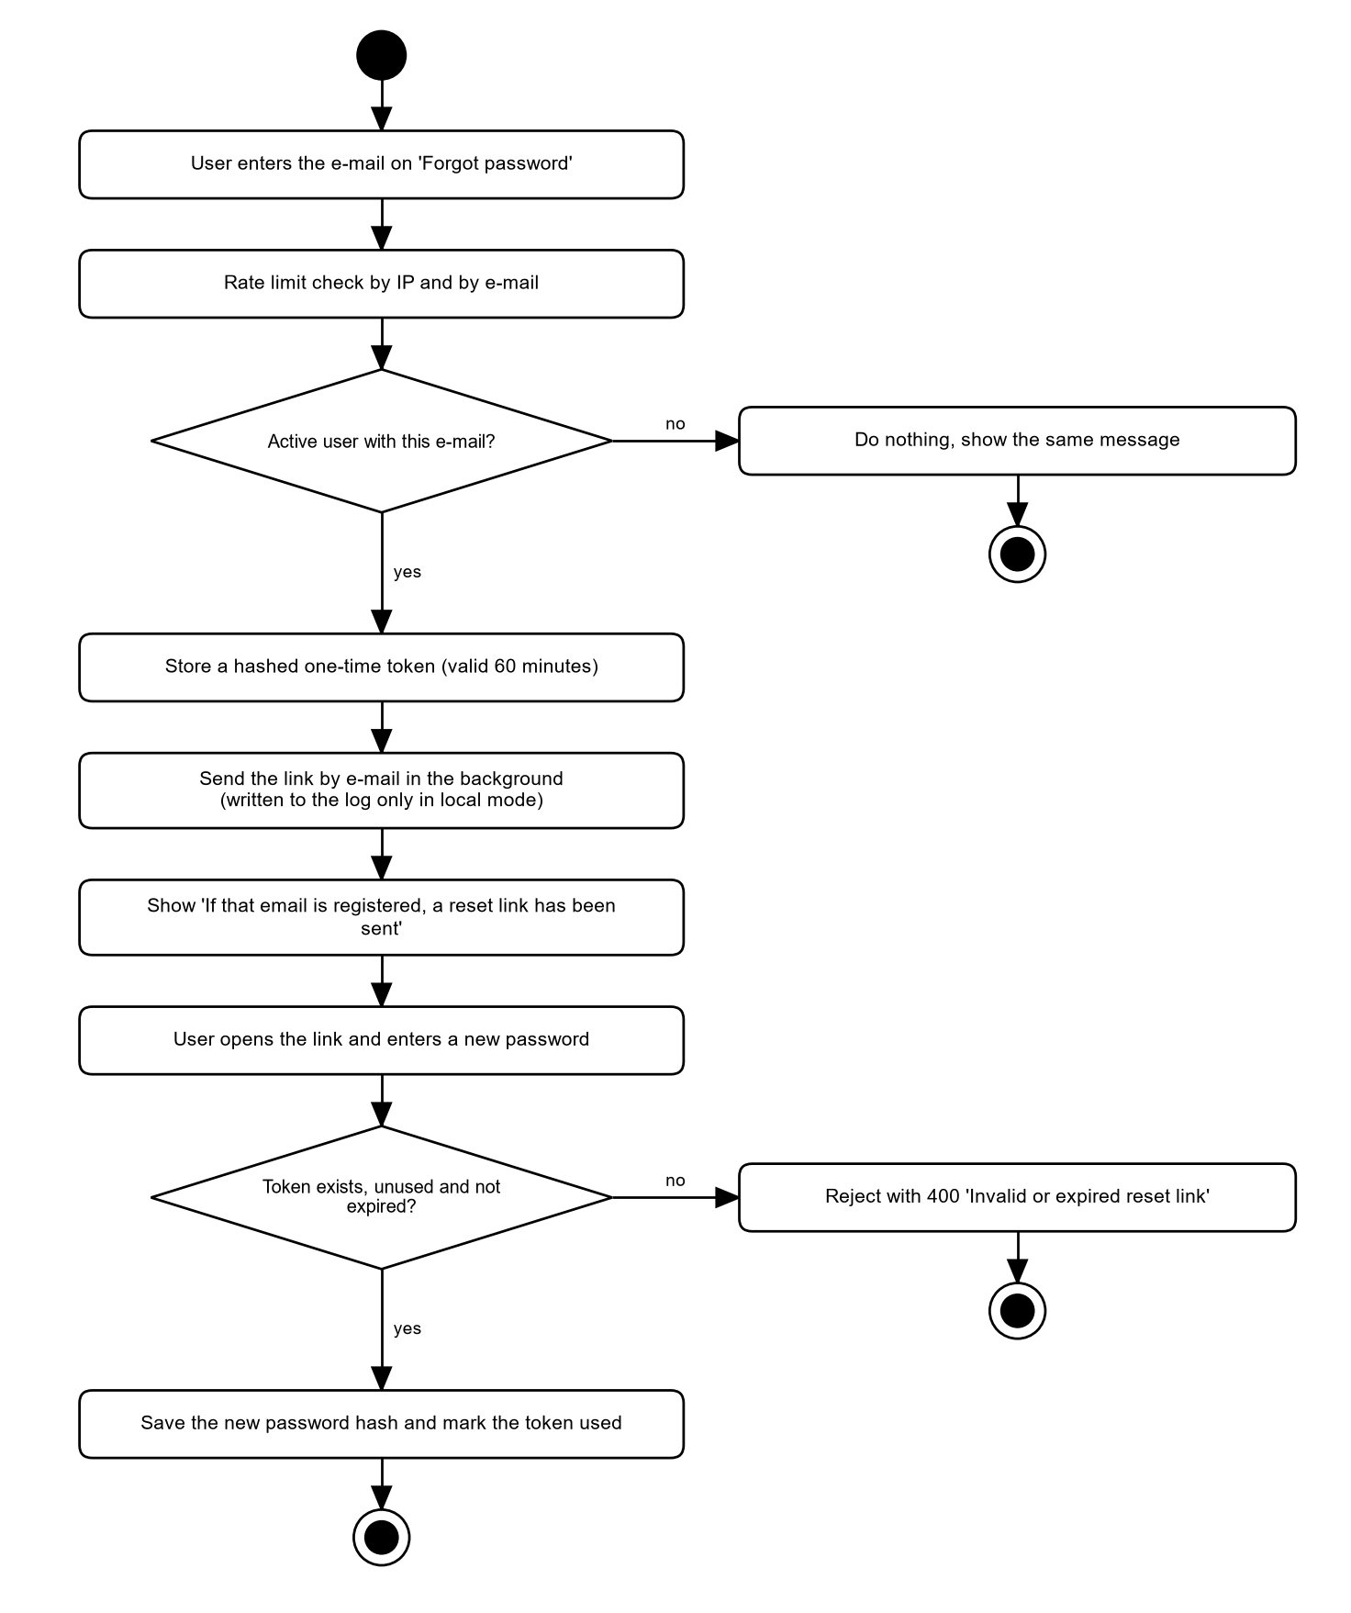
Figure 9: Activity diagram: password reset
The answer is the same for known and unknown e-mails. Only a hash of the token is stored. The token is valid for 60 minutes and works once.

29.4 Product creation, update and photos
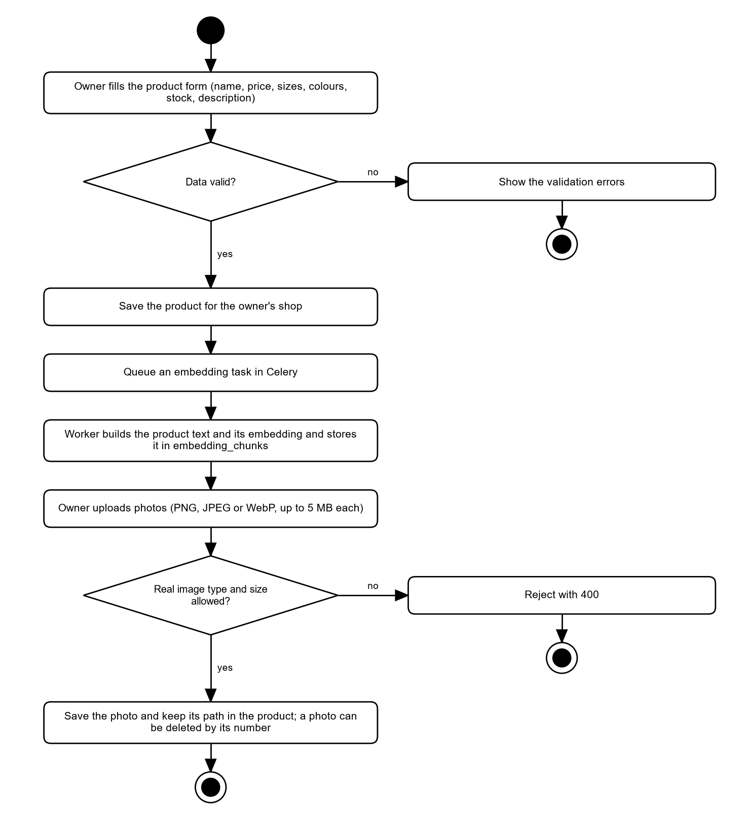
Figure 10: Activity diagram: product creation, update and photos
A saved product queues an embedding task. Photos are checked by their real file signature and size before they are stored.

29.5 Csv or excel import
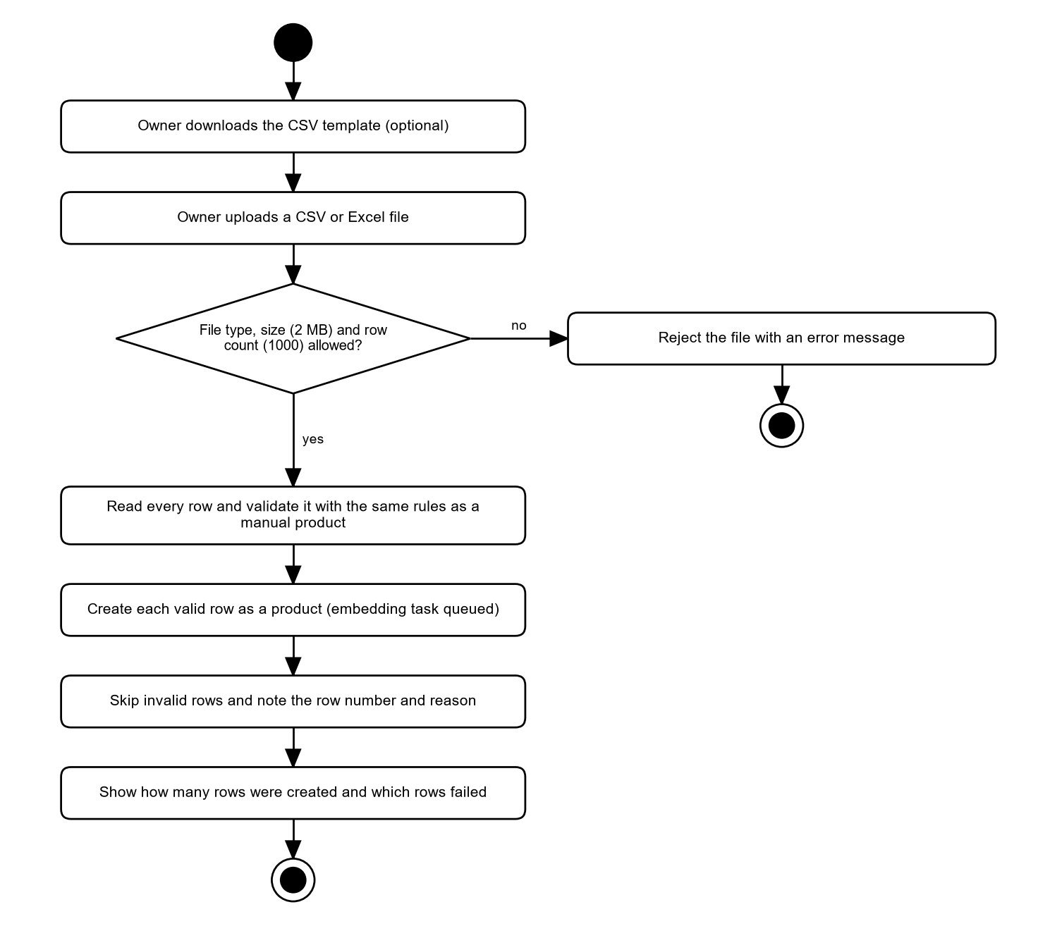
Figure 11: Activity diagram: CSV or Excel import
The file is limited in size and rows. Every row passes the same validation as a manual product. Failed rows are reported by row number.

29.6 Ai message processing
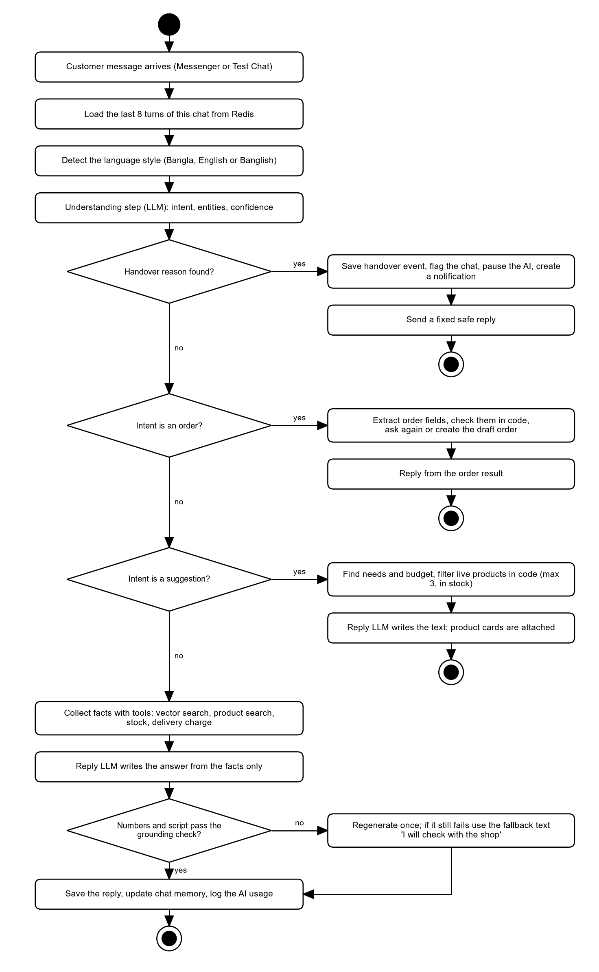
Figure 12: Activity diagram: AI message processing
This is the main pipeline of the AI engine. It checks hand-over first, then handles orders and suggestions, and otherwise answers from facts. The reply is checked before it leaves the engine.

29.7 Retrieval and suggestion
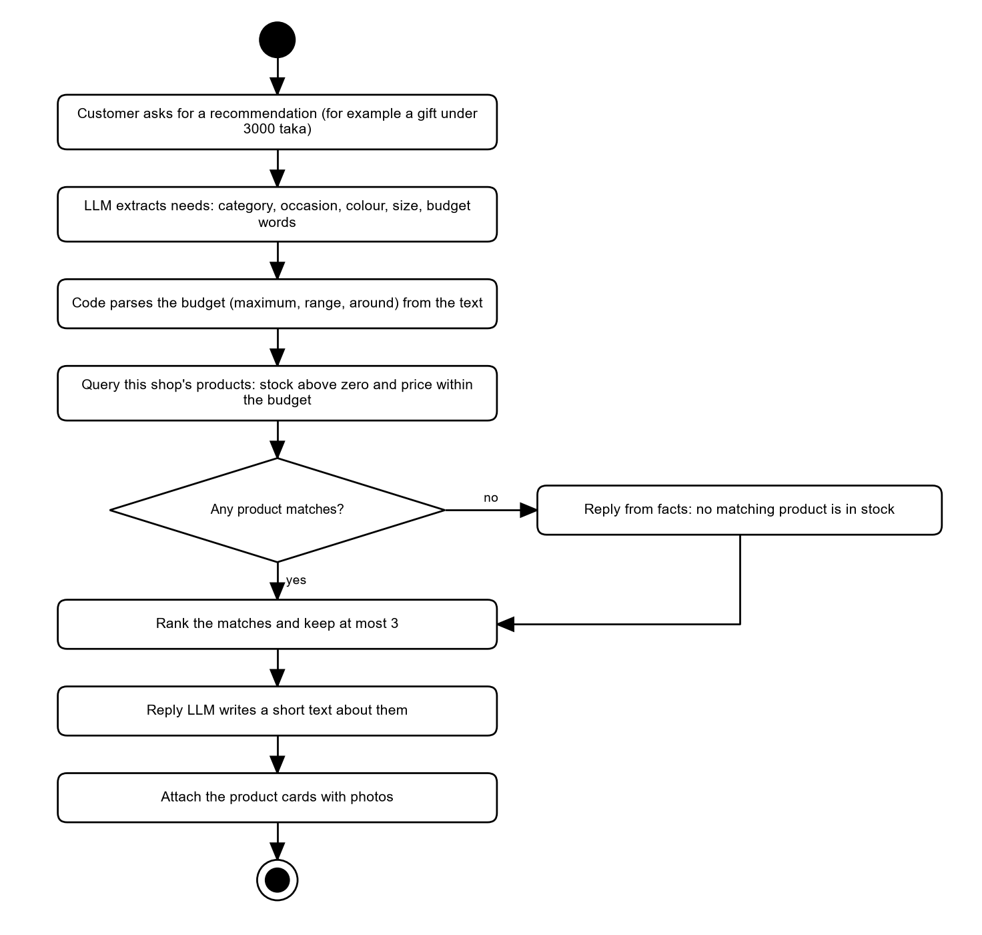
Figure 13: Activity diagram: retrieval and suggestion
The budget is read in code and the filter runs on live data, so a zero-stock product cannot appear even if the language model suggests it.

29.8 Order draft
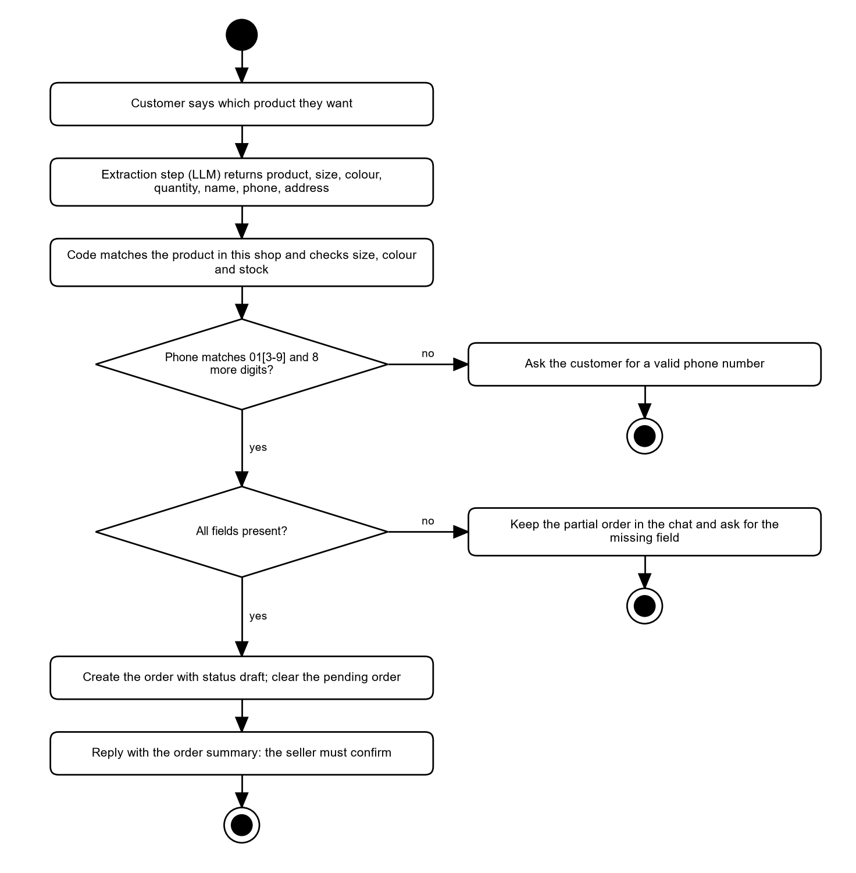
Figure 14: Activity diagram: order draft
Code, not the language model, validates the phone number, the product, the size, the colour and the stock. Missing fields are asked for one by one. The AI cannot confirm an order.

29.9 Order management
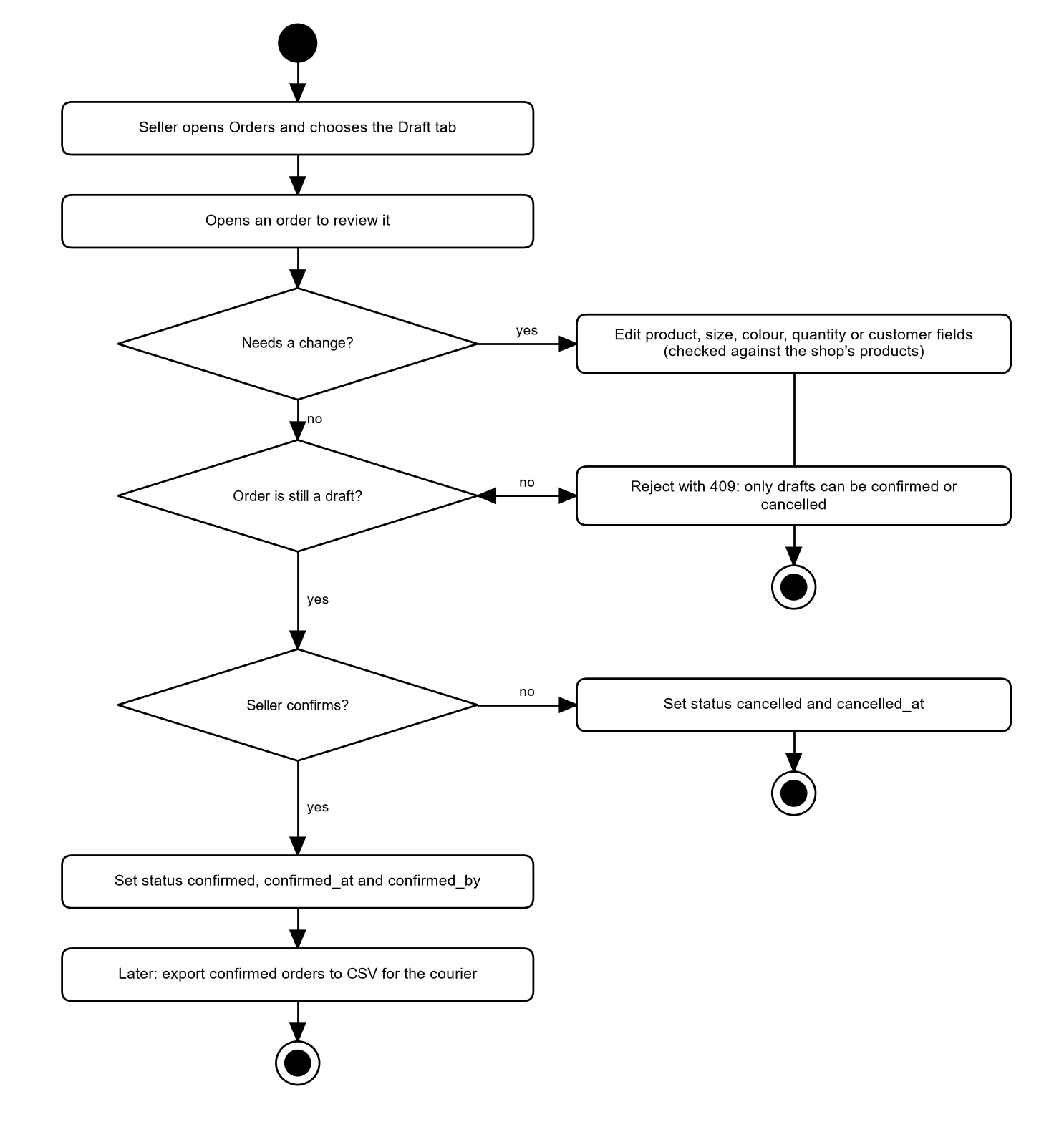
Figure 15: Activity diagram: order management
Only draft orders can be edited, confirmed or cancelled. Changing the product takes the catalogue price. Confirming does not change stock.

29.10 Csv export
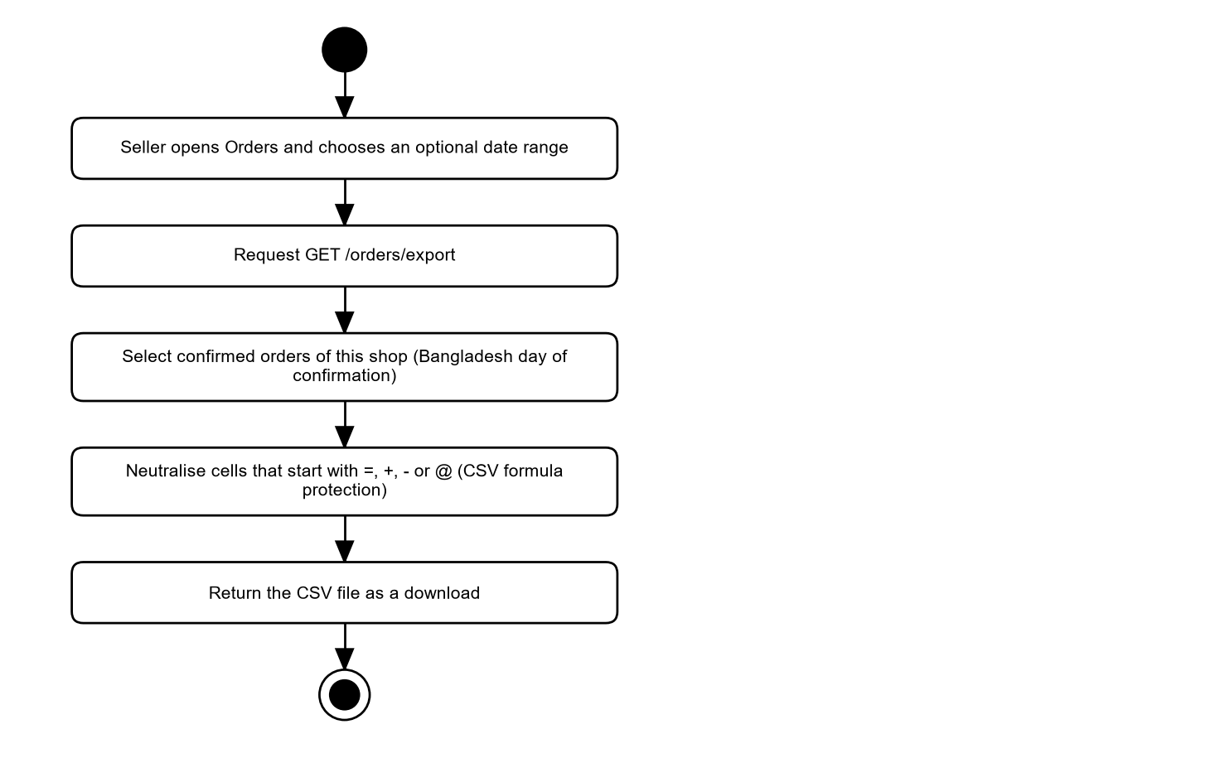
Figure 16: Activity diagram: CSV export
The export covers confirmed orders in Bangladesh time. Cells that look like spreadsheet formulas are neutralised.

29.11 Human handover
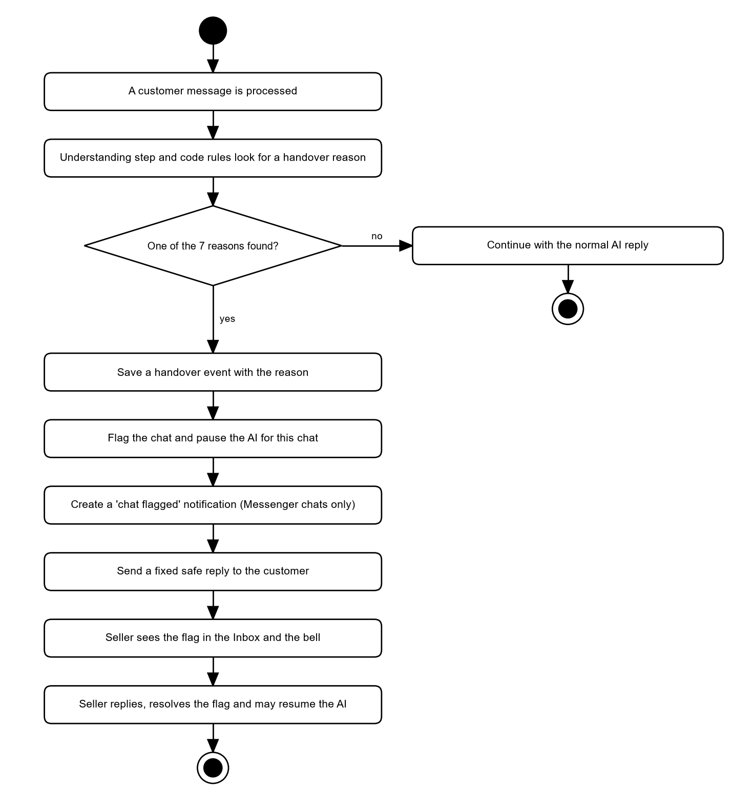
Figure 17: Activity diagram: human handover
One of 7 reasons triggers the hand-over. The AI stops for that chat until the seller resumes it. A notification is created for Messenger chats.

29.12 Facebook page connection
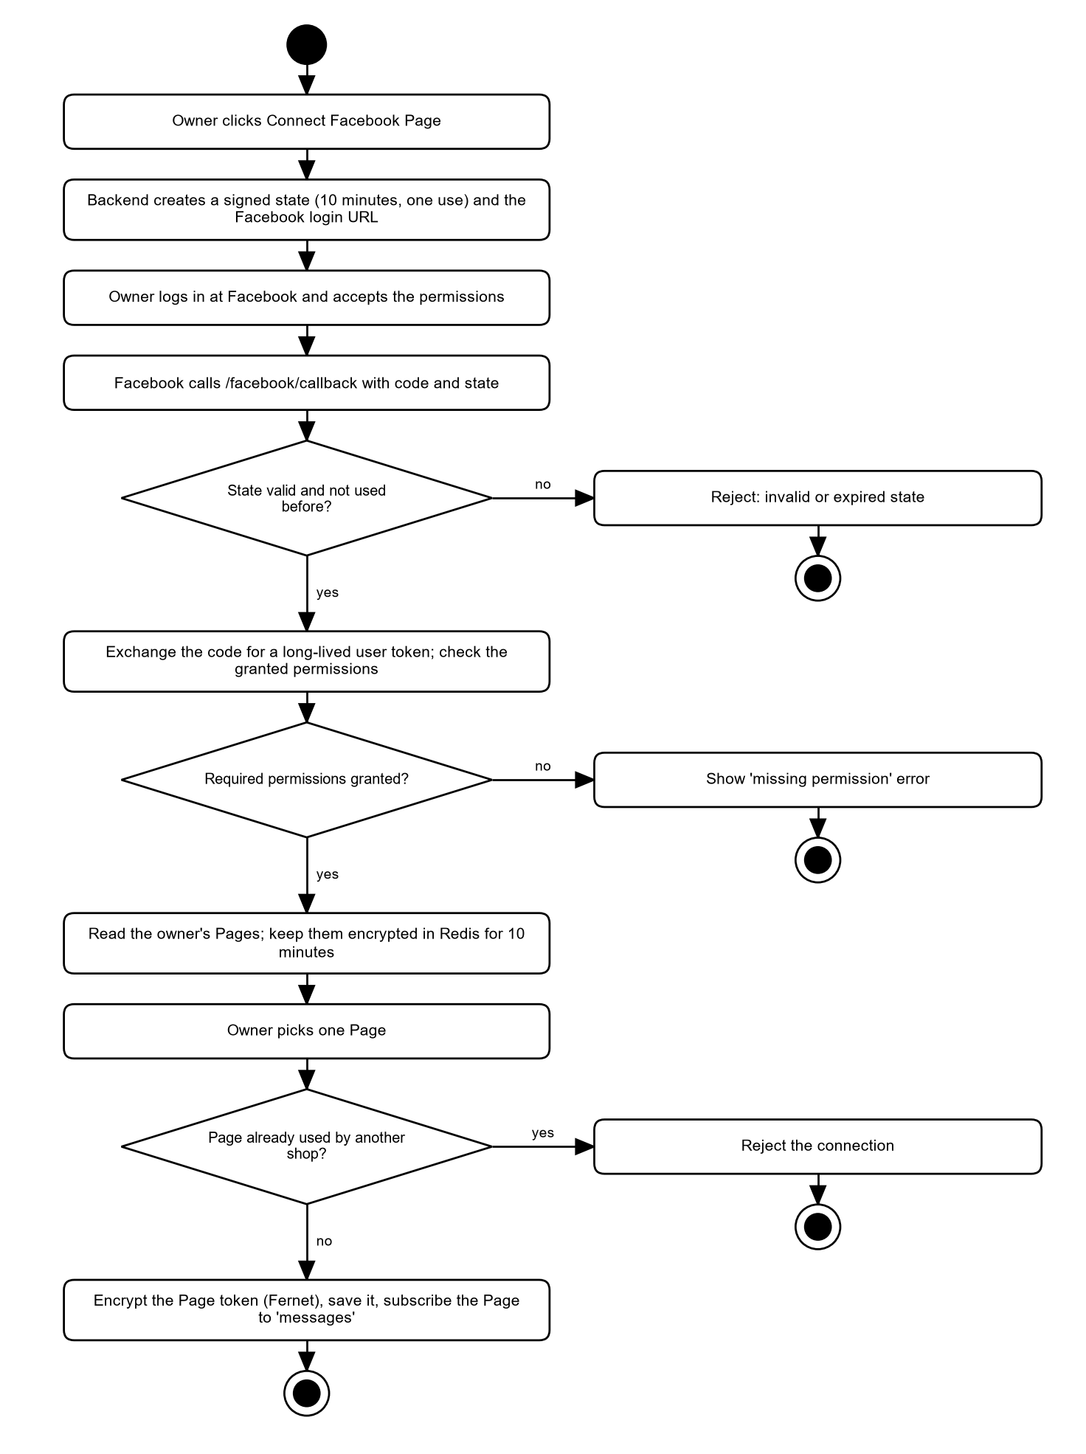
Figure 18: Activity diagram: Facebook Page connection
The state value is signed and works once for 10 minutes. The list of Pages is kept encrypted in Redis for 10 minutes. The Page token is encrypted before it is stored.

29.13 Messenger webhook and reply delivery
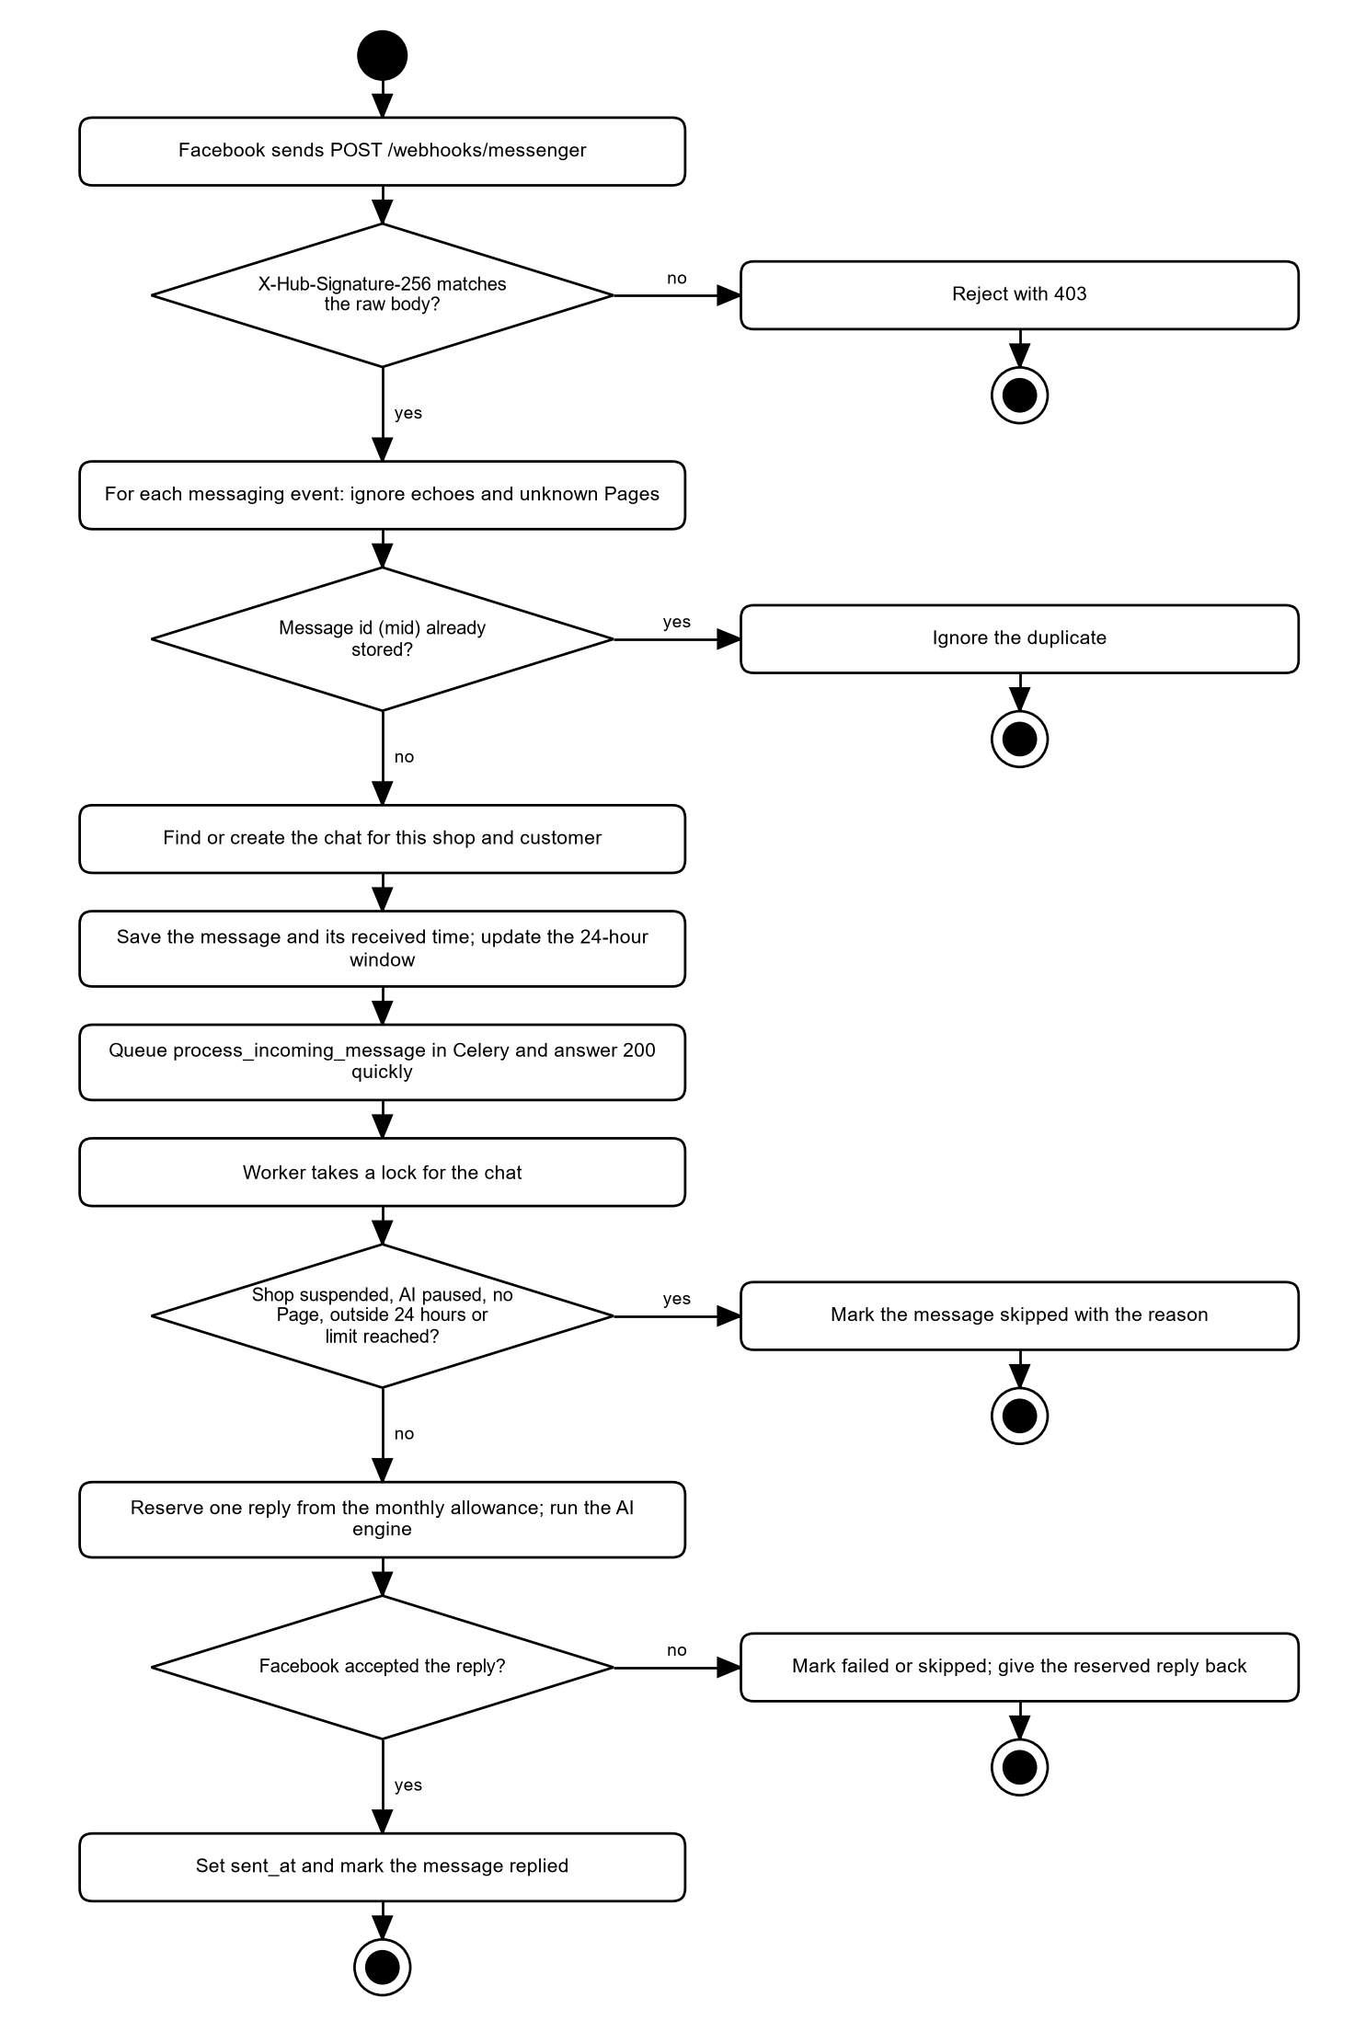
Figure 19: Activity diagram: Messenger webhook and reply delivery
The webhook only verifies, stores and queues; it answers quickly. The worker applies the skip rules, reserves one reply from the monthly allowance, runs the engine and sends the reply. A reply is counted only when Facebook accepted it.

29.14 Seller reply from the inbox
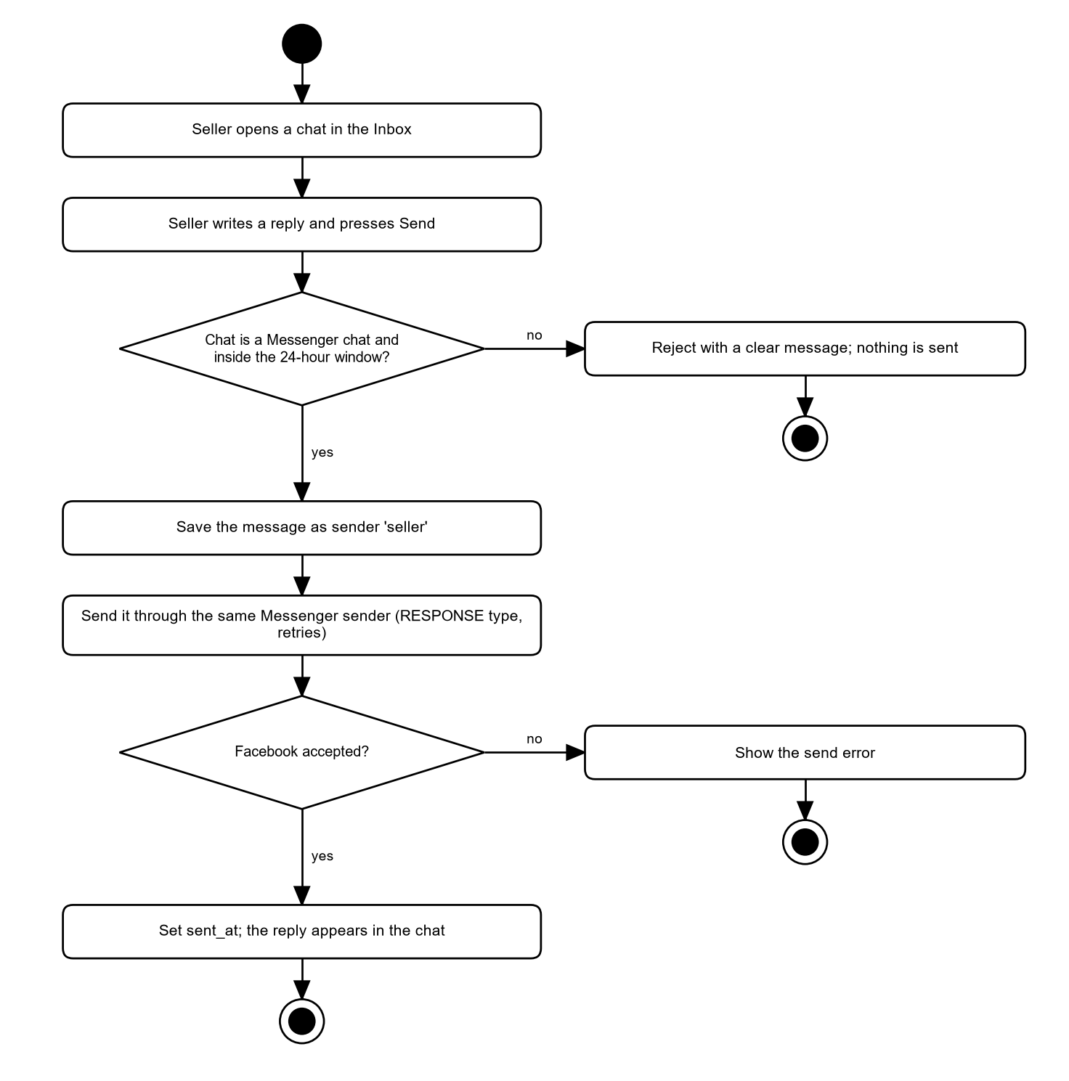
Figure 20: Activity diagram: seller reply from the Inbox
A manual reply uses the same sender as the AI, so the same window and retry rules apply.

29.15 Shop deletion
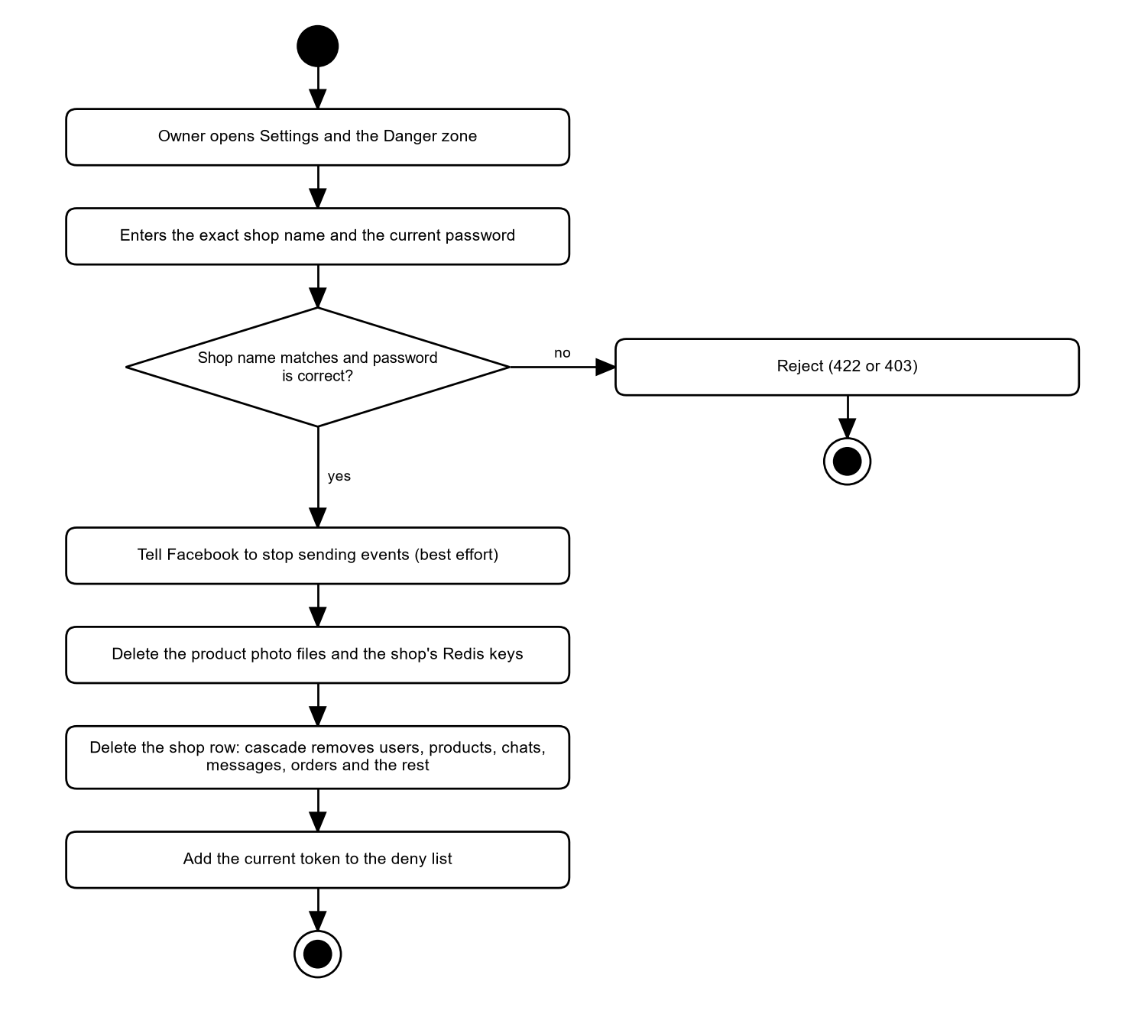
Figure 21: Activity diagram: shop deletion
The deletion needs the password and the exact shop name. Cascading foreign keys remove all shop data in one delete.

29.16 Weekly insights
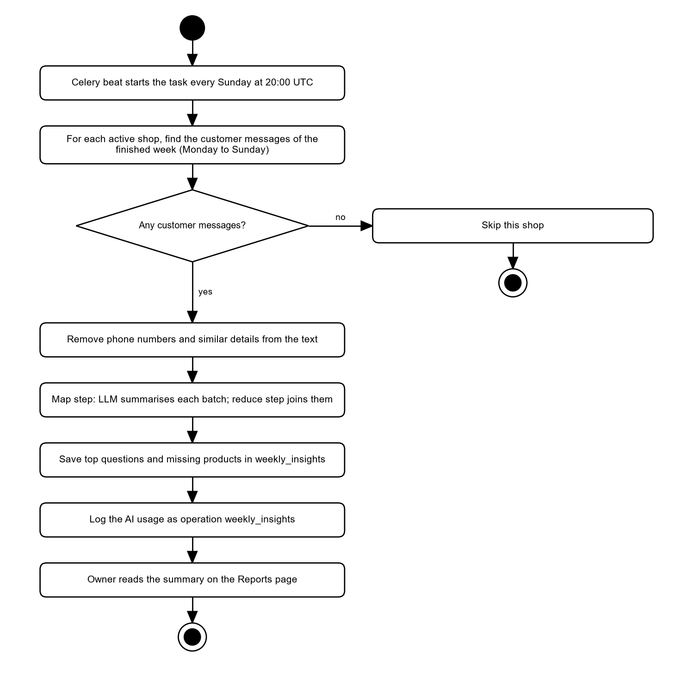
Figure 22: Activity diagram: weekly insights
Personal details are removed before the language model sees any text. The result is stored once per shop and week.

30. Sequence Diagrams
The sequence diagrams show the real interactions between parts of the system. Solid arrows are calls, dashed arrows are returns.

30.1 Customer message to ai reply
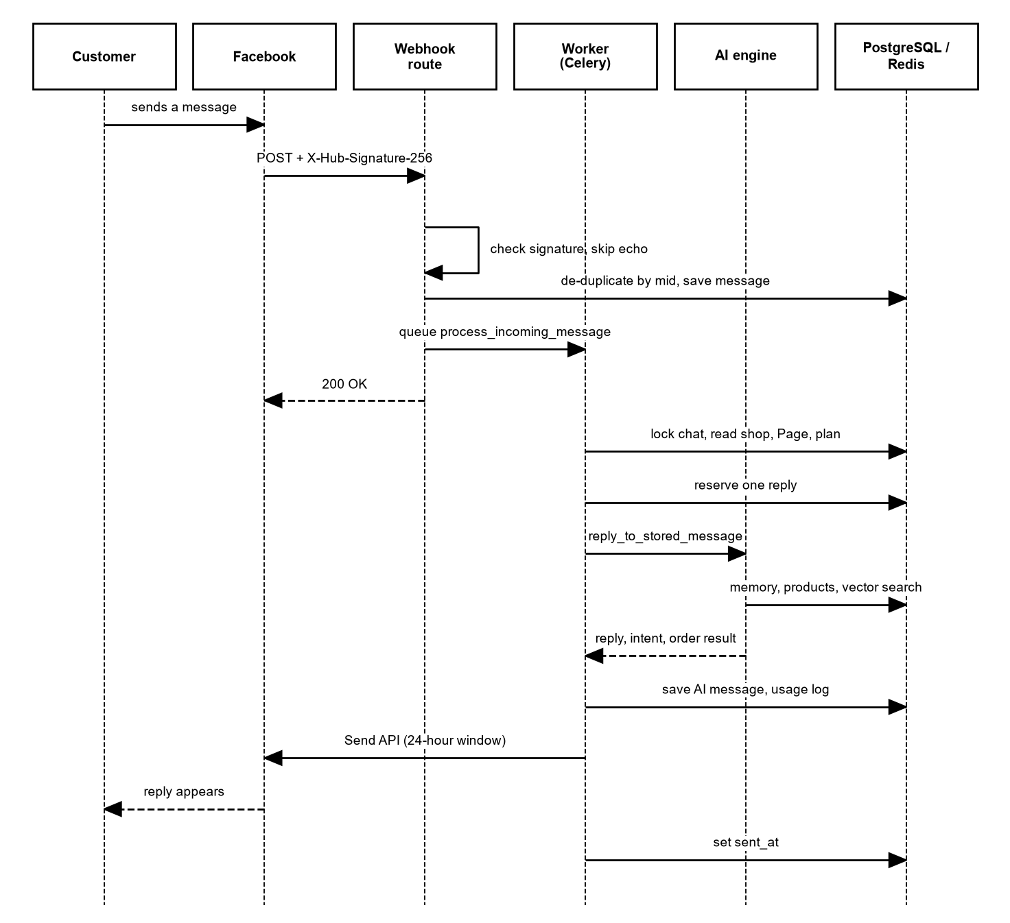
Figure 23: Sequence diagram: customer message to AI reply
The webhook route verifies the signature, stores the message and queues a task, then answers 200 to Facebook. The worker locks the chat, reserves a reply, runs the AI engine, saves the reply, sends it and sets sent_at.

30.2 Understanding, retrieval and reply
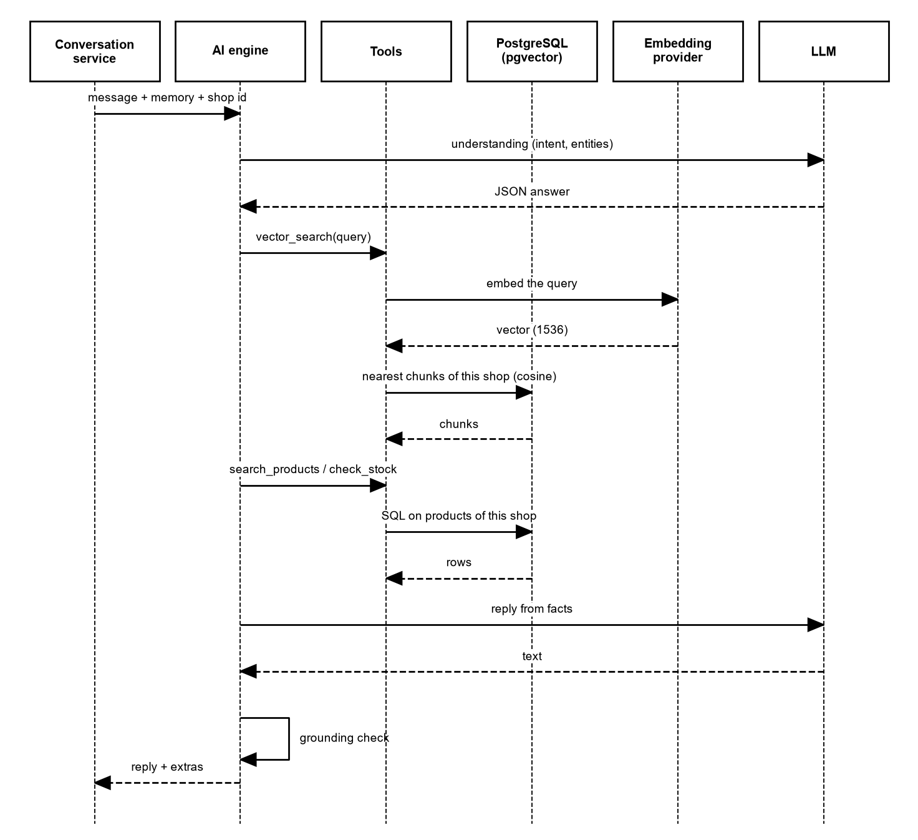
Figure 24: Sequence diagram: understanding, retrieval and reply
The engine asks the language model to understand the message, calls tools for vector search and product data, and writes the reply from the facts. A grounding check runs before the reply leaves the engine.

30.3 Order collection
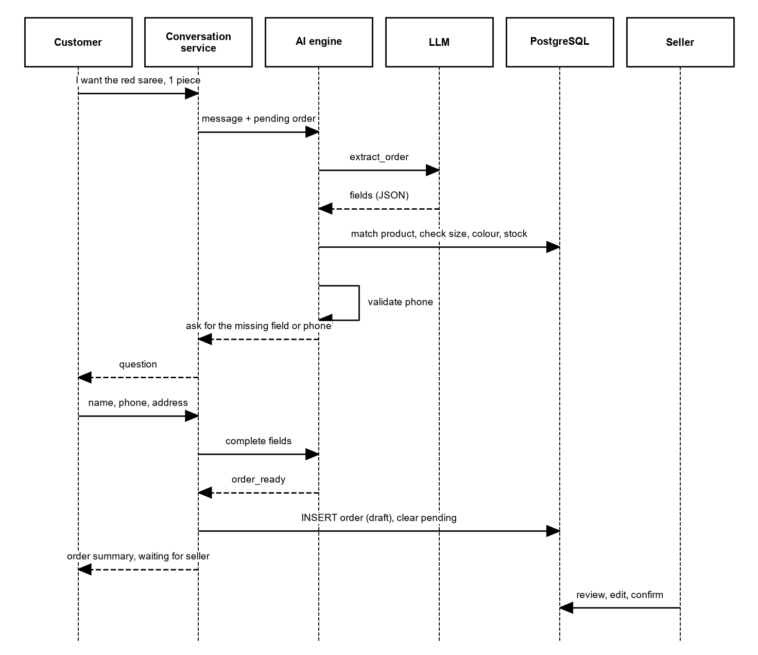
Figure 25: Sequence diagram: order collection
The engine extracts the fields; code checks them against the shop's products and the phone format. When all fields are valid, the conversation service writes the draft order.

30.4 Seller reply
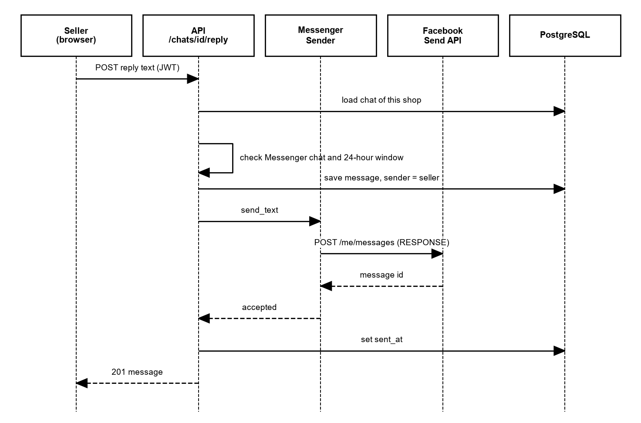
Figure 26: Sequence diagram: seller reply
The API checks the chat and the 24-hour window, saves the reply and sends it through the Messenger sender.

30.5 Facebook page connection
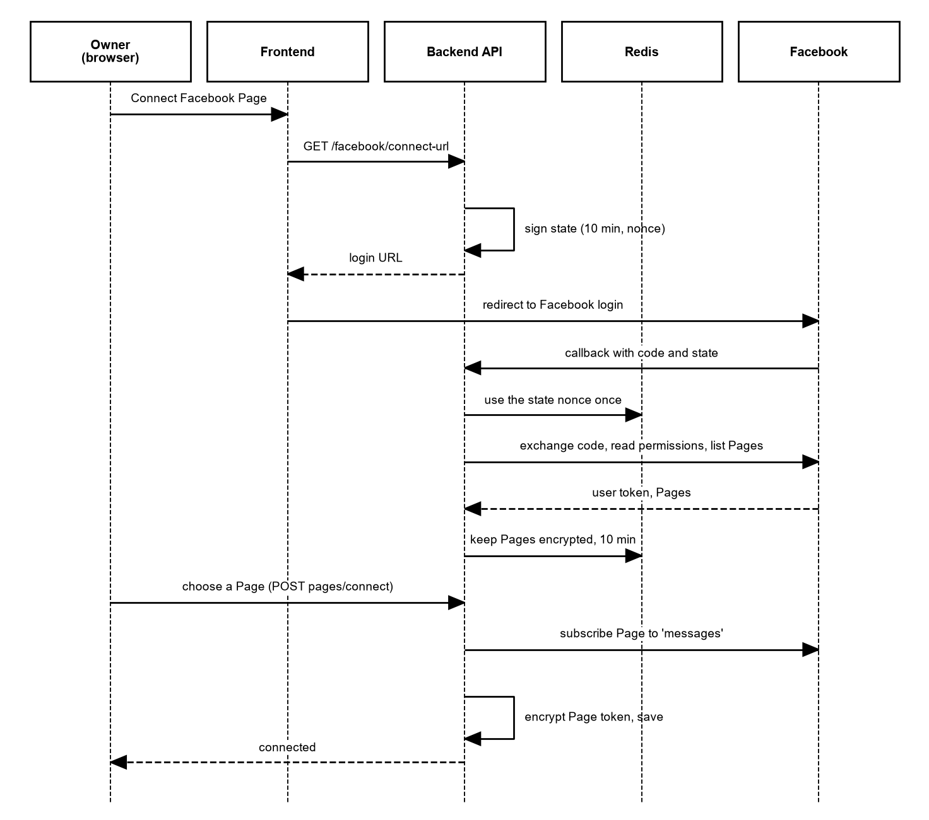
Figure 27: Sequence diagram: Facebook Page connection
The state is signed and used once. The Page list is kept in Redis while the owner chooses. The Page token is encrypted before it is saved.

30.6 Login, protected request and logout
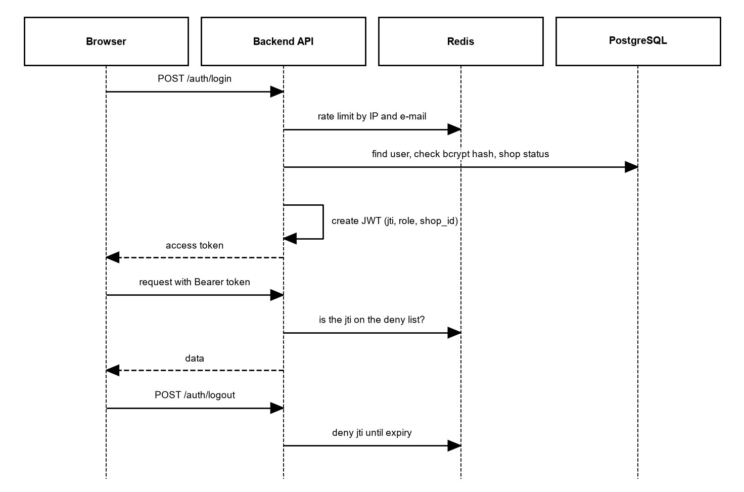
Figure 28: Sequence diagram: login, protected request and logout
Each protected request checks that the token id is not on the deny list. Logout adds the token id to the list until the token would expire.

30.7 Product embedding
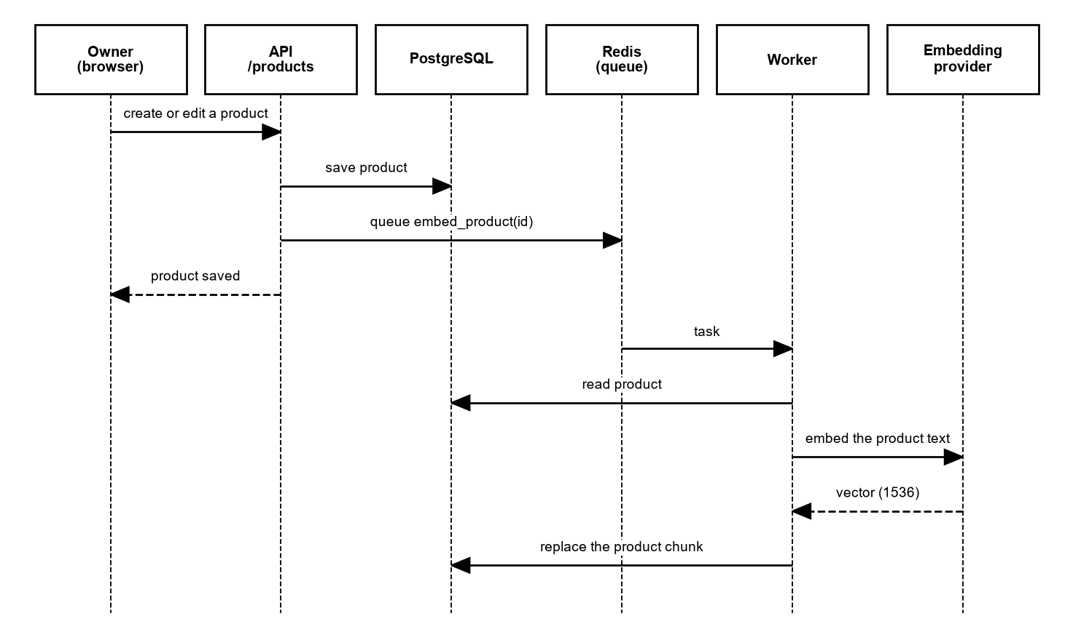
Figure 29: Sequence diagram: product embedding
Saving a product returns at once; the worker creates the embedding and replaces the product's chunks.

30.8 Test chat
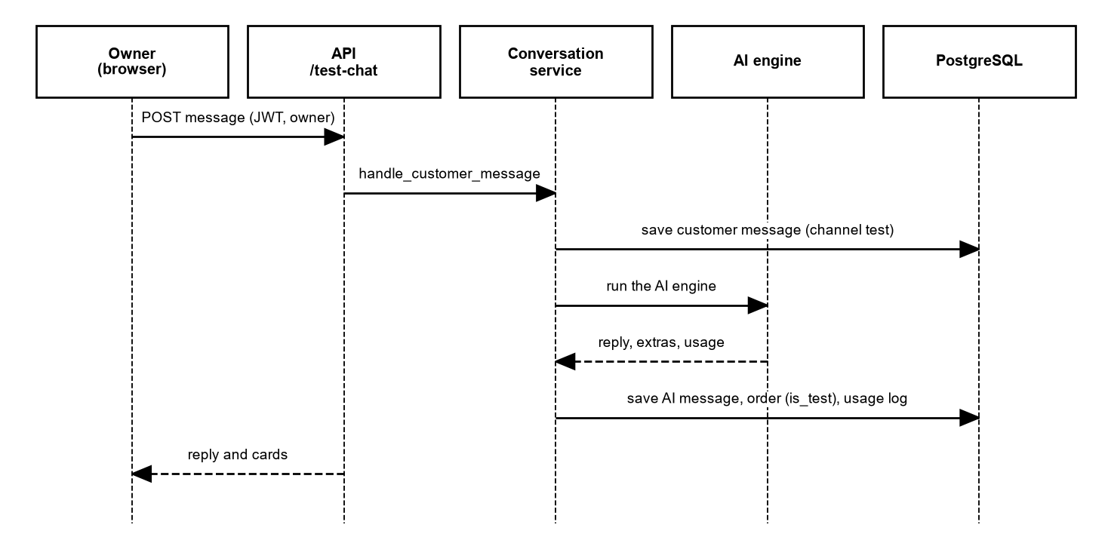
Figure 30: Sequence diagram: Test Chat
Test Chat uses the same conversation service as Messenger, but the chat channel is test and nothing goes to Facebook.

30.9 Weekly insights
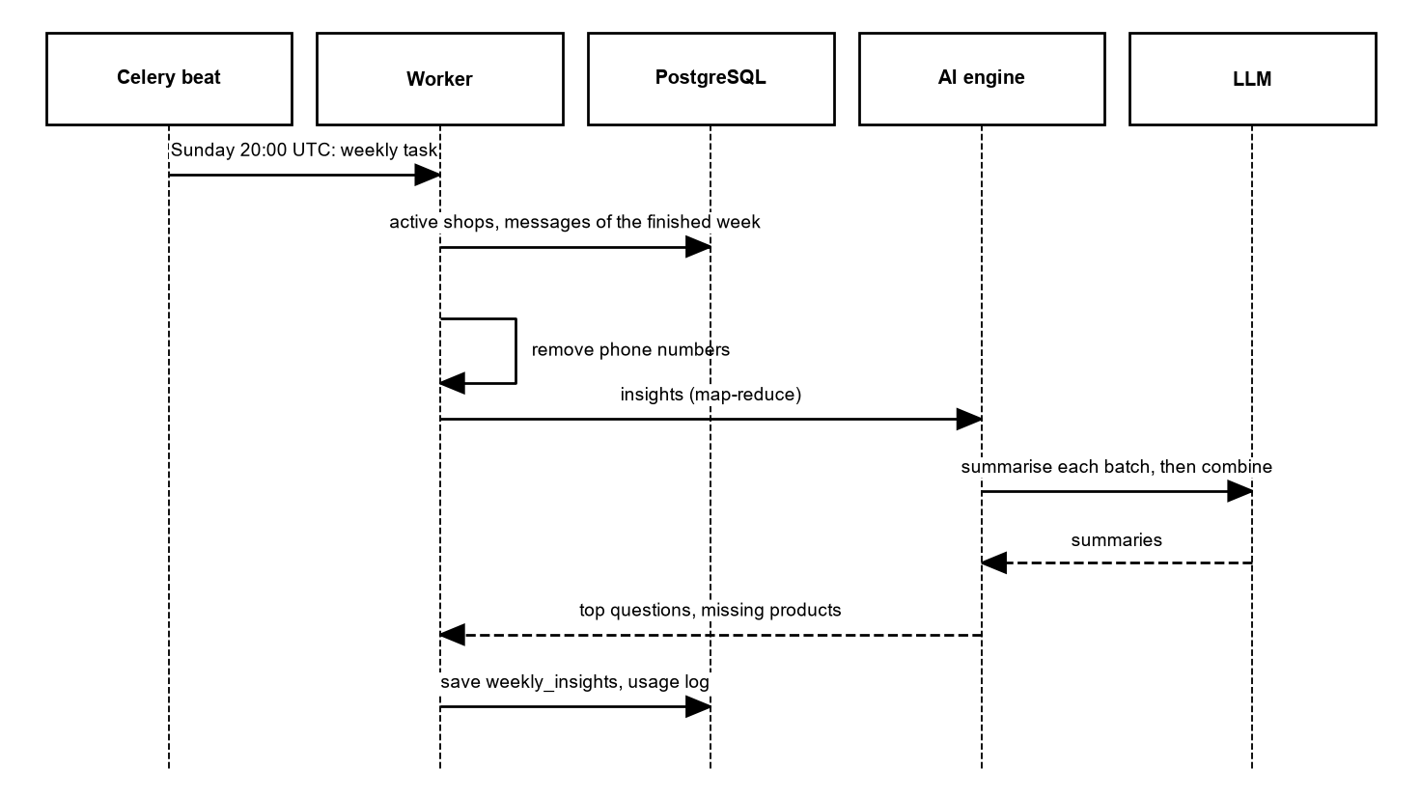
Figure 31: Sequence diagram: weekly insights
Celery beat starts the task. Phone numbers are removed before the text goes to the model, which summarises in batches and then combines the summaries.

31. State Diagrams
These state diagrams show states that exist in the code and database: order status, chat control flags, the processing status of a customer message (stored in messages.extras), shop status, Facebook connection and order collection.

31.1 Order status
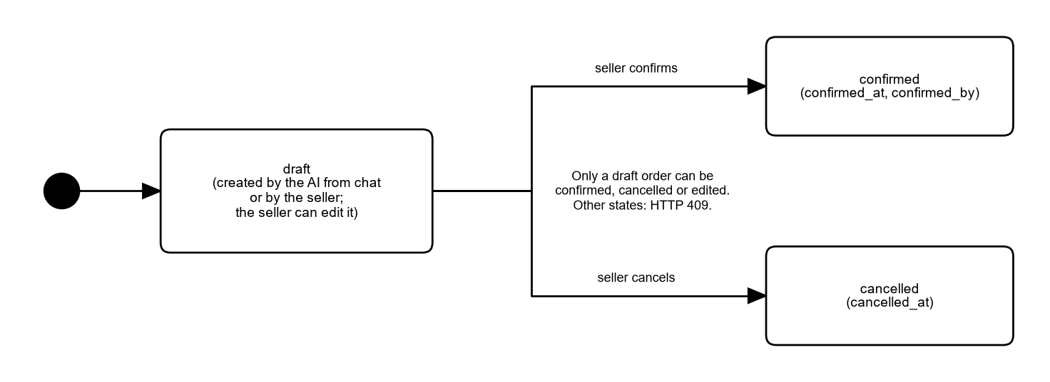
Figure 32: State diagram: order status
The orders.status column allows draft, confirmed and cancelled (CHECK constraint). Only a draft can change.

31.2 Chat control: AI pause and flag
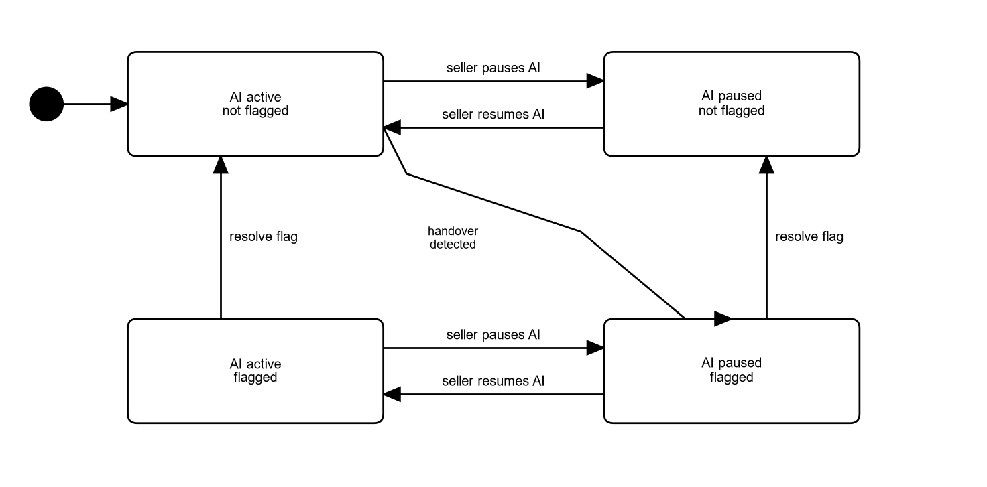
Figure 33: State diagram: chat control: ai pause and flag
A chat has two independent flags: ai_paused and is_flagged. A hand-over sets both. Resolve flag does not resume the AI, and resume does not clear the flag.

31.3 Customer message processing
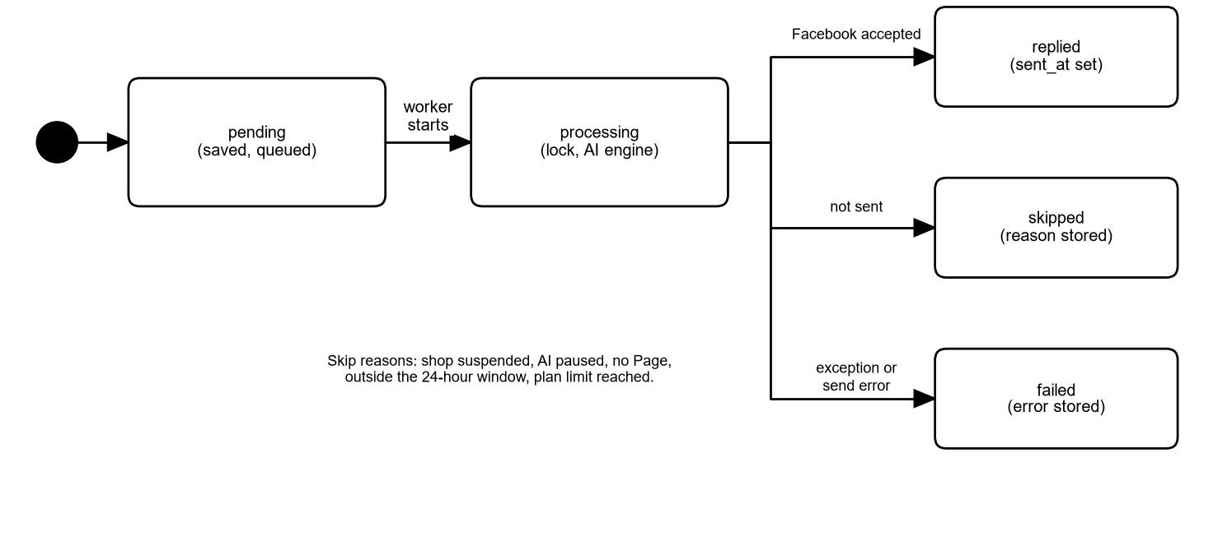
Figure 34: State diagram: customer message processing
The status ai_status is stored in the message extras: pending, replied, skipped or failed. A skipped or failed reply is not counted against the plan.

31.4 Shop status
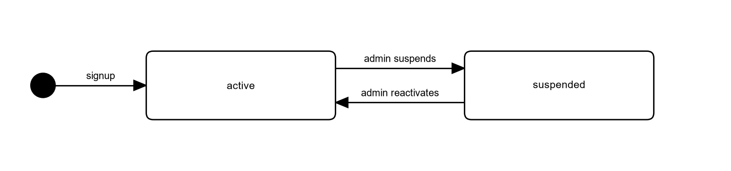
Figure 35: State diagram: shop status
The shops.status column allows active and suspended (CHECK constraint).

31.5 Facebook connection
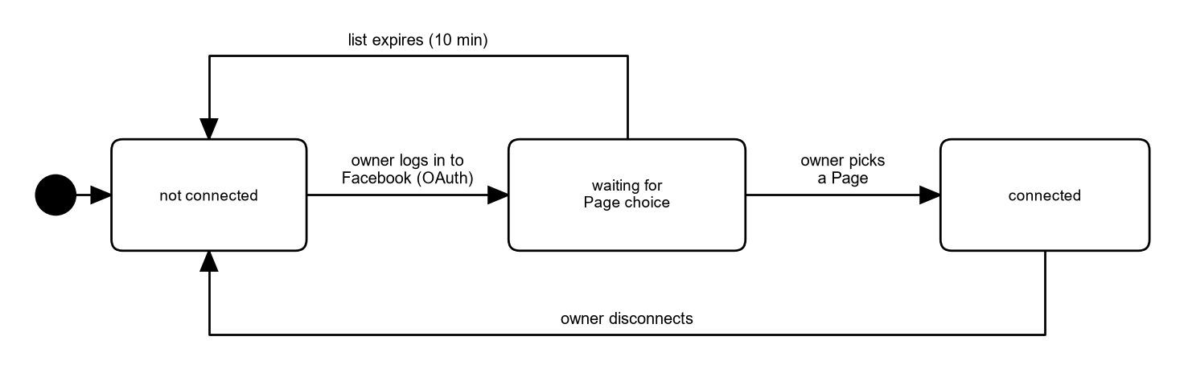
Figure 36: State diagram: facebook connection
The list of Pages is kept in Redis for 10 minutes. After a Page is chosen it is stored with an encrypted token.

31.6 Order collection in chat
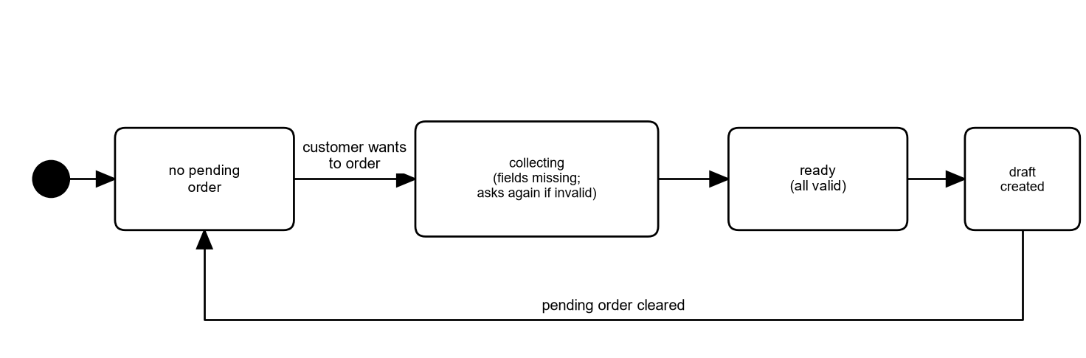
Figure 37: State diagram: order collection in chat
The partly collected order is kept in chats.pending_order and forgotten after the time to live (24 hours by default).

32. System Architecture
ShopSathi is built from a web frontend, a backend API, a background worker, a database, a cache and queue, and a separate AI engine package. The design keeps the AI engine free of any web or database code, so that it can be tested alone.
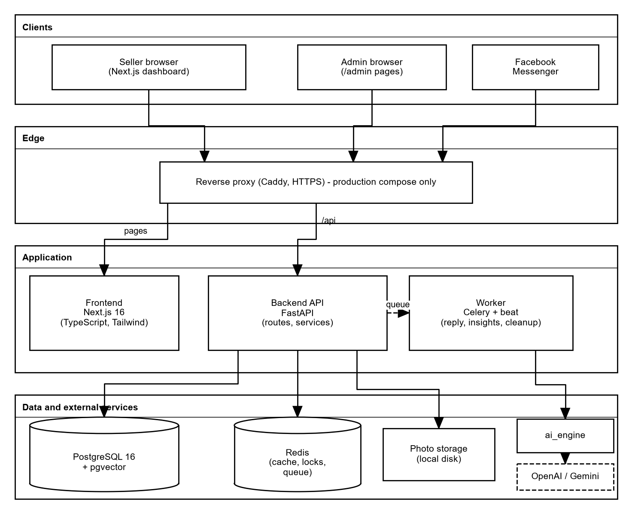
Figure 38: System architecture
The browser talks to the Next.js frontend and the FastAPI backend. In the production compose a Caddy reverse proxy sits in front and gives HTTPS. Facebook sends webhooks to the API. Long work (AI replies, embeddings, weekly insights) runs in the Celery worker, which takes jobs from Redis. PostgreSQL with pgvector stores all data. The worker calls the ai_engine package, which calls OpenAI or Gemini.
Table 29: Technology stack
Layer | Technology (as used in the repository) | Role
Frontend | Next.js 16, TypeScript, Tailwind CSS | Seller, moderator and admin pages; calls the API with a bearer token
Backend API | FastAPI, SQLAlchemy 2 (synchronous), Alembic, Pydantic | Routes, validation, services, permissions
Worker | Celery with Redis broker; Celery beat for the weekly job | Reply to Messenger messages, embeddings, weekly insights
Database | PostgreSQL 16 with the pgvector extension | All tables; vector(1536) with an HNSW cosine index
Cache and queue | Redis | Celery queue, rate limits, token deny list, chat memory, locks, temporary Page list
AI engine | Python package shopsathi_ai (LangChain for OpenAI and Gemini, mock providers, optional local embeddings) | Understanding, retrieval, suggestions, ordering, hand-over, reply checking
Proxy (production compose) | Caddy | HTTPS and routing of /api and the pages
Packaging | Docker images for backend and frontend; docker-compose.prod.yml; render.yaml | Run and deploy

32.1 Main design decisions
- The AI engine does not import the backend. The backend gives it a gateway object for shop data. This is why the evaluation harness can run the real engine against an in-memory shop.
- Slow work leaves the web request. The webhook only stores the message and queues a task, so Facebook gets a quick answer.
- Facts come from tables, not from the model. Prices and stock are read live. The language model only writes text around the facts.
- Every query is scoped by shop. Services receive the shop id from the token, and helper functions add the shop filter.
- Providers are replaceable. A setting selects the OpenAI, Gemini or mock model, and OpenAI, local or mock embeddings.

33. Component Diagram
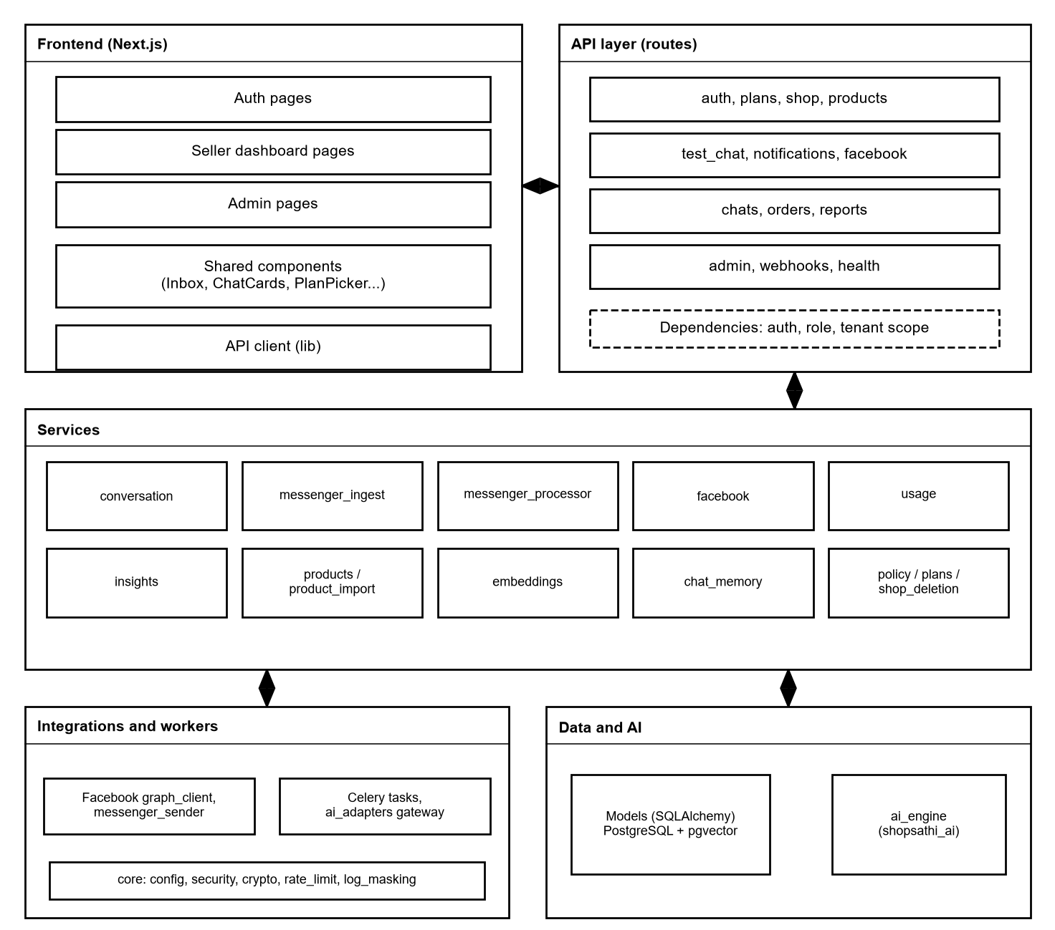
Figure 39: Component diagram
The frontend calls the API routes. Routes use dependencies for login, role and shop scope, then call services. Services use the models, the integrations (Facebook client and sender) and the ai_engine package. The core package holds settings, security, encryption, rate limits and log masking.
Table 30: Components and their files
Component | Main files | Responsibility
Routes | backend/app/api/v1/routes: auth, shop, plans, products, policy, test_chat, notifications, facebook, chats, orders, reports, admin, webhooks, health | HTTP interface, input and output schemas
Services | conversation, messenger_ingest, messenger_processor, facebook, usage, plans, insights, products, product_import, embeddings, chat_memory, policy, storage, shop_deletion, email, tenant | Business logic
Models | backend/app/models (13 files, 19 tables) | SQLAlchemy tables
Integrations | integrations/facebook: graph_client, messenger_sender, webhook | Graph API calls, Send API with retries, signature check
Workers | workers: celery_app, tasks, dispatch | Tasks: embed_product, delete_product_embeddings, embed_policy, process_incoming_message, generate_weekly_insights, ping
AI adapters | ai_adapters: gateway, factory | Gives the engine shop-scoped data and builds the providers from settings
AI engine | ai_engine/shopsathi_ai (engine, understanding, language, handover, ordering, extraction, suggestions, budget, retrieval, tools, reply, validators, insights, chunking, prompts, providers) | The conversation pipeline
Frontend | frontend/src: 30 page and layout files, 11 shared components, 14 library files | User interface

34. Deployment Diagram
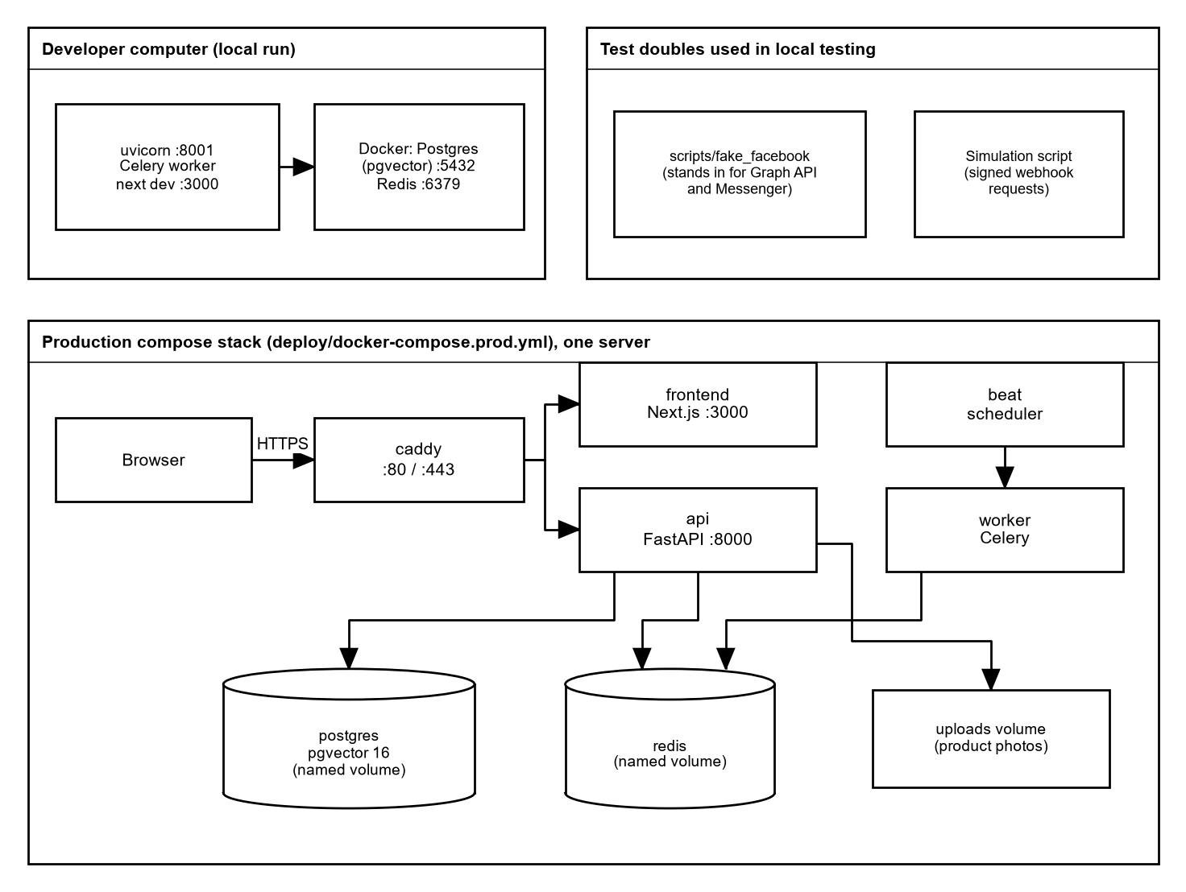
Figure 40: Deployment diagram
Two setups were used. For development, the API, worker and frontend run directly on a computer, with PostgreSQL and Redis in Docker, and test doubles stand in for Facebook. The production compose stack (caddy, frontend, api, worker, beat, postgres, redis) was built and run on a developer computer only. A public server deployment was not done.
Section 61 explains the deployment files, and section 62 the Docker images.

35. AI Architecture
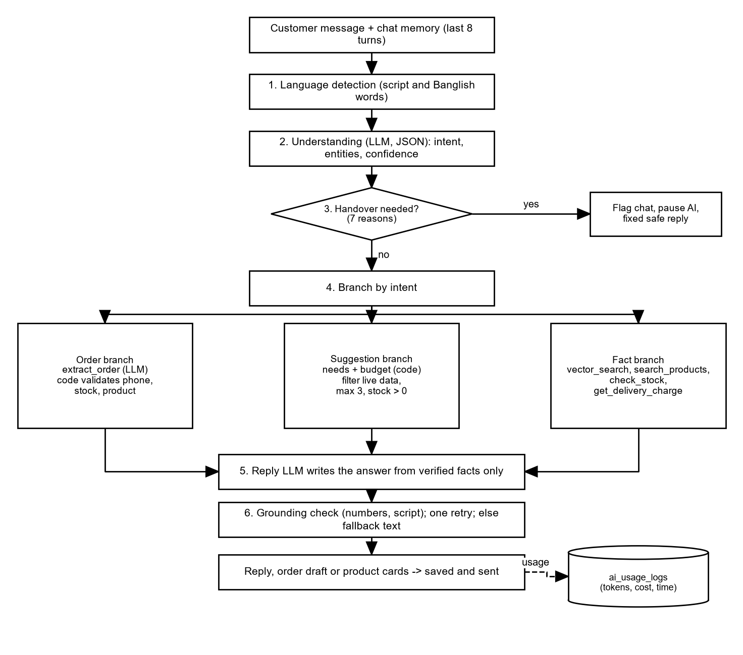
Figure 41: AI architecture: the pipeline of the engine
The engine detects the language, asks the model to understand the message, and checks the hand-over rules first. Orders, suggestions and fact questions each have their own branch. The reply is written from verified facts and then checked in code. Every model call writes a usage record.
Section 46 explains each step in detail.

36. Messenger Architecture
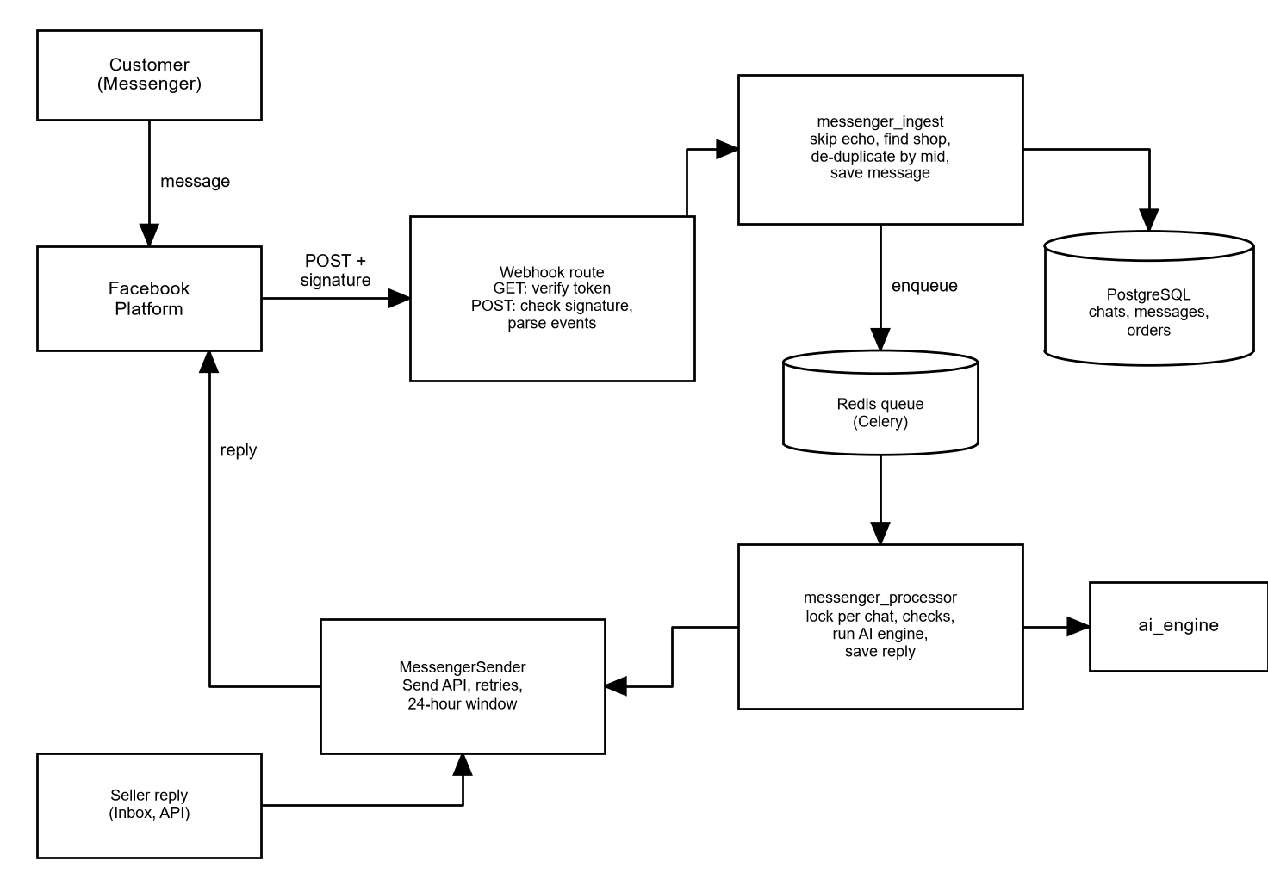
Figure 42: Messenger architecture
A customer message reaches the webhook route, which verifies the signature and calls messenger_ingest. The message is saved and a Celery task is queued. messenger_processor runs the AI engine and gives the reply to MessengerSender, which calls the Send API inside the 24-hour window. Seller replies from the Inbox use the same sender.
Section 50 describes the Facebook security checks.

37. ER Diagram
The database has 19 tables. The overview shows which table belongs to which. The detailed diagrams show the columns. In the detailed diagrams, "1" marks the parent end and "N" the child end of a relation. The column types come from the SQLAlchemy models (the same ones that the migrations create).
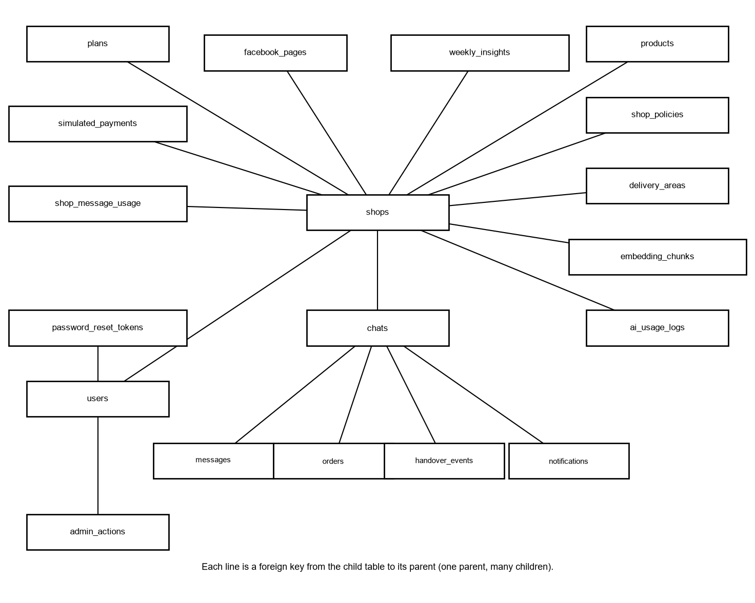
Figure 43: ER overview of all 19 tables
Almost every table has a foreign key to shops. Messages, orders, hand-over events and notifications also point to chats. Password reset tokens and admin actions point to users.
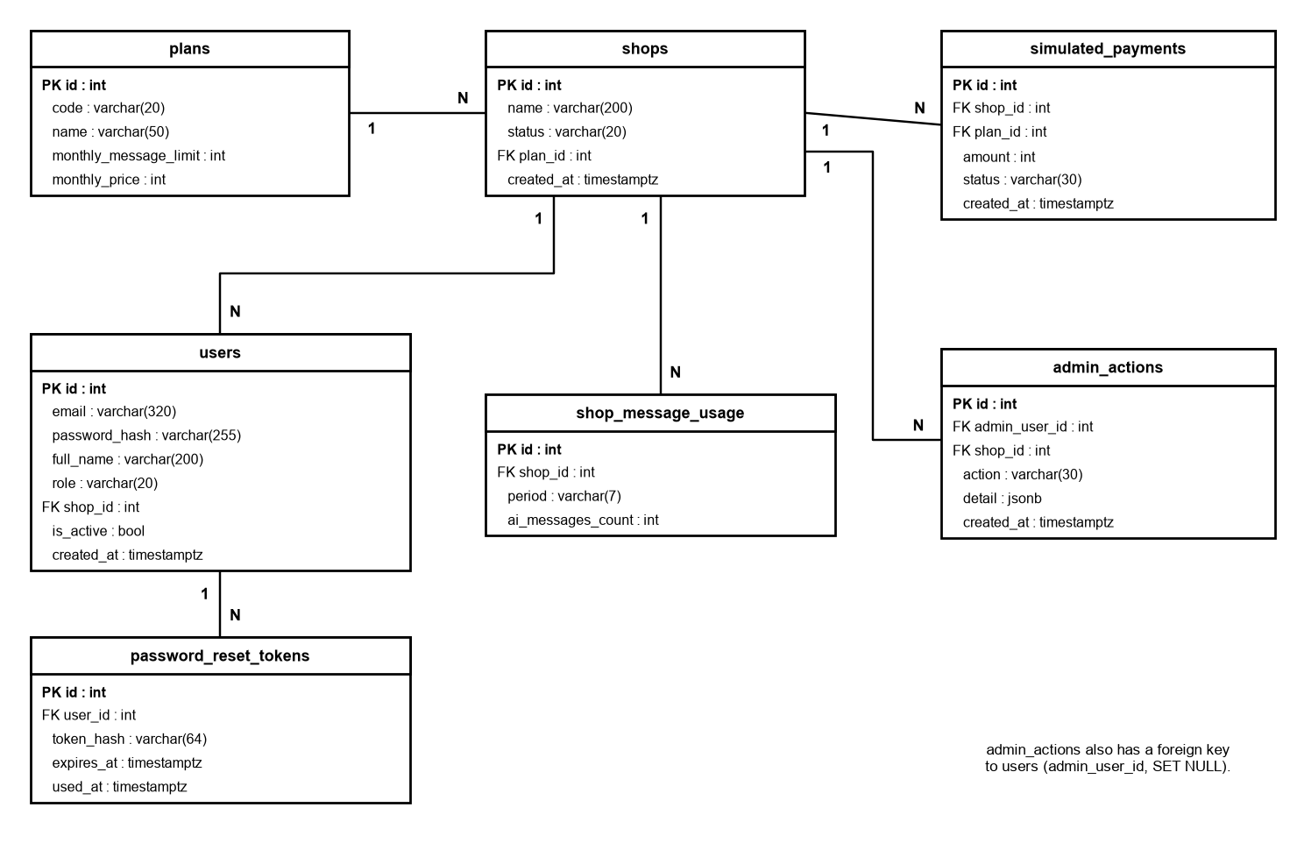
Figure 44: ER diagram: plans, shops, users and usage
Plans, shops and users form the base. A shop has one plan; users belong to a shop (platform admins have no shop).
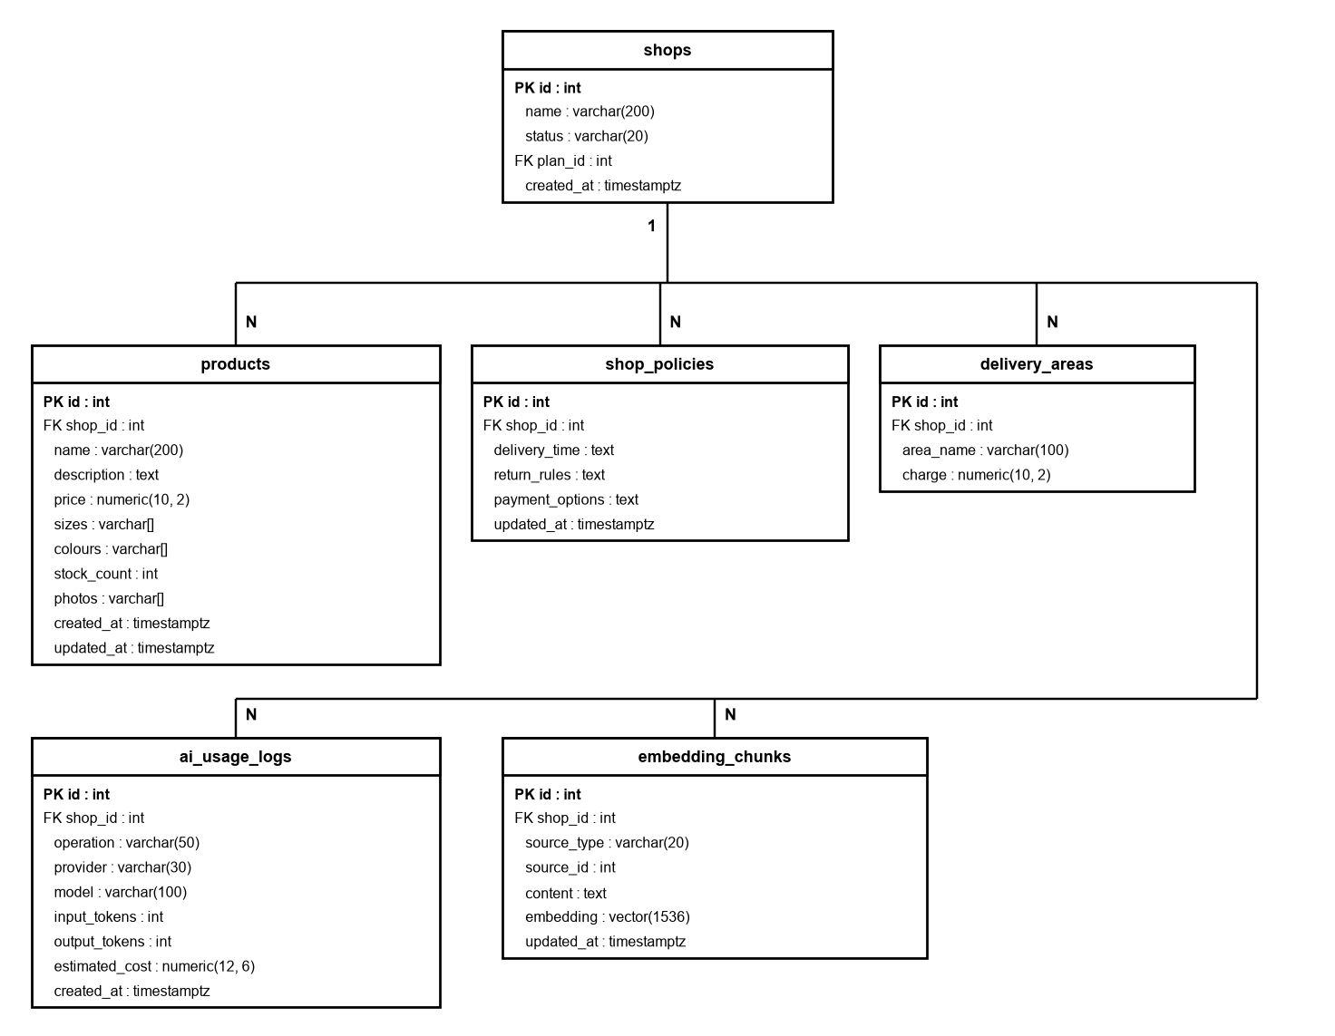
Figure 45: ER diagram: catalogue, policy, embeddings and AI usage
Products, policy, delivery areas, embedding chunks and AI usage logs all belong to one shop.
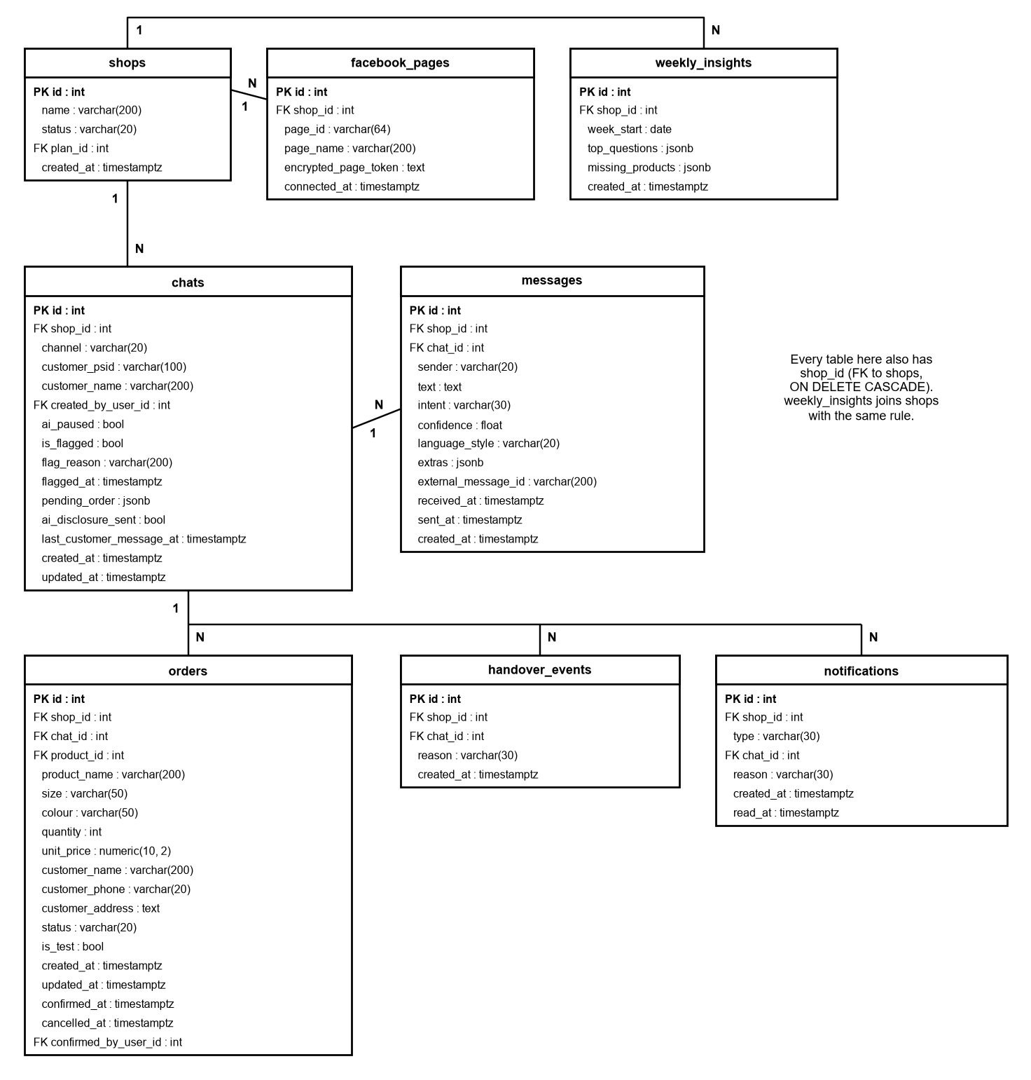
Figure 46: ER diagram: chats, messages, orders and Facebook
A chat has many messages. Orders, hand-over events and notifications refer to a chat. The Facebook Page and the weekly insights belong to the shop.

38. Database Schema
The tables below are produced from the SQLAlchemy models of the project, which Alembic migrations 0001 to 0013 create. "Key" shows PK for primary key, FK for foreign key and the delete rule, and U for unique. Time columns are timestamptz. The shop_id column on shop-owned tables is the tenant key (section 48).

38.1 Table plans
The three plans (free, basic, pro) with the monthly AI reply limit and the price.
Table 31: Columns of plans
Column | Type | Null | Key | Default
id | integer | no | PK
code | varchar(20) | no | U
name | varchar(50) | no
monthly_message_limit | integer | no
monthly_price | integer | no

Constraints: UNIQUE (code); ck_plans_code: CHECK (code IN ('free', 'basic', 'pro')).

38.2 Table shops
One row per shop: name, status (active or suspended) and the plan.
Table 32: Columns of shops
Column | Type | Null | Key | Default
id | integer | no | PK
name | varchar(200) | no
status | varchar(20) | no |  | active
plan_id | integer | no | FK plans.id
created_at | timestamptz | no |  | now()

Constraints: ck_shops_status: CHECK (status IN ('active', 'suspended')).

38.3 Table ai_usage_logs
One row per AI call with operation, provider, model, tokens, estimated cost and time.
Table 33: Columns of ai_usage_logs
Column | Type | Null | Key | Default
id | integer | no | PK
shop_id | integer | no | FK shops.id cascade
operation | varchar(50) | no
provider | varchar(30) | no
model | varchar(100) | no
input_tokens | integer | no
output_tokens | integer | no
estimated_cost | NUMERIC(12, 6) | no
created_at | timestamptz | no |  | now()

38.4 Table delivery_areas
Delivery charge per area for a shop. Area names are unique per shop, ignoring case.
Table 34: Columns of delivery_areas
Column | Type | Null | Key | Default
id | integer | no | PK
shop_id | integer | no | FK shops.id cascade
area_name | varchar(100) | no
charge | NUMERIC(10, 2) | no

Constraints: ck_delivery_areas_charge_non_negative: CHECK (charge >= 0).

38.5 Table embedding_chunks
Text chunks of products and policies with their 1536-number embedding (pgvector).
Table 35: Columns of embedding_chunks
Column | Type | Null | Key | Default
id | integer | no | PK
shop_id | integer | no | FK shops.id cascade
source_type | varchar(20) | no
source_id | integer | no
content | TEXT | no
embedding | VECTOR(1536) | no
updated_at | timestamptz | no |  | now()

Constraints: ck_embedding_chunks_source_type: CHECK (source_type IN ('product', 'policy')).

38.6 Table facebook_pages
The connected Page of a shop. The Page access token is stored encrypted.
Table 36: Columns of facebook_pages
Column | Type | Null | Key | Default
id | integer | no | PK
shop_id | integer | no | FK shops.id cascade, U
page_id | varchar(64) | no | U
page_name | varchar(200) | no
encrypted_page_token | TEXT | no
connected_at | timestamptz | no |  | now()

Constraints: UNIQUE (page_id); UNIQUE (shop_id).

38.7 Table products
The shop catalogue: price, stock, sizes, colours and up to 5 photo paths.
Table 37: Columns of products
Column | Type | Null | Key | Default
id | integer | no | PK
shop_id | integer | no | FK shops.id cascade
name | varchar(200) | no
description | TEXT | no
price | NUMERIC(10, 2) | no
sizes | varchar[] | no |  | {}
colours | varchar[] | no |  | {}
stock_count | integer | no |  | 0
photos | varchar[] | no |  | {}
created_at | timestamptz | no |  | now()
updated_at | timestamptz | no |  | now()

Constraints: ck_products_price_positive: CHECK (price > 0); ck_products_stock_non_negative: CHECK (stock_count >= 0); ck_products_max_photos: CHECK (cardinality(photos) <= 5).

38.8 Table shop_message_usage
Counter of AI replies per shop and month (period like 2026-10).
Table 38: Columns of shop_message_usage
Column | Type | Null | Key | Default
id | integer | no | PK
shop_id | integer | no | FK shops.id cascade
period | varchar(7) | no
ai_messages_count | integer | no |  | 0

Constraints: UNIQUE (shop_id, period).

38.9 Table shop_policies
One row per shop with delivery time, return rules and payment options.
Table 39: Columns of shop_policies
Column | Type | Null | Key | Default
id | integer | no | PK
shop_id | integer | no | FK shops.id cascade, U
delivery_time | TEXT | no
return_rules | TEXT | no
payment_options | TEXT | no
updated_at | timestamptz | no |  | now()

Constraints: UNIQUE (shop_id).

38.10 Table simulated_payments
Records of the simulated payment made when a paid plan is chosen. No real money is involved.
Table 40: Columns of simulated_payments
Column | Type | Null | Key | Default
id | integer | no | PK
shop_id | integer | no | FK shops.id cascade
plan_id | integer | no | FK plans.id
amount | integer | no
status | varchar(30) | no
created_at | timestamptz | no |  | now()

Constraints: ck_simulated_payments_status: CHECK (status IN ('simulated_success')).

38.11 Table users
Owners, moderators and platform admins. A platform admin has no shop.
Table 41: Columns of users
Column | Type | Null | Key | Default
id | integer | no | PK
email | varchar(320) | no | U
password_hash | varchar(255) | no
full_name | varchar(200) | no
role | varchar(20) | no
shop_id | integer | yes | FK shops.id cascade
is_active | boolean | no |  | true
created_at | timestamptz | no |  | now()

Constraints: ck_users_shop_id_by_role: CHECK ((role = 'platform_admin') = (shop_id IS NULL)); ck_users_role: CHECK (role IN ('owner', 'moderator', 'platform_admin')).

38.12 Table weekly_insights
The weekly AI summary per shop: top questions and missing products.
Table 42: Columns of weekly_insights
Column | Type | Null | Key | Default
id | integer | no | PK
shop_id | integer | no | FK shops.id cascade
week_start | DATE | no
top_questions | JSONB | no |  | []
missing_products | JSONB | no |  | []
created_at | timestamptz | no |  | now()

Constraints: UNIQUE (shop_id, week_start).

38.13 Table admin_actions
A log of what the platform admin did to shops (suspend, reactivate, plan change).
Table 43: Columns of admin_actions
Column | Type | Null | Key | Default
id | integer | no | PK
admin_user_id | integer | yes | FK users.id set null
shop_id | integer | yes | FK shops.id set null
action | varchar(30) | no
detail | JSONB | no |  | {}
created_at | timestamptz | no |  | now()

38.14 Table chats
A conversation with one customer (Messenger) or a Test Chat. Holds the pause and flag state and the partly collected order.
Table 44: Columns of chats
Column | Type | Null | Key | Default
id | integer | no | PK
shop_id | integer | no | FK shops.id cascade
channel | varchar(20) | no
customer_psid | varchar(100) | yes
customer_name | varchar(200) | yes
created_by_user_id | integer | yes | FK users.id set null
ai_paused | boolean | no |  | false
is_flagged | boolean | no |  | false
flag_reason | varchar(200) | yes
flagged_at | timestamptz | yes
pending_order | JSONB | yes
ai_disclosure_sent | boolean | no |  | false
last_customer_message_at | timestamptz | yes
created_at | timestamptz | no |  | now()
updated_at | timestamptz | no |  | now()

Constraints: ck_chats_channel: CHECK (channel IN ('messenger', 'test')).

38.15 Table password_reset_tokens
Hashed one-time reset tokens with an expiry and a used time.
Table 45: Columns of password_reset_tokens
Column | Type | Null | Key | Default
id | integer | no | PK
user_id | integer | no | FK users.id cascade
token_hash | varchar(64) | no | U
expires_at | timestamptz | no
used_at | timestamptz | yes

Constraints: UNIQUE (token_hash).

38.16 Table handover_events
One row each time the AI hands a chat to the seller, with the reason.
Table 46: Columns of handover_events
Column | Type | Null | Key | Default
id | integer | no | PK
shop_id | integer | no | FK shops.id cascade
chat_id | integer | no | FK chats.id cascade
reason | varchar(30) | no
created_at | timestamptz | no |  | now()

Constraints: ck_handover_events_reason: CHECK (reason IN ('complaint', 'refund', 'abusive_language', 'low_confidence', 'off_topic', 'not_in_shop_data', 'human_requested')).

38.17 Table messages
Every message of a chat, from the customer, the AI or the seller, with intent, confidence and delivery details.
Table 47: Columns of messages
Column | Type | Null | Key | Default
id | integer | no | PK
shop_id | integer | no | FK shops.id cascade
chat_id | integer | no | FK chats.id cascade
sender | varchar(20) | no
text | TEXT | no
intent | varchar(30) | yes
confidence | FLOAT | yes
language_style | varchar(20) | yes
extras | JSONB | no |  | {}
external_message_id | varchar(200) | yes
received_at | timestamptz | yes
sent_at | timestamptz | yes
created_at | timestamptz | no |  | now()

Constraints: ck_messages_sender: CHECK (sender IN ('customer', 'ai', 'seller')); UNIQUE (shop_id, external_message_id).

38.18 Table notifications
Notifications for the seller; the only type is chat_flagged.
Table 48: Columns of notifications
Column | Type | Null | Key | Default
id | integer | no | PK
shop_id | integer | no | FK shops.id cascade
type | varchar(30) | no
chat_id | integer | no | FK chats.id cascade
reason | varchar(30) | no
created_at | timestamptz | no |  | now()
read_at | timestamptz | yes

Constraints: ck_notifications_type: CHECK (type IN ('chat_flagged')).

38.19 Table orders
Orders with status draft, confirmed or cancelled. The product name and price are copied so old orders stay readable.
Table 49: Columns of orders
Column | Type | Null | Key | Default
id | integer | no | PK
shop_id | integer | no | FK shops.id cascade
chat_id | integer | yes | FK chats.id set null
product_id | integer | yes | FK products.id set null
product_name | varchar(200) | no
size | varchar(50) | yes
colour | varchar(50) | yes
quantity | integer | no
unit_price | NUMERIC(10, 2) | no
customer_name | varchar(200) | no
customer_phone | varchar(20) | no
customer_address | TEXT | no
status | varchar(20) | no |  | draft
is_test | boolean | no |  | false
created_at | timestamptz | no |  | now()
updated_at | timestamptz | no |  | now()
confirmed_at | timestamptz | yes
cancelled_at | timestamptz | yes
confirmed_by_user_id | integer | yes | FK users.id set null

Constraints: ck_orders_status: CHECK (status IN ('draft', 'confirmed', 'cancelled')); ck_orders_quantity_positive: CHECK (quantity > 0).

39. Database Relationships
All relations are many-to-one from the child to the parent. The delete rule tells what happens to the child when the parent row is deleted.
Table 50: Foreign keys
Child table | Column | Parent | On parent delete
shops | plan_id | plans.id | restrict (no action)
ai_usage_logs | shop_id | shops.id | cascade
delivery_areas | shop_id | shops.id | cascade
embedding_chunks | shop_id | shops.id | cascade
facebook_pages | shop_id | shops.id | cascade
products | shop_id | shops.id | cascade
shop_message_usage | shop_id | shops.id | cascade
shop_policies | shop_id | shops.id | cascade
simulated_payments | shop_id | shops.id | cascade
simulated_payments | plan_id | plans.id | restrict (no action)
users | shop_id | shops.id | cascade
weekly_insights | shop_id | shops.id | cascade
admin_actions | admin_user_id | users.id | set null
admin_actions | shop_id | shops.id | set null
chats | shop_id | shops.id | cascade
chats | created_by_user_id | users.id | set null
password_reset_tokens | user_id | users.id | cascade
handover_events | shop_id | shops.id | cascade
handover_events | chat_id | chats.id | cascade
messages | shop_id | shops.id | cascade
messages | chat_id | chats.id | cascade
notifications | shop_id | shops.id | cascade
notifications | chat_id | chats.id | cascade
orders | shop_id | shops.id | cascade
orders | chat_id | chats.id | set null
orders | product_id | products.id | set null
orders | confirmed_by_user_id | users.id | set null

39.1 What the delete rules mean
- cascade on shop_id: deleting a shop deletes all its rows. This is how shop deletion (FR-36) removes the data of a shop in one statement.
- set null on orders.chat_id, orders.product_id and orders.confirmed_by_user_id: an order stays readable even if the chat, product or user is removed.
- set null on admin_actions: the admin log keeps its rows without personal shop data.
- restrict on plan_id: a plan that is used cannot be deleted.

39.2 Tenant isolation in the database
Every table that holds shop data has a non-null shop_id. Additional composite indexes start with shop_id. A message has shop_id and chat_id, and the unique rule (shop_id, external_message_id) makes the Facebook message id unique per shop, so a duplicate webhook cannot create a second message.

40. Indexing & Migration

40.1 Indexes and unique rules
Table 51: Indexes
Table | Index | Columns | Unique
shops | ix_shops_plan_id | plan_id | no
ai_usage_logs | ix_ai_usage_logs_shop_created | shop_id, created_at | no
delivery_areas | ix_delivery_areas_shop_id | shop_id | no
delivery_areas | uq_delivery_areas_shop_area | shop_id, lower | yes
embedding_chunks | ix_embedding_chunks_shop_source | shop_id, source_type, source_id | no
embedding_chunks | ix_embedding_chunks_embedding_hnsw | embedding | no
products | ix_products_shop_id | shop_id | no
shop_message_usage | ix_shop_message_usage_shop_id | shop_id | no
simulated_payments | ix_simulated_payments_shop_id | shop_id | no
users | ix_users_email | email | yes
users | ix_users_shop_id | shop_id | no
weekly_insights | ix_weekly_insights_shop_id | shop_id | no
admin_actions | ix_admin_actions_created | created_at | no
admin_actions | ix_admin_actions_shop_id | shop_id | no
chats | ix_chats_shop_channel_updated | shop_id, channel, updated_at | no
chats | uq_chats_shop_messenger_psid | shop_id, customer_psid | yes
password_reset_tokens | ix_password_reset_tokens_user_id | user_id | no
handover_events | ix_handover_events_chat_id | chat_id | no
handover_events | ix_handover_events_shop_created | shop_id, created_at | no
messages | ix_messages_shop_chat | shop_id, chat_id | no
messages | ix_messages_chat_id | chat_id | no
notifications | ix_notifications_shop_read_created | shop_id, read_at, created_at | no
orders | ix_orders_chat_id | chat_id | no
orders | ix_orders_shop_status_created | shop_id, status, created_at | no

The index ix_embedding_chunks_embedding_hnsw is an HNSW index with cosine distance on the vector(1536) column. A test checks that it is created. The unique partial index uq_chats_shop_messenger_psid allows one Messenger chat per shop and customer; Test Chat chats are not limited by it.

40.2 Vector storage
Embeddings are stored in embedding_chunks.embedding as vector(1536). The dimension equals the OpenAI model text-embedding-3-small. A text is cut into chunks of at most 600 characters. Each chunk keeps the shop id, the source type (product or policy) and the source id. Retrieval filters by shop first and then orders by cosine distance. A re-embed command can rebuild missing chunks and remove orphans, and it reports a dimension mismatch.

40.3 Migrations
Table 52: Alembic migrations
Revision | File | What it creates
0001 | 0001_initial.py | initial empty migration
0002 | 0002_shops_users_password_reset_tokens.py | shops users password reset tokens
0003 | 0003_plans_and_usage.py | plans, simulated payments, message usage, shops.plan_id
0004 | 0004_products.py | products
0005 | 0005_shop_policy.py | shop policies and delivery areas
0006 | 0006_embeddings_and_ai_usage.py | embedding_chunks (pgvector) and ai_usage_logs
0007 | 0007_chats_and_messages.py | chats and messages
0008 | 0008_orders_and_pending_order.py | orders and chats.pending_order
0009 | 0009_handover_events_and_notifications.py | handover_events and notifications
0010 | 0010_facebook_pages.py | facebook_pages
0011 | 0011_unique_messenger_chat.py | one Messenger chat per shop and customer
0012 | 0012_weekly_insights.py | weekly AI chat insights
0013 | 0013_admin_actions.py | platform admin action log

Migrations run with alembic upgrade head. The Docker entrypoint of the backend runs the migrations before the API starts. Migration 0001 is an empty first revision.

41. UI/UX Design
The interface is plain on purpose. The users are shop owners who may not be technical, and many use a phone.
- One top bar with the same menu on every seller page. On a phone it becomes a Menu button.
- Plain words. Labels such as Orders, Inbox, Products, Shop policy and Test chat.
- Clear states. Orders are shown by tabs: Draft, Confirmed, Cancelled. Flagged chats show a label and a count.
- Safe actions. Confirm and cancel are separate; deleting the shop needs the password and the exact shop name.
- Honest notes. Test Chat shows that nothing is sent to Facebook. Reports say that the AI summary is written by AI and that counts are approximate.
- Responsive layout. Tables become cards on a phone; 70 of 70 page-width checks found no sideways overflow (section 57).
The real interface uses colour for buttons and labels. The screenshots in this report are converted to grayscale to keep the report black and white.

41.1 Page map
Table 53: Page map of the frontend
Area | Pages (route)
Public | / (start), /login, /signup, /forgot-password, /reset-password
Seller | /dashboard, /dashboard/products, /products/new, /products/[id], /policy, /test-chat, /facebook, /plan, /staff, /settings
Owner and moderator | /dashboard/inbox, /inbox/[id], /orders, /orders/[id]; the notification bell on every page
Owner | /dashboard/reports
Platform admin | /admin (shops), /admin/shops/[id], /admin/plans, /admin/ai-usage, /admin/health

42. Wireframes
The wireframes show the layout of the main pages in black and white. They were drawn from the implemented pages, not before them.
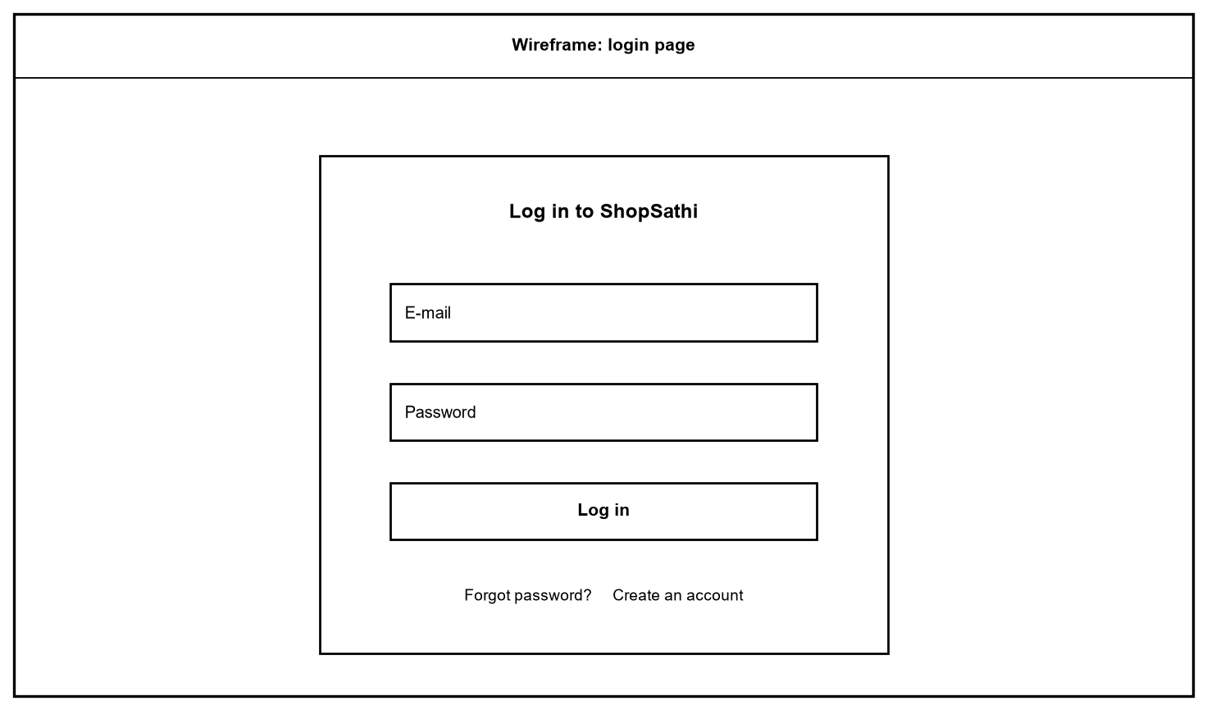
Figure 47: Wireframe: login page
A single centred box with e-mail, password, a Log in button and links to Forgot password and Sign up.
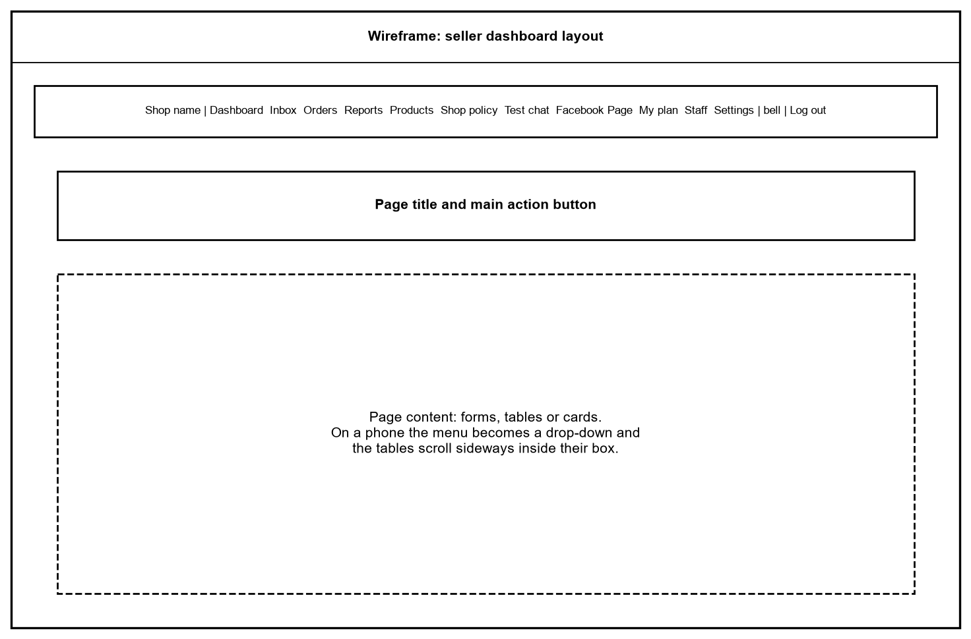
Figure 48: Wireframe: seller dashboard layout
Every seller page has the same top bar with the menu, the notification bell and Log out, then a page title with its main action, then the content.
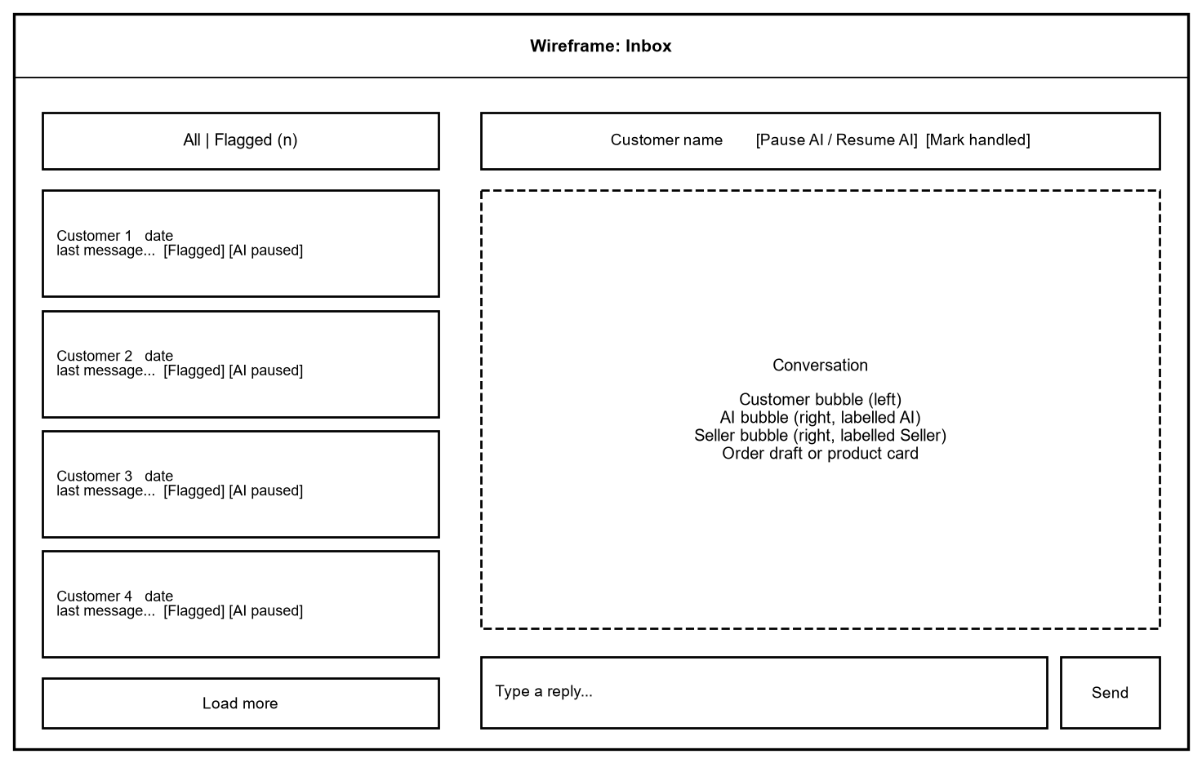
Figure 49: Wireframe: Inbox
The left column lists chats with filter, flags and Load more. The right side shows the open conversation, the pause or resume button and the reply box.
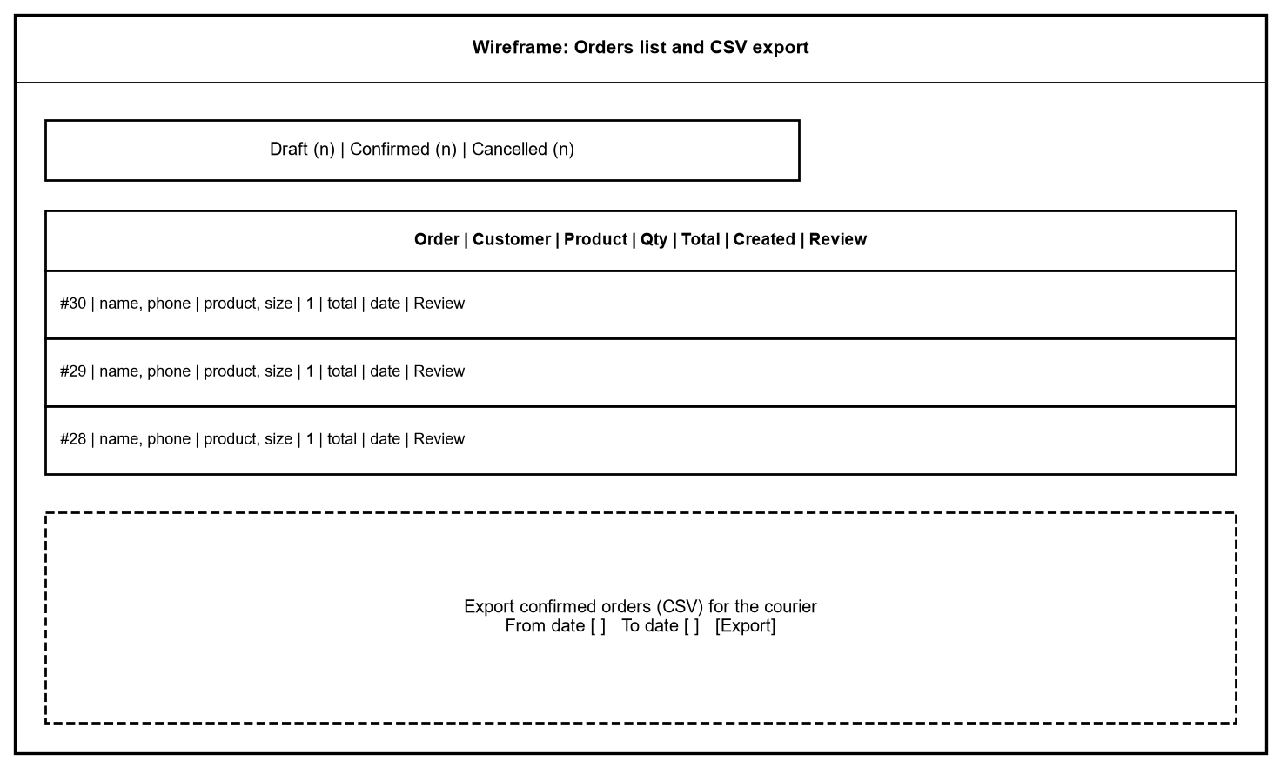
Figure 50: Wireframe: Orders list and CSV export
Tabs for the three order states, a table of orders with a Review link, and the export box with an optional date range.

43. UI Screens
All screens are real screenshots of the running application on a developer computer, with demo data of two invented shops (names ending with "(demo)"). They were taken in Microsoft Edge at 1366 by 800 pixels and converted to grayscale. Section 76 repeats the full list as the screenshot index and adds the phone screens.

43.1 Public pages
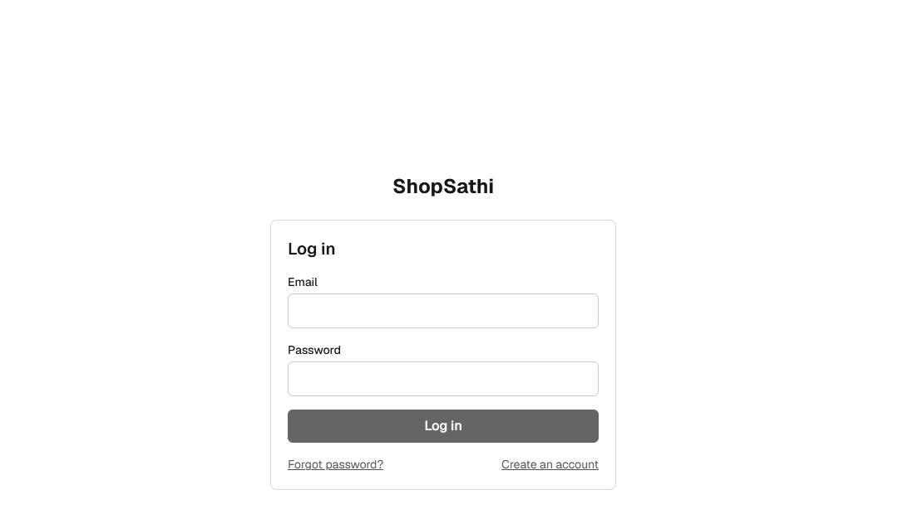
Figure 51: Screenshot: Login page
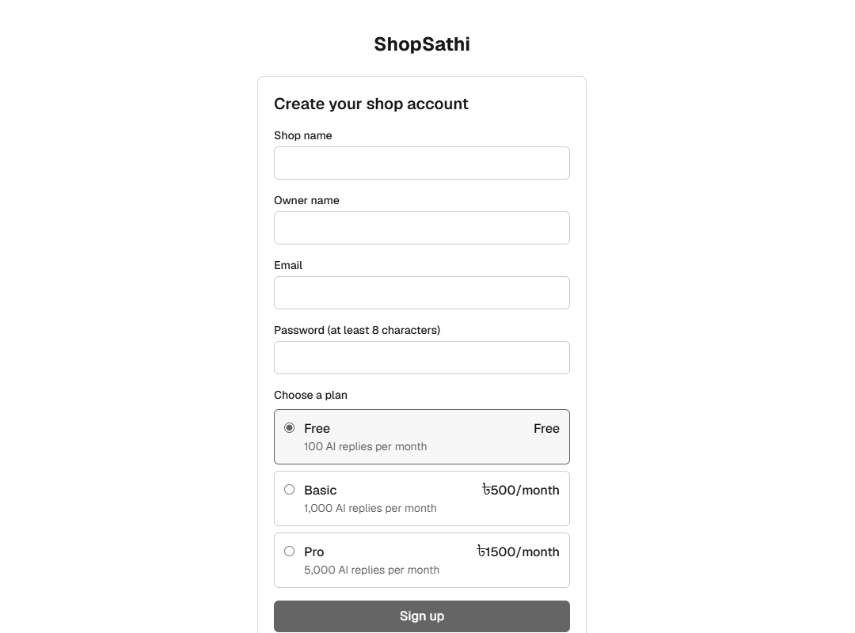
Figure 52: Screenshot: Sign up page with plan choice
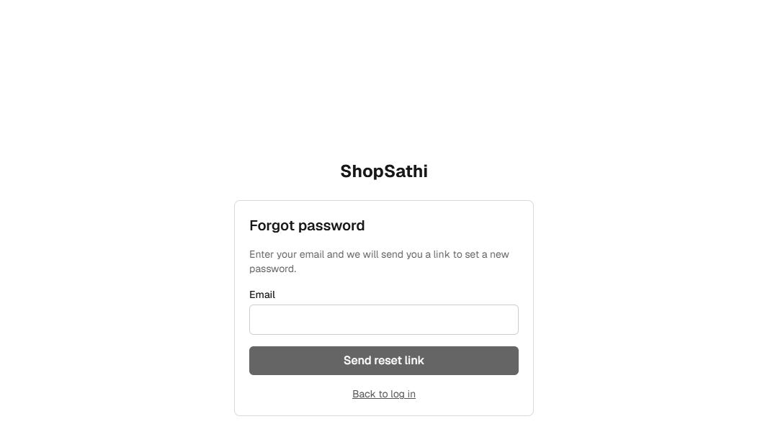
Figure 53: Screenshot: Forgot password page

43.2 Seller set-up
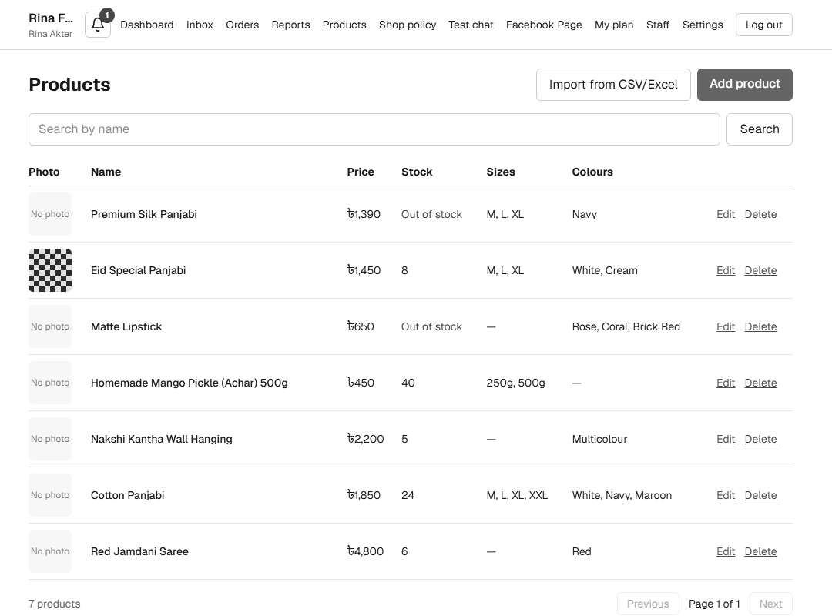
Figure 54: Screenshot: Products list with search, stock and photos
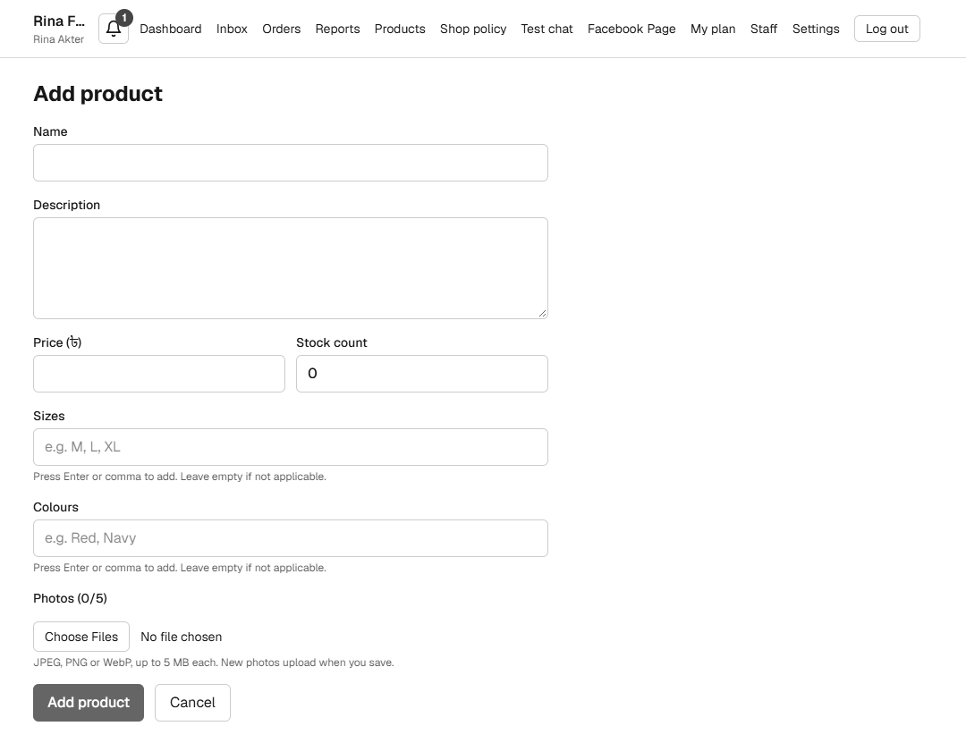
Figure 55: Screenshot: Add product form
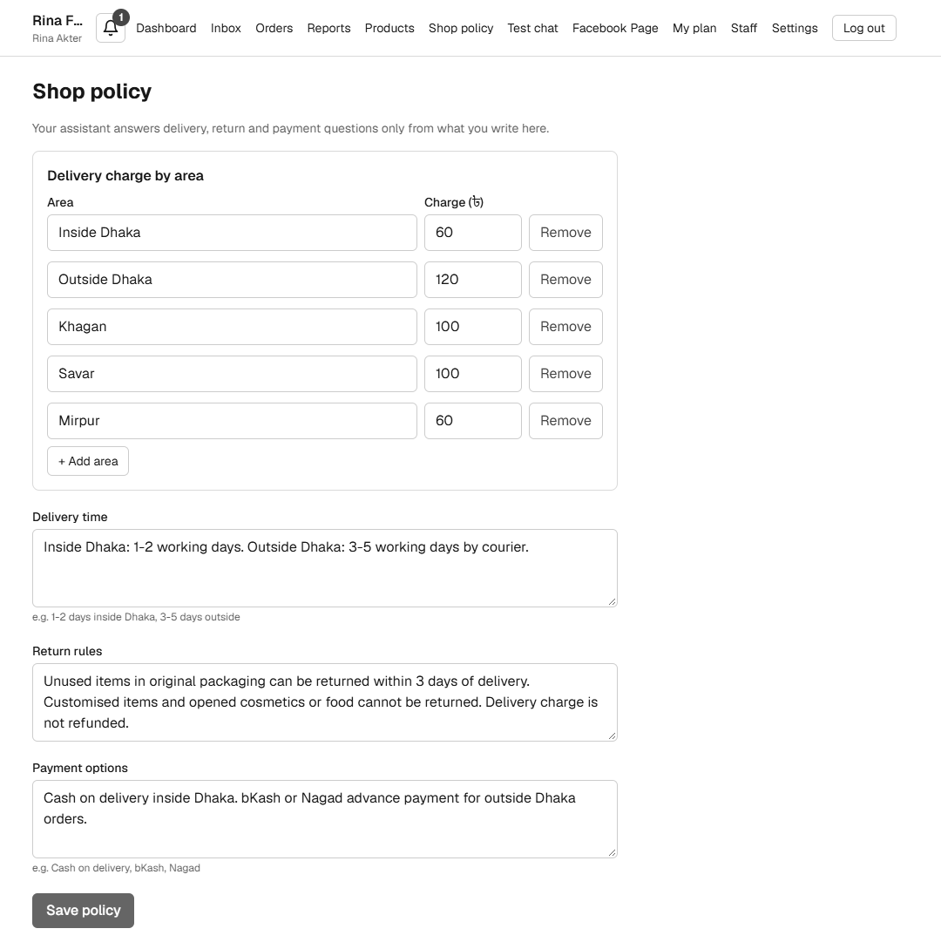
Figure 56: Screenshot: Shop policy and delivery charges
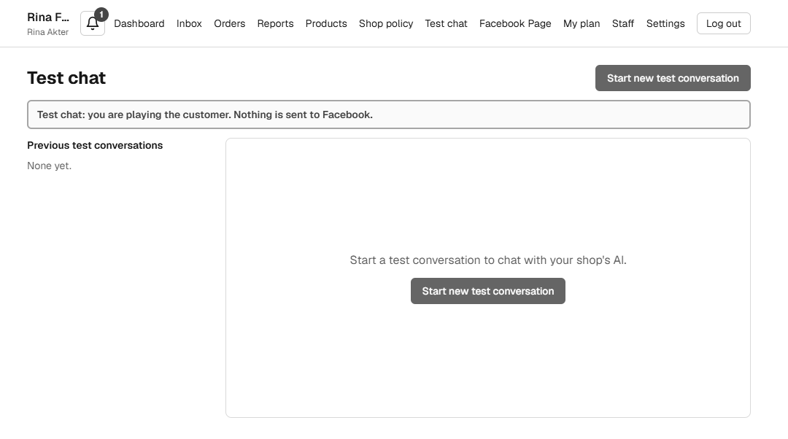
Figure 57: Screenshot: Test Chat before a conversation
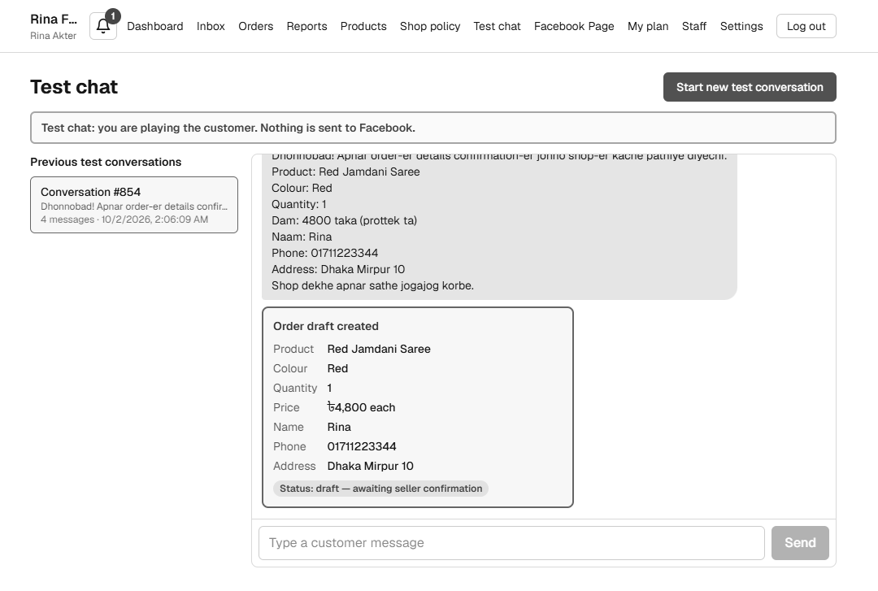
Figure 58: Screenshot: Test Chat with an order draft (real OpenAI model)
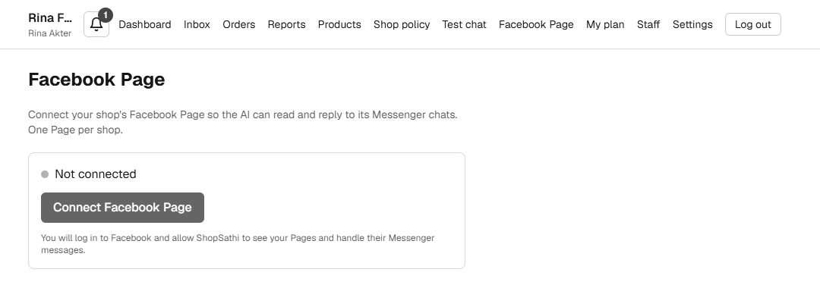
Figure 59: Screenshot: Facebook Page page (not connected)
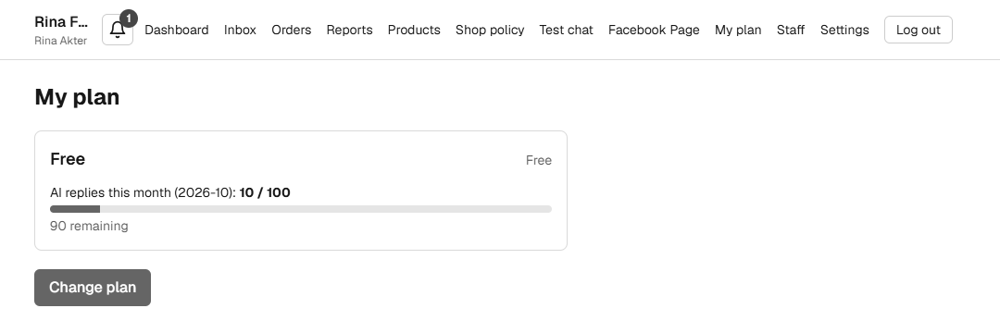
Figure 60: Screenshot: My plan with usage
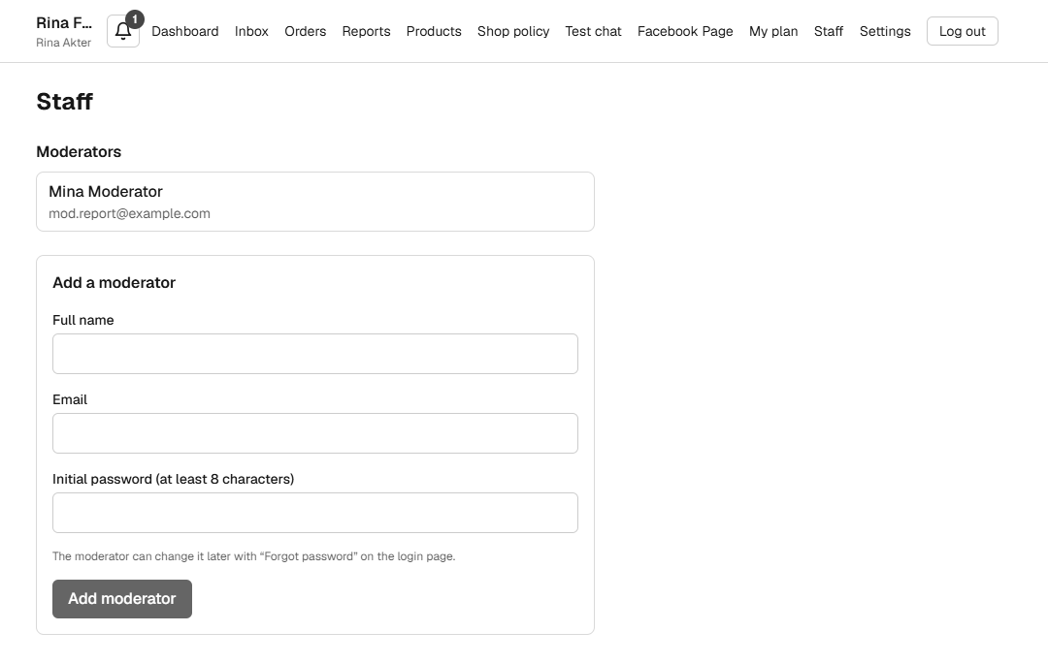
Figure 61: Screenshot: Staff page with a moderator

43.3 Daily work
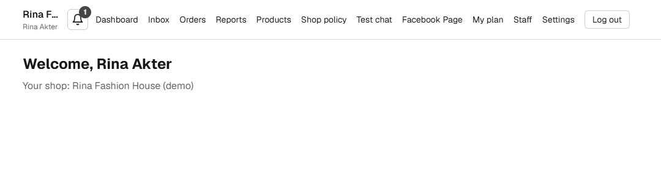
Figure 62: Screenshot: Dashboard start page
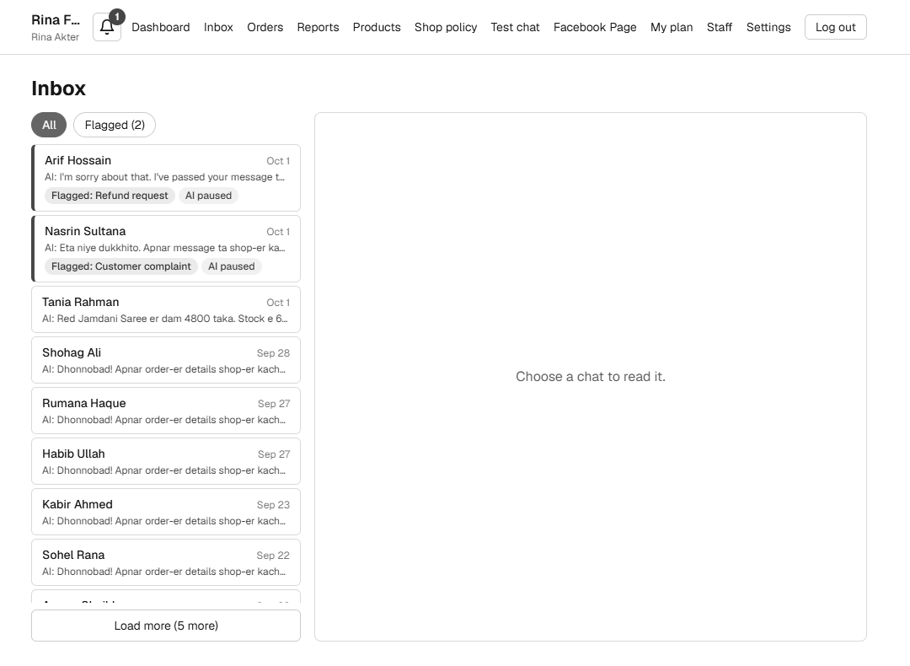
Figure 63: Screenshot: Inbox with flagged chats
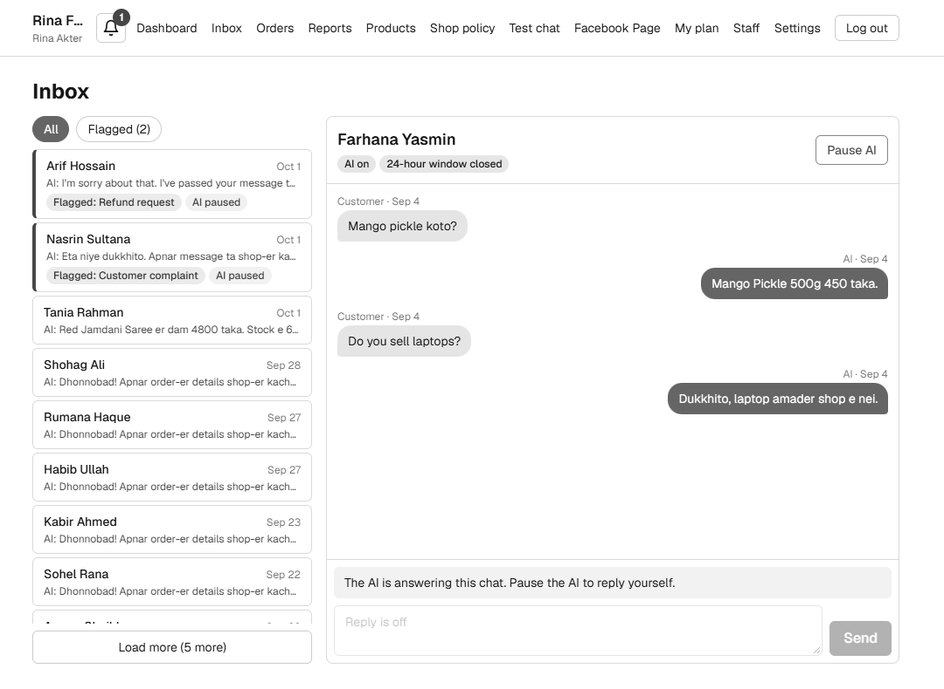
Figure 64: Screenshot: Open conversation in the Inbox
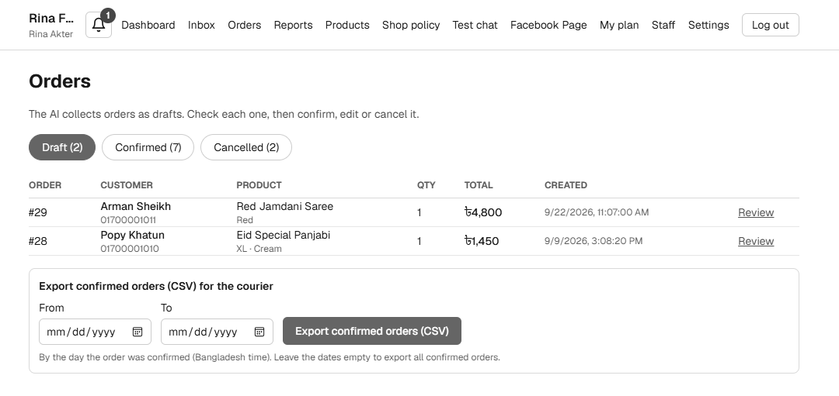
Figure 65: Screenshot: Orders: draft tab and CSV export
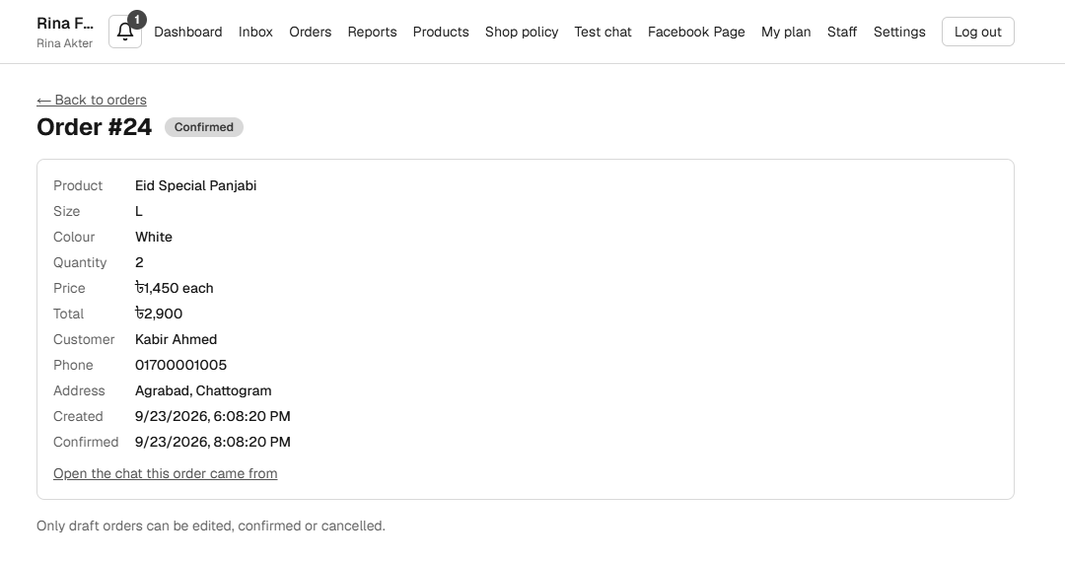
Figure 66: Screenshot: Order detail
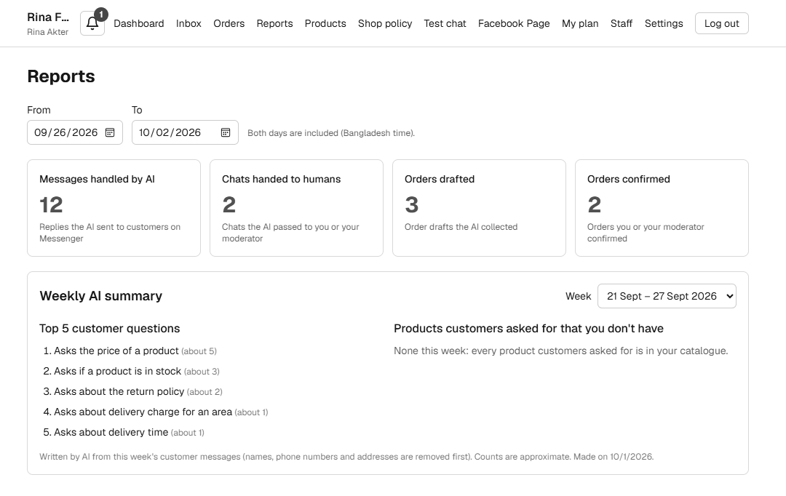
Figure 67: Screenshot: Reports with the weekly AI summary
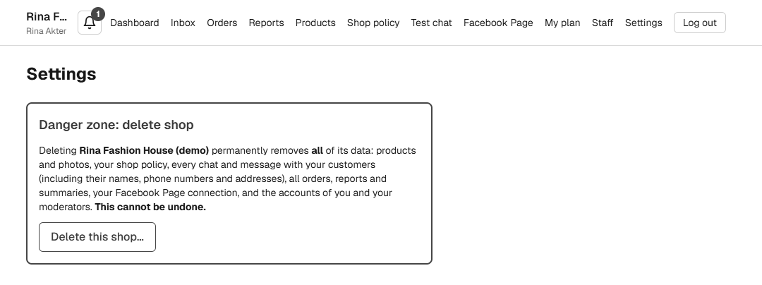
Figure 68: Screenshot: Settings with the danger zone

43.4 Moderator and admin
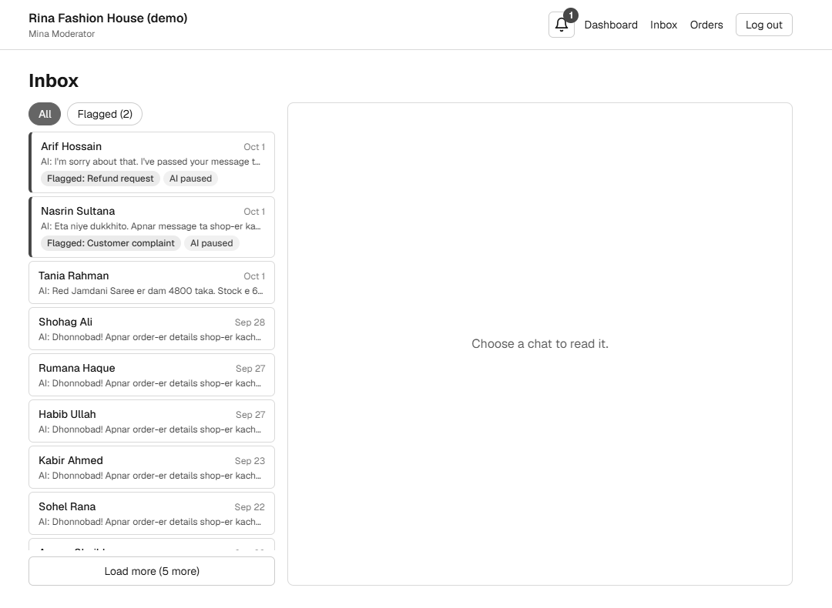
Figure 69: Screenshot: Moderator sees the Inbox
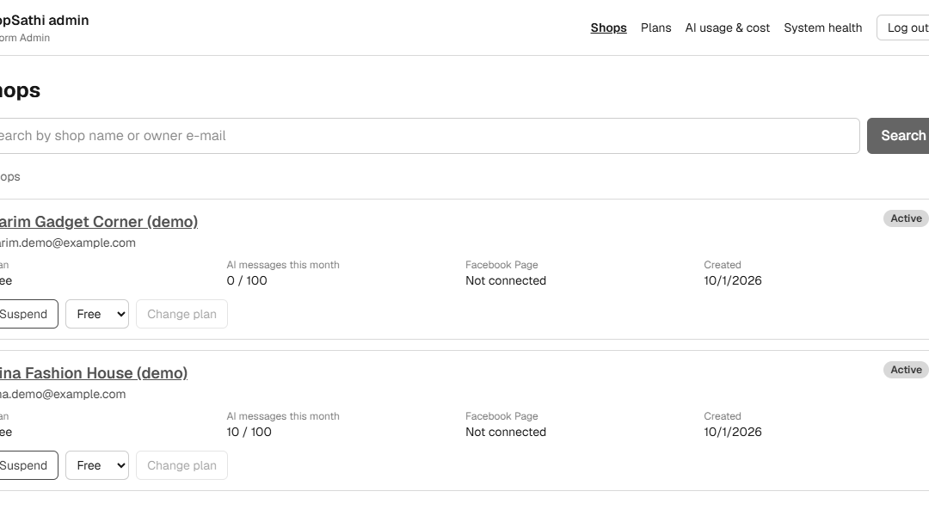
Figure 70: Screenshot: Admin: shops list
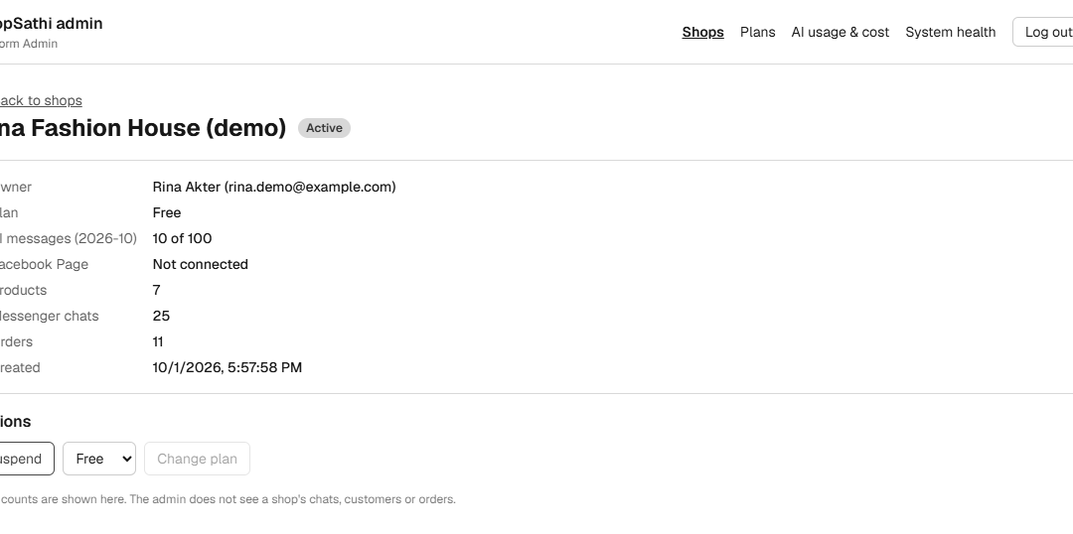
Figure 71: Screenshot: Admin: shop detail
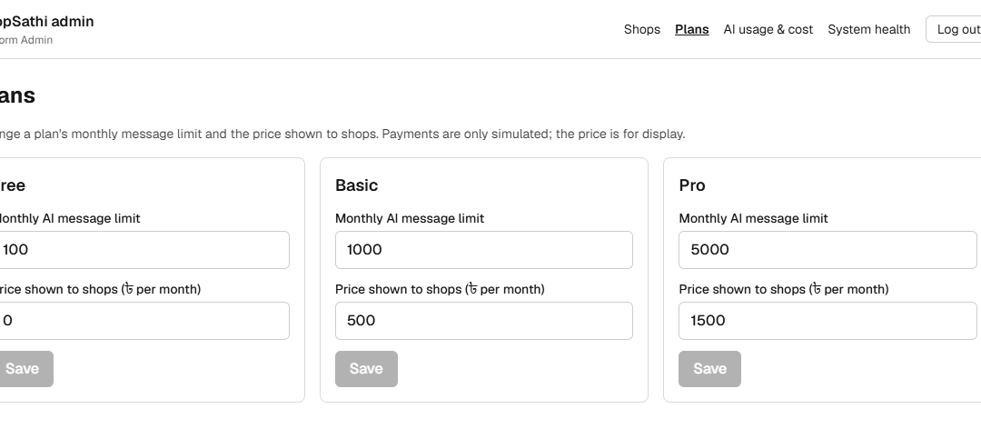
Figure 72: Screenshot: Admin: plans
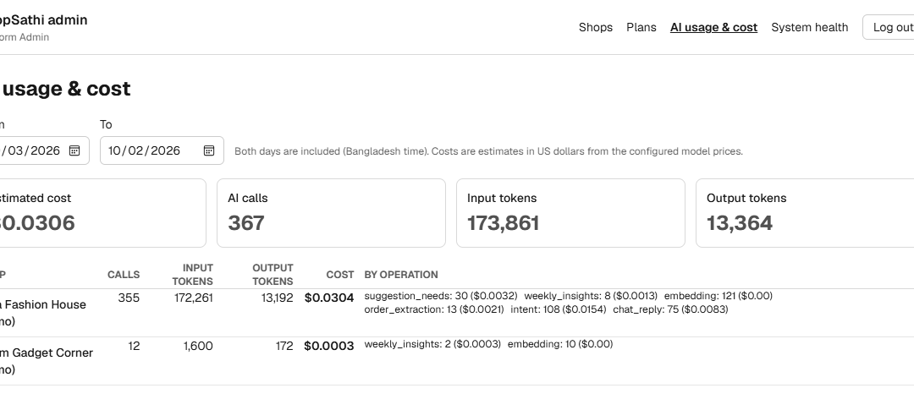
Figure 73: Screenshot: Admin: AI usage and cost
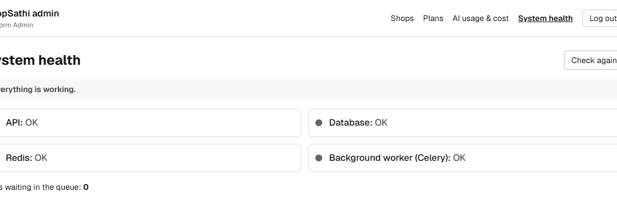
Figure 74: Screenshot: Admin: system health

43.5 Phone screens
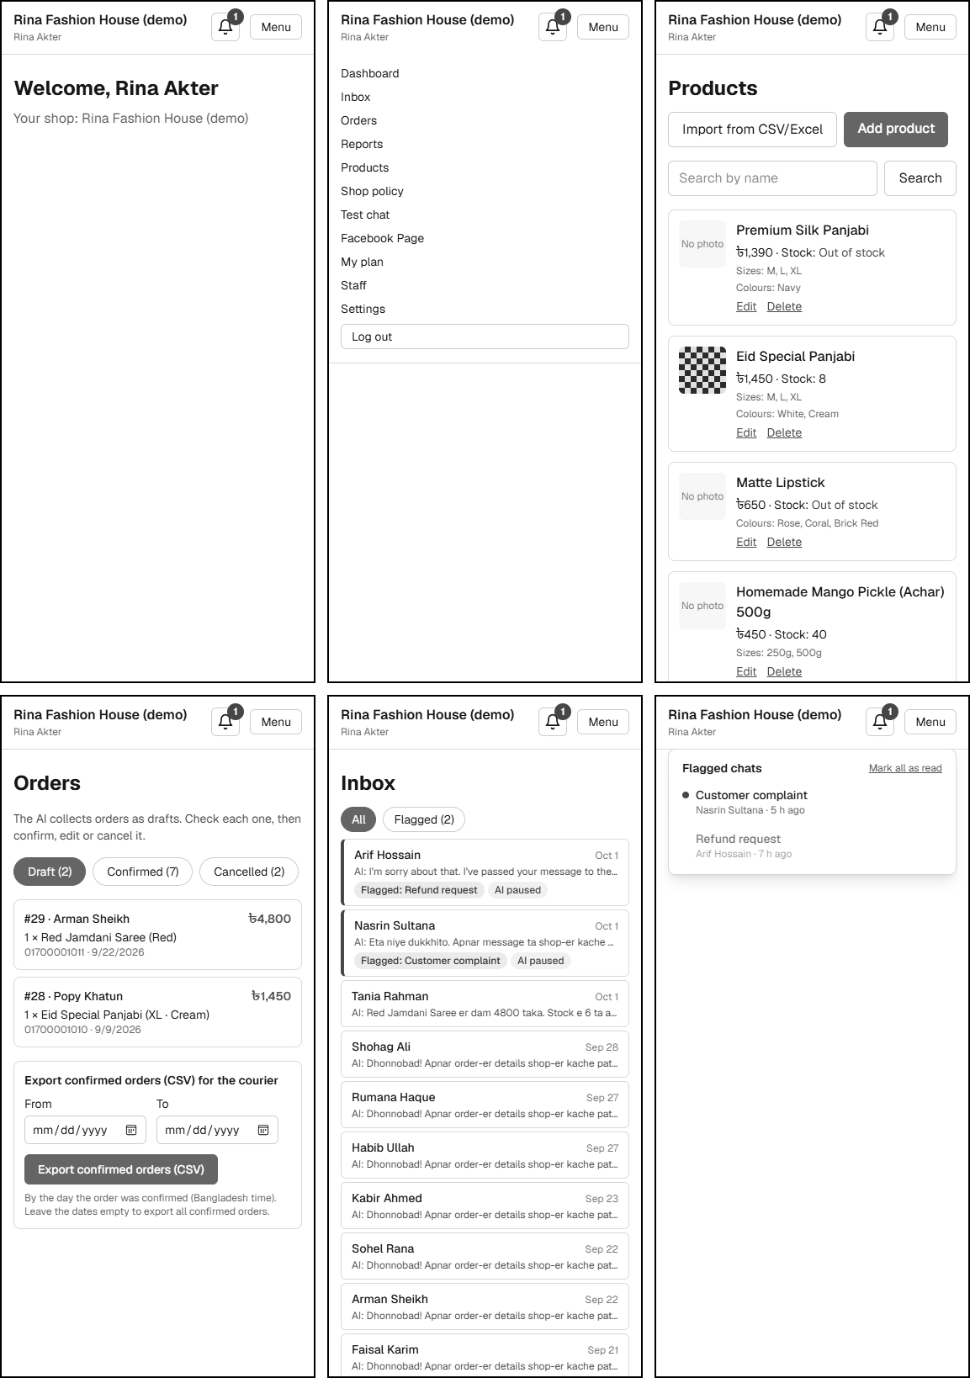
Figure 75: Screenshots at 375 px width: dashboard, menu, products, orders, Inbox and notifications
On a phone the menu is behind a Menu button, products and orders are cards, and the notification list opens over the page.

44. Module Implementation
This section describes how each module is built. The table of features at the end links every implemented feature to its code, API, database tables, tests, diagram section and requirement.

44.1 Authentication and roles
routes/auth.py handles sign-up, login, logout, me and password reset. Passwords are hashed with bcrypt. A token (HS256 JWT, 720 minutes by default) carries the user id, the role, the shop id and a unique jti. On logout the jti is stored in Redis until the token expires; every protected request checks that list. The role is read from the database. Login and reset are rate limited per IP and per e-mail.

44.2 Tenancy
The shop id comes from the token. services/tenant.py has scoped_select, which adds the shop filter. A request for another shop's object returns 404 (not 403), so that ids of other shops are not revealed.

44.3 Products, photos and import
services/products.py creates, updates and deletes products and calls a change hook, which queues the embedding task. Photos are saved by services/storage.py after a check of the real file signature (PNG, JPEG, WebP), the 5 MB limit and the 5-photo limit; if one file in an upload is not a valid image, the whole upload is rejected. The import reads CSV or Excel with pandas, checks each row with the same schema as a manual product and reports failed rows.

44.4 Policy and delivery
One policy row per shop (delivery time, return rules, payment options) and delivery areas with charges. Saving the policy queues the policy embedding. The AI tool get_delivery_charge reads the area charge.

44.5 Embeddings and retrieval
services/embeddings.py and the worker tasks turn products and policy into chunks (at most 600 characters) and embeddings, replace old chunks, and drop a stale result if the product changed during embedding. Every embedding call writes an ai_usage_logs row.

44.6 Conversation service
services/conversation.py is the one entry point for Test Chat and Messenger. It loads the chat memory, calls the engine through the gateway, saves the AI message, the pending order, the draft order, the hand-over event and the notification, and logs usage. A model outage gives the fallback reply.

44.7 Messenger ingest and processor
messenger_ingest.py checks events, finds or creates the chat, saves the message and queues the task. messenger_processor.py takes a Redis lock per chat, applies the skip rules, reserves one reply from the allowance, runs the engine, sends the reply, sets sent_at, and gives the reservation back if nothing was sent. A retried task does not answer twice.

44.8 Facebook integration
services/facebook.py creates the OAuth login URL, checks the state, exchanges the code, reads the permissions and Pages, and connects or disconnects a Page. graph_client.py follows paging and parses Facebook errors. messenger_sender.py sends text and photos with retries for temporary errors.

44.9 Inbox and orders
routes/chats.py lists chats (flagged first), shows a chat, pauses, resumes, resolves a flag and sends a manual reply. routes/orders.py lists orders by status, edits a draft, confirms, cancels and exports. Changing the product of a draft takes the catalogue price and re-checks size and colour.

44.10 Plans, usage and payment simulation
services/plans.py and usage.py handle the plans and the monthly counter. reserve_ai_reply and release_ai_reply change the counter atomically in SQL, so many chats at the same moment cannot pass the limit. Payment is a stored record simulated_success; no payment provider is called.

44.11 Reports and weekly insights
routes/reports.py counts AI messages sent, chats handed over, orders drafted and confirmed, by Bangladesh day. services/insights.py runs the weekly job: it takes the customer messages of one week (Monday to Sunday), removes names and phone numbers, asks the model to summarise in batches and combine, and stores the top questions and the missing products. The catalogue, not the model, decides whether a product exists.

44.12 Admin
routes/admin.py lists and searches shops, shows details, suspends and reactivates (with a log row), changes plans, edits plan limits, summarises AI usage and cost for a date range, and checks system health (API, database, Redis and a Celery ping).

44.13 Shop deletion and privacy
services/shop_deletion.py unsubscribes the Page (best effort), removes photo files and Redis keys, and deletes the shop row; foreign keys remove the rest. core/log_masking.py hides tokens, passwords and phone numbers in log records.

44.14 Frontend
Next.js app router pages call the API through lib/client.ts, which adds the bearer token. AuthProvider keeps the user, RoleGuard hides pages from roles that may not see them, and small components handle the Inbox, product forms, plan picker, chat cards and the notification bell.

44.15 Feature inventory
Table of all implemented features with the files, API, database tables, security rule, tests and the report section that explains them. Section numbers refer to subsections of this report.
Table 54: Feature inventory
Feature | Module | Backend / UI | Database | API | Security / AI rule | Tests | Sect.
Sign up | Auth | routes/auth.py, plans  UI: /signup | shops, users | POST /auth/signup | bcrypt hash | test_auth, test_plans | 29.1
Login, logout, token | Auth | core/security.py  UI: /login | users | POST /auth/login, /logout | JWT jti deny list, rate limit | test_auth_security | 29.2, 30.6
Password reset | Auth | routes/auth.py, services/email.py  UI: /forgot-password, /reset-password | password_reset_tokens | POST /auth/password-reset/* | hashed single-use token | test_auth | 29.3
Shop isolation | Tenancy | services/tenant.py  UI: - | all shop tables | all | shop_id from token | test_tenancy, test_privacy | 48
Owner / moderator / admin permissions | RBAC | core/roles.py  UI: RoleGuard | users | all | role from database | test_role_matrix | 20, 49
Moderator accounts | Staff | routes/shop.py  UI: /staff | users | GET/POST /shop/staff | owner only | test_staff | -
Product create, edit, delete, search | Products | services/products.py  UI: /products | products | /products | shop scope | test_products | 29.4
Product photo upload, delete | Products | services/storage.py  UI: ProductForm | products.photos | /products/{id}/photos | magic bytes, 5 MB, 5 photos | test_products | 29.4
CSV / Excel import | Import | services/product_import.py  UI: ProductImport | products | POST /products/import | size and row limits | test_product_import | 29.5
Shop policy and delivery | Policy | services/policy.py  UI: /policy | shop_policies, delivery_areas | /shop/policy | length limits | test_policy | -
Embeddings | AI data | services/embeddings.py, workers/tasks.py  UI: - | embedding_chunks | (background) | shop filter | test_embeddings | 30.7
Semantic search | AI | ai_engine retrieval.py, tools.py  UI: - | embedding_chunks | (AI) | never other shop's chunks | test_embeddings_and_retrieval | 30.2
Test Chat | Chat | routes/test_chat.py  UI: /test-chat | chats, messages | /test-chat/* | owner only; not counted | test_test_chat | 30.8
Language handling | AI | language.py, reply.py  UI: - | messages.language_style | (AI) | script check of reply | test_validators | 35
AI memory | AI | services/chat_memory.py  UI: - | Redis, messages | (AI) | 8 turns, 6 h | test_test_chat | 35
Suggestions, budget | AI | suggestions.py, budget.py  UI: ChatCards | products | (AI) | stock > 0, max 3 | test_suggestions, test_suggestions_api | 29.7
Stock checking | AI | tools.py, gateway.py  UI: - | products | (AI) | live data | test_suggestions_api | 30.2
Order draft, phone validation | AI | ordering.py, extraction.py, validators.py  UI: ChatCards | orders, chats.pending_order | (AI) | code-side checks | test_orders, test_orders_api | 29.8, 30.3
Order edit, confirm, cancel | Orders | routes/orders.py  UI: /orders | orders | /orders/{id} | only draft changes | test_orders_dashboard | 29.9
CSV export | Orders | routes/orders.py  UI: /orders | orders | GET /orders/export | formula neutralised | test_orders_dashboard | 29.10
Handover detection | AI | handover.py  UI: Inbox flag | handover_events, chats | (AI) | 7 reasons, code keywords | test_handover, test_handover_api | 29.11
AI pause / resume | Inbox | routes/chats.py  UI: Inbox | chats | /chats/{id}/pause, /resume | - | test_inbox | 31.2
Notifications | Notifications | routes/notifications.py  UI: NotificationBell | notifications | /notifications | shop scope | test_handover_api | 29.11
Facebook Page connection | Facebook | services/facebook.py  UI: /facebook | facebook_pages | /facebook/* | state, encryption | test_facebook | 29.12, 30.5
OAuth state validation | Facebook | services/facebook.py  UI: - | Redis | GET /facebook/callback | signed, single-use state | test_facebook | 29.12
Token encryption | Security | core/crypto.py  UI: - | facebook_pages | - | Fernet | test_secrets | 47
Webhook verification, signature | Messenger | integrations/facebook/webhook.py  UI: - | - | GET/POST /webhooks/messenger | HMAC SHA-256 | test_webhook_and_limits | 29.13
Duplicate-message protection | Messenger | services/messenger_ingest.py  UI: - | messages unique | (webhook) | unique (shop, mid) | test_messenger | 29.13
24-hour window | Messenger | messenger_sender.py  UI: Inbox | chats | (sender) | checked twice | test_messenger, test_limits_under_load | 29.13
Seller Inbox and reply | Inbox | routes/chats.py  UI: /inbox | chats, messages | /chats, /chats/{id}/reply | window check | test_inbox | 29.14, 30.4
AI usage limits, plans, usage tracking | Plans | services/usage.py, plans.py  UI: /plan | plans, shop_message_usage | /plans, /shop/plan | atomic reserve | test_plans, test_limits_under_load | 29.13
Reports | Reports | routes/reports.py  UI: /reports | messages, orders | /reports/summary | owner only | test_reports | -
Weekly insights | Insights | services/insights.py  UI: /reports | weekly_insights | /reports/weekly-insights | PII removed | test_insights | 29.16, 30.9
Admin: shops, plans, usage, health | Admin | routes/admin.py  UI: /admin | shops, plans, admin_actions | /admin/* | admin only | test_admin | 24
Shop deletion | Privacy | services/shop_deletion.py  UI: /settings | all | DELETE /shop | password + name | test_privacy | 29.15
Background processing | Workers | workers/*  UI: - | Redis | - | retry, lock | test_messenger, test_insights | 30.1
Error handling | All | routes, processor  UI: ui.tsx | messages.extras | all | no secrets in errors | test_messenger | 31.3
Docker | Deploy | Dockerfile, compose  UI: - | - | - | - | manual run | 34

45. API Documentation
The API is a FastAPI application under the prefix /api/v1. The list below was generated from the OpenAPI description that the application itself produces (63 operations), and the roles from the access rules that the role test checks. Authentication is a bearer token in the Authorization header. A name followed by ? is an optional field. Common errors for protected endpoints are 401 (no or invalid token), 403 (role not allowed), 404 (object missing or in another shop) and 422 (invalid input); only the other errors are listed. One more endpoint is not in the OpenAPI list: GET /api/v1/facebook/callback, the address Facebook redirects the browser to after login (hidden from the docs).
The interactive API documentation (/docs) is published only in local runs.

45.1 Health and authentication
Table 55: API: health and authentication
Endpoint | Purpose | Role | Request | Success | Other errors
GET  /health | Report API, database and Redis state (200 ok or 503 degraded). | Public | none | 200 | 503 degraded
POST  /auth/signup | Create a shop and its owner; choose a plan; returns a token. | Public | shop_name, owner_name, email, password, plan_code?, simulated_payment_confirmed? | 201 AuthResponse | 409 e-mail used
POST  /auth/login | Log in with e-mail and password; returns a token. | Public | email, password | 200 AuthResponse | 401 bad login; 403 suspended; 429 rate limit
POST  /auth/logout | Revoke the current token. | Any logged-in user | none | 200 MessageResponse
GET  /auth/me | Return the logged-in user and shop. | Any logged-in user | none | 200 MeResponse
POST  /auth/password-reset/request | Ask for a reset link (same answer for any e-mail). | Public | email | 200 MessageResponse | 429 rate limit
POST  /auth/password-reset/confirm | Set a new password with the reset token. | Public | token, new_password | 200 MessageResponse | 400 bad or expired token

45.2 Plans, shop and staff
Table 56: API: plans, shop and staff
Endpoint | Purpose | Role | Request | Success | Other errors
GET  /plans | List the plans with limit and price. | Public | none | 200
GET  /shop/plan | Show the shop's plan and this month's usage. | Owner, Moderator | none | 200 ShopPlanResponse
POST  /shop/plan/change | Change the plan (simulated payment for paid plans). | Owner | plan_code, simulated_payment_confirmed? | 200 ShopPlanResponse
GET  /shop/staff | List moderators of the shop. | Owner | none | 200
POST  /shop/staff | Add a moderator. | Owner | email, full_name, password | 201 StaffOut | 409 e-mail used
DELETE  /shop | Delete the shop and all its data (password and shop name needed). | Owner | password, shop_name | 200 MessageResponse | 403 wrong password; 422 wrong name; 429
GET  /shop/policy | Read the shop policy and delivery areas. | Owner | none | 200 PolicyOut
PUT  /shop/policy | Save the shop policy and delivery areas. | Owner | delivery_time?, return_rules?, payment_options?, delivery_areas? | 200 PolicyOut

45.3 Products
Table 57: API: products
Endpoint | Purpose | Role | Request | Success | Other errors
GET  /products | List and search products with paging. | Owner | q, page, page_size | 200 ProductPage
POST  /products | Create a product. | Owner | name, description?, price, sizes?, colours?, stock_count? | 201 ProductOut
GET  /products/import/template | Download the CSV import template. | Owner | none | 200
POST  /products/import | Import products from a CSV or Excel file. | Owner | multipart: file(s) | 200 ImportResult | 4xx bad file, too large or too many rows
GET  /products/{product_id} | Read one product. | Owner | product_id | 200 ProductOut
PUT  /products/{product_id} | Update a product. | Owner | product_id  name, description?, price, sizes?, colours?, stock_count? | 200 ProductOut
DELETE  /products/{product_id} | Delete a product and its photos and embeddings. | Owner | product_id | 204
POST  /products/{product_id}/photos | Upload one or more photos (max 5 per product). | Owner | product_id  multipart: file(s) | 200 ProductOut | 4xx not an image, too large or over 5 photos
DELETE  /products/{product_id}/photos/{index} | Remove one photo by position. | Owner | product_id, index | 200 ProductOut

45.4 Test Chat and notifications
Table 58: API: test chat and notifications
Endpoint | Purpose | Role | Request | Success | Other errors
GET  /test-chat/sessions | List the owner's Test Chat sessions. | Owner | none | 200
POST  /test-chat/sessions | Start a Test Chat session. | Owner | none | 201 SessionOut
GET  /test-chat/sessions/{session_id}/messages | List the messages of a session. | Owner | session_id | 200
POST  /test-chat/sessions/{session_id}/messages | Send a customer message and get the AI reply. | Owner | session_id  text | 200 SendMessageResponse
GET  /notifications | List notifications, unread first. | Owner, Moderator | none | 200 NotificationList
POST  /notifications/read-all | Mark all notifications read. | Owner, Moderator | none | 200 MarkedRead
POST  /notifications/{notification_id}/read | Mark one notification read. | Owner, Moderator | notification_id | 200 NotificationOut

45.5 Facebook
Table 59: API: facebook
Endpoint | Purpose | Role | Request | Success | Other errors
GET  /facebook/connect-url | Get the Facebook login URL with a signed state. | Owner | none | 200 ConnectUrlOut
GET  /facebook/pages/available | List the Pages the owner may connect. | Owner | none | 200
POST  /facebook/pages/connect | Connect one of the listed Pages. | Owner | page_id | 200 ConnectedPageOut | 4xx Page not allowed or used by another shop
GET  /facebook/page | Show the connection status. | Owner | none | 200 PageStatusOut
POST  /facebook/page/disconnect | Disconnect the Page and delete the stored token. | Owner | none | 200 DisconnectOut

45.6 Inbox
Table 60: API: inbox
Endpoint | Purpose | Role | Request | Success | Other errors
GET  /chats | List Messenger chats (all or flagged). | Owner, Moderator | filter, page, page_size | 200 InboxPage
GET  /chats/{chat_id} | Read one chat with all messages. | Owner, Moderator | chat_id | 200 InboxChatDetail
POST  /chats/{chat_id}/pause | Pause the AI in this chat. | Owner, Moderator | chat_id | 200 InboxChatDetail
POST  /chats/{chat_id}/resume | Resume the AI in this chat. | Owner, Moderator | chat_id | 200 InboxChatDetail
POST  /chats/{chat_id}/resolve-flag | Mark the flag handled and its notifications read. | Owner, Moderator | chat_id | 200 InboxChatDetail
POST  /chats/{chat_id}/reply | Send a seller reply to the customer. | Owner, Moderator | chat_id  text | 201 InboxMessage | 409 AI not paused, no Page or window closed; 502 Facebook refused

45.7 Orders
Table 61: API: orders
Endpoint | Purpose | Role | Request | Success | Other errors
GET  /orders | List orders by status with paging. | Owner, Moderator | status, page, page_size | 200 OrderPage
GET  /orders/export | Download confirmed orders as CSV. | Owner, Moderator | from, to | 200
GET  /orders/product-options | Products with sizes and colours for the edit form. | Owner, Moderator | none | 200
GET  /orders/{order_id} | Read one order. | Owner, Moderator | order_id | 200 OrderOut
PATCH  /orders/{order_id} | Edit a draft order. | Owner, Moderator | order_id  product_id?, size?, colour?, quantity?, customer_name?, customer_phone?, customer_address? | 200 OrderOut | 409 not a draft
POST  /orders/{order_id}/confirm | Confirm a draft order. | Owner, Moderator | order_id | 200 OrderOut | 409 not a draft
POST  /orders/{order_id}/cancel | Cancel a draft order. | Owner, Moderator | order_id | 200 OrderOut | 409 not a draft

45.8 Reports
Table 62: API: reports
Endpoint | Purpose | Role | Request | Success | Other errors
GET  /reports/summary | Report numbers for a date range. | Owner | from, to | 200 ReportSummary
GET  /reports/weekly-insights | List weeks that have a summary. | Owner | none | 200
GET  /reports/weekly-insights/{week_start} | Read the summary of one week. | Owner | week_start | 200 WeeklyInsightOut

45.9 Platform admin
Table 63: API: platform admin
Endpoint | Purpose | Role | Request | Success | Other errors
GET  /admin/shops | List and search all shops. | Platform admin | q, page, page_size | 200 AdminShopPage
GET  /admin/shops/{shop_id} | Show one shop with counts. | Platform admin | shop_id | 200 AdminShopDetail
POST  /admin/shops/{shop_id}/suspend | Suspend a shop. | Platform admin | shop_id | 200 AdminShopDetail
POST  /admin/shops/{shop_id}/reactivate | Reactivate a shop. | Platform admin | shop_id | 200 AdminShopDetail
POST  /admin/shops/{shop_id}/plan | Change a shop's plan without payment. | Platform admin | shop_id  plan_code | 200 AdminShopDetail
GET  /admin/plans | List plans for editing. | Platform admin | none | 200
PUT  /admin/plans/{code} | Edit the limit and price of a plan. | Platform admin | code  monthly_message_limit, monthly_price | 200 AdminPlan
GET  /admin/ai-usage | AI usage and cost per shop for a date range. | Platform admin | from, to | 200 AiUsageReport
GET  /admin/system-health | Check API, database, Redis and the worker. | Platform admin | none | 200 SystemHealth

45.10 Webhook
Table 64: API: webhook
Endpoint | Purpose | Role | Request | Success | Other errors
GET  /webhooks/messenger | Facebook verification handshake (verify token). | Facebook | hub.mode, hub.verify_token, hub.challenge | 200 | 403 wrong verify token
POST  /webhooks/messenger | Receive Messenger events (signature checked). | Facebook | none | 200 | 403 bad signature; 413 body too large

45.11 Conventions
- JSON is used everywhere except file upload (multipart) and the CSV download.
- Dates and times are ISO 8601 in UTC. Report days and the monthly limit use Bangladesh time.
- Lists use page and page_size. An object of another shop gives 404, never its data.
- The CORS setting allows only the configured frontend origin.

46. AI Implementation
This section describes the AI engine in the package ai_engine/shopsathi_ai. Each part carries a status label: Implemented, Tested, Simulated, Real model, Not tested or Not implemented.

46.1 Engine overview
The class ConversationEngine receives the shop id, a chat context (recent turns, pending order, language, shop name) and the customer message. It returns the reply text, the intent, the confidence, the language style, optional product cards, the pending-order state, a hand-over decision and a list of model calls for the usage log. The engine never touches the database. It reads shop data through a gateway object, which the backend implements (ai_adapters/gateway.py) and the evaluation harness implements in memory.

46.2 Providers
Table 65: AI providers
Part | Options | Default | Status
Chat model | OpenAI (gpt-4o-mini), Gemini, mock | mock (LLM_PROVIDER) | OpenAI: Real model, tested. Gemini: Implemented, Not tested. Mock: tests only.
Embeddings | OpenAI text-embedding-3-small (1536), local model, mock | mock (EMBEDDING_PROVIDER) | OpenAI: Real model, tested. Local: Implemented, Not tested here. Mock: tests only.
Output format | JSON mode for understanding, extraction, needs and insights | - | Implemented, Tested
Settings | temperature 0.2, request timeout, one retry | - | Implemented

The mock provider is a keyword test double. It is not an AI. Automated tests with the mock prove the pipeline and the safety rules; they do not measure answer quality.

46.3 Pipeline steps
1. Language style. language.py looks at the script and a list of common Banglish words. The result is bangla, english or banglish. Bangla digits are turned into ASCII digits.
2. Understanding. One model call returns JSON: intent (price, size_stock, delivery, suggestion, order, complaint, other), entities such as product, size and colour, a confidence, and flags (refund, abusive language, human request, off-topic).
3. Hand-over decision. handover.py combines the flags with a keyword check in code and the confidence threshold (0.5 by default). The first matching reason in a fixed order is used: abusive_language, refund, complaint, human_requested, off_topic, low_confidence, not_in_shop_data.
4. Order branch. A second call extracts the order fields. Code then validates them (section 46.7).
5. Suggestion branch. A call extracts the need; the budget is parsed in code; products are filtered from live data (section 46.6).
6. Facts. Tools read the facts: vector search over the shop's chunks, product search, stock check and delivery charge.
7. Reply. The reply model gets only the facts and the recent turns and writes the reply in the customer's style.
8. Grounding check. Code checks that every number in the reply appears in the facts and that the script matches the style. If not, the reply is regenerated once; if it still fails, the engine says that it will check with the shop and flags the chat.
9. Result. The conversation service saves the reply and logs every model call.

46.4 Semantic retrieval and pgvector
Products and the policy are split into chunks of at most 600 characters and embedded. A product chunk is made from the product data (name, description, price, sizes, colours, stock). At question time the customer text is embedded and the nearest chunks of the same shop are read by cosine distance from embedding_chunks (HNSW index). Chunks below a minimum score (0.2 in general, 0.3 for products) are ignored. This finds a product when the customer uses other words, for example Banglish. Retrieval is used to find which product or policy text is meant. The price and stock in the reply always come from the products table, not from the chunk text. A test checks that retrieval never returns another shop's chunks.
Status: Implemented, Tested (mock embeddings in automated tests; OpenAI embeddings in the evaluation and load runs).

46.5 Memory
The last 8 turns of each chat are kept in Redis for 6 hours (CHAT_MEMORY_TURNS, CHAT_MEMORY_TTL_SECONDS). If Redis lost them, the service rebuilds them from the messages table (tested). The engine gets only recent turns and the shop name, not the whole history.

46.6 Suggestions and budget
The need is read by the model (for example gift, Eid, colour). The budget words (maximum, range, around a price) are read by code in budget.py, in English, Banglish and Bangla digits. Code then selects products of this shop with stock above zero and price in the budget, ranks them, and keeps at most three. The reply model only describes the selected products. So the zero-stock rule does not depend on the model. The evaluation counted 0 violations in 3 suggestions shown (a small sample).

46.7 Order collection
extraction.py asks the model for product, size, colour, quantity, name, phone and address. ordering.py checks them in code: the product must exist in this shop and have stock, the size and colour must be in the product's lists, the quantity must be possible, and the phone must be a Bangladesh mobile number (^01[3-9]\d{8}$ after removing spaces, dashes, Bangla digits and a +88 prefix). If something is missing or wrong the engine asks for that item and keeps the partial data in the chat. When everything is valid the engine sets order_ready and the conversation service creates the draft order in one transaction. If the product sold out in the meantime, nothing is created.

46.8 Hand-over (confidence and flags)
A reply with low confidence is not sent as a guess. The engine returns a short fixed holding reply in the customer's style that promises nothing, and the chat is flagged. For Messenger chats a notification is created. The seller can resume the AI at any time.

46.9 Usage tracking and failure handling
- Each model call is logged in ai_usage_logs with operation (intent, chat_reply, embedding, order_extraction, suggestion_needs, weekly_insights), provider, model, tokens, estimated cost and time. The cost uses configurable rates per model.
- A model call has a timeout of 20 seconds and one retry. When the model fails the conversation service returns the fallback reply and flags the chat; the worker does not crash (tested with a dead model).
- A monthly reply is reserved before the AI work and given back if no reply was sent.

46.10 What was tested and with what
Table 66: What was tested for the AI
Area | Automated tests (mock AI) | Real OpenAI model | Status
Pipeline, safety rules, validators | ai_engine: 251 tests; backend conversation tests | - | Tested
Answer quality (intent, price and stock) | Not meaningful with the mock | 32 sample cases, 2 minutes (section 56) | Tested on samples only
Order fields | 42 order tests | 24 of 24 fields on samples | Tested on samples only
Hand-over | 45 handover tests + 25 API tests | 6 of 6 flagged, 5 of 6 reasons right on samples | Tested on samples only
Speed | - | p90 5.8 s (local load test, section 59) | Tested locally
Weekly insights | 28 + 15 tests | Run on the demo data (the demo shop's summary in section 43) | Tested on demo data
Gemini provider, local embeddings | factory test only | Not run | Not tested

46.11 Limitations of the AI part
- The 200-message labelled test set from the proposal does not exist. The accuracy numbers are from 32 sample cases and are not final.
- The language model can still misread a message. The checks (grounding, validators, live data) reduce this but do not remove it.
- Bangla script quality was tested with only 6 sample cases.
- The model's speed depends on the provider on the day of the test.

47. Security
This section lists only the security measures that exist in the code and that a test checks. No claim is made about a penetration test or an external audit; none was done.
Table 67: Security measures
Area | Measure | Checked by
Password storage | bcrypt hashes, minimum length 8; no password or hash in any response or log | test_auth_security, test_secrets
Tokens | HS256 JWT with expiry and unique id; tampered, forged, expired, wrong-secret and alg: none tokens give 401 | test_auth_security
Logout | The token id goes on a Redis deny list; other sessions continue | test_auth_security
Role checks | Every endpoint is checked for four callers (anonymous, owner, moderator, admin); a new endpoint without a class fails the test | test_role_matrix
Tenant isolation | Shop id from the token; cross-tenant sweep over all id endpoints | test_tenancy, test_privacy
Rate limits | Login (10 per 5 minutes) and password reset (5 per 15 minutes) per IP and per account; shop deletion also limited | test_webhook_and_limits, test_privacy
Password reset | Token stored only as a hash, valid 60 minutes, single use; same answer for unknown e-mails | test_webhook_and_limits
Facebook secrets | Page token encrypted with Fernet; App Secret and keys only in environment variables; no secret in any response, in the OpenAPI schema or in the logs | test_secrets, test_facebook
Webhook | HMAC-SHA256 signature of the raw body; unsigned, wrong-signature or empty-secret requests rejected and nothing stored; body size limit | test_webhook_and_limits
Input handling | Pydantic validation; image type by file signature; CSV import limits; CSV export neutralises formula cells | test_products, test_product_import, test_orders_dashboard
Logging | Log masking removes tokens, passwords and phone numbers, including tracebacks | test_privacy, test_secrets
CORS and proxy | Only the frontend origin is allowed; forwarded headers are believed only from TRUSTED_PROXIES | test_transport
Repository | No .env file with real values and no key patterns in the repository; example env files hold no secrets | test_secrets
Docs | API documentation pages are published only in local runs | test_health

47.1 Not implemented or not verified
- HTTPS and the security headers (HSTS, X-Content-Type-Options, X-Frame-Options, Referrer-Policy) are added by Caddy in the production compose. This was checked in a local run with a local certificate. A public server with a real certificate was not tested.
- Two-factor login, account lock-out after repeated failures (only rate limits exist), and e-mail verification of new accounts: Not implemented in the current version.
- Dependency vulnerability scanning and an external penetration test: Not done.

48. Multi-Tenant Isolation
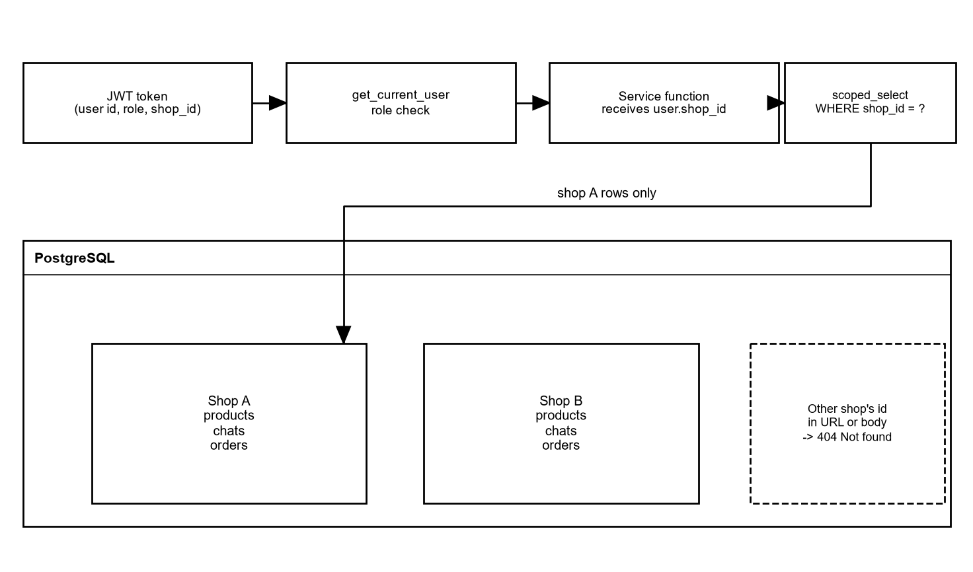
Figure 76: Multi-tenant isolation: how a request is scoped to one shop
The token holds the shop id. Services use it in every query. The database keeps the shop id on every shop-owned table with a foreign key.
- The shop id is never read from a request body or a URL; it comes from the verified token (test_shop_id_comes_from_token_only).
- A shop-scoped select helper adds WHERE shop_id = ... to queries; services for chats, orders, products, policy, Page and notifications use it.
- Asking for an object of another shop returns 404, so that the existence of the id is not shown.
- Retrieval filters embedding chunks by shop id before ranking; a test checks that another shop's chunks are never returned.
- The Messenger webhook finds the shop by the Page id; a Page only routes to its own shop, and a customer is one chat per shop.
- The cross-tenant sweep test logs in as the owner and moderator of shop B and calls every id endpoint of shop A; all return 403 or 404 and nothing changes.
- Deleting a shop removes all its rows by cascading foreign keys and leaves other shops untouched (tested).
Not implemented: PostgreSQL row-level security. Isolation is enforced in the application code and the schema, not by database policies.

49. Authentication/RBAC
Table 68: Authentication and role control
Item | How it works
Sign-up | Creates an owner and a shop. A platform admin is created only by a command-line tool (python -m app.cli create-admin), never by the API.
Login | E-mail and password; bcrypt check; rate limit; suspended shop refused. Returns a token valid for 720 minutes by default.
Token | HS256 JWT with sub, role, shop_id, exp and jti. The secret comes from JWT_SECRET; a test checks that it is required and not a placeholder.
Revocation | Logout, shop deletion and suspension stop tokens at once (deny list, user and shop status read on each request).
Role dependencies | require_owner, require_owner_or_moderator and require_platform_admin. The admin cannot use shop endpoints and a shop user cannot use admin endpoints.
Frontend | RoleGuard hides pages that a role may not use. This is only for comfort; the API enforces the rules.

The access of each role to each area is shown in Table "Permissions by role" in section 20, and for each endpoint in section 45.

50. Facebook Security
No App Secret, access token, encryption key or password is printed in this report. The settings are named only (section 63).
Table 69: Facebook security checks
Check | What the code does | Test
OAuth state | A signed token (purpose fb_connect, 10 minutes, one-time nonce in Redis). Invalid, expired, reused or foreign states are rejected and nothing is stored. | test_facebook
Permissions | The granted permissions must include pages_show_list, pages_messaging and pages_manage_metadata, else the owner gets a clear error. | test_facebook
Token handling | The code is exchanged for a long-lived user token; the user token is not stored. The list of Pages is kept encrypted in Redis for 10 minutes. The Page token is encrypted (Fernet) before it is saved. | test_facebook, test_secrets
One Page rules | A shop has one Page and a Page belongs to one shop (unique columns). | test_facebook
Webhook verification | GET returns the challenge only if the verify token matches FB_VERIFY_TOKEN. | test_messenger, test_webhook_and_limits
Signature | POST requires X-Hub-Signature-256 = HMAC-SHA256 of the raw body with the App Secret. Without a configured secret nothing is accepted. | test_webhook_and_limits
Echoes and unknown Pages | Messages sent by the Page itself, receipts and events for unknown Pages are ignored. | test_messenger
Duplicates | A message id (mid) is stored once per shop (unique rule); duplicates are processed once. | test_messenger
24-hour window | Checked in the processor and again in the sender; Facebook's own 'window closed' answer is not retried. | test_messenger
Disconnect | Unsubscribes the Page, deletes the stored token; still works if Facebook refuses the unsubscribe. | test_facebook
Logs | Errors are logged without tokens or customer text. | test_messenger, test_secrets

What was not tested: all these checks were tested against a fake Graph API, a stub Send API and signed test events. A real Page, a real App with live permissions, and Facebook's App Review were not used. Behaviour with real Facebook (rate limits, error codes, retries) may differ.

51. Testing Strategy
The project is tested at four levels: unit tests for pure logic, integration tests with a real PostgreSQL and Redis, API tests through the FastAPI test client, and manual or scripted runs for the whole chain. The AI is tested with the mock model for the rules and with the real model for quality and speed. All automated suites were run again on 2 October 2026 for this report.
Table 70: Test levels
Level | What it covers | Tool | Where
Unit | Validators, budget parsing, handover rules, chunking, metrics, language, providers | pytest | ai_engine/tests, evaluation/tests
Integration | Services with the real database and Redis: embeddings, usage limits, ingest and processor, shop deletion | pytest with PostgreSQL 16 + pgvector and Redis | backend/tests
API | Every route, permissions of four callers, validation, tenant sweep | pytest + FastAPI TestClient | backend/tests, tests/security
AI quality | Intent, price and stock, order fields, zero-stock rule, phone re-ask, flags | evaluation harness (mock and real model) | evaluation/
End to end (scripted) | Sign-up to Test Chat in the browser; signed Messenger events through webhook, worker and a stub Send API | Browser script, simulate_messenger_event.py, fake Facebook | backend/scripts
UI / responsive | All listed pages at 375 px and 1366 px | Browser check | docs/TEST_REPORT.md section 10
Performance | 50 chats on 20 shops; real model and mock | Load test tool | backend/scripts/loadtest
Security | 47 security tests and a secret scan | pytest | backend/tests/security

51.1 Test environment
One developer computer: Intel Core i7-12700K, 15.8 GB RAM, Windows 11, Python 3.14, PostgreSQL 16 with pgvector and Redis 7 in Docker. Facebook was never contacted. The tests that talk to Facebook use a fake Graph API (scripts/fake_facebook.py), a stub Send API, or direct calls with signed test events.

51.2 Three kinds of AI and Facebook testing
Table 71: Kinds of testing and their limits
Kind | Used for | What it proves | What it does not prove
Mock / simulated | All automated backend and AI engine tests, most load tests, the production stack run | The rules, the code paths and the data flow work | Answer quality; real Facebook behaviour
Real OpenAI model | Evaluation on 32 sample cases, the NFR-01 load runs, the screenshots of Test Chat, the weekly insights on demo data | The pipeline works with the real model; typical speed and cost | Final accuracy (the 200-message set does not exist); behaviour on a bad provider day
Real Facebook | Not used at any point | - | Everything that depends on the real Messenger platform: delivery, rate limits, permissions, App Review

52. Unit Testing
Unit tests run without a database. The AI engine package has its own test suite that runs in about half a second.
Table 72: Unit tests of the AI engine
File (ai_engine/tests) | Tests | Covers
test_conversation.py | 52 | Engine flow with the mock model: replies, language, fallback, grounding check
test_handover.py | 45 | Seven reasons, priority, keywords, threshold
test_orders.py | 42 | Extraction, field checks, phone, stock, partial orders
test_validators.py | 37 | Bangladesh phone numbers, digits, prefixes
test_suggestions.py | 31 | Needs, budget, filter, maximum of three
test_insights.py | 28 | Weekly insight map and reduce, redaction
test_embeddings_and_retrieval.py | 15 | Chunking, retrieval, scores
test_factory.py | 1 | Provider selection
Total | 251 | All passed (0.55 s)

The evaluation package has 82 more tests (metric functions, case-file checks, the in-memory gateway, an end-to-end mock run and the command line). All passed (2.2 s).

53. Integration Testing
The backend tests use a real PostgreSQL database with pgvector and a real Redis. They check the services together with the database. Important groups:
Table 73: Integration test groups
Group | File | Tests | Examples
Messenger ingest and delivery | test_messenger.py | 44 | Message to reply through the stub Send API, duplicate mid, window, limit, retries, order of messages
Embeddings | test_embeddings.py | 19 | Create, edit, delete, re-embed, stale result dropped, usage logged
Facebook connection | test_facebook.py | 21 | Full flow, bad states, permissions, disconnect
Shop deletion and privacy | test_privacy.py | 18 | Everything removed, cross-tenant sweep, log masking
Limits under load | security/test_limits_under_load.py | 6 | 24 chats at once, window, suspension while waiting
Weekly insights | test_insights.py | 15 | Job, redaction, Celery task and beat entry

54. API Testing
Every route has tests for success, validation, permissions and tenant isolation. The generated role matrix calls all endpoints as anonymous, owner, moderator and platform admin and compares with the documented access table.
Table 74: API test files and test counts
File (backend/tests) | Tests
test_auth.py | 13
test_plans.py | 14
test_staff.py | 7
test_products.py | 22
test_product_import.py | 17
test_policy.py | 19
test_test_chat.py | 15
test_handover_api.py | 25
test_inbox.py | 19
test_orders_api.py | 13
test_orders_dashboard.py | 19
test_reports.py | 10
test_admin.py | 15
test_suggestions_api.py | 10
test_tenancy.py | 2
test_health.py | 5
test_loadtest_tools.py | 7

Sample requests and responses are in section 74.

55. E2E Testing
End-to-end tests here are scripted runs of the real application, not an automated browser test suite. Frontend component or browser tests (for example Playwright or Cypress files in the repository): Not implemented in the current version.
Table 75: End-to-end runs
Run | What happened | Result | Kind
NFR-05 walk-through | A script drove the production build of the dashboard: sign-up, five products, Test Chat question "Cotton Panjabi er dam koto?" | 58.5 s machine time in total; the reply came after 6.2 s with the real model | Real model, local
Messenger simulation | simulate_messenger_event.py sends signed events to the webhook; the Celery worker answers; a stub Send API receives the reply | Reply reached the stub for the right customer; also run inside the production compose network | Simulated Facebook
Fake Facebook connection | scripts/fake_facebook.py stands in for the Graph API and login dialog | Connect, list Pages, subscribe, disconnect worked in tests | Simulated Facebook
Screenshots for this report | The running app was opened in Edge as owner, moderator and platform admin; a Test Chat conversation created an order draft | The screens listed in section 76 were captured | Real model, local
Production compose | Images built; seven containers healthy; migrations ran by themselves; HTTPS with a local certificate | Passed (see section 61) | Local only

56. AI Testing
AI quality is measured by the evaluation harness in evaluation/. It runs the real ConversationEngine on labelled cases against an invented shop. The harness reports each metric overall and for Bangla, English and Banglish. The proposal's 200-message labelled test set does not exist, so the run below used the 32 sample cases that test the harness. The report itself says that these percentages are not results for the product.

56.1 Real-model run on the 32 sample cases
Run on 2 October 2026 with gpt-4o-mini and OpenAI embeddings: 121 seconds in the engine, 63,108 input and 5,408 output tokens. Cases: Bangla 6, English 15, Banglish 11.
Table 76: Evaluation of the real model on 32 sample cases
Metric | Target | Result | Status
Intent accuracy (AI-R01) | >= 85% | 100% (16 of 16) | Pass on a small sample
Prices and stock match the catalogue (AI-R03) | >= 95% | 93.8% (15 of 16) | Below target on a small sample
Order fields correct (AI-R07) | >= 90% | 100% (24 of 24) | Pass on a small sample
Zero-stock products suggested (AI-R06) | 0 violations | 0 of 3 suggestions | Pass on a small sample
Invalid phone asked again (AI-R08) | 100% | 100% (2 of 2) | Pass on a very small sample
Flag precision and recall | reported | 6 of 6 and 6 of 6 | -
Correct flag reason | reported | 83.3% (5 of 6) | -
Language recognised | reported | 100% (32 of 32) | -

56.2 The two failures
- s-int-bl-delivery (Banglish): the customer asked "Inside Dhaka e delivery charge koto?". The reply gave a greeting and said it would check with the shop; it did not state the charge of 60 taka. This is the one price and stock miss.
- s-hov-en-notindata (English): "Do you sell laptops?" was flagged as off_topic while the label was not_in_shop_data. The chat was handed over correctly, but the reason differs.
With the mock model the harness runs only to prove that it works; the mock result is not a quality result. Both reports are in evaluation/reports/ (git-ignored).

56.3 Coverage of the proposal's AI requirements
Table 77: Proposal AI requirements and their status
ID | Requirement (short) | Status in the implementation
AI-R01 | Intent accuracy >= 85% | Implemented. 100% (16 of 16) on the samples; final accuracy not measured.
AI-R02 | Bangla, English, Banglish; reply in the same style | Implemented and tested; style recognised in 32 of 32 sample cases; the reply script is checked in code.
AI-R03 | Prices and stock match the catalogue, >= 95% | Implemented (live data, grounding check). 93.8% (15 of 16) on the samples, below 95%; final not measured.
AI-R04 | "I'll check with the shop" and flag instead of guessing | Implemented and tested.
AI-R05 | Suggest 1 to 3 in-stock products | Implemented and tested.
AI-R06 | Never suggest zero stock | Implemented in code (filter on live data); 0 violations in 3 sample suggestions; tests.
AI-R07 | Order fields >= 90% correct | Implemented. 100% (24 of 24) on the samples; final not measured.
AI-R08 | Check the phone number, ask again | Implemented and tested (37 validator tests; 2 of 2 on the samples).
AI-R09 | Ask for missing order fields | Implemented and tested.
AI-R10 | Flag and notify on complaint, refund, abuse, low confidence | Implemented and tested; 6 of 6 flagged chats correct on the samples, 5 of 6 reasons right.
AI-R11 | No order confirmation, price change or discount by the AI | The AI cannot confirm an order (tested). The code has no function that changes a price; numbers in replies must come from the facts.
AI-R12 | Weekly summary of top 5 questions and missing products | Implemented and tested; run on demo data with the real model.
AI-R13 | Embeddings updated within 1 minute | Implemented as a background task queued at once. The elapsed time was not measured by a test.

56.4 Other AI tests
- The backend conversation tests check the rules with the mock model: grounded replies, Bangla script replies, fallback when the model is down, usage logging per shop.
- The load tests used the real model with varied Banglish, English and Bangla questions about price, stock, delivery, return policy and order wishes.
- Not done: a Gemini run, a local-embeddings run, and a test with real shop owners' messages.

57. UI/Responsive Testing
All pages were opened at 375 px and at 1366 px width (each inside a frame of that width), logged in as the demo owner or the platform admin with demo data. The check was: no sideways scrolling of the page and no element sticking out of the screen, except inside a deliberately scrollable area. The check was first tried on a page known to be too wide.
Table 78: Page-width checks (docs/TEST_REPORT.md section 10)
Area | Pages | 375 px | 1366 px
Public | /, /login, /signup, /forgot-password, /reset-password | Pass | Pass
Seller | /dashboard, /products, /products/new, /products/[id], /policy, /test-chat, /facebook, /plan, /staff, /settings, /inbox, /inbox/[id], /orders, /orders/[id], /reports | Pass | Pass
Admin | /admin, /admin/shops/[id], /admin/plans, /admin/ai-usage, /admin/health | Pass | Pass

The test report records 70 of 70 checks passed and found no layout bug, so no layout was changed. Limits: touch target size, text legibility and a real phone browser were not tested; the narrow width was emulated in a desktop browser. npm run lint and npm run build are clean.
During the screenshots for this report we saw one visual problem: on a wide screen the notification list opens to the left of the bell and its left edge is about 20 pixels outside the page. On a phone it fits. This was not changed.

58. Test Results
Table 79: Automated test results
Suite | Tests | Result | Date
backend (pytest, includes 47 security tests) | 396 | 396 passed (5 min 9 s) | 2 Oct 2026
ai_engine (pytest) | 251 | 251 passed (0.55 s) | 2 Oct 2026
evaluation (pytest) | 82 | 82 passed (2.2 s) | 2 Oct 2026
frontend lint and build | - | Clean (recorded in docs/TEST_REPORT.md) | 2 Oct 2026
Total automated tests | 729 | 729 passed, 0 failed

58.1 Test case tables
Each row below is one test case that is backed by an automated test. "Actual" gives the result and the name of the test. A row is Pass only because the test passes on the final code.
Table 80: Test cases TC-01 to TC-23
Test ID | Feature | Input | Expected | Actual | Status
TC-01 | Sign-up | POST /auth/signup with shop name, e-mail, password | Shop and owner created; token returned | Pass (test_signup_creates_shop_and_owner) | Pass
TC-02 | Password hash | Sign up, read users row | Stored value is a bcrypt hash, not the password | Pass (test_passwords_are_stored_as_bcrypt_hashes...) | Pass
TC-03 | Login failure | Wrong password and unknown e-mail | Same 401 text for both | Pass (test_login_does_not_reveal_whether_an_account_exists) | Pass
TC-04 | Logout | Log out, reuse the token | Token rejected; other sessions still work | Pass (test_logout_revokes_the_token...) | Pass
TC-05 | Tampered token | Changed role, removed signature, alg none, expired | 401 each time | Pass (test_tampered_forged_and_expired_tokens_are_rejected) | Pass
TC-06 | Password reset | Request link, confirm with token | Password changed; token cannot be reused | Pass (test_password_reset_flow) | Pass
TC-07 | Reset token expiry | Use token after 60 minutes | 400 invalid or expired | Pass (test_password_reset_token_expires) | Pass
TC-08 | Login rate limit | More wrong logins than the limit | 429 for that account and for that address | Pass (test_login_rate_limit) | Pass
TC-09 | Suspended shop | Login and old token of a suspended shop | 403 / access lost | Pass (test_suspended_shop_cannot_log_in_or_use_api) | Pass
TC-10 | Tenant isolation | Owner of shop B reads shop A product/chat/order | 404 everywhere; nothing changes | Pass (test_cross_tenant_sweep_shop_b_cannot_reach_shop_a) | Pass
TC-11 | Role matrix | Every endpoint, four callers | Each caller gets the documented answer | Pass (test_every_endpoint_gives_every_role_the_right_answer) | Pass
TC-12 | Moderator rights | Moderator calls staff, plan change, products | 403 | Pass (test_moderator_forbidden_on_staff_and_plan_change) | Pass
TC-13 | Product create | POST /products valid data | 201 and product returned; embedding queued | Pass (test_crud, test_change_hooks_are_called) | Pass
TC-14 | Product validation | Invalid price or stock value | 422 with errors | Pass (test_validation_errors) | Pass
TC-15 | Photo upload | 6 photos to one product | Limit of 5 enforced | Pass (test_photo_upload_serves_url_and_limits_to_five) | Pass
TC-16 | Fake image | Upload a text file named .png | Rejected, nothing saved | Pass (test_upload_rejects_non_images_all_or_nothing) | Pass
TC-17 | Photo delete | DELETE photo by index | File removed from disk and product | Pass (test_remove_photo_deletes_file) | Pass
TC-18 | CSV import | File with valid and invalid rows | Valid rows created; invalid rows reported by row number | Pass (test_mixed_rows_report_row_numbers_and_reasons) | Pass
TC-19 | Import limits | File over 2 MB or over 1000 rows | Rejected with a clear error | Pass (test_file_too_large_and_too_many_rows) | Pass
TC-20 | Policy save | PUT /shop/policy with two areas | Saved; policy chunk embedded | Pass (test_save_then_update, test_policy_save_embeds_policy_chunks...) | Pass
TC-21 | Embeddings on edit | Edit a product | Old chunks replaced | Pass (test_editing_a_product_replaces_its_chunks) | Pass
TC-22 | Vector index | Inspect the database index | HNSW with cosine operator | Pass (test_index_is_hnsw_cosine) | Pass
TC-23 | Semantic search isolation | Search in shop A | Never a chunk of shop B | Pass (test_retrieval_never_returns_another_shops_chunks) | Pass

Table 81: Test cases TC-24 to TC-46
Test ID | Feature | Input | Expected | Actual | Status
TC-24 | Price question | "Cotton Panjabi er dam koto?" in Test Chat | Reply with the price from the catalogue | Pass (test_proposal_example_messages_get_grounded_replies) | Pass
TC-25 | Unknown question | A question with no shop data | "I will check with the shop" style reply | Pass (test_unknown_question_says_i_will_check_with_the_shop) | Pass
TC-26 | Bangla reply | Message in Bangla script | Reply in Bangla script | Pass (test_bangla_script_reply_is_in_bangla) | Pass
TC-27 | AI disclosure | Two messages in one chat | Disclosure only in the first AI reply | Pass (test_disclosure_is_sent_in_the_first_ai_reply_only) | Pass
TC-28 | Memory | Ten turns, then a question | Only the last turns are given to the engine; rebuilt from DB if Redis is empty | Pass (test_short_term_memory..., test_memory_is_rebuilt...) | Pass
TC-29 | Suggestion with budget | Gift request with a budget | Matching in-stock products with price | Pass (test_proposal_example_returns_matching_in_stock_products_with_price) | Pass
TC-30 | Zero stock | Only out-of-stock products match | No card for them | Pass (test_a_zero_stock_product_is_never_suggested) | Pass
TC-31 | Max three | Ten products match | At most three cards | Pass (test_at_most_three_cards) | Pass
TC-32 | Order collection | Product, then name, phone, address over turns | Asks for what is missing, then creates one draft | Pass (test_multi_turn_conversation_asks_for_what_is_missing...) | Pass
TC-33 | AI never confirms | Customer says "confirm my order" | Status stays draft | Pass (test_the_ai_never_confirms_an_order) | Pass
TC-34 | Phone validation | Invalid and valid numbers, Bangla digits, +88 | Invalid asked again; valid normalised to 01XXXXXXXXX | Pass (validator tests, 37 tests) | Pass
TC-35 | Out-of-stock order | Order of a product with zero stock | No draft | Pass (test_out_of_stock_product_is_refused_from_the_catalogue) | Pass
TC-36 | Handover reasons | One message per reason (7) | Chat flagged, AI paused, event saved | Pass (test_each_reason_flags_the_test_chat..., 7 cases) | Pass
TC-37 | Notification | Flagged Messenger chat | One notification per flag; none for a paused chat | Pass (test_messenger_chats_create_a_notification_for_every_reason) | Pass
TC-38 | Pause / resume | Pause, customer writes, resume | No AI reply while paused; reply after resume | Pass (test_a_paused_chat_gets_no_ai_reply_and_a_resumed_one_does) | Pass
TC-39 | Webhook handshake | GET with right and wrong verify token | Challenge echoed; 403 for wrong | Pass (test_verification_handshake) | Pass
TC-40 | Webhook signature | Unsigned, wrong secret, changed body | 403 and nothing stored | Pass (test_the_webhook_accepts_only_a_correct_signature) | Pass
TC-41 | Duplicate mid | Same event twice | Processed once | Pass (test_duplicate_mid_is_processed_once) | Pass
TC-42 | Echo events | Message sent by the Page itself | Ignored | Pass (test_echoes_receipts_and_the_pages_own_messages_are_ignored) | Pass
TC-43 | Reply delivery | Signed message through webhook, worker, stub Send API | Reply sent to the right customer; sent_at set | Pass (test_message_to_reply_through_the_send_api) | Pass
TC-44 | 24-hour window | Message older than 24 hours / just inside | Not answered / answered | Pass (test_a_message_older_than_24_hours_is_not_answered, ..._just_inside_...) | Pass
TC-45 | Monthly limit | Last allowed message and the next | Last answered; next skipped | Pass (test_the_last_message_within_the_limit_is_answered...) | Pass
TC-46 | Limit under load | 24 chats at once, limit 5 | Exactly 5 replies sent | Pass (test_the_monthly_limit_holds_when_many_chats_are_answered_at_once) | Pass

Table 82: Test cases TC-47 to TC-68
Test ID | Feature | Input | Expected | Actual | Status
TC-47 | Send failure | Facebook refuses the send | Not counted; worker keeps running | Pass (test_a_failed_send_is_not_counted_and_the_worker_survives) | Pass
TC-48 | Retries | Temporary Facebook errors | Limited retries; success counted once | Pass (test_temporary_errors_are_retried..., test_a_temporary_error_followed_by_success_counts_once) | Pass
TC-49 | Non-text message | Customer sends an image | Placeholder stored; handed to seller | Pass (test_non_text_messages_are_stored_as_a_placeholder_and_handed_over) | Pass
TC-50 | Facebook connect | Full OAuth flow with fake Facebook | Page stored with encrypted token | Pass (test_full_connect_flow_stores_the_page_token_encrypted) | Pass
TC-51 | OAuth state | Invalid, expired, reused, foreign state | Rejected; nothing stored | Pass (test_invalid_expired_reused_and_foreign_states_are_rejected) | Pass
TC-52 | Page of other shop | Connect a Page used by another shop | Rejected | Pass (test_a_page_connected_to_another_shop_is_rejected) | Pass
TC-53 | Inbox order | Flagged and normal chats | Flagged first, then latest activity | Pass (test_flagged_chats_come_first_then_latest_activity) | Pass
TC-54 | Seller reply | Reply while AI is paused | Sent through Send API and stored | Pass (test_reply_is_sent_through_the_send_api_and_stored) | Pass
TC-55 | Reply rules | Reply with AI active / outside window | Rejected / rejected | Pass (test_reply_is_rejected_while_the_ai_is_not_paused, ..._outside_the_24_hour_window) | Pass
TC-56 | Order edit | Change product of a draft | Catalogue price taken; size and colour re-checked | Pass (test_changing_the_product_takes_the_catalogue_price...) | Pass
TC-57 | Order transitions | Confirm and cancel; confirm a cancelled order | Allowed for drafts; 409 otherwise | Pass (test_confirm_and_cancel_transitions) | Pass
TC-58 | CSV export | Export with a date range | Fixed columns, confirmed only, Dhaka days | Pass (test_export_has_exact_columns..., test_export_range_uses_dhaka_days...) | Pass
TC-59 | CSV formula | Customer name starting with = | Cell neutralised | Pass (test_export_neutralises_spreadsheet_formulas) | Pass
TC-60 | Report | Range with messages, chats, orders | Counts at the boundaries; test data excluded | Pass (test_every_metric_at_the_range_boundaries, test_test_chat_data_is_excluded_everywhere) | Pass
TC-61 | Weekly insights | Seeded chats, run the job | Summary stored; phone numbers never reach the model | Pass (test_generation_from_seeded_chats..., test_customer_names_and_phone_numbers_never_reach_the_model) | Pass
TC-62 | Plan change | Change to a paid plan without confirmation | Rejected; with confirmation a simulated payment row | Pass (test_paid_plan_without_confirmation_is_rejected) | Pass
TC-63 | Admin suspend | Suspend a shop | Users blocked; customers get no AI reply; logged | Pass (test_suspend_blocks_the_shops_users..., test_a_suspended_shops_messenger_customers_get_no_ai_reply...) | Pass
TC-64 | Shop deletion | Delete with right password and name | All rows, files and keys removed; other shop intact | Pass (test_deleting_a_shop_removes_all_its_rows_files_and_keys...) | Pass
TC-65 | Deletion guard | Wrong password or wrong name | Nothing deleted | Pass (test_wrong_password_or_wrong_name_deletes_nothing) | Pass
TC-66 | Secrets in logs | Login, connect, webhook, full chat | No token, password or customer text in logs | Pass (test_no_secret_is_written_to_the_logs...) | Pass
TC-67 | Secrets in repository | Scan files that would be committed | No keys, no real .env | Pass (test_the_repository_contains_no_api_keys_or_private_keys) | Pass
TC-68 | Health | Stop the database or Redis | 503 degraded | Pass (test_health_answers_503_when_a_dependency_is_down) | Pass

58.2 Defects found by testing
The load and security work found these defects, all fixed and kept as tests: the monthly limit could be passed under concurrency (24 replies sent for a limit of 5), a single-message worker was too slow for 50 chats (p90 42.8 s), the first burst after a worker start was slow (p90 10.0 s), Celery results piled up in Redis, rate limits saw the proxy instead of the client, and one of our own tests checked nothing. Details are in docs/TEST_REPORT.md section 6.

59. Performance Evaluation

59.1 Environment and method
One Windows computer (i7-12700K, 15.8 GB). The load generator, API, worker, PostgreSQL and Redis all ran on it. Facebook was replaced by a stub Send API that answers in 150 ms. 20 test shops (Pro plan, three products each, a policy, a fake connected Page) and 50 chats were created. Each chat sent its messages through the real webhook with a valid signature, one every few seconds, and all chats started within half a second. Latency is sent_at - received_at from the database, the same figure the product records. The real-model runs used 2 messages per chat (100 messages), the mock runs 3 (150 messages).

59.2 Results
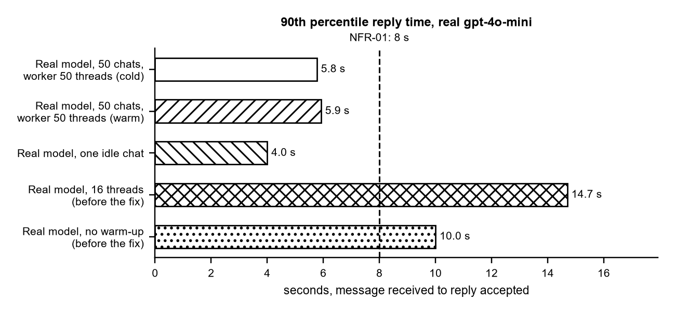
Figure 77: 90th percentile reply time with the real model
With a worker of 50 threads, p90 was 5.77 s from a fresh start and 5.92 s on the second run, against the 8 s target. The two longer bars are runs before the fixes (16 threads: 14.7 s; no worker warm-up: 10.0 s).
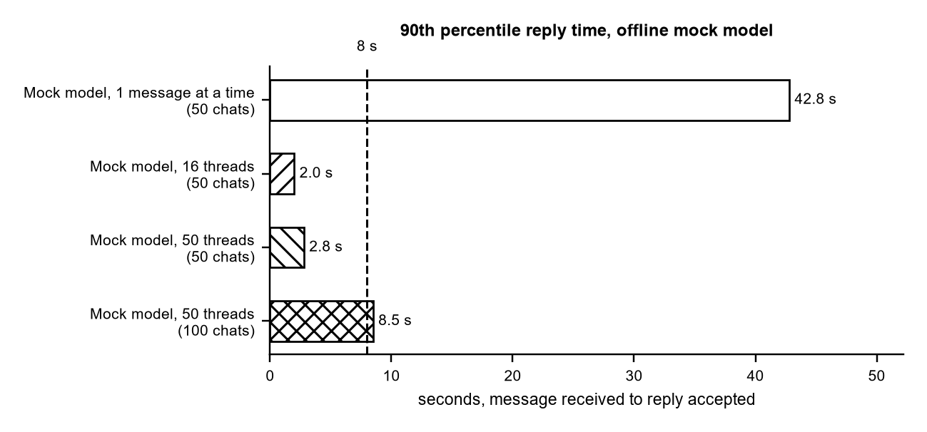
Figure 78: 90th percentile reply time with the offline mock model
The mock answers in about 0.1 s, so these runs show the cost of the pipeline itself. A worker that handles one message at a time failed (42.8 s). 50 threads passed with 50 chats; with 100 chats at once p90 was 8.5 s.
Table 83: Load test results
Run (final code) | p50 / p90 / p99 (s) | Target | Result
Real model, 50 chats, 50 threads, cold worker | 5.06 / 5.77 / 6.73 | p90 <= 8 s | Within the target (local, stub Facebook)
Real model, same worker, second run | 5.24 / 5.92 / 6.97 | p90 <= 8 s | Within the target
Real model, one idle chat | 3.3 / 4.0 | - | Baseline
Mock, 16 threads, 50 chats | 1.2 / 2.0 / 2.5 | p90 <= 8 s | Within the target
Mock, 50 threads, 50 chats | 1.9 / 2.8 / 3.1 | p90 <= 8 s | Within the target
Mock, 50 threads, 100 chats | 5.6 / 8.5 / 8.7 | p90 <= 8 s | Just over: limit of one worker process
Mock, one message at a time | 24.1 / 42.8 / 47.7 | p90 <= 8 s | Failed (all 150 handled after 58 s)

59.3 Other measurements
- A reply costs about 3 s of AI time (2 to 4 model calls). The rest of the p50 is the burst: 50 messages in one second, then 0.15 s to send.
- The webhook answered with p50 89 to 283 ms and p90 344 to 651 ms in the real-model runs.
- The setup of 20 shops plus the two real runs used about 530 model calls, about 5 US cents.
- NFR-05: the scripted sign-up with five products and one Test Chat question took 58.5 s of machine time.

59.4 What is verified and what is not
- Verified locally: NFR-01 and NFR-07 on one machine with a stub Facebook.
- Not verified: real Facebook latency and rate limits, a second API process, several worker processes, long runs of hours, and any public server.
- The result depends on the provider's speed on the day (about 1 to 1.5 s per call here).

60. NFR Evaluation
Table 84: Evaluation of the non-functional requirements
ID | Requirement | Evidence | Verdict
NFR-01 | AI reply within 8 seconds for 90% of messages. | p90 5.8 s with the real model (gpt-4o-mini), 50 chats, one machine, stub Facebook. 8.5 s at 100 chats with the mock model. | Tested locally; not tested with real Facebook
NFR-02 | 99% availability. | Not measured. The system was never run as a public service. | Not verified
NFR-03 | Passwords hashed, HTTPS, tokens encrypted. | bcrypt hashes, Fernet-encrypted Page tokens: tested. HTTPS is done by Caddy in the production compose; tested with a local certificate only. | Partly verified
NFR-04 | Customer data private to the shop. | Cross-tenant sweep and 47 security tests pass. | Tested
NFR-05 | A new owner can sign up, add 5 products and test the AI in under 15 minutes. | A scripted walk-through took 58.5 s of machine time; a person's time was estimated at 5 to 8 minutes, not measured with users. | Estimated, not user-tested
NFR-06 | Dashboard works on a phone and a laptop. | 70 of 70 page-width checks (375 px and 1366 px) showed no sideways overflow (docs/TEST_REPORT.md section 10). | Tested
NFR-07 | At least 20 shops and 50 simultaneous chats. | 50 chats on 20 shops: all answered, no failed message (local load test). | Tested locally
NFR-08 | AI usage is logged per shop. | ai_usage_logs, one row per AI call. | Implemented, tested
NFR-09 | Reply only inside Facebook's 24-hour window. | Checked in the processor and again in the sender. | Implemented, tested
NFR-10 | Logs must not contain secrets or customer data (added during implementation). | Log masking tests and a conversation test that scans the logs. | Tested
NFR-11 | The system can be started with Docker (added during implementation). | Production compose stack built and run locally; not deployed to a public server. | Tested locally

Only NFR-04, NFR-08, NFR-09 and NFR-10 are fully covered by automated tests. NFR-01, NFR-06, NFR-07 and NFR-11 are verified in a local setup. NFR-02 (99% availability) cannot be judged without a running public service and is not claimed.

61. Deployment
Status in one sentence: the system was run on a developer computer, including the production Docker stack with a local certificate. It was not deployed to a public server. The repository holds everything needed for two deployment options. Both are described in docs/DEPLOYMENT.md.
Table 85: Deployment options
Option | What it uses | Status
A: Render + Vercel | deploy/render.yaml creates the API (web service), the Celery worker, the Celery beat scheduler, a managed PostgreSQL 16 and a Redis-compatible store. The frontend goes to Vercel. | Files written. Not deployed, not tested on Render or Vercel (accounts and credentials were not available).
B: one server with Docker Compose | deploy/docker-compose.prod.yml with Caddy (HTTPS and Let's Encrypt), frontend, api, worker, beat, postgres and redis. | Built and run on a developer computer with a local certificate. Not run on a public server.

61.1 Production compose: what was checked locally
- Images build; the backend image runs as a normal user (uid 10001) and holds no secret.
- All seven containers reach the healthy state; the api runs the migrations by itself.
- Through the proxy: health 200, HTTP redirected to HTTPS, security headers added, API docs hidden (404), CORS allows only the frontend address.
- The Messenger simulation script ran inside the compose network: the worker container answered and the reply reached the stub.
- The api was restarted by Docker after a stop signal and was healthy after about 35 seconds.
- Found and fixed during this run: the proxy answered 503 before the api was ready; the beat container reported unhealthy; the site address must not contain a port.

61.2 Not done
- A public domain, a real certificate from Let's Encrypt, and a running public demo.
- Facebook App settings in Meta for Developers with the production webhook URL, and Facebook App Review.
- A real SMTP server for password-reset e-mail.
- Backups were described (pg_dump of the database volume) but a restore was not rehearsed.

62. Docker
Table 86: Docker images and services
Image / service | Base and content | Notes
shopsathi-backend (api, worker, beat, migrate, cli) | python:3.12-slim; installs requirements and the ai_engine package; no tests; one image for all roles chosen by the first argument | Built from the repository root. Health check calls /api/v1/health. Photos on a volume at /data/media. Worker uses a thread pool (50 threads by default).
shopsathi-frontend | Next.js standalone build; user node | Image about 309 MB. The backend address is compiled in at build time.
postgres | pgvector image for PostgreSQL 16 | Named volume pgdata
redis | Redis | Named volume redisdata
proxy | Caddy | Routes the API and the frontend; HTTPS; volume caddy_data keeps certificates

The backend image was about 694 MB. The entrypoint docker-entrypoint.sh has the commands api (runs alembic upgrade head, then uvicorn), worker, beat, migrate and cli.
# build and start the production stack (from the deploy folder)
cp .env.prod.example .env.prod # then fill in the values
docker compose --env-file .env.prod -f docker-compose.prod.yml up -d --build
docker compose --env-file .env.prod -f docker-compose.prod.yml ps

For local development, database/docker-compose.yml starts only PostgreSQL with pgvector and Redis, and the API, worker and frontend run directly on the computer.

63. Environment Setup
All settings are environment variables, read by backend/app/core/config.py. No secret has a default value in the code (a test checks this). The table lists the names, the group and, for non-secret settings, the default. A secret is never printed in this report. Values for a real run go into backend/.env (development) or deploy/.env.prod (production); both files are git-ignored, and the example files backend/.env.example and deploy/.env.prod.example contain only names and safe placeholders.
Table 87: Settings of the backend
Variable | Group | Default
APP_ENV | Core | local
DATABASE_URL | Database and Redis | secret: not shown
DB_POOL_SIZE | Database and Redis | 10
DB_MAX_OVERFLOW | Database and Redis | 20
DB_POOL_TIMEOUT_SECONDS | Database and Redis | 30
TEST_DATABASE_URL | Database and Redis | secret: not shown
REDIS_URL | Database and Redis | secret: not shown
FRONTEND_ORIGIN | Core | http://localhost:3000
BACKEND_PUBLIC_URL | Core | http://localhost:8000
MEDIA_ROOT | Core | media
MAX_UPLOAD_MB | Limits | 5
LLM_PROVIDER | AI | mock
LLM_MODEL | AI | gpt-4o-mini
EMBEDDING_PROVIDER | AI | mock
EMBEDDING_MODEL | AI | text-embedding-3-small
EMBEDDING_DIM | AI | 1536
OPENAI_API_KEY | AI | secret: not shown
GEMINI_API_KEY | AI | secret: not shown
AI_COST_RATES | AI | per-model price table
FB_APP_ID | Facebook | empty (set per environment)
FB_APP_SECRET | Facebook | secret: not shown
FB_GRAPH_API_VERSION | Facebook | v21.0
FB_OAUTH_REDIRECT_URI | Facebook | empty (set per environment)
FB_TOKEN_ENCRYPTION_KEY | Facebook | secret: not shown
FRONTEND_URL | Core | empty (set per environment)
FB_VERIFY_TOKEN | Facebook | secret: not shown
FB_SEND_MAX_ATTEMPTS | Facebook | 3
FB_SEND_RETRY_DELAY_SECONDS | Facebook | 0.5
TRUSTED_PROXIES | Core | 127.0.0.1
FB_GRAPH_BASE_URL | Facebook (test) | https://graph.facebook.com
FB_DIALOG_BASE_URL | Facebook (test) | https://www.facebook.com
CHAT_MEMORY_TURNS | AI | 8
CHAT_MEMORY_TTL_SECONDS | AI | 21600
RAG_MIN_SCORE | AI | 0.2
RAG_MIN_PRODUCT_SCORE | AI | 0.3
AI_CONFIDENCE_THRESHOLD | AI | 0.5
REPORT_MAX_RANGE_DAYS | Limits | 366
ORDER_PENDING_TTL_HOURS | AI | 24
CELERY_TASK_ALWAYS_EAGER | Workers | False
MAX_IMPORT_MB | Limits | 2
MAX_IMPORT_ROWS | Limits | 1000
JWT_SECRET | Security | secret: not shown
ACCESS_TOKEN_EXPIRE_MINUTES | Security | 720
PASSWORD_MIN_LENGTH | Security | 8
PASSWORD_RESET_EXPIRE_MINUTES | Security | 60
LOGIN_RATE_LIMIT | Security | 10
LOGIN_RATE_WINDOW_SECONDS | Security | 300
RESET_RATE_LIMIT | Security | 5
RESET_RATE_WINDOW_SECONDS | Security | 900
SMTP_HOST | E-mail | empty (set per environment)
SMTP_PORT | E-mail | 587
SMTP_USERNAME | E-mail | secret: not shown
SMTP_PASSWORD | E-mail | secret: not shown
SMTP_FROM | E-mail | ShopSathi <no-reply@shopsathi.local>
SMTP_USE_TLS | E-mail | True

63.1 Extra variables of the production compose
deploy/.env.prod.example adds: API_SITE, FRONTEND_SITE, ACME_EMAIL, HTTP_PORT, HTTPS_PORT, POSTGRES_USER, POSTGRES_PASSWORD, POSTGRES_DB, ADMIN_PASSWORD, WORKER_CONCURRENCY and SHOPSATHI_VERSION.

64. CI/CD
Not implemented in the current version. The repository has no continuous integration workflow (no .github/workflows file) and no automatic deployment pipeline. The tests are run by hand with the commands in section 72. The evaluation tool has an option --fail-on-target that exits with an error code, so that it could be used in a pipeline later.
Render can build and deploy from the Git repository automatically once the Blueprint is created (autoDeploy: true in render.yaml). This was not used.

65. Monitoring
Table 88: Monitoring
Item | What exists | Status
Health endpoint | GET /api/v1/health returns 200 or 503 with api, database and redis state | Implemented, tested
Admin health page | Shows API, database, Redis, the Celery worker (a ping task) and the number of jobs waiting in the queue | Implemented, tested (screenshot in section 43)
Docker health checks | api, worker, beat and others have checks; the proxy waits for a healthy api | Implemented, run locally
AI usage and cost | Admin page with usage and cost per shop for a date range (from ai_usage_logs) | Implemented, tested
Reply timings | Each AI reply stores queue, AI and send times in the message | Implemented, tested
Logs | Python logging with masking of secrets and personal numbers | Implemented, tested
External uptime monitor, alerts, metrics server (for example Prometheus) | Described in docs/DEPLOYMENT.md as advice | Not implemented in the current version

NFR-02 (99% availability) needs a public service running for weeks with a monitor. This was not done, so availability was not measured.

66. Results
The table compares the objectives of section 13 with the result.
Table 89: Objectives and results
Objective | Result | Evidence
1. Account, shop, products, photos, policy | Done | FR-01 to FR-10; test_auth, test_products, test_policy
2. Answers in three language styles from shop data | Done; quality measured on 32 samples only | FR-13, FR-14; section 56
3. Suggestions with budget | Done | FR-16; test_suggestions*
4. Order collection and draft | Done; AI never confirms | FR-17, BR-02; test_orders*
5. Handover | Done: 7 reasons | FR-18, FR-19; test_handover*
6. Facebook Page, webhook, 24-hour window | Done; tested with a simulated Facebook only | FR-20 to FR-22; test_facebook, test_messenger
7. Inbox, orders, CSV, reports, weekly summary | Done | FR-23 to FR-30
8. Isolation and roles | Done | FR-04, FR-05; 47 security tests
9. Plans, limits, usage, admin | Done; payment is a simulation | FR-31 to FR-35
10. Measure and report honestly | Done with limits (no 200-message test set; no real Facebook) | Sections 51 to 60

66.1 Size of the project
Table 90: Size of the project
Item | Count
API operations | 63 (plus the Facebook callback)
Database tables / migrations | 19 / 13
Backend routes files / services / models | 14 / 18 / 13
AI engine modules (excluding prompts and providers) | 17
Frontend page and layout files / shared components | 30 / 11
Automated tests (backend / AI engine / evaluation) | 396 / 251 / 82

The counts of files come from the repository on the date of this report.

66.2 Demonstration
The screenshots in section 43 and section 76 show the working application with demo data: the Inbox with two flagged chats, orders in three states, the reports page with the weekly AI summary, and a Test Chat in which the real model created an order draft.

67. Limitations
- Real Facebook was never used. All Messenger work was tested with a fake Graph API, a stub Send API and signed test events. Facebook App Review was not done. Real delivery, rate limits and error codes may behave differently.
- No public deployment. Availability (NFR-02) is not measured.
- No final AI accuracy. The 200-message labelled test set does not exist. The real-model numbers come from 32 sample cases; the price and stock result (93.8%) is below the 95% target on that small sample, and the one miss was a Banglish delivery-charge question.
- Speed was measured on one machine with a stub Facebook; one worker process handles about 16 messages per second.
- Payments are simulated. No real payment provider exists in the code.
- No e-mail verification of new accounts and no two-factor login. Password-reset e-mail was not tested with a real SMTP server.
- No Instagram, no voice or image understanding, no courier integration, no stock reduction on order confirmation.
- Isolation is in the application and the schema, not in database row-level security.
- Frontend has no automated browser tests; it was checked by lint, build, page-width checks and manual runs.
- Gemini provider and local embeddings exist in the code but were not run.
- Notification panel position: on a wide screen the list opens to the left of the bell and is slightly cut off at the page edge.
- No user study. The 15-minute sign-up goal (NFR-05) is an estimate from a scripted run.

68. Future Work
These items are ideas for later versions. None of them is part of the current system.
- Connect a real Facebook Page, run the App Review, and test real delivery and rate limits.
- Prepare the 200-message labelled test set from real chats (with permission), tune the prompts on a separate set, and report the accuracy targets.
- Deploy to a public server with a real domain, add an uptime monitor and alerts, and measure availability.
- Add real payments (for example bKash or Nagad) through a payment provider.
- Add a continuous integration workflow that runs the three test suites and the evaluation with the mock model.
- Add browser tests for the main flows.
- Instagram messaging, image understanding, and voice messages.
- Courier integration so that confirmed orders are sent automatically.
- Optional stock reduction when an order is confirmed.
- E-mail verification, two-factor login, and PostgreSQL row-level security as a second layer of isolation.
- Fix the notification panel position on wide screens.

69. Conclusion
ShopSathi is a working multi-tenant web application for small Facebook shops. A shop owner can create an account, add products and a policy, test the AI, connect a Facebook Page, follow customer chats in an Inbox, take over a chat, review draft orders, confirm them and export a CSV list for the courier. The AI engine answers in Bangla, English and Banglish from the shop's own data, suggests products inside a budget, collects order details with code-side checks, and hands difficult chats to a person. A platform admin can manage shops, plans, AI cost and system health.
The strongest parts of the project are its safety rules and its tests. Prices and stock are read from live data, the AI cannot confirm an order, every shop is separated from the others, and 729 automated tests pass. A local load test with the real model met the 8 second target (p90 5.8 s with 50 chats on 20 shops).
The project also has clear gaps, and this report names them. Real Facebook was never connected, so all Messenger behaviour was tested with a simulated Facebook. The system was not deployed to a public server, so availability was not measured. The 200-message labelled test set does not exist, so the final AI accuracy is not known; on 32 sample cases the price and stock result (93.8%) was just below the 95% target. Payments are only a simulation.
The next steps are clear: connect a real Page and run Facebook's review, build and use the labelled test set, deploy to a public server with monitoring, and add real payments. Section 68 lists them. We think the project reached its main goal, a safe and honest first version of an AI sales agent for small Bangladeshi shops, and it leaves a clean base for these steps.

70. References
These are the documents and technologies that the project used. The online documents were used as technical references while building the system; we did not copy text from them.
1. ShopSathi: An AI Sales Agent for Facebook Shops. SE-331 Project Proposal Report, Daffodil International University, Department of Software Engineering (project file ShopSathi.docx).
2. The Business Standard, July 2024: estimate of the number of f-commerce pages by the e-Commerce Association of Bangladesh. We quote it as cited in our proposal; we did not re-read the article for this report.
3. Meta. Messenger Platform documentation (webhooks, Send API, messaging window), https://developers.facebook.com/docs/messenger-platform
4. Meta. Facebook Login and Graph API documentation, https://developers.facebook.com/docs/
5. OpenAI. API documentation (chat completions with JSON output, embeddings), https://platform.openai.com/docs
6. pgvector: open-source vector similarity search for PostgreSQL, https://github.com/pgvector/pgvector
7. PostgreSQL Global Development Group. PostgreSQL documentation, https://www.postgresql.org/docs/
8. FastAPI documentation, https://fastapi.tiangolo.com/
9. SQLAlchemy documentation, https://docs.sqlalchemy.org/ and Alembic documentation, https://alembic.sqlalchemy.org/
10. Celery documentation, https://docs.celeryq.dev/ and Redis documentation, https://redis.io/docs/
11. Next.js documentation, https://nextjs.org/docs and Tailwind CSS documentation, https://tailwindcss.com/docs
12. LangChain documentation, https://python.langchain.com/
13. Jones, M., Bradley, J., Sakimura, N. RFC 7519: JSON Web Token (JWT), https://www.rfc-editor.org/rfc/rfc7519
14. Python Cryptographic Authority. cryptography: Fernet (symmetric encryption), https://cryptography.io/en/latest/fernet/
15. Caddy web server documentation, https://caddyserver.com/docs/ and Docker documentation, https://docs.docker.com/
16. Project documents in the repository: docs/PROGRESS.md, docs/TEST_REPORT.md, docs/DEPLOYMENT.md, docs/USER_GUIDE.md, evaluation/README.md and the report in evaluation/reports.

71. Appendix

A. Repository layout
Table 91: Repository layout
Folder | Content
backend/app | FastAPI application: api/v1/routes, services, models, schemas, core, integrations/facebook, workers, ai_adapters
backend/alembic | Database migrations 0001 to 0013
backend/tests | 396 backend tests, including tests/security (47)
backend/scripts | fake_facebook, simulate_messenger_event, load test tools, AI check scripts
ai_engine/shopsathi_ai | The AI engine package with prompts and providers
ai_engine/tests | 251 tests
evaluation | Evaluation harness, fixtures, sample cases, reports
frontend/src | Next.js app: app (pages), components, lib
database | Development compose file for PostgreSQL and Redis, init scripts, demo seed data
deploy | Production compose, Caddyfile, Render blueprint, env example
docs | PROGRESS, TEST_REPORT, DEPLOYMENT, USER_GUIDE, CONVENTIONS and this report's generator (docs/report)

B. CSV formats
Product import template (GET /products/import/template). Sizes and colours are separated by |; photos are web addresses.
name,description,price,sizes,colours,stock,photos
Cotton Panjabi,Comfortable everyday panjabi,1850,M|L|XL,White|Navy,24,https://example.com/panjabi.jpg

Order export (GET /orders/export). UTF-8 with a byte-order mark so that Excel shows Bangla text. The first rows of the file produced from the demo data:
order_id,confirmed_at,customer_name,customer_phone,customer_address,product_name,size,colour,quantity,unit_price,total_price
22,2026-08-21 13:08,Mahmuda Begum,01700001002,"Flat 4B, Green Road, Dhaka",Cotton Panjabi,XL,Navy,1,1850.00,1850.00
27,2026-09-01 14:07,Zahid Hasan,01700001009,"House 12, Road 5, Mirpur 10, Dhaka",Homemade Mango Pickle (Achar) 500g,500g,,3,450.00,1350.00

The names, numbers and addresses above belong to invented demo customers.

C. Database summary
Table 92: Tables and counts
Table | Columns | Indexes | CHECK rules
plans | 5 | 0 | 1
shops | 5 | 1 | 1
ai_usage_logs | 9 | 1 | 0
delivery_areas | 4 | 2 | 1
embedding_chunks | 7 | 2 | 1
facebook_pages | 6 | 0 | 0
products | 11 | 1 | 3
shop_message_usage | 4 | 1 | 0
shop_policies | 6 | 0 | 0
simulated_payments | 6 | 1 | 1
users | 8 | 2 | 2
weekly_insights | 6 | 1 | 0
admin_actions | 6 | 2 | 0
chats | 15 | 2 | 1
password_reset_tokens | 5 | 1 | 0
handover_events | 5 | 2 | 1
messages | 13 | 2 | 1
notifications | 7 | 1 | 1
orders | 19 | 2 | 2

D. Management commands
python -m app.cli --help
python -m app.cli create-admin --email <address> --full-name <name>
python -m app.cli seed
python -m app.cli reembed-all
python -m app.cli reembed-shop --shop-id <id>
python -m app.cli generate-insights --shop-id <id> --week-start <Monday date>

E. Where the other numbers come from
- Test counts: pytest --collect-only in backend, ai_engine and evaluation, and the runs of 2 October 2026.
- API and database lists: generated from the application's OpenAPI description and SQLAlchemy metadata by docs/report/extract_inventory.py.
- Load test numbers: docs/TEST_REPORT.md section 3. AI evaluation: evaluation/reports/report_20261002_002812_openai.md.

72. Installation Guide
This guide starts the system on one computer for development and testing. Needed: Docker, Python 3.11 or newer (the Docker image uses 3.12; the team ran 3.14), and Node.js 20 or newer. The commands are from the repository's README.

72.1 Database and Redis
cd database
cp .env.example .env
docker compose up -d

If ports 5432 or 6379 are already used, change POSTGRES_PORT or REDIS_PORT in database/.env and the URLs in backend/.env.

72.2 Backend
cd backend
python -m venv .venv
.venv\Scripts\activate # Windows; on Linux or Mac: source .venv/bin/activate
pip install -r requirements.txt
cp .env.example .env # then set JWT_SECRET (see the comment in the file)
alembic upgrade head
python -m app.cli seed # optional: invented demo shops
uvicorn app.main:app --reload

Open http://localhost:8000/api/v1/health. The answer should be {"status":"ok","api":"ok","database":"ok","redis":"ok"}. The AI uses the mock model by default. To use OpenAI, set LLM_PROVIDER=openai, EMBEDDING_PROVIDER=openai and OPENAI_API_KEY in backend/.env.

72.3 Worker and scheduler
celery -A app.workers.celery_app worker --loglevel=info --pool=solo
# for many chats at once (also on Windows):
# celery -A app.workers.celery_app worker --pool=threads --concurrency=50
celery -A app.workers.celery_app beat --loglevel=info

The worker keeps embeddings up to date and answers Messenger messages. Keep it running. Beat starts the weekly summary; run only one beat.

72.4 Frontend
cd frontend
cp .env.example .env.local
npm install
npm run dev

Open http://localhost:3000.

72.5 Platform admin and demo data
python -m app.cli create-admin --email you@example.com --full-name "Your Name"

The command asks for a password. The demo seed creates two invented shops with products, chats and orders.

72.6 Facebook without a Meta app (for testing)
uvicorn --app-dir scripts fake_facebook:app --port 8099
python scripts/simulate_messenger_event.py --page-id <connected page id> --text "Saree er dam koto?"

The fake Facebook stands in for the Graph API; the settings to use are described at the top of scripts/fake_facebook.py. Replies appear at http://localhost:8099/_debug/messages. A real Page needs the Facebook settings in section 63 and a public HTTPS address.

72.7 Tests
cd backend && pytest
cd ai_engine && pytest
cd evaluation && pytest
cd frontend && npm run lint && npm run build

72.8 Production stack with Docker
cd deploy
cp .env.prod.example .env.prod
docker compose --env-file .env.prod -f docker-compose.prod.yml up -d --build

Fill .env.prod first (addresses, secrets, AI key, Facebook values). The api container runs the migrations. Then create the admin with docker compose ... run --rm api cli create-admin --email .... More steps are in docs/DEPLOYMENT.md.

73. User Manual
This manual is a short version of docs/USER_GUIDE.md. Menu names are in bold. The dashboard works on a phone through the Menu button.

73.1 Shop owner
1. Sign up. Open the site, click Sign up, enter shop name, your name, e-mail and a password of at least 8 characters, and choose a plan. Free gives 100 AI replies a month, Basic 1,000, Pro 5,000. For Basic and Pro you confirm a simulated payment; no money is taken.
2. Add products. Products, then Add product. Enter name, price, stock, and optionally description, sizes, colours and up to 5 photos. For many products use Import from CSV/Excel and the template.
3. Write the shop policy. Shop policy: delivery time, return rules, payment options and the delivery charge for each area. The AI quotes charges only for areas you list.
4. Try the AI. Test chat, then Start new test conversation. Write like a customer, for example "Cotton Panjabi er dam koto?". Nothing is sent to Facebook and nothing counts against the limit.
5. Connect Facebook. Facebook Page, then Connect Facebook Page. Log in with Facebook, accept the permissions, choose the Page and connect it. This needs the Facebook app settings on the server.
6. Work in the Inbox. Flagged chats are on top. Open a chat to read it. Pause AI to reply yourself. Mark flag as handled when done. Resume AI to give the chat back.
7. Handle orders. Orders, Draft tab. Open an order, edit it if needed, then Confirm order or Cancel order. Export confirmed orders (CSV) with an optional date range for the courier.
8. Read reports. Reports shows four numbers for a date range and the weekly AI summary of top questions and missing products.
9. Manage staff and plan. Staff adds moderators. My plan shows usage and lets you change the plan.
10. Delete the shop. Settings, Danger zone. You need your password and the exact shop name. It cannot be undone.

73.2 Moderator
A moderator logs in with the e-mail and password that the owner created. The moderator sees Inbox, Orders and the notification bell. In the Inbox the moderator reads chats, pauses and resumes the AI, replies and marks flags as handled. In Orders the moderator edits, confirms and cancels draft orders and exports the CSV. Products, policy, Facebook, reports, staff and settings are not available.

73.3 Customer (on Messenger)
- Write to the shop's Facebook Page in Bangla, English or Banglish. The first reply says that it is the shop's automatic assistant.
- Ask about price, size, colour, stock, delivery charge or the return rule, or ask for suggestions with a budget.
- To order, tell the assistant which product you want. It asks for size, colour, quantity, your name, phone number and address. If the phone number is wrong it asks again.
- The shop confirms the order. The assistant never confirms it.
- For a complaint, a refund or a person, write it; the assistant tells you that the shop will reply. The shop answers within Facebook's 24-hour window.

73.4 Platform admin
The admin logs in on the normal login page and sees the admin pages: Shops (search, open, suspend, reactivate, change plan), Plans (monthly limit and displayed price), AI usage & cost (per shop for a date range) and System health (API, database, Redis, worker, queue length). The admin cannot see a shop's chats, customers or orders.

74. Sample API
The samples are real answers of the running API on a developer computer with demo data (invented shops and customers). Tokens are replaced by <token>; long lists are cut to one item. Replace $TOKEN with the token from the login answer.

74.1 Login
POST /api/v1/auth/login
Content-Type: application/json

{"email": "rina.demo@example.com", "password": "<password>"}

200 OK
{
"user": {
"id": 3,
"email": "rina.demo@example.com",
"full_name": "Rina Akter",
"role": "owner",
"shop_id": 3,
"is_active": true
},
"shop": {
"id": 3,
"name": "Rina Fashion House (demo)",
"status": "active",
"created_at": "2026-10-01T11:57:58.217244Z"
},
"access_token": "<token>",
"token_type": "bearer"
}

74.2 Wrong password
POST /api/v1/auth/login (wrong password)

401
{
"detail": "Invalid email or password"
}

74.3 Plan and usage
GET /api/v1/shop/plan
Authorization: Bearer $TOKEN

200 OK
{
"plan": {
"code": "free",
"name": "Free",
"monthly_message_limit": 100,
"monthly_price": 0
},
"usage": {
"period": "2026-10",
"used": 10,
"limit": 100,
"remaining": 90
}
}

74.4 List products
GET /api/v1/products?page=1&page_size=2
Authorization: Bearer $TOKEN

200 OK
{
"items": [
{
"id": 16,
"name": "Premium Silk Panjabi",
"description": "Silk-blend panjabi with hand embroidery for weddings and Eid. Currently sold out.",
"price": 1390.0,
"sizes": [
"M",
"L",
"XL"
],
"colours": [
"Navy"
],
"stock_count": 0,
"photos": [],
"created_at": "2026-10-01T14:13:53.260291Z",
"updated_at": "2026-10-01T14:13:53.260291Z"
}
],
"...": "second item and paging fields follow"
}

74.5 Orders
GET /api/v1/orders?status=confirmed&page=1&page_size=1
Authorization: Bearer $TOKEN

200 OK
{
"items": [
{
"id": 26,
"chat_id": 72,
"product_id": 3,
"product_name": "Nakshi Kantha Wall Hanging",
"size": null,
"colour": "Multicolour",
"quantity": 1,
"unit_price": 2200.0,
"total_price": 2200.0,
"customer_name": "Shohag Ali",
"customer_phone": "01700001007",
"customer_address": "Boro Bazar, Rajshahi",
"status": "confirmed",
"created_at": "2026-09-28T09:09:40Z",
"confirmed_at": "2026-09-29T05:09:40Z",
"cancelled_at": null,
"product_sizes": [],
"product_colours": [
"Multicolour"
]
}
],
"total": 7,
"page": 1,
"page_size": 1,
"counts": {
"draft": 2,
"confirmed": 7,
"cancelled": 2
}
}

74.6 Report summary
GET /api/v1/reports/summary?from=2026-09-26&to=2026-10-02
Authorization: Bearer $TOKEN

200 OK
{
"from_date": "2026-09-26",
"to_date": "2026-10-02",
"messages_handled_by_ai": 12,
"chats_handed_to_humans": 2,
"orders_drafted": 3,
"orders_confirmed": 2
}

74.7 Flagged chats
GET /api/v1/chats?filter=flagged&page=1&page_size=1
Authorization: Bearer $TOKEN

200 OK
{
"items": [
{
"id": 16,
"customer_name": "Arif Hossain",
"customer_label": "Arif Hossain",
"last_message": "I'm sorry about that. I've passed your message to the shop, and someone from the",
"last_message_sender": "ai",
"is_flagged": true,
"flag_reason": "refund",
"flagged_at": "2026-10-01T13:30:36.869896Z",
"ai_paused": true,
"last_activity_at": "2026-10-01T15:05:36.867714Z",
"window_open": true,
"window_closes_at": "2026-10-02T13:30:36.869896Z"
}
],
"total": 2,
"page": 1,
"page_size": 1,
"flagged_count": 2
}

74.8 Missing query fields
GET /api/v1/reports/summary (no dates)

422 Unprocessable
{"detail": [{"type": "missing", "loc": ["query", "from"], "msg": "Field required"},
{"type": "missing", "loc": ["query", "to"], "msg": "Field required"}]}

74.9 Messenger webhook event (shape)
Facebook sends this body to POST /api/v1/webhooks/messenger with the header X-Hub-Signature-256: sha256=<hmac of the raw body>. The values below are invented. The scripts/simulate_messenger_event.py tool builds and signs the same shape.
{"object": "page",
"entry": [{"id": "<page id>",
"messaging": [{"sender": {"id": "<customer PSID>"},
"recipient": {"id": "<page id>"},
"timestamp": 1790000000000,
"message": {"mid": "m_example_0001", "text": "Saree er dam koto?"}}]}]}

A correct signature gives 200; a wrong or missing one gives 403 and nothing is stored.

74.10 Health
GET /api/v1/health

200 OK
{
"status": "ok",
"api": "ok",
"database": "ok",
"redis": "ok"
}

75. Sample Test Cases
Section 58.1 lists 68 automated test cases (TC-01 to TC-68). The table below adds manual and scripted checks that are not in a pytest file. Each was run on the date shown in the source document.
Table 93: Manual and scripted checks
ID | Check | Steps | Expected | Result | Kind
MT-01 | Sign-up walk-through (NFR-05) | Script: sign up, add 5 products, ask one Test Chat question | All steps work; reply visible | 58.5 s machine time; reply after 6.2 s | Real model, local
MT-02 | Page width | Open all pages at 375 px and 1366 px | No sideways overflow | 70 of 70 passed | Browser check
MT-03 | Load test, real model | 50 chats, 20 shops, 100 messages | p90 <= 8 s | p90 5.77 s and 5.92 s | Real model, stub Facebook
MT-04 | Load test, mock | 50 and 100 chats, three worker types | Report p90 | 42.8 s, 2.0 s, 2.8 s, 8.5 s | Mock, stub Facebook
MT-05 | Evaluation, real model | 32 sample cases | Report the metrics | Intent 100%, price/stock 93.8%, order fields 100% | Real model, samples only
MT-06 | Production compose | Build, start seven containers, check health, HTTPS, CORS, headers | All healthy | Passed on a developer computer | Local only
MT-07 | Messenger simulation in compose | Signed event to the webhook, worker answers, stub receives | Reply for the right customer | Passed; 0.22 s with the mock AI | Simulated Facebook
MT-08 | Screenshots for this report | Log in as owner, moderator and admin; Test Chat order | Pages show demo data; order draft created | Passed; see sections 43 and 76 | Real model, local
MT-09 | Real Facebook Page | Connect a real Page and send a real message | - | Not tested | Not done
MT-10 | Public deployment | Open the deployed site | - | Not tested | Not done

76. Screenshots
The screenshots are real. They were captured from the running application (frontend in production mode on port 3000, API on port 8001, PostgreSQL and Redis in Docker, real OpenAI model for Test Chat) on 2 October 2026. Every image was converted to grayscale for this black and white report. Section 43 contains the main screens; the table lists all screenshots, and this section shows the extra ones.
Table 94: Screenshot index
No. | Screen | Group | Shown in
1 | Login page | Public pages | Section 43
2 | Sign up page with plan choice | Public pages | Section 43
3 | Forgot password page | Public pages | Section 43
4 | Products list with search, stock and photos | Seller set-up | Section 43
5 | Add product form | Seller set-up | Section 43
6 | Shop policy and delivery charges | Seller set-up | Section 43
7 | Test Chat before a conversation | Seller set-up | Section 43
8 | Test Chat with an order draft (real OpenAI model) | Seller set-up | Section 43
9 | Facebook Page page (not connected) | Seller set-up | Section 43
10 | My plan with usage | Seller set-up | Section 43
11 | Staff page with a moderator | Seller set-up | Section 43
12 | Dashboard start page | Daily work | Section 43
13 | Inbox with flagged chats | Daily work | Section 43
14 | Open conversation in the Inbox | Daily work | Section 43
15 | Orders: draft tab and CSV export | Daily work | Section 43
16 | Order detail | Daily work | Section 43
17 | Reports with the weekly AI summary | Daily work | Section 43
18 | Settings with the danger zone | Daily work | Section 43
19 | Moderator sees the Inbox | Moderator and admin | Section 43
20 | Admin: shops list | Moderator and admin | Section 43
21 | Admin: shop detail | Moderator and admin | Section 43
22 | Admin: plans | Moderator and admin | Section 43
23 | Admin: AI usage and cost | Moderator and admin | Section 43
24 | Admin: system health | Moderator and admin | Section 43
25 | Orders: Confirmed tab | Extra | Section 76
26 | Inbox filtered to flagged chats | Extra | Section 76
27 | Edit product page | Extra | Section 76
28 | Notification list on a laptop screen (cropped) | Extra | Section 76
29 | Phone screens (6 images in one picture) | Phone | Section 43

76.1 Extra screens
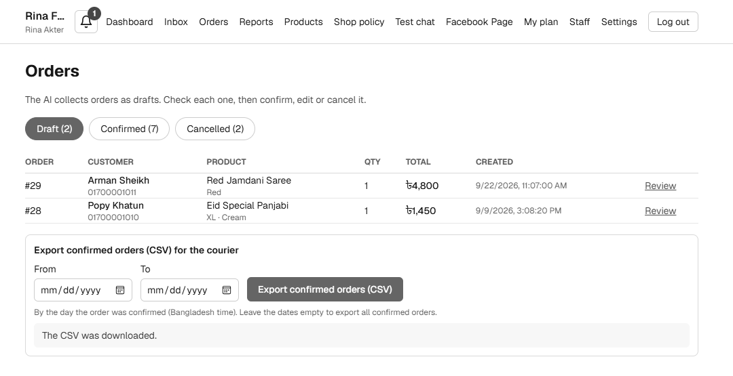
Figure 79: Screenshot: Orders: Confirmed tab
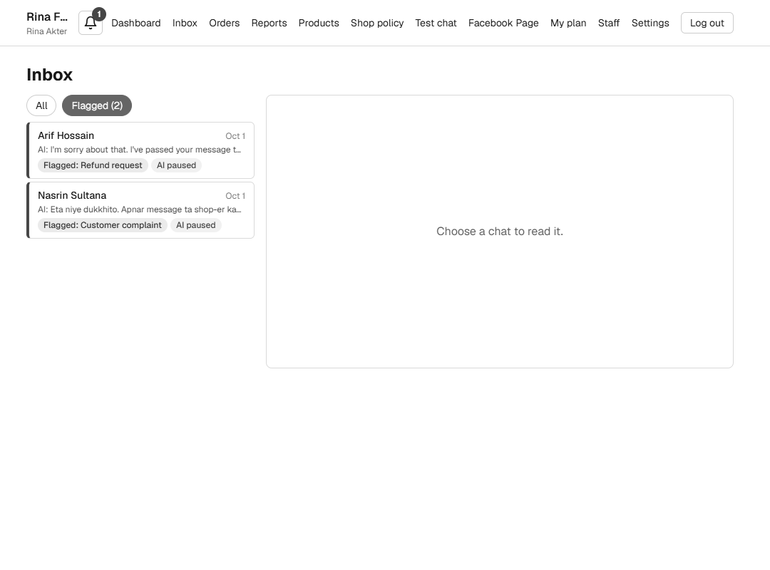
Figure 80: Screenshot: Inbox filtered to flagged chats
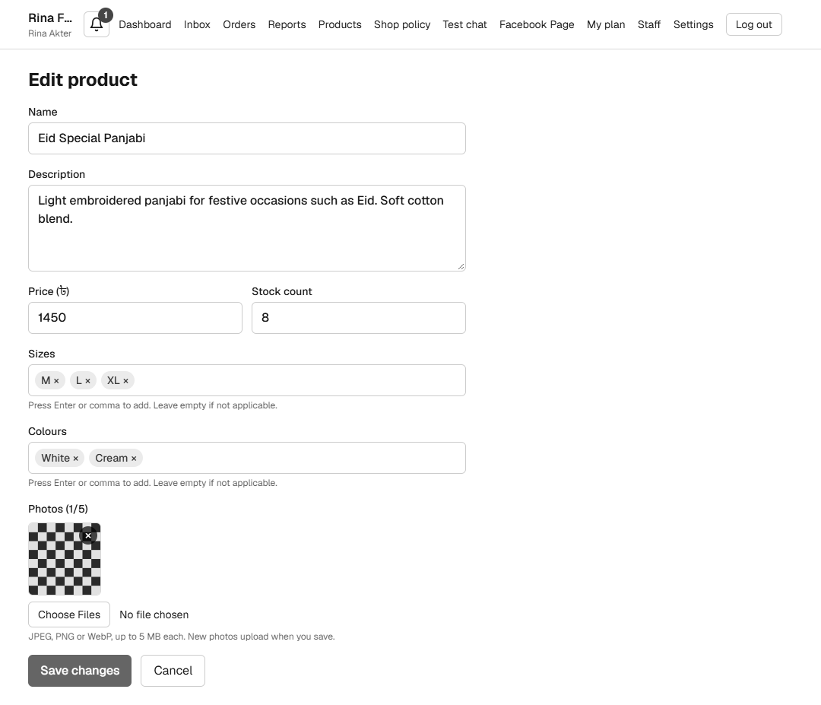
Figure 81: Screenshot: Edit product page
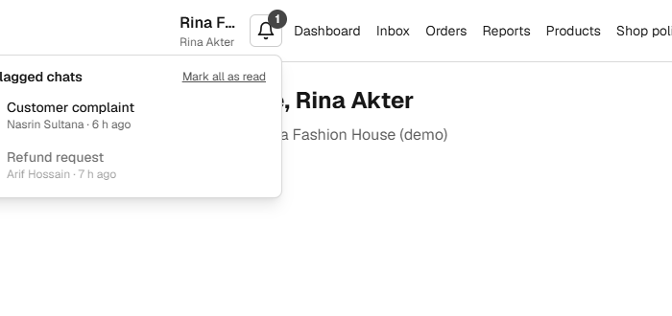
Figure 82: Screenshot: Notification list on a laptop screen (cropped)
The notification list in the last image opens to the left of the bell and its left edge is slightly outside the page on a laptop screen. This is a known small layout problem (section 67). On a phone the list fits (section 43.5).

