 | Curriculum Vitae  Md Abdullah Al Noor  Cell: +8801521-206609  E-mail: aalnoor74@gmail.com | 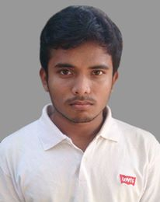
Profile:
A strong desire to work in a congenial working environment to develop myself through Hard
Working, creative thinking, problem solving, innovation and enrich my potentials efficiently and
Effectively.

Portfolio:

GitHub: https://github.com/abdullahalnoor

Previous work experience:

Job Type: Probation period
Company Name: Elpic Soft
Duration: 3 months
Post: Junior laravel developer

Skills:

Laravel , OOP-PHP, Bootstrap , HTML,CSS , Basic AJAX , JSON, JQuery, JavaScript and Vue Js.

Web App Develop PHP & Laravel :

Institution : BASIS Institute of Technology & Management (BITM)

Duration : 3 Months

Diploma in information communication technology

Institution : Bangladesh Korea Institute of Information and
Communication Technology (BKIICT - BCC)
Obtained CGPA : 3.27 out of 4
Session : July 2015 – June 2017
Passing Year : 2017

H.S.C. (Higher Secondary of School Certificate):

Institution : Kabi Nazrul Government College
Grade : A (4.00)
Group : Science
Passing Year : 2013

S.S.C (Secondary of School Certificate):

Institution : Darunnazat siddikia kamil madrasha
Grade : A+ (5.00)
Group : Science
Passing Year : 2011

Personal Information:

Name : Md Abdullah Al Noor
Father's Name : Md Abdul Halim
Mother's Name : Rayhan Begum
Permanent Address : Harippur, Islamabad,Titas,Comilla,
Present Address : Nimaikasary, Sanarpar, Shiddhirgonj, Naryangonj
Date of Birth : 16 October 1996
Religion : Islam
Marital Status : Single
Nationality : Bangladeshi (By Birth)

