GOVERNANCE
PORTFOLIO
Technology Risk · Control Assurance · Third-Party Risk · AI Governance
Md. Abdullah Al Owasi · 2026
Requirement → Control → Evidence → Exception → Residual Risk → Decision
An executive governance portfolio built for inspection: systems, decision logic, evidence structures, ownership models, exception treatment and residual-risk decisions across assurance, third-party risk and AI governance.

01 — EXECUTIVE THESIS
Governance earns value when material requirements become accountable controls, inspectable evidence, visible exceptions and explicit decisions. The portfolio applies that operating model across assurance, third-party risk and AI governance.
10 | 15 | 25 | 20
Governance systems | AI use cases | Buyer diligence paths | Vendor-risk questions
02 — DECISION ARCHITECTURE
Requirement | Control | Evidence | Exception | Residual Risk | Decision
03 — FLAGSHIP ARCHITECTURE
Enterprise Assurance Evidence Fabric
Control-to-evidence architecture connecting trust claims to owners, framework references, evidence, exception state and remediation decisions.
Evidence architecture: 15 control/evidence domains · 25 buyer-diligence paths
AI Governance Decision Architecture
AI-use-case register connecting purpose, data classes, stakeholders, human oversight, NIST AI RMF functions, controls, residual risk, monitoring and transparency decisions.
AI governance architecture: 15 mapped AI use cases
Third-Party Risk Decision Engine
Criticality-driven model connecting data exposure, assurance evidence, contractual obligations and residual risk to scrutiny depth and decision state.
TPRM architecture: 20-question assessment · 10 vendor-risk profiles

04 — GOVERNANCE SYSTEMS
ID | System | Primary lenses | Scale
P01 | Enterprise Trust & Customer Assurance | SOC 2 · ISO 27001 · GDPR Art. 28 · NIST AI RMF | 15 domains · 25 buyer questions
P02 | AI Governance Operating System | NIST AI RMF · GenAI Profile · ISO 42001 | 15 AI use cases
P03 | Third-Party Risk Management | GDPR Art. 28 · SOC 2 · ISO 27001 | 10 vendors · 20 questions
P04 | SOC 2 + ISO 27001 Control Evidence | AICPA TSC · ISO 27001:2022 | 15 control/evidence domains
P05 | Executive Technology Risk | ISO 27001 · NIST AI RMF | 15 risks · 15 KRIs
P06 | AI Transparency & Article 50 | EU AI Act Art. 50 · NIST AI RMF · ISO 42001 | 15 transparency cases
P07 | Shadow AI & Prompt DLP | NIST GenAI Profile · ISO 27001 · ISO 42001 | 12 controls
P08 | Procurement Security Triage | SOC 2 · ISO 27001 · GDPR · NIST AI RMF | 25 canonical answers
P09 | GDPR Article 28 DPA Engine | GDPR Art. 28 · ISO 27001 | 12 clauses
P10 | Continuous Audit Operations | SOC 2 · ISO 27001 | 15 audit requests
Executive risk and portfolio mix
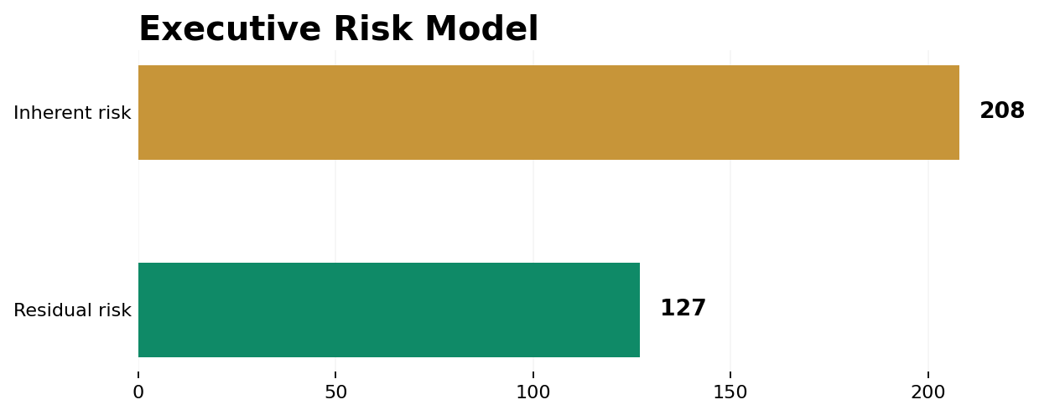 | 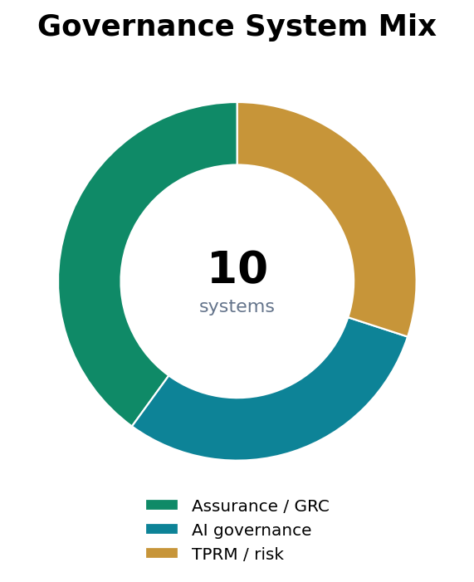

05 — AI RISK & OVERSIGHT SAMPLE
Selected use cases from the 15-use-case AI governance register. Risk values structure assessment across exposure, oversight depth, control treatment and transparency decisions.
Use case | Human oversight | Residual | RMF | Transparency
Customer chatbot | Escalation for material issues | Medium | MAP / MEASURE | AI interaction disclosure
Security questionnaire assistant | GRC approval | Medium | GOVERN / MEASURE | Evidence-backed claims
Code assistant | Developer review + CI tests | Medium | MAP / MEASURE | Internal-use controls
Executive risk summarizer | CISO / GRC approval | Low | GOVERN / MEASURE | Source-locked narrative
06 — THIRD-PARTY RISK DECISION LOGIC
Criticality → data exposure → assurance evidence → contractual obligations → residual risk → approve / remediate / accept / reject.
Approve | Remediate | Accept | Reject
Evidence supports risk posture | Gap has a bounded corrective path | Residual exposure is explicit | Exposure exceeds decision boundary
07 — TECHNICAL FOUNDATION
Python for structured governance workflows · SQL/data modeling for risk and evidence inventories · TypeScript/React/Next.js for typed decision interfaces · Git/GitHub for version control and traceability.
Education: Bachelor of Computer Science (Hons) — AI & Cybersecurity Specialization, SEGi University, Malaysia.

08 — FRAMEWORK BASIS
Framework | Operating lens
NIST AI RMF 1.0 | Govern · Map · Measure · Manage
ISO/IEC 27001:2022 | ISMS requirements · risk treatment · control ownership
AICPA Trust Services Criteria | Security · availability · processing integrity · confidentiality · privacy
ISO/IEC 42001:2023 | AI management-system governance
EU AI Act Article 50 | Transparency decisions for relevant AI contexts
GDPR Article 28 | Processor and subprocessor governance
09 — VERIFICATION
Website: https://aaowasi369v9.pages.dev/
Primary evidence: Governance_Evidence_Workbook.xlsx · Governance_Evidence_Matrix.xlsx
Framework sources: nist.gov · iso.org · aicpa-cima.com · digital-strategy.ec.europa.eu · eur-lex.europa.eu

