NEXORA Forge
Desktop Setup Guide with Pictures
Windows 10/11 • GitHub • Python • Tests • EXE build
This guide covers downloading the NEXORA Forge source, preparing a Windows PC, installing dependencies, configuring a local AI provider, running tests, building a Windows executable, and pushing reviewed changes to GitHub. Commands assume PowerShell unless stated otherwise.

Visual overview
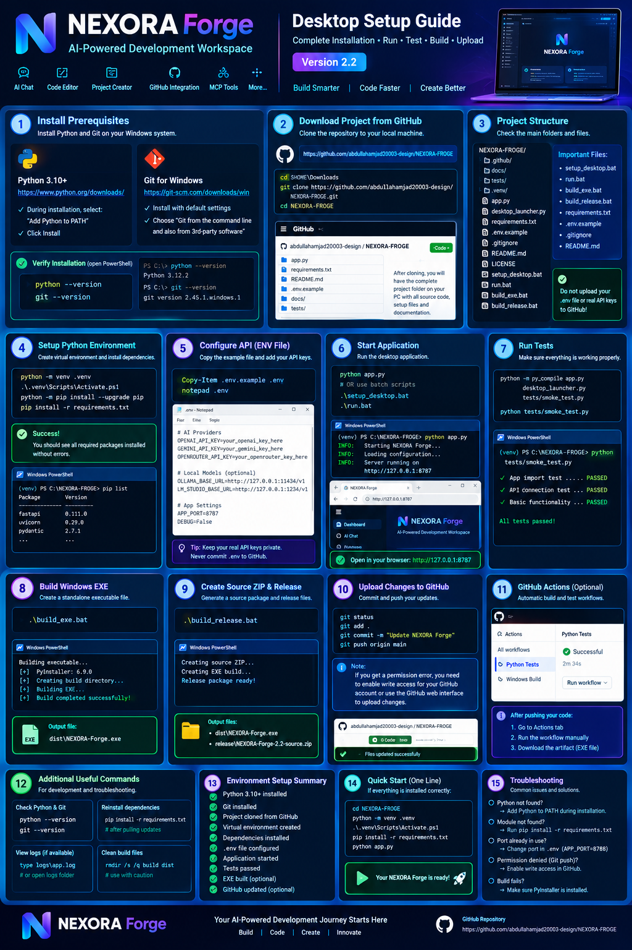
Illustrated overview of the setup workflow. The detailed commands below are the authoritative instructions.

1. Install the prerequisites
Install these tools first. During Python setup, select “Add Python to PATH”.
Python: https://www.python.org/downloads/
Git for Windows: https://git-scm.com/downloads/win
Optional editor: https://code.visualstudio.com/
python --version
git --version
pip --version

2. Download the project from GitHub
Open PowerShell. Clone the repository once. If you already have a local clone, open that folder instead of cloning again.
cd "$HOME\Downloads"
git clone https://github.com/abdullahamjad20003-design/NEXORA-FROGE.git
cd NEXORA-FROGE
git status

3. Create a Python virtual environment
A virtual environment keeps this project's Python dependencies separate from other projects.
python -m venv .venv
.\.venv\Scripts\Activate.ps1
python -m pip install --upgrade pip
pip install -r requirements.txt

If PowerShell blocks activation
Only for the current PowerShell process, run:
Set-ExecutionPolicy -Scope Process -ExecutionPolicy Bypass
.\.venv\Scripts\Activate.ps1

4. Configure API settings safely
Create the local configuration file if the project includes .env.example. Open it in Notepad and add only the provider settings you use. Never commit real API keys.
Copy-Item .env.example .env
notepad .env
Example placeholder configuration (the app must support these variable names):
AI_PROVIDER=ollama
AI_BASE_URL=http://127.0.0.1:11434/v1
AI_API_KEY=
AI_MODEL=
APP_HOST=127.0.0.1
APP_PORT=8787
Local model endpoints are examples only. Install and start the relevant local model server first. Cloud providers require a valid provider key and model ID.

5. Start NEXORA Forge
Use the startup method that matches the files in your downloaded version. Do not run both methods at the same time.
python app.py
If the project bundle includes batch scripts, you may instead run:
.\setup_desktop.bat
.\run.bat
If the app starts a local web UI, open the address printed in the terminal. The previously documented default was http://127.0.0.1:8787, but verify the actual startup output.

6. Run syntax checks and smoke tests
Run these commands from the project root. If a named file is not present, adapt the command to the actual project structure.
python -m py_compile app.py desktop_launcher.py tests/smoke_test.py
python tests/smoke_test.py

7. Build a Windows executable
A Windows EXE must be built on a suitable Windows environment with the required packaging dependencies installed. These commands are valid only if the matching scripts exist.
.\build_exe.bat
Expected output in the previously described workflow: dist\NEXORA-Forge.exe. Confirm that the file exists and launches before distributing it; an expected path is not proof of a successful build.

8. Prepare a source release ZIP
If the project includes a release script, run it and inspect the output directory.
.\build_release.bat
The previously proposed source archive path was release\NEXORA-Forge-2.2-source.zip. Confirm the real version and path in your build output.

9. Upload reviewed changes to GitHub
Review the staged changes and make sure no .env file, access token, private key, or sensitive runtime configuration is included. A GitHub write permission is required.
git status
git add .
git status
git commit -m "Update NEXORA Forge desktop setup"
git push origin main
If push is denied with 403 or permission errors, fix GitHub authentication and repository write permissions. Repeating the command will not grant access.

10. Optional: GitHub Actions
If the repository contains workflows under .github/workflows/, push the workflow files and open the repository's Actions tab. Run the workflow if manual dispatch is configured. Download the artifact only after the run completes successfully.
A GitHub Actions artifact is a workflow output; it is not automatically a permanent public GitHub Release.

Troubleshooting

'python' is not recognized
Reinstall Python with Add Python to PATH enabled, then reopen PowerShell.

'git' is not recognized
Install Git for Windows and reopen PowerShell.

requirements.txt not found
You may be in the wrong directory, or the source bundle may have a different layout. Run Get-ChildItem and locate the project root.

ModuleNotFoundError
Activate .venv and run pip install -r requirements.txt from the project root.

Port already in use
Check the app's configured port and close the other process or change the port in the supported configuration.

AI provider connection fails
Check base URL, model ID, provider availability, network connectivity, quota, and key validity. Never print the key in logs.

Git push denied
Confirm the correct GitHub account, remote URL, repository access, and write permissions.

EXE not found
Inspect the build output and logs. The executable may not have been built, or the packaging script may use a different output path.

Security checklist
- Keep real API keys in local .env or an appropriate secure credential store.
- Never commit .env, access tokens, private keys, or sensitive MCP configuration.
- Keep local web services bound to 127.0.0.1 by default.
- Review code changes before applying AI-generated edits.
- Require confirmation before destructive commands or external writes.
- Only claim an upload, API connection, test, or build succeeded after verifying the result.

Official links
- NEXORA Forge repository: https://github.com/abdullahamjad20003-design/NEXORA-FROGE
- Python downloads: https://www.python.org/downloads/
- Git for Windows: https://git-scm.com/downloads/win
- GitHub Actions: https://docs.github.com/en/actions
- GitHub file upload: https://docs.github.com/en/repositories/working-with-files/managing-files/adding-a-file-to-a-repository
- Gemini API docs: https://ai.google.dev/api
- OpenRouter docs: https://openrouter.ai/docs
- MCP transport spec: https://modelcontextprotocol.io/specification/latest/basic/transports
Scope note: this is a setup guide, not a claim that all planned NEXORA features are implemented. The repository's actual files, tests, and build logs determine which commands and features are available.

