Noise Robustness of a Quantum Circuit for Two-Flavor Neutrino Oscillation
Muhammad Abdullah Anwar
August 2026

Abstract
This work investigates whether a minimal single-qubit quantum circuit can accurately reproduce two-flavor neutrino oscillation probabilities, and quantifies the noise robustness of this circuit in simulation and on real IBM Quantum hardware. Using the atmospheric channel with NuFit 6.0 parameters, a three-gate circuit (RY–RZ–RY) matches the analytical oscillation formula to floating-point precision (MAE ≈ 6.8×10⁻¹⁷), confirming the circuit design is exact. Shot noise follows the theoretical 1/√n scaling law. Three noise mechanisms — depolarizing, amplitude damping, and phase damping — show a consistent damage ranking, with amplitude damping's asymmetric signature matching its physical origin as one-directional energy relaxation. A combined noise model, repeated across 5 seeds, places the failure threshold at severity 1.143 ± 0.017; converting this into a real-hardware safety margin is sensitive to calibration choice, with plausible estimates ranging from roughly 1× to roughly 38× current hardware noise. On real hardware, a repeated 4-trial statistical comparison (paired t-test) found no significant effect of error mitigation (dynamical decoupling, gate twirling; p = 0.523), reversing an initial single-trial result and illustrating the need for repeated trials on noisy NISQ hardware. Results are positioned against existing quantum-simulation-of-neutrino-oscillation literature, with an explicit account of where quantum simulation becomes computationally necessary beyond the tractable two-flavor case studied here.
Keywords: neutrino oscillation, quantum simulation, noise robustness, Qiskit, IBM Quantum

1. Introduction
Neutrinos are produced and detected as flavor eigenstates (electron, muon, tau) but propagate as superpositions of mass eigenstates. Because the mass eigenstates accumulate different quantum phases as the neutrino travels, the flavor composition oscillates periodically with the ratio of distance traveled to energy, L/E. This phenomenon — neutrino oscillation — was historically motivated by the solar neutrino problem: early detectors observed roughly one-third the predicted flux of electron neutrinos from the Sun. This deficit is not an unresolved anomaly; the "missing" neutrinos had changed flavor en route. Resolving it, however, required more than the vacuum oscillation formula used in this work: the solar L/E scale (Earth-Sun baseline ~10⁸ km, MeV-scale energies) is many orders of magnitude larger than the atmospheric case studied here (L/E up to ~2000 km/GeV) — large enough that the vacuum oscillation term averages to a near-constant value rather than tracing a clean sinusoid — and for the higher-energy solar neutrinos most precisely measured (e.g., by SNO), flavor conversion is in fact dominated by the Mikheyev–Smirnov–Wolfenstein (MSW) matter effect, a resonance driven by the Sun's density gradient, rather than by vacuum oscillation alone. The clean oscillatory pattern this project's circuit reproduces belongs to the atmospheric channel (Section 3), a different L/E regime in which vacuum oscillation is the appropriate and dominant description. Oscillation is now a well-established, precisely measured phenomenon, with global parameter fits (e.g., NuFit) continually refined from multiple experiments.
A one-qubit quantum circuit provides a natural, minimal platform for representing this physics: a qubit's superposition, described by a single mixing angle, mirrors the flavor-mixing structure of the two-flavor oscillation formula. This correspondence has been previously demonstrated in the literature (Section 6). This work adopts the same minimal circuit design but asks a question not emphasized in prior demonstration-focused studies: given that real quantum hardware is noisy, at what noise level does this circuit stop reliably reproducing the oscillation pattern, and how does that threshold compare to the noise levels of currently available quantum hardware? This reframes the project from a reproduction of known physics into a quantitative assessment of a specific circuit's practical reliability.

2. Background

2.1 Two-Flavor Oscillation Formula
The probability that a neutrino produced in one flavor is detected in another, under the two-flavor approximation, is:
P = sin²(2θ) · sin²(1.27 · Δm² · L / E)
where θ is the mixing angle, Δm² is the mass-squared splitting between the two relevant mass eigenstates (eV²), L is the distance traveled (km), and E is the neutrino energy (GeV). The constant 1.27 absorbs the necessary unit conversions for these units and requires no separate adjustment. The first factor, sin²(2θ), sets the maximum amplitude of oscillation and is independent of L and E; the second factor governs the oscillatory dependence on the ratio L/E specifically, not on L or E individually. This L/E-dependence was verified directly in this work (Section 4.5): probability values computed for different (L, E) pairs sharing the same ratio were found to agree to eight decimal places.

2.2 Channel Selection and Parameters
Two-flavor oscillation is an approximation to the full three-flavor picture, valid for a specific pair of flavors and a dominant mass splitting. This work models the atmospheric channel (νμ ↔ ντ), using parameters from NuFit 6.0 (Esteban et al., 2024), under the normal mass ordering assumption:
Parameter | Value | Source
θ23 (mixing angle) | 43.3° = 0.7557 rad | NuFit 6.0, normal ordering
Δm²31 (mass splitting) | 2.5 × 10⁻³ eV² | NuFit 6.0, atmospheric channel
This channel was selected specifically because it is physically appropriate for the L range studied (0–2000 km): atmospheric neutrino oscillation genuinely occurs over hundreds to thousands of kilometers, whereas the solar channel (θ12, Δm²21) would require L on the order of 150 million km (Earth–Sun distance) to be physically meaningful, and would therefore be inconsistent with the L range used here.
Note on parameter table selection: NuFit 6.0 reports two variants of the global fit, differing in whether Super-Kamiokande atmospheric data (SK-atm) and IceCube/DeepCore (IC24) data are included. The θ23 = 43.3° value used here corresponds specifically to the fit including this atmospheric data (the "IC24 with-SK" table), first octant, normal ordering. The variant excluding this atmospheric data instead favors the second octant (θ23 ≈ 48.5°–48.6°). Both are legitimate NuFit 6.0 results; this work uses the with-SK-atm, first-octant value as it reflects the fuller combined dataset.

2.3 Qubit Encoding
A single qubit's state can be described by a mixing angle between its two basis states, directly analogous to the flavor-mixing angle θ in the oscillation formula. The circuit used throughout this work consists of three gates:
- RY(2θ) — prepares a flavor-mixed initial state, mirroring the physical flavor-to-mass basis mixing.
- RZ(φ), where φ = 2 × 1.27 × Δm² × (L/E) — applies the relative phase accumulated between mass eigenstates as the neutrino propagates.
- RY(−2θ) — reverses the initial mixing transformation, projecting the evolved state back onto the flavor basis for readout.
Measurement (or, for exact analysis, direct extraction of the state's probability amplitudes) then yields the transition probability, analogous to detecting the neutrino in the non-original flavor.

3. Methods

3.1 Software and Hardware
All simulation work was performed in Qiskit 2.5.1 using Google Colab. Two simulation modes were used: an exact statevector simulator (Qiskit's Statevector class, no sampling randomness) to isolate circuit-design correctness, and a shot-based sampling simulator (AerSimulator) with configurable noise models to study realistic measurement conditions. Real hardware experiments were run on IBM Quantum's Open Plan (free tier) via the qiskit-ibm-runtime SamplerV2 primitive, on two backends: ibm_fez (initial single-trial validation, Section 4.6) and ibm_marrakesh (4-trial repeated mitigation analysis, Section 4.6), reflecting backend availability at the respective times of experimentation; all trials within the repeated-trial analysis ran on the single pinned ibm_marrakesh backend.

3.2 Noise Modeling
Three individual noise mechanisms were modeled using Qiskit Aer's noise module: depolarizing noise (random replacement of the qubit state with a maximally mixed state with some probability), amplitude damping (one-directional energy relaxation toward the ground state, modeling physical decoherence/T1 processes), and phase damping (loss of phase coherence without energy loss, modeling T2 dephasing). Readout (measurement) error was modeled separately via a symmetric bit-flip assignment matrix. Each mechanism was tested individually at both exaggerated "stress-test" strengths (5%, 15% per-gate error) and a "realistic" strength intended to approximate current hardware calibration levels (~0.3% gate error, 1% readout error, informed by typical published IBM superconducting-qubit specifications).
A combined noise model was additionally constructed, applying all three mechanisms simultaneously (scaled by a single "severity" parameter from 0 to 1.5×), to represent the fact that real hardware experiences all of these error sources concurrently rather than in isolation.
Severity scale definition: severity is a normalized multiplier on a fixed set of per-gate error probabilities, independent of the two discrete stress-test levels used in Section 4.3. At severity = s, the per-gate error probability for depolarizing noise is 0.10×s, for amplitude damping is 0.10×s, and for phase damping is 0.05×s, with readout error scaling as 0.01×(0.5+s). Severity = 1.0 therefore corresponds to a 10% depolarizing / 10% amplitude-damping / 5% phase-damping combined per-gate error rate — a fixed reference point defined independently for this sweep, not literally equal to either the 5% or 15% single-mechanism stress levels reported in Section 4.3 (which tested each mechanism individually at those exact values). This distinction matters for interpreting the reported failure threshold and margin below (Sections 4.4, 5.3).

3.3 Failure Criterion
To answer the central research question — at what noise level does the circuit fail to recover the oscillation pattern — a specific, physically motivated failure criterion was defined: contrast retention, the ratio of the measured peak-to-trough probability range to the ideal (noiseless) peak-to-trough range. This metric was chosen over alternatives (mean absolute error, correlation coefficient) because it directly captures oscillation visibility — a standard concept in interference physics — and distinguishes a genuinely degraded signal from one that is merely statistically noisy but still clearly oscillating. Failure was defined as contrast retention falling below 50%.

3.4 Reproducibility
All stochastic simulations used a fixed random seed (seed = 42 for single-run analyses; seeds 1–5 averaged for the shot-scaling study). Qiskit, Python, and package versions were recorded (Qiskit 2.5.1). All notebooks were verified to execute in full, in order, without error prior to reporting any result.

4. Results

4.1 Exact Circuit Verification
Using an exact statevector simulation (no sampling), the circuit's output probability was compared against the analytical formula across 200 points spanning L/E = 0.1–2000 km/GeV. The mean absolute error was 6.80×10⁻¹⁷, with a maximum error of 3.33×10⁻¹⁶ — both consistent with floating-point precision limits rather than any genuine discrepancy. This confirms the three-gate circuit design exactly reproduces the intended physics, independent of any sampling or hardware effects.
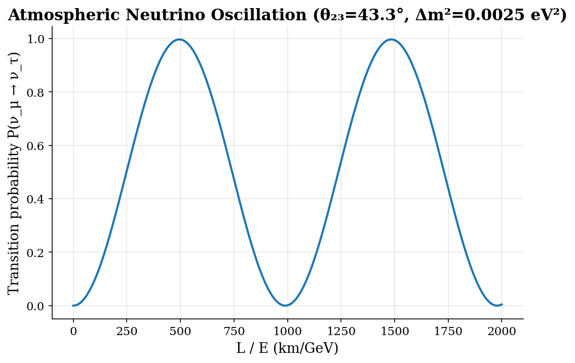
Figure 1. Analytical transition probability P(νμ→ντ) as a function of L/E (km/GeV), computed from the two-flavor oscillation formula using NuFit 6.0 atmospheric-channel parameters (θ23=43.3°, Δm²31=2.5×10⁻³ eV²). The curve oscillates between 0 and sin²(2θ)≈0.996, with period set by Δm² and E.
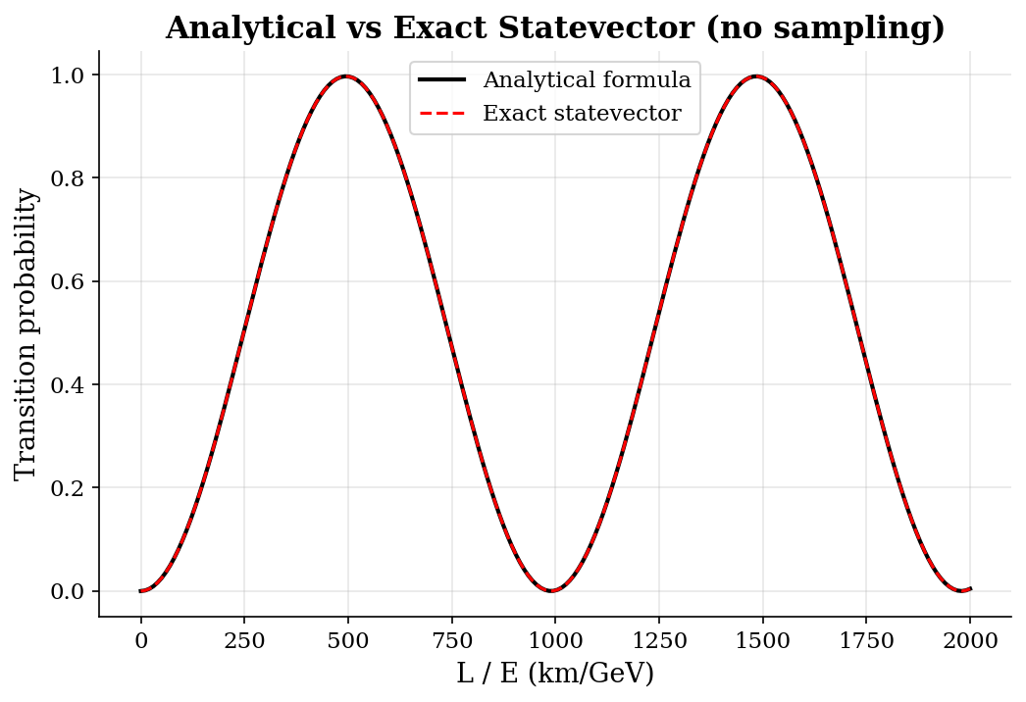
Figure 2. Exact (noiseless) qubit-circuit output (red dashed) overlaid on the analytical formula (black solid) across the same L/E range as Figure 1. The two curves are visually indistinguishable, consistent with the reported floating-point-level agreement (MAE ≈ 6.8×10⁻¹⁷), confirming the three-gate circuit exactly reproduces the intended physics.

4.2 Sampling (Shot) Noise
With finite measurement shots, the circuit's output carries statistical sampling noise even when the circuit itself is exact. This was quantified across shot counts of 100, 1000, 8000, and 10000, averaged over five random seeds, and compared against the exact statevector baseline:
Shots | Mean MAE | Std. Dev.
100 | 0.0257 | ±0.0082
1,000 | 0.0076 | ±0.0037
8,000 | 0.0026 | ±0.0009
10,000 | 0.0023 | ±0.0005
The observed error scaling closely tracked the theoretical 1/√n prediction: the ratio of MAE between 100 and 1000 shots was 3.37 (theory: 3.16), between 1000 and 8000 shots was 2.90 (theory: 2.83), and between 8000 and 10000 shots was 1.15 (theory: 1.12). This confirms that residual error in sampled simulations is governed by standard statistical sampling noise, fully separable from the circuit-design error quantified in Section 4.1.
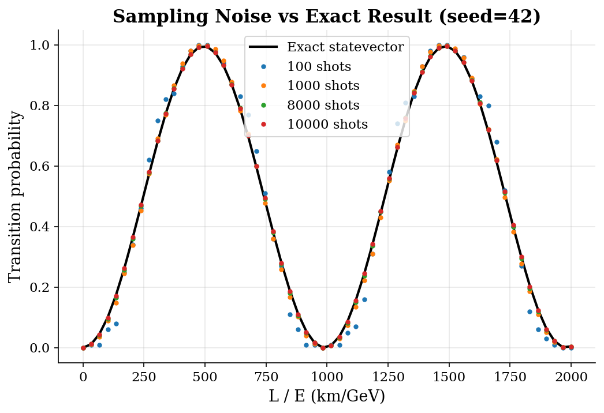
Figure 3. Circuit output sampled at 100, 1000, 8000, and 10000 shots (colored points) compared against the exact statevector baseline (black curve). Scatter around the baseline shrinks as shot count increases, consistent with the theoretical 1/√n sampling-noise scaling reported in Section 4.2.

4.3 Individual Noise Mechanism Comparison
Three noise mechanisms were compared at three noise-strength configurations, measured as mean absolute error (MAE) against the exact baseline, along with peak suppression (reduction in maximum probability) and trough elevation (increase in minimum probability):
Configuration | Depolarizing MAE | Amplitude Damping MAE | Phase Damping MAE
Stress 5% | 0.0403 | 0.0318 | 0.0122
Stress 15% | 0.1182 | 0.0984 | 0.0426
Realistic (~0.3%+1% readout) | 0.0067 | 0.0054 | 0.0051
This ranking (depolarizing most damaging, then amplitude damping, then phase damping) held consistently across all three noise strengths, strengthening the qualitative conclusion beyond any single arbitrary parameter choice. Notably, at realistic hardware-calibration noise levels, MAE remained below 0.007 for all three mechanisms — roughly an order of magnitude smaller than under 15% stress-test conditions — indicating that current-generation quantum hardware noise introduces comparatively modest distortion to this signal.
Amplitude damping showed a distinctive asymmetric signature at every tested strength: peak suppression consistently exceeded trough elevation (e.g., at realistic strength, 0.0147 vs. 0.0110). This is physically consistent with amplitude damping's origin as one-directional energy relaxation toward the ground state — it pulls high probabilities down, but has little effect on probabilities already near zero, since there is nowhere lower to decay to.
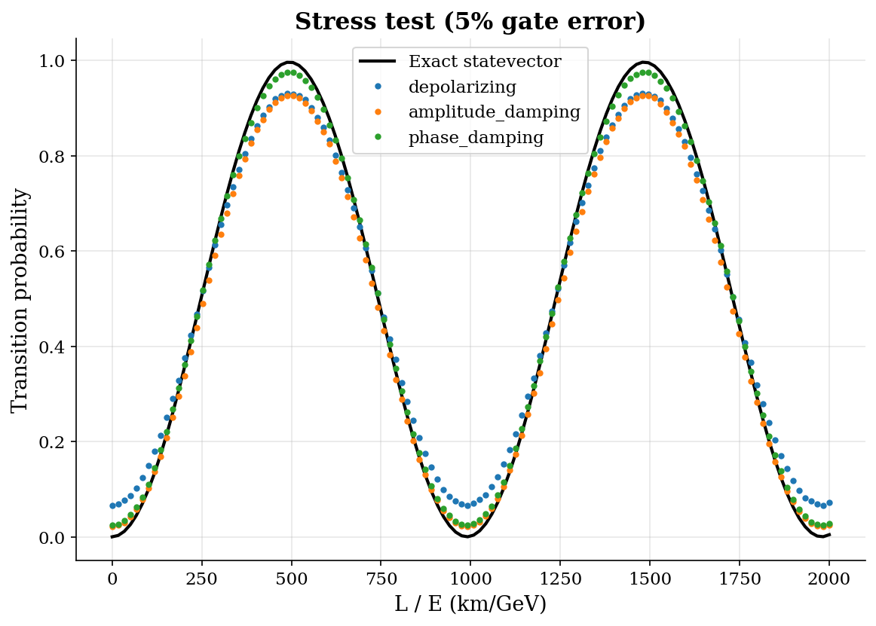
Figure 4a. Transition probability under stress-test noise (5% per-gate error probability) for three mechanisms: depolarizing (blue), amplitude damping (orange), and phase damping (green), against the exact noiseless baseline (black). All three visibly distort the curve; depolarizing shows the largest deviation at this strength.
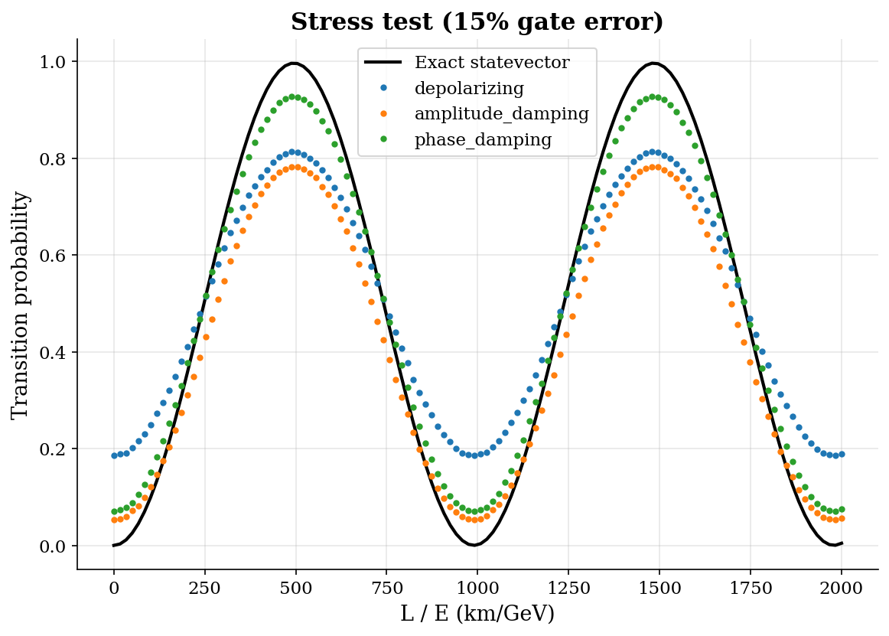
Figure 4b. Same comparison as Figure 4a at a higher stress-test strength (15% per-gate error). Distortion is more pronounced for all three mechanisms, with the same relative ranking (depolarizing > amplitude damping > phase damping) preserved.
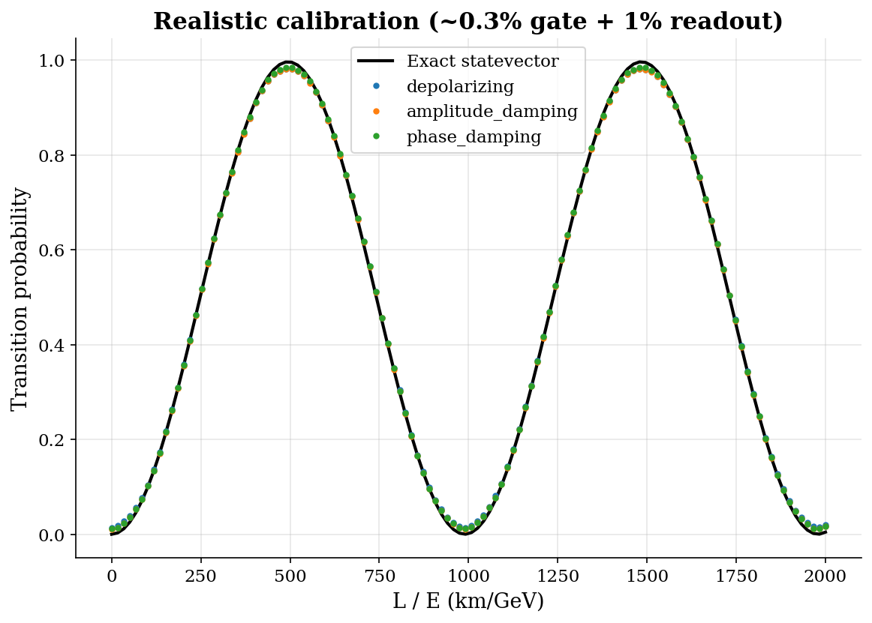
Figure 4c. Transition probability under realistic hardware-calibration noise (~0.3% per-gate error, 1% readout error) for the same three mechanisms. Distortion is an order of magnitude smaller than in Figures 4a-4b, with depolarizing noise still the most damaging and phase damping the least.

4.4 Combined Noise and Failure Threshold
A combined noise model, applying all three mechanisms simultaneously plus readout error, was swept across the severity scale defined in Section 3.2, from 0 to 1.5. To assess robustness, the full sweep was repeated across 5 independent random seeds. Contrast retention decreased monotonically with severity in all seeds, and the 50%-retention failure threshold was computed separately for each: 1.174, 1.130, 1.135, 1.130, and 1.145, giving a mean threshold of 1.143 ± 0.017 — a tight spread indicating this threshold is a stable, reproducible feature of the circuit and noise model rather than an artifact of any single random realization.
Sensitivity to the choice of failure cutoff was also tested directly, using the mean retention curve across all 5 seeds: a 40% cutoff yields a threshold severity of 1.487; 50% yields 1.142; 60% yields 0.855. This range brackets the headline result and shows it is not highly sensitive to the specific (necessarily somewhat arbitrary) cutoff choice.
Translating this threshold into a real-hardware safety margin is less straightforward than it first appears, because the severity scale is a single dial that fixes the relative proportions of gate error and readout error together, and real hardware does not necessarily preserve those proportions. Calibrating severity against the ~0.3% per-gate error assumed in Section 4.3 gives severity ≈0.03, and a margin of roughly 28–50× (centered ≈38×) depending on the cutoff. Calibrating severity instead against the directly measured readout error from Section 4.6 (1.40% on ibm_marrakesh) gives severity ≈0.90 — close to the failure threshold itself, implying a margin of only ≈1.3×. These two calibrations disagree by roughly 30-fold because they represent different assumptions about which error type dominates; the model cannot represent "low gate error, high readout error" and "high gate error, low readout error" simultaneously with one parameter. The honest conclusion is that this single-parameter severity model does not support a precise real-hardware safety-margin figure: it reliably shows the circuit tolerates a wide, stably-measured range of combined noise before failing (Section 4.4), but converting that range into a specific multiple of real hardware noise depends heavily on which noise source is treated as representative, and the resulting estimates span from a comfortable margin to essentially no margin at all.
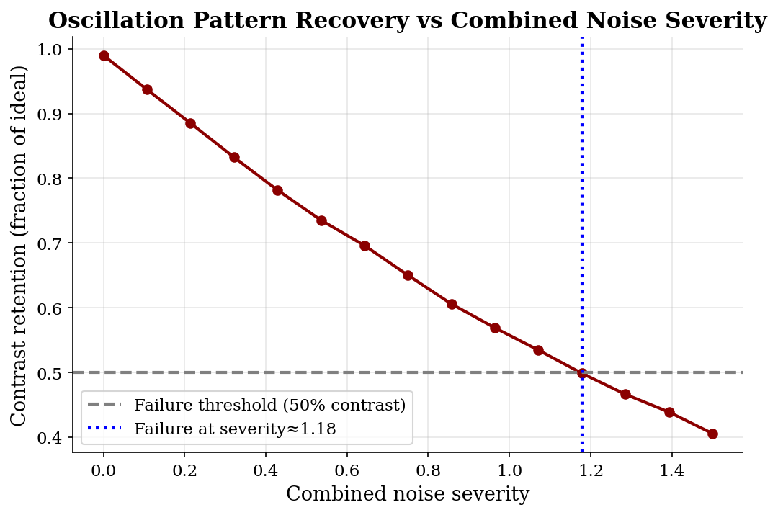
Figure 5. Contrast retention (fraction of ideal peak-to-trough amplitude preserved) as combined noise severity increases from 0 to 1.5, averaged across 5 random seeds. The dashed horizontal line marks the 50% failure threshold; the dotted vertical line marks the corresponding crossing point at severity ≈1.18. The real-hardware-equivalent severity depends on calibration choice (see Section 4.5) and is not marked here.

4.5 L/E Equivalence Verification
As a direct test that the physics depends only on the ratio L/E rather than on L or E individually, four (L, E) pairs sharing a fixed ratio of 500 km/GeV — (500, 1.0), (1000, 2.0), (250, 0.5), and (2500, 5.0) — were evaluated using the exact statevector circuit. All four produced the identical probability, 0.99620475, to eight decimal places, confirming the expected L/E dependence.

4.6 Real Hardware Validation and Error Mitigation
The circuit was executed on real IBM Quantum hardware across 20 L/E points at 4000 shots per point (backend: ibm_fez), comparing raw execution against execution with dynamical decoupling and gate twirling — the native Sampler-level error-suppression techniques available in the current Qiskit runtime (resilience_level, an alternative interface, applies only to the Estimator primitive and was not usable in this Sampler-based workflow), consistent with the minimal-cost mitigation approach used in recent decoherence studies on comparable NISQ hardware (Rhyno et al., 2025). This single-trial comparison gave raw MAE = 0.0099 and mitigated MAE = 0.0095, a 3.7% apparent improvement (Figure 6).
A single trial is weak evidence on noisy NISQ hardware, so this comparison was repeated across 4 independent trials (10 L/E points, 2000 shots each), with the backend held fixed throughout (ibm_marrakesh):
Trial | Raw MAE | Mitigated MAE
1 | 0.0121 | 0.0156
2 | 0.0122 | 0.0153
3 | 0.0152 | 0.0113
4 | 0.0119 | 0.0142
Mean ± SD | 0.0129 ± 0.0014 | 0.0141 ± 0.0017
Since each mitigated trial used the same transpiled circuits and L/E points as its corresponding raw trial (submitted as matched pairs on the same pinned backend), a paired t-test is the statistically appropriate test here rather than an independent-samples test. A paired t-test gave t = −0.721, p = 0.523 — not statistically significant, with mitigated MAE trending slightly higher than raw, opposite the single-trial result. The corrected conclusion is that dynamical decoupling and gate twirling show no statistically significant effect on this circuit's real-hardware accuracy; the original 3.7% improvement is attributed to favorable statistical variation in a single trial. This null result is, in fact, close to the physically expected outcome for gate twirling specifically: Qiskit's Sampler-level gate twirling is designed to convert coherent errors into stochastic ones by randomizing two-qubit gates, and this circuit contains no two-qubit gates at all, so gate twirling has essentially no error to act on here. Dynamical decoupling, which fills idle time on other qubits during two-qubit-gate execution elsewhere on the chip, is similarly of limited relevance to a single active qubit running a 3-gate circuit with little idle time. Both techniques were included as the default, minimal-cost Sampler-level options rather than because they were expected to meaningfully help a circuit of this shape; the null result is consistent with that expectation, not a surprising failure of the techniques. Because the rigorous 4-trial result was established on ibm_marrakesh while the single-trial illustration used ibm_fez, this null result does not strictly generalize across backends.
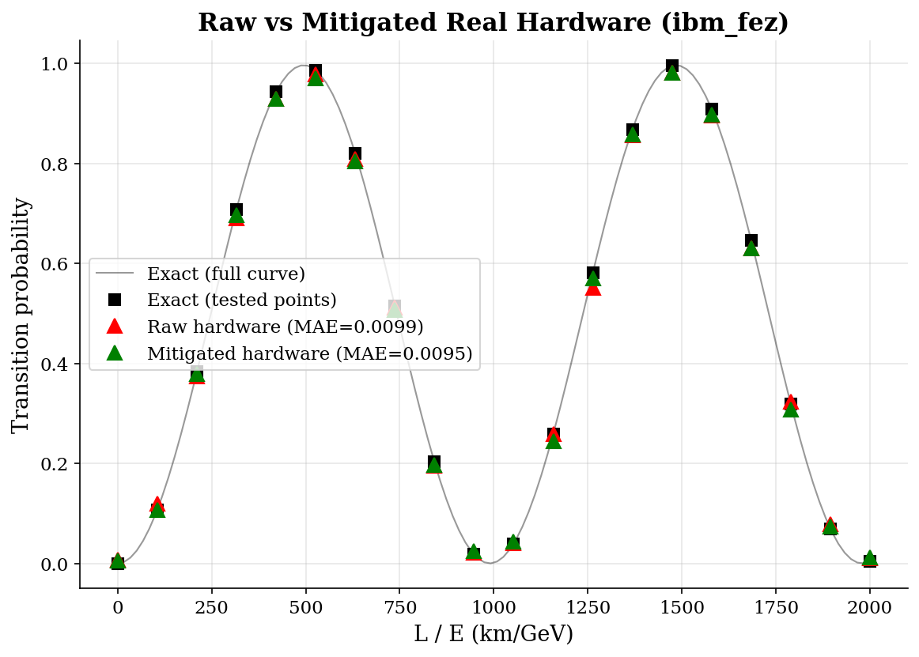
Figure 6. Raw vs. error-mitigated execution on ibm_fez (single-trial illustration; red triangles = raw, green triangles = mitigated, black squares = exact prediction, gray line = full exact curve). This single-trial gap is not statistically significant — see the 4-trial test above.
An earlier trial using automatic (least-busy) backend selection produced a spurious 24.8% mitigation "effect," later traced to an uncontrolled backend switch between the two compared conditions rather than to mitigation itself. This was corrected by pinning the backend explicitly for all subsequent comparisons, illustrating why single, uncontrolled comparisons are unreliable on shared cloud quantum hardware.

5. Discussion

5.1 Why a Quantum Computer for This Problem?
It is reasonable to ask why quantum hardware is used at all, given that the three-gate, single-qubit circuit studied here is trivially and instantly solvable on a classical computer using elementary trigonometry. The honest answer, for the two-flavor case specifically, is that it is not computationally necessary — this project's two-flavor circuit functions as a minimal, exactly verifiable proof-of-concept, not a demonstration of quantum advantage.
Quantum simulation becomes genuinely necessary in two related extensions beyond the scope of this work. First, the full three-flavor picture, governed by the complete PMNS mixing matrix (three mixing angles, a CP-violating phase, two independent mass splittings), requires at least two entangled qubits and a deeper circuit (Section 5.2) — still classically tractable for a single neutrino, but a natural stepping stone toward the second and more fundamental case: many-body collective neutrino oscillations, as occur in dense astrophysical environments such as supernovae, where neutrinos interact with one another via forward scattering. Simulating N mutually entangled neutrinos requires representing a Hilbert space of dimension 2^N, which grows exponentially and becomes classically intractable for realistic N — precisely the regime in which quantum computers, whose N qubits natively span a 2^N-dimensional space, offer a genuine and necessary computational advantage. This project's validated single-qubit methodology (exact circuit verification, systematic noise characterization, real-hardware confirmation) is presented as a necessary and rigorously verified foundation for extending toward that intractable regime, rather than as a demonstration of advantage in itself.

5.2 Extension to Three-Flavor Oscillation
A full three-flavor implementation was outside this project's scope, but its requirements were characterized explicitly. Representing three mass/flavor states requires either two qubits (a 4-dimensional Hilbert space, one dimension more than needed, with the unused state constrained via circuit design) or a single qutrit (3-level system) — the latter more natural physically but requiring specialized hardware not generally available on standard superconducting-qubit platforms such as those used in this work. The two-qubit approach would require entangling gates (e.g., CNOT) in addition to generalized rotation gates, since genuine three-state mixing requires qubit correlation rather than independent rotation, plus an additional phase term encoding δCP, the CP-violating phase with no analog in the two-flavor case. Overall circuit depth would grow from three gates to an estimated 8–12 gates. This characterization directly informs feasibility assessment for follow-up work extending this project's validated methodology to the three-flavor case.

5.3 Limitations
- This work uses the two-flavor approximation exclusively; three-flavor effects (Section 5.2) and CP violation are not modeled.
- The "realistic" noise-calibration values used in Section 4.3 are informed estimates based on typical published superconducting-qubit specifications, not device-specific calibration data pulled programmatically at run time. Section 4.6's directly measured real-hardware readout error (1.40%) is in fact notably higher, relative to the assumed gate error, than this estimate implies — a discrepancy discussed in Section 4.5, where it substantially widens the uncertainty on any real-hardware noise-margin figure.
- The combined-noise severity scale (Section 4.4) is a simplified single-parameter model and does not capture all possible correlations between noise mechanisms on real hardware.
- Shot-noise scaling (Section 4.2) was validated using five fixed random seeds; this is consistent in rigor with the 5-seed threshold analysis in Section 4.4.
- Sampler-native mitigation techniques (dynamical decoupling, gate twirling) do not directly address readout error, which remains a plausible dominant residual error source for this circuit; readout-error mitigation (e.g., assignment-matrix inversion) was not available as a native option in the Qiskit runtime version used and is a natural direction for follow-up work — particularly relevant given Section 4.6's finding that the tested mitigation techniques showed no significant effect.
- The repeated-trial hardware analysis (Section 4.6) used 4 trials per condition at reduced shot count (2000, vs. 4000 in the original single-trial run) to conserve free-tier hardware quota; a larger number of trials would further tighten the confidence interval on the (currently null) mitigation effect, though the qualitative conclusion — that a single trial is insufficient evidence, and that no significant mitigation effect is detectable at this sample size — is already well supported.

6. Related Work
Quantum simulation of neutrino oscillation has been demonstrated using several encoding approaches. Argüelles and Jones (2019) demonstrated both two-flavor (single-qubit) and three-flavor (two-qubit) quantum circuit simulations of neutrino oscillation, establishing the foundational approach this work adopts for the two-flavor case. Joshi, Rajpoot, and Shukla (2025) implemented closely related single-qubit two-flavor circuits for neutrino propagation through matter, validated on both simulators and real IBM hardware; the same lead author's subsequent 2026 work explored an alternative bosonic/cavity-mode encoding. Nguyen et al. (2022) and Turro et al. (2025) explored qutrit-based (three-level) encodings as an alternative to multi-qubit representations for the three-flavor case, while Singh, Arvind, and Dorai (2025) implemented three-flavor simulation on nuclear magnetic resonance hardware rather than superconducting qubits. Collective, many-body neutrino oscillations — the classically intractable regime motivating quantum simulation's necessity, as discussed in Section 5.1 — have been explored by Hall et al. (2021), Spagnoli et al. (2025), and Bleau et al. (2026), the latter introducing a qubit-efficient Dicke-state-based encoding for dense neutrino gas simulations.
This body of work establishes that quantum circuits can accurately reproduce neutrino oscillation probabilities, generally validated against theory and, in several cases, real hardware. This project adopts the same minimal single-qubit two-flavor approach for its exact verifiability, but extends beyond reproduction to address a quantitative robustness question not emphasized in this literature: at what combined noise level does the circuit stop reliably recovering the oscillation pattern, and by what safety margin does this threshold exceed real current-hardware noise levels (Section 4.4)? This work further reports a directly verified, controlled comparison of raw versus error-mitigated real-hardware execution (Section 4.6), including a transparent account of a methodological pitfall encountered and corrected during real-hardware experimentation — a degree of process detail intended to support reproducibility, and reported here even though it did not favor a clean, more attractive-looking result.

7. Conclusion
This work confirmed that a minimal three-gate, single-qubit quantum circuit exactly reproduces the two-flavor neutrino oscillation formula (MAE ≈ 10⁻¹⁷ against an exact statevector baseline), and separately characterized how sampling noise, individual noise mechanisms, and combined realistic noise degrade this result. The central finding is a quantitative, statistically robust noise-robustness threshold: repeated across 5 random seeds, the circuit's oscillation pattern remains reliably recoverable (contrast retention ≥50%) up to a combined noise severity of 1.143 ± 0.017. Converting this threshold into a specific real-hardware safety margin is sensitive to which measured error type (gate error or readout error) the noise-severity scale is calibrated against, with plausible estimates ranging from roughly 1× to roughly 38× current hardware noise (Section 4.5); the threshold itself, in the model's own units, is the robustly-estimated quantity, while any single real-hardware multiple should be read as approximate. Real-hardware validation, including a repeated, statistically tested error-mitigation comparison across 4 trials on a single pinned backend, found no significant effect of the tested mitigation techniques (dynamical decoupling, gate twirling) on this shallow circuit — a result that reversed an initial, more favorable single-trial finding, underscoring the necessity of repeated trials when drawing conclusions from noisy NISQ hardware. This process also surfaced a genuine methodological lesson about the importance of backend-pinning and result verification in shared cloud quantum computing experiments. These results, together with an explicit accounting of the qubit and gate requirements for extending to the three-flavor case, position this work as a rigorously verified foundation for future investigation of the classically intractable many-body neutrino oscillation regime, where quantum simulation offers genuine and necessary computational advantage.

References
Argüelles, C. A., & Jones, B. J. P. (2019). Neutrino oscillations in a quantum processor. Physical Review Research, 1(3), 033176. arXiv:1904.10559.
Bleau, K., Ilic, N., Kopp, J., Rahaman, U., & Yu, X. Y. (2026). Quantum Simulation of Collective Neutrino Oscillations using Dicke States. arXiv:2604.07452.
Esteban, I., Gonzalez-Garcia, M. C., Maltoni, M., Martinez-Soler, I., Pinheiro, J. P., & Schwetz, T. (2024). NuFit-6.0: updated global analysis of three-flavor neutrino oscillations. Journal of High Energy Physics, 12, 216. nu-fit.org.
Hall, B., Roggero, A., Baroni, A., & Carlson, J. (2021). Simulation of collective neutrino oscillations on a quantum computer. Physical Review D, 104, 063009. arXiv:2102.12556.
Joshi, S., Rajpoot, G., & Shukla, P. (2025). Quantum circuits for simulating neutrino propagation in matter. Physica Scripta, 100, 085111. arXiv:2503.20238.
Joshi, S. (2026). Quantum simulation of neutrino oscillations with bosonic encoding. arXiv:2606.18755.
Nguyen, H. C., Bach, B. G., Nguyen, T. D., Tran, D. M., Nguyen, D. V., & Nguyen, H. Q. (2023). Simulating neutrino oscillations on a superconducting qutrit. Physical Review D, 108, 023013. arXiv:2212.14170.
Rhyno, B., Majumder, S., Vishveshwara, S., & Najafi, K. (2025). Quantum critical dynamics and emergent universality in decoherent digital quantum processors. arXiv:2512.13143.
Singh, G., Arvind, & Dorai, K. (2025). Simulating three-flavor neutrino oscillations on a nuclear magnetic resonance quantum processor. Physica Scripta, 100, 085106. arXiv:2412.15617.
Spagnoli, L., et al. (2025). Collective neutrino oscillations in three flavors on qubit and qutrit processors. Physical Review D, 111, 103054. arXiv:2503.00607.
Turro, F., Chernyshev, I. A., Bhaskar, R., & Illa, M. (2025). Qutrit and qubit circuits for three-flavor collective neutrino oscillations. Physical Review D, 111, 043038. arXiv:2407.13914.

Appendix A: Software and Reproducibility Details
- Qiskit version: 2.5.1
- Simulator: Qiskit Aer AerSimulator (shot-based); Qiskit Statevector (exact)
- Real hardware: IBM Quantum Platform, Open Plan, backends ibm_fez and ibm_marrakesh (see Section 3.1)
- Random seed: 42 (single-run analyses); seeds 1–5 (averaged shot-scaling study)
- Code repository: https://github.com/abdullahanwar965-lab/quantum-neutrino-oscillation
- Data/artifact archive DOI: 10.5281/zenodo.21979040
- Python version: 3.12.13

