Software Requirement Specifications

Online Voting System (Web-Based Application)

Submitted by
Muhammad Abdullah Aqeel
Roll No: S25BINFT7M04018
Submitted to
Dr. Suleman Shah

Department of Information Technology
Faculty of Computing
The Islamia University of Bahawalpur

Session: 2024–2025

Summary

This Software Requirements Specification (SRS) document presents a comprehensive and authoritative description of the Online Voting System — a Web-Based Application developed as a final year project by Muhammad Abdullah Aqeel (Roll No: S25BINFT7M04018) under the supervision of Dr. Suleman Shah, in the Department of Information Technology, The Islamia University of Bahawalpur.
Democratic participation is the cornerstone of governance at every level — from student union elections at universities to national political contests. Yet traditional paper-based voting continues to suffer from a range of well-documented problems: susceptibility to ballot fraud, logistical complexity, high administrative costs, slow result compilation, and poor accessibility for geographically dispersed or physically challenged voters. These shortcomings erode public trust and depress voter turnout, particularly among younger, digitally-connected generations.
The Online Voting System addresses these challenges by delivering a secure, transparent, and user-friendly web-based platform through which eligible voters can register, authenticate, and cast their vote from any internet-connected device. The system enforces a strict one-person-one-vote policy using database-level constraints combined with multi-factor authentication. Votes are encrypted and anonymised immediately upon submission, ensuring that no vote can ever be linked back to an individual voter. Real-time result tabulation is automated, eliminating human counting errors and reducing result announcement time from days to seconds.
This document covers the system's purpose, scope, product perspective, user characteristics, literature review of existing systems, proposed technology stack, functional requirements (in the standard SRS format), non-functional requirements, use case diagrams, use case descriptions, process flow diagrams, and IEEE-format references — providing a complete blueprint for the design and implementation phases of the project.

1. Introduction
Voting is the most fundamental mechanism through which individuals exercise collective decision-making power. Whether in the context of a university student body election, a corporate board election, or a national general election, the integrity, accessibility, and efficiency of the voting process directly determine the legitimacy of its outcome. Pakistan, like many developing nations, continues to rely predominantly on paper-based voting infrastructures that are expensive to administer, time-intensive to count, and vulnerable to manipulation.
According to the Election Commission of Pakistan (ECP) and independent election observers, the 2024 general elections saw numerous reports of delayed result compilation, ballot stuffing allegations, and logistical failures that undermined public confidence. At the institutional level — universities, local councils, and professional associations — the situation is often worse, with informal or poorly monitored processes that exclude absentee members entirely.
The Online Voting System is a web-based application that provides a modern, scalable, and secure alternative to paper-based voting. It is designed to serve educational institutions, community organisations, and small-to-medium governance bodies as a trustworthy digital election management platform. The system enforces the fundamental principles of democratic voting: universal access (for eligible voters), ballot secrecy (anonymity), integrity (one-person-one-vote), transparency (publicly verifiable results), and auditability (tamper-evident logs).
This project is developed as a final year capstone project at the Department of Information Technology, The Islamia University of Bahawalpur, under the supervision of Dr. Suleman Shah. It is implemented as a full-stack web application using React.js on the frontend, Node.js/Express on the backend, and MongoDB as the primary database.

1.1 Purpose
The primary purpose of this Software Requirements Specification document is to formally define and communicate the complete set of functional and non-functional requirements of the Online Voting System to all project stakeholders — including the developer (Muhammad Abdullah Aqeel), the supervisor (Dr. Suleman Shah), the external examiner, and any future maintainers or developers who may extend the system.
The specific objectives of the Online Voting System project are:
- To develop a fully functional, secure, and responsive web-based voting platform accessible from desktop and mobile devices.
- To implement robust multi-factor authentication (password + OTP via email/SMS) to ensure that only eligible, verified voters can cast ballots.
- To enforce one-person-one-vote integrity through database-level unique vote constraints and backend validation.
- To guarantee ballot anonymity by cryptographically decoupling voter identity from cast votes immediately upon submission.
- To automate election result calculation and provide real-time result dashboards upon election closure.
- To provide an administrative panel enabling election creation, candidate management, voter roll management, and comprehensive audit log review.
- To produce a system that can serve as a reusable, extensible template for digital election management in academic and civic contexts.

1.2 Scope
The Online Voting System is a standalone, browser-based web application. It operates as a three-tier architecture (frontend, backend API, database) deployable on a standard cloud infrastructure. The system is scoped to serve two primary user classes: Voters and Administrators.
Within Scope — Items that will be developed in this version:
- Voter registration with identity verification (CNIC number, institutional email).
- Secure login with JWT session management and Time-based OTP (TOTP) two-factor authentication.
- Election management module: Admin creates elections, sets start/end dates, adds candidates, and controls election state (Draft, Active, Closed).
- Ballot casting module: Authenticated voters view active elections, select a candidate, and submit their encrypted, anonymised vote.
- One-person-one-vote enforcement: Database constraints prevent any voter from submitting more than one vote per election.
- Automated result calculation and real-time result display upon election closure.
- Admin dashboard with voter management, election oversight, and tamper-evident audit logs.
- Responsive frontend compatible with Chrome, Firefox, Safari, and Edge on desktop and mobile.
Out of Scope — Items NOT developed in this version:
- Blockchain-based vote immutability (proposed for a future version).
- Biometric authentication (fingerprint or facial recognition).
- National ID card integration with NADRA database for automatic voter eligibility verification.
- Native mobile application (iOS/Android); the web app is responsive but is not a native app.
- Support for preferential voting, ranked-choice voting, or multi-seat proportional representation.

1.3 Product Perspective
The Online Voting System is an independent, self-contained application. It is not a module of any existing university information system and does not integrate with external government databases in its initial version. However, its API-first backend architecture is designed with extensibility in mind: future integrations with NADRA (for CNIC verification), the Election Commission of Pakistan, or institutional student management systems would require minimal architectural changes.
From an end-user perspective, the system is a web portal where voters authenticate, view the current ballot, select their candidate, and receive a confirmation receipt. From an administrative perspective, it is an election management dashboard where admins create and monitor elections, manage the voter roll, and access comprehensive audit reports. The underlying system ensures that the integrity of the voting process is maintained independently of the trust placed in any individual administrator — a principle known as end-to-end verifiability.

1.4 User Characteristics
The system caters to three distinct user roles:
Voter (Registered User): The primary end-user. May be a university student, faculty member, community organisation member, or any eligible participant. Expected to have basic digital literacy: able to navigate a website, fill a form, and use email. No technical background required. Interacts with: registration, login, ballot, confirmation, and results modules.
Guest User (Unauthenticated Visitor): A visitor who has not yet registered or logged in. Can view publicly accessible election announcements and results (if the admin enables public result visibility). Cannot access the ballot or any voter-specific features.
Administrator: A technically proficient user — typically the election organiser or a designated IT officer — responsible for setting up and managing elections. Has access to the complete admin dashboard. Expected to understand basic web application concepts. Responsible for: creating elections, registering candidates, managing the voter roll, closing elections, and reviewing audit logs.

1.5 Similar Apps and Systems / Literature Review
A review of existing online voting systems and related academic work reveals both the current state of the art and the specific gaps that this project addresses:
Voatz (USA): A commercial blockchain-based mobile voting app used in limited US state elections. While innovative, it was criticised in a 2020 MIT security audit for multiple critical vulnerabilities including vote manipulation potential and insufficient ballot privacy. It is proprietary and not accessible to small organisations.
Helios Voting (Ben Adida, 2008): An open-source, web-based voting system providing end-to-end cryptographic verifiability using homomorphic encryption. Widely used in academic elections. Its cryptographic complexity, however, makes it difficult to deploy and maintain without specialist knowledge.
i-Voting, Estonia (2005-present): The world's most mature national internet voting system, operational since 2005. Uses national digital ID cards for authentication. Achieves 50%+ of votes cast online in recent Estonian elections. However, its infrastructure is specifically built for national ID integration and is not replicable without government backend access.
PollingPlace (Various): Multiple commercial SaaS products (such as ElectionBuddy, Simply Voting) offer hosted voting services. These are subscription-based and do not allow self-hosting, making them unsuitable for a university-level project requiring source-level control and auditability.
Academic Research: Heiberg et al. (2014) demonstrated that re-voting (replacing an earlier vote with a later one) is the most effective mitigation against coercion in internet voting. Bernhard et al. (2017) showed that end-to-end verifiability can be achieved without sacrificing ballot privacy through cryptographic mixing networks. These findings directly inform the security design of the proposed system.
Key gaps addressed by this project: most existing solutions are either too complex for small-organisation deployment, proprietary and cost-prohibitive, or lack the combination of OTP-based MFA, vote anonymisation, and real-time audit logging in a single open-source platform.

1.6 Proposed Technologies
The following technology stack has been selected based on project requirements, team expertise, industry relevance, and alignment with the curriculum of the Department of Information Technology, IUB:

Layer | Technology | Purpose | Version
Frontend | React.js | Dynamic UI & single-page application | 18.x
 | Tailwind CSS | Responsive styling & layout | 3.x
Backend | Node.js / Express | REST API and business logic | 20.x / 4.x
 | JWT / Bcrypt | Authentication & password hashing | Latest
Database | MongoDB | NoSQL document store for votes, users | 7.x
 | Redis | Session caching and OTP storage | 7.x
Security | HTTPS / TLS 1.3 | Transport-layer encryption | TLS 1.3
 | Helmet.js / CSRF | HTTP security headers & CSRF protection | Latest
Deployment | Docker / AWS EC2 | Containerization & cloud hosting | Latest
 | GitHub Actions | CI/CD pipeline automation | Latest

2. Requirements
The Online Voting System encompasses four major functional domains: voter account management, election and candidate management, ballot casting and vote integrity, and administrative oversight and reporting. Voters can register on the platform by providing their personal and institutional credentials; upon approval, they receive login access. Authentication is strengthened with a one-time password (OTP) delivered via email, ensuring that only the legitimate account holder can initiate a voting session. Once authenticated, a voter is presented with the ballot for any active election they are eligible to participate in. They select their preferred candidate and submit their vote; the system immediately encrypts and anonymises the vote record before persisting it, ensuring that even a database breach cannot link a vote to its caster. A digital confirmation receipt is issued to the voter. The system enforces the one-person-one-vote rule through a unique database constraint on the (voter_id, election_id) pair — any duplicate submission attempt is rejected at both the application and database levels. Administrators access a protected dashboard where they can create and configure elections, add and manage candidates, control election lifecycle state transitions (Draft to Active to Closed), manage the registered voter roll, and access comprehensive tamper-evident audit logs of all system events.

2.1 Functional Requirements

FR001 — Voter Registration (Sign Up)
Field | Details
Name | FR001
Purpose | Enable an eligible individual to create a voter account on the platform.
Description | A prospective voter fills out the registration form with their personal and institutional details. The system validates all inputs, checks for duplicate CNIC and email, hashes the password, creates the account with PENDING_APPROVAL status, and notifies the admin for approval. Once the admin approves, the voter receives a confirmation email and can log in.
User(s) | Prospective Voter (Public Visitor)
Input | Full Name (required); CNIC Number (13 digits, unique); Institutional / National Email (unique, valid format); Password (min 8 characters, one digit, one special character); Confirm Password; Department / Constituency (dropdown); Optional: Profile Photo (JPG/PNG, max 2MB)
Output | A new voter account is created with PENDING_APPROVAL status. Admin is notified. Upon admin approval, the voter receives a confirmation email and can log in to the system.

FR002 — Voter Login with OTP
Field | Details
Name | FR002
Purpose | Allow a registered and approved voter to securely authenticate and access the voting portal.
Description | The voter enters their registered email and password. On successful credential validation, the system generates a 6-digit Time-based OTP, delivers it to the voter's registered email address, and prompts for OTP entry. Upon correct OTP entry within the validity window, a JWT access token is issued and the voter is redirected to their dashboard.
User(s) | Registered Voter, Administrator
Input | Registered Email Address; Password; 6-digit OTP (delivered to registered email, valid for 5 minutes)
Output | A JWT access token is issued. Voter is redirected to the Voter Dashboard. Login event (timestamp, IP address) is recorded in the audit log.

FR003 — Cast Vote
Field | Details
Name | FR003
Purpose | Allow an authenticated, eligible voter to cast exactly one vote in an active election.
Description | The authenticated voter navigates to the active election ballot. The system verifies the voter is eligible for the election and has not already voted. The voter reviews the list of candidates, selects exactly one, and confirms their choice. The system encrypts and anonymises the vote, persists it to the database, and issues a confirmation receipt. The voter's 'has_voted' flag for this election is set to TRUE, preventing re-submission.
User(s) | Registered Voter (authenticated, approved, eligible)
Input | Selected Candidate ID (exactly one, from the active election ballot); Voter confirmation of choice
Output | Vote is encrypted, anonymised, and stored in the database. Voter's participation flag is set to TRUE. A unique confirmation receipt (token) is issued and displayed to the voter. Vote submission event is logged in the audit trail.

FR004 — Admin: Create & Manage Election
Field | Details
Name | FR004
Purpose | Allow an administrator to create, configure, and manage the full lifecycle of an election.
Description | The authenticated admin navigates to the Election Management section of the admin dashboard. They create a new election by providing a title, description, eligible voter group, start and end datetime, and adding one or more candidates. The admin can transition the election state: Draft (configuration only) -> Active (voting open) -> Closed (voting ends, results finalised). Closing an election triggers automatic result calculation.
User(s) | Administrator
Input | Election Title; Description; Eligible Voter Group/Constituency; Start Date & Time; End Date & Time; Candidate List (each candidate: name, party/position, photo); Election State (Draft / Active / Closed)
Output | Election is created and persisted. State transitions are logged. Upon closure, vote tallies are computed and the result is published. All events are recorded in the audit log.

FR005 — View Results
Field | Details
Name | FR005
Purpose | Display election results to voters and the public after the election is closed.
Description | Once an election is in the Closed state, the results page becomes accessible. It displays the total votes cast, each candidate's vote count and percentage, and the winner. If the admin has enabled public result visibility, results are accessible to unauthenticated guests as well.
User(s) | Registered Voter, Guest User (if admin enables public results), Administrator
Input | Election ID (selected by user from the results list); Optional: Admin toggle for public visibility
Output | A results page is displayed showing: winner's name and party, vote counts per candidate, percentage breakdown bar chart, total votes cast, and voter turnout percentage.

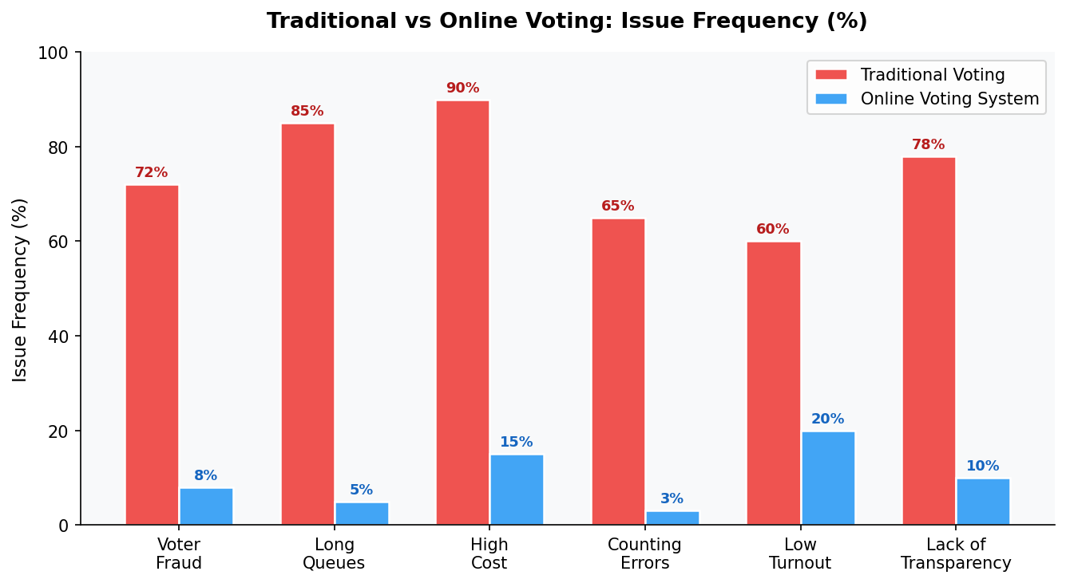
Figure 1: Traditional Voting vs Online Voting System — Issue Frequency Comparison (%)
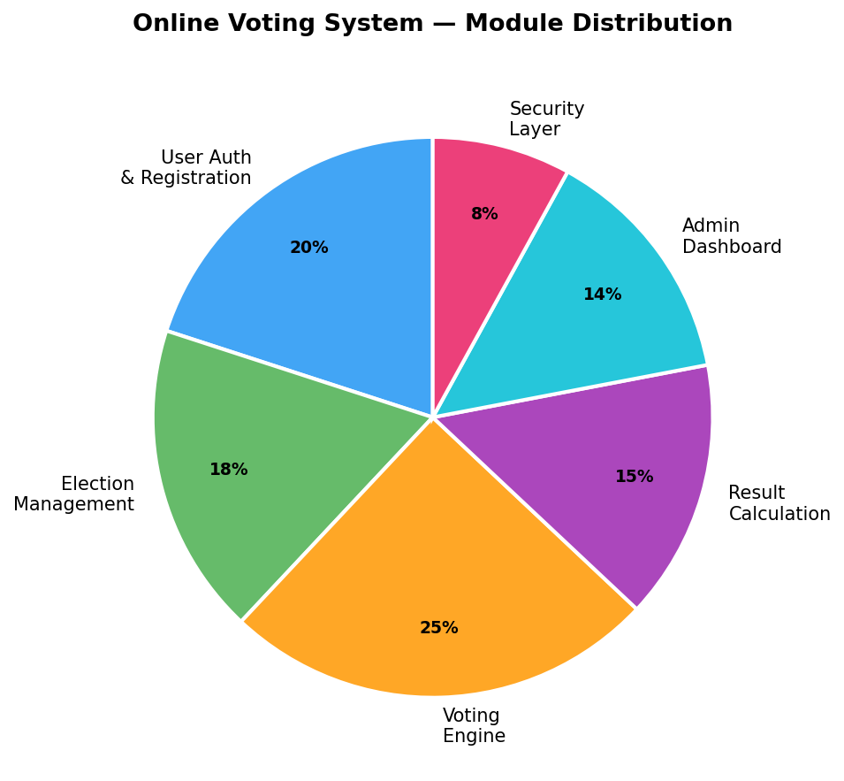
Figure 2: Online Voting System — Module Distribution by Development Effort

2.2 Non-Functional Requirements
Non-functional requirements define the quality constraints, operational standards, and system-wide properties that the Online Voting System must satisfy. These requirements are especially critical for a voting platform, where a single security flaw or performance failure during an election can undermine the entire exercise. All non-functional requirements below are measurable and testable.

ID | Category | Requirement | Metric
NFR001 | Performance | Voting action completed within 3 seconds | Response time < 3s
NFR002 | Availability | System uptime of 99.9% during election period | 99.9% uptime SLA
NFR003 | Scalability | Support 1,000+ concurrent voters | 1000+ concurrent users
NFR004 | Security | HTTPS, JWT, OTP, end-to-end encryption of votes | OWASP Top 10 compliant
NFR005 | Integrity | One-person-one-vote enforced at DB level | Zero duplicate votes
NFR006 | Anonymity | Vote records decoupled from voter identity | No vote-to-voter traceability
NFR007 | Usability | Accessible on all modern browsers and mobile | WCAG 2.1 AA standard
NFR008 | Auditability | All critical actions logged with timestamp & IP | Tamper-evident audit log

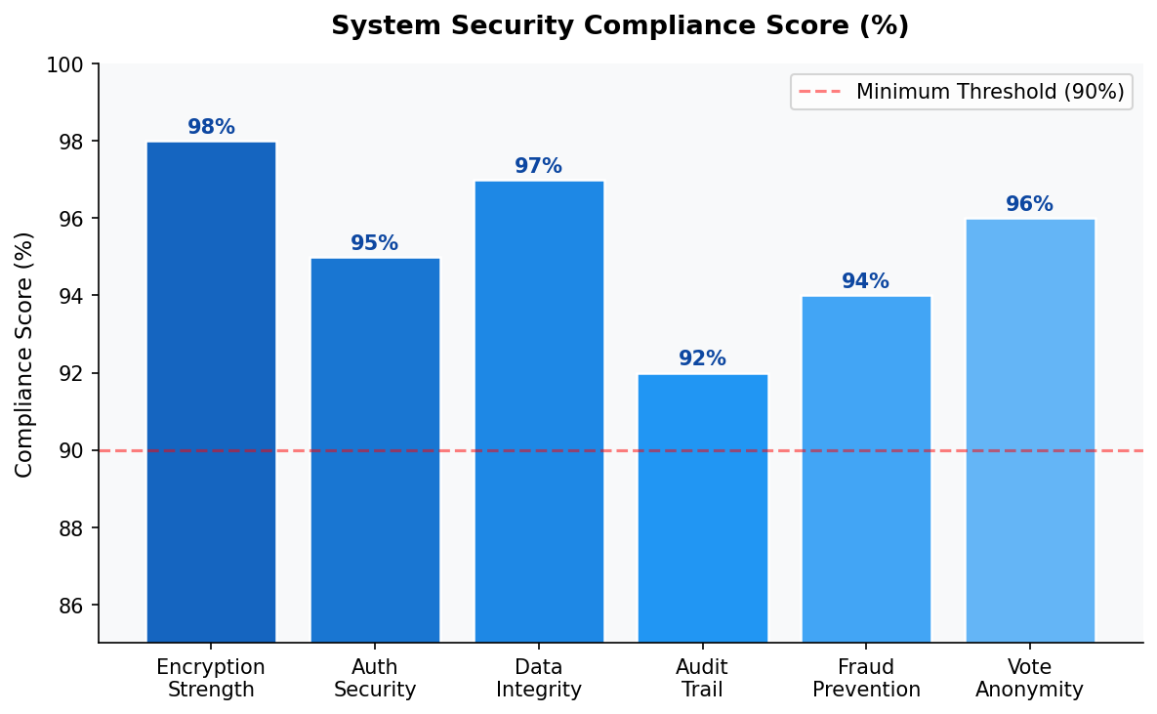
Figure 3: System Security Compliance Score by Security Domain (%)

3. Use Cases and Flow of Processes
Use cases describe the interactions between the system's actors and the application's functional capabilities. The system recognises three actors: the Voter (authenticated registered user), the Guest User (unauthenticated visitor), and the Administrator. The system-level use case diagram below presents all major use cases and their association with the appropriate actor. Each use case corresponds directly to one or more functional requirements defined in Section 2.

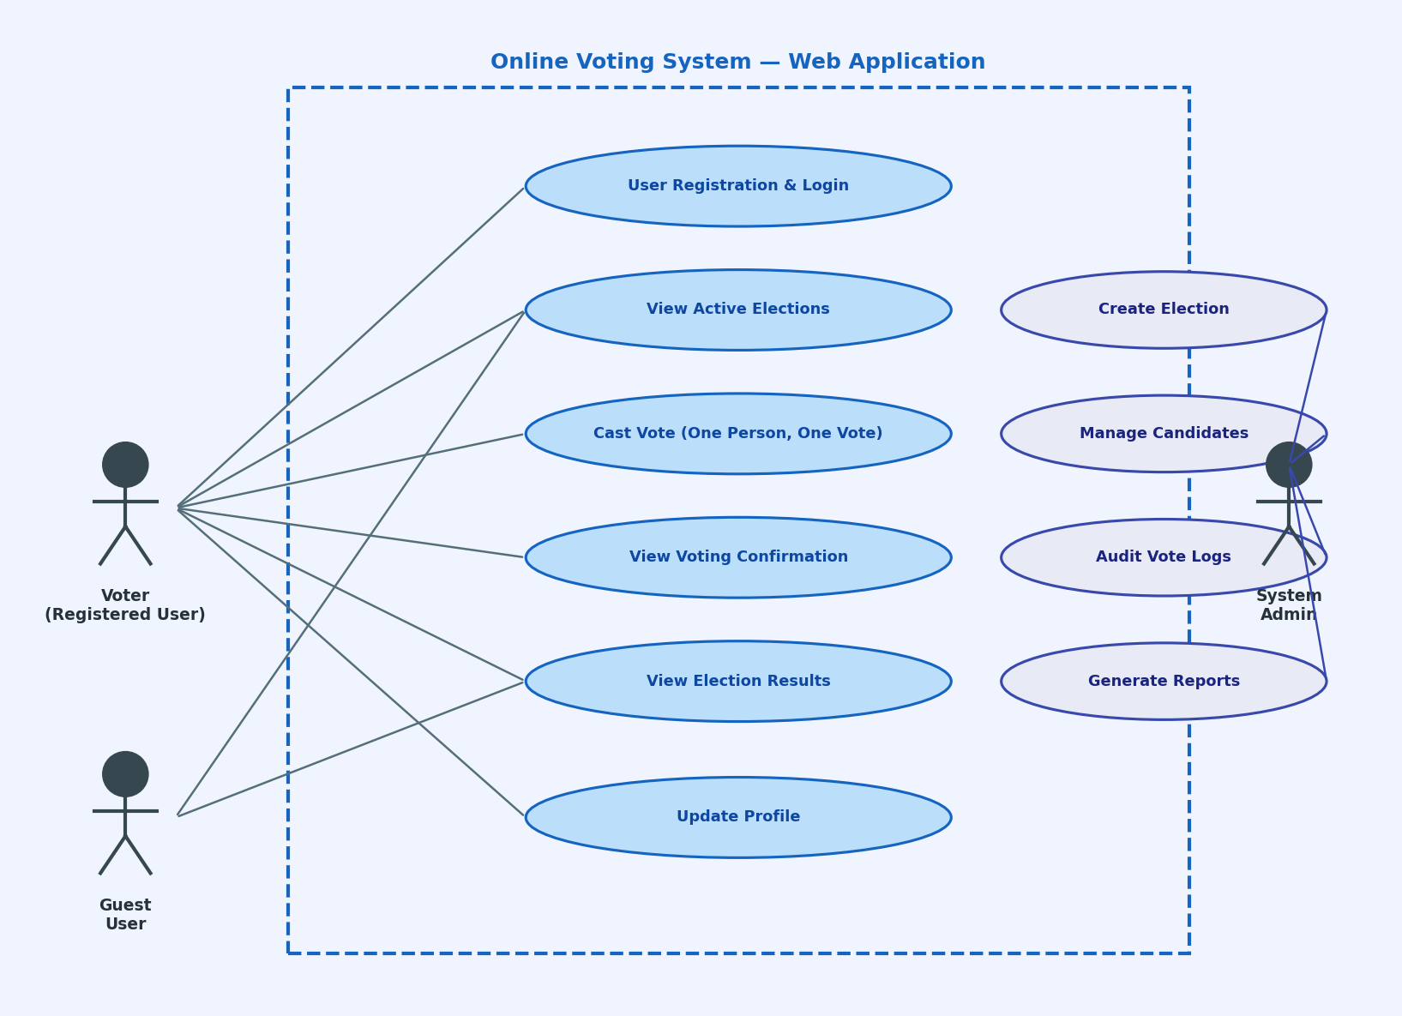
Figure 4: System Level Use Case Diagram — Online Voting System Web Application

3.1 Use Case 1 — Voter Registration
Field | Details
ID | UC001
Name | Voter Registration (Sign Up)
Description | This use case describes the complete process by which a new eligible individual registers as a voter on the Online Voting System platform.
Requirement(s) | FR001
Actor(s) | Prospective Voter (Public Visitor), Administrator (for approval step)
Precondition | The actor must not have an existing account with the same CNIC or email address. The registration page must be publicly accessible.
Postcondition | A new voter account is created with PENDING_APPROVAL status. The admin receives a notification. Upon approval, the voter receives a confirmation email and can log in.
Basic Flow | Basic Flow:  1. Actor opens the application and clicks 'Register'.  2. Actor completes the registration form: Full Name, CNIC, Email, Password, Department.  3. System validates all inputs (format, uniqueness, password strength).  4. System hashes the password using bcrypt (12 rounds).  5. System creates voter account with PENDING_APPROVAL status.  6. System notifies the admin of a new registration awaiting approval.  7. Admin reviews the submission and clicks 'Approve'.  8. System activates the account and emails the voter a confirmation.  Alternative Flow:  — Admin manually creates voter accounts by importing a CSV voter roll.  Exceptions:  — Duplicate CNIC or email: System displays 'Account already exists.'  — Weak password: Inline password strength indicator prompts improvement.  — Invalid CNIC format: Field-level validation error displayed immediately.

3.2 Use Case 2 — Cast Vote
Field | Details
ID | UC002
Name | Cast Vote in Active Election
Description | This use case describes the end-to-end process by which an authenticated, eligible voter casts their ballot in an active election, with full one-person-one-vote enforcement and vote anonymisation.
Requirement(s) | FR003
Actor(s) | Registered Voter (authenticated, approved, eligible for the election)
Precondition | The voter must be logged in with a valid JWT session. An election must currently be in the Active state. The voter must not have already voted in this election.
Postcondition | The voter's vote is encrypted, anonymised, and persisted. Participation flag is set. Confirmation receipt is issued. Event is logged in the audit trail.
Basic Flow | Basic Flow:  1. Authenticated voter navigates to 'Active Elections'.  2. System checks voter eligibility for each listed election.  3. Voter selects an election and clicks 'Vote Now'.  4. System verifies voter has not already voted (checks participation flag).  5. System displays the ballot: list of candidates with names and photos.  6. Voter selects exactly one candidate and clicks 'Confirm Vote'.  7. System prompts for final confirmation ('Are you sure?').  8. Voter confirms; system encrypts the vote and decouples voter identity.  9. Vote record is persisted; participation flag set to TRUE.  10. System generates and displays a unique confirmation receipt token.  Alternative Flow:  — Voter returns to ballot without selecting a candidate: Submit button remains disabled.  Exceptions:  — Already voted: System redirects to 'You have already voted' page with receipt.  — Election closed mid-session: System notifies voter and redirects to results.  — Session expired: Voter is redirected to login page; vote is NOT recorded.

3.3 Use Case 3 — Admin Manages Election
Field | Details
ID | UC003
Name | Admin Creates and Manages Election Lifecycle
Description | This use case describes the administrator's ability to create a new election, configure candidates, transition the election through its lifecycle states, and close it to trigger automatic result computation.
Requirement(s) | FR004
Actor(s) | Administrator
Precondition | Admin must be authenticated with the ADMIN role. At least one candidate must be added before transitioning to Active state.
Postcondition | Election is created, configured, and transitioned through Draft > Active > Closed states. Results are automatically computed upon closure. All actions are recorded in the audit log.
Basic Flow | Basic Flow:  1. Admin logs in and navigates to 'Election Management'.  2. Admin clicks 'Create New Election'.  3. Admin enters: title, description, eligible group, start/end datetime.  4. Admin adds candidates (name, party/affiliation, photo).  5. System saves election in Draft state.  6. On start date, admin transitions election to Active (or system auto-activates).  7. Eligible voters can now cast votes.  8. Admin monitors real-time vote count on the dashboard.  9. On end date, admin closes the election (or system auto-closes).  10. System tallies all votes, computes percentages, declares winner.  11. Results are published; admin can download the official result report.  Alternative Flow:  — Admin edits candidate list before election goes Active.  — Admin downloads voter participation report in CSV format.  Exceptions:  — Attempt to activate election with zero candidates: System blocks transition.  — Admin attempts to delete an Active election: System denies, only suspension is allowed.  — System auto-close fails: Notification sent to admin for manual closure.

The process flow diagram below presents the complete voting journey from the voter opening the web application to the issuance of the confirmation receipt, including all decision points and exception paths.

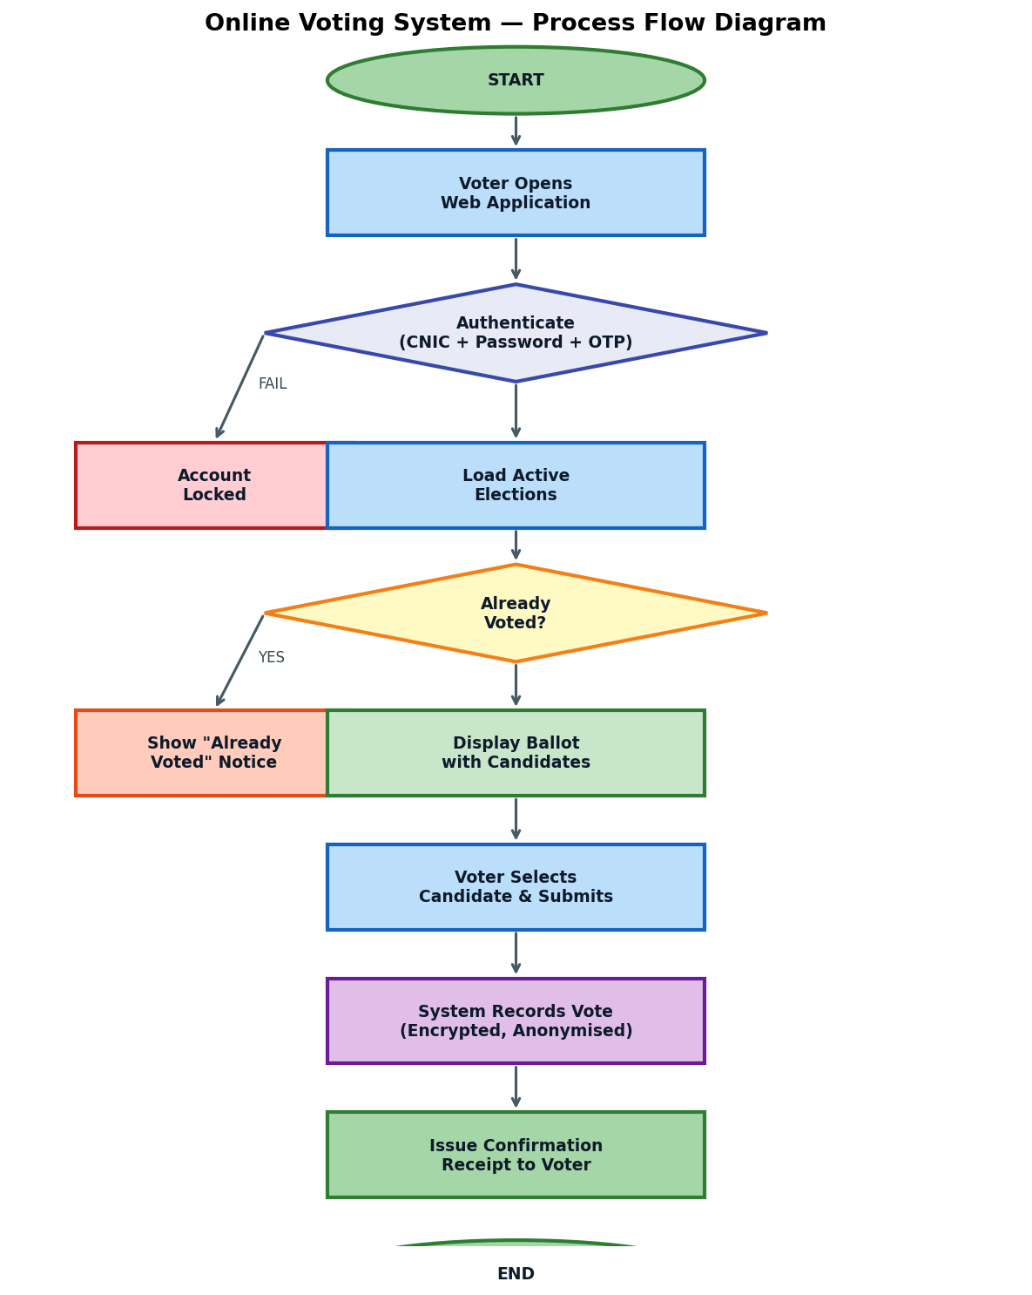
Figure 5: Online Voting System — Complete Process Flow Diagram (Voter Journey)

4. References
The following references have been consulted in the preparation of this Software Requirements Specification and will inform the design and implementation phases of the Online Voting System:
- [1] S. Heiberg, P. Laud, and J. Willemson, 'The Application of I-Voting for Estonian Parliamentary Elections of 2011,' in Proc. Vote-ID, Springer LNCS, vol. 6897, pp. 208–223, 2011.
- [2] M. Bernhard, J. Benaloh, A. Halderman, R. Rivest, P. Ryan, P. Stark, V. Teague, P. Vora, and D. Wallach, 'Public Evidence from Secret Ballots,' in Proc. 6th International Joint Conference on Electronic Voting (E-Vote-ID), 2017.
- [3] D. Springall, T. Finkenauer, Z. Durumeric, J. Kitcat, H. Hursti, M. MacAlpine, and J. A. Halderman, 'Security Analysis of the Estonian Internet Voting System,' in Proc. ACM CCS, 2014.
- [4] B. Adida, 'Helios: Web-based Open-Audit Voting,' in Proc. 17th USENIX Security Symposium, pp. 335–348, 2008.
- [5] M. R. Clarkson, S. Chong, and A. C. Myers, 'Civitas: Toward a Secure Voting System,' in Proc. IEEE Symposium on Security and Privacy (S&P), 2008.
- [6] A. Essex, J. Clark, and C. Adams, 'Eperio: Mitigating Technical Complexity in Cryptographic Election Verification,' in Proc. USENIX EVT/WOTE, 2012.
- [7] N. Asokan, 'Fairness in Electronic Commerce,' Ph.D. dissertation, Univ. of Waterloo, 1998. (Referenced for non-repudiation protocol design.)
- [8] OWASP Foundation, 'OWASP Top Ten 2021 — The Ten Most Critical Web Application Security Risks,' Available: https://owasp.org/Top10/, accessed 2024.
- [9] IEEE Std 830-1998, 'IEEE Recommended Practice for Software Requirements Specifications,' IEEE, New York, 1998.
- [10] Election Commission of Pakistan, 'Annual Report 2023,' ECP Publications, Islamabad, 2023. Available: https://www.ecp.gov.pk

