name : abdullah ayman
lab2 :
qeustion 1 : Create a view for student names with their subjects’ names
which they will study
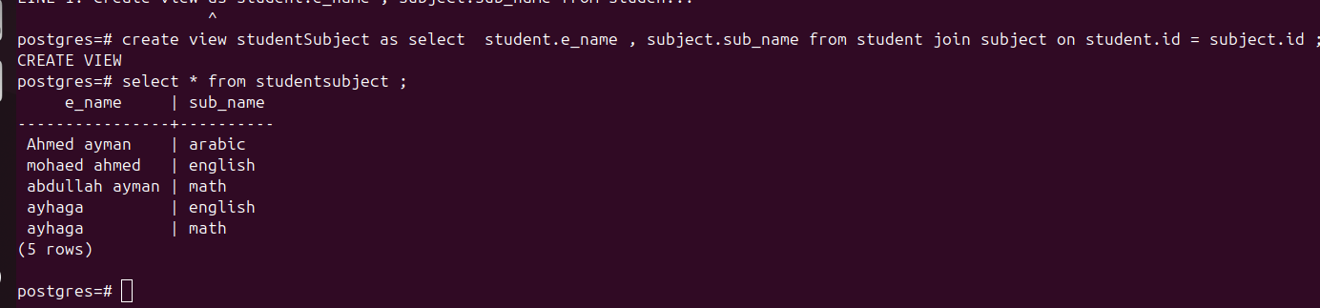
question 2 : Create a view for tracks names and the subjects which belong
to it.

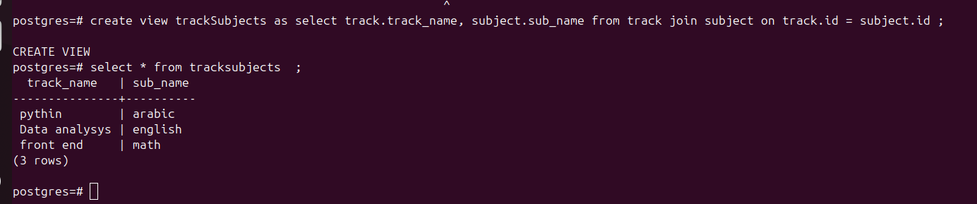
lab 3 :
question 1 : Write a query to find out which subjects are not associated with any track.
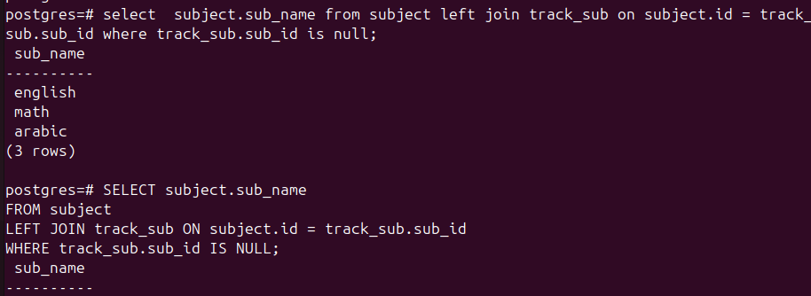
Question 2 : Display name and age of each students

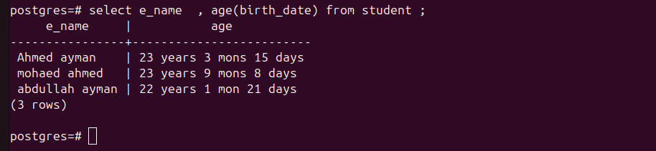
question 3 : Display the name of students with their rounded score in each subject
SELECT student.e_name AS student_name, ROUND(grades.grade) AS rounded_scoreFROM
grades
JOIN
student ON grades.stu_id = student.id;

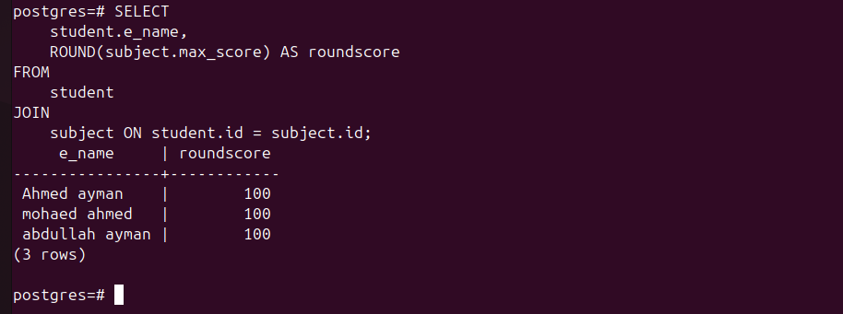
question 4 : Display the name of students with the year of Birthdate

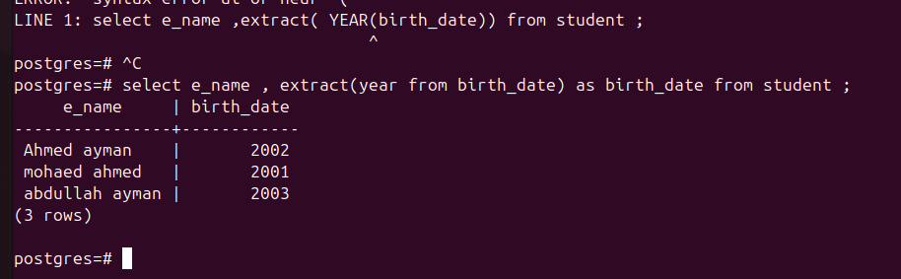
question 5 : Add new exam result, in date column use NOW() function


question 6 : Write a query to calculate the average grade obtained by a specific student
across all exams

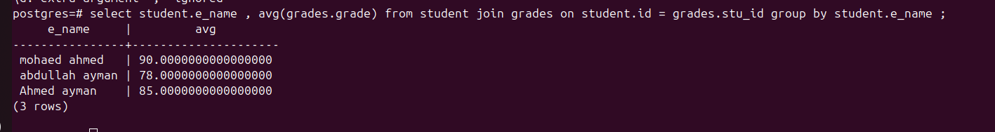

question 7 : Write a query to replace all occurrences of 'gmail.com' in email addresses
with 'iti.com'

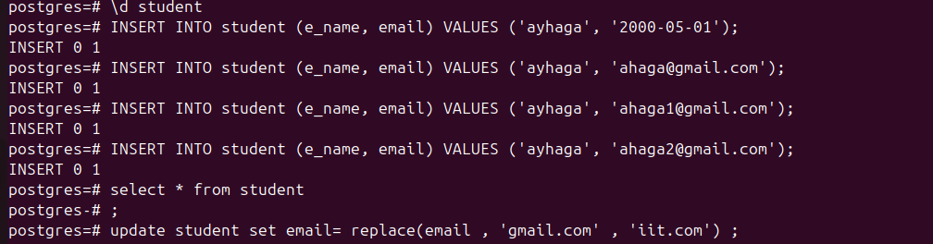
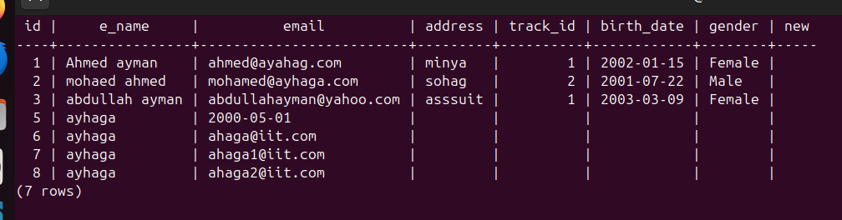
question 8 : Write a query to calculate the difference in days between the current date
and each exam date.

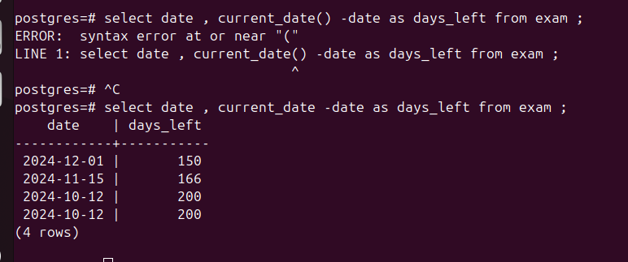
question 9 : Write a query to check if each student's email address ends with '.com'.
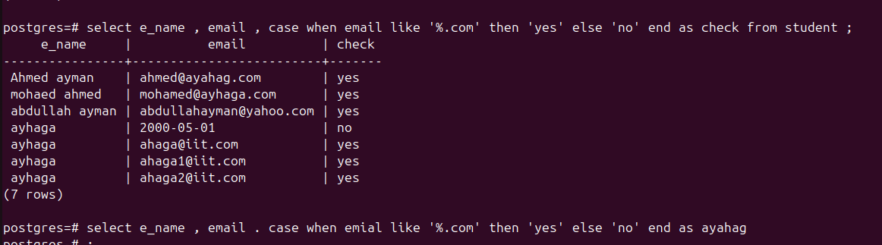
question 10 : Display each exam date like ‘MM/DD/YYYY’.

