PostgreSQL lab1

name : abdullah ayman

Q1 : Create your tables with their columns in PostgreSQL:

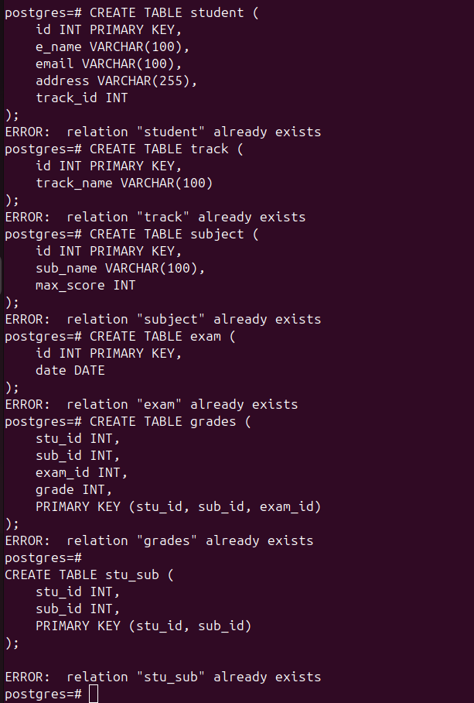
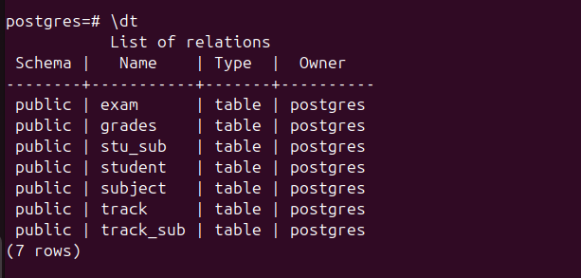
question 2 : Insert at minimum 3 Rows at each table.

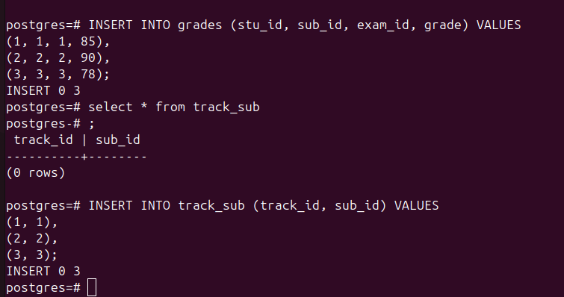
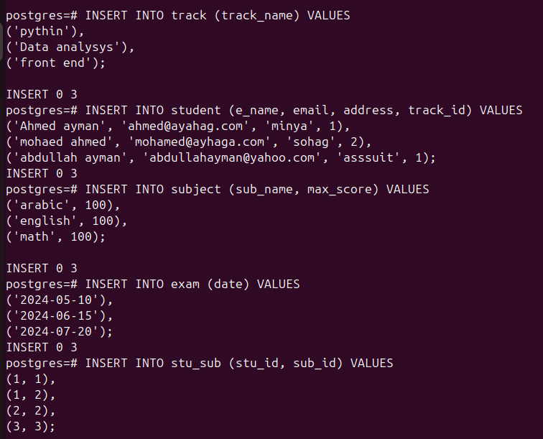
question 3 : Add birth date column for the student table.

question 4 : Add gender column which hold only 2 values (Male or
Female).

question 5 : add/Alter foreign key constrains in your tables.



question 6 : Display male students who are born before 1991-10-01.

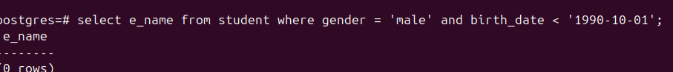
question 7 : Display students’ names that begin with A.

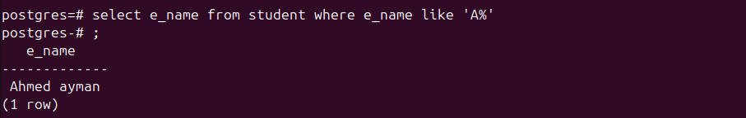
question 8 : Display subjects and their max score sorted by max score.

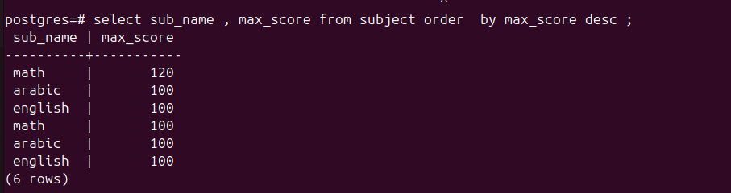
question 9 : Display the subject with highest max score .

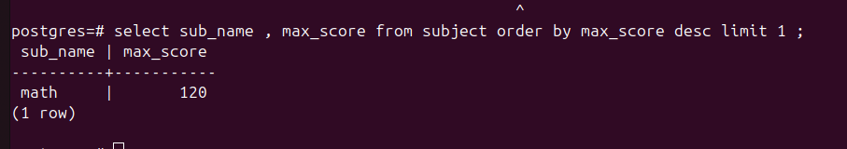
lab2
question 1 : Display the number of students their name is “Mohammed”


question 2 : Display the number of males and females

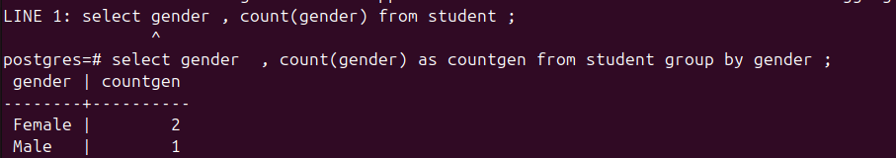
question 3 : Display the repeated first names and their counts if higher
than 2.

question 4 : Display all students and track name they belong to

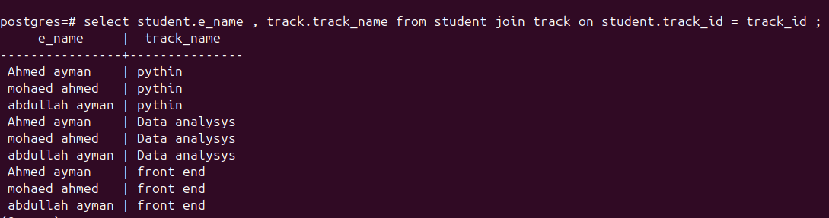
question 5 : Display all students except those who are in OS track

