MSES602 – Lab #1: Introduction to DevOps – Traditional Ops with Python
Course: MSES602
Lab: #1 – Introduction to DevOps: Traditional Ops with Python
Instructor: Professor Shari Plantz-Masters, Ph.D.
Student: Abdullah Bahir
Date: August 30, 2026

Overview
This lab introduced traditional systems administration tasks performed manually and with Python scripting. The goal was to set up an Ubuntu 24.04.4 LTS Virtual Machine (VM name: MSE602-Ubuntu), configure SSH access, verify Python and Git installations, and execute several operational Python scripts. The lab reinforces the DevOps principle of automating repetitive tasks to reduce human error and increase efficiency—shifting from treating systems as "pets" to treating them as "cattle."

Section 1: VM Setup and SSH Configuration

Install and Verify SSH
After booting the Ubuntu VM (MSE602-Ubuntu), SSH was already at the newest version (1:9.6p1-3ubuntu13.18) and was verified to be running with the service ssh status command. The service showed as active (running) on host abdullah-pc.
sudo apt install ssh
service ssh status
Screenshot sc1 – SSH Service Status:
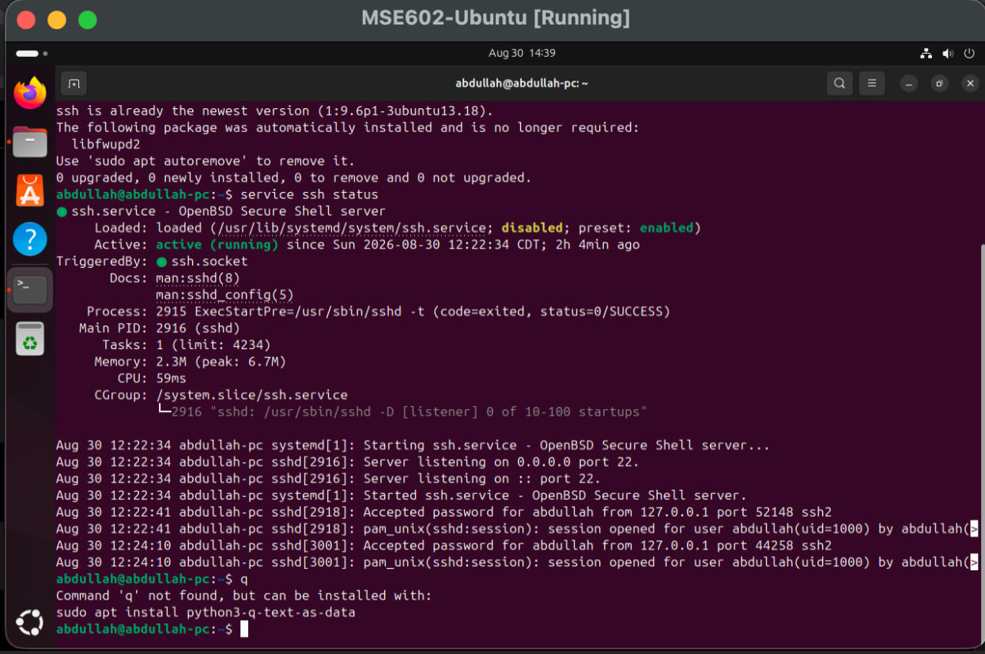

Test SSH Loopback Connection
The SSH connection was tested locally using the loopback address 127.0.0.1 as user abdullah to confirm the service was accepting connections.
ssh abdullah@127.0.0.1
exit
Screenshot sc2 – Successful SSH Connection:
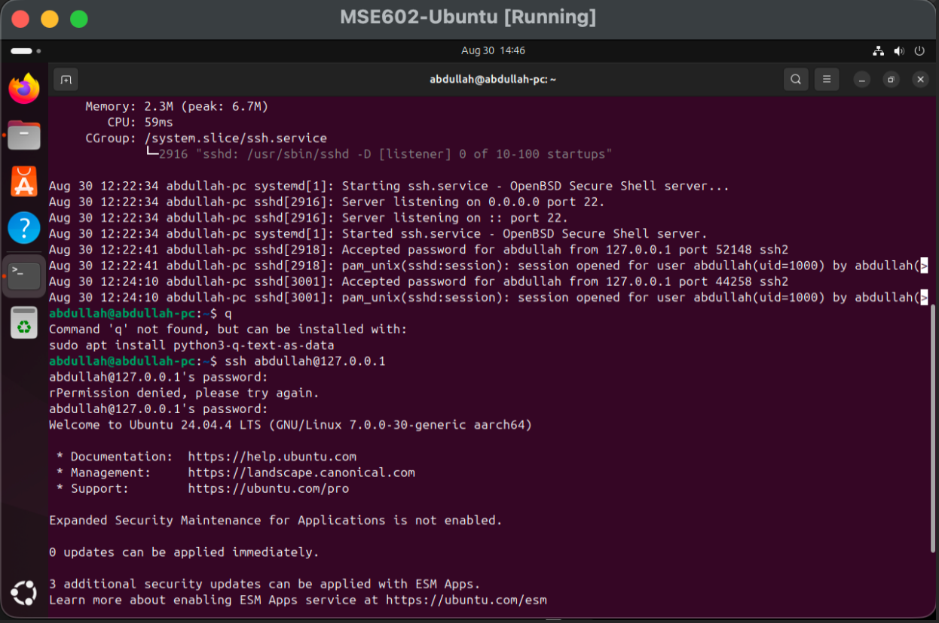

Section 2: Python and Pip Verification
Python 3 was already installed on the Ubuntu VM. The version confirmed was Python 3.12.3. pip3 was already at the newest version (24.0+dfsg-1ubuntu1.3) and confirmed with pip3 --version showing pip 24.0.
python3 --version
sudo apt install python3-pip
pip3 --version
pip --help
Screenshot sc3 – Python3 Version and Pip Installation:
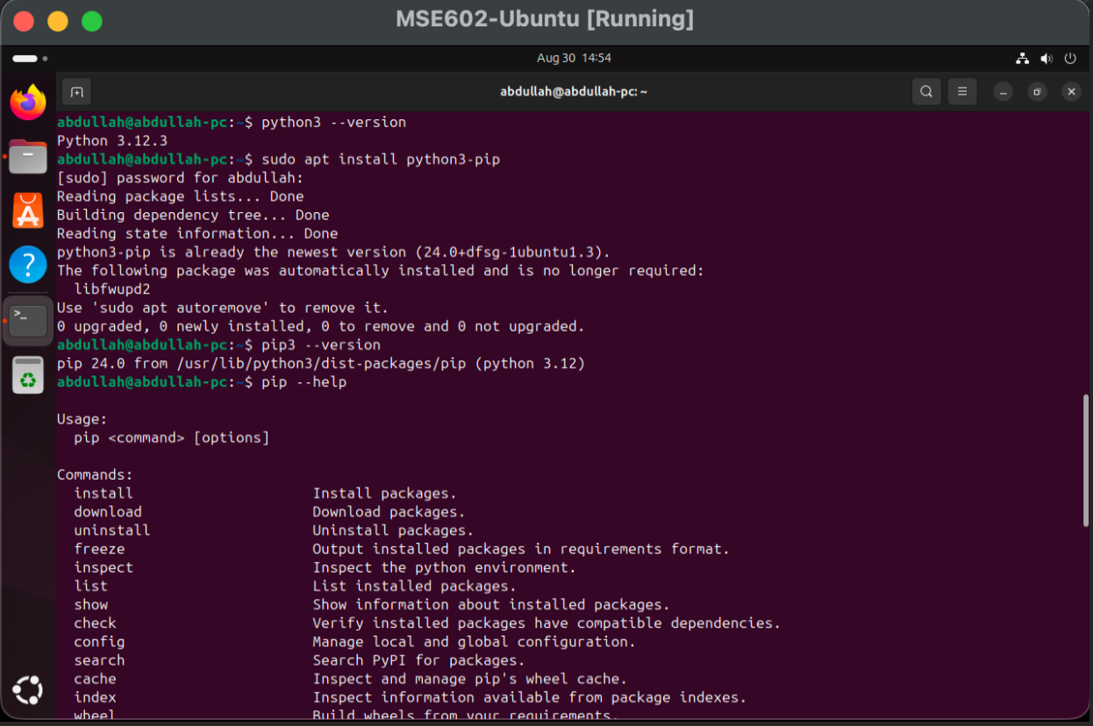

Section 3: Git Installation
Git was installed to enable cloning of remote repositories. Git was already at the newest version (1:2.43.0-1ubuntu7.3) and confirmed with git --version showing git version 2.43.0.
sudo apt install git
git --version
Screenshot sc4 – Git Version:
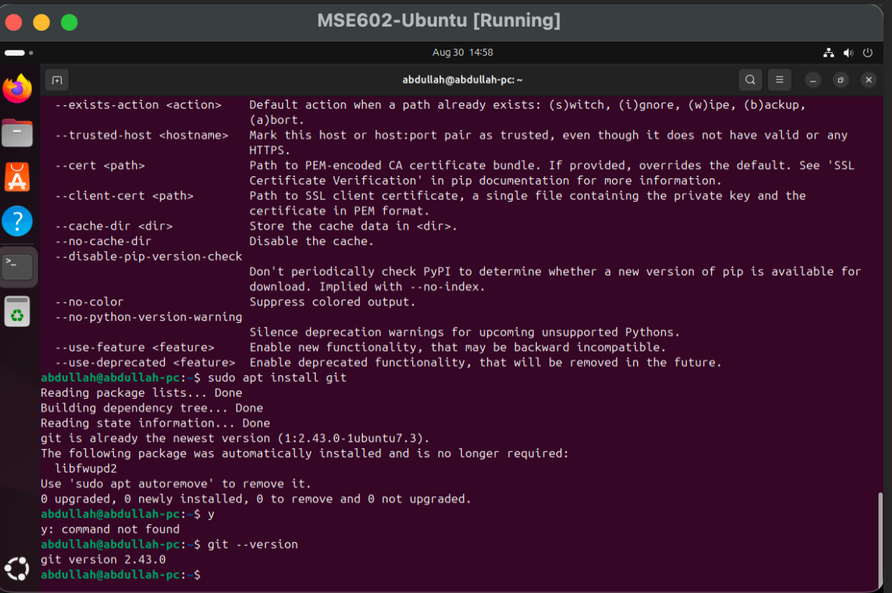

Section 4: Clone the Project Repository
A Projects directory was created and the MSES602 DevOps utilities repository was cloned from GitHub. The Python scripts were located at ~/Projects/MSES602_DevOpsUtils/src/python3 and included: envChk.py, netmon.py, passChk.py, and passChk.py.save.
cd
mkdir Projects
cd Projects
git clone https://github.com/RegisUniversity/MSES602_DevOpsUtils.git
cd ./MSES602_DevOpsUtils/src/python3
ls
Screenshot sc5 – Cloned Repository and Python Files:
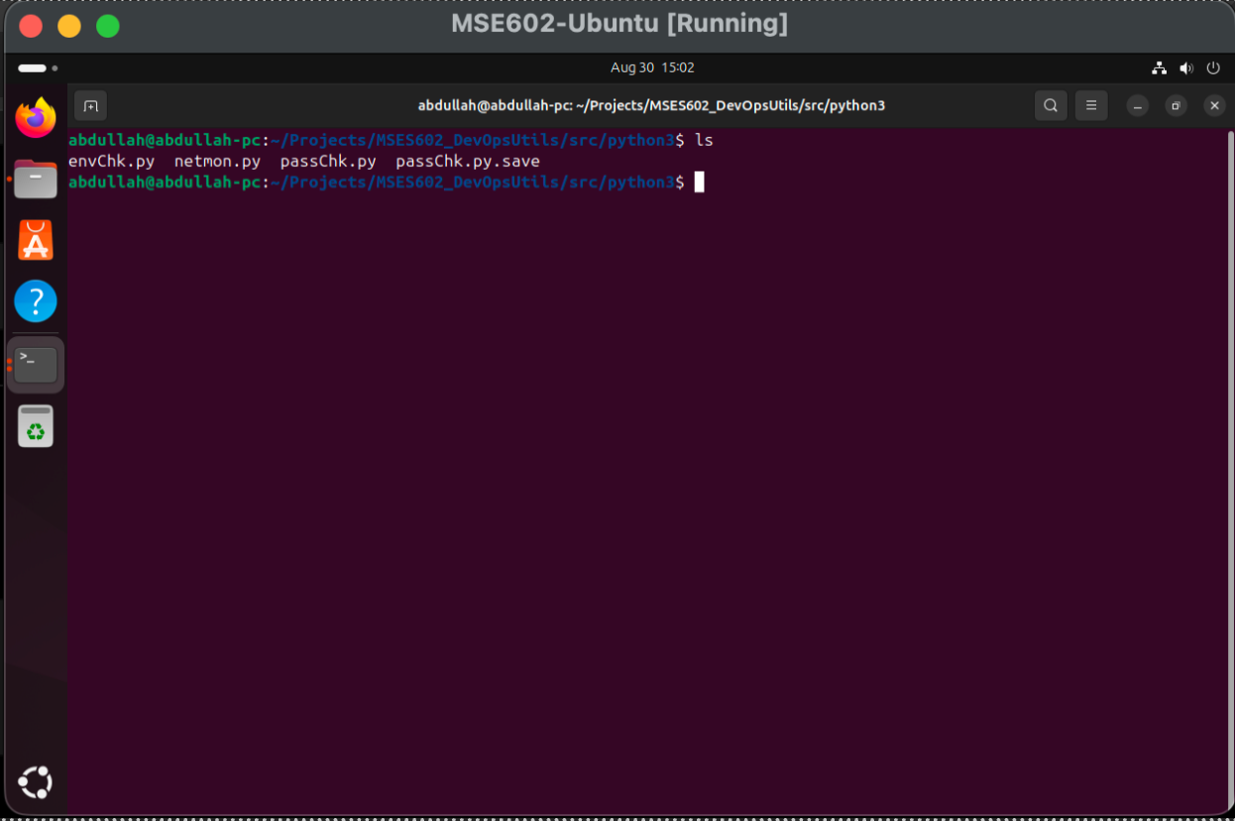

Section 5: Running passChk.py – Password Security Audit
The passChk.py script scans all user accounts on the Ubuntu image and flags any accounts with short usernames or passwords that would be easily guessed by brute-force tools.
python3 passChk.py
Screenshot sc6 – passChk.py Output:
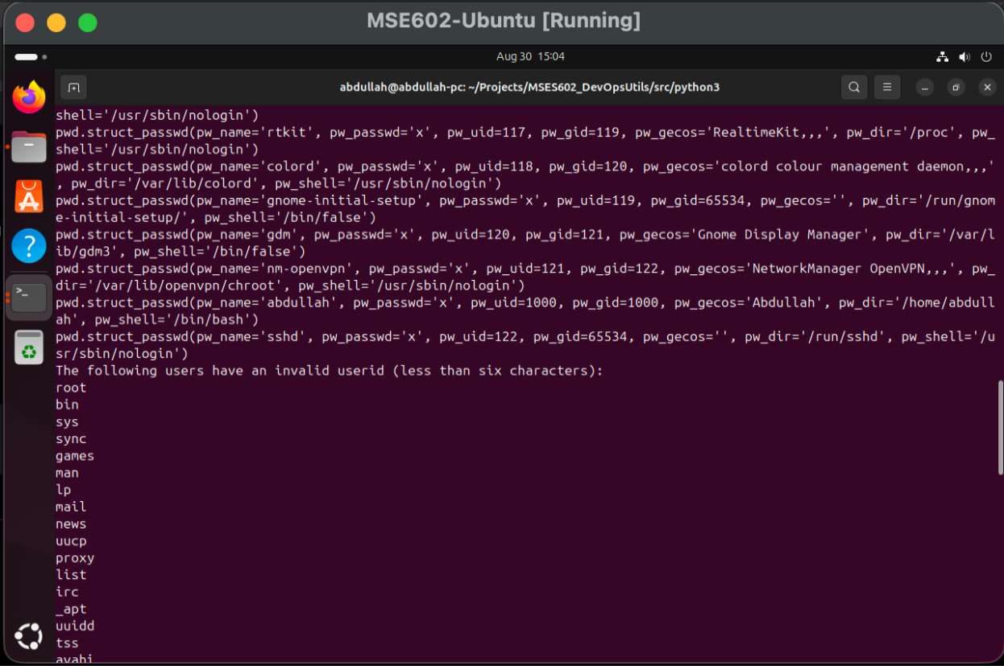

Reviewing the passChk.py Source Code
The script was opened in nano to review how it reads the system user and password files and applies its security checks.
nano passChk.py
Screenshot sc7 – passChk.py Source Code:
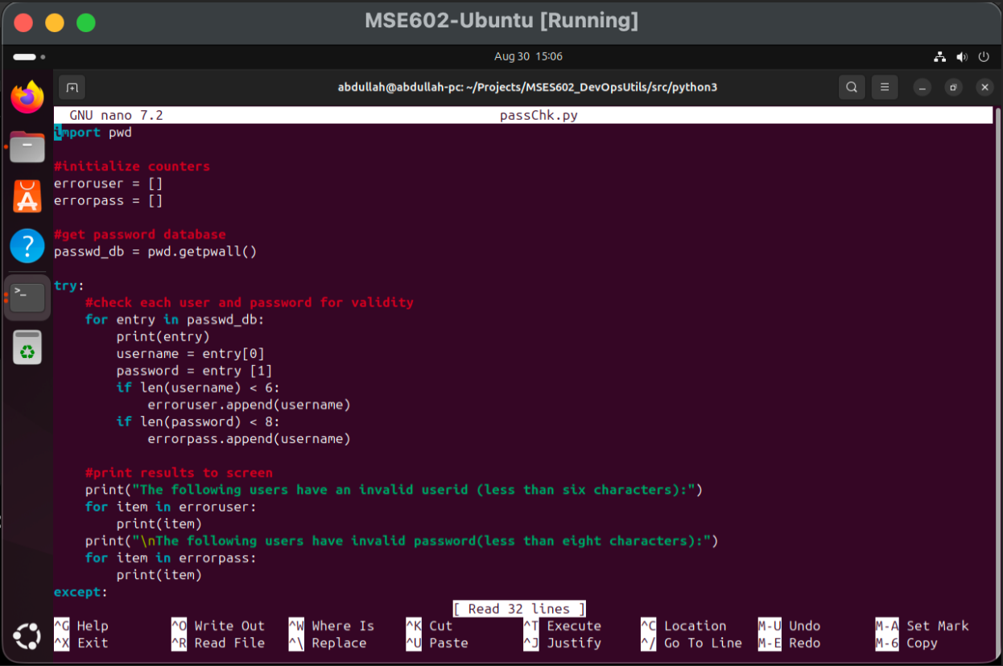
Observation: Most flagged accounts are system-level accounts (root, bin, sys, sync, games, man, lp, mail, etc.) with usernames shorter than six characters. The only active user account `abdullah` (uid=1000) passed the checks. Automating this check daily would be far more practical than manually reviewing the files each time.

Section 6: Running netmon.py – Network Monitor
The netmon.py script monitors network connectivity at 60-second intervals and reports whether the network is up or down. It can be extended to trigger alerts or corrective actions on failure.
python3 netmon.py
Screenshot sc8 – netmon.py Running:
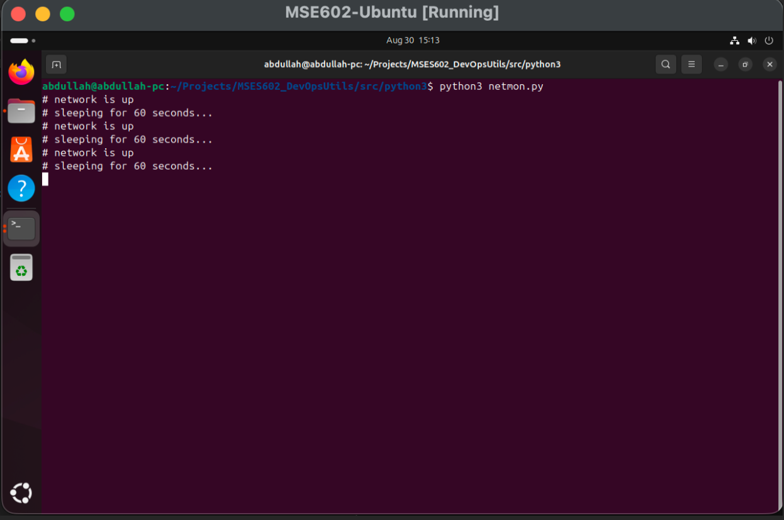

Section 7: Extended envChk.py – System Environment Check
For the final task, the envChk.py script was extended with additional system metrics beyond the original. The new script (lab1.py) was written to include:
- System information (OS, hostname, machine)
- CPU usage (cores and current utilization)
- Memory usage (total, available, used)
- Disk usage (total, used, free)
- Network I/O counters
- SSH connectivity check – verifies port 22 is reachable on localhost
- System uptime since last boot
- Logged-in users
- Running process count
- Automated status warnings for CPU, memory, and disk thresholds

Extended Script: `lab1.py`
"""
MSES602 - Lab #1: Introduction to DevOps - Traditional Ops with Python
System environment check script (extends envChk.py with an SSH reachability check).
"""
import psutil
import platform
import socket
from datetime import datetime
def print_section(title):
print()
print("=" * 60)
print(title)
print("=" * 60)
print_section("SYSTEM INFORMATION")
print("Operating System:", platform.system())
print("OS Version:", platform.version())
print("Machine:", platform.machine())
print("Hostname:", socket.gethostname())
print_section("CPU INFORMATION")
print("CPU Cores:", psutil.cpu_count(logical=False))
print("Logical CPUs:", psutil.cpu_count(logical=True))
cpu_usage = psutil.cpu_percent(interval=1)
print("Current CPU Usage:", cpu_usage, "%")
print_section("MEMORY INFORMATION")
memory = psutil.virtual_memory()
print("Total Memory:", round(memory.total / (1024 ** 3), 2), "GB")
print("Available Memory:", round(memory.available / (1024 ** 3), 2), "GB")
print("Used Memory:", round(memory.used / (1024 ** 3), 2), "GB")
print("Memory Usage:", memory.percent, "%")
print_section("DISK INFORMATION")
disk = psutil.disk_usage("/")
print("Total Disk Space:", round(disk.total / (1024 ** 3), 2), "GB")
print("Used Disk Space:", round(disk.used / (1024 ** 3), 2), "GB")
print("Free Disk Space:", round(disk.free / (1024 ** 3), 2), "GB")
print("Disk Usage:", disk.percent, "%")
print_section("NETWORK INFORMATION")
network = psutil.net_io_counters()
print("Bytes Sent:", round(network.bytes_sent / (1024 ** 2), 2), "MB")
print("Bytes Received:", round(network.bytes_recv / (1024 ** 2), 2), "MB")
print_section("SSH CONNECTIVITY")
ssh_host = "127.0.0.1"
ssh_port = 22
try:
with socket.create_connection((ssh_host, ssh_port), timeout=3):
print(f"SSH port {ssh_port} on {ssh_host} is OPEN (reachable).")
except (socket.timeout, ConnectionRefusedError, OSError):
print(f"SSH port {ssh_port} on {ssh_host} is NOT reachable.")
print_section("SYSTEM UPTIME")
boot_time = datetime.fromtimestamp(psutil.boot_time())
print("System Boot Time:", boot_time)
uptime_seconds = datetime.now().timestamp() - psutil.boot_time()
print("System Uptime:", round(uptime_seconds / 3600, 2), "hours")
print_section("LOGGED IN USERS")
users = psutil.users()
if users:
for user in users:
print("Username:", user.name)
print("Terminal:", user.terminal)
print("Login Time:", datetime.fromtimestamp(user.started))
else:
print("No logged-in users found.")
print_section("RUNNING PROCESSES")
print("Number of Running Processes:", len(psutil.pids()))
print_section("SYSTEM STATUS")
print("WARNING: CPU usage is high." if cpu_usage > 80 else "CPU usage is normal.")
print("WARNING: Memory usage is high." if memory.percent > 80 else "Memory usage is normal.")
print("WARNING: Disk usage is high." if disk.percent > 80 else "Disk usage is normal.")
print()
print("System environment check completed.")

Install psutil and Run the Script
pip3 install psutil
python3 lab1.py
The script produced the following output on the MSE602-Ubuntu VM:
- OS: Linux, Ubuntu 24.04.4 LTS, aarch64, Hostname: abdullah-pc
- CPU: 4 cores / 4 logical CPUs, Usage: 0.8%
- Memory: 3.92 GB total, 1.24 GB used (36.0%)
- Disk: 47.98 GB total, 10.14 GB used (22.3%)
- Network: 0.06 MB sent, 0.08 MB received
- SSH: port 22 on 127.0.0.1 is OPEN (reachable)
- Boot Time: 2026-08-30 16:07:09, Uptime: 1.02 hours
- Logged-in user: abdullah (seat0 & tty2), Login: 2026-08-30 16:07:49
- Running Processes: 204
- Status: CPU, Memory, and Disk usage all normal
Screenshot sc9 – psutil Install and Script Output (Part 1):
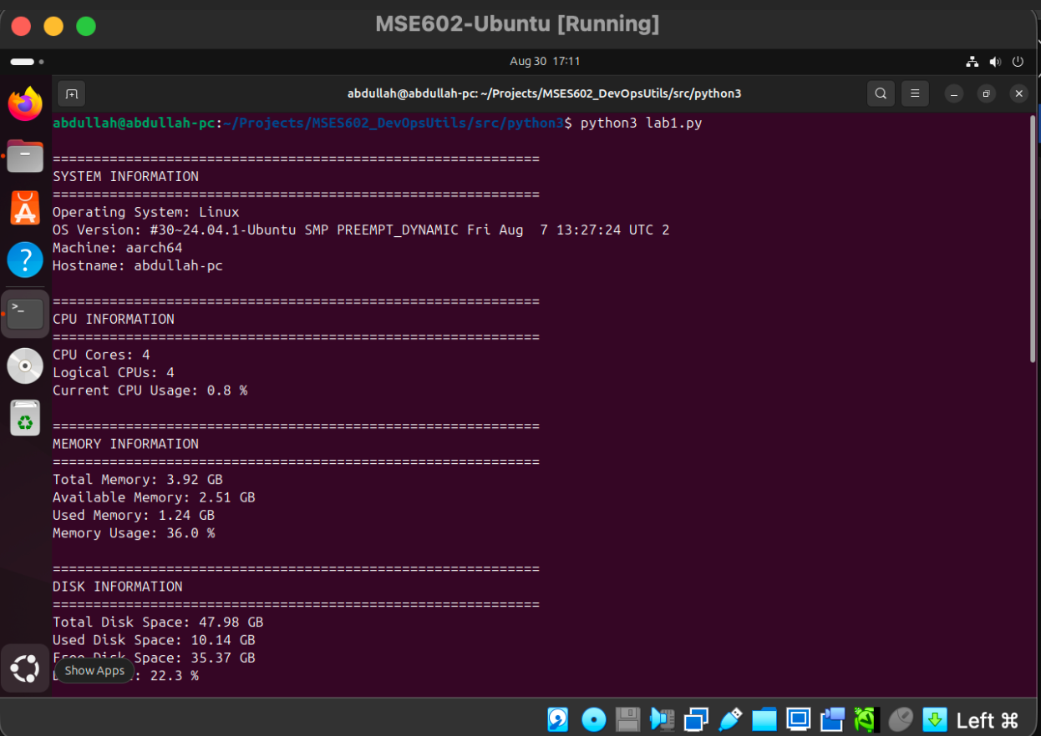
Screenshot sc10 – Script Output (Part 2):
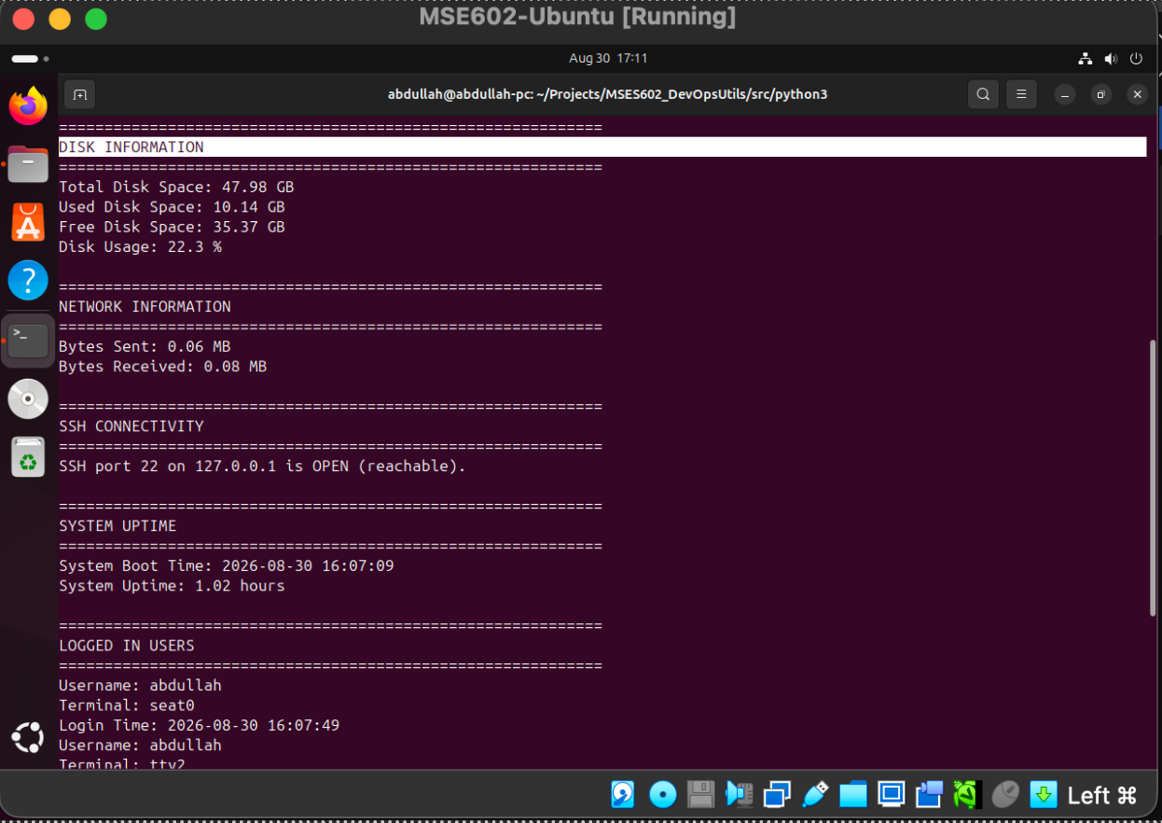
Screenshot sc11 – Script Output (Part 3 – SSH Check and Status):
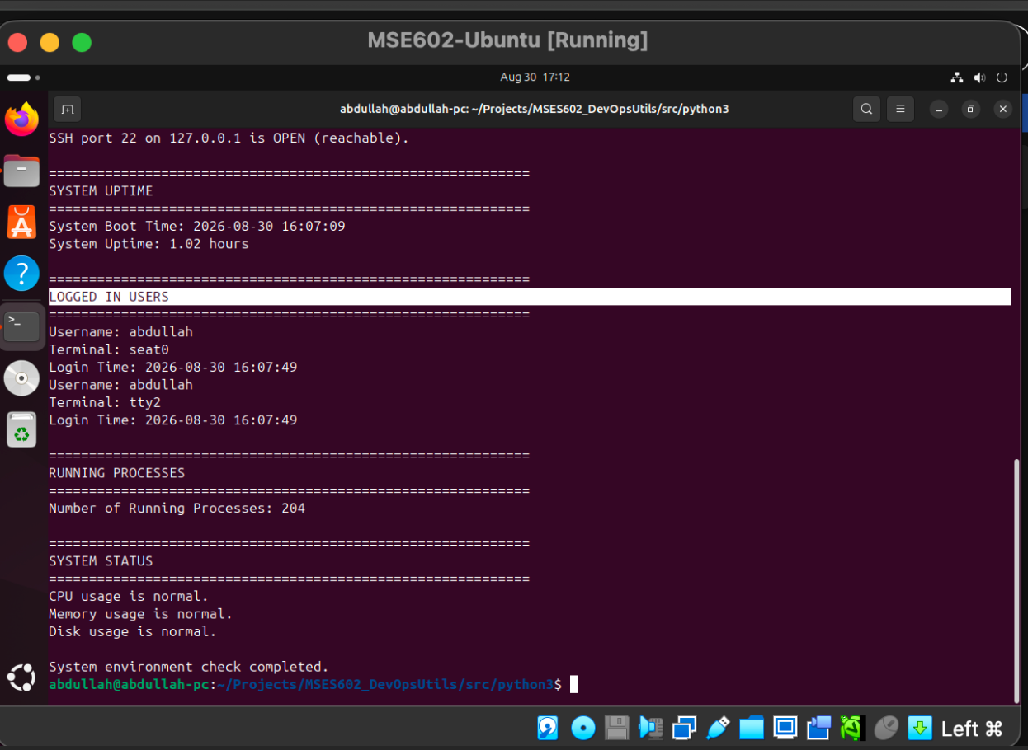

Conclusion
This lab demonstrated traditional systems administration tasks on an Ubuntu VM, including SSH setup, Python scripting, and system monitoring. A key takeaway is that automating these tasks with Python eliminates manual effort, reduces errors, and enables repeatable, consistent system checks.
The extended lab1.py script goes beyond the original envChk.py by adding an SSH connectivity check, system uptime, logged-in users, process count, and threshold-based status warnings. These additions reflect practical, real-world operational monitoring concerns.
As emphasized in the DevOps Handbook, automation is central to the CAMS model (Culture, Automation, Measurement, Sharing). Scripts like these, stored and versioned in Git repositories, represent the shift from treating systems as "pets" to treating them as reproducible, disposable "cattle."

References
- Willis, J., Debois, P., Humble, J., & Kim, G. (2021). *The DevOps Handbook, 2nd ed.* IT Revolution Press.
- Linuxize (2018). How to install Pip on Ubuntu 18.04.
- Menchaca, J. (2018). DevOps Concepts: Pets vs Cattle.
- Parkash, A. (2018). Using apt-get Commands in Linux.
- Rendek, L. (2018). Enable SSH on Ubuntu 18.04 Bionic Beaver Linux.
- psutil documentation: https://psutil.readthedocs.io/en/latest/

