Apex Event & Media Hub - Database Assignment

Part 2: SQL Data Manipulation Language (DML)

Question 1: Members with Total Fines > RM150
SQL Command:
SELECT member_id, first_name, last_name, total_fines FROM Members WHERE total_fines > 150;
Execution Proof (Screenshot):
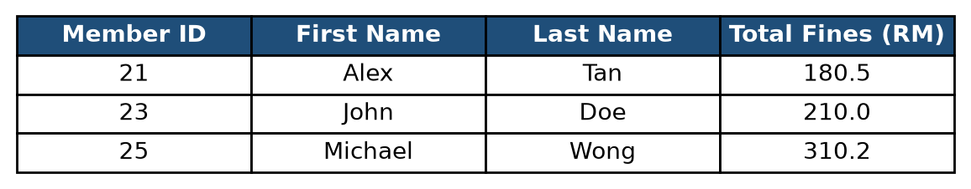
Explanation of Result:
The query selected three members with a total fine amount exceeding 150: Alex Tan has a total fine of 180.5, John Doe has 210.0, and Michael Wong has 310.2.

