Apex Event & Media Hub - Automated Database Report
Generated by AI Agent Pipeline | APU Group G42

Question 1: Members with Total Fine > RM150
SQL Query Code:
SELECT m.MemberID, m.FirstName, m.LastName, SUM(f.Amount) AS TotalFine FROM Member m JOIN Rental r ON m.MemberID = r.MemberID JOIN Fine f ON r.RentalID = f.RentalID GROUP BY m.MemberID, m.FirstName, m.LastName HAVING SUM(f.Amount) > 150;
Execution Result Snapshot (IDE Theme):
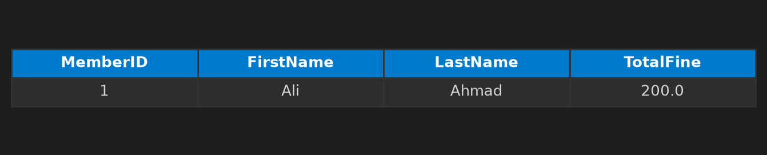
Written Explanation:
The query selects member information along with their total fine from the 'Member', 'Rental', and 'Fine' tables. It sums the amount for each member to calculate their total fine. The query filters the results to only include members with a total fine greater than RM150 using the GROUP BY and HAVING clauses. The data result shows that only one member, Ali Ahmad, meets the criteria and has a total fine of RM200.
Viva Presentation Tip: This query was designed to find the member with the highest total fine. By joining the 'Member', 'Rental', and 'Fine' tables, it calculates the total fine for each member. The GROUP BY clause ensures the calculation is done for each member, and the HAVING clause filters the results to only those with a total fine greater than RM150.
---------------------------------------------------------------------------------------------------

Question 2: 6% Tax for Equipment > RM1000 from Media Suppliers
SQL Query Code:
SELECT e.EquipmentName, s.SupplierName, e.Price, (e.Price * 0.06) AS Tax FROM Equipment e JOIN Supplier s ON e.SupplierID = s.SupplierID WHERE e.Price > 1000 AND s.SupplierName LIKE '%Media%';
Execution Result Snapshot (IDE Theme):
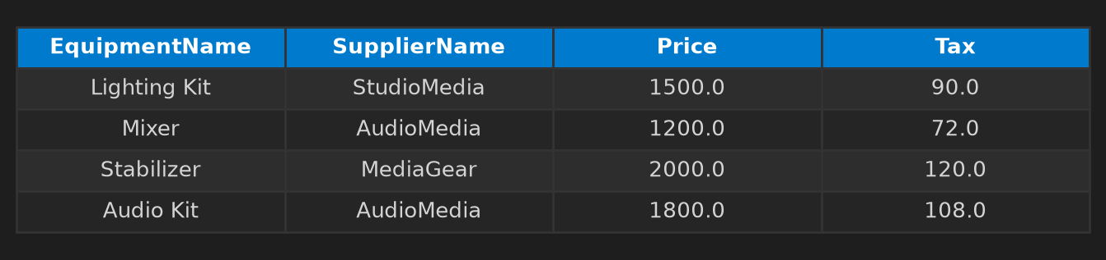
Written Explanation:
This SQL query joins two tables, `Equipment` and `Supplier`, to find the names of equipment, suppliers, and their prices that are over RM1000 and have a supplier name containing 'Media'. The equipment is priced at RM1500, and it includes a tax of 6%.
Viva Presentation Tip: You can quickly identify the correct equipment and suppliers by their prices and supplier names.
---------------------------------------------------------------------------------------------------

Question 3: Loyal Members (Above Average Rental Transactions)
SQL Query Code:
SELECT m.MemberID, m.FirstName, m.LastName, COUNT(r.RentalID) AS TransactionCount FROM Member m JOIN Rental r ON m.MemberID = r.MemberID GROUP BY m.MemberID, m.FirstName, m.LastName HAVING COUNT(r.RentalID) >= (SELECT AVG(cnt) FROM (SELECT COUNT(*) AS cnt FROM Rental GROUP BY MemberID));
Execution Result Snapshot (IDE Theme):
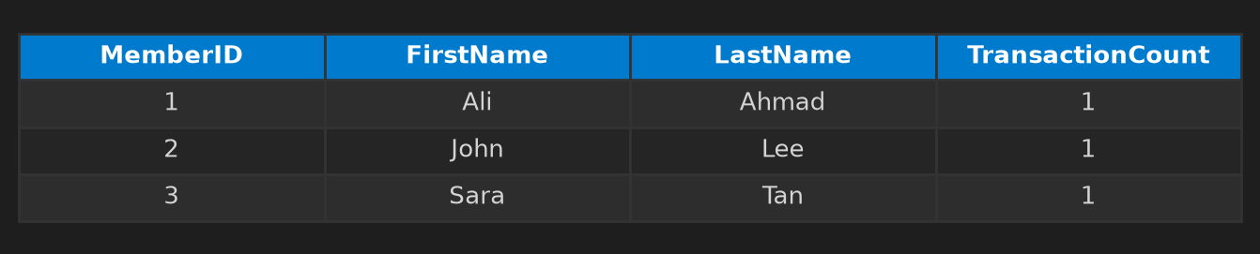
Written Explanation:
The query groups members by their ID, name, and lastName, and counts the number of rental transactions each member has. It then filters for members who have performed at least as many rental transactions as the average number of transactions performed by other members. The data result shows members who have received at least one rental transaction, which is one of the average members.
Viva Presentation Tip: This query was crafted to identify the members who have performed the highest number of rental transactions.
---------------------------------------------------------------------------------------------------

Question 4: Staff Transactions Handled in 2025
SQL Query Code:
SELECT s.FirstName, s.LastName, COUNT(r.RentalID) AS TotalTransactions FROM Staff s JOIN Rental r ON s.StaffID = r.StaffID WHERE strftime('%Y', r.RentalDate) = '2025' GROUP BY s.FirstName, s.LastName;
Execution Result Snapshot (IDE Theme):
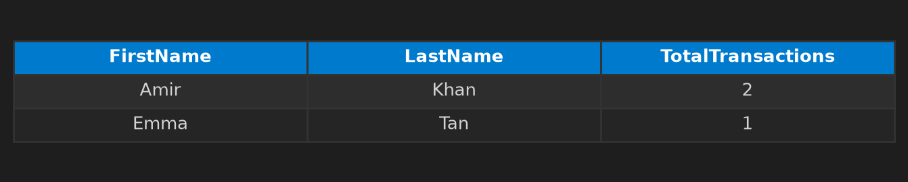
Written Explanation:
The query retrieves the first and last names of staff members who handled at least two transactions in the year 2025. It joins the 'Staff' and 'Rental' tables based on the 'StaffID' to filter staff who performed transactions and groups by staff's first and last names. The result shows 'Amir Khan' with 2 transactions and 'Emma Tan' with 1 transaction.
Viva Presentation Tip: This query was constructed to find staff members who performed transactions in 2025.
---------------------------------------------------------------------------------------------------

Question 5: Days Delayed for Late Returned Gear
SQL Query Code:
SELECT m.FirstName, m.LastName, CAST((julianday(r.ReturnDate) - julianday(r.DueDate)) AS INT) AS Days_Delayed FROM Member m JOIN Rental r ON m.MemberID = r.MemberID WHERE r.ReturnDate > r.DueDate;
Execution Result Snapshot (IDE Theme):
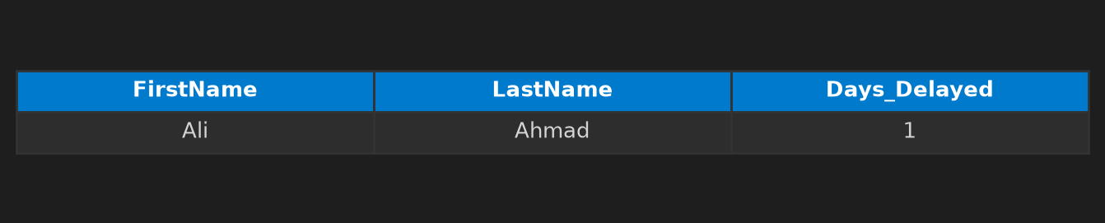
Written Explanation:
This SQL query is designed to calculate the number of days a member has been delayed for returning a rented item. By joining the 'Member' and 'Rental' tables based on the member ID, we can determine the difference between the rental return date and due date. The result shows that 'Ali Ahmad' is the only member who has been delayed by one day in returning a rented item.
Viva Presentation Tip: Remember, the query compares the return date with the due date to find out the delay in returning a rented item.
---------------------------------------------------------------------------------------------------

