SQL Notlari

01 - Introduction to tables and databases ¶

This module presents an introduction to the SQL language through 5 notebooks.
- The first notebook below details the general principles of tables and databases, the main elements allowing the use of the SQL language.
- The second notebook will present the main SQL queries.
- The third notebook will introduce a central element for SQL queries : the joints.
- The fourth notebook will present the basic operations to modify tables or databases.
- The fifth notebook (optional) will introduce SQLAlchemy, a tool allowing to use SQL queries directly with Python.

Databases: DBMS and RDB

A Database management system (DBMS) is a software that allows users to access a database. The DBMS manages the access (identification, security) and interprets queries in order to input, modify, return or delete data. There are two main families of SGDBs: the relational SGDBs and the NoSQL SGDBs
DBMSs can be associated with development environments softwares (IDEs) that contain text editors and SQL consoles that allow writing and executing SQL queries in a simplified way.
The most used DBMS currently are:
- PostGreSQL
- Microsoft SQL Server
- MySQL
- Oracle Database
These DBMS are used on IDEs such as DBeaver or Microsoft SQL SERVER Management Studio.
Relational databases (RBDr) have been used since the 1970s and are now extremely popular. These databases use tables to store data. These tables follow a strict schema which imposes constraints on the structure of the data.
To interact with these DBMS, we can generally use the SQL (Structured Query Language) language to create queries on the databases. SQL is very widespread and rather simple to use. It is therefore a must-have language in the Data world.

Diagrams and tables

Tables used in databases are sets of records (or observations) that form the rows of the table. Each of the values in a record corresponds to an attribute. The attributes form the columns of the table..
We can compare a table to an excel table (or to a DataFrame), the records corresponding to the rows and the attributes to the columns.
Tables are characterized by their schema. The schema of a table must contain its attributes, its types and its constraints on its own attributes. We can say that the schema is a definition or a "fingerprint " of the table.
Let's look at the example of the Films table:
FilmId | Name | Director
1 | Bohemian Rhapsody | Bryan Singer
2 | Avengers : Infinity War | Joe Russo & Anthony Russo
3 | The Batman | Matt Reeves
Each row in the table corresponds to a film. The columns of the table correspond to their characteristics:
- FilmId: the unique identifier of the film (an integer).
- Name: The name of the film (a string of characters).
- Director: the director (a string of characters).
By defining the name and type of each attribute we defined the schema of the table.
We will often refer to a table with its name followed by the name of its attributes in brackets:

Films(FilmId, Name, Director)
This representation is called the formal representation of the table.

1. Types of variables
In SQL the attributes can take many types. Depending on the DBMS, the types may vary. The following are the main ones:
Type SQL | Type
INTEGER | Integer
FLOAT | Decimal floating point
DOUBLE | Double-precision floating-point
BOOLEAN | Boolean value (True or False)
DATE | Date
DATETIME | Date and time
VARCHAR | String of characters
- (a) Give the diagram and the formal representation of the Sales table described below.
SaleId | Item | Sale Date | Quantity | Unit Price
1 | pen | 2020-05-18 | 2 | 0.45
2 | eraser | 2020-06-24 | 1 | 0.99
3 | binder | 2020-09-05 | 3 | 2.49

# Insert your code here
"""
SaleId : the unique identifier of the sale (INTEGER).
Item : The name of the item (VARCHAR).
Sale Date : date of sale (DATE)
Quantitiy : quantitity of items (INTEGER)
Unit Price : unit price of item (FLOAT or DOUBLE)
​
"""
​
​
​
'''
`SaleId`: Unique identifier of the sale (INTEGER)
`Item`: Name of the item sold (VARCHAR)
`Sale Date`: Date of sale (DATE)
`Quantity`: Quantity of items sold (INTEGER)
`Unit Price`: Unit price of the item (FLOAT or DOUBLE)
​
The formal representation of the table is given by:
Sales(SaleId, Item, Sale date, Quantity, Unit Price)
'''
​
​

2. Transactions
A transaction is a sequence of operations requiring read or write access. This transaction is performed via a database management system
To guarantee the integrity of a database, the transactions must be reliable.
One way to ensure reliable transactions is to check 4 ACID properties. Acid is the acronym for:
- Atomicity: A transaction must be able to be realised in its entirety or it will be aborted. If even a single operation of the transaction is refused, all other operations of the transaction will be refused.
- Consistency: The initial and the final states of the database must be consistent, i.e. all integrity constraints of the database must be respected after a transaction.
- Isolation: A transaction must run independently of transactions that are running at the same time. The intermediate states of a transaction are hidden from the others.
- Durability: When a transaction is validated, its effects must be stored and therefore persist even in the case of a system crash or power failure.
Relational databases check the ACID properties while NoSQL databases do not. NoSQL transactions are therefore less reliable, but they can perform better on large databases.

Keys and constraints

1. Primary key
Let's take the Films table defined earlier:
FilmId | Name | Director
1 | Bohemian Rhapsody | Bryan Singer
2 | Avengers : Infinity War | Joe Russo & Anthony Russo
3 | The Batman | Matt Reeves
The FilmId attribute is an identifier that uniquely defines each line.
We can say that this attribute defines the primary key of the Films table.
The attributes Name and Director do not have to respect this constraint: movies can have the same name or the same director.
To indicate that the attribute FilmId is the primary key, we underline it in the formal representation of the table:

Films(FilmId, Name, Director)
What you need to know about primary keys:
- The primary key of a table is the element that allows to uniquely identify a record of the table.
- The primary key can be composed of one or more attributes (we will talk about this later when we will present the composite keys.
- The primary key must always be filled in and must be unique (two records cannot have the same primary key).
- b) Give the primary keys of the following tables:
Sales :
SaleId | Item | Sale Date | Quantity | Unit Price
1 | pen | 2020-05-18 | 2 | 0.45
2 | eraser | 2020-06-24 | 1 | 0.99
3 | binder | 2020-09-05 | 3 | 2.49
Transactions :
ItemID | TransactionID | VisitorID | Timestamp
4000 | 356475 | 599528 | 1433222276276
11117 | 315335 | 599528 | 1433193500981
4000 | 381345 | 552148 | 1433193915008
# Insert your code here
"""
Sales = PK SaleId
​
Transactions = PK TransactionID
​
"""
​
​
​
'''
The primary key of the Sales table is: SaleID. This is a unique and systematic identifier.
The primary key of the Transactions table is: TransactionID. Indeed, an ItemID and a VisitorID can be linked
to several transactions. Also, depending on the precision of your timestamp, there could be several transactions
simultaneously.
'''
​
​

2. Foreign key
In general, relational databases contain several tables. For example, we can find in the same database the table Actors:
ActorId | Firstname | Lastname | CountryId
1 | Rami | Malek | 1
2 | Robert | Downey Jr. | 2
3 | Chris | Hemsworth | 2
and the table Countries:
CountryId | Name
1 | USA
2 | Australia
2 | France
The formal representation of the Countries table is:

Countries(CountryId, Name)
We notice that the Actors table contains the attribute CountryId which refers to the primary key of the Countries table. This attribute is a foreign key of the Actors table. The foreign key is represented by a # in the formal representation of the table :
Actors(ActorId, Firstname, Lastname, #CountryId)
A foreign key identifies a column (or a set of columns) of a table as a reference to a column of another table (the referenced table). The column of the referenced table must be a primary key. Thus the foreign key constraint guarantees that each of the values in the table exists in the referenced table.
For example, it is not possible to add a Spanish actor in the Actors table because the CountryId for Spain does not exist in the **Countries table.
Here is the Casting table from the same database which associates the actors with the movies they played in.
ActorId | FilmId | Role
1 | 1 | Freddie Mercury
2 | 2 | Tony Stark
3 | 2 | Thor
The Casting table is an allocation table : it allows to link the tables Films et Actors.
- c) Give the representation of the Casting table.
- d) Can we add the row (2, 4, Sherlock Holmes) to the Casting table? Why?
# Insert your code here
​
"""
c)
Casting(#ActorId, #FilmId, Role)
​
d)
No , we can not. Because there is no film with FilmId 4.
​
"""
​
​
'''
c) Casting(#ActorId, #FilmId, Role)
d) The answer is no. The FilmId column of the Casting table is a foreign key referring to the primary key
of the Movies table. As there is no FilmId equal to 4 in the Movies table, it is impossible to add the row to the Casting table.
You would first have to add the row (4, Sherlock Holmes, Guy Ritchie) to the Movies table.
​
'''
​

3. Composite key
A composite key is a key on several attributes. There are composite primary keys, for example an address: for it to be unique you have to specify the number, the street name, the city name, the postal code and the country. We could store all this information in a single variable, but we would lose the possibility of making queries by city or street for example.
Coming back to the Casting table, the primary key is neither FilmId (because there are several actors playing in the same movie), nor ActorId (because an actor can play in different movies).
So the primary key of Casting is the couple (FilmId, ActorId) which uniquely defines a tuple in this table. Thus we have :
Casting(#ActorId, #FilmId, Role)
The Books table lists books written by Sir Arthur Conan Doyle and published in several languages.
StoryId | Language | Title
30 | en | Cyprien Overbeck-Wells
30 | fr | Cyprien Overbeck-Wells
31 | en | The Red-Headed League
31 | fr | La Ligue des rouquins
- e) What is the primary key of the Books table?
# Insert your code here
​
# (StoryId, Language) is PK
​
​
'''
The StoryId attribute is not unique in the Books table: in fact translations of the same story must have the same StoryId.
The title is not unique either because the title can be the same for two books in different languages.
The only way to uniquely define a book is therefore the couple (StoryId, Language).
'''
​

4. Constraints
To modify a table, you must respect the constraints imposed on it. There are 4 types of constraints:
- Domain constraint: It defines what value an attribute can take, i.e. the data type and restrictions on this type.
- Key constraint: The rows of a table cannot have the same primary key.
- Table constraint: This is a constraint that generalizes the two previous ones. When creating a table, we add a constraint on the values that the attributes can take.
- Referential integrity constraint: An attribute can only take as a value a value that exists as a key (primary or not) in another relationship. The Referential integrity constraint therefore prohibits the existence of a tuple that refers to a tuple that does not exist in another table.

Relational diagrams

As we have seen with the foreign keys, the tables can be connected: this is called a relational diagrams. The connection can be a column existing in both tables, or 2 distinct columns linked by another table (attribution table).
The rows of a table can therefore correspond to rows in other tables. We can have three types of correspondence:
- One to One : a row corresponds to another row in the other table
- One to Many: a row in a table corresponds to several rows in another table.
- Any to Many : a row of a table can correspond to several rows of the other table and conversely.
Keeping the same database as before, we can build the Synopsis table which gives the summary of each film in the Films table.
SynopsisId | FilmId | Synopsis
1 | 1 | songs
2 | 2 | explosions
3 | 3 | investigation
- f) What is the relationship between the Films and Actors tables?
- g) What is the relationship between the Films and Synopsis tables?
- h) What is the relationship between the Films and Casting tables?
# Insert your code here
​
"""
f) many - many
​
g) one - one
​
h)
​
"""
'''
f) Several actors play in the same movie and an actor can play in different movies.
It is thus a Many to Many relationship.
g) Each movie corresponds to a synompsis and vice versa (we can notice that FilmId is a primary key of Synopsis).
It is thus a One to One relation.
h) Each movie can correspond to several rows of the Casting table (all rows corresponding to the movie).
On the other hand, a row of the Casting table corresponds to only one movie. It is thus a One to Many relation.
'''
​

Conclusion

You learned what a relational database is and what are its main characteristics.
Here is what you need to remember from this notebook before moving on to the SQL Queries course:
- The main characteristics of relational databases (diagrams, attributes, tuples, ACID properties).
- The primary keys identify a tuple of a table in a unique way.
- Foreign keys are primary keys in another table.
- Keys can be composite.
- The main types of diagrams between tables.

02 - SQL queries

In the previous notebook we saw the structure of relational databases. In this notebook, you will learn the syntax of SQL queries with the help of a widget that we have developed. The widget allows you to execute queries directly on the database, in the usual Python environment of the platform, and with the SQL syntax.

How to use the widget
To launch the widget, you just have to execute the cells containing the code:
from Widget_Template import build_SQL_widget
build_SQL_widget("name_of_the_database.db")
This command will bring up an interface allowing you to run SQL queries on the given database. In order to do so, you must specify your query as an argument to the build_SQL_widget function:

This widget is based on the SQLAlchemy toolkit which will be presented in notebook 5. More pecisely the DBMS used here is SQLite. Some queries may therefore be different (or unavailable) from other DBMSs. If this is the case, these queries will be indicated and you will be able to find a reference on the alternative way to proceed with SQLite.

The projection

The projection is the fundamental query in SQL. It consists in displaying some columns of a table thanks to the keyword SELECT.
To display the whole table, you can select all the columns with the asterisk *.
We then specify the name of the table with the keyword FROM.
It will be useful to get into the habit of returning to the line after each command, and to mark the end of the query with the symbol ;.
The query will therefore take this form:
SELECT *
FROM table;
- a) Run the following cell to import and instantiate the widget, and to specify the database that we want to query: chinook.db.
- b) Use the Widget to display through an SQL query all columns of the albums table.
The table albums looks like this:
AlbumId | Title | ArtistId
1 | For Those About To Rock We Salute You | 1
2 | Balls to the Wall | 2
3 | Restless and Wild | 2

'''
SELECT *
FROM albums;
'''
​
​
From here on, you won't need to call the widget anymore: the cells should appear automatically. If a problem occurs or you want to add a SQL cell, just add a code cell and execute the build_SQL_widget("chinook.db") function again.
To show only a subset of a table, we enter the names of the selected columns after the SELECT and we separate them with a comma.
- c) Display the AlbumId and ArtistId columns from the albums table.

'''
SELECT AlbumId, ArtistId
FROM albums;
'''
​
​
To avoid repetition in a projection, you can use the keyword DISTINCT before the column names.
- d) Display all distinct ArtistId of the table albums.

'''
SELECT DISTINCT ArtistId
FROM albums;
'''
​
​
- e) Display the name, first name and position of the employees, contained in the employees table. You will first need to identify the corresponding columns.
The employees table looks like this:
EmployeeId | LastName | FirstName | Title | ReportsTo | BirthDate | HireDate | Address | City | State | Country | PostalCode | Phone | Fax | Email
1 | Adams | Andrew | General Manager | NaN | 1962-02-18 00:00:00 | 2002-08-14 00:00:00 | 11120 Jasper Ave NW | Edmonton | AB | Canada | T5K 2N1 | +1 (780) 428-9482 | +1 (780) 428-3457 | andrew@chinookcorp.com
2 | Edwards | Nancy | Sales Manager | 1.0 | 1958-12-08 00:00:00 | 2002-05-01 00:00:00 | 825 8 Ave SW | Calgary | AB | Canada | T2P 2T3 | +1 (403) 262-3443 | +1 (403) 262-3322 | nancy@chinookcorp.com
3 | Peacock | Jane | Sales Support Agent | 2.0 | 1973-08-29 00:00:00 | 2002-04-01 00:00:00 | 1111 6 Ave SW | Calgary | AB | Canada | T2P 5M5 | +1 (403) 262-3443 | +1 (403) 262-6712 | jane@chinookcorp.com

'''
SELECT LastName, Firstname, Title
FROM employees;
'''
​
​

The simple selection

The simple selection consists in choosing elements of a table checking a particular condition. We use the SELECT command in association with the WHERE keyword to define the condition(s). The general syntax is as follows:
SELECT column1, column2
FROM table1
WHERE condition;

1. Conditional operators
The following are the main operators to build conditions is SQL:
Operator | Description
= | Equal
<> | Not equal
> | Greater than
< | Less than
>= | Greater than or equal to
<= | Less than or equal to
IN | TRUE if the operand is equal to one of a list of expressions possibles
BETWEEN | TRUE if the operand is within the range of comparisons
LIKE | The LIKE operator is used in a WHERE clause to search for a specified pattern in a column
IS NULL | The IS NULL operator is used to test for empty values (NULL values)
IS NOT NULL | The IS NOT NULL condition is used in SQL to test for a non-NULL value.
It is also possible to combine several conditions with the logical operators AND, OR and NOT.
Here you will find some queries to put these notions into practice. We will use the employees table.
- a) Write an SQL query to fetch the employees living in 'Calgary'.

'''
SELECT *
FROM employees
WHERE City = 'Calgary';
'''
​
​
- b) Write an SQL query to fetch the employees living in 'Edmonton' or in 'Lethbridge'.

'''
SELECT *
FROM employees
WHERE City = 'Edmonton' OR City = 'Lethbridge';
'''

- c) Write an SQL query to display the name, the first name and the position of the employees who have a hierarchical superior (the column ReportsTo contains the Id of the employee's hierarchical superior).

'''
SELECT LastName, FirstName, Title
FROM employees
WHERE ReportsTo IS NOT NULL;
'''

- d) Write an SQL query to display employees whose ID is smaller than 5.

'''
SELECT *
FROM employees
WHERE EmployeeId <= 5;
'''

- e) Write an SQL query to display employees whose ID is between 2 and 7 (included).

'''
SELECT *
FROM employees
WHERE EmployeeId >= 2 AND EmployeeId <= 7;
'''
#or
'''
SELECT *
FROM employees
WHERE EmployeeId BETWEEN 2 AND 7;
'''

- f) Write an SQL query to display employees born before May 10, 1973. Pay attention to the date format.

'''
SELECT *
FROM employees
WHERE BirthDate <= '1973-05-10';
'''

2. Regular Expressions (Regex)
As seen in module 131 - Text Mining -, regular expressions also called regex, are strings that describe, according to a precise syntax, a set of possible characters. The regex syntax in SQL is slightly different from the regex syntax in Python.
Here are the most frequently used regular expressions:
Regular Expressions | Description
% | matches any combination of characters of any size
_ | matches any single character
+ | matches at least one instance of the previous expression
^ | corresponds to the beginning of the line
$ | searches at the end of the line
< | matches only if the word starts at this point
> | matches only if the word ends at this point
\n | matches if there is a line break
[ ] | matches if any of the characters between brackets are present
[^...] | matches if any of the characters between brackets and before the ^ are present
[ABQ]% | the string must start with an A, B or Q and can be of any length
[AB][CD]% | the string must start with an A or B and the second character must be C or D and can be of any length
[A-Z]% | the string must start with a character from A to Z and can be of any length
[A-Z0-9]% | the string must start with a letter from A to Z or a number from 0 to 9 and can be of any length
[^A-C]% | the string cannot start with a character from A to C but can be of any length
%[A-Z] | the string must end with a character from A to Z and can be of any length
%[%$#@]% | the string can be of any length and must have at least one match with a bracketed character
We will now use regular expressions in SQL with the keyword LIKE. We will use the table tracks.
The tracks table looks like this:
TrackId | Name | AlbumId | MediaTypeId | GenreId | Composer | Milliseconds | Bytes | UnitPrice
1 | For Those About To Rock (We Salute You) | 1 | 1 | 1 | Angus Young, Malcolm Young, Brian Johnson | 343719 | 11170334 | 0.99
2 | Balls to the Wall | 2 | 2 | 1 | None | 342562 | 5510424 | 0.99
3 | Fast As a Shark | 3 | 2 | 1 | F. Baltes, S. Kaufman, U. Dirkscneider & W. Hoffman | 230619 | 3990994 | 0.99
- g) Write an SQL query to display information for titles beginning with P.

'''
SELECT *
FROM tracks
WHERE Name LIKE 'P%';
'''

- h) Write an SQL query to display information for 3-character titles

'''
SELECT *
FROM tracks
WHERE Name Like '___';
'''

- i) Write an SQL query to display titles of less than 5 characters.

'''
SELECT *
FROM tracks
WHERE Name NOT LIKE '_____%';
'''
​
​
- j) Write a SQL query to display tracks composed by 'Jimi Hendrix'. Attention, according to the albums the first name and the name can be reversed.

'''
SELECT *
FROM tracks
WHERE Composer LIKE '%Jimi%' AND Composer LIKE '%Hendrix%';
'''
#This syntax allows us to get all the titles whose composer names include Jimi and Hendrix,
#in any order.

- k) Write a SQL query to display music from an association of several artists.
Hint: For an association of several artists, the name is separated by a / or - except for the group AC/DC.

'''
SELECT Name, Composer
FROM tracks
WHERE (Composer LIKE '%/%' AND Composer NOT LIKE '__/__') OR Composer LIKE '%-%';
'''

Data Sorting

It is possible to sort the results of a query by column values in ascending order by using the ORDER BY keyword with ASC (default), or DESC (to sort in descending order).
Answer the following questions using the tracks table.
- l) Sort the music titles in alphabetical order: we will limit the query to the first 10 titles.
The keyword LIMIT allows to choose the number of results to display.

'''
SELECT Name
FROM tracks
ORDER BY Name ASC LIMIT 10;
'''
#ou puisque ASC est le paramètre par défaut du mot-clé ORDER BY
'''
SELECT Name
FROM tracks
ORDER BY Name LIMIT 10;
'''
​
​
- l) Write a SQL query to display AC/DC titles in alphabetical order.

'''
SELECT Name, Composer
FROM tracks
WHERE Composer LIKE '%AC/DC%'
ORDER BY Name;
'''
​
​
- m) Display the 5 longest tracks in the tracks table as well as their duration.
We can use the column Milliseconds.

'''
SELECT Name, Milliseconds
FROM tracks
ORDER BY Milliseconds DESC LIMIT 5;
'''
​
​

Conclusion

In this notebook we learned how to make SQL queries to examine a database
Here are the main operations that you need to remember:
- Projection :
SELECT col1, col2
FROM table;
- Simple Selection :
SELECT *
FROM table
WHERE condition;
- Conditional operators and regular expressions with LIKE.
- Data Sorting :
SELECT *
FROM table
ORDER BY col ASC;

03 - Advanced SQL queries

In the second notebook we learned how to make basic SQL queries through a widget integrated to the platform.
In this notebook, you will learn how to write advanced SQL queries.

Joints

Joints are used to join different tables that have at least one attribute in common.
We will illustrate the concept of joins with the help of the following 2 tables : Persons table
Name | Car
Lila | Twingo
Tiago | Clio
Berenice | C4 Cactus
Joseph | Twingo
Romy | Scenic
and Vehicles table:
Car | Price
Twingo | 11000
Swift | 14500
C4 Cactus | 23000
Prius | 30000
206 | 14000

1. The INNER JOIN
This type of join will allow to concatenate the tuples from two 2 tables if a condition is satisfied..
This condition can be of any type as long as it returns a boolean. This condition will often be the equality of a common attribute; a primary key for the first table and a foreign key for the other. In this case the foreign key will refer to the primary key of the first table.
It is necessary to specify the attributes that we want to use to perform the join. We first fill-in the tables in the INNER JOIN (or simply in the JOIN) and then we use the keyword ON followed by the common attribute.
This kind of join is not recommended because it can often lead to the loss of many entries. On the other hand, the inner join does not produce any NaN.

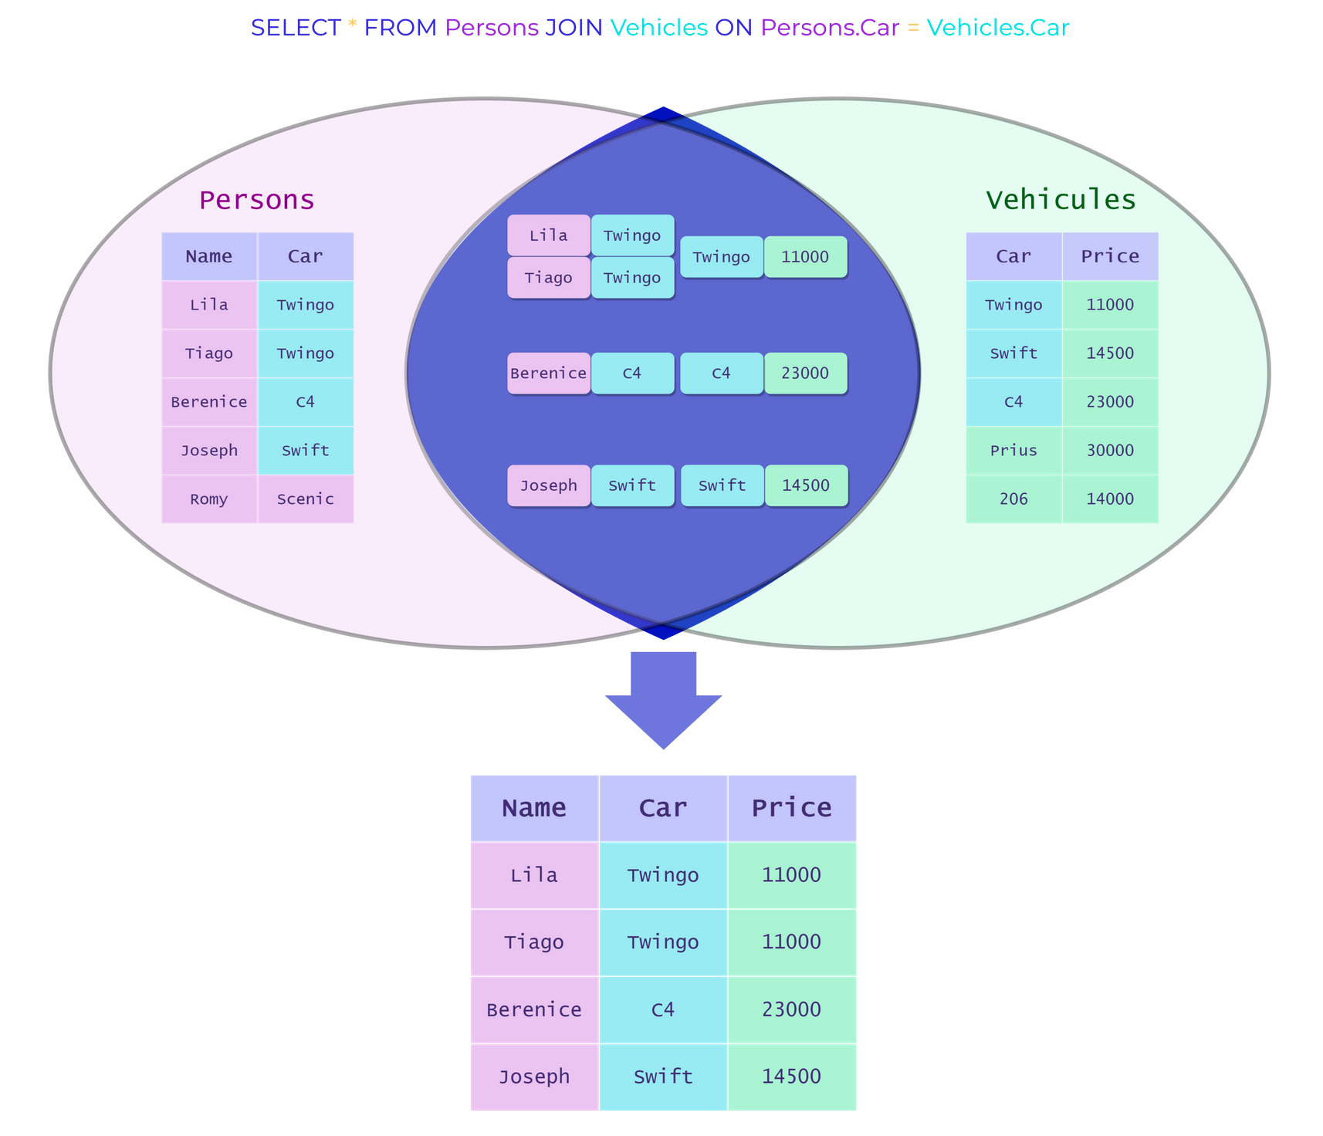

Here Car is the primary key of Vehicles and the foreign key of Persons. We add to the Persons table all the information contained in Vehicles about the cars of the individuals presented in the table.
- a) Run the following cell to import and instantiate the Widget, and specify that the database to query is chinook.db.
- b) Use the Widget to do an internal join using the column GenderId, primary key of the table genre and foreign key of the table tracks.
As a reminder the tracks table looks like :
TrackId | Name | AlbumId | MediaTypeId | GenreId | Composer | Milliseconds | Bytes | UnitPrice
1 | For Those About To Rock (We Salute You) | 1 | 1 | 1 | Angus Young, Malcolm Young, Brian Johnson | 343719 | 11170334 | 0.99
2 | Balls to the Wall | 2 | 2 | 1 | None | 342562 | 5510424 | 0.99
3 | Fast As a Shark | 3 | 2 | 1 | F. Baltes, S. Kaufman, U. Dirkscneider & W. Hoffman | 230619 | 3990994 | 0.99
The table genres looks like this:
GenreId | Name
1 | Rock
2 | Jazz
3 | Metal
The syntax tracks.GenreId instead of GenreId to designate the GenreId column of tracks allows to avoid the ambiguity with the column of the same name in genres. When the columns do not have the same name as another column from another table, this syntax is not mandatory but recommended to remain clear in the code.
from Widget_Template import build_SQL_widget
build_SQL_widget("chinook.db")

​
​

'''
SELECT *
FROM tracks
JOIN genres ON tracks.GenreId = genres.GenreId;
'''
​
​
We can notice that the column GenreId is present 2 times in the table resulting from the join. We also notice that we kept information that we did not wish here.
- c) Using a projection and an inner join, display the columns tracks.Name, tracks.GenreId and genres.Name in a single table.
from Widget_Template import build_SQL_widget
build_SQL_widget("chinook.db")
​
​

'''
SELECT tracks.Name, tracks.GenreId, genres.Name
FROM tracks
JOIN genres ON tracks.GenreId = genres.GenreId;
'''
​
​
When joining tables you often get columns with the same name. You can remove this ambiguity by using the keyword AS when using SELECT.
- d) Using a projection, an inner join and the keyword AS, display in a single table the renamed columns Title, NumberGenre and NameGenre.
from Widget_Template import build_SQL_widget
build_SQL_widget("chinook.db")
​
​

'''
SELECT tracks.Name AS Title, tracks.GenreId AS NumberGenre, genres.Name AS NameGenre
FROM tracks
JOIN genres ON tracks.GenreId = genres.GenreId;
'''
​
​
​
- e) Display in the same table the title of the albums in the albums table with the name of the associated artist who is listed in the artists table.
The albums table is the following :
AlbumId | Title | ArtistId
1 | For Those About To Rock We Salute You | 1
2 | Balls to the Wall | 2
3 | Restless and Wild | 2
The artists table:
ArtistId | Name
1 | AC/DC
2 | Accept
3 | Aerosmith
from Widget_Template import build_SQL_widget
build_SQL_widget("chinook.db")
​
​

'''
SELECT albums.Title, artists.Name
FROM albums
JOIN artists ON artists.ArtistId = albums.ArtistId;
'''
​
​

2. RIGHT JOIN / LEFT JOIN
The RIGHT JOIN is a join between 2 tables that returns all the records of the right table even if there is no match with the left table. If there is no match, the missing values are set to NULL or None.
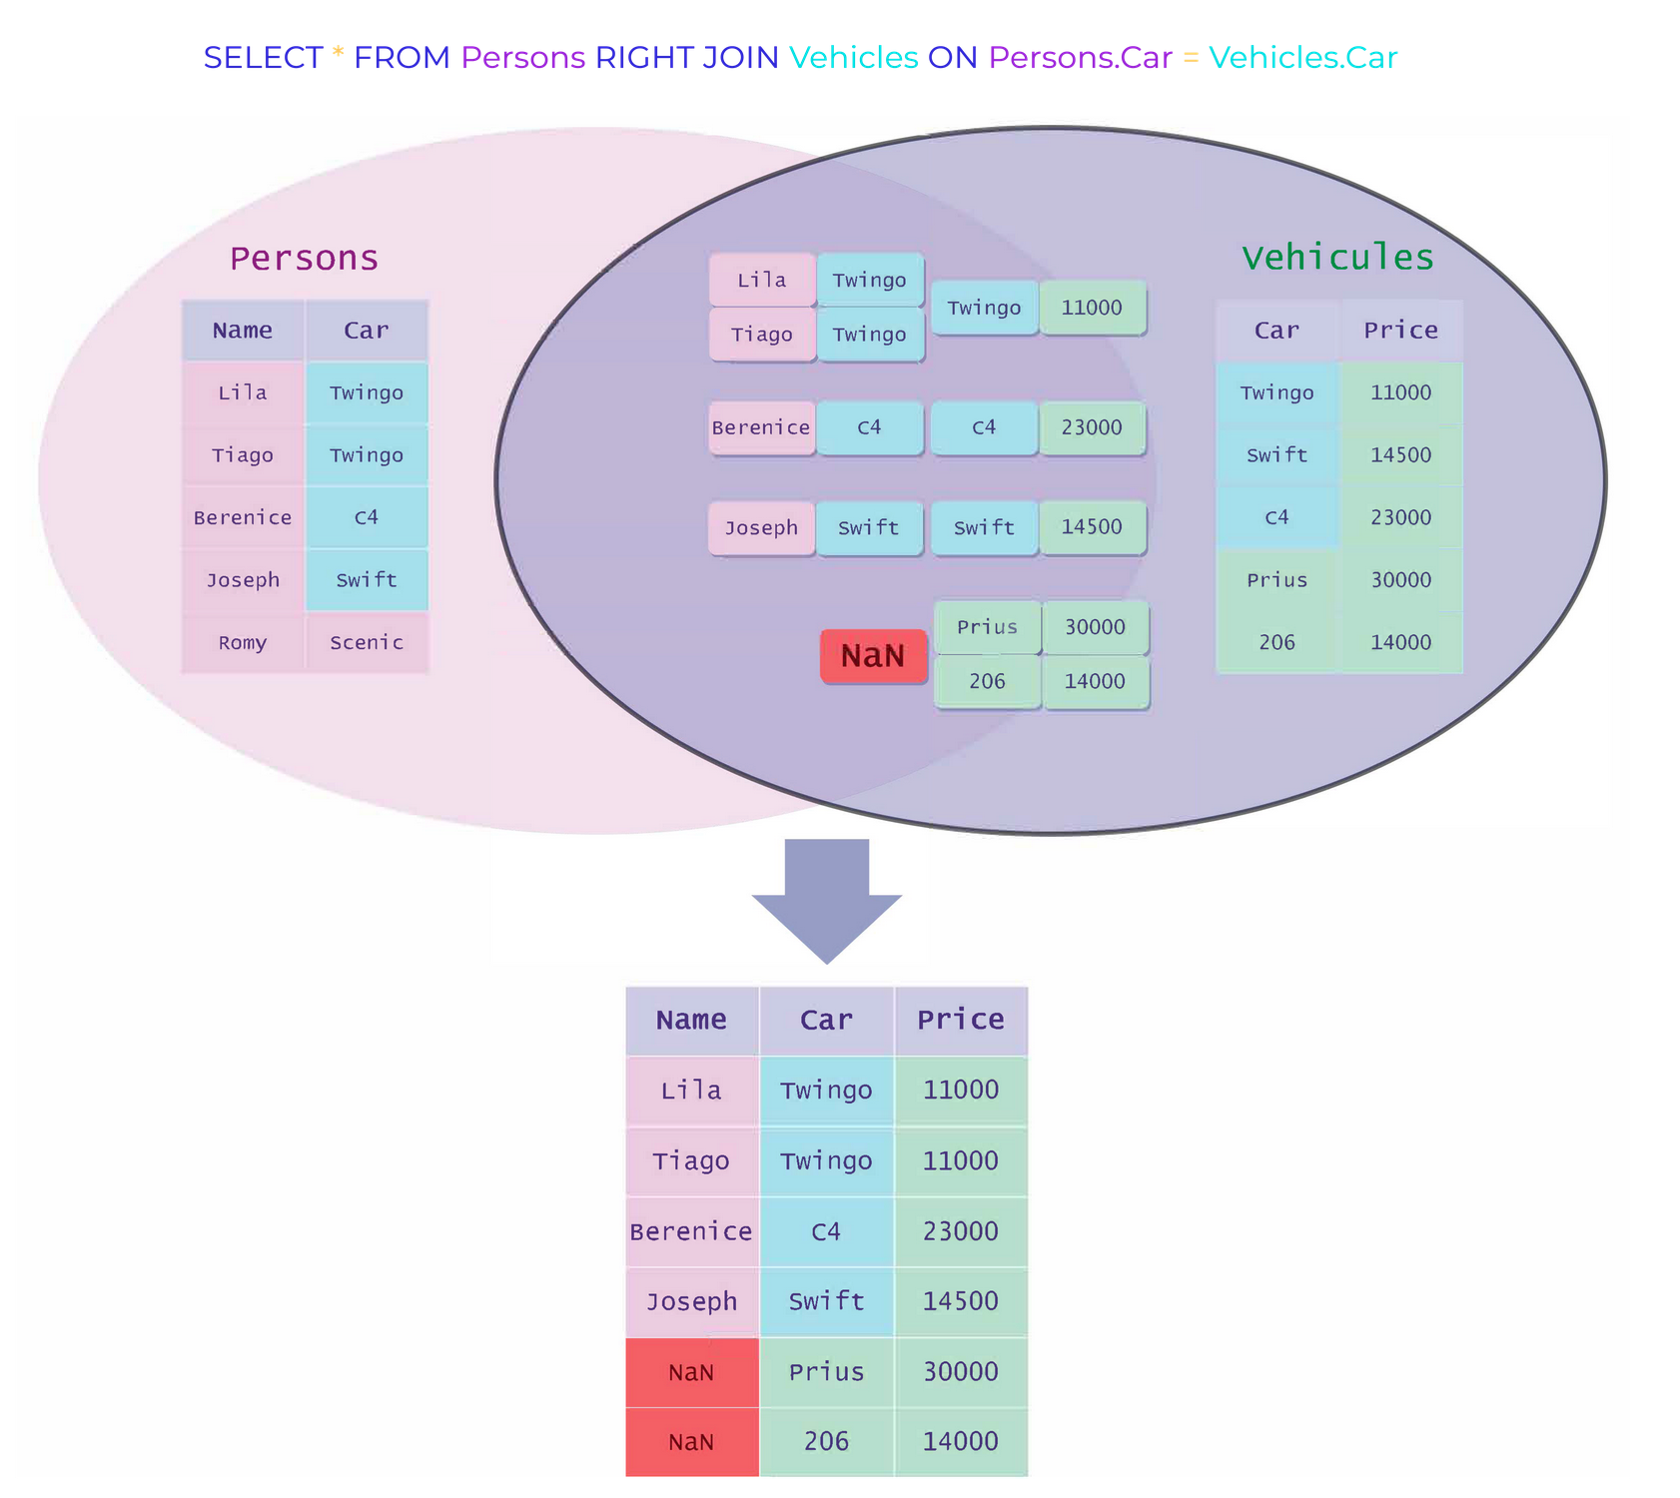

On the other hand, you can also use the LEFT JOIN which works in the same way by reversing the order of the tables.

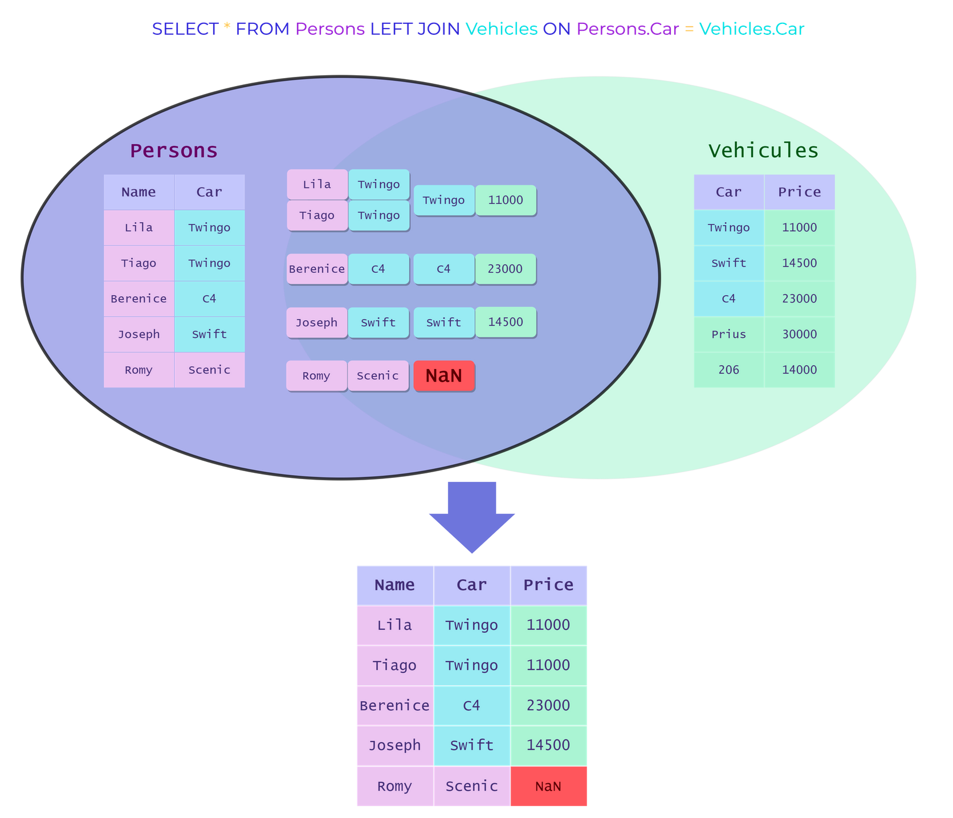
- f) With a left join, display the composers for rows in the artists table that have exactly one artist in the tracks table as a composer, or None if applicable. We will remove the rows where the artist of the tracks table is not specified.
from Widget_Template import build_SQL_widget
build_SQL_widget("chinook.db")
​
​

'''
SELECT tracks.Composer, tracks.Name AS Song, artists.Name
FROM tracks
LEFT JOIN artists ON tracks.Composer = artists.Name
WHERE tracks.Composer IS NOT NULL;
'''
​
​
- g) Using a left join, display the titles of tracks for which an artist from artists participated in the composition and None otherwise. Note that sometimes several artists have worked on the same music;
We can use the following syntax: table1.words LIKE ('%' || table2.word || '%'). The operator || allows to concatenate strings, and like the the % operator, it always allows you to specify that the sequence that follows or precedes can be any one of them, so we consider all cases where the word table2.word appears in the sequence table1.words.
from Widget_Template import build_SQL_widget
build_SQL_widget("chinook.db")
​
​

'''
SELECT artists.Name, tracks.Composer, tracks.Name AS Song
FROM artists
LEFT JOIN tracks ON tracks.Composer LIKE ('%' || artists.Name || '%');
'''
​
​
The RIGHT JOIN is not available on SQLite, but you can simulate it by reversing the order of the tables using the LEFT JOIN command.
- h) Simulating a right-join with a left-join, display the composers for the rows in the tracks table that are present in the artists table, or None if applicable.
from Widget_Template import build_SQL_widget
build_SQL_widget("chinook.db")
​
​
'''
SELECT tracks.Composer, tracks.Name AS Song, artists.Name
FROM tracks
LEFT JOIN artists ON tracks.Composer = artists.Name;
'''
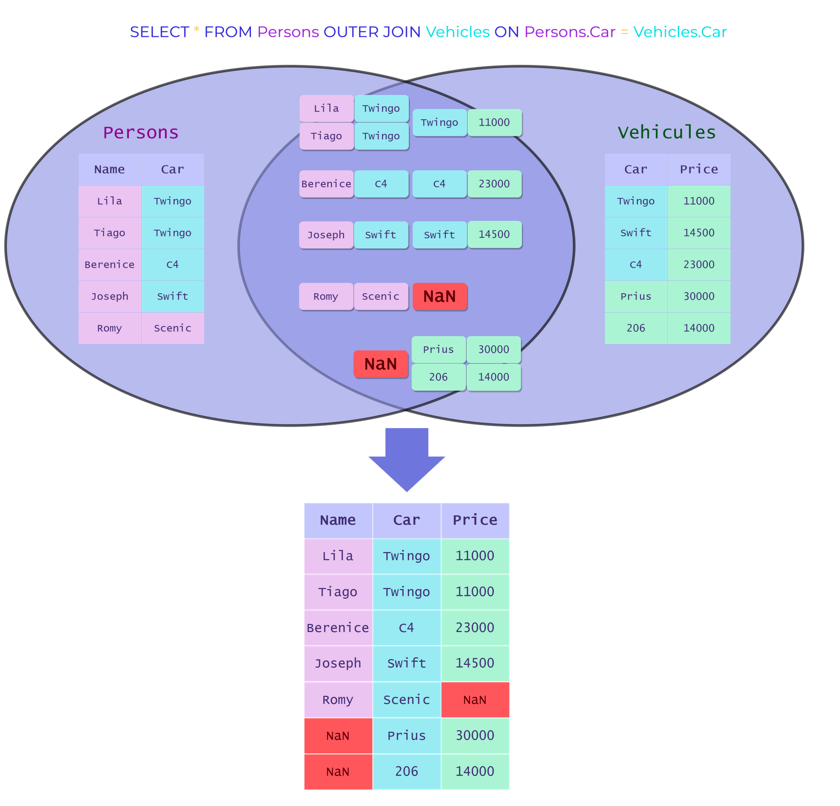
​
​

3. The OUTER JOIN
The external join or OUTER JOIN is a join between 2 tables that returns all records from both tables even if there is no match between them. If there is no match, the missing values are defined as NULL.

The OUTER JOIN it is not available on SQLite, we detail above the process to simulate it.
The external join is just a combination of a LEFT JOIN and a RIGHT JOIN. So we need to perform these two operations and join the 2 resulting tables using the keyword UNION.
- i) By simulating an external join, get a table with all the artists present in the artists and tracks tables (with the corresponding music). We will remove the rows where the artist of the tracks table is not specified.
from Widget_Template import build_SQL_widget
build_SQL_widget("chinook.db")
​
​

'''
SELECT tracks.Composer, tracks.Name AS Song, artists.Name
FROM artists
LEFT JOIN tracks ON tracks.Composer = artists.Name
WHERE tracks.Composer IS NOT NULL
UNION
SELECT tracks.Composer, tracks.Name AS Song, artists.Name
FROM tracks
LEFT JOIN artists ON tracks.Composer = artists.Name
WHERE tracks.Composer IS NOT NULL;
'''
​
​

4. Exotic Joins
You can also make joins on queries: this is called a nested join. This allows you to join 3 or more tables!
The syntax is as follows:
SELECT table1.column1, a.column1 ...
FROM table1
JOIN (SELECT ...
FROM table2
JOIN table3 ON ...) AS a
ON ...;
The a alias on the subquery is essential to be able to do the join on this query, in particular to be able to name a column of the table created by this subquery.
- j) Using a nested inner join on the tracks, albums and artists tables, display in a table the titles of the music as well as the album they are part of and their performer.
from Widget_Template import build_SQL_widget
build_SQL_widget("chinook.db")
​
​
'''
SELECT tracks.Name AS 'Musique', a.Title AS 'Album', a.Name AS 'Artiste'
FROM tracks
JOIN (SELECT *
FROM albums
JOIN artists ON artists.ArtistId = albums.ArtistId) AS a
ON tracks.AlbumId = a.AlbumId;
'''
​
​
In the case where a table allows access to information linked with entries in the same table, it can be useful to join the table with itself. This is called a self-join, the syntax remains the same but we need the alias to remove ambiguities!
For example, if we want to use the employees table to group the information of an employee with his hierarchical superior (contained in the ReportsTo column) we will use the following syntax:
SELECT a.LastName, a.FirstName, a.Title, a.ReportsTo, e.LastName, e.FirstName, e.Title
FROM employees AS a
JOIN employees AS e ON a.ReportsTo = e.EmployeeId;
from Widget_Template import build_SQL_widget
build_SQL_widget("chinook.db")
​
​

Aggregate functions

Up to now we have only performed operations line by line. We can also do operations on several lines for example an average or a count: these are the aggregation functions. The most classical ones are the following:
Aggregate functions | SQL language
COUNT | counts how many rows are in a particular column
MAX | returns the highest values in a particular column
MIN | returns the lowest value in a particular column
AVG | calculates the average of a group of selected values
SUM | returns the total sum of a numeric column
- k) Count the number of tracks in the tracks table.
from Widget_Template import build_SQL_widget
build_SQL_widget("chinook.db")
​
​

'''
SELECT COUNT(TrackId)
FROM tracks;
'''
​
​
- l) Display the average duration of a track in the tracks table, using the Milliseconds column.
from Widget_Template import build_SQL_widget
build_SQL_widget("chinook.db")
​
​
'''
SELECT AVG(Milliseconds) AS 'Average duration'
FROM tracks;
'''
​
​

GROUP BY

To get results by category and not only on a whole table, it is possible to apply aggregation functions by grouping according to one or more attributes using the keyword GROUP BY. The syntax is as follows:
SELECT column1, f(column2)
FROM table1
GROUP BY column1;
The repetition of column1 is necessary, this code allows to display f(column2) for each type of the column1.
- m) Display the number of albums per artist using the albums table, and the COUNT and GROUP BY keywords.
from Widget_Template import build_SQL_widget
build_SQL_widget("chinook.db")
​
​
'''
SELECT ArtistId, COUNT(AlbumId) AS Albums
FROM albums
GROUP BY ArtistId;
'''
​
​
- n) With an inner join, replace the column ArtistId of the previous query by the name of the artists using the table artists, we will also display the number of albums per artist.
from Widget_Template import build_SQL_widget
build_SQL_widget("chinook.db")
​
​
'''
SELECT Name, Albums
FROM artists
JOIN (SELECT ArtistId, COUNT(AlbumId) AS Albums
FROM albums
GROUP BY ArtistId) AS a
ON artists.ArtistID = a.ArtistId;
'''
​
​
You can also group by several columns, and apply several functions with the syntax :
SELECT column1, ..., columnN, f(columnA), ..., f(columnZ)
FROM table1
GROUP BY column1, ..., columnN;
- o) If we want to display the total duration and the number of songs of each album by artist, we will need the tracks, artists and albums tables, and thus a nested join.
from Widget_Template import build_SQL_widget
build_SQL_widget("chinook.db")
​
​
#We can decide to join the 3 tables according to the ArtistId and AlbumId and then perform the operations and groupings
'''
SELECT NomArtiste, NomAlbum, SUM(Milliseconds) AS DureeAlbum, COUNT(b.Name) AS NbMusiques
FROM (SELECT tracks.Name, Milliseconds, a.Title AS NomAlbum, a.Name AS NomArtiste
FROM tracks
JOIN (SELECT *
FROM albums
JOIN artists ON albums.ArtistId = artists.ArtistId) AS a
ON tracks.AlbumId = a.AlbumId) AS b
GROUP BY NomArtiste, NomAlbum;
'''
​
#Otherwise we decide to group and operate between tracks and albums according
#to the ArtistID, and then we add the information about the artist.
​
'''
SELECT Name AS NomArtiste, NomAlbum, DureeAlbum, NbMusiques
FROM artists
JOIN (SELECT ArtistId, Title AS NomAlbum, SUM(Milliseconds) AS DureeAlbum, COUNT(Name) AS NbMusiques
FROM tracks
JOIN albums ON tracks.AlbumId = albums.AlbumId
GROUP BY NomAlbum, ArtistId) AS a
ON artists.ArtistId = a.ArtistId;
'''
​
​

1. Upstream selection
We can associate selections to the grouping. Upstream selection concerns conditions on the table before grouping. It is done like a classic selection with the keyword WHERE, here used before the GROUP BY:
SELECT column1, f(column2)
FROM table1
WHERE condition(table1)
GROUP BY column1;
In an upstream selection, the condition concerns the entire table.
- p) Display the number of songs longer than 400 seconds by AlbumId using the tracks table.
from Widget_Template import build_SQL_widget
build_SQL_widget("chinook.db")
​
​
'''
SELECT AlbumId, COUNT(AlbumId) AS LongMusics
FROM tracks
WHERE Milliseconds > 400000
GROUP BY AlbumId;
'''
​
​
- q) Display the number of songs longer than 400 seconds by album name using an inner join between the tracks and albums tables
from Widget_Template import build_SQL_widget
build_SQL_widget("chinook.db")
​
​
'''
SELECT Title, NbLongMusics AS LongMusics
FROM albums
JOIN (SELECT AlbumId, COUNT(Name) AS NbLongMusics
FROM tracks
WHERE Milliseconds > 400000
GROUP BY AlbumId) AS a
ON albums.AlbumId = a.AlbumId;
'''
​
​

2. Downstream selection
The Downstream selection concerns conditions on the table after grouping. It is done with the HAVING keyword used after the GROUP BY. The HAVING keyword allows selection using functions such as SUM(), COUNT(), AVG()...
SELECT column1, f(column2)
FROM table1
GROUP BY column1
HAVING condition;
The condition concerns the request before the HAVING, that is, on the result from :
SELECT column1, f(colum2)
FROM table1
GROUP BY column1
- r) Display albums that are not singles (i.e. that have at least 2 songs), by AlbumId using the tracks table.
from Widget_Template import build_SQL_widget
build_SQL_widget("chinook.db")
​
​
'''
SELECT albums.AlbumId, NbMusics, Title
FROM albums
JOIN (select AlbumId,COUNT(AlbumId) AS NbMusics from tracks
GROUP BY AlbumId
HAVING NbMusics >= 2) as a
ON albums.AlbumId = a.AlbumId;
'''
​
​
- s) Display albums that are not singles by using an inner join between the tracks and albums tables.
from Widget_Template import build_SQL_widget
build_SQL_widget("chinook.db")
​
​
'''
SELECT Title AS NomAlbum, COUNT(tracks.AlbumId) AS NbMusics, Name
FROM tracks
JOIN albums ON tracks.AlbumId = albums.AlbumId
GROUP BY NomAlbum
HAVING NbMusics >= 2;
'''
​
​

Conclusion

In this course we have learned how to make advanced SQL queries.
Here are the main operations to remember from this course:
- The inner join :
SELECT *
FROM table1
JOIN table2 ON table1.column1 = table2.column2;
- Group by with aggregate functions:
SELECT column1, f(column2)
FROM table1
GROUP BY column1;
- The Main Aggregate Functions : COUNT, SUM, AVG, MIN, MAX.

04 - Operations on tables

In the previous notebooks, we learned how to make queries on databases. In this notebook will learn how to populate a database by creating, modifying and deleting tables.
In this notebook, we will see how to populate the college.db database with the educational path of students from an educational institution.
Errors may occur in this module since you will create, modify and delete elements of a database; reset the kernel will not be enough to reset the database. If a problem occurs, the easiest way is to delete the tables that you have created with the command DROP TABLE IF EXISTS name_table;. You can then refer to the correction cells. This manipulation will be further detailed in the last section of this notebook.

CREATE TABLE

The table creation is done with the keyword CREATE TABLE followed by the table name. Then in the brackets, you have to specify the name of the columns as well as their type and constraints. Finally you have to specify the primary and foreign keys**.
You can find a reminder of this notions in the first notebook of this module.
- a) Run the next cell to import and instantiate the Widget, and specify that the database to query is college.db. You will have direct access to the Widget in the following cells.
- b) In the newly created input field, execute the following SQL command to create the courses table that will contain the different courses offered by the institution, describing them with an id and a name.
CREATE TABLE `courses` (
id INTEGER NOT NULL,
name VARCHAR,
PRIMARY KEY (id));
The NOT NULL constraint after the id attribute means that this attribute must always be filled in the table (because it is an identifiant).
from Widget_Template import build_SQL_widget
build_SQL_widget("college.db")
​
​
id | firstname | lastname | course_id
1 | Jean | Dubois | 1
2 | Martin | Dupont | 2
If you want to verify that the table has been created in the database you can use the SELECT * FROM courses; query.
- c) Create a table students that will identify students at the university. The attributes of this table will be the id of the student, his first name firstname, his last name lastname, as well as the identifier course_id of the course followed.
You can specify the primary key with the keyword PRIMARY KEY, and the foreign key with FOREIGN KEY followed by the name of the foreign key and the keyword REFERENCES followed by the name of the reference table as well as the name of the foreign key in this table.
from Widget_Template import build_SQL_widget
build_SQL_widget("college.db")
​
​
'''
CREATE TABLE students (
id INTEGER NOT NULL,
firstname VARCHAR,
lastname VARCHAR,
course_id INTEGER,
PRIMARY KEY (id),
FOREIGN KEY (course_id) REFERENCES courses (id));
'''
​
​
If you ran code without creating the foreign key constraint, you won't be able to run the solution cell because the courses table already exists in your database. You will need to start over by deleting the tables as explained in the "Deleting Tables" section below in this notebook.

Adding constraints

When we create a table, we cannot always specify constraints (for example primary keys or foreign keys) at the very moment of its creation. Fortunately there are commands that allow you to add them later.
If you haven't specified the foreign key in the students table, you could run the following code:
ALTER TABLE students
ADD CONSTRAINT FK_course_id
FOREIGN KEY (course_id) REFERENCES course (id);
In SQLite, the ADD CONSTRAINT method from ALTER TABLE is not available, so you have to use a temporary table to make the changes. The procedure is detailed in the [documentation](https://www.sqlite.org/lang_altertable.html#otheralter)
The previous command is divided into 3 parts:
- The ALTER TABLE keyword is used to specify the name of the table on which to add the constraint.
- The keyword ADD CONSTRAINT allows you to choose the name of the constraint.
- The syntax of the constraint.
Here is a non-exhaustive list of constraints used in SQL**, as well as the syntax associated with each of them:
Constraints | Syntax
Primary key | PRIMARY KEY (name_primary_key)
Foreign Key | FOREIGN KEY (name_key) REFERENCES foreign_table (name_key_foreign_table)
Checking condition | CHECK (condition)
Uniqueness | UNIQUE (name_column)

Adding rows

** New insertions in a database table are transactions and therefore check the database consistency rules (the ACID properties, presented in the 1st notebook). The general syntax for inserting rows into a table in SQL is as follows:
INSERT INTO name_table
VALUES
tuple1,
tuple2,
...
...,
tupleN;
When creating new courses, the school director needs to add them to the database, so new lines must be inserted.
- d) Insert the rows corresponding to the paths (1, "Data Engineering") and (2, "Data Science") in the table courses.
from Widget_Template import build_SQL_widget
build_SQL_widget("college.db")
​
​

'''
INSERT INTO parcours
VALUES
(1, "Data Engineering"),
(2, "Data Science");
'''
​
​
- e) In the same way, add to the students table the new students "Jean Dubois" in "Data Engineering" and "Martin Dupont" in "Data Science". Remember to use the primary and foreign keys of the table.
from Widget_Template import build_SQL_widget
build_SQL_widget("college.db")
​
​

'''
INSERT INTO students
VALUES
(1, "Jean", "Dubois", 1),
(2, "Martin", "Dupont", 2);
'''
​
​
- f) Check that the rows have been added to the tables.
from Widget_Template import build_SQL_widget
build_SQL_widget("college.db")
​
​
id | firstname | lastname | course_id
1 | Jean | Dubois | 1
2 | Martin | Dupont | 2
'''
SELECT *
FROM parcours;
'''
#and
'''
SELECT *
FROM students;
'''
​
​

Deleting rows

In the same way that we can insert rows, we can delete rows with the following syntax.
DELETE FROM name_table
WHERE column = value;
- g) The student Jean Dubois has just unregistered from the educational institution. Delete him from the table students.
from Widget_Template import build_SQL_widget
build_SQL_widget("college.db")
​
​
Query ran successfully.
'''
DELETE FROM students
WHERE id=1;
'''
​
​
- h) Try deleting the Data Science row from the courses table. Why is this not possible?
from Widget_Template import build_SQL_widget
build_SQL_widget("college.db")
​
​
(sqlite3.IntegrityError) FOREIGN KEY constraint failed

DELETE FROM courses
WHERE id=2;

'''
DELETE FROM courses
WHERE id=2;
'''
​
#Impossible to delete this course because the students table refers to this course row by a foreign key
​
​

Modifying rows

The last operation that we can performe on rows is the modification. This can happen when there is an error on an attribute of a row. One (or more) row(s) is modified using the UPDATE and SET keywords and the following syntax:
UPDATE table
SET column1 = new_value
WHERE column2 = old_value;
Here we modify column1 with the new_value for all rows whose column2 is old_value.
- i) The director made a typo for student ID 2 in the students table. Change his name to Durand instead of Dupont
from Widget_Template import build_SQL_widget
build_SQL_widget("college.db")
​
​
Query ran successfully.
'''
UPDATE students
SET lastname = 'Durand'
WHERE id = 2;
'''
​
​
You can make several updates on the same line(s) at the same time by separating them with a comma.
- j) The student's name is "Smith", but his first name is "Marin" and not "Martin", so help him find his name.
from Widget_Template import build_SQL_widget
build_SQL_widget("college.db")
​
​
Query ran successfully.
'''
UPDATE students
SET lastname = 'Dupont', firstname = 'Marin'
WHERE id = 2;
'''
​
​

Delete Tables

Finally, we can delete tables from a database. To do this, the syntax to use is the following:
DROP TABLE IF EXISTS name_table;
- k) Delete the students and then courses tables.
If you first delete the courses table, while the students table depends on it through its primary key, it won't work.
from Widget_Template import build_SQL_widget
build_SQL_widget("college.db")
​
​
'''
DROP TABLE IF EXISTS students;
'''
​
#then
​
'''
DROP TABLE IF EXISTS courses;
'''
​
# if you want to check that the tables have been deleted, you can as usual use SELECT * FROM table;
​
​

Conclusion

In this notebook, you learned how to manipulate directly the tables of a database. These are the main commands to remember:
- To create a table:
CREATE TABLE table (
col1 TYPE1 CONTRAINTS1,
col2 TYPE2, PRIMARY KEY (col1));
- To add a constraint:
ALTER TABLE table
ADD CONSTRAINT name_constraint
CODE(constraint);
- To insert new rows:
INSERT INTO table
VALUES tuple1, tuple2;
- To delete rows:
DELETE FROM table
WHERE col1 = value;
- To modify rows:
UPDATE table
SET col1 = value1
WHERE col2 = val2;
- To delete rows:
DROP TABLE IF EXISTS table;

05 - BONUS : SQLAlchemy

Throughout this module we presented the SQL language. We used a widget developed by our team allowing to write queries directly from a Jupyter notebook. This widget is actually based on a SQL toolkit named SQLAlchemy. This toolkit allows to exploit relational databases directly with Python.
In this notebook, we will create SQL queries directly with SQLAlchemy.
For this module you need to have basic knowledge of Python
- Run the following cell to import the packages for this notebook.
# Run the following cell to import the packages
import sqlite3, sqlalchemy
from sqlalchemy import Table, Column, Integer, String, ForeignKey, MetaData, create_engine, text, inspect
from IPython.display import Markdown, display
​
​

1. SQLAlchemy

SQLAlchemy is a Python library widely used to connect to a relational database management system. It allows to interpret SQL code.
We will use a SQLite database, lighter and easier to use than most of the other DBMS.
The first important element of this module is the engine. It allows us to connect to a database and perform SQL queries in text format. The create_engine function creates a connection to a database. The argument is a string which has the following format : 'sqlite:///chemin_vers_la_base_de_donnees.db'
- a) Create a connection to the database chinook.db.
import sqlite3, sqlalchemy
from sqlalchemy import Table, Column, Integer, String, ForeignKey, MetaData, create_engine, text, inspect
from IPython.display import Markdown, display
# Insert your code here
engine = create_engine('sqlite:///chinook.db', echo=True)
​
# Solution
​
engine = create_engine('sqlite:///chinook.db', echo=True)
# the argument echo = True allows us to display the SQL language translation of the commands
​
​
A very useful class is the Inspector. The Inspector is a valuable tool to understand both the schema of the tables as well as the constraints between them.
- b) Run the following cell to instantiate the Inspector class in a variable named inspector.
inspector = inspect(engine)
​
​
inspector
<sqlalchemy.engine.reflection.Inspector at 0x7f9856b87be0>
The method get_table_names allows us to retrieve the names of the different tables that constitute the database.
- c) Execute the following cell to display the different tables present in the database.
inspector.get_table_names()
​
​
2023-05-10 07:17:04,886 INFO sqlalchemy.engine.Engine SELECT name FROM sqlite_master WHERE type='table' ORDER BY name
2023-05-10 07:17:04,886 INFO sqlalchemy.engine.Engine [raw sql] ()
['albums',
'artists',
'customers',
'employees',
'genres',
'invoice_items',
'invoices',
'media_types',
'playlist_track',
'playlists',
'sqlite_sequence',
'sqlite_stat1',
'tracks']
The get_columns method from the Inspector class allows to display the characteristics of the different attributes of a table passed as argument.
- d) Display the attributes of the albums table.
inspector.get_columns(table_name='albums')
​
​
2023-05-10 07:17:08,138 INFO sqlalchemy.engine.Engine PRAGMA main.table_xinfo("albums")
2023-05-10 07:17:08,139 INFO sqlalchemy.engine.Engine [raw sql] ()
[{'name': 'AlbumId',
'type': INTEGER(),
'nullable': False,
'default': None,
'autoincrement': 'auto',
'primary_key': 1},
{'name': 'Title',
'type': NVARCHAR(length=160),
'nullable': False,
'default': None,
'autoincrement': 'auto',
'primary_key': 0},
{'name': 'ArtistId',
'type': INTEGER(),
'nullable': False,
'default': None,
'autoincrement': 'auto',
'primary_key': 0}]
Notice that the get_columns method returns a list of 3 elements. Each of these elements groups the information of an attribute of the table. It can contain the table name but also a primary_key argument which is set to 1 if the attribute is a primary key.
The get_foreign_keys method from the inspector object allows to display the foreign keys associated to a table passed as argument.
- e) Display the foreign keys of the albums table.
inspector.get_foreign_keys(table_name='albums')
​
​
2023-05-10 07:17:11,906 INFO sqlalchemy.engine.Engine PRAGMA main.foreign_key_list("albums")
2023-05-10 07:17:11,907 INFO sqlalchemy.engine.Engine [raw sql] ()
2023-05-10 07:17:11,908 INFO sqlalchemy.engine.Engine SELECT sql FROM (SELECT * FROM sqlite_master UNION ALL SELECT * FROM sqlite_temp_master) WHERE name = ? AND type = 'table'
2023-05-10 07:17:11,908 INFO sqlalchemy.engine.Engine [raw sql] ('albums',)
[{'name': None,
'constrained_columns': ['ArtistId'],
'referred_schema': None,
'referred_table': 'artists',
'referred_columns': ['ArtistId'],
'options': {}}]
To perform SQL queries, we need a connection to the engine object. To connect to the engine we can use the connect method which returns an instance of the Connection class.
- f) Instantiate the Connection class in a variable named conn.
# Insert your code here
​
conn = engine.connect()
​
conn = engine.connect()
​
​
We can now use the execute method associated with an instance of the Connection class created earlier.
the execute method takes as argument a string that corresponds to our query in SQL language.
To get the result of this query in Python, we use the fetchall method.
- g) Display 10 rows of the column Title of the table Albums.
In order to make sure that our request is well interpreted by SQLAlchemy we will use the function text.
# Insert your code here
​
t = text("Select * From albums Limit 10")
result = conn.execute(t)
result.fetchall()
2023-05-10 07:17:22,082 INFO sqlalchemy.engine.Engine Select * From albums Limit 10
2023-05-10 07:17:22,082 INFO sqlalchemy.engine.Engine [generated in 0.00074s] ()
[(1, 'For Those About To Rock We Salute You', 1),
(2, 'Balls to the Wall', 2),
(3, 'Restless and Wild', 2),
(4, 'Let There Be Rock', 1),
(5, 'Big Ones', 3),
(6, 'Jagged Little Pill', 4),
(7, 'Facelift', 5),
(8, 'Warner 25 Anos', 6),
(9, 'Plays Metallica By Four Cellos', 7),
(10, 'Audioslave', 8)]
- h) For each order in the invoices table, the price is identified by Total. Display the total amount of orders by customer ID CustomerId using the GROUP BY method. We can sort the results by descending order.
# Insert your code here
​
t = text("Select CustomerId, Round(SUM(Total), 2) as sum_total, Round(AVG(Total), 2) as avg_total From invoices Group By CustomerId LIMIT 5")
result = conn.execute(t)
result.fetchall()
​
2023-05-10 07:17:28,871 INFO sqlalchemy.engine.Engine Select CustomerId, Round(SUM(Total), 2) as sum_total, Round(AVG(Total), 2) as avg_total From invoices Group By CustomerId LIMIT 5
2023-05-10 07:17:28,872 INFO sqlalchemy.engine.Engine [generated in 0.00069s] ()
[(1, 39.62, 5.66),
(2, 37.62, 5.37),
(3, 39.62, 5.66),
(4, 39.62, 5.66),
(5, 40.62, 5.8)]
As you can see, it is very easy to execute queries using SQLAlchemy

2. Table creation

We are going to go back to notebook number 4 and you will again see how to populate the college.db database. This time we will use the SQLAlchemy syntax
The object created by the function MetaData allows to gather several information one or several databases. In particular we can gather information on the tables which compose the databases.
- i) Create a database called college.db.
# Insert your code here
engine = create_engine('sqlite:///college.db', echo=True)
​
​
​
- j) Instantiate an object MetaData named meta.
# Insert your code here
​
meta = MetaData()
​
​
To create a table we use the Table class. This function is linked to the engine object. The first two arguments are the name of the table, as well as the meta object that we created earlier. The remaining arguments are objects of type Column each representing an attribute of the table. The constructor of this object takes as arguments a name, the type of the attribute (String, Integer, ...) and if it is a primary key or not (primary_key=True)
It is possible that errors will occur in this module since you will be creating, modifying and deleting elements of a database. Resetting the kernel will not be enough to reset the database. If a problem arises, you can delete the tables that are causing the problem. You can use the sql = text('DROP TABLE IF EXISTS courses;') and result = engine.execute(sql) command and then refer to the correction cells.
- k) Create a table courses which will identify the student's course. This table will have as attributes the identifier id of the course which will be a primary key and its name name.
- l) Use the create_all method associated with the meta object to save changes to the database (the argument taken by this function is an engine object).
sql = text('DROP TABLE IF EXISTS courses')
result = engine.execute(sql)
2023-05-10 07:18:31,500 INFO sqlalchemy.engine.Engine DROP TABLE IF EXISTS courses
2023-05-10 07:18:31,501 INFO sqlalchemy.engine.Engine [generated in 0.00055s] ()
2023-05-10 07:18:31,517 INFO sqlalchemy.engine.Engine COMMIT
sql = text('DROP TABLE IF EXISTS students')
result = engine.execute(sql)
2023-05-10 07:18:53,303 INFO sqlalchemy.engine.Engine DROP TABLE IF EXISTS students
2023-05-10 07:18:53,303 INFO sqlalchemy.engine.Engine [generated in 0.00059s] ()
2023-05-10 07:18:53,304 INFO sqlalchemy.engine.Engine COMMIT
# Insert your code here
​
courses = Table(
'courses', meta,
Column('id', Integer, primary_key=True),
Column('name', String)
)
​
meta.create_all(engine)
2023-05-10 07:19:04,193 INFO sqlalchemy.engine.Engine BEGIN (implicit)
2023-05-10 07:19:04,194 INFO sqlalchemy.engine.Engine PRAGMA main.table_info("courses")
2023-05-10 07:19:04,195 INFO sqlalchemy.engine.Engine [raw sql] ()
2023-05-10 07:19:04,195 INFO sqlalchemy.engine.Engine PRAGMA temp.table_info("courses")
2023-05-10 07:19:04,195 INFO sqlalchemy.engine.Engine [raw sql] ()
2023-05-10 07:19:04,196 INFO sqlalchemy.engine.Engine
CREATE TABLE courses (
id INTEGER NOT NULL,
name VARCHAR,
PRIMARY KEY (id)
)

2023-05-10 07:19:04,197 INFO sqlalchemy.engine.Engine [no key 0.00032s] ()
2023-05-10 07:19:04,203 INFO sqlalchemy.engine.Engine COMMIT
Thanks to the echo=True, we can see the code used to create the table:
CREATE TABLE courses (
id INTEGER NOT NULL,
name VARCHAR,
PRIMARY KEY (id)
)
We notice that the code is the same than the query you used in the previous notebook to create the courses table
In SQL we choose the name of the table after the CREATE TABLE method. Then, between brackets, we specify the name of the columns as well as their type and constraints. Finally we specify the primary keys.
- m) Create a table students having as attributes an identifier id which will be the primary key, a first name firstname in String format, a last name lastname in String format, as well as the identifier parcours_id of the followed course which is a foreign key
A foreign key can be specified using the following syntax:
Column('column_name', type, ForeignKey("table_name.column_name"))
# Insert your code here
​
students = Table(
'students', meta,
Column('id', Integer, primary_key=True),
Column('firstname', String),
Column('lastname', String),
Column('course_id', Integer, ForeignKey("courses.id")),
)
​
meta.create_all(engine)
​
2023-05-10 07:19:18,514 INFO sqlalchemy.engine.Engine BEGIN (implicit)
2023-05-10 07:19:18,514 INFO sqlalchemy.engine.Engine PRAGMA main.table_info("courses")
2023-05-10 07:19:18,515 INFO sqlalchemy.engine.Engine [raw sql] ()
2023-05-10 07:19:18,516 INFO sqlalchemy.engine.Engine PRAGMA main.table_info("students")
2023-05-10 07:19:18,516 INFO sqlalchemy.engine.Engine [raw sql] ()
2023-05-10 07:19:18,516 INFO sqlalchemy.engine.Engine PRAGMA temp.table_info("students")
2023-05-10 07:19:18,517 INFO sqlalchemy.engine.Engine [raw sql] ()
2023-05-10 07:19:18,518 INFO sqlalchemy.engine.Engine
CREATE TABLE students (
id INTEGER NOT NULL,
firstname VARCHAR,
lastname VARCHAR,
course_id INTEGER,
PRIMARY KEY (id),
FOREIGN KEY(course_id) REFERENCES courses (id)
)

2023-05-10 07:19:18,518 INFO sqlalchemy.engine.Engine [no key 0.00030s] ()
2023-05-10 07:19:18,525 INFO sqlalchemy.engine.Engine COMMIT
Notice how SQL translates this new constraint:
CREATE TABLE students (
id INTEGER NOT NULL,
name VARCHAR,
lastname VARCHAR,
course_id INTEGER,
PRIMARY KEY (id),
FOREIGN KEY(course_id) REFERENCES parcours (id)
)

3. Table modifications

When modifying a table, it is necessary to prevent any manipulation error. To create a transaction, the machine must be connected using the connect method of the engine.
A transaction has a beginning and an end. The beginning of the transaction is indicated by the begin function associated with the object previously created by the connect method.
Via cet objet, on pourra appeler la fonction rollback dans le cas où une opération de la transaction n'a pas été autorisée : on revient à l'état initial de la table. Through this object, we can call the rollback function: This function allows us to return to the initial state of the table.
The commit function allows to validate the transaction. In Python, this gives us the following structure: :
# We create the connection
with engine.connect() as connection:
# beginning of the transaction
with connection.begin() as transaction:
# we try to execute a transaction
try:
connection.execute(instruction)
# if the transaction fails
except:
transaction.rollback()
raise
# if the transaction is successful
else:
transaction.commit()
The instruction argument corresponds to the operation that will be performed within the transaction.
When performing a query (which is the simplest form of transaction) this operation is done implicitly.

Inserting rows
In a table, you can insert or delete rows. These operations are considered as transactions and therefore have to respect the rules that ensure the consistency of the database.
To insert tuples, we must first create a list that contains tuples. These tuples must represent the values of the different attributes of the table: the list is therefore the same length as the number of rows you want to insert and each tuple has the same number of entries as the table.
- n) Create a list values1 containing the information of the 2 courses of the table courses, we will identify them by (1, "Data Engineering") and (2, "Data Science"). Create a list values2 containing the information of 2 students of the table students, we will choose the names and first names we want. Be careful to respect the constraints linked to the uniqueness of the primary key and to the existence of the foreign key.
# Insert your code here
​
values1 = [
(1, "Data Engineering"),
(2, "Data Science"),
]
​
values2 = [
(1, "Jean", "Dubois", 1),
(2, "Martin", "Dupont", 2),
]
​
​
​
The SQL syntax for adding a tuple to a table is as follows:
INSERT INTO name_table
VALUES tuple;
This command is in SQL language. If we want to execute it in python we have to write it in text format.
We will indicate 'INSERT INTO {tablename} VALUES ({markers})' where tablename will be the name of the table and markers will be a variable specifying the format of the tuples that will be introduce into the table.
Once we defined tablename and markers, we can update our SQL query by changing its format using the format (doc) . This method allows to substitute values inside strings.
This allows tablename and markers to be considered not as a string but as an argument.
To define a marker correctly, you can use the following function ','.join( '?' * len(values[0])) This function allows to define a format corresponding to a tuple of the right length.
- o) Execute the following cell to insert the values previously defined in the list values1 into the table parcours.
# We create the connection
with engine.connect() as connection:
# beginning of the transaction
with connection.begin() as transaction:
# we try to execute the transaction
try:
# We indicate the format of a tuple of this table
markers = ','.join('?' * len(values1[0]))

# We use the SQL language in text format where markers is the format of a tuple
ins = 'INSERT INTO {tablename} VALUES ({markers})'

# This particular format is specified with the format function
ins = ins.format(tablename=courses.name, markers=markers)

# Finally we can use the tuples created by executing the SQL command
connection.execute(ins, values1)
# if the transaction fails
except:
transaction.rollback()
raise
# if the transaction is successful
else:
transaction.commit()
​
​
2023-05-10 07:20:48,719 INFO sqlalchemy.engine.Engine BEGIN (implicit)
2023-05-10 07:20:48,720 INFO sqlalchemy.engine.Engine INSERT INTO courses VALUES (?,?)
2023-05-10 07:20:48,720 INFO sqlalchemy.engine.Engine [raw sql] [(1, 'Data Engineering'), (2, 'Data Science')]
2023-05-10 07:20:48,721 INFO sqlalchemy.engine.Engine COMMIT
If you run the previous code twice, an error will appear because the tuples are already present in the database. The uniqueness constraint of the primary key is then no longer respected.
- p) Using an SQLAlchemy transaction, insert into the students table the values previously defined in the values2 list.
# Solution
​
with engine.connect() as connection:
with connection.begin() as transaction:
try:
markers = ','.join('?' * len(values2[0]))
ins = 'INSERT INTO {tablename} VALUES ({markers})'

ins = ins.format(tablename=students.name, markers=markers)
connection.execute(ins, values2)
except:
transaction.rollback()
raise
else:
transaction.commit()
​
​
2023-05-10 07:21:06,718 INFO sqlalchemy.engine.Engine BEGIN (implicit)
2023-05-10 07:21:06,719 INFO sqlalchemy.engine.Engine INSERT INTO students VALUES (?,?,?,?)
2023-05-10 07:21:06,719 INFO sqlalchemy.engine.Engine [raw sql] [(1, 'Jean', 'Dubois', 1), (2, 'Martin', 'Dupont', 2)]
2023-05-10 07:21:06,720 INFO sqlalchemy.engine.Engine COMMIT
- q) You can run the following cell to see the elements contained in the databases
# Execute this cell
with engine.connect() as connection:
results = connection.execute("SELECT * FROM students;")
print(results.fetchall())
​
with engine.connect() as connection:
results = connection.execute("SELECT * FROM courses;")
print(results.fetchall())

​
​
2023-05-10 07:21:16,412 INFO sqlalchemy.engine.Engine SELECT * FROM students;
2023-05-10 07:21:16,412 INFO sqlalchemy.engine.Engine [raw sql] ()
[(1, 'Jean', 'Dubois', 1), (2, 'Martin', 'Dupont', 2)]
2023-05-10 07:21:16,413 INFO sqlalchemy.engine.Engine SELECT * FROM courses;
2023-05-10 07:21:16,414 INFO sqlalchemy.engine.Engine [raw sql] ()
[(1, 'Data Engineering'), (2, 'Data Science')]

Deleting tables
If you want to delete rows, you have to be careful about the consistency of the database. In our example, we cannot delete only the tuple of one of the two courses of the table courses. Indeed, in the students table, one of the attributes refers to the primary key of an educational course. This attribute would therefore no longer make sense, and the ACID transactions allow us to prohibit this kind of transaction.
If a course is removed from the university's program and must be removed from the database, the rows of the associated students in the table must also be deleted students.
Here we will delete the students table.
- r) Firstly delete the table students from the database. Secondly check that the table is deleted by trying to insert a tuple.
# Solution
​
sql = text('DROP TABLE IF EXISTS students;')
result = engine.execute(sql)
2023-05-10 06:35:08,818 INFO sqlalchemy.engine.Engine DROP TABLE IF EXISTS students;
2023-05-10 06:35:08,818 INFO sqlalchemy.engine.Engine [cached since 26.45s ago] ()
2023-05-10 06:35:08,819 INFO sqlalchemy.engine.Engine COMMIT
# Insert your code here
​
sql = text('DROP TABLE IF EXISTS courses;')
result = engine.execute(sql)
​
​
2023-05-10 06:35:06,873 INFO sqlalchemy.engine.Engine DROP TABLE IF EXISTS courses;
2023-05-10 06:35:06,873 INFO sqlalchemy.engine.Engine [generated in 0.00057s] ()
2023-05-10 06:35:06,880 INFO sqlalchemy.engine.Engine COMMIT

Conclusion

In this notebook we presented how to connect to a relational database and perform queries. This is what you should remember :
- the structure needed to conncect to a database with SQLAlchemy
- the syntax to perform SQL queries using SQLAlchemy
- the syntax to create, modify or delete a table in SQL
Feel free to consult our Cheat Sheet on SQL to summarize the concepts studied during this module.

