NoSQL databases (MongoDB)



1. Introduction to MongoDB

a) What is NoSQL?
Relational databases have been used since the 1970s. They are widely used and well documented and are very useful to represent relationships between different entities. However, they require a strict schema. Nowadays, developers have storage systems that are simpler to use.
With Big Data, we are faced with a multitude of different types of data. For example, if we want to store the activity of a user on a website. This website will evolve, have new pages, new features. If we want to track the use of these new features, we may need to update the schema of our database.
Recently, the focus has been on NoSQL databases which allow for greater flexibility on the data schema and thus manage data with a wide range of formats.
Originally, NoSQL means No SQL, which means, database management systems that are not based on the relational paradigm. It has been Not Only SQL (not just SQL) as the boundary between the two families has become blurrier.
NoSQL DBMSs are made up of a wide range of technologies, techniques and paradigms, but there are three main families:
- Document-oriented databases
- Column-oriented databases
- Graph-oriented databases
Below, we will detail what a document-oriented database is.

b) Document-oriented databases
In a relational database, data is stored in rows and columns, forming a table, following a strict schema.
{"menu": {
"sandwichs": [
{"name": "Melthouse","bread":"Wheat","sauce": "Ceasar"},
{"name": "Italian BMT", "extras": ["pickles","onions","lettuce"],"sauce":["Chipotle","Aioli"]},
{"name": "Steakhouse Melt","bread":"Parmesan Oregano"}
}}
It would be complex to store them in a relational database. Indeed, there is no strict schema and we notice that our data (here sandwiches) have different attributes.
However, this is not the case with document-oriented databases where we will store information in documents. A document is a set of key-values. That is why these databases are adequate to process our semi-structured data.
These documents are then organized into what we call collections. In this way, we make sure that similar documents are grouped together. Finally, we put our collections into databases. This way, we can organize our data.
The following tools provide document-oriented databases:
- Couchbase
- CouchDB
- MongoDB
We will see in particular MongoDB which is the reference in this field.

c) Installation
We will use Docker to handle MongoDB in order to avoid wasting time during the installation.
Write the following lines in a docker-compose.yml file:
version: "3.3"
services:
mongodb:
image : mongo:5.0
container_name: my_mongo
volumes:
- ./sample_training:/data/db
ports:
- 27017:27017

It is possible to associate a user to our MongoDB server. To do this, we can use this file instead.
Run the following command:
docker-compose up -d
With the docker ps command, we can verify that our MongoDB container is operational. Now, let's switch to the environment with Mongo using the following command:
docker exec -it my_mongo bash
We are in a different environment from our personal machine, we can write mongo and press the tab key to see that several commands dedicated to Mongo are available whereas they were not there initially.
root@47359760cda5:/# mongo
mongod mongodump mongoexport mongofiles mongoimport mongorestore mongos mongosh mongostat mongotop
We will see how to manipulate data on MongoDB in the next chapter. To exit the MongoDB environment, simply issue the exit command.

2. Data manipulation with MongoDB (CRUD)
In the previous chapter, we understood the interest of document oriented-databases, now let's practice all this with CRUD (Create Read Update Delete) methods.

a) MongoDB Shell and the JSON type
To launch our Mongo queries, we will go through the MongoDB dedicated console, named MongoDB Shell. To launch it, we will enter the container as before with the command below:
docker exec -it my_mongo bash
Run the following command:
mongosh
We are in the MongoDB shell and we normally get the following display:
test>
Here, test is the name of the database we are in. By default, we arrive in a database named test. We look at the existence of other databases with the show dbs command. To see the presence of collections in a database, we use the show collections command.
We should have no result because our database is empty. We first need to import data. We will work with JSON (JavaScript Object Notation) files.
Before that, let's talk quickly about this type. We already know that it is part of the semi-structured data family. Thos files are not "complicated". Indeed, if we see our previous example of a JSON file, it was easy to read thanks to its key-value system.
However, it has some flaws. The first is that we are working mainly with textual data which makes the processing of other types of data more complex. Furthermore, a JSON file, despite its ease of understanding, is not lightweight.
Another type of file that is close to JSON, is named BSON (Binary Structured Object Notation) which is called Binary JSON.
Unlike with the JSON format, we can have many different types, the files are lighter and it is easier to process. The drawback of this file is its lack of readability as it is a binary file.
MongoDB will store its data in BSON format, but when we query it, we will be able to see it in JSON format.
To import data, we'll need to use the mongoimport command which will import documents into a collection from a JSON file. We will have to run this command outside the MongoDB Shell, to exit the console we use the exit command.
Using our Docker container, we have linked the sample_training folder with our MongoDB container. In the folder where the docker-compose up -d command was run, we will create a folder called sample_training. Then we will put the JSON files that we will use for the course.
# In a different console, you should not write the following commands in the MongoDB Shell or in the console of the MongoDB container.

mkdir sample_training
cd sample_training

sudo wget https://dst-de.s3.eu-west-3.amazonaws.com/mongo_fr/companies.json
sudo wget https://dst-de.s3.eu-west-3.amazonaws.com/mongo_fr/grades.json
sudo wget https://dst-de.s3.eu-west-3.amazonaws.com/mongo_fr/zips.json
Import the data from the zips.json file into a zips collection in the sample database:
# In the console of the MongoDB container, you should not write this command in the MongoDB Shell.

mongoimport -d sample -c zips --file /data/db/zips.json
We should have the following message indicating that the import was successful.
root@47359760cda5:/# mongoimport -d sample -c zips --file /data/db/zips.json
2022-10-10T09:25:26.821+0000 connected to: mongodb://localhost/
2022-10-10T09:25:27.049+0000 29470 document(s) imported successfully. 0 document(s) failed to import.
It is also possible to export a collection to a file JSON. To do this, we use the command mongoexport.
Let's look at our first document with the command below:
db.zips.findOne()
However, we have nothing. Let's unpack the query. The keyword db refers to the current database. In this case, it is test. Next, the collection name follows the word db, this will mean that we are selecting the zips collection. Finally, we will call our functions at the end, here the findOne function returns a document from the collection.
Here we have no documents because we are not in the right database.
Go to the right database with use and display a document from the zips collection:
use sample

db.zips.findOne()
Here, we get a random document, but the challenge will be to retrieve a document according to specific characteristics. To do this, we will use the MongoDB Query Language (MQL). The use command also allows to create databases. Indeed, writing use mongo will create a database called mongo even if it does not exist before.

b) Reading data
Indeed, it is possible to retrieve specific documents according to the document keys. Let's analyze the document obtained previously:
{
_id: ObjectId("5c8eccc1caa187d17ca6ed1d"),
city: 'BREMEN',
zip: '35033',
loc: { y: 33.973664, x: 87.004281 },
pop: 3448,
state: 'AL'
}
The document has several keys. We will see the first document with a key pop worth 3450 :
db.zips.findOne({"pop":3450})
Display a document whose state attribute is MA for the state of Massachusetts.
db.zips.findOne({"state":"MA"})
We have only one document, but this states contains more than one city. Let's use the find function instead of the findOne function with the same query:
db.zips.find({"state":"MA"})
The console displays 20 documents but there are more. To see the rest, you have to use the it command which will display the rest.

c) Inserting documents
To insert documents, you must use the insertOne function.
db.zips.insertOne({"city" : "Paris","pop":"1000000","state": "France"})
We can add duplicated documents. Indeed, we can re-run the previous command as many times as we want without getting any error.
However, when displaying the documents, despite similar characteristics, the _id attribute will be different each time. This is the identifier of the document and it must be unique in the collection.
Otherwise, the Duplicate Key error will be returned. This identifier is of type ObjectID and if we do not specify one when inserting the document, it is automatically generated by MongoDB.
It is possible to insert a suite of documents to our collection. To do so, we will have to use the insertMany function which will take as argument an array of documents.
db.zips.insertMany([
{"city":"Paris","state":"France"},
{"city": "Courbevoie","state":"France"}
])
If we add several documents with identifiers, one of which is already in our collection, then no document will be added.

d) Updating documents
It is possible to update the values of the keys of our document. To do this, we have to use the updateOne command.
The first argument will be used to determine the document to be modified and the second argument will decide what action we want to take on the document.
Let's imagine that the city of BREMEN has changed its state and that this city has become French, we would write :
db.zips.updateOne({"city":"BREMEN"},{$set : {"state":"France"}})

db.zips.find({"state":"France"})
The change has been made as shown in the last command. The value replacement will be done by the keyword $set where we specify the key and the value we want to assign.
There are other actions. For example, sometimes we have an array as a value of a key. If we want to add an element to this array, we would have to give the array as a whole and with $set.
The keyword $push enables to add an element to an already existing array. To do this, we will create a new collection grades from the file grades.json to the database sample. Then, for the student with _id equal to ObjectId("56d5f7eb604eb380b0d8d9c8"), let's add the element {"exam": "quizz" , "score": 100.0} :
To import the JSON file:
mongoimport -d sample -c grades --file /data/db/grades.json

mongosh
To see what a document looks like:
db.grades.findOne()
{
_id: ObjectId("56d5f7eb604eb380b0d8d8d5"),
student_id: 0,
scores: [
{ type: 'exam', score: 85.08219987294274 },
{ type: 'quiz', score: 97.95868307329667 },
{ type: 'homework', score: 37.01609289831771 },
{ type: 'homework', score: 7.934055059943413 }
],
class_id: 466
}
To add the element {"exam": "quiz" , "score": 100.0} to the array scores:
db.grades.updateOne(
{"_id":ObjectId("56d5f7eb604eb380b0d8d9c8")},
{$push: {"scores" : {"exam": "quizz" , "score": 100.0}}}
)
As in the previous sections, it is possible to update multiple documents. For this, we use the updateMany function.

e) Deleting documents
To delete a document, we use the command deleteOne. It is recommended to use it with the document ID, to be sure to delete the desired document. It is also possible to delete a sequence of documents with the deleteMany function.
Delete documents where the cities have {"state": "France"} :
db.zips.deleteMany({"state":"France"})
However, you have to be careful when using these functions, as it will not be possible to retrieve the data.
We can delete a collection with the drop function, as shown in the line below:
db.zips.drop()
A database with 0 collections is immediately deleted. We can verify this with the test database which is present when we connect to MongoDB Shell but is absent when we use the show dbs command.

3. Advanced MQL queries
We know how to do the basic operations on the MongoDB Shell, but it is possible to do much more with the MQL.

a) Operators
On MongoDB, it is possible to filter documents according to numerical data. Let's take the zips collection where we have information about the number of inhabitants of a city. It will be possible to retrieve the documents listing the documents where the population is above a specific threshold.

Operator | Description
$eq | Equal
$ne | Not equal
$gt | Greater than
$lt | Less than
$gte | Greater than or equal to
$lte | Less than or equal to
Let's see how they work with the example below. We want to retrieve all the documents where we have a population greater than or equal to 12678.
db.zips.find({"pop" : {$gte : 12678}})
There are also conditional operators to put multiple conditions on our queries. For example, we might want to display cities with a population between 10000 and 20000. To do this, we will have to select the cities with a population greater than 10000 and less than 20000.

Operator | Description
$and | AND logical
$or | OR logical
$nor | NOR logical
$not | NOT logical
Let's filter the documents according to the interval given as an example, for this we will need the $and operator and we use it in the following way:
db.zips.find({
$and : [
{"pop":{$lt : 20000}},
{"pop":{$gt : 10000}}]
}
)
To do the logical AND, it is possible to do it implicitly. That is, without the $and operator, let's take the query with the interval [10000,20000], without the $and operator, we would have written :
db.zips.find(
{
"pop": { $lt: 20000 },
"pop": { $gt: 10000 }
}
)
It is also possible to compare the values of the keys of the same document with the help of the keyword $expr, let us see its use by detecting the documents of the collection grades where the values of the keys class_id and student_id are equal.
db.grades.find(
{
"$expr": {$eq : ["$student_id","$class_id"]}
}
)

b) The "Cursor" methods
The result of the find function is a list of documents, but it corresponds to what we call a Cursor. Here are some useful functions on this object. We can find the list of available functions here.
The name Cursor comes from the fact that we are not working directly on the collection but on the result of a query that we call Cursor.

sort
As its name suggests, the sort function is used to sort the documents returned by the find function. We simply need to specify on which key we want to sort our documents. This key can be numeric or a string. Let's see an example:
db.grades.find().sort({"student_id":-1})
Here, we sort our documents according to the key student_id and we put them in descending order via the value -1. We put in ascending order by putting 1 instead of -1. It is also possible to sort our documents according to two keys, it will simply have to be added in the dictionary given as argument to the sort method.
db.grades.find().sort({"student_id":-1,"class_id":1})

limit
The find function returns up to the first 20 documents, sometimes we want to retrieve a fragment in the same way as the head function of pandas. We can do this with the limit function:
db.zips.find().limit(5)
Here we return only 5 documents. We can also do this after the sort function:
db.zips.find().limit(5).sort({"city":1})
The order between sort and limit does not matter, we will have the same documents in both cases.

count
Finally, it is possible to count the number of documents returned by the query using the count function:
db.zips.find().count()

c) Projection
From the beginning, we retrieve the whole document but we may be interested in only one key of the document. In the same way as with relational databases, it is possible to perform projections. We will see how to do this with the following query. In the zips collection, let's display the populations of the cities in the state of Texas with the command below:
db.zips.find({"state":"TX"},{"pop":1})
The first part will be used to filter the documents and the second part will be used to filter the keys we are interested in. We can make a parallel with the function .loc of the pandas library of Python. The result of the query returns only the populations of the cities in Texas with the document id.
If you do not want to filter on the lines, it is possible to put empty braces {} in the first part of the function find.
db.zips.find({},{"pop":1})
By associating the value 1 to the key pop, we tell MongoDB to include only the number of inhabitants in our results. It is possible to do the opposite operation and exclude the key pop from our results, we will have to associate the value 0 to pop. Here is an overview of the command db.zips.find({"state": "TX"},{"pop":0}) :
[
{
_id: ObjectId("5c8eccc1caa187d17ca74cf7"),
city: 'CARROLLTON',
zip: '75006',
loc: { y: 32.965736, x: 96.882464 },
state: 'TX'
},
{
_id: ObjectId("5c8eccc1caa187d17ca74cfb"),
city: 'PLANO',
zip: '75024',
loc: { y: 33.075211, x: 96.784307 },
state: 'TX'
},
The documents do not contain the key pop. To collect several keys, we will have to add the key wished following the others:
Display the names and populations of cities in the state of Texas :
db.zips.find({"state":"TX"},{"pop":1,"city":1})
Be careful, it is not possible to put 0's and 1's in the part dedicated to the projection. The only exception is when we want to remove the index from our results. We can write {_id:0}
We frequently have an array or a dictionary as value of a key. It is possible to retrieve its "sub-elements" using dot notation. Let's illustrate this with a new collection called cie giving information about companies.
Import the data to the cie collection of the sample database from the companies.json file:
mongoimport -d sample -c cie --file /data/db/companies.json
Display a document from the cie collection:
use cie

db.cie.findOne()
As we can see, we have a rather long document but with tables and sub-dictionaries. Let's look at the document where the key name is Sony and the key acquisitions, we have the following result:
sample> db.cie.find({ "name": "Sony" }, { "acquisitions": 1 })
[
{
_id: ObjectId("52cdef7c4bab8bd675297e6f"),
acquisitions: [
{
price_amount: 260000000,
price_currency_code: 'USD',
term_code: null,
source_url: 'http://www.techcrunch.com/2008/04/22/sony-buys-gracenote-for-260m/',
source_description: 'Sony Buys Gracenote for $260M',
acquired_year: 2008,
acquired_month: 4,
acquired_day: 22,
company: { name: 'Gracenote', permalink: 'gracenote' }
},
{
price_amount: null,
price_currency_code: 'USD',
term_code: null,
source_url: 'http://www.freshnews.com/news/273657/sony-electronics-acquires-convergent-media-systems',
source_description: 'Sony Electronics Acquires Convergent Media Systems',
acquired_year: 2010,
acquired_month: 1,
acquired_day: 28,
company: {
name: 'Convergent Media Systems',
permalink: 'convergent-media-systems'
}
},
{
price_amount: null,
price_currency_code: 'USD',
term_code: null,
source_url: 'http://paidcontent.org/article/419-sony-buys-developer-of-hit-game-littlebigplanet/',
source_description: 'Sony Buys Developer Of Hit Game LittleBigPlanet',
acquired_year: 2010,
acquired_month: 3,
acquired_day: 2,
company: { name: 'LittleBigPlanet', permalink: 'littlebigplanet' }
},
{
price_amount: 380000000,
price_currency_code: 'USD',
term_code: null,
source_url: 'http://allthingsd.com/20120702/sony-acquires-cloud-gaming-company-gaikai-for-380-million/',
source_description: 'Sony Acquires Cloud-Gaming Company Gaikai For $380 Million',
acquired_year: 2012,
acquired_month: 7,
acquired_day: 2,
company: { name: 'Gaikai', permalink: 'gaikai' }
}
]
}
]
The key acquisitions is an array of dictionaries. To access the different elements of our array, we go through the index as in a classical array. However the index is not between brackets, but after a dot, so acquisitions.0 will represent the first element of our array.
Since the elements are dictionaries, we have more keys to collect. If we want to know the acquisition date of the first company in the acquisitions array, we will do acquisitions.0.acquired_year
Display the names and years of creation of companies that acquired their first *"outside" company after 2007:
db.cie.find(
{ "acquisitions.0.acquired_year": {$gt : 2007} },
{"name":1,"founded_year":1,"_id" : 0}
)
Here we have worked on the first element of the key acquisitions but we may need to see in detail all the elements of the array. To iterate over the elements we can use the $elemMatch operator, let's see how it works.
For example, let's try to find out who acquired the company LittleBigPlanet. We know that it is Sony thanks to the result of the command: db.cie.find({ "name": "Sony" }, { "acquisitions": 1 }). We will use the different keys associated with the acquisition date: acquired_year, acquired_month and acquired_day.
db.cie.find(
{"acquisitions":
{"$elemMatch":
{"acquired_year":2010,
"acquired_month": 3,
"acquired_day":2}}},
{"name":1}
)
Here we have two documents that are returned where the company name is indeed Sony.
It would have been easier to use the name of the acquired company but it is not possible with the find method because it is nested in the company key . We have to use the aggregations that we will discuss in the next chapter.
Display the names of companies that have acquired businesses with a currency other than the dollar:
db.cie.find(
{"acquisitions":
{ "$elemMatch":
{"price_currency_code" : {"$ne":"USD"}}}},
{"name":1, "_id":0}
)

4. Aggregations and Indexes

a) Aggregation
We have seen the possibilities of retrieving data with MQL, but we encountered some limitations. For example, we saw on the previous chapter, the inability of accessing a key located in a nested field. To have more possibilities, we use the aggregation framework.
From the aggregation, we can set up pipelines. A pipeline consists of several steps (stage). The way it works is different from MQL where we were looking for the desired documents. Here we will work directly from the collection where we will pass the documents to our pipeline, this is closer to functional programming. Let's look briefly at a first example of aggregation:
db.cie.aggregate([
{$match : {"offices.city":"Seattle"}},
{$project : {"_id":1,"name":1}}
]
)
Here we are retrieving documents from the cie collection where offices are located in the city of Seattle. From these documents we only want the document id and the company name.
An aggregation starts with the aggregate function that we apply to a collection and that takes an array of steps. We can put as many steps as we want, giving the possibility to make more queries as stated in the preamble.
Let's focus on the most important steps in a pipeline:

match
The first stage we'll cover is match. At first glance, it seems equivalent to the find function where we look for documents that match what we want. However, we should think of the match keyword as a filter, we run the entire collection through the filter and in the end we get back only the documents we want.
In the previous chapter, we had trouble finding the company that acquired LittleBigPlanet but with the aggregation framework we would have found Sony as follows:
db.cie.aggregate([
{$match : {"acquisitions.company.name":"LittleBigPlanet"}}
]
)
We don't need to iterate over the array of the acquisitions key. Using the dot notation, we can check in the array with company key if there is if an element has the value LittleBigPlanet in the name key.
We can couple this match with the boolean operators we saw in MQL. For example, let's try to find the companies where Elon Musk was an employee. To do this, we'll use the relationships key with the first_name and last_name keys of the person key.
db.cie.aggregate([
{$match :
{$and :
[
{"relationships.person.first_name":"Elon"},
{"relationships.person.last_name":"Musk"}
]
}
}]
)
We have documents, but it is difficult to check if they are the right documents. For this we use the project operator.

project
Let's retrieve only the company names from the previous query:
db.cie.aggregate([
{$match :
{$and :
[
{"relationships.person.first_name":"Elon"},
{"relationships.person.last_name":"Musk"}
]
}
},
{$project : {"_id":1,"name":1}}
]
)
We have 4 results including the document ID and the company name. We can think that this is a simple projection like with the find function but it is not the case.
We will use it to format our results. Indeed, from the returned document, instead of having name, we could write society :
db.cie.aggregate([
{$match :
{$and :
[
{"relationships.person.first_name":"Elon"},
{"relationships.person.last_name":"Musk"}
]
}
},
{$project : {"_id":1,"society":"$name"}}
]
)
Here we assign the value of the key name to the new key society. It is also possible to assign a dictionary to a new key:
db.cie.aggregate([
{$match :
{$and :
[
{"relationships.person.first_name":"Elon"},
{"relationships.person.last_name":"Musk"}
]
}
},
{$project :
{"_id":1,"society":"$name",
"employee":
{"first_name":"$relationships.person.first_name",
"last_name":"$relationships.person.last_name"
}}
}
]
)
Modify the previous query, in the returned results, the boss key should contained a leader key that indicates the name of the director (we assume here that it is the first element of relationships), so you can use the title key ). You will need the functions concat and arrayElemAt.
db.cie.aggregate([
{$match :
{$and :
[
{"relationships.person.first_name":"Elon"},
{"relationships.person.last_name":"Musk"}
]
}
},
{$project :
{"_id":1,"society":"$name",
"employee":
{"name": {$concat : [
{$arrayElemAt : ["$relationships.person.first_name",0]}," ",
{$arrayElemAt : ["$relationships.person.last_name",0]}]},
"title":{$arrayElemAt : ["$relationships.title",0]} }
}}
]
)

group
The last stage we'll look at is group and as the name suggests, we're going to make up packages of documents like the GROUP BY command in SQL. Let's group the companies according to their year of foundation:
db.cie.aggregate(
[
{
$group: {"_id":"$founded_year"}
}
]
)
It is possible to sort with the $sort operator which is different from the sort function:
db.cie.aggregate(
[
{
$group: {"_id":"$founded_year", "nb_cie":{$sum:1}}
},
{
$sort: {nb_cie:-1}
}
]
)
Here, -1 means that we sort in descending order, while 1 allows us to sort in ascending order.
Combine the operators match, group and sort to get the number of companies whose founding year is greater than 1999 and which have premises in Paris.
db.cie.aggregate(
[ {
$match: {"offices.city":"Paris","founded_year":{$gt:1999}}
},
{
$group: {"_id":"$founded_year", "nb_cie":{$sum:1}}
},
{
$sort: {nb_cie:-1}
}
]
)

b) Indexes
An index is used to improve the performance of our queries. Indeed, let's imagine we are in the library and we are looking for "The Promise of the Dawn " by Romain Gary. We will go to the letter G and then search for Gary and finally "The Promise of Dawn ". Our search is more efficient this way, if we didn't have this index, we would have taken much longer to retrieve the book.
That's why we're going to add an index to our collections. To do this, we will choose a key of the document as our index. This attribute should be chosen according to the queries we perform.
Let's illustrate with the zips collection, let's assume that we make our queries according to the name of the cities. To create our index, we will use the following line:
db.zips.createIndex({"city":1})
Before that, let's observe the performance on the query below with the function explain("executionStats") :
db.zips.find({"city":"BOSTON"},{"city":1}).explain("executionStats")
Let's look at the executionStats section:
executionStats: {
executionSuccess: true,
nReturned: 17,
executionTimeMillis: 8,
totalKeysExamined: 0,
totalDocsExamined: 29470,
executionStages: {
stage: 'PROJECTION_SIMPLE',
nReturned: 17,
executionTimeMillisEstimate: 0,
works: 29472,
advanced: 17,
needTime: 29454,
needYield: 0,
saveState: 29,
restoreState: 29,
isEOF: 1
The query took 8 ms, let's look at the performance after index:
executionStats: {
executionSuccess: true,
nReturned: 17,
executionTimeMillis: 0,
totalKeysExamined: 17,
totalDocsExamined: 17,
executionStages: {
stage: 'PROJECTION_SIMPLE',
nReturned: 17,
executionTimeMillisEstimate: 0,
works: 18,
advanced: 17,
needTime: 0,
needYield: 0,
saveState: 0,
restoreState: 0,
isEOF: 1
We are faster because we use an index.
In our previous scenario where we were looking for the book by Romain Gary, we went to the G section of the library. To optimize our search, we could first go by the category of our book, and then search by the author's name. We can do the same on MongoDB with the Compound Index.
We can illustrate this again with the zips collection by filtering by state, then filtering on city names. We create this index composed of two keys in the following way:
db.zips.createIndex({"state":1,"city":1})
Thus, by specifying the name of the state, the query is more efficient.

5. Querying MongoDB using Python
As for most databases, it is possible to use a programming language to query our data. MongoDB offers the pymongo library to make queries from Python.

a) First connection with `MongoClient
Download the pymongo library with the following command:
pip3 install pymongo
The first step is to connect to MongoDB, for this we use the MongoClient object as follows:
client = MongoClient(
host="127.0.0.1",
port = 27017
)
Our MongoDB container uses port 27017 so we linked it with port 27017 of the local machine. This object takes additional arguments like a username and password bound to a user. However here we don't need them since when instantiating our MongoDB container we didn't specify these parameters there.
Copy the following lines into a python file :
from pymongo import MongoClient

client = MongoClient(
host="127.0.0.1",
port = 27017
)

print(client.list_database_names())
As output, we should have the result of the show dbs command on the MongoDB Shell. To select the database we want, we just write the name of the database in square brackets preceded by the variable holding the MongoClient. For example, here if we write client["sample"], we select the sample database.
Once the database is selected, it is possible to list the available collections with the list_collection_names method and to choose a collection in the same way as the database selection.
Put the zips collection from the sample database into the c_zips variable and call the find_one method:

sample = client["sample"]
c_zips = sample["zips"]
# we can write like this also
# c_zips = client["sample"]["zips"]

print(list(c_zips.find_one()))
As its name indicates, the find_one method returns a document from the collection like the findOne function in MongoDB Shell. Actually, many functions are common to those of MongoDB Shell , for this reason we will detail only a few of them. The functions are available on the documentation of pymongo.
The small difference in Python is that we have to put the result of the find_one function in a list, otherwise we would have had an object of type pymongo.command_cursor.CommandCursor.
We will now create a collection and insert documents into it. We use the function below, to create a collection with the name rand :
rand = sample.create_collection(name="rand")

# We can check the creation of the collection with this
print(sample.list_collection_names())
Now let's insert the documents we want with the function insert_many which will take a dictionary array as argument:
data = [
{"name": "Melthouse","bread":"Wheat","sauce": "Ceasar"},
{"name": "Italian BMT", "extras": ["pickles","onions","lettuce"],"sauce":["Chipotle", "Aioli"]},
{"name": "Steakhouse Melt","bread":"Parmesan Oregano"},
{"name": "Germinal", "author":"Emile Zola"},
{"pastry":"cream puff","flavour":"chocolate","size":"big"}
]

rand.insert_many(data)

b) Some useful operations
If we want to retrieve keys in particular, we will use projections with the find function. Let's get the city key from the documents in the zips collection:
zips = client["sample"]["zips"]

for i in list(zips.find({},{"_id":0,"city":1})):
print(i)
With pymongo, we are not limited as in the MongoDB Shell. We can apply the limit function to get only a sample of the results:
zips = client["sample"]["zips"]

for i in list(zips.find({},{"_id":0,"city":1}).limit(12)):
print(i)
It is possible to have the unique modalities of the values of a key of a document, in the same way as a SELECT DISTINCT with the distinct function, let's do this with the state key of the documents of the zips collection:
zips = client["sample"]["zips"]

print(zips.find().distinct("state"))
For long documents, the print function does not give an aesthetic result, we can use the pprint function of the pprint library:
from pprint import pprint

pprint(client["sample"]["cie"].find_one())
We can process documents via regular expressions. To do this, we will use the re library to create the regular expression and give it to the find function by specifying the key on which we want to use the regular expression. Let's look at this with the query below which determines the names of documents whose cities are just numbers in the zips collection:
import re

zips = client["sample"]["zips"]

exp = re.compile("^[0-9]*$")
pprint(list(zips.find({"city": exp}, {"city": 1})))
It is also possible to use regular expressions on the MongoDB Shell via the $regex keyword.
To do an aggregation, we use the aggregate function which takes a list as argument. Here, we collect the name of the company that acquired the company Tumblr :
pprint(
list(
client["sample"]["cie"].aggregate(
[
{"$match": {"acquisitions.company.name": "Tumblr"}},
{"$project": {"_id": 1, "society": "$name"}}
]
)
)
)

c) Training exercise
Let's illustrate the set of commands seen by requesting the Current API of OpenWeatherMap. Indeed, we will request the API Current through Python.
The program below can be used to request the API:
# Do not forget to create a variable in your console with the export command
# You can choose the city of your choice, you only need to write the name in english

# You will need to create a variable WEATHER with your key of OpenWeatherMap

import os
import requests

KEY = os.getenv("WEATHER")
CITY = "COURBEVOIE"

r = requests.get(
url="https://api.openweathermap.org/data/2.5/weather?q={}&appid={}".format(
CITY, KEY
)
)
From the query, retrieve the keys weather and main in a clean_data dictionary:
import os
import requests

KEY = os.getenv("WEATHER")
CITY = "COURBEVOIE"

r = requests.get(
url="https://api.openweathermap.org/data/2.5/weather?q={}&appid={}".format(
CITY, KEY
)
)

data = r.json()

clean_data = {i: data[i] for i in ["weather", "main"]}

clean_data["weather"] = clean_data["weather"][0]
Add time and city to the clean_data dictionary:
from datetime import datetime

current = datetime.now().strftime("%H:%M:%S")
clean_data["time"] = current
clean_data["city"] = city
Add the retrieved data to a weather collection in the sample database:
from pymongo import MongoClient

client = MongoClient(host="localhost", port=27017)

sample = client["sample"]

col = sample.create_collection(name="weather")

col.insert_one(clean_data)
Iterate over a list of cities of your choice and insert the data into your weather collection:
def make_data(city):
r = requests.get(
url="https://api.openweathermap.org/data/2.5/weather?q={}&appid={}".format(
city, KEY
)
)
data = r.json()
clean_data = {i: data[i] for i in ["weather", "main"]}
clean_data["weather"] = clean_data["weather"][0]
return clean_data

def add_key(data, city):
current = datetime.now().strftime("%H:%M:%S")
data["time"] = current
data["city"] = city

return data

def add_data(client, cities):

col = client["sample"]["weather"]

for city in cities:
data = make_data(city)
data = add_key(data, city)
col.insert_one(data)

add_data(client, ["courbevoie", "puteaux", "lourdes","bourg-la-reine"])
Retrieve the documents where the main subkey is "Clear" and display only the name of the city without the document ID :
col=client["sample"]["weather"]

for i in list(col.find({"weather.main": "Clear"}, {"_id": 0, "city": 1})):
print(i)
How many documents have a key value temp_min greater than or equal to 289 and a key value temp_max less than or equal to 291 (temperatures are in Kelvin)
col=client["sample"]["weather"]

print(
len(
list(
col.find(
{
"$and": [
{"main.temp_min": {"$gte": 287}},
{"main.temp_max": {"$lte": 291}},
]
}
)
)
)
)
# We can use also the count_documents function :

print(
col.count_documents(
{
"$and": [
{"main.temp_min": {"$gte": 287}},
{"main.temp_max": {"$lte": 291}},
]
}
)
)

# With the implicit AND

print(
col.count_documents(
{"main.temp_min": {"$gte": 287}, "main.temp_max": {"$lte": 291}},
)
)
Return the number of documents we have according to the weather.main subkey
col=client["sample"]["weather"]

for i in list(col.aggregate([{"$group": {"_id": "$weather.main", "nb": {"$sum": 1}}}])):
print(i)

7. Conclusion and Evaluation

a) Conclusion and complements
We have seen with this course, the importance of document oriented databases. Then, we used these databases via the world reference MongoDB. We learned how to handle documents in our collections in a basic way via MQL but also the aggregation framework and even Python with pymongo. Finally, we observed a methodology for data modeling with MongoDB.
Nowadays, it is common to have a graphical interface to follow our databases, this is also the case for MongoDB. Several graphical interfaces are available for MongoDB.
The most known and promoted by MongoDB is Atlas. We advise you to take a look at it since a trial period is available and it never expires.
From this interface, it will be possible to set up a cluster of machines for your databases on MongoDB, to deploy and maintain your databases and finally to use the cloud to meet our infrastructure needs. MongoDB calls this interface Database as a Service and it is true that it is easier to use than the MongoDB Shell or the pymongo library.
Moreover, there are options to visualize our data via the Charts tab (It is even possible to make fractals.)
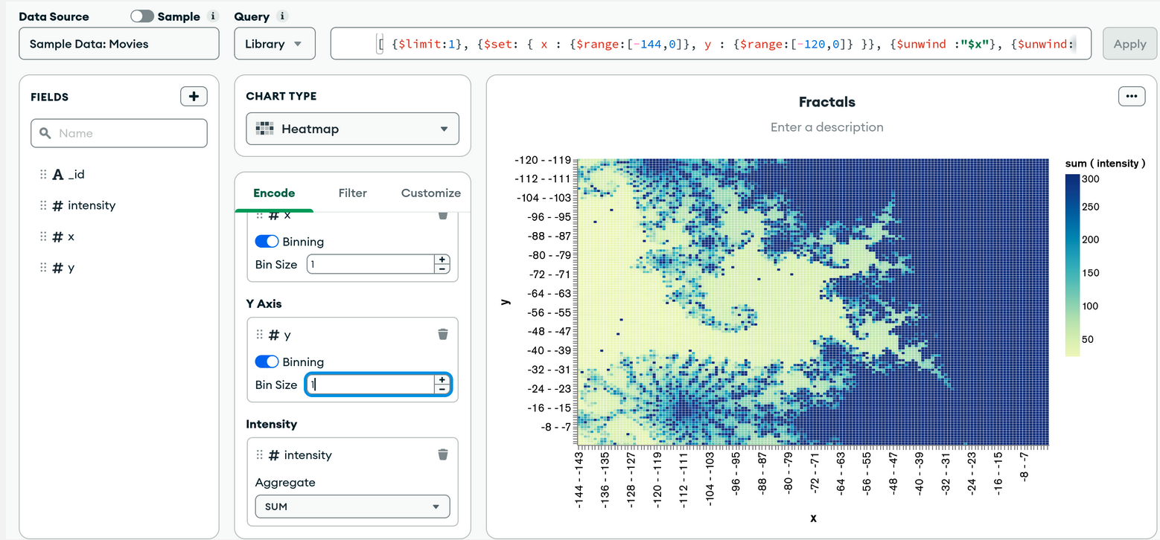
Among the other interfaces allowing to visualize the data present on a MongoDB database, it is possible to use MongoDB Express, which links MongoDB to Express the JavaScript framework. We will put it into practice with the following file that we will name docker-compose.yml:

version: "3.3"

services:
database:
container_name: my_mongo
image: mongo:5.0
environment:
- MONGO_INITDB_ROOT_USERNAME=admin
- MONGO_INITDB_DATABASE=auth
- MONGO_INITDB_ROOT_PASSWORD=pass
networks:
- mongo-compose-network
ports:
- '27017:27017'
volumes:
- ./sample_training:/data/db

mongoexpress:
container_name: mongo-express
image: mongo-express:0.54
depends_on:
- database
networks:
- mongo-compose-network
environment:
- ME_CONFIG_MONGODB_SERVER=my_mongo
- ME_CONFIG_MONGODB_ADMINUSERNAME=admin
- ME_CONFIG_MONGODB_ADMINPASSWORD=pass
- ME_CONFIG_MONGODB_ENABLE_ADMIN=true
- ME_CONFIG_BASICAUTH_USERNAME=admin
- ME_CONFIG_BASICAUTH_PASSWORD=pass
ports:
- '8081:8081'
volumes:
- ./sample_training:/data/db

networks:
mongo-compose-network:
Run the command docker-compose up -d (in a different folder than the first docker-compose made. The first docker-compose must also be stopped, use the docker-compose down command to do so.
Now that the new docker-compose has been launched, we just have to go to on the browser to the IP address of our virtual machine (or localhost for those who work on their personal machine) with the port 8081, for example we will have with a virtual machine the following address: 54.77.119.74:8081/. We are invited to authenticate ourselves, we will have to write admin and pass. Once it is done, we get the following interface:
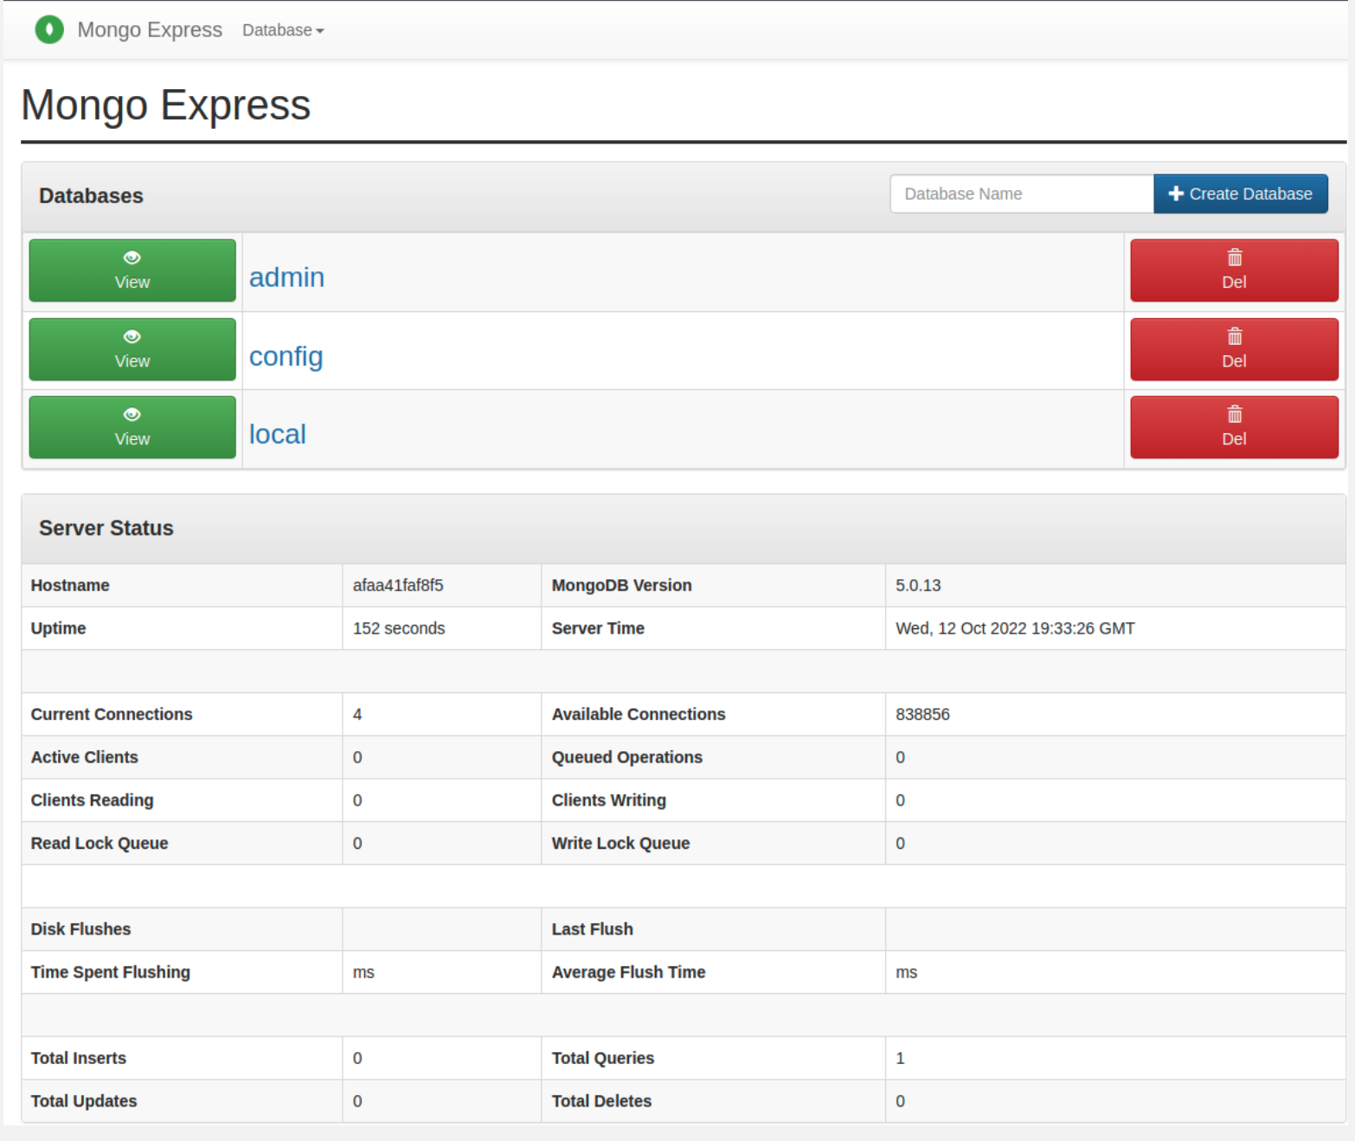
We have the possibility to see statistics about our MongoDB usage at the bottom of this interface. However, the most interesting part is to have a look at the different databases available (which would have been available via the show dbs command). We can delete some but also create one easily using the buttons.
This is what we are going to do by creating a new database with the New Database button that we will call TEST :
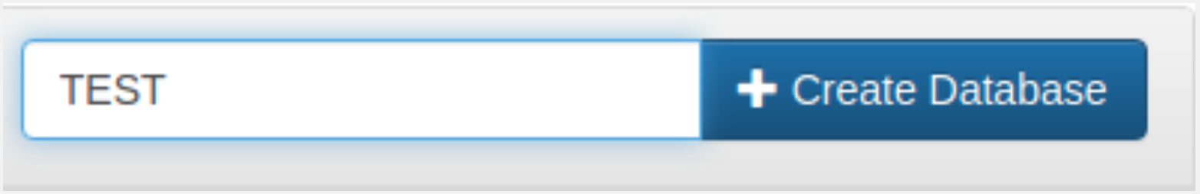
Moving to the new database, in a similar way we can create a collection. Let's do it and name it DISCO. We arrive at this page:
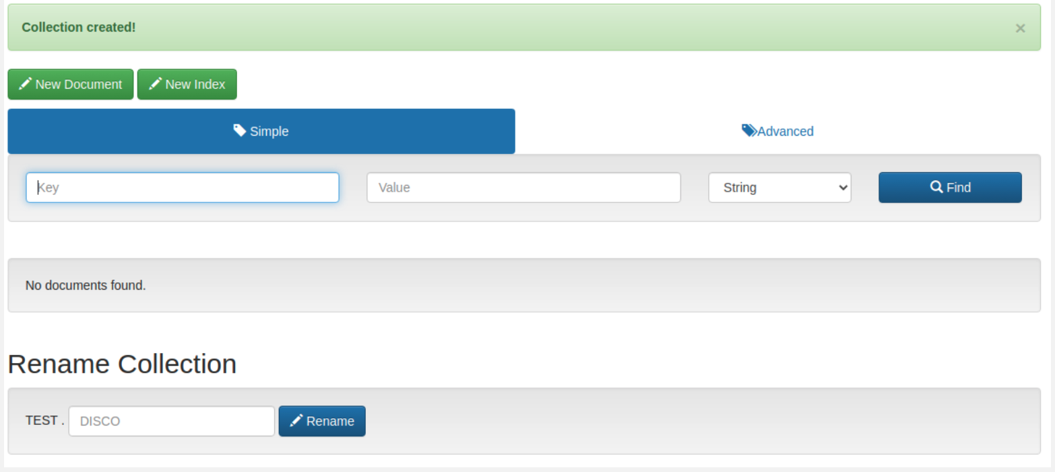
We will add a document to the DISCO collection using the New Document button. We access an interface that asks us to write our document in the JSON format:
Copy and paste the document below onto the interface:
{
'_id': '2',
'singer': 'Bee Gees',
'title': 'Stayin Alive'
}
It is recommended to use this website to check that our JSON files are in the right format.
Then press the Save button. We will find our document in the Disco collection. It is also possible to filter the documents in two different ways:
- Via the Simple button where we play with the keys :
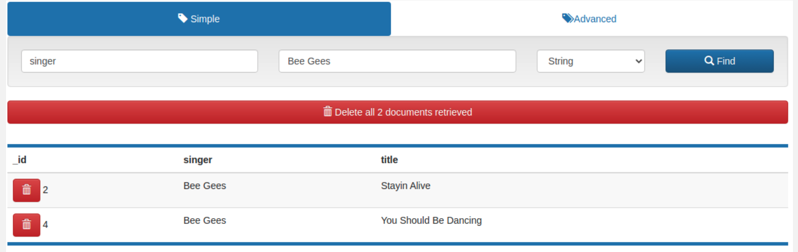
- Via the Advanced button, where we have to use the arguments of the find function:
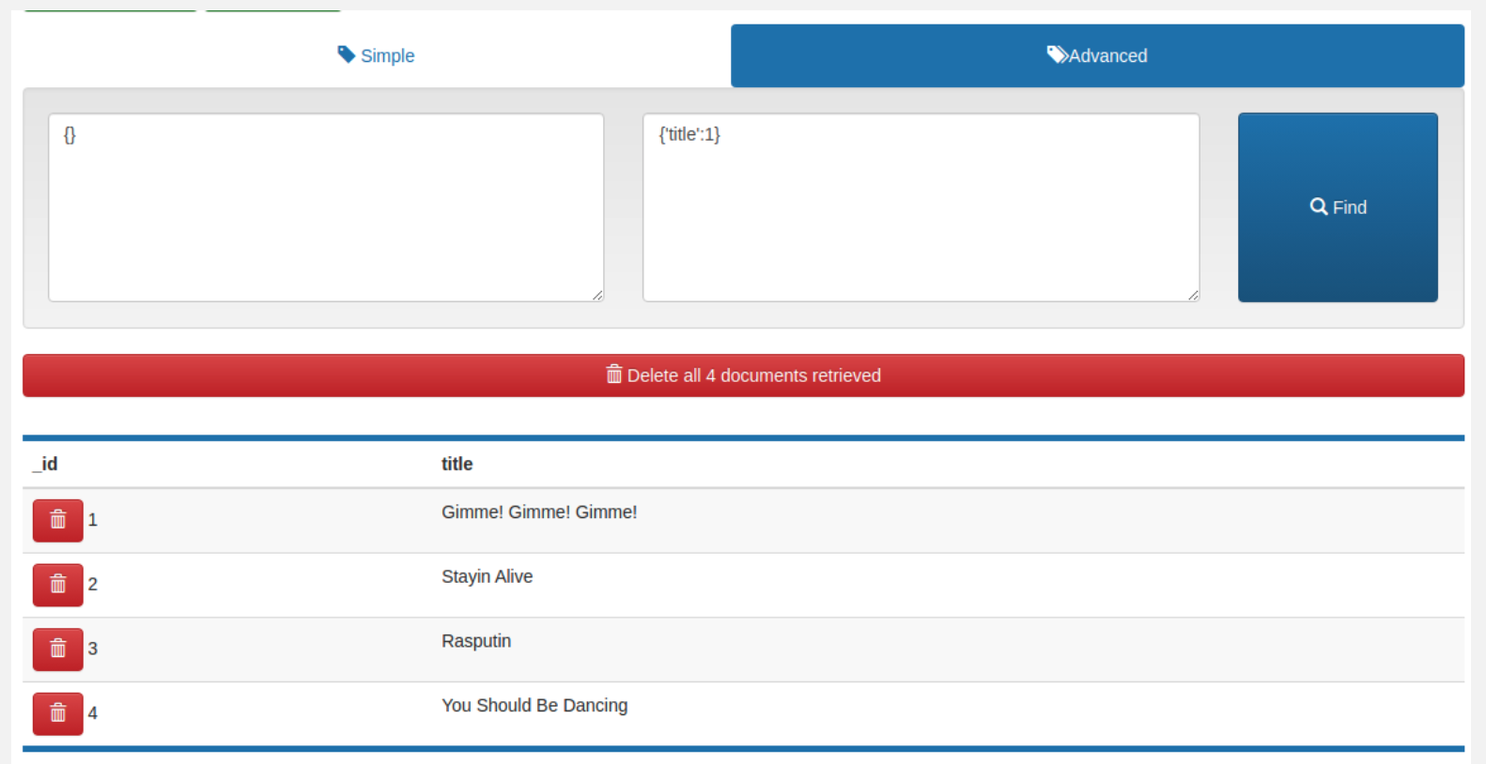
Let's import more data without writing the documents manually. Let's go back to the MongoDB dedicated container with the following command:
docker exec -it my_mongo bash
We have previously specified an authentication, which must be specified when importing the data:
mongoimport -d sample -c zips --authenticationDatabase admin --username admin --password pass --file data/db/zips.json
By clicking on Mongo Express and refreshing the page, we notice the presence of our new database with sample. By clicking on the View button, we find the zips collection and by pressing the View button again, we see a preview of the documents in the zips collection. We can see the whole document by clicking on one of the documents. It will redirect us to the JSON interface, where we can edit the document.
For example, we can change the value of the key state in this document:
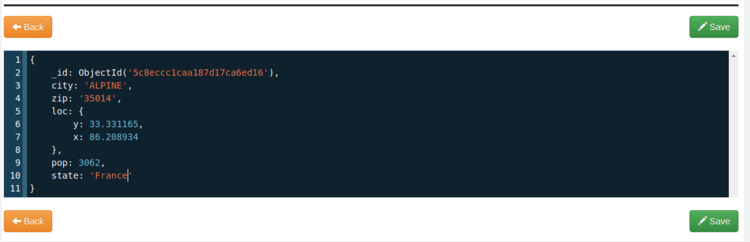

b) Evaluation
In this exam, we will connect to a MongoDB database available on a remote server. We will not cover data insertion and modification, only queries.

Connection to the database
First, we will connect to the database and explore what we can find there.
- (a) To connect to MongoDB, launch the following python script.

from pymongo import MongoClient

full_dns_name = 'mongodb://ec2-54-229-30-76.eu-west-1.compute.amazonaws.com:27017'
username = 'test'
password = 'test'
authSource = 'admin'

client = MongoClient(host=full_dns_name, username=username, password=password, authSource=authSource)
- (b) Display the list of available databases.
There should be only one available database : arxiv.
- (c) Display the list of collections available in this database.
You should see the papers collection. This collection contains abstracts of articles available on the site arXiv.
- (d) Display one of the documents in this collection.
We can use the pprint function of the pprint library to improve the display of results.
- (e) Display the number of documents in this collection.

Exploring the base
In this part, we will explore the database. Note that most queries can be done "by hand" after extracting the database but this part must be done with pymongo.
The title attribute contains the title of the articles. The submitter attribute contains the name of the researcher who submitted the paper for publication.
- (a) Display the title of 10 articles.
- (b) Display the first 10 authors in alphabetical order.
- (c) Display the number of articles that have not been published by "Damien Chablat".
The update_date attribute contains information about the date the document was uploaded to the site. The format of this data is yyyy-mm-dd.
- (d) Display the number of papers uploaded in 2014. This can be based on a regular expression.
The abstract attribute contains the abstract of the article.
- (e) Display the title of an article that contains the expression Machine Learning. We can use a regular expression.
- (f) Display the number of publications per submitter for the 10 most prolific people. We can use an aggregation pipeline with the keywords $group, $sort, $limit.
You will have to return to Daniel the python file with the queries and the results of the queries. It is possible to return a jupyter notebook.

8. Recap

- Terminalden giris
Mongosh

- Show coomands
show dbs
show collections

- find , pretty
db.colllection.find().limit(2).pretty()

-find ,findOne, filter with coloumn
db.zips.find({"state":"MA"})
db.zips.findOne({"pop":3450})

- insertOne, insertMany
db.zips.insertOne({"city" : "Paris","pop":"1000000","state": "France"})
db.zips.insertMany([
{"city":"Paris","state":"France"},
{"city": "Courbevoie","state":"France"}
])

- updateOne
db.zips.updateOne({"city":"BREMEN"},{$set : {"state":"France"}})

-deleteMany
db.zips.deleteMany({"state":"France"})

