Kafka



00 - Linkler - Turkce
Apache Kafka ile proje hazırladık | Java | Python | Scala | Docker | Spring Boot | Kafka Streams
- https://www.youtube.com/watch?v=Ej-HcZd-Alo&list=PLZYKO7600KN9ttvG0mFYzP82AbIdeJYwq&index=6

01 - Introduction to Kafka
Apache Kafka, originally developed by LinkedIn and made open source in 2011, is a tool that is growing in popularity.
Yet few people really know how to use it, or even define it. For some, it is a message broker. For others, it is an ETL (Extract, Transform, Load) that simply transports data from a source system to another target system. Some even consider it to be a database.
These multiple definitions are due to the fact that Kafka's use cases are numerous. Initially, it was designed as a message agent, but has since evolved to be defined as a distributed streaming platform.
There are many reasons for the adoption of Kafka :
- The publish - subscribe approach.
- Distributed architecture, for scalability (scaling).
- The connector system.
- Processing of data stream or Stream processing.

a. Publish - Subscribe
Before presenting the publish subscribe approach and its advantages, let's start by giving some context on the problems it can solve and the alternatives.
First, let's imagine that your company has several systems for managing orders, stocks, etc. Of course these systems are not completely independent, and when an order is received, they are not completely independent.
Of course these systems are not completely independent, and when an order is received, you will probably want to update the stock.
So the order management system (orders management) must be able to communicate with the stock management system (stock management).

This communication can be done in several ways. For example, an API (e.g. HTTP API) could be created on the inventory management system side that the order management system could call to update the inventory.
However, there is a problem with this solution. What happens if the management system is temporarily down? The API call will not be able to be made correctly and the stocks will not be updated even though an order has been placed, which can create obvious complications (such as a stock-out).
For this reason, it is generally preferable to use a message queue or simply a message queue (message queue) in such cases.
A message queue is a technique that allows for an asynchronous service-to-service connection. Messages sent by the source service are stored in the queue, then processed by the target service, after which the messages are removed from the queue.

Thus, if the target service is down for a period of time, messages will accumulate in the queue and will be processed, usually in order (FIFO, first in first out), when the service resumes.
However, this queuing system has its limitations. To illustrate this, let's imagine that another system needs to receive information when an order has been placed. For example, one might want to send a confirmation e-mail after the order has been received.
Since in a queue, messages are deleted after being processed by a target service, the same queue cannot be used to communicate with the email management system. Therefore, a new queue will have to be created to handle the link with this new service.

Two message queues are still manageable, but one can imagine that there will in fact be many, many dependent services that will need to be connected, each time by means of a new queue. This generates complexity that can easily be removed by adopting a publish - subscribe approach.
In publish - subscribe (or Pub/Sub) message systems, the source systems (publishers or producers) do not pre-destine messages for any particular target system. The messages sent are categorised into topics, and the target systems (receivers or consumers) subscribe to the relevant topics.
Thus several consumers can subscribe to the same topics, which avoids duplicate links. The source and target systems are then said to be loosely coupled: the producers communicate with the consumers without having any a priori knowledge about their characteristics.

A consequence of this approach is that messages cannot be directly deleted from the topic by the Pub/Sub message system after being processed by a consumer. They are kept for a configurable retention period. Other consumers will therefore also be able to receive the message. It is however usually possible for a consumer to inform the Pub/Sub agent that the message has been processed. The message will then no longer be visible to the consumer in question.
You can now understand the advantage of the publish - subscribe approach compared to a classic queue. These characteristics are all the more interesting in the case of micro-services architectures, which are becoming increasingly popular. In this type of architecture, the various processes of an enterprise are decomposed into many autonomous applications with limited responsibilities, which must nevertheless communicate with each other, often by means of a Pub / Sub message agent.
The Pub / Sub approach adopted by Kafka is therefore one of the reasons for its popularity. But Kafka differs from other Pub / Sub message systems in a number of ways, including its distributed architecture.

b. Distributed architecture
One of the main features that has driven the adoption of Kafka is undoubtedly its distributed architecture, which allows it to process several trillion messages per day on very large clusters.
More specifically, Apache Kafka uses a Producer / Brokers / Consumers architecture. The brokers are the different servers in the cluster, in charge of replication and data partitioning.

There are two types of partitions: leaders and followers. There is one leader per partition and these leaders are distributed evenly among the brokers. In the following example, there is one leader partition per broker and the replication factor is 2. The two replicas of the leader partition are called follower partitions

Leader and follower assignment is done by voting using Apache Zookeeper. We will not go into details about this tool: the only thing we need to know is that Zookeeper is used to do administration and maintenance of distributed systems. Here it is used by Kafka to decide which partitions are leaders and followers. When a broker goes down, the partitions that were leaders are reassigned via Zookeeper: there must always be a single primary partition per partition. That is, if the broker containing the leader partition fails, one of the replicas (follower partition) will become the new leader partition.
Note, however, that in future versions of Kafka, the use of Zookeeper will be removed, in favour of internal partition management.
This distributed architecture allows Kafka to handle huge message volumes on very large clusters, and also to be fault-tolerant thanks to partition replication.

c. Kafka Connect
Another advantage of Kafka is its connector system Kafka Connect. Connectors are reusable components which, as the name suggests, allow different systems to be connected to Kafka.
Thus, many technologies provide connectors to transfer data to or from Kafka. For example, if you want to ingest data from a MongoDB database, you can simply install and configure the official MongoDB connector for Kafka. You can see a list of Kafka connectors on the Confluent website (the main contributor of Kafka).
So you can use Kafka Connect to transfer data between two databases through Kafka, for example to load data from an enterprise application using a relational database into a data lake, without having to code connectors for the source and target systems (sink).

However, when transferring this type of data, it is often necessary to carry out an intermediate transformation step (filters, aggregations, etc.). This is called an ETL (Extract Transform Load). There are several tools for performing ETLs (for example Talend). But Kafka can also be used as such, especially by transforming data using the Kafka Streams API.

d. Kafka Streams
The [Kafka Streams] API (https://kafka.apache.org/28/documentation/streams/) allows you to create derived topics from other topics, by performing transformations on them. This is known as stream processing or stream processing.
In concrete terms, Kafka Streams allows you to perform operations such as filters, aggregations (averages, sums, etc.), but also joins between different streams. The resulting stream is persisted in a new topic.
Kafka Streams can be used in conjunction with Kafka Connect to perform ETL:

However, it should be noted that Kafka Streams applications must be developed in Java or Scala programming languages, which can be complex to learn.
However, there are alternative solutions for stream processing, such as Spark Streaming which has an API in Python and which we will cover in this course, or ksqlDB which allows stream processing with SQL, and which is based on the Kafka Streams API.

e. Conclusion
If Kafka was first conceived as a distributed publish - subscribe message agent, the addition of APIs such as Kafka Streams or Kafka Connect and its numerous connectors makes it today a complete event streaming platform, with multiple use cases. It is now used by many companies to manage all messages, as well as to perform ETL, or even in some cases as a database. Indeed, the retention of messages is configurable for each topic, and can even be infinite, which will make it possible to find all the messages.

02 - Getting started with Kafka

a. Starting Kafka with Docker
For this course, we will use Docker to start a Kafka cluster, the Zookeeper server needed to run it, and Kafka UI, an open source web interface to administer the cluster.
Note that this is not the recommended deployment mode for a Kafka cluster in production, but docker allows a very simple and fast configuration, so we can focus on the use of Kafka.
Download and unzip the kafka.zip archive.
wget https://dst-de.s3.eu-west-3.amazonaws.com/kafka_fr/kafka.zip
unzip kafka.zip
A kafka folder has been created, which contains a docker-compose.yml file and 3 Python scripts :
- producer.py
- consumer.py
- admin.py
cd kafka
ls
The docker-compose.yml file is used to instantiate all the necessary services :
version: "3.2"
services:
zookeeper:
image: wurstmeister/zookeeper
ports:
- "2181"

kafka:
image: wurstmeister/kafka
depends_on:
- zookeeper
ports:
- "9092-9094:9092"
environment:
KAFKA_ADVERTISED_HOST_NAME: X.X.X.X
KAFKA_ZOOKEEPER_CONNECT: zookeeper:2181
volumes:
- /var/run/docker.sock:/var/run/docker.sock

kafkaui:
image: provectuslabs/kafka-ui
depends_on:
- kafka
- zookeeper
ports:
- "8080:8080"
environment:
KAFKA_CLUSTERS_0_NAME: local
KAFKA_CLUSTERS_0_BOOTSTRAPSERVERS: "kafka:9092"
Use the nano text editor to change the value of the KAFKA_ADVERTISED_HOST_NAME to the public IP address of your Virtual Machine.
nano docker-compose.yml
As a reminder, you can find the public IP address of your Virtual Machine in the "Machine status" box of this page.
Then, run the docker-compose with the command :
docker-compose up -d
Then increase the number of brokers in the cluster using the --scale option of the docker-compose up command :
docker-compose up --scale kafka=3 -d
You can view the containers created using the docker container ls command.
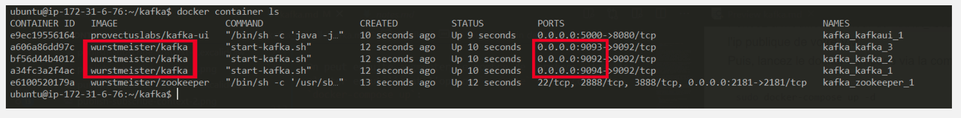
You can now access Kafka UI at address X.X.X.X:8080 (replacing X.X.X.X with the public ip of your Virtual Machine):
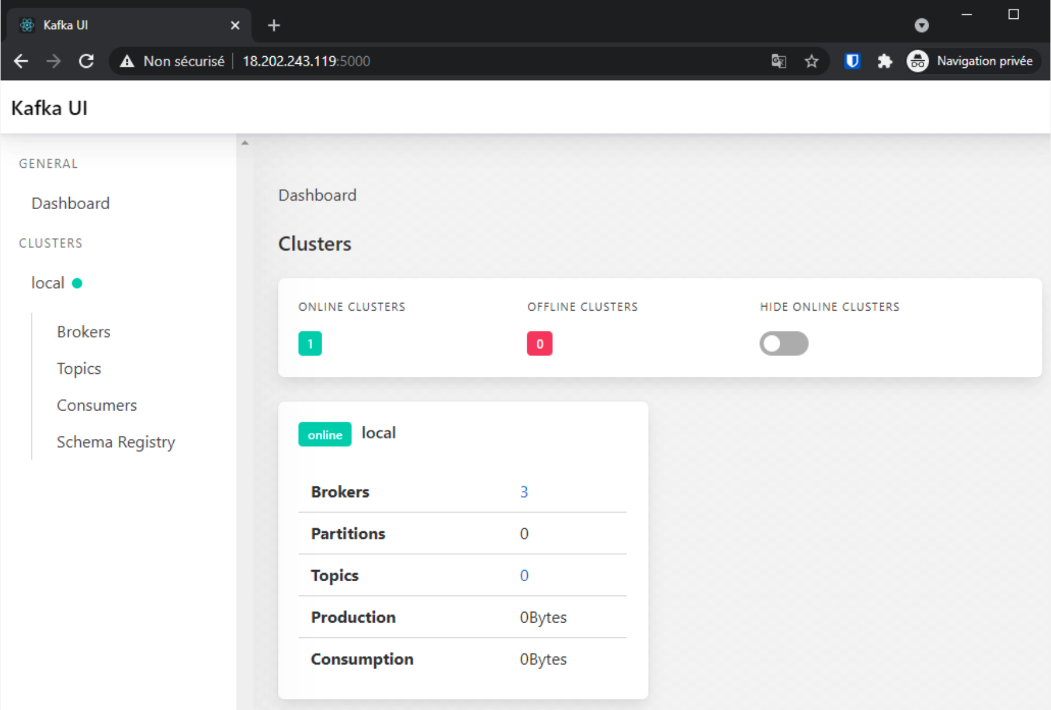
Kafka UI provides a web interface for monitoring and administering Kafka (viewing brokers and their status, creating topics, etc.). You can explore the interface to discover its features.
Create, from the interface, a test topic composed of two partitions replicated 3 times:
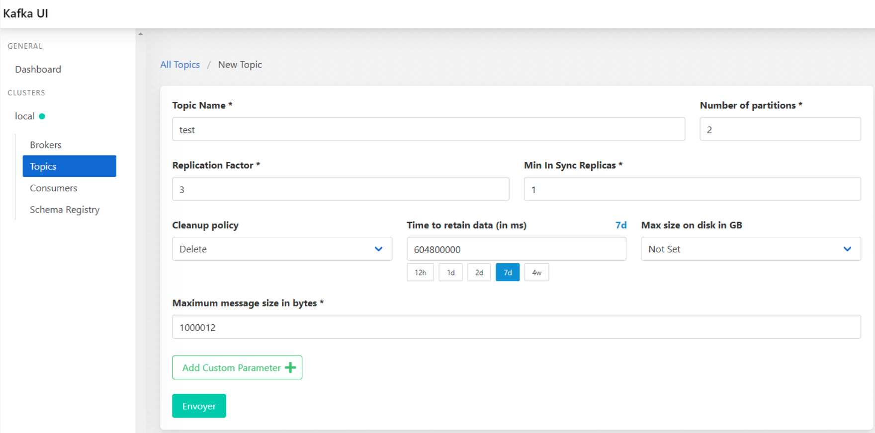
The Kafka UI may take a while to refresh, especially after creating a topic. Wait a few seconds after creating the topic until it appears in the list. If it still does not appear, you can create it again.

b. Producers
Our cluster is now ready to be used, so we can produce and consume messages in the test topic.
Many clients exist to interact with a Kafka cluster. Here we will use the kafka-python Python client.
Install kafka-python with pip.
pip3 install kafka-python
The producer.py file is used to create a Kafka producer that will insert 30 messages into the test topic :

from kafka import KafkaProducer

kafka_producer = KafkaProducer(
bootstrap_servers="localhost:9092"
)

for i in range(1, 30):
kafka_producer.send(topic="test", value=f"New message # {i}".encode("utf-8"))

kafka_producer.flush()
Run the producer.py file :
python3 producer.py
You can view the topic messages directly from Kafka UI :
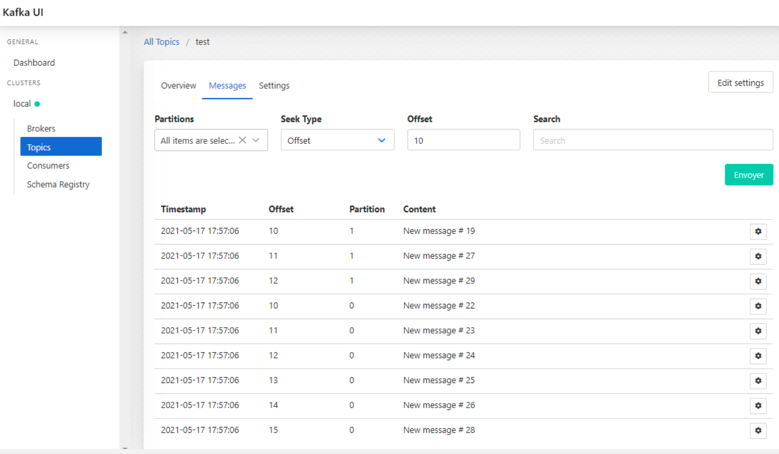
You will notice that the messages are not sorted in the exact order in which they were issued by the producer. The messages are in fact ordered within a partition, but once there is more than one partition, it cannot be guaranteed that they will be consumed in the order of production.
Another interesting property of Kafka is the possibility to partition messages by key (key). Indeed, it is possible to associate a key with each message at the time of transmission. All messages with the same key will be stored on the same partition.
Using nano, modify the producer.py file to associate a key with each message :
from kafka import KafkaProducer

kafka_producer = KafkaProducer(
bootstrap_servers="localhost:9092"
)

for i in range(1, 30):
kafka_producer.send(
topic="test",
value=f"New message # {i}".encode("utf-8"),
# the key will be '0' for even messages, and '1' for odd messages
key=f"{i % 2}".encode("utf-8")
)

kafka_producer.flush()
Before running the producer.py file again, you must first delete and then recreate the topic test. You can do this using the Kafka UI, or the admin.py script :
python3 admin.py delete --name test
python3 admin.py create --name test --partition 2 --replication 3
Run again the producer.py file
python3 producer.py
You can see from Kafka UI that even-numbered messages are all on one partition, and odd-numbered messages on another :
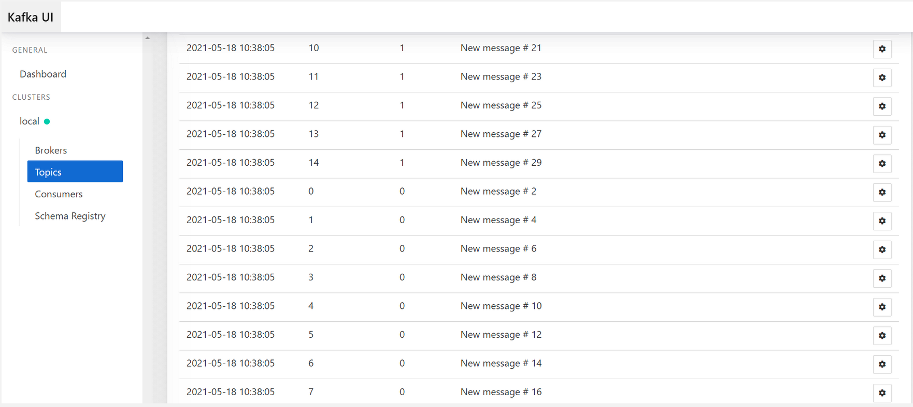
This possibility of partitioning by key is particularly useful for ensuring that messages corresponding to the same group (and therefore associated with the same key) will be consumed in the order of production, since the messages are ordered within a partition (and not a topic).
For example, in an application that manages order events, we want to ensure that an "Order creation" event will be consumed before an "Order cancellation" event. To do this, we can choose to partition the messages by order or customer identifier. Thus, the events relating to the same order will be stored in the same partition, and will therefore be consumed in the order of production.
If you partition messages by key, make sure that the number of keys is at least equal to the number of partitions. If it is less, some partitions will not be used.

c. Consumers
Now that the test topic has been populated with some messages, we can consume the topic with the consumer.py script :
from kafka import KafkaConsumer

kafka_consumer = KafkaConsumer(
"test",
bootstrap_servers="localhost:9092",
auto_offset_reset="earliest"
)

for message in kafka_consumer:
print(message.value.decode("utf-8"))
Run the consumer.py file
python3 consumer.py
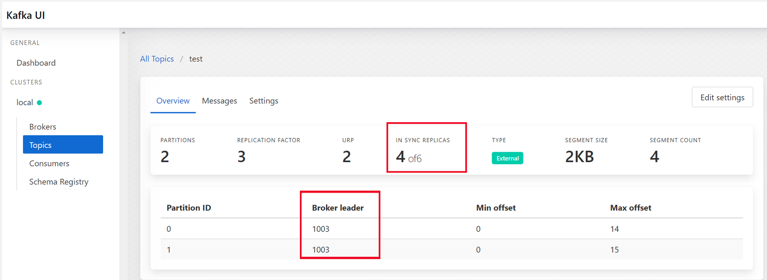
The messages produced are found by the consumer. It can be seen that this consumer retrieves all the messages, distributed over the two partitions. However, it is possible to spread the load over several consumers within the same consumer group.
We also notice that after reading all the messages, the python script does not stop: indeed, the consumer is still reading the topic. If a new message arrives in the topic, it will be processed instantly. You will have to force the program to stop manually.

d. Fault tolerance
In the previous chapter, we presented the distributed architecture of Kafka as a major advantage, both for the possibilities of scaling that it allows, as well as for the induced fault tolerance.
Indeed, the possibility of replicating data on different brokers allows to maintain operational condition, even when one of the brokers goes down.
In the cluster we have used so far, we can easily simulate the loss of a broker by decreasing the number of containers using the command :
docker-compose up --scale kafka=2 -d
The number of brokers in the cluster has therefore been reduced from three to two. If you look at Kafka UI, you can see that for the topic test, it says "4 of 6 in sync replicas". This is because the cluster now only has 2 brokers, so it is no longer possible to have 3 replicas for each partition.
You may also notice a change in the Broker leader. If the broker that has been deleted contained a leader partition, a follower broker will be automatically assigned as the leader broker.

Despite the deletion of the broker, and thanks to the replication, you will see by running the consumer.py script again that all the data has been preserved, and is still accessible by the consumers.
python3 consumer.py

03 - Validation of knowledge
This module is not assessed, but the MCQ below will allow you to check that you have acquired the necessary knowledge.

Question 1
What is Kafka ?
A message agent that works in Publish Subscribe.
A Python library.
A batch data processing tool
A distributed event streaming platform.

Question 2
What is a broker of a Kafka cluster ?
A cluster failure.
One of the servers of the cluster, which can contain the data of one or more partitions.
A connection between kafka and a database
A Docker image.

Question 3
What happens when a broker fails ?
A broker cannot fail.
If the data contained in the broker was replicated, it will always by available.
When possible, the leading partitions of the broker will be automatically reallocated to other brokers
The cluster is no longer accessible.

Question 4
How to ensure that messages related to a user will be consumed in the production order, in the case of a partitioned topic ?
This is impossible, Kafka cannot guarantee this by scheduling messages.
There is nothing to do, Kafka guarantees the ordering of messages within the topic.
We need to partition the messages by key, using the user ID as a key.
You need to store the user data in an external database.

Question 5
What is Kafka Connect ?
A component of Apache Kafka allowing to develop and use connectors to integrate data from external systems to and from Kafka.
A VPN for Kafka.
A python client for Kafka.
A version of Kafka for the Cloud.

