Machine Learning for Data Engineers¶

01 - Introduction

1. Introduction

1.1 Definition
Automatic Learning, also called Machine Learning, is a type of artificial intelligence. This Artificial Intelligence learns from the data provided to it and this learning will allow it to make decisions. We are talking more commonly about machine learning models : we then refer to the training of an algorithm on data. It will often be the aim of using this model in order to carry out predictions on new data, unknown by the model.

1.2 Supervised learning or unsupervised learning
Machine Learning brings together two main types of learning issues :
- The supervised learning : It is when there is a target variable. From labeled data, we try to predict this variable. We have explanatory variables available and we want to predict the information contained in the target variable. The available data is labeled, this means that we know the value of the target variable for this data. This is necessary to allow the model to train : learn about data.
The supervised learning can be subdivided into two main techniques :
- The regression : We try to predict a quantitative type variable.

- The classification : We try to predict a qualitative type variable.

- The unsupervised learning : It is when there is no target variable : we try to discover the underlying structures within a database.
The unsupervised learning can be subdivided into two main techniques :
- The dimension reduction : We transform our variables to reduce the number of columns in our data.
- The clustering : We are trying to group our observations within groups.

- As part of this module we will focus on the supervised learning problem. We will thus present the algorithms and methods that will allow us to do predictive modeling.*

2. Why do modeling?

2.1 A decision support tool
The use of machine learning can be very interesting within companies in the development of decision - making tools. The development of models, such as predictive marketing models, facial recognition or fraud detection, makes it possible to facilitate the treatment of certain issues but also to support companies from a financial or strategic point of view.

2.2 Data treatment pipeline
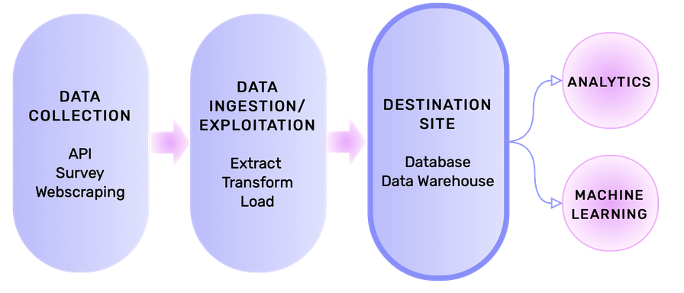

It is important to keep in mind that the analyzes and applications of machine learning models are only the final stages through which the data pass. Upstream, these same data will have undergone several transformations.
Following the definition of needs, the data collection stages must be implemented. We are talking about Data Collection. For example, the use of webscraping techniques can allow us to recover data from websites. At the end of this step we will have one or more data sources.
These same data must then be recovered and added to a destination site, we then speak of Data Ingestion. The destination site may be a database, a data warehouse or a data lake. During this stage, it will be necessary to think about the structure that we want to have our data adopted. This structure will have capital importance in the rest of the process of data processing. This ingestion step encompasses ETL stages (extract, transform and load): the data is extracted, transformed and finally loaded in the final destination site. These steps are essential because they guarantee a good level of data quality. Once these steps are finalized, the professions can then recover the data necessary for their analyzes and projects to process them.

2.3 The role of the Data Engineer
Machine learning applications are not at the heart of the Data Engineer fields of action, despite everything, understanding of concepts and issues is essential because the data engineer collaborates closely with the Data Scientist. Indeed, the Data Engineer must be capable of understanding the application of these models. It is also important to note that the border between data professions can be blurred in business.

3. Model and performance evaluation

3.1 The concept of performance
We approach in this first notebook, the concept of model performance since it is at the heart of the supervised learning problem. The performance measurement makes it possible to assess the operational nature of the models. Indeed, the better a model performs, the more reliable and therefore usable it is.
For example, we can imagine a model that classifies emails. The goal is to identify which spam are. If our model is ineffective then then non-fraudulent emails could be badly classified and vice versa: the use of our model is here counterproductive since it will not have allowed us to identify among all emails those who are fraudulent.
It should be noted that the performance is largely determined by the quality of the data that is available. We must therefore ensure that our data is well processed before moving on to the modeling stage.
More concretely, to know the performance and therefore decide that a model is operational, we measure using metrics the quality of the prediction by comparing the values predicted to the real values on the data sample which is at our disposal to make the model.
The realization of the model is a delicate step because it is necessary to ensure that it is generalizable. Although the performance measurement of our model is done on the data we have available, the objective is that it is efficient on new data from which we do not know the outcome (the target variable). In the event that the model performs only on the data it knows but not on new data, we are talking about overfitting. The model is then too suitable to the data on which it has been trained.

3.2 The simple hold-out technique : Train - Test - Split
To be sure not to be in this kind of case, the prediction performance of models must be evaluated on part of the data that has not been observed by the model. For this, we divide the data into two parts, a part dedicated to training and another dedicated to the evaluation. We then obtain the real predictive performance of a model. Below the typology used and the definitions associated with each term :
- Training set :
This is the part of the database on which the model will learn and train. The model parameters will therefore be estimated during this step.
- Test set :
This is the part of the database that has never been studied by the model, it is therefore on this part of the data that performance is assessed.
The model training set often represents 70 to 80% of the total data volume for a test set representing 20 to 30%. There is nevertheless no general rule, these proportions may vary depending on the nature and volume of the data.

3.3 Metrics
Performance measures are made using metrics which depend on the type of variable that is predicted: regression or classification. Their nature and use will be developed in the following notebooks.

3.4 Models deployment
Once the model has been trained and evaluated if a model is deemed operational then comes the production stage. Once production models can be used on a business scale. The model is then used to make predictions on new data. He can then have a crucial role in the team's decision - making.

4. Conclusion

4.1 To remember
- The supervised learning is distinguished from unsupervised learning : we are looking in the first case to predict a target variable predefined, in the second to find within the data not labeled existing structures.
- We speak of regression when we seek to predict a quantitative variable and classification when we seek to predict a qualitative variable.
- The separation of the dataset into a training part and a test part makes it possible to assess performance and the generalization capacity of a model.
- The performance assessment of a model on data that has never been trained is essential, this allows you to deceive an over - approval problem.

4.2 What's next ?
In the next notebook we will introduce the Scikit-Learn API. This Python module allows you to set up machine learning models in a few lines of code in a very simplified way.

02 - Introduction to the Scikit-Learn API

1. Introduction
We have just seen the basics of Machine Learning :
- What is the difference between supervised learning and unsupervised learning?
- What is the difference between regression and classification?
- What is a target variable? explanatory variables?
- What is the Hold out technique?
We will see in this notebook how to implement a basic classification and regression Machine Learning model with the Scikit-Learn module.
The objective of this notebook is :
- Understand the usefulness and power of Scikit-Learn,
- Train a classification model with Scikit-Learn,
- Train a regression model with Scikit-Learn.

1.1 Scikit-Learn
Scikit-Learn is a Python module built from NumPy, Scipy and matplotlib to train Machine Learning models as simply as possible. Each model has its own class that must be instantiated to create a model.
All classes of models of Scikit-Learn have the following three methods:
- fit : Trains the model on a dataset.
- predict : Performs a prediction from explanatory variables.
- score : Metric which allows to compare the target variable to the prediction.
Therefore, to train a Machine Learning model with Scikit-Learn, this will always be done in the same way in 4 lines of code:

# Instancing of the chosen model
# To create a model, we generate an object of the class corresponding to this object
# LinearRegression is a regression algorithm
# We can specify some parameters of the algorithm between the brackets.

model = LinearRegression()

# Model training on the training dataset

model.fit(X_train,y_train)

# Prediction of the target variable for the testing dataest, these predictions are stored in y_pred

y_pred = model.predict(X_test)

# Evaluation of the model: from X_test, we predict the target variable that we compare to y_test

model.score(X_test,y_test)
Whether to develop a classification or regression algorithm, this will be almost always in the same way.

2. Classification

2.1 Reminder
In Machine Learning, the objective is to predict the value of a target variable from explanatory variables. In a classification problem, the target variable takes discrete values. These values can be numeric or literal but in both cases, the target variable takes a finished number of values.
The different values taken by the target variable are what are called classes.
The objective of the classification is therefore to predict the class of an observation from its explanatory variables.
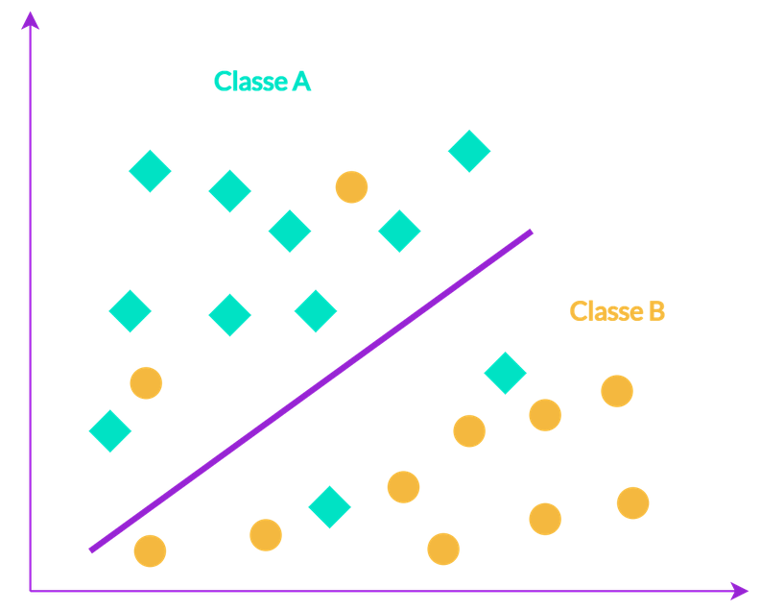

2.2 Practical Application
The following exercise deals with a dataset which aims to predict whether a patient is diabetic or not according to certain medical measures. Note that several constraints have been imposed in this dataset: all patients are female, at least 21 years old and of Pima Indian origin.
Here is the data description:
Variable | Description
'Pregnancies' | Number of pregnancies
'Glucose' | Plasma glucose concentration
'BloodPressure' | Blood pressure
'SkinThickness' | Thickness of the triceps
'Insulin' | Serum insulin at 2 o'clock
'BMI' | Body mass index
'DiabetesPedigreeFunction' | Pedigree function of diabetes
'Age' | Age
'Outcome' | 0 if the patient does not have diabetes, 1 otherwise
The objective of this classification is therefore to predict whether a patient will have diabetes or not.
- (a) Run the following cell to initialize the notebook and load the pandas library under its usual alias.
import warnings
warnings.filterwarnings('ignore')
​
import pandas as pd
- (b) Read the file 'diabetes.csv' in a DataFrame called df_class and display the first five lines of then Dataframe.
df_class = pd.read_csv("diabetes.csv")
​
df_class.head()
​
 | Pregnancies | Glucose | BloodPressure | SkinThickness | Insulin | BMI | DiabetesPedigreeFunction | Age | Outcome
0 | 6 | 148 | 72 | 35 | 0 | 33.6 | 0.627 | 50 | 1
1 | 1 | 85 | 66 | 29 | 0 | 26.6 | 0.351 | 31 | 0
2 | 8 | 183 | 64 | 0 | 0 | 23.3 | 0.672 | 32 | 1
3 | 1 | 89 | 66 | 23 | 94 | 28.1 | 0.167 | 21 | 0
4 | 0 | 137 | 40 | 35 | 168 | 43.1 | 2.288 | 33 | 1
- (c) Display the information of the DataFrame df_class.
df_class.info()
<class 'pandas.core.frame.DataFrame'>
RangeIndex: 768 entries, 0 to 767
Data columns (total 9 columns):
# Column Non-Null Count Dtype
--- ------ -------------- -----
0 Pregnancies 768 non-null int64
1 Glucose 768 non-null int64
2 BloodPressure 768 non-null int64
3 SkinThickness 768 non-null int64
4 Insulin 768 non-null int64
5 BMI 768 non-null float64
6 DiabetesPedigreeFunction 768 non-null float64
7 Age 768 non-null int64
8 Outcome 768 non-null int64
dtypes: float64(2), int64(7)
memory usage: 54.1 KB
The dataset is very clean : there are no missing values and the types are good. Note that this is very rarely the case: usually a phase of pre-processing is essential before the modeling part. The next step will be to identify the target variable and the explanatory variables.
As a reminder, we try to predict whether a patient will be suffering from diabetes or not according to medical characteristics. So, here the target variable is Outcome which takes a finished number of values (0 or 1): we are in a classification problem.
- (d)
  - (1) In a DataFrame called X, store the explanatory variables from the dataset (all except the Outcome column). To do this, you can help yourself with the method drop from a DataFrame.
  - (2) In a DataFrame called y, store the target variable Outcome.
df_class = pd.read_csv("diabetes.csv")
df_class.head()
 | Pregnancies | Glucose | BloodPressure | SkinThickness | Insulin | BMI | DiabetesPedigreeFunction | Age | Outcome
0 | 6 | 148 | 72 | 35 | 0 | 33.6 | 0.627 | 50 | 1
1 | 1 | 85 | 66 | 29 | 0 | 26.6 | 0.351 | 31 | 0
2 | 8 | 183 | 64 | 0 | 0 | 23.3 | 0.672 | 32 | 1
3 | 1 | 89 | 66 | 23 | 94 | 28.1 | 0.167 | 21 | 0
4 | 0 | 137 | 40 | 35 | 168 | 43.1 | 2.288 | 33 | 1
df_class = pd.read_csv("diabetes.csv")
​
y = df_class['Outcome']
​
X = df_class.drop('Outcome', axis=1)
As explained in the previous notebook, we will now have to separate the dataset into 2 parts :
- The training set which is used to train the classification model, i.e to find the parameters of the model that best separate the classes.
- The test set which is used to evaluate the model on data it has never seen. This evaluation will allow us to judge the ability to generalize the model.
A very useful function for performing this operation is the train_test_split function of the sklearn.model_selection sub-module.
- (e) Run the next cell to import train_test_split.
from sklearn.model_selection import train_test_split
This function is used as follows:
X_train, X_test, y_train, y_test = train_test_split(X, y, test_size = 0.15)
- X_train and y_train are the explanatory and target variables of the training set.
- X_test and y_test are the explanatory and target variables of the test set.
- The test_size argument corresponds to the proportion of the dataset we want to keep for the test set. In the previous example, this proportion corresponds to 15% of the initial dataset.
- The random_state argument allows to guarantee the reproducibility of the results by setting the randomness. In other words, by setting it to a number (no matter what its value), we make sure to get the same result if we use the function again.
- (f) With the function train_test_split, separate the dataset into a training set (X_train,y_train) and a test set (X_test, y_test) so that the test part contains 20% of the initial dataset. Set the random_state to 42.
from sklearn.model_selection import train_test_split
​
X_train, X_test, y_train, y_test = train_test_split(X, y, test_size = 0.2, random_state=42)
We can now go to the modeling part.
For this, we will train a decision tree, it is a simple algorithm that requires no pre-processing on the dataset. You will see more in depth its operation in the next notebook, only keep at the idea that: the classification tree is a Machine Learning algorithm to train a classification model available on Scikit Learn.
- (g) Load the DecisionTreeClassifier function from the sklearn.tree sub-module.
from sklearn.tree import DecisionTreeClassifier
To train a Machine Learning algorithm, it will always be done in the same way as seen above.
- (h)
  - (1) Instantiate a DecisionTreeClassifier model called dt_clf with a random_state set to 42.
  - (2) Train the model on the training dataset thanks to the fit method of the DecisionTreeClassifier class.
#Modele instantiation
dt_clf = DecisionTreeClassifier(random_state=42)
​
#Modele training
dt_clf.fit(X_train, y_train)
DecisionTreeClassifier(random_state=42)
- (i)
  - (1) Make a prediction on the test data and store these predictions in y_pred_test.
  - (2) Show the first 5 predictions.
#Prediction on test data
y_pred_test = dt_clf.predict(X_test)
​
print(y_pred_test[:5])
[1 0 0 0 0]
- (j) Display the first 5 rows of y_test and compare them to y_pred_test.
dictP = {'y_test' : y_test,
'y_prediction' : y_pred_test,
'tf' : y_test == y_pred_test}
df_p = pd.DataFrame(dictP)
​
df_p.head()
​
 | y_test | y_prediction | tf
668 | 0 | 1 | False
324 | 0 | 0 | True
624 | 0 | 0 | True
690 | 0 | 0 | True
473 | 0 | 0 | True

2.3 Score Elle Hesapladim
true_pred_count = df_p.loc[df_p.tf == True].count()[0]
total_pred_count = df_p.count()[0]
​
score = true_pred_count / total_pred_count
score
0.7467532467532467
- (k)
  - (1) Evaluate the model using the score method on the training data.
  - (2) Evaluate the model using the score method on the test data.
print("score train : " , dt_clf.score(X_train, y_train))
​
print("score test : ", dt_clf.score(X_test,y_test))
score train : 1.0
score test : 0.7467532467532467
You can notice that the score between the training set and the test set is decreasing. This is called overfitting, you will see this in the next notebooks.
The score method is a metric that will compare the results of predictions of your dataset X compared to y. In classification, the score corresponds to the accuracy : this is the correct prediction rate carried out by the model.
Here is an example to fully understand the calculation :

We have just seen an example of classification. Now let's go to regression.

3. Regression

3.1 Reminder
In Machine Learning, the objective is to predict the value of a target variable from explanatory variables. In a regression problem, the target variable takes continuous values. These values are numerical : price of a house, quantity of oxygen in the air of a city, etc. The target variable can therefore take an infinity of values.
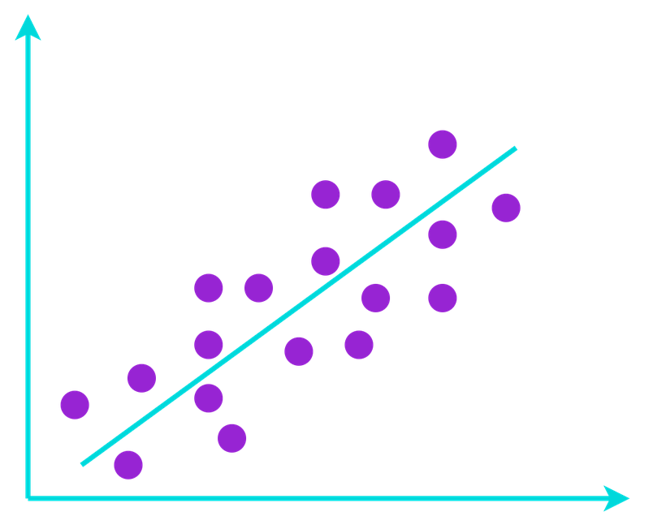

3.2 Practical Application
The following exercise relates to a dataset on the characteristics of different cars with the price for each.
Here is the data description:
Variable | Description
'symboling' | "Sweetness of the car" : +3 : The automobile is risky, -3 : fairly safe
'wheelbase' | Space between wheels
'carlength' | Car length
'carwidth' | Car width
'carheight' | Car height
'curbweight | Unloaded weight
'enginesize' | Engine size
'stroke' | Combustion cycle
'compressionratio' | Compression ratio
'horsepower' | Horses
'price' | Car price
The objective of this regression will therefore be to predict the car price according to certain characteristics.
- (a)
  - (1) Read the file 'carPrice.csv' in a DataFrame called df_reg specifying that the first column contains the index.
  - (2) Display the first five lines of the DataFrame df_reg.
df_reg = pd.read_csv('carPrice.csv', index_col=0)
df_reg.head()
 | symboling | wheelbase | carlength | carwidth | carheight | curbweight | enginesize | stroke | compressionratio | horsepower | price
car_ID
1 | 3 | 88.6 | 168.8 | 64.1 | 48.8 | 2548 | 130 | 2.68 | 9.0 | 111 | 13495.0
2 | 3 | 88.6 | 168.8 | 64.1 | 48.8 | 2548 | 130 | 2.68 | 9.0 | 111 | 16500.0
3 | 1 | 94.5 | 171.2 | 65.5 | 52.4 | 2823 | 152 | 3.47 | 9.0 | 154 | 16500.0
4 | 2 | 99.8 | 176.6 | 66.2 | 54.3 | 2337 | 109 | 3.40 | 10.0 | 102 | 13950.0
5 | 2 | 99.4 | 176.6 | 66.4 | 54.3 | 2824 | 136 | 3.40 | 8.0 | 115 | 17450.0
df_reg = pd.read_csv('carPrice.csv', index_col = 0)
​
df_reg.head()
- (b) Show information of the DataFrame df_reg.
df_reg.info()
<class 'pandas.core.frame.DataFrame'>
Int64Index: 205 entries, 1 to 205
Data columns (total 11 columns):
# Column Non-Null Count Dtype
--- ------ -------------- -----
0 symboling 205 non-null int64
1 wheelbase 205 non-null float64
2 carlength 205 non-null float64
3 carwidth 205 non-null float64
4 carheight 205 non-null float64
5 curbweight 205 non-null int64
6 enginesize 205 non-null int64
7 stroke 205 non-null float64
8 compressionratio 205 non-null float64
9 horsepower 205 non-null int64
10 price 205 non-null float64
dtypes: float64(7), int64(4)
memory usage: 19.2 KB
The dataset is very clean : there are no missing values and the types are good. The next step is to identify the target variable and the explanatory variables. Here the target variable is : price which takes an infinite number of values : we are in a regression problem.
- (c)
  - (1) In a DataFrame called X, store explanatory dataset variables (all except the price column).
  - (2) In DataFrame called y, store the target variable price.
df_reg = pd.read_csv('carPrice.csv', index_col = 0)
​
y = df_reg['price']
​
X = df_reg.drop('price', axis = 1)
- (d) Separate data into a training set (X_train, y_train) and a test set (X_test, y_test) by keeping 20% of the data for the test sample. Set the random_state to 42.
from sklearn.model_selection import train_test_split
​
X_train, X_test, y_train, y_test = train_test_split(X, y, test_size = 0.2, random_state=42)
As for the classification part, we can now go to the modeling part. As a reminder, we want to predict the price of a car according to different characteristics.
To do this, we will train a regression tree : it is a simple algorithm that does not require any pre-processing on the dataset. You will see more in depth its operation in the next notebook, just keep in mind that : the regression tree is a Machine Learning algorithm to train a regression model available on Scikit Learn.
- (e) Load the DecisionTreeRegressor function from the sklearn.tree sub-module.
from sklearn.tree import DecisionTreeRegressor
As for classification, to train a Machine Learning algorithm, it will always be done in the same way.
- (f)
  - (1) Instantiate a DecisionTreeRegressor model called dt_reg with a random_state set to 42.
  - (2) Train the model on the training dataset using the fit method of the DecisionTreeRegressor class.
#Model instantiation
dt_reg = DecisionTreeRegressor(random_state=42)
​
#Model training
dt_reg.fit(X_train, y_train)
DecisionTreeRegressor(random_state=42)
- (g)
  - (a) Make a prediction on test data and store these predictions in y_pred_test.
  - (b) Display the first 5 predictions.
#Prediction on test data
y_pred_test = dt_reg.predict(X_test)
​
print(y_pred_test[:5])
[36880. 15998. 8949. 12170. 31600.]
- (h) Display the first 5 lines of y_test and compare them toy_pred_test.
import numpy as np
y_test_mean = np.mean(y_test)
​
dictP = {'y_test' : y_test,
'y_prediction' : y_pred_test,
'difference' : abs(y_test - y_pred_test),
'dif_percent' : (abs(y_test - y_pred_test) / y_test) * 100,
'test_mean' : y_test_mean}
​
df_p = pd.DataFrame(dictP)
​
df_p.head()
 | y_test | y_prediction | difference | dif_percent | test_mean
car_ID
16 | 30760.000 | 36880.0 | 6120.000 | 19.895969 | 13489.894317
10 | 17859.167 | 15998.0 | 1861.167 | 10.421354 | 13489.894317
101 | 9549.000 | 8949.0 | 600.000 | 6.283380 | 13489.894317
133 | 11850.000 | 12170.0 | 320.000 | 2.700422 | 13489.894317
69 | 28248.000 | 31600.0 | 3352.000 | 11.866327 | 13489.894317
- (i)
  - (1) Evaluate the model using the score method on the training data.
  - (2) Evaluate the model using the score method on the test data.
print("score train : " , dt_reg.score(X_train, y_train))
​
print("score test : ", dt_reg.score(X_test, y_test))
score train : 0.9983023910011115
score test : 0.9294582786142872
The score method, as for classification, is a metric that will compare the results of predictions of your dataset X compared to y. The difference is that in regression, the score is the coefficient of determination:
𝑅2=1−∑𝑖=1𝑛(𝑦𝑖^−𝑦𝑖)2∑𝑖=1𝑛(𝑦𝑖−𝑦𝑖¯)2
with :
- 𝑦𝑖
- our target variable,
- 𝑦𝑖^
- the predictions of the target,
- 𝑦𝑖¯
- the mean of the target variable.
How to interpret this coefficient ?
The closer it is to 0, the more the scatter plot spreads around the regression line. On the contrary, the closer it is to 1, the more the scatter plot gets around the regression linee. Thus, the closer it is to 1, the more predicted your data will be predicted.

4. Conclusion

4.1 To remember
In this course, you have been introduced to solving a regression and classification problem using Machine Learning.
We have used the Scikit-learn library to instantiate:
- a classification model,
- a regression model.
The different steps that we have studied are the basis of any Machine Learning problem :
- The data is prepared by separating the explanatory variables from the target variable.
- We split the dataset in two (a training set and a test set) using the function train_test_split from the sklearn.model_selection sub-module.
- We instantiate a model like DecisionTreeClassifier or DecisionRegressor thanks to the class constructor.
- We train the model on the training dataset using the fit method.
- A prediction on test dataset is carried out thanks to the predict method.
- We assess the performance of our prediction thanks to the score method.

4.2 What's next?
We will see in the next notebook how the Machine Learning models work : linear models and trees models.

03 - Tree and linear models

1. Introduction
In this notebook we will study tree models and linear models. We choose to study these models because they are simple and interpretable. However, it should be noted that there are many other models. It is therefore reasonable to ask what the advantage of using one of these models would be over another.
In the previous notebook, it was stated that training tree models required little or no preprocessing. This kind of argument can of course lead us to use one algorithm rather than another. But there are other reasons for choosing algortihms.
When we use a linear model, we assume that there is a linear relationship between our explanatory variables and our target variable. These models are very intuitive and reliable and are popular in many sectors. On the other hand, when the relationships between the variables are more complex, the use of this type of algorithm does not lead to high performance models. In this case, non-linear models, including tree-type models, should be preferred.
Tree-type models also have their limitations, in particular, simple decision trees are subject to overfitting. This means that the model will be "overfitted" to the training data and will perform poorly on new data. However, techniques exist to overcome this problem.

2. Decision Trees

2.1 Introduction
A decision tree is a Machine Learning model used in both regression and classification. This model seeks to separate the samples into groups of samples that are as "homogeneous" as possible with respect to the target variable. The more homogeneous they are, the better the model performs.
To separate them, it will perform a series of tests on the different variables in the dataset. These steps are represented by nodes in the tree.
The decision tree has several elements: nodes (including the root node), branches and leaves which are the terminal nodes at the ends of the tree.
- Each node corresponds to a test on a variable.
- Each of the branches represents a result of this test.
- Each leaf of the tree (end node) indicates the predicted value of the target variable.
The tree is read from top to bottom, level by level.

2.2 Regression Trees
In order to better understand their construction, we will take as an example a decision tree for a regression problem. In our case, we want to predict the amount of compensation (Y, the target variable) offered by an insurance company from the number of claims made (X, the explanatory variable). Here is the decision tree that we obtain after training the model:
- How to read our decision tree?
  - The root node (the first node), contains all the samples of the training set. Here there are 50 samples: samples=50.
The first test that will be performed is Number of Claims < = 23.5. We look at each sample to see if there are less than 23.5 claims. If so, these samples go into the left child node, if not into the right child node.
The average value of the compensation amount (over all samples contained in y_train) is equal to 71.3 : value = 71.3.
The error measure chosen here is the Mean Absolute Error: absolute_error = 71.3. This is the mean absolute error calculated from the values of y_train and the mean 71.3.
The computation will be as follows:
  - We subtract 71.3 from each value in y_train.
  - We compute absolute differences.
  - Finally, these values are averaged. This gives the Mean Absolute Error.
Note that this measure of error is what allows the model to select the variable and the threshold that will be used in each node. The aim is to minimise this error at each stage: the prediction must be as close as possible to the real values for each group of samples.
  - The child nodes are the intermediate nodes of the tree. They are obtained after applying the test presented in the previous nodes. In our example, there is only one level of intermediate nodes after the root node. In the left child node, all samples have a number of complaints less than or equal to 23.5 and in the right child node a number greater than 23.5.
In our case we have intentionally limited the depth of the tree to simplify the explanation but there could be many more.
  - Finally, the leaves, also called terminal nodes, represent the outcome of the model. One can differenciate a leaf from a node because it is not followed by a child node.
The contents of the leaf are interpreted this way, here we consider the far left leaf: it contains all the samples that have a number of claims less than or equal to 6.5. The samples that fall into this leaf count as 10. The model predicts an amount of 14.7 for these samples. This is the average amount of compensation received by this group of samples.
- Some additional explanations:
  - One may ask how the numbers within the nodes are determined: 23.5, 6.5 and 84.5. These are thresholds that are obtained from successive tests. Indeed, in an iterative way, several thresholds will be tested. The threshold that minimizes the error (here the MAE) is the one that will be chosen.
In other words, we are looking for the value within the variable that will allow us to separate our samples as well as possible. By separating the sample groups, we can make a more accurate prediction of the target variable for each group. The final sample groups are represented by the leaves.
So in our example, 23.5 is the threshold that minimizes the error: this is the first condition we will test. Then considering this condition, we proceed in the same way. In the left child node, we will look for the threshold inferior or equal to 23.5 which will again minimize the error. On the right, we will look for the threshold, higher than 23.5 which will minimize the error.
  - The color depends on the predicted value. The higher the predicted value, the more intense the color.
This example was meant to explain the reading of a decision tree. We will not go into detail about this case study. In the context of creating a Machine Learning model, it is of course necessary to continue studying the performance of the model by studying its metrics. MSE, RMSE, MAE, we will present them all in the second part of the notebook.

2.3 The classification tree: Women and children first?
Here we will create a classification model for the Titanic dataset. It contains information about the different passengers on board. We want to predict if they survived the wreck. This is a case of binary classification. We also want to check if the priority was given to women and children during the wreck as the expression "Women and children first" says.
The dataset we will use is called titanic.csv and the different explanatory variables as well as the target variable (survived) are the following :
Name of the the column | Description
survived | 0 = Dead, 1 = Alive
pclass | Ticket class (1st, 2nd or 3rd)
sex | Passenger Sex (0 = Male, 1 = Female)
age | Passager Age
sibsp | Number of brother/sister/husband/wife on board
parch | Number of father/mother/children on board
fare | Price of the ticket
embarked_c | Embarkation port (1 = Cherbourg)
embarked_q | Embarkation port (1 = Queenstown)
embarked_s | Embarkation port (1 = Southampton)
Note that the dataset has been voluntarily simplified in order to be able to directly apply a Machine Learning model. We do not consider here any data preparation step, which would have been necessary in a real case.
- (a) Run the following cell to import the dataset.
import pandas as pd
​
df = pd.read_csv('titanic.csv', index_col=0)
​
df.info()
​
<class 'pandas.core.frame.DataFrame'>
Int64Index: 712 entries, 1 to 712
Data columns (total 10 columns):
# Column Non-Null Count Dtype
--- ------ -------------- -----
0 Survived 712 non-null int64
1 Pclass 712 non-null int64
2 Sex 712 non-null int64
3 Age 712 non-null float64
4 SibSp 712 non-null int64
5 Parch 712 non-null int64
6 Fare 712 non-null float64
7 Embarked_C 712 non-null int64
8 Embarked_Q 712 non-null int64
9 Embarked_S 712 non-null int64
dtypes: float64(2), int64(8)
memory usage: 61.2 KB
- (b) Separate the data into a feats DataFrame containing the explanatory variables and target containing the Survived variable.
df.head()
 | Survived | Pclass | Sex | Age | SibSp | Parch | Fare | Embarked_C | Embarked_Q | Embarked_S
PassengerId
1 | 0 | 3 | 0 | 22.0 | 1 | 0 | 7.2500 | 0 | 0 | 1
2 | 1 | 1 | 1 | 38.0 | 1 | 0 | 71.2833 | 1 | 0 | 0
3 | 1 | 3 | 1 | 26.0 | 0 | 0 | 7.9250 | 0 | 0 | 1
4 | 1 | 1 | 1 | 35.0 | 1 | 0 | 53.1000 | 0 | 0 | 1
5 | 0 | 3 | 0 | 35.0 | 0 | 0 | 8.0500 | 0 | 0 | 1
feats = df.drop('Survived', axis=1)
​
target = df['Survived']
- (c) Create the training set and the test set with a 75/25 split. Display the length of each object.
from sklearn.model_selection import train_test_split
​
X_train, X_test, y_train, y_test = train_test_split(feats,
target,
test_size=0.25,
random_state=42)
​
# The random_state parameter is used to set the distribution between the training and test sets
​
print(len(X_train), len(y_train), len(X_test), len(y_test))
534 534 178 178
We can now instantiate our classifier DecisionTreeClassifier from the sub-module sklearn.tree.
from sklearn.tree import DecisionTreeClassifier

model = DecisionTreeClassifier()
We choose to specify the depth of the tree: here it is equal to 3 for the readability of the tree.
from sklearn.tree import DecisionTreeClassifier

model = DecisionTreeClassifier(max_depth = 3)
The model is trained on the training set using the fit method :
model.fit(X_train, y_train)
The next step will be to perform the predictions on the test set to evaluate our model.
- (d) Run the following cell to instantiate the model and train it on the training set.
from sklearn.tree import DecisionTreeClassifier
​
model = DecisionTreeClassifier(max_depth = 3, random_state=42)
​
model.fit(X_train, y_train)
​
DecisionTreeClassifier(max_depth=3, random_state=42)
- (e) Run the following cell to display the score of our model on the training set and on the test set.
Calculating the score on the training set is equivalent to predicting on the explanatory variables of the training set X_train and compare this prediction with y_train.
print('Score on train set', model.score(X_train, y_train))
​
print('Score on test set', model.score(X_test, y_test))
​
Score on train set 0.8277153558052435
Score on test set 0.7191011235955056
The analysis of the score on the training set and on the test set allows to identify the overfitting. Indeed, the score on the training test is higher than the test score. To overcome this problem we will add another parameter: min_samples_leaf. This parameter indicates the minimum number of samples required for a node separation. So, if there are not enough samples, the node will be a leaf (a final node). The parameters max_depth and min_samples_leaf are two essential parameters to avoid overfitting.
- (f) Run the following cell to instantiate a second model and train it on the training set.
from sklearn.tree import DecisionTreeClassifier
​
model_min_samples = DecisionTreeClassifier(max_depth = 3, min_samples_leaf = 25, random_state=42)
​
model_min_samples.fit(X_train, y_train)
​
DecisionTreeClassifier(max_depth=3, min_samples_leaf=25, random_state=42)
- (g) Run the following cell to display the score of our model on the training set and on the test set.
print('Score on train set', model_min_samples.score(X_train, y_train))
​
print('Score on test set', model_min_samples.score(X_test, y_test))
​
Score on train set 0.8071161048689138
Score on test set 0.7808988764044944
Although the score on the training set has slightly decreased, we notice that the gap between the score on the training set and the score on the test set is reduced. We therefore decide to continue with this model which generalizes better on the data it does not know.
In the previous notebook you learned that the default score for classification models was accuracy. So this is the score obtained here. Many other metrics exist to study the performance of these models. We will study these metrics in the second part of this notebook.

The interpretation of the model
One of the strong points of decision trees is the simplicity of interpreting how they work. In the same way that we analyzed our regression tree, we can analyze our classification tree. With this study, we want to know which variables are the most important for the model and which thresholds it uses to make its predictions.
- (h) Run the following cell to display the model decision tree.
%matplotlib inline
import matplotlib.pyplot as plt
from sklearn.tree import plot_tree
​
fig, ax = plt.subplots(figsize=(40, 20))
​
plot_tree(model_min_samples,
feature_names=[
'Pclass', 'Sex', 'Age', 'SibSp', 'Parch', 'Fare', 'Embarked_C',
'Embarked_Q', 'Embarked_S'
],
class_names=['Died', 'Survived'],
filled=True,
rounded=True)
​
plt.show()
​
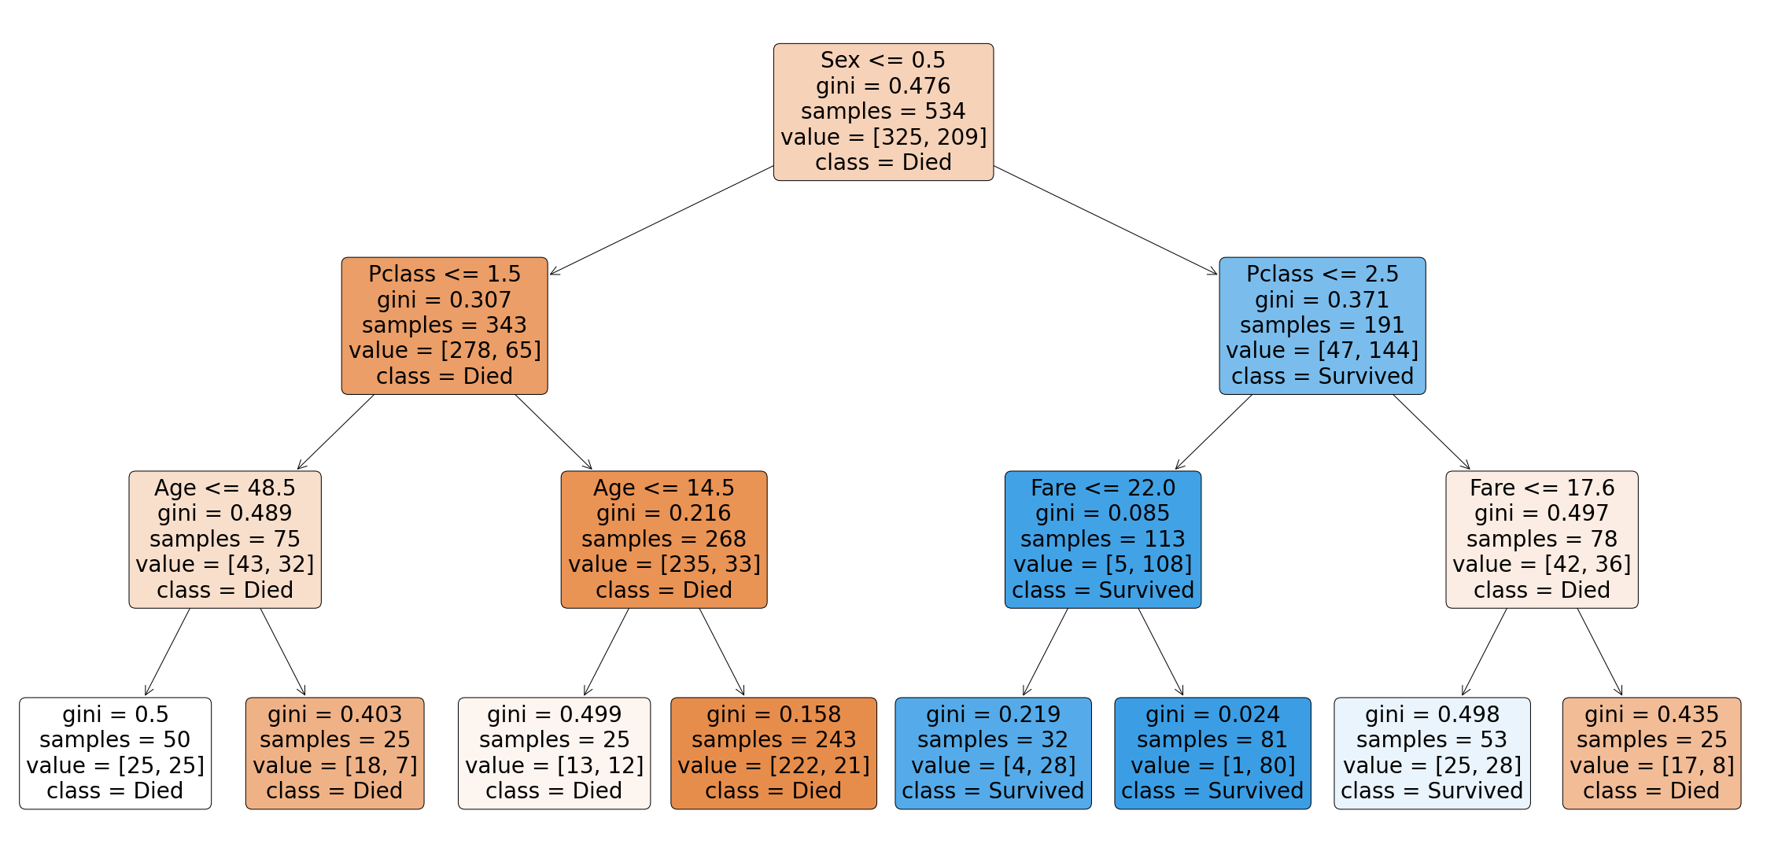
- How to read the decision tree?
- The root node, the node at the top of the tree, contains all the samples of the training set, there are 534 samples: samples=534.
The first test that will be performed corresponds to Sex < = 0.5. As a reminder, Sex is a binary variable, it is equal to 0 when the individual is a man, 1 when it is a woman. We then look at the value for each sample. All the samples for which the variable Sex is 0, go in the left child node, if not in the right child node. More simply, all men go in the left child node, all women in the right child node.
The parameter value indicates the distribution of classes in y_train before any separation. We have initially 325 individuals who are dead and 209 who are alive. The class parameter indicates which is the majority class. Here it is the class 0 "Died": class = Died.
Finally, for a classification problem, the error is calculated using the Gini criterion. This criterion is between 0 and 0.5. The higher this criterion is, the more heterogeneous the node is and the lower the criterion is, the more homogeneous it is. A node is homogeneous when it contains only samples of one class, the Gini criterion is equal in this case to 0.
The objective of our model is to separate our classes as well as possible, so we want to end up with nodes as homogeneous as possible. Finally, the more homogeneous a leaf will be, with a low Gini criterion, the better the model will perform.
- We remind that the child nodes are the intermediate nodes of the tree. In the first left child node, we retrieve all the male individuals. There are 343 males in the training set (samples=343). The application of the condition described in the root node, allows us to reduce the Gini score by almost 0.169, we go from 0.476 to 0.307. The application of this condition has increased the homogeneity of the node. In this child node, there are more people who died than survived (278 > 65). The majority class is Died.
- The separations follow until the leaves, the terminal nodes, are obtained. The predicted class for the samples belonging to the leaf is the majority class. The color code is as follows: Orange when the majority class is class 0, Blue when it is class 1. The intensity of the color depends on the value of the Gini criterion, the lower it is the more intense the colors are. For the leftmost leaf, we have a Gini criterion equal to 0.5. There are 50 samples and the distribution is 25 samples belonging to class 0 and 25 samples to class 1. The node is therefore perfectly heterogeneous. This means that the model is wrong for 25 individuals, i.e. 50% of the samples of this sheet.
Finally, the variables that enabled the classification of the samples, ranked in order, are Sex, Pclass, Age and Fare. The higher a variable is placed in the tree, the more important it played a role in the classification.
But how to quantify the role of each variable?
Instead of displaying the tree, or in addition to this analysis, it is possible to study the "feature importances" of the model. This attribute of the model class, called feature_importances_, allows to classify the variables according to the role they played in the prediction choices of the model. The sum of these values is 1.
The importance of a variable is calculated from the decrease in node impurity weighted by the probability of reaching the node. And the probability of reaching the node is obtained by dividing the number of samples reaching the node by the total number of samples.
Finally, the higher the importance value, the more important the variable.
- (i) Run the following cell to display the importance of the variables in the model.
%matplotlib inline
​
feat_importances = pd.DataFrame({
"Variables":
feats.columns,
"Importance":
model_min_samples.feature_importances_
}).sort_values(by='Importance', ascending=False)
​
​
feat_importances.nlargest(4, "Importance").plot.bar(x="Variables",
y="Importance",
figsize=(15, 5),
color="#4529de");
​
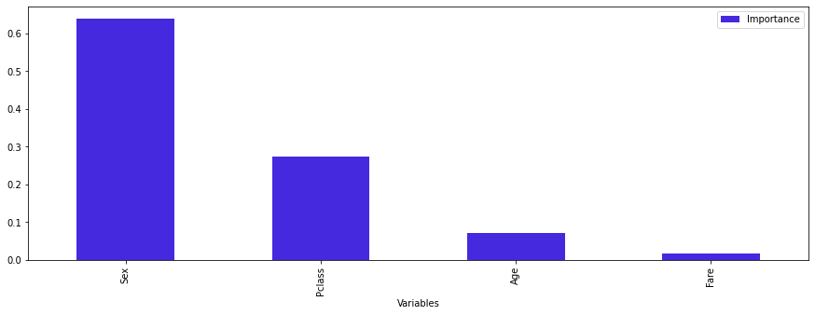
feats.columns
Index(['Pclass', 'Sex', 'Age', 'SibSp', 'Parch', 'Fare', 'Embarked_C',
'Embarked_Q', 'Embarked_S'],
dtype='object')
model_min_samples.feature_importances_
array([0.2728341 , 0.63966631, 0.07067184, 0. , 0. ,
0.01682774, 0. , 0. , 0. ])
feat_importances
 | Variables | Importance
1 | Sex | 0.639666
0 | Pclass | 0.272834
2 | Age | 0.070672
5 | Fare | 0.016828
3 | SibSp | 0.000000
4 | Parch | 0.000000
6 | Embarked_C | 0.000000
7 | Embarked_Q | 0.000000
8 | Embarked_S | 0.000000
From these elements, we are able to decide on the accuracy of the expression "women and children first" (within the context of the data we have at our disposal). The women are indeed among the people who survived most after the disaster. The Sex variable is the most important one in the model. Nevertheless, even if age is among the three most important variables in the tree, a more precise analysis of the tree does not allow us to validate this assertion.

3. Linear models
Linear models are among the simplest Machine Learning models. This is what we will study in this second part of the notebook.

3.1 Linear regression
Let X be the explanatory variable and y the target variable, obtained from a data set. In this context, a simple linear regression model will consist in modeling the link between the explanatory variable X and the target variable y. We therefore predict the values of y from the values of X.
The model can be written as an affine function : 𝑦=β0+β1𝑥+ε
where :
- 𝑦
- is a continuous quantitative variable to be explained (the target variable).
- 𝑥
- is a continuous quantitative variable (the explanatory variable).
- β0
and β1
- are respectively the intercept and the slope of the function.
- ε
- is a random error term following a normal distribution with a mathematical expectation zero and standard deviation σ.
In other words, this means that the values of y are obtained from a linear combination of these elements: β0
, β1, 𝑥 and ε
.
However, only the values of the explanatory variable 𝑥
are known. It is therefore necessary to estimate the values of the parameters β0 and β1 to predict the value of y. This is what is done when the model is trained, also called estimation.
In this step, we will estimate the values of the coefficients β0 and β1 by β̂ 0 and β̂ 1, then we will have :𝑦̂ =β̂ 0+β̂ 1𝑥. where 𝑦̂ corresponds to the prediction of the model, β̂ 0 and β̂ 1 to the model coefficients estimation.
The error term is defined by ε=𝑦−𝑦̂ . This is the difference between the true value of y and the predicted value. The objective when training the model is to reduce this residual difference as much as possible. So, the parameters β̂ 0 and β̂ 1 chosen will be those that minimize the error of the model.
Finally, the closer the predicted value 𝑦̂
is to the true value of y, the better the model performs.
To better understand how this step works, you will be able to try to minimize this error by yourself. To evaluate the error of the model as a whole, we use a metric called the Mean Squared Error. Unlike the Mean Absolute Error, which we mentioned when we analyzed the decision tree, rather than calculating the absolute value of the difference, we square the difference between the true value and the predicted value. These squared differences are then summed.
The model metrics will be presented in more detail later in the notebook.
The interactive figure below will allow you to visualize how this error is calculated as a function of β1 :
- The blue points represent the dataset for which we want to evaluate the quality of the predictions. In general, this is the test dataset.
- The red line is the regression function parameterized by β1. In this example, β0 is set to 0 to simplify the illustration. The green lines are the distances between the target variable and the predictions obtained from the regression function parameterized by β1.
- (a) Run the next cell to display the interactive figure. Using the cursor below the figure, try to find a value of β1 that minimizes the prediction error.
from widgets import interactive_MSE
​
interactive_MSE()
​
VBox(children=(HBox(children=(Figure(axes=[Axis(grid_lines='none', label='x', scale=LinearScale(max=4.0, min=-…
Let us now turn to the practical application of a linear regression. For this example, we choose to simulate data. For this we use the make_regression function of the scikit-learn library.
In our dataset we will have 1 explanatory variable, 1 target variable and 100 samples. We set the standard deviation of the error distribution to 10.
- (b) Run the following cell to generate and view the simulated dataset.
%matplotlib inline
​
from sklearn.datasets import make_regression
​
X, y = make_regression(n_samples=100,
n_features=1,
n_informative=1,
noise=10,
random_state=42)
​
X = pd.DataFrame(X, columns=["X1"])
​
y = pd.Series(y)
​
plt.figure(figsize=(10, 8))
​
plt.scatter(X, y, color = "#4529de")
​
​
plt.title("\n\n Nuage de points \n\n", fontsize=20)
​
plt.xlabel("X",labelpad=20, fontsize=20)
​
plt.ylabel("Y", rotation=365, labelpad=20, fontsize=20)
​
plt.show()
​
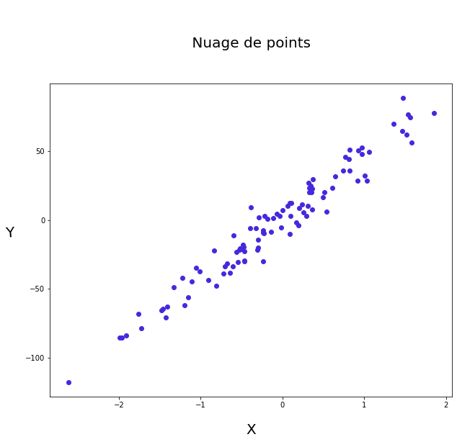
- (b) Separate the data set into a training set and a test set, set the random_state to 42. Instantiate the linear regression model and train it on the training set.
from sklearn.model_selection import train_test_split
​
from sklearn.linear_model import LinearRegression
​
X_train, X_test, y_train, y_test = train_test_split(X,
y,
test_size=0.3,
random_state=42)
​
model = LinearRegression()
​
model.fit(X_train, y_train)
LinearRegression()
The model model created has the attributes intercept_ and coef_ which correspond to the y-intercept and the directing coefficient of the model line. These are respectively β0
and β1
.
- (c) Display the estimated coefficients when training the model.
print(model.intercept_)
​
print(model.coef_[0])
-0.3634325914496843
44.3350278641543
#We will have
# ==> 𝑦̂ = −0.36 + 44.335 × X
We will have 𝑦̂ =−0.36+44.335×𝑥
.

The interpretation of the models
It is important to note that the coefficients of a linear regression model are interpretable. The estimated coefficient β̂ 1
quantifies the relationship between the target variable and the explanatory variable. The constant β̂ 0 captures all the information not explained by 𝑥. In our case we can interpret the coefficients as follows: when x increases by one unit then y increases on average by 44.35 units.
Let's imagine that the target variable is a salary and that the explanatory variable is the number of years of education. The parameter β̂ 1 will quantify the average increase in salary with an additional year of education. For example: 𝑦̂ =1000+200∗𝑥
. On average, for an additional year of education, one earns 200€ more. If an individual has completed 2 years of education, the prediction of his salary will be 1400€. If he has completed 3 years of education, we will have a prediction of 1600€.
Once the parameters of the model have been estimated, we can use them to predict the target variable, thanks to the predict method.
- (d) Calculate the model predictions on the test set, then the prediction errors. Display them.
predictions = model.predict(X_test)
​
print("score train : " , model.score(X_train, y_train))
​
print("score test : ", model.score(X_test, y_test))
​
df_error = pd.DataFrame({'y_test' : y_test,
'prediction' : predictions,
'error' : abs(y_test - predictions)})
​
df_error.head()
score train : 0.9568021400619922
score test : 0.9408983055235901
 | y_test | prediction | error
83 | -48.949080 | -59.248598 | 10.299518
53 | 89.033145 | 65.159041 | 23.874104
70 | 44.409196 | 35.659922 | 8.749273
45 | -5.911314 | -17.747558 | 11.836244
44 | -7.624431 | -10.744629 | 3.120198
To have a clear idea of how our linear model fits the data, the most efficient way is to draw the regression line on the scatterplot. The values predicted by the model can be found on the regression line.
- (e) Run the next cell to display the test set and the regression line obtained from the estimation of the model parameters.
plt.figure(figsize=(10, 8))
​
plt.scatter(X_test, y_test, color='#4529de')
​
plt.plot(X_test, predictions ,color='#26dbe0')
​
plt.title("\n\nRegression line and scatterplot on the test set \n\n", fontsize=20)
​
plt.xlabel("X",labelpad=20, fontsize=20)
​
plt.ylabel("Y", rotation=360, labelpad=20, fontsize=20)
​
plt.show()
​
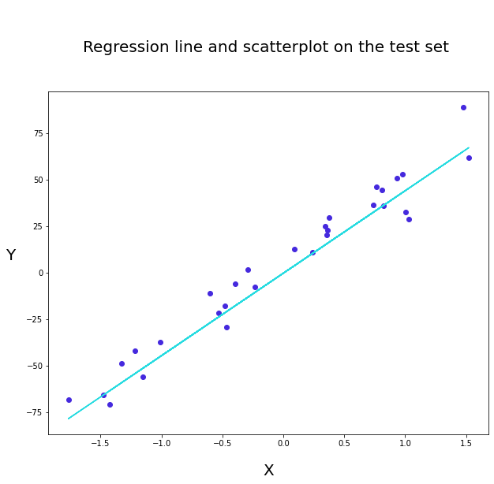
plt.figure(figsize=(10, 8))
​
plt.scatter(X_test, y_test, color='#4529de', label= 'Real Values')
​
plt.scatter(X_test, predictions ,color='r', label= 'Predictions')
​
plt.plot(X_test, predictions ,color='g', alpha=0.4, label= 'Regression Model')
​
plt.title("\n\nRegression line and scatterplot on the test set \n\n", fontsize=20)
​
plt.xlabel("X",labelpad=20, fontsize=20)
​
plt.ylabel("Y", rotation=360, labelpad=20, fontsize=20)
​
plt.legend()
​
plt.show()
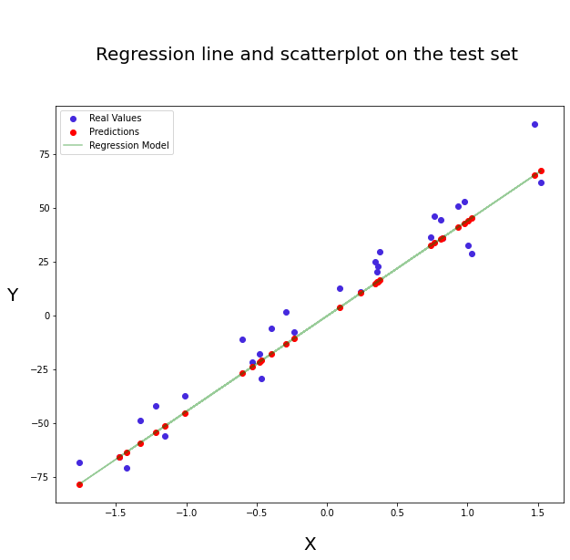
Although the graphical visualization is very informative, it is not easy to quantify the errors of the model. One solution is to calculate a performance metric. There are several metrics for regression models. In the previous notebook, we presented the coefficient of determination, this metric is mainly used to study the performance of linear regression models and is not adapted to all models. We present here, three other useful metrics:
- Mean Absolute Error (MAE) : It is the average of the absolute differences between the true values and the predicted values of the model. It is easily interpreted with respect to the target variable, because it has the same unit.
- Mean Squared Error (MSE) : It is the average of the squared differences between the true and predicted values of the target variable. It is not in the same unit as the target variable, which makes its interpretation more complex. This metric penalizes large errors more than the MAE. It is therefore interesting when we absolutely want to avoid these problems.
- Root Mean Squared Error (RMSE) : This is the square root of the Mean Squarred Error. It also penalizes large differences in prediction. It has the same unit as the target variable so it will be more interpretable than the MSE.
Keep in mind that the choice of metrics may vary from case to case. Model performance analysis can differ across industries and applications. There is no such thing as an optimal metric. It is also possible to create a metric that meets our own criteria, the objective being to be able to decide if the model is sufficiently efficient to be selected in a specific case of application.
The scikit-learn library offers a very rich sub-module of metrics, sklearn.metrics. So you can calculate these metrics without worrying about their formula.
- The function mean_squared_error of the sklearn.metrics sub-module is used as follows :
mean_squared_error(y_true, predictions)
where :
y_true corresponds to the true values of the target variable.
predictions corresponds to the values predicted by our model.
- The function mean_absolute_error of the sklearn.metrics sub-module is used as follows :
mean_absolute_error(y_true, predictions)
where :
y_true corresponds to the true values of the target variable.
predictions corresponds to the values predicted by our model.
- (f) Write a function that returns the MAE, MSE and RMSE for a model. Display the scores on the test set by applying the coded function.
import numpy as np
from sklearn.metrics import mean_absolute_error, mean_squared_error
​
mae = mean_absolute_error(y_test, predictions)
mse = mean_squared_error(y_test, predictions)
rmse = np.sqrt(mse)
print(f' MAE = {mae}\n MSE = {mse}\n RMSE = {rmse}')
MAE = 8.694207566057269
MSE = 103.47302683438758
RMSE = 10.17216922953937
def metrics(y_test, predictions):

mae = mean_absolute_error(y_test, predictions)
mse = mean_squared_error(y_test, predictions)
rmse = np.sqrt(mse)

return print(f' MAE = {mae}\n MSE = {mse}\n RMSE = {rmse}')
​
metrics(y_test, predictions)
MAE = 8.694207566057269
MSE = 103.47302683438758
RMSE = 10.17216922953937

3.2 Logistic regression
Among the linear models, logistic regression is one of the most affordable and widely used models for classification. We present here again a case of binary classification.
Its principle is simple: we use this algorithm to model the relationship between explanatory variables and the categorical target variable. To model this relationship we use a function. This is quite similar to the linear regression for which we speak of an affine function. The values taken by our target variable are discrete here: [0, 1]. The "points" are therefore distributed at the top and bottom of our graph.
Let's now move on to the practical application. For this example, we choose to simulate data once again. For this we use the make_classification function of the scikit-learn library. In our dataset we will have 1 explanatory variable, 1 target variable and 200 samples.
The data simulated here have the advantage of not requiring any prior processing. It is important to keep in mind that this case is extremely rare. Before training an algorithm such as logistic regression on data, it is necessary to perform some preparation and processing steps.
- (a) Run the following cell to generate and view the simulated dataset.
%matplotlib inline
import matplotlib.pyplot as plt
​
import pandas as pd
import numpy as np
import seaborn as sns
​
from sklearn.datasets import make_classification
​
%matplotlib inline
​
X, y = make_classification(n_samples=200,
n_features=1,
n_clusters_per_class=1,
n_informative=1,
n_repeated=0,
n_redundant=0,
shuffle=True,
random_state=42)
​
X = pd.DataFrame(X, columns=["X"])
​
y = pd.Series(y)
​
fig = plt.figure(figsize=(10, 8))
​
sns.scatterplot(data=X,
x=X["X"],
y=y,
hue=y,
s=400,
alpha=0.3,
palette=["#a329de", "#26dbe0"],
legend='full')
​
plt.title("\n\n Scatter plot \n\n", fontsize=20)
​
plt.xlabel("X", labelpad=20, fontsize=20)
​
plt.ylabel("Y", rotation=365, labelpad=20, fontsize=20)
​
plt.show()
​
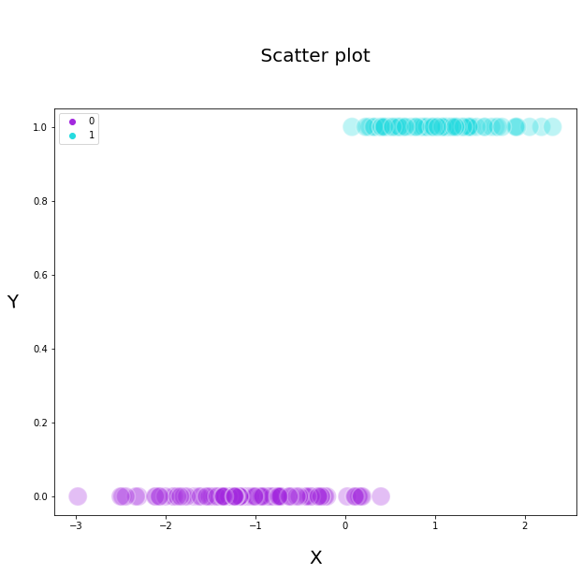
X.head()
 | X
0 | -1.529872
1 | 0.892394
2 | 1.143009
3 | 1.103094
4 | 1.047986
y[:5]
0 0
1 1
2 1
3 1
4 1
dtype: int64
To model the relationship between X and y, we use a function that takes the form of an S: the sigmoid function. Here is the formula of this function: 𝑓(𝑥)=11+e−𝑥
. Dans notre cas précis on a : 𝑦=11+e−(𝛽0+𝛽1∗𝑋1). We will therefore estimate 𝛽0 and 𝛽1
when training the model.
- (b) Run the following cell to graphically display a sigmoid function on our data.
%matplotlib inline
​
fig = plt.figure(figsize=(10, 8))
​
sns.scatterplot(data=X,
x=X["X"],
y=y,
hue=y,
s=200,
alpha=0.3,
palette=["#a329de", "#26dbe0"],
legend='full')
​
sns.regplot(data=X, x=X["X"], y=y, logistic=True, ci=None, color="#f1c232")
​
plt.xlabel("X", fontsize=20, labelpad=20)
​
plt.ylabel("Y", fontsize=20, rotation=365, labelpad=20)
​
plt.title("\n\n Scatter plot and sigmoid function \n\n", fontsize=20)
​
plt.show()
​
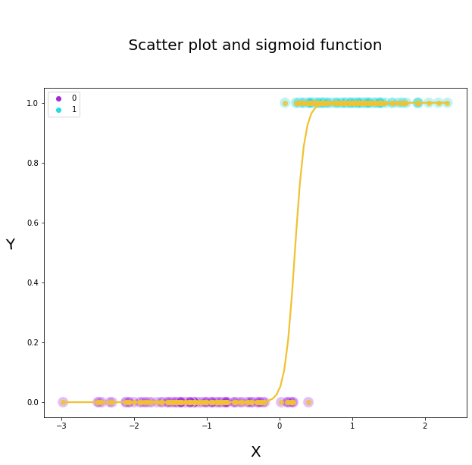
From the values of X and the estimated parameters of our function we can obtain the predictions of y. These predictions will be between 0 and 1. These values can be interpreted as probabilities. Thus, for each sample, we will have an output probability of belonging to the classes. To determine to which class each sample belongs, a threshold must be established. By default this threshold is set to 0.5. If the output probability is less than 0.5 then we predict class 0 for the sample, otherwise class 1. This threshold can of course be modified according to the use cases.
We voluntarily do not go into the details of the estimation process, which would make the explanation more complex.
- (c) Separate the data set into a training set and a test set. Instantiate the logistic regression model and train it on the training set.
from sklearn.model_selection import train_test_split
​
from sklearn.linear_model import LogisticRegression
​
​
X_train, X_test, y_train, y_test = train_test_split(X,
y,
test_size=0.25,
random_state=42)
​
model = LogisticRegression()
​
model.fit(X_train,y_train)
LogisticRegression()
Once the model is trained we are able to display the predictions of our model on the samples of the test set. As explained before, the prediction corresponds to a probability (the values are between 0 and 1). To obtain these probabilities, we use the predict_proba method rather than the predict method. The predict method returns in the case of a classification a class. This class is determined from the threshold set as explained above. The default threshold is 0.5. The predict_proba method returns the probabilities of belonging to the 2 classes.
- (d) We now move on to the model predictions.
  - (1) Make predictions on the test set with the predict method.
  - (2) Perform predictions on the test set with the predict_proba method.
  - (3) Display on a graph the probability predictions for class 1.
#(1)
​
preds = model.predict(X_test)
​
#(2)
​
preds_proba = model.predict_proba(X_test)
​
# We keep only the probabilities of class 1
​
preds_proba = pd.DataFrame(preds_proba).iloc[:,1]
​
#(3)
​
plt.figure(figsize=(10, 8))
​
plt.scatter(X_test, preds_proba, color="#4529de", s=200, alpha=0.3)
​
plt.xlabel("X", fontsize=20, labelpad=20)
​
plt.ylabel("Predictions", fontsize=20, labelpad=50, rotation=360)
​
plt.title("\n\n Prediction scatter plot (sigmoidal shape) \n\n", fontsize=20)
​
plt.show()
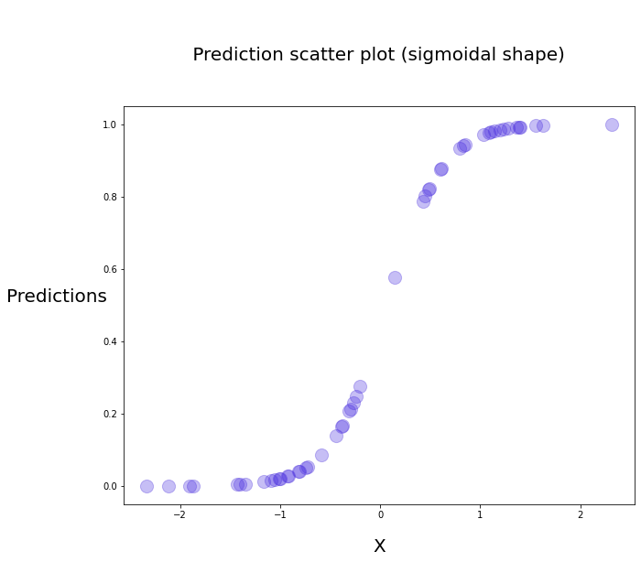
Following the predictions of the results on our test set, we can proceed to the evaluation of the performance of our model. There are several metrics that can be used to evaluate the performance of a classification model.
- Accuracy.
- Precision and recall
- F1-score
Each metric evaluates the performance of the model with a different approach.
In order to explain these notions, we will introduce 4 very important concepts.
- True positive (TP) an observation classified as positive (class 1) by the model that is actually positive (class 1).
- False positive (FP) an observation classified as positive (class 1) by the model but which was actually negative (class 0).
- True Negative (TN) an observation classified as negative (class 0) by the model that is actually negative (class 0).
- False negative (FN) an observation classified as negative (class 0) by the model but which was actually positive (class 1).

Accuracy
Accuracy is the best known metric for evaluating a classification model.
It simply corresponds to the rate of correct predictions made by the model. As a reminder, this is the metric that is used by default when using the score method. It is assumed that 𝑛
samples are available.
We note 𝑚𝑎𝑡ℎ𝑟𝑚𝑉𝑃
the number of True Positives and 𝑚𝑎𝑡ℎ𝑟𝑚𝑉𝑁 the number of True Negatives.<br The accuracy is then given by :
accuracy=TP+TN𝑛
The accuracy_score function of the sklearn.metrics sub-module allows to obtain the accuracy from the predictions of a model:
accuracy_score(y_true, predictions)
- y_true contains the true values of y.
- predictions contains the values predicted by the model.

Precision
Accuracy** is a metric that answers the question: Of all the positive predictions in the model, how many are true positives?
If we note FP
the number of False Positives of the model, then the accuracy is given by :
precision=TPTP+FP
A high accuracy score informs us that the model does not randomly classify all observations as positive.
The precision_score function of the sklearn.metrics sub-module allows to obtain the recall from the predictions of a model :
precision_score(y_true, predictions)
- y_true contains the true values of y.
- predictions contains the values predicted by the model.

Recall
Recall is a metric that quantifies the proportion of truly positive observations that have been correctly classified as positive by the model.
If we note FN
the number of False Negatives, then the recall is given by :
rappel=TPTP+FN
A high recall score informs us that the model is able to detect truly positive observations.
The recall_score function of the sklearn.metrics sub-module allows to obtain the recall from the predictions of a model:
recall_score(y_true, predictions)
- y_true contains the true values of y.
- predictions contains the values predicted by the model.

Confusion matrix
The confusion matrix counts for a dataset the values of TP, TN, FP and FN, which allows us to calculate the three previous metrics:
Confusion Matrix=[TNFNFPTP]
The confusion_matrix function of the sklearn.metrics sub-module allows to generate the confusion matrix from the predictions of a model :
confusion_matrix(y_true, predictions)
- y_true contains the true values of y.
- predictions contains the values predicted by the model.
- (e) Create a function that returns the accuracy, precision, recall and confusion matrix from our model predictions on the test set.
def score(y_test, preds):
from sklearn.metrics import confusion_matrix, accuracy_score, precision_score, recall_score
​
return (accuracy_score(y_test, preds), precision_score(y_test, preds),
recall_score(y_test, preds), confusion_matrix(y_test, preds))
​
score(y_test, preds)
(0.98, 0.9565217391304348, 1.0, array([[27, 1],
[ 0, 22]]))
The analysis of the previous metrics allows us to see that the model has very good performances.
The performances on each class seem homogeneous. Only one sample was misclassified: it is a false positive. The model has classified it as class 1 when it is actually class 0.
To make sure that each class is correctly predicted, we can use another function of the sklearn.metrics sub-module called classification_report. It returns all the metrics we presented above and also the performance per class. We are then able to know if the model correctly predicts all the classes or only a part of them. This analysis is particularly relevant when there is an imbalance of classes and one class is overrepresented in the dataset. This imbalance often results in weaker performance on the minority class.
- (f) Display the classification report for our predictions on the test set.
from sklearn.metrics import classification_report
​
print(classification_report(y_test, preds))
​
precision recall f1-score support

0 1.00 0.96 0.98 28
1 0.96 1.00 0.98 22

accuracy 0.98 50
macro avg 0.98 0.98 0.98 50
weighted avg 0.98 0.98 0.98 50

You may notice that another metric is displayed in the classification report, the f1_score. The f1-score is a metric that allows you to combine precision and recall, since it is the average of both.

F1 Score=2 ×( Precision × Recall )( Precision + Recall )
The f1-score is one of the metrics to focus on when there is a class imbalance. By looking at accuracy only, the results could be skewed.
Once you have analyzed the performance of the model, you should not stop there. It is essential to interpret the model. Interpreting the model as presented when analyzing the decision trees allows to understand how the model's explanatory variables contributed to the model's prediction choices.
In the case of logistic regression, the analysis is similar to that used for the linear regression model. We will interpret the coefficients of our model.
- (g) Display the estimated constant and coefficient for the model.
print('intercept_ = ', model.intercept_)
​
print('coef_ =' ,model.coef_[0])
intercept_ = [-0.22966554]
coef_ = [3.6127951]
The interpretation of the coefficients of the logistic regression is, however, a little different from that of the linear regression. The coefficients must be interpreted by calculating their odd-ratios.
The odd-ratios are obtained by calculating the exponential of the coefficients. For example, after estimating β1, the odd-ratio will be equal to 𝑒β1
.
But how is this value interpreted?
In our case, we estimated the value of β1 to be 3.61. Its odd ratio will be equal to 37. This can be interpreted as follows: when the explanatory variable increases by one unit, then the chances of belonging to class 1 increase by 3600%. More generally, if the odd ratio is greater than 1, it means that an increase of one unit in the explanatory variable increases the chances of belonging to the positive class. If it is equal to 1, the variable has no impact on the target variable and finally if it is less than 1, an increase of one unit of the variable decreases the chances of belonging to the positive class.
For example if an odd ratio equals 1.2, it means that the chances of belonging to class 1 increase by 20%. When a odd ratio is equal to 2, the chances of belonging to class 1 increase by 100%, an odd ratio of 3 by 200% etc. On the contrary, for a odd ratio equal to 0.2, the chances of belonging to class 1 decrease by 20% and so on..
- (h) Calculate the odd ratio of the estimated coefficient β1.
import numpy as np
​
np.exp(model.coef_[0])
​
array([37.06952118])
We have just reviewed all the modeling steps for regression and classification models. We have presented decision trees as well as linear models.

4. Conclusion

4.1 To remember
- There are different types of models and the available data guide us on the type of model to apply (linear or non-linear models).
- The decision tree is one of the most interpretable models. Reading the decision tree gives us indications of both the performance of the model and the variables that contribute most to the model. Although very similar in their interpretation, the regression and classification trees differ on a few points, such as the metric used.
- Linear models are the most well-known models: linear regression for regression and logistic regression for classification. These models are particularly interesting because we are able to interpret their coefficients: immediately for the linear regression and thanks to the odd ratios for the logistic regression.
- Linear models are quite restrictive when preparing data. It requires a certain amount of attention since in most cases it is necessary to scale the variables.
- Decision trees are subject to overfitting. We must therefore be very careful when training models. Some parameters, such as the depth of the tree or a minimal number of samples per node, allow to limit the risks of overfitting.

4.2 What's next ?
In the next notebook we will look at the methodology for preparing data for modeling. So far we have worked with very clean datasets and in the previous modules you have worked with the pandas library to format your data. We will see in the next notebooks what are the essential steps to prepare the data and how to implement these steps in a consistent way with the Scikit-Learn library.

04 - Methodology: From preparation to modelling

1. Introduction
Before training the model, a considerable amount of data preparation work is required, known as Data Preparation: cleaning, encoding, scaling and more. This notebook aims to detail the steps of the methodology to apply when creating a Machine Learning model. We will go through the steps and methods you can use (descriptions and illustrations).

1.1 Presentation of the preparation steps
We will start by mentioning the main steps in the data preparation process.
- From raw data to variables
The initial data format may be inadequate for data analysis and modelling. In this case, it will be necessary to create a data table with the so-called explanatory variables of the model as well as the target variable, the one we are trying to predict.

We could be confronted with several cases, such as this one: the data we wish to use are found in various sources, and we need to bring them together by using joins. In this illustration, after structuring our data, we obtain four explanatory variables and one target variable. The target variable, the one we are trying to predict, is here a qualitative binary variable. It predicts being in one category or another. For example, 0 corresponds to the category "Healthy " and 1 to the category "Sick ".
- Data Cleaning
Once collected, the data may require cleaning. Special characters, missing data, case heterogeneity: all of these can be a problem when modelling our data.
- Encoding
The available data is not always numerical: categorical, textual or date type, all these types of data require special processing to convert them into numerical values because Machine Learning algorithms only take numerical values as input. This data format is therefore essential for their proper functioning.
- Transformation
The application of some Machine Learning algorithms requires the verification of a set of assumptions. To respect these assumptions, it is often necessary to apply transformations to our variables. Examples of such transformations are logarithmic transformation, standardization and normalization. It should be noted that not all algorithms need the same processing. Linear models or, more generally, those that use the notion of distance are often very sensitive to these transformations, which are then very important for their proper functioning. In particular, the scaling of variables will be essential before training a linear model.

1.2 Data leakage
A very important notion when creating models is data leakage. The purpose of a model is, after its deployment (the final stage), to be used on new data in order to make predictions. We remind you that we are predicting the target variable which is this time unknown.
As part of its implementation, the model is trained on data that has been selected. In order to evaluate performance objectively, it is very important to have a certain amount of data on which the model will be tested. This data must not be known by the model.
For this step to go as smoothly as possible, it is necessary to be very rigorous in the data preparation process. From the beginning, you need to make sure that some of the data is set aside. If this is not done properly, information contained in this part of the data could leak out and contribute to the training of the model. This would then bias the results of the model in its evaluation. The very first step is therefore to separate our dataset into a training and a test part.

2. Data preparation techniques

2.1 Separation of the dataset
The dataset is separated into a training set and a test set. As explained in the first notebook, this step is essential for the whole modelling process to run smoothly. Without the test set, it is impossible to know how a model will behave when faced with new data. Depending on the nature and quantity of the data available, the volume of these two sets of data may vary. Still, the 80/20 or 70/30 split is very common.

To separate your dataset, you can just use the train_test_split function from the scikit-learn library. Here is the syntax:

from sklearn.model_selection import train_test_split

X_train, X_test, y_train, y_test = train_test_split(X, y, test_size=0.20)

# X is the explanatory variables DataFrame

# y is the target variable

2.2 Data cleaning
Once the datasets are separated, one can start to study the quality of the data. The overall quality of the dataset is usually dealt with during data collection and structuring. After this preliminary step, the data should no longer have any major problems: column names, mismatch between variables, etc.
We can then focus on studying the content of the variables: management of variable types, missing values, outliers, among others.

2.2.1 Handling missing values
Missing values are a very common problem. There are several ways to deal with them. There are three options: keep, replace or delete.
  - Keep them.
In some cases, keeping missing values may be relevant. Indeed, the absence of values can provide us with information.
A simple example will help to illustrate this. Let's say we have a customer data base. We would like to use this database to create a model that will indicate which customers are likely to be interested in a new service. The variable of interest here is the phone number.

This variable has missing values. The absence of some values within this variable may be very important for the model as it could give us information about the interest and trust the customer has in the company. It may simply indicate that they have refused to provide this information.
In this case, it is necessary to check with statistical tests what the contribution of keeping this information could be in relation with the target variable.
  - Replace them.
In the case of a small number of missing values, one can decide to replace them. There are several types of indicators that may be relevant:
- The average.
- The median.
- The mode.
However, there are many other ways to replace these values. A study of the whole dataset may allow us to replace them more wisely. It is also possible to replace them randomly according to the distribution of the values. The most important thing to remember is that there are no rules, the important thing is to choose the best solution by carefully studying our variables. By replacing missing values we can introduce bias, so we need to be very careful at this stage to ensure that this processing does not negatively impact our dataset. In previous modules you may have used to replace them, the fillna method from the DataFrame class of the pandas library. Here is the syntax:

# Let X be a DataFrame, with explanatory variables, we impute the mean of each variable

X.fillna(X.mean(), inplace=True)
  - Remove them.
There are a couple of situations where missing data can be deleted.
- The absence of data may indicate a data quality problem.
- Too much missing data can make it impossible to use a variable.
Deleting missing values may be seen as the easiest solution to adopt. On the other hand, it is not always appropriate, especially since data is a rare resource. Deleting rows where missing data may be found could result in a huge loss of information. Care must therefore be taken at this stage. To delete them, you already know the method dropna of the DataFrame class of the pandas library. Here is the syntax you can use:

# Let X be a DataFrame, with explanatory variables, we impute the mean of each variable

X.dropna(inplace=True)

2.2.2 Management of outliers and extreme values
The first element to consider is the difference in meaning when talking about outliers or extreme values.
Let's take the example of an age variable, if within this variable we end up with the number 500, then it is an outlier because this value cannot be explained. People today hardly ever live over 100 years.
Now consider a variable that contains the monthly salaries of a group of individuals. Most of the individuals in the group earn between 1500€ and 3500€. If there are lower salaries in this variable such as €600 or higher ones around €10,000, we cannot say that these are outliers. They are extreme values. Indeed, these values make sense but do not reach or exceed the range of the most represented values.

In the first case, it is important to correct this value or to delete the information because it is wrong. In the second case, the choice is not straightforward because the information has a high probability of being correct. On the other hand, if it is left in, its rare character may reduce the performance of the model or prevent it from converging.
Let us consider two types of variables: continuous and discrete.
- Continuous variable: A continuous variable takes an infinite or uncountable number of values.
- Discrete variable: A discrete variable takes a finite or countable number of values.
In the case of a continuous variable, the study of the distribution of values will allow us to detect outliers.
A simple way to deal with this aspect is to compute the quantiles or percentiles on our variable.
A good solution in these cases is to correct these values, with a more accurate value or if the quality of the data is in doubt, to delete the line.
In the case of discrete values, which we will consider as categorical variables here, it will be necessary to look carefully to see if one or more categories are not under or over-represented. One solution is to work on the distribution of these categories. If a category only appears a few times compared to others, we can, for example, decide to delete it. Also, if a category is over-represented in a variable, it can be decided not to keep it. Extreme care is required when dealing with such variables. The nature and significance of the variables may justify their conservation. A fraud detection model is a perfect example of the case where the over-representation of a value must be treated with care.
In addition, it should be noted that these corrections are made in order to create Machine Learning models, which for the most part require long data preparation steps. These corrections can be different depending on how we want to work with the data (analyses, ...).

2.3 Data encoding
As stated in the introduction of this notebook, a categorical and textual variable will have to be re-encoded. Indeed, most Machine Learning algorithms only take numerical variables as input. There are several encoding techniques, two of which are mentioned here: Ordinal Encoding and One Hot Encoding.

2.3.1 One Hot Encoding
An indicator variable is a binary qualitative variable taking the values 0 or 1. These variables are created from the categories that make up categorical variables (more than 2 categories). It is called One Hot Encoding .
When there are exactly 2 categories, there is no need to create several new variables, just replace one value with 0 and the other with 1. Leaving these two variables would make the information redundant.
If we take the example of a variable with 3 categories, applying this technique will allow us to obtain 3 binary variables. For the first (category 1), the variable will be 1 if an individual corresponds to category 1, 0 otherwise. The procedure is the same for the other two categories.

Although this method returns 3 new variables in our example, it is important to note that not all of them can be retained in a model. Indeed, it will be necessary to keep N-1 variables otherwise we would face a problem of multicollinearity which will affect the performance of our model. This multicollinearity problem arises from the fact that we can predict the occurrence of the third variable (third category) using the other two categories.

2.3.2 Ordinal Encoding
Instead of creating several variables from a categorical variable, the idea here is to transform the categories of our variable by values. This transformation is relevant when there is an order between the categories but it can always be substituted by the One Hot Encoding technique.
For example, let's take a variable of fruit names, there are three categories: Plum, Pear and Apple. If these categories are replaced by numbers (0, 1, 2), this will not make sense because there is no order between these fruits. In this case, we can only use the One Hot Encoding technique.
On the other hand, if we have a variable which evaluates the satisfaction of a customer. The categories it contains are : Little Satisfied, Satisfied and Very Satisfied. This time we can re-encode our variable in an ordinal way because there is an order between these categories. We will have :
Little Satisfied = 0 Satisfied = 1 Very Satisfied = 2

In order to respect the logical order between the categories, attention should be given to ensure that this is specified. In the absence of numerical values, this order is unknown beforehand.

2.4 Transformation of data
There are many scaling techniques, the best known being normalisation and standardisation.

Normalisation between 0 and 1
Normalisation consists of bordering all the values of a variable between 0 and 1. The approach is simple: for each variable, the minimum value of the variable is subtracted from each value and divided by the difference between the maximum value and the minimum value.

𝑥𝑖−𝑚𝑖𝑛(𝑥)𝑚𝑎𝑥(𝑥)−𝑚𝑖𝑛(𝑥)

# Let X be a DataFrame, explanatory variables

(X - X.min()) / (X.max() - X.min())
This technique is preferred when the variables do not follow a normal distribution.

Standardisation (Normalisation Z-Score)
In contrary to normalisation, it is recommended to apply standardisation when the distribution of the variable follows a normal distribution. Standardisation allows the mean value of the variable to be subtracted from each value and divided by its standard deviation.

𝑥𝑖−𝑚𝑒𝑎𝑛(𝑥)𝑠𝑡𝑑(𝑥)

# Let X be a DataFrame, explanatory variables

(X - X.mean()) / (X.std())

Outliers and extreme values
In case of outliers or extreme values, the application of the two previous techniques is not appropriate since they are sensitive to extreme values (minimum, average and maximum). DIn this case, the Robust Scaling technique is more relevant as it relies on the first, second (median) and third quartile of the distribution, which are not sensitive to extreme values.
The formula is as follows :

𝑥𝑖−𝑚𝑒𝑑𝑖𝑎𝑛(𝑥)𝑞3(𝑥)−𝑞1(𝑥)

# Let X be a DataFrame, explanatory variables

(X - X.median()) / (X.quantile(q=0.75) - X.quantile(q=0.25))

3. The integration of the preparation steps in the modelling process

3.1 The fit_transform and transform methods
In this section, we present the fit_transform and transform methods which will simplify the integration of the preparation steps in the creation of a Machine Learning model. Indeed, there are many scikit-learn tools that will allow us to realize modifications on the training and test set, in a rigorous way, in a few lines of code. There is a real advantage to using these methods rather than the pandas or numpy methods and functions, they are specifically adapted to Machine Learning.
The first thing to remember when using the fit_transform and transform methods is the notion of data leakage.
The transformations are calibrated on the training set (fit_transform) and then applied to the test set (transform). When performing the training, since the test set (explanatory variables and target variable) is available, one may be tempted to calibrate the transformations on the entire dataset. If this is done, it may lead to data leakage and thus an artificial increase in model performance.
There is also another important case to note. When applying OneHotEncoding, new variables are created from the categories of one or more variables. In this case, it is also important to apply a transform and not a fit_transform on the test set or any new data on which the model is applied. Indeed, the set of explanatory variables has been fixed when the model was trained. Imagine that a new category is added to the test set or the new data, then the model will not be able to apply because the set of explanatory variables will be different.
The syntax will always be as follows. Here we use the StandardScaler as an example, which allows us to apply the Z-Score transformation to our data.

from sklearn.preprocessing import StandardScaler

# Let X_train and X_test, the training and test sets respectively, be explanatory variables

scaler = StandardScaler()

X_train_scaled = scaler.fit_transform(X_train)

X_test_scaled = scaler.transform(X_test)
In this case, the mean and standard deviation of the values of each of the variables is calculated on the training set. The transformation is done on the training set. Then, in a second step, from the indicators calculated on the training set, the transformations will be performed on the test set.
The following three parts will be a kind of non-exhaustive catalogue of methods that you can use to apply the modifications presented above using the fit_transform and transform methods.

3.2 Data cleaning

3.2.1 Managing missing data

- The SimpleImputer method
This method allows you to impute missing values within the data. In the example below, the imputation strategy chosen is the mean: strategy="mean". Other strategies could obviously be chosen: median (strategy="median"), mode (strategy="most_frequent"), etc.

from sklearn.impute import SimpleImputer

# Let X_train and X_test, the training and test sets respectively, be explanatory variables

import numpy as np

imputer = SimpleImputer(missing_values=np.nan, strategy='mean')

X_train_imputed = imputer.fit_transform(X_train)

X_test_imputed = imputer.transform(X_test)
We will not present them here, but there are other imputation methods such as the KNNImputer or the IterativeImputer.

3.2.2 Management of outliers and extreme values
There are two possible scenarios:
The distribution includes extreme values which are consistent.
The distribution includes outliers which are errors.
As mentioned above, it is complicated to find a solution in the case where the values are consistent. Indeed, replacing them may cause a loss of information. It is therefore necessary to deal with them on a case-by-case basis. In the case where these outliers are errors, they should be replaced. For this we can also use a transformer.
In order to delimit the "acceptable" limits of the distribution of values, we can calculate the interquartile range (IQR). The interquartile range is the difference between the 3rd and the 1st quartile value:
IQR=Q3−Q1
The interval that will be considered as "valid" generally corresponds to :
[Q1−(1.5∗IQR);Q3+(1.5∗IQR)]
Rather than using an existing transformer we will create one to deal with these outliers by considering the interquartile range.

from sklearn.base import BaseEstimator, TransformerMixin

class IQR(BaseEstimator, TransformerMixin):

def __init__(self):
return None

def fit(self, X, y = None):
self.q1 = X.quantile(0.25)
self.q3 = X.quantile(0.75)
self.iqr = self.q3 - self.q1
return self

def transform(self, X, y = None):
def test_bound(element):
if element<(self.q1-self.iqr*1.5):
element = self.q1 - 1.5*self.iqr
elif element>(self.q3+self.iqr*1.5):
element=self.q3 + 1.5*self.iqr
return element
return X.apply(lambda x : test_bound(x))
To do this, we create a class that inherits from BaseEstimator and TransformerMixin. Here, the idea is not to detail the creation of this transformer, but simply to show that it is possible to create the transformer you want in a few lines.
In the same way as the transformers already implemented, the syntax is as follows:
# Let X_train and X_test be the training and test sets, respectively, of the explanatory variables

iqr = IQR()

X_train_iqr = iqr.fit_transform(X_train)

X_test_iqr = iqr.transform(X_test)

3.3 Encoding
In the previous section, we presented two encoding techniques: One Hot Encoding and Ordinal Encoding. There are two transformers that allow us to perform these transformations very simply: There are two transformers that allow us to perform these transformations very simply: OneHotEncoder and OrdinalEncoder. We didn't mention it earlier but the target variable may also need to be re-encoded. To do this, a specific transformer must be used, the LabelEncoder. The operation is the same as for the OrdinalEncoder.
Here are the dedicated methods on scikit-learn :
- One Hot Encoding
from sklearn.preprocessing import OneHotEncoder

# The drop parameter avoids the problem of multicollinearity
ohe = OneHotEncoder(drop="first", sparse=False)

ohe.fit_transform(X_train)

ohe.transform(X_test)
- Ordinal Encoding
from sklearn.preprocessing import OrdinalEncoder

import numpy as np

oe = OrdinalEncoder(unknown_value = np.nan, categories = ["Little Satisfied", "Satisfied", "Very Satisfied"])

oe.fit_transform(X_train)

oe.transform(X_test)
- Label Encoding
from sklearn.preprocessing import LabelEncoder

le = LabelEncoder()

le.fit_transform(y_train)

le.transform(y_test)

3.4 Transformation
In the previous section we presented three transformations to scale our data: standardisation, normalisation and RobustScaling.
Here are the dedicated methods on scikit-learn :
- Standardisation
from sklearn.preprocessing import StandardScaler

# Let X_train and X_test be the training and test sets of explanatory variables, respectively

scaler = StandardScaler()

X_train_scaled = scaler.fit_transform(X_train)

X_test_scaled = scaler.transform(X_test)
- Normalisation
from sklearn.preprocessing import MinMaxScaler

# Let X_train and X_test be the training and test sets of explanatory variables, respectively

scaler = MinMaxScaler()

X_train_scaled = scaler.fit_transform(X_train)

X_test_scaled = scaler.transform(X_test)
- RobustScaling
from sklearn.preprocessing import RobustScaler

# Let X_train and X_test be the training and test sets of explanatory variables, respectively

scaler = RobustScaler()

X_train_scaled = scaler.fit_transform(X_train)

X_test_scaled = scaler.transform(X_test)

4. Training, prediction and measurement of model performance

4.1 Modelling with the scikit-learn API
In the second notebook of this module, the scikit-Learn API was presented. With a few lines of code, you can train and evaluate a Machine Learning model.
As a reminder, these are the methods : The methods fit, predict and score will be used here to respectively: train, predict and measure the performance of the trained model.
Following the separation of the dataset into a training and a test set and the application of the preparation steps, we have these four objects available: X_train, X_test, y_train and y_test.
- X_train : These are the explanatory variables that will be used to train the model.
- y_train : This is the target variable that will be used to train the model.
- X_test : These are the explanatory variables that will be used to measure the performance of the model.
- y_test : This is the target variable that will be used to measure the performance of the model.
Let's imagine that we are dealing with a supervised classification problem and that we want to use the logistic regression algorithm. The syntax will be as follows:
from sklearn.linear_model import LogisticRegression

model = LogisticRegression() # We instanciate the model

model.fit(X_train, y_train) # We train the model

y_pred = model.predict(X_test) # We predict the target

model.score(X_test, y_test) # We compute the score of the model by comparing the predictions with the true values
As a reminder, when we evaluate the performance of the model we compare the prediction of our trained model on the test set (X_test) and the true value of the target variable of the test set (y_test). Behind the score method, there is therefore the prediction of this variable that is made, in the same way as when using the predict method.

5. The scikit-learn pipeline
We have just seen a large number of tools from the scikit-Learn library that allow us to carry out the necessary transformations for our dataset in a very synthetic and rigorous way. These steps taken separately can be long to implement.
To overcome this problem, there is a function in the sklearn.pipeline sub-module which allows us to gather all these transformations within the same object. This is a pipeline. Here is a possible syntax:
from sklearn.pipeline import Pipeline

pipe = Pipeline(
[('simple_imputer', SimpleImputer(missing_values=np.nan, strategy='mean')),
('scaler', StandardScaler()),
('model_logistic', LogisticRegression())])

pipe.fit(X_train, y_train)

predictions = pipe.predict(X_test)

print(pipe.score(X_test, y_test))
As you can see in the code, the pipeline trains on the training set and predicts on the test set. The syntax is thus the same as a model that we wish to train. Behind its operation are the fit_transform and transform methods.

6. Conclusion

6.1 To remember
- There are many data preparation steps: cleaning, encoding, transformation, etc.
- The separation of the dataset into a training and test set therefore comes before all these data processing stages.
- The data preparation stages must be applied rigorously to the training and test sets to ensure that there is no data leakage or deviation from the variables used to train the model.
- The fit_transform and transform methods allow transformations to be applied to the training and test sets in a rigorous manner.
- The use of a Pipeline allows the data preparation and modelling steps to be brought together.

6.2 What's next?
In the next notebook we will see an example of application in the case of a supervised classification problem.

