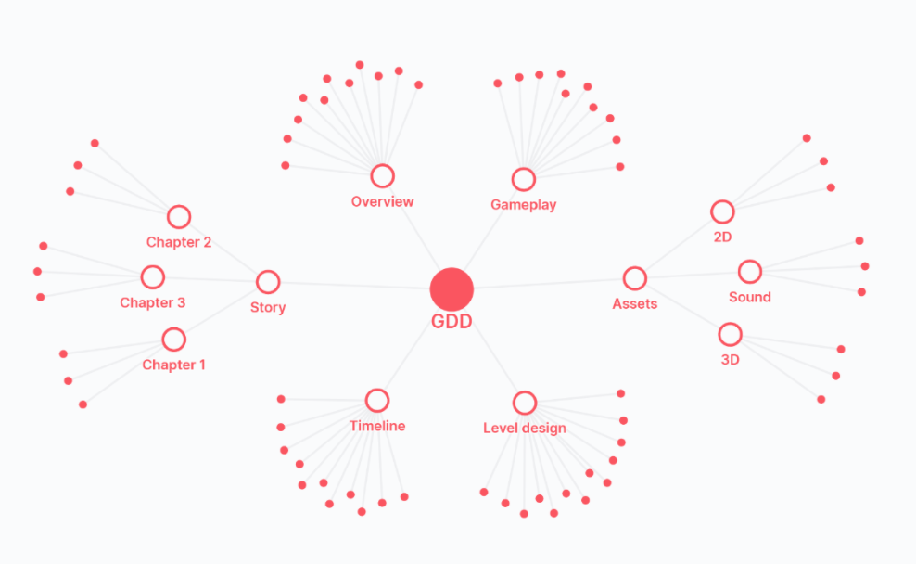

**🎮️ Name of the game: Arena combat cars/Firefighting cars/ Firefight arena**  
**👥 Stakeholders:**

* Dev: Yahya, Abdullah
* Design: n
* QA: Talha

# Overview

## 📐 Project scope

* **Budget:**
* **Timeline:**

## 🗣️ Elevator Pitch

*An addictive game that will let user play in an arena with Cars/Trucks equipped with guns/bombs.*

Keys Tags: Arena, firefighting cars, cars of all types (include trucks for higher levels), weapon selection.

## 💵 Monetization

*The game will generate money mainly with adds and in-app purchase.*  
*Idea is that there will be less adds in the beginning but will increase when we get a desired amount of users.*

# Story

*The game will let users to select a car/truck and then select a weapon. The user will then select an arena to play in. The cars, weapons and arena will be of a basic type in the beginning and will adopt to higher levels in later stages. In a first version of the game, there will be one mode in the game with a time limit (but user will be able to select how many opponents are needed.). Other modes can be added in later versions (for example have a tournament, or time unlimited fight round). At the end of an arena fight there will be a display of the winner with ranking of all players in the arena.*

# Gameplay

After starting the game, select car (go forward), select weapon (go forward), select arena (go forward), select mode (no of players) , GO PLAY.

At first there will be a great view of the arena from different angels with some rocky music (user can either watch it or skip it). Then the real gameplay will start.

The user is steering the car in the arena while aming its opponents with shots. there will be life status on a bar is shown on the oponent cars.  
The controls: Car movement is controlled by user using joypad from the left part of the screen. From the right part the user moves the weapon in horizontal axis. There are 2 weapon buttons, one for fire and one for rocket launcher that is available periodically. Both the weapons need to aim at opponent and at a certain distance.

After the fight there is a winner. The results are displayed on the screen with a rankings. Select if user want to replay or go back to home.

## Core Game Mechanic #1

* Details: Simple to start
* How it works: *The game play will be as simple as possible. When the user starts the game, it should take very few steps to start the game play.*

## Core Game Mechanic #2

* Details: *Great UI*
* How it works: *Great UI comes with great control of cars and launching fire/rockets. The control should be as simple as possible. The car acceleration can be made automatic with options to brake and booster accelerator. The steering can have 3 options(arrows, steering wheel or move mobile). There will be 2 fire buttons(one normal fire and another one for rocket)*

## Core Game Mechanic #3

* Details: In-app purchase
* How it works: In-app purchase should be very attractive items and easier to purchase. Strategy for purchase ? adds?

# Game elements

*Describe your game world, including all the characters, location, object, and other elements in it.*

## 👤 Characters

* cars and trucks with different models
* weapons with different models
* ...<paste some pics here>

## 🗺️ Locations

* arenas of different types. check some examples from rocket league(PS4).
* ...<paste some arena pics here>
* ...

## 🏆️ Levels / missions

* In version 1, it will be just one mode. new arenas will be unlocked when you have played previos ones.
* ...
* ...

## 📦️ Objects

* objects in the arena will be different for different arenas
* ...
* ...

# Assets

*Here is where you will include all of the assets needed as well as brief descriptions.*

## 🎨 Art

* ...
* ...
* ...

## 🔊 Sound

* ...
* ...
* ...

## 🏃‍ Animation

* ...
* ...
* ...