Abdullah Imran
IT 332
12/07/2025
IT332 Final Project
The purpose of this project is to review the content that has been covered in class:
1. Install a copy of Windows Server 2025 in a virtual environment using VirtualBox or VM Ware. Make sure to
configure the server time, and name. Name your server “<YourlastName>FinalProject”
• Paste screenshot here: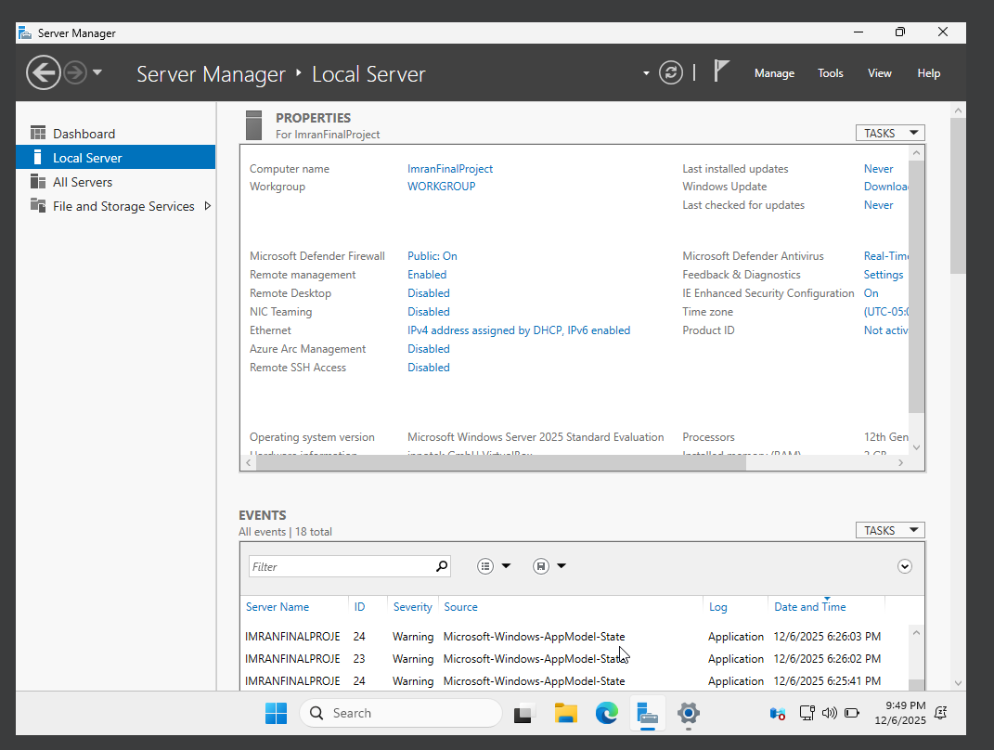
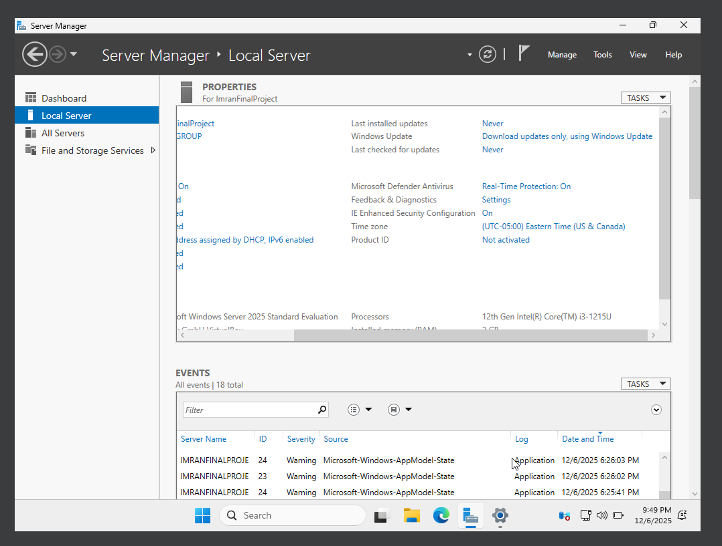
2. Install and configure Active Directory and DNS on the virtual server. Use the domain name
<YourNameMason.edu>; for instance, if your name is Peter, it becomes PeterMason.edu.
• Paste screenshot here:
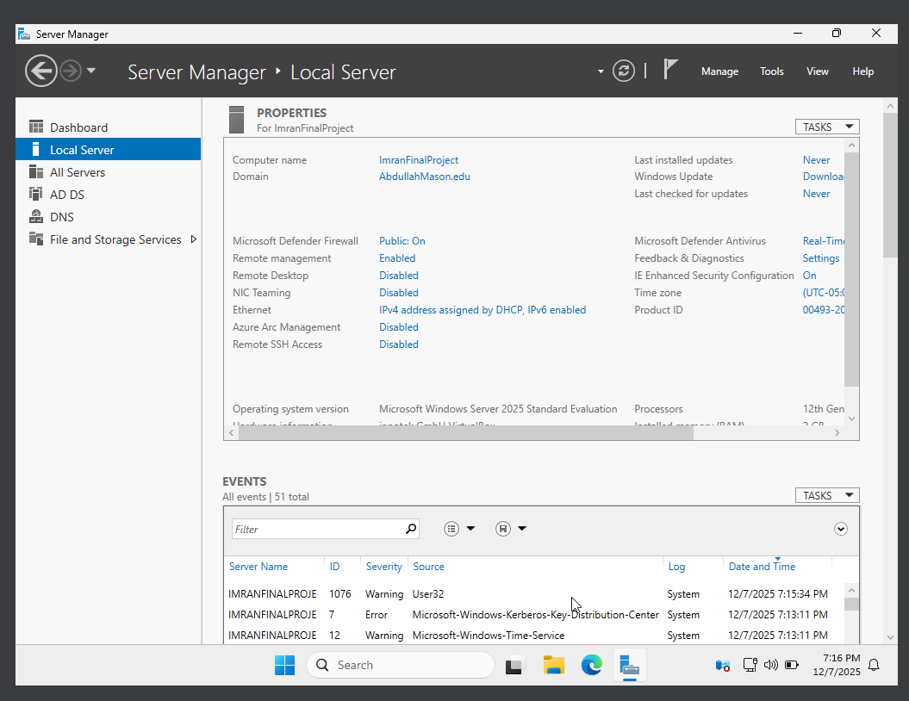
3. Install IIS and configure it to look for a page called index.html as its default page. Customize a simple index.htm
page to say: “This is <yourname> webpage running in IIS on my <servername> server in my <domainname>
domain, and I am very happy to have it hosted here. This is contributing to get me another 100 for my final
grade”. Load the page in Internet Explorer using http://<YourDomain>.
• Paste screenshot here:
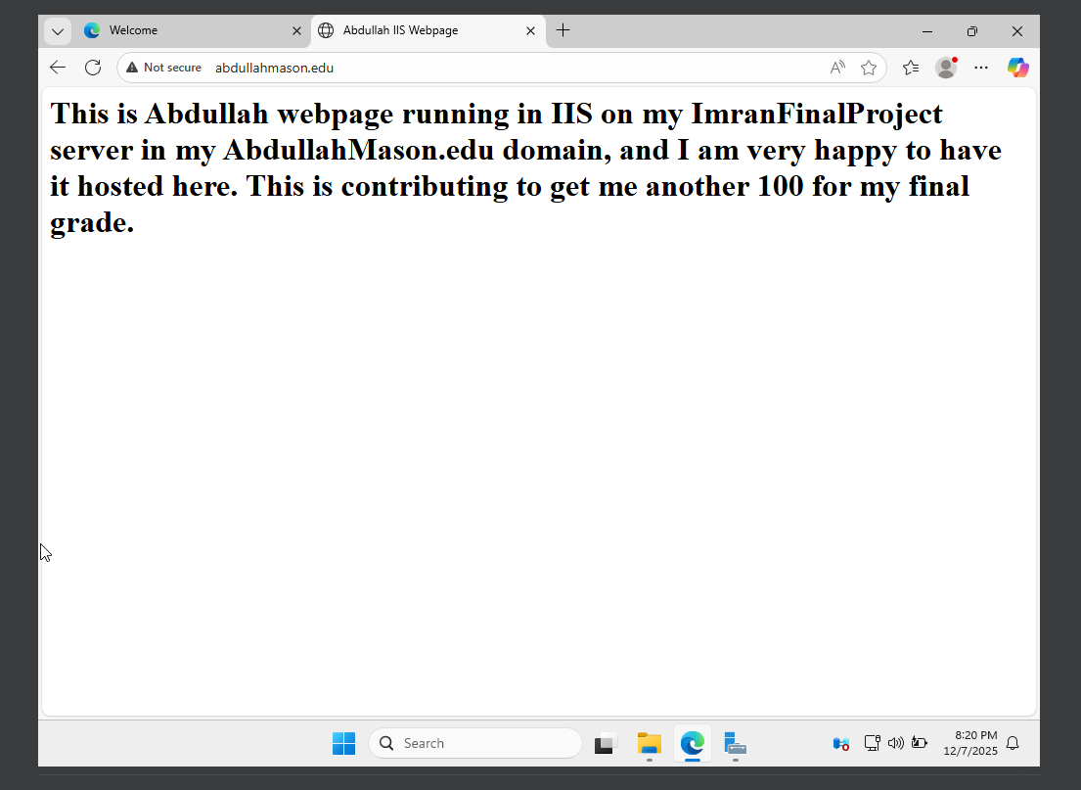

4. Install Apache on the same system (windows server). Configure Apache to listen on port 8000. Create another
index.html page to say: “This is <yourname> webpage running in Apache on my <servername> server in my
<domainname> domain and I am very happy to have it hosted here. This is contributing to get me another 100
for my final grade”. Note: You should be able to load the page in Internet Explorer using http://<YourDomain>.
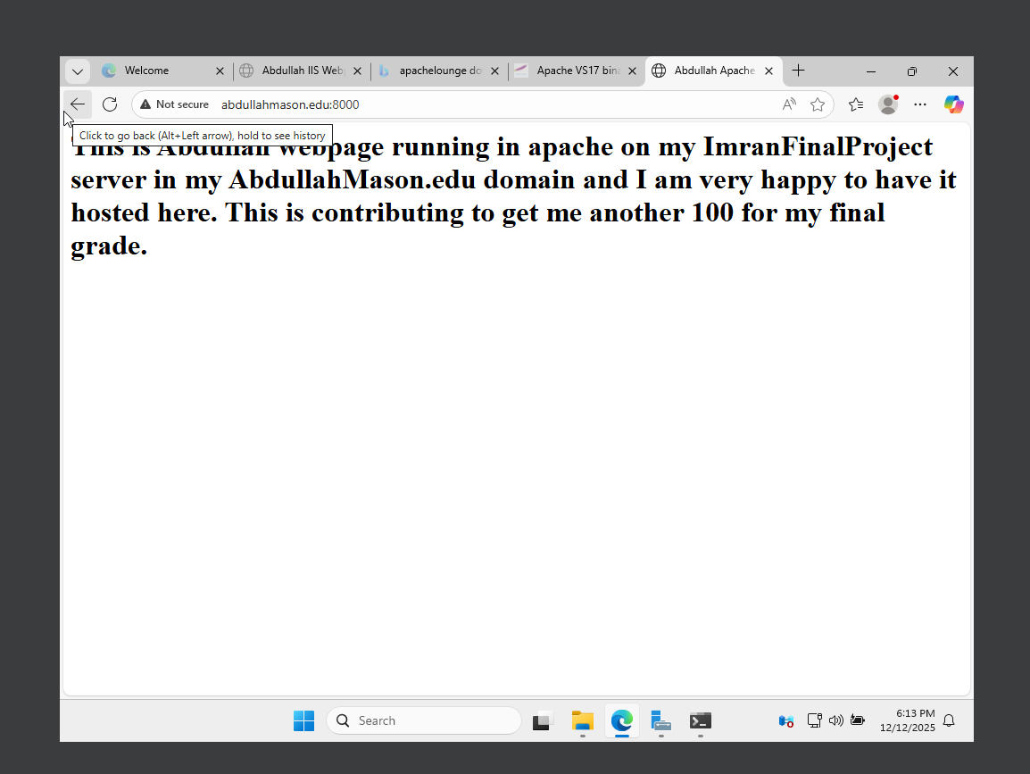
• Paste screenshot here:
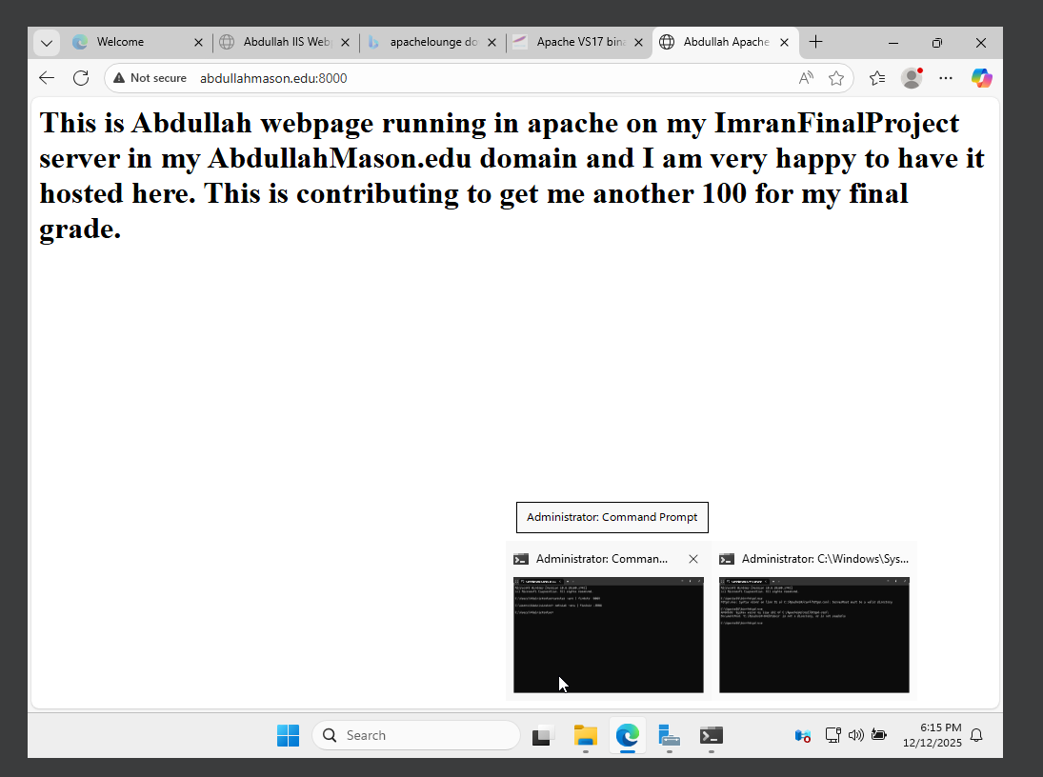
5. Configure DNS to have www.yournameMason.edu. Check and see if you can get to the
www.vournameMason.edu and that the default page is loaded.
• Paste screenshot here:
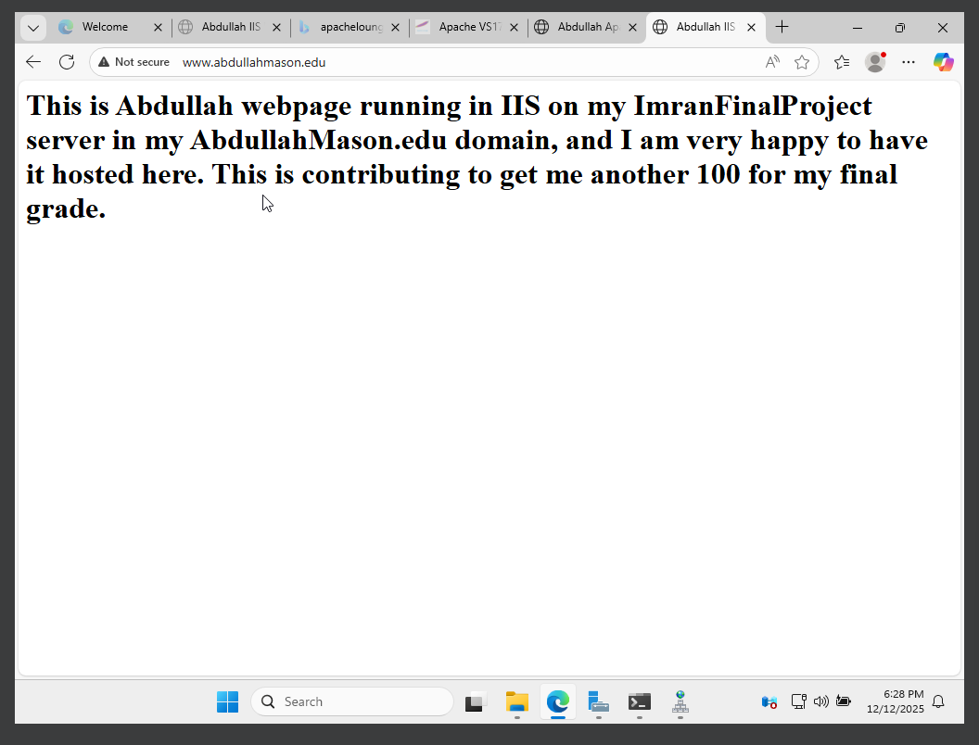
6. Configure and install an FTP server. Create a virtual directory that points to C:\public; create C:\public first if
you need to. Use any FTP client to upload or download files from there. In DNS create an alias called
ftp.yournameMason.edu that points to the ftp server. Make sure you can access the ftp via
ftp.yournameMason.edu.
• Paste screenshot here:
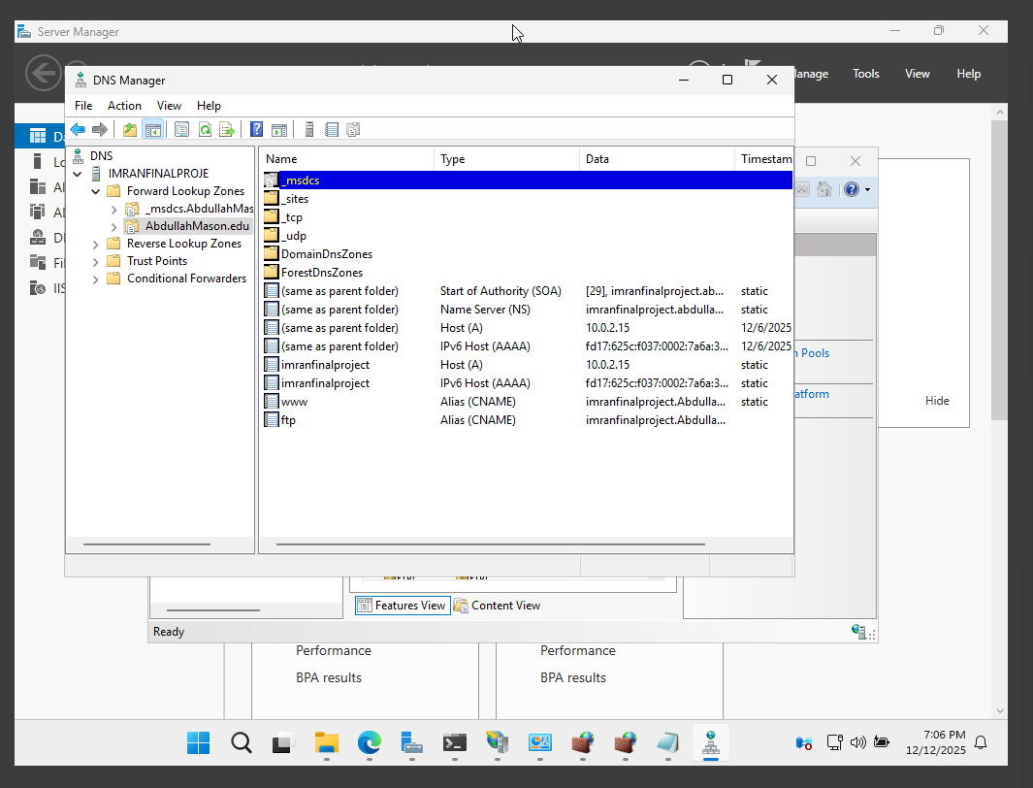
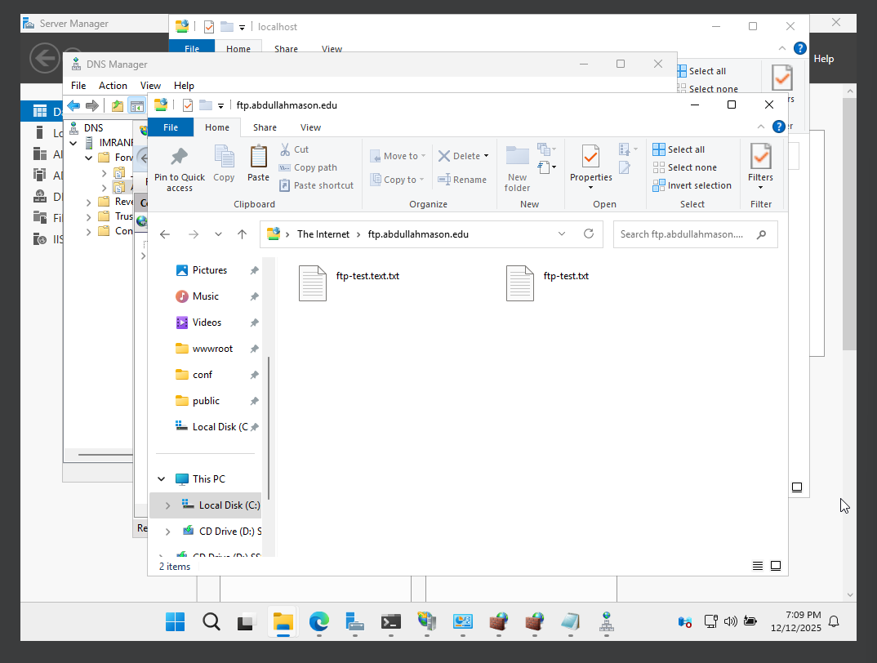
7. Install a Content Management System to build your sites. Either in your Windows Web Server or in your Linux,
install PHP and MySQL. Go to https://www.joomla.org/ or to https://wordpress.com/, look up any other
installation requirements and install Joomla! or WordPress in your server and show that you can customize the
main page.
• Paste screenshot here:
