**Data Warehouse and Business Intelligence Lab**

**DEARTMENT** Department of Data Science

**COURSE NAME** Data Warehouse and Business Intelligence Lab

**COURSE CODE** DS-306

**MANUAL LAB 1**

**TASK 1:**

* **Install Microsoft SQL Server on Windows**
* **Install Microsoft Analysis Services**
* **Install SQL Server Integration Services**

**TASK 2:**

* **Familiarize yourself with UI and create a sample database**

**MANUAL LAB 2**

**TASK 1:**

* **Create Northwind database. The database schema is as follows.**
* **Implement referential integrity constraints**

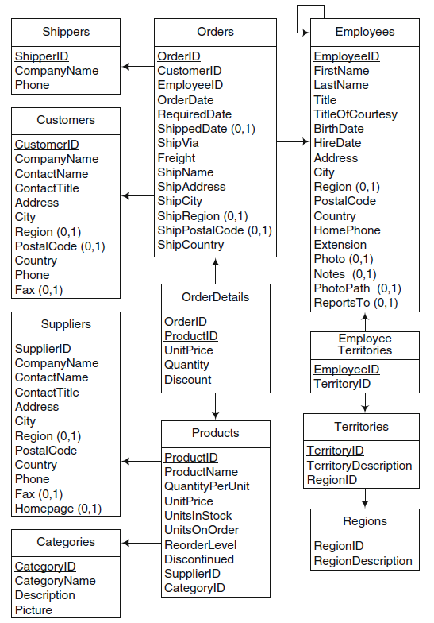

**TASK 2: Populate the schema with at least 5 rows**

* For each table enter data in it using visual method or using queries

**TASK 3: Write SQL queries for the following basic statements**

1. Select the names of employees who are working in Region A.
2. Count the number of employees working in Territory A.
3. Find the names of employees who were hired before the age of 21 years.
4. Show the distribution of products in each category.
5. Compute the number of orders which included suppliers from Lahore and where shipped to Islamabad.

**TASK 4: Write SQL queries for the following statements that can help the executives**

1. What is the total amount of discount offered during the last month and compare it with the discount in June last year?
2. Give a report of the products that were sold the most in the last year
3. How many products of supplier 2 were shipped by shipper 3 to customers in Faisalabad? And compare it with that of Karachi
4. Give a report of the month wise distribution of orders placed from Lahore
5. Which product was sold the most?
6. Compare the products that were sold the most in different regions
7. Compute the amount of the product delivered by shippers during the first quarter of the year 2024 in the region of Lahore and compared its performance with that of the last year.
8. Identify the products that are sold the most in cold and hot weathers.
9. Show the distribution of the discount offered on the suppliers from different cities during the year 2024.
10. Select the products, the names of suppliers who bought the products that fall in the category of cosmetics and were shipped on 1 January 2024. Also, compare the performance of each month is same report.