ES Semester Project # 11

Automatic Sorting System

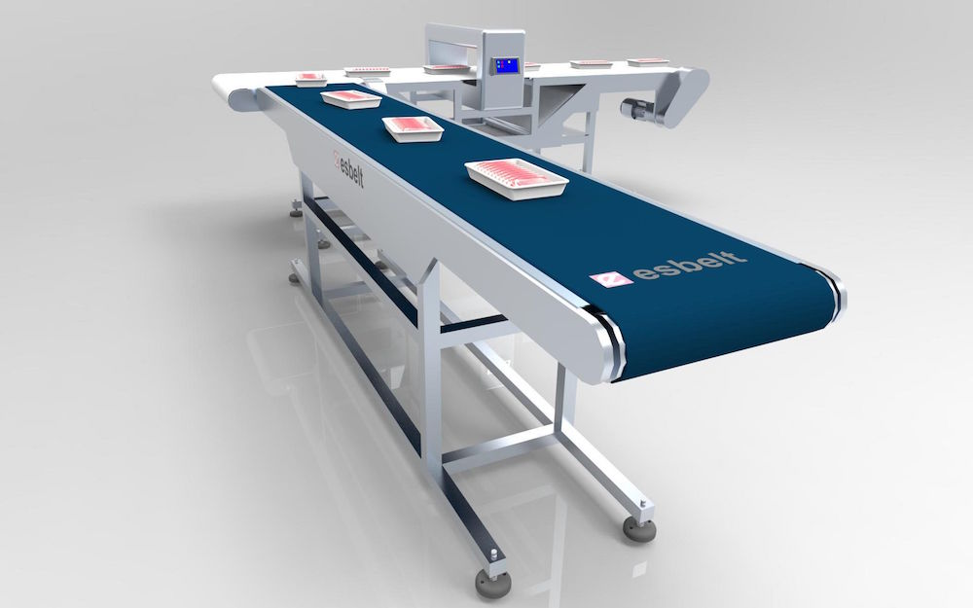

**Presented by: -**

Rana Umer: 2020_MC_01

Muhammad Hammad : 2020_MC_07

Abdullah Farooq : 2020_MC_15

Muhammad Baqir : 2020_MC_27

Ibrahim Haroon: 2020_MC_28

Abdul Rehman Farooq: 2020_MC_29

**CONTENTS**

* **Project Introduction (3)**
* **Electric Components (3-9)**
* **Hardware Components (9-10)**
* **List of internal peripherals (11)**
* **Pinouts for Connection (12)**
* **Circuit Diagram (13)**
* **Flowchart (14-15)**
* **Bill of Materials (16)**

**Project Introduction: -**

We were assigned to make an **Automatic Sorting System.**

The system sorts the products based on their heights. The products less than 3cm are discarded. The products having heights in between 3-5cm are sorted in a separate box while products having heights greater than 5cm are sorted in a separate box.

When the system is turned on it asks for Password. The system runs after entering the correct password.

An LCD displays the count of both products. Whenever a product is discarded the system gives warning using a Buzzer and a red LED.

**Electrical Components: -**

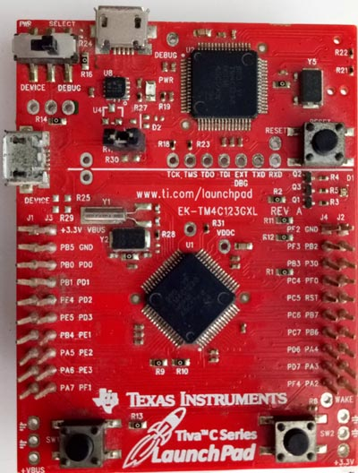**1. Tiva Microcontroller: -**

The TM4C123G is a member of the class of high-performance 32-bit ARM cortex M4 microcontroller with a broad set of peripherals developed by Texas Instrumentals. The TIVA launchpad has a built-in processor clock frequency of up to 80MHz with a floating-point unit (FPU).

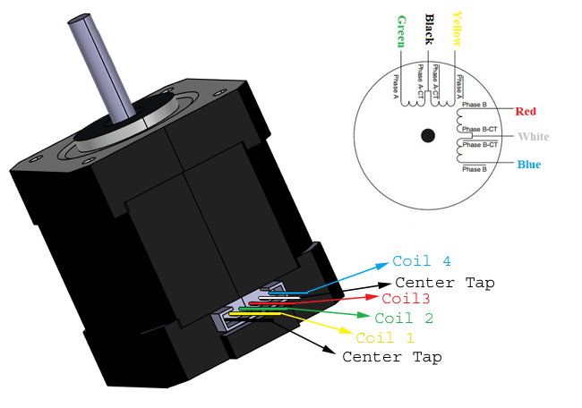**2. Stepper Nema 17: -**

NEMA 17 stepper motor is a stepper motor with a 1.7 x 1.7-inch (42 x 42 mm) faceplate. The Nema 17 stepper motor is larger and generally heavier than a Nema 14 stepper motor, but this also means it has higher torque. NEMA 17 is a hybrid stepper motor, the driving voltage is 12-36V.

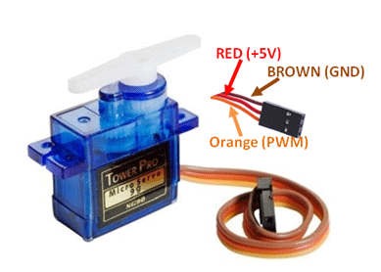**3. Servo motor SG90: -**

Micro Servo Motor SG90 is a tiny and lightweight server motor with high output power. Servo can rotate approximately 180 degrees (90 in each direction), and works just like the standard kinds but smaller. You can use any servo code, hardware or library to control these servos.

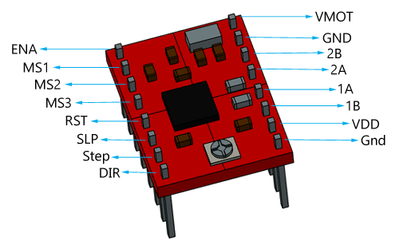**4. Motor driver a4988: -**

The A4988 is a complete micro stepping motor driver with built-in translator for easy operation. It is designed to operate bipolar stepper motors in full-, half-, quarter-, eighth-, and sixteenth-step modes, with an output drive capacity of up to 35 V and ±2 A.

**5. IR sensor: -**

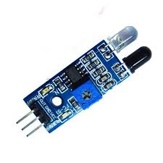 An infrared sensor (IR sensor) is a radiation-sensitive optoelectronic component with a spectral sensitivity in the infrared wavelength range 780 nm … 50 µm. IR sensors are now widely used in motion detectors, which are used in building services to switch on lamps or in alarm systems to detect unwelcome guests.

In our case we detect the height of the product using IR sensor.

**6. LCD 16x2: -**

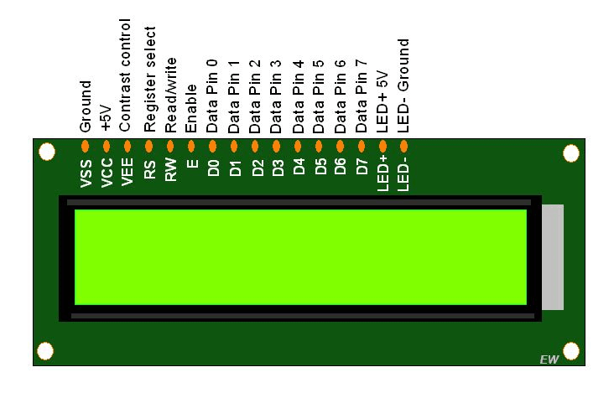16 x 2 LCD is a perfect I2C LCD display for Arduino and Raspberry Pi with high contrast and easy deployment. 16x2 means two lines and each line has 16 columns, 32 characters in total. With the help of Grove I2C connector, only 2 signal pins and 2 power pins are needed. You don't even need to care about how to connect these pins. Just plug it into the I2C interface on Arduino/Raspberry via the Grove cable. There won't be complicated wiring, soldering, worrying about burning the LCD caused by the wrong current limiting resistor.

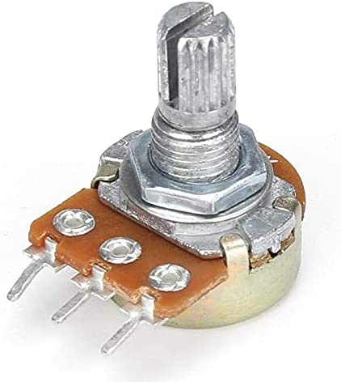**7. Potentiometer: -**

It is a single turn 10k Potentiometer with a rotating knob. These potentiometers are also commonly called as a rotary potentiometer or just POT in short. These three-terminal devices can be used to vary the resistance between 0 to 10k ohms by simply rotating the knob.

**8. Buzzer: -**

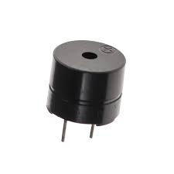A buzzer or beeper is an audio signaling device, which may be mechanical, electromechanical, or piezoelectric (*piezo* for short). Typical uses of buzzers and beepers include alarm devices, timers, and confirmation of user input such as a mouse click or keystroke.

**9. LED: -**

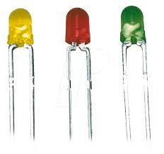A light**-**emittingdiode (LED) is a semiconductor light source that emits light when current flows through it. Electrons in the semiconductor recombine with electron holes, releasing energy in the form of photons. The color of the light (corresponding to the energy of the photons) is determined by the energy required for electrons to cross the band gap of the semiconductor. White light is obtained by using multiple semiconductors or a layer of light-emitting phosphor on the semiconductor device.

**10. Switch: -**

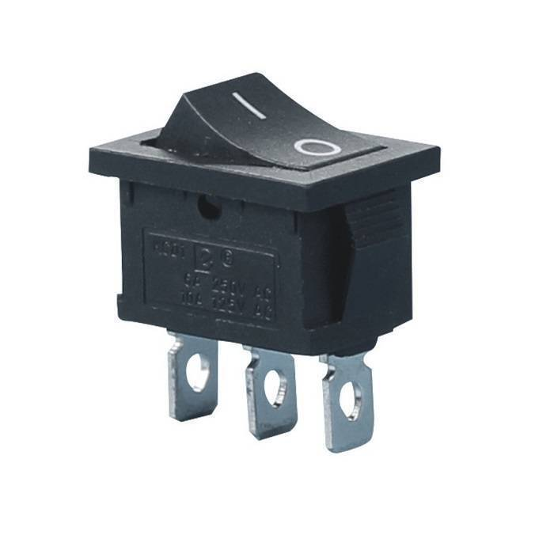 A switch is an electrical component that can disconnect or connect the conducting path in an electrical circuit, interrupting the electric current or diverting it from one conductor to another. The most common type of switch is an electromechanical device consisting of one or more sets of movable electrical contacts connected to external circuits. When a pair of contacts is touching current can pass between them, while when the contacts are separated no current can flow.

**10. Keypad: -**

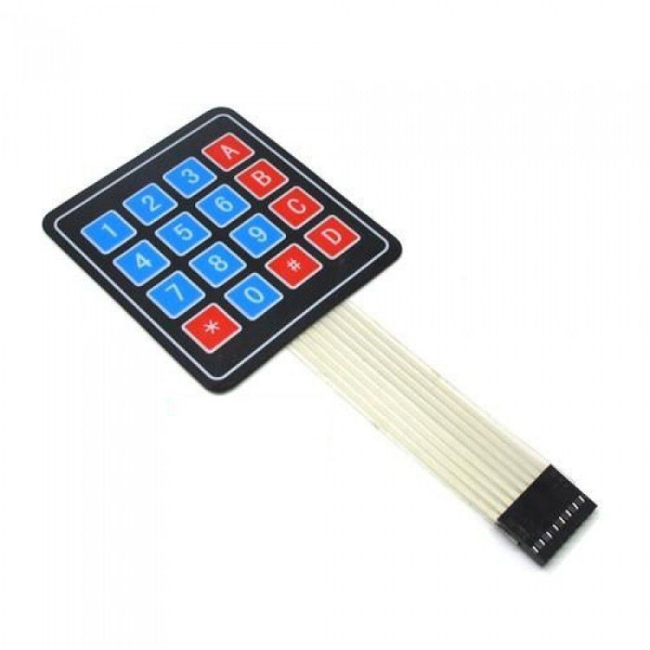A keypad is a block or pad of buttons set with an arrangement of digits, symbols, or alphabetical letters. Pads mostly containing numbers and used with computers are numeric keypads. Keypads are found on devices which require mainly numeric input such as calculators, television remotes, push-button telephones, vending machines, ATMs, Point of Sale devices, combination locks, and digital door locks. Many devices follow the E.161 standard for their arrangement.

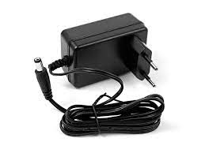**11. 12V Power Supply: -**

The 12V power supply provides the Stepper motor 1500mA current and 12 volts.

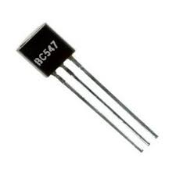**12. Transistor bc547: -**

BC547 is a bipolar junction transistor (BJT). It is kind of an NPN transistor. It has three terminals: Emitter, Collector and Base. The maximum current gain of BC547 is 800A. The Collector−Emitter Voltage is 65V.

**13. Jumper Wires: -**

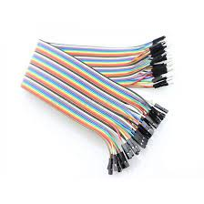 Jumper wires are simply wires that have connector pins at each end, allowing them to be used to connect two points to each other without soldering. Jumper wires are typically used with breadboards and other prototyping tools in order to make it easy to change a circuit as needed. Fairly simple. In fact, it doesn’t get much more basic than jumper wires.

**14. Vero Board: -**

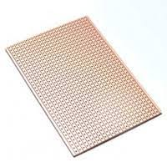Veroboard is a brand of [stripboard](https://en.wikipedia.org/wiki/Stripboard), a pre-formed [circuit board](https://en.wikipedia.org/wiki/Circuit_board) material of copper strips on an insulating [bonded paper](https://en.wikipedia.org/wiki/FR-2) board which was originated and developed in the early 1960s by the [Electronics](https://en.wikipedia.org/wiki/Electronics) Department of [Vero Precision Engineering Ltd](https://en.wikipedia.org/wiki/Vero_Precision_Engineering_Ltd) (VPE). It was introduced as a general-purpose material for use in constructing [electronic circuits](https://en.wikipedia.org/wiki/Electronic_circuits) - differing from purpose-designed [printed circuit boards](https://en.wikipedia.org/wiki/Printed_circuit_boards) (PCBs) in that a variety of electronic circuits may be constructed using a standard wiring board.

**Hardware Components:**

**1. PVC Sheets: -**

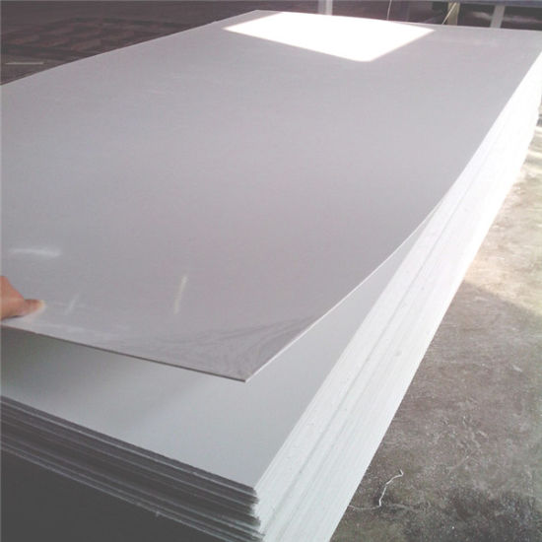Polyvinyl Chloride (PVC) is one of the most widely used plastics in the world. This industrial plastic is often used to make chemical storage tanks, oil tanks and photographic developing instruments. If you would like to build a greenhouse or winterize your windows, look no further than our PVC sheet selection.

**2. Belt: -**

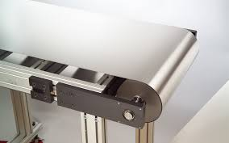Belt conveyer is necessary in the production line of gravel and construction waste and is mainly used to connect the broken equipment of different levels, sand production facilities and screening equipment. We used it to move are objects to be sorted.

**3.Tyre: -**

In this project we used tyre for moving the belt. There are two tyre at two ends of the belt which are placed on the shaft of the stepper motors.

**4.Nut Bolts: -**

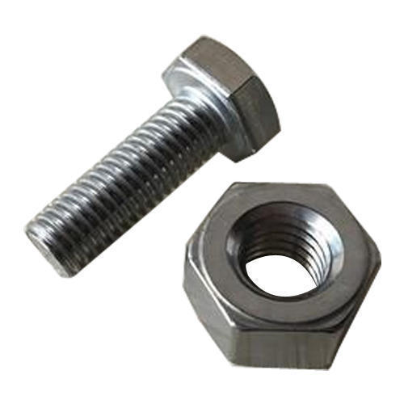

A nut is a type of a fastener with a threaded hole. Nuts are almost always used in conjunction with a mating bolt to fasten multiple parts together. We used them to fasten the sensors on the wall.

**List of Internal peripherals used: -**

The PWM sent to the motor determines position of the shaft and based on the duration of the pulse sent via the control wire; the rotor will turn to the desired position. The servo motor expects to see a pulse every 20 milliseconds(ms) and the length of the pulse will determine how far the motor turns.

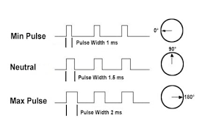

**Pinouts for connections: -**

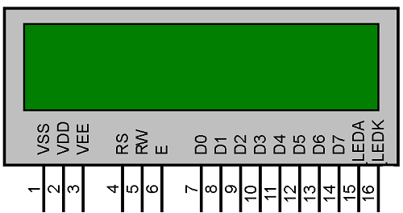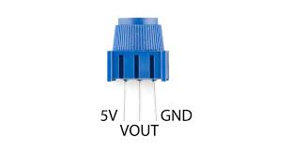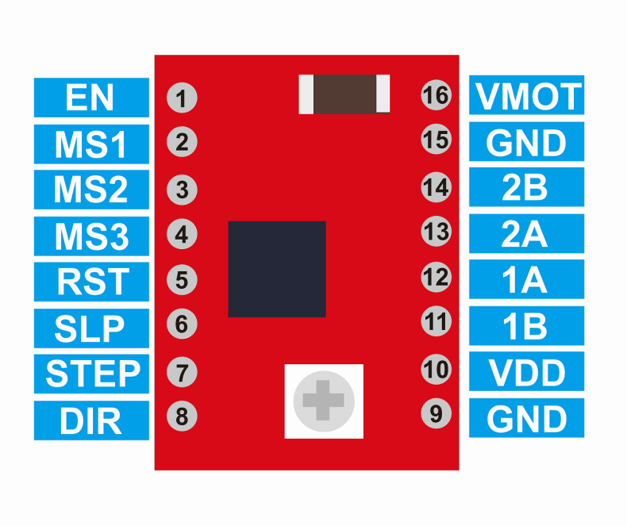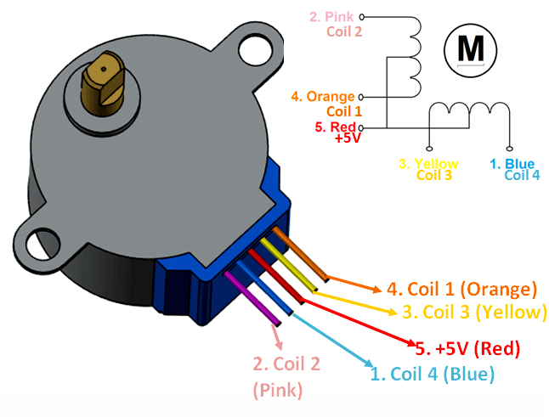

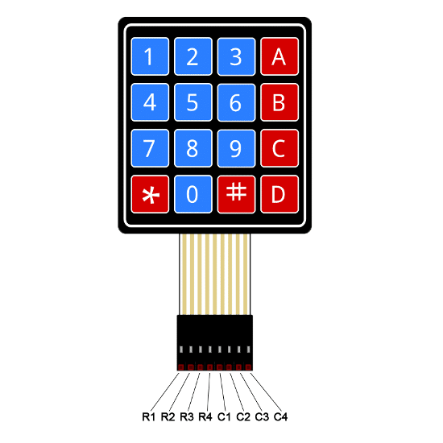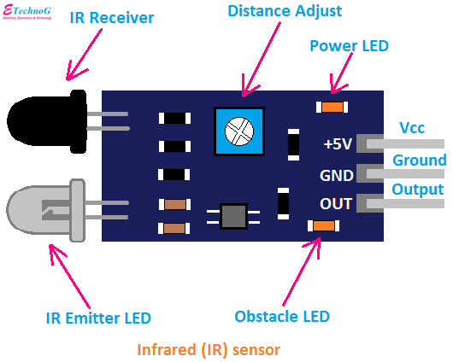

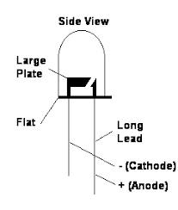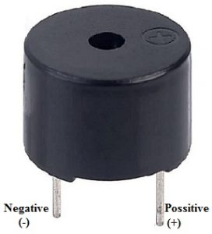

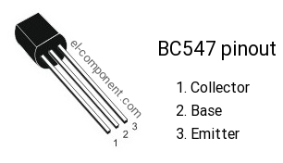

**Circuit Diagram: -**

**1st Tiva microcontroller (For servo motor): -**

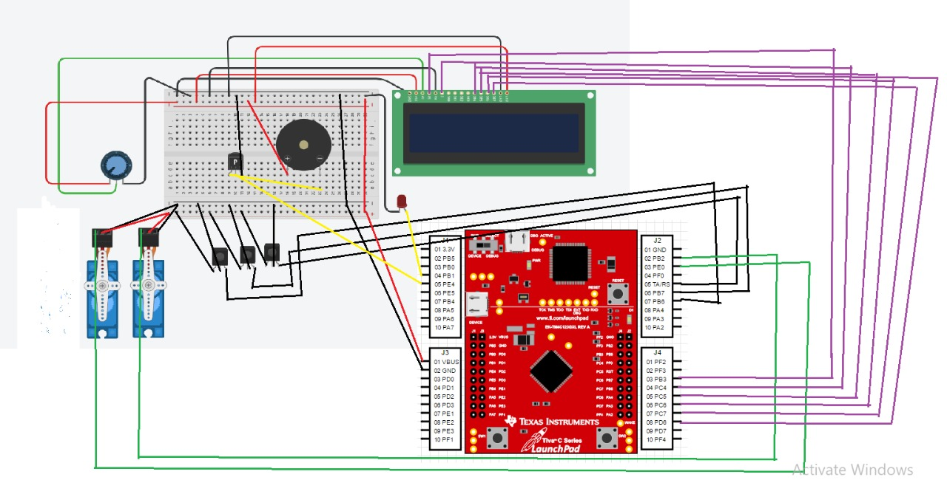**2nd Tiva microcontroller (For stepper motor): -**

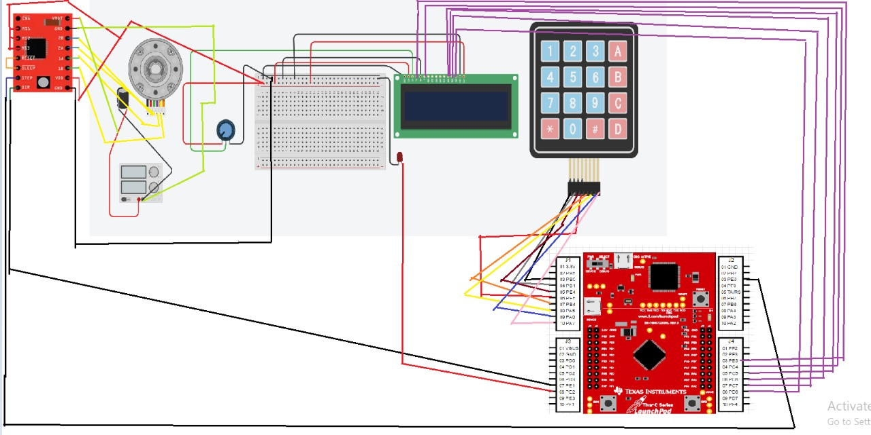

**Flowcharts: -**

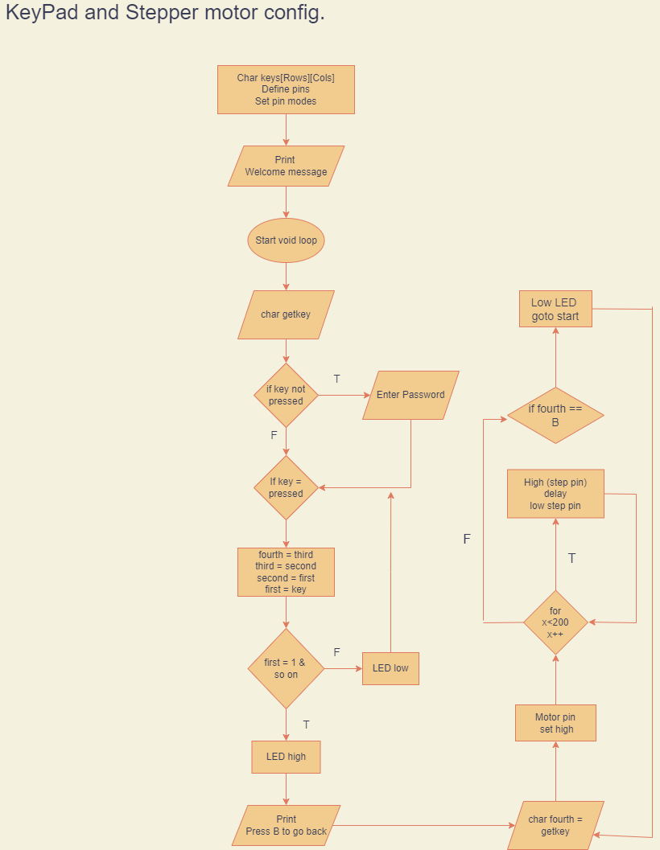

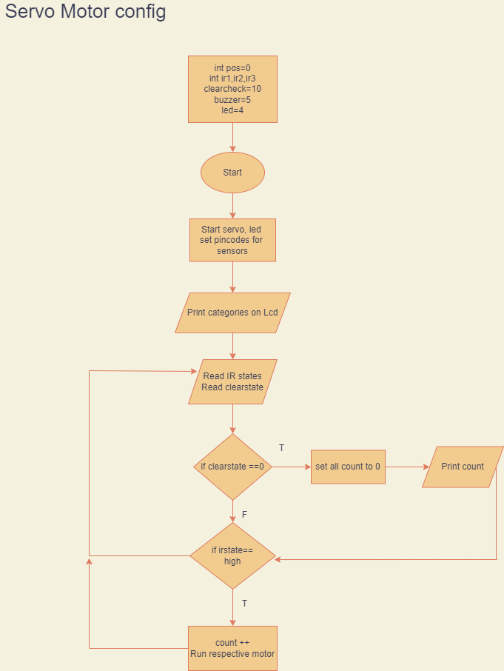

|  |  |
| --- | --- |
| **Components** | **Price** |
| Stepper motor | **400 x2 = 800** |
| Tiva TM4C123GH6PM | **4500x2=9000** |
| Servo motor | **250x2 = 500** |
| Motor driver | **140x2= 280** |
| IR sensor | **80 x 3 = 240** |
| LCD 16x2 | **530x2 = 1060** |
| Potentiometer 10k | **70** |
| Buzzer | **30** |
| Led | **10 x 2 = 20** |
| Switch | **80** |
| Keypad | **100** |
| 12V Power supply | **170** |
| Transistor BC547 | **13** |
| Wires | **350** |
| Veroboard | **300** |
| Total | **13,013** |