ExpenseMate - Personal Expense Manager
Architecture & Design Diagrams
System Architecture - Database ERD - Use Case Diagram - Project Schedule
Prepared By: Muhammad Abdullah
Reviewed By: Areebah Khan

1. Use Case Diagram
The use case diagram below defines the primary interactions between the User (Primary Actor) and the ExpenseMate system.
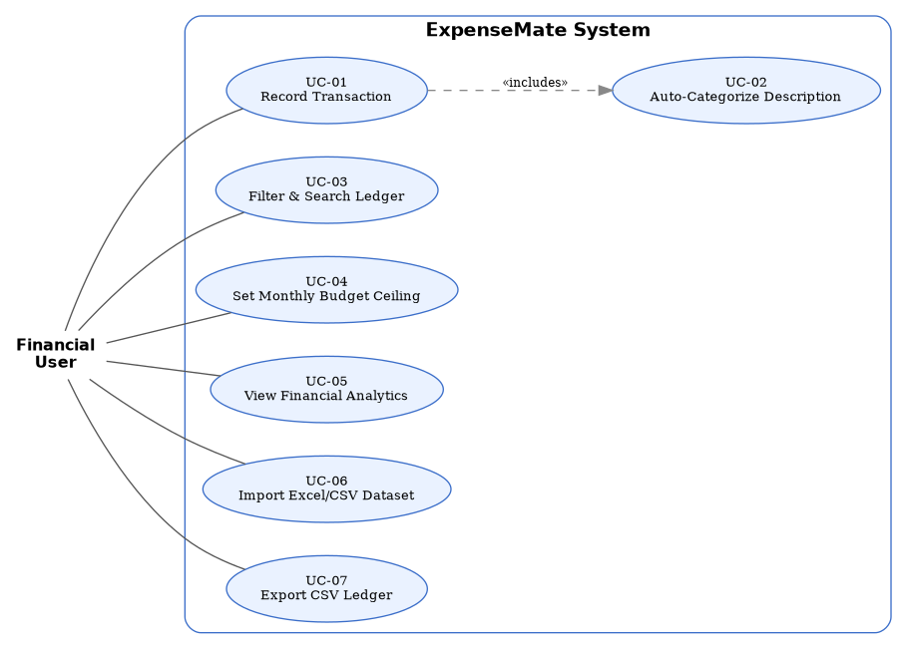
Figure 1: Use Case Diagram - ExpenseMate System

1.1 Detailed Use Case Descriptions

UC-01: Record Transaction with Auto-Categorization
Primary Actor: User
Preconditions: Application is loaded.
1. User navigates to Transactions page and clicks "+ New Transaction".
2. User inputs description (e.g. "Uber ride to campus").
3. System triggers keyword auto-categorization and suggests category "Transport".
4. User enters amount (e.g. 1500), selects date, payment method, and currency.
5. User submits form.
6. Backend validates input (amount > 0, valid date format) and saves record into PostgreSQL/Memory database.
7. Ledger and Dashboard metrics update dynamically.

UC-04: Set Monthly Budget Ceiling & Monitor Thresholds
Primary Actor: User
Preconditions: Category exists in system.
1. User navigates to Budgets page.
2. User selects an expense category (e.g. Food) and enters a monthly spending limit (e.g. Rs. 25,000).
3. System saves the budget limit record.
4. System computes actual_spent / limit x 100 and displays a status badge: <80% Normal (Green), 80-89% Warning (Yellow), 90-99% Critical (Orange), >=100% Exceeded (Red).

UC-06: Import Dataset (.xlsx / .csv)
Primary Actor: User
1. User navigates to Import/Export tab.
2. User selects an Excel file (e.g. ExpenseMate_Dummy_Dataset_180.xlsx).
3. System parses the spreadsheet, validates rows, and auto-assigns category IDs based on description keywords.
4. System renders an interactive preview table showing row numbers, status badges, and validation notes.
5. User clicks "Confirm & Commit Records".
6. Valid rows are inserted into the database; total imported count is displayed.

2. High-Level System Architecture
ExpenseMate uses a 3-tiered architecture pattern structured for maximum clarity, low cyclomatic complexity, and easy explanation in university viva evaluations.
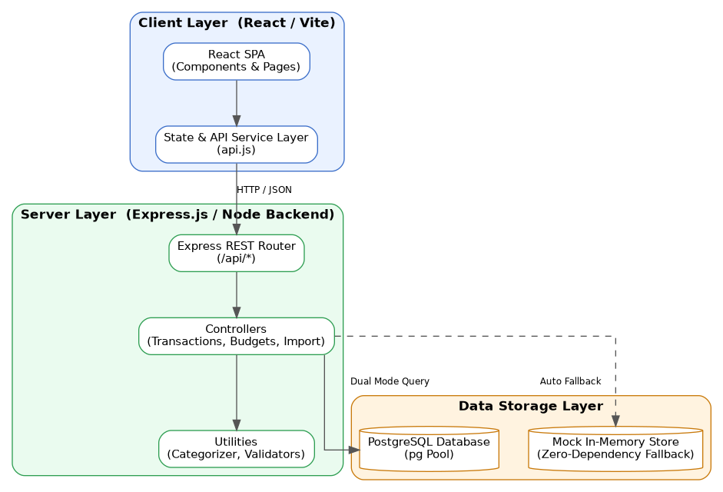
Figure 2: 3-Tier Architecture - Client, Server, and Data Storage Layers

2.1 Layer Breakdown

Client Layer (client/src)
- Built with React 18, Vite, Lucide React icons, and Chart.js / react-chartjs-2.
- Clean component separation: Sidebar.jsx, Navbar.jsx, SummaryCard.jsx, TransactionTable.jsx, TransactionForm.jsx, BudgetCard.jsx, ChartComponent.jsx.
- Single API client service wrapper (services/api.js).

Server Layer (server/)
- Express framework listening on port 5000.
- Modular route mapping: /api/transactions, /api/budgets, /api/categories, /api/dashboard, /api/import, /api/export.
- Controllers handle business logic, input validation, and budget warning status calculations.

Data Storage (server/db/connection.js)
- Primary: PostgreSQL pg.Pool connection executing DDL (database/schema.sql) & seed (database/seed.sql).
- Secondary: Automated in-memory repository store. If PostgreSQL is offline, the system seamlessly handles all SQL operations in memory without crashing or requiring manual configuration.

3. Database Schema (Entity-Relationship Diagram)
The PostgreSQL schema is composed of three normalized entities: CATEGORIES, TRANSACTIONS, and BUDGETS.
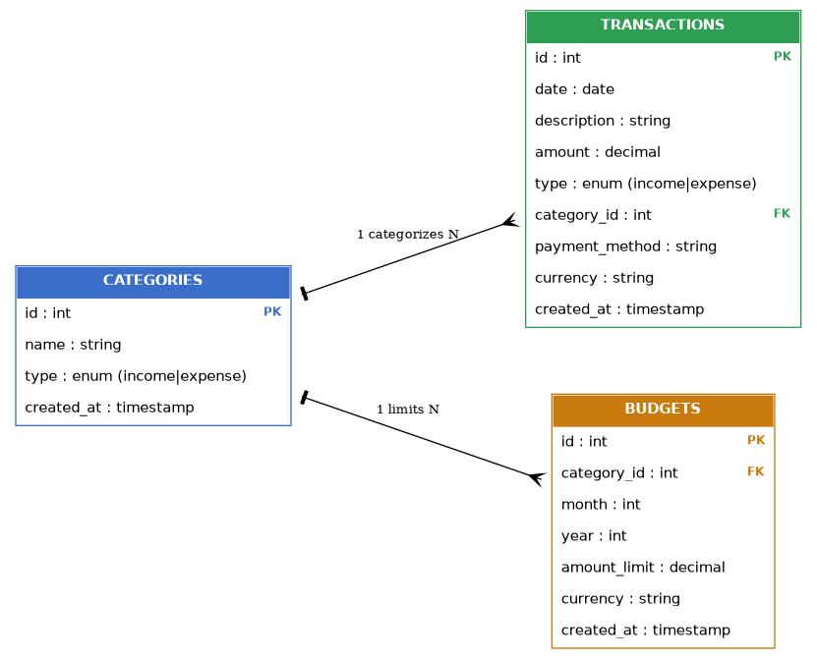
Figure 3: Entity-Relationship Diagram - ExpenseMate Database

- CATEGORIES (1) - categorizes - (N) TRANSACTIONS
- CATEGORIES (1) - limits - (N) BUDGETS

4. Project Schedule (Gantt Chart)
The project followed a 6-phase, 14-day Software Construction lifecycle from requirements analysis through documentation and viva preparation.
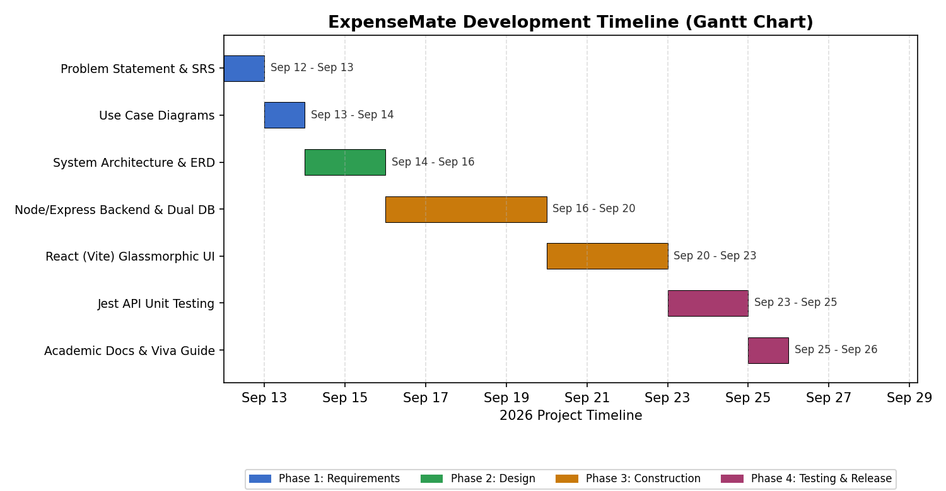
Figure 4: ExpenseMate Development Timeline

Phase | Duration | Deliverables | Status
1. Requirements & Analysis | Days 1 - 2 | Problem statement, SRS, Use Cases, NFRs | Completed
2. Architectural Design | Days 3 - 4 | 3-Tier Node/Express/React Architecture, ER Diagram, Schema DDL | Completed
3. Backend Construction | Days 5 - 7 | Express routes, Controllers, Rule Categorizer, Dual DB Fallback | Completed
4. Frontend Construction | Days 8 - 10 | React Vite SPA, Glassmorphic CSS system, Components & Charts | Completed
5. Testing & Verification | Days 11 - 12 | Jest API integration tests, dataset import verification | Completed
6. Documentation | Days 13 - 14 | Complete 9 academic docs | Completed

