C / VB Converter 
Abdullah Haidar ( 91799 )
Supervised by Dr May Dheiny
INFO400 2019-2020

Outline:
- Introduction
- String manipulation issue in C
- Declarations
- Output / Input
- Alternations
- Loops
- Tests

1
Introduction
The goal of this project was to develop a compiler that converts C code to VB code. The compiler checks the validity of the C code and the convert it to a working VB code. The result is a fully functioning compiler with a graphical user interface. This report presents the major issues tackled in the development process and how they were compromised . The final part of the report presents some of the tests performed for validation.

String manipulation issue in C
Dealing with strings is frustrating task as functions like strcat and sprintf might show unexpected behavior. In the example below there are two sample codes : the first one performs normally however the second one fails unexpectedly with the only difference being the value of N.

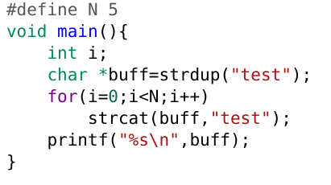
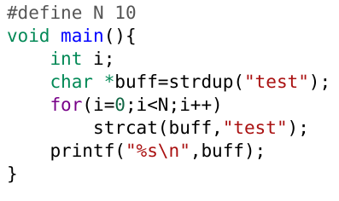
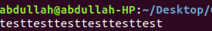
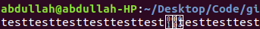

Suggested solutions where to use strncat and snprintf , but these also have issues when copying to the same buffer and the size of the buffer must be know before.
A simple way to avoid this problem is by us implementing the string functions. The file strings.h contains all the functions needed by the compiler.
Declarations
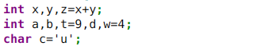

The production follows an LA approach with the type as inherited value. 2
Several points must be considered here:
- Multiple declarations in VB is similar to C when the variables has no values assigned, so we can simply list the varibles and then add the type. However in multiple declarations for variables with values we must add the type after every assignment. So the type must be inherited from the parent and the type will be added after every assignment when the production is reduced.
- The identifiers must be unique , so we store the variables in a symbol table ( linked list ) and check if the new variable is defined before. The production must store the left variables before it moves to the next variables, otherwise this expression will lead to an error : int x , y , z = x + y ;
- The varibles with values and the variables without values must be grouped separately so that we can define the type of the variables without values once. So the non terminal varList will have two string values : variablesWithoutValues and variablesWithValues which will be concatenated later.

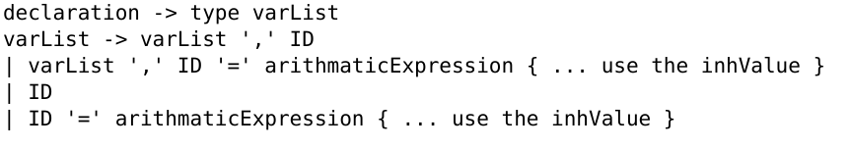
Output / Input
We use a global variable counter to track the indices of the variables
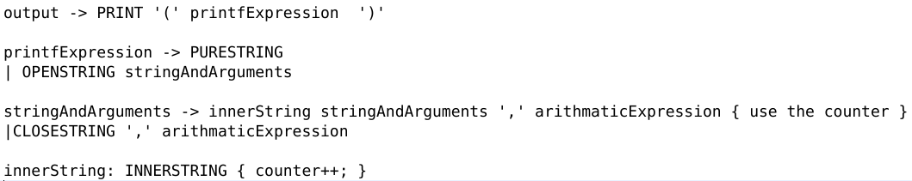
An open string is a token starting with “ and ends in %
An inner string is a token starting with d , f , c or lf and ends in %
A close string is a token starting with d, f, c or lf and ends in ”
A pure string doesn’t contain any %
The arguments can be any arithmetic expression

The parse tree below is for the following expression :
printf(“ Hello %d how %d are %d you ” ,x ,y,z) 3

output
PRINT
(
)
printfExpression
“Hello {0} how {1} are {2} you ” , x , y ,z

stringAndArguments
openString
innerString
stringAndArguments
,
arithmeticExpression
stringAndArguments
,
arithmeticExpression
arithmeticExpression
innerString
closeString
,
“ Hello %
counter=0
d how %
counter=1
d are %
counter=2
d you ”
{2} you ” , x
counter--;
{1} are {2} you ” , x , y

counter--;
“ {0} how {1} are {2} you ” , x , y ,z
x
y
z

This also ensures that the number of arguments and identifiers is the same.
4

Alternations
The dangling else problem was solved by dividing statements into two types :
- ifStmt which is a closed if statement (either no alternations or every if has an else)
- openIfStmt which is an open if statement (either the else has an open statement or there is an if followed by anything )
Loops
Two main points:
- The for loop in VB is only a range type loop , so we must make a restriction on the C for loop such that it represents a range. Another approach is to convert C for loops that don’t represent a range ( as in for( i=100;i*x<10 ;i /=2) ) into a while loop in VB. The later approach will make the grammar more complex and erroneous , so in this project C for loops must be of range type or else it must be converted into while loops before giving it to the compiler.
- The dangling else problem appears here also, as in this example :
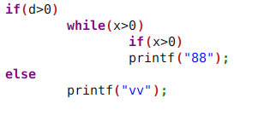
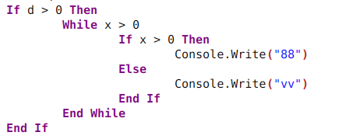

this problem was mitigated by introducing two extra productions :
- openWhileLoop : while with open If
- openForLoop : for with open If

Tests
Below are samples of the tests performed, all test cases are in the examples folder.

- General expressions:

5
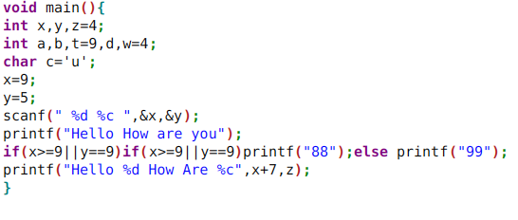
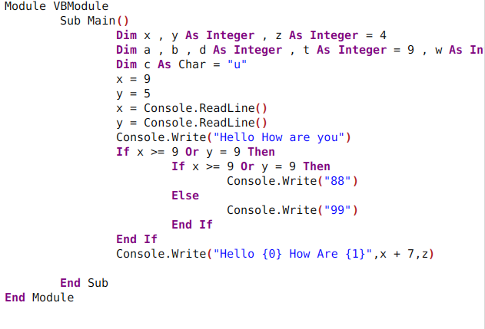
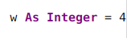

- Loop and alternation expressions:

6

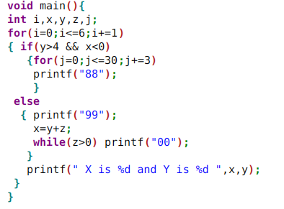

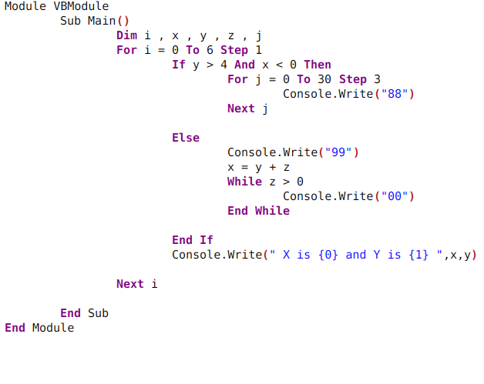
7

