Errors and Solutions

Week 1
AI Lab - Week 1
Error: The symbolic method and the threshold method gave different answers for the same case. For score 68 with complete work, the symbolic method said Hold and the threshold method said Review.
Error screenshot:
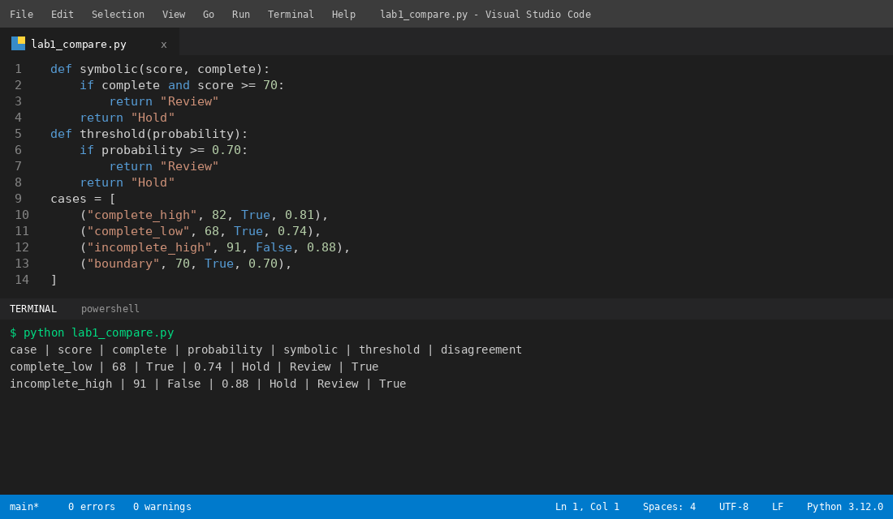
Solution: I kept both answers side by side in the output table and checked the reason for each case.
Solution screenshot:


